Virtual 3D histological analysis of soft tissues by contrast-enhanced microfocus computed tomography: screening contrast-enhancing staining agents
Delia Hoffmann^{1,2,3}, Walid El Aazmani¹, Lara Engelen⁴, Greet Kerckhofs^{1,2,4,5}
¹ Pole of Morphology, Institute of Experimental and Clinical Research, UCLouvain, Brussels, Belgium
² Prometheus, Division of Skeletal Tissue Engineering, KU Leuven, Leuven, Belgium
³ Skeletal Biology and Engineering Research Center, KU Leuven, Leuven, Belgium
⁴ Biomechanics lab, Institute of Mechanics, Materials and Civil Engineering, UCLouvain, Louvain-la-Neuve, Belgium
⁵ Department Materials Engineering, KU Leuven, Leuven, Belgium

The gold standard for studying biological tissues at the microscale (i.e. histology) is tissue sectioning with subsequent colorimetric or fluorescent staining and microscopic evaluation. However, it loses the 3D information of the tissue. In many research fields, it is essential to analyze the 3D distribution of different tissue types and constituents, and therefore to maintain the integrity of the biological tissues. As non-invasive imaging technique, contrast-enhanced microfocus X-ray computed tomography (CECT) is a promising solution to image soft tissues in addition to mineralized tissues in full 3D. However, there is still a lack of systematic screening and comparison of X-ray contrast-enhancing staining agents (CESAs) for their potential to highlight tissues and their constituents in whole organs.
Therefore, in this study, fixed murine auricles, incubated with Hafnium-substituted Wells-Dawson polyoxometalate (Hf-WD POM), cationic iodinated contrast agent CA4+ and/or Lugol’s iodine, were scanned with high-resolution microCT. The tissues were then embedded and processed for colorimetric staining. By comparing CECT images and corresponding tissue sections, we identified and segmented tissue types such as the epidermis, dermis, hair follicles, sebaceous glands, adipose tissue, muscle, cartilage and vessels. The three CESAs conferred different contrasts to these tissue types. We are also assessing the effect of CESA staining on subsequent histological assessment by sectioning and colorimetric staining. We found that the CESAs can only be partly washed out (even after 21 days in PBS) and could modify the biochemical properties of the tissues, rendering them more fragile for cutting. Additionally, they could change the binding properties of subsequent histological stains.
Taken together, CECT is a promising technique for 3D histological analysis of biological tissues and will give us a better insight in the spatial distribution and interrelationship of tissues. However, it should be considered that the CESAs may influence subsequent colorimetric histological assessment.
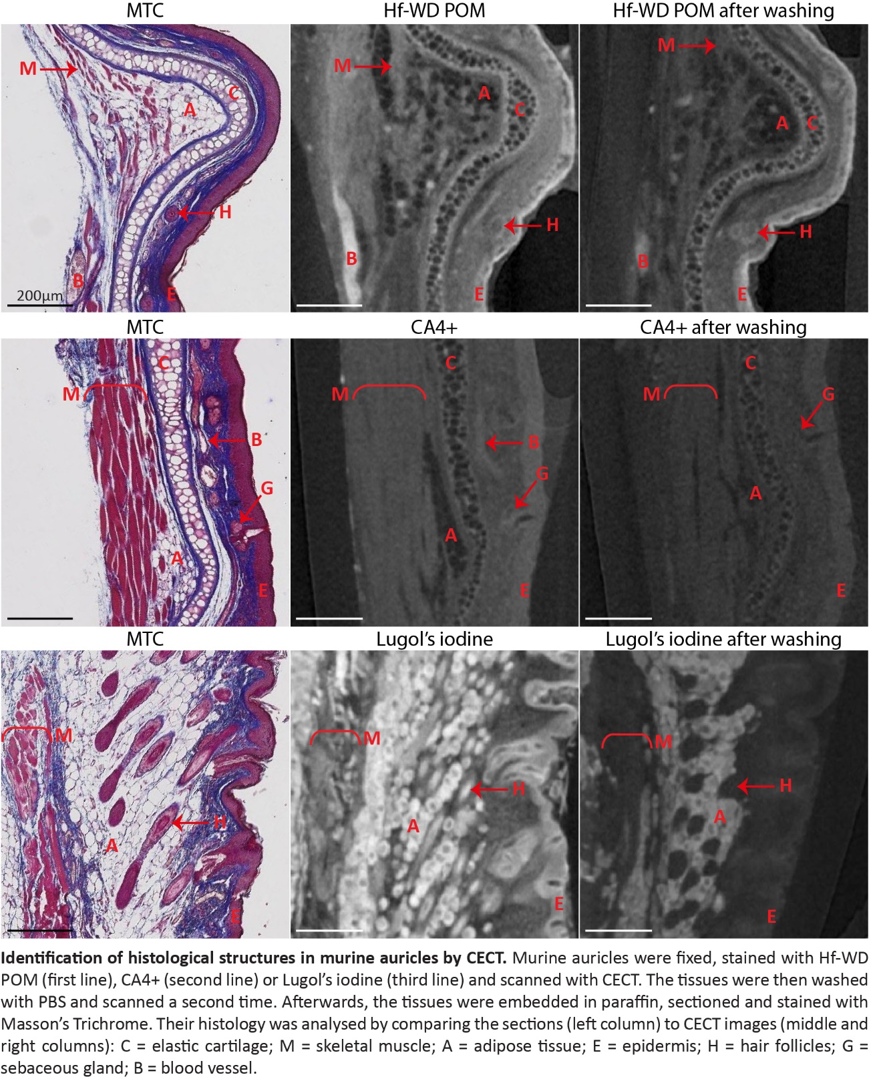

Keywords: 3D histology, contrast-enhancing staining agents, tissue segmentation
Session: Life Sciences

