Perceptual simultaneity between nociceptive and visual stimuli depends on their spatial congruence

Louise Manfron^{a,b}, Lieve Filbrich^{a,b} , Victoria Molitorª, Alessandro Farnè^{c}, André Mouraux^{a,b,d}, Valéry Legrain^{a,b,d,}*

ª Institute of Neuroscience, Université catholique de Louvain, Brussels, Belgium
^{b} Psychological Sciences Research Institute, Université catholique de Louvain, Louvain-la-Neuve, Belgium
^{c} ImpAct team, Lyon Neuroscience Research Center, INSERM U1028, CNRS UMR5292, Lyon, France
^{d} Louvain Bionics, Université catholique de Louvain, Louvain-la-Neuve, Belgium

*Corresponding author: Institute of Neuroscience, Université catholique de Louvain, Avenue Mounier 53, boite COSY B1.53.04, 1200, Brussels, Belgium. E-mail address: valery.legrain@uclouvain.be (V. Legrain)

Abstract
To protect our body against physical threats, it is important to integrate the somatic and extra-somatic inputs generated by these stimuli. Temporal synchrony is an important parameter determining multisensory interaction, and the time taken by a given sensory input to reach the brain depends on the length and conduction velocity of the specific pathways through which it is transmitted. Nociceptive inputs are transmitted through very slow conducting unmyelinated C and thinly myelinated Aδ nociceptive fibers. It was previously shown that to perceive a visual stimulus and a thermo-nociceptive stimulus applied on the hand as coinciding in time, the nociceptive stimulus must precede the visual one by 76 ms for nociceptive inputs conveyed by Aδ fibers and 577 ms for inputs conveyed by C fibers. Since spatial proximity is also hypothesized to contribute to multisensory interaction, the present study investigated the effect of spatial congruence between visual and nociceptive stimuli. Participants judged the temporal order of visual and nociceptive stimuli, with the visual stimuli flashed either next to the stimulated hand or next to the opposite unstimulated hand, and with nociceptive stimuli evoking responses mediated by either Aδ or C fibers. The amount of time by which the nociceptive stimulus had to precede the visual stimulus for them to be perceived as appearing concomitantly was smaller when the visual stimulus occurred near the hand receiving the nociceptive stimulus as compared to when it occurred near the contralateral hand. This illustrates the challenge for the brain to process the synchrony between nociceptive and non-nociceptive stimuli to enable their efficient interaction to optimize defensive reaction against physical dangers.

Keywords: Nociception, Pain, vision, multisensory, temporal order judgment, space.

Introduction
Surrounding objects with which we interact are often perceived through different sensory modalities. Hence, proper coordination between the different sensory modalities is crucial to optimize integration of their respective inputs, generate a coherent percept, and trigger appropriate behavioral responses. This is particularly achieved when different sensory stimuli occur close in time (Meredith, Nemitz, & Stein, 1987; Spence & Squire, 2003; Stein & Meredith, 1993) and space (e.g. Fairhall & Macaluso, 2009; Graziano & Cooke, 2006; Graziano, Hu, & Gross, 1997; Spence, 2001). The ability to efficiently integrate multiple sensory stimuli arising from the same event could be particularly important for painful sensory stimuli that signal the imminence of a danger threatening the physical integrity of the body. Pain is typically generated by activation of the nociceptive system, a physiological system specifically involved in the detection and transmission of information about high intensity stimuli which have the potential capacity to damage tissue. The mechanisms of multisensory interactions between somatic and extra-somatic stimuli have been widely studied with innocuous tactile stimuli, and relatively little with stimuli specifically activating the nociceptive system. In addition to its importance for understanding the contribution of multisensory interactions for adaptation to threats, the nociceptive system illustrates particularly well the challenge for the brain to assess the temporal synchrony of sensory inputs requiring different times to reach the brain. Indeed, the time taken by a given sensory input to reach the brain depends on the location at which the eliciting stimulus is received, i.e. its distance from the brain (e.g. Bergenheim, Johansson, Granlund, & Pedersen, 1996; Wedel, 2012) and on the conduction velocity with which it is conveyed to the brain (e.g. Manfron, Filbrich, Nijs, Mouraux, & Legrain, 2020). The nociceptive system mainly consists of thinly-myelinated Aδ fibers with a conduction velocity of ∼10m/s (Kakigi & Shibasaki, 1991) and unmyelinated C fibers with a conduction velocity of ∼1m/s (Opsommer, Masquelier, & Plaghki, 1999). When applying brief heat stimuli on the hand dorsum, the generated nociceptive inputs are expected to elicit their first cortical response at about 150 ms for inputs conveyed by Aδ fibers and at almost 1 s for inputs transmitted by C fibers (Plaghki & Mouraux, 2005). The more distant the stimulated body part, the greater the delay between the latencies of Aδ- and C-fiber responses, i.e. smaller when the face is stimulated (Romaniello, Iannetti, Truini, & Cruccu, 2003; Truini, Galeotti, Cruccu, & Garcia-Larrea, 2007) and greater for the foot (Opsommer et al., 1999). In contrast, visual inputs reach their first cortical relay in less than 100 ms (Michel, Seeck, & Murray, 2004). In the case of co-occurring visual and nociceptive stimuli, visual input will most often reach the brain before the nociceptive input, and unlike visual input, the latency at which nociceptive input will reach the brain will depend on the time required for the thermal stimuli to heat the skin, the transduction time, the length of the peripheral nerve fibers conveying the nociceptive input to the spinal cord, and the speed at which that input is then transmitted to the cortex. Considering all these temporal parameters, the binding of concurrent visual and nociceptive inputs likely requires compensating for the asynchrony of the times at which the different sensory inputs reach the brain. Such differences in timing between the visual and nociceptive systems has led to experimental situations in which the onsets of the different stimuli have been artificially shifted in time to maximize the chances that the stimuli reach the cortex in the same time-window with the aim of facilitating their mutual interactions (e.g. Filbrich, Blandiaux, Manfron, Farnè, De Keyser, & Legrain, 2019; Lewald & Guski, 2003)
Recently, studies proposed to precisely and individually measure the necessary asynchrony between nociceptive and visual inputs for them to be perceived as occurring simultaneously using temporal order judgment (TOJ) tasks (Manfron, Filbrich et al., 2020; Zampini, Bird, Bentley, Watson, Barrett, Jones, & Spence, 2007). In these tasks, laser-induced radiant-heat and visual stimuli were administered to participants in pairs, separated by different time intervals. Participants were asked to judge which of the two stimuli was perceived first. In Zampini et al.’s study, participants could additionally respond if they perceived the two stimuli as simultaneous. The point of subjective simultaneity (PSS), i.e., the delay between the two stimuli at which the two stimuli have equal chance to be perceived as occurring first (Manfron, Filbrich et al., 2020; Zampini et al., 2007) or at which they are judged as occurring simultaneously (Zampini et al., 2007), was measured as indexing the necessary asynchrony for perceptual simultaneity. In the study of Zampini et al. (2007), the thermo-nociceptive stimuli were applied on the forearm with a thermal energy activating Aδ fibers and the visual stimuli were projected onto the same skin area. The mean PSS value was estimated at ∼40 ms (under a condition during which participants’ attention was equally shared between the nociceptive and visual stimuli). More precisely, the nociceptive stimulus transmitted through Aδ fibers needed to precede the visual stimulus by 40 ms on average in order for both stimuli to be perceived at the same time. Using a similar paradigm with nociceptive stimuli applied on the hand dorsum, Manfron, Filbrich et al. (2020) estimated such a delay at ∼76 ms. In the latter study, lower laser thermal energies were also applied to selectively activate ultra-slow C fibers having a lower thermal activation threshold than Aδ-fiber nociceptors. Thermal stimuli mediated by C fibers had to precede visual stimuli by ∼577 ms on average to achieve perception of simultaneity, evidencing that the asynchrony is dependent on the type of thermo-nociceptive fibers that are stimulated.
In these two studies, nociceptive and visual stimuli were always applied in close spatial proximity to each other, that is, the visual stimulus was projected onto or presented near the skin area on which the nociceptive stimulus was applied. Spatial congruence between sensory stimuli was found to be a key feature in determining multisensory interactions (e.g. Brozzoli, Ehrsson, & Farnè, 2014; di Pellegrino & Làdavas, 2015; Farnè, Demattè, & Làdavas, 2005; Fujisaki, Kitazawa, & Nishida, 2012; Macaluso & Maravita, 2010; Serino, 2019; Stein & Meredith, 1993). Interactions between somatic (e.g. tactile, nociceptive) and extra-somatic (e.g. visual, auditory) stimuli are particularly enhanced when the extra-somatic stimuli occur within the peripersonal space of the body, defined as a representation of the body slightly extending in the space adjacent to the stimulated limb (e.g. De Paepe, Crombez, & Legrain, 2017; di Pellegrino & Làdavas, 2015; Filbrich, Alamia, Blandiaux, Burns, & Legrain, 2017; Filbrich, Halicka, Alamia, & Legrain, 2018; Legrain & Torta, 2015; Serino, 2019). The peripersonal space plays a critical role in the processing of threatening stimuli as it represents the area of external space where objects can have an immediate impact on body integrity (Graziano & Cooke, 2006; Legrain & Torta, 2015). Accordingly, it has been repeatedly shown that interactions between visual and nociceptive stimuli, i.e. their capacity to modify the perception of each other, are greatest when the visual stimuli are approaching or presented near the bodily area on which the nociceptive stimuli are applied (De Paepe, Crombez, & Legrain, 2015; De Paepe et al., 2017; De Paepe, Crombez, Spence, & Legrain, 2014; De Paepe, Crombez, & Legrain, 2016; Filbrich, Alamia, Blandiaux, et al., 2017; Filbrich et al., 2019; Filbrich et al., 2018; Manfron, Legrain, & Filbrich, 2020; Vanderclausen, Filbrich, Alamia, & Legrain, 2017). Therefore, it might reasonably be assumed that the necessary time delay between nociceptive and visual stimuli for them to be perceived as occurring simultaneously depends on whether they are spatially congruent or not. For instance, studies having used TOJ or simultaneity judgment tasks between visual and tactile (Spence, Baddeley, Zampini, James, & Shore, 2003; Spence, Shore, & Klein, 2001) or between visual and auditory stimuli (Spence et al., 2003; Zampini, Guest, Shore, & Spence, 2005; Zampini, Shore, & Spence, 2003a; Zampini, Shore, & Spence, 2003b) showed that PSS values were smaller when two different sensory stimuli were presented within the same spatial area, as compared to when they were presented at different locations. This suggests that when the two different inputs were closer in space, their interaction increased, leading to smaller time intervals between the inputs for them to be perceived at the same time. In addition, authors observed greater just-noticeable differences (JND) when the two stimuli were closer together (provided, however, that stimuli were presented laterally to either side of the body midline [Zampini et al., 2003b]). Derived from the slope of the psychometric functions used to fit participants’ judgements, the JND corresponds to the minimum amount of time necessary between the two stimuli to perceive their order accurately. The flattening of the slope, and therefore an increase of the JND, would index a lower precision in the ability to discriminate the temporal order between the two stimuli when they are close together. This would suggest that spatial proximity facilitated the interaction between the stimuli of the different sensory modalities, as if they arose from a single sensory event, and, consequently, made them difficult to be perceived as distinct stimuli despite the instruction to report the temporal order between two stimuli (Spence et al., 2003; Spence et al., 2001; Zampini et al., 2003a; however, see Zampini et al., 2003b for an alternative explanation).
In addition to the distance of the peripheral receptors and the conduction speed of the nociceptive inputs, the aforementioned data suggest that the proximity of the visual stimulus relative to the body area on which the nociceptive stimuli are applied also influences the perceived asynchrony between visual and nociceptive inputs. Although the temporal and spatial aspects of the different sensory inputs are closely related during multisensory interactions, they have mostly been studied separately. Considering them jointly, especially during visuo-nociceptive interactions, is relevant to understand how humans can efficiently detect and react to potentially harmful sensory events. The present experiment investigated whether the amount of time by which the nociceptive stimulus must precede the visual stimulus for them to be perceived as presented first equally often depends on the spatial proximity between the two stimuli. We first predicted that spatial congruence between nociceptive and visual stimuli presented in pairs would decrease the PSS between the two stimuli. It is indeed hypothesized that two sensory inputs occurring in the same spatial area would allow the brain to compensate for their different times of arrival. In addition, based on the results of previous experiments (Spence et al., 2003; Spence et al., 2001; Zampini et al., 2003a), we expected order judgments to be less precise when the stimuli were spatially congruent. To these aims, we applied brief laser-induced thermal stimuli on participants’ hand dorsa with an energy eliciting responses mediated by either Aδ fibers or C fibers, in order to generate thermo-nociceptive inputs transmitted with different conduction velocities. The visual stimuli were delivered by means of a white light-emitting diode placed either next to the hand onto which the laser stimuli were applied or next to the opposite non-stimulated hand.

Methods

Participants
Thirty-seven volunteers participated in the study, randomly assigned to one of two groups. The number of participants in each group was based on previous studies having used similar experimental paradigms (e.g. Filbrich, Alamia, Blandiaux, et al., 2017; Filbrich, Alamia, Burns, & Legrain, 2017; Filbrich et al., 2018; Manfron, Filbrich et al., 2020). Exclusion criteria were non-corrected vision difficulties, any severe neurological or psychiatric diseases, cardiac problems, chronic pain disorders, trauma of the upper limbs within the lasts 6 months preceding the experiment, tissue damage or dermatological disease of the hands, regular use of psychotropic drugs, and intake of analgesic drugs (e.g., NSAIDs and paracetamol) within the 12 hours before the experiment. Having participated in the experiments of our previous study (Manfron, Filbrich et al., 2020) was also considered as an exclusion criterion. The data of five participants were excluded from the analyses because of technical failures (see data analyses section). The mean age of the remaining 32 participants (19 women, 13 men) was 22.81 years (SD= ± 3.22, range 18-30). According to the Flinders Handedness Survey (Nicholls, Thomas, Loetscher, & Grimshaw, 2013), 28 participants were right-handed and 4 left-handed. The local ethic committee (Comité d’Éthique hospitalo-facultaire, Saint-Luc University Hospital & UCLouvain) approved the experimental procedure in agreement with the Declaration of Helsinki. All volunteers signed an informed consent prior to the experiment and received financial compensation for their participation.

Stimuli and apparatus
Visual stimuli consisted of 5-ms flashes delivered by means of a white light-emitting diode (LED) with a 17-lm luminous flux, a 6.40-cd luminous intensity, and a 120° diffusion angle (GM5BW97330A, Sharp Corporation, Japan).
Thermo-nociceptive stimuli consisted of radiant heat stimuli applied on one of the hand dorsa using a temperature-controlled CO₂ laser stimulator (10,6 µm wavelength, Laser Stimulation Device, SIFEC, Ferrières, Belgium). The laser beam was conveyed through a 10-m optical fiber ending with a head containing the optics used to collimate the laser beam to 6 mm diameter at the target site. The laser head was held upon the participant’s hand by means of an articulated arm attached to a camera tripod system (Manfrotto, Cassola, Italy). The laser head was fixed into a clamp attached to a 3-way head, allowing displacements of the laser target perpendicularly to the hand’s dorsum by means of two sliders in all directions. A laser stimulus lasted 100 ms with a 10-ms heating ramp to reach the target temperature, followed by a 90-ms plateau; heating was then stopped. Laser energy was controlled in temperature measured at the skin target site by means of a radiometer in the laser head. The laser output power was thus adapted to the online measurement of the skin temperature at the site of stimulation, to reach the specified temperature. The target temperature was individually determined according to the activation threshold of unmyelinated C fibers and thinly myelinated Aδ fibers, respectively. Thresholds were estimated using an adaptive staircase procedure. The absolute detection threshold was used to determine detections triggered by C-fiber inputs, and reaction times (RTs) to determine detections triggered by Aδ-fiber inputs. These two different procedures are based on the differences in physiological properties of Aδ and C fibers, namely that C fibers have a lower activation threshold than Aδ fibers and that Aδ fibers have a faster conduction velocity than C fibers (for details, see Churyukanov, Plaghki, Legrain, & Mouraux, 2012). Threshold assessments were done separately for each hand. To measure C-fiber activation threshold, series of laser stimuli were delivered with a starting temperature of 39°C and participants were asked to respond whether they felt or not the sensation elicited by each stimulus. When the stimulus was not reported, the temperature of the stimulus of the next trial was incremented by 0.5°C. When it was reported, the temperature was decreased by 0.5°C. The procedure lasted until four reversals were encountered. The average of the four temperatures that led to a reversal was considered as the activation threshold of C fibers. To measure Aδ-fiber activation threshold, a similar procedure was used except that RTs were used as adaptive criterion. As the conduction velocity of Aδ fibers is faster than that of C fibers (Plaghki & Mouraux, 2005), it has been shown that a cut-off of 650 ms effectively discriminates the responses elicited by the activity of Aδ fibers and C fibers respectively, during stimulation of the hand dorsum (Churyukanov et al., 2012). The participants were thus required to press a button as fast as possible when they felt the stimulus. They held the button in the hand opposite to the one on which laser stimuli were applied. The first stimulus was delivered with a temperature of 46°C. When RTs were greater than or equal to 650 ms, the temperature of the stimulus of the next trial was increased by 0.5°C. When RTs were smaller than 650 ms (indicating a detection mediated by Aδ fibers), the temperature was decreased by 0.5°C. After four reversals, the procedure was stopped and the average of the four temperatures that led to a reversal was considered as the activation threshold of Aδ fibers.
Individual detection thresholds were used to determine, for each participant, the target temperature of the stimuli used during the TOJ task. To avoid overheating of participants’ hands and habituation, only one type of fiber was tested for each participant. Half of the participants were presented stimuli activating only C fibers, while participants of the other group were presented stimuli eliciting sensations compatible with the activation of Aδ fibers. For each participant of the C-fiber group, the two threshold measurement procedures described above were applied, and the estimated threshold values for C and Aδ fibers were averaged to obtain the target temperature value. At such intensity, stimuli were expected to activate C-fiber afferents without concomitantly activating Aδ-fiber afferents. For each participant of the Aδ-fiber group, only the procedure to determine the Aδ-fiber activation threshold was used, and the experimental target temperature was set 5°C above the Aδ-fiber activation threshold to ensure the stimulation of Aδ fibers without producing any burn lesions (for details, see Lenoir, Algoet, et al., 2018). Participants were asked to qualify the elicited sensation using a list of descriptor words (see Nahra & Plaghki, 2003) to ensure that it was compatible with the activation of the target fiber. Accordingly, participants of the C-fiber group qualified the sensation elicited by stimuli of the target temperature as warm, while participants of the Aδ-fiber group qualified the sensation as pricking.

Procedure
During the experiment, participants sat on a chair in front of a table in a lighted room. A fixation cross was located on the table surface, aligned with their midsagittal plane, pasted at 40 cm from their trunk. They were asked to place their hands palms down on the table, with the metacarpophalangeal joint between each index finger and the thumb located 1 cm from two landmarks. The landmarks were separated by 30 cm from each other along a line perpendicular to participants’ midsagittal plane, at 30 cm from their trunk. At equal distance from each landmark (∼18 cm), 10 cm above the perpendicular line, participants gazed at the central fixation cross. The white LED was pasted on one of the two landmarks according to the tested condition and the experimental blocks (see Fig. 1).
The TOJ task consisted of four blocks of 40 trials each. A trial consisted of a pair of one visual stimulus and one laser stimulus delivered at the target temperature determined according to the group to which participants had been assigned (i.e., eliciting sensation compatible with either C-fiber or Aδ-fiber activation). Before the task, two pairs of stimuli were administered to all participants to get familiarized with the task and the sensation elicited by the activation of the specific fibers. Their performance was not recorded. During the task, the laser stimuli were applied on the left hand during two blocks, and on the right hand during the two other blocks (see below). For each hand, the trials of one block were delivered with the visual stimulus presented next to the hand receiving the laser stimulus (ipsilateral condition). During the other block, the visual stimulus was presented next to the opposite hand, i.e., the non-stimulated hand (contralateral condition; Fig. 1). Since the psi adaptive procedure was used and 40 trials were necessary to estimate the parameters of interest (see Measures section), the main variable (i.e., visual stimulus ispi- vs. contralateral to the stimulated hand) was manipulated in a block-design instead of mixing it in the same block.
A trial started with a warning signal from the experimenter. Approximatively 500 ms later, the first stimulus of the visuo-nociceptive pair was delivered, followed by the second stimulus according to different stimulus onset asynchronies (SOAs). For the C-fiber group, stimuli were separated by 16 possible SOAs: +100, +220, +270, +320, +370, +420, +460, +490, +510, +540, +580, +630, +680, +730, +780, +900 ms. For the Aδ-fiber group, there were 14 possible SOAs: ±200, ±150, ±100, ±80, ±60, ±40, ±20 ms. Positive values indicate that the laser stimulus was applied before the visual stimulus, negative values indicate that the visual stimulus was presented before the laser stimulus. The laser stimulus always preceded the visual stimulus in the C-fiber group, because of the very late latency of responses to C-fiber stimuli. Also, the number of possible SOAs was larger in that group because of the larger variability of the responses during trials with C-fiber stimuli, as compared to trials with Aδ-fiber stimuli (see Manfron, Filbrich et al., 2020). The to-be-presented SOA was determined at each trial using the adaptive psi method considering the participant’s responses to all previous trials of the block (Kingdom & Prins, 2010). Based on a Bayesian framework, this adaptive procedure estimates the posterior distribution of the parameters of interest by minimizing their expected entropy (i.e., uncertainty) trial by trial, so that the SOA selected at each trial gives the most information to estimate the parameters of interest without probing extensively all the possible SOAs (for further details about the use of the psi method in the context of TOJ tasks, see Filbrich, Alamia, Burns, & Legrain, 2017).
For each trial, participants were asked to judge which of the visual or the thermo-nociceptive stimulus they perceived as occurring first during two blocks, one for each spatial congruence condition (i.e., visual stimulus ipsilateral vs. contralateral to the hand receiving the laser stimulus). During the two other blocks, they were asked to report which stimulus of the pair was perceived as second. Using both “which is first” and “which is second” responses was intended to dissociate genuine changes in the perceived temporal order from potential response/decisional biases (see Shore, Spence, & Klein, 2001; Filbrich, Torta, Vanderclausen, Azañón, & Legrain, 2016 for a detailed description and discussion). Within each of the two groups, half of the participants of each group responded to “which is first” with the laser stimuli applied to the left hand and to “which is second” with the laser stimuli applied to the right hand. The reverse was done for the other half of participants. Judgments were reported verbally, with no speed requirement, by using the words ‘visual’ or ‘laser’. The order of the four blocks was counterbalanced for each participant. Once the experimenter encoded the participants’ response (by pressing a key of the remote-control computer), the next trial started 2000 ms later. The laser beam was displaced after every trial to avoid habituation and skin overheating.
To check that the used temperatures elicited appropriate sensations related to C fibers or Aδ fibers respectively, participants qualified after each trial their perception using a list of descriptor words (Nahra & Plaghki, 2003). A trial was discarded and repeated if the laser stimulus was not perceived, if the C-fiber laser stimulus was qualified as pricking, or if the Aδ-fiber laser stimulus was qualified as warm. Each block lasted approximately 5 minutes. After each block, there was a short break period during which the LED was displaced to the landmark next to the other hand. The entire experiment, including instructions and threshold measurements, lasted about 1 hour and a quarter.

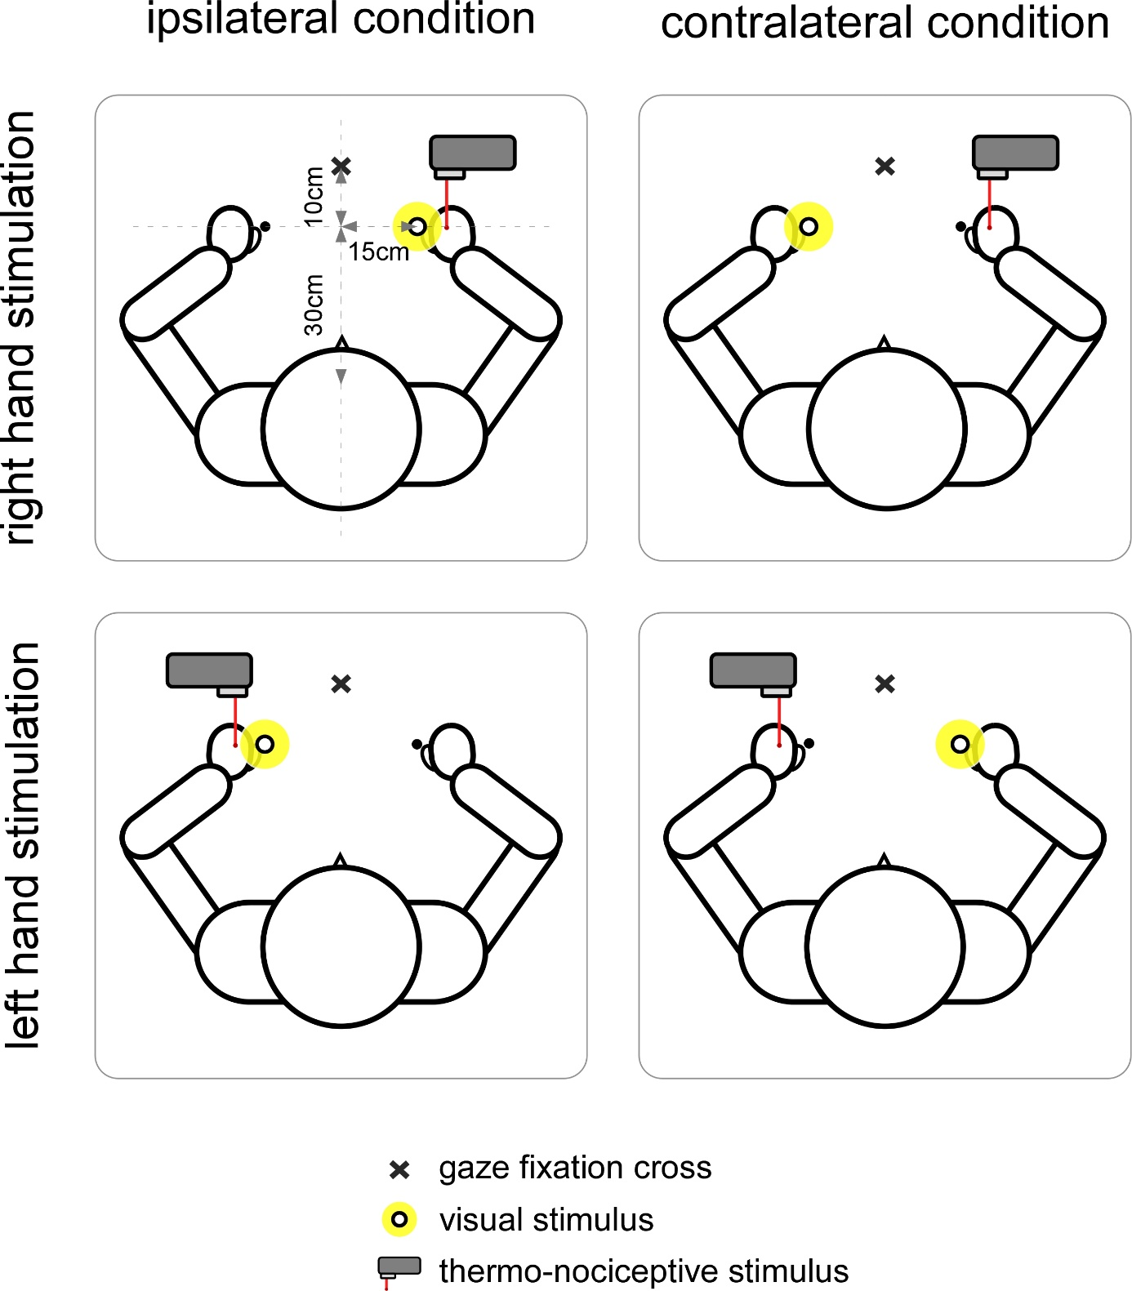
Figure 1. Design of the experiment. Participants performed temporal order judgments on pairs of thermo-nociceptive (CO₂ laser illustrated by the red laser beam) and visual stimuli (light-emitting diode, illustrated by the white circle with yellow halo when on, and black dot when off), while staring at the fixation cross. Participants were seated on a chair, palms’ down on a table at ∼30cm from the trunk, 15 cm on either side of the fixation cross. One group received thermo-nociceptive stimuli eliciting responses of C fibers whereas the other group received nociceptive stimuli eliciting Aδ-fiber responses. Laser stimuli were applied on either the left or the right hand depending on the stimulation blocks. Across blocks, the visual stimulus was presented either next to the stimulated hand (ipsilateral condition), or next to the opposite non-stimulated hand (contralateral condition).

Measures
Activation threshold and target temperature values of laser stimuli were measured in degrees Celsius.
To estimate TOJ performance, the proportion of thermo-nociceptive stimuli perceived as being presented first was computed as a function of the SOAs for each experimental condition. TOJ parameters were estimated by a logistic function f(x)=1/(1+exp(-β(x-α))) at each trial (Kingdom & Prins, 2010). Analyses were made on the last estimates of the block, corresponding to the last update of the adaptive procedure. The main parameter of interest was the α value, corresponding to the threshold of the function which characterizes the point of subjective simultaneity (PSS), that is, the SOA at which the thermo-nociceptive stimulus and the visual stimulus are perceived as occurring first equally often (i.e., the 0.5 criterion on the ordinate; Fig. 2). Accordingly, the PSS was used as a measure of the amount of time that was needed between the thermo-nociceptive stimulus and the visual stimulus to have equal chance to be perceived as occurring first, indexing the asynchrony at which they were perceived at the same time (Spence et al., 2001). Based on Manfron, Filbrich et al. (2020), its prior estimates were set to 500±200 ms for the C-fiber group and 70±20 ms for the Aδ-fiber group. The β value was analyzed as second parameter of interest. It corresponds to the slope of the psychometric curve and describes the noisiness of the results, i.e., the variability of participants' responses during the experiment (Kingdom & Prins, 2010). Lower and higher abilities to discriminate the temporal order of the two stimuli is represented by lower and greater values of β, respectively. Its prior estimates were set to 0.06 ±0.6 for both fiber groups.

Data analyses
Five participants were discarded from the analyses due to technical failures and/or excessive habituation that affected participants’ ability to perceive the laser stimuli throughout the experiment, resulting in high variability in their responses during the TOJ task, as evidenced by flat psychometric slopes. Statistical analyses were conducted with IBM SPSS 23. First, we tested whether activation threshold and target temperature values were similar between the two hands by using paired sample t tests for each fiber group. Next, before analyzing TOJ data, data from the two response modes (“which is first?” vs. “which is second?”), and therefore those of the left-hand and right-hand stimulation blocks, were averaged for each spatial congruence condition (ipsilateral vs contralateral) and each group (Aδ fibers vs C fibers). Therefore, the response mode and stimulated hand variables were disregarded from analyses. Resulting PSS and slope values were then compared using analyses of variance (ANOVAs) for repeated measures with the spatial congruence as within-subject factor (ipsilateral vs. contralateral) and the group as between-subjects factor (C-fiber vs. Aδ-fiber). Effect sizes were measured by means of partial Eta squared for ANOVAs and Cohen’s d for t tests. If necessary, contrast analyses were performed. Significance level was set at p-value < 0.05. Data are expressed in means plus or minus standard deviation (M±SD).

Results

Activation threshold and target temperature values
Comparisons of the threshold values between the two hands did not reveal any significant difference, for none of the groups (C-fiber: left hand= 39.9±1.31°C; right hand= 39.8±1.67°C, t(15) = 0.47, p = 0.642, d = 0.12 ; Aδ-fiber: left hand= 47.5±2.00°C, right hand= 47.9±2.36 °C; t(15)= -0.99, p = 0.337, d = -0.25). These values are in the range of the temperatures usually associated with C-fiber and Aδ-fiber afferent activation respectively (Churyukanov et al., 2012; Plaghki et al., 2010). Consequently, the target temperature values used during the experiment were not different between the left and the right hands for both the C-fiber group (left hand: 44.25±1.24°C; right hand: 44.50±1.63°C; t(15) = -0.89, p = 0.388, d = -0.22) and the Aδ-fiber group (left hand: 52.31±2.02 °C; right hand: 52.69±1.89 °C; t(15)= -1.695, p = 0.111, d = -0.42).

TOJ values
The ANOVA performed on the PSS values showed a significant main effect of the group factor (F(1,30) = 240.17, p < 0.001, η²_{p} = 0.89), confirming that PSS between visual and thermo-nociceptive stimuli was dependent on the type of stimulated thermo-nociceptive fiber. The ANOVA also revealed a significant main effect of spatial congruence (F(1,30) = 10.65, p = 0.003, η²_{p} = 0.262), with no significant interaction with the group factor (F(1,30) = 2.337, p = 0.137, η²_{p} = 0.072). This suggests that the location of the visual stimulus relative to the hand receiving the thermo-nociceptive stimuli affected the PSS in a similar fashion for the two subtypes of applied thermo-nociceptive stimuli (see Figs. 2 and 3). When C fibers were stimulated, PSS values were ∼40 ms greater when the visual stimulus was presented contralaterally to the stimulated hand, as compared to when it was presented ipsilaterally (ipsilateral: 501±121ms; contralateral: 539±108 ms). This difference was ∼12 ms when Aδ fibers were stimulated (ipsilateral: 79±13 ms; contralateral: 92±18 ms).
Regarding the slope values, the data of one participant in the C-fiber group was removed from the analyses because the slope value of the ipsilateral condition was identified as an outlier as compared to the group mean. The ANOVA revealed a significant main effect of group (F(1,29)=11.56, p = 0.002, η²_{p} = 0.28) with higher slope values for the Aδ-fiber group (0.055) than for the C-fiber group (0.012). No significant main effect of spatial congruence emerged from the analyses (F(1,29) = 3.211, p = 0.084, η²_{p} = =0.10) nor any significant interaction between both factors (F(1,29)= 3.264, p = 0.081, η²_{p} = 0.10) (see Fig. 2 and 3).
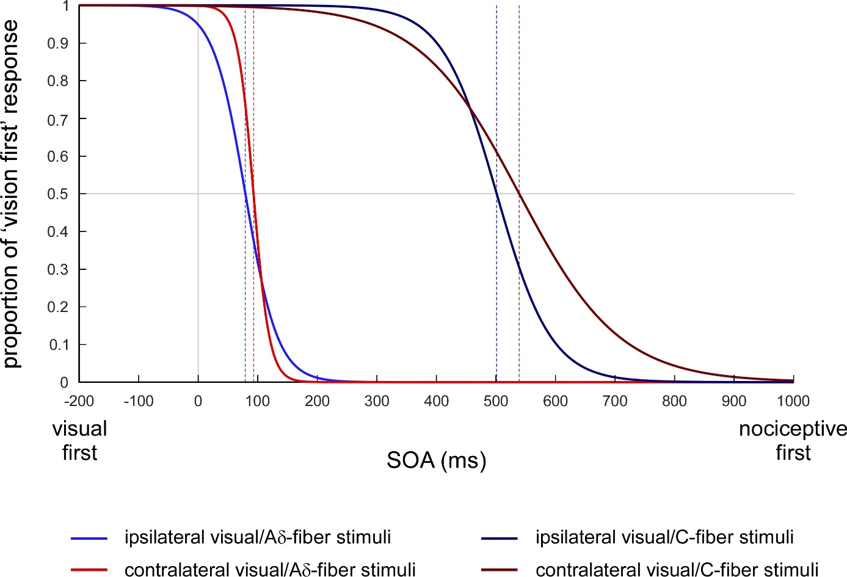
Figure 2. Logistic functions fitting participants performances. The graph illustrates the averaged results for the 16 participants of each group. The left curves correspond to the fitted logistic functions for the group of participants having received thermal stimuli eliciting responses mediated by Aδ fibers, with the light blue curve representing the condition in which the visual stimulus was presented on the side of space ipsilateral to the hand on which the thermo-nociceptive stimulus is applied and the light red curve the condition in which the visual stimulus was presented on the side of space contralateral to the hand on which the thermo-nociceptive stimulus is applied. The right curves correspond to the fitted logistic functions for group of participants having received thermal stimuli activating selectively C fibers, with the dark blue curve representing the ipsilateral condition and the dark red curve the contralateral condition. The x-axis represents different hypothetical stimulus onset asynchronies (SOAs) between the visual and the thermo-nociceptive stimuli: negative values indicate that the visual stimulus was presented first, while positive values indicate that the nociceptive stimulus was presented first. The y-axis represents the proportion of trials in which the participants perceived the visual stimulus as first presented. In both groups, the visual stimulus always needed to be administered after the nociceptive stimulus, but, most importantly, the point of subjective simultaneity of the contralateral condition was larger than the PSS of the ipsilateral condition, for both types of thermo-nociceptive fibers.

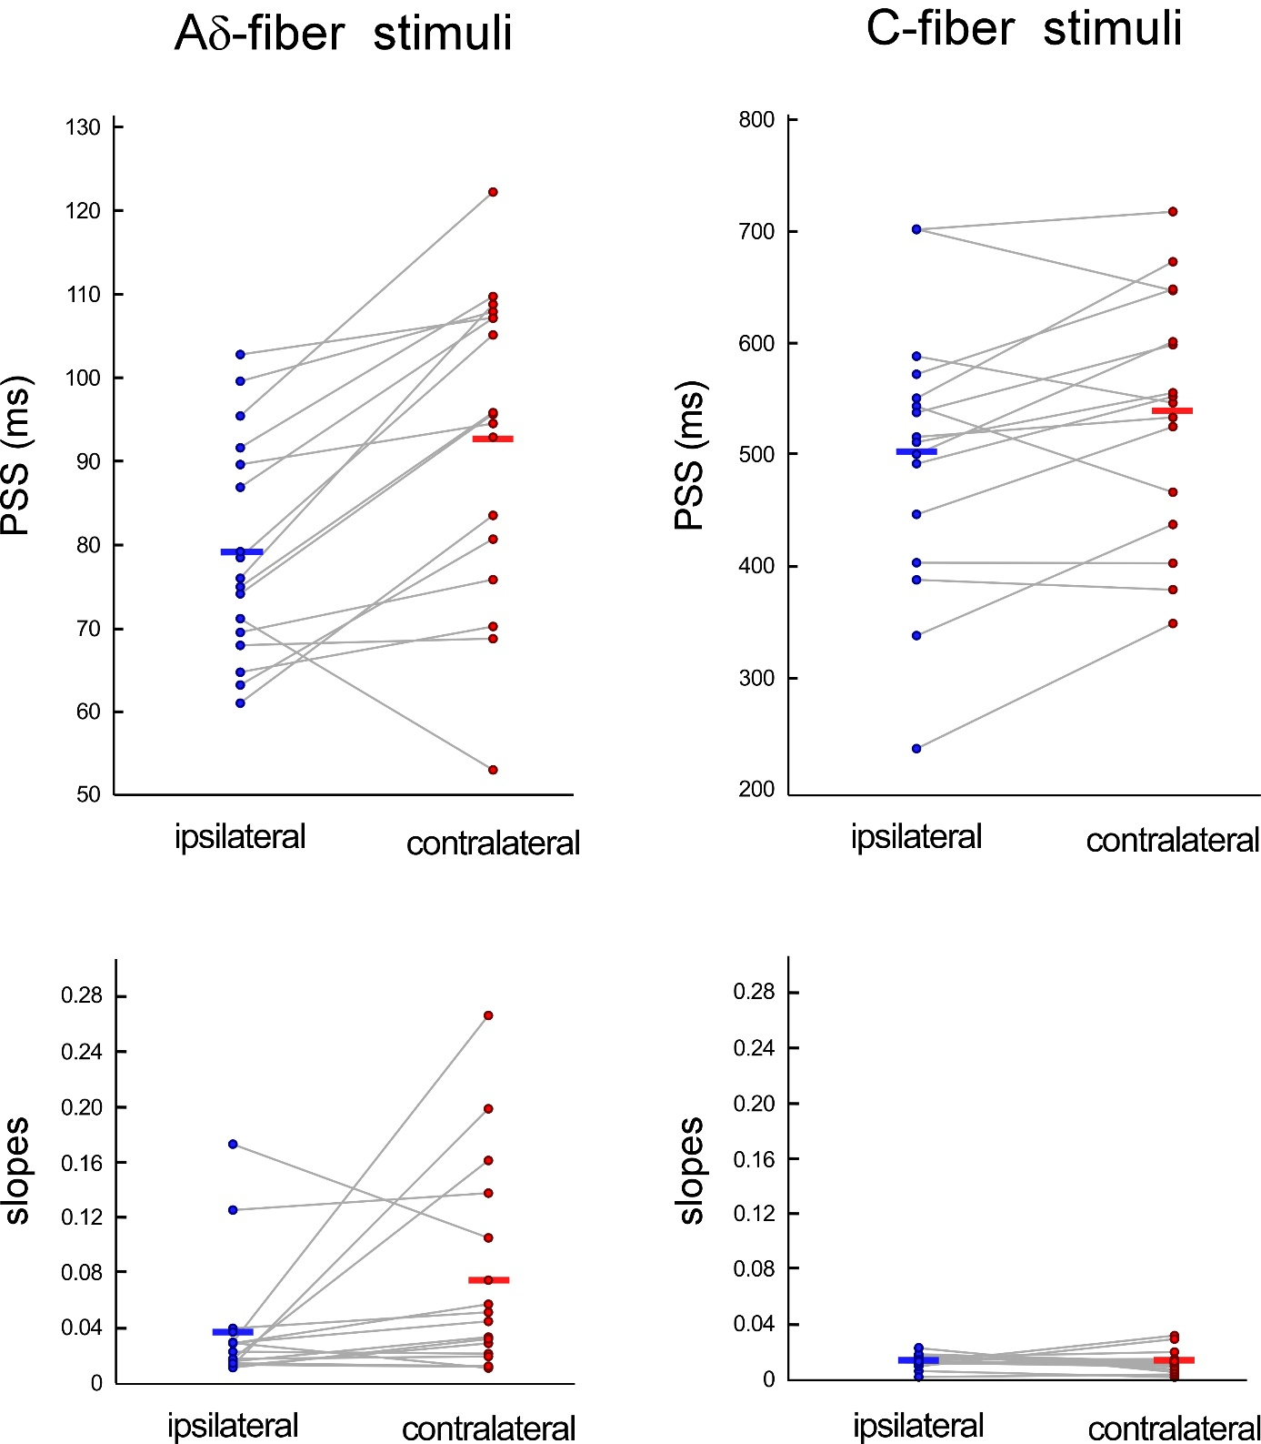

Figure 3. Individual PSS and slope values per group. The figure shows scatter plots displaying individual PSS values (on the top) and individual slope values (on the bottom), represented by the black dots, for each group (Aδ vs C-fiber) according to the visual condition (ipsilateral vs contralateral). The black strips show the means of each parameter. Data of the same participant are linked by a light grey line.

Discussion
Efficient multisensory interactions notably depend on the temporal co-occurrence between stimuli belonging to different sensory modalities (e.g. Macaluso et al., 2016; Meredith, Nemitz, & Stein, 1987; Morein-Zamir, Soto-Faraco, & Kingstone, 2003; Spence & Squire, 2003; Stein & Meredith, 1993; Sugita & Suzuki, 2003). It is however a challenge for the brain to integrate sensory inputs triggered by a given event but arriving at cortical level with different delays (Colonius & Diederich, 2004; Fujisaki, Kitazawa, & Nishida, 2012; Meredith et al., 1987; Spence & Squire, 2003) because of differences in transduction and/or conduction times. Moreover, in the case of somatic stimuli, peripheral conduction distances and hence peripheral conduction times depend greatly on where the stimuli occur on the body (e.g., Plaghki & Mouraux, 2005, Cruccu et al., 2008). This is most striking for nociceptive input conveyed by unmyelinated C fibers because of their very slow conduction velocity. Studies have investigated the factors influencing perceptual asynchrony during interactions between visual-auditory, visual-tactile and visual-nociceptive modalities by measuring the ability of participants to perceive the temporal order between the stimuli of the tested modalities (Manfron, Filbrich et al., 2020; Spence et al., 2001; Spence et al.,, 2003; Zampini et al., 2003a; Zampini et al., 2005; Zampini et al., 2007).
The present study investigated whether the ability to perceive the temporal order between visual and nociceptive stimuli was also dependent on the spatial proximity between the location of the visual stimulus and the body area on which the thermo-nociceptive stimulus was applied. In line with previous studies that investigated visual-auditory (Spence et al., 2003; Zampini, Guest, et al., 2005; Zampini et al., 2003a) and visual-tactile interactions (Spence et al., 2003; Spence et al., 2001), the results showed that the PSS between visual and thermo-nociceptive stimuli was significantly smaller when the two stimuli were close together, i.e. when the visual stimulus was applied near the stimulated hand as compared to when it was applied near the opposite hand. This was observed regardless of whether the nociceptive inputs were conveyed by Aδ or C fibers. This indicates perceptual simultaneity with smaller asynchrony between visual and nociceptive stimuli when they are close together than when they are far from each other. These results are in agreement with those of other studies having recurrently shown that visual stimuli and nociceptive stimuli mostly conveyed by Aδ fibers optimally interact when the visual stimuli are presented in the close vicinity of the limb on which the nociceptive stimuli are applied, whatever the position of the stimulated limb in external space and the visual field in which the visual stimuli appear (De Paepe et al., 2014, 2015, 2017; Filbrich, Alamia, Blandiaux, et al., 2017; Filbrich et al., 2018; Vanderclausen et al., 2017).
Two non-exclusive mechanisms could potentially explain the effect of spatial congruence on the perception of simultaneity between sensory inputs transmitted through different modality pathways: crossmodal attention and multisensory integration. First, according to the attention-switching hypothesis, when task stimuli are not located next to each other, participant’s attention must be shifted from the location of the first stimulus of the pair toward the location of the second stimulus to correctly judge their temporal order (Spence, 2001; Zampini et al., 2003a). In other words, the greater PSS values observed in the contralateral condition would reflect the cost of shifting attention from one location to another. On the contrary, in the ipsilateral condition, as participants only focus their attention on one single location to meet the requirements of the task, interactions between the ipsilateral stimuli would be improved, as compared to the contralateral condition, leading to smaller PSS values. Additionally, in accordance with the prior-entry effect (e.g. Spence, 2001; Spence & Parise, 2010; Titchener, 1908; Filbrich, Alamia, Burn, & Legrain, 2017), it could also be that the first stimulus of the pair has actually attracted attention to its own location, having facilitated the processing and the perception of the second stimulus when it occurred at the same location, as compared to when it appeared in the opposite side of space.
Second, according to the multisensory integration hypothesis, presenting two sensory stimuli simultaneously – or at least within the same time-window – at the same location increases the likelihood to bind them together and perceive them as one unique and coherent sensory event, as compared to when they are presented in different locations (e.g. Spence, 2001; Spence & Squire, 2003; Stein & Meredith, 1993; Welch, 1999; however,see also Spence, 2013 for a different account). In the context of TOJ tasks, the tendency of merging the stimuli into a single integrated percept would speed up their processing. This integration would seem relatively automatic given that, by judging the temporal order of the two stimuli, participants are explicitly asked to perceive them as two distinct sensory events in those tasks. In turn, the disadvantage of integrating the two stimuli would also make it difficult to dissociate them as two distinct events, decreasing the precision of their temporal order judgments. On the contrary, presenting the stimuli at distinct locations would increase their discriminability and lead to better performances. This was indeed shown in previous TOJ studies by higher just-noticeable difference (JND) values – and therefore flatter slope values – when the two stimuli were presented at the same location, as compared to when they were presented at distinct locations (Spence et al., 2003; Spence et al., 2001; Zampini et al., 2003a). However, in the present study, no significant differences were observed for the slope values between the conditions during which visual and nociceptive stimuli were presented at the same location and those during which they were presented at opposite locations. This suggests that the precision of the participants’ judgments was not affected by the spatial congruence between the two stimuli. The method we used in the present study is however quite different from the one used in previous experiments (Spence et al., 2003; Spence et al., 2001; Zampini et al., 2003a). We used an adaptive procedure to present the different time-interval conditions, and the last estimate of the slope was used to index participants’ performances. In previous studies, fixed time intervals were presented with a constant stimulation procedure, and the JND was derived from the probability of 75% of perceiving the temporal order of the stimuli correctly. The use of different methods is nevertheless unlikely to explain the differences between the results of present vs. previous studies. Indeed, the different estimates of the slope values of the TOJ functions seem usually similarly sensitive to the same factors, whatever the procedures used to present the stimuli and the methods used to estimate the participants’ performance (Heed & Azañon, 2014; Vanderclausen, Filbrich, De Volder, & Legrain, 2021). If the integrative hypothesis for interpreting slope changes during TOJ is correct, this would mean that our participants were less likely to integrate visual stimuli with nociceptive stimuli than they would with other types of stimuli. However, this conclusion is conditional on the fact that slopes have been correctly estimated, as this parameter may be more difficult to estimate than thresholds with a relatively small number of trials (Kingdom & Prins, 2010).
A significant difference between slope values was only observed when comparing the performance of the participants having received thermo-nociceptive stimuli selectively activating C fibers to those having received nociceptive stimuli above the threshold of Aδ fibers. This could possibly be accounted for by the fact that the sensation evoked by C-fiber stimuli is often considered as being poorly defined in terms of location and timing compared to the sensation elicited by Aδ-fiber stimulations (Plaghki & Mouraux, 2005), making their temporal order judgments more difficult (Manfron, Filbrich et al., 2020).
In everyday life, the different sensory inputs arising from the same object generally stimulate their respective receptors at the same time and, although the generated inputs are transmitted to the brain with different latencies, we are still able to perceive them as simultaneous. The lag between each input is not perceived as long as they fall within the same time-window of integration, which tolerates a margin of error (e.g. Colonius & Diederich, 2004; Fujisaki et al., 2004; Morein-Zamir et al., 2003; Spence & Squire, 2003; Sugita & Suzuki, 2003). However, it is not possible to determine the extent of this time-window of interactions for a given situation since it varies according to many different factors, such as the sensory modality of the inputs, their implied link of causality, their spatial congruence, the attention allocated to them, the memory of past experiences as well as the respective intensity and duration of the stimuli (Colonius & Diederich, 2004; Fujisaki et al., 2012; Meredith et al., 1987; Stein & Meredith, 1993). There are two hypotheses that have been put forward to explain how such temporal binding of stimuli of different sensory modalities within that time-window is achieved. Whereas some authors proposed an overlapping of the discharge trains of multisensory neurons elicited by each sensory input, as suggested by electrophysiological recordings of single cells in the superior colliculus of the cat (Meredith et al., 1987), others rather suggested a resynchronization of the input of each sensory modality on the basis of the speed of their respective afferents (e.g. Colonius & Diederich, 2004), Considering somatosensory inputs, both the speed of the afferent fibers and the peripheral conduction distance could influence the ability of the brain to resynchronize different sensory inputs.
Finally, conversely to daily life situations in which multisensory interactions are shaped by past experiences and often concern different inputs that arise from the same sensory event (e.g. Macaluso et al., 2016; Welch, 1999), in experimental research the sensory modalities are often manipulated by basic and distinct stimuli. In that context, it might therefore be necessary to artificially introduce a temporal lag between the different stimuli for participants to perceive them simultaneously. It is also worth noting that multisensory research often uses brief stimuli with sharp onsets, while in more ecological environmental situations, multisensory interactions are also supported by tonic and long-duration stimulations. The techniques used in present and previous studies regarding visuo-nociceptive interactions mostly targeted activation of the quickly-responding cutaneous thermo-nociceptors that preferentially respond to phasic stimulation. Slow-adapting thinly-myelinated and unmyelinated fibers were also described to respond preferentially to more tonic stimulation profiles (Bromm & Treede, 1984; Meyer & Campbell, 1981; Schepers & Ringkamp, 2010; Treede et al., 1998; Treede et al., 1995). It might be relevant to use other stimulation techniques and procedures that preferentially activate those receptors to investigate whether multisensory interactions with thermo-nociceptive stimuli applied distantly could be facilitated by the activity of nociceptors more sensitive to sustained stimulation.
In conclusion, the present study demonstrated that presenting visual and thermo-nociceptive stimuli at the same location decreases the necessary time lag between the two stimuli to perceive them as presented first equally often. This could suggest that spatial congruence between a visual and a nociceptive stimulus, by increasing their interactions, could facilitate the resynchronization of the brain of their respective times of arrival. The fact that spatial congruence shortens the time interval at which the two stimuli could be perceived as presented first equally often, with no evidence of affecting judgement precision, may suggest mutual attentional facilitation rather than integrative mechanisms, although the two putative mechanisms are not mutually exclusive. It is important to note that previous studies on visuo-nociceptive interactions only measured responses preferentially generated by Aδ fiber activity. For the first time, we have shown indexes of interactions between visual stimuli and thermal stimuli specifically and selectively activating C fibers. As Aδ and C fibers do not have the same physiological properties and give rise to qualitatively different sensations, it would be interesting for future experiments to test whether they are involved in the same way in multisensory interactions.

Data Availability Statements
The datasets generated during and/or analyzed during the current study are available from the corresponding author on reasonable request.

Declaration of competing interest
None

Acknowledgements
L.F. and V. L. are supported by the Funds for Scientific Research of the French-speaking Community of Belgium (F.R.S.-FNRS).

References
Bergenheim, M., Johansson, H., Granlund, B., & Pedersen, J. (1996). Experimental evidence for a sensory synchronization of sensory information to conscious experience. In S. R. Hameroff, A. W. Kaszniak, & A. C. Scott (Eds.), Toward a science of consciousness: The first Tuscon discussions and debates (pp. 303-310). Cambridge, MA: MIT Press.
Brozzoli, C., Ehrsson, H. H., & Farne, A. (2014). Multisensory representation of the space near the hand: from perception to action and interindividual interactions. Neuroscientist, 20(2), 122-135. doi:10.1177/1073858413511153
Churyukanov, M., Plaghki, L., Legrain, V., & Mouraux, A. (2012). Thermal detection thresholds of Adelta- and C-fibre afferents activated by brief CO2 laser pulses applied onto the human hairy skin. PLoS ONE, 7(4), e35817. doi:10.1371/journal.pone.0035817
Colonius, H., & Diederich, A. (2004). Multisensory interaction in saccadic reaction time: a time-window-of-integration model. Journal of Cognitive Neuroscience, 16(6), 1000-1009.
Cruccu, G., Aminoff, M.J., Curio., Guérit, J.M., Kakigi, R., Mauguière, F., Rossini, P.M., Treede, R.-D., Garcia-Larrea, L. (2008). Recommendations for the clinical use of somatosensory-evoked potentials. Clin. Neurophysiol., 119, 1705-1719.
De Paepe, A., Crombez, G., & Legrain, V. (2015). From a somatotopic to a spatiotopic frame of reference for the localization of nociceptive stimuli. PLoS ONE, 10(8), e0137120. doi:10.1371/journal.pone.0137120
De Paepe, A., Crombez, G., & Legrain, V. (2017). Remapping nociceptive stimuli into a peripersonal reference frame is spatially locked to the stimulated limb. Neuropsychologia, 101, 121-131. doi:https://doi.org/10.1016/j.neuropsychologia.2017.05.015
De Paepe, A., Crombez, G., Spence, C., & Legrain, V. (2014). Mapping nociceptive stimuli in a peripersonal frame of reference: Evidence from a temporal order judgment task. Neuropsychologia, 56(0), 219-228. doi:http://dx.doi.org/10.1016/j.neuropsychologia.2014.01.016
De Paepe, A. L., Crombez, G., & Legrain, V. (2016). What's coming near? The influence of dynamical visual stimuli on nociceptive processing. PLoS ONE, 11(5), e0155864. doi:10.1371/journal.pone.0155864
di Pellegrino, G., & Làdavas, E. (2015). Peripersonal space in the brain. Neuropsychologia, 66, 126-133. doi:http://dx.doi.org/10.1016/j.neuropsychologia.2014.11.011
Fairhall, S., & Macaluso, E. (2009). Spatial attention can modulate audiovisual integration at multiple cortical and subcortical sites. European Journal of Neuroscience, 29(6), 1247-1257.
Farnè, A., Demattè, M. L., & Làdavas, E. (2005). Neuropsychological evidence of modular organization of the near peripersonal space. Neurol, 65(11), 1754-1758. doi:10.1212/01.wnl.0000187121.30480.09
Filbrich, L., Alamia, A., Blandiaux, S., Burns, S., & Legrain, V. (2017). Shaping visual space perception through bodily sensations: Testing the impact of nociceptive stimuli on visual perception in peripersonal space with temporal order judgments. PLoS ONE, 12(8), e0182634. doi:10.1371/journal.pone.0182634
Filbrich, L., Alamia, A., Burns, S., & Legrain, V. (2017). Orienting attention in visual space by nociceptive stimuli: investigation with a temporal order judgment task based on the adaptive PSI method. Exp Brain Res, 235, 2069-2079. doi:10.1007/s00221-017-4951-2
Filbrich, L., Blandiaux, S., Manfron, L., Farnè, A., De Keyser, R., & Legrain, V. (2019). Unimodal and crossmodal extinction of nociceptive stimuli in healthy volunteers. Behavioural Brain Research, 362, 114-121. doi:https://doi.org/10.1016/j.bbr.2019.01.002
Filbrich, L., Halicka, M., Alamia, A., & Legrain, V. (2018). Investigating the spatial characteristics of the crossmodal interaction between nociception and vision using gaze direction. Conscious Cogn, 57, 106-115. doi:https://doi.org/10.1016/j.concog.2017.11.011
Filbrich, L., Torta, D.M., Vanderclausen E., Azañón, E., & Legrain V. (2016) Using temporal order judgements to investigate attention bias toward pain and threat-related information. Methodological and theoretical issues. Consciousness and Cognition, 41, 135-138.
Fujisaki, W., Kitazawa, S., & Nishida, S. y. (2012). Multisensory Timing. In Stein (Ed.), The New Handbook of Multisensory Processing (pp. 301-317). Cambridge, MA: MIT Press.
Graziano, M. S. A., & Cooke, D. F. (2006). Parieto-frontal interactions, personal space, and defensive behavior. Neuropsychologia, 44(6), 845-859. doi:http://dx.doi.org/10.1016/j.neuropsychologia.2005.09.009
Graziano, M. S. A., Hu, X. T., & Gross, C. G. (1997). Visuospatial properties of ventral premotor cortex. J Neurophysiol, 77(5), 2268-2292.
Kakigi, R., & Shibasaki, H. (1991). Estimation of conduction velocity of the spino-thalamic tract in man. J Electroencephalography Clinical Neurophysiology, 80(1), 39-45. doi:https://doi.org/10.1016/0168-5597(91)90041-U
Kingdom, F. A. A., & Prins, N. (2010). Psychophysics - A practical introduction. London: Elsevier Academic Press.
Legrain, V., & Torta, D. M. (2015). Cognitive psychology and neuropsychology of nociception and pain. In G. Pickering & S. Gibson (Eds.), Pain, Emotion and Cognition: A complex Nexus (pp. 2-20). Paris: Springer.
Lenoir, C., Algoet, M., & Mouraux, A. (2018). Deep continuous theta burst stimulation of the operculo-insular cortex selectively affects Aδ-fibre heat pain. J. Physiol., 596, 4767-4787.
Lewald, J., & Guski, R. (2003). Cross-modal perceptual integration of spatially and temporally disparate auditory and visual stimuli. Cognitive Brain Research, 16, 468-478. doi:10.1016/S0926-6410(03)00074-0
Macaluso, E., Hartcher-O’Brien, J., Talsma, D., Adam, R., Vercillo, T., & Noppeney, U. (2016). The curious incident of attention in multisensory integration: bottom-up vs. top-down. Multisensory Research, 29(6-7), 557-583. doi:10.1163/22134808-00002528
Macaluso, E., & Maravita, A. (2010). The representation of space near the body through touch and vision. Neuropsychologia, 48(3), 782-795. doi:http://dx.doi.org/10.1016/j.neuropsychologia.2009.10.010
Manfron, L., Filbrich, L., Nijs, E., Mouraux, A., & Legrain, V. (2020a). Investigating perceptual simultaneity between nociceptive and visual stimuli by means of temporal order judgments. Neuroscience Letters, 735, 135156.
Manfron, L., Legrain, V., Filbrich, L. (2020b). Seeing or not seeing where your hands are. The influence of visual feedback about hand position on the interaction between nociceptive and visual stimuli. Multisensory Research, 33, 457-478.
Meredith, M. A., Nemitz, J. W., & Stein, B. E. (1987). Determinants of multisensory integration in superior colliculus neurons. I. Temporal factors. Journal of Neuroscience, 7(10), 3215-3229.
Morein-Zamir, S., Soto-Faraco, S., & Kingstone, A. (2003). Auditory capture of vision: examining temporal ventriloquism. Cognitive Brain Research, 17(1), 154-163.
Michel, C. M., Seeck, M., & Murray, M. M. (2004). The speed of visual cognition. In M. Hallett, L.H. Phillips II, D.L. Schomer, J.M. Massey (Eds.), Supplements to Clinical neurophysiology (Vol. 57, pp. 617-627): Elsevier.
Nahra, H., Plaghki, L. (2003). The effects of A-fiber pressure block on perception and neurophysiological correlates of brief non-painful and painful CO₂ laser stimuli in humans. Eur. J. Pain, 7, 189-199.
Nicholls, M. E., Thomas, N. A., Loetscher, T., & Grimshaw, G. M. (2013). The Flinders Handedness survey (FLANDERS): a brief measure of skilled hand preference. Cortex, 49(10), 2914-2926. doi:10.1016/j.cortex.2013.02.002
Opsommer, E., Masquelier, E., & Plaghki, L. (1999). Determination of nerve conduction velocity of C-fibres in humans from thermal thresholds to contact heat (thermode) and from evoked brain potentials to radiant heat (CO2 laser). Neurophysiologie Clinique/Clinical Neurophysiology, 29(5), 411-422.
Plaghki, L., & Mouraux, A. (2005). EEG and laser stimulation as tools for pain research. J Curr Opin Investig Drugs, 6(1), 58-64.
Romaniello, A., Iannetti, G. D., Truini, A., & Cruccu, G. (2003). Trigeminal responses to laser stimuli. Neurophysiologie Clinique/Clinical Neurophysiology, 33(6), 315-324.
Serino, A. (2019). Peripersonal space (PPS) as a multisensory interface between the individual and the environment, defining the space of the self. Neuroscience & Biobehavioral Reviews, 99, 138-159. doi:https://doi.org/10.1016/j.neubiorev.2019.01.016
Shore, D.I., Spence, C., Klein, R.M. (2001). Visual prior entry. Psychological Science, 12(3), 205-212.
Spence, C. (2001). Crossmodal attentional capture: a controversy resolved? In: Folk C, Gibson B (eds) Attention, distraction and action: multiple perspectives on attentional capture. Elsevier Science, Amsterdam,, pp 231–262.
Spence, C. (2013). Just how important is spatial coincidence to multisensory integration? Evaluating the spatial ruel. Ann NY Acad Sci, 1296, 31-49.
Spence, C., Baddeley, R., Zampini, M., James, R., & Shore, D. I. (2003). Multisensory temporal order judgments: When two locations are better than one. Perception, 65(2), 318-328.
Spence, C., Shore, D. I., & Klein, R. M. (2001). Multisensory prior entry. J Exp Psychol Gen, 130(4), 799-832. doi:10.1037//0096-3445.130.4.799
Spence, C., & Squire, S. (2003). Multisensory integration: maintaining the perception of synchrony. J Current Biology, 13(13), R519-R521.
Stein, B. E., & Meredith, M. A. (1993). The merging of the senses: The MIT Press.
Sugita, Y., & Suzuki, Y. (2003). Audiovisual perception: Implicit estimation of sound-arrival time. Nature, 421(6926), 911-912.
Truini, A., Galeotti, F., Cruccu, G., & Garcia-Larrea, L. (2007). Inhibition of cortical responses to Aδ inputs by a preceding C-related response: Testing the “first come, first served” hypothesis of cortical laser evoked potentials. Pain, 131(3), 341-347.
Vanderclausen, C., Filbrich, L., Alamia, A., & Legrain, V. (2017). Investigating peri-limb interaction between nociception and vision using spatial depth. Neurosci Lett, 654, 111-116. doi:https://doi.org/10.1016/j.neulet.2017.05.060
Wedel, M.J. (2012). A monument of inefficiency: The presumed course of the recurrent laryngeal nerve in sauropod dinosaurs. Acta Palaeontologica Polonica, 57(2), 251–256.
Zampini, M., Bird, K. S., Bentley, D. E., Watson, A., Barrett, G., Jones, A. K., & Spence, C. (2007). 'Prior entry' for pain: attention speeds the perceptual processing of painful stimuli. Neurosci Lett, 414(1), 75-79. doi:10.1016/j.neulet.2006.12.006
Zampini, M., Guest, S., Shore, D. I., & Spence, C. (2005). Audio-visual simultaneity judgments. Perception & Psychophysics, 67(3), 531-544.
Zampini, M., Shore, D., & Spence, C. (2003a). Audiovisual temporal order judgments. Experimental Brain Research, 152(2), 198-210.
Zampini, M., Shore, D. I., & Spence, C. (2003b). Multisensory temporal order judgments: The role of hemispheric redundancy. International Journal of Psychophysiology, 50, 165-180.

