Back-gate bias effect on FDSOI MOSFET RF Figures of Merits and Parasitic Elements
B. Kazemi Esfeh¹, V. Kilchytska¹, B. Parvais², N. Planes³, M. Haond³, D. Flandre¹ and J.-P. Raskin¹
¹ICTEAM, Université catholique de Louvain, 1348 Louvain-la-Neuve, Belgium
Email: Babak.kazemiesfeh@uclouvain.be, Tel: (+32) 10478386
²Imec, IMEC, Kapeldreef 75, 3001 Leuven, Belgium
³ST, ST-Microelectronics, 850 rue J. Monnet, 38926 Crolles, France

Abstract—This work demonstrates that the back-gate terminal of a 28nm FDSOI MOSFET can be used up to several tens of GHz for signal processing. Furthermore, the dependence of the main RF figures-of-merit on the back gate bias are experimentally extracted using a 3-port characterization in the frequency range of 10 MHz – 26.5 GHz. We propose a small-signal equivalent circuit constructed based on 3-port measurements allowing for more complete extraction of parasitic elements comparing to the 2-ports one. The effect of back-gate bias on cut-off frequencies is demonstrated and explained in terms of its influence on the relevant parasitic elements.
Keywords-cut-off frequencies; FDSOI; 3-port S-parameters;

Introduction
FDSOI transistors are widely recognized as a promising candidate to continue downscaling beyond the 28 nm-node for low power and mixed-signal CMOS applications ‎[1]. This technology presents key advantages: Lower variability by using undoped channel ‎[2] and better electrostatic control ‎[3] are amongst the most important improved DC parameters. Moreover, this technology has shown promising RF performances with high current cut-off frequency (f_{T}) and maximum oscillation frequency (f_{max}) ‎[4]-[5]. One of the most interesting features of this technology is the possibility of back-gate control schemes thanks to ultra-thin buried oxide (BOX) combined with a highly-doped layer underneath the BOX, so called ground-plane (GP), allowing for further improvement of both static and dynamic behaviors of the device ‎[6]. In this work, a 3-ports configuration of FDSOI nMOSFET is employed for extracting the parasitic elements based on an extended small-signal equivalent circuit. The effect of back-gate bias on RF Figures of Merit (FoM) for both front and back gates is investigated and discussed through small-signal equivalent circuit elements.

Device and measurement setup description
The studied FDSOI nMOSFET is fabricated in the 28 nm FDSOI platform of ST-Microelectronics ‎[7]. Si body, BOX and equivalent gate oxide thickness are 7 nm, 25 nm and 1.3 nm respectively. The channel is rotated by 45° from the <100> plane. The multi-finger device with 40 parallel fingers, 30 nm of length and 1 µm of width each is designed and embedded in coplanar waveguide access pads for RF characterization. The FDSOI nMOSFET has common source configuration that provides the possibility of 3-port measurement in which the front-gate, drain and the back-gate are referred to RF port1, 2 and 3 respectively. Fig. 1a illustrates the simplified cross section: the device layout features a particular access to the back-gate, including a heavily doped n-type GP located below the BOX and an n-well which provides a natural substrate insulation between the devices (so called flip-well architecture ‎[8]). The schematic of the fabricated double-gate nMOSFET is shown in Fig.1b.
(a)
BG
S
S
G
D
S
S
S
S
Short
Open
UTBB
(b)
Fig. 1. (a) Simplified cross section, and (b) the schematic of battery of nMOSFET with open and short de-embedding structures.
“Open” and “short” de-embedding structures are implemented thus allowing for withdrawal of the effects of interconnections on extrinsic capacitances and series resistances. A 4-port Agilent PNAX VNA accompanied with a DC semiconductor-parameter analyzer (HP 4145) are applied to perform the on-wafer 3-port S-parameters measurement up to 26.5 GHz using ground-signal-ground (GSG) pattern infinity probes.

3-port RF FOMs extraction
MOSFET RF performance is evaluated by two major FoM, i.e. f_{T} and f_{max}. By definition, f_{max} is the frequency at which the (unilateral) power gain is equal to unity (0 dB) and f_{T} is the unity current gain frequency at which the short circuit current gain (h₂₁) becomes unity (0 dB). f_{T} and f_{max} are extracted from the measured S-parameters extrapolating h₂₁ and unilateral power gain, U, to 0 dB. Similarly to the methodology reported in [9] for 4-port extraction, in case of 3-port S-parameters measurements where port1, port2 and port3 are defined as the front gate, drain and back gate, respectively, h₂₁ and h₂₃ are defined as:

${ h}_{21}=\frac{Y_{21}Y_{33}-Y_{23}Y_{31}}{Y_{11}Y_{33}-Y_{31}Y_{13}}$ (1)
$h_{23}=\frac{Y_{23}Y_{11}-Y_{21}Y_{13}}{Y_{33}Y_{11}-Y_{13}Y_{31}}$ (2)
from which cut-off frequency for front-gate (f_{T}) and back-gate (f_{Tbg}) can be directly extracted. The unilateral power gain for front gate (U) and back gate (U_{bg}) are calculated from 3-port Y-parameters as:
$U=\frac{1}{4}∙\frac{{|Y_{21}-Y_{12}|}^{2}}{Re\left(Y_{11}\right)Re\left(Y_{22}\right)-Re\left(Y_{21}\right)Re\left(Y_{12}\right)}$ (3)
$U_{bg}=\frac{1}{4}∙\frac{{|Y_{23}-Y_{32}|}^{2}}{Re\left(Y_{33}\right)Re\left(Y_{22}\right)-Re\left(Y_{23}\right)Re\left(Y_{32}\right)}$ (4)

from which the maximum oscillation frequency for front gate (f_{max}) and back gate (f_{maxbg}) are extracted.
Fig. 2 shows the f_{T} and f_{max} related to the front-gate as a function of V_{gs} for V_{ds} = 1 V and back-gate biases, V_{bg} = 0, 1.8 and 3.0 V. As can be seen in Fig. 2a and b, at V_{bg} = 0 V, the maximum f_{T} and f_{max} for 30 nm-long device is as high as ~355 GHz. From Fig. 2a and b, it can be seen that application of a positive V_{bg} interestingly shifts the maximum cut-off frequencies to a lower V_{g}, however, with slightly decreased peak values. The consequence of the back-gate biasing is firstly, the possibility to get the f_{T} and f_{max} peak values at lower V_{g}, as expected, (due to threshold voltage shift with V_{bg}) and secondly, flatter f_{T} and f_{max} versus V_{g} curves, i.e. wider V_{g} range with maximum values of f_{T} and f_{max}.

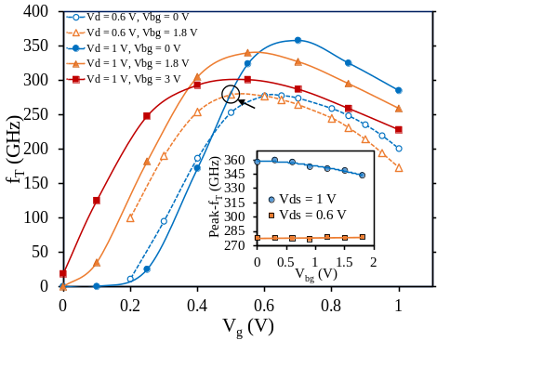
(a)
Front-gate |  |  |  |  |  |  | Back-gate
(Ω) | (Ω) | (mS) | (mS) | (fF) | (fF) | (fF) | (mS) | (fF) | (fF) | (fF) | (fF) | (Ω)
R_{g} | R_{sd} | g_{mi} | g_{ds} | C_{gstot} | C_{gdtot} | C_{dstot} | g_{mbgi} | C_{bgstot} | C_{bgdtot} | C_{bggtot} | C_{WSub} | R_{Well}
11 | 5 | 50 | 3.8 | 15 | 9 | 21 | 4 | 17 | 2.8 | 1.7 | 11.4 | 30
Front-gate |  |  |  |  |  |  | Back-gate
(Ω) | (Ω) | (mS) | (mS) | (fF) | (fF) | (fF) | (mS) | (fF) | (fF) | (fF) | (fF) | (Ω)
R_{g} | R_{sd} | g_{mi} | g_{ds} | C_{gstot} | C_{gdtot} | C_{dstot} | g_{mbgi} | C_{bgstot} | C_{bgdtot} | C_{bggtot} | C_{WSub} | R_{Well}
11 | 5 | 50 | 3.8 | 15 | 9 | 21 | 4 | 17 | 2.8 | 1.7 | 11.4 | 30
(a)
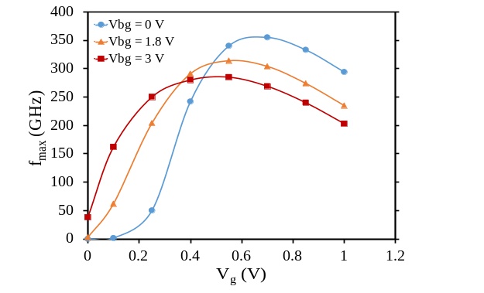
(b)
Fig. 2. Front-gate (a) f_{T} for V_{ds} = 0.6 and 1 V and (b) f_{max} for V_{ds} = 1 V as a function of V_{g} for various V_{bg}.
Fig. 2a includes results for V_{d} = 0.6 V. One can see that even at such a low V_{d}, the device features rather high f_{T} ~280 GHz in a maximum, which is, moreover, stable w.r.t. V_{bg} (inset in Fig. 2a). Considering low voltage and power applications (< 0.6 V), one can get f_{T} of 280 GHz at V_{d} = 0.6 V as high as f_{T} for V_{d} = 1V by V_{bg} tuning (example is indicated by arrow in Fig. 2a).
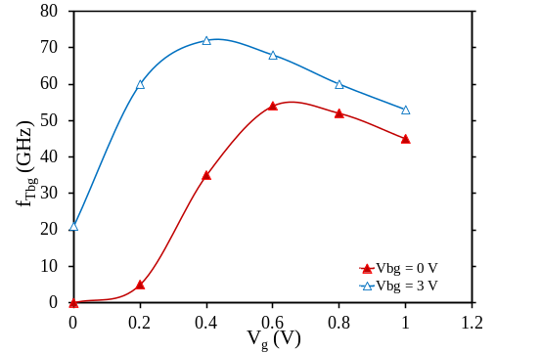
(a)
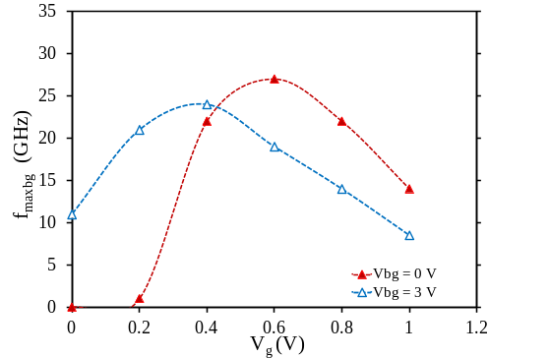
(b)
Fig. 3. Back-gate (a) f_{Tbg} and (b) f_{maxbg} versus V_{g} for V_{bg} = 0 and 3 V.

Plots of RF FoMs related to the back-gate transistor f_{Tbg} and f_{maxbg} are illustrated in Fig. 3a and b versus V_{gs} showing the double gate behavior of FDSOI transistor. From Fig. 3, it can be observed that a maximum f_{Tbg} of 55 GHz – 70 GHz and a maximum f_{maxbg} of 24 GHz – 27 GHz depending on the bias are achieved. The RF FoMs behavior under different V_{bg} is discussed below in terms of small-signal equivalent circuit and parasitic elements.

Model and extraction
Based on a 3-port model of FDSOI MOSFET shown in Fig. 1, its small-signal equivalent circuit including both intrinsic and extrinsic components is proposed in Fig. 4. By applying different bias conditions, all elements can be extracted (Table I). Clear advantage of 3-port w.r.t. 2-port measurement [4] is the possibility of more complete extraction of parasitic elements such as e.g. well resistance (R_{Well}), total back-gate capacitance (C_{bgtot}), etc.

Fig. 4. Complete small-signal equivalent circuit of the 3-port FDSOI MOSFET in saturation including the sum of intrinsic (‘i’) and extrinsic (‘e’) elements denoted by ‘tot’.
Lower g_{mbgi} comparing to g_{mi} (Table I) (due to thicker BOX w.r.t. gate oxide) results, indeed, in a lower f_{Tbg} comparing to f_{T} (Fig. 2a and 3a) (see Eq.5). As reported in ‎[9], back-gate resistance (R_{bge}), the main reason of f_{maxbg} drop (Eq. 6), is mainly related to the parasitic back-gate network and its value is essentially given by the well. Therefore, f_{maxbg} is much lower than f_{max} (Fig. 2b and 3b) due to 3x higher R_{bg} (R_{Well}) w.r.t R_{g} (Table I). The reduction of f_{T} and f_{max} with an increase of V_{bg} for V_{d} = 1 V case (Fig. 2) can be explained by the g_{m} (both ‘i’ and “e”) decrease and channel conductance (g_{ds}) increase (Table I). Since f_{max} is dependent on both f_{T} and g_{ds} (Eq. 6), the degradation effect on f_{max} is more pronounced. As shown in Fig. 3a, an increase of V_{bg} from 0 to 3 V, results in increase of f_{Tbg} which is supposed to be mainly due to C_{bgtot} decrease with V_{bg} increase (Table I). However, f_{maxbg} decreases with V_{bg} increase that could be explained by increasing of g_{ds} dominating over the C_{bgtot} and g_{mbgi} improvement.
- Extracted front- and back-gate elements in saturation (V_{ds} = 1 V) and maximum g_{mi} when V_{bg} = 0 v and 3 V.
V_{bg}=3 V |  |  | V_{bg}=0 V Front-gate
(mS) | (mS) | (mS) | (Ω) | (Ω) |  | (mS) |  | (mS) |  | (mS) | (fF)
g_{mi} | g_{me} | g_{ds} | R_{g} | R_{sd} |  | g_{mi} |  | g_{me} |  | g_{ds} | C_{gtot}
58 | 48 | 7.1 | 11 | 5 |  | 60.5 |  | 50.5 |  | 4.5 | 25.7
V_{bg}=3 V |  |  | V_{bg}=0 V Back-gate
(mS) | (mS) | (fF) | (fF) |  | (mS) |  | (mS) |  | (Ω)
g_{mbgi} | g_{mbge} | C_{bgtot} | C_{bgtot} |  | g_{mbgi} |  | g_{mbge} |  | R_{Well}
5 | 3.7 | 15 | 22 |  | 4.8 |  | 4.1 |  | 30

$f_{T}≈\frac{g_{m}}{2πC_{gtot}}$ (5)
$f_{max}≈\frac{f_{T}}{2.\sqrt{\left(R_{s}+R_{g}\right)g_{ds}+2πf_{T}R_{g}C_{gd}}}$ (6)

Conclusion
Effect of back-gate bias on RF FoM of front- and back-gate FDSOI MOSFET is studied based on the 3-port measurements. Back-gate bias application shifts and flattens f_{T}, F_{max} versus V_{g} curves thus giving more flexibility to the designers for the choice of DC points where maximum f_{T} and f_{max} is achievable. In low-V_{g} range (<0.5 V), back-gate bias tuning allows f_{T} in low-V_{d} case to outperform f_{T} in high-V_{d} case. An equivalent small-signal circuit including back-gate network was reconstructed and main parasitic elements of FDSOI devices were assessed. The effect of back-gate bias on RF FoM was explained through its effect on relevant parasitic small-signal equivalent elements.

Acknowledgment
The work was partially funded by Eniac “Places2Be” and Ecsel “Waytogofast” projects.

References
- International Technology Roadmap for Semiconductor (ITRS), 2011 Edition. <http://www.itrs.com>.
- Nobuyuki Sugii et al., “Comprehensive study on vth variability in silicon on Thin BOX (SOTB) CMOS with small random-dopant fluctuation: Finding a way to further reduce variation,” 2008 IEEE International Electron Devices Meeting, San Francisco, CA, 2008, pp. 1-4.
- T. Skotnicki et al., “Innovative Materials, Devices, and CMOS Technologies for Low-Power Mobile Multimedia,” in IEEE Transactions on Electron Devices, vol. 55, no. 1, pp. 96-130, Jan. 2008.
- B. Kazemi Esfeh, V. Kilchytska, V. Barral, N. Planes, M. Haond, D. Flandre and J. -P. Raskin, “Assessment of 28 nm UTBB FD-SOI Technology Platform for RF Applications: Figures of Merit and Effect of Parasitic Elements,” Solid-State Electronics, vol. 117, pp. 130-137, 2016.
- S. Shopov and S. P. Voinigescu, “Characterization of the High Frequency Performance of 28-nm UTBB FDSOI MOSFETs as a Function of Backgate Bias,” 2014 IEEE Compound Semiconductor Integrated Circuit Symposium (CSICS), La Jolla, CA, 2014, pp. 1-4.
- Q. Liu et al., “Impact of back bias on ultra-thin body and BOX (UTBB) devices,” 2011 Symposium on VLSI Technology - Digest of Technical Papers, Honolulu, HI, 2011, pp. 160-161.
- N. Planes et al., “28nm FDSOI technology platform for high-speed low-voltage digital applications,” 2012 Symposium on VLSI Technology (VLSIT), Honolulu, HI, 2012, pp. 133-134.
- J.-P. Noel, O. Thomas, M.-A. Jaud, C. Fenouillet-Beranger, P. Rivallin, P. Scheiblin, T. Poiroux, F. Boeuf, F. Andrieu, O. Weber, O. Faynot and A. Amara, “UT2B-FDSOI Device Architecture Dedicated to Low Power Design Techniques,” ESSDERC 2010, pp. 210-213.
- J. C. Barbé, L. Lucci, A. Siligaris, P. Vincent and O. Faynot, “4-port RF performance assessment and compact modeling of UTBB-FDSOI transistors,” 2015 IEEE Radio Frequency Integrated Circuits Symposium (RFIC), Phoenix, AZ, 2015, pp. 355-358.

