Transferability of fracture toughness from miniaturized specimens using cohesive zone models in nuclear fusion structural assessment
Chih-Cheng Chang^{a,b*}, Dmitry Terentyev^{a,d}, Alexander Bakaev^{c}, Aleksandr Zinovevª , Cihan Tekoğlu^{e}, Thomas Pardoen^{b,f}

ª Structural Materials Group, Institute of Nuclear Materials Science, SCK CEN, 2400 Mol, Belgium
^{b} Institute of Mechanics, Materials and Civil Engineering, UCLouvain, 1348 Louvain-la-Neuve, Belgium
^{c} Nuclear Engineering Office, Institute of Nuclear Materials Science, SCK CEN, 2400 Mol, Belgium
^{d} Department of Materials, Textiles and Chemical Engineering, Ghent University, Technologiepark 46, Zwijnaarde (Ghent), B-9052 Belgium
^{e}Department of Mechanical Engineering, TOBB ETÜ, 06510 Çankaya/Ankara, Turkey
^{f} WEL Research Institute, Avenue Pasteur 6, 1300 Wavre, Belgium

Keywords: SSTT, EUROFER97, Fracture toughness testing, Ductile fracture, Cohesive Zone model

Abstract
Miniaturized specimens are designed, tested and simulated using finite element analysis in order to identify a fracture model for EUROFER97 and to justify the transferability of the cracking resistance with respect to standard-sized samples. EUROFER97 is a reduced activation ferritic martensitic (RAFM) steel, considered as the main candidate for structural material in nuclear fusion reactors such as ITER. The need for miniaturization is primarily driven by high cost of irradiation in material test reactors. Here, miniaturized disk compact tension specimens are tested with a thickness of 4 mm and compared to standard 20 mm thick compact tension specimens. The interchangeability of miniaturized specimens in capturing the crack resistance behavior of standard specimens is assessed relying on a cohesive zone model to simulate ductile crack growth. The Gurson-Tvergaard-Needleman model is used to identify the parameters of the traction-separation law and to take into account the dependence of the cohesive strength on the near crack tip stress triaxiality. The cohesive parameters are further calibrated based on the miniaturized test data and validated against the load-CMOD curves, crack front shapes, and J-R curves. The calibrated cohesive parameters are then applied to the reference geometry for final validation. The results demonstrate that a cohesive zone formalism can reliably predict the resistance to crack extension of reference specimens without any additional parameter adjustment. This approach highlights the feasibility of specimen size reduction if sufficiently rich fracture models are used, beyond single-parameter fracture mechanics, offering a cost-effective solution to execute neutron irradiation campaigns.

1. Introduction
Fracture toughness is a key mechanical property in structural engineering, representing the material's resistance against crack propagation from a pre-existing sharp defect. The evaluation of the fracture toughness plays a critical role in ensuring the integrity and safety of structures. The experimental measurement of fracture toughness is thus essential for selecting and designing structural materials that can withstand anticipated loading scenarios without compromising safety for both anticipated and off-normal operation. In the context of fusion, this is essential for ensuring structural integrity, particularly in scenarios involving potential thermal shock and associated thermomechanical loadings. This is especially important after neutron irradiation which causes the degradation of material properties expressed in reduction of ductility and loss of fracture toughness [1, 2].
The material investigated in this work is the EUROFER97, a reduced activation ferritic martensitic (RAFM) steel. EUROFER97 has emerged as a preferred structural material for fusion reactors owing to its reduced long-term radiative decay [3, 4]. As a part of nuclear technology advancements, EUROFER97 is designated for application in the Test Blanket Module (TBM) in ITER and is planned for the DEMO reactor as well. The use of EUROFER97 in fusion applications requires qualification tests, validation of design principles, and integration into design codes such as RCC-MRx [5]. Therefore, specimens exposed to neutron irradiation are needed for this purpose.
Standard specimens offering valid fracture data may not be compatible with the dimensions available in the irradiation devices, which are in turn needed to characterize the effect of the neutron irradiation on the degradation of the crack resistance. Indeed, the fusion dedicated neutron source facilities for material testing will provide very limited irradiation volume [6]. To address this issue, IAEA has launched an initiative [7] to consider specimen miniaturization and establish guidelines for the standards which would be applicable for fusion materials specifically. In addition, significant efforts are engaged under European project EUROfusion, where the development of the SSTT is at the focus of a work package covering engineering data design integration [8]. Specimen size needs thus to be reduced because of limited volume in irradiation capsules. Specimen size reduction also minimizes highly radioactive waste. However, according to the current ASTM E1820 standard [9], the validity region based on exclusion lines are independent of size while an upper limit for the toughness value (so called J-limit) and maximum crack extension (∆a) limit depend on the specimen size, namely on the thickness. The data points obtained beyond the defined J-limit or ∆a -limit must be excluded, as they are considered invalid. When the specimen thickness is reduced, these limits become more restrictive, leading to fewer data points that satisfy the validity criteria. As a result, for miniaturized specimens, the remaining valid portion of the test may be insufficient, making the test invalid according to the standard.
Another challenge associated with transferring fracture toughness data from miniaturized specimens to standard geometries lies in the influence of the crack tip constraint conditions such as stress triaxiality. Conventional J-based methodology with extraction of the initiation plane strain toughness J_{Ic} is inherently a single parameter toughness approach, which therefore does not account for constraint variations [10, 11]. Indeed, the near crack tip stress triaxiality and plastic strain distribution can significantly vary when changing dimensions, directly affecting the ductile failure process hence the magnitude of the work dissipated in the fracture process zone. This leads to size effects on the J-R curves both the initiation value J_{Ic} (which is equal to the work per unit area spent in the fracture process zone) and tearing modulus. The remedy is to use a physics-microstructure approach which aims at directly connecting the mechanisms of ductile fracture and which should intrinsically capture the size dependence - this is the so-called local approach of fracture or micromechanics-based approach of fracture, see e.g. [12-15].
Ductile failure proceeds by the nucleation of voids on second-phase particles and inclusions, the growth of the voids under plastic deformation and the coalescence into cracks [13, 16-20]. Micromechanical models such as the Gurson yield criterion and its extension by Tvergaard and Needleman - named GTN model - provide a pressure-dependent description for porous metals and capture void growth as well as, with extensions for nucleation and coalescence [21, 22]. The GTN model as well as many enhancements or other damage models, suffer from inherent mesh/size dependency and therefore require non-local regularisation techniques [23-26]. Non-local damage models and robust associated FE formulations keep being developed using more and more advanced description of the fracture process, see e.g. [27]. However, these formulations and implementations are not fully standard yet, nor available on most commercial FE platforms. The cohesive zone model (CZM) has been selected as an intermediate choice to introduce the response of the material in the fracture process zone while overcoming the problem of mesh dependency. In this phenomenological approach, the fracture process is represented through a traction–separation law whose behaviour can be motivated from a mechanical description of the ductile fracture process.
Historically, the cohesive zone concept was formulated in the early 1960s by Dugdale and Barenblatt replacing the plastic zone at a crack tip with a cohesive process zone [28, 29], thereby eliminating the stress singularity and providing a physical framework for progressive separation. Modern cohesive models link traction and separation through traction–separation laws (TSLs) which is essentially characterized by a peak stress or strength $σ_{c}$ and a work of fracture $Γ_{c}$. The cohesive parameters obtained from this law can be considered as effective properties representing the failure process after proper calibration. The very first study to use a CZM model to simulate ductile crack growth was the work by Tvergaard and Hutchinson through the seminal paper of 1992 [30]. The parameters of the TSL were connected to the process of void nucleation, growth and coalescence using the GTN model. In this study, the authors imposed a uniaxial straining condition on the GTN model to calculate $σ_{peak}$ and $Γ_{c}$ ​for different values of the initial porosity and hardening laws. They argued that the stress state near the crack tip can be reasonably well represented by uniaxial straining. However, uniaxial straining is a more severe stress state than the one really developing in front of a blunted crack. This choice also neglects the variations of stress triaxiality that can occur when changing specimen configuration and dimensions, which is at the core of the present study. This was recognized soon by Brocks and Siegmund and others who investigated the relationship between $Γ_{c}$and $σ_{peak}$ and the stress triaxiality [31]. These authors and others adapted to CZM implementation to modify the peak stress on-the-fly in the FE simulation as a function of the stress state in the neighboring elements [32, 33]. However, this solution reintroduces some degrees of mesh dependency in the formulation. This has opened to hybrid formulations that combine a local GTN model (or similar) driving the constitutive response until the loss of ellipticity of the equations (hence the onset of mesh dependency) before jumping into a TSL formalism [34, 35]. However, the most practical solution for a robust and computationally efficient approach remains to select the $σ_{peak}$ and $Γ_{c}$ beforehand by an independent determination of the most appropriate crack tip stress state (such as in the original paper by Tvergaard and Hutchinson) and use a non adaptative TSL. This is the approach followed for instance in the context of thin plate ductile tearing [36]. This is the approach followed in this work as well, which will essentially require to perform two FE simulations : one without damage to determine the crack tip stress state and then one with a CZM model using the appropriate $σ_{peak}$ and $Γ_{c}$ for that stress state.
In order to apply and challenge the CZM-based methodology in the context of fracture data transferability, fracture toughness tests are conducted at room temperature (RT) on two specimen types: extra-miniaturized disk compact tension (mini DCT) sample with a thickness of 4 mm and industrial size compact tension (CT20) sample with a thickness of 20 mm. These tests are supplemented by uniaxial tensile tests for the determination of the hardening law. Subsequently, the dependence of the parameters of the traction-separation law on stress triaxiality is determined using the GTN model while the exact value of $Γ_{c}$ is fine tuned on the experimental data for miniaturized DCT samples. Furthermore, comparisons are made with various fracture-related information such as crack shape, crack extension, and J-R curve, ensuring a comprehensive evaluation of the simulated data against raw as well as post-processed experimental results. The set of cohesive zone parameters derived using the miniaturized DCT samples is then applied to the CT20 geometry to assess the conservatism when transitioning from miniaturized to larger specimens.

2. Material and methods

2.1 Experimental

2.1.1 Material

The third batch of EUROFER97 with the plate ID number 48 was investigated in the frame of EUROfusion work package WPMAT [8]. It is also known as the European reference RAFM steel. The dimensions of the plate are 2450 x 1000 x 25mm³ after hot rolling. The heat treatments (heat number 994566) applied by the producer included normalization at 980°C for 37.8 minutes and tempering at 760°C for 145 minutes. The chemical composition of this EUROFER97 is given in Table 1. The basic mechanical properties of EUROFER97 can be found in [37], and the microstructure characterization was recently reported in [38].
Table 1. Chemical composition of EUROFER97 batch 3 (wt.%)
C | Si | P | S | Ni | Cr | Mo | V
0.099 | 0.024 | 0.001 | 0.0017 | 0.008 | 8.78 | 0.002 | 0.19
Ta | W | Ti | Cu | Nb | Al | B | Co
0.11 | 1.11 | 0.001 | 0.003 | 0.002 | 0.003 | 0.0008 | 0.003

2.1.2 Uniaxial tensile testing
Miniaturized cylindrical tensile samples with a gauge diameter of 2 mm were tested in order to extract the hardening law. The specimens were cut along the rolling direction of the plate (L direction). The technical drawing is shown in Fig. 1. The uniaxial tensile tests were performed using INSTRON bench following ASTM E8/E8M. Two tests were conducted to ensure statistical robustness, and all tests were performed at RT under a fixed strain rate equal to $2.78×{10}^{-4}s^{-1}$ . More information about the tensile test methodology can be found in a former work [39] in particular regarding the determination of the hardening law beyond the necking point.
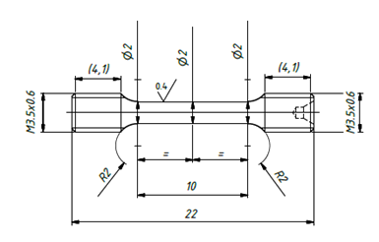
Fig. 1. Technical drawing of the miniaturized cylindrical tensile specimen.

2.1.3 Fracture toughness testing
Two types of fracture toughness specimens were investigated: DCT samples, namely mini DCT with a diameter of 13.36 mm and 4mm in thickness, and CT samples, namely CT20 with dimensions equal to 48 mm x 50 mm x 20 mm were also tested to generate reference data.
Fig. 2(a) shows pictures of these specimens with a scale bar of one euro coin for real-size reference. Please note that the specimens shown in Fig. 2(a) are representative samples used only to illustrate the relative size. The actual specimens used for testing were side-grooved after fatigue pre-cracking. Fig. 2(b, c) provides the technical drawings of each specimen, with the exact dimensions.
Fig. 3(a, b) shows how the clip gauge was mounted on the mini DCT and CT20 samples, respectively. All tested specimens were fatigue pre-cracked under ASTM E1820 guidelines, with parameters adjusted to achieve a stable crack of the required length for each geometry. The pre-crack length during the pre-cracking process was estimated based on the variation of the compliance determined from clip gauge readings and the final pre-crack length a₀ was later verified by post-fracture measurements. All the specimens were side-grooved after fatigue pre-cracking to ensure a straight crack front and promote uniform crack growth through the thickness. Fracture toughness tests were conducted using the unloading compliance method in accordance with ASTM E1820 to determine the J-R curves.

(a) | (b)
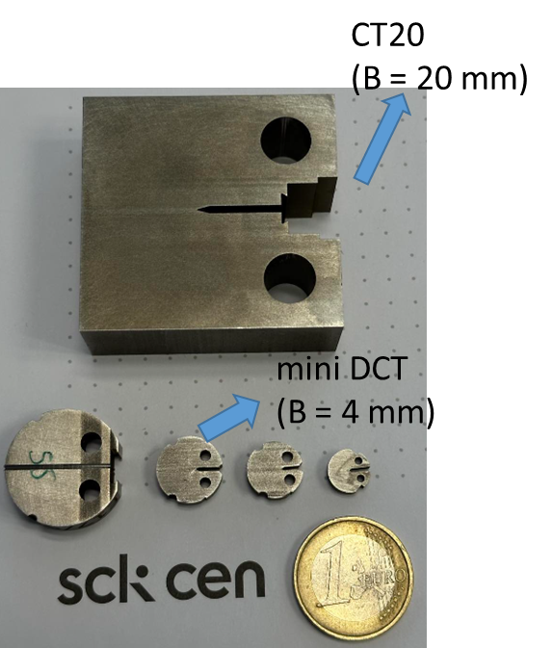 | 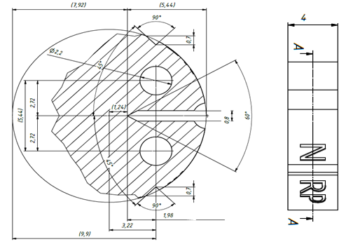
 | (c)
 | 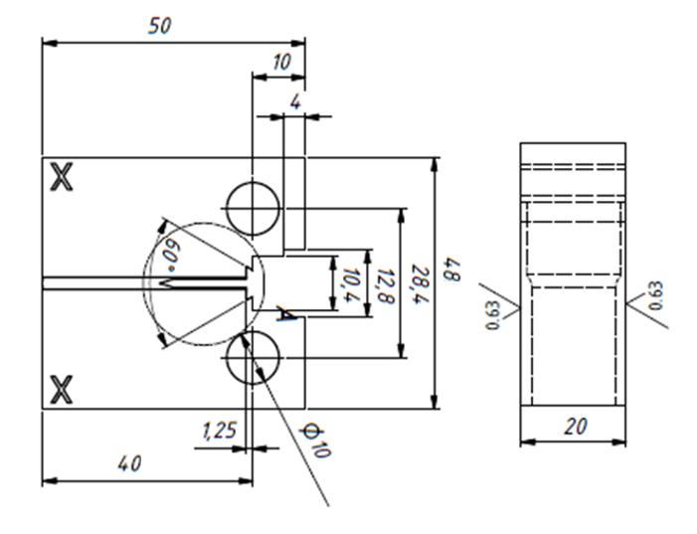
Fig. 2. (a) Actual size of the test samples with a 1 euro coin as the scale bar and the technical drawings of (b) mini DCT and (c) CT20.
(a) | (b)
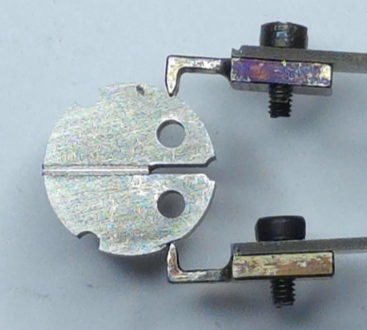 | 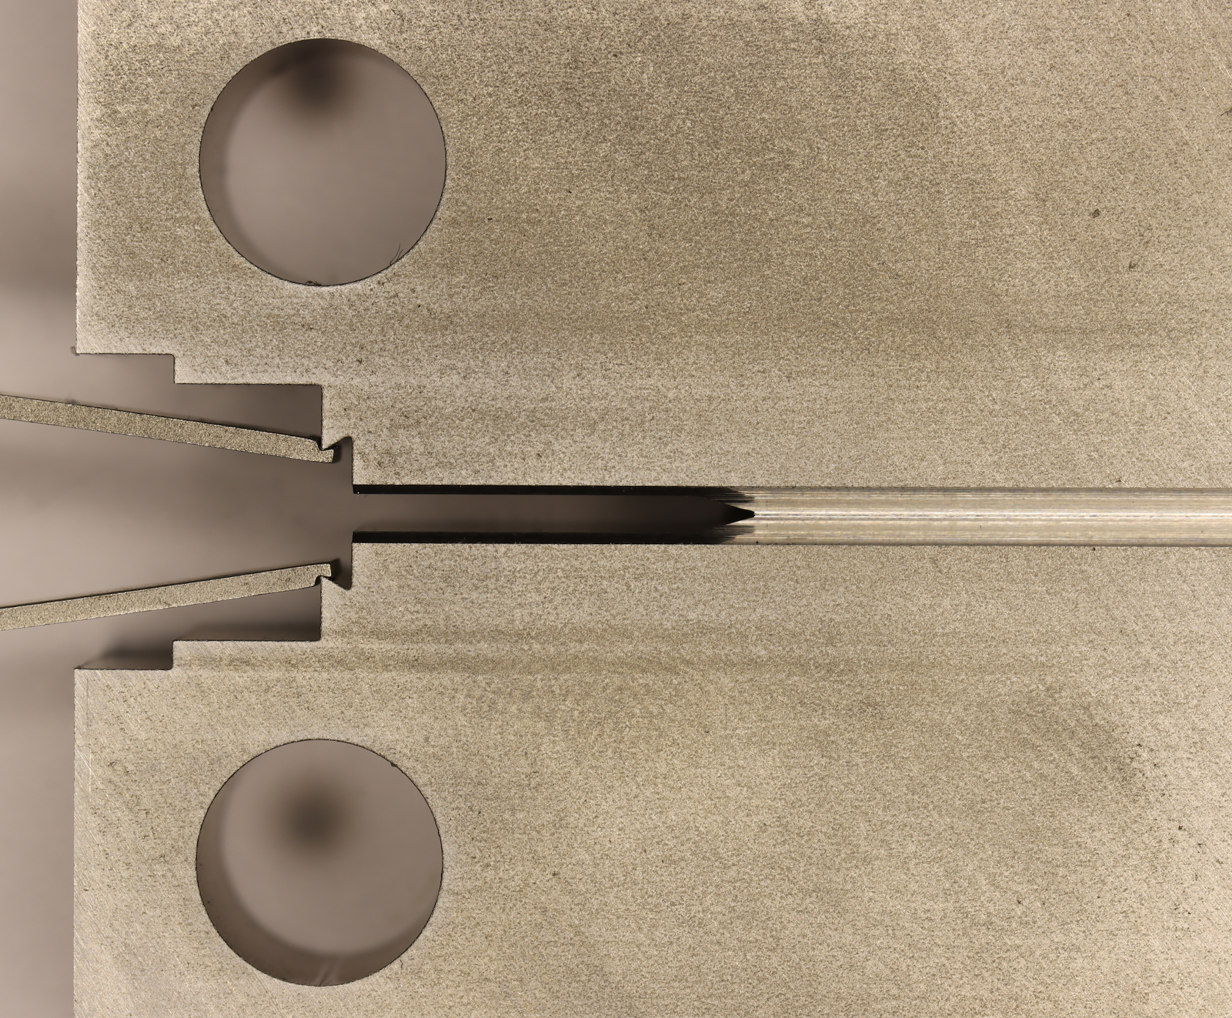
Fig. 3. The mounting of clip gauge on (a) mini DCT and (b) CT20.

2.2 FEM procedures
The commercial finite element software ANSYS Mechanical 2023 R2 is used to simulate the fracture tests performed on the different specimens. The mechanical behavior is represented by isotropic linear elasticity and isotropic J₂ plasticity. The fracture process is represented by a Cohesive Zone Model (CZM). The CZM, a built-in function in ANSYS, is used to simulate the initiation and propagation of cracks by accounting for the separation of material surfaces. It models the interaction between surfaces through a traction-separation law (TSL). The variation of the cohesive parameters with stress triaxiality, including cohesive stress and cohesive energy, is calibrated using the GTN model (using single element simulations deformed under fixed stress triaxiality). The approach is validated by measuring the accuracy of predicted load-CMOD curves, crack propagation front patterns, and J-R curves for each test specimen. More information is given hereafter about the different parts of the model..

FEM model
The finite element (FE) models are directly constructed based on technical drawings and actual measurements to minimize deviations from the machined samples and enhance the accuracy of the simulations. Boundary conditions replicate the experimental setup: the displacement is applied at the surface of the pin for both geometries, and appropriate symmetry conditions are imposed. Fig. 4 illustrates the meshing strategy with the mini DCT geometry as an example. Fig. 4(a) provides an overview of the mesh layout, employing 20-node higher-order elements (SOLID186 from the ANSYS element library). The mesh density is increased around the crack region, where the stress, strain, and displacements gradients are significant, and coarsened in areas where these values are minimal or constant, improving computational efficiency. Fig. 4(b) provides a close-up view of the crack region. The crack region is separated into two parts – crack front and crack propagation region. The mesh density is increased near the crack front to capture the stress triaxiality distribution and plastic strains as accurately as possible. Uniform quadrilateral meshes were used along the crack propagation path. Fig. 4(c) shows a detailed view of the crack tip, modelled as a notched region with a finite radius of 5 µm to prevent stress singularities and more accurately represent realistic conditions. It has been reported in the literature that the magnitude of the precrack tip opening has a negligible effect on the stress and strain field in the crack tip region if the initial radius is significantly smaller than the critical crack tip opening displacement [40].

(a) | (b)
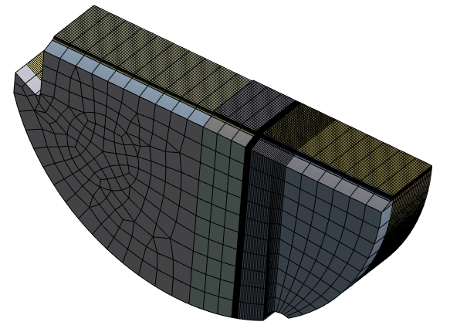 | 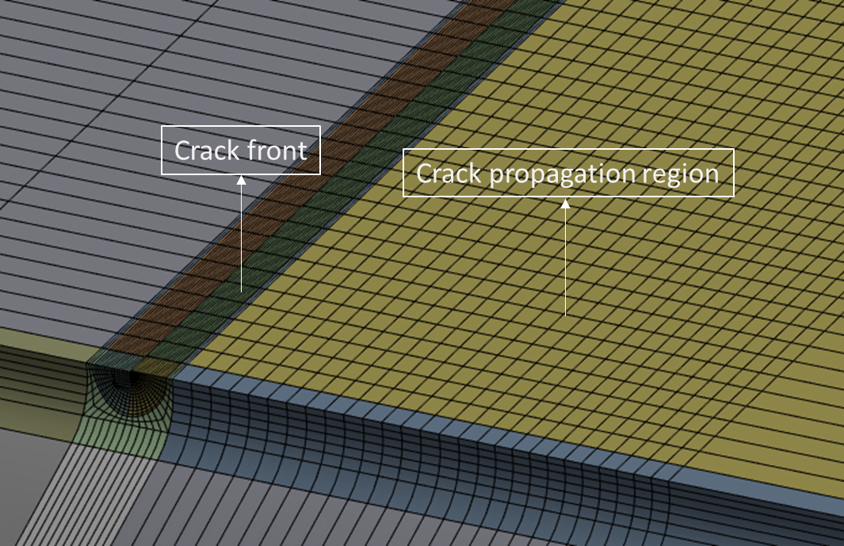
(c)
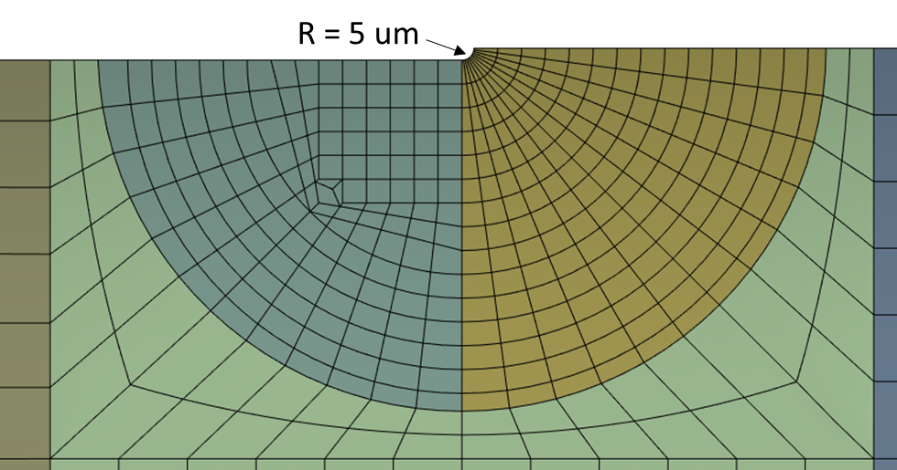
Fig. 4. FE model with (a) mesh design for whole specimen, (b) a zoom-in of the crack plane and (c) details of the precrack tip region.

2.2.2 Cohesive zone model
Tvergaard and Hutchinson [33] relied on a traction-separation law that reproduces some of the essential features of the GTN model, as schematically depicted in Fig. 5(b). This method involves calibrating the TSL parameters—cohesive stress (σ_{c}​), cohesive energy (Г_{c}), and critical separation (δ_{c}), illustrated in Fig. 5(c) —based on stress-displacement curves extracted by integrating a version of the GTN model. In this study, cohesive stress and energy are the primary parameters calibrated.
Ductile crack growth in metals involves a sequence of void nucleation, growth, and coalescence, as depicted in Fig. 5(a), which is relatively well captured by the Gurson–Tvergaard–Needleman (GTN) model. The yield surface of the GTN model is defined by the yield locus
$$∅= {\left[\frac{σ_{eq}}{\overline{σ}}\right]}^{2}+2q_{1}f^{*}cosh\left[\frac{3q_{2}σ_{m}}{2\overline{σ}}\right]-1-{\left(q_{1}f^{*}\right)}^{2}$$ | (5)

where $σ_{eq}$ represents the effective macroscopic von Mises stress, $\overline{σ}$ is the instantaneous yield stress of the fully dense matrix material, $σ_{m}$is the mean (=hydrostatic) stress, and f is the effective void volume fraction. The parameters q1 and q2​ are the fitting parameters ​introduced by Tvergaard [41] to capture with the Gurson model the response of FE void cell simulations more accurately.
The total void volume fraction, f, evolves due to contributions from both nucleation and growth of voids, as defined by:
$\dot{ f}={\dot{f}}_{nucl}+{\dot{f}}_{growth}$. | (6)
The nucleation of voids is strain-controlled, and the rate of nucleation (${\dot{f}}_{nucl}$) is expressed, following [42], as:
$${\dot{f}}_{nucl}=\frac{f_{n}}{S_{n}\sqrt{2π}}exp\left[{-\frac{1}{2}\left(\frac{{\overline{ε}}^{pl}-ε_{N}}{S_{n}}\right)}^{2}\right]{\dot{ε}}^{pl}$$ | (7)
where ${\dot{ε}}^{pl}$ is the microscopic equivalent plastic strain in the matrix material, ${\overline{ε}}^{pl}$ is the equivalent plastic strain of matrix material, $ε_{N}$ is the microscopic mean strain for nucleation, $S_{n}$is the standard deviation of the strain at nucleation, and $f_{n}$ is the void volume fraction that can potentially nucleate. The growth of voids is directly influenced by the plastic strain rate and is quantitatively modelled as follows:
${\dot{f}}_{growth}=(1-f){\dot{ε}}_{kk}^{p}$. | (8)
where ${\dot{ε}}_{kk}^{p}$ is the trace of the macroscopic plastic strain rate tensor.
To determine the cohesive stress and cohesive energy in the TSL, a sequence of finite element simulations are performed, combining pure J₂ plasticity modelling and integration of the GTN model. The first step consisted of J₂ plasticity simulations of the cracked specimens using the FE code ANSYS to determine the local stress triaxiality in the near-crack-tip region. The hardening law is the one determined experimentally. The peak stress triaxiality at the mid-thickness ahead of the crack tip was identified, and the detailed results of these simulations are reported in Section 3.3. In the next step, single-element simulations with the GTN model are performed using the FE code ABAQUS to evaluate the traction–separation response subjected to the triaxiality extracted from last step. A two-dimensional, 8-node biquadratic plane-strain element (CPE8) was used for this purpose, maintaining constant stress triaxiality throughout the loading history as per a methodology detailed in [43-45] (note that a simple integrator of the GTN model could have been used instead of running a single-element simulation). The procedure allows identifying the cohesive stress and cohesive energy as a function of the imposed triaxiality, as described in detail in Section 3.4. Finally, simulations with crack growth are carried out in ANSYS using the TSL parameters generated from the GTN model, in order to assess its predictive capability. The CZM is implemented through the contact-based debonding formulation, representing a zero-thickness interface. The initial linear elastic response ensures that all plastic deformation is captured by the surrounding bulk elements, while the cohesive law accounts only for the energy dissipated during separation, thus avoiding non-physical double-counting of plastic work as discussed by Nielsen and Hutchinson [36]. The cohesive parameters obtained in this manner were subsequently validated against the experimental load–CMOD curves, crack-front morphology, and J–R curves, as detailed in Section 3.5.
(a) | (b)
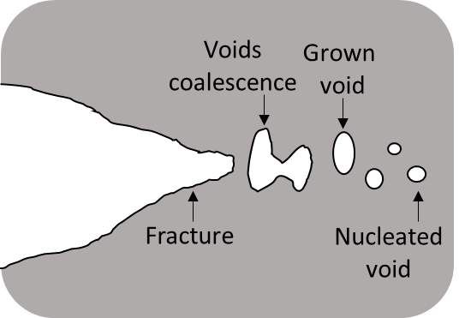 | 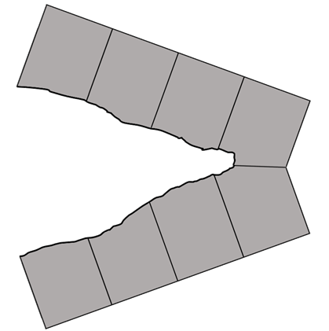
(c)
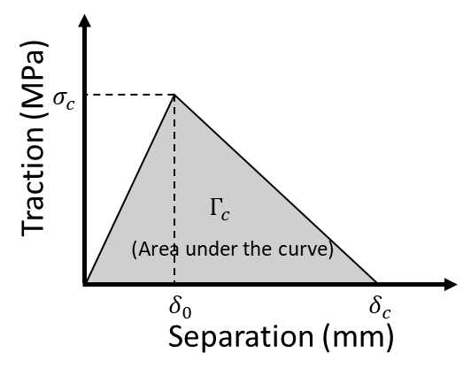
Fig. 5. Schematic representations of (a) the ductile crack propagation process, illustrating void nucleation, growth, and coalescence, (b) crack propagation simulated with the cohesive zone model (CZM) and (c) traction-separation law used to simulate crack initiation and propagation.

Hence, the methodology proceeds as follows, see summary in Fig. 6:
Step 1 . Tensile test – for the extraction of the hardening law and GTN parameters
Step 2. GTN based prediction of the relationship between applied triaxiality, cohesive stress, and cohesive energy using hardening laws obtained from Step 1
Step 3. Fracture toughness simulation (without CZM) – to determine the maximum triaxiality near the crack tip for each geometry
Step 4. Fracture toughness simulation on mini DCT (with CZM) – using the cohesive parameters corresponding to the maximum triaxiality obtained from Step 3
Step 5. Compare the FEM results with experimental data in terms of Load–CMOD curve, crack front shape, and J-R curve and adjust the cohesive energy to get best agreement
Step 6. Fracture toughness simulation of CT20 (with CZM) – using the triaxiality dependent cohesive stress and calibrated triaxiality dependent cohesive energy and compare the FEM results to experimental data
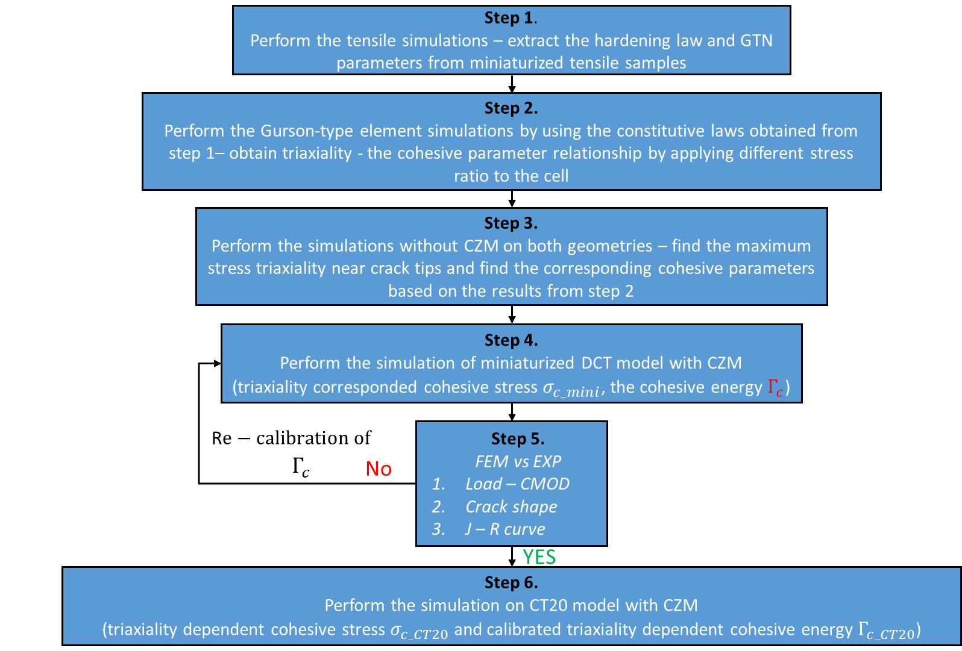
Fig. 6. Flow chart of the computational modelling methodology.

3. Results and discussion

3.1 Hardening law
Fig. 7(a) shows the engineering stress – strain curve and the true stress-strain law extracted using the inverse method described in appendix. The true fracture strain is equal to 1.7. This means that very large strains can be expected in the near crack tip region even if the stress triaxiality is much larger. Hence, one needs an accurate description of the hardening law up to large strains, far beyond the onset of necking.
In order to assess the accuracy of the extracted hardening law, Fig. 7(b) compares the engineering stress – strain from experiments (black curve) and FEM (blue curve) using the extracted hardening law and the GTN parameters. The agreement is very good.

(a) | (b)
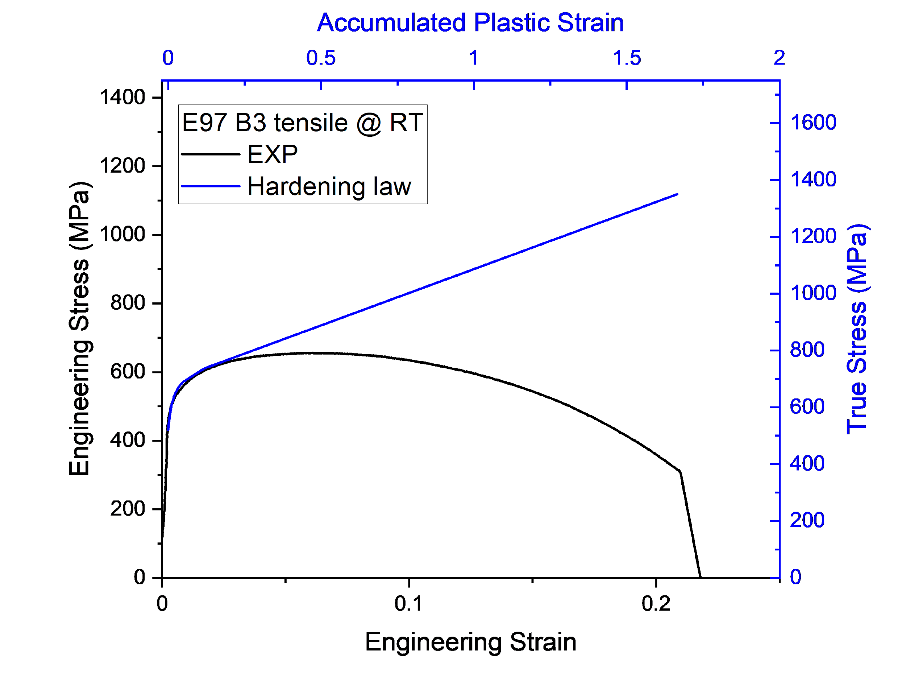 | 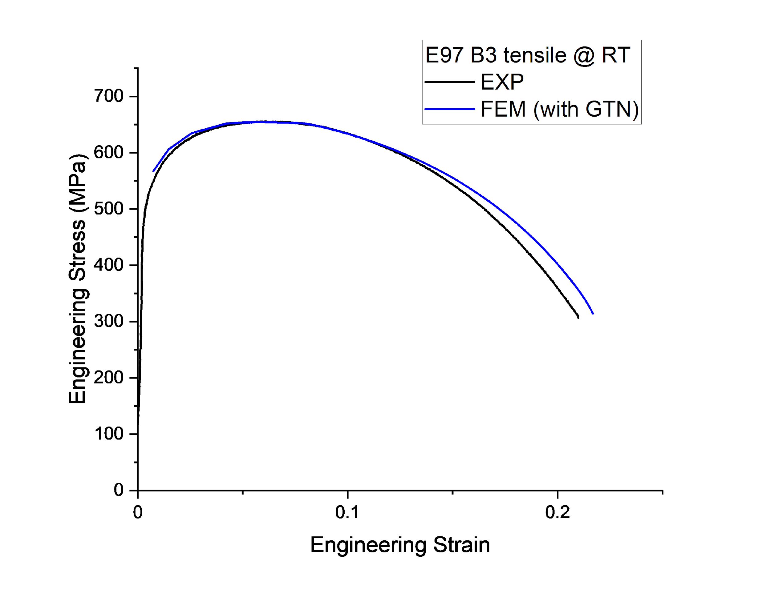
Fig. 7. (a) Comparison of true stress – true strain response (shown in blue) and engineering stress – strain (shown in black); (b) Comparison of engineering stress – strain obtained by FEM using best-fit hardening law and experimental curve

3.2 Experimental fracture toughness
Fig. 8(a) shows the measured load-CMOD curves for each geometry tested at RT, where two tests were conducted to assess reproducibility. The unloading compliance segments were removed to enable a clearer comparison with the FEM results. The response is highly non-linear indicating intense plastic deformation. The smaller the sample, the sooner the maximum load is reached at ~ 2.3 kN (at CMOD ~ 1.5 mm) for the mini DCT. For the CT20, the maximum force is reached at ~ 52 kN (at CMOD ~ 3 mm). The present set of experiments was performed for CMOD up to 3 mm, to keep the crack extension within 0.5-1 mm, also in the context of validation by FEM. Fig. 8(b) shows the corresponding J-R curves from both repeats for each geometry, confirming good reproducibility of the fracture tests. The representative J_{Q} value was extracted according to the ASTM E1820 standard, corresponding to the 0.2 mm offset line. The mean J_{Q} value of mini DCT is equal to 599 kJ/m², whereas it is equal to 964 kJ/m² for CT20. The J_{Q} value of the mini DCT is approximately 60% lower than for CT20.

(a) | (b)
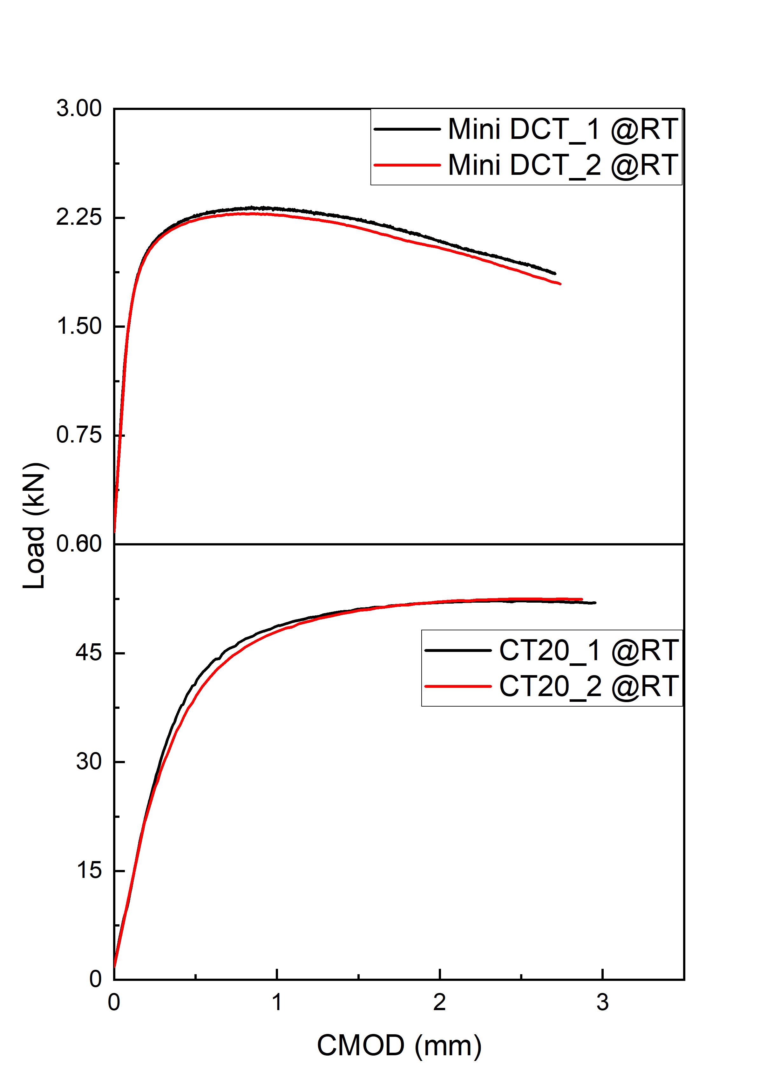 | 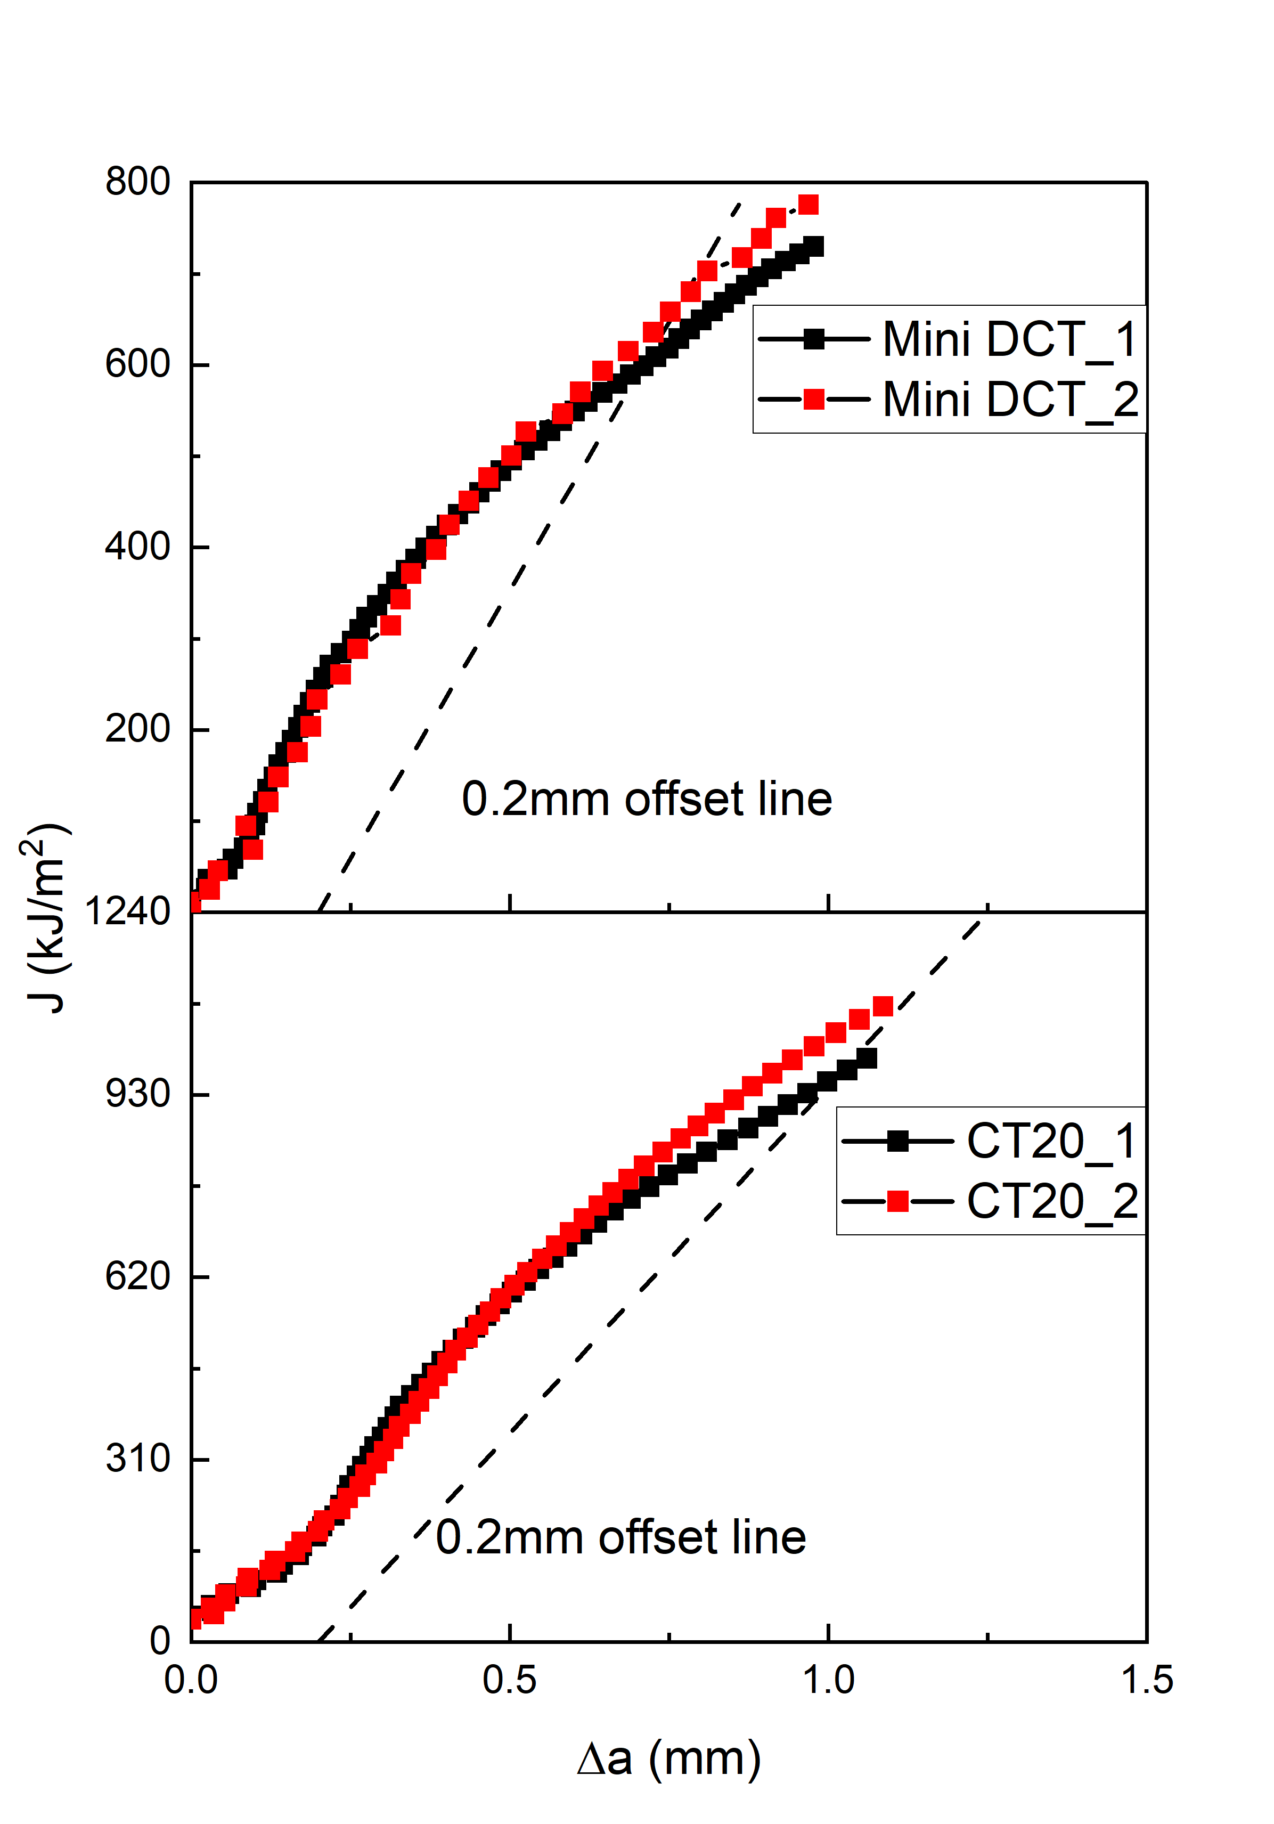
Fig. 8. Experimental (a) load–CMOD curves and (b) J-R curves for mini DCT and CT20 specimens.
Visual and SEM inspection of the cold-broken (i.e. the load was applied at cryogenic temperature to avoid any extra ductile deformation) specimen was performed in order to post-process the results of the fracture toughness tests and construct the crack resistance curve. This is needed to carefully define the morphology and position of the crack at the beginning and end of the fracture test. Fig. 9 illustrates the different regions of a cold-broken half sample – fatigue pre-cracked region, stretched zone, and ductile tearing region. The stretched zone represents the zone ductile deformation associated to the crack tip blunting, hence involving no dimples. The stretched zone width could be included or excluded from the measurement of the total crack extension [9]. In the present analysis, it is included. The resulting J-R curve is determined by the best fit of the J value and crack extension following the procedure of the ASTM E1820 standard [9].
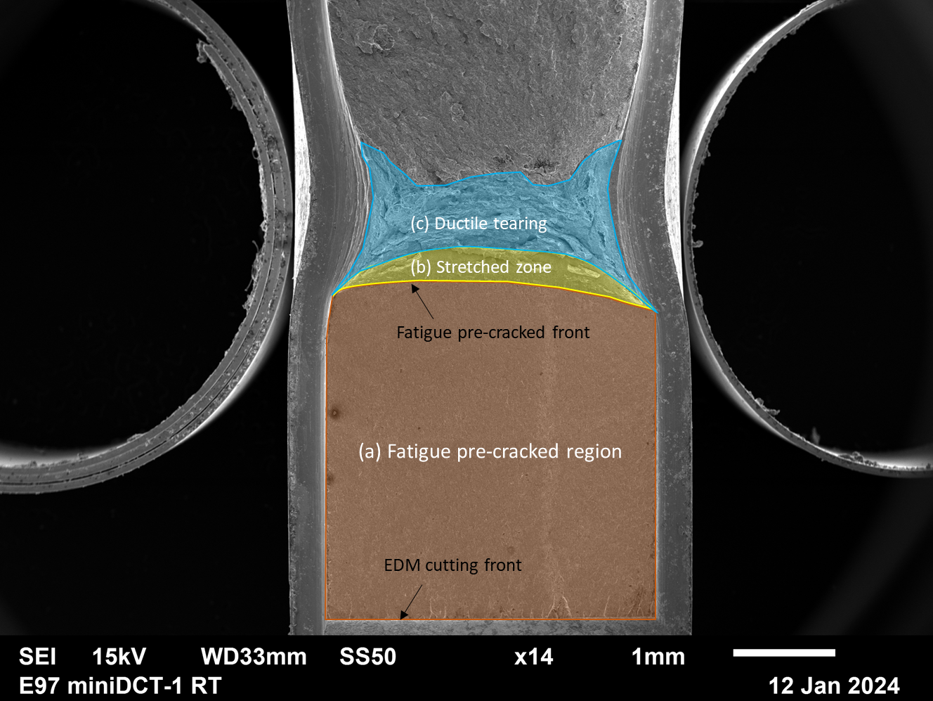
Fig. 9. Micrographs showing the boundary of the EDM cut, fatigue pre-crack, stretched zone and ductile tearing region.
The length of the fatigue pre-crack (from EDM cutting front to fatigue pre-cracked front) was accurately measured using SEM micrographs. This is the value used in the FE model. The shape and the width of the stretched zone and ductile tearing region formed as a result of the crack extension will be compared to the FE results, and this information will be used to validate the accuracy of the FE model.
Fig. 10 shows magnifications of the fracture surface of each specimen giving more details on the fatigue pre-crack zone, stretch zone, ductile fracture region and final rupture zone. The fatigue pre-crack zone exhibits the expected smooth surface compared to the ductile fracture region which makes the pre-cracking front and ductile crack extension path clearly visible. As explained above, the stretched zone corresponds to the material region involved in the blunting of the pre-crack. Hence the stretch zone width (SZW) represents the material’s ability to open a pre-crack through plastic distortions before cracking. The SZW can be geometrically related to the critical crack tip opening displacement which is a one indicator of fracture toughness (related to J_{c} through the yield stress and Shih factor). The average SZW was measured as equal to 0.37 mm, and 0.2 mm for the mini DCT and CT20, respectively. The SZW measurement was conducted by tracing the stretch zone boundary, delineated by the blue enclosed contour, as shown in Fig. 10. These results show that the SZW decreases with increasing specimen thickness.
The fracture process proceeds by the nucleation, growth and coalescence of voids as revealed by the SEM micrographs of the fracture surface. The dimples at the centre of the fracture surface are larger than those near the edges due to the difference in stress state: tension dominant fracture in the middle and shear slant-type dominant fracture near the edge with close plane stress conditions. This variation in stress state also explains the curvature of the crack front, which is primarily due to the tunnelling effect. In the centre of the specimen, higher stress triaxiality promotes faster crack propagation, whereas near the edges, plastic localization is favoured, leading to the slant mode. This slant fracture is associated with smaller dimples due to limited void growth before coalescence under shear-dominated deformation [25]. The final fracture zone exhibits the expected brittle fracture morphology induced by the liquid nitrogen condition. The fracture process and failure mechanisms are consistent across both specimens, regardless of differences in specimen size and geometry. This observation provides the substantiation for the application of the same FEM model to describe the tests performed on small and large specimens.

(a)
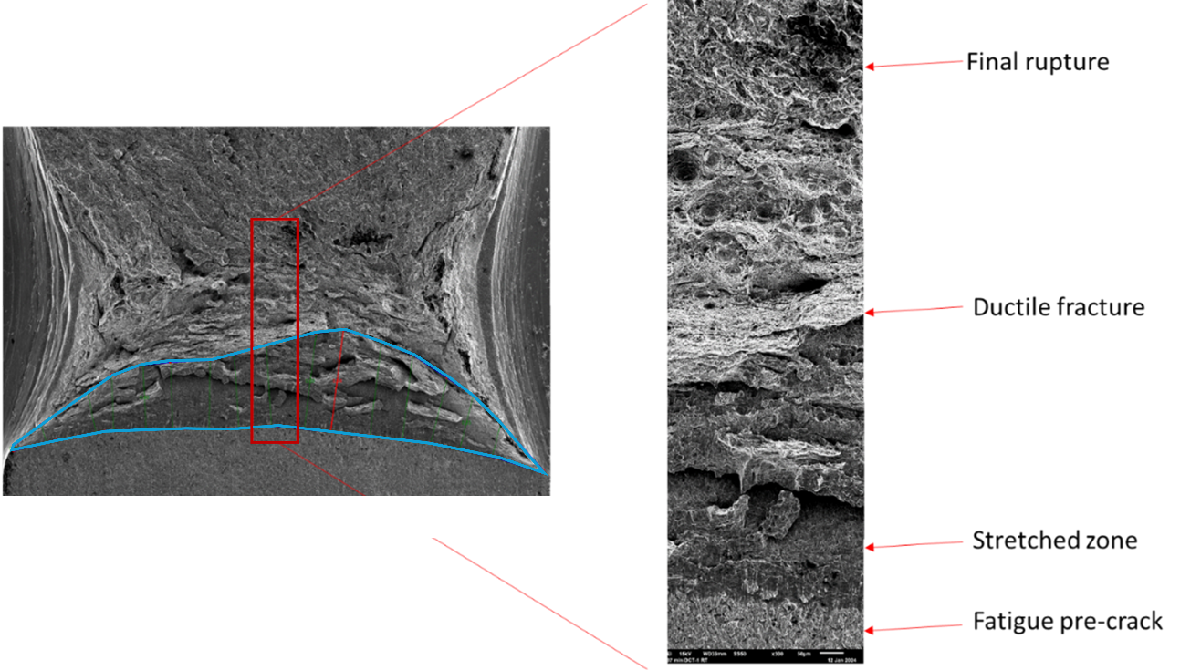
(b)
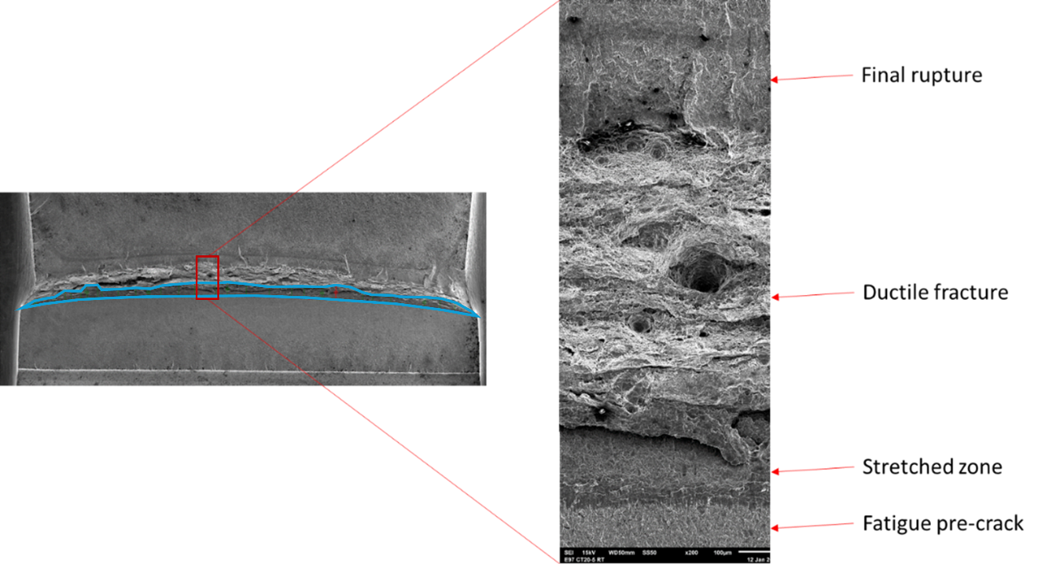
Fig. 10. Fractography of (a) mini DCT and (b) CT20 with detailed features marked and with the measurement of SZW (blue line).

3.3 Static FEM simulations of fracture specimens
Fig. 11 shows the comparison of the load-CMOD response predicted by the static J₂ FE simulations (without CZM) with the experimental data for each tested geometry. The results demonstrate that load-CMOD response is properly captured using the hardening law extracted from the tensile data up to crack initiation. Small displacement increments were enforced in order to detect as precisely as possible the magnitude of the maximum stress triaxiality which is important for selecting the right TSL parameters. Once again, no CZM is used in these simulations, as explained in Section 2. The objective here is only to determine the maximum mean crack tip stress triaxiality at the mid-thickness region. The maximum stress triaxiality is found equal to 2.51 and 2.97 for the 4 and 20 mm CT thickness, respectively.
The decrease of the SZW with increasing specimen size in the previous section can be attributed to differences in constraint at the crack tip. The mini DCT, with the largest SZW, experienced lower constraint, confirmed by a calculated stress triaxiality of 2.51. In contrast, the CT20, which has the narrowest SZW, underwent less plastic deformation before the local fracture strain is attained in the fracture process zone, owing to higher constraint at the crack tip, quantified by a stress triaxiality of 2.97. The difference between a stress triaxiality of 2.51 and 2.97 may appear small, but, as known since the early days of the micromechanics of ductile fracture, the void growth rate depends exponentially on stress triaxiality which would lead to about 20% difference in fracture strain for the 4 mm and 20 mm thick samples [46, 47].
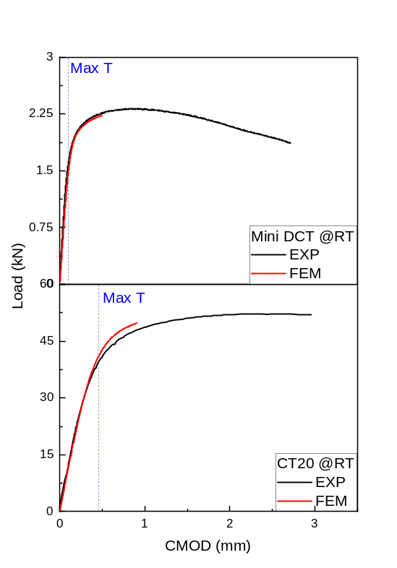

Fig. 11. Static FEM predictions of the fracture simulations indicting also at what level of loading the maximum of stress triaxiality is attained in the near crack tip region for each type of specimen.

3.4 GTN-based determination of traction-separation law
Knowing the representative level of stress triaxiality in the fracture process zone and expected level of the maximum plastic strain, the next step involves the usage of the GTN model to deduce the cohesive stress and energy at the specific stress triaxiality, as required to proceed with CZM-based FE simulations of the cracking process. The GTN parameters used to determine the TSL parameters are summarized in Table 2. Fig. 12(a) shows the results of the GTN prediction under various applied stress triaxiality. The traction – separation curves were constructed based on the stress and strain curves in the main loading direction (parallel to $σ_{22}$). The predicted$σ_{22}$ stress has been normalized by the yield stress. The parameter D represents the side length of the element, which is a characteristic length scale in ductile fracture equivalent to the average distance between voids. A typical value for the length scale associated with ductile fracture in ferritic steels is D = 100 μm [31, 32], which was used for this study as a first estimate (and which can be later fine-tuned if needed, it is only a matter of rescaling the TSL). The peak stress increases as stress triaxiality increases, while both the fracture strain (and maximum displacement) and area under the curve decrease, see also early results by Siegmund and Brocks [32]. The maximum traction value in Fig. 12(a) (a) for each applied triaxiality is identified as the cohesive stress and the area under each curve is the cohesive energy. Fig. 12(b) shows the dependence of cohesive stress (left axis) and cohesive energy (right axis) on the imposed stress triaxiality. The cohesive stress and cohesive energy used in our simulations were calculated from Fig. 12(b) with the corresponding triaxiality obtained in Section 3.3 for each geometry.

Table 2 GTN parameters used in this studied relying on the former study [39]
$$q_{1}$$ | $$q_{2}$$ | $$f_{0}$$ | $$f_{n}$$ | $$ε_{N}$$ | $$S_{n}$$
1.5 | 1 | 0 | 0.00055 | 0.059 | 0.02

(a) | (b)
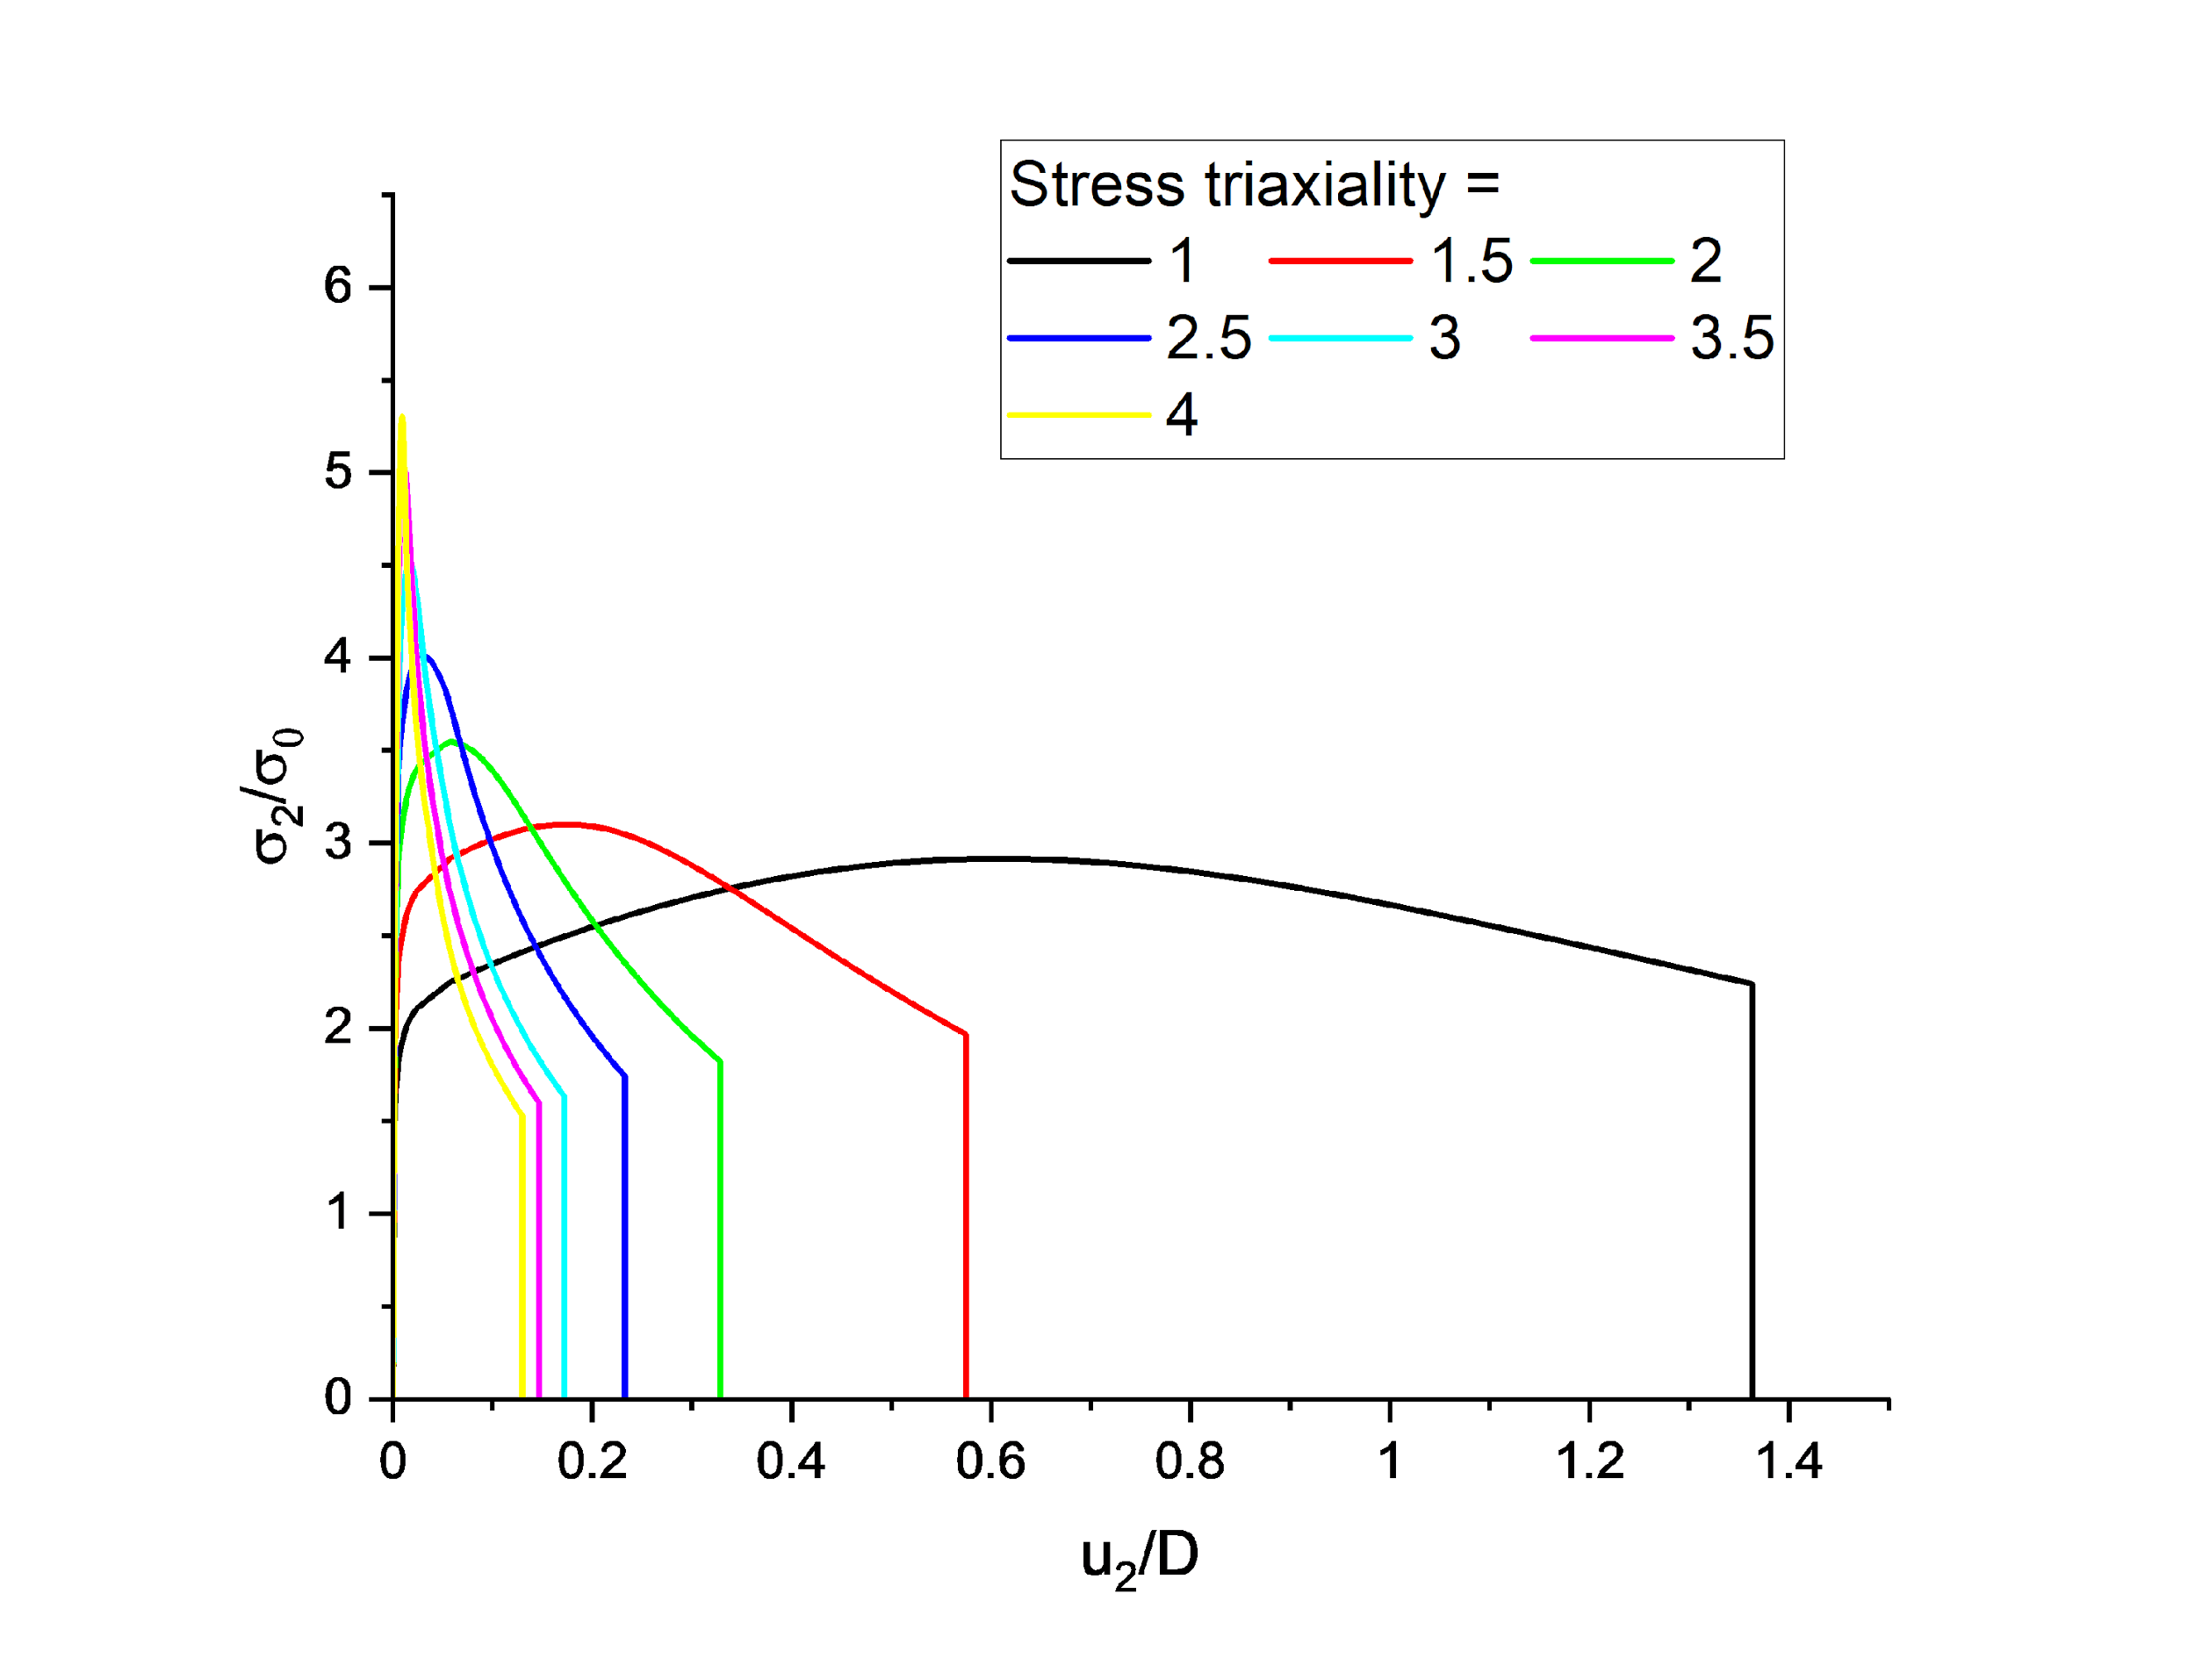 | 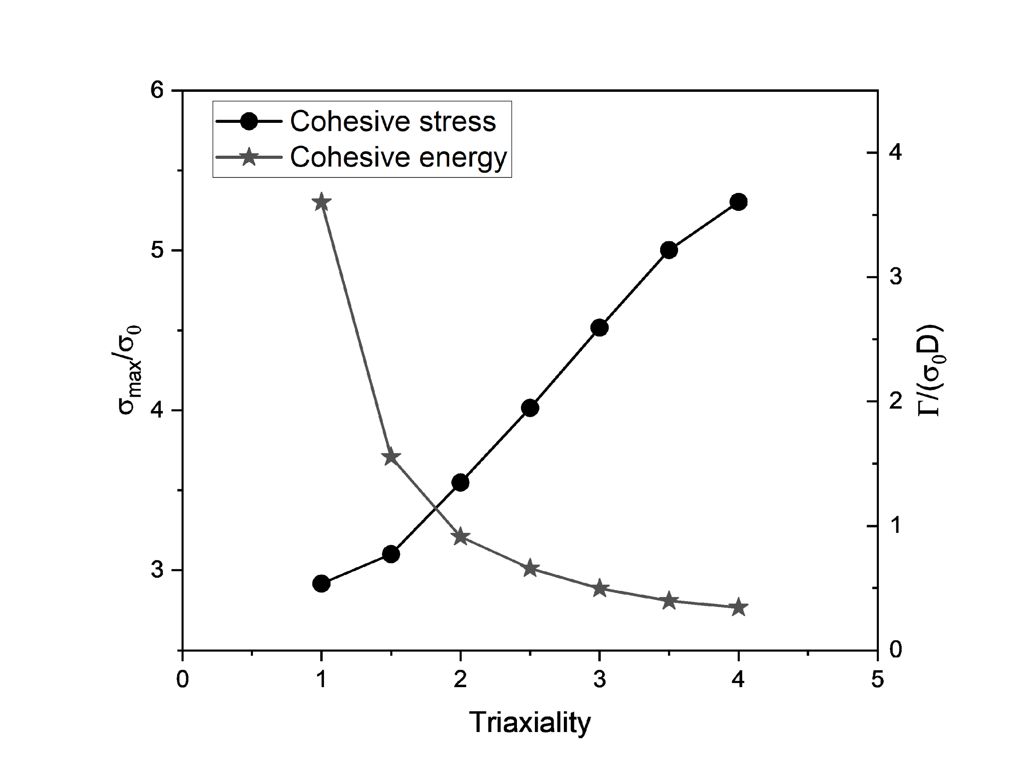
Fig. 12. GTN predictions: (a) the traction–separation responses under various imposed stress triaxialities, and (b) the dependence of cohesive stress and cohesive energy on the imposed triaxiality

3.5 FEM simulations of fracture specimens with CZM
The cohesive stress and cohesive energy corresponding to the conditions associated to the mini DCT were determined to be equal to 2084 MPa and 33.9 kJ/m², respectively, using interpolation between a stress triaxiality of 2.5 and 3 from the result given in Fig. 12(b). Fig. 13(a) compares the experimental and predicted load–CMOD responses, relying on the original, uncalibrated CZM parameters derived directly from the GTN-type simulations. The predicted load-CMOD response falls below the experimental data, i.e. the crack resistance is underestimated by the model.

(a) | (b)
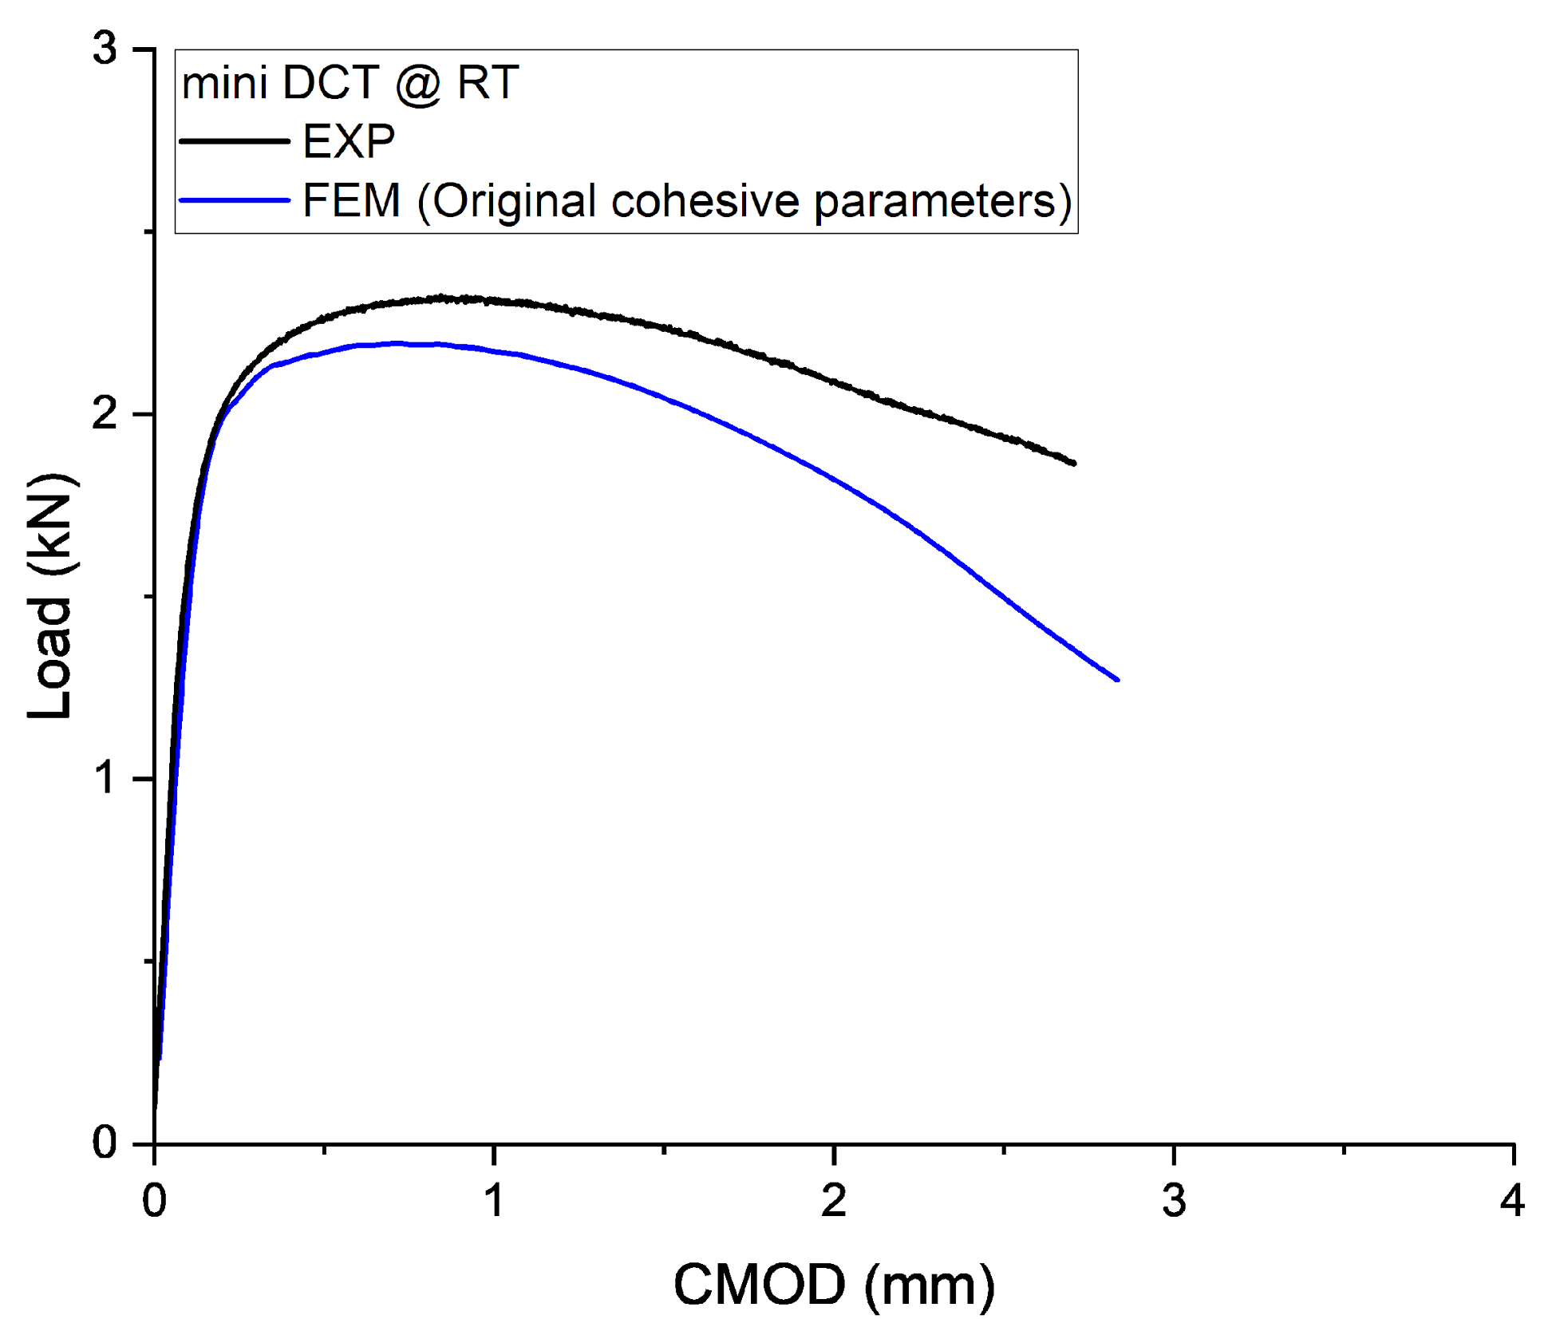 | 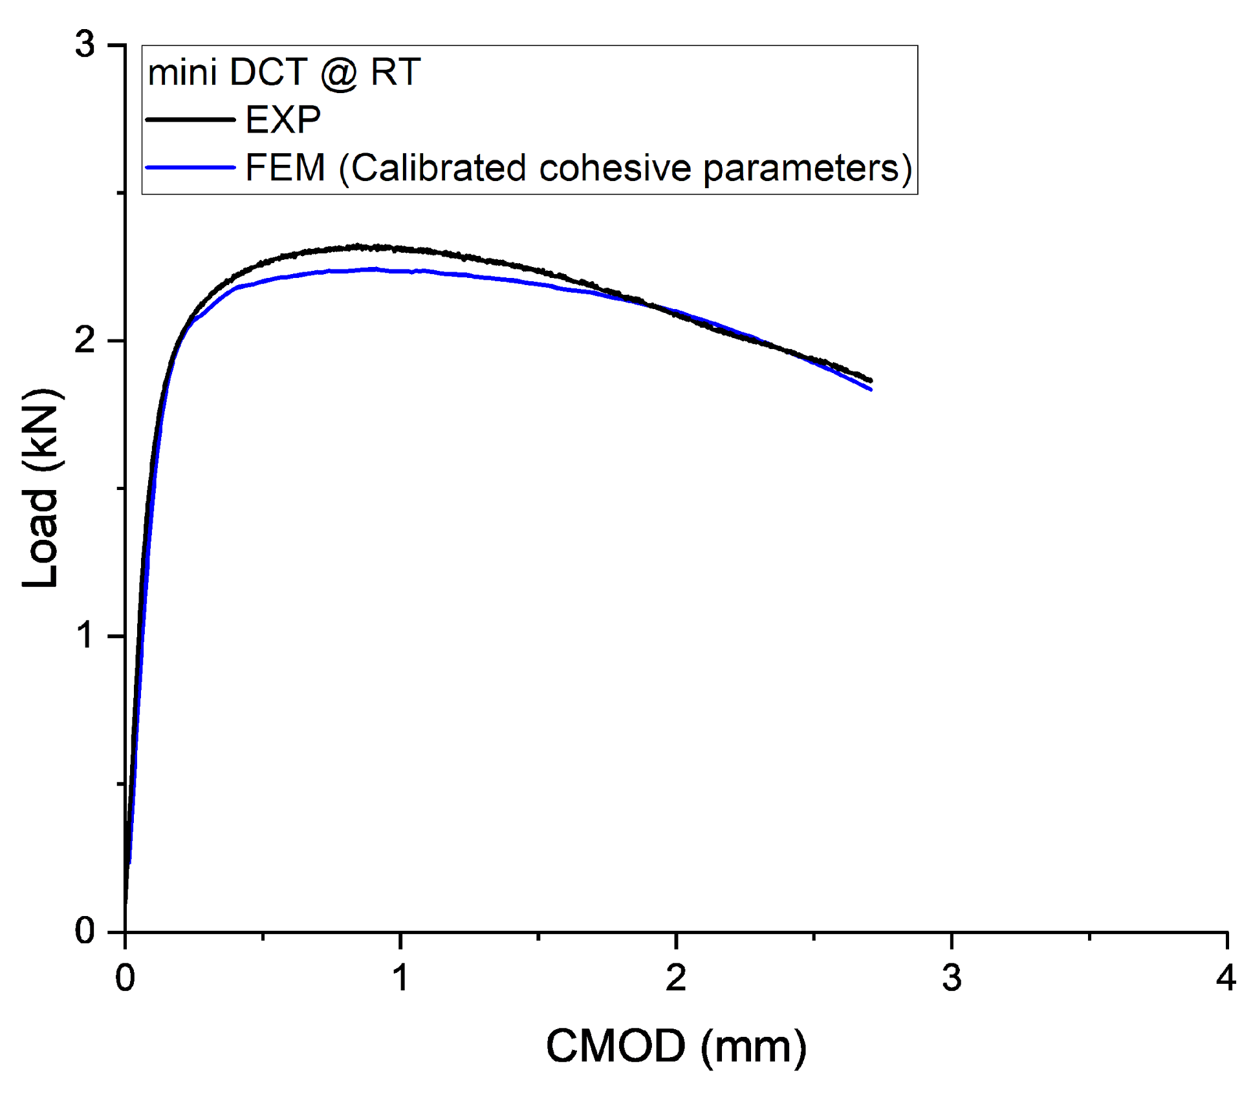
(c)
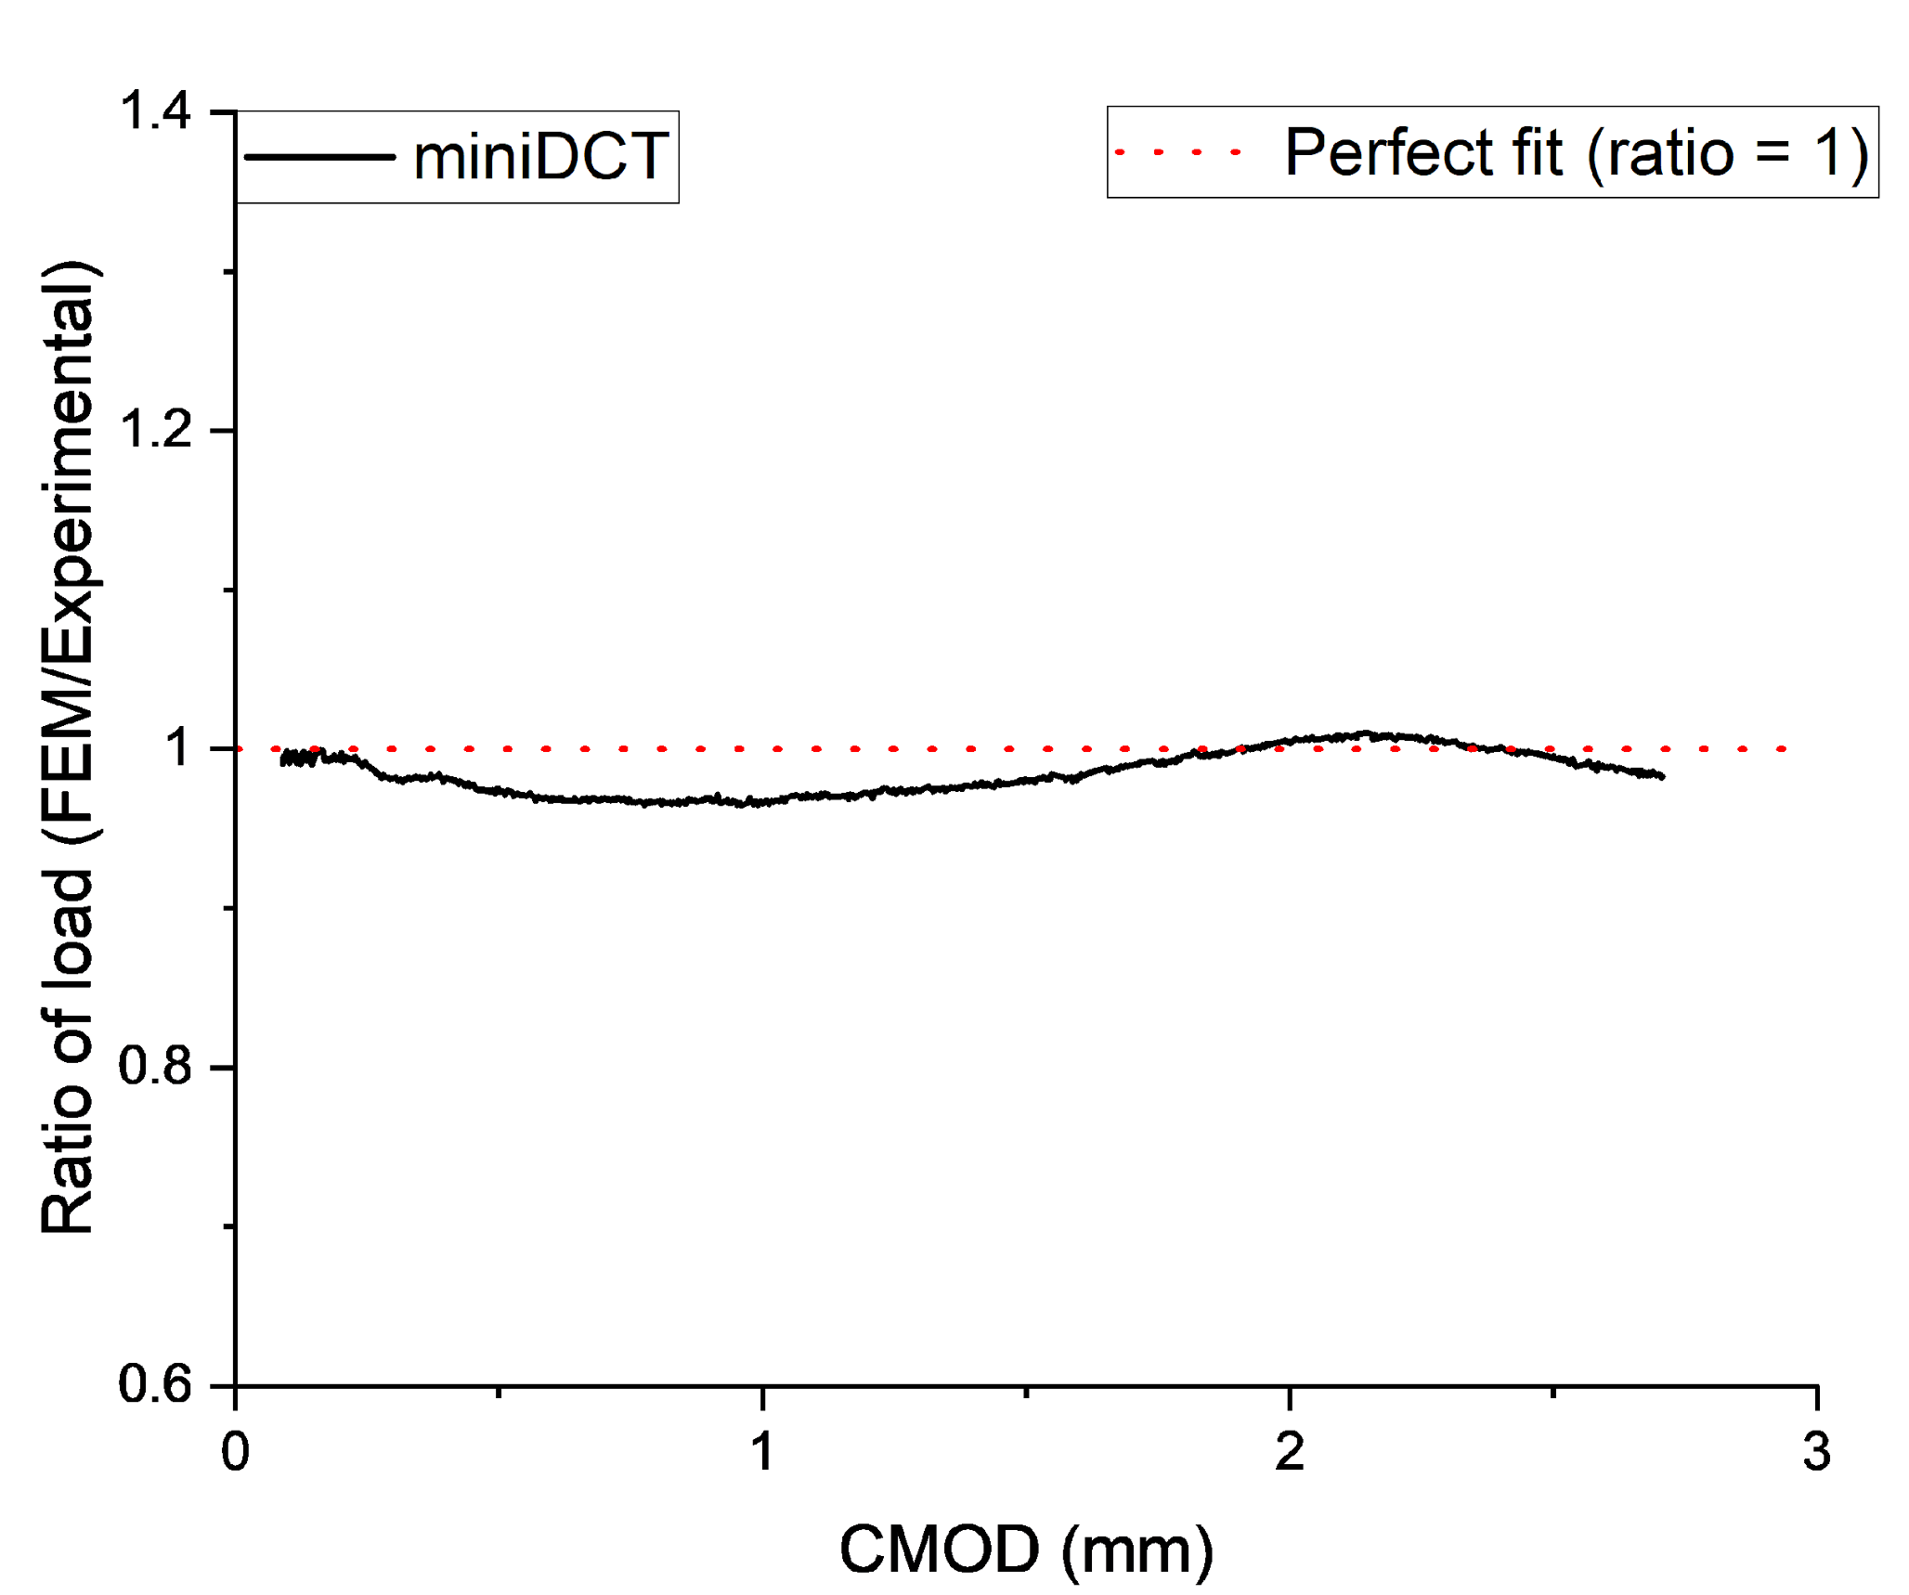
Fig. 13. The FEM results of mini DCT compared to experimental data using (a)cohesive parameters obtained from GTN-type element simulations, (b)calibrated cohesive parameters and (c)the quality of fit represented as ratio of the experimental to FEM predicted load vs. CMOD.

This comparison indicates that the CZM parameters require further adjustment for reasons that are discussed and justified in section 4. Only the CZM energy (which is underestimated by the GTN version used here and/or because underestimated value of D, see section 4) is re-calibrated while keeping the same cohesive stress. The best fit for the mini DCT experimental data, in terms of Load-CMOD curve, crack length, crack shape and the J-R curve, was achieved with a cohesive energy of 45.7 kJ/m². The load–CMOD curve for the mini DCT sample resulting from the optimized FEM dataset is shown in Fig. 13(b). Fig. 13(c) shows the quality of the fit presented as the load ratio compared to experimental data, demonstrating an overall prediction accuracy above 96%. The calibrated cohesive energy between the triaxiality range 2.5 - 3 is shown in Fig. 14.
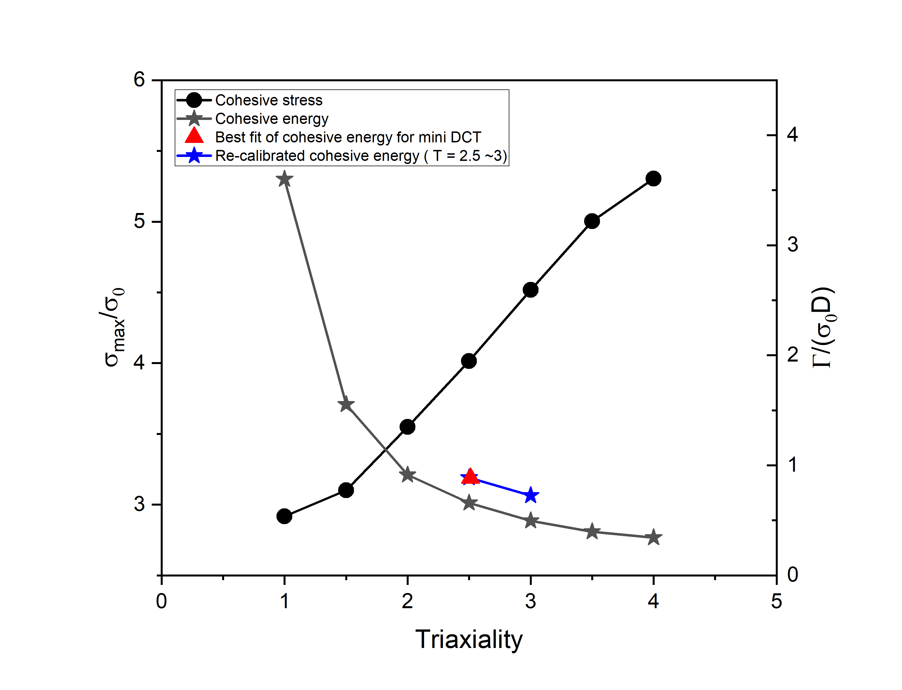
Fig. 14. The dependence of cohesive stress and calibrated cohesive energy on imposed triaxiality.

For CT20, the same approach was applied for the cohesive parameters, but using the interpolation based on the calibrated cohesive energy. No further re-calibration was performed for CT20. Table 3 summarizes the cohesive parameters. Fig. 15 shows the load-CMOD curves for CT20 samples using the calibrated cohesive parameters and the quality of the fit. The accuracy of the prediction of load–CMOD curve exceeds 94%.
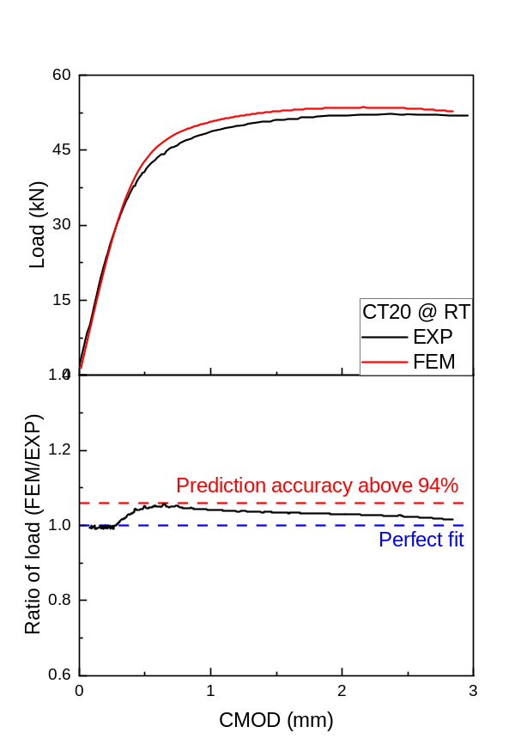
Fig. 15. FEM result of the fracture test simulations with CZM for CT20 compared to experimental curve and accuracy of the prediction estimated as ratio of the experimental to FEM predicted load vs. CMOD.
The crack propagation pattern (crack front shape) predicted by FEM was compared with the experimental patterns, as shown in Fig. 16, along with the corresponding J-R curves. This is a particularly convincing result that such a local complex characteristic is well captured. From the J-R curve, the predicted crack length from FEM is confirmed to be comparable to the experimental result. The maximum predicted crack length for the mini DCT specimen is 1.11 mm, compared to the experimental value of 0.97 mm (measured at mid-thickness), with 86% accuracy. For the CT20 specimen, the predicted crack length is 1.07 mm, while the experimental value is 1.09 mm. Furthermore, the predicted J-R curves were compared to the experimental data. The predicted J_{Q} value for the mini DCT is 682 kJ/m², while the experimental value is 599 kJ/m², resulting in a prediction accuracy of approximately 86%. For the CT20, the predicted J_{Q} value is 819 kJ/m² compared to the experimental value of 964 kJ/m², corresponding to a prediction accuracy of about 85%. Hence, the effect of change of constraint on J_{Q} is captured but underestimated. It is worth noting that the J-R curve for mini DCT falls outside of the validity region for the maximum bearing capacity (J_{max}) as defined by ASTM E1820 norm. However, calibrating the cohesive energy using mini DCT provides good agreement with the J-R curve obtained for CT20, which delivers a valid test result, thus confirming the success of the proposed approach.
Table 3. Cohesive parameters used in simulations for each sample geometry.
 | Cohesive stress ($σ_{c}$​), MPa | Cohesive energy ($Γ_{c}$), kJ/m² | Remark
Mini DCT | 2084 | 45.7  (originally 33.9) | $Γ_{c}$ was obtained by recalibration
CT20 | 2324 | 35.3  (originally 26.2) | $Γ_{c}$ was proportionally increased

(a)
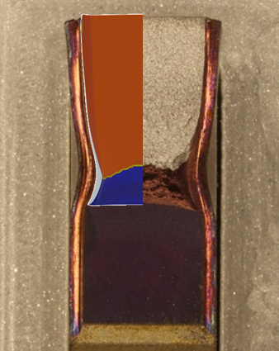 | 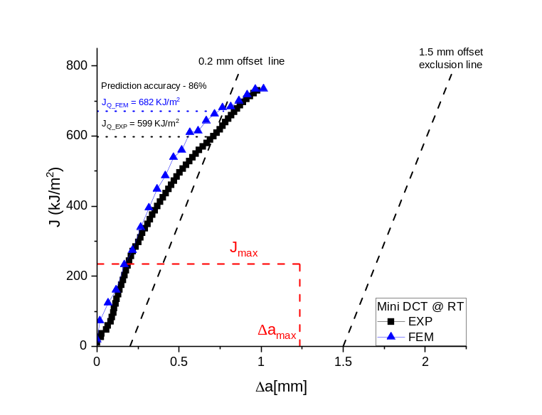
(b)
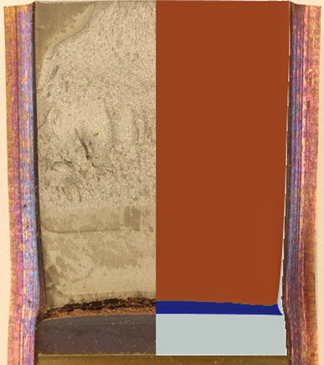 | 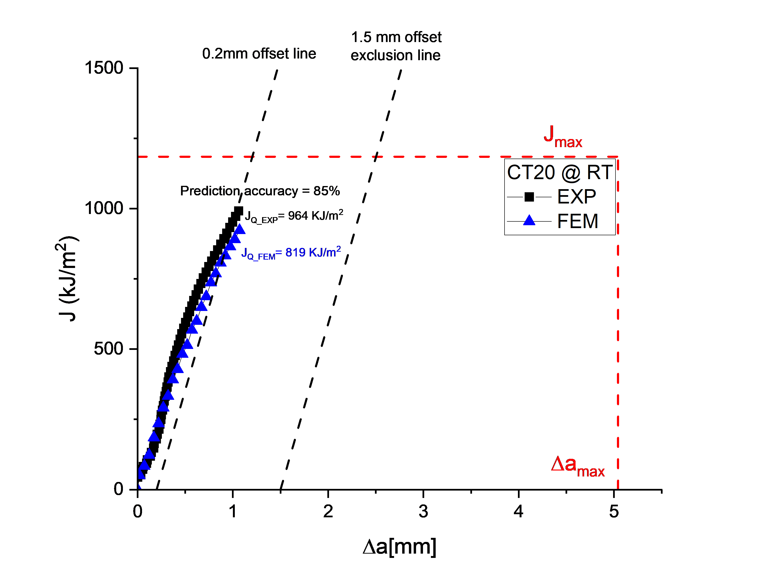
Fig. 16. The crack propagation (blue region) from FEM compared to the real sample and the comparison of predicted and experimental J-R curves of (a) mini DCT and (b) CT20

4. Discussion

4.1 J_{Q} and SZW value discrepancies
The difference in J_{Q} between the mini DCT and CT20 specimens (599 kJ/m² vs 964 kJ/m²) highlights the influence of specimen size and thickness on measured fracture toughness. However, J_{Q} value of mini DCT may not be appropriate for characterizing the fracture toughness, as it corresponds to a crack extension of 0.7 mm, which exceeds 60% of the maximum allowable crack extension ${∆a}_{max }$(0.25(W-$a_{0 })$ $≈$ 1.14mm) specified by the ASTM E1820 standard. This behavior was also found and reported by Li et al. [48] for RPV steel. Nevertheless, the fractography indicated that the mini DCT specimen exhibited a significantly larger stretch zone width (SZW ≈ 0.37 mm) compared to the CT20 (SZW ≈ 0.20 mm). Normally, a larger SZW implies higher crack-tip toughness due to more extensive blunting before fracture initiation. This apparent contradiction emphasizes the complexity of determining meaningful initiation toughness values for very ductile materials, where conventional J_{Q} or J_{Ic} criteria may not fully capture true crack initiation resistance. For EUROFER97, the high toughness and extensive plastic deformation result in steep R-curves at the onset of tearing, complicating the direct comparison of J_{Q} values from specimens of different thicknesses. Consequently, J_{Q} measurements from miniaturized tests should be interpreted cautiously, recognizing their potential limitations.

4.2 Transferability of cohesive parameters
Despite the challenges associated with interpreting J_{Q} directly from miniaturized specimens, the study demonstrates the effective use of miniaturized specimens to characterize fracture toughness through a robust modelling approach. While a 4 mm thick DCT specimen alone cannot provide a formally valid J_{Q} according to ASTM standards, its experimental data (load–CMOD response, crack growth resistance behavior, and fracture surface features) proved invaluable in calibrating a predictive cohesive zone model.
The cohesive zone model initially utilized parameters derived from GTN-type element simulations, indicating that higher stress triaxiality leads to higher cohesive strengths but lower cohesive energies. However, direct use of GTN-estimated parameters underpredicted crack resistance in the mini DCT, necessitating calibration of cohesive energy. Increasing the cohesive energy from the initial GTN-derived estimate of 33.9 kJ/m² to approximately 45.7 kJ/m² significantly improved the agreement with experimental results. One potential reason to explain why the damage-fracture energy was underestimated by about 25% is the absence of treatment of the coalescence phase with the relatively rudimentary version of the GTN model. When looking at GTN predictions or FE void cell calculations deep in the coalescence regime from literature (e.g.[49]), an underestimation of 25% is certainly reasonable. At high stress triaxiality. But this re-calibration step also corrects for the choice of the length scale D parameter which can vary from one steel batch to another as connected to the inclusion population for instance. In other words, such re-calibration of cohesive energy will always be needed due to the difficulty to determine an absolute definitive value for D and there is no need to enter into further complexity in the treatment of void growth and coalescence. The key point of the methodology is that the cohesive stress is not modified and that when one cohesive energy is re-calibrated for one specimen geometry, the GTN-based stress triaxiality dependence can be applied to get the cohesive energy of all other specimen geometries.
After calibrating cohesive parameters using the mini DCT data, no further adjustments were required to accurately predict the fracture behavior of the larger CT20 specimen. The calibrated cohesive parameters effectively captured crack propagation, crack front shapes, and J-R curves in the CT20 geometry, demonstrating high accuracy (approximately 85–95% agreement). The multi-step approach (tensile test → small specimen fracture toughness test → inverse FEM with GTN-type element simulations → CZM re-calibration) successfully produced a model that could predict the fracture behavior of a larger, ASTM-valid specimen using data from a mini specimen. Thus, miniaturized fracture tests, combined with cohesive zone modelling calibrated for constraint and size effects, offer a viable pathway for accurate fracture toughness evaluation where standard-size testing is impractical.

5. Summary and conclusions

A combined experimental and computational study dedicated to the extraction and calibration of cohesive parameters using miniaturized samples has been performed and validated by comparing to standard specimen results. This study addresses the need for methods that effectively exploit test results from miniaturized specimens, which typically deliver non-valid results according to current standards. Miniaturized samples are frequently employed in fracture toughness investigations, particularly for irradiated materials or localized phenomena such as chemical segregation, weld heat-affected zones, thermal fatigue regions, or environmentally impacted areas. Current validity criteria impose strict limitations on specimen dimensions, yield stress, elastic modulus, and J_{Ic} values, often necessitating large specimen dimensions exceeding 10 mm thickness. Testing such large samples under neutron irradiation involves substantial costs and complex procedures due to high residual radioactivity.

In this study, tests were conducted on small specimens producing admittedly invalid results by ASTM/ISO standards. An FEM-based procedure was established to determine cohesive zone model (CZM) parameters. Utilizing auxiliary tensile tests and a GTN-type element model, the dependence of cohesive stress on local stress triaxiality was determined to account for specimen size effects. The procedure was applied to EUROFER97 steel using ANSYS software. Cohesive parameters calibrated on 4 mm thick samples successfully predicted fracture behavior in 20 mm thick samples without additional adjustments. FEM results for load-CMOD, J-R curves, and crack morphology demonstrated excellent agreement with experimental data. Microstructural analysis confirmed consistent fracture mechanisms across specimen sizes, validating the physical equivalence and justifying the miniaturization procedure. Based on the above outcomes, the following conclusions can be drawn:
- Miniaturization of the fracture toughness test by reducing the sample thickness from 20 to 4 mm in EUROFER97 material remains physically justified as the same fracture mechanisms are involved, which is proven by the in-depth microstructural investigation.
  - The J_{Q} value is not representative of the true crack initiation resistance due to extremely steep R-curve effect, as confirmed when analysing the stretch zone width. This is a second motivation to propose an approach that goes beyond a one parameter fracture mechanics transferability scheme.
  - A multi-step scheme based on uniaxial tensile test, fracture toughness test on mini-sample, inverse FEM procedure and Gurson-based procedure to identify a CZM model allow building a FEM model to simulate ductile crack extension in a larger sample with the thickness sufficient to respect the validity criteria imposed by the norms.
  - Gurson-based predictions can be effectively used for the peak stress determination. However, the cohesive energy had to be re-calibrated by about 25% to take into account the absence of treatment of the final void coalescence step and uncertainty on the value of the length scale parameter entering the failure process.
  - The FEM fracture toughness test procedure was applied on 4 mm thick mini-sample to predict the J-R curve for 20 mm thick samples, with 85% accuracy without any further adjustment, including very good agreement with the experimental crack morphology.
  - FEM calculations were performed using the code ANSYS Mechanical with bilinear contact debonding model which is a cost effective solution given the scale of the crack extension and dimension of the considered sample size (40×50×20 mm) delivering a good agreement with experimental data for the determination of load-CMOD and J-R curves at the same time.

The methodology will be further developed for (i) simulation of the large crack extension up to 1.5 mm; (ii) simulation at elevated temperatures; (iii) simulation of the neutron irradiated samples with the overall objective to assess the fracture toughness and J-R curve in support of the population of the material property handbook. This approach aims to enhance efficiency and cost-effectiveness of fracture toughness testing procedures while minimizing radioactive wastes by enabling sample size reduction.

Acknowledgments
This work has been carried out within the framework of the EUROfusion Consortium, funded by the European Union via the Euratom Research and Training Programme (Grant Agreement No. 101052200—EUROfusion). Views and opinions expressed are however those of the author(s) only and do not necessarily reflect those of the European Union or the European Commission. Neither the European Union nor the European Commission can be held responsible for them.

References

1. Mueller P, Spätig P, Bonadé R, Odette GR, Gragg D. Fracture toughness master-curve analysis of the tempered martensitic steel Eurofer97. Journal of Nuclear Materials.386-388(2009):323–7. https://doi.org/10.1016/j.jnucmat.2008.12.122
2. Ilchuk N, Spätig P, Odette GR. Fracture toughness characterization in the lower transition of neutron irradiated Eurofer97 steel. Journal of Nuclear Materials.442(2013):S58–S61. https://doi.org/10.1016/j.jnucmat.2013.01.002
3. Kohyama A, Hishinuma A, Gelles DS, Klueh RL, Dietz W, Ehrlich K. Low-activation ferritic and martensitic steels for fusion application. Journal of Nuclear Materials.233-237(1996):138–47. https://doi.org/10.1016/S0022-3115(96)00327-3
4. Baluc N, Gelles DS, Jitsukawa S, Kimura A, Klueh RL, Odette GR, et al. Status of reduced activation ferritic/martensitic steel development. Journal of Nuclear Materials.367-370(2007):33–41. https://doi.org/10.1016/j.jnucmat.2007.03.036
5. AFCEN. RCC-MRx 2022 2022.
6. Arbeiter F, Diegele E, Fischer U, Garcia A, Ibarra A, Molla J, et al. Planned material irradiation capabilities of IFMIF-DONES. Nuclear Materials and Energy.16(2018):245–8. https://doi.org/10.1016/j.nme.2018.05.026
7. Vicente SGd. New CRP: Towards the Standardization of Small Specimen Test Techniques for Fusion Applications - Phase II (F13021) 2022 [Available from: https://www.iaea.org/newscenter/news/new-crp-towards-the-standardization-of-small-specimen-test-techniques-for-fusion-applications-phase-ii-f13021.
8. Pintsuk G, Diegele E, Dudarev SL, Gorley M, Henry J, Reiser J, et al. European materials development: Results and perspective. Fusion Engineering and Design.146(2019):1300–7. https://doi.org/10.1016/j.fusengdes.2019.02.063
9. Standard Test Method for Measurement of Fracture Toughness - ASTM E1820 2024.
10. Henry BS, Luxmoore AR. The stress triaxiality constraint and the Q-value as a ductile fracture parameter. Engineering Fracture Mechanics.57(1997):375–90. https://doi.org/10.1016/S0013-7944(97)00031-3
11. O'Dowd NP, Shih CF. Family of crack-tip fields characterized by a triaxiality parameter—I. Structure of fields. Journal of the Mechanics and Physics of Solids.39(1991):989–1015. https://doi.org/10.1016/0022-5096(91)90049-T
12. Gao X, Faleskog J, Shih CF, Dodds RH. Ductile tearing in part-through cracks: experiments and cell-model predictions. Engineering Fracture Mechanics.59(1998):761–77. https://doi.org/10.1016/S0013-7944(97)00174-4
13. Pineau A. Global and Local Approaches of Fracture — Transferability of Laboratory Test Results to Components. In: Argon AS, editor. Topics in Fracture and Fatigue. New York, NY: Springer New York; 1992. p. 197–234.
14. Pineau A, Pardoen T. 2.06 - Failure of Metals. In: Milne I, Ritchie RO, Karihaloo B, editors. Comprehensive Structural Integrity. Oxford: Pergamon; 2007. p. 684–797.
15. Xia L, Shih CF, Hutchinson JW. A computational approach to ductile crack growth under large scale yielding conditions. Journal of the Mechanics and Physics of Solids.43(1995):389–413. https://doi.org/10.1016/0022-5096(94)00069-H
16. Benzerga AA, Leblond J-B, Needleman A, Tvergaard V. Ductile failure modeling. International Journal of Fracture.201(2016):29–80. 10.1007/s10704-016-0142-6
17. Marino B, Mudry F, Pineau A. Experimental study of cavity growth in ductile rupture. Engineering Fracture Mechanics.22(1985):989–96. https://doi.org/10.1016/0013-7944(85)90038-4
18. Pardoen T, Scheyvaerts F, Simar A, Tekoğlu C, Onck PR. Multiscale modeling of ductile failure in metallic alloys. Comptes Rendus Physique.11(2010):326–45. https://doi.org/10.1016/j.crhy.2010.07.012
19. Pineau A, Benzerga AA, Pardoen T. Failure of metals I: Brittle and ductile fracture. Acta Materialia.107(2016):424–83. https://doi.org/10.1016/j.actamat.2015.12.034
20. Tvergaard V. Material Failure by Void Growth to Coalescence. In: Hutchinson JW, Wu TY, editors. Advances in Applied Mechanics. 27: Elsevier; 1989. p. 83–151.
21. Gurson AL. Continuum Theory of Ductile Rupture by Void Nucleation and Growth: Part I—Yield Criteria and Flow Rules for Porous Ductile Media. Journal of Engineering Materials and Technology.99(1977):2–15. 10.1115/1.3443401
22. Tvergaard V, Needleman A. Analysis of the cup-cone fracture in a round tensile bar. Acta Metallurgica.32(1984):157–69. https://doi.org/10.1016/0001-6160(84)90213-X
23. De Borst R, Sluys LJ, Muhlhaus HB, Pamin J. FUNDAMENTAL ISSUES IN FINITE ELEMENT ANALYSES OF LOCALIZATION OF DEFORMATION. Engineering Computations.10(1993):99–121. 10.1108/eb023897
24. Leblond JB, Perrin G, Devaux J. Bifurcation Effects in Ductile Metals With Nonlocal Damage. Journal of Applied Mechanics.61(1994):236–42. 10.1115/1.2901435
25. Nguyen V-D, Pardoen T, Noels L. A nonlocal approach of ductile failure incorporating void growth, internal necking, and shear dominated coalescence mechanisms. Journal of the Mechanics and Physics of Solids.137(2020):103891. https://doi.org/10.1016/j.jmps.2020.103891
26. Peerlings RHJ, Geers MGD, de Borst R, Brekelmans WAM. A critical comparison of nonlocal and gradient-enhanced softening continua. International Journal of Solids and Structures.38(2001):7723–46. https://doi.org/10.1016/S0020-7683(01)00087-7
27. Chen Y, Lorentz E, Besson J. Crack initiation and propagation in small-scale yielding using a nonlocal GTN model. International Journal of Plasticity.130(2020):102701. https://doi.org/10.1016/j.ijplas.2020.102701
28. Barenblatt GI. The Mathematical Theory of Equilibrium Cracks in Brittle Fracture. In: Dryden HL, von Kármán T, Kuerti G, van den Dungen FH, Howarth L, editors. Advances in Applied Mechanics. 7: Elsevier; 1962. p. 55–129.
29. Dugdale DS. Yielding of steel sheets containing slits. Journal of the Mechanics and Physics of Solids.8(1960):100–4. https://doi.org/10.1016/0022-5096(60)90013-2
30. Tvergaard V, Hutchinson JW. The relation between crack growth resistance and fracture process parameters in elastic-plastic solids. Journal of the Mechanics and Physics of Solids.40(1992):1377–97. https://doi.org/10.1016/0022-5096(92)90020-3
31. Siegmund T, Brocks W. Prediction of the Work of Separation and Implications to Modeling. International Journal of Fracture.99(1999):97–116. 10.1023/A:1018300226682
32. Siegmund T, Brocks W. A numerical study on the correlation between the work of separation and the dissipation rate in ductile fracture. Engineering Fracture Mechanics.67(2000):139–54. https://doi.org/10.1016/S0013-7944(00)00054-0
33. Tvergaard V, Hutchinson JW. Effect of strain-dependent cohesive zone model on predictions of crack growth resistance. International Journal of Solids and Structures.33(1996):3297–308. https://doi.org/10.1016/0020-7683(95)00261-8
34. Huespe AE, Needleman A, Oliver J, Sánchez PJ. A finite strain, finite band method for modeling ductile fracture. International Journal of Plasticity.28(2012):53–69. https://doi.org/10.1016/j.ijplas.2011.05.010
35. Park J, Kweon S, Park K. Gurson-Cohesive modeling (GCM) for 3D ductile fracture simulation. International Journal of Plasticity.175(2024):103914. https://doi.org/10.1016/j.ijplas.2024.103914
36. Nielsen KL, Hutchinson JW. Cohesive traction–separation laws for tearing of ductile metal plates. International Journal of Impact Engineering.48(2012):15–23. https://doi.org/10.1016/j.ijimpeng.2011.02.009
37. Gaganidze E, Gillemot F, Szenthe I, Gorley M, Rieth M, Diegele E. Development of EUROFER97 database and material property handbook. Fusion Engineering and Design.135(2018):9–14. https://doi.org/10.1016/j.fusengdes.2018.06.027
38. Duerrschnabel M, Jäntsch U, Gaisin R, Rieth M. Microstructural insights into EUROFER97 batch 3 steels. Nuclear Materials and Energy.35(2023):101445. https://doi.org/10.1016/j.nme.2023.101445
39. Chang C-C, Terentyev D, Bakaev A, Zinovev A, Serra DD, Verleysen P, et al. On the equivalence of mini-flat and cylindrical tensile geometries to extract hardening law and ductility of Eurofer97. Fusion Engineering and Design.194(2023):113717. https://doi.org/10.1016/j.fusengdes.2023.113717
40. Kaniadakis A, Nguyen V-D, Besson J, Pardoen T. Strain hardening effect on ductile tearing under small scale yielding plane strain conditions. Journal of the Mechanics and Physics of Solids.202(2025):106171. https://doi.org/10.1016/j.jmps.2025.106171
41. Tvergaard V. Influence of voids on shear band instabilities under plane strain conditions. International Journal of Fracture.17(1981):389–407. 10.1007/BF00036191
42. Chu C, Needleman A. Void Nucleation Effects in Biaxially Stretched Sheets. Journal of Engineering Materials and Technology.102(1980):249. 10.1115/1.3224807
43. Lecarme L, Tekog˜lu C, Pardoen T. Void growth and coalescence in ductile solids with stage III and stage IV strain hardening. International Journal of Plasticity.27(2011):1203–23. https://doi.org/10.1016/j.ijplas.2011.01.004
44. Tekog̃lu C. Representative volume element calculations under constant stress triaxiality, Lode parameter, and shear ratio. International Journal of Solids and Structures.51(2014):4544–53. https://doi.org/10.1016/j.ijsolstr.2014.09.001
45. Tekog̃lu C, Koçhan B. Unit cell calculations under fully characterized stress states. International Journal of Plasticity.156(2022):103358. https://doi.org/10.1016/j.ijplas.2022.103358
46. Rice JR, Tracey DM. On the ductile enlargement of voids in triaxial stress fields∗. Journal of the Mechanics and Physics of Solids.17(1969):201–17. https://doi.org/10.1016/0022-5096(69)90033-7
47. Kim J, Gao X, Srivatsan TS. Modeling of void growth in ductile solids: effects of stress triaxiality and initial porosity. Engineering Fracture Mechanics.71(2004):379–400. https://doi.org/10.1016/S0013-7944(03)00114-0
48. Li M, Chaouadi R, Uytdenhouwen I, Pardoen T, Bonny G. The Effect of Loss of Constraint on the Initiation of Ductile Fracture in a Mini-CT. Volume 1: Codes & Standards2023.
49. Pardoen T, Hutchinson JW. An extended model for void growth and coalescence. Journal of the Mechanics and Physics of Solids.48(2000):2467–512. https://doi.org/10.1016/S0022-5096(00)00019-3
50. Mahler M, Aktaa J. Approach for J-R curve determination based on sub-size specimens using a triaxiality dependent cohesive zone model on a (ferritic-martensitic) steel. Engineering Fracture Mechanics.144(2015):222–37. 10.1016/j.engfracmech.2015.06.086
51. Bridgman PW. Studies in Large Plastic Flow and Fracture: Harvard University Press; 1964.

Appendix

Hardening law extraction
The hardening law of a material, or the relationship between true stress - true strain, describes how the plastic yield surface evolves during deformation. This information can be obtained from a tensile test, but only up to the point of ultimate tensile strength (UTS where diffuse necking begins, by using
$$σ_{true}= σ_{engi}\left(1+ε_{eng}\right),$$ | (1)
$$ε_{true}= lnln \left(1+ε_{eng}\right),$$ | (2)
where $σ_{true}, ε_{true}$ indicate the true axial stress and true accumulated plastic strain, respectively. $σ_{eng}, { ε}_{eng}$ indicate the engineering stress and strain, respectively.
After the onset of necking, the hardening law cannot be directly derived from the force-displacement data due to the localized deformation occurring across the sample’s gauge section in the “necked” region. Therefore, local information regarding the neck geometry and cross-section reduction is required to deduce the true stress and true strain beyond the necking point. With advancements in digital image correlation (DIC), this method has been employed to capture the true stress-strain curve post-necking [Li, 2018 #18]. For EUROFER97, true stress-strain curves were reported in [50] using both the DIC method and the Bridgman correction[51]. The study revealed that the post-necking behavior exhibited a quasi-linear trend, extending to large strains before fracture initiation. Furthermore, in our previous study [39], we demonstrated that assuming a linear increase in the hardening law from the UTS to the fracture point using the following equations,
$$σ_{true f}= \frac{F_{f}}{A_{f}},$$ | (3)
$$ε_{true f}= lnln \left(\frac{A_{o}}{A_{f}}\right) ,$$ |  | (4)
where $σ_{true f}, ε_{true f}$ indicate true axial fracture stress and true fracture strain, respectively. $F_{f}$ is the load at the moment of failure. $A_{o}, A_{f}$ are the cross-section area of the thinnest gauge section before the test and after the fracture, respectively.
By changing the slope of the linear extrapolation, one can accurately reproduce the engineering stress-strain curve using FE calculations. For more details, we refer a reader to our preceding work [39].

