Temperature- and strain rate-dependent plastic deformation of ITER specification tungsten
Francisco Miranda^{1,2}*, Aleksandr Zinovev², Kateryna Poleshchuk², Dmitry Terentyev^{2,3}, Chao Yin⁴, Kim Verbeken³, Thomas Pardoen^{1,5}
¹Institute of Mechanics, Materials and Civil Engineering (iMMC), Université catholique de Louvain (UCLouvain), Louvain-la-Neuve, Belgium
²SCK CEN, Mol, Belgium
³Ghent University, Department of Materials, Textiles and Chemical Engineering, Ghent, Belgium
⁴School of Nuclear Science and Technology, University of Science and Technology of China, Hefei, China
⁵WEL Research Institute, Wavre, Belgium

Abstract
Tungsten has been selected as the plasma-facing material for ITER’s first wall and divertor. Plasma-facing components in fusion environments must withstand extreme thermal and mechanical loads, particularly during transient events such as edge localized modes. These events generate significant thermal gradients and large mechanical loads, subjecting the material to a wide range of strain rates. Failure of these components could interrupt the reactor operation and potentially damage the surrounding systems, including the test blanket modules. To evaluate the mechanical integrity of material under such conditions, tensile tests were conducted on two ITER-specification tungsten grades for divertor components at temperatures between 250 °C and 550 °C and strain rates ranging from 6.4 × 10⁻⁴ to 6.4 × 10⁻² s⁻¹. The goal of the study is to determine the viscoplastic behavior of tungsten and to assess the impact of temperature and strain rate on its mechanical performance. The fracture surfaces and initial microstructures were analyzed by scanning electron microscopy. The results reveal a clear strain rate dependency of the strength and ductility, with a ductile-to-brittle transition at lower temperatures and higher strain rates. Differences in performance between the two tungsten grades are linked to microstructural features and impurity content. These findings highlight the importance of the processing route and initial microstructure on the mechanical performance of plasma facing components.

Introduction
Pure tungsten (W) has been selected as the primary material for various plasma-facing components (PFCs) in fusion reactors, notably in the ITER project [1,2], and is a prime candidate for DEMO, a future demonstration power plant [3,4], in which it will be used in the divertor and first wall. This choice is driven by favorable physical and thermal properties, needed to withstand the extreme environment of a fusion plasma. These properties include the highest melting point among all metals (around 3422 ℃), excellent thermal conductivity, low sputtering yield, and minimal tritium retention, all of which are essential for maintaining structural integrity and minimizing fuel contamination in a fusion environment [5].
These characteristics are particularly important in the divertor region, where the material must sustain continuous exposure to high-energy particles and intense thermal loads. The low sputtering yield limits the erosion rates, thereby extending component lifetime and reducing the frequency of maintenance or replacement. Furthermore, tungsten’s low coefficient of thermal expansion mitigates thermal fatigue, a critical factor in components subjected to cyclic heating and cooling.
However, tungsten has its challenges. At lower temperature, it exhibits intrinsic brittleness due to the body-centered cubic (BCC) crystal structure, which lacks sufficient slip systems for accommodating plastic deformation at modest stresses, hence limiting ductility [6,7]. This brittleness becomes more pronounced after neutron irradiation, which not only shifts the ductile-to-brittle transition temperature (DBTT) to higher values but also degrades the thermal conductivity and induces microstructural changes such as swelling, irradiation-induced precipitation of transmutation products and embrittlement [5]. These irradiation-induced defects can accumulate over time, leading to a progressive deterioration of the mechanical performance and an increasing risk of failure under operational conditions.
In these conditions, PFCs are subjected to intense thermal loads from the plasma, leading to steep temperature gradients between the plasma-facing surface and the cooling channels. These gradients generate significant stresses, which can result in fatigue, cracking, and finally lead to material failure. Moreover, transient plasma events such as edge localized modes and disruptions impose additional thermal shocks that are expected to deposit about 1–10 GW/m² of thermal energy onto the divertor surface on a 0.2–0.5 ms short pulse occurring at a frequency of ~1 Hz [8]. These events can induce strain rates on the order of several s⁻¹ [9], far exceeding those typically encountered in conventional materials testing. The combination of high strain rates and elevated temperatures presents a major challenge for component design, and a comprehensive understanding of tungsten’s behavior under such extreme conditions is needed.
Experimental studies have shown that the mechanical behavior of tungsten, including the flow stress and ductility, is highly sensitive to both temperature and strain rate [10–13]. This sensitivity complicates the extrapolation of laboratory data, often obtained under quasi-static conditions, to the dynamic or loading rate varying, high temperature environment of a fusion reactor. Therefore, expanding the database of tungsten’s mechanical properties under relevant conditions remains crucial for accurate modeling and reliable design of PFCs [14]. In particular, understanding the interplay between microstructural features such as grain size, dislocation density, impurity content, and mechanical performance is essential for optimizing material processing routes and improving in-service durability. As a general trend for metallic materials, one would expect an increase on the strain rate sensitivity with increasing temperature [15]. At temperature over 750 ℃, this remains valid for tungsten as reported in literature [12], nevertheless this trend does not apply for the temperature range between 200 ℃ and 700 ℃, as reported by various sources [10,11,13].
This work focuses specifically on ITER specification tungsten used in divertor applications, where the most severe thermal and mechanical loads are expected. Given the limited availability of neutron irradiation facilities and the high cost of large-scale irradiation experiments, the use of miniaturized specimens has become a cornerstone of fusion materials research since these specimens require less irradiation volume and allow for a more efficient use of experimental resources. These geometries have been applied by diverse authors in previous studies, even for non-irradiated material [11,16–18].
In this work, the tensile properties of two commercially available ITER specification tungsten grades are studied under a fusion relevant range of temperatures and strain rates. Variability of the mechanical properties, which could be associated to a difference in the thermomechanical treatment, content and distribution of impurity atoms and microstructural features, is demonstrated. Insights regarding the difference in DBTT, between materials, derived from tensile testing and fractography analysis are discussed.
This study aims to provide insights into the mechanical behavior of two ITER specification tungsten grades under a range of temperature and strain rates. The results will contribute to the refinement of rate dependent hardening laws used in finite element simulations of PFCs and support the ongoing development of robust, high-performance materials for future fusion devices. The temperature range applies to the layers of the divertor closer to the cooling pipes, i.e. to the middle of the component [3]. The investigated range of strain rates reflects thermal fluctuations only and cannot be linked to edge localized modes as these are out of our current experimental capabilities.

Methodology
The two investigated commercial ITER specification W materials are referred to as IGW and ATW, produced by A.L.M.T. Corporation (Japan) and Advanced Technology & Materials Co., Ltd. (China), respectively, the chemical composition reported by the manufacturers is shown in Table 1. These materials are supplied in the form of 12 mm thick plates, which were subjected to a hot rolling during manufacturing to improve the strength and ductility. This thermomechanical process results in a microstructure composed of elongated, "pancake-like" grains aligned along the rolling direction [16]. The rolling process also introduces a crystallographic texture and a distribution of low-angle grain boundaries (LAGBs), which influence the anisotropic mechanical behavior of the material. Within these grains, dislocation structures and sub-grain boundaries are commonly found, with sub-grain dimensions typically in the range of several micrometers [19,20].
Table 1: Chemical composition reported by manufacturers [wt. %]
Material | W | Fe | Ni | N | O | Si | C
ATW | 99.99 | < 0.0005 | < 0.0005 | < 0.002 | < 0.002 | < 0.001 | 0.0024
IGW | 99.99 | 0.0004 | 0.0001 | < 0.001 | < 0.001 | < 0.0005 | < 0.001

In order to evaluate the mechanical performance of these materials under relevant conditions, uniaxial tensile tests were conducted on miniature flat tensile specimens. The geometry of these specimens is illustrated in Figure 1. The total length is equal to 16 mm, the gauge length is 5.2 mm, and the effective cross-sectional area is 1.6 mm² (1.6 mm width × 1 mm thickness). The gauge length to width ratio equal to 3.25 closely approximates the ASTM E8M-24 standard, which recommends a ratio of 4 for flat specimens [21].
The influence of specimen thickness on mechanical properties is considered negligible when the grain size is significantly smaller than the thickness, typically less than one-tenth, ensuring that each cross section represents a statistically valid volume element [22,23]. Literature values indicate that the average grain size of these tungsten grades is below 100 μm, with sub-grain sizes ranging from 3 to 5 μm [16,19,24]. This implies that each cross section contains hundreds of grains, thereby providing a representative mechanical response and minimizing the influence of individual grain orientations or edge effects.
Due to the anisotropic texture introduced during rolling, three principal orientations need to be defined: longitudinal (RD), transverse (TD), and short transverse (S), as shown in Figure 1. In this study, only longitudinally oriented specimens were tested, as these specimens are expected to exhibit the most favorable mechanical properties and a lower DBTT which allows for a wider testing temperature range [25,26].Additionally, the RD orientation is the usual choice for irradiation experiments, where the DBTT shift becomes technically easier to address since the testing temperatures stay lower than for the TD orientation. The samples were cut using an electric discharge machine (EDM), which minimizes thermal and mechanical damage during machining. No additional surface treatment was applied, preserving the 'as machined' surface condition for testing. The specimens were extracted from across the whole plate thickness, except for the “skin” layer, and were tested at random since they are undistinguishable from each other.

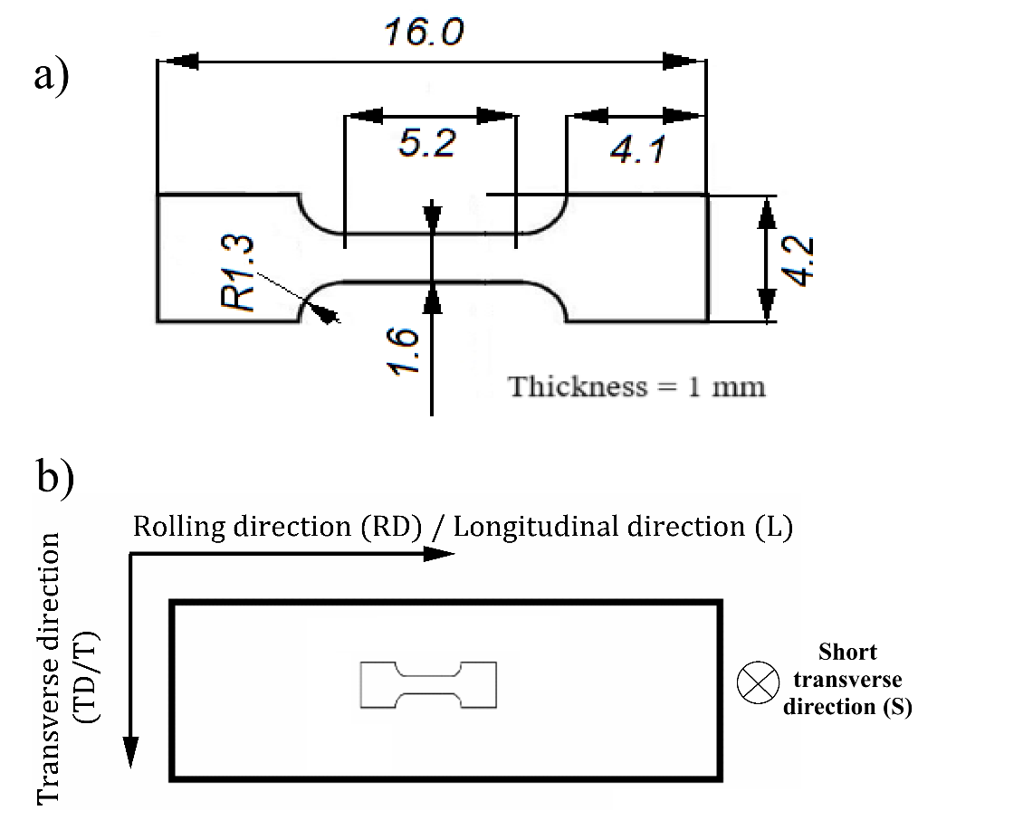
Figure 1: a) Schematics of subminiaturized flat tensile specimens, dimensions are given in mm; b) Specimen orientation relative to the rolling direction.
Tensile tests were performed in air over a temperature range of 250 ℃ - 550 ℃ to investigate the onset of ductility in tungsten, which is known to exhibit a ductile to brittle transition temperature (DBTT) in this temperature interval for this orientation [27]. This range was selected to capture the transition from brittle to ductile behavior and to assess the influence of temperature on the strain rate sensitivity. For each temperature and strain rate combination, two to four repetitions were conducted to increase statistical reliability and to account for potential variability in specimen preparation or material heterogeneity.
A 5 kN load cell was used for all tests, and a preload of 100 N, around 62.5 MPa for nominal dimensions, was applied to ensure proper alignment of the specimen and to eliminate gaps in the loading train before testing. The tests were carried out at constant displacement rates of 0.2, 2, and 20 mm/min, corresponding to nominal strain rates of 6.4 × 10⁻⁴ s⁻¹, 6.4 × 10⁻³ s⁻¹, and 6.4 × 10⁻² s⁻¹, respectively. These strain rates were chosen to span a range of quasi static loading conditions, allowing for the evaluation of strain rate effects.
To minimize the measurement uncertainty, the testing bench was calibrated and qualified according to ASTM standards prior to the experiments. The load was recorded using a strain gauge-based load cell, while displacement was measured via the actuator, corresponding to the piston movement. Although this method does not directly measure strain within the gauge section, the engineering curves are corrected considering the machine compliance.
The mechanical properties were defined as follows: the yield strength (YS) was determined at 0.2% plastic strain offset from the linear elastic region, and the ultimate tensile strength (UTS) is the maximum engineering stress. Due to the inconsistent appearance of the yield point phenomenon in the investigated tungsten grades, the stress at 2% plastic strain, which will be referred as σ_{2%} throughout the text, was used to evaluate strain rate sensitivity, rather than the conventional YS. This approach provides a more consistent metric for comparing material behavior across different strain rates and temperatures. Ductility was characterized by means of uniform elongation, total elongation, and reduction of area.
The reference stress σ_{2%} was used to determine the strain rate sensitivity for each material and temperature. The strain rate sensitivity (m) is defined as [28]:
 | $m=\frac{∂ln(σ)}{∂ln(\dot{ε})}$, | Eq (1)
where σ is the stress (taken at 2% plastic strain) and $\dot{ε}$ is the nominal strain rate. In order to determine m, the flow stress of continuous stress–strain curves, at different strain rates, is taken at the same selected plastic strain of 2% [15]. If the plastic deformation is assisted by a thermally activated process, it is possible to identify the rate-controlling mechanism of plastic deformation by determining the activation volume, v*, that can be written as a function of the strain rate sensitivity as [29]:
 | $v^{*}=\frac{k_{B}T}{σm}$ , | Eq (2)
where k_{B} is the Boltzmann constant, T is the absolute temperature and σ_{2%} is taken as σ.
The specimen dimensions before and after testing were measured using an optical projector, in accordance with ASTM guidelines. This ensured accurate determination of elongation and reduction of area, which are critical for assessing ductility. Fracture surfaces were examined using scanning electron microscopy (SEM; JEOL-6610LV) at an accelerating voltage of 15 kV, spot size of 50 nm with secondary electron detector, and a working distance of 15 mm. The characterization focused on identifying features such as cleavage facets, cracks, and intergranular fracture patterns, which provide insight into the dominant deformation and fracture modes under different testing conditions.
Electron backscatter diffraction (EBSD) analysis is performed to study the grain geometry with the goal to explore the relationship between tensile properties and microstructure. The EBSD data is analyzed through TSL OIM Analysis 8 software and a lower limit of 15° is used to define high angle grain boundaries, ND inverse pole figures are presented. The grain morphology, aspect ratio of elongated grains and equivalent diameters are reported.

Results and discussion

Tensile testing
Representative engineering stress–strain curves for tests performed at all test temperatures and strain rates are presented in Figure 2, including only tests exhibiting some degree of ductility. The YS and UTS of both pure tungsten grades increase with increasing strain rate and with decreasing temperature. The uniform elongation is reduced at higher temperatures, with very early necking at 550 ℃ for the lowest strain rate. Additionally, for any given temperature-strain rate pair, ATW exhibits a higher YS and UTS compared to IGW.
Figure 2: Representative stress–strain curves obtained from tensile tests performed at all studied temperatures and strain rates.
At 250 ℃, the materials exhibit decreasing ductility with increasing strain rates, Figure 3 shows the variation of the uniform elongation as a function of strain rate, being fully brittle at the highest test rate (not shown in Figure 2). A major decrease of the resistance to plastic localization takes place with increasing strain rate at 250 ℃. This reduction is associated with the presence of a more pronounced yield drop phenomenon at higher strain rates, leading to an early localization of the plastic strain as reported by [30]. Furthermore, this effect is more evident for ATW which is expected to have a higher content of impurities, in particular carbon, as shown in Table 1. In the tests conducted at 400 ℃ and 550 ℃, the uniform elongation increases with increasing strain rate. This last trend is explained by the equilibrium between the multiplication and annihilation of dislocations: a higher rate of multiplication at higher strain rates leads to a higher steady state dislocation density [31], associated to a lower apparent strain hardening capacity.
Figure 3: Strain rate dependency of the uniform elongation for (a) IGW and (b) ATW. Crosses indicate purely brittle fracture of the material.

The strain rate sensitivity defined by equation (1) is graphically represented as the slope of the curves plotting representing the σ_{2%} strength versus strain rate as shown in Figure 4. Figure 5 shows the strain rate sensitivity, m, as a function temperature for both materials, and gives the 95% confidence band for ITER specification W. The strain rate sensitivity decreases, in this range of conditions, which is consistent with trends reported earlier in the literature for W and molybdenum (Mo, another refractory BCC metal) [11,32]. In particular, this pure W grade from literature exhibits some degree of ductility at temperatures as low as 200 ℃. This difference can be attributed to a different thermomechanical process that is imposed to W to enhance ductility at low temperatures. These results are in accordance with reported trends for the 200 ℃ to 700 ℃ temperature range [10,11,13].
Figure 4: Strain rate dependence of the flow stress at 2% plastic deformation for (a) IGW and (b) ATW. The slope of the fitting lines represents the strain rate sensitivity at a given temperature.
Figure 5: Temperature dependence of strain rate sensitivity for both ITER specification W grades and reported literature values for W and Mo [11,32].

Figure 6 illustrates the strain rate dependency of the reduction of area, determined by measuring the final cross-section area of the specimen using an optical projector. At 250 ℃, the reduction of area drops to zero at the highest strain rate, which is another indication for the transition from ductile to purely brittle fracture. For both materials, the reduction of area increases with increasing temperature, and there is a slight decrease of the reduction of area or no dependance with strain rate, suggesting that the accumulation of damage in the necking region of the specimen did not significantly change with increasing strain rate.
Figure 6: Strain rate dependency of area reduction for (a) IGW and (b) ATW. Crosses indicate brittle fracture of the specimen.
Table 2 and Table 3 gather all data on the reduction of area, uniform elongation and total elongation for IGW and ATW, respectively. In addition to the previously discussed trends for uniform elongation (Figure 3) and reduction of area (Figure 6), the total elongation of both tungsten grades exhibits some differences. At 250 °C, both materials show a decrease in total elongation with increasing strain rate, ultimately reaching zero plastic strain at the highest strain rate. This behavior indicates a transition from ductile to brittle fracture. However, the decrease is more pronounced in the case of IGW. At 400 °C, IGW does not display a clear trend with increasing strain rate, whereas ATW shows an increase in total elongation as the strain rate rises. Finally, at 550 °C, both materials demonstrate an increase of total elongation with increasing strain rate.
Table 2:Summary of total elongation, reduction of area at fracture, and uniform elongation for every temperature-strain rate test pair condition for IGW.
Temperature [℃] | Nominal strain rate [1/s] | Average total elongation [%] | Average reduction of area at fracture [%] | Average uniform elongation [%]
250 | 6.4 × 10⁻⁴ | 15.5 | 12.7 | 6.8
250 | 6.4 × 10⁻³ | 9 | 6.5 | 4.7
250 | 6.4 × 10⁻² | BRITTLE | BRITTLE | BRITTLE
400 | 6.4 × 10⁻⁴ | 24.5 | 35.7 | 5.3
400 | 6.4 × 10⁻³ | 24.5 | 36.5 | 6.9
400 | 6.4 × 10⁻² | 22.8 | 28 | 7.7
550 | 6.4 × 10⁻⁴ | 22.7 | 55 | 1.5
550 | 6.4 × 10⁻³ | 22.8 | 46.5 | 3
550 | 6.4 × 10⁻² | 28.2 | 51.3 | 5.8

Table 3: Summary of total elongation, reduction of area at fracture, and uniform elongation for every temperature-strain rate test pair condition for ATW.
Temperature [℃] | Nominal strain rate [1/s] | Average total elongation [%] | Average reduction of area at fracture [%] | Average uniform elongation [%]
250 | 6.4 × 10⁻⁴ | 17.5 | 15 | 5.4
250 | 6.4 × 10⁻³ | 16 | 12 | 0.5
250 | 6.4 × 10⁻² | BRITTLE | BRITTLE | BRITTLE
400 | 6.4 × 10⁻⁴ | 24 | 41 | 4.2
400 | 6.4 × 10⁻³ | 27.8 | 45.5 | 5.8
400 | 6.4 × 10⁻² | 30.3 | 44 | 6.1
550 | 6.4 × 10⁻⁴ | 21.5 | 60 | 0
550 | 6.4 × 10⁻³ | 20 | 60 | 0.5
550 | 6.4 × 10⁻² | 26.3 | 49.5 | 4.3

The temperature dependence of the activation volume, calculated with equation (2), is shown in Figure 7 normalized by the cube of the Burger’s vector, with b = 0.274 nm [29] and compared to data available in the literature.
Figure 7: Temperature dependence of the activation volume for ITER specification W, pure W from literature [10,11] and W-1%Re from [10].
The activation volume is around 10 b³ at the relatively small plastic deformation of 2% at 250 ℃. This magnitude of the activation volume is consistent with a kink pair formation mechanism activating the screw dislocation slip in BCC metals near the ductile to brittle transition temperature [29]. With increasing temperature, the activation volume increases for the entire test window. This trend is consistent with literature for pure tungsten. In particular, IGW follows the values reported for a similar material produced by A.L.M.T. [11]. With increasing temperature, the activation volume rises over 100 b³. This suggests a transition of the plastic deformation mechanism from kink pair formation to dislocation-dislocation depinning, where the entire locked dislocation segment must unlock to active the slip. The mean spacing between the pinning points would correspond to the mean free path of dislocations given by $\frac{1}{\sqrt{ρ\text{0}}}$ where ρ₀ is the dislocation density. Taking a dislocation density equal to 1 × 10¹³ m⁻² which is typical for rolled tungsten [33], the dislocation spacing is about 300 nm. The activation volume of 175 b³ corresponds to a spacing of about 50 nm (assuming dislocation line cross-section to be b²). To get a better agreement, the dislocation density should be close to 4 × 10¹⁴ 1/m², which is much higher than that reported in the literature of (2-8) × 10¹² 1/m² [33]. Nevertheless, there are other defects interacting with the dislocations besides dislocations themselves, such as interstitial impurities and grain boundaries which contribute to the pinning of dislocation as well. The difference between the two materials studied in this work could be attributed to the presence of interstitial elements which would also interfere dislocation movement. The higher concentration of impurities in ATW tungsten would mean that, at high temperature, the pinning due to these impurities would reduce the effective activation volume since they localize the stress field, making dislocation movement more difficult.

Electron microscopy

Fracture surfaces
Scanning electron microscopy micrographs displaying a selection of fracture surfaces of IGW and ATW are presented in Figure 8 and Figure 9, respectively.
At 250 ℃, the fracture surfaces corresponding the lowest strain rate tests exhibit both intergranular and transgranular features in approximately equal shares as well as a few secondary cracks, these features are all present on the detail shown on Figure 10. These features indicate a moderate grain boundary failure resistance [16]. Even though the fracture surface exhibits only brittle features, the corresponding tensile curves reveal some degree of ductility at this temperature for the two lowest strain rates (Figure 2), even presenting some non-negligible necking, as shown in Figure 6.
At 400 ℃, the materials exhibit a fracture mechanism different than at 250 ℃. Additionally, variation of the strain rate led to changes on the fracture surface of the materials. Figure 11 presents details of the IGW fracture surfaces, from different specimens than the ones used for Figure 8. When tested at a strain rate of 6.4 × 10⁻⁴, IGW exhibits knife edge necking of individual grains, and with one main macro crack. At the highest test rate, 6.4 × 10⁻² s⁻¹, the material exhibits a distributed and homogeneous pattern without a main crack and with the presence of cleavage regions, signaling that, at this strain rate and temperature, the conditions are not satisfied for the cracks to coalesce into one main crack. The presence of cleavage regions could be related to the crack propagating through some of the larger grains of the material, since the measured mean equivalent diameter of this region is about 100 μm, which is consistent with the size of large grains in commercial tungsten grades [16,34,35]. Regarding ATW, the fracture surfaces show a homogeneous parallel knife edge pattern with a clear grain boundary detachment path for both strain rate extremes. These observations support the hypothesis that some microstructural features like the sub-grain size, or the steady state dislocation density, are interfering with the different content and distribution of interstitial elements for both materials. Thus, the difference in behavior that is found at this temperature could be associated with these minor alloying elements and their interaction with the dislocations and grain boundaries during plastic deformation. Additionally, the brittle features detected at 400 ℃ and 6.4 × 10⁻² s⁻¹ together with a sharper decrease of the reduction of area with strain rate at 250 ℃, as evidenced in Figure 11 and Figure 6 respectively may be an indication of IGW having a slightly higher DBTT than ATW which does not exhibit these features.
At 550 ℃, all fractures surfaces show a considerable reduction of area and a similar parallel knife edge necking fracture pattern. The patterns and features on these fractographies are typically found on commercially available tungsten products, like plates or rods, when undergoing ductile fracture [11,16]. Since the tests were performed parallel to the rolling direction, the grains become thinner with an increase of the aspect ratio length/width, this could lead to stress generated in the direction perpendicular to the load and to the detachment of the grain boundaries.
 | 6.4 × 10⁻⁴ s⁻¹ | 6.4 × 10⁻² s⁻¹
250 ℃ | 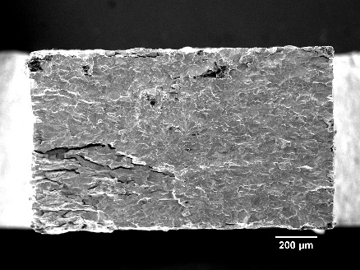
400 ℃ | 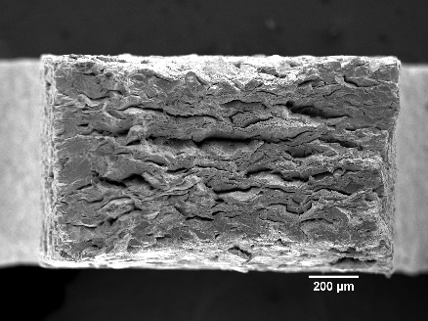 | 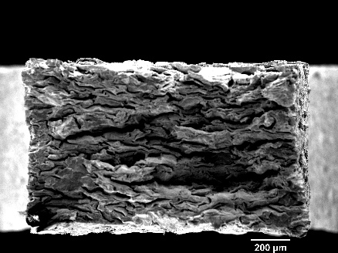
550 ℃ |  | 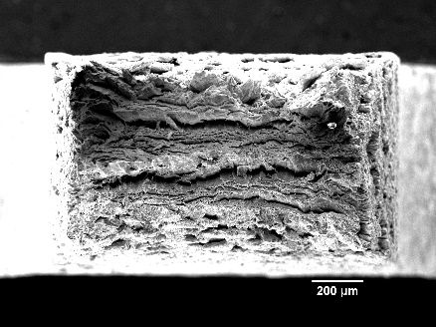

Figure 8: IGW fracture surfaces corresponding to all test temperatures at the lowest and highest strain rates presented in this work.

 | 6.4 × 10⁻⁴ s⁻¹ | 6.4 × 10⁻² s⁻¹
250 ℃ | 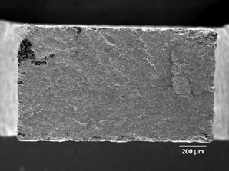
400 ℃ | 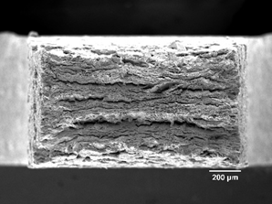 | 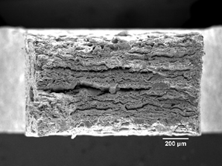
550 ℃ | 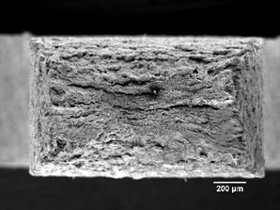 | 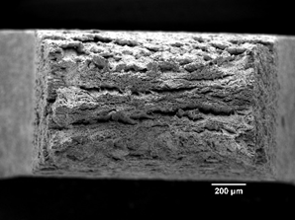

Figure 9: ATW fracture surfaces corresponding to all test temperatures at the lowest and highest strain rates presented in this work.

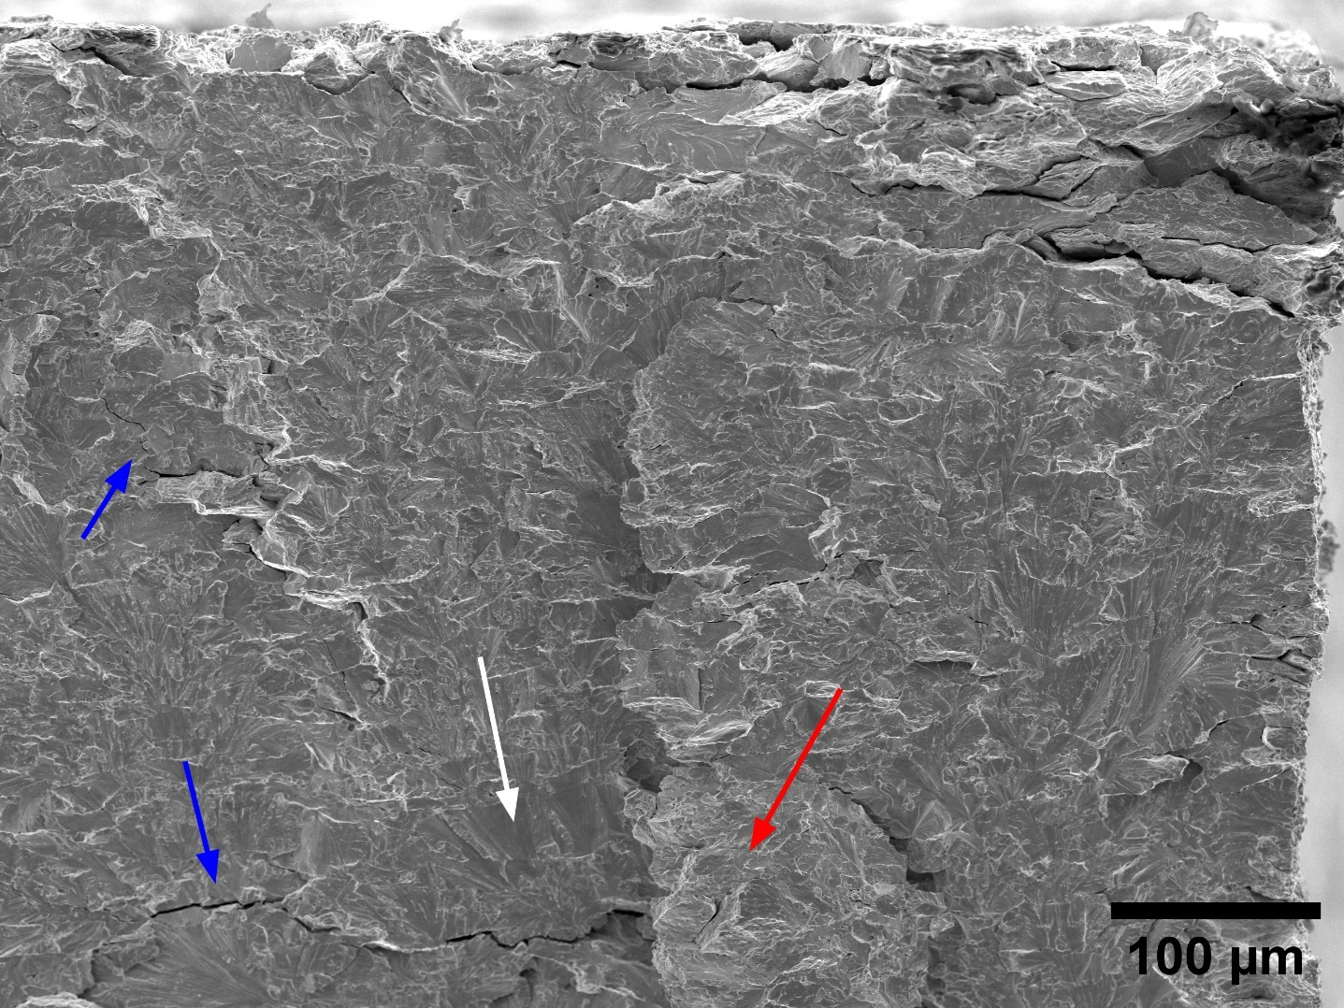
Figure 10: Detail of the fracture surface of an ATW specimen tested at 250 ℃ with a strain rate of 6.4 × 10⁻⁴ s⁻¹. The blue arrows indicate secondary cracks, while the white and red arrows indicate transgranular and intergranular fracture features, respectively.
Figure 11: Detail of two fracture surfaces of IGW tested at 400 ℃ with two different strain rates. a) specimen tested at 6.4 × 10⁻⁴ s⁻¹ exhibits a parallel knife edge necking pattern while b) when tested at 6.4 × 10⁻² s⁻¹ shows transgranular features, red circles, and non-parallel cracks.

Electron backscatter diffraction
Figure 12 shows the initial microstructure presented through inverse pole figure maps of IGW and ATW, Additionally, Table 4 gathers information on the equivalent grain diameter, namely the median value (D50) as well as the 10th and the 90th percentiles of the distribution (D10 and D90, respectively), alongside the median aspect ratio, defined as the ratio of the short axis over the long axis of the grains. Additionally, the fraction of low angle grain boundaries (LAGB, misorientation angle: 2°-15°), and the LAGB density are calculated. This analysis reveals that the grains have a similar pancake-like shape for IGW and ATW. Nevertheless, there is a small difference in grain size, with ATW having smaller grains throughout the entire distribution. Regarding the aspect ratio, both plates show a similar short to long axis relation, which is consistent with similar manufacturing routes. These results highlight the similar microstructure of both materials at this scale, indicating that the differences on mechanical response have to be related to differences at a lower scale. The LAGB density is slightly higher for the IGW material, this is consistent with previously reported values for IGW [36] and ATW [37], and may suggest a marginally higher degree of deformation in IGW relative to ATW. The LAGB fraction follows a similar trend, with IGW exhibiting a slightly higher proportion of low-angle boundaries compared to ATW, further supporting the notion of a more deformed substructure in the former. In this context, the slightly higher LAGB density observed in IGW provides an additional population of internal barriers to dislocation motion. Nevertheless, the mechanical differences at elevated temperature are consistent with ATW’s higher impurity content reducing the effective activation volume despite its slightly lower LAGB density, indicating that impurity related pinning becomes more influential than subgrain boundary related barriers in this temperature range.
IGW | ATW
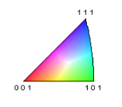
Figure 12: ND inverse pole figures of IGW and ATW.
Table 4: Grain sizes, grain aspect ratio, low angle grain boundary density and low angle boundary fraction of IGW and ATW based on the IPFs shown on Figure 12.
Material | IGW | ATW
D10 [μm] | 17.4 | 16.7
D50 [μm] | 93.7 | 76.9
D90 [μm] | 182.9 | 174.3
Aspect ratio | 0.39 | 0.38
LAGB fraction | 0.626 | 0.550
LAGB density [1/ μm] | 0.52 | 0.4

Conclusions
The strain rate dependency of the tensile properties of two W grades IGW and ATW was studied in the temperature range 250 ℃ to 550 ℃ and strain rate range from 6.4 × 10⁻⁴ to 6.4 × 10⁻² s⁻¹. The main findings of this work are:
- The strength of both pure tungsten grades increases with increasing strain rate and decreasing temperature. The strain rate sensitivity (m) decreases with increasing temperature, the ATW grade is slightly more sensitive to the strain rate than IGW at 400 ℃ and above. This difference in sensitivity is attributed to the higher amount of interstitial impurities that interact with the dislocations during plastic deformation.
- At 250 ℃, the materials show decreasing ductility at higher strain rates, being brittle at the highest rate. The fracture surfaces at the lowest strain rate exhibit both intergranular and transgranular patterns as well as the presence of secondary cracks.
- At 400 ℃, the uniform elongation increases with increasing strain rate for both grades, while the reduction of area at fracture shows opposite trends with strain rate: it decreases for IGW, and it increases for ATW. At the lowest strain rate, both materials show knife edge necking of individual grains with one main macro crack. At the highest strain rate, the IGW grade exhibits more brittle features than the ATW grade. This variability is attributed to microstructural differences between the two materials.
- At 550 ℃, as the strain rate increases, the uniform elongation increases and the reduction of area decreases, while remaining considerable. All studied fracture surfaces show a similar parallel knife edge necking fracture pattern.
- At 250 ℃, both materials exhibit a transition from ductile to brittle fracture in the strain rate range from 6.4 × 10⁻³ s⁻¹ to 6.4 × 10⁻² s⁻¹. The IGW grade shows a sharper decrease of ductility compared to ATW when increasing the strain rate at this temperature. Additionally, IGW shows some brittle features on the fracture surface after testing at 400 ℃ and 6.4 × 10⁻² s⁻¹ while this is not the case for ATW. This hints that this transition happens at a slightly higher temperature for IGW than for ATW for a given strain rate.
- Based on the mechanistic theory of plasticity driven by activation of screw dislocation motion, the activation volume is estimated to be around 10 b³ at 250 ℃ (consistent with reported kink pair formation at RT), and it increases with temperature for the whole tested range indicating a transition of the main mechanism behind the plastic deformation to dislocation-dislocation interactions. Additionally, ATW exhibits a smaller activation volume than IGW, this is presumably attributed to the interaction of interstitial elements with the dislocations.
These results highlight the influence of the initial microstructure and of the content of impurities on the tensile properties of pure tungsten, both being determined by the production route of the commercially available plates. The results should not be extrapolated to higher temperatures, where the strain rate sensitivity is expected to raise significantly the closer to the melting temperature. Additionally, in the quest to better predict the performance of tungsten under fusion conditions, it is necessary to perform tests at strain rates similar to those expected under transient events like edge dislocation modes.

Acknowledgements
This work has been carried out within the framework of the EUROfusion Consortium, funded by the European Union via the Euratom Research and Training Programme (Grant Agreement No. 101052200— EUROfusion). Views and opinions expressed are however those of the author(s) only and do not necessarily reflect those of the European Union or the European Commission. Neither the European Union nor the European Commission can be held responsible for them.

References
[1] R.A. Pitts, A. Loarte, T. Wauters, M. Dubrov, Y. Gribov, F. Köchl, A. Pshenov, Y. Zhang, J. Artola, X. Bonnin, L. Chen, M. Lehnen, K. Schmid, R. Ding, H. Frerichs, R. Futtersack, X. Gong, G. Hagelaar, E. Hodille, J. Hobirk, S. Krat, D. Matveev, K. Paschalidis, J. Qian, S. Ratynskaia, T. Rizzi, V. Rozhansky, P. Tamain, P. Tolias, L. Zhang, W. Zhang, Plasma-wall interaction impact of the ITER re-baseline, Nuclear Materials and Energy 42 (2025) 101854. https://doi.org/10.1016/J.NME.2024.101854.
[2] R.A. Pitts, X. Bonnin, F. Escourbiac, H. Frerichs, J.P. Gunn, T. Hirai, A.S. Kukushkin, E. Kaveeva, M.A. Miller, D. Moulton, V. Rozhansky, I. Senichenkov, E. Sytova, O. Schmitz, P.C. Stangeby, G. De Temmerman, I. Veselova, S. Wiesen, Physics basis for the first ITER tungsten divertor, Nuclear Materials and Energy 20 (2019). https://doi.org/10.1016/j.nme.2019.100696.
[3] J.H. You, E. Visca, T. Barrett, B. Böswirth, F. Crescenzi, F. Domptail, M. Fursdon, F. Gallay, B.E. Ghidersa, H. Greuner, M. Li, A. V. Müller, J. Reiser, M. Richou, S. Roccella, C. Vorpahl, European divertor target concepts for DEMO: Design rationales and high heat flux performance, Nuclear Materials and Energy 16 (2018) 1–11. https://doi.org/10.1016/J.NME.2018.05.012.
[4] T.R. Barrett, G. Ellwood, G. Pérez, M. Kovari, M. Fursdon, F. Domptail, S. Kirk, S.C. McIntosh, S. Roberts, S. Zheng, L. V. Boccaccini, J.H. You, C. Bachmann, J. Reiser, M. Rieth, E. Visca, G. Mazzone, F. Arbeiter, P.K. Domalapally, Progress in the engineering design and assessment of the European DEMO first wall and divertor plasma facing components, Fusion Engineering and Design 109–111 (2016) 917–924. https://doi.org/10.1016/J.FUSENGDES.2016.01.052.
[5] G. Pintsuk, A. Hasegawa, Tungsten as a Plasma-Facing Material, in: Comprehensive Nuclear Materials: Second Edition, Elsevier, 2020: pp. 19–53. https://doi.org/10.1016/B978-0-12-803581-8.11696-0.
[6] T.L. Johnston, R.G. Davies, N.S. Stoloff, Slip character and the ductile to brittle transition of single-phase solids, Philosophical Magazine 12 (1965) 305–317. https://doi.org/10.1080/14786436508218873.
[7] E. Tarleton, S.G. Roberts, Dislocation dynamic modelling of the brittle–ductile transition in tungsten, Philosophical Magazine 89 (2009) 2759–2769. https://doi.org/10.1080/14786430902992619.
[8] M. Wirtz, J. Linke, T. Loewenhoff, G. Pintsuk, I. Uytdenhouwen, Thermal shock tests to qualify different tungsten grades as plasma facing material, Phys. Scr. T167 (2016) 014015. https://doi.org/10.1088/0031-8949/T167/1/014015.
[9] I. Uytdenhouwen, Degradation of first wall materials under ITER relevant loading conditions, 2011. https://biblio.ugent.be/publication/4336949 (accessed July 18, 2025).
[10] P.L. Raffo, Yielding and fracture in tungsten and tungsten-rhenium alloys, Journal of the Less Common Metals 17 (1969) 133–149. https://doi.org/10.1016/0022-5088(69)90047-2.
[11] K. Sasaki, K. Yabuuchi, S. Nogami, A. Hasegawa, Effects of temperature and strain rate on the tensile properties of potassium-doped tungsten, Journal of Nuclear Materials 461 (2015) 357–364. https://doi.org/10.1016/j.jnucmat.2015.03.015.
[12] B.D. Beake, A.J. Harris, J. Moghal, D.E.J. Armstrong, Temperature dependence of strain rate sensitivity, indentation size effects and pile-up in polycrystalline tungsten from 25 to 950 °C, Mater. Des. 156 (2018) 278–286. https://doi.org/10.1016/j.matdes.2018.06.063.
[13] D. Brunner, V. Glebovsky, Analysis of flow-stress measurements of high-purity tungsten single crystals, Mater. Lett. 44 (2000) 144–152. https://doi.org/10.1016/S0167-577X(00)00017-3.
[14] M. Fursdon, J.H. You, M. Li, Towards reliable design-by-analysis for divertor plasma facing components – Guidelines for inelastic assessment (part 1: Unirradiated), Fusion Engineering and Design 147 (2019). https://doi.org/10.1016/j.fusengdes.2019.06.007.
[15] W.F. Hosford, Mechanical Behavior of Materials, Cambridge University Press, 2009. https://doi.org/10.1017/CBO9780511810923.
[16] C. Yin, D. Terentyev, T. Pardoen, A. Bakaeva, R. Petrov, S. Antusch, M. Rieth, M. Vilémová, J. Matějíček, T. Zhang, Tensile properties of baseline and advanced tungsten grades for fusion applications, Int. J. Refract. Metals Hard Mater. 75 (2018) 153–162. https://doi.org/10.1016/j.ijrmhm.2018.04.003.
[17] M. Fukuda, S. Nogami, A. Hasegawa, H. Usami, K. Yabuuchi, T. Muroga, Tensile properties of K-doped W-3%Re, in: Fusion Engineering and Design, Elsevier Ltd, 2014: pp. 1033–1036. https://doi.org/10.1016/j.fusengdes.2014.02.062.
[18] M. Fukuda, T. Tabata, A. Hasegawa, S. Nogami, T. Muroga, Strain rate dependence of tensile properties of tungsten alloys for plasma-facing components in fusion reactors, Fusion Engineering and Design 109–111 (2016) 1674–1677. https://doi.org/10.1016/j.fusengdes.2015.10.032.
[19] C. Yin, D. Terentyev, A. Dubinko, T. Zhang, M. Wirtz, S. Antusch, R.H. Petrov, T. Pardoen, Impact of neutron irradiation on hardening of baseline and advanced tungsten grades and its link to initial microstructure, Nuclear Fusion 61 (2021) 066012. https://doi.org/10.1088/1741-4326/abf417.
[20] M. Fukuda, Y. Seki, K. Ezato, K. Yokoyama, H. Nishi, S. Suzuki, T. Hirai, Performance evaluation of tungsten for ITER divertor toward mass production, Fusion Engineering and Design 167 (2021). https://doi.org/10.1016/j.fusengdes.2021.112283.
[21] Test Methods for Tension Testing of Metallic Materials, (2024). https://doi.org/10.1520/E0008_E0008M-24.
[22] P. Jung, A. Hishinuma, G.E. Lucas, H. Ullmaier, Recommendation of miniaturized techniques for mechanical testing of fusion materials in an intense neutron source, Journal of Nuclear Materials 232 (1996) 186–205. https://doi.org/10.1016/S0022-3115(96)00394-7.
[23] A. Kohyama, K. Hamada, H. Matsui, Specimen size effects on tensile properties of neutron-irradiated steels, Journal of Nuclear Materials 179–181 (1991) 417–420. https://doi.org/10.1016/0022-3115(91)90113-L.
[24] D. Terentyev, C.C. Chang, C. Yin, A. Zinovev, X.F. He, Neutron irradiation effects on mechanical properties of ITER specification tungsten, Tungsten 3 (2021) 415–433. https://doi.org/10.1007/s42864-021-00105-6.
[25] C. Yin, G. Bonny, D. Terentyev, Anisotropy in the hardness of single crystal tungsten before and after neutron irradiation, Journal of Nuclear Materials 546 (2021). https://doi.org/10.1016/j.jnucmat.2020.152759.
[26] A. Bakaev, D. Terentyev, A. Zinovev, C.-C. Chang, C. Yin, V.A. Bakaev, E.E. Zhurkin, Application of sub-miniaturized bending tests to extract tensile properties from neutron-irradiated metallic alloys, Journal of Nuclear Materials 558 (2022) 153320. https://doi.org/10.1016/j.jnucmat.2021.153320.
[27] C. Yin, D. Terentyev, T. Zhang, S. Nogami, S. Antusch, C.C. Chang, R.H. Petrov, T. Pardoen, Ductile to brittle transition temperature of advanced tungsten alloys for nuclear fusion applications deduced by miniaturized three-point bending tests, Int. J. Refract. Metals Hard Mater. 95 (2021). https://doi.org/10.1016/j.ijrmhm.2020.105464.
[28] Q. Wei, S. Cheng, K.T. Ramesh, E. Ma, Effect of nanocrystalline and ultrafine grain sizes on the strain rate sensitivity and activation volume: fcc versus bcc metals, Materials Science and Engineering: A 381 (2004) 71–79. https://doi.org/10.1016/j.msea.2004.03.064.
[29] Q. Wei, L.J. Kecskes, Effect of low-temperature rolling on the tensile behavior of commercially pure tungsten, Materials Science and Engineering: A 491 (2008) 62–69. https://doi.org/10.1016/j.msea.2008.01.013.
[30] M. Scapin, L. Peroni, C. Torregrosa, A. Perillo-Marcone, M. Calviani, Effect of Strain-Rate and Temperature on Mechanical Response of Pure Tungsten, Journal of Dynamic Behavior of Materials 5 (2019) 296–308. https://doi.org/10.1007/s40870-019-00221-y.
[31] H. Fan, Q. Wang, J.A. El-Awady, D. Raabe, M. Zaiser, Strain rate dependency of dislocation plasticity, Nat. Commun. 12 (2021) 1845. https://doi.org/10.1038/s41467-021-21939-1.
[32] R.P. Carreker, R.W. Guard, Tensile Deformation of Molybdenum as a function of Temperature and Strain Rate, JOM 8 (1956) 178–184. https://doi.org/10.1007/BF03377669.
[33] A. Dubinko, C. Yin, D. Terentyev, A. Zinovev, M. Rieth, S. Antusch, M. Vilémová, J. Matějíček, T. Zhang, Plastic deformation in advanced tungsten-based alloys for fusion applications studied by mechanical testing and TEM, Int. J. Refract. Metals Hard Mater. 95 (2021) 105409. https://doi.org/10.1016/J.IJRMHM.2020.105409.
[34] D. Terentyev, C. Yin, A. Dubinko, C.C. Chang, J.H. You, Neutron irradiation hardening across ITER diverter tungsten armor, Int. J. Refract. Metals Hard Mater. 95 (2021). https://doi.org/10.1016/j.ijrmhm.2020.105437.
[35] D. Terentyev, C.C. Chang, C. Yin, A. Zinovev, X.F. He, Neutron irradiation effects on mechanical properties of ITER specification tungsten, Tungsten 3 (2021) 415–433. https://doi.org/10.1007/s42864-021-00105-6.
[36] D. Terentyev, C. Yin, C.C. Chang, Z. Chen, S. Mao, M. Ye, Anisotropy in tensile properties of ITER-conformant and cross-rolled tungsten grades, Fusion Engineering and Design 222 (2026) 115457. https://doi.org/10.1016/j.fusengdes.2025.115457.
[37] C. Yin, D. Terentyev, T. Zhang, S. Nogami, S. Antusch, C.C. Chang, R.H. Petrov, T. Pardoen, Ductile to brittle transition temperature of advanced tungsten alloys for nuclear fusion applications deduced by miniaturized three-point bending tests, Int. J. Refract. Metals Hard Mater. 95 (2021). https://doi.org/10.1016/j.ijrmhm.2020.105464.

