Contrast-enhanced microfocus computed tomography of body parts and organs: screening and validation of contrast agents
Delia Hoffmann^{1,2}, Sarah Vangrunderbeeck^{1,3,4}, Louis Maistriaux⁵, Karem Tohala Pulgarin^{1,2,6}, Lies Fievé⁵, Jérôme Duisit^{5,7,8}, Benoît Lengelé^{5,8}, Catherine Behets⁵, Greet Kerckhofs^{1,4,6,9}
¹ Prometheus, Division of Skeletal Tissue Engineering, KU Leuven, Leuven, Belgium
² Skeletal Biology and Engineering Research Center, KU Leuven, Leuven, Belgium
³ Molecular Design and Synthesis, Department of Chemistry, KU Leuven, Leuven, Belgium
⁴ Biomechanics lab, Institute of Mechanics, Materials and Civil Engineering, UCLouvain, Louvain-la-Neuve, Belgium
⁵ Pole of Morphology, Institute of Experimental and Clinical Research, UCLouvain, Brussels, Belgium
⁶ 2IP Imaging Platform, Institute of Experimental and Clinical Research, UCLouvain, Brussels, Belgium
⁷ Pole of Experimental Surgery and Transplantation, Institute of Experimental and Clinical Research, UCLouvain, Brussels, Belgium
⁸ Department of Plastic and Reconstructive Surgery, Cliniques Universitaires Saint-Luc, Brussels, Belgium
⁹ Department Materials Engineering, KU Leuven, Leuven, Belgium

The gold standard for visualizing soft biological tissue components at the micro-scale, like parenchyma, extracellular matrix or vasculature, is tissue sectioning with subsequent immunohistochemical or colorimetric staining and microscopic evaluation (i.e. histology). This technique has a high discriminative power, but loses the three-dimensional (3D) information of the tissue. Also, the tissue treatment is highly time-consuming, especially for bone because it needs to be decalcified. In the research field of tissue engineering and regenerative medicine, it is essential to analyze the 3D distribution of the different tissue substructures and therefore to maintain the integrity of the biological tissues. As non-invasive imaging technique, microfocus X-ray computed tomography (microCT) is a promising solution to study whole tissues. It has been well-established for mineralized tissues, like bone. Unfortunately, soft tissues with poor X-ray absorbance remain invisible. Therefore, increasing effort is done to develop X-ray attenuating staining agents that visualize soft tissues in addition to mineralized tissues.
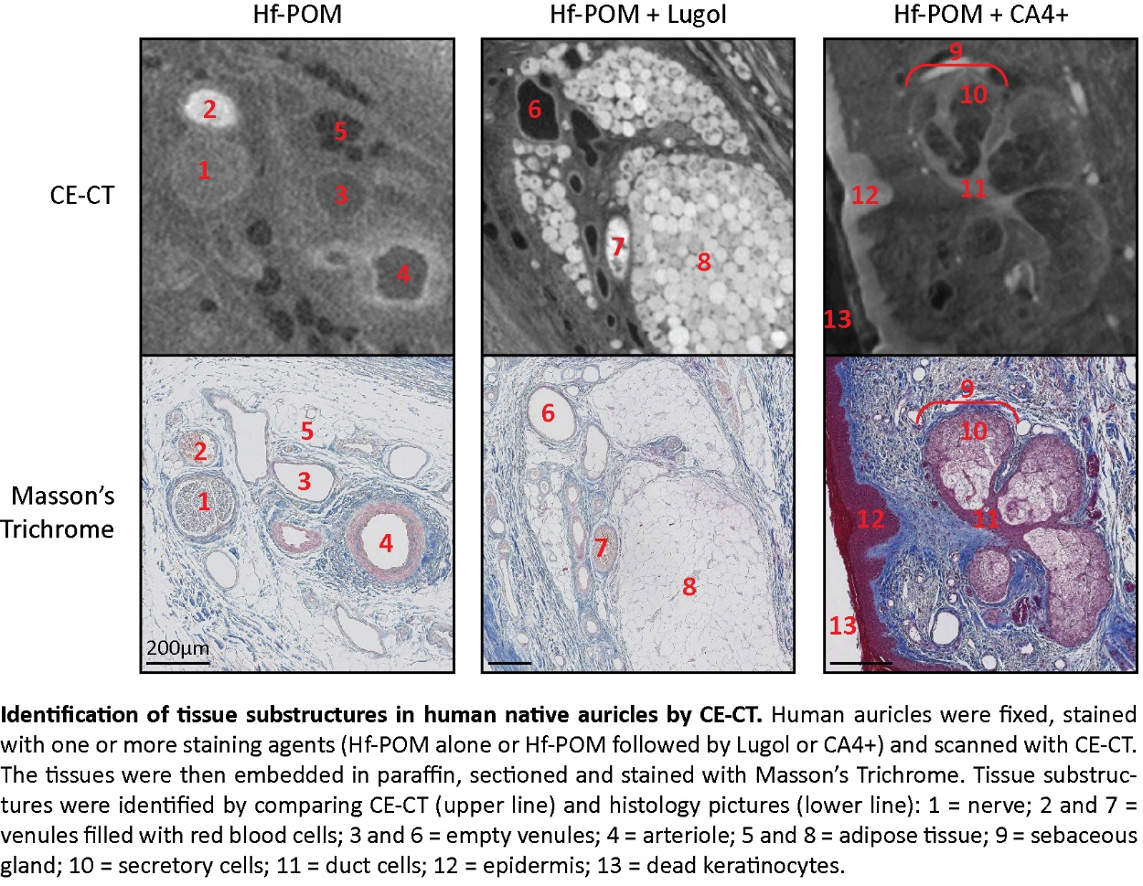
In this study, we screened and validated previously described staining agents for contrast-enhanced microCT (CE-CT) for their potential to stain and to discriminate different tissue substructures in human and animal body parts and organs. After dissection, the tissues were fixed with formaldehyde, incubated with Hafnium-substituted Wells-Dawson polyoxometalate (Hf-POM), cationic iodinated contrast agent CA4+ and/or Lugol’s iodine, and scanned with CE-CT. The tissues were then embedded in paraffin and sections were colored with Masson’s trichrome. We compared CE-CT images and corresponding histological sections to identify tissue substructures stained by these staining agents. In human auricles, the three staining agents contrasted blood vessels, epidermis, dermis, sebaceous glands, hair follicles and nerves. Fat cells could be easily identified because of a negative staining by Hf-POM in contrast to intensive staining by Lugol’s iodine. Both staining agents highlighted collagen fibers in the extracellular matrix, and Hf-POM contrasted elastic fibers in the aorta. In the murine esophagus, we could identify all subtissue layers (stratified squamous epithelium, lamina propria, muscularis mucosae, submucosa, muscularis externa). In the human and piglet spleen, red pulp could be distinguished from white pulp and in murine lungs, we could follow the branching from the bronchioles up to individual alveoli. Interestingly, the different staining agents contrasted the subtissues in different ways, allowing us to decipher the binding mechanisms in future studies. Taken together, CE-CT is a promising technique for 3D virtual histology of biological tissues, and more specifically (biopsies of) whole body parts and full organs. Compared to standard histology, it is less destructive and the tissue treatment is less time-consuming, and the resolution goes down into the micrometer range. Moreover, 3D analysis of the images will allow us to get better insights in spatial distribution and interrelationship of the different subtissues (work in progress).

