Photophysical Characterization of New Osmium (II)
Photocatalysts for Hydrohalic Acid Splitting
Sara A. M. Wehlin,‡, † Ludovic Troian-Gautier,‡, ⊥, † Andrew B. Maurer,‡ M. Kyle Brennaman,‡ Gerald J. Meyer‡*
‡Department of Chemistry, University of North Carolina at Chapel Hill, Chapel Hill, North Carolina, 27599-3290, United States
⊥Laboratoire de Chimie Organique, Université Libre de Bruxelles (ULB), CP 160/06, 50 avenue F.D. Roosevelt, B-1050 Brussels, Belgium.
† These authors contributed equally

ABSTRACT. Two osmium(II) photocatalysts bearing a dicationic 4,4’-bis-(trimethylaminomethyl)-2,2′-bipyridine (tmam) ligand and 2,2’-bipyridine ([Os(bpy)₂(tmam)]⁴⁺) or 4,4’-(CF₃)₂-2,2’-bipyridine ([Os((CF₃)₂bpy)₂(tmam)]⁴⁺) ancillary ligands were synthesized and characterized for applications in HX splitting. Iodide titration studies in acetone solutions provided evidence for an in situ formed terionic complex with two iodide ions as evidenced by ¹H NMR and UV-visible absorption spectroscopies, as well as by Density Functional Theory (DFT) calculations and Natural Bond Order (NBO) analysis. The photocatalyst [Os(bpy)₂(tmam)]⁴⁺ was shown to be inefficient at iodide oxidation. In contrast, visible light excitation of [Os((CF₃)₂bpy)₂(tmam)]⁴⁺ led to rapidiodide oxidation, k_{q} = 2.8 x10¹¹ M^{–1} s^{–1}. The data reveal that Os(II) photocatalysts can be fine-tuned for application in HX splitting.

INTRODUCTION
The photo-conversion of inexpensive feedstocks to high energy chemical fuels with solar photons continues to be an important goal with the potential for a very positive impact on society.¹⁻¹² Photocatalysis is also under active research as a method to generate new organic molecules useful as drugs or chemical reagents.¹³⁻²⁰ Molecular approaches to solar fuel production and organic synthesis have traditionally utilized Ru(II) and Ir(III) photocatalysts with low-lying metal-to-ligand charge transfer excited states. Little attention has been paid to Os(II) photocatalysis even though they provide greater spin-orbit coupling than analogous Ru(II) catalysts, and absorb light over wider spectral windows than both Ir(III) and Ru(II). Os(II) photocatalysts have also recently been reported for photochemical upconversion.²¹⁻²⁵ Here we report the synthesis and characterization of two novel Os(II) photocatalysts designed for applications in HX splitting, Scheme 1.

Scheme 1. Tetracationic Os(II) photocatalysts reported here for HI splitting bearing the di-cationic 4,4’-bis(trimethylaminomethyl)-2,2’-bipyridine (tmam) ligand. The photocatalysts are referred to as Os-CF₃ and Os-bpy throughout this manuscript.

Water splitting with hydrogen gas generation has attracted much attention, yet another promising target is HX splitting.^{3, 26-30} Both reactions produce hydrogen gas, but water is a net four electron transfer reaction while HX splitting necessitates only two, Equations 1 and 2.^{26, 31-34}

2 H₂O H₂ + O₂ (1)

2 HX H₂ + X₂ (2)

We have previously shown that highly charged Ru(II) cationic photocatalysts provide a means to overcome the Coulombic repulsion of the two halide ions in Equation 2.^{35, 36} Low dielectric constant solvents enhance ion-pairing and have led to interesting mechanism(s) of excited-state reactivity and photocatalysis. This approach has the potential to be very efficient for HX splitting as the X₂ product is neutral and has no Coulombic incentive to remain associated with the photocatalyst. Iodide is the most easily oxidized and polarizable of the stable halides and rapid excited-state reactivity has been reported even when the free energy change was near zero.³⁷ Nevertheless, the yields of solvated oxidized halide species remains very low ( < 5%) in these studies. The use of Os(II) may result in greater efficiency as the excited state has more triplet character and triplets are known to enhance the yield of separated charges after excited-state electron transfer relative to singlet excited states.³⁸⁻⁴²
Osmium photocatalysts are comparable to the corresponding ruthenium photocatalysts, yet are less potent oxidants.^{43, 42} The osmium photocatalysts are also expected to be less susceptible to ligand loss photochemistry as the anti-bonding ligand-field states are high in energy.⁴⁴ In polypyridyl photocatalysts, the osmium metal center is easier to oxidize than the ruthenium while the bipyridine-based reductions are almost unchanged.⁴⁵ This leads to a smaller energy gap in osmium photocatalysts. This smaller energy gap in osmium polypyridyl complexes is exemplified by the photoluminescence maximum of [Ru(bpy)₃]²⁺ at ~610 nm vs. 740 nm for [Os(bpy)₃]²⁺.⁴⁶ In addition, the enhanced spin-orbit coupling of the third row metal provides low energy absorption bands that have been assigned to singlet-to-triplet transitions. Enhanced visible light absorption and high photochemical stability represent a significant advantage for solar applications.
Here we report the synthesis and characterization of the tetracationic Os(II) photocatalysts shown in Scheme 1. The photocatalysts have MLCT excited-state lifetimes sufficient for diffusional excited-state electron transfer reactivity in fluid solution. A Franck-Condon line shape analysis of the low temperature photoluminescence spectra, as well as traditional Stark spectroscopy were utilized to characterize the excited states. It follows that osmium excited-states store less free energy, and thus are less potent photo-oxidants. Iodide titration studies provided compelling evidence that the photocatalysts formed terionic complexes with two iodide ions in acetone solution. The photocatalyst with unsubstituted 2,2’-bipyridine ancillary ligands, Os-bpy, did not undergo excited-state reactivity while Os-CF₃, which was specifically designed to localize the excited-state on the ancillary ligands photo-oxidized iodide rapidly. The strategy of preorganization of ground-state reactants with photocatalysts is shown to be a useful strategy for efficient photocatalysis with the short excited-state lifetime of osmium(II) photocatalysts that may be exploited in future studies with applications in solar energy conversion and organic synthesis.

EXPERIMENTAL
Materials. Acetone (Burdick and Jackson, 99.98 %) and acetonitrile (Burdick and Jackson, 99.9%) were used as received. Argon gas (Airgas, 99.998 %) was passed through a Drierite drying tube before use. Tetrabutylammonium iodide (TBAI, Sigma-Aldrich, ≥ 99.0 %), tetrabutylammonium hexafluorophosphate (TBAPF₆, Sigma-Aldrich, for electrochemical analysis, ≥ 98 %), were used as received. Deuterated acetone was purchased from Cambridge Isotope Laboratories, Inc. 4,4’-bis(trifluoro)-2,2’-bipyridine⁴⁷ (CF₃bpy) and 4,4’-bis-(trimethylaminomethyl)-2,2′-bipyridine⁴⁸ (tmam) were synthesized according to reported protocols. All other chemicals were used as received from commercial distributors with a minimum purity level of 98 %. All solutions were purged with argon for at least 30 minutes before all electrochemical, photoluminescence and titrations experiments.
Nuclear Magnetic Resonance. Characteristic NMR spectra and halide titration experiments were obtained at room temperature on a Bruker Advance III 600 MHz spectrometer equipped with a broadband inverse (BBI) probe. Solvent residual peaks were used as internal standards for ¹H (δ =2.05 ppm for (CD₃)₂CO) and δ = 3.31 ppm for CD₃OD) chemical shift referencing. NMR spectra were processed using MNOVA software.
Electrospray Ionization Mass Spectrometry (ESI-MS). Samples were analyzed with a Q Exactive HF-X (ThermoFisher, Bremen, Germany) mass spectrometer. Samples were introduced via a heated electrospray source (HESI) at a flow rate of 10 µL/min. One hundred time domain transients were averaged in the mass spectrum. HESI source conditions were set as: nebulizer temperature 100 deg C, sheath gas (nitrogen) 15 arb, auxillary gas (nitrogen) 5 arb, sweep gas (nitrogen) 0 arb, capillary temperature 250 degrees C, RF voltage 100 V. The mass range was set to 200-2000 m/z. All measurements were recorded at a resolution setting of 120,000. Solutions were analyzed at 0.1 mg/mL or less based on responsiveness to the ESI mechanism. Xcalibur (ThermoFisher, Breman, Germany) was used to analyze the data. Molecular formula assignments were determined with Molecular Formula Calculator (v 1.2.3).
UV-Visible Absorption. UV−Vis absorption spectra were recorded on a Varian Cary 60 UV−Vis spectrophotometer with a resolution of 1 nm. The molar absorption coefficient of the two complexes was determined by diluting a stock solution of osmium complex and represent averages of at least three independent measurements.
Steady-State Photoluminescence. Room temperature steady state photoluminescence (PL) spectra were recorded on an Edinburgh FLS920 fluorescence spectrophotometer using a 450 W xenon arc lamp as the excitation source and a photomultiplier tube (Hamamatsu 2658P) as the detector. The photoluminescence intensity was integrated for 0.3 s at 1 nm resolution and averaged over three scans. All PL spectra were corrected by calibration of each instrument’s spectral response with a standard tungsten-halogen lamp. The PL quantum yield, Ф_{PL}, was measured by comparative actinometry using [Os(bpy)₃]²⁺.2PF₆– in acetonitrile (Φ = 0.00462) as a quantum yield standard.⁴⁹
Temperature control during 77K photoluminescence measurements was maintained by using a Janis Dual Reservoir VPF system with four-way fused quartz windows. Both 77K spectra were obtained in butyronitrile glasses. The resulting photoluminescence spectra were fit to a single-mode Franck-Condon lineshape analysis, as described previously.^{36, 50} The fit was performed in Wolfram Mathematica 11, using a Levenberg-Marquardt least squares error minimization method.
Time-Resolved Photoluminescence. Time-resolved PL data were collected on a FLS920 spectrophotometer by time- correlated single-photon-counting (TCSPC). Excitation light pulses at 484 nm were produced by using a diode laser (Edinburgh Instruments EPL- 485; 93 ps full-width at half-maximum pulse width) operated at 2 MHz (0.122 ns/point). The spectral bandwidth of the emission monochromator was set to 20 nm. A 630 nm, long-pass filter was used after the sample to eliminate scatter and second-order grating effects.
Time-resolved PL data were also acquired on a nitrogen dye laser with excitation centered at 445 nm, as described previously.⁵¹ Pulsed light excitation was achieved with a Photon Technology International (PTI) GL-301 dye laser that was pumped by a PTI GL-3300 nitrogen laser. The PL was detected by a Hamamatsu R928 PMT optically coupled to a ScienceTech Model 9010 monochromator terminated into a LeCroy Waverunner LT322 oscilloscope. Decays were monitored at the photoluminescence maximum and averaged over 180 scans.
Non-radiative and radiative rate constants were calculated from the quantum yields, Ф_{PL} = k_{r}/(k_{r} + k_{nr}) and lifetimes, τ = 1/(k_{r} + k_{nr}).
Electrochemistry. Cyclic voltammetry/square wave voltammetry was performed with a BASi Epsilon potentiostat in a standard three-electrode-cell, i.e. a platinum working electrode, platinum counter electrode and a non-aqueous silver/silver chloride (Pine) reference electrode that was referenced to an external ferrocene (Fe(Cp)₂, +650 mV vs NHE)⁵² standard. Experiments were performed in 0.1 M TBAClO₄ acetone electrolyte.
Halide Titrations. Iodide titration experiments were performed in acetone with approximately 10 μM of the osmium photocatalyst with a UV-Vis spectroscopic assay. Stock solutions were prepared such that approximately 0.3 equivalents of tetrabutylammonium iodide (TBAI) was titrated before recording each spectrum while maintaining a constant photocatalyst concentration. Time-resolved and steady-state PL titration experiments were performed in the same manner, but were purged with argon for 30 minutes prior to the photoluminescence assay.
The ¹H NMR titrations were performed using Bruker Avance III 600 MHz spectrometer equipped with a broadband inverse (BBI) probe using 600 µL of a 500 µM [Os(LL)₂(tmam)]⁴⁺(PF₆–)₄ solution in deuterated acetone. Titration was performed by 0.25 equivalent additions of TBAI (10 µL additions). Each spectrum was averaged over 32 scans and was not corrected for dilution.
Equilibrium Constants. Equilibrium constants were determined by plotting the absorbance change (ΔAbs) as a function of the iodide concentration. The data were fit to a 1:2 stoichiometry expression.⁵³
$$∆Abs= \frac{ε_{∆Os:I}K_{1}{[Os]}_{0}\left[I^{–}\right]+ ε_{∆Os:2I}{K_{1}K}_{2}{[Os]}_{0}{[I^{–}]}^{2}}{1+K_{1}\left[I^{–}\right]+ K_{1}K_{2}{{[I}^{–}]}^{2}}$$
Transient Absorption Spectroscopy. Nanosecond transient absorption measurements were acquired with 532 nm light excitation on a previously described apparatus with an instrument response function of 10 ns.⁵⁴-⁵⁶
Stark Spectroscopy. Stark spectra were obtained through the use of a previously published apparatus.^{57, 58} Briefly, a 150 W xenon arc lamp was passed through a monochromator (McPherson 272) and focused on a 1 cm² sample area. Highly concentrated samples, ~3 mM, were placed in a thin path length optical cell and submerged in liquid nitrogen to form a glass. One side of the optical cell was oscillated at 2900 Hz between +1.5 kV and –1.5 kV to generate an oscillating electric field across the sample. The oscillating signal was processed by a lock-in amplifier (SRS 530), an oscilloscope (LeCroy Wavesurfer 3054), and in-house LabView software. An average of 10⁶ data points per wavelength at a 1 nm step width were collected.
Relevant electronic parameters of the dipole moment change, ∆µ, and the angle of the dipole moment change vector with respect to the transition dipole moment, ζ were determined through the use of Monte Carlo simulations using a Levenberg-Marquardt least squares minimization method with modulation of each variable. Values were visualized by plotting the extinction coefficient change (∆ε), obtained directly from experiment, as a function of wavenumber. The data were fit to a standard 2-state model Liptay Formalism, as described in Equation 3.⁵⁹⁻⁶¹
$Δε=F^{2}\left[A_{χ}ε+B_{χ}\frac{d(ε)}{dν}+C_{χ}\frac{d^{2}(ε)}{dν^{2}}\right]$ (3)

Theoretical Calculations. Density Functional Theory (DFT) calculations were carried out using the Gaussian 09 program package, while applying default algorithms and parameters.⁶² First, the ground state (singlet) structures of two osmium complexes with zero, one and two iodide anions located at the positions indicated by ¹H NMR, were optimized to their minimum energy. In all calculations, the B3LYP functional was used,⁶³⁻⁶⁶ with the LANL2DZ basis set⁶⁷⁻⁶⁹ with an added f-polarization function applied to osmium, cc-PVDZ-PP with an added f-polarization function applied to iodide,⁷⁰ and 6-311G* applied to all other elements.⁷¹ The harmonic vibrational frequencies were calculated for each osmium complex, with all combinations of no iodide or iodide present, with the same level of calculation and by confirming no contribution from negative frequencies, it was confirmed that the resulting structures correlated to true minima of the potential energy surface.
Second-order perturbations analysis of intermolecular interactions of natural atomic charges used for Coulombic work term calculations were performed with the NBO 3 program, as implemented in the Gaussian program package. The resulting Cartesian coordinates of all atoms in the structures and their associated charges were analyzed using a Coulomb’s law expression and visualized using Wolfram Mathematica 11.
Synthesis of [Os((CF₃)₂bpy)₂Cl₂]. 4,4’-bis(trifluoro)-2,2’-bipyridine (382 mg, 1.31 mmol) and ammonium hexachloroosmate (274 mg, 0.62 mmol) were suspended in a microwave tube containing 8.5 mL of argon sparged ethylene glycol. The reaction mixture was heated under microwave irradiation to reach 200 °C in 3 minutes and was held at this temperature for 30 minutes. After cooling, 20 mL of a 1M Na₂S₂O₄ aqueous solution was added and the mixture was cooled for 30 minutes in an ice bath. The solution was then filtered and the precipitate was washed with water to remove impurities and with hexane to remove excess of unreacted ligand. The final product, [Os((CF₃)₂bpy)₂Cl₂] was obtained as a black-purple microcrystalline solid. The complex was used without further purification.
Synthesis of [Os(bpy)₂Cl₂]. 2,2’-bipyridine (747 mg, 4.8 mmol) and ammonium hexachloroosmate (1.0 g, 2.3 mmol) were suspended in 40 mL or argon sparged ethylene glycol. The reaction mixture was heated to reflux for one hour under argon. After reaction, the mixture was cooled to room temperature and 40 mL of a saturated Na₂S₂O₄ aqueous solution was added. The mixture was cooled in an ice bath for 30 minutes prior to being filtered. The precipitate was washed with water and diethylether. The final product, [Os(bpy)₂Cl₂] was obtained as a black-purple microcrystalline solid. The complex was used without further purification.
Synthesis of [Os(bpy)₂(tmam)]⁴⁺(PF₆–)₄. [Os(bpy)₂Cl₂] (100mg, 0.174 mmol) and tmam.2PF₆⁻ (103 mg, 0.174 mmol) were combined with 15 mL of an EtOH/H₂O 1:1 mixture in an ACE tube. The mixture was purged with argon for 30 minutes after which the tube was sealed and the reaction was heated at 120°C for 48 hours. After reaction, the mixture was brought to room temperature and evaporated under reduced pressure. The residue was dissolved in methanol and filtered on a 0.2 µm syringe filter. The filtrate was concentrated under reduced pressure and purified by size exclusion LH20 column chromatography using MeOH as eluent. The desired fraction was collected and evaporated under reduced pressure. The residue was finally dissolved in water and precipitated by the addition of a saturated NH₄PF₆ aqueous solution. The precipitate was filtered, washed with water and diethyl ether to yield a brown solid (185mg, 79%). ¹H NMR (600 MHz, Acetone-d₆): δ 8.94 (s, 2H), 8.81 (t, J = 7.6 Hz, 4H), 8.25 (d, J = 6.0 Hz, 2H), 8.09 – 8.03 (m, 4H), 7.97 (d, J = 5.6 Hz, 2H), 7.91 (d, J = 5.6 Hz, 2H), 7.71 (dd, J = 6.0, 1.8 Hz, 2H), 7.55 – 7.51 (m, 2H), 7.46 – 7.42 (m, 2H), 4.89 (s, 4H), 3.40 (s, 18H). ¹³C NMR (600 MHz, Acetone-d₆) δ 161.32, 159.62, 159.56, 152.74, 152.59, 151.67, 138.82, 137.68, 132.95, 129.56, 129.34, 129.31, 125.54, 67.71, 53.91. HRMS (ESI-MS) m/z: [M-(2PF₆)]²⁺ Calcd for C₃₈H₄₄N₈P₂F₁₂Os 547.12937; Found 547.12610.
Synthesis of [Os((CF₃)₂bpy)₂(tmam)]⁴⁺(PF₆–)₄. [Os((CF₃)₂bpy)₂Cl₂] (100mg, 0.118 mmol) and tmam.2PF₆⁻ (70 mg, 0.118 mmol) were combined with 15 mL of an EtOH/H₂O 1:1 mixture in an ACE tube. The mixture was purged with argon for 30 minutes after which the tube was sealed and the reaction was heated at 120°C for 3 days. After reaction, the mixture was brought to room temperature and evaporated under reduced pressure. The residue was dissolved in methanol and filtered on a 0.2 µm syringe filter. The filtrate was concentrated under reduced pressure and purified by size exclusion LH20 column chromatography using MeOH as eluent. The desired fraction was collected and evaporated under reduced pressure. The residue was finally dissolved in water and precipitated by the addition of a saturated NH₄PF₆ aqueous solution. The precipitate was filtered, washed with water and diethyl ether to yield a brown solid (70mg, 36%).¹H NMR (600 MHz, Acetone-d₆) δ 9.44 (d, J = 7.4 Hz, 4H), 8.99 (s, 2H), 8.44 (d, J = 6.1 Hz, 2H), 8.36 (d, J = 6.0 Hz, 2H), 8.31 (d, J = 5.9 Hz, 2H), 7.75 (m, J = 5.0 Hz, 6H), 4.90 (s, 4H), 3.40 (s, 18H). ¹³C NMR (600 MHz, Acetone-d₆) δ 161.16, 160.81, 160,26, 154.44, 153.51, 139. 45, 133.18, 129.68, 122.75, 67.56, 54.00. HRMS (ESI-MS) m/z: [M-(PF₆)]⁺ Calcd for C₄₂H₄₀N₈P₂F₂₄Os 683.10414; Found 683.09993.

RESULTS AND DISCUSSION
Figure 1. Synthetic routes to obtain [Os(CF₃bpy)₂(tmam)]⁴⁺ and [Os(bpy)₂(tmam)]⁴⁺.
The synthesis of [Os(LL)₂(tmam)]⁴⁺ photocatalysts, where tmam is 4,4’-bis-(trimethylaminomethyl)-2,2′-bipyridine and LL is 2,2′-bipyridine (bpy) or 4,4′-(CF₃)₂-2,2′-bipyridine (CF₃), is shown in Figure 1. [OsCl₆]^{2–} was reacted with 2,2′-bipyridine or 4,4′-(CF₃)₂-2,2′-bipyridine in ethylene glycol at 200°C to yield the corresponding [Os(LL)₂(Cl)₂] complexes. These were then reacted with tmam in EtOH/water mixtures to yield the final complexes. The final products were purified by size exclusion (LH20) column chromatography and precipitated as the hexafluorophosphate (PF₆⁻) salts after ion metathesis.
The photophysical and photochemical properties of the complexes were characterized in argon purged acetonitrile and acetone. The absorption spectra of both complexes are shown in Figure 2. The intense bands (ε = 80,000-100,000 M^{–1} cm^{–1}) at ~290 nm were identified as ligand centered (LC) π-π* transitions, based on assignments reported on related osmium polypyridyl complexes.^{72, 73} Similarly, the absorption bands beyond ~400 nm were assigned as metal-to-ligand charge transfer (MLCT) bands.^{45, 72, 73} The MLCT transitions at 400-550 nm, with a molar extinction coefficient (ε ≈ 15,000 M^{–1}cm^{–1}), were assigned as spin allowed ¹MLCT transitions. The tailing absorption bands beyond 550 nm were assigned as singlet-to-triplet excitations.⁷² These formally spin forbidden transitions are expected to be more intense in osmium complexes than in ruthenium complexes due to increased spin orbit coupling.^{45, 72}
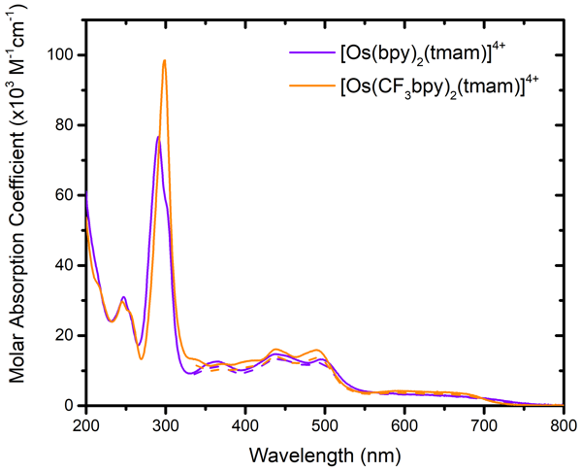
Figure 2. The UV-Vis absorption spectra of [Os(CF₃bpy)₂(tmam)]⁴⁺ (orange) and [Os(bpy)₂(tmam)]⁴⁺ (purple) in acetonitrile (solid) and acetone (dash).
Visible light excitation of either complex resulted in room temperature photoluminescence (PL) centered at 815 nm and 775 nm for Os-bpy and Os-CF₃ respectively. The electron-withdrawing trifluoromethyl substituents on the ancillary ligands of Os-CF₃ led to a 40 nm (~ 79 meV) hypsochromic shift of the PL compared to the unsubstituted 2,2’-bipyridine complex. Hence even though the π* levels of the 4,4′-(CF₃)₂-2,2′-bipyridine ligand are lower than that of bipyridine and the tmam ligand, the strong inductive effect of the four –CF₃ susbuituents on the Os^{III/II} potential resulted in a bue shofted PL maximum. The corresponding excited-state lifetimes were well described by a first-order kinetic model. These were relatively short, 68 and 54 ns for Os-bpy and Os-CF₃ respectively in argon purged acetone. Consequently, the non-radiative decay rate constants for the osmium complexes were relatively large (k_{nr} ~10⁷ s^{–1}) compared to related ruthenium complexes (k_{nr} ~ 10⁶ s^{–1}).⁷⁴⁻⁷⁶ The excited-state lifetimes, quantum yields, k_{r}, k_{nr} and other relevant photophysical data are gathered in Table 1.
A quasi-reversible redox wave assigned to the Os^{III/II} metal center was measured by cyclic and square wave voltammetry in 0.1 M tetrabutylammonium perchlorate (TBAClO₄) acetone electrolyte. The oxidations were centered at +1.28 and +1.10 V vs NHE for Os-CF₃ and Os-bpy, respectively. Notably, the potential measured for Os-bpy was ~ 500 meV less positive than the corresponding oxidation of [Ru(bpy)₂(tmam)]⁴⁺,³⁶ which agrees with previously published correlations.⁴⁵ The Os-CF₃ complex displayed a reversible E_{1/2}(Os^{n/n–1}) ligand-centered reduction at –0.62 V vs NHE. Scanning more negatively resulted in a broad, irreversible reduction wave which was assigned to the tmam ligand.^{36, 77} In the case of Os-bpy, a similarly broad, irreversible reduction wave was recorded at ~ –0.7 V vs NHE, which was used to estimate a first reduction potential for Os-bpy.

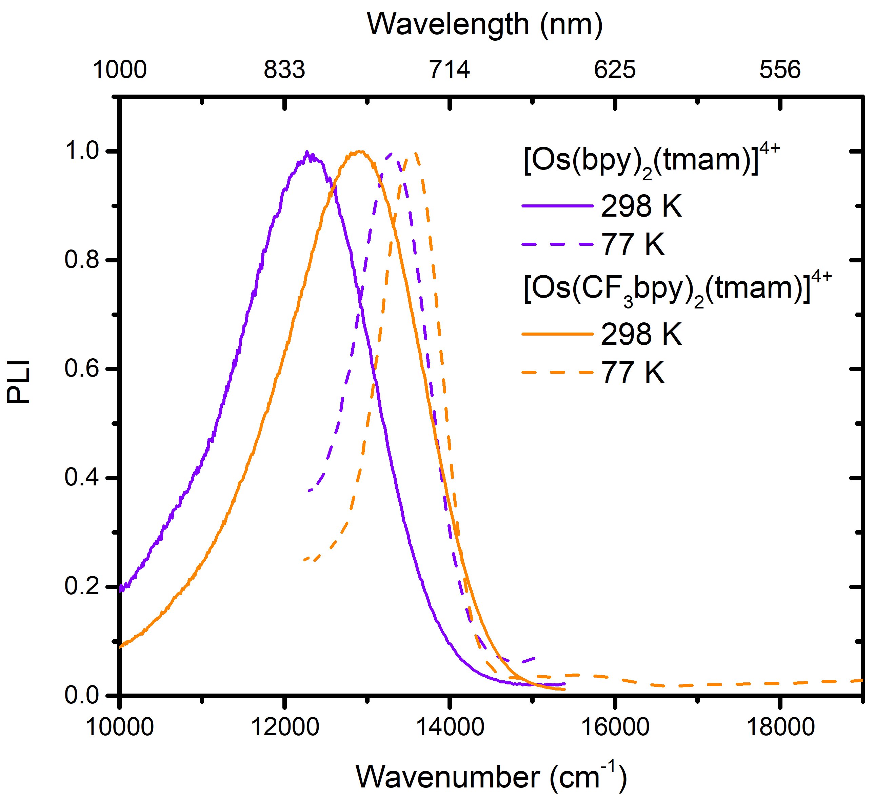
Figure 3. Photoluminescence spectra of [Os(CF₃bpy)₂(tmam)]⁴⁺ (orange) and [Os(bpy)₂(tmam)]⁴⁺ (purple) in acetone at room temperature (solid) and in butyronitrile at 77K (dash).
Table 1. Photophysical properties of the indicated osmium [PF₆–] complexes in acetone.
Complex | MLCT_{max}^{[a]} (ε)^{[b]} | PL_{max}^{[a]} | τ ^{[c]} | φ^{[d]} | k_{r} ^{[e]} | k_{nr} ^{[e]}
[Os(bpy)₂(tmam)]⁴⁺ | 439 (13,300), 493 (12,200) | 815 | 68 | 0.0014 | 6.8 x10⁴ | 1.9 x10⁷
[Os(CF₃bpy)₂(tmam)]⁴⁺ | 438 (14,100), 491 (13,700) | 775 | 54 | 0.0037 | 2.1 x10⁴ | 1.5 x10⁷
^{[a]} in nm. ^{[b]} Molar absorption coefficient in M^{–1} cm^{–1}. ^{[c]} Excited-state lifetime in ns, ±10%. ^{[d]} Quantum yield measured by comparative actinometry using [Os(bpy)₃]²⁺ φ = 0.00462 as reference.⁴⁹ ^{[e]} Radiative and non-radiative rate constants, s^{–1}.

Table 2. Relevant reduction potentials and ΔG_{ES} values for the indicated osmium [PF₆–] complexes.
Complex | E(Os^{5+/4+})^{[a]} | E(Os^{4+/3+})^{[a]} | E(Os^{3+/2+})^{[a]} | ΔG_{ES} (eV) ^{[b]} | E(Os^{4+*/3+})^{[a]}
[Os(bpy)₂(tmam)]⁴⁺ | +1.10 | ~ –0.7 | - | 1.73 | ~ 1.0
[Os(CF₃bpy)₂(tmam)]⁴⁺ | +1.28 | –0.62 | ~ –0.8 | 1.80 | 1.18
^{[a]} V vs NHE. ^{[b]} Determined from blue edge tangent straight line fit of room temperature PL spectra.
For heteroleptic photocatalysts with MLCT excited states, Blakley and DeArmond provided compelling evidence that the excited state localizes onto the most easily reduced ligand.⁷⁸ The electrochemical responses of the osmium complexes were suggestive of different excited-state localization. The first reduction supported the assignment of the Os-CF₃ excited-state localized on the 4,4’-(CF₃)₂-2,2’-bipyridine ligand and the formulation of the excited state as [Os^{III}(CF₃-bpy)(CF₃-bpy•–)(tmam)]^{4+*}. However, in the case of Os-bpy, the excited-state assignment was not as straightforward due to the irreversible electrochemistry. However, the 2,2’-bipyridine centered reduction in the related [Os^{III}(bpy)₃]²⁺ occurs 300 mV (–0.99 V vs NHE)⁷⁹ more negative than the one observed in the present case. Hence, this suggested the formulation of the excited state as [Os^{III}(bpy)₂(tmam•–)]^{4+*}.
These assignments were tested by Stark spectroscopy. Figure 4 provides the absorption spectra measured at 77K in butyronitrile. Both osmium complexes displayed typical MLCT absorption features with transition in the 550-750 nm region that corresponded to direct singlet-to-triplet MLCT transitions.^{80, 81} A large electric field (> 0.4 MV cm^{–1}) was then applied to generate the corresponding Stark spectra, Figure 4. As has been noted previously,⁵⁸ the low energy ‘triplet’ region is more pronounced and better resolved in the Stark spectra relative to the absorption spectra. When probed with polarized light, the Stark effect allowed determination of the charge transfer angle relative to the transition dipole moment which was closely aligned with the ground state dipole moment.⁸² For Os-CF₃, the lowest energy ¹MLCT transition had different intensities when a horizontally or vertically polarized probe beam was used. This was in contrast with Os-bpy where the same lowest energy ¹MLCT transition was independent of the polarization of the probe light, indicative of a transition closely in line with the ground-state dipole, or a transition towards the tmam ligand. The angle of the dipole moment change vector with respect to the transition dipole moment (ζ) and dipole moments (∆µ) for each of the three major bands in the Stark spectra are gathered in Table 3.
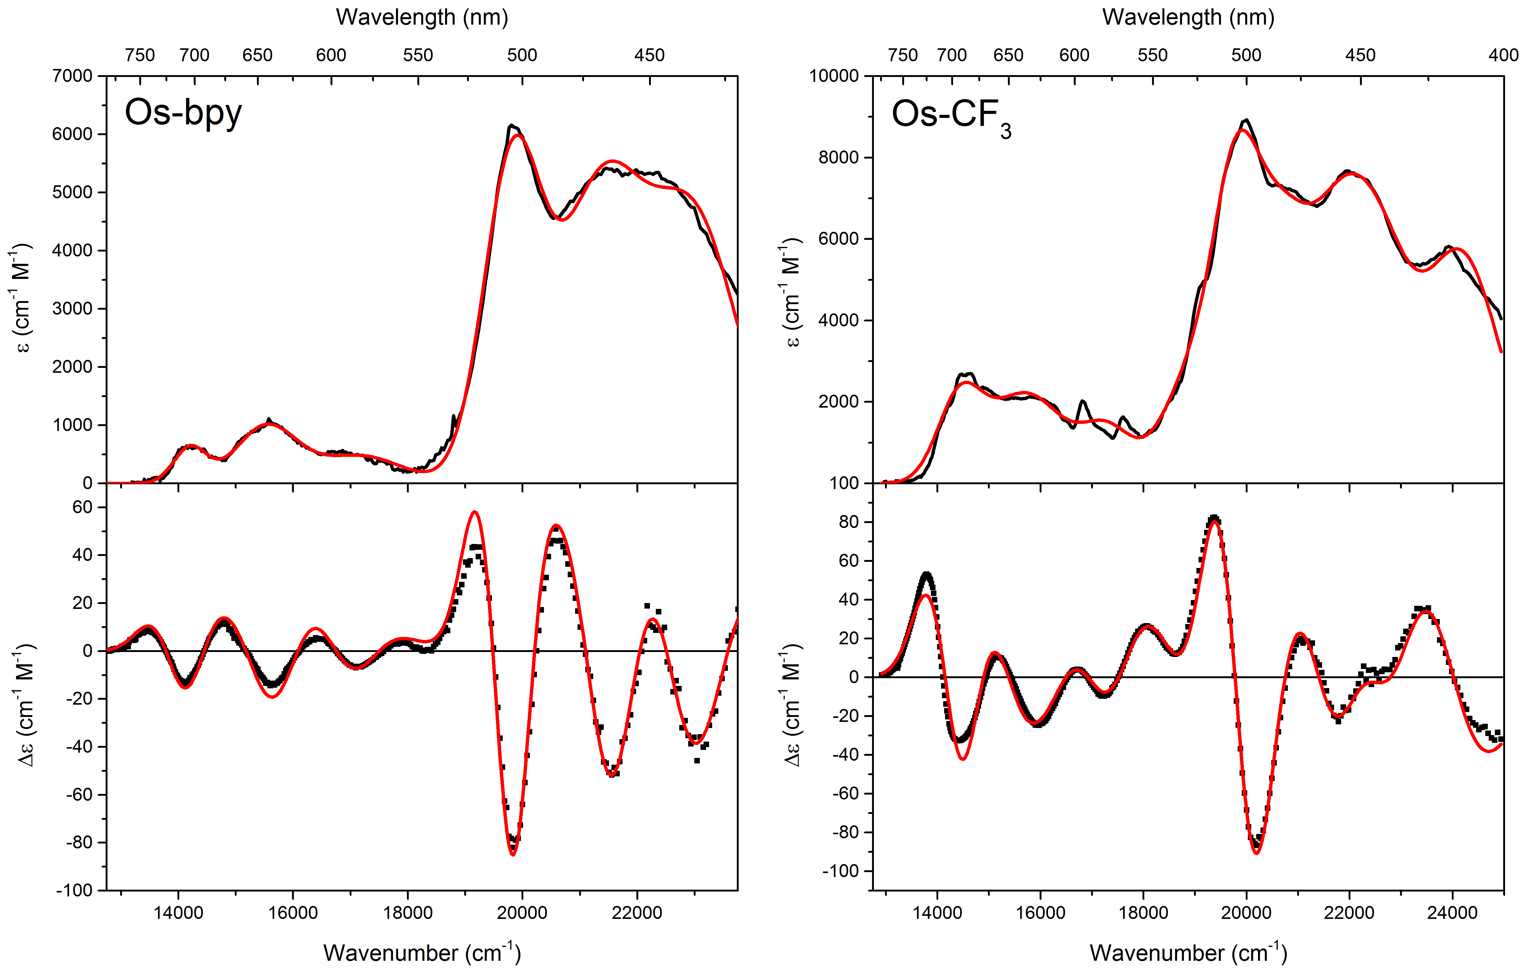
Figure 4. Absorption (top) and Stark (bottom) spectra (black, with overlaid fits in red) of [Os(bpy)₂(tmam)]⁴⁺ (left) and [Os((CF₃)₂bpy)₂(tmam)]⁴⁺ (right). All spectra were recorded in butyronitrile at 77K and scaled to an applied field of 1 MV cm^{–1}.
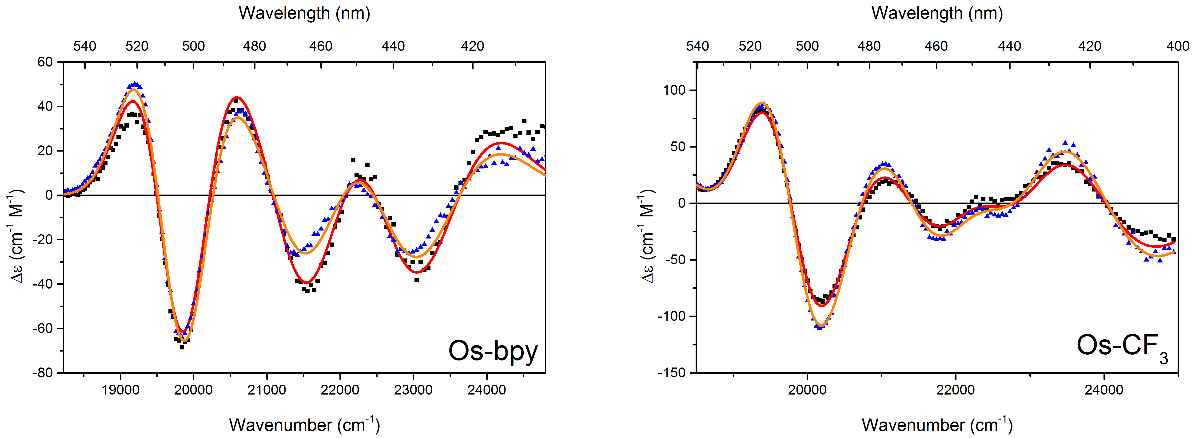
Figure 5. Stark spectra of [Os(bpy)₂(tmam)]⁴⁺ (left) and [Os((CF₃)₂bpy)₂(tmam)]⁴⁺ (right) recorded with horizontally (blue dots) and vertically (black dots) polarized light (corresponding fit as solid lines). All spectra were recorded in butyronitrile at 77K and scaled to an applied field of 1 MV cm^{–1}.

The dipole moment change extracted from the Stark spectroscopic data also provided valuable information on the character of the transitions and the excited-state electronic structure. The largest dipole moment change, i.e. 12.9 D, was measured for Os-CF₃. Dipole moment changes associated with Os-bpy were of smaller magnitude, i.e. ~10.5 D. These values are in agreement with the trends that would be expected based on substituents effects, as reported on prototypical ruthenium(II) substituted 2,2’bipyridine complexes.⁵⁷
Overall, the results obtained through Stark spectroscopy and electrochemistry were complementary in formulating an excited state localized on the 4,4’-(CF₃)₂-2,2’-bipyridine ligand for Os-CF₃ and on 4,4’-bis-(trimethylaminomethyl)-2,2′-bipyridine for Os-bpy.

Table 3. Changes in dipole moment (∆µ) and the angle between the dipole moment change vector and the transition dipole moment for selected transitions of the indicated Os(II) complexes.
Complex | Transition (cm^{–1}) | ζ (°) | ∆µ (D)
[Os(bpy)₂(tmam)]⁴⁺ | 19800 | 49 ± 12 | 7.8 ± 0.6
 | 21600 | 34 ± 9 | 10 ± 0.5
 | 22900 | 33 ± 6 | 11 ± 0.6
[Os(CF₃bpy)₂(tmam)]⁴⁺ | 20100 | 30 ± 8 | 12.9 ± 0.5
 | 21800 | 82 ± 7 | 9.2 ± 0.5
 | 22600 | 85 ± 7 | 8.2 ± 0.4

The excited-state reduction potential was determined for each photocatalyst from the measured ground-state reduction potentials: E_{1/2}(Os^{4+*/3+}) = E_{1/2}(Os^{4+/3+}) – ∆G_{ES}, where ΔG_{ES} is the free energy stored in the excited state.^{83, 84} The osmium photocatalysts are modest photooxidants with excited-state reduction potentials of E_{1/2}(Os^{4+*/3+}) = ~1.0 and 1.18 V vs NHE for Os-bpy and Os-CF₃, respectively. The relevant electrochemical and thermodynamic properties are gathered in Table 2.
Density Functional Theory (DFT) calculations were performed to gain insight into the charge distribution of the osmium (II) photocatalysts and their ability to form ion-pairs with iodide. The structures of both complexes, with and without iodide, were first optimized by DFT calculations and then natural bond order (NBO) analysis was performed on the optimized structures.⁸⁵⁻⁸⁷ A Coulomb’s law type expression given in Equation 4 was used to calculate the Gibbs free energy associated with ion-pairing.
$G_{w}=\frac{Z\left(I^{–}\right)Z\left({Os}^{4+}\right)e^{2}}{4πε_{0}ε_{r}a}$ (4)
In this equation e is the elementary charge, ε₀ is the vacuum permittivity, ε_{r} is the relative permittivity and a is the distance between the charged species. The Z(I–) term is the charge of the iodide anion and Z(Os⁴⁺) the charge of the tetracationic osmium complex, where the individual charges assigned to each atom were utilized, rather than an approximate spherical model with delocalized charge. Figure 6a provides a contour plot that highlights the very large free energy (~ 450 meV) of interaction between iodide and what has been termed a tmam binding “pocket”, that has previously been reported^{35, 48} and is described further below. The structures optimized with one iodide present in the tmam binding “pocket” highlight a large free energy (~ 300 meV) of interaction with a second iodide that associates closer to the osmium center as is shown in Figure 6b.
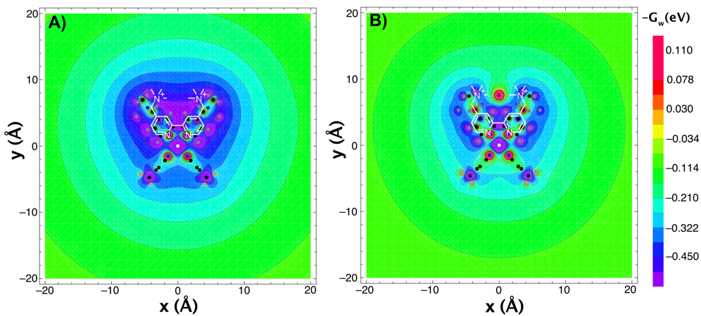
Figure 6. Contour plots Os-CF₃ showing the plane that contains the tmam ligand, describing the Coulombic free energy (in eV) experienced without (a) and with (b) an iodide anion present in the tmam pocket.
These DFT and NBO calculations were correlated with experimental results obtained through ¹H NMR spectroscopy. The atomic resolution provided by ¹H NMR confirmed the tmam ligand as the first binding site as evidenced by drastic shifts in the 3,3’ H atom resonance (~0.9 Δppm) of the bipyridine portion of the tmam ligand with small or no changes to the 3,3′-H resonances of the ancillary ligands, for Os-CF₃ and Os-bpy, respectively, Figure 7. The roofed-doublet pattern for the methylene H atoms that became apparent after 1 equivalent of iodide was added, has been previously reported and is fully consistent with the ion pairing imposing a more rigid configuration.³⁶ The shifts in the 3,3’ tmam resonances also saturate beyond 1-2 equivalents, while other resonances still shifted with increasing halide concentration. This further supports the hypothesis that the tmam pocket is the primary binding site. A second binding site, closer to the osmium metal center, was suggested by simultaneous shifts of the 5,5’ H atom resonances on the tmam ligand and the 6 and 5 H atoms resonances on the ancillary ligands. There was no spectroscopic experimental evidence that pointed towards the second iodide influencing the position of the first iodide within the tmam binding pocket. While higher order species could not be ruled out, the dominant species at high iodide concentration was consequently determined as a 1:2 ion pair; [Os⁴⁺:2I–]²⁺ termed a ‘terionic species”.
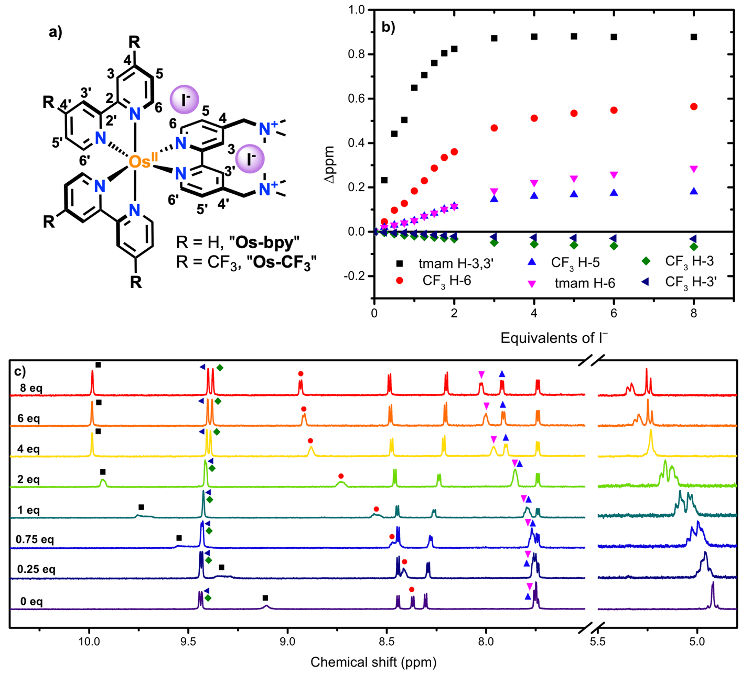
Figure 7. a) Proposed structure of the terionic complexes. b) The chemical shifts of indicated hydrogen atoms of Os-CF₃ plotted against the number of TBAI equivalents in d₆-acetone with up to 8 equivalents. c) ¹H NMR spectra of Os-CF₃ with 0 to 8 equivalents of TBAI in d₆-acetone showing both the aromatic region and methylene hydrogens of the tmam ligand.
Iodide also induced substantial shifts in the UV-Vis absorption spectra of the osmium photocatalysts. In the case of Os-CF₃, a decrease and minor red shifts of the MLCT absorption were observed and used to estimate the two stepwise equilibrium constants, K_{eq1} = 2 x10⁶ M^{–1} and K_{eq2} = 9 x10⁴ M^{–1} for the iodide ion pairs.^{53, 88} These equilibrium constants enabled determination of the mole fraction of all the species present during the iodide titration, Figure 8a. From DFT and NBO analysis, iodide stabilization in the tmam pocket was approximately 450 meV, or 43 kJ mol^{–1}, while the measured equilibrium constants provided approximately 35 and 28 kJ mol^{–1}. This discrepancy highlighted a tendency of the theoretical calculations to overestimate equilibrium constants for ion-pairing while using the Coulomb’s law approach.
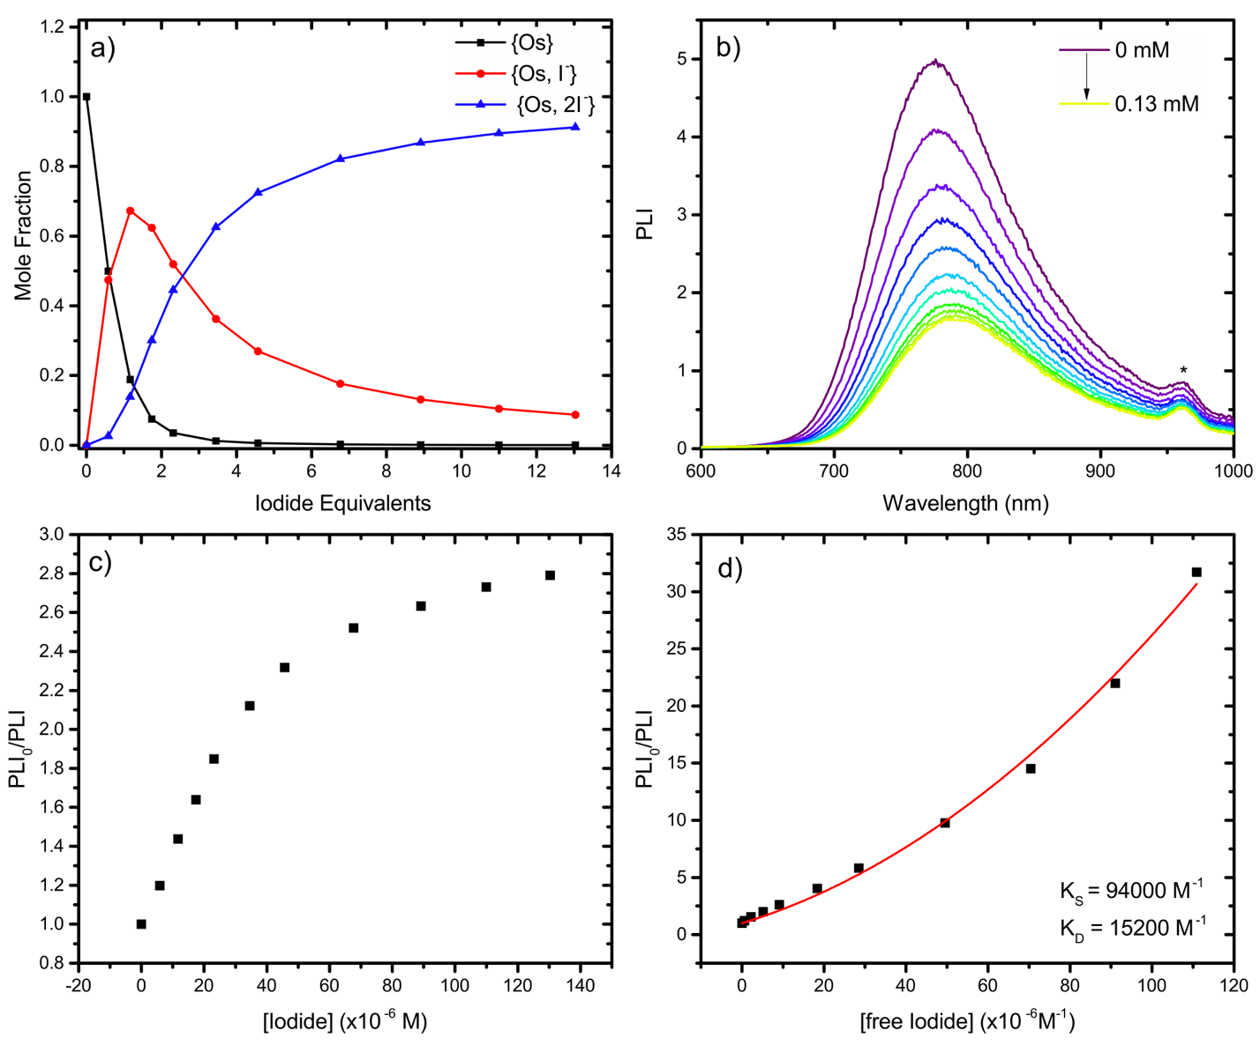
Figure 8. a) Mole fractions of the indicated species with increasing amount of TBAI. b) Steady state PL decays of [Os(CF₃bpy)₂(tmam)]⁴⁺ with increasing amount of TBAI. * denotes the second harmonic of the excitation wavelength c) Stern-Volmer plot of [Os(CF₃bpy)₂(tmam)]⁴⁺ with TBAI in acetone. d) Same data as in c) with contributions from the terionic species subtracted out. Overlaid in red is a fit to Equation 5 from which the static, K_{S}, and dynamic, K_{D}, quenching constants were extracted.
As described previously, both Os photocatalysts displayed room temperature photoluminescence (PL) in acetone solutions, but only Os-CF₃ was quenched by iodide addition. In fact, iodide induced a small blue shift and increase in the PL intensity from Os-bpy, Figure S4 The excited-state quenching behavior of Os-CF₃ was reminiscent of the analogous ruthenium tmam-photocatalysts that have been previously reported.³⁵ The steady-state photoluminescence intensity (PLI) decreased when iodide was present and showed saturated behavior at high iodide concentrations, Figure 8 b. A slight red shift in the PL spectra was also observed. Time-resolved PL decays were well described by a first-order kinetic model throughout the titration. The excited-state lifetimes decreased with added iodide, and showed saturation behavior with a lifetime of ~ 20 ns when more than 8 equivalents of iodide were present. The PL decays also revealed a decrease in initial amplitude, characteristic of a static quenching mechanism. An equilibrium constant for the ground state adduct, K_{s} = 2 x 10⁴ M^{–1}, was extracted from the initial amplitude in accordance with a static Stern–Volmer model. This value is slightly lower than that determined by UV-Vis titration experiments (K_{eq} = 9 x 10⁴ M^{–1}).
The interesting saturation behavior in the Stern−Volmer plots was consistent with the formation of a luminescent species assigned to the [Os⁴⁺:2I–]²⁺ terionic species. The Stern–Volmer data was consistent with the presence of three photoluminescent species: (i) the initial photocatalyst with an excited-state lifetime τ0 = 54 ns, (ii) a singly ion-paired species, and (iii) the terionic species with an excited-state lifetime of ~20 ns.
Photoluminescence contributions from the terionic species were subtracted from the steady state PL data and a Stern-Volmer analysis of the resultant data showed the upward curvature that is characteristic of dynamic and static quenching, Figure 8d. Overlaid on this data is a fit to the quadratic Stern-Volmer expression, Equation 5.

$\frac{\left({PLI}_{0}\right)}{\left(PLI\right)}=1+{(K}_{D}+K_{S})\left[Q\right]+K_{D}K_{S}{\left[Q\right]}^{2}$ Eq. 5
From this analysis a static (K_{S} = 9.4 x10⁴ M^{–1}) and dynamic quenching rate constant (K_{D} = 15,200 M^{–1} were extracted that corresponds to k_{q} = 2.8 x10¹¹ M^{–1}s^{–1}. The K_{S} value obtained in this manner was in good agreement with the second equilibrium constant determined by UV-Vis titrations. The magnitude of k_{q} was close to the diffusion limit in acetone.⁸⁹⁻⁹¹ Nanosecond transient absorption data measured after pulsed 532 nm light excitation provided some evidence for formation of the reduced Os photocatalyst and the oxidized iodide species, I₂•–, however the signal-to-noise ratio was very poor and this precluded a more detailed analysis.

CONCLUSIONS
In conclusion, two novel osmium photocatalysts were synthesized, which promoted terionic species with iodide through the use of a dicationic tmam ligand in acetone. Upon visible light excitation, the Os-CF₃ terionic complex was shown to be quenched by iodide, contrary to Os-bpy. At low iodide concentrations, a combination of static and dynamic quenching mechanisms was determined with k_{q} = 2.8 x10¹¹ M^{–1}s^{–1}. The excited-state lifetime showed saturation behavior at ~20 ns. Stark spectroscopy revealed that the excited-state dipole was oriented away from the tmam binding pocket in Os-CF₃, which has direct relevance to underlying photocatalytic mechanisms. The fundamental photophysical behavior of these photocatalysts obtained from UV-Visible absorption, PL and Stark spectroscopies, as well as the binding sites of iodide, provide design principles that may be utilized in the future design of new photocatalysts for halide oxidation and HX splitting.

DATA AVAILABILITY
The data that support the findings of this study are available from the corresponding author upon reasonable request.

ACKNOWLEDGMENTS
This material is based upon work solely supported as part of the Alliance for Molecular PhotoElectrode Design for Solar Fuels (AMPED), an Energy Frontier Research Center (EFRC) funded by the U.S. Department of Energy, Office of Science, Office of Basic Energy Sciences under Award Number DE-SC0001011. We thank the University of North Carolina’s Department of Chemistry Mass Spectrometry Core Laboratory for their assistance with mass spectrometry analysis. L.T.-G. is a Postdoctoral researcher of the Fonds de la Recherche Scientifique – FNRS.

REFERENCES
¹ S. Ardo, and G. J. Meyer, Chem. Soc. Rev. 38 (2009) 115.
² S. Ardo et al., Energ. Environ. Sci. 8 (2015) 1484.
³ A. F. Heyduk, and D. G. Nocera, Science 293 (2001) 1639.
⁴ A. Hagfeldt et al., Chem. Rev. 110 (2010) 6595.
⁵ J. Zhang et al., in Molecular Devices for Solar Energy Conversion and Storage, edited by H. Tian, G. Boschloo, and A. Hagfeldt (Springer Singapore, Singapore, 2018), pp. 151.
⁶ L. Alibabaei, M. K. Brennaman, and T. J. Meyer, in Molecular Devices for Solar Energy Conversion and Storage, edited by H. Tian, G. Boschloo, and A. Hagfeldt (Springer Singapore, Singapore, 2018), pp. 229.
⁷ D. Wang et al., J. Am. Chem. Soc. 140 (2018) 719.
⁸ M. Grätzel, Nature 414 (2001) 338.
⁹ B. O'Regan, and M. Grätzel, Nature 353 (1991) 737.
¹⁰ L. Francàs et al., ACS Catal. 7 (2017) 5142.
¹¹ N. S. Lewis, and D. G. Nocera, Proc. Natl. Acad. Sci. USA 103 (2006) 15729.
¹² M. G. Walter et al., Chem. Rev. 110 (2010) 6446.
¹³ J. Twilton et al., Nat. Rev. Chem 1 (2017) 0052.
¹⁴ M. H. Shaw, J. Twilton, and D. W. C. MacMillan, J. Org. Chem. 81 (2016) 6898.
¹⁵ S. Cerfontaine et al., J. Am. Chem. Soc. 142 (2020) 5549.
¹⁶ R. Bevernaegie et al., J. Am. Chem. Soc. 142 (2020) 2732.
¹⁷ N. A. Romero, and D. A. Nicewicz, Chem. Rev. 116 (2016) 10075.
¹⁸ B. Xu et al., J. Am. Chem. Soc. 142 (2020) 6206.
¹⁹ C. M. Morton et al., J. Am. Chem. Soc. 141 (2019) 13253.
²⁰ T. M. Monos, and C. R. J. Stephenson, in Iridium(III) in Optoelectronic and Photonics Applications, edited by E. Zysman-Colman (John Wiley & Sons Ltc., Chichester, West Sussex, 2017), pp. 541.
²¹ Y. Sasaki et al., J. Mater. Chem. C 5 (2017) 5063.
²² Y. Wei et al., Advanced Optical Materials 8 (2020) 1902157.
²³ S. M. Borisov, A. Alemayehu, and A. Ghosh, J. Mater. Chem. C 4 (2016) 5822.
²⁴ R. Haruki et al., Chem. Commun. (2020)
²⁵ Y. Sasaki et al., Angew. Chem. Int. Ed. 58 (2019) 17827.
²⁶ L. Troian-Gautier et al., Chem. Rev. 119 (2019) 4628.
²⁷ D. C. Powers et al., Inorg. Chem. 53 (2014) 9122.
²⁸ G. Li, M. D. Brady, and G. J. Meyer, J. Am. Chem. Soc. 140 (2018) 5447.
²⁹ M. D. Brady et al., ACS Appl. Mater. Interfaces 10 (2018) 31312.
³⁰ M. D. Brady et al., J. Am. Chem. Soc. 139 (2017) 15612.
³¹ T. J. Meyer, M. V. Sheridan, and B. D. Sherman, Chem. Soc. Rev. 46 (2017) 6148.
³² R. Matheu et al., Nat. Rev. Chem 3 (2019) 331.
³³ M. D. Kärkäs et al., Chem. Rev. 114 (2014) 11863.
³⁴ J. D. Blakemore, R. H. Crabtree, and G. W. Brudvig, Chem. Rev. 115 (2015) 12974.
³⁵ S. A. M. Wehlin et al., J. Am. Chem. Soc. 140 (2018) 7799.
³⁶ L. Troian-Gautier, S. A. M. Wehlin, and G. J. Meyer, Inorg. Chem. 57 (2018) 12232.
³⁷ B. H. Farnum, J. J. Jou, and G. J. Meyer, Proc. Natl. Acad. Sci. USA 109 (2012) 15628.
³⁸ J. Olmsted, and T. J. Meyer, J. Phys. Chem 91 (1987) 1649.
³⁹ S. I. Satoh, T. Nakajima, and Y. Shirota, Research on Chemical Intermediates 21 (1995) 939.
⁴⁰ S. Gentemann et al., J. Am. Chem. Soc. 116 (1994) 281.
⁴¹ J. Rodriguez et al., J. Am. Chem. Soc. 113 (1991) 1652.
⁴² J. W. Verhoeven et al., ChemPhysChem 6 (2005) 2251.
⁴³ E. Finkenberg et al., J. Phys. Chem 82 (1978) 526.
⁴⁴ D. Kumaresan et al., in Photochemistry and Photophysics of Coordination Compounds II, edited by V. Balzani, and S. Campagna (Springer Berlin Heidelberg, Berlin, Heidelberg, 2007), pp. 101.
⁴⁵ E. M. Kober et al., Inorg. Chem. 27 (1988) 4587.
⁴⁶ J. V. Caspar et al., Chem. Phys. Lett. 91 (1982) 91.
⁴⁷ R. M. O’Donnell et al., J. Am. Chem. Soc. 138 (2016) 3891.
⁴⁸ W. B. Swords, G. Li, and G. J. Meyer, Inorg. Chem. 54 (2015) 4512.
⁴⁹ J. V. Caspar et al., J. Am. Chem. Soc. 104 (1982) 630.
⁵⁰ T. C. Motley et al., Inorg. Chem. 56 (2017) 13579.
⁵¹ L. Troian-Gautier et al., J. Am. Chem. Soc. 138 (2016) 16815.
⁵² I. Noviandri et al., J. Phys. Chem. B 103 (1999) 6713.
⁵³ P. Thordarson, Chem. Soc. Rev. 40 (2011) 1305.
⁵⁴ R. Argazzi et al., Inorg. Chem. 33 (1994) 5741.
⁵⁵ B. N. DiMarco, R. M. O’Donnell, and G. J. Meyer, J. Phys. Chem. C 119 (2015) 21599.
⁵⁶ B. N. DiMarco et al., Chem. Sci. 9 (2018) 940.
⁵⁷ A. B. Maurer, E. J. Piechota, and G. J. Meyer, J. Phys. Chem. A 123 (2019) 8745.
⁵⁸ A. B. Maurer, and G. J. Meyer, J. Am. Chem. Soc. 142 (2020) 6847.
⁵⁹ W. Liptay, Angew. Chem. Int. Ed. 8 (1969) 177.
⁶⁰ W. Liptay, in Excited States, edited by E. C. Lim (Elsevier, 1974), pp. 129.
⁶¹ E. Jalviste, and N. Ohta, J. Photoch. Photobio. C 8 (2007) 30.
⁶² M. J. Frisch et al., Gaussian, Inc., Wallingford CT, 2016.
⁶³ C. Lee, W. Yang, and R. G. Parr, Phys. Rev. B 37 (1988) 785.
⁶⁴ A. D. Becke, J. Chem. Phys. 98 (1993) 5648.
⁶⁵ P. J. Stephens et al., J. Phys. Chem 98 (1994) 11623.
⁶⁶ S. H. Vosko, L. Wilk, and M. Nusair, Can. J. Phys. 58 (1980) 1200.
⁶⁷ P. J. Hay, and W. R. Wadt, J. Chem. Phys. 82 (1985) 299.
⁶⁸ W. R. Wadt, and P. J. Hay, J. Chem. Phys. 82 (1985) 284.
⁶⁹ P. J. Hay, and W. R. Wadt, J. Chem. Phys. 82 (1985) 270.
⁷⁰ K. A. Peterson, J. Chem. Phys. 119 (2003) 11099.
⁷¹ R. Krishnan et al., J. Chem. Phys. 72 (1980) 650.
⁷² E. M. Kober, and T. J. Meyer, Inorg. Chem. 23 (1984) 3877.
⁷³ E. M. Kober, B. P. Sullivan, and T. J. Meyer, Inorg. Chem. 23 (1984) 2098.
⁷⁴ G. A. Crosby, and J. N. Demas, J. Am. Chem. Soc. 93 (1971) 2841.
⁷⁵ J. V. Caspar, and T. J. Meyer, Inorg. Chem. 22 (1983) 2444.
⁷⁶ L. Troian-Gautier, and C. Moucheron, Molecules 19 (2014) 5028.
⁷⁷ E. Zysman-Colman et al., Chem. Mater. 20 (2008) 388.
⁷⁸ R. L. Blakley, and M. K. DeArmond, J. Am. Chem. Soc. 109 (1987) 4895.
⁷⁹ M. M. Richter, and K. J. Brewer, Inorg. Chim. Acta 180 (1991) 125.
⁸⁰ E. M. Kober, and T. J. Meyer, Inorg. Chem. 21 (1982) 3967.
⁸¹ G. B. Shaw et al., J. Phys. Chem. A 108 (2004) 4998.
⁸² S. G. Boxer, J. Phys. Chem. B 113 (2009) 2972.
⁸³ A. W. Adamson et al., J. Chem. Ed. 61 (1984) 221.
⁸⁴ D. W. Thompson, A. Ito, and T. J. Meyer, Pure and Applied Chemistry 85 (2013) 1257.
⁸⁵ A. E. Reed, L. A. Curtiss, and F. Weinhold, Chem. Rev. 88 (1988) 899.
⁸⁶ A. E. Reed, and F. Weinhold, J. Chem. Phys. 83 (1985) 1736.
⁸⁷ F. Weinhold, and J. E. Carpenter, in The Structure of Small Molecules and Ions, edited by R. Naaman, and Z. Vager (Springer US, Boston, MA, 1988), pp. 227.
⁸⁸ Y. Liu et al., Chem 3 (2017) 411.
⁸⁹ S. A. M. Wehlin et al., J. Am. Chem. Soc. 139 (2017) 12903.
⁹⁰ F. M. Morel, and J. G. Hering, Principles and applications of aquatic chemistry (John Wiley & Sons, 1993),
⁹¹ S. L. Murov, I. Carmichael, and G. L. Hug, Handbook of Photochemistry, 2nd edition (Marcel Dekker, Inc.,New York, 1993),

