In Press in Journal of Cross-Cultural Psychology

Organizational Dehumanization and Emotional Labor: A Cross-Cultural Comparison Between Vietnam and the United Kingdom

Nathan Nguyen¹, Quoc Anh Dao², Thi Lac An Nhan², and Florence Stinglhamber¹
¹Université catholique de Louvain, Psychological Sciences Research Institute, Belgium
²University of Social Sciences and Humanities, Vietnam National University Ho Chi Minh City, Vietnam

Author Note
This study was funded by the “Fonds Spéciaux de la Recherche” of the Université catholique de Louvain and by ARC under grant n°16/20-071 of the French Community of Belgium.
Correspondence concerning this article should be addressed to Nathan Nguyen, Psychological Sciences Research Institute, Place Cardinal Mercier, 10, L3.05.01, 1348 Louvain-la-Neuve, Belgium. E-mail: nathan.nguyen@uclouvain.be. Phone: +32 10 47 30 76. Fax: +32 10 47 37 74.
Abstract
This study examined cross-cultural differences in the relationships between organizational dehumanization and both job satisfaction and turnover intentions through emotional labor (i.e., surface acting). In particular, we expected that power distance, i.e., a critical value usually discussed as part of the national culture, would mitigate the deleterious effects of both organizational dehumanization and surface acting on job satisfaction and turnover intentions. Data were collected from employees in two countries that differ in power distance, namely Vietnam (N = 235) and the United Kingdom (N = 334). First, we found that perceptions to be dehumanized by one’s organization were indirectly related to poor job satisfaction and more turnover intentions through surface acting, regardless of the country. Second, our results showed that the deleterious effects of both organizational dehumanization and surface acting on work-related outcomes were weaker in Vietnam (a high power distance country) than in the United Kingdom (a low power distance country). Theoretical and practical implications are discussed from the perspective of organizational dehumanization and emotional labor literature.
Keywords: Organizational dehumanization, Emotional labor, Surface acting, Power distance, Vietnam, United Kingdom

Organizational Dehumanization and Emotional Labor: A Cross-Cultural Comparison Between Vietnam and the United Kingdom
Organizational dehumanization, which refers to an employee’s perception of being used as an instrument or a tool by his or her organization (Bell & Khoury, 2011), is a reality for many employees. Organizational dehumanization has been found to decrease job satisfaction (e.g., Caesens et al., 2017), and increase turnover intentions (e.g., Caesens et al., 2019) and avoidance behaviors (Demoulin et al., 2020). While extant research on the effects of organizational dehumanization has mostly focused on well-being, attitudes, and behaviors, its consequences on emotional aspects have only just begun to gain attention. Recently, research has investigated the role of organizational dehumanization on emotional labor, which refers to the management of emotions as a requirement of work duties (Grandey, 2000). In particular, scholars found that the more employees experience to be dehumanized, the more they perform emotional labor (i.e., surface acting; Nguyen & Stinglhamber, 2018, 2020). In turn, surface acting has been found to result in maladaptive outcomes such as reduced job satisfaction as well as more turnover intentions (e.g., Mesmer-Magnus et al., 2012).
While the literature on emotional labour acknowledges the importance of considering cultural aspects in its examination (e.g., Grandey & Gabriel, 2015), the nascent literature on organizational dehumanization has not yet integrated culture into research on the topic, suggesting that culture may not be an important consideration. Yet, it is now common for organizations to outsource their products and services to other countries (Tran, 2007), so that organizations are becoming increasingly culturally diverse (Lian et al., 2012). Now more than ever, it would certainly be a mistake to throw cultural influences baby out with the bathwater. In line with the above, Wang (2016) has drawn attention that culture interferes with various behavioral and psychological processes. The author stated that culture may help us “reduce, and eliminate biases; (…) and understand human cognition and behavior as constructive processes that take place in the interaction between individuals and their environments” (Wang, 2016, p. 593). Consequently, she has called for a better integration of culture into the literature rather than simply acknowledge its existence. All this underlines the importance, on the one hand, to continue to reflect cultural aspects in the literature on emotional labor and, on the other hand, to also urgently examine these cultural effects in the recent literature on organizational dehumanization.
As a baseline model, this research first proposed that surface acting resulting from organizational dehumanization would lead to low job satisfaction and high turnover intentions. We then explored whether the deleterious effects of both organizational dehumanization and surface acting on employees would differ across countries. In particular, we considered the cultural value of power distance in the present research. Since both organizational dehumanization and surface acting involve a relationship of authority between the organization and its employee, power distance, which implies precisely power and authority values, seems to be the most relevant cultural value to consider in this research. In doing so, it contributes to the literature on emotional labor which has focused primarily on the cultural value of individualism-collectivism to explain differences in emotional labor experiences (e.g., Allen et al., 2014; Grandey & Gabriel, 2015; Luo et al., 2019; Mastracci & Adams, 2019; Matsumoto et al., 2008; Nixon et al., 2020) at the expense of power distance, that is also highly relevant in contexts of emotional labor (e.g., Arens et al., 2013). Practically, we explored cross-cultural differences by relying on two samples of employees from Vietnam and the United Kingdom (UK), two countries that are assumed to differ in terms of power distance (Hofstede et al., 2010).
Organizational Dehumanization and Outcomes
The concept of organizational dehumanization is derived from the social psychology literature on dehumanization, which refers to a psychological process in which individuals deny humanity to others, thus treating them as less than human beings (Haslam, 2006). According to the dual model of dehumanization of Haslam (2006), two forms exist. First, animalistic dehumanization refers to the denial of characteristics that distinguish humans from animals, such as maturity and logic. This form is mainly mentioned in ethnicity, immigration, and war contexts. Second, mechanistic dehumanization implies the denial of attributes that differentiate humans from inert objects, such as interpersonal warmth and emotional responsiveness. This form is particularly relevant in contexts like technology, medicine, and pornography.
In an organizational setting, although both forms of dehumanization may exist, scholars have argued that the mechanistic form is more likely to occur than the animalistic form (Caesens et al., 2017; Christoff, 2014). In accordance with this view, Bell and Khoury (2011) defined organizational dehumanization as “the experience of an employee who feels objectified by his or her organization, denied personal subjectivity, and made to feel like a tool or instrument for the organization’s ends” (p. 168).
Drawing upon Deci and Ryan’s (1985) self-determination theory (SDT), dehumanizing organizational treatments have been suggested as thwarting the individuals’ psychological needs (e.g., autonomy and relatedness; Christoff, 2014). Yet, according to SDT, psychological needs satisfaction elicits individuals’ well-being, while psychological needs thwarting fosters individuals’ ill-being. Therefore, employees dehumanized by their organization should display indicators of psychological ill-being leading to reduced job satisfaction. In addition, Bell and Khoury (2011) stated that “dehumanization is a negative experience that diminishes the individual and is therefore likely to motivate the individual to dissociate from the organization” (p. 184). Perceptions of being dehumanized by one’s organization should thus result in more intentions to leave the organization. Consistent with these views, scholars empirically found that employees perceiving dehumanization from the organization report lower levels of job satisfaction (e.g., Caesens et al., 2017) and higher levels of turnover intentions (e.g., Caesens et al., 2019). Based on the above, we expected that organizational dehumanization would be (a) negatively associated with job satisfaction and (b) positively related to turnover intentions (Hypothesis 1).
Emotional Labor (Surface acting) as a Mediator
Emotional labor occurs when employees do not have inner feelings that are in line with their roles, so that they must actively regulate their emotions to express appropriate emotions (Hochschild, 1983). One key strategy of emotional labor is surface acting, which represents an attempt to hide, fake, or even amplify, felt emotions to display the required emotions (Grandey, 2000). By keeping constant, the discrepancy between the inner emotions felt and the desired emotional expression, surface acting is thought to deplete personal resources, thereby leading to poor well-being and negative attitudes toward the organization (Brotheridge & Lee, 2002; Grandey, 2000). Supporting this idea, meta-analyses indicated that surface acting is negatively related to job satisfaction and positively associated with intentions to leave the organization (Mesmer-Magnus et al., 2012).
Concerning the antecedents of surface acting, emotional labor models have suggested that the quality of interactions at work, and in particular interpersonal mistreatment, is an important determinant of emotional labor (Grandey, 2000). Research has shown that mistreatment stemming from inter- (clients and patients) and intra- (coworkers and supervisors) organizational members drives employees to demonstrate more surface acting (e.g., Adams & Webster, 2013; Carlson et al., 2012; Grandey et al., 2004). The reason lies in the conservation of resources (COR) theory (Hobfoll, 1989), which holds that individuals strive to preserve valuable resources (e.g., social resources) when they perceive that they are threatened. Particularly, social relationships are thought to be crucial resources at work as they facilitate access to other valuable resources (Hobfoll, 2002; Holman et al., 2008). Yet, interpersonal mistreatment is a threat to social resources (Adams & Webster, 2013). Employees being mistreated at work will thus strive to protect or, at the very least, limit the loss of resources by avoiding conflict that would entail a loss of social resources. From this perspective, employees may surface act to maintain positive interactions with the abuser and thus preserve social resources. Despite the growing body of literature on the effects of interpersonal mistreatment on emotional labor (Adams & Webster, 2013), little is known about the mistreatment coming from the organization.
As a mistreatment stemming from the organization, organizational dehumanization might also entail surface acting (Nguyen & Stinglhamber, 2018, 2020). Like any mistreatment, it is an emotion-provoking experience (Adams & Webster, 2013). Bastian and Haslam (2011) indeed found that targets of dehumanization are more likely to report negative emotions. Building upon the COR theory, we expected that, despite the negative emotions they may feel, employees experiencing organizational dehumanization will engage in surface acting to prevent or to reduce any future loss of resources. Precisely, not respecting the organizational rules in terms of emotional displays, would induce important losses because of the potential interpersonal conflicts that would arise. Thus, by engaging in surface acting as a result of the felt organizational dehumanization, employees preserve a good working climate, avoiding conflicts with members of the workplace. Consistent with this idea, some scholars have recently shown that the more employees feel dehumanized by their organization, the more they perform surface acting (Nguyen & Stinglhamber, 2018, 2020). Based on the above, we suggested that surface acting would mediate the relationships between organizational dehumanization and (a) job satisfaction and (b) turnover intentions (Hypothesis 2).
The Organizational Dehumanization-Outcomes Relationship across Countries
Hofstede (1980) defined power distance as an indicator of a country’s preference for authority and power inequality in the workplace. In high power distance countries, the unbalanced distribution of power is thought to be better accepted than in low power distance ones. High power distance countries acknowledge the existence of a hierarchy so that the expression of obedience and respect to figures of authority is accepted as a societal norm (Farh et al., 2007). As a result, it is permissible for a hierarchical source to give orders without being questioned in high power distance countries (Earley & Erez, 1997).
Following the above, one can defend the idea that dehumanizing treatments from an authority, that is the organization, should be less detrimental to high power distance countries than to low power distance ones. The cognitive emotion regulation of Garnefski et al. (2001) provides a framework that seems relevant to further explain this assumption. One sub-dimension of this model is acceptance, which refers to the degree to which an individual accepts negative events. According to Carver et al. (1989), the acceptance of a negative situation is associated with adaptive outcomes, whereas the opposite is related to maladaptive consequences. The reason is that acceptance may imply thoughts of resigning that would allow the situation to become less harmful in contrast to non-acceptance (Carver et al., 1989). On the basis of the above, the adverse effects of organizational dehumanization would thus depend on how countries consider this phenomenon as acceptable. As mentioned earlier, since high power distance countries acknowledge the existence of hierarchy, they are more inclined to express obedience and, therefore, are more likely to accept mistreatment by authority figures (Farh et al., 2007). As a mistreatment stemming from a figure of authority, organizational dehumanization might thus be considered as more acceptable in high power distance countries. Precisely, being treated as a tool or an instrument by the organization might be taken for granted in these countries. Such a vision implies a state of resignation that would allow perceiving dehumanizing treatment by the organization as less burdensome and, therefore, less harmful to employees (Carver et al., 1989). Accordingly, people experiencing organizational dehumanization in high power distance countries might be more prone to display adaptive work-related outcomes than low power distance ones.
Based on the abovementioned rationales, we expected that the strength of the relationships between organizational dehumanization and outcomes would be weaker in high power distance countries compared to low power distance ones. Since Vietnam is higher on power distance than the UK (Hofstede et al., 2010), we predicted that the country would moderate the relationships between organizational dehumanization and (a) job satisfaction and (b) turnover intentions, so that these relationships would be weaker in Vietnam than in the UK (Hypothesis 3).
The Surface Acting-Outcomes Relationship across Countries
In the context of emotion regulation, Asian and Western countries differ in their management of emotions in relationships due to cultural differences in power distance (Matsumoto, 1990). Matsumoto et al. (2008) suggested that high power distance countries (e.g., Asian countries; Hofstede et al., 2010) are more likely to use emotional suppression (i.e., surface acting) when interacting with others because individuals in these countries strive to maintain group cohesion and harmony among people. In line with this view, Mesquita and Delvaux (2013) indicated that Asian countries seek to cultivate and promote positive working relationships by expressing positive emotions to others. The emotional dissonance of emotional suppression should thus be low-effort and low-stress because the management of inner feelings seems more natural and anchored. In contrast, low power distance countries (e.g., Western countries; Hofstede et al., 2010) tend to encourage open expression of true feelings. The reason is that these countries tend to support assertiveness and prohibit self-regulation in interactions with people of higher status (Matsumoto, 2007). However, in the workplace, employees are required to display emotions that maintain positive interpersonal interactions. Emotional suppression would thus be less natural and, therefore, would drain more mental resources.
Supporting these views, cross-cultural research has shown that emotional suppression (surface acting) is less costly in countries where power distance is high than in those where it is low. Soto et al. (2011) found that emotional suppression is associated with more well-being in Hong Kong (high power distance) than in America (low power distance). In a similar vein, Cheung and Park (2010) showed that the effect of emotional suppression on depressive symptoms varies across cultural differences so that this relationship is weaker for Asians than for Europeans. Overall, these findings support the idea that surface acting is less deleterious in high power distance countries. Given that Vietnam has a higher index of power distance than the UK (Hofstede et al., 2010), we hypothesized that the country would moderate the effects of surface acting on (a) job satisfaction and (b) turnover intentions so that these effects would be weaker in Vietnam than in the UK (Hypothesis 4).
Method
Participants and Procedure
Sample 1
The Vietnamese (VN) participants were recruited via our professional networks. To be eligible to participate, employees had to be Vietnamese citizens and not self-employed. They received 50,000 VND (1.5£) as financial compensation for their participation. Two hundred and thirty-five out of 300 employees completed a paper copy of the questionnaire (i.e., a response rate of 78%). Of these participants, 30.2% were male and 68.9% were female with a mean age of 28.57 years old (SD = 6.62). On average, they had tenure in their organizations of 3.98 years (SD = 4.32). The majority worked in medium-sized organizations (10-249 employees; 46%) and held a bachelor’s degree (54.9%). Participants worked in teaching and education (14.9%), followed by retail and sales (14.5%), accountancy, banking, and finance (13.6%), consulting and management (10.6%), marketing and public relations (6%), transport and logistics (6%), health and social care (5.1%), and property and construction (4.3%) for the most represented.
Sample 2
The British (UK) participants were recruited via a crowdsourcing platform (i.e., Prolific Academic). To take part in the survey, employees had to be British citizens and not self-employed. They were offered 1.5£ as monetary compensation for their time. Three hundred and thirty-four employees responded to a web-based version of the questionnaire (i.e., a response rate of 100%). Of these participants, 41% were male and 59% were female. On average, they were 37.65 years old (SD = 10.82), have been working in their current organization for 6.95 years (SD = 6.84). Most of them worked in medium-sized organizations (10-249 employees; 33%) and held a bachelor’s degree (46.4%). Participants worked in health and social care (13.2%), teaching and education (12.9%), retail and sales (12.3%), public sector and public administration (10.2%), information technology and services (9%), accountancy, banking, and finance (7.2%), engineering and manufacturing (3.9%), and science and pharmaceuticals (3.3%) for the most represented.
Measures
All participants filled out the questionnaire in their native tongue. We first established the equivalence of meaning in both English and Vietnamese by using the translation-back-translation methodology used in cross-cultural research (e.g., Brislin, 1980). More precisely, a Vietnamese researcher in psychology, fluent in English, translated original English measures into Vietnamese. A native Vietnamese-American translator with expertise in both English and Vietnamese proceeded the back-translations. Then, the back-translated items were compared to the original items to examine the accuracy of the translation. Differences between the original and back-translated versions were discussed between the two translators to reach a consensus on the final wording.
Unless otherwise indicated, participants assessed the following items on a 7-point scale ranging from “1” (strongly disagree) to “7” (strongly agree).
Organizational Dehumanization (α_{VN} = .85; α_{UK} = .94)
We used the 11-item scale from Caesens et al. (2017) to assess participants’ perception of being dehumanized by their organization. A sample item included “My organization considers me as a tool devoted to its own success.”
Surface Acting (α_{VN} = .87; α_{UK} = .90)
Participants’ use of surface acting was measured with four items of the well-known scales of Brotheridge and Lee (2002) and Grandey (2003). Participants indicated how often they regulated their emotional expressions via a 7-point scale ranging from “1” (never) to “7” (always). A sample item was “I fake a good mood when interacting with others.”
Job Satisfaction (α_{VN} = .83; α_{UK} = .93)
We assessed employees’ level of satisfaction with their job by using the four items of Eisenberger et al. (1997). A sample item was “All in all, I’m very satisfied with my current job.”
Turnover Intentions (α_{VN} = .92; α_{UK} = .93)
We used the three-item of Jaros (1997) to measure participants’ intentions to leave their organizations. A sample item was “I often think about quitting this organization.”
Control Variables
We controlled for individuals’ positive affectivity and negative affectivity, as they were shown to affect the use of surface acting (e.g., Grandey, 2000). We used Thompson’s (2007) short version of the Watson and Clark’s (1999) Positive and Negative Affectivity Schedule (PANAS). It included five positive (e.g., active) and five negative (e.g., nervous) mood-relevant traits. Employees indicated the extent to which they generally feel each trait (i.e., on average) by using a 7-point Likert-type scale ranging from “1” (not at all) to “7” (extremely). In addition, following Becker’s (2005) recommendations, gender, age, education, organizational size, and organizational tenure were included in our analyses since they were correlated with our variables of interest (Table 1). We tested our models with and without these control variables. The results showed that the inclusion of these control variables did not change the conclusion of our findings. Therefore, the results presented below were free from those control variables for the sake of parsimony.
[Insert Table 1 about here]
Results
Measurement Models
For each sample, a series of confirmatory factor analyses were performed to examine the distinctiveness of organizational dehumanization, surface acting, job satisfaction, and turnover intentions using Mplus 7.4. Because the number of parameters to be estimated was too large relative to each final sample size, we used a parceling strategy (e.g., item-to-construct balance technique; Little et al., 2002). Precisely, because the other variables were already measured using a relatively small number of items (i.e., three or four items), we have reduced the number of indicators to four for organizational dehumanization only. Table 2 indicates that the four-factor model of each sample fitted the data well, and was significantly better than the more constrained measurement models. All the factor loadings of the indicators on their latent variables were significant in both samples. For the VN sample, standardized loadings ranged from .57 to .91 for organizational dehumanization, from .67 to .92 for surface acting, from .75 to .91 for job satisfaction, and from .80 to .95 for turnover intentions. For the UK sample, they ranged from 85 to .94 for organizational dehumanization, from .72 to .93 for surface acting, from .80 to .95 for job satisfaction, and from .85 to .96 for turnover intentions.
[Insert Table 2 about here]
Structural Models
For each sample, we tested a structural equation model examining how organizational dehumanization was associated with job satisfaction and turnover intention, both directly and indirectly, via surface acting. Both structural models showed a good fit to the data (χ² (84) = 203.23; RMSEA = .08; SRMR = .07; CFI = .94; TLI = .93 and χ² (84) = 231.13; RMSEA = .07; SRMR = .04; CFI = .97; TLI = .96, for the VN sample and the UK sample, respectively). The results showed that organizational dehumanization was negatively associated with job satisfaction (γ = -.24, p < .001 and γ = -.58, p < .001, for the VN sample and the UK sample, respectively), which is in line with Hypothesis 1a. The results also indicated that the positive link between organizational dehumanization and turnover intentions was significant (γ = .23, p < .001 and γ = .49, p < .001, for the VN sample and the UK sample, respectively), confirming Hypothesis 1b. Furthermore, organizational dehumanization was positively related to surface acting (γ = .33, p < .001 and γ = .37, p < .001, for the VN sample and the UK sample, respectively). In turn, surface acting was negatively linked to job satisfaction (β = -.14, p < .05 and β = -.29, p < .001, for the VN sample and the UK sample, respectively) and positively correlated with turnover intentions (β = .21, p < .001 and β = .30, p < .001, for the VN sample and the UK sample, respectively). Figure 1 displays the standardized parameter estimates of the mediation model of each sample. We investigated further the mediating role of surface acting by performing a bootstrapping analysis on our latent variables for each sample (Cheung & Lau, 2008). The results indicated that the indirect effects of organizational dehumanization on both job satisfaction (indirect effect = -.05; 95% CI = [-.11; -.01] and indirect effect = -.10; 95% CI = [-.13; -.04], for the VN sample and the UK sample, respectively) and turnover intentions (indirect effect = .07; 95% CI = [.03; .21] and indirect effect = .11; 95% CI = [.06; .17], for the VN sample and the UK sample, respectively) through surface acting were significant. In sum, these findings showed that surface acting partially mediated the organizational dehumanization-job satisfaction and -turnover intentions relationships, thus supporting Hypotheses 2a and 2b.
[Insert Figure 1 about here]
Multi-Group Analyses
To examine whether the structural paths of the mediation model differed across samples, we performed a multi-group analyses. Following the recommendations of Byrne (2009), we compared a full-constrained model (i.e, all the structural paths were constrained to be equal across samples) to alternative models in which each structural path was allowed to vary across samples. The results showed that the models that allowed the organizational dehumanization-job satisfaction path (Δχ² (1) = 6.35, p < .05) and the organizational dehumanization-turnover intentions path (Δχ² (1) = 5.60, p < .05) to vary across samples were better than the full-constrained model, which is in line with Hypotheses 3a and 3b. In addition, the analyses indicated that the models in which the surface acting-job satisfaction path (Δχ² (1) = 4.06, p < .05) and the surface acting-turnover intentions path (Δχ² (1) = 4.03, p < .05) varied across samples were better than the full-constrained model, thus supporting Hypotheses 4a and 4b. Finally, the chi-square difference test was not significant between the model that allowed the path between organizational dehumanization and surface acting to vary across samples and the full-constrained model (Δχ² (1) = 0.85, p > .05), indicating that the country does not seem to moderate the organizational dehumanization-surface acting relationship. Overall, these results suggested that the negative effects of organizational dehumanization and surface acting on job satisfaction and turnover intentions were weaker in Vietnam than in the UK. The moderating effects of the country on the organizational dehumanization-outcomes and the surface acting-outcomes relationships are illustrated in Figure 2 and Figure 3, respectively.
[Insert Figure 2 about here]
[Insert Figure 3 about here]
Discussion
This research aimed to examine how perceptions of organizational dehumanization shaped employees’ well-being (job satisfaction) and attitudes toward the organization (turnover intentions) through surface acting. Furthermore, responding to the call from researchers for a better integration of cultural aspects within the current literature, this study empirically investigated cultural differences (VN, a high power distance country versus the UK, a low power distance country) in the organizational dehumanization-outcomes and surface acting-outcomes relationships. By exploring cross-cultural facets in these relationships, our study offers valuable theoretical and practical contributions to both the organizational dehumanization and emotional labor literature.
First, our results indicate that surface acting partially mediates the relationships between organizational dehumanization and work-related outcomes (i.e., job satisfaction and turnover intentions) in each country . These findings are in line with Nguyen and Stinglhamber’s (2018) research that showed that employees who experience dehumanization from their organizations fake or suppress their inner feelings to display the required emotions (Grandey, 2000). Our results are also in accordance with emotional labor models that indicate that surface acting is detrimental to employees’ well-being and attitudes toward the organization (Grandey, 2000).
Although not a main focus of this research, our findings highlight that Vietnamese employees (M = 3.35; SD = 1.13) feel less dehumanized by their organization than their British counterparts (M = 3.95; SD = 1.48), t(564) = 5.19, p < .001. This difference might lie in the Vietnamese economic model that relies on mass production (Tran, 2007). In such a context, employees are expected to be compliant and flexible, so that it is common for Vietnamese employees to work overtime and around the clock to achieve the organization’s objectives (Tran, 2007). In line with the above, Chan and Wang (2004) found in their interviews that “in Vietnam, [employees] frequently have to work overtime, even up to midnight. But [they] feel that [they] are lucky here” (p. 635). Even more startling is that some workers practice gestures performed at work during their leisure time to boost their productivity (Tran, 2001). Vietnamese culture seems to convey the societal norm that employees should help their organization achieve its goals by being efficient and performant. Organizational dehumanization that refers to the perception of being valued solely based on one’s performance at work or being a tool devoted to the organization’s success seems to be, to some extent, more rooted in the Vietnamese culture. Such entrenchment might explain why perceptions to be dehumanized by one’s organization are lower in Vietnam than in the UK. Importantly, our findings indicate that despite these differences in organizational dehumanization perceptions, this phenomenon still entails poor well-being and fosters negative attitudes toward the organization through surface acting.
Second, the present research shows that the harmful effects of organizational dehumanization on employees’ well-being and attitudes toward the organization differ across countries. Our findings indicate that organizational dehumanization has less impact in a high power distance country (Vietnam) than in a low power distance one (the UK) in terms of job satisfaction and turnover intentions. This conclusion is based on the assumption that organizational dehumanization is perceived as more normative and tolerable in high power distance countries and, therefore, less detrimental to employees in these countries. By revealing for the first time the influence of country, this research represents an important caveat to prior research on organizational dehumanization. In particular, this research suggests that we should be more nuanced in interpreting the effects of organizational dehumanization in previous studies since they may vary across countries.
Third, consistent with our hypotheses, our findings reveal that the adverse effects of surface acting on employees’ job satisfaction and turnover intentions is weaker for Vietnam than for the UK. As stated above, since Vietnamese culture is high on power distance as compared to the UK (Hofstede et al., 2010), this study supports the view that surface acting -or suppression of emotions- is less costly and stressful for people in high power distance countries than for those in low power distance ones (Cheung & Park, 2010; Soto et al., 2011). Importantly, although previous research has acknowledged the key role of cultural differences in the surface acting-work-related outcomes relationships, this research refines the emotional labor literature by suggesting that power distance may also be a cultural pathway to explain the mitigation of the deleterious effects of surface acting on employees’ well-being and attitudes toward the organization.
Fourth, our findings seem to go against prior research that showed that high power distance is more likely to be related to undesirable work behavior (e.g., Farh et al., 2007; Kirkman et al., 2009). Indeed, the present study suggests that the deleterious effects of both organizational dehumanization and surface acting on employees’ job satisfaction and turnover intentions are weaker in high power distance countries. That being said, these findings are not totally at odds with the literature. Indeed, Lian et al. (2012) proposed that the cultural value of power distance is double-edged for workplace mistreatment. Specifically, the authors found that when the consequence reflects evaluations (e.g., job satisfaction) or attitudinal reactions (e.g., turnover intentions) to the mistreating individual, power distance will mitigate the relationship, which is in line with our findings. In contrast, when the consequence reflects the same type of mistreating behavior as that experienced (e.g., organizational deviance), power distance will rather exacerbate the relationship. On the basis of the above, one can defend the idea that the cultural value of power distance may serve as an adaptive and maladaptive function in the workplace. Consequently, future research should investigate, for instance, whether the relationship between organizational dehumanization and organizational deviance would be stronger in high power distance countries than in low power distance ones.
Finally, although we did not hypothesize about this, it is interesting to note that our findings indicate that the relationship between organizational dehumanization and surface acting does not appear to differ across cultures. Most models of emotional labor suggest that display rules are determinant in the development of emotional labor strategies. Nevertheless, scholars pointed out that even though employees are aware of display rules, they still have the choice of whether or not to follow them (e.g., Gosserand & Diefendorff, 2005). Yet, as mentioned earlier, employees who feel dehumanized by their organization surface act to comply with organizational display rules (Nguyen & Stinglhamber, 2018). Since power distance implies the expression of obedience and respect to figures of authority, one can assume that the positive effect of organizational dehumanization on surface acting would be stronger in high power distance countries only when employees perceive organizational display rules. In other words, cross-cultural differences in the organizational dehumanization-surface acting relationship would emerge only when employees are aware of display rules. Therefore, a fruitful future direction would be to explore whether the three-way interaction between organizational dehumanization, perceived display rules, and country influences surface acting.
Limitations
Despite these contributions, this study has several limitations that should be acknowledged. First, like most cross-cultural research, our study used a cross-sectional design that does not allow establishing the direction of causality. Future research should adopt longitudinal or experimental designs to address this issue. Second, the use of self-reported measures makes our study vulnerable to common method variance (CMV) that might amplify the strength of the relationships between our variables. However, methodology remedies were used to reduce method effects (e.g., Conway & Lance, 2010). Precisely, we guaranteed the anonymity of the participants, and we reduced individuals’ apprehension about evaluation by stating in the introduction of the questionnaire that “there is no right or wrong answers”. We increased the involvement of participants, which resulted in more accurate responses, by giving them the opportunity to contact us with questions about the study. In addition, given that organizational dehumanization and surface acting are, by definition and nature, individual perceptions, self-reported measures were by far the most appropriate technique for capturing employee perception of organizational dehumanization and participants’ use of emotional labor strategies (Conway & Lance, 2010). Finally, another way “to rule out substantial method effects is to demonstrate construct validity of the measures used” (Conway & Lance, 2010, p. 329). Consistent with the above, our results showed that the organizational dehumanization and surface acting scales had good internal consistency, good discriminant validity, and were correlated with well-known outcomes, i.e., job satisfaction and turnover intentions. Therefore, one can reasonably assume that our conclusions are not the result of biases or even chance. Thirdly, this research focused mainly on the mechanistic form of dehumanization because it is more likely to occur within organizational contexts (e.g., Bell & Khoury, 2011; Christoff, 2014). Nevertheless, authors do not deny the possibility that the animalistic dehumanization may also exist within the workplace. A fruitful direction for future research would, therefore, be to study both forms of dehumanization to examine their distinctiveness in relation to cultural aspects. Fourth, this study examined only the cultural value of power distance as it involves a measure of preference for authority and power inequality in the workplace. Future research should clearly investigate the role of other cultural values such as individualism-collectivism, uncertainty-avoidance, or masculinity-femininity to gain a deeper understanding of the deleterious effects of both organizational dehumanization and surface acting on employees’ well-being and attitudes toward the organization. Finally, we were not able to establish the measurement invariance between our two samples. Because we adopted a parceling strategy in our analyses, this analysis would have indeed been somewhat irrelevant (for more details, see Meade & Kroustalis, 2006). Yet, Boer et al. (2017) argued that, when quantitative measures differ in metric across cultures, “the validity of inferences about cultural variability is in doubt” (p. 713). Since it has not been tested, it cannot be ruled out that some measurement variance may have threatened the validity of the conclusions of this study. Future research should therefore replicate our current findings by using larger samples, thus allowing testing for measurement invariance.
Practical implications
First, our research suggests that perceptions of organizational dehumanization contribute to poor well-being and attitudes toward the organization. Organizations should, therefore, put in place strategies and policies to reduce the feelings of dehumanization among their staff. The growing literature on organizational dehumanization offers some avenues for action. In particular, it has been shown that high procedural justice (Bell & Khoury, 2016), high perceived organizational support, and low abusive supervision (Caesens et al., 2017, 2019) decrease employees’ perception of dehumanizing treatment. These findings should motivate organizations to implement favorable conditions (e.g., job autonomy) and training programs (e.g., personal development) to enhance employees’ perceptions that their well-being is cared. In addition, organizations should reduce the abusive behavior of managers toward their collaborators. Concretely, organizations should help and encourage their managers to undertake training to develop their management skills and correct abusive practices. As a result, trained managers would help to reduce feelings of organizational dehumanization among the personnel. Second, our findings underline the harmful effects of surface acting on employees’ well-being. Organizations would benefit from helping their staff to better manage their emotions by offering coping training to reduce the use of surface acting that is harmful to them. One promising approach is mindfulness techniques. Indeed, Hülsheger et al. (2013) showed that the practice of mindfulness contributes to enhancing workers’ well-being by lessening the use of surface acting. Finally, our work indicates that the deleterious effects of organizational dehumanization and surface acting on employees’ well-being and attitudes toward the organization are stronger in low power distance countries. These findings should encourage organizations within low power distance countries to ensure that their employees benefit from the interventions suggested above.
Conclusion
This paper provides new contributions to the current literature by investigating how cultural differences may shape the effects of both organizational dehumanization and surface acting on employees’ well-being and attitudes toward the organization. Our results suggest that individuals belonging to different socio-cultural contexts have different interpretations of organizational practices and emotion regulation, resulting in different consequences for them. In sum, this research advocates the need to be more nuanced when attempting to generalize the findings on organizational dehumanization or emotional labor obtained in Western samples.
Compliance with Ethical Standards
Conflict of interest
On behalf of all authors, the corresponding author states that there is no conflict of interest.
Ethical approval
All procedures performed in studies involving human participants were in accordance with the ethical standards of the institutional and/or national research committee and with the 1964 Helsinki declaration and its later amendments or comparable ethical standards.
Informed consent
Informed consent was obtained from all individual participants included in the study.
References
Adams, G. A., & Webster, J. R. (2013). Emotional regulation as a mediator between interpersonal mistreatment and distress. European Journal of Work and Organizational Psychology, 22, 697-710. https://doi.org/10.1080/1359432X.2012.698057
Allen, J. A., Diefendorff, J. M., & Ma, Y. (2014). Differences in emotional labor across cultures: A comparison of Chinese and US service workers. Journal of Business and Psychology, 29, 21-35. https://doi.org/10.1007/s10869-013-9288-7
Arens, E. A., Balkir, N., & Barnow, S. (2013). Ethnic variation in emotion regulation: Do cultural differences end where psychopathology begins? Journal of Cross-Cultural Psychology, 44, 335-351. https://doi.org/10.1177/0022022112453314
Bastian, B., & Haslam, N. (2011). Experiencing dehumanization: Cognitive and emotional effects of everyday dehumanization. Basic and Applied Social Psychology, 33, 295-303. https://doi.org/10.1080/01973533.2011.614132
Becker, T. E. (2005). Potential problems in the statistical control of variables in organizational research: A qualitative analysis with recommendations. Organizational Research Methods, 8, 274–289. https://doi.org/10.1177/1094428105278021
Bell, C. M., & Khoury, C. (2011). Organizational de/humanization, deindividuation, anomie, and in/justice. In S. Gilliland, D. Steiner, & D. Skarlicki (Eds.), Emerging Perspectives on Organizational Justice and Ethics (pp. 167-197). Information Age Publishing.
Bell, C. M., & Khoury, C. (2016). Organizational powerlessness, dehumanization, and gendered effects of procedural justice. Journal of Managerial Psychology, 31, 570-585. https://doi.org/10.1108/JMP-09-2014-0267
Boer, D., Hanke, K., & He, J. (2018). On detecting systematic measurement error in cross-cultural research: A review and critical reflection on equivalence and invariance tests. Journal of Cross-Cultural Psychology, 49, 713-734. https://doi.org/10.1177/0022022117749042
Brislin, R. W. (1980). Translation and content analysis of oral and written material. In H. C. Triandis & J. W. Berry (Eds.), Handbook of cross-cultural psychology. Allyn and Bacon.
Brotheridge, C. M., & Lee, R. T. (2002). Testing a conservation of resources model of the dynamics of emotional labor. Journal of Occupational Health Psychology, 7, 57-67. https://doi.org/10.1037/1076-8998.7.1.57
Byrne, B. (2009). Structural equation modeling with AMOS: Basic concepts, applications, and
programming. Taylor and Francis Group.
Caesens, G., Nguyen, N., & Stinglhamber, F. (2019). Abusive supervision and organizational dehumanization. Journal of Business and Psychology, 34, 709-728. https://doi.org/10.1007/s10869-018-9596-z
Caesens, G., Stinglhamber, F., Demoulin, S., & De Wilde, M. (2017). Perceived organizational support and employees’ well-being: The mediating role of organizational dehumanization. European Journal of Work and Organizational Psychology, 26, 527-540. https://doi.org/10.1080/1359432X.2017.1319817
Carlson, D., Ferguson, M., Hunter, E., & Whitten, D. (2012). Abusive supervision and work-family conflict: The path through emotional labor and burnout. The Leadership Quarterly, 23, 849-859. https://doi.org/10.1016/j.leaqua.2012.05.003
Carver, C. S., Scheier, M. F., & Weintraub, J. K. (1989). Assessing coping strategies: A theoretically based approach. Journal of Personality and Social Psychology, 56, 267-283. https://doi.org/10.1037/0022-3514.56.2.267
Chan, A., & Wang, H. Z. (2004). The impact of the state on workers' conditions: Comparing Taiwanese factories in China and Vietnam. Pacific Affairs, 77, 629-646.
Cheung, G. W., & Lau, R. S. (2008). Testing mediation and suppression effects of latent variables: Bootstrapping with structural equation models. Organizational Research Methods, 11, 296-325. https://doi.org/10.1177/1094428107300343
Cheung, R. Y., & Park, I. J. (2010). Anger suppression, interdependent self-construal, and depression among Asian American and European American college students. Cultural Diversity and Ethnic Minority Psychology, 16, 517-525. https://doi.org/10.1037/a0020655
Christoff, K. (2014). Dehumanization in organizational settings: Some scientific and ethical considerations. Frontiers in Human Neuroscience, 8, 748.
Conway, J. M., & Lance, C. E. (2010). What reviewers should expect from authors regarding common method bias in organizational research. Journal of Business and Psychology, 25, 325-334. https://doi.org/10.1007/s10869-010-9181-6
Deci, E. L., & Ryan, R. M. (1985). The general causality orientation scale: Self-determination in personality. Journal of Research in Personality, 19, 109-134.
Demoulin, S., Nguyen, N., Chevallereau, T., Fontesse, S., Bastart, J., Stinglhamber, F., & Maurage, P. (2020). Examining the role of fundamental psychological needs in the development of metadehumanization : A multi-population approach. British Journal of Social Psychology. https://doi.org/10.1111/bjso.12380
Earley, P. C., & Erez, M. (1997). The transplanted executive: Why you need to understand how workers in other countries see the world differently. Oxford University Press.
Eisenberger, R., Cummings, J., Armeli, S., & Lynch, P. (1997). Perceived organizational support, discretionary treatment, and job satisfaction. Journal of Applied Psychology, 82, 812-820. https://doi.org/10.1037/0021-9010.82.5.812
Farh, J. L., Hackett, R. D., & Liang, J. (2007). Individual-level cultural values as moderators of perceived organizational support–employee outcome relationships in China: Comparing the effects of power distance and traditionality. Academy of Management Journal, 50, 715-729. https://doi.org/10.5465/amj.2007.25530866
Garnefski, N., Kraaij, V., & Spinhoven, P. (2001). Negative life events, cognitive emotion regulation and emotional problems. Personality and Individual Differences, 30, 1311-1327. https://doi.org/10.1016/S0191-8869(00)00113-6
Gosserand, R. H., & Diefendorff, J. M. (2005). Emotional display rules and emotional labor: the moderating role of commitment. Journal of Applied Psychology, 90, 1256-1264. https://doi.org/10.1037/0021-9010.90.6.1256
Grandey, A. A. (2000). Emotional regulation in the workplace: A new way to conceptualize emotional labor. Journal of Occupational Health Psychology, 5, 95-110. https://doi.org/10.1037/1076-8998.5.1.95
Grandey, A. A. (2003). When “the show must go on”: Surface acting and deep acting as determinants of emotional exhaustion and peer-rated service delivery. Academy of Management Journal, 46, 86-96. https://doi.org/10.5465/30040678
Grandey, A. A., Dickter, D. N., & Sin, H. P. (2004). The customer is not always right: Customer aggression and emotion regulation of service employees. Journal of Organizational Behavior, 25, 397-418. https://doi.org/10.1002/job.252
Grandey, A. A., & Gabriel, A. S. (2015). Emotional labor at a crossroads: Where do we go from here? Annual Review of Organizational Psychology and Organizational Behavior, 2, 323-349. https://doi.org/10.1146/annurev-orgpsych-032414-111400
Haslam, N. (2006). Dehumanization: An integrative review. Personality and Social Psychology Review, 10, 252-264. https://doi.org/10.1207/s15327957pspr1003_4
Hobfoll, S. E. (1989). Conservation of resources: A new attempt at conceptualizing stress. American psychologist, 44, 513-524.
Hobfoll, S. E. (2002). Social and psychological resources and adaptation. Review of General Psychology, 6, 307-324. https://doi.org/10.1037/1089-2680.6.4.307
Hochschild, A. R. (1983). The managed heart: Commercialization of human feeling. University of California Press.
Hofstede, G. H. (1980). Culture’s consequences: International differences in work-related values. Sage.
Hofstede, G. H., Hofstede, G. J., & Minkov, M. (2010). Cultures and organizations: Software of the mind: Intercultural cooperation and its importance for survival. McGrawHill.
Holman, D., Martinez-Iñigo, D., & Totterdell, P. (2008). Emotional labour and employee well-being: an integrative review. In N. M. Ashkanasy, & C. L. Cooper (Eds.), Research companion to emotion in organizations (pp. 301-315). Edward Elgar Publishing.
Hülsheger, U. R., Alberts, H. J., Feinholdt, A., & Lang, J. W. (2013). Benefits of mindfulness at work: the role of mindfulness in emotion regulation, emotional exhaustion, and job satisfaction. Journal of Applied Psychology, 98, 310-325. https://doi.org/10.1037/a0031313
Jaros, S. J. (1997). An assessment of Meyer and Allen's (1991) three-component model of organizational commitment and turnover intentions. Journal of Vocational Behavior, 51, 319-337. https://doi.org/10.1006/jvbe.1995.1553
Judd, C. M., Westfall, J., & Kenny, D. A. (2017). Experiments with more than one random factor: Designs, analytic models, and statistical power. Annual Review of Psychology, 68, 601-625. https://doi.org/10.1146/annurev-psych-122414-033702
Kirkman, B. L., Chen, G., Farh, J. L., Chen, Z. X., & Lowe, K. B. (2009). Individual power distance and follower reactions to transformational leaders: A cross-level, cross-cultural examination. Academy of Management Journal, 52, 744-764. https://doi.org/10.5465/amj.2009.43669971
Lian, H., Ferris, D. L., & Brown, D. J. (2012). Does power distance exacerbate or mitigate the effects of abusive supervision? It depends on the outcome. Journal of Applied Psychology, 97, 107-123. https://doi.org/10.1037/a0024610
Little, T. D., Cunningham, W. A., Shahar, G., & Widaman, K. F. (2002). To parcel or not to parcel: Exploring the question, weighing the merits. Structural Equation Modeling, 9, 151-173. https://doi.org/10.1207/S15328007SEM0902_1
Luo, A., Guchait, P., Lee, L., & Madera, J. M. (2019). Transformational leadership and service recovery performance: The mediating effect of emotional labor and the influence of culture. International Journal of Hospitality Management, 77, 31-39. https://doi.org/10.1016/j.ijhm.2018.06.011
Mastracci, S., & Adams, I. (2019). Is emotional labor easier in collectivist or individualist cultures? An east–west comparison. Public Personnel Management, 48, 325-344. https://doi.org/10.1177/0091026018814569
Matsumoto, D. (1990). Cultural similarities and differences in display rules. Motivation and Emotion, 14, 195-214. https://doi.org/10.1007/BF00995569
Matsumoto, D. (2007). Individual and cultural differences in status differentiation: The status differentiation scale. Journal of Cross-Cultural Psychology, 38, 413-431. https://doi.org/10.1177/0022022107302311
Matsumoto, D., Yoo, S. H., & Fontaine, J. (2008). Mapping expressive differences around the world: The relationship between emotional display rules and individualism versus collectivism. Journal of Cross-Cultural Psychology, 39, 55-74. https://doi.org/10.1177/0022022107311854
Matsumoto, D., Yoo, S. H., & Nakagawa, S. (2008). Culture, emotion regulation, and adjustment. Journal of Personality and Social Psychology, 94, 925-937. https://doi.org/10.1037/0022-3514.94.6.925
Meade, A. W., & Kroustalis, C. M. (2006). Problems with item parceling for confirmatory factor analytic tests of measurement invariance. Organizational Research Methods, 9, 369-403. https://doi.org/10.1177/1094428105283384
Mesmer-Magnus, J. R., DeChurch, L. A., & Wax, A. (2012). Moving emotional labor beyond surface and deep acting: A discordance-congruence perspective. Organizational Psychology Review, 2, 6-53. https://doi.org/10.1177/2041386611417746
Mesquita, B., & Delvaux, E. (2013). A cultural perspective on emotion labor. In A. A. Grandey, J. M. Diefendorff, & D.E. Rupp (Eds.), Emotional labor in the 21st century: Diverse perspectives on emotion regulation at work (pp. 271-292). Routledge.
Nguyen, N., & Stinglhamber, F. (2018). Emotional labor and core self-evaluations as mediators between organizational dehumanization and job satisfaction. Current Psychology. https://doi.org/10.1007/s12144-018-9988-2
Nguyen, N., & Stinglhamber, F. (2020). Workplace mistreatment and emotional labor: A latent profile analysis. Motivation and Emotion, 44, 474-490. https://doi.org/10.1007/s11031-019-09803-8
Nixon, A. E., Ceylan, S., Nelson, C. E., & Alabak, M. (2020). Emotional labour, collectivism and strain: a comparison of Turkish and US service employees. Work & Stress, 34, 168-188. https://doi.org/10.1080/02678373.2019.1598515
Soto, J. A., Perez, C. R., Kim, Y. H., Lee, E. A., & Minnick, M. R. (2011). Is expressive suppression always associated with poorer psychological functioning? A cross-cultural comparison between European Americans and Hong Kong Chinese. Emotion, 11, 1450-1455. https://doi.org/10.1037/a0023340
Thompson, E. R. (2007). Development and validation of an internationally reliable short-form of the positive and negative affect schedule (PANAS). Journal of Cross-Cultural Psychology, 38, 227-242. https://doi.org/10.1177/0022022106297301
Tran, A. N. (2001). Global subcontracting and women workers in comparative perspective. In C. Brundenius, & J. Weeks (Eds.), Globalization and third world socialism: Cuba and Vietnam (pp. 217-236). Palgrave Macmillan. https://doi.org/10.1057/9780333977361_12
Tran, A. N. (2007). Alternatives to the “race to the bottom” in Vietnam: Minimum wage strikes and their aftermath. Labor Studies Journal, 32, 430-451. https://doi.org/10.1177/0160449X07300730
Wang, Q. (2016). Why should we all be cultural psychologists? Lessons from the study of social cognition. Perspectives on Psychological Science, 11, 583-596. https://doi.org/10.1177/1745691616645552
Watson, D., & Clark, L. A. (1999). The PANAS-X: Manual for the positive and negative affect schedule-expanded form. https://doi.org/10.17077/48vt-m4t2

Table 1
Descriptive Statistics and Bivariate Correlations Coefficients among Variables
 | M_{VN} | SD_{VN} | 1 | 2 | 3 | 4 | 5 | 6 | 7 | 8 | 9 | 10 | 11 | 12 | M_{UK} | SD_{UK}
1. Organizational dehumanization | 3.35 | 1.13 | (.85/.94) | -.05 | .36** | -.65** | .61** | .00 | .01 | -.11 | .10 | .01 | -.35** | .21** | 3.95 | 1.48
2. Power distance | 3.59 | 0.98 | .14* | (.73/.79) | .03 | .09 | -.10 | -.06 | .06 | -.11* | -.02 | .17** | .06 | -.05 | 3.42 | 0.95
3. Surface acting | 3.25 | 1.26 | .30** | -.10 | (.87/.90) | -.42** | .42** | .07 | -.09 | -.11* | -.09 | .04 | -.27** | .35** | 4.19 | 1.23
4. Job satisfaction | 5.47 | 1.23 | -.29** | .07 | -.21** | (.83/.93) | -.74** | -.03 | -.01 | .13* | .05 | -.05 | .51** | -.25** | 4.64 | 1.67
5. Turnover intentions | 3.19 | 1.71 | .30** | -.07 | .30** | -.49** | (.92/.93) | -.05 | -.12* | -.07 | -.08 | -.08 | -.44** | .21** | 3.74 | 2.03
6. Gender | - | - | -.05 | -.11 | -.01 | -.02 | .01 | - | -.14* | -.04 | .07 | -.06 | .03 | .04 | - | -
7. Age | 28.57 | 6.62 | .09 | .19** | -.14* | -.03 | -.08 | .01 | - | -.07 | -.04 | .45** | .16** | -.05 | 37.65 | 10.82
8. Education | 3.56 | 0.83 | -.08 | -.06 | .10 | .09 | .02 | .01 | .02 | - | .06 | -.06 | .13* | -.03 | 3.72 | 0.98
9. Organizational size | 3.65 | 2.02 | .20** | .03 | .05 | -.03 | .01 | -.08 | .05 | .13* | - | .13* | -.02 | -.06 | 5.07 | 2.70
10. Organizational tenure | 3.98 | 4.32 | -.07 | .14* | -.09 | .13 | -.17* | .06 | .69** | .03 | .02 | - | .01 | -.02 | 6.95 | 6.84
11. Positive affectivity | 5.23 | 0.89 | -.21** | .16* | -.34** | .48** | -.35** | -.08 | .08 | -.07 | .03 | .11 | (.85/.87) | -.31** | 4.35 | 1.15
12. Negative affectivity | 2.66 | 0.97 | .34** | .03 | .38** | -.28** | .31** | -.02 | -.03 | .17** | .01 | -.13* | -.33** | (.84/.84) | 2.30 | 1.04
Note. N_{VN} = 235; N_{UK} = 334. Correlation coefficients are below the diagonal for the VN sample and above the diagonal for the UK sample. Cronbach’s alpha values are on the diagonal (VN/UK). Gender was coded 1 for male and 2 for female. The level of education was coded from “1” (low level of education) to “6” (high level of education). The organizational size was coded from “1” (small organization) to “9” (large organization). M = mean; SD = standard deviation; VN = Vietnam; UK = United Kingdom.
*p < .05. **p < .01.

Table 2
Fit Indices for both VN and UK Measurement Models
Model | χ² | df | RMSEA | SRMR | CFI | TLI | Δχ² | Δ_{df}
Vietnam
1. Four-factor model | 203.23 | 84 | .08 | .07 | .94 | .93 | --- | ---
2. Three-factor model (OD and SA = 1 factor) | 545.15 | 87 | .15 | .13 | .78 | .73 | 341.92*** | 3
3. Three-factor model (JS and ITQ = 1 factor) | 464.23 | 87 | .14 | .10 | .82 | .78 | 261.00*** | 3
4. Two-factor model (SA, JS, and ITQ = 1 factor) | 917.54 | 89 | .20 | .16 | .60 | .52 | 714.31*** | 5
5. One-factor model | 1237.66 | 90 | .24 | .17 | .44 | .35 | 1034.43*** | 6
United Kingdom
1. Four-factor model | 231.13 | 84 | .07 | .04 | .97 | .96 | --- | ---
2. Three-factor model (OD and SA = 1 factor) | 1034.23 | 87 | .18 | .13 | .80 | .76 | 803.10*** | 3
3. Three-factor model (JS and ITQ = 1 factor) | 553.65 | 87 | .13 | .04 | .90 | .88 | 322.52*** | 3
4. Two-factor model (SA, JS, and ITQ = 1 factor) | 1284.52 | 89 | .20 | .11 | .75 | .71 | 1053.39*** | 5
5. One-factor model | 1949.10 | 90 | .25 | .13 | .61 | .55 | 1717.97*** | 6
Note. N_{VN} = 235; N_{UK} = 334. RMSEA = root mean square error of approximation; SRMR = standardized root mean square residual; CFI = comparative fit index; TLI = Tucker-Lewis index; OD = organizational dehumanization; SA = surface acting; JS = job satisfaction; TI = turnover intentions.
***p < .001.

Figure 1
Mediation Model
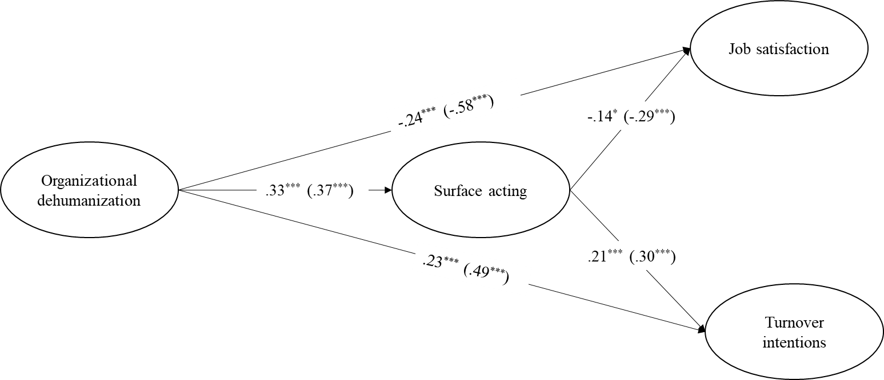
Note. Standardized coefficients for the mediation model (Sample VN, N = 235). Standardized coefficients are into parentheses for the UK sample (N = 334).
*p < .05. ***p < .001.

Figure 2
Relationship Between Organizational Dehumanization and Outcomes as a Function of the Country
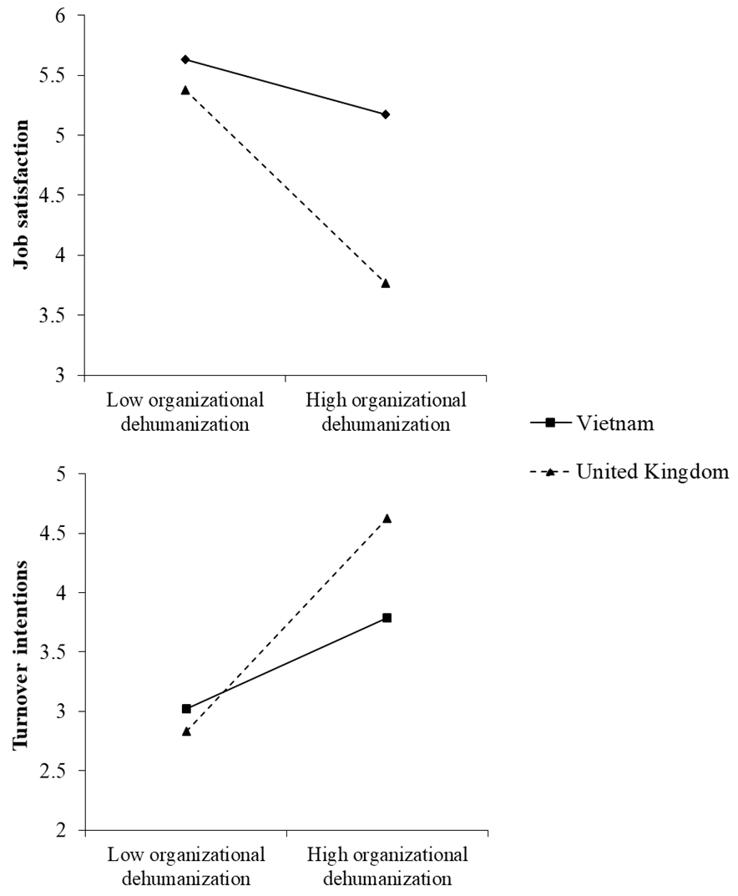
Note. The slopes for the relationships between organizational dehumanization and job satisfaction and turnover intentions were statistically significant for Vietnam (B = -.23, p < .05 and B = .39, p < .001, respectively) and the UK (B = -.82, p < .001 and B = .91, p < .001, respectively). In addition, the slopes were found to be different from each other (t = -4.76, p < .001 and t = 3.49, p < .001, respectively).

Figure 3
Relationship Between Surface Acting and Outcomes as a Function of the Country
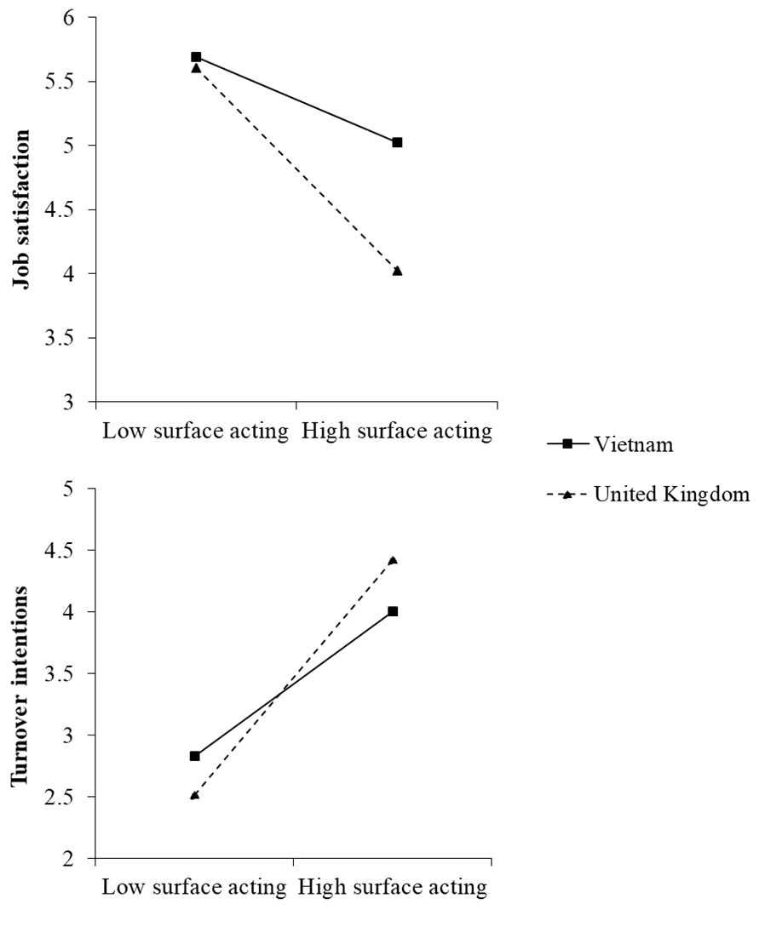
Note. The slopes for the relationships between surface acting and job satisfaction and turnover intentions were statistically significant for Vietnam (B = -.25, p < .001 and B = .44, p < .001, respectively) and the UK (B = -.60, p < .001 and B = .72, p < .001, respectively). In addition, the slopes were found to be different from each other (t = -3.20, p < .01 and t = 2.25, p < .05, respectively)

To preclude any effect of employees’ job sectors, we performed a series of mixed models following the procedure of Judd, Westfall, and Kenny (2017). Specifically, participants and individuals’ job sectors were assigned as random factors, and organizational dehumanization was included as a fixed factor. Surface acting, job satisfaction, and turnover intentions were assigned as the dependent variables. The analyses showed a significant fixed effect of organizational dehumanization on surface acting (F(1,56) = 1.859, p < .01), job satisfaction (F(1,56) = 1.975, p < .001), and turnover intentions (F(1,56) = 1.639, p < .01), suggesting that organizational dehumanization impacts surface acting, job satisfaction, and turnover intentions above and beyond employees’ job sectors.
Here again, we performed a series of mixed models following the abovementioned procedure to preclude any effect of employees’ job sectors. The analyses indicated a significant fixed effect of organizational dehumanization on surface acting (F(1,63) = 1.987, p < .001), job satisfaction (F(1,63) = 4.789, p < .001), and turnover intentions (F(1,63) = 4.523, p < .001). Overall, these results suggested that organizational dehumanization influences surface acting, job satisfaction, and turnover intentions above and beyond employees’ job sectors.

