Virgil’s Visions of Sin: quisque suos patimur manis (Aen. 6.743)

Aeneid 8.18–21

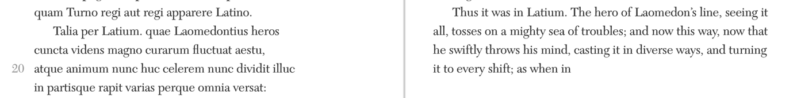

Why is Aeneas here called “Laomedonean hero”? Note use of “Laomedonean” by Calaeno the harpie after Aeneas’ ruse (3.247–57), Dido’s use to describe perjured Aeneas (4.541–2 nescis heu, perdita, necdum / Laomedonteae sentis periuria gentis?), narrator’s use for Trojans focalized through Rumour in Latium (7.104–106). Evander will speak, more correctly, of “Priam the son of Laomedon” (8.158 Laomedontiaden Priamum).

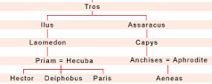

Virgil, Georgics 1.498–506

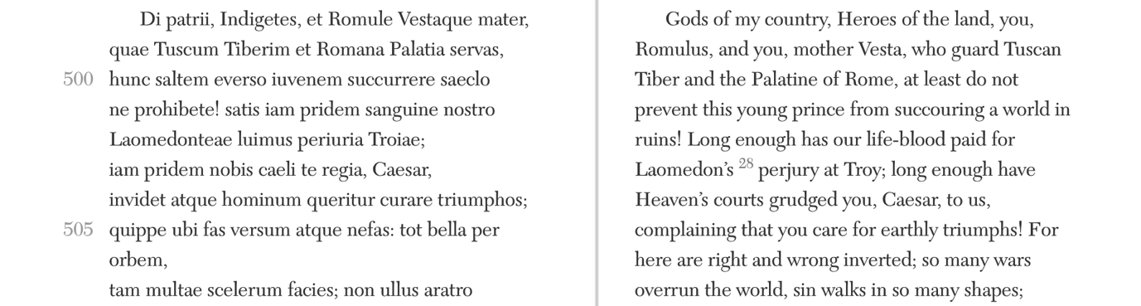

Virgil, Eclogues 4.8–15, 31–38

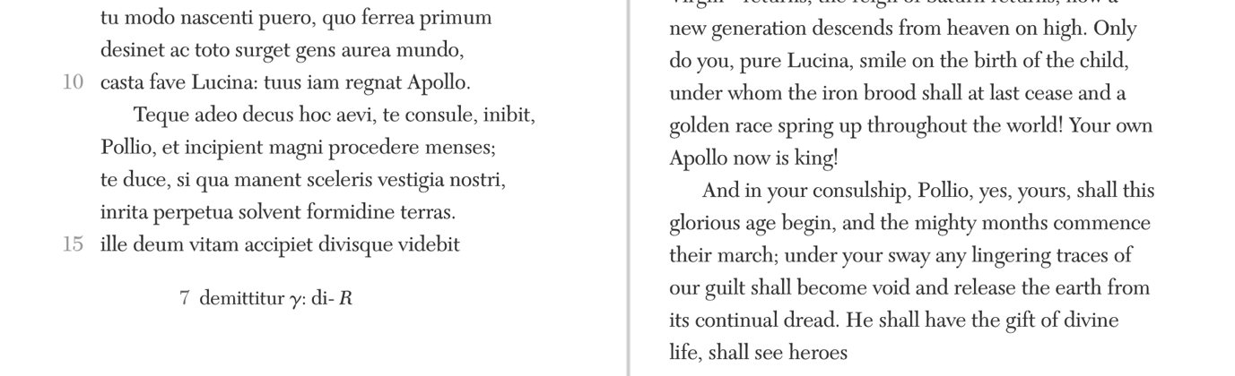
--
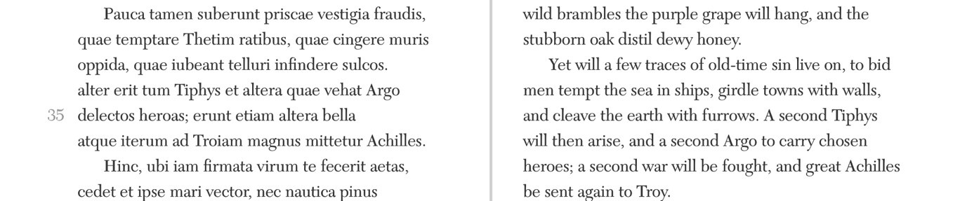

Aeneid 5

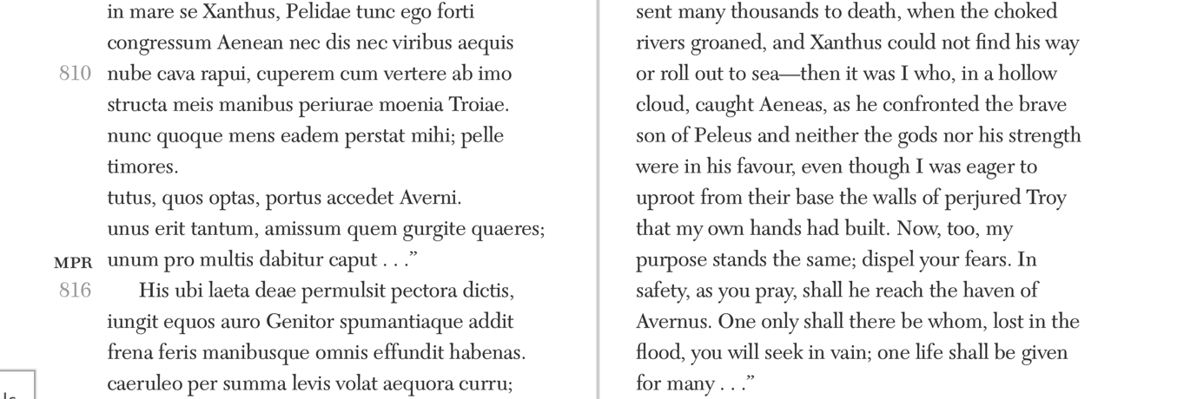

Horace, Odes 1.2

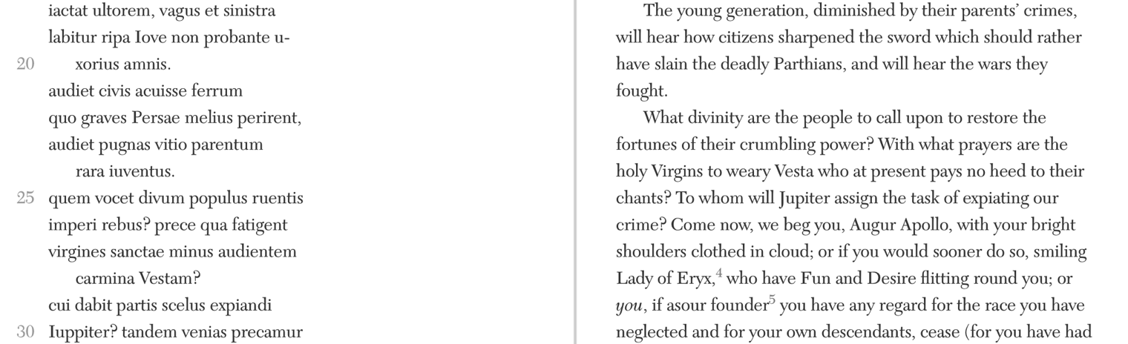
--
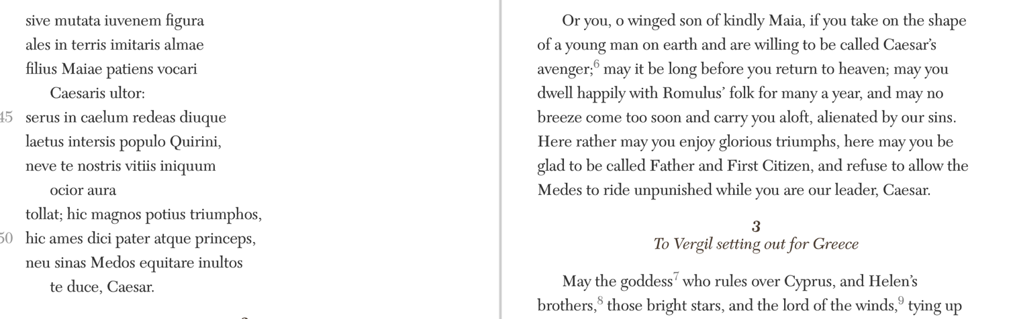

Horace, Odes 3.30

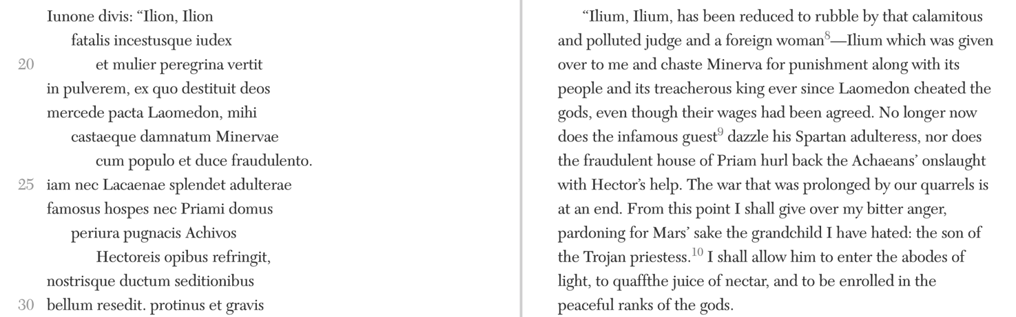

Horace, Odes 3.6
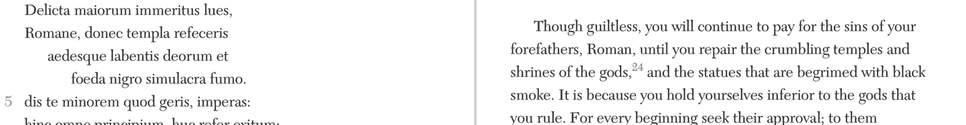
--
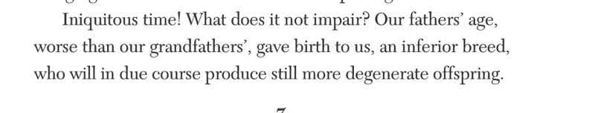
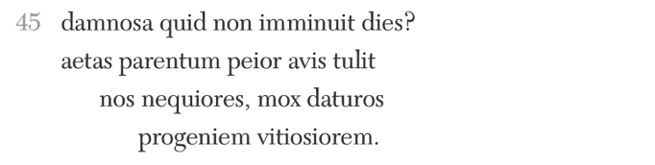

Cf. Homer Iliad 20

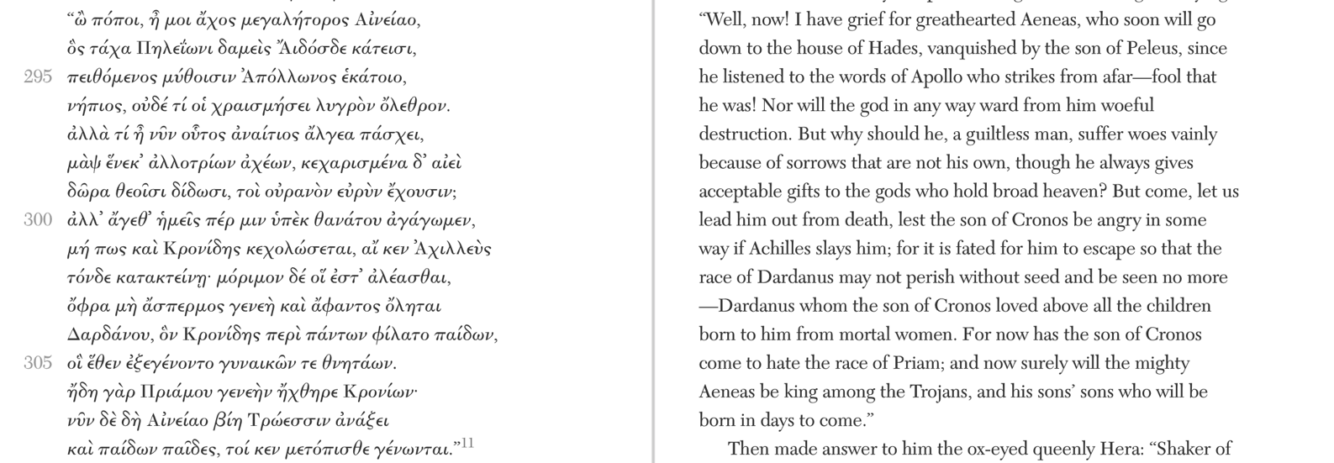

—immeritus lues, Romane < ‘But why should he, a guiltless man (ἀναίτιος), suffer vainly’

Horace Odes 3.30
1 Exegi monumentum aere perennius, “I have erected a monument more lasting than bronze . . . one which neither rain nor the ungovernable North Wind can ever destroy…” 11 et qua pauper aquae Daunus agrestium / regnavit populorum, “[I shall be spoken of] where Daunus, short of water, ruled over a country people…”

—Laomedon < Λαομέδων ‘ruler of his people’ >>> regnavit populorum

Empedocles B 115 (West)
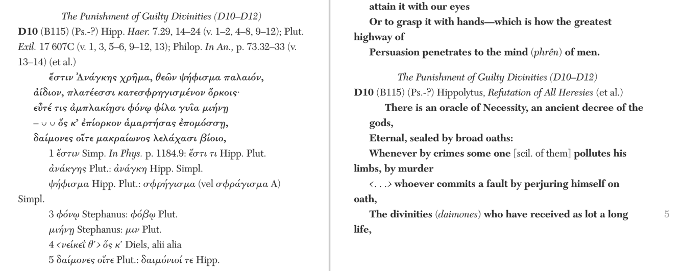
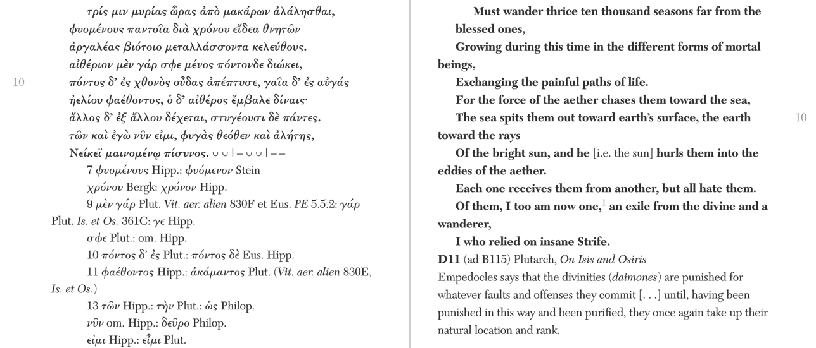

“The only point I want to underline is that a fault is placed at the beginning of the daimôn’s descent into matter and the cycles of reincarnation, and the long succession of births over innumerable generations is imagined as an atonement for that ancient transgression . . . Whatever the case, the fault is presented as a perjury in the next line, the breaking of an oath . . . The Katharomoi uses these and other elements of earlier and contemporary poetic tradition to build its unique, profoundly original image of an ancient crime extending its taint through the rebirths of many generations—a deeply unfamiliar reworking of tradition.”
—Renaud Gagné, Ancestral Fault in Ancient Greece, 2013, pp. 461–3

Homer Iliad 21.441–460 (Neptune to Apollo)
“Neither rememberest thou all the woes that we twain alone of all the gods endured at Ilios, what time we came at the bidding of Zeus and served the lordly Laomedon for a year's space at a fixed wage (μισθῷ ἔπι ῥητῷ), and he was our taskmaster and laid on us his commands. I verily built for the Trojans round about their city a wall, wide and exceeding fair, that the city might never be broken; and thou, Phoebus, didst herd the sleek kine of shambling gait amid the spurs of wooded Ida, the many-ridged. But when at length the glad seasons were bringing to its end the term of our hire, then did dread Laomedon defraud us twain of all hire, and send us away with a threatening word (ἀπειλήσας δ᾿ ἀπέπεμπε). He threatened that he would bind together our feet and our hands above, and would sell us into isles that lie afar. Aye, and he made as if he would lop off with the bronze the ears of us both. So we twain fared aback with angry hearts, wroth for the hire he promised but gave us not. It is to his folk now that thou showest favour, neither seekest thou with us that the overweening Trojans may perish miserably in utter ruin with their children and their honoured wives."

Stephanie West, “Lycophron Italicised”, JHS 1984, p. 151
‘Hindsight as foresight makes no sense’, comments Auden , à propos of the Aeneids prophecies of Augustan splendour, ‘Wouldn't Aeneas have asked “What next? After this triumph, what portends?”’ If Cassandra's predictions suggest a like question, Lycophron's first readers should not have been at a loss for an answer. The era which opened with Heracles' vengeance on Laomedon's perjury (33) was over; a new age was beginning. A king who traced his descent from Heracles reigned in the land of the righteous Proteus (128 ff.), where an Argive princess had become a great goddess (1291-4) and where, as anyone familiar with Herodotus would suppose, the brightest hopes might be entertained of the harvest to be expected from the intermingling of Greek and Oriental cultures made possible by Alexander's conquests and encouraged by his example.

Sib. Or. 3.411–413
σήματα δ’ οὐκ ἀγαθοῖο, κακοῖο δὲ φύσεται ἀρχή.  παμφύλου πολέμοιο δαήμονας ἕξει ἄνακτας,  Αἰνεάδας *διδούς* αὐτόχθονος, ἐγγενὲς αἷμα.  ἀλλὰ μεταῦτις ἕλωρ ἔσῃ ἀνθρώποισιν ἐρασταῖς.  Ἴλιον, οἰκτείρω σε· | And not signs of good But a beginning of evil shall be made; The baneful violence of general war Ye'll have, sons of Æneas, Dative blood Of Ilus from the soil. But afterwards a spoil shalt thou become for greedy men. O Ilium, I pity thee;

Augustine, City of God 2.3
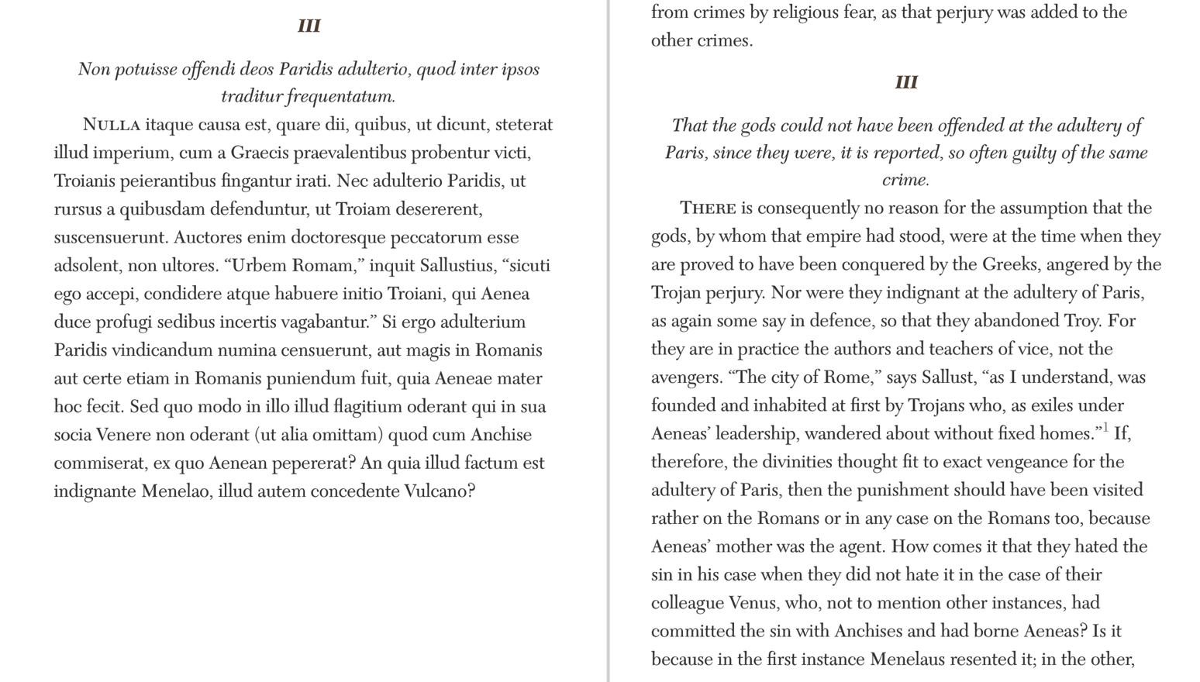
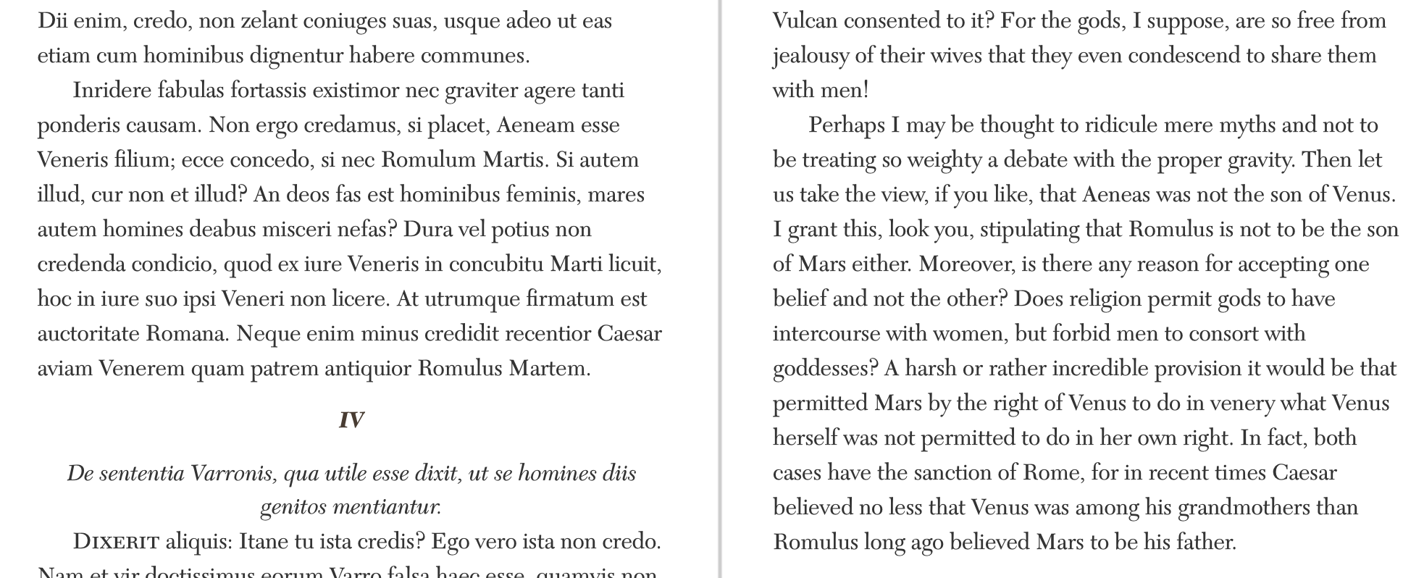

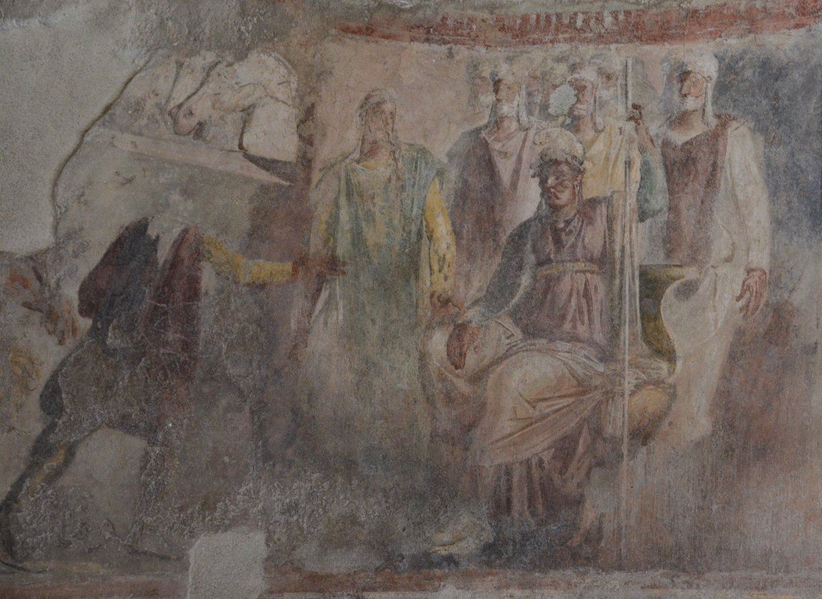

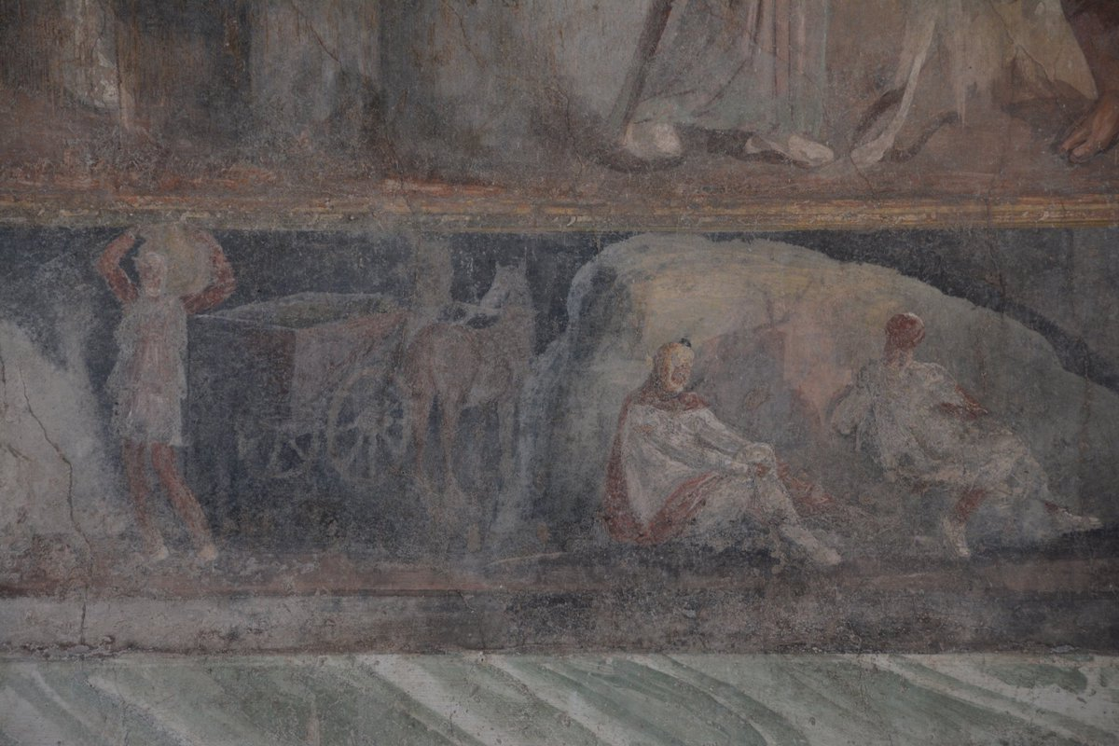
Hercules' battle with Laomedon (?) , and scenes of Trojan fighting, House of Loreius Tibutinus, Pompeii

