Chapter 7
Journalistic Roles: How do Journalists Think about Their Roles in Society?
Author 1, Author 2, Author 3,…

Introduction
When the United Nations addresses the role of journalism in the world, it typically stresses journalism’s capacity to foster democracy, dialogue and development. The news media gives people access to the information they need to make critical decisions about their lives, argued Secretary-General Ban Ki-moon in his message for the World Press Freedom Day in 2012: The media “holds leaders accountable, exposes corruption, and promotes transparency in decision-making.” These are standards recognizable around the world for the roles journalists should seek to perform in society. They are seemingly universal, but it would be misguided to assume that journalists everywhere agree on these norms or value them in comparable ways. Democracy might be a touchstone in places in the Global West, just as development might be the journalistic raison d’être in parts of the Global South. This chapter explores this issue – looking for points of agreement and disagreement in how the world’s journalists think about their social roles and examining those factors that might explain commonalities or differences.
Journalists often think about their social role when they are faced with particular, local situations that seem to require a journalistic response. Given that these situations are indeed local, we should probably expect that journalists in different parts of the world would tailor their role to the particular situations they face. Thus, we should expect to see a rich variety of journalistic roles around the world. However, what about situations where journalists in different parts of the world face similar phenomena and must think about their role? Will diverse journalists converge on a shared understanding of the journalistic role? A case in point is the US, where journalist and media observer Tom Rosenstiel (2016) argued: “We need journalists to watch for public malfeasance, stealing, corruption, law breaking, private enrichment, rewarding friends, and abuse of power. Even in the era of declining trust in media, this role—the journalist as investigator—still gets high marks.” However, journalists in parts of the developing world face these abuses of power regularly. Do they also call for an investigator role? Some journalists likely do. But, take, for example, the Ghanaian journalist Mahama Haruna (2009), who argues journalism in his country must be a check on “blackmail, intimidation, tyranny and an agent of confusion, conflicts, anarchy and chaos” and serve as an instrument of “national development.” We might conclude from these contrasting positions that journalists – even when confronted with similar challenges – might think about their roles in ways that are situated within local, historical contexts.
Thus, this chapter examines the interpretative repertoires journalists employ when they think about journalism’s place in society. We will survey journalistic roles as markers of journalism’s professional identity, focusing on tensions arising from a co-existence between institutional universality and global cultural diversity. An institution implies a shared set of norms, practices, and outlooks (Parsons, 2007). This chapter puts this assumption of shared roles to the test – looking for both common and divergent journalistic roles around the world, as well as for similar and different hierarchies of journalistic roles. Thus, the results of the analysis here will have implications for how we think about journalism as a social institution.

Normative roles of journalists around the world
Perceptions and articulations of journalistic roles have long been central to the understanding of journalism and its comparative study. Journalists define their social roles in various ways, which helps them place their work within a framework of meaning (Aldridge & Evetts, 2003). As we live in a time when journalistic ideals have become more ambivalent and liquid after the turn of the century (Koljonen, 2013), the study of journalistic roles has become more dynamic and relevant than ever. Consistent with the overarching theoretical framework laid out in Chapter 2, we conceptualize journalistic roles as discursively constituted. As structures of meaning, they set the parameters of what is appropriate and desirable in the institutional context of journalism. Journalistic roles are never static; they are subject to discursive (re)creation, (re)interpretation, appropriation, and contestation. In the context of struggles over professional jurisdiction, the discourse of journalistic roles legitimizes certain norms, ideas and practices and delegitimizes others. At the core of this discourse is journalism’s identity and locus in society (Carlson, 2017; Hanitzsch & Vos, 2016, 2017).
Journalists generally articulate and enact journalistic roles on four analytically distinct levels: normative and cognitive role orientations, and practiced and narrated role performance (Hanitzsch & Vos, 2017). These categories capture conceptually distinct ideas: what journalists ought to do, what they want to do, what journalists do in practice, and what they think or say they do. Journalistic orientations may not always and certainly not fully translate into real practice, especially when external factors constrain journalists’ editorial autonomy. A number of studies do indeed point to a “gap” between the roles journalists aspire to and the roles they execute in practice (Mellado & Van Dalen, 2014; Tandoc, Hellmueller, & Vos, 2013). At the same time, however, there is substantive evidence pointing to a robust correlation between journalists’ attitudes and practices (Kepplinger, Brosius & Staab, 1991; Patterson & Donsbach, 1996; van Dalen, de Vreese, & Albæk, 2012).
For the Worlds of Journalism Study, we paid particular attention to role orientations, by which we refer to discursive constructions of the institutional values, attitudes and beliefs regarding the position of journalism in society. These orientations can be normative and cognitive. Normative roles indicate what is generally desirable to think or do in a given context (Schmidt, 2008). Norms appear external to individual journalists; they encompass generalized and aggregate expectations that are deemed desirable in society (Donsbach, 2012). Normative roles speak to how journalists are expected to meet the aspirations and ideals of the general public.
Siebert, Peterson, and Schramm’s (1956, p. 1) premise that journalism’s normative core “always takes on the form and coloration of the social and political structures within which it operates” still seems plausible today. This is because normative roles are generally discursively negotiated between journalists and actors within other social institutions (Vos, 2016). Articulated from within western notions of democracy, most normative approaches emphasize individual liberties and freedom. Christians et al. (2009), for instance, identified four principal normative roles of journalists: monitorial, facilitative, radical, and collaborative. Many societies in the Global South may prioritize collective needs and social harmony (Mehra, 1989). In developing and transitional countries, journalists are often expected to act in the capacity of nation builders, partners of the government, and agents of empowerment (Romano, 2005). From a comparative point of view, conceptualizations of normative roles need to account for such diversity – by including roles that emphasize socio-economic development and partnership with government as well as roles related to the management of self and everyday life (Hanitzsch & Vos, 2016).
Hence, normative roles of journalists refer to larger public expectations about the way journalism should serve society. These expectations are articulated both in professional discourse and in broader conversations about the desirable place of journalism vis-à-vis the larger public. The Worlds of Journalism Study provides us with an unprecedented opportunity to examine the global panoply of journalists’ normative roles. Typically, survey researchers mention a number of specific roles to journalists and ask them to indicate the extent to which they feel these roles are important. While we adopted a similar technique for cognitive roles (discussed later in this chapter), we used a more flexible strategy for the study of normative roles. During each interview, we invited respondents to name, using their own words, the three most important roles journalists should play in their countries. This way, we were able to capture journalists’ interpretative repertoires by which they describe journalism’s place in society.
This strategy produced a wealth of complex data. Overall, we compiled more than 70,000 entries from 20,638 respondents. Not all journalists had responded to the question, while others mentioned fewer than three roles, and several respondents named even more than three roles. In an attempt to reduce complexity, we eliminated responses that were not related to journalistic roles specifically but to professional standards and practices more broadly, such as mentions of “neutrality”, “impartiality”, “accuracy”, “objectivity” and “honesty”. We then inductively coded the remaining 45,047 entries into 41 distinct normative roles, following a dictionary informed by both the academic literature and the coding itself (e.g., Hanitzsch & Vos, 2016). It took us several iterations to arrive at a sufficiently consistent way of coding.
Figure 7.1 presents a visualization of the 41 roles in terms of their relative importance. Larger words indicate that the interviewed journalists had mentioned these roles more frequently. Since differences between the most popular roles and those rarely mentioned by the journalists loom extremely large, we applied a square-root transformation to the frequencies. This allows us also to visualize the roles less prominently featured by the interviewed journalists.

===Figure 7.1===

The results impressively show that it is still the “classic” concepts – journalists acting as “informers”, “reporters”, “watchdogs”, “investigators”, “monitors”, and “educator” – that are dominating the global imagination of journalists. These six normative roles account for half of the total number of answers (50%). This indicates that, journalism’s basic professional premises, at least in the view of the journalists, remain relatively unchanged – despite its ongoing transformation. Furthermore, normative roles closely related to the news media’s contribution to political discourse continue to reign, which marks a notable contrast to journalism’s growing relevance for and contribution to everyday life and the management of self (Eide & Knight, 1999; Hanusch & Hanitzsch, 2013). Roles such as the “service provider”, “marketer”, “adviser”, and the “inspiratory” are still largely underplayed. Professional and public discourse tends to brand these roles as the unworthy “other”, often placed in the context of increasing commercialization in the media, which is why many journalists may have found it hard to acknowledge them as normatively desirable roles (Hanitzsch & Vos, 2016).
These responses thus impressively demonstrate that journalists still see their normative roles primarily in the political arena – a finding that is consistent across the countries investigated. The total proportion of political roles mentioned by the journalists was larger than 80 percent in all investigated countries. The monitorial capacity of journalism as an institution to hold ruling powers to account is slightly more pronounced in democratic societies, but it is also undisputed in less democratic contexts. A larger number of journalists in China, for instance, mentioned the “collaborator” role (33%), yet many of them also subscribed to the idea of journalists acting as “monitors” (35%). This is not necessarily a contradiction. Party leaders have actively promoted a media watchdog role to reassert control over a partly dysfunctional bureaucracy. By calling individual transgressors to account, watchdog journalism may even strengthen the Party’s legitimacy for policing the political, economic, and social boundaries of an authoritarian market society (Yuezhi, 2000).
The “educator” is the only frequently mentioned role that journalists in non-western countries mentioned more often than their colleagues in the western world (22 vs. 12%, respectively). Journalists in many Asian and African countries strongly emphasized a pedagogical role, through which journalists raise public awareness and knowledge about social issues (Statham 2007), most notably in Indonesia and the Philippines as well as in Botswana, Kenya and Sierra Leone. Germany was the only western country where a significant proportion of journalists (27%) mentioned the “educator” role, which they did mostly in reference to the German term “Aufklärung”, a notion that also carries a meaning usually connected to “enlightenment”.
While Figure 7.1 very much reflects the dominant discourse about the kind of roles that publics expect journalists to perform in society, it also pinpoints a number of roles rarely mentioned in both the academic literature and public conversation. Examples are roles related to the development of public opinion, with journalists acting in the capacity of an “opinion guide”, “commentator”, “analyst”, or “debater”. Other examples are: journalists who argue for a role as the “people’s voice” through giving a voice to the socially disadvantaged (Janowitz, 1975); the “chronicler”, who takes note of recent history to be stored in collective memory; and the “mediator” by reducing social tensions and mediating between rival groups (McQuail, 2000).
We also discovered that, especially in non-western countries, many journalists articulated a normative demand for intervention in social processes and for a more constructive attitude toward ruling powers. Emblematic of social intervention is the role of the “change agent”, which was also found in other studies (Chan, Pan & Lee 2004; Hanitzsch 2011; Pintak 2014). These journalists do not only report on social grievances but also actively promote measures to remedy those problems and thus drive political and social reform. Such a normative demand was reported particularly from Bangladesh, India and Ethiopia. In these and several other countries, journalists also emphasized the importance of a “facilitator” role, which refers to a journalistic approach foregrounding the media’s constructive support of the government’s efforts to achieve commonly shared social goals, such as social and economic development (Romano, 2003; Wong, 2004). In some political contexts, such as in China, such a stance may ultimately lead to acceptance of government objectives, expressed by the role of the “collaborator”. It should be noted, though, that a constructive role for journalism is also increasingly propagated in the West (see Haagerup, 2014).
Overall, this first analysis demonstrates that the normative core of journalism around the world is still invariably built on the news media’s contribution to political processes and conversation, while other areas, such as the management of self and everyday life, remain marginalized. In a time when, in many parts of the world, the institution of journalism faces existential challenges and calls for reinvention (Waisbord, 2013), its fundamental professional ideology, as articulated by the journalists, still seems to be surprisingly intact. We wondered, however, about the extent to which these normative premises are reflected in journalists’ cognitive roles.

Cognitive roles of journalists: monitorial, collaborative, interventionist and accommodative
Cognitive roles of journalists are the institutional values, attitudes and beliefs journalists embrace as a result of their occupational socialization. While normative roles articulate a framework of desirable practice, cognitive roles represent the journalists’ own professional aspirations and ambitions. As a discourse shared by journalists, these roles tend to appear as evident, natural and self-explaining; they act as markers of professional identity (Aldridge & Evetts, 2003; Schultz, 2007). In this capacity, cognitive roles often serve to maintain the boundaries of professional jurisdiction: between journalists working for institutional news media on the one hand, and producers of user-generated contents who merely reproduce the discursive techniques of journalism on the other.
No overview can do justice to the large body of research on cognitive roles. Early studies in the United States cultivated a distinction between neutral and gatekeeper vs. participant and advocate roles (Cohen, 1963; Janowitz, 1975). Weaver and Wilhoit (1996) suggested an influential classification into four roles, disseminator, interpreter, adversarial, and populist mobilizer. The application of their questionnaire to a variety of countries has culminated in two seminal collections documenting the professional attitudes of journalists around the world (Weaver, 1998a, Weaver & Willnat, 2012). Both volumes point to substantial cross-national differences in journalists’ role orientations, which clearly speaks against the idea of a universal understanding of journalistic roles institutionalized in journalism globally. The previous Worlds of Journalism Study has arrived at very similar conclusions, finding major differences in the extent to which journalists want to involve themselves in social matters (Hanitzsch et al., 2011). In this chapter, we argue that cross-national differences in cognitive journalistic roles are primarily related to the way journalists emphasize four general role dimensions in their work: monitorial, collaborative, interventionist, and accommodative roles.
The monitorial role sits at the heart of journalism’s core identity in all developed democracies, but also in many less democratic societies. This role is broadly grounded in the ideal of journalism acting as “Fourth Estate,” with journalists voicing criticism, holding those in power to account and, in so doing, creating a critically minded citizenry (Christians et al., 2009; Hanitzsch & Vos, 2016). The legitimacy of journalists to act in a monitorial role is most strongly anchored in journalism’s institutional position vis-à-vis political authorities. Journalists may exercise this function in a more or less active fashion. They might act as critical observers of institutional conduct (e.g., political decisions), responding to transgression as they become aware of it. Journalists may also pro-actively investigate and scrutinize government claims and gather information about issues they conceive of as suspicious (Meyen & Riesmeyer, 2012; Weaver & Wilhoit, 1996). Watchdog journalism is even more assertive; journalists who embrace this mode provide an independent critique of society and its institutions (McQuail, 2000). An important function of monitorial journalism is the mobilization of citizens to participate in political activity (Weaver et al., 2007). Journalists may act as agents of empowerment (Romano, 2003) by framing the news “in a way that invites people into civic activity and political conversation” (Rosen, 2000, p. 680).
A collaborative role, on the other hand, entails an understanding of journalists acting as partners of the government and supporting it in their efforts to bring about development and social well-being (Christians et al., 2009; Hanitzsch, 2007; Hanitzsch & Vos, 2016). This role dimension calls on journalists to support authorities in defense of the social order against threats of crime, conflict and natural emergencies (Christians et al., 2009). In this capacity, journalists may actively defend the government and its policy through acting as “propagandists” (Pasti, 2005, p. 99), or as “agitators” (Wu, Weaver & Johnson, 1996, p. 544). As facilitators, journalists may voluntarily assist the government in its efforts to maintain social harmony and advance socio-economic development (George, 2013; Wong, 2004) – an approach that often emphasizes nation-building and the preservation of national unity (Pintak & Nazir, 2013; Romano, 2003). Furthermore, journalists may see it as their responsibility to provide legitimacy to the government by explaining political decisions to the people and guiding public opinion (Lee, 2001), e.g., in the tradition of the Mexican “oficialista” (Hallin, 2000, p. 99). In such a “mouthpiece” role, journalists remain markedly paternalistic toward “the people”; they ostensibly “improve communication” between officials and citizens (Chan & So, 2005, p. 73), thus ultimately contributing to the consolidation of power inequalities in society.
An interventionist role is characterized by a strong disposition of journalists to pursue a particular mission and promote certain values. Interventionist journalists are typically involved, socially committed, and motivated to involve themselves in social affairs (Hanitzsch, 2007). They tend to conceive of themselves as “participants” in political life rather than as objective bystanders. Journalists may act in the capacity of advocates of particular groups and causes, missionaries for certain values and ideologies, facilitators of national development, and as agents for change. Journalists may consider themselves as spokespeople for specific societal groups and their causes, or – more generally – for the socially disadvantaged (Janowitz, 1975). Identification with a particular group is at the core of advocacy journalism, with journalists acting as campaigners, as “lobbyists”, as a “voice for the poor” (Pintak & Nazir, 2013, p. 649). Journalists acting as “missionaries” often propagate particular ideals, values, and ideologies (Köcher, 1986) or support specific causes, such as the preservation of Arabic culture or the interests of Palestinians (Ramaprasad & Hamdy, 2006). Especially in transitional and developing societies, journalists also advocate for social change and drive political and social reform (Chan, Pan & Lee, 2004; Hanitzsch, 2011; Pintak, 2014). As agents of change, journalists typically emphasize quality of life, social equity, citizen participation in public life, and human development (Romano, 2005). In such a capacity, journalists would try to change society to what it might become, rather than just mirroring social reality (Wasserman, 2013).
The accommodative role, finally, entails an understanding that is – among all four role dimensions discussed here – most strongly oriented towards audience members as consumers, most notably – though not exclusively – through providing orientation for the management of self and everyday life. Journalists who embrace an accommodative role strive to provide their audiences with the sort of information most appealing to the public. This could be consumer journalism, featuring various kinds of commercial products and patterns of leisure-time activities, or more generally help, advice, guidance, and information about the management of everyday life through “news-you-can-use” content (Eide & Knight, 1999; Underwood, 2001). This role of journalism has become important in a time and in places where identity work has become an individual exercise and traditional social institutions fail to provide collective orientation in an increasingly multi-optional society (Hanitzsch & Vos, 2016; Hanusch & Hanitzsch, 2013). Journalists do not only contribute to affect regulation (e.g., by providing entertainment and relaxation content), they can also stimulate rewarding social and cognitive experiences that contribute to emotional well-being in more complex and sustainable ways, e.g., by fostering a sense of insight, meaning, and social connectedness (Bartsch & Schneider, 2014).
These four dimensions, we believe, provide a useful framework to account for the global diversity of journalistic roles. Each of these dimensions captures a variety of distinct journalistic roles that share a number of similarities. The interventionist dimension, for instance, includes roles such as the advocate, missionary, facilitator, and agent of change. What these four roles have in common is a strong journalistic disposition toward involvement and social commitment. Furthermore, we argue that the way the role dimensions relate to one another reveals a theoretical structure of higher order (see Figure 7.2). The monitorial role, for instance, is likely to be inversely related to the collaborative role. Journalists who strongly embrace a monitorial understanding may arguably not be very keen to support the government. The underlying theoretical link, we believe, is power distance, here defined as the locus of journalism vis-à-vis the power center in society (Hanitzsch, 2007). Journalists who maintain considerable distance from authorities are more likely to embrace a monitorial role, while their colleagues closer to power centers in society may tend to see themselves as collaborators or partners of authorities.

===Figure 7.2===

Likewise, an interventionist role, which calls on journalists to transform society, may often be at odds with an accommodative role, which strongly appeals to the taste of the audience. The underlying theoretical link seems to be the source of journalists’ determination of communication goals. Self-determined journalists define those goals (e.g., a better society) in their own intellectual and professional terms, while other journalists may ground communication goals more strongly in perceptions of audience demands. Bourdieu (2005, p. 42) has suggested that both approaches result from tensions between an “intellectual” and “commercial pole” of the journalistic field. On the intellectual pole, the journalistic logic is strongest, with journalists and media organizations forming public debate rather than merely reflecting it. On the other side of the field, societies tend to construe journalism’s contribution as a service to the audience, though not necessarily out of commercial motives. Journalists embracing an accommodative role thus emphasize the needs and desires of the audience, or what they believe them to be. Interventionist journalists, by way of contrast, depart from their own, personal aspirations and provide their audiences with the contents that they believe is critical to achieving social transformation.
These two higher-order theoretical dimensions, greater vs. smaller power distance and self-determination vs. audience determination, open up a relational space onto which we believe we can meaningfully map the cross-national diversity of journalistic roles. In such a “coordinate system”, we would expect the four role dimensions to correspond to vectors pointing into different directions.
Three qualifications are in order, however. First, we are not suggesting that theoretically linked role dimensions are mutually exclusive. The opposite of interventionism, for instance, is not an accommodative understanding but one that emphasizes detachment and non-involvement (Hanitzsch, 2007). Likewise, the opposite of a collaborative approach is not monitorial but adversarial journalism. Second, in the day-to-day routine of editorial work, journalists typically subscribe to multiple roles, often simultaneously. Hence, the above dimensions correspond to ideal types of journalistic roles; they are a necessarily parsimonious representation of a reality that is far more complex on the ground. Rather than subscribing to a single journalistic role in its pure form, we assume that journalists would discursively position themselves in a continuum between these ideal-type role dimensions. Third, and finally, the four dimensions outlined above represent differences in journalistic roles at the aggregate level of societies and may not replicate well at the individual level – a phenomenon often observed in cross-national comparisons (Welzel & Inglehart, 2016).
The results presented in this chapter are based on journalists’ subjective assessments of the importance of 18 specific professional roles. In the interview, the statements representing these roles were introduced to the journalists with the following question: “Please tell me how important each of these things is in your work.” Respondents were then asked to rate the importance of these roles using a scale ranging from 5 (“extremely important”) to 1 (“unimportant”). Table XXX in the Appendix presents an overview of journalists’ responses to the role statements, averaged per country along with standard deviations. With 67 countries covered, discussing each and every single aspect of journalistic roles would go beyond the scope of this book. For such analysis, we believe, a more targeted comparison of perhaps a few rather than many countries would be more insightful. For the purpose of this chapter, we therefore constructed four indexes based on the above theoretical considerations. Like other composite variables created for this book, these index measures should be considered formative rather than reflexive (see Chapter 3).
In technical terms, we computed the four role indexes by averaging the journalists’ responses to all indicators that belong to the same index (that is, the same role dimension). This strategy allowed us to retain the original scale of measurement, with a value of five pointing to maximum importance and a value of one representing no importance at all. Taken together, the four indexes contain 13 out of the 18 role indicators. The index covering the monitorial role was built from four statements, including “Provide political information”, “Monitor and scrutinize politics”, “Monitor and scrutinize business”, and “Motivate people to participate in politics”. The collaborative role index includes two indicators, “Support government policy” and “Convey a positive image of political leaders”, whereas the index representing an interventionist role contains four statements: “Advocate for social change”, “Influence public opinion”, “Set the political agenda”, and “Support national development”. The accommodative role index, finally, is based on three indicators, “Provide entertainment and relaxation”, “Provide news that attract largest audience” and “Provide advice, orientation and direction for daily life”.

Global trends: monitorial role is most highly appreciated
Table 7.1 presents an overview of journalists’ average responses to the 18 key aspects of journalistic roles along with overall mean scores for the four role indexes. Consistent with the previous Worlds of Journalism Study (Hanitzsch et al., 2010) and other comparative surveys (Weaver, 1998; Weaver & Willnat, 2012), the professional principles of realism, analysis, inclusiveness, and detachment seem to be canonic around the world. Across all investigated countries, journalists most highly appreciated roles such as “Reporting things as they are”, “Providing analysis of current affairs”, “Letting people express their views”, and “Being a detached observer”.

===Table 7.1===

Notably, journalists tend to embrace the detached observer role even in societies in which we found a relatively high regard for an interventionist or collaborative role. Table XXX in the Appendix, which reports a breakdown of average scores for all 67 investigated countries, demonstrates that this is particularly the case in several non-western countries. This finding points to a – sometimes latent, sometimes acute – conflict between a professional understanding journalists were trained into on the one hand, and a reality of journalistic practice on the other. The ideal of journalists acting as detached observers and objective bystanders has been developed in newsrooms in advanced industrialized societies and has subsequently been exported to large parts of the non-western world through institutional transfer, training and education as well as the diffusion of occupational ideologies (Golding, 1977). Owing to the economic and cultural hegemony of western media corporations, western capital and funding as well as media assistance programs, these values have become the global gold standard of news production. Journalists in the Global South obviously uphold these ideals even when they contradict the realities on the ground.
Aspects that relate to a collaborative or facilitative understanding of journalism’s role in society, however, received very weak support from the average journalist. Around the world, journalists demonstrated relatively little appreciation for roles such as “Conveying a positive image of political leaders” and “Support government policy”. Different from the more canonical roles reported earlier, the importance of government support and positive coverage is a controversial issue globally, as the large amount of cross-national variance indicates (43 and 34 %, respectively). Surely, one would hardly find any positive reference to these roles in textbooks for journalists; hence, journalists may find it difficult to articulate support for them even when they are enacted in professional practice.
Likewise, journalists in the vast majority of countries found an adversarial role relatively unappealing. “To be an adversary of the government” turned out to be popular in just a few countries, such as Egypt, Kosovo, and Thailand. Arguably, an adversarial understanding is journalism’s response to political and social ruptures that often create a strong public sentiment against the government. Egypt is a case in point. The surveys with Egyptian journalists were conducted in 2012, at a time when Muslim Brotherhood leader Mohamad Morsi was elected 5th president of Egypt by a slight margin. Public opinion and the country’s intellectual environment were divided over his presidency at a time of heightened political polarization. The news media, enjoying unprecedented freedoms after the 2011 revolution, became a battleground for both revolutionary and counterrevolutionary forces (Alexander & Aouragh, 2014). In June 2013, massive public protests, supported by highly adversarial media coverage, finally led to Morsi’s removal from office by General Abdel Fattah el-Sisi.
Kosovo, where interviews took place in 2014 and 2015, is another example. Journalists in the country turned strongly adversarial after the two competing major political parties, the left-leaning Democratic Party of Kosovo (PDK) and right-leaning Democratic League of Kosovo (LDK), formed a governing coalition following an inconclusive parliamentary election in 2014. The alliance between the two parties, together covering a broad ideological spectrum from the left to the right, effectively annihilated political opposition except for smaller parties voicing ethno-nationalistic policies. In a heated political climate – mostly due to chronic public discontent with ineffective governance and continuing hostilities between Kosovo’s ethnic Albanian and Serb populations – the media became the only true opposition in the country’s political landscape.
Space does not allow for a detailed discussion of cross-national similarities and differences for all 18 aspects of journalistic roles as measured by the Worlds of Journalism Study. In the following, we will thus focus our analysis on the four role dimensions, monitorial, collaborative, interventionist, and accommodative. Table 7.1 reveals a clear hierarchy of journalistic roles around the world. The monitorial role was most highly appreciated across the globe, though we found some considerable cross-national variation (national differences account for 16 % of the variance). At the same time, the unimodal distribution of mean scores in Figure 7.3 does not suggest strong differences between groups of countries.

===Figure 7.3===

This is clearly different for the collaborative role. As noted earlier, a collaborative understanding of journalism’s role via-à-vis society is indeed little appreciated by journalists worldwide. The extent to which journalists think that supporting government policy and conveying a positive image of political leaders is an important aspect of their job, however, varies considerably between countries, as Figure 7.3 illustrates. The distribution of country means is bimodal (or double-peaked), pointing to the existence of two larger clusters of societies. In a bigger group of countries, the collaborative role is strongly and fairly consistently disapproved by journalists, while in another, smaller group of societies, this role seems to have some notable appeal to those working for the news media.
The interventionist and accommodative roles are seen as almost equally important by journalists globally. Cross-cultural variation is much greater for journalists’ preferences for an interventionist role than for aspects associated with an accommodative role. For the latter, country differences account for 19 percent of the overall variation, while with almost 34 percent, cross-national variability looms much larger for interventionism. As Figure 7.3 shows, the distribution of country means for interventionist role yields a pronounced bimodal distribution. Societies broadly split into two groups – one in which journalists are strongly motivated by an interventionist attitude, and another group in which this aspect is much less pronounced. We explore these differences in the following section.

A global map of journalists’ professional views
For the sake of parsimony, we base the following analysis of cross-national similarities and differences on the four higher-order role dimensions identified above. Taken together, these roles – along with their empirical indicators – yield a relational space that seems to cover a great deal of the relevant cross-cultural differences in journalistic roles. In such a universe of professional dispositions, it makes sense to interpret journalists’ preferences for certain roles in relation to, or vis-à-vis, other roles. One methodological strategy to take advantage of relative dispositions is by centering a journalist’s responses on the overall mean across her or his ratings of all four role dimensions. This technique, also called ipsatization or within-subject standardization, has proved to be useful in a large number of cross-cultural comparisons using self-reported data (Fischer, 2004; Hofstede, 1980). Technically, centering converts raw scores provided by survey participants into relative scores, so that each centered score indicates the extent to which the journalist embraced a certain role more strongly than he or she tended to embrace others. Since centering can also eliminate some more substantive information from the data (Fischer, 2004), we interpreted centered scores in conjunction with the respective non-centered index scores. Table 7.2 therefore reports both types of information.
Figure 7.4 provides an intuitive sense of the relative similarities and differences between the 67 countries. Based on an adaptation of multidimensional scaling, the map visualizes similarities and differences between countries in relation to the four role dimensions. Since the figure was generated from centered mean scores, the origin of the four vectors (the role dimensions) represents the overall average (grand mean) for all countries across all role dimensions. Hence, the location of a country reflects a national hierarchy of journalistic roles relative to role hierarchies in other societies. This way, the logic of centering is applied to national aggregates of journalists’ responses. Each centered average score indicates the extent to which journalists in a national journalistic culture embrace a certain role more strongly than they tend to embrace others.

===Figure 7.4===

As can be seen from Figure 7.4, the representation of empirical similarities and differences between countries replicates the theorized relationships between the four roles dimensions and the two underlying dimensions. The angle between two vectors represents their correlation; hence, the monitorial role dimension is inversely related to the collaborative role, and the interventionist role dimension is negatively associated with the accommodative role. As reasoned above, two higher-order theoretical dimensions underpin the relationships between the four indexes. On the horizontal axis, the importance of a monitorial vis-à-vis a collaborative role maps onto higher vs. smaller power distance. A monitorial attitude corresponds to larger power distance, as journalists tend to see themselves as critical watchdogs holding powers to account. For journalists following a collaborative approach, power distance is smaller, as they conceive of themselves as partners of authorities with whom to work toward commonly shared goals (e.g., national development or unity). The vertical axis, representing an emphasis on an interventionist vs. an accommodative role, is conceptually connected to the determination of communication goals. Journalists in contexts with a strong emphasis on the accommodative role, such as in large parts of continental Western and Central Europe, tend to see themselves as providing a service to the audience (audience determination). Journalistic cultures in Latin America, on the other hand, place greater emphasis on the journalism’s autonomy in determining its communication goals (self-determination). In other words, in societies with greater self-determination, journalists report according to what they believe is crucial for their audiences, while audience-determination leads journalists to emphasize content that is needed or desired by their audiences.
Cross-national similarities and differences in Figure 7.4 do not point to clearly delimited clusters of countries, however, as cultural similarities are a matter of degree. Countries on the left side of the map, where power distance tends to be smaller, are slightly more coherent, while on the other side of the figure, societies seem to be more disparate. Generally, countries located to the left side of the figure represent politically restrictive environments. In the quadrant located to the lower right (between the arrows representing a monitorial and accommodative role), we find societies that tend to be socio-economically more developed than the countries in the quadrant to the upper left (between the vectors for an interventionist and collaborative role). Despite sometimes large-looming differences between western countries noted in several previous studies (e.g., Köcher, 1986; Patterson & Donsbach, 1996), journalistic cultures in these societies actually form a relatively coherent cluster. Most western journalistic cultures share an aversion to an overt collaborative and interventionist approach; they differ mostly in the relative emphasis placed on a monitorial vs. an accommodative role. Overall, the differences in the prioritization of journalistic roles in western countries shrink to relative similarity when positioned vis-à-vis global diversity.
As mentioned above, monitorial and accomodative roles do not necessarily contradict each other; journalistic cultures can embrace both a monitorial and accommodative role at the very same time. US journalism is a case in point, as its location in Figure 7.4 indicates. The drama and conflict built into the critical coverage of politics – the result of monitorial journalism – is highly appealing to a substantive proportion of the audience (Bennett, 2016). In other words, there is little ground to think that monitorial and watchdog news are inherently unattractive to audiences. Overall, the importance of the monitorial role is undisputed among journalists from all western countries. A major source of difference, however, is the extent to which journalistic cultures stress an accommodative role over an interventionist approach. Journalists in Spain, Portugal and Greece, for instance, have the most appreciation for the interventionist role compared to their colleagues in other western societies. Disparities between journalists in western European countries, which have a strong tradition of media regulation and public service broadcasting, seem to be related to different readings of the notion of “public service”. German, Austrian and Icelandic journalists, for instance, place their public mission more centrally in the context of detachment, objectivity, and “reporting things as they are” (see Table XXX in the Appendix). Their Danish and Swedish colleagues, by way of contrast, define their duties more in their own terms – looking at journalism as an institution critically contributing to the exercise of democracy.
Our analysis also provides further evidence for the existence of multiple paradigms under the larger conceptual umbrella of development journalism, thus challenging the idea of a single, unitary mode of journalism aspiring to contribute to national development (Edeani, 1993; Kalyango Jr. et al., 2016; Romano; 2005). From Figure 7.4, we can identify three distinct modes of development journalism: collaborative, interventionist, and monitorial.
The collaborative paradigm – sometimes discussed under the label of developmental journalism (Kunczik, 1988; Ogan, 1980) – frames development journalism as a practice in which journalists and state authorities work together as partners with the ostensive goal to bring about socio-economic development. Typically exercised in contexts where government maintains tight control over the media, its main responsibility is that of publicizing government policies, projects, statements, and activities (Edeani, 1993). In a number of Asian contexts, the collaborative paradigm is culturally connected to the promotion of social harmony and consensus (Wong, 2004). Singapore is emblematic of this approach, which the city state’s founding father, Lee Kuan Yew, neatly summarized in a 1971 address of General Assembly of the International Press Institute in Helsinki: “Freedom of the press, freedom of the news media, must be subordinated to the overriding needs of the integrity of Singapore, and to the primacy of purpose of an elected government.” Since then, open censorship has been largely replaced by self-censorship, achieved through economic disincentives against non-cooperation with the state. Through “calibrated coercion”, the government has achieved effective media control through creative legislation and exercising fine political judgment to maintain a press system that balances government interests, the profit motives of publishers, the professional needs of journalists, and the public’s demand for information (George, 2007). Frisch, Belair-Gagnon and Agur (2017) have observed a similar tendency, which they refer to as “media capture”, in Hong Kong after its handover to China.
The interventionist paradigm of development journalism calls on journalists to drive social reform and defend certain social, cultural or national values (e.g., in parts of the Islamic world). Through a high sense of professionalism, journalists assume a strong responsibility vis-à-vis the citizenry and help audience members not only to be well informed but also to be meaningfully educated, motivated, inspired, and moved into action (Edeani, 1993; Kalyango Jr. et al., 2016). In this context, journalists may act as agents of empowerment, foregrounding concepts of quality of life, social equity, citizen participation in public life and human development (Romano, 2005). In Figure 7.4, the interventionist branch of development journalism is exemplified by the Philippines. Notably driven by the pioneering work of Nora C. Quebral, Filipino scholars have been at the forefront of promoting development communication as a distinctive area of inquiry since the 1970s. Since then, development journalism has found an institutional stronghold at the University of the Philippines Los Baños, which soon established a Department of Development Journalism, and another Department of Development Broadcasting and Telecommunication.
The monitorial paradigm of development journalism, finally, combines elements of social interventionism with a strong monitorial component. As Figure 7.4 indicates, this approach is typical for many transitional democracies, including the post-communist societies in Eastern Europe. The monitorial branch of development journalism most strongly emphasizes a watchdog role that calls on journalists to highlight problems and weaknesses in government policies and performance, thus allowing for corrective action (Romano, 2005). Based on a separate analysis of South African journalists, de Beer (2016) argues that such blending of monitorial and “classic” development journalism powerfully challenges a long held traditional dichotomy propagated by liberal and developmental media theory, according to which journalists should either be watchdogs or developmental journalists but not both at the same time (see also Hanusch & Uppal, 2015, for a similar argument based on surveys with Fijian journalists). The evidence collected through the Worlds of Journalism Study clearly demonstrates that it is indeed possible for the media to fulfill both roles. Notably, journalism in Spain, Portugal and Greece come close to this paradigm, although it may sound slightly unconventional to group these societies under the label of development journalism. However, such classification becomes plausible considering the specific histories of these three southern European countries, which shook off their authoritarian heritage only in the 1970s.

Monitorial and collaborative roles
As noted above, the monitorial role tends to be emphasized more strongly in western societies than in the non-western world (see Table 7.2). The power of a monitorial approach in journalism is clearly related to democratic governance and the extent to which societies maintain political freedom. Monitorial journalism is most pronounced in Sweden and Denmark – countries that continue to lead international democracy and political freedom rankings (e.g., Economist Intelligence Unit, 2016; Freedom House, 2015) – as well as in the United States, where the watchdog function of the press is grounded in a liberal pluralist understanding, which envisions the media as essential to the creation and maintenance of a democratic republic. Historically, this has contributed to an unshakable and almost sacred commitment to journalism as the “Fourth Estate”, providing a necessary check on the government (Brennan, 2000).
The monitorial role is less emphasized by journalistic cultures in Africa (in Ethiopia and Kenya most notably), in the Gulf region (Oman, Qatar, and the UAE), and in large parts of East, South and Southeast Asia (particularly in China, Malaysia and Singapore). In these societies, journalists enjoy little political freedoms – obviously a prerequisite for the practice of monitorial journalism. This conclusion is also supported by the fact that Japan, South Korea and Hong Kong, where journalists and the news media enjoy some considerable freedom relative to other countries in the region, are the only Asian countries where the monitorial role is fairly appreciated. The results also show that growing restrictions on civil rights and political liberties are taking their toll among Russian and Hungarian journalists. Press freedom in Russia, as reported by Freedom House and Reporters Without Borders, has seen a continued decline since 2000 when Vladimir Putin was elected president. Although less dramatic, we observe a similar tendency in Hungary, a member state of the European Union. The country’s press freedom ratings continue to fall particularly since Viktor Orban, leader of the national-conservative Fidesz party, returned to power in 2010.
Journalists from Turkey, on the other hand, reported a relatively strong appreciation for the monitorial role, although the situation has likely changed after the survey was conducted in 2014 and 2015. Furthermore, journalistic cultures in South America seem to be divided about the importance of monitorial journalism. Journalists in Argentina and Brazil – two countries suffering from political and economic crises leading to massive street protests against the government – place greater emphasis on the monitorial role than do their colleagues in Chile, Columbia and Ecuador. This result is consistent with earlier findings suggesting that Latin American journalists have a more critical attitude, especially during moments of political tension (Mellado et al., 2012; Waisbord, 2000).
Overall, a monitorial role is much more pronounced among journalists in countries that provide journalists with greater media freedom and democratic liberties as well as in societies where emancipative values play a more significant role. This role can thrive best in societies where journalists enjoy greater editorial autonomy and experience smaller political, economic and organizational influence. Table 7.3 reports a series of correlation analyses on the contextual level for each of the four role dimensions. The results clearly indicate that while democracy is not a precondition for journalism to exist, journalists need democratic and media freedom to exercise a monitorial role. Figure 7.5 convincingly illustrates the close relationship between the prevalence of the monitorial role and democratic performance. The strong relevance of socio-cultural value orientations is also consistent with results from a previous study (Hanitzsch, Hanusch & Lauerer, 2015). The global drift toward “emancipative values” is believed to give rise to post-materialist values such as individual autonomy, self-expression, and free choice and, ultimately, to promote greater emancipation from authority (Inglehart & Welzel, 2005). Clearly, maintaining distance between journalism and social institutions central to the exercise of power (such as the government and political parties) – in other words, greater emancipation from authority – is at the heart of monitorial journalism.

===Figure 7.5===

The global spread of the collaborative role broadly shows the opposite picture in comparison with the monitorial role, the latter one being less pronounced in most western developed democracies, in large parts of East Europe, and in Japan. Supporting government policy and providing a positive image of political leadership is most strongly appreciated by journalists in countries that are socio-economically less developed, in political climates that tend to restrict journalistic freedom, or in societies that combine both conditions. Ethiopian journalism is a case in point. The country is among the socio-economically least-developed nations in the sample. Ethiopian authorities actively promote development journalism as the “official” reporting style for state media, effectively coopting journalists to support not only national development but also government decisions (Skjerdal, 2011). Likewise, journalists in China, Russia and the three Gulf states are forced into a collaborative role in a political climate that leaves them with fairly limited freedoms.
The situation is slightly different in Southeast Asia, where journalists also gave relatively high regard to a collaborative role. Explanations are likely to be multi-causal. In Singapore and Thailand, journalists’ stronger emphasis on a collaborative role is likely driven by a political culture unconducive to journalistic autonomy, while in Indonesia, the primary motivation may rest with journalists’ responsibilities for publicly shared development goals, such as socio-economic wellbeing and national unity. In many, if not all, countries in the region, the collaborative role resonates well with the idea of journalism being driven by “Asian values”, which ostensibly stress government-media partnership to “promote the larger good of social harmony and stability together with economic growth and development” (Wong, 2004, p. 37).
Altogether, the collaborative role is much more emphasized by journalists in countries where the state constrains media freedom and political liberties, with journalists being less likely to act as watchdogs in a politically more restrictive climate. As the results reported in Table 7.3 demonstrate, the appreciation for a collaborative role is stronger in countries where journalists face considerable political, economic and organizational pressures and where personal networks play an important role as a source of influence. Figure 7.6 provides a strong illustration of this point, looking at the relationship between the prevalence of a collaborative role and press freedom as measured annually by Freedom House. Like in many other analyses reported in this book, however, the relationship is not entirely deterministic. The locations of countries in the Figure do not follow a straight line, which indicates that similar levels of media freedom do not necessarily coincide with a similar prevalence of a collaborative role. The comparison between Sudan and the United Arab Emirates is a case in point. Both countries score low in terms of press freedom but different with regard to the dominance of the collaborative role. Furthermore, correlation coefficients point to a stronger emphasis on a collaborative role in societies less dominated by emancipative values. It is important to note, however, that with the data at hand, we are unable to quantify the true impact of a specific factor, such as press freedom, on journalistic culture in the presence of strong inter-correlations between contextual measures. In our sample, the Economist Intelligence Unit’s Democracy Index is powerfully associated with Freedom House’s annual Press Freedom measure (r = –.92***; N = 66) and with emancipative values (r = .78***; N = 57), while the World Bank’s Rule of Law measure highly correlates with Transparency International’s Corruption Perceptions Index (r = .94***; N = 67). Hence, journalistic cultures do not necessarily depend on a single external influence but on a combination of factors that together give way to specific national preferences for journalistic roles. This, again, underscores the importance of historical contextualities for the emergence and prioritization of journalistic roles.

===Figure 7.6===

Interventionist and accommodative roles
The interventionist role of journalists is, in relative terms, more strongly appreciated in socio-economically less developed countries. Consistent with previous research (e.g., Edeani, 1993; Ramaprasad, 2001), advocacy for social change, the influence of public opinion and the political agenda as well as support of national development are media functions that journalists find important in many African contexts. A strong emphasis on interventionism is also a defining element of Latin American journalism, where it resonates with a journalistic heritage that championed journalism as advocacy and active interpretation of political reality (Waisbord, 2000). Despite a notable move toward more independent and objective news, journalism in Latin America has historically been rooted in a tradition of ideological attachment and outright opinionated coverage.
Furthermore, our data also points to a trend of journalistic interventionism being more strongly articulated in societies that are going through disruptive changes and where the political climate is permissive of journalists playing a more proactive role in political discourse. This is clearly visible throughout Eastern Europe, where societies have experienced a process of profound political, economic, and cultural transformation. Other examples are the EU member states Greece, Portugal and Spain, which were, at the time the interviews were conducted, in the midst of a severe economic crisis.
Different contexts seem to incubate distinctive approaches to interventionism. Journalists in Croatia, for instance, report a similar preference for an interventionist role as do their colleagues in Ecuador, despite strikingly different journalistic cultures. Journalists in Croatia combine an interventionist attitude with a strong monitorial component, while their Ecuadorian counterparts tend to blend journalistic interventionism more closely with a collaborative approach. Especially the latter example suggests a more general pattern in the comparative picture: If the impulse to political and social intervention coincides with a climate of tight political restrictions, journalists tend to displace an interventionist attitude and replace it with a stronger emphasis on a collaborative role. Journalists in Ethiopia and the United Arab Emirates are strongly inclined to advocate for social change and support national development, but in a political culture that leaves little space for dissent, they place less emphasis on setting the political agenda and influencing public opinion.
On the whole, the interventionist role seems to be strongly related to socio-economic development, the quality of the institutional framework in a country and the prevalence of emancipative values. As the results reported in Table 7.3 demonstrate, journalists are more willing to take on an interventionist role in less wealthy societies and in countries where the influence and authority of law is relatively weak. Of all the contextual relationships, the correlation is strongest for transparency. Journalists are keener to embrace an interventionist role in societies that are less effective in fighting corruption. In societies facing problems of low human and economic development as well as strong legal and institutional uncertainty, journalists tend to be more willing to act as “agent of changes” in order to fight social grievances and transform society – provided that the state does not substantively restrict media freedom and political liberties.
The accommodative role, finally, is most strongly articulated by journalists in most parts of the Anglo-Saxon world, namely in Australia, Great Britain, Ireland, New Zealand, and the United States, but not in Canada. These are countries that broadly belong to the liberal or North-Atlantic model (Hallin & Mancini, 2004). Later in this book, we will refer to this group of societies as the corporate libertarian model, in which journalism operates in a politically and economically deregulated environment and thus tends to be firmly market driven (see Chapter 11). Canada does not follow this trend, mostly because its journalists are regionally divided in their role affiliation: Journalists working for Anglophone media find the accommodative role significantly more appealing than those working for Francophone news outlets. Bonin et al. (2017) found this to be a consistent trend among French-speaking journalists around the world. Francophone journalists identify more strongly with a politicized role rather than one that puts audience needs in the focus.
The roles of “providing entertainment and relaxation”, “providing news that attract largest audience” and “providing advice, orientation and direction for daily life” found considerable traction among journalists in Central Europe (Austria, Czech Republic, Germany, and Switzerland), Belgium and the Netherlands as well as in many Nordic countries (Finland, Iceland, and Norway). Using the classification Hallin and Mancini (2004) have established, these countries belong to the North/Central European model of media systems that stands in the tradition of democratic corporatism. In these societies, the news media tends to be seen as a social institution for which the state has a responsibility, while at the same time, journalists enjoy a great deal of freedom. Overall, the importance of the accommodative role alongside with a high appreciation for the monitorial approach among journalists in this part of Europe powerfully demonstrates that critical watchdog journalism can successfully coexist with an approach that emphasizes the needs and desires of the audience.
An accommodative role also turned out to be particularly popular in Russia. Russian journalists score exceptionally low on the importance of the watchdog role, yet they are not particularly keen to embrace an outright collaborative role. A reasonable way out of often conflicting expectations is a greater emphasis on an accommodative role. Under conditions of tightening political control, it is arguably much safer for journalists and media organizations to steer clear of potentially dangerous territory by implementing a stronger market orientation – through appealing to the “taste” of the audience through news that emphasizes entertainment and issues of everyday life, providing content such as celebrity, consumer and service news. Here again, we were particularly struck by the similarities between Russian and Hungarian journalists. Although the political situation in Hungary is by no means comparable to Russia, Hungarian journalists seem to have chosen similar strategies in coping with a sometimes hostile political environment.
Journalists in Portugal, Spain and all of Latin America placed relatively little emphasis on the accommodative role. This, again, points to remarkable similarities between journalistic cultures in the Hispanic and Lusophone world. These regions are historically connected through centuries of colonial rule. Hallin and Papathanassopoulos (2002) argue that in both regions, the conflict between liberal democratic and authoritarian traditions continued through most of the 20th century. A greater prevalence of clientelism, in which access to social resources is controlled by patrons and delivered to clients in exchange for deference and various kinds of support, has made it more difficult for journalists to develop a sense of a public interest connected to society as a whole rather than to particular social groups.

Conclusions
As we have shown in this chapter, the normative core of journalism is still linked to journalism’s political obligations. Journalists around the world cling to interpretative repertoires that broadly link the news media to the promotion of political self-governance by articulating support for roles such as being an informer, watchdog, and disseminator. Meanwhile, journalists express some support for being entertainers, populizers, and advisers, but these roles get far less traction with journalists as normative goals than do other roles. The domain of everyday life, while a seemingly important location for the management of everyday life and a focus of much journalistic work (Eide & Knight, 1999; Hanusch & Hanitzsch, 2013; Hanitzsch & Vos, 2016), is not a strong normative anchor for the institution of journalism as a whole, while it may well do so in specific areas of journalism (e.g., lifestyle news).
Overall, our results impressively show journalists around the world do not only share a common understanding of how journalism should be serving society, their professional identities also seem to withstand, or ignore, the changing contexts of their practice. Still, despite a lack of rigid professional boundaries, journalists tend to coalesce around a common normative framework of practice (Carlson, 2017). In times of uncertainty, the professional ideology of journalism, as articulated by the journalists, shows astonishing signs of consolidation around its key values (Wiik, 2009).
When it comes to cognitive roles, the data show a clear hierarchy of roles around the world. The monitorial role is atop the hierarchy, although more dominant in the West than in the nonwestern world. Meanwhile, the collaborative role sits firmly at the bottom of the hierarchy, albeit valued more in the non-western than western world. Meanwhile the interventionist and accommodative roles find similar support around the world, with the interventionist role being more strongly supported in less developed countries and countries facing disruptive changes, and the accommodative role garnering greater support in more developed and stable countries. Global diversity is also apparent within the bounds of seemingly similar journalistic traditions. While journalists in the Western world are strongly supportive of the monitorial role, they are nevertheless divided by orientation to the accommodative versus the interventionist role. Likewise, development journalism is refracted through differing orientations towards the collaborative, interventionist, and monitorial roles. This reminds us that development and democracy are not mutually exclusive bases for journalism.
That being said, the data presented in this chapter shows democratic conditions and the strong presence of emancipative values favor journalistic cultures embracing a monitorial role. Lower levels of democracy, meanwhile, are associated with a collaborative role. These results provide further support for the importance of the political context as a major source of cross-national variation in journalistic cultures, which is argued in much of comparative journalism research (Gurevitch & Blumler, 2004; Hallin & Mancini, 2004; Weaver, 1998). Taken as a whole, the monitorial role finds the strongest support around the world, but political, economic, social, and cultural factors all illuminate global diversity in journalistic roles. This lends support to the basic proposition that social systems leave an imprint on journalistic roles (Siebert, Peterson, & Schramm, 1956; Vos 2016), but it also points to global similarities, particularly in terms of a monitorial role, that transcend local contexts, similar to the previous Worlds of Journalism Study (Hanitzsch et al., 2011).
We believe this chapter aids in the theorization and conceptualization of journalistic roles. We see how these roles represent differences in journalists’ orientation to social actors and events. In some journalistic cultures it is common for journalists collaborate with those in power, while in other societies, journalists are monitorial of those in power. Hence, an underlying theoretical structure is based on power distance (Hanitzsch, 2007). Likewise, in some journalistic cultures, journalists are interventionist in social affairs, driven by self-determination, while in other countries, journalists are accommodative to their audiences, driven by audience determination. Here, an underlying structure is one of determination. Role orientation, then, is a matter of how journalists face the world and to whom and how they direct their ambitions.
This chapter used a slightly different nomenclature to identify journalists’ cognitive roles from that used in previous studies. We do this advisedly, mindful of using concepts with familiarity, resonance, and parsimony (Gerring, 1999). The monitorial and collaborative roles have a recognizable denotation tied to existing scholarship (e.g., Christians et al., 2009; Hanitzsch et al., 2011). Those meanings are tapped here. The interventionist role is derived from previous work by Hanitzsch (2007) that conceptualized interventionism as a theoretical dimension of journalistic roles. That meaning is fleshed out here as a journalistic role focused on the pursuit of a journalistic mission and the promotion of certain social values. The accommodative role, meanwhile, is largely a new label. We believe it captures a theoretically coherent cognitive role, while avoiding excess meaning from previous terms in the roles literature, such as populist mobilizer (Weaver & Wilhoit, 1997). The accommodative role, still under-articulated in normative terms, is nevertheless a distinct role, often dealing with matters of everyday life.
We also believe this chapter has practical merit – not only to aid journalists in clarifying how they think about the purpose of their work, but also to assist policymakers and media development professionals in understanding the political, economic, social, and organizational conditions that influence journalists’ conceptions of their roles in society. When the next UN Secretary General addresses World Press Freedom Day, she or he can do so with a clearer sense of the hierarchy of journalistic roles around the world and the factors that animate those roles.

References
Please add any additional references here.

Figure 7.1: Visualization of roles mentioned by journalists

Word cloud based on square-root-transformed frequencies.

Figure 7.2: Monitorial, collaborative, interventionist and accommodative roles of journalists
Monitorial
Collaborative
Interventionist
Accommodative

Table 7.1: Journalistic roles across countries
 | N | Mean⁽¹⁾ | F⁽²⁾ | Eta²
Report things as they are | 27,142 | 4.50 | 63.66 | .134
Provide analysis of current affairs | 27,023 | 4.08 | 53.98 | .117
Let people express their views | 26,906 | 3.98 | 64.61 | .137
Be a detached observer | 26,773 | 3.97 | 65.47 | .139
Provide political information | 26,779 | 3.71 | 55.37 | .120
Monitor and scrutinize politics | 26,767 | 3.70 | 73.98 | .155
Advocate for social change | 26,729 | 3.61 | 126.46 | .238
Provide news that attracts largest audience | 26,997 | 3.52 | 106.08 | .206
Monitor and scrutinize business | 26,767 | 3.50 | 61.96 | .133
Support national development | 26,417 | 3.45 | 206.02 | .340
Provide advice, orientation and direction for daily life | 26,911 | 3.37 | 60.73 | .130
Influence public opinion | 26,670 | 3.36 | 112.30 | .218
Motivate people to participate in politics | 26,679 | 3.15 | 61.36 | .132
Provide entertainment and relaxation | 26,800 | 3.10 | 57.26 | .124
Set the political agenda | 26,409 | 2.95 | 81.38 | .169
Be an adversary of the government | 25,701 | 2.48 | 76.25 | .162
Support government policy | 26,382 | 2.21 | 298.77 | .428
Convey a positive image of political leaders | 26,435 | 2.10 | 205.41 | .340
Monitorial role | 27,213 | 3.51 | 77.46 | .158
Interventionist role | 27,208 | 3.35 | 207.62 | .335
Accommodative role | 27,300 | 3.33 | 96.93 | .190
Collaborative role | 26,732 | 2.16 | 306.27 | .431
⁽¹⁾ weighted; all p<.001; ⁽²⁾ df=66, except for “Be an adversary of the government”: df=65; all p<.001

Figure 7.3: Journalistic roles across countries (distribution of country means)
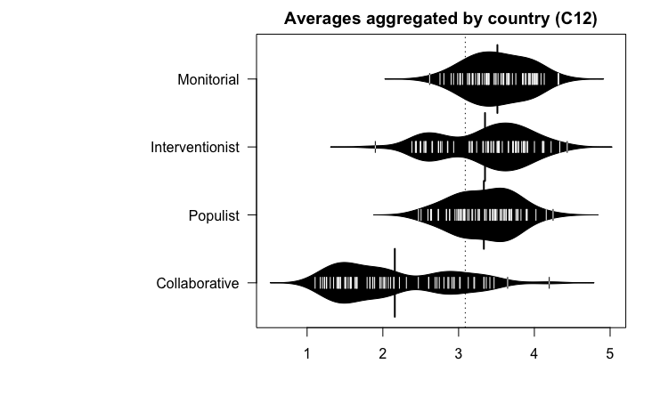
Scale: 5 = “extremely important” … 1 = “unimportant”.
Accommodative

Figure 7.4: Journalistic roles – differences between countries
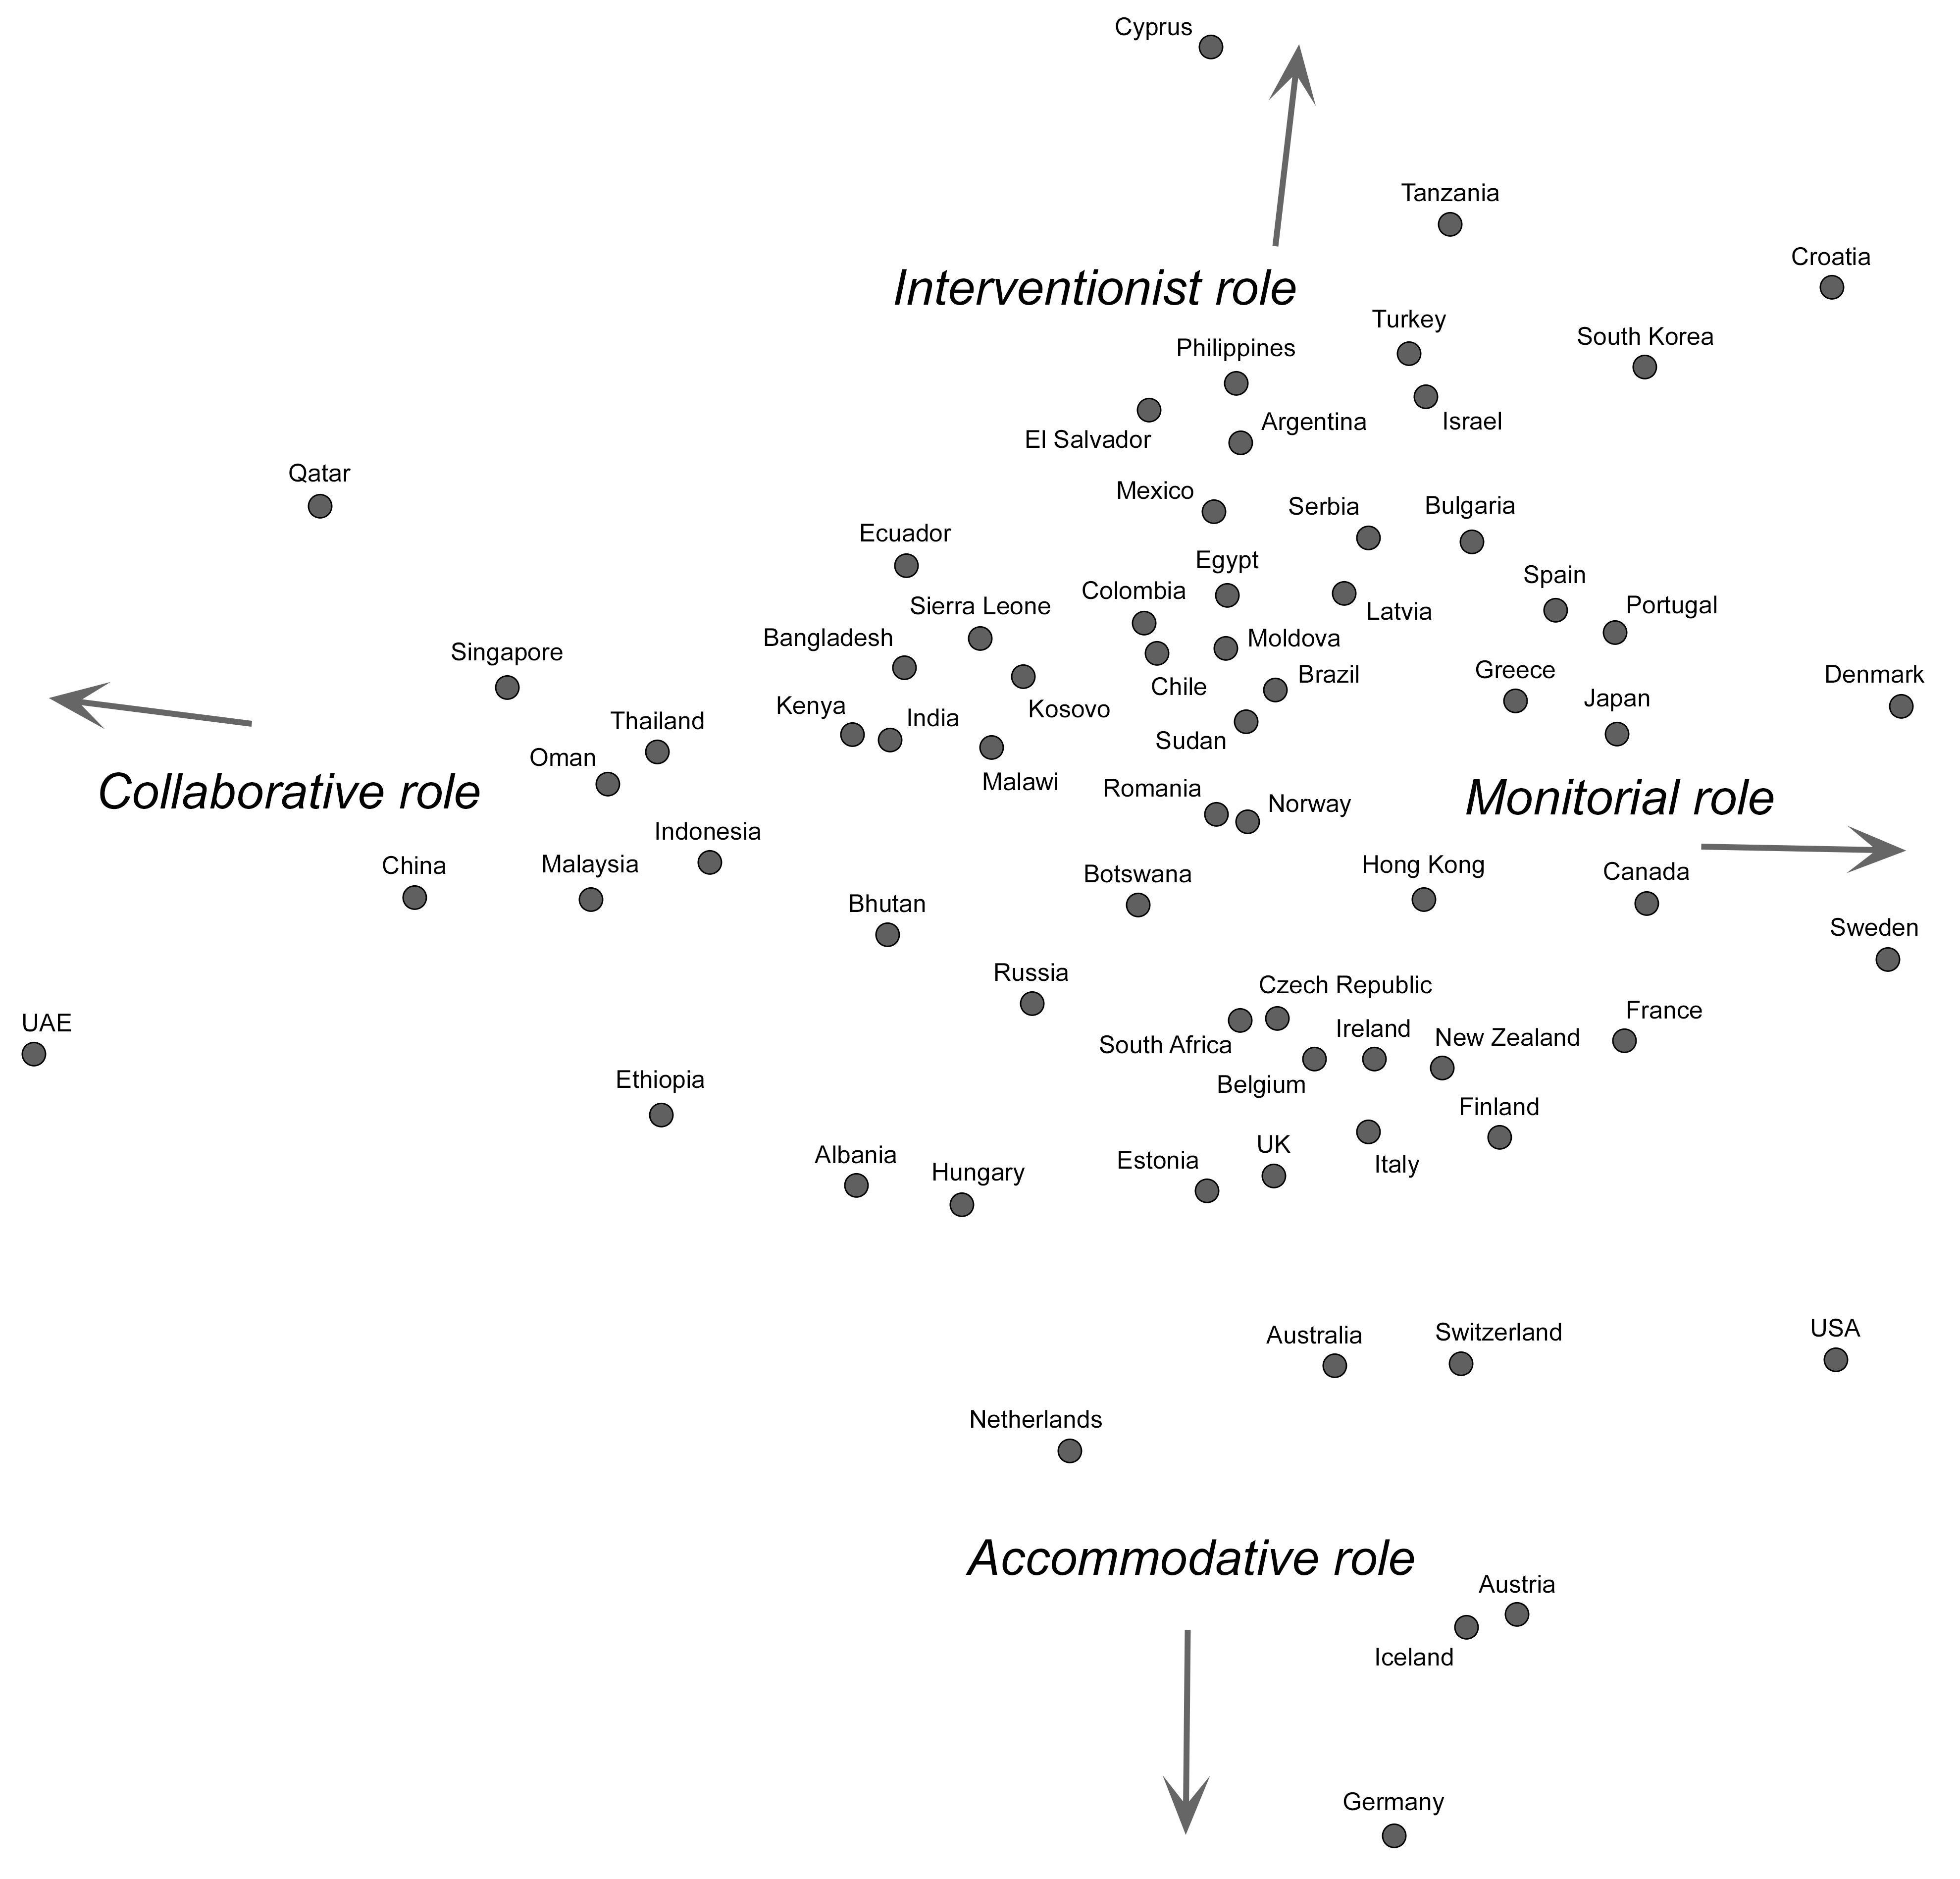
Co-plot based on centered mean scores; Coefficient of Alienation: .15; Average of Correlations: .89.

Table 7.2: Journalistic roles – differences between countries
 | Monitorial role |  |  | Collaborative role |  |  | Interventionist role |  |  | Accommodative role
 | Mean | (SD) | Centered mean | Mean | (SD) | Centered mean | Mean | (SD) | Centered mean | Mean | (SD) | Centered mean
Albania | 2.81 | (.86) | -.22 | 2.14 | (.99) | -.88 | 3.51 | (.72) | .49 | 3.63 | (.76) | .61
Argentina | 3.66 | (.86) | .57 | 2.22 | (.98) | -.87 | 3.51 | (.86) | .42 | 2.98 | (.95) | -.12
Australia | 3.25 | (1.01) | .53 | 1.57 | (.74) | -1.15 | 2.65 | (.90) | -.07 | 3.41 | (.90) | .69
Austria | 3.31 | (1.12) | .62 | 1.31 | (.57) | -1.37 | 2.54 | (.80) | -.16 | 3.60 | (.83) | .91
Bangladesh | 3.58 | (.84) | .11 | 2.87 | (1.17) | -.58 | 3.79 | (.78) | .33 | 3.60 | (.87) | .15
Belgium | 3.15 | (1.03) | .62 | 1.50 | (.66) | -1.02 | 2.57 | (.81) | .04 | 2.88 | (.89) | .36
Bhutan | 3.88 | (.73) | .44 | 2.93 | (1.12) | -.50 | 3.36 | (.83) | -.07 | 3.57 | (1.06) | .14
Botswana | 4.09 | (.83) | .45 | 2.81 | (1.20) | -.83 | 3.76 | (.81) | .12 | 3.90 | (.99) | .26
Brazil | 3.39 | (.90) | .49 | 1.83 | (.90) | -1.07 | 3.32 | (.81) | .42 | 3.05 | (.88) | .15
Bulgaria | 3.47 | (.98) | .46 | 1.54 | (.80) | -1.46 | 3.66 | (.80) | .66 | 3.35 | (.99) | .34
Canada | 3.59 | (1.06) | 1.06 | 1.26 | (.52) | -1.27 | 2.66 | (.91) | .10 | 2.64 | (.91) | .11
Chile | 3.56 | (1.09) | .31 | 2.31 | (1.13) | -.95 | 3.72 | (.98) | .46 | 3.45 | (1.05) | .18
China | 3.18 | (.85) | -.21 | 3.47 | (1.01) | .07 | 3.40 | (.73) | .00 | 3.55 | (.76) | .15
Colombia | 3.94 | (.92) | .30 | 2.71 | (1.10) | -.92 | 4.11 | (.76) | .47 | 3.79 | (.96) | .15
Croatia | 4.31 | (.60) | 1.06 | 1.87 | (1.18) | -1.39 | 3.87 | (.78) | .61 | 3.00 | (.91) | -.28
Cyprus | 3.23 | (1.15) | .37 | 2.04 | (1.13) | -.82 | 3.66 | (.86) | .78 | 2.50 | (1.04) | -.34
Czech Republic | 3.01 | (.95) | .47 | 1.43 | (.70) | -1.11 | 2.73 | (.88) | .18 | 2.99 | (.95) | .46
Denmark | 3.89 | (.61) | 1.32 | 1.17 | (.37) | -1.40 | 2.76 | (.82) | .19 | 2.47 | (.69) | -.11
Ecuador | 3.76 | (.89) | .20 | 3.02 | (1.21) | -.52 | 3.87 | (.84) | .31 | 3.57 | (.93) | .01
Egypt | 4.02 | (.70) | .46 | 2.61 | (1.14) | -.95 | 4.00 | (.71) | .44 | 3.61 | (.81) | .05
El Salvador | 3.92 | (.78) | .36 | 2.74 | (1.09) | -.82 | 4.11 | (.74) | .54 | 3.49 | (1.01) | -.08
Estonia | 3.26 | (.98) | .25 | 1.66 | (.77) | -1.34 | 3.43 | (.73) | .42 | 3.67 | (.83) | .67
Ethiopia | 3.67 | (.87) | -.06 | 3.41 | (1.13) | -.33 | 3.72 | (.79) | -.01 | 4.16 | (.82) | .40
Finland | 3.36 | (1.02) | .70 | 1.23 | (.44) | -1.43 | 2.86 | (.76) | .20 | 3.19 | (.75) | .53
France | 3.50 | (.84) | 1.05 | 1.23 | (.52) | -1.19 | 2.44 | (.90) | -.04 | 2.63 | (.86) | .19
Germany | 3.03 | (1.24) | .39 | 1.26 | (.53) | -1.36 | 2.44 | (.81) | -.19 | 3.77 | (.78) | 1.16
Greece | 3.64 | (.98) | .82 | 1.57 | (.85) | -1.24 | 3.18 | (.87) | .36 | 2.88 | (1.05) | .06
Hong Kong | 3.64 | (.77) | .80 | 1.83 | (.96) | -1.01 | 2.93 | (.75) | .09 | 2.95 | (.75) | .11
Hungary | 3.05 | (1.26) | .01 | 2.15 | (1.23) | -.87 | 3.24 | (.92) | .20 | 3.70 | (.92) | .66
Iceland | 2.90 | (1.05) | .69 | 1.11 | (.30) | -1.12 | 1.90 | (.79) | -.34 | 3.02 | (.86) | .78
India | 3.60 | (.84) | .13 | 2.91 | (1.19) | -.56 | 3.71 | (.81) | .24 | 3.66 | (.95) | .18
Indonesia | 3.60 | (.64) | .09 | 3.21 | (.75) | -.30 | 3.53 | (.65) | .03 | 3.68 | (.64) | .17
Ireland | 3.26 | (.98) | .62 | 1.44 | (.66) | -1.19 | 2.78 | (.90) | .14 | 3.08 | (.86) | .44
Israel | 3.40 | (1.08) | .35 | 1.65 | (.95) | -1.41 | 3.83 | (.95) | .77 | 3.34 | (.97) | .29
Italy | 3.12 | (1.00) | .69 | 1.35 | (.67) | -1.07 | 2.43 | (.79) | -.01 | 2.84 | (.99) | .39
Japan | 4.01 | (.62) | .95 | 1.65 | (.64) | -1.41 | 3.38 | (.70) | .33 | 3.18 | (.73) | .12
Kenya | 3.52 | (.93) | .05 | 2.94 | (1.10) | -.53 | 3.75 | (.87) | .27 | 3.70 | (.97) | .21
Kosovo | 3.39 | (.98) | .07 | 2.47 | (1.12) | -.84 | 3.78 | (.82) | .47 | 3.63 | (.99) | .30
Latvia | 3.27 | (1.05) | .37 | 1.63 | (.83) | -1.26 | 3.53 | (.74) | .63 | 3.14 | (1.04) | .26
Malawi | 4.13 | (.75) | .26 | 3.20 | (1.25) | -.67 | 4.13 | (.71) | .25 | 4.02 | (.84) | .17
Malaysia | 3.48 | (.76) | -.03 | 3.36 | (1.03) | -.15 | 3.53 | (.72) | .00 | 3.70 | (.78) | .18
Mexico | 4.03 | (.73) | .37 | 2.69 | (1.04) | -.97 | 4.22 | (.73) | .56 | 3.70 | (.92) | .04
Moldova | 3.28 | (1.03) | .28 | 1.89 | (.82) | -1.11 | 3.58 | (.83) | .57 | 3.28 | (.97) | .26
Netherlands | 2.75 | (.94) | .20 | 1.58 | (.61) | -.96 | 2.49 | (.76) | -.06 | 3.37 | (.79) | .82
New Zealand | 3.39 | (1.06) | .75 | 1.42 | (.70) | -1.21 | 2.74 | (.96) | .08 | 3.03 | (.93) | .38
Norway | 2.93 | (1.05) | .41 | 1.44 | (.60) | -1.06 | 2.85 | (.89) | .33 | 2.84 | (.78) | .32
Philippines | 4.04 | (.77) | .60 | 2.61 | (1.00) | -.83 | 3.85 | (.70) | .41 | 3.26 | (.86) | -.18
Portugal | 3.71 | (.88) | .93 | 1.51 | (.77) | -1.26 | 3.14 | (.85) | .37 | 2.73 | (.86) | -.04
Oman | 3.37 | (.63) | -.18 | 3.33 | (.87) | -.22 | 3.75 | (.60) | .20 | 3.76 | (.69) | .20
Qatar | 2.62 | (1.12) | -.53 | 3.33 | (1.00) | .17 | 3.43 | (.98) | .27 | 3.26 | (.95) | .09
Romania | 3.18 | (1.10) | .19 | 1.79 | (.84) | -1.19 | 3.53 | (.87) | .54 | 3.44 | (.95) | .46
Russia | 3.02 | (.84) | .05 | 2.02 | (1.00) | -.95 | 3.33 | (.77) | .36 | 3.51 | (.79) | .54
Serbia | 3.65 | (1.01) | .43 | 1.96 | (1.09) | -1.27 | 3.90 | (.87) | .66 | 3.42 | (1.05) | .18
Sierra Leone | 3.84 | (.67) | .13 | 3.01 | (1.04) | -.71 | 4.12 | (.65) | .41 | 3.89 | (.72) | .17
Singapore | 3.19 | (.94) | .04 | 3.13 | (1.20) | -.01 | 3.15 | (.88) | .03 | 3.08 | (.88) | -.06
South Africa | 3.38 | (1.06) | .40 | 1.87 | (.99) | -1.10 | 3.17 | (.91) | .21 | 3.48 | (.91) | .50
South Korea | 3.98 | (.67) | .92 | 2.07 | (.76) | -.99 | 3.46 | (.66) | .40 | 2.73 | (.73) | -.33
Spain | 4.00 | (.79) | .85 | 2.00 | (.87) | -1.14 | 3.53 | (.78) | .38 | 3.07 | (.84) | -.08
Sudan | 4.32 | (.81) | .36 | 2.86 | (1.49) | -1.11 | 4.43 | (.60) | .47 | 4.25 | (.78) | .28
Sweden | 3.93 | (.73) | 1.35 | 1.20 | (.40) | -1.37 | 2.56 | (.88) | -.02 | 2.60 | (.70) | .03
Switzerland | 3.34 | (.96) | .72 | 1.39 | (.55) | -1.22 | 2.50 | (.77) | -.11 | 3.22 | (.81) | .61
Tanzania | 3.85 | (.48) | .41 | 2.10 | (.58) | -1.34 | 4.34 | (.49) | .90 | 3.47 | (.39) | .03
Thailand | 3.95 | (.57) | .09 | 3.65 | (.81) | -.20 | 3.91 | (.55) | .06 | 3.90 | (.62) | .05
Turkey | 3.66 | (.73) | .51 | 1.98 | (1.06) | -1.17 | 3.86 | (.77) | .71 | 3.12 | (.98) | -.05
UAE | 3.13 | (1.14) | -.50 | 4.20 | (.98) | .53 | 3.46 | (1.01) | -.18 | 3.82 | (.95) | .16
UK | 2.99 | (1.12) | .46 | 1.41 | (.66) | -1.09 | 2.57 | (.91) | .05 | 3.08 | (.92) | .57
USA | 3.97 | (.71) | 1.24 | 1.51 | (.84) | -1.22 | 2.38 | (.89) | -.35 | 3.07 | (.84) | .34

Table 7.3: Correlates of monitorial, collaborative, interventionist and accommodative roles
 | Monitorial role |  | Collaborative role |  | Interventionist role |  | Accommodative role
 | r |  | r |  | r |  | r
Press freedom (FH) ª | .655 | *** | -.685 | *** | -.183 |  | .301 | *
Press freedom (RSF) ^{b} | .499 | *** | -.551 | *** | -.183 |  | .313 | **
Democracy ^{c} | .677 | *** | -.656 | *** | -.204 |  | .252 | *
Rule of law ^{d} | .429 | *** | -.297 | * | -.443 | *** | .281 | *
GNI per capita ^{e} | .313 | * | -.163 |  | -.446 | *** | .246 | *
Transparency ^{f} | .438 | *** | -.261 | * | -.511 | *** | .283 | *
Human development ^{g} | .421 | *** | -.334 | ** | -.288 | * | .201
Emancipative values ^{h} | .568 | *** | -.530 | *** | -.438 | *** | .366 | **
Political influences | -.492 | *** | .699 | *** | -.010 |  | -.363 | **
Economic influences | -.553 | *** | .585 | *** | .159 |  | -.272 | *
Organizational influences | -.342 | ** | .415 | *** | .294 | * | -.435 | ***
Procedural influences | -.016 |  | -.028 |  | .119 |  | -.051
Personal networks | -.300 | * | .519 | *** | -.262 | * | -.115
Editorial autonomy | .355 | ** | -.502 | *** | .030 |  | .053
Notes: ***p<.001; **p<.01; *p<.05. Scores for roles centered. N=67 (countries) and N=19,088 (respondents) unless otherwise indicated. ª Freedom House; scale reversed. ^{b} Reporters Without Borders; scale reversed. ^{c} Economist Intelligence Unit; N=66. ^{d} World Bank; percentile rank. ^{e} World Bank; Atlas method; N=66; current US$. ^{f} Transparency International. ^{g} UNDP; N=66. ^{h} Scores calculated based on WVS/EVS data N=58.

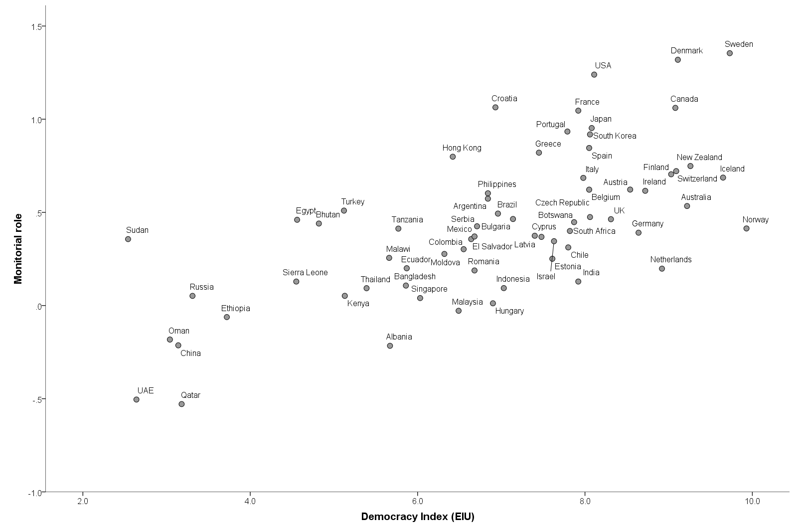
Figure 7.5: Monitorial role and democracy
Note: N=66. Data source: Worlds of Journalism Study; Economist Intelligence Unit.

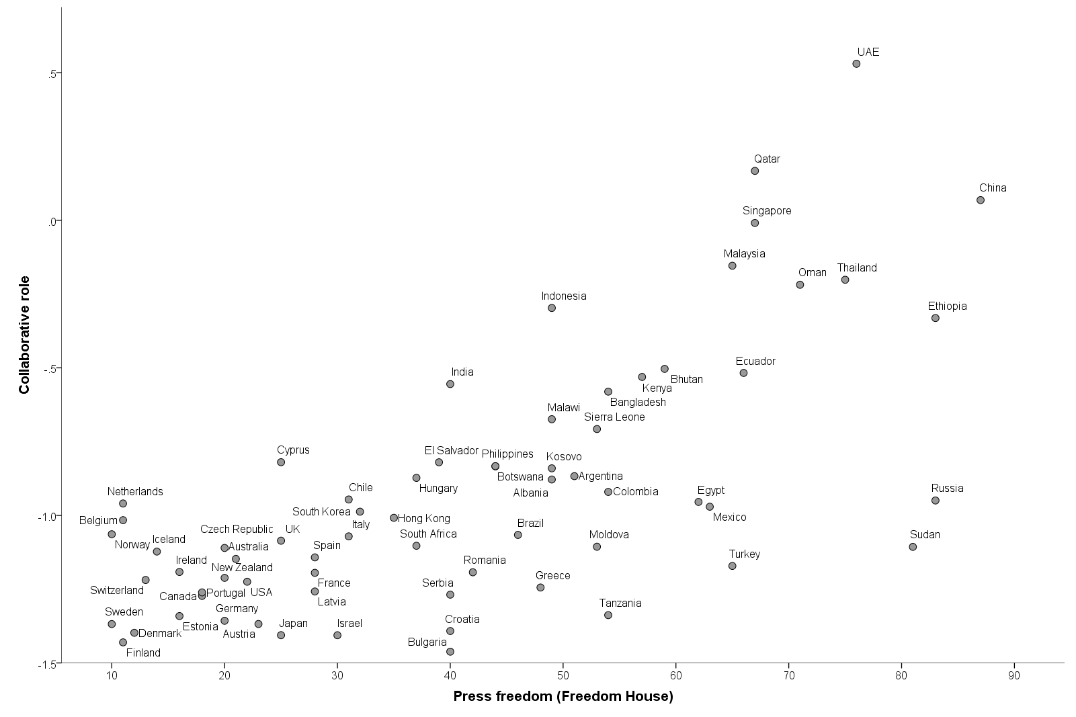
Figure 7.6: Collaborative role and press freedom
Note: N=66. Data source: Worlds of Journalism Study; Freedom House; higher values indicate smaller press freedom.

http://www.un.org/en/events/pressfreedomday/2012/sgmessage.shtml
https://freedomhouse.org/report/freedom-press/2013/egypt
https://freedomhouse.org/report/nations-transit/2016/kosovo
For each individual journalist, we first computed the average (mean) score across all four indexes of journalistic roles and then subtracted this mean from each raw score. The resulting centered scores average to zero for every single respondent, which has the advantage that it removes potential acquiescence bias from the data, that is, the general tendency of some respondents (or groups of respondents) to respond more positively or negatively to a given survey question regardless of its content.
The figure was created using Visual CoPlot (developed by David Talby and Adi Raveh; http://davidtalby.com/vcoplot/). The coefficient of alienation, indicating the loss of information arising from the transformation of multidimensional data into two dimensions, amounts to .15, and correlations between vectors average to .89. This points to a reasonable empirical solution (Bravata, Shojania, Olkin, & Raveh, 2008).
https://freedomhouse.org/report/freedom-press/; https://rsf.org/en/ranking

