Aryl-Substituent Effects on Spin Crossover in [Fe(H₂Bpz₂)₂(bipy-R)] Complexes: Structure - Magnetism Correlations

Mengmeng Wang¹, Koen Robeyns¹, Aurelian Rotaru², Tim Hochdörffer³, Dominik Maskowicz⁴, Mariusz Wolff⁵, Juliusz Wolny³, Miroslaw Sawczak⁴, Rafał Jendrzejewski⁴, Volker Schuenemann³, Yann Garcia¹

¹Institute of Condensed Matter and Nanosciences, Molecular Chemistry, Materials and Catalysis (IMCN/MOST), Université catholique de Louvain, Place L. Pasteur 1, 1348, Louvain-la- Neuve, Belgium.
²Department of Electrical Engineering and Computer Science and MANSiD Research Center, “Stefan cel Mare” University, University Street, 13, Suceava 720229, Romania.
³Department of Physics, RPTU University Kaiserslautern-Landau, Erwin-Schrödinger-Str. 46, 67663 Kaiserslautern, Germany.
⁴Photophysics Department, The Szewalski Institute of Fluid-Flow Machinery, Polish Academy of Sciences, Fiszera 14, 80-231 Gdańsk, Poland.
⁵Institute of Functional Materials and Catalysis, Faculty of Chemistry, University of Vienna, Währinger Str. 38-42, 1090 Vienna, Austria.

Abstract
Spin crossover (SCO) materials reversibly switch between high-spin and low-spin states in response to external stimuli, accompanied by pronounced changes in electronic, magnetic, and optical properties, underpinning their potential in data storage, sensing, and molecular electronics.¹⁻³ Spin transition behavior is influenced by ligand field and cooperative interactions, necessitating systematic studies to understand the structure-SCO property relationship.⁴ Aryl groups, characterized by their unique π-conjugation, steric effects, and fluorescence properties, play a crucial role in modulating the structure, electronic behavior and photophysical properties of complexes. In this work, we introduce phenyl (phen), 1-naphthyl (1-nap), 2-naphthyl (2-nap), and anthryl (an) groups into the SCO complex [Fe(H₂Bpz₂)₂(bipy)],⁵ to afford four Fe(II) complexes [Fe(H₂Bpz₂)₂(bipy-R)] (R = phen, 1; R = 1-nap, 2; R = 2-nap, 3; R = an, 4) and investigated their SCO properties (Scheme 1). Complexes 1 and 3 undergo one-step SCO with ~57%/50% completeness and T_{1/2} = 139 K/152 K. Complexes 2 and 4 exhibit two-steps gradual SCO with ~45%/30% completeness (T_{1/2} = 242 K/289 K) for the first step and ~29%/50% completeness (T_{1/2} = 137 K/176 K) for the second step revealed by magnetic measurements. The different SCO behaviors are attributed to the electronic effects of substituents and the unique crystal stacking patterns, involving π··· π interactions.
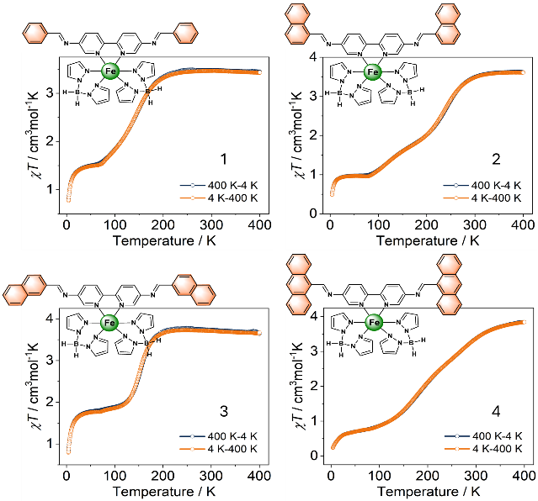
Scheme 1. Complexes 1-4 and their χ_{M}T vs. T plots.

Recent Publications
- X. Li, N. E. I. Belmouri, M. Sy, M. Wolff, A. Rotaru, S. van Terwingen, D. Maskowicz, M. Sawczak, R. Jendrzejewski, K. Boukheddaden, Y. Garcia, J. Am. Chem. Soc. 147 (2025) 46608–46620.
- M. M. Wang, M. Wolff, J. Yadav, D. Pinkowicz, Y. Garcia, Interactions 246 (2025) 117.
- M. M. Wang, Y. Draoui, K. Robeyns, J. Yadav, Z. Han, M. Wolff, D. Maskowicz, A. Rotaru, D. Pinkowicz, M. Sawczak, R. Jendrzejewski, Y. Garcia, Cryst. Growth Des. (2026, 10.1021/acs.cgd.5c01701).
- Y. Garcia, G. Bravic, D. Chasseau, C. Gieck, W. Tremel, P. Gütlich, Inorg. Chem. 44 (2005) 9723-9730.
- S. Xue, Y. Guo, A. Rotaru, H. Müller-Bunz, G.G. Morgan, E. Trzop, E. Collet, J. Oláh, Y. Garcia, Inorg. Chem. 57 (2018) 9880-9891.

Biography
 | Mengmeng Wang received her Ph.D. degree in 2022 from Nankai University. She then obtained a FNRS Postdoctoral researcher position at UCLouvain in Prof. Yann Garcia’s group in Belgium. Her current research interests focus on molecule-based magnetic materials (spin crossover materials, single-molecule magnets, opto-magnetic hybrid materials, multifunctional magnetic materials). She has published 32 publications with a h-index = 15 (810 citations, ResearchGate, March 2026) and presented oral contributions at several international conferences including the ICAMANA series, co-organized by UMP @Oujda and UCLouvain, GFSM 2024 in Khouribga, RSC MC17 in Edinburgh and EuChemS 2026 in Antwerpen.  Email: mengmeng.wang@uclouvain.be

