Cell-specific transcriptomics and knockout reveal aquaporin function in grass stomatal movements

Lei Ding^{1,#}, Maxime J. Laurent¹, Sylvain Legay², Stijn Aesaert^{3,4}, Julien Georgery¹, David Cohen⁵, Laurens Pauwels^{3,4,6}, Didier Le Thiec⁵, Valentin Couvreur⁷, Dirk Inzé^{3,4}, François Chaumont^{1,#}
¹ Louvain Institute of Biomolecular Science and Technology, UCLouvain, 1348 Louvain-la-Neuve, Belgium
² Luxembourg Institute of Science and Technology, Technology, 5, Rue Bommel, L-4940 Hautcharage, Luxembourg
³ Department of Plant Biotechnology and Bioinformatics, Ghent University, 9052 Ghent, Belgium
⁴ VIB Center for Plant Systems Biology, Technologiepark 71, 9052 Ghent, Belgium
⁵ INRAE, Université de Lorraine, AgroParisTech, SILVA, F-54000, Nancy, France
⁶ Current address: Department of Biotechnology, Faculty of Bioscience Engineering, Ghent University, Proeftuinstraat 86, 9000 Ghent, Belgium
⁷ Earth and Life Institute, UCLouvain, 1348 Louvain-la-Neuve, Belgium

# Corresponding authors: francois.chaumont@uclouvain.be and lei.ding@uclouvain.be

ORCIDs
Lei Ding: https://orcid.org/0000-0003-1262-5289
Maxime J. Laurent: https://orcid.org/0009-0001-1364-8223
Sylvain Legay: https://orcid.org/0000-0002-2057-7443
Stijn Aesaert: https://orcid.org/0000-0001-8787-7347
David Cohen: https://orcid.org/0000-0002-0320-8865
Laurens Pauwels: https://orcid.org/0000-0002-0221-9052
Didier Le Thiec: https://orcid.org/0000-0002-4204-551X
Valentin Couvreur: https://orcid.org/0000-0002-1087-3978
Dirk Inzé: https://orcid.org/0000-0002-3217-8407
François Chaumont: https://orcid.org/0000-0003-0155-7778
Total word count: 7337; Introduction: 1099; Materials and Methods: 2079; Results: 2122; Discussion: 2037; The number of figures: 6; Figures in color: 6.

Summary
- The high efficiency of grass stomatal movement is believed to be due to their unique four-celled structure, with two dumbbell-shaped guard cells (GCs) flanked by two subsidiary cells (SCs). The molecular interaction between these cells requires further investigation.
- To investigate genes, including those encoding aquaporins (AQPs), expressed in maize GCs and SCs, RNA sequencing was performed on microdissected GCs and SCs from epidermis harvested during day and night. A CRISPR-based tissue-specific knockout system was then used to target ZmPIPs belonging to the PIP1 subfamily in maize GCs or SCs.
- A general transcriptomic analysis first revealed that genes preferentially expressed in SCs compared to GCs during the day were primarily involved in lipid transport, localization, and metabolism, while genes more highly expressed in GCs were associated with photosynthesis, chloroplasts, and plastids. Interestingly, the expression of several AQP genes varied both spatially and temporally. The knockout of ZmPIP1s in GCs resulted in greater stomatal opening compared to wild-type plants, particularly under mild water deficit conditions.
- Overall, these findings reveal transcriptomic specificities between maize GCs and SCs, providing valuable insights into the regulation of rapid stomatal movements in grasses, and highlight the role of ZmPIP1s in these processes.

Keywords
Maize; stomatal movement; aquaporins; RNA-seq; guard cells; subsidiary cells; phylogenetic analysis; cell-specific knockout

Plain Language Summary
Grasses dominate in many ecosystems, with the most successful evolution of four-celled stomatal morphology, i.e., guard cells (GCs) flanked by two subsidiary cells (SCs). By studying the transcriptomic profiles of GCs and SCs and specifically inactivating aquaporin genes of interest, this study provides insights into the molecular characteristics and coordination between GCs and SCs during stomatal movement.
Introduction
Stomata allow CO₂ to diffuse into leaves for photosynthesis, while simultaneously causing water loss through transpiration. To maximize water use and carbon fixation efficiency, the stomatal pore dynamics are regulated by various environmental stimuli (drought, vapor pressure deficit, light, CO₂, etc.) (Durand et al., 2019). The opening and closing of stomata depend on variations in the turgor pressure of the guard cells (GCs) surrounding the pore and, consequently, on water flux through their plasma membrane (PM). Events that modulate stomatal opening and closure involve the regulation of transporters and channels, such as H⁺-ATPases, K⁺ inward and outward channels, S- and R-type anion channels and aquaporins (AQPs). These membrane proteins are activated by complex signaling cascades that mainly comprise light, carbonic dioxide (CO₂), hydrogen peroxide (H₂O₂) and acid abscisic (ABA) signaling pathways (Kim et al., 2010; Grondin et al., 2015; Jezek & Blatt, 2017; Rodrigues et al., 2017; Sussmilch et al., 2019; Hsu et al., 2021; Takahashi et al., 2022).
Plant AQPs constitute a highly divergent family that clusters phylogenetically into different subfamilies, including the plasma membrane intrinsic proteins (PIPs). PIPs are further divided into two groups PIP1 and PIP2, which exhibit different subcellular localizations and activities when expressed in heterologous systems or in maize protoplasts. When expressed alone, PIP1s are retained in the endoplasmic reticulum (ER), whereas PIP2s are found in the PM. However, PIP1s and PIP2s can assemble in heterotetramers, resulting in the colocalization of both proteins in the PM and an increase in cell membrane water permeability (Fetter et al., 2004; Zelazny et al., 2007).
Several PIPs have been shown to play a role in stomatal movements, which is dependent on the ABA signaling pathway. In Arabidopsis, ABA activates OST1 kinase, which in turn activates AtPIP2;1, facilitating the inward flow of H₂O₂ and the outward flow of H₂O (Grondin et al., 2015; Rodrigues et al., 2017). In maize, ZmPIP2;5 expression positively regulates stomatal closure induced by either ABA or water deficit treatments (Ding et al., 2022). This regulation is associated with H₂O₂ accumulation in GCs, entering through PIPs, including ZmPIP2;5 (Ahmed et al., 2024; Ding et al., 2025). Interestingly, ZmPIP1;6, a member of the PIP1 subfamily, also contributed to ABA-induced stomatal closure in maize (Ding et al., 2025). Experiments in Xenopus oocytes further suggest that CO₂ accumulates in GCs by crossing the membrane through AtPIP2;1 AQP (Wang et al., 2016). Once inside, CO₂ is converted into bicarbonate (HCO₃–) and protons by carbonic anhydrase, which directly interacts with AtPIP2;1 to increase its channel activity (Wang et al., 2016). Intercellular HCO₃– then activates S-type anion channels, such as SLAC1 (Wang et al., 2016; Yamamoto et al., 2016; Zhang et al., 2018). However, no significant stomatal closure or opening phenotype was observed in detached leaves or intact plants of the Atpip2;1 knock out (KO) line. Furthermore, Blatt et al. (2022) argued that the proposed activation of SLAC1 by bicarbonate (HCO₃⁻) remains unconvincing, as the concentrations required to stimulate SLAC1 activity are approximately 40 to 400 times higher than the physiological CO₂ range present in leaves. Consequently, further studies are required to clarify the potential role of AQPs in CO₂-induced regulation of stomatal movements.
Grasses dominate in many ecosystems, with the most successful evolution of four-celled stomatal morphology, i.e., GCs flanked by two subsidiary cells (SCs). Water use efficiency (WUE) is improved in grasses due to (i) specific morphology/geometry of the stomatal complexes, which offers mechanical advantages, and (ii) efficient functional molecular interactions between SCs and GCs (Chen et al., 2017; Nunes et al., 2020; Durney et al., 2023). With different arrangements and ontogenies, SCs are present in grasses and succulents of the Crassulaceae family (Chen et al., 2017; Gray et al., 2020; Cheng & Raissig, 2023). SCs have attracted numerous scientists to decipher their roles in the rapid movement of grass stomata (Chen et al., 2017; Hepworth et al., 2018; Lawson & Matthews, 2020; McKown & Bergmann, 2020; Cheng & Raissig, 2023; Nguyen et al., 2023). Franks and Farquhar (2007) proposed that stomatal opening and closure in grasses benefit from a “see-saw” exchange of osmotic and turgor pressure between GCs and SCs during stomatal movements. Recently, Durney et al. (2023) also explained the advantage of four-celled complexes in respect to geometry by finite element method model. They demonstrated that GCs and SCs form a reciprocal pressure system, and SCs function as springs to restrain lateral GC movement. The pressurized SCs have a mechanical influence on the system by restraining the size of the stomatal pore when GC pressure is low. However, it remains unclear whether similar signaling pathways exist in SCs as in GCs, regulating membrane transporters including AQPs and subsequent stomatal movements.
qPCR and transcriptomic data revealed that many AQP genes are expressed in stomata (Heinen et al., 2014; Durand et al., 2020; Berkowitz et al., 2021; Lopez-Anido et al., 2021; Sun et al., 2022). By microdissecting the whole stomatal complexes from maize and qPCR, Heinen et al. (2014) showed that most ZmPIPs are expressed and their expression generally follows a diurnal pattern, with high expression during the day compared to the night, and that about 80% of the total ZmPIP mRNA expressed in the stomatal complexes belong to the PIP1 group. While transcriptome data in stomata was previously only available for dicot species, an advance in understanding gene expression in grass stomata was recently achieved by Sun et al. (2022) with single nucleus RNA sequencing (snRNA-seq) in maize GCs and SCs. However, a very limited number of nuclei from GCs was obtained and additional information was required to explore the whole transcriptome network in maize stomatal complexes.
In this study, we investigated the transcriptome profiles in maize GCs and SCs during the day and night using a whole transcriptomic approach (RNA-Seq), which revealed that two pathways, carotenoid biosynthesis, and arginine and proline metabolism, were enriched in SCs during the day. The former is related to ABA biosynthesis and degradation, and the latter is important for osmotic adjustment and the proline signaling pathway. We also observed that several AQP isoforms were differentially expressed in GCs and SCs between day and night, indicating their specific roles in stomatal movements. We then successfully knocked out ZmPIP1 genes specifically in GCs using a clustered regularly interspaced short palindromic repeats (CRISPR)-based tissue-specific knockout system, CRISPR-TSKO (Decaestecker et al., 2019). The knockout of ZmPIP1s in GCs resulted in greater stomatal opening compared to wild-type plants, particularly under mild water deficit conditions. The kinetics of stomatal opening/closure in response to CO₂ changes exhibited a slight delay in the GCPIP1 KO lines compared to the WT, though this difference was not statistically significant.

Materials and Methods
Microdissection of GCs and SCs and RNA extraction
Maize (Zea mays L.) B104 seeds were germinated and transferred to potting soil, as previously described (Ding et al., 2020). The plants were grown in a phytotron under a 16/8 h light/dark cycle (25/22 °C) and a daytime light intensity of 200 mmol. m⁻². s⁻¹ at the top of the leaves. Humidity was maintained between 60% and 70% in the growth chamber.
Epidermal strips were peeled from the third leaf of two-week-old maize seedlings. They were placed on microscope glass slides (plain microscope slides 76x26mm, 0.8 mm x 1.00 mm, AGL4242) and flash-frozen with liquid nitrogen. The samples were immediately stored at -80 °C until microdissection. The samples were collected at two times, i.e., day (two hours after the light onset) and night (two hours after the light offset). Four independent collections were carried out.
On the day before the microdissection, the peeled epidermal strips were freeze-dried at -40 °C for 10 h under pressure of 10 Pa in a Labconco® Free-Zone Plus freeze-drier. At the end of the process, the temperature slightly increased to room temperature for 3 h. A few drops of absolute ethanol were placed on the strips to flatten them. The samples were stored in a desiccator under vacuum at room temperature until microdissection, to avoid rehydration.
GCs and SCs were collected using a PALM MicroBeam system (Carl Zeiss MicroImaging GmbH). GCs or SCs were selected using Zeiss software and cut using a laser (Fig. 1A). After cutting, cells were pressure catapulted and collected immediately in a tube with an adhesive cap (Carl Zeiss™ 415190-9211-000). Approximately 1500 cells were collected in one tube, and two tubes were used to collect cells for each sample. After cell collection, 175 µL of lysis buffer with 1% (v/v) β-mercaptoethanol was immediately added to each tube with two steel beads. The tubes were shaken at maximum speed for 30 s with an MM2 mixer mill (Retsch) and incubated for 5 min at room temperature to improve the lysis yield. Lysates from the same sample were pooled into one tube that was stored at -20 °C until RNA extraction. In total, 16 samples of 3000 cells were microdissected with two cell types (GCs and SCs), two sampling time (day and night) and four replicates. Microdissection was performed at approximately 19 °C and 30% relative humidity. RNA extraction was performed using RNeasy Plus Micro Kits (Qiagen) following the manufacturer’s instructions, which include a step of genomic DNA elimination. Total RNA was eluted with 14 µL of nuclease-free water and stored at -80 °C until further use.

RNA-seq
cDNA amplification was prepared from 10.5 µl (about 10pg) total RNA with Takara SMART-Seq® v4 Ultra® Low Input RNA Kit. Libraries were prepared from 150ng cDNA using Nextera XT DNA Library Preparation Kit and Nextera index Kit V2. The sequencing was carried out at the LCSB sequencing platform (RRID: SCR_021931) at the University of Luxembourg. The pooled libraries were sequenced on an Illumina NextSeq500 (NextSeq 500/550 High Output Kit v2.5 (300 Cycles)) to generate 100 base-pair paired-end reads. FASTQ files were imported in pairs in CLC genomics workbench v11.0.1 discarding poor-quality reads (<Q30). For each library, reads were trimmed and filtered using the following criteria: sequence quality score <0.01, no ambiguous nucleotides, minimum read length >35 nucleotides, trimming against the Illumina adaptor sequence and polyN >8, and finally a hard trim of 20 nucleotides at the 5’ end and 2 nucleotides at the 3’ end. The filtered reads were aligned on the genome contained in the file “Zea_mays.B73_RefGen_v4.dna.toplevel.fa.gz” from the B73 v4 version (downloaded on https://ftp.gramene.org/maize/v4/fasta/zea_maysb73v4/dna/ ), as the annotations for this version were more stable. A count matrix was further obtained (Supplementary Table S1).

Differentially expressed gene and gene set enrichment analysis
The RNA-seq count matrix was analyzed using the DESeq2 v1.40.2 package (Love et al., 2014). Genes with less than one read in 10% of the samples were removed before normalization and were considered non-expressed.
To perform principal component analysis (PCA), normalized counts were transformed using the vst function in DESeq2, and the top 500 genes with the most variation were used to calculate the principal components with the plotPCA function. The samples were colored based on cell types and sampling times.
For differential analysis, the model used in DESeq2 considered the cell type, sampling time, and interaction between the two covariates. The p-values were adjusted (p-adj) using the FDR method implemented in the results function. Genes with an absolute log₂-fold change greater than 0.58, i.e., fold change >1.5 and a p-adj smaller than 0.05, were considered differentially expressed genes (DEGs). Three p-adj cut-offs (0.001, 0.01, and 0.05) were used to characterize the significance intensity. DEGs were listed in supplementary Table S2.
GO and KEGG gene set enrichment analyses were performed using the clusterProfiler v4.4.4 package (Yu et al., 2012) and the figures were plotted using the enrichplot v1.16.2 package. The GO annotations were retrieved from NCBI with the AnnotationHub v3.4.0 package.

Phylogenetic analysis
Protein sequences of maize AQPs reported by Chaumont et al. (2001) and Lawrence et al. (2013) were retrieved from the NCBI database using EDirect. These were then used as queries in a BLASTp search against the NCBI database to identify novel AQP genes. Accessions of sequences with more than 30% identity were downloaded, duplicates were removed, and each accession was analyzed individually. Particular attention was paid to the length of the protein sequence, number of predicted transmembrane domains, presence of NPA motifs, and CD search-predicted families (https://www.ncbi.nlm.nih.gov/Structure/cdd/wrpsb.cgi). The transmembrane domains were localized using DeepTMHMM (Hallgren et al., 2022). The NPA motifs were searched with an R script using the str_locate_all function in the stringr v1.5.0 package (Wickham & Bryan, 2023). Various combinations of NPA, NPI, NPL, NPS, NPV, and NPT were searched. Sequences with more than two motifs were examined manually, and the positions were aligned to UniProt predictions. Motifs consistent with the prediction were retained as the main motifs. Accessions with six transmembrane domains, two NP(A) motifs, and those predicted to belong to the major intrinsic protein (MIPs) family were retained and defined as AQPs. Using the protein accession numbers, gene models were obtained for the B73 genomes v4 and v5, each giving access to the physical location in these genome versions. The AQP list was then compared with those reported by Bari et al. (2018) and Su et al. (2022).
AQP protein sequences were aligned using Molecular Evolution Genetic Analysis (MEGA) X software. Alignment was performed using the muscle method, and phylogenetic analysis was performed using the maximum likelihood method based on the Jones-Taylor-Thornton (JTT) matrix model with 1000 bootstrap replicates. The new AQPs were named according to the old nomenclature and proximity to the previously identified isoforms.

Transgenic maize plants
To generate the genetic constructs expressing ZmPIP1;1, ZmPIP1;3, ZmPIP1;6, and ZmPIP2;5 fused with mYFP under the control of their own promoter, a 3 kb region upstream of their open reading frame (ORF) was amplified from genomic DNA (gDNA) and considered as their promoter. Because of the difficulty in directly amplifying such fragments from gDNA with primers containing the attB sequences required for Gateway® cloning (~50 bp), we first amplified longer fragments than needed with shorter primers (~20 bp) (Supplemental Table S3) and inserted them into the pGEM®-T Easy (Promega) vector. Afterward, a ~3 kb part was reamplified from these fragments using Gateway® primers (Supplemental Table S3). Primers with attB sequences were also used to amplify the ZmPIP2;5 promoter, which was previously cloned in our laboratory (Maistriaux et al., 2024). ZmPIP1;3, ZmPIP1;6, and ZmPIP2;5 promoters were cloned from B73 gDNA and ZmPIP1;1 promoter from W22 gDNA. The mYFP-ZmPIP sequences were amplified from the constructs developed by Zelazny et al. (2007). The promoters and mYFP-ZmPIP fragments were assembled into the pBb7m24GW expression vector (https://vectorvault.vib.be/collection/pbb7m24gw) using Gateway® cloning (Thermo Fisher).
CRISPR-TSKO plasmids were constructed using the Green Gate technique (Fig. S1 as described by Decaestecker et al. (2019)) using pHb-U1-A-ccdB-G-U9 as a destination vector. The final construct included either the GC-specific promoter of ZmMUTE (Zm00001d009778) (Wang, Hongliang et al., 2019) or the subsidiary cell-specific promoter of sugar transporter Closed Stomata 1 (ZmCST1, Zm00001d038226) (Wang, Hai. et al., 2019), a linker, sequences encoding Cas9 and a fluorescence tag (mCherry), the matching 3` region (500 bp sequence after the stop codon of ZmMUTE or ZmCST1), and gRNA cassettes with the U3 promoter from rice (for gRNA 1 and gRNA 3), and wheat (for gRNA 2 and gRNA 4) by using a split Cas9/gRNA crossing system (Lorenzo et al., 2025). The guide RNA sequences and targeted ZmPIP1s are listed in Supplementary Table S4. ZmMUTE and ZmCST1 promoters were cloned from B73 gDNA with the primers listed in Supplementary Table S3. We removed the BsaI restriction enzyme site found in the ZmCST promoter by mutagenesis PCR using the primers listed in Supplementary Table S3. The two fragments were then assembled with Green Gate technique.
To validate the functionality of the genetic constructs, biolistic was performed with the Biolistic® PDS-1000/He device (Kikkert, 1993) to transiently express the constructs in maize leaf mature zone. For one bombardment, 500 μg of gold microcarriers were coated with 5 μg of DNA following the guidelines given in the protocol. One-week-old B104 maize seedlings were used for the bombardment. The abaxial side of the leaves was targeted. After the bombardment, the plants were grown for two days before checking the fluorescence. The tested plasmids included pPIP1;1::mYFP-ZmPIP1;1, pPIP1;3::mYFP-ZmPIP1;3, pPIP1;6::mYFP-ZmPIP1;6, pPIP2;5::mYFP-ZmPIP2;5 and SC-PIP1KO, as well as the positive control of p35S::mVenus-pK7::mCherry and negative control of mVenus-pK7::mCherry (Maistriaux et al., 2024). The vectors used are listed in Supplementary Table S5.
The B104 inbred maize line was transformed according to Ding et al. (2020) making use of the maize transformation platform of the Center for Plant Systems Biology (VIB-Ghent University, Belgium). The presence of the transgenes was confirmed by PCR by targeting mYFP (for mYFP expression lines), proZmMUTE-linker and linker-Cas9 (for TSKO lines) using genomic DNA as template. For the mYFP plants, gDNA was extracted from the youngest leaf of two-week-old maize seedlings. For TSKO plants, gDNA was extracted from either the youngest leaf for verification of transgene presence, or from epidermal peels for investigating CRISPR-induced mutations. T₀ independent lines were obtained, and seeds were generated by backcrossing with B104 inbred lines. T₁ transgenic and non-transgenic sibling plants were used in this study for the phenotyping experiments.

Confocal microscopy
The fluorescence of mYFP, mCherry and cyan fluorescent protein (CFP) in maize leaves from transgenic lines was observed using an LSM 710 confocal microscope (Zeiss, Oberkochen, Germany). mYFP was excited at 513 nm and emitted at 527 nm, whereas mCherry was excited at 587 nm and emitted at 610 nm. CFP was excited at 430 nm and emitted at 485 nm. For TSKO plants, a 0–1 cm region from the third leaf was checked for mCherry fluorescence. Before confocal analysis, nuclei were stained with Hoechst 33342 (Thermo Scientific) for 20 min.
The PM fluorescence intensity of mYFP-ZmPIP and CFP-ZmPIP2;1 in GCs and SCs was quantified using ImageJ (NIH; https://imagej.nih.gov/ij/).

Stomatal aperture
The stomatal apertures of TSKO plants were measured under light and ABA treatments. Stomatal opening was induced according to the method described by Ding et al. (2022). For light-induced stomatal opening, the stomatal aperture was measured 30, 60, and 120 min after induction. For ABA treatment, 30 µM ABA was applied by incubating the leaf segments in the opening buffer, and the stomatal aperture was measured after 120 min of treatment. Stomata were imaged with a fluorescence microscope (Axio observer 7; Zeiss) equipped with a CCD camera (ORCA‐Flash 4.0 LT C11440; Hamamatsu). The aperture size was measured with ImageJ software.

Stomatal conductance
Maize plants were grown in greenhouses, as described in our previous study (Ding et al., 2020). Three-week-old plants were used for the stomatal conductance (g_{s}) measurement. g_{s} was recorded continuously every 30 s using a Li-Cor 6400XT portable photosynthesis system (LI-COR, Lincoln, Nebraska, USA) as described in our previous studies (Ding et al., 2022; 2025). The leaf chamber temperature was maintained at ~28°C and the light intensity was 1500 μmol.m⁻².s⁻¹(with 10% blue + 90% red light). CO₂ concentration was initially set at 400 μmol.mol⁻¹ controlled with a CO₂ cartridge (Liss). Different CO₂ concentrations were then applied to induce stomatal opening and closure.

Whole plant transpiration rate
The whole-plant transpiration rate was measured according to the method described by Ding et al. (2022). For mild water deficit conditions, we stopped watering the pots until soil water potential reached −0.1 to −0.2 MPa.

Results
Differentially expressed gene analysis in maize GCs and SCs
GCs and SCs were microdissected during the day and night (Fig. 1A). Total RNA was extracted, and gene expression profiles for 38179 expressed genes were obtained by RNAseq. Principal component analysis (PCA) revealed that the samples clustered into four groups based on the cell types (GCs vs. SCs) and sampling times (day vs. night) (Fig. S2). PC1 was primarily associated with sampling time, whereas PC2 reflected cell type differences. Together, these two components explained 43% of the variance in the RNA-seq data. To validate the RNA-seq results, we assessed the expression patterns of GC and SC marker genes involved in stomatal movement (Sun et al., 2022) across diurnal phases. As expected, most marker genes exhibited preferential expression in their respective cell type (Figs. S3 and S4).
Differential expression analysis revealed clear transcriptional differences between GCs and SCs at both day and night. During the day, 1,582 genes were differentially expressed between the two cell types Fig. 1B), while during the night, 564 genes showed differential expression Fig. 1C). Temporal comparisons also indicated diel regulation within both cell types: in GCs, a total of 1,054 genes differed between day and night Fig. 1D), while in SCs, 1,279 genes were diel-regulated (Fig. 1E).
To identify the biological processes in maize GCs and SCs, GO and Kyoto Encyclopedia of Genes and Genomes (KEGG) gene set enrichment analyses were performed on the DEGs. During the day, DEGs related to carotenoid biosynthesis (KEGG identifier (kid): zma00906) were significantly enriched in the SCs (Fig.1F). This pathway included genes encoding for the phytoene synthase 3 (ZmPSY3) and the 9-cis-epoxycarotenoid dioxygenase 6 (ZmNCED6), which both are involved in the synthesis of ABA, and the ABA 8`-hydroxylase 4 (ZmCYP707A4/ ZmAbh4) that is involved in the degradation of ABA (Fig. 1G). Arginine and proline metabolism pathways (kid: zma00330) were also enriched in SCs. On the other hand, carbon metabolism pathway (kid: zma01200) was enriched in GCs when compared with SCs. GO resources also highlighted that genes expressed at a higher level in SCs than in GCs during the day were related to lipid transport (GO: 0006869), lipid localization (GO: 0010876), and lipid metabolic process (GO: 0006629), whereas genes highly expressed in GCs were related to photosynthesis, chloroplasts, and plastids (Fig. S5). At night, no significant functional enrichment was identified by KEGG analysis, while GO analysis only detected enrichment for genes with a higher expression in SCs relative to GCs (Fig. S6). Most of these highly expressed genes in SCs were related to membranes during the night, with the following enriched GO terms (Fig. S6): organelle membranes (GO:0031090), integral components of membranes (GO:0016021), intrinsic components of membranes (GO:0031224), and membranes (GO:0016020).
To know the sampling time effects on DEGs, we also performed the gene set enrichment analysis by comparing gene expression at night and day for each cell type. In GCs, the enriched pathways were mostly found for genes expressed at day, while only “thiamine metabolism” was identified as an enriched pathway from the gene set exhibiting a higher expression at night (Fig. S7). Further GO analysis indicated that many more genes were highly expressed in the day than in the night (Fig. S8). These genes were related to photosynthesis, chloroplasts, and plastids. In SCs, KEGG analysis showed that genes in ribosome and glyoxylate and dicarboxylate metabolism pathways were more expressed during the night than the day (Fig. S9). The genes that were more expressed during the day than the night were involved in the pathways of photosynthesis-antenna proteins, carotenoid biosynthesis, circadian rhythm, metabolic pathways, etc. Further GO analysis revealed that many gene sets were more expressed in the night than in the day in SCs, while this was less pronounced in GCs (Fig. S10).

Phylogenetic analysis of maize AQPs
Before studying the expression of AQP genes in the RNA-seq data, we decided to update the AQP gene list for maize using the B73 v4 and v5 reference genomes. Forty-three AQP genes were identified (Fig. 2A; Table S6), representing 10 additional AQP genes compared to the original list from Chaumont et al. (2001) and Lawrence et al. (2013). The sequences were grouped into four clusters according to four AQP subfamilies (Fig. 2A), namely Nodulin Intrinsic Proteins (NIPs), PIPs, Small Basic Intrinsic Proteins (SIPs), and Tonoplast Intrinsic Proteins (TIPs). As a preliminary result, our analysis confirmed that no Uncharacterized Intrinsic Proteins (XIPs) were present in the maize genomes. Two new AQPs were grouped with PIPs (ZmPIP2;8 and ZmPIP2;9), five with NIPs (ZmNIP1;3, ZmNIP1;4, ZmNIP2;4, ZmNIP3;3 and ZmNIP4;1) and three with TIPs (ZmTIP2;4, ZmTIP3;3 and ZmTIP3;4). ZmPIP1;3 and ZmPIP1;4, previously considered to be two different genes (Chaumont et al., 2001), are in fact the same gene. Therefore, we removed ZmPIP1;4 from the list, in accordance with the most recent updates of the AQP gene family (Su et al., 2022). ZmPIP1;6 that was discarded by Su et al. (2022) should still be considered a maize AQP gene. In fact, this gene was not initially annotated in the publicly available B73 genome v5. However, it has now been included, despite being classified as a noncoding gene. In addition, ZmPIP1;6 expression was detected by RT-qPCR in maize roots, leaves and in stomatal complexes. ZmPIP1;6 plays roles in stomatal movement and acts as a water and CO₂ channel when expressed in Xenopus oocytes and yeast cells, respectively (Hachez et al., 2006; Hachez et al., 2008; Heinen et al., 2014; Ding et al., 2025). Table S6 gives the most current accession numbers of the 43 AQP genes and includes the gene name, the gene model in B73 genome v4 (Zm-B73-REFERENCE-GRAMENE-4.0) and B73 genome v5 (Zm-B73-REFERENCE-NAM-5.0), the NCBI gene symbol, their physical position and the NCBI protein sequence accession. The pan-gene IDs of AQP genes were also included (Hufford et al., 2021).

Expression of AQPs in maize GCs and SCs
The expression of the 43 AQP genes was then quantified and compared between GCs and SCs during the day and night (Fig. 2B; Fig. S11). All genes except ZmTIP2;4 were expressed in both cell types, with clear isoform specific and diel regulation patterns. Several PIP, TIP and SIP genes, including ZmPIP1;1, ZmPIP1;2, ZmPIP1;3, ZmPIP1;5, ZmPIP2;1, ZmPIP2;2, ZmPIP2;3, ZmPIP2;5, ZmTIP1;1, ZmTIP2;2, ZmTIP2;3, ZmSIP1;2, and ZmSIP2;1 showed higher expression during the day than at night in GCs and/or SCs. During the day, ZmPIP1;5, ZmPIP2;5, and ZmNIP1;2 were more strongly expressed in GCs than in SCs, while for ZmPIP1;3, ZmPIP2;1, ZmTIP2;3, ZmTIP3;4, and ZmTIP4;1, this expression pattern was reversed, suggesting isoform-specific regulation.
To confirm these transcriptomic trends at the protein level, the promoters and 5′ UTRs of ZmPIP1;1, ZmPIP1;3, ZmPIP1;6 (Ding et al., 2025), and ZmPIP2;5 were fused to mYFP cDNA and the proteins expressed in maize. The fluorescence signal was quantified in the PM of both GCs and SCs (Fig. S12). Confocal imaging during the day revealed YFP-ZmPIP1;1 in both GCs and SCs, with an approximately 1.9-fold higher signal in SCs than in GCs. YFP-ZmPIP1;3 and YFP-ZmPIP1;6 were strongly enriched in SCs, exhibiting 3.3-fold and 3.2-fold higher fluorescence than in GCs, respectively (Fig. 2C). In contrast, YFP-ZmPIP2;5 was predominantly detected in GCs (SC/GC fluorescence ratio of ~0.5 in line 2), with some independent lines showing signal exclusively in GCs (Fig. 2C). CFP-ZmPIP2;1 expressed under the constitutive p35S promoter (Mohanty et al., 2009; Pou et al., 2022) exhibited markedly higher fluorescence in SCs than in GCs (~4.2-fold), suggesting post-translational regulations (Fig. 2C).
Notably, the fluorescence of YFP-ZmPIP1;6 and CFP-ZmPIP2;1 decreased or relocalized during stomatal closure at night (Supplementary Video S1), indicating dynamic regulation of AQP abundance and subcellular localization. Such dynamic turnover and trafficking may account for the discrepancies between transcript and protein levels observed for some isoforms; for instance, ZmPIP1;1 and ZmPIP1;6 transcripts showed no daytime differences between GCs and SCs, whereas their encoded proteins accumulated more strongly in SCs. Another explanation for differences between transcript and protein levels could be the absence of certain cis-regulatory elements in the promoter sequence used for the expression of the fluorescent proteins.

GC-specific silencing of PIP1s in maize plants
While most data regarding the function of AQPs in stomata focused on PIP2 proteins, few data were available on the role of PIP1 in stomatal movements. To further understand the role of PIP1s in maize stomatal movement, GCs- and SC-specific silencing of ZmPIP1s was performed using the CRISPR-TSKO method (Fig. 3A; Fig. S1).
In GC-PIP1KO plants, Cas9-mCherry fluorescent signal was detected in the GC nuclei from cells located in the elongation zone (Fig. 3B), while no signal was detected in SCs, confirming the cell-specific Cas9 expression. To verify the gene editing of ZmPIP1s, gDNA was extracted from maize leaf epidermis of six lines, and ZmPIP1 gene-specific primers were used to amplify ZmPIP1 genes. In the analyzed three lines, we observed a deletion between gRNA1 and gRNA2, and gRNA3 and gRNA4 in the genome sequence of ZmPIP1;1, ZmPIP1;2, ZmPIP1;3, and ZmPIP1;6 (Fig. 3G; Fig. S13; Fig. S14; Supplementary Note S1 (sequence alignments)). In SC-PIP1KO stable transformed plants, Cas9-mCherry fluorescent signal was mostly detected in the nucleus of epidermal cells, while there was a weak signal in the nucleus of SCs (Fig. 3 E and F), suggesting that the ZmCST1 promoter was not cell-type specific or that regulatory sequences were missing in the transgenic cassette. However, a strong mCherry signal was detected only in the nucleus of SCs when the construct was transiently expressed in maize leaves by biolistics (Fig. 3C), while no fluorescent signal was detected in the nucleus of SCs of WT plants (Fig. 3D). We verified ZmPIP1 gene editing in stable transformants by amplifying and sequencing ZmPIP1;2 gDNA, as a proxy. We showed the presence of a deletion between gRNA1 and gRNA2, and gRNA3 and gRNA4 in ZmPIP1;2 genomic sequence of (Fig. S15; Supplementary Note S1). Altogether these results demonstrated the efficiency of CRISPR-TSKO in maize plants. However, while we obtained these TSKO lines for GCs, the ZmCST1 promoter fragment used for SC specific KO appeared leaky, as it was also expressed in epidermal cells, and these TSKO were not further genotyped.

The stomatal movement was affected by silencing PIP1 genes in GCs under light, ABA and CO₂ treatments
As we succeeded in generating maize lines with specific ZmPIP1 KO in GCs, we characterized the physiological parameters associated with stomata. First, we measured stomatal aperture in three independent GC-PIP1KO lines following light induction. In WT plants, stomatal aperture increased significantly between 30 and 60 minutes. However, this increase was not observed in two of the KO lines (lines 1 and 3) (Fig. 4A). Between 60 and 120 minutes, stomatal aperture increased by approximately 4%, 14%, 9%, and 34% in WT, lines 1, 2, and 3, respectively (Fig. 4A). g_{s} of line 1 was also recorded during high light (1500 μmol.m⁻².s⁻¹) and low light (100 μmol.m⁻².s⁻¹) cycles, and the results showed that g_{s} was lower than in WT plants after two light cycles (Fig. S16).
Under ABA treatment for 120 min, stomatal aperture decreased in WT and GC-PIP1KO plants when compared with the control treatment (Fig. 4B). However, stomatal aperture was higher in the GC-PIP1KO lines than in WT plants under both control and ABA treatments (statistically significant for lines 2 and 3). During the time-series response, stomatal aperture in lines 2 and 3 decreased significantly after 60 minutes of treatment, while no significant change was observed in WT plants (Fig. S17). After 120 minutes of treatment, a decrease of approximately 32% and 21% in stomatal aperture were observed in WT and line 3, respectively.
We also measured the whole-plant transpiration rate under well-watered conditions and no difference was observed between WT and GC-PIP1KO line 1 plants (line 1) (Fig. 5A and E), while plants from line 2 transpired more water than in the WT plants (Fig. 5B and F). Under mild water deficit treatment (Ψsoil = -0.1~-0.2 MPa), whole-plant Tr was higher in both GC-PIP1KO lines (lines 1 and 2) than in WT plants (Fig. 5C, D, G and H). Daily transpiration was approximately 18 % higher in both GC-PIP1KO lines than in WT plants (Fig. 5E and 5I).
Finally, we also analyzed the stomatal behavior according to the CO₂ concentration, as overexpressing ZmPIP1;6 in maize enhanced CO₂-induced stomatal closure (Ding et al., 2025). No significant difference in g_{s} was detected between WT and the two GC-PIP1KO lines under 400 ppm, 100 ppm, and 800 ppm CO₂ (Fig. 6A and D). When CO₂ was shifted from 400 ppm to 100 ppm or from 100 ppm to 800 ppm, g_{s} increased (Fig. 6B, E, G and I) and decreased (Fig. 6C, F, H and J) slightly more slowly in GC-PIP1KO plants than in WT plants. However, the half-time for g_{s} increase or decrease (T_{1/2}) was not statistically significant between GC-PIP1KO lines and WT (Fig. 6G and H).

Discussion

Genes differently expressed in GCs and SCs
Thanks to advances in sequencing techniques, our understanding of gene expression in plants has progressed from whole organ resolution to cellular resolution (Seyfferth et al., 2021). In maize, Sun et al. (2022) showed the transcriptome of a single nucleus in GCs and SCs and mapped the signaling network coordinating stomatal movement. However, the yield of GC nuclei was low (44 GCs vs. 1513 SCs), which could be explained by the small size and irregular shape of GCs, further increasing the risk of losing the expression of certain genes. Our study adds a temporal dimension (day/night) and a targeted cell-type comparison, thereby filling an important gap in the current paradigm of transcriptomic data from GCs and SCs in maize and other grasses.
During the day, comparisons between cell types and diurnal cycles revealed that GCs were significantly enriched in GO and KEGG categories related to photosynthesis and chloroplast function (Lawson, 2009). These findings indicate that GCs are transcriptionally dominated by photosynthetic and chloroplast development processes, maximizing energy production and promoting stomatal opening. In contrast, the night–day comparison showed that GCs upregulated a limited number of GO terms related to chromatin and nucleosome organization, RNA binding, and protein–chromatin complex assembly. These categories suggest enhanced nuclear and transcriptional regulation during the dark period, likely related to circadian reset and transcriptional silencing once photosynthetic activity ceases. The presence of terms related to ribosome biogenesis and peptide biosynthetic process also implies moderate activation of translational maintenance pathways that support basal metabolism. Furthermore, the enrichment of thiamine metabolism in GCs at night suggests increased synthesis of vitamin B₁ cofactors that could support carbohydrate metabolism, energy production, and the synthesis of nucleic acids and fatty acids in the absence of photosynthesis. Overall, the limited number of night-enriched pathways indicates that GC metabolism is largely downregulated in darkness, consistent with the reduction of energy-demanding processes.
In contrast, SCs displayed strong enrichment for lipid metabolism, sterol and membrane biogenesis, cytoskeletal organization, and protein translation during the day, indicating that they provide the mechanical and metabolic support required for rapid changes in GC turgor. At night, SCs remained transcriptionally active (Fig. S6), exhibiting GO categories associated with membrane maintenance, RNA and tRNA modification, and protein processing, reflecting sustained structural maintenance and preparation for reactivation upon illumination.
This diurnal complementarity strongly supports the model that SCs maintain structural and metabolic readiness, whereas GCs execute light-driven stomatal movements, powered by energy flux. Together, these findings provide new mechanistic insights into the dumbbell-shaped stomatal architecture of grass: its rapid movement is supported not only by cellular morphology and signaling networks, but also by a transcriptomic division of labor between GCs and SCs operating on a diurnal cycle.
To better understand the molecular basis of SCs involvement in stomatal movement, we therefore proceed to a more detailed analysis of the SC transcriptome. Genes related to lipid transport, localization and metabolism were more highly expressed in SCs than in GCs during the day. This observation suggests that the lipid signaling pathway in SCs may play important roles in regulating stomatal opening and closure, potentially affecting the cell wall plasticity and the PM structure (Distefano et al., 2008; Furt et al., 2011; Hou et al., 2016; Jacq et al., 2017; Sun et al., 2022). For example, COTYLEDON VASCULAR PATTERN 2 (CVP2) gene is involved in lipid metabolism and encodes an inositol polyphosphate 5’ phosphatase (5PTase), which hydrolyzes inositol 1,4,5-trisphosphate (IP3) and thus terminates the IP3 signaling pathway. Arabidopsis cvp2 mutated plants have IP3 levels more than three times higher than WT plants, and this IP3 accumulation induces hypersensitivity to ABA-induced inhibition of seed germination (Carland & Nelson, 2004). IP₃ functions as a second messenger in ABA signaling by inducing the release of cytosolic Ca²⁺, thereby mediating stomatal closure (Sanders et al., 1999; Lemtiri-Chlieh et al., 2003). Interestingly, IP₃ also modulates K⁺ channel activity, inhibiting inward K⁺ channels and activating outward K⁺ channels, to promote stomatal closure (Blatt et al., 1990), a response triggered by a transient rise in cytosolic Ca²⁺ concentration (McAinsh et al., 1990). Phospholipase C (PLC) is also involved in lipid metabolism, and its expression was higher in SCs than in GCs. Hunt et al. (2003) reported that PLC positively regulates ABA-induced stomatal closure by producing IP3. Interestingly, PLC produces phosphatidic acid (PA), which binds to ABI1, a negative regulator of ABA responses, and decreases PP2c-type phosphatase activity (Leung et al., 1997; Mishra et al., 2006; Lee et al., 2007). Genes involved in carotenoid metabolism, including ABA synthesis (9-cis-epoxycarotenoid dioxygenase 6 and phytoene synthase 3) and catabolism (ABA 8`-hydroxylase 4), were enriched in SCs compared with GCs. This result suggests that ABA is mainly synthesized and degraded in SCs. Sun et al. (2022) demonstrated that ABA concentration in SCs was 75% of that in GCs, while the volume of SCs was nearly eight times greater than that of GCs. It has been hypothesized that ABA shuttles between GCs and SCs through the ABA transporter ABCG22, which is expressed in both SCs and GCs, and degraded in SCs by ABA 8`-hydroxylase 4 (ZmCYP707A4/ ZmAbh4), which is specifically expressed in SCs (Fig 1) (Sun et al., 2022). Overall, we proposed that SCs serve as producers and reservoirs of ABA, which can interact with lipid signaling to affect stomatal movement. The transport of ABA into GCs activates ABA signaling and induces stomatal closure.
The arginine and proline metabolism pathways were also enriched in SCs compared to GCs. Proline is an important osmolyte and a component of metabolic signaling networks that can affect stomatal movement (Szabados & Savouré, 2010).

AQPs are functionally expressed in GCs and SCs
We have previously shown that most PIP genes are expressed in maize stomatal complexes, and that their expression follows a diurnal pattern (Heinen et al., 2014). Here, we investigated the expression of all AQP genes in GCs and SCs during the day and night. These results highlight the role of specific isoforms in stomatal movements. For example, ZmPIP2;5 was more highly expressed in GCs than in SCs during the day, but this difference disappeared at night. In maize lines constitutively overexpressing ZmPIP2;5, stomatal closure is more sensitive to water deficit or ABA treatments than in WT plants (Ding et al., 2022). ABA-induced stomatal closure involved the regulation of H₂O₂ and water movement across the GC PM, which is affected by the deregulation of ZmPIP2;5 expression (Ding et al., 2022; Ahmed et al., 2024).
We also observed that the expression of ZmPIP2;1 was higher in SCs than in GCs and, interestingly, ZmPIP2;1-CFP signal was more intense in SCs than in GCs in stably transformed maize lines under the control of the constitutive p35S promoter, suggesting cell-specific post-translation regulation controlling the abundance of ZmPIP2;1 (Chaumont and Tyerman, 2014).).
While the expression of ZmPIP1s contributes mainly to the total expression of ZmPIPs in maize stomatal complexes (Heinen et al., 2014), few data on the physiological roles of ZmPIP1s were available. We recently reported that the expression of mYFP-PIP1;6 expressed under the control of ZmPIP1;6 promoter was more intense in SCs than in GCs (Ding et al., 2025). Interestingly, stomatal opening was greater in ZmPIP1;6 overexpressing plants than in WT, while closure exhibited greater sensitivity to elevated CO₂ concentration or abscisic acid (ABA) treatment (Ding et al., 2025). This could be related to the function of ZmPIP1;6 that facilitates the transport of H₂O and CO₂ (Heinen et al., 2014). Here, we successfully achieved GC–specific knockout of all ZmPIP1 genes, demonstrating the feasibility of cell-specific inactivation of genes or a family of genes in maize using the CRISPR-TSKO method. We found that stomata opened more under both control and water deficit/ABA treatments in the mutant, relative to WTs. The kinetics of stomatal opening and closure under light and elevated CO₂ treatments were slightly reduced; however the T_{1/2} of the g_{s} changes upon CO₂ increase or decrease did not differ significantly between GC-PIP1KO and WT plants. Similarly, a slightly delay or no difference of stomatal opening and closure induced by CO₂ dynamics was observed in atpip2;1 mutant than in WT plants (Wang et al., 2016; Grondin et al., 2015). In contrast, in p35S::ZmPIP1;6 OE maize plants, the stomatal closure was faster compared with the WT plants (Ding et al., 2025). This weak phenotypes in PIP1 KO plants may result from a compensatory mechanism that enhances the expression or activity of PIP2 proteins to counteract the cell-specific PIP1 KO. Additional RNAseq analyses or western blots on microdissected GCs could help clarify this.
Nevertheless , our results indicated that PIP1s play an role in stomatal movement, confirming the data obtained with the overexpression of ZmPIP1;6 (Ding et al., 2025). Few studies have shown the relationship between PIP1s and stomatal movement in other species. In Arabidopsis plants overexpressing Vicia faba VfPIP1, stomata closed more rapidly upon ABA and dark treatments than in WT plants (Cui et al., 2008). In tomato plants overexpressing Malus domestica MdPIP1;3, stomata closed faster under drought stress than in WTs (Wang et al., 2017). In contrast, slower stomatal closure was observed in soybean plants overexpressing GmPIP1;6 than in WT plants under salt stress (Zhou et al., 2014). Overall, these results indicate that PIP1 AQPs exert conserved, but isoform- and cell type-dependent roles in regulating stomatal movement. PIP1s expressed in GCs (e.g., ZmPIP1;5) likely facilitate the rapid exchange of water, H₂O₂, and CO₂ necessary for dynamic stomatal adjustment, whereas those in SCs (e.g., ZmPIP1;3 and ZmPIP1;6) likely contribute to hydraulic coupling within the stomatal complex. It remains to be determined whether PIP1s in SCs also participate in ABA- and/or CO₂-induced stomatal closure signaling. Furthermore, coordinated expression of PIP1s in GCs and/or SCs may balance the activity of PIP2 isoforms, thereby fine-tuning membrane permeability to water and other small solutes. The specific roles of each ZmPIP1 isoform (ZmPIP1;1, ZmPIP1;2, ZmPIP1;3 and ZmPIP1;5) in stomatal movement could be addressed in the future using a similar strategy, but a compensatory mechanism or the redundancy of ZmPIP1 function could attenuate the phenotypes.
The role of ZmPIP1 expressed in SCs also needs to be investigated. In this study, the ZmCST1 promoter, which was thought to be specific to SCs (Wang, Hai. et al., 2019; Sun et al., 2022) was used to drive the expression of Cas9-mCherry in SCs. In stably transformed maize lines, the activity of the ZmCST1 promoter was low and the expression of Cas9-mCherry was not specific to SCs, as the signal was mainly detected in the nucleus of epidermal cells. This could indicate that not all the cis-elements responsible for the SC specificity were present in the promoter sequence used in this work or that the mutation of the BsaI site present in the promoter, which we had to introduce for cloning, altered the cell specificity. Obtaining SC-specific promoter will be necessary for ZmPIP1 silencing in SCs.
Compared to the roles of PIPs in stomatal movement, little is known about TIPs, NIPs, and SIPs. We show here that ZmTIP, ZmNIP and ZmSIP genes were expressed in both GCs and SCs, with several isoforms preferably expressed in GCs or SCs. This indicates that AQPs present in the tonoplast (TIPs), the ER (SIPs) or that have other substrate specificities than water, H₂O₂ or CO₂ (NIPs) contribute to the physiology of stomatal complexes. This constitutes interesting and valuable information for further investigation of the exact role of these proteins in stomatal movements.
AQPs are broadly expressed throughout leaf tissues (Hachez et al., 2008; Ding et al., 2024). Controlling their expression in both stomatal and non-stomatal cells helps protect leaves from desiccation under water-deficit conditions. Wong et al. (2022) recently proposed that AQP gating maintains hydraulic stability in leaf mesophyll cells by limiting water loss under steep humidity gradients. Our findings complement this model by demonstrating that GC–specific PIP1s are also important for protecting leaves from dehydration by regulating stomatal movements. Promoting timely stomatal closure, AQPs (combinations of PIP1s and PIP2s) effectively reduce transpirational water loss under limited water conditions. Together, these findings indicate that AQPs expressed in different cells play a shared functional role in maintaining hydraulic safety, while enabling rapid physiological responses to environmental changes. This is achieved by dynamically modulating membrane permeability to not only water but also small solutes such as CO₂ and H₂O₂.

Data availability
The data that support the ﬁndings of this study are available in the article and in Supporting Information, including Figs S1–S17, Tables S1–S6, Video S1 and Note S1. The RNA-seq dataset generated in this study has been deposited in the NCBI Gene Expression Omnibus (GEO) under accession number GSE309067. Accession numbers of ZmPIP1s are listed in Table S6.

Acknowledgement
This work was supported by the Belgian National Fund for Scientific Research (FNRS) (grants J.0026.21, T.0026.23, 1B.148.21), the Interuniversity Attraction Poles Programme-Belgian Science Policy (grant IAP7/29), the “Communauté française de Belgique-Actions de Recherches Concertées” (grants ARC11/16-036 and ARC16/21-075) V.C. is a Research Associate from the FNRS. L.D. was a postdoctoral researcher of the FRS‐FNRS and then funded by the European Research Council (ERC) under the European Union’s Horizon 2020 research and innovation programme (Grant agreement 101043083 to V.C.). M.J.L. work was funded by the Fonds pour la Formation à la Recherche dans l’Industrie et dans l’Agriculture - FRIA (grant 1.E.086.21F). We thank Thomas B. Jacobs for his invaluable suggestion and discussion about the application of CRISPR-TSKO techniques in maize.

Author contribution
L.D. and F.C. designed the experiments. L.D., M.J.L., S.L., S.A., and J.G. performed the experiments. S.L. carried out RNAseq. L.D., M.J.L., and S.L. analyzed RNAseq data. L.D., M.J.L., and F.C. analyzed the data. L.P. and D.I. supervised the maize transformation. D.C., and D.L.T supervised microdissection and RNA extraction from GCs and SCs. L.D., M.J.L and F.C. wrote the manuscript. All the authors contributed to the discussion and revision of the manuscript. L.D., V.C., and F.C. supervised the project.

Competing interests
None declared.

Supporting information
Table S1. The count matrix of RNA-seq.
Table S2. The differential expressed genes (DEGs).
Table S3. The primers used in this study.
Table S4. The guide RNA sequences and targeted ZmPIP1s.
Table S5. The vectors used in this study.
Table S6. The accession numbers of the 43 AQP genes.
Figure S1. Assembles of TSKO constructs by green gate techniques.
Figure S2. Principal Component Analysis (PCA) of RNA-seq gene expression profiles.
Figure S3. The expression of marker genes that were preferably expressed in GCs during day and night.
Figure S4. The expression of marker genes that were preferably expressed in SCs during day and night.
Figure S5. Gene Ontology (GO) enrichment analysis of differentially expressed genes in SCs in comparison with in GCs during the day.
Figure S6. Gene Ontology (GO) enrichment analysis of differentially expressed genes in SCs in comparison with in GCs during the night.
Figure S7. KEGG pathway enrichment analysis of differentially expressed genes at night when compared with at day in GCs.
Figure S8. Gene Ontology (GO) enrichment analysis of differentially expressed genes at night when compared with at day in GCs.
Figure S9. KEGG pathway enrichment analysis of differentially expressed genes at night when compared with at day in SCs.
Figure S10. Gene Ontology (GO) enrichment analysis of differentially expressed genes at night when compared with at day in SCs.
Figure S11. The expression of ZmNIPs and ZmSIPs in GCs and SCs. Data was collected from the RNA-seq results analysis.
Figure S12. Workflow for quantifying fluorescence intensity in maize GCs and SCs.
Figure S13. The PCR amplification of ZmPIPs in GC-KO and SC-KO lines.
Figure S14. The PCR amplification of ZmPIP1;2 in WT and GC-KO independent maize lines.
Figure S15. The PCR amplification of ZmPIP1;2 in SC-KO plants.
Figure S16 g_{s}-time curves under different light treatments in WT and GC-PIP1KO plants.
Figure S17 Stomatal aperture in WT and two GC-PIP1KO lines under ABA treatments.
Supplementary Video S1 The time series of fluorescence of CFP-ZmPIP2;1 and YFP-ZmPIP1;6 during stomatal closure induced by dark.
Supplementary Note S1 The alignment of DNA sequence.

References
Ahmed J, Ismail A, Ding L, Yool AJ, Chaumont F. 2024. A new method to measure aquaporin-facilitated membrane diffusion of hydrogen peroxide and cations in plant suspension cells. Plant Cell Environ 47(2): 527-539.
Bari A, Farooq M, Hussain A, Qamar MT, Abbas M, Mustafa G, Karim A, Ahmed I, Hussain T. 2018. Genome-wide bioinformatics analysis of aquaporin gene family in maize (Zea mays L.). J. Phylogenet. Evol. Biol 6(197): 10.4172.
Berkowitz O, Xu Y, Liew LC, Wang Y, Zhu Y, Hurgobin B, Lewsey MG, Whelan J. 2021. RNA-seq analysis of laser microdissected Arabidopsis thaliana leaf epidermis, mesophyll and vasculature defines tissue-specific transcriptional responses to multiple stress treatments. Plant J 107(3): 938-955.
Blatt MR, Thiel G, Trentham DR. 1990. Reversible inactivation of K⁺ channels of Vcia stomatal guard cells following the photolysis of caged inositol 1, 4, 5-trisphosphate. Nature 346(6286):766-769.
Blatt MR, Jezek M, Lew VL, Hills A. 2022. What can mechanistic models tell us about guard cells, photosynthesis, and water use efficiency?. Trends in Plant Science 27(2):166-179.
Carland FM, Nelson T. 2004. COTYLEDON VASCULAR PATTERN2–mediated inositol (1, 4, 5) triphosphate signal transduction is essential for closed venation patterns of Arabidopsis foliar organs. The Plant Cell 16(5): 1263-1275.
Chaumont F, Barrieu F, Wojcik E, Chrispeels MJ, Jung R. 2001. Aquaporins constitute a large and highly divergent protein family in maize. Plant physiology 125(3): 1206-1215.
Chen Z-H, Chen G, Dai F, Wang Y, Hills A, Ruan Y-L, Zhang G, Franks PJ, Nevo E, Blatt MR. 2017. Molecular evolution of grass stomata. Trends in Plant Science 22(2): 124-139.
Cheng X, Raissig MT. 2023. From grasses to succulents - development and function of distinct stomatal subsidiary cells. New Phytologist 239(1): 47-53.
Cui X-H, Hao F-S, Chen H, Chen J, Wang X-C. 2008. Expression of the Vicia faba VfPIP1 gene in Arabidopsis thaliana plants improves their drought resistance. Journal of Plant Research 121(2): 207-214.
Decaestecker W, Buono RA, Pfeiffer ML, Vangheluwe N, Jourquin J, Karimi M, Van Isterdael G, Beeckman T, Nowack MK, Jacobs TB. 2019. CRISPR-TSKO: A Technique for Efficient Mutagenesis in Specific Cell Types, Tissues, or Organs in Arabidopsis. Plant Cell 31(12): 2868-2887.
Ding L, Milhiet T, Couvreur V, Nelissen H, Meziane A, Parent B, Aesaert S, Van Lijsebettens M, Inzé D, Tardieu F, et al. 2020. Modification of the expression of the aquaporin ZmPIP2; 5 affects water relations and plant growth. Plant physiology 182(4): 2154-2165.
Ding L, Milhiet T, Parent B, Meziane A, Tardieu F, Chaumont F. 2022. The plasma membrane aquaporin ZmPIP2;5 enhances the sensitivity of stomatal closure to water deficit. Plant, Cell & Environment 45(4): 1146-1156.
Ding L, Fox AR, Chaumont F. 2024. Multifaceted role and regulation of aquaporins for efficient stomatal movements. Plant, Cell & Environment 47(9): 3330-3343.
Ding L, Laurent MJ, Milhiet T, Aesaert S, Van Lijsebettens M, Pauwels L, Nelissen H, Inzé D, Chaumont F. 2025. The maize aquaporin ZmPIP1; 6 enhances stomatal opening and CO2-and ABA-induced stomatal closure. Journal of Experimental Botany 76(10): 2832-2845.
Distefano AM, GARCÍA‐MATA C, Lamattina L, Laxalt AM. 2008. Nitric oxide‐induced phosphatidic acid accumulation: a role for phospholipases C and D in stomatal closure. Plant, Cell & Environment 31(2): 187-194.
Durand M, Brendel O, Buré C, Le Thiec D. 2019. Altered stomatal dynamics induced by changes in irradiance and vapour‐pressure deficit under drought: impacts on the whole‐plant transpiration efficiency of poplar genotypes. New Phytologist 222(4): 1789-1802.
Durand M, Cohen D, Aubry N, Bure C, Tomaskova I, Hummel I, Brendel O, Le Thiec D. 2020. Element content and expression of genes of interest in guard cells are connected to spatiotemporal variations in stomatal conductance. Plant, Cell & Environment 43(1): 87-102.
Durney CH, Wilson MJ, McGregor S, Armand J, Smith RS, Gray JE, Morris RJ, Fleming AJ. 2023. Grasses exploit geometry to achieve improved guard cell dynamics. Curr Biol 33(13): 2814-2822 e2814.
Fetter K, Van Wilder V, Moshelion M, Chaumont F. 2004. Interactions between plasma membrane aquaporins modulate their water channel activity. The Plant Cell 16(1):215-228.
Furt F, Simon-Plas F, Mongrand S. 2011. Lipids of the plant plasma membrane. The plant plasma membrane: 3-30.
Franks PJ, Farquhar GD. 2007. The mechanical diversity of stomata and its significance in gas-exchange control. Plant physiology 143(1):78-87.
Gray A, Liu L, Facette M. 2020. Flanking support: how subsidiary cells contribute to stomatal form and function. Frontiers in plant science 11: 881.
Grondin A, Rodrigues O, Verdoucq L, Merlot S, Leonhardt N, Maurel C. 2015. Aquaporins contribute to ABA-triggered stomatal closure through OST1-mediated phosphorylation. The Plant Cell 27(7): 1945-1954.
Haberer G, Kamal N, Bauer E, Gundlach H, Fischer I, Seidel MA, Spannagl M, Marcon C, Ruban A, Urbany C. 2020. European maize genomes highlight intraspecies variation in repeat and gene content. Nature Genetics 52(9): 950-957.
Hachez C, Heinen RB, Draye X, Chaumont F. 2008. The expression pattern of plasma membrane aquaporins in maize leaf highlights their role in hydraulic regulation. Plant Molecular Biology 68(4): 337-353.
Hachez C, Moshelion M, Zelazny E, Cavez D, Chaumont F. 2006. Localization and quantification of plasma membrane aquaporin expression in maize primary root: a clue to understanding their role as cellular plumbers. Plant Molecular Biology 62(1): 305-323.
Hallgren J, Tsirigos KD, Pedersen MD, Almagro Armenteros JJ, Marcatili P, Nielsen H, Krogh A, Winther O. 2022. DeepTMHMM predicts alpha and beta transmembrane proteins using deep neural networks. bioRxiv: 2022.2004. 2008.487609.
Heinen RB, Bienert GP, Cohen D, Chevalier AS, Uehlein N, Hachez C, Kaldenhoff R, Le Thiec D, Chaumont F. 2014. Expression and characterization of plasma membrane aquaporins in stomatal complexes of Zea mays. Plant Molecular Biology 86(3): 335-350.
Hepworth C, Caine RS, Harrison EL, Sloan J, Gray JE. 2018. Stomatal development: focusing on the grasses. Curr Opin Plant Biol 41: 1-7.
Hou Q, Ufer G, Bartels D. 2016. Lipid signalling in plant responses to abiotic stress. Plant, Cell & Environment 39(5): 1029-1048.
Hsu PK, Dubeaux G, Takahashi Y, Schroeder JI. 2021. Signaling mechanisms in abscisic acid-mediated stomatal closure. Plant J 105(2): 307-321.
Hufford MB, Seetharam AS, Woodhouse MR, Chougule KM, Ou S, Liu J, Ricci WA, Guo T, Olson A, Qiu Y. 2021. De novo assembly, annotation, and comparative analysis of 26 diverse maize genomes. Science 373(6555): 655-662.
Hunt L, Mills LN, Pical C, Leckie CP, Aitken FL, Kopka J, Mueller‐Roeber B, McAinsh MR, Hetherington AM, Gray JE. 2003. Phospholipase C is required for the control of stomatal aperture by ABA. The Plant Journal 34(1): 47-55.
Jacq A, Pernot C, Martinez Y, Domergue F, Payré B, Jamet E, Burlat V, Pacquit VB. 2017. The Arabidopsis lipid transfer protein 2 (AtLTP2) is involved in cuticle-cell wall interface integrity and in etiolated hypocotyl permeability. Frontiers in plant science 8: 263.
Jezek M, Blatt MR. 2017. The membrane transport system of the guard cell and its integration for stomatal dynamics. Plant physiology 174(2): 487-519.
Kikkert JR. 1993. The biolistic® PDS-1000/He device. Plant cell, tissue and organ culture 33(3): 221-226.
Kim TH, Bohmer M, Hu H, Nishimura N, Schroeder JI. 2010. Guard cell signal transduction network: advances in understanding abscisic acid, CO2, and Ca2+ signaling. Annu Rev Plant Biol 61: 561-591.
Lawrence S, Novak N, Xu H, Cooke J. 2013. Herbivory of maize by southern corn rootworm induces expression of the major intrinsic protein ZmNIP1; 1 and leads to the discovery of a novel aquaporin ZmPIP2; 8. Plant signaling & behavior 8(8): e24937.
Lawson T. 2009. Guard cell photosynthesis and stomatal function. New Phytologist 181(1): 13-34.
Lawson T, Matthews J. 2020. Guard Cell Metabolism and Stomatal Function. Annu Rev Plant Biol 71: 273-302.
Lee Y, Kim YW, Jeon BW, Park KY, Suh SJ, Seo J, Kwak JM, Martinoia E, Hwang I, Lee Y. 2007. Phosphatidylinositol 4, 5‐bisphosphate is important for stomatal opening. The Plant Journal 52(5): 803-816.
Lemtiri-Chlieh F, MacRobbie EA, Webb AA, Manison NF, Brownlee C, Skepper JN, Chen J, Prestwich GD, Brearley CA. 2003. Inositol hexakisphosphate mobilizes an endomembrane store of calcium in guard cells. Proceedings of the National Academy of Sciences 100(17): 10091-10095.
Leung J, Merlot S, Giraudat J. 1997. The Arabidopsis ABSCISIC ACID-INSENSITIVE2 (ABI2) and ABI1 genes encode homologous protein phosphatases 2C involved in abscisic acid signal transduction. The Plant Cell 9(5): 759-771.
Lopez-Anido CB, Vaten A, Smoot NK, Sharma N, Guo V, Gong Y, Anleu Gil MX, Weimer AK, Bergmann DC. 2021. Single-cell resolution of lineage trajectories in the Arabidopsis stomatal lineage and developing leaf. Dev Cell 56(7): 1043-1055 e1044.
Love MI, Huber W, Anders S. 2014. Moderated estimation of fold change and dispersion for RNA-seq data with DESeq2. Genome biology 15(12): 550.
Lorenzo CD, Impens L, Sanches M, Vandeputte W, Wytynck P, Aesaert S, Coussens G, Inzé D, Nelissen H, Pauwels L. 2025. Evaluation of Transgenerational Gene Editing Efficiency and Inheritance of Edits Using a Split Cas9/gRNA Crossing System in Zea mays. Plant biotechnology journal.
Maistriaux LC, Laurent MJ, Jeanguenin L, Prado SA, Nader J, Welcker C, Charcosset A, Tardieu F, Nicolas SD, Chaumont F. 2024. Genetic variability of aquaporin expression in maize: From eQTLs to a MITE insertion regulating PIP2; 5 expression. Plant physiology 196(1): 368-384.
McAinsh MR, Brownlee C, Hetherington AM. 1990. Abscisic acid-induced elevation of guard cell cytosolic Ca²⁺ precedes stomatal closure. Nature 343(6254):186-188.
McKown KH, Bergmann DC. 2020. Stomatal development in the grasses: lessons from models and crops (and crop models). New Phytol 227(6): 1636-1648.
Mishra G, Zhang W, Deng F, Zhao J, Wang X. 2006. A bifurcating pathway directs abscisic acid effects on stomatal closure and opening in Arabidopsis. Science 312(5771): 264-266.
Mohanty A, Luo A, DeBlasio S, Ling X, Yang Y, Tuthill DE, Williams KE, Hill D, Zadrozny T, Chan A. 2009. Advancing cell biology and functional genomics in maize using fluorescent protein-tagged lines. Plant physiology 149(2): 601-605.
Nguyen TB, Lefoulon C, Nguyen TH, Blatt MR, Carroll W. 2023. Engineering stomata for enhanced carbon capture and water-use efficiency. Trends in Plant Science 28(11):1290-1309.
Nunes TD, Zhang D, Raissig MT. 2020. Form, development and function of grass stomata. The Plant Journal 101(4): 780-799.
Pou A, Hachez C, Couvreur V, Maistriaux LC, Ismail A, Chaumont F. 2022. Exposure to high nitrogen triggered a genotype-dependent modulation of cell and root hydraulics, which can involve aquaporin regulation. Physiol Plant 174(1): e13640.
Rodrigues O, Reshetnyak G, Grondin A, Saijo Y, Leonhardt N, Maurel C, Verdoucq L. 2017. Aquaporins facilitate hydrogen peroxide entry into guard cells to mediate ABA-and pathogen-triggered stomatal closure. Proceedings of the National Academy of Sciences 114(34): 9200-9205.
Sanders D, Brownlee C, Harper JF. 1999. Communicating with calcium. The Plant Cell 11(4): 691-706.
Seyfferth C, Renema J, Wendrich JR, Eekhout T, Seurinck R, Vandamme N, Blob B, Saeys Y, Helariutta Y, Birnbaum KD, et al. 2021. Advances and Opportunities in Single-Cell Transcriptomics for Plant Research. Annu Rev Plant Biol 72: 847-866.
Su Y, Liu Z, Sun J, Wu C, Li Y, Zhang C, Zhao L. 2022. Genome-wide identification of maize aquaporin and functional analysis during seed germination and seedling establishment. Frontiers in plant science 13: 831916.
Sun G, Xia M, Li J, Ma W, Li Q, Xie J, Bai S, Fang S, Sun T, Feng X, et al. 2022. The maize single-nucleus transcriptome comprehensively describes signaling networks governing movement and development of grass stomata. Plant Cell 34(5): 1890-1911.
Sussmilch FC, Schultz J, Hedrich R, Roelfsema MRG. 2019. Acquiring control: the evolution of stomatal signalling pathways. Trends in Plant Science 24(4): 342-351.
Szabados L, Savouré A. 2010. Proline: a multifunctional amino acid. Trends in Plant Science 15(2): 89-97.
Takahashi Y, Bosmans KC, Hsu P-K, Paul K, Seitz C, Yeh C-Y, Wang Y-S, Yarmolinsky D, Sierla M, Vahisalu T. 2022. Stomatal CO₂/bicarbonate sensor consists of two interacting protein kinases, Raf-like HT1 and non-kinase-activity requiring MPK12/MPK4. Science Advances 8(49): eabq6161.
Wang C, Hu H, Qin X, Zeise B, Xu D, Rappel W-J, Boron WF, Schroeder JI. 2016. Reconstitution of CO₂ regulation of SLAC1 anion channel and function of CO₂-permeable PIP2;1 aquaporin as CARBONIC ANHYDRASE4 interactor. The Plant Cell 28(2): 568-582.
Wang H, Guo S, Qiao X, Guo J, Li Z, Zhou Y, Bai S, Gao Z, Wang D, Wang P. 2019. BZU2/ZmMUTE controls symmetrical division of guard mother cell and specifies neighbor cell fate in maize. PLoS Genetics 15(8): e1008377.
Wang H, Yan S, Xin H, Huang W, Zhang H, Teng S, Yu YC, Fernie AR, Lu X, Li P, et al. 2019. A Subsidiary Cell-Localized Glucose Transporter Promotes Stomatal Conductance and Photosynthesis. Plant Cell 31(6): 1328-1343.
Wang L, Li Q-T, Lei Q, Feng C, Zheng X, Zhou F, Li L, Liu X, Wang Z, Kong J. 2017. Ectopically expressing MdPIP1;3, an aquaporin gene, increased fruit size and enhanced drought tolerance of transgenic tomatoes. BMC Plant Biology 17(1): 246.
Wickham H, Bryan J. 2023. R packages: " O'Reilly Media, Inc.".
Wong SC, Canny MJ, Holloway-Phillips M, Stuart-Williams H, Cernusak LA, Márquez DA, Farquhar GD. 2022. Humidity gradients in the air spaces of leaves. Nature Plants 8(8):971-978.
Yamamoto Y, Negi J, Wang C, Isogai Y, Schroeder JI, Iba K. 2016. The transmembrane region of guard cell SLAC1 channels perceives CO2 signals via an ABA-independent pathway in Arabidopsis. The Plant Cell 28(2): 557-567.
Yu G, Wang L-G, Han Y, He Q-Y. 2012. clusterProfiler: an R package for comparing biological themes among gene clusters. Omics: a journal of integrative biology 16(5): 284-287.
Zelazny E, Borst JW, Muylaert M, Batoko H, Hemminga MA, Chaumont F. 2007. FRET imaging in living maize cells reveals that plasma membrane aquaporins interact to regulate their subcellular localization. Proc Natl Acad Sci U S A 104(30): 12359-12364.
Zhang J, Wang N, Miao Y, Hauser F, McCammon JA, Rappel W-J, Schroeder JI. 2018. Identification of SLAC1 anion channel residues required for CO2/bicarbonate sensing and regulation of stomatal movements. Proceedings of the National Academy of Sciences 115(44): 11129-11137.
Zhou L, Wang C, Liu R, Han Q, Vandeleur RK, Du J, Tyerman S, Shou H. 2014. Constitutive overexpression of soybean plasma membrane intrinsic protein GmPIP1;6 confers salt tolerance. BMC Plant Biol 14: 181.

Figure legends
Figure 1. RNA-seq analysis and differentially expressed genes (DEGs) in maize GCs and SCs during the day and night. A, GCs and SCs were collected by laser microdissection. Approximately 3000 SCs and pairs of GCs were collected. B-E, Comparison of DEGs between cell types (SCs vs GCs) or sampling times (night vs day). The number of DEGs is indicated in each panel, with the left side indicating genes preferably (or preferentially) expressed in GCs (B and C) or in day (D and E), and the right side indicating genes preferentially expressed in SCs (B and C) or in night (D and E). The colors indicate different adjusted p-value (padj) ranges: purple for padj < 0.001, blue for padj < 0.01, green for padj < 0.05, and yellow for non-significant changes. F, Enriched pathways analyzed with KEGG in SCs compared to GCs. G, Genes involved in the carotenoid biosynthesis pathway shown in F.
Figure 2. Expression of AQP genes in maize GCs and SCs during the day and night. A, Phylogenetic tree of the AQP family in maize B73 cultivar. Four subfamilies are observed with different background colors. AQP protein sequences were aligned using the Muscle algorithm, and a tree was constructed using the maximum likelihood method based on the JTT matrix-based model with 1000 bootstrap replicates. These methods were implemented using MEGA X software. Numbers at nodes represent bootstrap support values (percentages), and the scale bar indicates 1.0 amino acid substitutions per site. B, Expression of ZmPIPs and ZmTIPs in GCs and SCs. Data was collected from the RNA-seq results analysis. Data were normalized using the log₂ method from “normalized counts + 0.5”. Four replicates were included in this experiment. Individual data points were presented, and error bars indicated the standard error (SE). Different colors indicated the different samples. One‐way ANOVA with Tukey’s post-test was applied to detect the significant difference at the P<0.05 level between each sample. Different letters indicate significant differences among GC_day, GC_night, SC_day and SC_night for the same gene. C, Fluorescence signal of mYFP-PIP1;1, mYFP-PIP1;3, mYFP-PIP1;6, mYFP-PIP2;5 and CFP-PIP2;1 in the mature zone of a newly fully expanded leaf, detected by confocal microscopy. T₁ plants were grown in soil in a phytotron, and three-week-old plants were used for fluorescence observation. The relative fluorescence signal in SCs compared with GCs was quantified in ImageJ. The blue reference line indicates a ratio of 1 (equal signal in SCs and GCs), and the numbers indicate the fold difference. Error bars indicated SE.
Figure 3. Genetic constructs and tissue-specific knockout (TSKO) of ZmPIP1s in GCs (GC-PIP1KO) or SCs (SC-PIP1KO). A, Schematic representation of the T-DNA used to target ZmPIP1s in GCs and SCs in B104 maize line. pZmMUTE and pZmCST1 are reported to be specifically expressed in GCs and SCs, respectively. Cas9, CRISPR associated protein 9. mCherry, red fluorescent protein. Ter, terminator (500 bp endogenous downstream sequence). OsU3 and TaU3, RNA polymerase III promoters from rice and wheat, respectively. gRNA1-4, guide RNA. gRNA1 and gRNA2 target ZmPIP1;1, ZmPIP1;2, ZmPIP1;3 and ZmPIP1;5 (there is a mismatch between the sequence of gRNAs and ZmPIP1;5). gRNA 3 and gRNA4 are specific for ZmPIP1;6. B, mCherry fluorescence and nuclear staining in GCs of leaf elongation zone of stably transformed T1 plants. Plants were grown in soil in a phytotron, and three-week-old seedlings were used for the experiment. C, Transient expression of the SC-PIP1KO genetic construct in mature zone of the leaf by biolistics. The positions of the nuclei are indicated by dotted circles. D, mCherry autofluorescence signals in WT plants. The positions of the nuclei are indicated by the dashed circles. E and F, Detection of mCherry fluorescence signals in the epidermis (E) and stomata (F) in the mature zone of a newly fully expanded leaf of stably transformed T1 plants. The positions of the nuclei are indicated by dotted circles. Plants were grown in soil in a phytotron, and three-week-old seedlings were used for the experiment. G, Comparison of ZmPIP1;1/1;2/1;3 sequences in WT and GC-PIP1KO lines. The sequence of the four gRNAs is shown. The plants were grown in soil in a phytotron, the epidermis was peeled from three-week-old seedlings and gDNA was extracted. Specific primers were designed to amplify ZmPIP1;1/1;2/1;3 with the DNA template. After loading the PCR products onto agarose gel, a product smaller than expected was found and the band was cut and purified for a second PCR amplification. The new PCR product was loaded onto the gel and the band (the same size as first PCR cycle) was cut and purified for further Sanger sequencing. As a control for the ZmPIP1;1/1;2/1;3 sequences in WT, the band with the expected size from the first round PCR was cut and purified for sequencing.
Figure 4. Changes in maize stomatal aperture. A, Stomatal opening of WT and three independent GC-PIP1KO was induced by incubating leaf segments from the mature zone of a newly fully expanded leaf in an incubation buffer. B, Stomatal aperture of WT and three GC-PIP1KOKO lines under ABA treatment. For ABA treatment, stomatal opening was first induced by incubating mature leaf segments from a newly fully expanded leaf in an incubation buffer for 60 min. Stomatal closure was induced by transferring the segments into a new incubation buffer containing 10 μM ABA for 120 min. Plants were grown in soil in a phytotron, and three-week-old seedlings were used for the experiment. Data are expressed as the mean ± SE from more than two independent experiments. One‐way ANOVA with Tukey’s post-test was used to detect significant differences at the P<0.05 level. A, Different lowercase letters indicate significant differences among the time points (30, 60, and 120 min) within each line independently. Different uppercase letters indicate significant differences between WT and KO plants at each time point (30, 60 or 120 min). B and C, Different letters indicate significant differences based on the ABA × genotypes interaction.
Figure 5 Transpiration rate under well-watered and mild water deficit conditions. A and E, Transpiration of WT and GC-PIP1KO line 1 under well-watering treatment. B and F, Transpiration of WT and GC-PIP1KO line 2 under well-watering treatment. C and G, Transpiration of WT and GC-PIP1KO line 1 under water-deficit treatment (Ψsoil = -0.1~-0.2 MPa). D and H, Transpiration of WT and GC-PIP1KO line 2 under water-deficit treatment. E-H, Average daily transpiration of WT and GC-PIP1KO lines under well-watering (E and F) and water-deficit (G and H) treatments. Grey backgrounds in A-D indicate dark periods during plant growth. Vapour pressure deficit (VPD) data was shown in right y-axis in A-D. Maize plants were grown in soil in a phytotron, and four-week-old seedlings were used for the experiment. Data are expressed as the mean ± SE. Two-tailed student’s t-test was used to compare the significant difference in transpiration rate between WT and GC-PIP1KO plants at the level of *P<0.05 and **P<0.01.
Figure 6. Kinetics of g_{s} in response to changing [CO₂] concentrations in WT and GC-PIP1KO lines. A and D, Recording of g_{s} at 400, 100, and 800 ppm [CO₂], as indicated by different background bar. B and E, Relative increase in g_{s} when [CO₂] increased from 400 ppm to 100 ppm. C and F, Relative decrease in g_{s} when [CO₂] increased from 100 ppm to 800 ppm. G-J, Half-time (T_{1/2}) of the g_{s} changes induced by an increase or decrease in [CO₂]. The maize plants were grown in a greenhouse. Data are expressed as the mean ± SE from indicated number (n) of plants in each figure. Data collected during the 120 s preceding the CO₂ change were considered to represent stable gₛ and were used for plotting the relative gₛ–time curves. To estimate the T_{1/2} of gₛ increase or decrease, a plateau followed by one-phase decay model was fitted to the relative gₛ–time curves using ordinary least-squares regression in GraphPad Prism. For gₛ increases, the initial rising phase was quantified as indicated by dashed ovals in panels A and D. Two-tailed student’s t-tests were applied to assess difference in T_{1/2} between WT and GC-PIP1KO plants. ns, not significant difference.

Figure 1
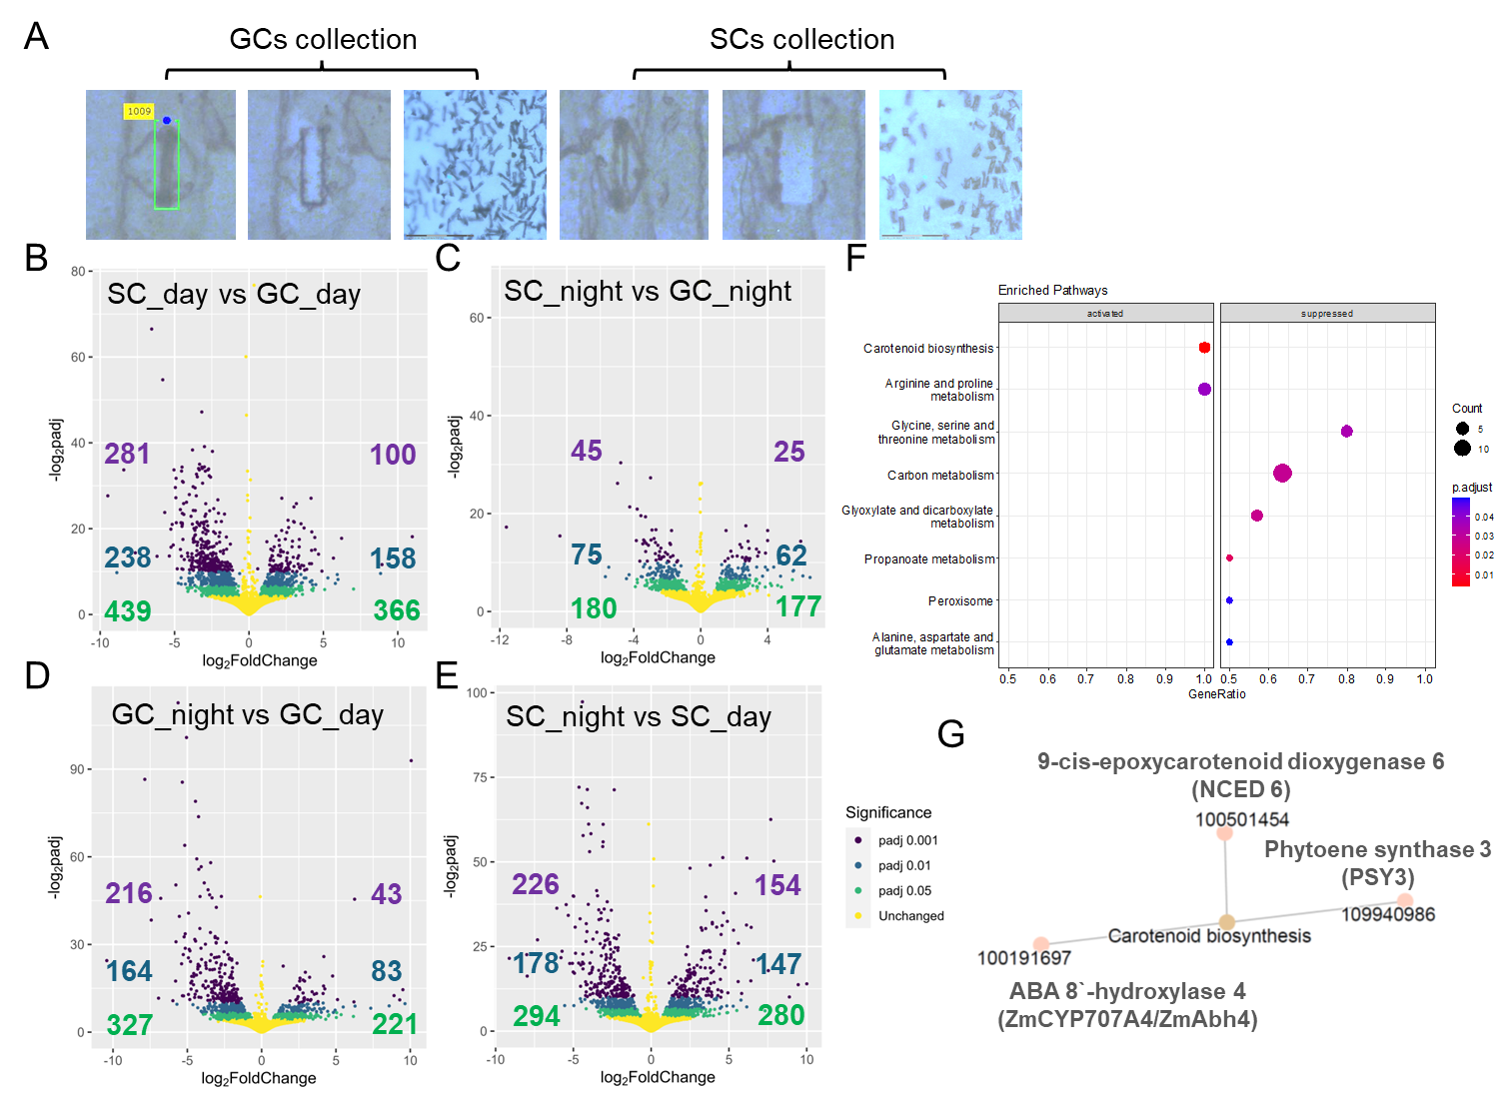

Figure 2
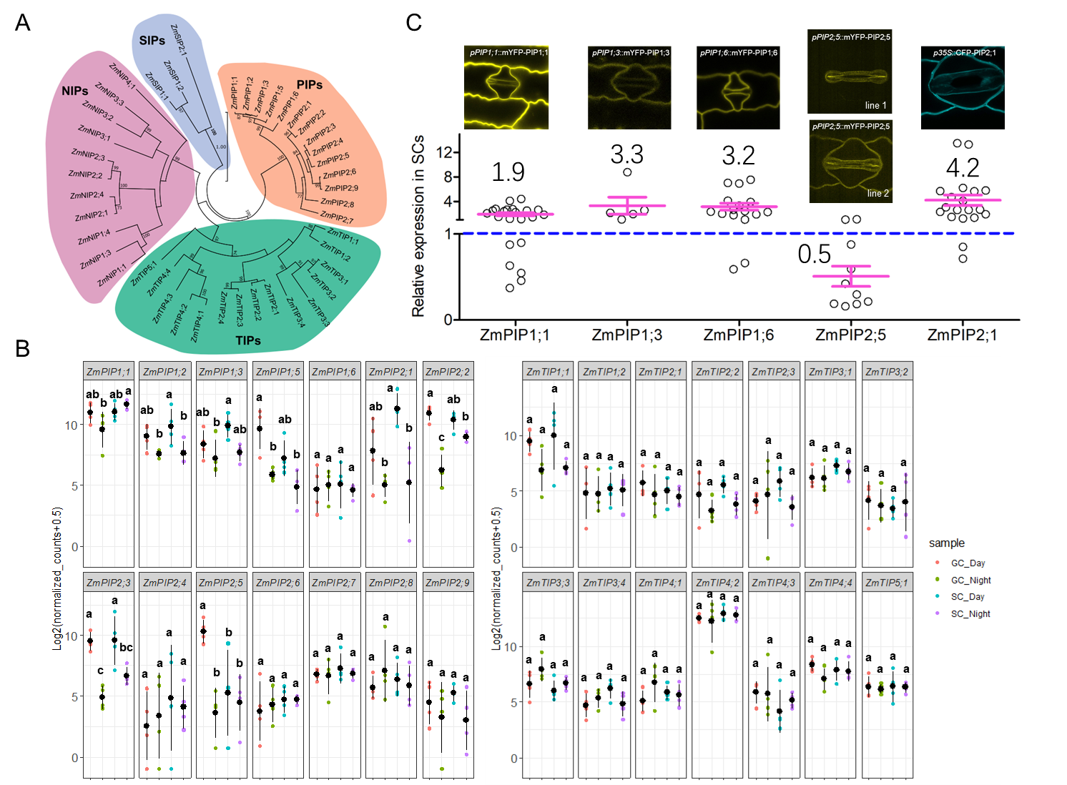

Figure 3
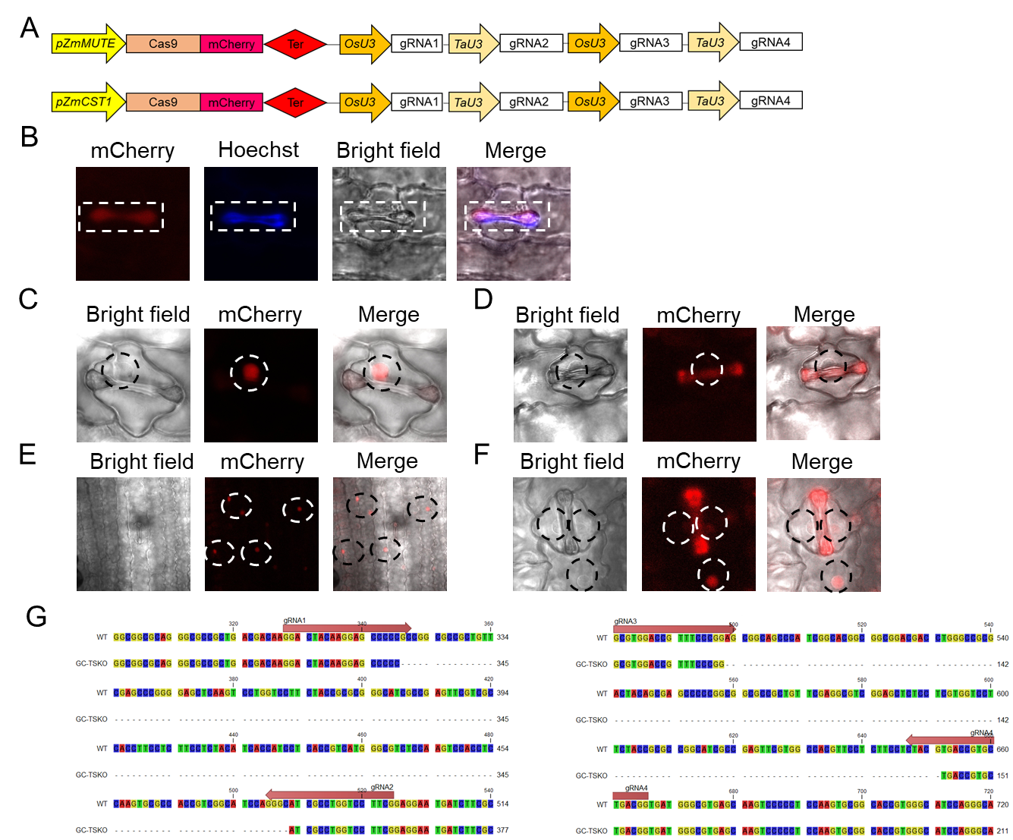

Figure 4
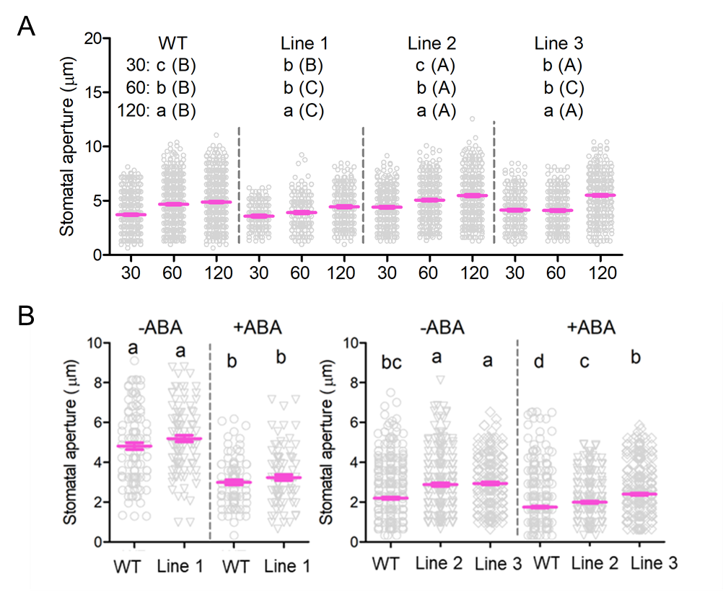

Figure 5
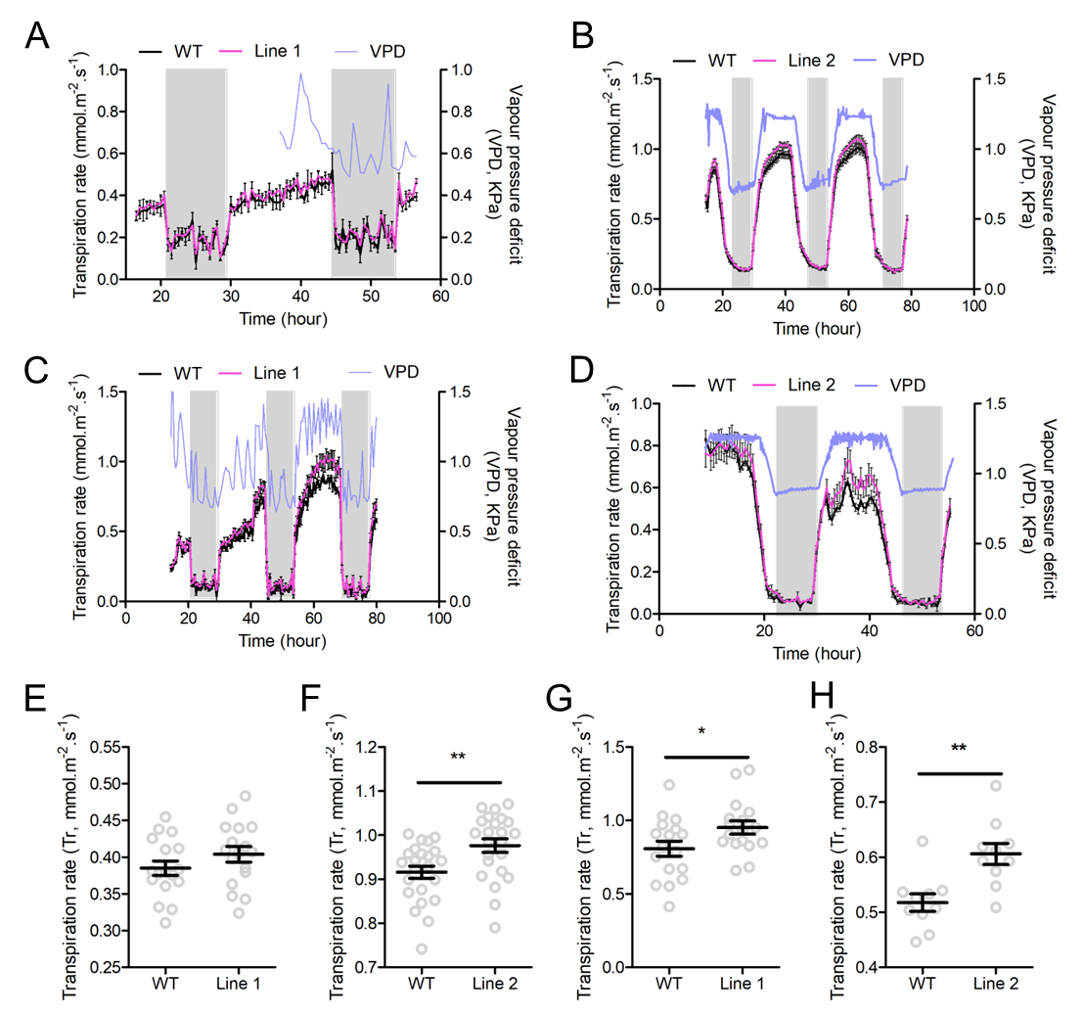

Figure 6
