Post-script version of the full article published in the International Journal of Life Cycle Assessment: https://doi.org/10.1007/s11367-024-02377-9



Towards more circular building services: a social footprint of the sectors manufacturing and remanufacturing chillers for the European market
Sébastien Loreau^{1,}*, André Stephan^{1,2} and Daniel Cooper³
¹ Louvain Research Institute for Landscape, Architecture, Built Environment, Université catholique de Louvain, B-1348 Louvain-la-Neuve, Belgium
² Faculty of Architecture, Building and Planning, The University of Melbourne, Victoria 3010, Australia
³ Department of Mechanical Engineering, University of Michigan, Ann Arbor, Michigan 48109, USA
* Corresponding author: sebastien.loreau@uclouvain.be – ORCID: 0000-0001-8572-2691

Abstract
Purpose: Buildings and construction are major drivers of anthropogenic environmental effects. Remanufacturing building products, and especially chillers, can help deliver a more sustainable renovation in Europe. While the environmental and economic benefits of this practice have been investigated, social aspects remain understudied. This research addresses the need to assess the social life cycle of new and remanufactured chillers while proposing innovative solutions to select social impact categories and explore social hotspots in detail.
Methods: We use social data from PSILCA, and global multi-regional input-output data from Eora, to quantify the social footprint associated with the sectors manufacturing and remanufacturing chillers in three major purveyors of the European market, i.e., China, Italy, and Czechia. In doing so, we purposely limit our scope to 28 social impact categories out of the 55 categories available in PSILCA. These are selected where the impact intensity of at least one country exceeds the third quartile of the intensities of all sectors. Further, we disaggregate supply chains by using structural path analysis. In doing so, we further narrow our scope to the most critical impact category in each country (i.e., where the impact intensity is the most distant from the median of the intensities of the three countries).
Results: Results reveal the significance of the social footprint of the sector manufacturing chillers in China. More specifically, 12 impact categories show abnormally high intensities, including Child labour, Forced labour and Trafficking in persons. In contrast, the social footprint of the sectors manufacturing chillers in Italy and Czechia is smaller, with the most critical impact category being Migration flows and Gender wage gap, respectively. The sectors manufacturing chillers in China and Czechia are responsible for around 40% of the contributions to the Association and bargaining rights, and the Gender wage gap issues, respectively, suggesting an important opportunity for reducing these issues by enforcing appropriate policies in these sectors. Results also show that remanufacturing chillers in Italy or Czechia is not always the best option to minimise social impacts.
Conclusion: This research brings new knowledge to the field of social life cycle assessment. It successfully demonstrates the applicability of two innovative methods, i.e., one to select social impact categories and one to explore social hotspots in detail. This work will contribute to raising our awareness of the social issues embedded in the products we buy, and especially those we install in our buildings that we are claiming to be sustainable.

Keywords
Reuse; building services; air-conditioning machine; multi-regional; input-output analysis; structural path analysis.

1. Introduction
Buildings and construction are responsible for around 50% of primary energy demand and resource consumption (Dixit, 2017), as well as around 30% of all waste flows (Global Alliance for Buildings and Construction, International Energy Agency & United Nations Environment Programme [UNEP], 2020), globally. Their role in transitioning to any form of future environmental sustainability is paramount (Pomponi & Moncaster, 2017). Building services (i.e., plumbing, heating, ventilation, and electrical services) are the equipment that provides the conditions for us to live and work in our buildings (Chartered Institution of Building Services Engineers, 2023). They can be responsible for one third of the embodied environmental impacts of a new office building (Chau, Yik, Hui, Liu, & Yu, 2007; Lambertz, Theißen, Höper, & Wimmer, 2019; Ylmén, Peñaloza, & Mjörnell, 2019), and around 30% of the investment costs of a new office building (Flamant, Deroisy, Delem, & Decuypere, 2014). They are considered a priority for the development of a more circular economy in the construction sector (Athanassiadis, 2017), yet they have received little research attention as compared to other categories of construction assemblies, such as structure or envelope assemblies.
Chillers are products designed to deliver chilled water. They are used as part of mechanical systems to condition the air of our buildings. They are commonly seen in office buildings because of the need for cooling. The process of manufacturing a new chiller is extremely energy-intensive. It is estimated that 378 MWh are required to produce a 1000 kW air-cooled chiller (Ministère de la transition écologique – Ministère en charge du logement, 2022), which is equivalent to the electricity use of ~ 100 European households for a year (Eurostat, 2023a, 2023b). In addition, manufacturing a chiller requires a broad range of materials (including critical materials for the motors), and relies on complex supply chains (Hamot & Bagenal George, 2021). Chillers are one of the most valuable building services equipment in our buildings (Cheshire, 2016). They are being replaced after 25 years of service on average, even though values as low as 7 years and as high as 42 years were recorded (American Society of Heating Refrigerating and Air-Conditioning Engineers, 2023). One of the main reasons for replacement is due to building alteration, meaning that the product might still be working when discarded (Webb, Thomson, & Kelly, 2000). Reusing chillers can therefore be greatly beneficial. For example, in a small city like Brussels, Belgium, if we reuse all discarded chillers, we could save the equivalent of the electricity use of ~ 2 000 households, annually (Loreau, Stephan, Cooper, & Maerckx, 2022).
Direct reuse of discarded chillers might not always be possible though. This is because discarded chillers might not comply with current requirements, including ecodesign requirements and legislation on fluorinated greenhouse gases (European Parliament & Council of the European Union, 2009, 2014). As such, discarded chillers can be remanufactured. Remanufacturing is a process in which returned products (or waste) are disassembled, all parts are inspected, repairable parts are fixed, the rest are replaced with new ones, and finally reassembled and tested to restore them into as-new condition (Rizova, Wong, & Ijomah, 2020). It is a promising strategy for chillers, as it allows both broken and obsolete components to be replaced by new ones (Cheshire, 2014). In addition, remanufacturers provide warranties, which is essential to meet the needs of building designers and contractors (Addis, 2006). Loreau et al. (2022) showed that chillers have a high potential for reuse and remanufacturing in a city like Brussels. This was also pointed out by Addis (2006) on a more global level. In the Netherlands, several companies already specialise in remanufacturing such products, including Comron International bv (Comron International bv, 2023), Hos bv (HOS bv, 2023), and VRT International (VRT International, 2023).
Reusing and remanufacturing discarded building products is deeply encouraged by policies in Europe. The Commission identified the reuse of waste material as a lead action to deliver sustainable renovation (European Commission, 2019, 2020). It is expected to deliver positive environmental, social, and economic impacts. While there are numerous studies and models to quantify the environmental and economic benefits of remanufacturing products (e.g., van Loon and Van Wassenhove (2018), Kwak and Kim (2016), Lahrour, Brissaud, and Zwolinski (2019), Vogt Duberg, Sundin, and Tang (2023)), attempts to quantify social impacts are rare, and the few available studies do not use the social life cycle assessment method (e.g., Golinska, Kosacka, Mierzwiak, and Werner-Lewandowska (2015)).
The Social Life Cycle Assessment (S-LCA) is a methodology to assess the social impacts of products and services across their life cycle. It is considered as the most effective assessment method to date for the social sustainability of products and organizations (Garrido, 2017). S-LCA is based on the ISO 14040 and 14044 standards and thus includes the same four phases as Life Cycle Assessment. It is a recent methodology which is still under development. The first guidance document for conducting a S-LCA study for products was published in 2009 (UNEP, 2009), and it was updated in 2020 (UNEP, 2020). Although S-LCA practice has greatly evolved, to date there is still no standardized approach to S-LCA in the construction sector (Backes & Traverso, 2023).

1.1 Aim of the paper
This paper aims to quantify and disaggregate the social footprint of the sectors manufacturing and remanufacturing chillers, and their supply chains across various economies that are pertinent to sustaining the European Union (EU27). We focus on a comparison between three economies – the top importer of chillers, the top producer of chillers, and a potential candidate for future development of remanufacturing activities (i.e., China, Italy, and Czechia, respectively). We adopt a socially extended multi-regional input-output analysis and follows the latest guidelines by the UNEP. The input-output-based approach is preferred to the process-based approach because it provides a more comprehensive overview of the supply chain of the system being studied (UNEP, 2020). Our aim translates into three distinct objectives:
- to develop an approach to estimate the social footprint of manufacturing and remanufacturing activities that is transparent, replicable and provides a justification for the selection of impact categories.
- to demonstrate its applicability through case studies of three different economies to evaluate the social impact intensities in different contexts.
- to enrich our analysis with structural path analyses of the most critical impact category in each investigated country to identify social hotspots in each supply chain.

1.2 Definition of key terms
As defined by the UNEP (2020), a social footprint refers to the end result of a S-LCA study, in terms of adverse effects, overall or by impact category/subcategory. A social impact category (referred to as impact category throughout) is a social issue that is potentially affected by the activities under study (UNEP, 2020). Common impact categories are Human Rights, Working Conditions, Cultural Heritage, Governance, and Socio-economic repercussions. Each social impact category is related to a specific stakeholder category, e.g., Workers, Local communities, Value chain actors (e.g., suppliers), Consumers, Children, and Society. A social hotspot is a unit process (an input-output sector in this study) located in a region where a problem, a risk, or an opportunity may occur in relation to a social issue that is considered to be threatening social well-being or that may contribute to its further development (UNEP, 2020).
The structural path analysis technique is a common approach to analysing the supply chains of unit processes or input-output sectors. The mathematical framework is detailed in the literature (Crama, Defourny, & Gazon, 1984; Defourny & Thorbecke, 1984). The result of a structural path analysis is a list of pathways, ranked from the most contributing to the least and containing a chain of nodes. Each node represents a good or service provided from one stage to another within the supply chain analysed. Structural path analysis can be employed to identify the most important contributions to the production layers in the upstream stages of the supply chain (Lenzen, Murray, Korte, & Dey, 2003). This relies on grouping pathway contributions (e.g., by countries, sectors, or stages), which is referred to as product layer decomposition. Examples are available in the literature, e.g., Pomponi and Stephan (2021), where structural path analysis was used to identify water, energy, and carbon dioxide hotspots in the supply chain of the construction sector of four different economies.

1.3 Structure of the article
The article is structured as follows. Section 2 reviews previous works, to inform the development of our approach. Section 3 presents both methods and data used. Results are shown in Section 4, and discussed in Section 5, along with policy recommendations and the main limitations of this research. Section 6 concludes the article.

2. Previous works on the social performance of building products
To the best knowledge of the authors of this paper, there are no previous studies assessing the social life cycle of chillers. As such, this section reviews existing research which broadly falls in the domain of the social life cycle assessment of machinery and equipment. In addition, and because only studies utilising a process-based approach were found, this section also reviews existing research related to the social life cycle assessment of concrete products that utilises an input-output-based approach (as this paper).
Existing research related to the domain of social life cycle assessment of machinery and equipment mainly focuses on assessing the social impacts of the waste management of electrical and electronic equipment, e.g., Abeliotis, Chroni, and Lasaridi (2017), Ghisellini, Passaro, and Ulgiati (2023), Lu et al. (2014), Umair, Björklund, and Petersen (2015), Rodrigues, Angelo, and Marujo (2020). Existing studies usually mention the UNEP guidelines. However, their level of detail varies significantly. Among the five aforementioned studies, only two perform a full S-LCA, in the sense that they effectively assess social impacts and they are not limited to a theory, i.e., Ghisellini et al. (2023) and Umair et al. (2015) – see Table 1. Existing research related to the social life cycle assessment of concrete products that utilises an input-output-based approach was found from the literature review by Backes and Traverso (2023), i.e., Kono, Ostermeyer, and Wallbaum (2018), Martínez-Muñoz, Martí, and Yepes (2022), Penadés-Plà, Martínez-Muñoz, García-Segura, Navarro, and Yepes (2020) – see Table 1. These studies mention the UNEP guidelines and perform a full S-LCA according to the authors of the review.
The number of impact categories considered in the reviewed studies varies between 4 to 20, and only Kono et al. (2018) provided a justification for their selection. Impact categories were selected based on the quality of the indicators, i.e., social indicators with low quality, containing any aspect with the worst quality level, were excluded from the assessment. Ghisellini et al. (2023) and Umair et al. (2015) followed a process-based approach for the life cycle inventory and collected data using interviews, on-field analyses and/or the literature. The other authors utilised an input-output-based approach for their life cycle inventory and used the same data source, i.e., PSILCA (the Product Social Impact Life Cycle Assessment database) which is currently the most up-to-date and transparent data source (Mancini et al., 2018). Ghisellini et al. (2023) and Umair et al. (2015) assessed potential impacts qualitatively, in terms of relationships between observations and impact categories. The other authors presented their impact assessment results quantitatively. Martínez-Muñoz et al. (2022) and Penadés-Plà et al. (2020) aggregated their results by stakeholder, and for one country only, which does not allow a good understanding of the social issues at stake. Moreover, they did not provide any justification on the weighting that was used for the aggregation.
Only Kono et al. (2018), and Penadés-Plà et al. (2020) performed a social hotspot analysis. While Kono et al. (2018) studied all eight impact categories considered in the impact assessment, Penadés-Plà et al. (2020) focused on a subset of impact categories. These were selected based on a previous study by Hosseinijou, Mansour, and Shirazi (2014). Both studies used the embedded method in PSILCA to calculate the hotspots. This method is somewhat approximative, because contributions are aggregated in the first tier only, and they are not detailed at each stage of the supply chain, along different pathways. Despite the low resolution of the results, Kono et al. (2018) were able to observe some variety in social hotspots depending on the regions where the product is manufactured. Penadés-Plà et al. (2020) observed some variety in social hotspots depending on the impact category considered.

Table 1 – Previous works relevant to this paper and their main characteristics
Reference | Product |  | Impact categories |  |  | Life cycle inventory approach |  | Impact assessment results |  |  | Social hotspots
Reference | Product |  | Number assessed | Selection method |  | Life cycle inventory approach |  | Type | Aggregation level |  | Availability | Impact categories | Calculation method
Ghisellini et al. (2023) | Waste electrical and electronic equipment |  | 4 | Not communicated |  | Process |  | Qualitative | Not applicable |  | No | Not applicable | Not applicable
Kono et al. (2018) | Green concrete |  | 8 | Data quality analysis |  | Input-Output |  | Quantitative | No aggregation |  | Yes | 8 | Embedded method in PSILCA
Martínez-Muñoz et al. (2022) | Bridge decks |  | 20 | Not communicated |  | Input-Output |  | Quantitative | By stakeholders |  | No | Not applicable | Not applicable
Penadés-Plà et al. (2020) | Bridge |  | 18 | Not communicated |  | Input-Output |  | Quantitative | By stakeholders |  | Yes | 13 | Embedded method in PSILCA
Umair et al. (2015) | Electronic information and communication technology waste |  | 4 | Not communicated |  | Process |  | Qualitative | Not applicable |  | No | Not applicable | Not applicable
This study (2024) | Chillers |  | 28 | Statistical analysis |  | Input-Output |  | Quantitative | No aggregation |  | Yes | 3 | Structural path analysis

Overall, existing studies suffer from three main issues. First, they do not cover the social life cycle assessment of chillers specifically, despite the significance of these building products (see Section 1). Second, they struggle to justify their choice of impact categories (this was also observed by Backes and Traverso (2023) at the indicator level). Only Kono et al. (2018) justify why impact categories are selected based on the reliability of their indicators. Other studies either refer to the literature or do not provide any justification. Failing to justify the choice of impact categories can lead to overlooking potential social issues, which can defeat the purpose of a S-LCA. Third, the few studies performing a hotspot analysis do not provide a good resolution of the supply chain. They rely on the embedded method in PSILCA where contributions are aggregated in the first tier only. Failing to detail contributions at each stage of the supply chain, along different pathways can lead to overlooking potential individual hotspots and cannot capture linkages in the supply chain across different countries further upstream. There is therefore a need to assess the social life cycle of chillers while developing a decision-support method for selecting impact categories, as well as improving on the embedded method in PSILCA to perform a hotspot analysis. This study addresses these needs.

3. Data and methods

3.1 Overall research approach
This research follows the social life cycle assessment approach described in the latest UNEP guidelines (UNEP, 2020). This approach includes four steps, i.e., goal and scope definition, social life cycle inventory, social impact assessment, and social life cycle interpretation. Aspects related to the first three steps are described in Sections 3.2 to 3.8. Aspects related to the social life cycle interpretation are described in Section 5.
Section 3.2 defines the goal and scope of the study, while Sections 3.3 and 3.4 detail the method we used to select the case study sectors and the relevant impact categories, respectively. Section 3.5 discusses the social life cycle inventory for this study. Section 3.6 describes the calculation method behind the assessment of impact intensities at the sector level and Sections 3.7 and 3.8 present the method we use to quantify impact intensities at the product level and to identify social hotspots, respectively. Note that the term “impact intensity” is preferred to its equivalent “social impact” used in PSILCA. In this paper, we use the term “impact intensity” for quantification purposes, and the term “social impact” for conceptual matters.
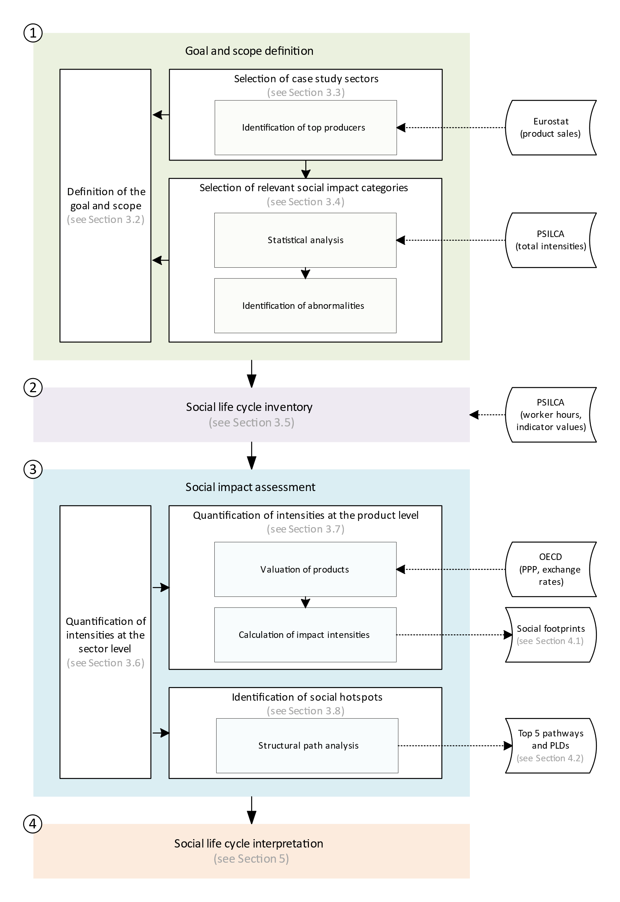
Figure 1 – Overall research approach followed in this paper. Note: PSILCA stands for the Product Social Impact Life Cycle Assessment database; OECD stands for Organisation for Economic Co-operation and Development; PPP stands for Purchasing power parities; PLD stands for Product Layer Decomposition.

3.2 Goal, scope, and data
The goal of this social life cycle assessment study is to quantify and disaggregate the social footprint of the sectors manufacturing and remanufacturing chillers, and their supply chains across various economies that are pertinent to sustaining the European Union (EU27).
The functional unit chosen in this study is the same as the one considered in the INIES database for a chiller of the intermediate category of cooling capacity, i.e., “Act as a chiller with a cooling capacity of 500 kW to 1000 kW and a design life of 22 years” (Ministère de la transition écologique – Ministère en charge du logement, 2022). We considered that the service provided by a remanufactured chiller is equivalent to the one provided by a new chiller. We also considered that the sales price of a remanufactured chiller is 70% of that of a new chiller, which is a common assumption in the literature (Kwak & Kim, 2016).
The product system is built based on economic input-output tables, and more specifically the Eora multi-regional input-output tables released in 2019 (for which the reference year is 2015). The Eora database was initially developed by Manfred Lenzen and colleagues (Lenzen, Kanemoto, Moran, & Geschke, 2012; Lenzen, Moran, Kanemoto, & Geschke, 2013). These tables represent worldwide commercial transactions between country-specific sectors – as they consider the whole economy. They provide a comprehensive overview of the supply chain of the system being studied. However, in essence, their data are aggregated, e.g., on the sector-country level. Section 3.3 details the selection of the case study sectors for this study.
The system boundaries are set considering the physical perspective (Zanchi, Delogu, Zamagni, & Pierini, 2018), and the focus is on economic flows that characterize the value chain until the product is ready to leave the final factory gate.
The study uses an activity variable to reflect the share of a given activity associated with each unit process. Because of its availability in the PSILCA database, the activity variable selected is worker-hours. Worker-hours is the most used activity variable in S-LCA studies (UNEP, 2020). It consists of the number of worker-hours necessary to complete a production activity/unit process (UNEP, 2020).
The study uses cut-off criteria to reduce the calculation time of a structural path analysis and to avoid analysing pathways that are too insignificant. As such, pathways with a low contribution to total impact intensities are left out. Thresholds are set as low as required for the structural path analysis to cover at least 80% of the supply chain contributions. More details are provided in Section 4.2.
The study uses PSILCA as the source of generic data for the life cycle inventory. More details are provided in Section 3.5.
This study follows a new method for the selection of impact categories and associated indicators and stakeholders. Impact categories are selected based on a statistical analysis of the total impact intensities of every sector in the PSILCA database, and an analysis of abnormalities for the selected sectors. More details are provided in Section 3.4.
This study relies on the two impact assessment methods embedded in PSILCA, i.e., the reference scale method and the social impacts weighting method. The reference scale method is used to assess social risks associated with every sector. More specifically, the method translates indicator raw values in risk levels for every sector. For each indicator, a specific scale was developed by PSILCA (Loubert et al., 2023). The social impact weighting method is used to quantify impact intensities. More specifically, the method aggregates indicator risk levels and worker-hours into impact intensities according to social impact categories for every sector. More details are provided in Section 3.6.

3.3 Selection of case study sectors
We selected the case study sectors manufacturing and remanufacturing chillers in two steps. First, we identified and selected three different economies, i.e., a top importer of chillers in the EU27, a top producer of chillers in the EU27, and a potential candidate for the future development of remanufacturing activities in the EU27. Then, we identified and selected the sectors manufacturing and remanufacturing chillers for these countries in the Eora database, used by PSILCA.
To identify the top importer country, we used the dataset DS-059322 (Eurostat, 2023c) related to the European international trade, and to identify the two EU27 producer countries, we used the dataset DS-056120 (Eurostat, 2023d) related to the European production of manufactured goods. We considered the product code with the following description: “Air conditioning machines with refrigeration unit (excluding those used in motor vehicles, self-contained or split-systems machines)”, which includes chillers. We selected the reference year of 2019 because it is the last full year before the COVID-19 pandemic arrived in Europe. According to these datasets, China contributed 74% of the imports to the EU27 from extra EU27 countries in 2019 (in value). Italy produced more than 50% of the sold production in the EU27 in 2019 (in value). Czechia (note that Czechia is the official short-form name of the Czech Republic (United Nations, 2016)) was ranked number 5 in the EU27 top producer country ranking in 2019 (in value) and produced a bit less than 5% of the sold production in the EU27 in 2019 (in value). More importantly, Czechia ranked below the EU27 average for personnel costs within the manufacturing industry (Eurostat, 2022). In consequence, this study considers China as the top importer of chillers in the EU27, Italy, as the top producer of chillers in the EU27, and Czechia, as a potential candidate for the future development of remanufacturing activities in Europe.
To identify the case study sectors in the Eora database, we used the definitions in the Statistical classification of economic activities in the European Community (Eurostat, 2008). According to this document, the manufacturing of chillers falls into the Manufacture of non-domestic cooling and ventilation equipment class, which belongs to the Manufacture of other general-purpose machinery group, under the Manufacture of machinery and equipment n.e.c. division. Note that the terms “non-domestic” and “industrial” are used as synonyms in the statistical classification and refer to machinery and equipment that are not of a type designed principally for use by private households. A direct match was found for Italy and Czechia at the division level, i.e., the Manufacture of machinery and equipment n.e.c. A somewhat more accurate but less straightforward match was found for China at the group level, i.e., the Other general industrial machinery. This is considered the best possible match, in the absence of any English publication describing the Chinese statistical classification. Note, that only commodity-sectors were considered in this study. They were preferred to industry-sectors because a commodity represents an average for the provision of a certain good (i.e., a chiller in this study) from different industries.
The Eora database does not include any specific commodity-sectors for remanufactured goods. According to the Statistical classification of economic activities in the European Community, the rebuilding or remanufacturing of machinery and equipment is considered a manufacturing activity and included in other divisions of this section. As such, this study adopts the same sectors for both manufacturing and remanufacturing activities (see Section 5.3 for limitations). Table 2 presents the selected sectors for this study.
Table 2 – Selected sectors for this study
 | China  (top importer) | Italy  (top producer) | Czechia  (potential remanufacturer)
Manufacturing of  chillers | Other general industrial machinery | Machinery and equipment n.e.c. | Machinery and equipment n.e.c.
Remanufacturing of chillers | Other general industrial machinery | Machinery and equipment n.e.c. | Machinery and equipment n.e.c.

3.4 Selection of relevant social impact categories
We selected the relevant social impact categories for manufacturing and remanufacturing chillers in three steps. First, we conducted a statistical analysis of the total impact intensities of every sector in the PSILCA database, and for each impact category. Second, we compared the total impact intensities of the selected sectors (see Section 3.3) with these statistical results. Then, we selected the relevant impact categories based on the performance of the selected sectors.
In the statistical analysis, we normalized the total impact intensities of every sector by taking the median value of the respective categories as a reference. The results are shown in Figure 2, where the median of every category appears at the same level on the y-axis. The boxes show the limits of the first and third quartile, and the whiskers show the minimum and maximum values of each category (excluding outliers). Maximum values are particularly high for the impact categories of Embodied biodiversity footprints, Illiteracy male, Child labour female and Child labour total.
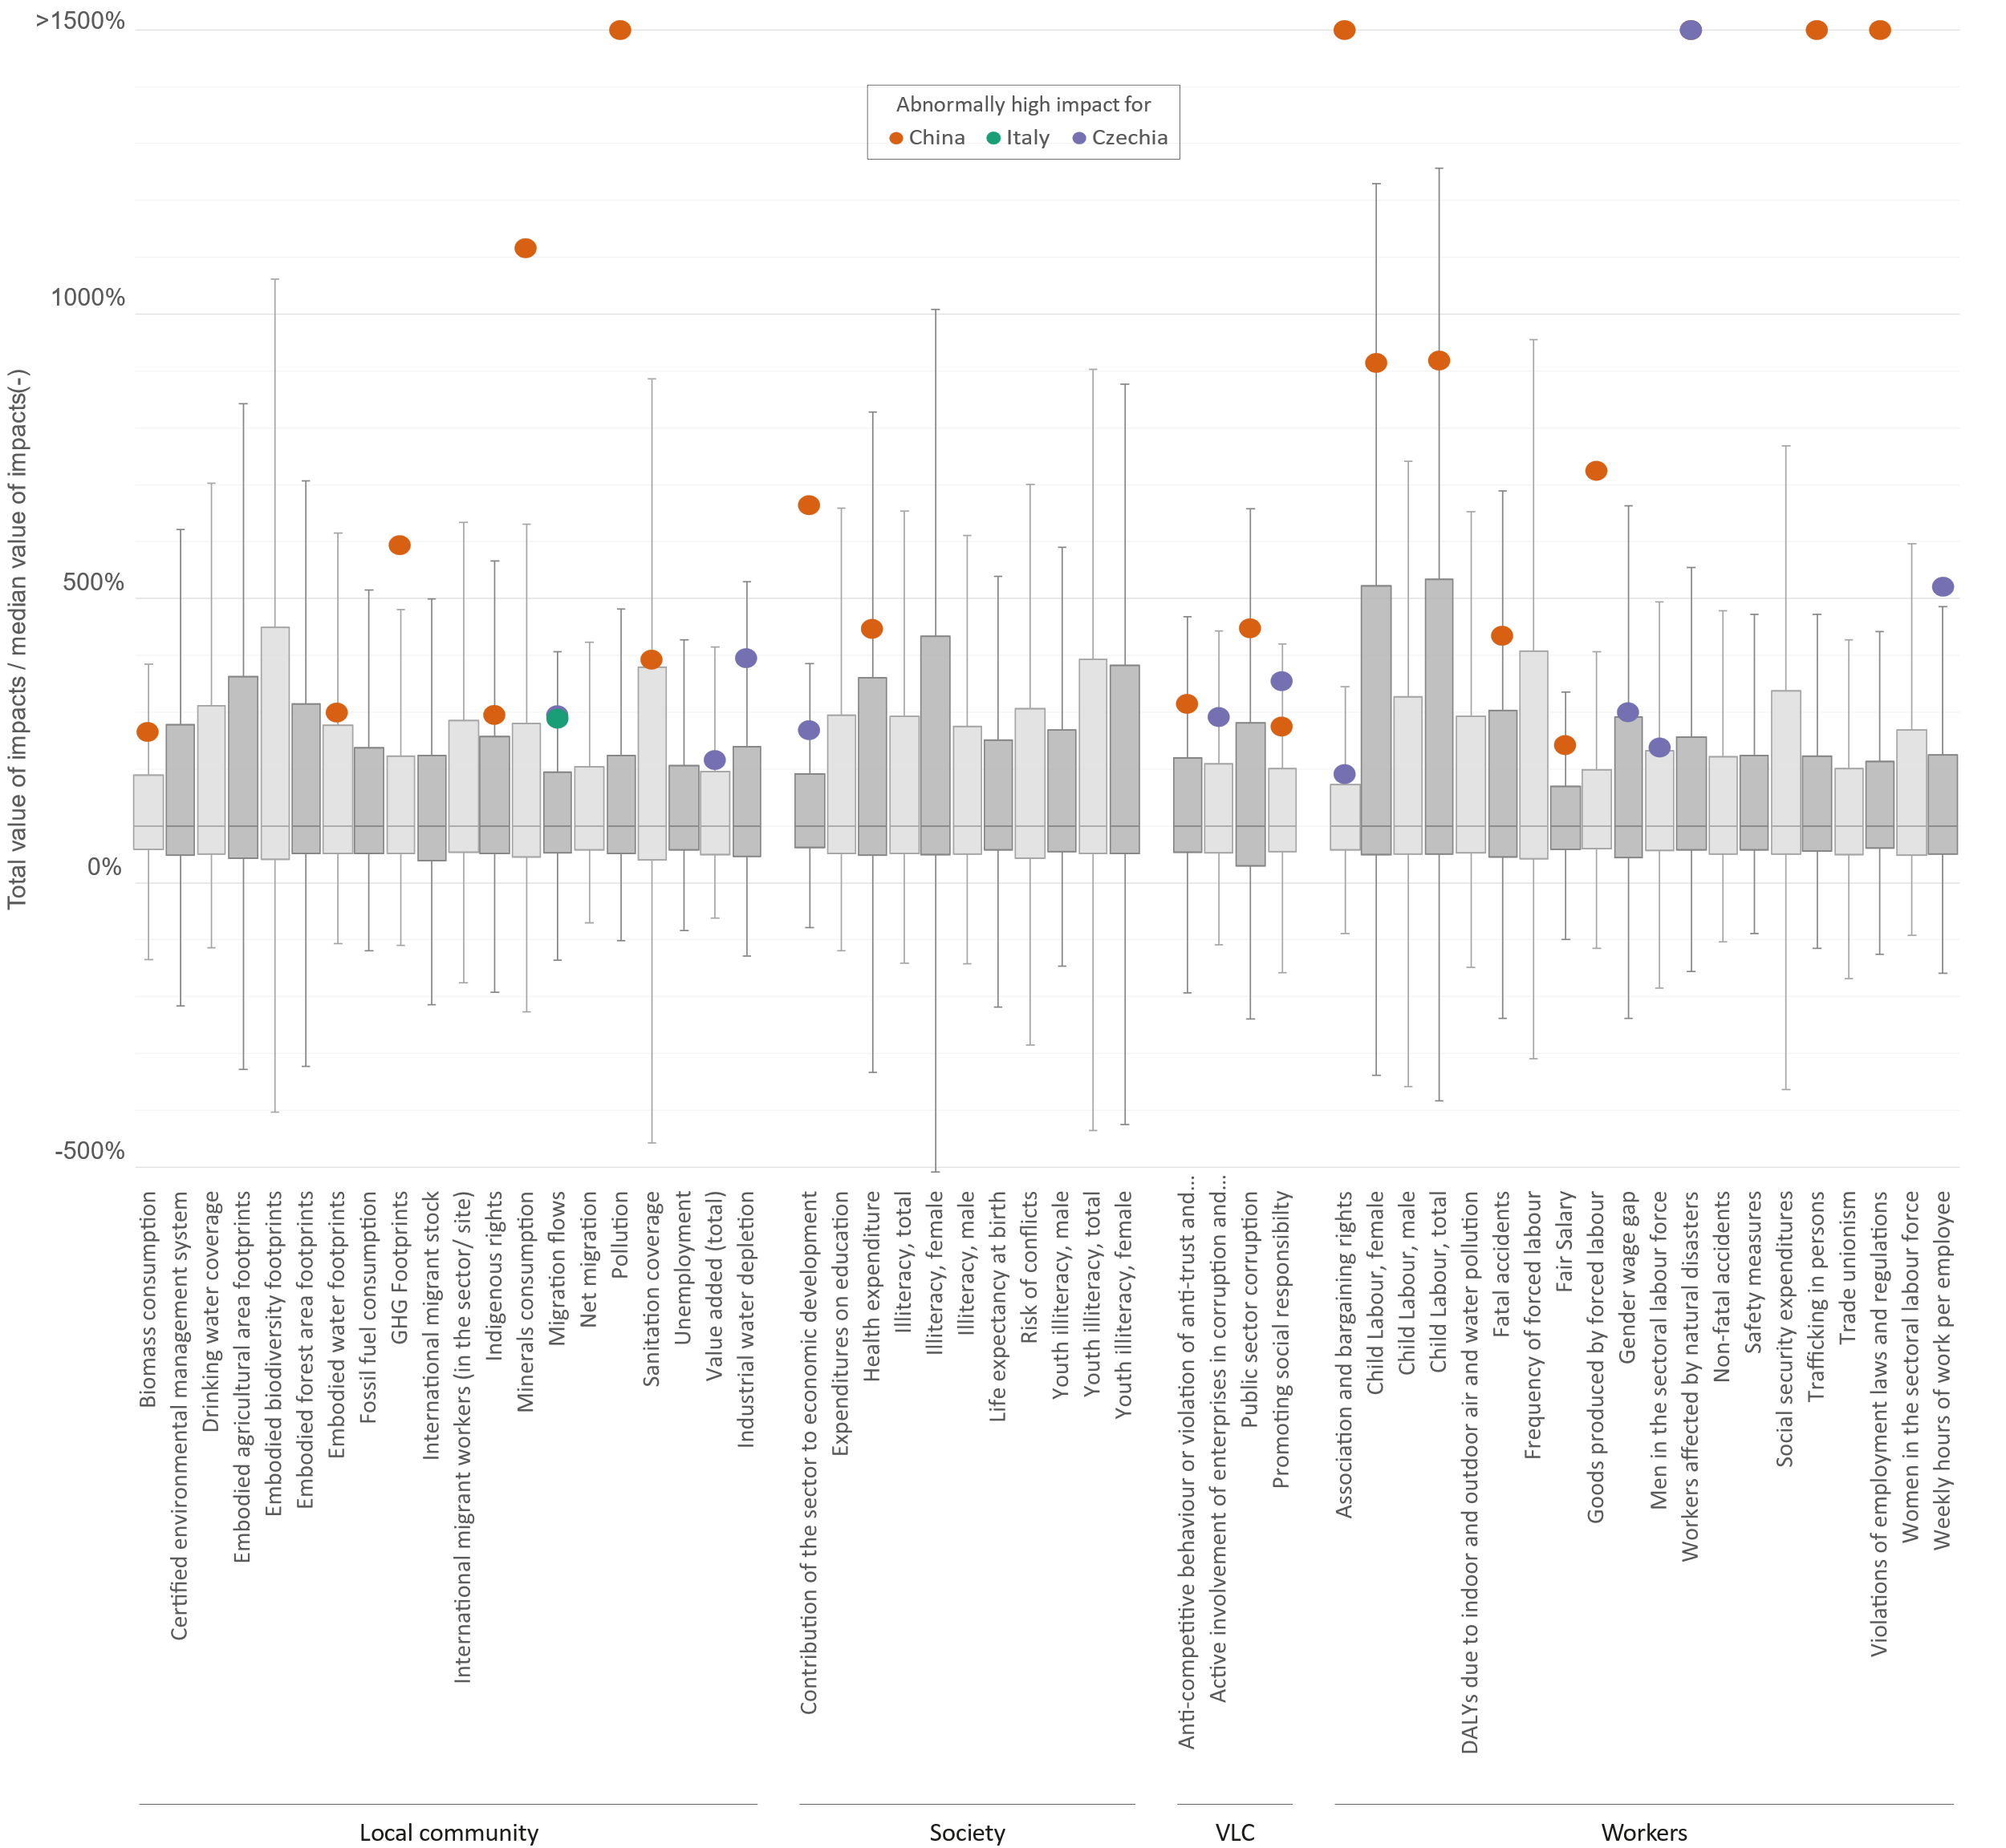
Figure 2 – Results of the statistical analysis of the total impact intensities of every sector in the PSILCA database, by impact category. Impact intensities are normalized by taking the median value of the respective categories as a reference. Note: VLC stands for value chain actors.
In comparing the total impact intensities of the selected sectors (see Section 3.3) with these statistical results, we considered that total impact intensities exceeding the third quartile of an impact category were abnormal. The results are shown in Figure 2. In total, China has 20 abnormal total impact intensities, Czechia has 11, and Italy has one. Four total impact intensities in China are higher than 1500% of the median (i.e., Pollution, Association and bargaining rights, Trafficking in persons and Violations of employment laws and regulations).
To select the relevant impact categories, we looked for impact categories for which at least one of the selected sectors showed an abnormal value, i.e., a value of total impact intensity that exceeds the third quartile for an impact category. In total 28 impact categories were found. Table 3 presents the selected impact categories for this study, along with their associated stakeholders and indicators.
Table 3 – Selected social impact categories, along with their associated stakeholder and indicators
Stakeholder | Impact category | Abbreviation | Indicators
Local community | Biomass consumption | BM | Extraction of biomass (related to area)
Local community | Biomass consumption | BM | Extraction of biomass (related to population)
Local community | Embodied water footprints | EWF | Embodied water footprint
Local community | GHG Footprints | GHGF | Embodied CO2 footprint
Local community | GHG Footprints | GHGF | Embodied CO2-eq footprint
Local community | Indigenous rights | IR | Indigenous People Rights Protection Index
Local community | Indigenous rights | IR | Presence of indigenous population
Local community | Minerals consumption | MC | Extraction of industrial and construction minerals
Local community | Minerals consumption | MC | Extraction of ores
Local community | Migration flows | MF | Emigration rate
Local community | Migration flows | MF | Immigration rate
Local community | Migration flows | MF | Asylum seekers rate
Local community | Pollution | P | Pollution level of the country
Local community | Sanitation coverage | SC | Sanitation coverage
Local community | Value added (total) | VAT | Embodied value-added total
Local community | Industrial water depletion | WU | Level of industrial water use (related to renewable water re-sources)
Local community | Industrial water depletion | WU | Level of industrial water use (related to total withdrawal)
Society | Contribution of the sector to economic development | CE | Contribution of the sector to economic development
Society | Health expenditure | HE | Health expenditure, domestic general government
Society | Health expenditure | HE | Health expenditure, external resources
Society | Health expenditure | HE | Health expenditure, out-of-pocket
Society | Health expenditure | HE | Health expenditure, total
Value chain actors | Anti-competitive behaviour or violation of anti-trust and monopoly legislation | AC | Presence of anti-competitive behaviour or violation of anti-trust and monopoly legislation
Value chain actors | Active involvement of enterprises in corruption and bribery | AI | Active involvement of enterprises in corruption and bribery
Value chain actors | Public sector corruption | C | Public sector corruption
Value chain actors | Promoting social responsibility | PSR | Social responsibility along the supply chain
Workers | Association and bargaining rights | ACB | Right of Association
Workers | Association and bargaining rights | ACB | Right of Collective bargaining
Workers | Association and bargaining rights | ACB | Right to Strike
Workers | Child Labour, female | CL | Children in employment, female
Workers | Child Labour, total | CL | Children in employment, total
Workers | Fatal accidents | FA | Rate of fatal accidents at workplace
Workers | Fair Salary | FS | Living wage, per month
Workers | Fair Salary | FS | Minimum wage, per month
Workers | Fair Salary | FS | Sector average wage, per month
Workers | Goods produced by forced labour | GFL | Goods produced by forced labour
Workers | Gender wage gap | GW | Gender wage gap
Workers | Men in the sectoral labour force | M | Men in the sectoral labour force
Workers | Workers affected by natural disasters | ND | Workers affected by natural disasters
Workers | Trafficking in persons | TP | Trafficking in persons
Workers | Violations of employment laws and regulations | VL | Violations of mandatory health and safety standards
Workers | Violations of employment laws and regulations | VL | Evidence of violations of laws and employment regulations
Workers | Weekly hours of work per employee | WH | Weekly hours of work per employee

3.5 Social life cycle inventory
The study uses PSILCA as the source of generic data for the life cycle inventory.
PSILCA is a social life cycle assessment database developed by GreenDelta. This database provides transparent and up-to-date information on social aspects of products throughout their life cycle for about 15 000 industries and commodities (GreenDelta, 2022). PSILCA was preferred over its competitor SHDB (i.e., Social Hotspots Database) for the following reasons. It covers more countries (190 against 140 with SHDB), more processes (14 839 against 7 980 with SHDB), it covers commodities, the data is more recent (dated from 2015 against 2011 for SHDB), and it provides data quality information for every process in the database (which is not the case of SHDB) (Benoit Norris, Bennema, & Norris, 2018; Loubert et al., 2023).
PSILCA uses statistical agencies such as the World Bank, the International Labour Organisation, the World Health Organization, and the United Nations as main sources of data. These are supplemented with private or governmental databases where applicable. All the sources used in PSILCA are documented in the database (Loubert et al., 2023).

3.6 Quantification of impact intensities at the sector level
The quantification of impact intensities at the sector level relies on the five following steps embedded in PSILCA. Firstly, a risk level is attributed to every sector, for each indicator. Secondly, a specific number of worker-hours is calculated and assigned to each sector. Thirdly, worker-hours are summed up along the supply chain by risk levels, for every sector and each indicator. Fourthly, indicator contributions are calculated by multiplying the worker-hours with the appropriate characterization factors. Fifthly, an impact intensity is calculated for every sector and impact category, by aggregating the appropriate indicator contributions.
In the first step, risk levels are assessed using the reference scale method. This method consists of translating social raw data into risk levels (UNEP, 2020). To this end, reference scales were developed by PSILCA for each indicator. Table 4 shows an example of a reference scale for the indicator Right of association. For this specific indicator, PSILCA derives raw data from a variety of sources, including the Database on Institutional Characteristics of Trade Unions, Wage Setting, and State Intervention and Social Pacts. For example, according to these sources, there are major restrictions on the right of association in the sector manufacturing chillers in China. In consequence, the PSILCA database shows that there is a high risk in that sector for the right of association. Note that the higher the risk, the worse the social situation is, even if the name of the indicator seems positive, e.g., right of association. There is only one impact category related to positive impacts in PSILCA, i.e., the Contribution of the sector to economic development, which is assessed through different opportunity levels (see Table 6).
Table 4 – Example of reference scale for the indicator Right of association
Raw data | Risk level
Right of association | No risk
Right of association, with minor restrictions  (e.g. recognition procedures, workplace elections, thresholds) | Low risk
Right of association, with major restrictions  (e.g. monopoly union, prior authorization, major groups excluded) | High risk
No right of association | Very high risk
Not available | No data

In the PSILCA database, worker-hours are the basic activity variable. They are related to 1 USD of sector output. Worker-hours are calculated by dividing the unit labour costs by the mean hourly labour costs per employee, where the unit labour costs are calculated by dividing the compensation of employees by the gross output in USD per country (sector and year specific). Data for the compensation of employees are taken from the Eora satellite accounts (KGM & Associates Pty. Ltd., 2019). Gross outputs are calculated from Eora, by summing the intermediate consumption and the value added of each group of producing unit (industry) (European Communities, International Monetary Fund, Organisation for Economic Co-operation and Development, United Nations, & Bank, 2009). Data on mean nominal hourly labour cost per employee are available from the International Labour Organization (International Labour Organization, 2023). For example, the number of worker-hours in the sector manufacturing chillers in China is 2.3E-3 hours for 1 USD of sector output.
In the third step, we calculate total worker-hours, as the sum of the direct worker-hours calculated in the previous step, and the worker-hours occurring upstream in the supply chain. To account for upstream worker-hours, we use the standard Leontief’s inverse $L$, which is equal to ${(I-A)}^{-1}$ where $A$ is the Eora technological matrix that captures direct supplier relationships (Miller & Blair, 2009). Total worker-hours (denoted as $m$ in the following equation) are defined as $m=f∙L$, where $f$ is the direct worker-hours. Table 5 shows an example of the total worker-hours required to generate 1 USD of output in the sector manufacturing chillers in China, by risk levels for the indicator Right of association.
Table 5 – Example of the total worker-hours required to generate 1 USD of output in the sector manufacturing chillers in China, by risk levels for the indicator Right of association
Risk level | Total worker-hours (hours)
No risk | 2.9E-04
Low risk | 3.8E-05
High risk | 6.7E-03
Very high risk | 2.9E-08
No data | 2.0E-04

In the fourth step, indicator contributions are calculated using the social impact weighting method developed by PSILCA (Loubert et al., 2023). The social impact weighting method consists of translating worker-hours into indicator contributions. To this end, characterization factors with exponential relationships were developed by PSILCA, see Table 6. A characterization factor of 1 is assigned to medium risk levels, thus results are expressed in medium risk hours. Direct (total) indicator contributions are calculated by multiplying direct (total) worker-hours by the characterization factor and summing when appropriate. For example, the direct indicator contribution associated with the indicator Right for association and the sector manufacturing chillers in China is 2.3E-2 med risk hours. The total indicator contribution of the same sector is 6.7E-2 med risk hours.
Lastly, impact intensities are calculated by aggregating indicator contributions, by impact categories. For example, the Association and bargaining rights impact intensity is calculated by aggregating the indicator contributions of the Right of Association, the Right of Collective bargaining, and the Right to Strike (see Table 3).
Table 6 – Characterization factors used in PSILCA
Risk/opportunity level | Characterization factor
Very low risk | 0.01
Low risk | 0.1
Medium risk | 1
High risk | 10
Very high risk | 100
No risk/opportunity | 0
Low opportunity | 0.1
Medium opportunity | 1
High opportunity | 10
No data | 0.1

3.7 Quantification of impact intensities at the product level
The quantification of impact intensities at the product level consists of multiplying the impact intensities at the sector level by the sales price of the product under study. This is because the impact intensities at the sector level are expressed for 1 USD of sector output.
To calculate the sales price of the product under study, we used the purchasing power parities and exchange rates available in the Organisation for Economic Co-operation and Development (2023b) and Organisation for Economic Co-operation and Development (2023a). Purchasing power parities are the rates of currency conversion that try to equalise the purchasing power of different currencies, by eliminating the differences in price levels between countries. We first postulated that the value of a new chiller was 100 USD and that the value of a remanufactured chiller was 70% of this, as in Kwak and Kim (2016). Then, we used the purchasing power parities of 2015 to translate those prices into local prices, and the exchange rates of the same year to translate these local prices into comparable sales prices in USD. The year 2015 was chosen because it is the reference year of the Eora tables used in PSILCA. Table 7 shows the results. It shows that a new chiller would be sold 82 USD in Italy, while the same chiller would be sold 35% cheaper in Czechia.
Table 7 – Valuation of the products in the three different economies investigated in this study
 | Type of product | Assumed value (USD) | Purchasing power parities (Local currency/USD) | Local price (Local currency) | Exchange rate (Local currency/USD) | Sales price (USD)
China | New chiller | 100 | 3.871 | 387 | 6.227 | 62
China | Remanu-factured chiller | 70 | 3.871 | 271 | 6.227 | 44
Italy | New chiller | 100 | 0.739 | 74 | 0.901 | 82
Italy | Remanu-factured chiller | 70 | 0.739 | 52 | 0.901 | 57
Czechia | New chiller | 100 | 12.938 | 1294 | 24.599 | 53
Czechia | Remanu-factured chiller | 70 | 12.938 | 906 | 24.599 | 37

3.8 Identification of social hotspots
The identification of social hotspots relies on the structural path analysis technique We use the pyspa Python® package developed by Stephan and Bontinck (2019) to conduct the analysis. The algorithm is described in detail in Stephan, Crawford, and Bontinck (2019).
The code reads the Eora technological matrix $A$ representing the inputs and outputs of the 14 839 sectors across 190 regions. The code also reads a spreadsheet providing the metadata for each sector of each region, namely its ID, Name, Region, and direct and total multipliers for the selected social impact category.
Once the data are read, the code conducts the structural path analysis of each selected sector (see Section 3.3). The code iterates over the technological vector (column) in the matrix $A$, representing the selected sector. It compares the total impact intensity associated with each technological input with the specified cut-off threshold (the threshold varies for each impact category – see Section 4.2). If that total impact intensity is above or equal to the threshold, this input is considered and all upstream inputs are also screened using the same threshold until no single input matches the threshold criteria or we have reached the maximum number of stages (in this case we specified 10 stages upstream).
The result of the structural path analysis is a list of pathways, ranked from the most contributing to the least and containing a chain of nodes (see Section 1.2 for definitions).The contribution of the pathway is the direct social flow input into its most upstream node (excluding other inputs into further upstream nodes). This enables us to characterise the supply chains driving the social footprint of the sectors manufacturing and remanufacturing chillers of each country, across the 14 839 sectors in the technological matrix and the 190 regions. The approach provides an unprecedented resolution of the results, which helps address the existing research gaps.
In the context of this study, we limited the identification of social hotspots to the most critical social impact categories in each country (i.e., where the impact intensity is the most distant from the median of the intensities of the three countries) (see Section 4.2).

4. Results
This section presents the results, focusing on the social footprints of the sectors manufacturing and remanufacturing chillers in China, Italy, and Czechia (Section 4.1), as well as the social hotspots for the most critical social impact category in each country (Section 4.2). Social hotspots are based on a total of 5 383 348 data points extracted through structural path analysis broken down into 211 679 data points for China, 4 800 126 for Italy, and 371 543 for Czechia. The detailed results of the three structural path analyses can be found at https://www.doi.org/10.6084/m9.figshare.24659421.

4.1 Social footprint of the sectors manufacturing and remanufacturing chillers
Figure 3 shows the social footprint for the three countries we analysed in terms of relative values. For each impact category, absolute values are divided by the median values for the three countries.
Figure 3 allows us to identify impact categories where impact intensities exceed five times the median value, and therefore the social topics of concern in relation to the manufacture of chillers in a specific country. For instance, the following topics tend to be concerning in China (the ratio impact intensity by the median value follows in brackets): Indigenous rights (7), Minerals consumption (16), Pollution (23), Sanitation coverage (5), Health expenditure (6), Association and bargaining rights (37), Child Labour, female (7), Child Labour, total (10), Fatal accidents (6), Goods produced by forced labour (8), Trafficking in persons (21), Violations of employment laws and regulations (16).
We can also identify impact categories with a maximum value lower than 2 times the median value, suggesting a closer agreement between the different countries, i.e., Migration flows, Value added (total), Industrial water depletion, Anti-competitive behaviour or violation of anti-trust and monopoly legislation, Active involvement of enterprises in corruption and bribery, Promoting social responsibility, Weekly hours of work per employee.
The figure also allows us to identify the most critical impact category in each country, which is the impact category Association and bargaining rights in China (with a ratio impact intensity by the median value of 37), the impact category Migration flows in Italy (with a ratio of 2), and the impact category Gender wage gap in Czechia (with a ratio of 3). These social topics are further explored in Section 4.2.
Finally, we can also see that within a specific country, remanufactured chillers show lower levels of impact intensities than new chillers. However, when considering all three countries, there are some instances where new chillers show lower levels of impact intensities than new chillers, meaning that it might be preferable to opt for a new chiller instead of a remanufactured one to minimise negative social impacts. This is particularly true when the intention is to minimise the following impact categories (the difference in the ratio impact intensity by the median value follows in brackets): Migration flows, for which a new Chinese chiller is preferable to a remanufactured Czech chiller (0.4); Active involvement of enterprises in corruption and bribery, for which a new Chinese chiller is preferable to a remanufactured Italian chiller (0.4); and Public sector corruption, for which a new Czech chiller is preferable to a remanufactured Italian chiller (0.3).
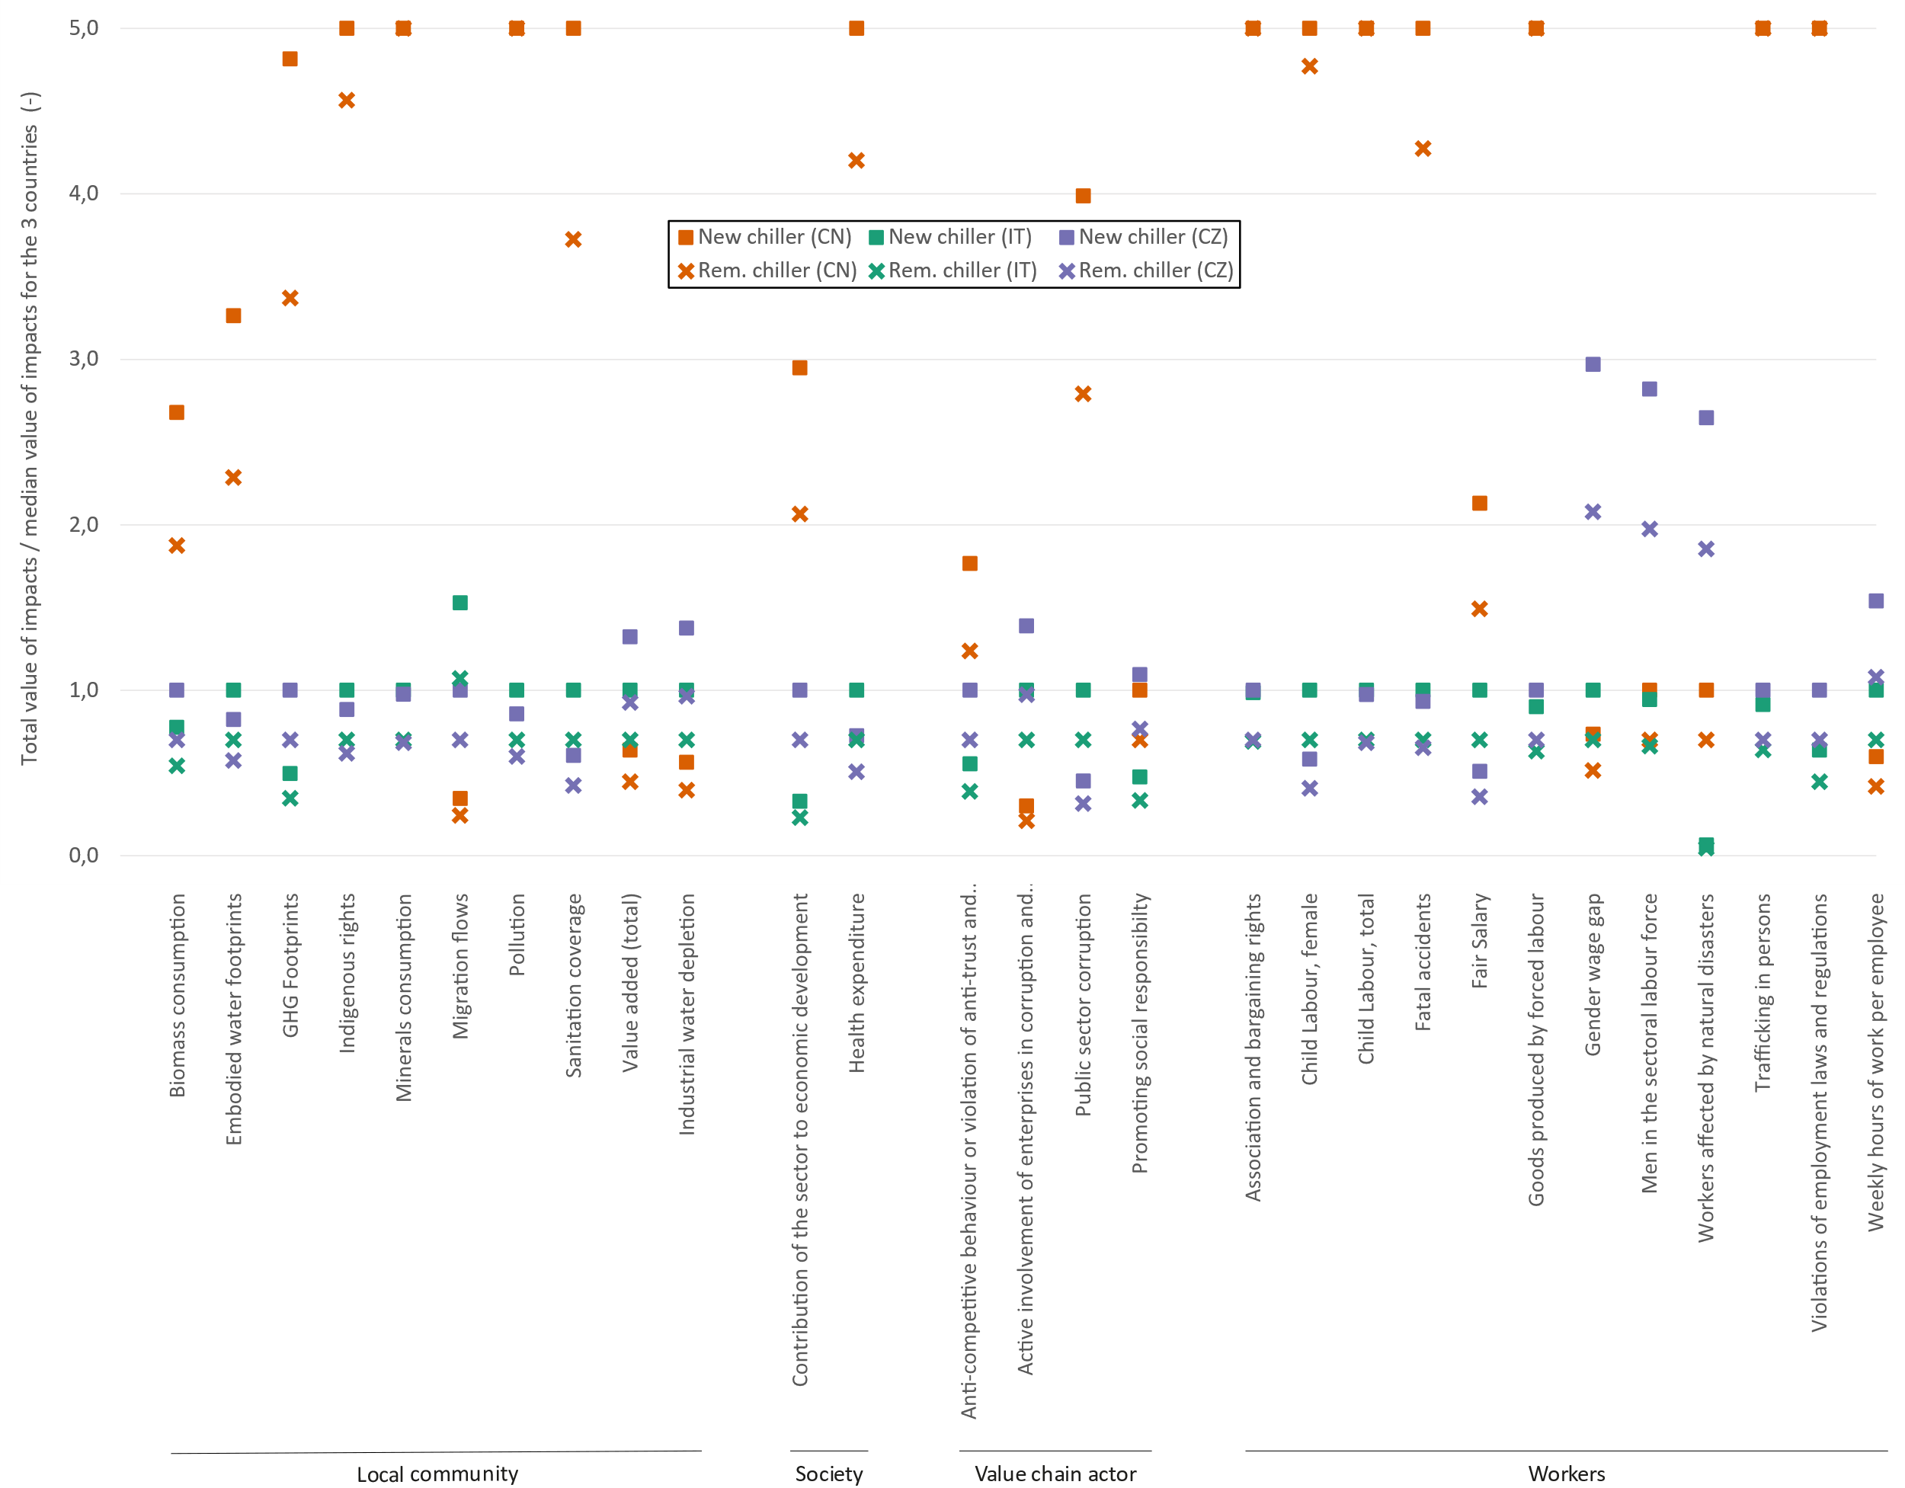
Figure 3 – Social footprint of the sectors manufacturing and remanufacturing chillers in China, Italy, and Czechia. Impact intensities are normalized by taking the median value of the respective categories as a reference (new chillers). Note: CN stands for China; IT stands for Italy; CZ stands for Czechia and Rem. stands for remanufactured.

4.2 Social hotspots of the sectors manufacturing and remanufacturing chillers
This section focuses on the most critical impact category in each country, i.e., the impact category Association and bargaining rights in China, the impact category Migration flows in Italy, and the impact category Gender wage gap in Czechia (see Section 4.1).
Systematically for each impact category in a specific country, we first look at the top five pathways and their contribution. Then we investigate the top five countries and sectors in the supply chain. Finally, we analyse the contributions of each sector by stage of the supply chain via product layer decomposition (see Section 1.2 for definitions).
Figure 4 (a) shows the top five pathways contributing to the Association and bargaining rights footprint of the sector manufacturing and remanufacturing chillers in China. The most contributing sector is the Other general industrial machinery. The direct contribution is 34%, and the contribution of this sector one stage upstream is 5%. This indicates an important opportunity for reducing the social issue by acting within this sector using appropriate actions, measures, and policies. Figure 4 (b) shows the top five contributing countries in the supply chain. China contributes for 100%. This suggests a local social issue. Figure 4 (d) depicts the product layer decomposition of the Association and bargaining rights intensity. The curve peaks at Stage 1 and is globally decreasing onwards, with a plateau for the sectors contributing less than 1% of the total intensity between Stage 1 and 2. Stage 1 contributions account for more than half of the supply chain intensity, and more than 90% of the supply chain intensity is covered over Stages 1, 2 and 3. This suggests a relatively short supply chain. However, almost half of the supply chain intensity is covered by sectors representing less than 3% each. This indicates a moderate dispersion of the supply chain. This is also supported by the fact that it was necessary to reduce the cut-off threshold as low as 0,0001% of the total intensity to cover 80% of the supply chain contributions. In total, 56 740 individual pathways were extracted.
Figure 5 (a) shows the top five pathways contributing to the Migration flows footprint of the sector manufacturing and remanufacturing chillers in Italy. The most contributing sector is the Manufacture of machinery and equipment n.e.c. The direct contribution is 11%, and the contribution of this sector one stage upstream is 9%. This indicates a limited opportunity for reducing the social issue if acting within this sector. Figure 5 (b) shows the top five contributing countries in the supply chain. Italy contributes a bit less than 50%, and Germany contributes a bit more than 30%. This suggests that the social issue is shared between those two countries, and more globally, with other neighbouring countries. Figure 5 (d) shows the product layer decomposition of the Migration flows intensity. The curve peaks at Stage 2. The sector contributions follow the same trend, except for the sector of Manufacture of machinery and equipment n.e.c. where the contribution in Stage 1 is higher than Stage 2 and for the sectors contributing less than 1% of the total intensity where the contribution in Stage 2 is lower than Stage 3 and onwards. Stage 1 contributions account for less than 20% of the supply chain intensity, and the threshold of 90% is only reached at Stage 5. This suggests a relatively long supply chain. More than half of the supply chain intensity is covered by sectors representing less than 3% each. This indicates a high dispersion of the supply chain. This is also supported by the fact that it was necessary to reduce the cut-off threshold as low as 0,00001% of the total intensity to cover 80% of the supply chain contributions. In total, 835 319 individual pathways were extracted. This dispersion pattern is typical of developed economies which are often characterised by a service-dominated economy, as observed in other studies, such as Pomponi and Stephan (2021).
Figure 6 (a) shows the top five pathways contributing to the Gender wage gap footprint of the sector manufacturing and remanufacturing chillers in Czechia. The most contributing sector is the Manufacture of machinery and equipment n.e.c. The direct contribution is 24%, and the contribution of this sector one stage upstream is 19%. This indicates an important opportunity for reducing the social issue by acting within this sector using appropriate actions, measures, and policies. Figure 6 (b) shows the top five contributing countries in the supply chain. Czechia contributes more than 80%. This suggests a local social issue. Figure 6 (d) depicts the product layer decomposition of the Gender wage gap intensity. The curve peaks at Stage 1 and is globally decreasing onwards, with a quasi-plateau between Stage 2 and 3. Interestingly, only the sector of Manufacture of machinery and equipment n.e.c. follows the same trend, and all other sectors contribute less in Stage 1 than in Stage 2. Stage 1 contributions account for a bit more than 40% of the supply chain intensity, and the threshold of 90% is only reached at Stage 4. This suggests a rather long supply chain. Less than 30% of the supply chain intensity is covered by sectors representing less than 3% each. This indicates a moderate dispersion of the supply chain. This is also supported by the fact that it was necessary to reduce the cut-off threshold as low as 0,0001% of the total intensity to cover 80% of the supply chain contributions. In total, 75 941 individual pathways were extracted.
Note that China was not found to be an important contributor to the Migration flows and the Gender wage gap issues in Italy and Czechia, respectively. This does not mean that these economies do not rely on China. On the contrary, if we consider the activity variable worker-hours, we see that China appears to be the top international contributor of both countries and accounts for at least 3-4% of the total contributions. This is in line with observations made by Pomponi and Stephan (2021).

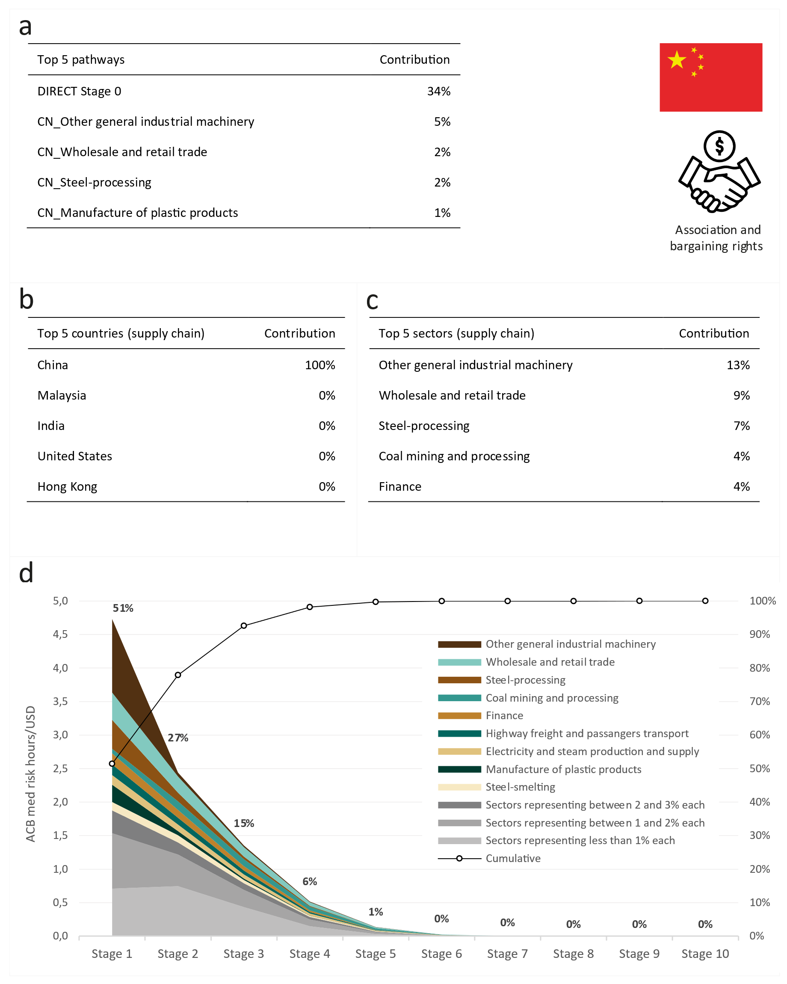
Figure 4 – (a) Top 5 pathways contributing to the Association and bargaining rights (ACB) footprint of the sector manufacturing and remanufacturing chillers in China, (b/c) Top 5 countries/sectors contributing to the ACB footprint, excl. direct contribution, (d) Product layer decomposition of the ACB intensity. Note that CN stands for China.
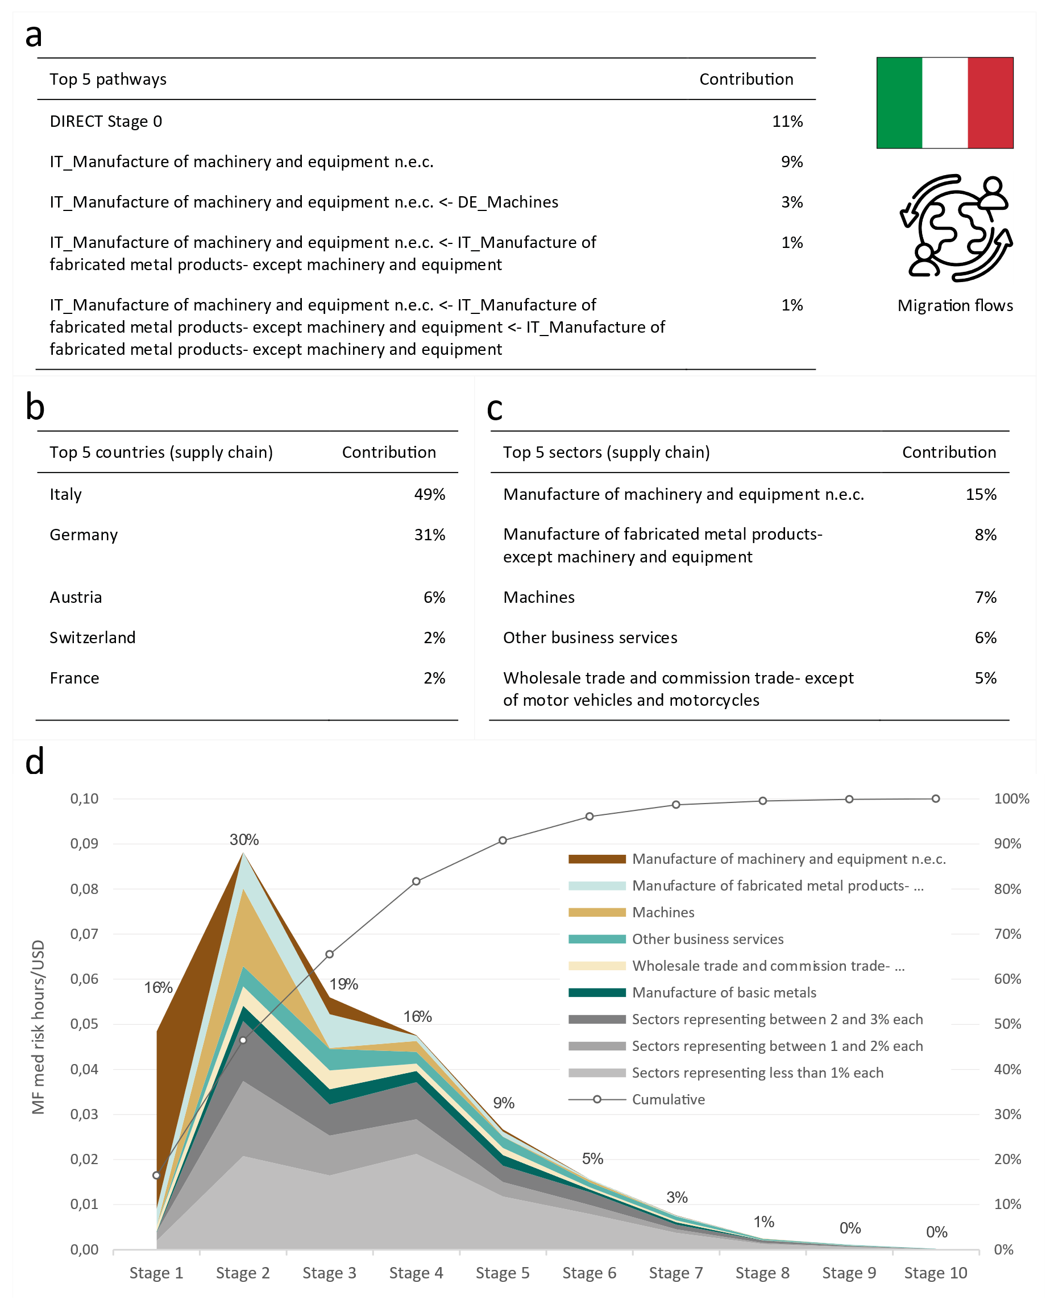
Figure 5 – (a) Top 5 pathways contributing to the Migration flows (MF) footprint of the sector manufacturing and remanufacturing chillers in Italy, (b/c) Top 5 countries/sectors contributing to the MF footprint, excl. direct contribution, (d) Product layer decomposition of the MF intensity. Note that IT stands for Italy and DE for Germany.
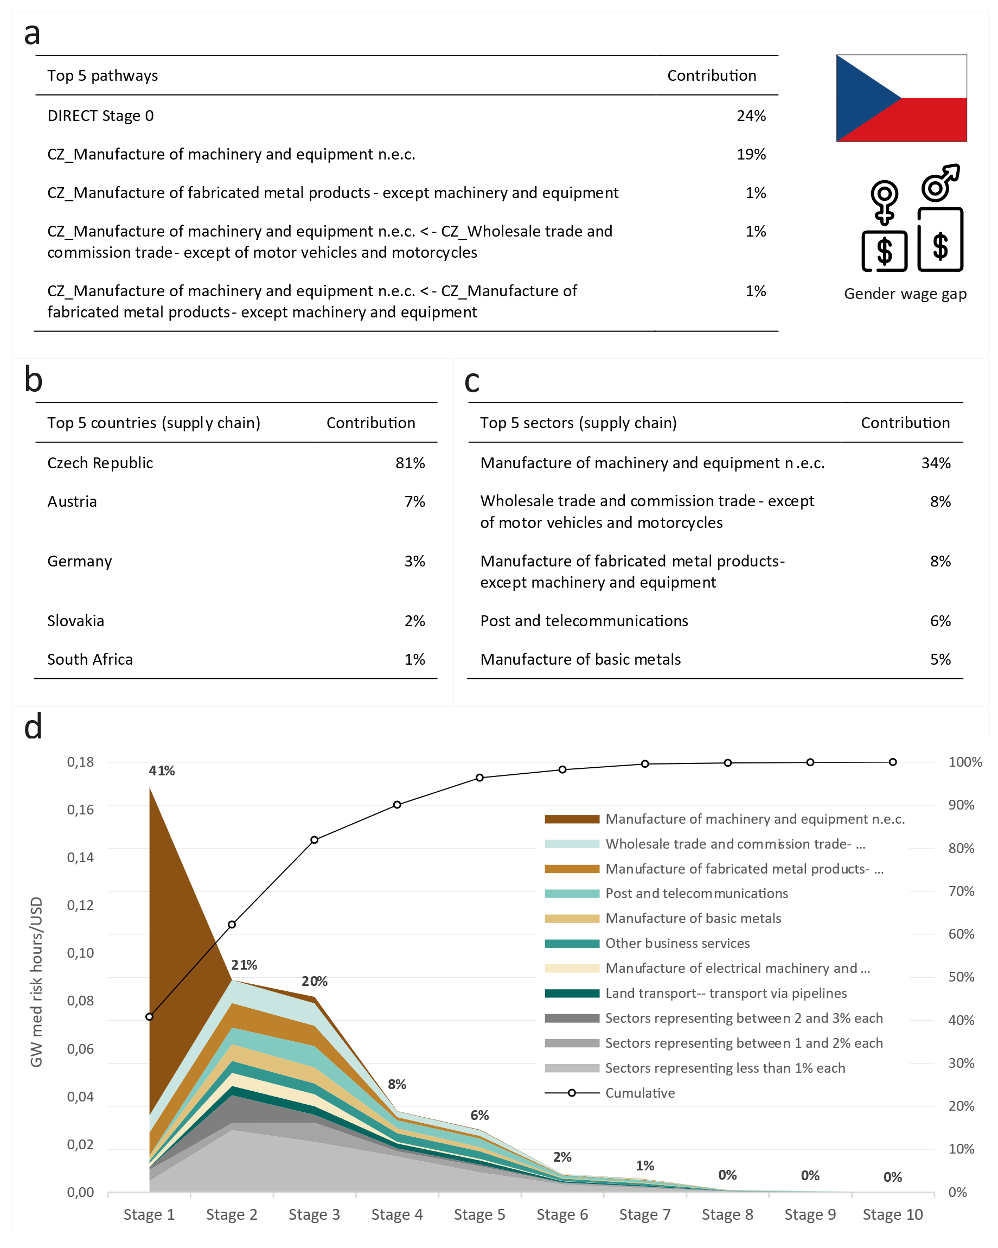
Figure 6 – (a) Top 5 pathways contributing to the Gender wage gap (GW) footprint of the sector manufacturing and remanufacturing chillers in Czechia, (b/c) Top 5 countries/sectors contributing to the GW footprint, excl. direct contribution, (d) Product layer decomposition of the GW intensity. Note that CZ stands for Czechia.

5. Discussion

5.1 Advancing research on the social life cycle methodology, and the social footprint of the sectors manufacturing and remanufacturing chillers
This work has both confirmed previous findings and produced novel contributions. These are discussed below. The two first topics relate to contributions to the social life cycle assessment method, and the following topics relate to contributions to knowledge in the social life cycle assessment of chillers.
Firstly, we demonstrate the applicability of a new method for selecting social impact categories (see Section 3.4). Based on statistical analysis and an analysis of abnormalities, we successfully selected 28 impact categories for this work, out of the 55 available categories in PSILCA. This provides an alternative to actual techniques to select impact categories, such as the one proposed by Kono et al. (2018).
Secondly, we demonstrate the applicability of the structural path analysis for identifying social hotspots, and its potential to provide results in a better resolution than what is currently available in existing studies, such as Kono et al. (2018), and Penadés-Plà et al. (2020) (see Sections 3.8 and 4.2). For example, we were able to identify the significant contribution of the German sector Machines to the Italian Migration flows footprint in Stage 2, which would not have been possible with the current embedded method in PSILCA. In addition to assisting in the identification of social hotspots, the structural path analysis technique offers many more potentials when combined with social life cycle assessment. Because the structural path analysis technique disentangles the whole supply chain, it provides the opportunity to create groupings (e.g., by countries, sectors, or stages), slice the data at a high resolution, and identify patterns that would otherwise not be visible. In this paper, we used this technique to explore the contributions of countries and sectors to social impact intensities, by stage. We identified highly contributing sectors, and their position in the supply chain, which helped us reveal opportunities to reduce social issues. Similarly, the structural path analysis technique could be used to explore the contributions of countries and sectors to uncertainty, by stage for example. This would allow us to better understand where action is needed to reduce uncertainty.
Thirdly, we reveal the significance of the social footprint of the sector manufacturing chillers in China. More specifically, 12 impact categories show abnormally high intensities, including Child labour, Forced labour, Trafficking in persons, and the most significant being Association and bargaining rights. In contrast, the social footprint of the sectors manufacturing chillers in Italy and Czechia is smaller, with the most critical impact category being Migration flows and Gender wage gap, respectively (see Section 4.1).
Fourthly, we reveal that remanufacturing chillers is globally a better option to minimise social impacts, but not systematically. More than opting for a remanufactured product, the importance lies in the selection of the manufacturing country (see Section 4.1). This was also observed by Backes and Traverso (2023).
Fifthly, we reveal different contribution patterns for each social issue in the selected countries (see Section 4.2). For instance, contributions to the Association and bargaining rights and the Gender wage gap footprints are local in China and Czechia, respectively, while contributions to the Migration flows footprint in Italy are more global, with contributions from Germany and other European neighbouring countries. China shows a relatively shorter supply chain than the two other countries (the 90% of the supply chain contribution threshold is reached at Stage 3 for China, Stage 4 for Czechia, and Stage 5 for Italy). All countries show very dispersed supply chains, with important supply chain contributions from the sectors representing each < 3% (contributions ranging from 29% to 56%).
Sixthly, we demonstrate the significant difference between direct and total impact intensities for the sectors manufacturing and remanufacturing chillers (see Section 4.2). This reinforces the need to steadily transition to methods of analysis which promote both accuracy and completeness, such as hybrid life cycle assessment (Crawford, Bontinck, Stephan, Wiedmann, & Yu, 2018; Pomponi & Lenzen, 2018), since the truncation error that process-based methods introduce can influence results and conclusions.
Seventhly, we demonstrate the existence of important opportunities for reducing the Association and bargaining rights and the Gender wage gap issues in China and Czechia, respectively, by enforcing appropriate actions, measures, and policies in the sectors of Other general industrial machinery in China and Manufacture of machinery and equipment n.e.c. in Czechia. This is because the sector Other general industrial machinery contributes almost 40% of the total contributions in China, and the sector Manufacture of machinery and equipment n.e.c. contributes more than 40% of the total contributions in Czechia (see Section 4.2).
Lastly, we demonstrate the social performance of reusing chillers, which is one of the first attempts of its kind. To this end, we use the S-LCA framework, and we compare the social footprint associated with manufacturing and remanufacturing chillers. In doing so, we confirm that S-LCA, and by extension, other life cycle assessment methodologies (i.e., Life Cycle Assessment and Life Cycle Costing), are essential tools to identify the sustainability benefits and trade-offs along the value chain of products and processes. They can help us to characterise to what extent the reuse practise contributes to ease pressure on planetary boundaries (Elobeid, 2023; Steffen et al., 2015) and ultimately guide us towards a more sustainable development that meets the needs of the present without compromising the ability of future generations to meet their own needs (Brundtland et al., 1987).

5.2 Policy recommendations
The social life cycle assessment framework, and related stakeholder and impact categories, have obvious connections to the seventeen Sustainable Development Goals (SDGs) that have been internationally accepted by governments, industries, and organizations (United Nations, 2023). Fourteen of the seventeen SDGs concern social impacts (UNEP, 2020). For example, the impact category Association and bargaining rights relates to the SDG 8 (Decent work and economic growth), the impact category Migration flows relates to the SDG 10 (Reduced inequalities) and 16 (Peace, justice, and strong institutions), and the impact category Gender wage gap relates to the SDG 5 (Gender equality) and 10 (Reduced inequalities). To reduce the social footprint of the sectors manufacturing and remanufacturing chillers, we propose three main recommendations considering the results (these are in addition to our recommendation to deal locally with social hotspots as discussed in the last point of Section 5.1).
Firstly, and as demonstrated by this paper, all economies need to invest in sourcing the most accurate and systemically complete data on social flows, across sectors and processes. Uncertainty in the data will systematically result in uncertainty in the decision-making process and the enaction of policies. In addition, the following actions should be mandated: mapping additional processes across the economy, providing a higher sectorial resolution for input-output sectors, and establishing a consistent method to collect and compile input-output data (Mahajan et al., 2018). This will enable a much more refined understanding of the supply chains of the sectors manufacturing and remanufacturing chillers, the identification of social hotspots, and their management.
Secondly, embodied social flows need to be made more visible in both the manufacturing and the construction industries if we are to tackle them. Product regulations, building regulations and the public sector need to enforce the consideration of embodied social impacts (e.g., by enforcing social performance targets, ideally at the most international level possible). Additionally, manufacturing companies and building developers need to further consider embodied social impacts in their purchases to filter out any low social performance items (e.g., by using appropriate subcontractor policies).
Thirdly, it is important to note that as global temperatures continue to rise (at least 1.02 °C and counting), there will be even greater demand for cooling technologies. According to the International Energy Agency (2018), energy needs for space cooling will triple by 2050. With the growing demand for cooling driven by economic and population growth in the hottest parts of the world, a careful selection of construction products with a low social footprint will be necessary, especially in China, where social impacts seem to be more significant than in other places (see Section 4.1).

5.3 Limitations and future work
While our focus is on the social footprint of the sectors manufacturing, and remanufacturing chillers (including their supply chains), it is worth stressing that social impacts occur throughout many other phases of the life cycle of a product (Sev, 2009) and these should all be carefully considered. This is one of the limitations of our work, along with the following considerations.
Firstly, the results are as accurate as the social data collected by PSILCA, and the Eora multi-regional input-output data. In PSILCA, the quality of social data is assessed by attributing a score from 1 (meaning very good performance) to 5 (meaning very poor performance) in relation to five indicators, i.e., the reliability of the source, the completeness conformance, the temporal conformance, the geographical conformance, and the further technical conformance. All indicators used in our hotspot analysis were assessed with a value of 1 or 2, except for the geographical conformance of the Gender wage gap (which was assessed with a value of 3), and the further technical conformance of the Right of association, the Immigration rate, the Asylum seekers rate, the Emigration rate, and the Gender wage gap (which were assessed with a value of 5). A value of 5 for the further technical conformance indicator means that the data used is from either an unknown sector or a distinctly different sector. This can be resolved by the collection of site-specific data, which would also provide further insights and an opportunity to verify the identified hotspots (UNEP, 2020). On the other hand, the Eora data suffer from the accumulated limitations of data gathering, aggregation, assumptions, computing errors and linearity. Specifically, coarse sectoral resolution which is common in input-output data does limit the potential for interventions since it does not show which products within a sector represent the ‘hotspots’ for the impacts. More information on the limitations of input-output analysis can be found in Lenzen (2000). This can be resolved with further disaggregation of the global economy into even more country-sector pairs (Lenzen et al., 2017), and hybrid life cycle inventories which yield more accurate results (Pomponi & Lenzen, 2018). In addition to the above, it is important to note that the Eora data is characterised by a heterogeneous classification. This makes the overall information basis more stable but leads to different denominations for the same sectors in the original Eora database. Even though efforts were made in the PSILCA database to harmonise these sector names across the different countries, there remain some instances where we might question this, e.g., the German sector Machines, and the Italian sector Manufacture of machinery and equipment n.e.c.
Secondly, the structural path analysis does not provide a 100% coverage of the supply chain, when disaggregating it into its individual inputs. While we have ensured coverages of a minimum of 80%, we are still missing a share of the social footprint in our analysis, which is composed of extremely small inputs, scattered across the supply chain.
Thirdly, this study focuses on three selected impact categories (the most critical for each of the case study sectors), which might not be representative of other impact categories in a specific country. As such, another research is needed to investigate the sectors manufacturing and remanufacturing chillers across every single impact category for which data is available, to draw more conclusive insights and recommendations. This is particularly true for China, where 12 impact categories show abnormally high intensities (see Section 4.1).
Fourthly, the underlying data did not allow us to robustly produce social footprints for remanufacturing activities specifically. This is because of the lack of specific commodity-sectors for remanufactured goods in the Eora database (see Section 3.3). Remanufacturing activities are currently accounted for in the same commodity-sectors as manufacturing activities, while in fact they rely on a series of specific actors, such as core brokers (Lange, 2017), and include specific process chain steps, such as disassembly, cleaning, inspection/diagnostics, rebuilding, and reassembly (Bullinger, Spath, Warnecke, & Westkämper, 2009). As discussed in Section 5.2, we recommend that all economies map additional processes across the economy and more specifically remanufacturing activities. These factors will need to be considered in future research to improve the relevance and specificity of the results.
Further, it is worth stressing that the approach we used to quantify impact intensities in this study is an example of a mechanistic modelling approach. Studies following this type of approach focus on providing a first reflection on social impacts/aspects. They do not explicitly describe impact pathways, i.e., the relations between social causes (e.g., company activity) and their effects (e.g., damage or benefit to human well-being). Further work should consider assessing impact pathways.

6. Conclusions
Buildings and the construction sector are some of the most significant contributors to global environmental burdens. They represent both a challenge and an opportunity to work towards mid-century climate goals and beyond. Remanufacturing building products, and especially chillers, can help deliver a more sustainable renovation in Europe. While the environmental and economic benefits of this practice have received global research attention, social aspects remain understudied. In particular, the social footprint of the sectors manufacturing and remanufacturing chillers has never been quantified before.
In this research, we use social data from PSILCA, global multi-regional input-output data from Eora, and structural path analysis. We apply them to three major purveyors of the European market (i.e., China, Italy, and Czechia) to quantify the social footprint associated with the sectors manufacturing and remanufacturing chillers and to disaggregate their supply chains. We quantify the social footprint for 28 social impact categories out of the 55 categories available in PSILCA, that we select where the impact intensity of at least one country exceeds the third quartile of the intensities of all sectors. We disaggregate the supply chains for the most critical impact category in each country (i.e., where the impact intensity is the most distant from the median of the intensities of the three countries). Our results offer a richer picture of the distribution of impacts across geographies and sectors, than what is currently seen in the literature.
The social footprint of the sector manufacturing chillers in China is significant, with 12 impact categories showing abnormally high intensities, including Child labour, Forced labour and Trafficking in persons. In contrast, the social footprint of the sectors manufacturing chillers in Italy and Czechia is smaller, with the most critical impact category being Migration flows and Gender wage gap, respectively. The sectors manufacturing chillers in China and Czechia are responsible for around 40% of the contributions to the Association and bargaining rights, and the Gender wage gap issues, respectively, suggesting an important opportunity for reducing these issues by enforcing appropriate policies in these sectors. The contributions to the Association and bargaining rights issue in China are local and contributing pathways are relatively short, while contributions to the Migration flows issue in Italy are more global, and contributing pathways are much longer. We also observe that remanufacturing chillers in Italy or Czechia is not always the best option to minimise social impacts.
This work will contribute to raising our awareness of the social issues embedded in the products we buy, and especially those we install in our buildings that we are claiming to be sustainable.

Authors contributions:
SL designed the original research idea. AS adjusted the base data that we received from PSILCA. SL produced the structural path analyses. SL wrote the paper and produced its figures with advice from AS and DC. SL revised the paper with the help of AS and DC.

Declaration of competing interest:
The authors declare that they have no known competing financial interests or personal relationships that could have appeared to influence the work reported in this paper.

Acknowledgements:
Sébastien Loreau was funded through a research fellowship (applied PhD program) from the Brussels fund for innovation Innoviris under grant number 2020-PHD-25.

Data availability:
The outputs of this study as well as other files used within this paper are available at the links below.
- The open-access link to the three structural path analysis files used within this paper, including to generate the graphs of the results: https://www.doi.org/10.6084/m9.figshare.24659421
- The link to the PSILCA database used within this paper, including to quantify social footprints: https://nexus.openlca.org/database/PSILCA
- The open-access link to the Eora database used within the PSILCA database: https://worldmrio.com/eora/
- The open-access link to the repository of the pyspa package used within this paper to perform the three structural path analyses: https://github.com/hybridlca/pyspa

References
Abeliotis, K., Chroni, C., & Lasaridi, K. (2017, Jun 22-23, 2017). Social Life Cycle Assessment for WEEE Reuse. Paper presented at the XI Convegno dell’Associazione Rete Italiana LCA 2017, Università di Siena.
Addis, B. (2006). Building with Reclaimed Components and Materials: A Design Handbook for Reuse and Recycling. London: Earthscan.
American Society of Heating Refrigerating and Air-Conditioning Engineers. (2023). Service Life Data Query - Centrifugal Chiller. Retrieved from: http://weblegacy.ashrae.org/publicdatabase/system_service_life.asp?c_region=0&state=NA&building_function=NA&c_size=0&c_age=0&c_height=0&c_class=0&c_location=0&selected_system_type=2&c_equipment_type=8
Athanassiadis, A. (2017). Economie circulaire dans le secteur de la construction à Bruxelles : Etat des lieux, enjeux et modèle à venir. Retrieved from https://document.environnement.brussels/opac_css/elecfile/RAP_2017_Economie_Circulaire_Construction.pdf
Backes, J. G., & Traverso, M. (2023). Social Life Cycle Assessment in the Construction Industry: Systematic Literature Review and Identification of Relevant Social Indicators for Carbon Reinforced Concrete. Environment, Development and Sustainability. doi:10.1007/s10668-023-03005-6
Benoit Norris, C., Bennema, M., & Norris, G. (2018). The Social Hotspots Database. Supporting documentation. Update 2019. Retrieved from https://nexus.openlca.org/ws/files/23286
Brundtland, G., Khalid, M., Agnelli, S., Al-Athel, S., Chidzero, B., Fadika, L., . . . de Botero, M. M. (1987). Our Common Future (\'Brundtland report\'). Retrieved from https://sustainabledevelopment.un.org/content/documents/5987our-common-future.pdf
Bullinger, H. J., Spath, D., Warnecke, H. J., & Westkämper, E. (2009). Handbuch Unternehmensorganisation: Strategien, Planung, Umsetzung (3 ed.). Heidelberg: Springer Berlin.
Chartered Institution of Building Services Engineers. (2023). What is Building Services? Retrieved from https://www.cibse.org/training/careers-in-building-services/what-is-building-services
Chau, C. K., Yik, F. W. H., Hui, W. K., Liu, H. C., & Yu, H. K. (2007). Environmental impacts of building materials and building services components for commercial buildings in Hong Kong. Journal of Cleaner Production, 15(18), 1840-1851. doi:10.1016/j.jclepro.2006.10.004
Cheshire, D. (2014). TM56: Resource Efficiency of Building Services. London: CIBSE.
Cheshire, D. (2016). Building Revolutions. Applying the circular economy to the built environment. Newcastle upon Tyne: AECOM.
Comron International bv. (2023). Used Industrial Refrigeration Equipment. Retrieved from https://www.comronusedfreezers.com/
Crama, Y., Defourny, J., & Gazon, J. (1984). Structural decomposition of multipliers in input-output or social accounting matrix analysis. Economie appliquée, XXXVII (1), 215-222. doi:n/a
Crawford, R. H., Bontinck, P.-A., Stephan, A., Wiedmann, T., & Yu, M. (2018). Hybrid life cycle inventory methods – A review. Journal of Cleaner Production, 172, 1273-1288. doi:10.1016/j.jclepro.2017.10.176
Defourny, J., & Thorbecke, E. (1984). Structural Path Analysis and Multiplier Decomposition within a Social Accounting Matrix Framework. The Economic Journal, 94(373), 111-136. doi:10.2307/2232220
Dixit, M. K. (2017). Life cycle embodied energy analysis of residential buildings: A review of literature to investigate embodied energy parameters. Renewable and Sustainable Energy Reviews, 79, 390-413. doi:10.1016/j.rser.2017.05.051
Elobeid, E. (2023). How the circular economy can help us stay within planetary boundaries. Ellen MacArthur Foundation. Retrieved from https://www.ellenmacarthurfoundation.org/how-the-circular-economy-can-help-us-stay-within-planetary-boundaries
European Commission. (2019). The European Green Deal. Brussels
European Commission. (2020). A Renovation Wave for Europe - greening our buildings, creating jobs, improving lives. Brussels
European Communities, International Monetary Fund, Organisation for Economic Co-operation and Development, United Nations, & Bank, W. (2009). System of National Accounts 2008. New York: United Nations.
Directive 2009/125/EC of the European Parliament and of the Council of 21 October 2009 establishing a framework for the setting of ecodesign requirements for energy-related products (recast) (Text with EEA relevance), (2009).
Regulation (EU) No 517/2014 of the European Parliament and of the Council of 16 April 2014 on fluorinated greenhouse gases and repealing Regulation (EC) No 842/2006 (Text with EEA relevance), (2014).
Eurostat. (2008). NACE Rev. 2. Statistical classification of economic activities in the European Community. Luxembourg: European Communities.
Eurostat. (2022). Key figures on European business (2022 edition). Retrieved from https://ec.europa.eu/eurostat/documents/15216629/15230677/KS-06-22-075-EN-N.pdf/930f2188-48cb-ef84-678e-e6f96682b072?t=1672841155329
Eurostat. (2023a). Electricity and heat statistics Retrieved from https://ec.europa.eu/eurostat/statistics-explained/index.php?title=Electricity_and_heat_statistics#Consumption_of_electricity_per_capita_in_the_households_sector
Eurostat. (2023b). Household composition statistics Retrieved from https://ec.europa.eu/eurostat/statistics-explained/index.php?title=Household_composition_statistics#Increasing_number_of_households_composed_of_adults_living_alone
Eurostat. (2023c). International Trade - EU trade since 2002 by HS2-4-6 and CN8 (new content) (DS-059322). Retrieved from: https://ec.europa.eu/eurostat/comext/newxtweb/
Eurostat. (2023d). Statistics on the production of manufactured goods - Sold production, exports and imports. Retrieved from: https://ec.europa.eu/eurostat/databrowser/view/DS-056120/legacyMultiFreq/table?lang=en
Flamant, G., Deroisy, B., Delem, L., & Decuypere, R. (2014). Construire passif et durable : le projet pilote Ecoffice. Les Dossiers du CSTC(2013/4.13). doi:n/a
Garrido, S. R. (2017). Social Life-Cycle Assessment: An Introduction. In M. A. Abraham (Ed.), Encyclopedia of Sustainable Technologies (pp. 253-265). Oxford: Elsevier.
Ghisellini, P., Passaro, R., & Ulgiati, S. (2023). Environmental and Social Life Cycle Assessment of Waste Electrical and Electronic Equipment Management in Italy According to EU Directives. Environments, 10(7), 106. doi:10.3390/environments10070106
Global Alliance for Buildings and Construction, International Energy Agency, & United Nations Environment Programme. (2020). GlobalABC Roadmap for Buildings and Construction: Towards a zero-emission, efficient and resilient buildings and construction sector. Retrieved from Paris: https://globalabc.org/sites/default/files/inline-files/Global%20Roadmap_FINAL.pdf
Golinska, P., Kosacka, M., Mierzwiak, R., & Werner-Lewandowska, K. (2015). Grey Decision Making as a tool for the classification of the sustainability level of remanufacturing companies. Journal of Cleaner Production, 105, 28-40. doi:10.1016/j.jclepro.2014.11.040
GreenDelta. (2022). PSILCA. Retrieved from https://psilca.net/
Hamot, L., & Bagenal George, C. (2021). TM65: Embodied carbon in building services: A calculation methodology. London: CIBSE.
HOS bv. (2023). Used industrial/commercial refrigeration equipment. Retrieved from https://www.hosbv.com/
Hosseinijou, S. A., Mansour, S., & Shirazi, M. A. (2014). Social life cycle assessment for material selection: a case study of building materials. The International Journal of Life Cycle Assessment, 19(3), 620-645. doi:10.1007/s11367-013-0658-1
International Energy Agency. (2018). The Future of Cooling. Paris: International Energy Agency.
International Labour Organization. (2023). Statistics on labour costs. Retrieved from: https://ilostat.ilo.org/topics/labour-costs/
KGM & Associates Pty. Ltd. (2019). Full Eora (2019 release - data from 2015). Retrieved from: https://worldmrio.com/eora/
Kono, J., Ostermeyer, Y., & Wallbaum, H. (2018). Trade-Off between the Social and Environmental Performance of Green Concrete: The Case of 6 Countries. Sustainability, 10(7), 2309. doi:10.3390/su10072309
Kwak, M., & Kim, H. (2016). Modeling the time-varying advantages of a remanufactured product: Is "reman" better than "brand new"? Journal of Mechanical Design, Transactions of the ASME, 138(5). doi:10.1115/1.4032808
Lahrour, Y., Brissaud, D., & Zwolinski, P. (2019). The strategy for implementing remanufacturing process in a commercial enterprise, the case study of a French company. Procedia CIRP, 80, 554-559. doi:10.1016/j.procir.2019.01.046
Lambertz, M., Theißen, S., Höper, J., & Wimmer, R. (2019). Importance of building services in ecological building assessments. Paper presented at the E3S Web of Conferences.
Lange, U. (2017). Resource efficiency through remanufacturing. Retrieved from
Lenzen, M. (2000). Errors in Conventional and Input-Output—based Life—Cycle Inventories. Journal of Industrial Ecology, 4(4), 127-148. doi:10.1162/10881980052541981
Lenzen, M., Geschke, A., Abd Rahman, M. D., Xiao, Y., Fry, J., Reyes, R., . . . Yamano, N. (2017). The Global MRIO Lab – charting the world economy. Economic Systems Research, 29(2), 158-186. doi:10.1080/09535314.2017.1301887
Lenzen, M., Kanemoto, K., Moran, D., & Geschke, A. (2012). Mapping the Structure of the World Economy. Environmental Science & Technology, 46(15), 8374-8381. doi:10.1021/es300171x
Lenzen, M., Moran, D., Kanemoto, K., & Geschke, A. (2013). Building Eora: A Global Multi-Region Input–Output Database At High Country And Sector Resolution. Economic Systems Research, 25(1), 20-49. doi:10.1080/09535314.2013.769938
Lenzen, M., Murray, S. A., Korte, B., & Dey, C. J. (2003). Environmental impact assessment including indirect effects—a case study using input–output analysis. Environmental Impact Assessment Review, 23(3), 263-282. doi:10.1016/S0195-9255(02)00104-X
Loreau, S., Stephan, A., Cooper, D. R., & Maerckx, A. (2022). Assessing material and embodied flows related to building services in office buildings — the case of Brussels, Belgium. IOP Conference Series: Earth and Environmental Science, 1122(1), 012030. doi:10.1088/1755-1315/1122/1/012030
Loubert, M., Maister, K., Di Noi, C., Radwan, L., Ciroth, A., & Srocka, M. (2023). PSILCA v3.1 Database documentation. Retrieved from https://nexus.openlca.org/ws/files/25214
Lu, B., Li, B., Wang, L., Yang, J., Liu, J., & Wang, X. V. (2014). Reusability based on Life Cycle Sustainability Assessment: Case Study on WEEE. Procedia CIRP, 15, 473-478. doi:10.1016/j.procir.2014.06.046
Mahajan, S., Beutel, J., Guerrero, S., Inomata, S., Larsen, S., Moyer, B., . . . Havinga, I. (2018). Handbook on Supply, Use and Input-Output Tables with Extensions and Applications. New York: United Nations.
Mancini, L., Eynard, U., Eisfeldt, F., Ciroth, A., Blengini, G. A., & Pennington, D. (2018). Social assessment of raw materials supply chains: A life-cycle-based analysis. Retrieved from Luxembourg, Luxembourg: https://op.europa.eu/en/publication-detail/-/publication/f29c7adb-1f8a-11e9-8d04-01aa75ed71a1/language-en
Martínez-Muñoz, D., Martí, J. V., & Yepes, V. (2022). Social Impact Assessment Comparison of Composite and Concrete Bridge Alternatives. Sustainability, 14(9), 5186. doi:10.3390/su14095186
Miller, R. E., & Blair, P. D. (2009). Input-Output Analysis: Foundations and Extensions (2 ed.). Cambridge: Cambridge University Press.
Ministère de la transition écologique – Ministère en charge du logement. (2022). Groupe de production d’eau glacée [500 à 1000 kW] - Donnee Environnementale par Defaut (V.1.1) Retrieved from: https://www.base-inies.fr/iniesV4/dist/consultation.html?id=29257
Organisation for Economic Co-operation and Development. (2023a). Exchange rates. Retrieved from: https://data.oecd.org/conversion/exchange-rates.htm#indicator-chart
Organisation for Economic Co-operation and Development. (2023b). Purchasing power parities (PPP). Retrieved from: https://data.oecd.org/conversion/purchasing-power-parities-ppp.htm#indicator-chart
Penadés-Plà, V., Martínez-Muñoz, D., García-Segura, T., Navarro, I. J., & Yepes, V. (2020). Environmental and Social Impact Assessment of Optimized Post-Tensioned Concrete Road Bridges. Sustainability, 12(10), 4265. doi:10.3390/su12104265
Pomponi, F., & Lenzen, M. (2018). Hybrid life cycle assessment (LCA) will likely yield more accurate results than process-based LCA. Journal of Cleaner Production, 176, 210-215. doi:10.1016/j.jclepro.2017.12.119
Pomponi, F., & Moncaster, A. (2017). Circular economy for the built environment: A research framework. Journal of Cleaner Production, 143, 710-718. doi:10.1016/j.jclepro.2016.12.055
Pomponi, F., & Stephan, A. (2021). Water, energy, and carbon dioxide footprints of the construction sector: A case study on developed and developing economies. Water Research, 194, 116935. doi:10.1016/j.watres.2021.116935
Rizova, M. I., Wong, T. C., & Ijomah, W. (2020). A systematic review of decision-making in remanufacturing. Computers & Industrial Engineering, 147, 106681. doi:10.1016/j.cie.2020.106681
Rodrigues, L. M., Angelo, A. C. M., & Marujo, L. G. (2020). Conceptual Framework to Social Life Cycle Assessment of e-Waste Management: A Case Study in the City of Rio de Janeiro. In P. Singh, R. P. Singh, & V. Srivastava (Eds.), Contemporary Environmental Issues and Challenges in Era of Climate Change (pp. 219-234). Singapore: Springer Singapore.
Sev, A. (2009). How can the construction industry contribute to sustainable development? A conceptual framework. Sustainable Development, 17(3), 161-173. doi:10.1002/sd.373
Steffen, W., Richardson, K., Rockström, J., Cornell, S. E., Fetzer, I., Bennett, E. M., . . . Sörlin, S. (2015). Planetary boundaries: Guiding human development on a changing planet. Science, 347(6223), 1259855. doi:doi:10.1126/science.1259855
Stephan, A., & Bontinck, P.-A. (2019). pyspa (Version 2.4). Retrieved from https://github.com/hybridlca/pyspa
Stephan, A., Crawford, R. H., & Bontinck, P.-A. (2019). A model for streamlining and automating path exchange hybrid life cycle assessment. The International Journal of Life Cycle Assessment, 24(2), 237-252. doi:10.1007/s11367-018-1521-1
Umair, S., Björklund, A., & Petersen, E. E. (2015). Social impact assessment of informal recycling of electronic ICT waste in Pakistan using UNEP SETAC guidelines. Resources, Conservation and Recycling, 95, 46-57. doi:10.1016/j.resconrec.2014.11.008
UNEP. (2009). Guidelines for social life cycle assessment of products: social and socio-economic LCA guidelines complementing environmental LCA and Life Cycle Costing, contributing to the full assessment of goods and services within the context of sustainable development. Paris: United Nations Environment Programme.
UNEP. (2020). Guidelines for Social Life Cycle Assessment of Products and Organizations 2020. Paris: United Nations Environment Programme.
United Nations. (2016). Czechoslovakia and Successor States: Czech Republic, Slovakia. Retrieved from https://www.un.org/en/about-us/member-states/czechoslovakia
United Nations. (2023). Take Action for the Sustainable Development Goals. Retrieved from https://www.un.org/sustainabledevelopment/sustainable-development-goals/
van Loon, P., & Van Wassenhove, L. N. (2018). Assessing the economic and environmental impact of remanufacturing: a decision support tool for OEM suppliers. International Journal of Production Research, 56(4), 1662-1674. doi:10.1080/00207543.2017.1367107
Vogt Duberg, J., Sundin, E., & Tang, O. (2023). Assessing the profitability of remanufacturing initiation: a literature review. Journal of Remanufacturing. doi:10.1007/s13243-023-00132-1
VRT International. (2023). Used Refrigeration Equipment. Retrieved from https://www.used-refrigeration.com/
Webb, R. S., Thomson, D. S., & Kelly, J. R. (2000). Building services component reuse: A response to the need for adaptability. Building Services Engineering Research and Technology, 21(2), 91-97. doi:10.1177%2F014362440002100203
Ylmén, P., Peñaloza, D., & Mjörnell, K. (2019). Life Cycle Assessment of an Office Building Based on Site-Specific Data. Energies, 12(13), 2588. doi:10.3390/en12132588
Zanchi, L., Delogu, M., Zamagni, A., & Pierini, M. (2018). Analysis of the main elements affecting social LCA applications: challenges for the automotive sector. The International Journal of Life Cycle Assessment, 23(3), 519-535. doi:10.1007/s11367-016-1176-8

Knowledge about the embodied environmental impacts of building services is scarce. The study by Chau et al. (2007) refers to 25 commercial buildings, while the two other studies refer to one office building each and do not discuss the statistical significance of their results.

