The Belgian Tetris revisited
The influence of political knowledge on the impact of metaphors

Jérémy Dodeigne (UCL & ULg), Julien Perrez (ULg), Min Reuchamps (UCL)

Authors:

Jérémy Dodeigne is Post-doctoral researcher at the Université catholique de Louvain (UCL, Belgium) and Part-time Lecturer at the University of Liège (ULg, Belgium).

Julien Perrez is assistant professor in the Department of Modern Languages University of Liège (ULg, Belgium), where he teaches Dutch Linguistics. His research interests include foreign language learning (especially French-speaking learners of Dutch), the expression of spatial relations in typologically diverging languages and the study of metaphors in political discourse.

Min Reuchamps is professor of political science at the Institut de sciences politiques Louvain-Europe of the Université catholique de Louvain (UCL, Belgium). His research interests include federalism and multilevel governance, Belgian politics, democratic innovations as well as language and politics.

Acknowledgments:

Because their answers made this article possible, we are greatly indebted to the several hundred respondents to our surveys. We would also like to express our gratitude to Jehan Bottin, Maximilien Cogels, Maxime Lazard, Benoît Lecloux and Aleksi Otto Eerola for their research assistance as well as Pauline Heyvaert for her insightful comments on earlier drafts. The research reported in this article was supported by the Fonds spéciaux pour la recherche of the Université catholique de Louvain and of the Université de Liège, Belgium, and by the Fonds de la Recherche Scientifique — FNRS under grant no. PDR-T.1036.15.

Note to the SoF 2016 participants

In our presentation, we will focus on the influence of political knowledge on the impact of the Belgian Tetris metaphor. In this paper, we present at length the theoretical background and the experiments on which our presentation will be based.

Federalism is often presented through metaphors, such as the metaphor of the family or of a – crazy – machine, but little is known about the impact of such metaphors on citizens. In the previous edition of the Conference Belgium: The State of the Federation, we presented an experiment assessing the impact of the real-life Tetris metaphor on citizens’ representations and preferences about federalism. The experiment, conducted in Belgium, was made of different groups, controlling for the presence, in a text, of a metaphor. The results showed that being exposed to the text with the Tetris metaphor does influence the participants’ representations of federalism towards a more institutional representation and above all more regional autonomy.
On this basis, we conducted a new experiment, testing for the specific impact of the metaphor (text with metaphor and text without metaphor, as well as a control group, without any text and therefore metaphor). The results confirmed the importance of the text, but also more specifically of the metaphor. What is even more interesting is that we could test for the interaction between political knowledge and the impact of the metaphor. These tests reveal that the respondents with a lower level of political knowledge are indeed those who are influenced by the metaphors, while the respondents with a higher level are not impacted. These findings are important both for the study of federalism in Belgium and the study of the complex interactions between discourse and political preferences.

In discourse analysis, metaphors play a key role and they might also have an impact on federalism. The objective of this paper is precisely to tackle this issue, namely the impact of metaphors on citizens’ federal representations and preferences combining the insights of linguistics and political science. Although the study of metaphors is a lesser-known branch for political scientists, the fact that “We live by metaphors” has now been widely accepted by the scholarly community of linguists around the world after the seminal work of Lakoff and Johnson (1980, 1999). The Conceptual Metaphor Theory (CMT) they developed is based on the idea that metaphors are conceptual in nature, allowing us to perceive, understand and structure our environment. Central to this process is the mapping between a target domain, related to abstract entities and processes, and a source domain, based on the sensorimotor perception of our environment, in terms of which the target domain is structured and understood. Consider for instance the conceptual metaphor time is motion. According to CMT, we understand the abstract domain of time in terms of our physical experience of space (see for instance Casasanto & Boroditsky 2008, Kövecses 2010, Lakoff & Johnson 1980, 1999). Such conceptual metaphors are realized in various communication modes, including language, pictures and co-verbal gestures (see for instance Forceville & Urios-Aparisi 2009 on the multimodal character of conceptual metaphors). This is why studying how metaphors are realized in language can help us to understand how we make sense of our environment.
Metaphors can thus be found in our daily life, including our political life. Based on the idea that metaphors do not only reflect the perceived reality, but also function as cues through which citizens come to understand complex political processes and through which they shape political behaviors (Bougher 2012), it is often suggested that metaphors have an impact on representations. However, in the literature, this political impact of metaphors is assumed instead of being empirically established. That is why a more global understanding of what this political impact could consist of, is needed. The aim of this study is precisely to look at how specific metaphors might impact on the citizens’ representations and preferences of federalism, and in so doing controlling for the influence of political knowledge.
This article builds on two experiments done in Belgium. In this country, the future of federalism is a hotly debated political issue for it basically means the future of Belgium herself. Several metaphors have been used to express in more familiar terms the complexity of Belgian federalism and its dynamics (Reuchamps & Perrez, 2012; Perrez & Reuchamps, 2015c). Among them, the “Belgian Tetris” metaphor has been proposed in the media as a way to explain the nature of Belgian federalism in terms of its powers distribution. Our experiment is based on this real-life metaphor that we use to distinguish different groups.
In the first experiment, we randomly assigned the participants to four groups: one control group, a second group to which the metaphor was shown as both a text and a picture, a third group that saw only the metaphor as a picture, and the fourth group that saw only the metaphor as a text. Comparing the four experimental groups will make it possible (i) to measure the impact of the Tetris metaphor on the citizens’ representations of Belgian federalism, (ii) to assess to what extent the different metaphorical media (text and/or picture) differently contribute to this impact and (iii) to measure the impact on citizens’ preferences about the evolution of federalism.
In the second experiment, we sought to verify that it is really the metaphor (i.e. Belgian federalism as a Tetris) of the experimental text that has an influence on political preferences. Therefore, for this experiment, we randomly assigned the participants to three groups: one control group, a second group that saw the original version of the experimental text with the Tetris metaphor, a third group that saw a neutral version of the experimental text, that is without the Tetris metaphor (i.e. Belgian Tetris was replaced by Belgian federalism).
Above all, for both experiments, we check for the influence of political knowledge. To do so, we will run analyses that assess the interactions between political knowledge and the impact of the metaphor on the respondents’ preferences for the future of federalism in Belgium. In answering these questions, this study will contribute to a better understanding of the role and functions metaphors play in political discourse and so doing in the understanding of their impact on federalism.

Discourse and Federalism
As advocated by Critical Discourse Analysis (CDA), discourse can be regarded as a “form of social practice” (Fairclough & Wodak, 1997), in that “through discourses, social actors constitute objects of knowledge, situations and social roles as well as identities and interpersonal relations between different social groups and those who interact with them” (Wodak et al., 2009: 8). In that sense, discourses can contribute to the construction of social and political reality. In political science, it is also increasingly acknowledged that ‘discourses’ are not mere words and ideas assembled in oral or text material. Discourses matter in politics. This is the motto of the new “discursive institutionalism” (Campbell & Pedersen, 2001: 9-14). Discourse contributes to explaining political phenomena as “they exert a causal influence in political reality and, thereby, engender institutional change (or continuity)” (Schmidt, 2008: 306).
“Taking discourse seriously” as advocated by Panizza and Miorelli (2013) does not entail that actors’ discourses constitute the panacea for explaining all institutional changes, far from it. The substantial argument behind discursive institutionalism is that scientific knowledge accumulated by historic institutionalism and rational institutionalism are as extensive as their analytical frameworks restrict them. In other words, institutional evolution cannot be exclusively understood by the mere interrelationships of power and interests among strategic actors. Institutional changes also require to analyze politics as the results of “discursive interactions of sentient actor” (Schmidt, 2009: 529). In this respect, discourse constitutes a key resource for actors in their tentative to de(legitimate) the institutions they develop.
Based on this understanding of the function of discourse in politics, the starting point of this article is that discourses should also be taken seriously in federal studies as one of the factors affecting processes of federalization. Students of federalism have already paid attention to the importance of discourse in their analysis of processes of federalization (Burgess, 2006). For instance, British scholars showed that in the United Kingdom, the very word federalism (the “F” word) is intentionally absent in British actors’ discourses: Unionist British actors despite the “F” word not only about the federalization of their own British Union state but also the federalization of the European Union (Burgess, 1995). When Tony Blair honored its campaign process of delivering a Scottish Parliament and a Welsh assembly, British actors preferred to adopt a discourse based on the idea of devolution which constitutes a minor threat to the sacrosanct ‘British Union’. In other words, if the UK was to follow the track of federalization, it would be everything but under the F-word. In Belgium, the use of the word “federalism” since the 1960s tells much about the political dynamics: initially, it was opposed by those who wanted to keep Belgium together and as time (and the state reforms) went by, it then became their preference as it came in opposition to confederalism or independence (Deschouwer, 2012; Reuchamps, 2009).
The British and Belgian examples show that discourses are central and strategic resources for political actors: they deliberately develop and adopt specific words to de(legitimate) the process of federalization. They should therefore be taken seriously. How to study discourse about federalism? To answer this question, it is first necessary to establish that a discourse “encompasses not only the substantive content of ideas but also the interactive processes by which ideas are conveyed” (Schmidt, 2008: 305). This is precisely the way ideas are conveyed that constitute the core of this article: we aim at testing whether or not metaphors (the ‘Tetris metaphor of Belgian federalism’ in this study) influence citizens’ representations of federalism, and even their institutional preferences about it.

the political impact of metaphors
Conceptual metaphors can be defined as “understanding one conceptual domain in terms of another conceptual domain” (Kövecses, 2010). They are of particular importance in politics as has been highlighted by many scholars (see among others Carver & Pikalo, 2008; Charteris-Black, 2011, 2013; Lakoff, 1996; Musolff, 2004). This can be explained by two main factors. On the one hand, most of our political concepts are metaphorical in nature (Lakoff, 1996). This means that our understanding of complex and abstract political concepts and processes is based on conceptual metaphors. This has been confirmed by numerous studies showing the importance of metaphors in various kinds of political discourse, including elite discourse (see for instance Charteris-Black 2011, 2013; Debras & L’Hôte, 2015, L’Hôte, 2012), media discourse (Musolff 2004) or citizen discourse (Perrez & Reuchamps 2014, 2015c).
On the other hand, metaphors are central to the domain of politics because they have the potential to frame the debate (Lakoff, 2004) and indirectly convey hidden ideologies (Goatly, 2007). Framing can be defined as “[…] select[ing] some aspects of a perceived reality and mak[ing] it more salient in a communicating text, in such a way as to promote a particular problem definition, causal interpretation, moral evaluation, and/or treatment recommendation for the described item” (Entman, 1993: 52). Using a particular metaphor to depict a given reality will activate a particular frame and highlight some aspects of this reality, while hiding others. Through framing, “metaphor helps construct particular aspects of reality and reproduce (or subvert) dominant schemas” (Koller, 2009: 121).
This framing function of metaphors implicitly suggests that they influence or even determine the representations of a given reality in the receiver’s mind. However, in the literature, this political impact of metaphors is often taken for granted, as if the production of a particular metaphor automatically triggered different representations of a given entity (see Perrez & Reuchamps 2015a). But as it has been suggested by Krennmayr and colleagues (2014: 67): “if metaphorical language can potentially influence people’s views on topics, and consequently their actions, it is important to know under which conditions people are most likely to build representations of a text they read on a metaphorical schema”.
Theoretically, there are good reasons to assume the impact of metaphors. It is well established in the literature that metaphor is a central component of human cognition; it is “a central cognitive process for abstract conceptualization and reasoning” (Johnson, 2010: 412). Three studies of Thibodeau and Boroditsky (2011, 2013, 2015) tend to confirm this role of metaphors on reasoning. In their contributions, they aim at assessing what role metaphors play on how people reason about crime. Based on a set of experiments, including a stimulus text in which crime was alternatively presented as a virus or a beast, they observed that the participants tend to significantly opt for solutions that were consistent with the frame instantiated by the metaphor, notably more enforcement measures when crime was compared to a beast than when it was compared to a virus. These findings lead the authors to the conclusion that “even minimal (one-word) metaphors can significantly shift people’s representations and reasoning about important real-life domains” (Thibodeau & Boroditsky 2011: 10).
In a follow-up study, Steen and colleagues (2014) question Thibodeau and Boroditsky’s conclusions by pointing to a series of methodological issues, among which, the absence of a control version of the stimulus text, in which crime would have been presented in a neutral fashion, and the fact that the initial metaphorical frame (beast vs. virus) was supported by other metaphorical words in the rest of the text, that might have reinforced the initial frame. Accordingly, Steen et al. (2014) designed a new version of the stimulus text, in which the supporting metaphorical units were replaced by non-metaphorical ones, and added a control condition in which crime was presented as a problem. Their results do not show any effects of the metaphorical frames. All three conditions led the subjects to equally opt for more enforcement-oriented measures, suggesting that the nature of the text itself could trigger this effect. Steen and colleagues (2014) concluded that more research was needed to understand under which conditions metaphors could have an impact on citizens.
Among these conditions, the nature of the metaphor itself, that is the extent to which the metaphor is novel or not, might be of particular importance. Bowdle and Gentner (2005) have shown that individuals can process ‘conventional’ metaphors as quickly as they can process literal meanings, but that individuals need more time to comprehend ‘novel’ metaphors. These results suggest that both types of metaphors are processed differently and could lead to different representations. This was confirmed by Krennmayr et al. (2014), who found that novel metaphors had an influence on how individuals structured their representations of a news article. According to some researchers, this use of novel metaphors could be regarded as an instance of deliberate metaphor (Steen 2008, 2011), which further suggests that the degree of deliberateness of the metaphor, rather than its degree of novelty, might lead to different representations (Steen, 2015). Although this notion of deliberate metaphor has received some criticism in the literature (see for instance Gibbs 2011, 2015), this distinction between deliberate metaphor and non-deliberate ones appears to be of particular interest to political discourse, considering that deliberate metaphors, in that they are not internalized in conventional language usage, are typically the ones that are used in political discourse. It could accordingly been hypothesized that such deliberate metaphors might have a greater impact on representations.

Studying federalism through metaphors
The research objective of this study is precisely about assessing the political impact of ‘novel’ or more specifically deliberate metaphors on Belgian citizens’ views about federalism, taking into account the influence of political knowledge. Two more specific outcomes are investigated: on the one hand, citizens’ representations of Belgian federalism and, on the other hand, citizens’ preferences vis-à-vis regional autonomy in Belgium. Participants’ representations refer in this article to the established concept of social representations developed by Moscovici. Representations refer to a “system of values, ideas and practices with a twofold function: first to establish an order which will enable individuals to orient themselves in their material and social world and to make their way through it; and secondly to enable communication by providing a code for social exchange and a code for naming and classifying unambiguously the various aspects of their worlds and their individual and group history” (Moscovici, 1973: xiii). Representations provide a cognitive map, making sense of the unknown. This process of “familiarising the unfamiliar” (de-Graft Aikins, 2012) is operated through two mechanisms: anchoring and objectification (Moscovici, 1984: 29). Firstly, anchoring is a mechanism that “anchors strange ideas, to reduce them to ordinary categories and images, to set them into a familiar context”. Secondly, objectification is a process transforming “something abstract into something almost concrete, to transfer what is in the mind to something existing in the physical world” (Moscovici, 1984: 29).
For instance, the terms ‘Devolution’ in the UK or ‘federalization’ in Belgium served as the anchor for regional self-rule – transforming this concept into the more familiar notion of ‘devolving’ things from one place to another. Similarly, ‘Holyrood’ or ‘L’helysette’ (seats name of respectively the Scottish and the Walloon governments) currently used by journalists, politicians and citizens are the objectification of this process of devolution/federalization, becoming the concrete and physical expressions of regional institutions in Scotland and Wallonia. Representations are therefore cognitive schemes of actions for individuals. In the social representations theory, metaphors hold a ‘privilege’ place as they are reputed to be powerful cognitive tools for anchoring and objectifying complex social and political phenomena (Lakoff, 1996, 2004), such as the processes of federalization which is the object of this article. In conclusion, if metaphors do make a difference, they should influence citizens’ representations. In return, and this is the most critical part of social representations theory, citizens’ representations determine social and political behaviour.
Does it mean that metaphors could explain everything about citizens’ representations as well as preferences about regional autonomy? Surely not. We strongly acknowledge that citizens’ representations as well as their preferences reflect complex and often long-term processes of socialization. As such, metaphors alone cannot make a difference. Having said that, it can also be opposed that citizen’s preferences are not frozen or fully constructed yet. This is what the data from recent voter surveys in Belgium (2009 and 2014) suggest: many voters responded that federalization is ranked among the latest determinants of their vote (Deschouwer et al., 2015; Swyngedouw et al., 2014). In this respect, metaphors operating as key linguistic-cognitive resources could make a difference: they would permit undecided voters – but also some already decided voters – to perceive the issue of federalism differently, and arguably to be more pertinent in their vote.

Hypotheses
As developed in the analytical framework, we aim at assessing whether or not metaphors do make a difference for citizens. More precisely, do metaphors impact citizens’ representations of Belgian federalism? And by consequence, do metaphors through citizens’ representations alter preferences vis-à-vis regional autonomy in Belgium? Linguists would be mostly interested in the first question. Political scientists would probably be more interested in the ultimate consequence raised in the second question. Two hypotheses guide our research.
Firstly, we hypothesize that, in the absence of metaphor, citizens’ representations of Belgium federalism should be dominated by identity accounts. As discussed in the previous section, federalism is mainly framed as a tension – or the result of this tension – between two language groups: Dutch-speakers and French-speakers. This linguistic dynamic is intrinsically linked to the question of identities both national and sub-national: Belgian, Flemish and Walloon, to name but the three main ones. Federalism in Belgium is indeed the response to the language- and identity-loaded conflicts that date back to the creation of Belgium (Deschouwer, 2012). This hypothesis is, furthermore, supported by a former study that showed the predominance of a love relationship – between Flemings and Walloons in citizens’ own discourses (Authors). Federalism in Belgium is thus often portrayed in terms of inter-community relations between the Dutch-speaking north and the French-speaking south. The issue of the distribution of powers between the substate governments, that is the Regions and the Communities, always comes as a consequence of the tensions between the language groups.
Secondly, in the absence of metaphor, the ‘identitarian reflex’ would be more salient which would ultimately lead to express ‘usual’ preferences about regional autonomy, i.e. unitarist preferences in the French-speaking voters (Reuchamps, 2013). On the opposite, a metaphor that would impact upon participants’ representations permits new forms of reasoning based on an alternative understanding of Belgian federalism. We hypothesize that this ‘alternative understanding’ (preventing ‘identitarian reflex’) leads to expressing preferences about regional autonomy à contre-courant the average trend observed in the population.

Data and Method
Our choice for an experimental research design relies on two main reasons. It is the only way to generate data in which the impact of deliberate metaphor about Belgian federalism can be distinctively assessed through the causal mechanism presented. Furthermore, experimental research design is very well suited for theory-testing (Morton & Williams 2008) which is the main research objective of this article. It permits strong causal inference by manipulating the variables of interest while controlling the effects of other intervening factors.

Experimental material and set-up
To assess the impact of metaphors on the citizens’ political representations and preferences about Belgian federalism, the experiment relies on an article published in the Belgian newspaper Le Soir (13-14 July 2013) in which Belgian federalism was compared to a Tetris game. Our interest in this article is the opportunity to recourse to ‘natural’ material in our experimental research design as the original article included a picture (Figure 1) and a text of 208 words (Figure 2), and thus strengthening ecological validity. The authentic nature of our experimental text is a notorious advantage considering it has been produced by a journalist in a ‘natural’ setting in order to present the state reform as clearly as possible to its readers. In other words, even though the research design remains per se experimental, its material relies on a genuine novel metaphor from the ‘real’ social and political environment we aim to explore. This allows use to avoid ‘laboratory-made’ metaphors – as usually employed in previous studies (see for instance Thibodeau & Boroditsky 2011, 2013, 2015) – and consequently permit to reduce partially the artificiality of the experiment.

Figure 1. The Tetris metaphor published in the newspaper article Le Soir (13-14 July 2013)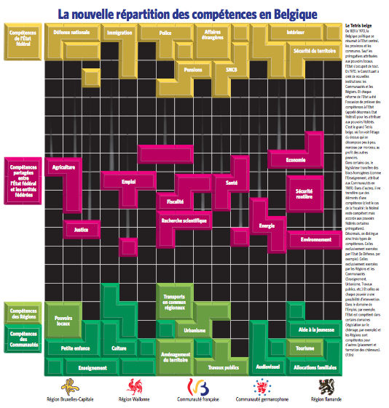

Figure 2. The experimental text
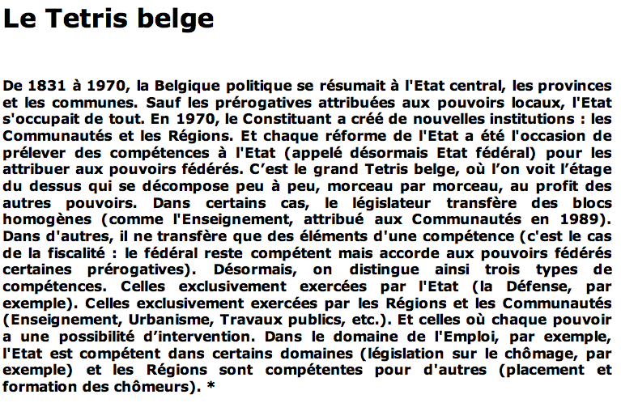

Experiment 1 – Four conditions: control, text, picture, text + picture
In order to assess the impact of this metaphor on the citizens’ perception towards Belgian federalism, we designed a test consisting of three experimental conditions and one control condition (Figure 3). In the first experimental condition (full condition), the participants were exposed to the original article (including the text and the picture). In the second and third experimental conditions, the participants were respectively exposed either to the text (text condition) or the picture (picture condition). In the control condition, the participants were not exposed to any material at all.
In the second stage of the experiment, the participants were asked to achieve three interrelated tasks: (1) a free description task, based on a free description of their own perception of Belgian federalism, (2) a questionnaire measuring the participants’ preferences about regional autonomy and (3) a last set of questions measuring citizen’s political knowledge collected as control variables.

Figure 3. Summary of the experimental research design and the causal mechanism – Experiment 1
No metaphor | Metaphors = Belgian Federalism as a Tetris
Control condition  (G1) | Full condition  (G2) | Picture condition  (G3) | Text condition  (G4)
Nothing | Picture + Text | Picture | Text
Participants’ representations of Belgian federalism

Participants’ preferences about regional autonomy

The participants were 1st year university French-speaking students. In total 623 participants took part to the first stage but the final sample covers 508 students once excluded incomplete answers. The number of participants is equally distributed across the four groups, between 114 and 128 students per experimental conditions (see Table 1 below). Because participants are students, they are not selected randomly, it is thus more accurate to speak of ‘quasi-experimental design’ (Gribbons and Herman, 1997). Nonetheless, considering the current state of the art, providing a first and systematic assessment of the potential impact of metaphor is our main research objective, not the representativeness of participants. In other words, at this stage, we seek to identify a causal mechanism, not yet its generalization towards the overall population.

Table 1. Participants’ profile across the experimental conditions – Experiment 1
 | N | % | PK  (0-5) | PI  (0-10) | Gender  (% Men) | Belgian  (0-10) | Walloon  (0-10)
Control | 131 | 25.8 | 2.85 | 5.96 | 49.2 | 8.15 | 6.44
Full | 131 | 25.8 | 2.88 | 5.88 | 47.7 | 8.61 | 6.84
Picture | 120 | 23.6 | 2.90 | 5.67 | 41.8 | 8.76 | 6.63
Text | 126 | 24.8 | 2.83 | 5.64 | 44.4 | 8.51 | 6.34
Total | 508 | 100.0 | 2.87 | 5.79 | 45.9 | 8.50 | 6.56
Chi² test | - | - | F_{(0.127)}=.078 p=.927 | F_{(3.16)}=.551 p=.648 | F_{(0.138)}=.554  p=.646 | F_{(8.22)}=1.51 p=.328 | F_{(6.237)}=0.458 p=.712
Key: PK= political knowledge, PI=political interest

To ensure the different experimental groups were homogenous, we controlled the participants’ level of political knowledge, interest in politics, gender as well as ethno-territorial identities. Homogeneity across experimental groups is crucial as these five variables are used as control variables in a multivariate linear regression to estimate participants’ preferences about regional autonomy. The operationalization of the variables is the following: political interest is based on participants’ self-positioning on a 0-10 scale where 0 means not interested in politics at all and 10 means very interested in. For measuring the level of political knowledge, we follow standard procedure of previous surveys on students in Belgium (Reuchamps et al., 2014) by asking participants to respond to 5 general questions about Belgian politics (e.g., “Which political function can you fulfill without being directly elected?”). If participants respond correctly to all given items, they have a score of 5 on a 0-5 scale.
To measure participants’ ethno-territorial identities, following a previous survey with students (Reuchamps et al., 2014), we have asked them to what extent they feel Belgian, Walloon, Francophone and Flemish on a scale running from 0 (no identification at all) to 10 (complete identification). This type of measurement allows participants to express strong national identity alone, strong regional identity alone, or equally strong/weak national and regional identities. In multinational countries such as Belgium, it is indeed important to allow participants to express their ‘nested identities’ instead of forcing them to express only one territorial identity. A one-way ANOVA with the score of these five variables as dependent variable and the experimental condition as independent variable confirms that there are not any significant differences between the four groups (p-values between 0.328 and 0.927).

Experiment 2 – Three conditions: control, text, picture, text + picture
In the second experiment, we sought to verify that it is really the metaphor (i.e. Belgian federalism as a Tetris) of the experimental text that has an influence on political preferences. Therefore, for this experiment, we randomly assigned the participants to three groups: one control group, a second group that saw the original version of the experimental text with the Tetris metaphor, a third group that saw a neutral version of the experimental text, that is without the Tetris metaphor (i.e. Belgian Tetris was replaced by Belgian federalism). The following table shows the two experimental texts:
The Belgian tetris  From 1831 to 1970, Belgium came down to the central state, the provinces and the municipalities. Except for the prerogatives devolved to the local authorities, the State took care of everything. In 1970, the constituent power created new institutions: communities and regions. And every state reform has been the occasion to take competences from the state (from there on called the federal state) to redistribute them to federal authorities. This is the big Belgian Tetris, where we see the upper floor that is falling apart (decomposing), block by block, at the benefit of other authorities. In certain cases, the legislator is transferring homogeneous blocks (like education, handed over to the communities in 1989). In other cases, what is involved is just transferring some elements of a competence (it’s the case of the tax system: the federal state remains competent but assigned certain prerogatives to the federal entities). From now on, we therefore make a distinction between three types of competences. The ones that are exclusively exercised by the federal state (like Defense, for example). The ones that are exclusively exercised by the Regions and Communities (Education, Town planning, Public works, and so on). An the ones for which each power has some possibility of intervention. In the area of employment, for instance, the (federal) State is competent for certain domains (unemployment legislation, for instance) and the Regions are in charge of other ones (training courses of unemployed people). | The Belgian tetris federalism  From 1831 to 1970, Belgium came down to the central state, the provinces and the municipalities. Except for the prerogatives devolved to the local authorities, the State took care of everything. In 1970, the constituent power created new institutions: communities and regions. And every state reform has been the occasion to take competences from the state (from there on called the federal state) to redistribute them to federal authorities. This is the big Belgian Tetris, where we see the upper floor that is falling apart (decomposing), block by block, at the benefit of other authorities. In certain cases, the legislator is transferring homogeneous blocks competences (like education, handed over to the communities in 1989). In other cases, what is involved is just transferring some elements of a competence (it’s the case of the tax system: the federal state remains competent but assigned certain prerogatives to the federal entities). From now on, we therefore make a distinction between three types of competences. The ones that are exclusively exercised by the federal state (like Defense, for example). The ones that are exclusively exercised by the Regions and Communities (Education, Town planning, Public works, and so on). An the ones for which each power has some possibility of intervention. In the area of employment, for instance, the (federal) State is competent for certain domains (unemployment legislation, for instance) and the Regions are in charge of other ones (training courses of unemployed people).

For all other elements of the experimental design, experiment 1 and experiment 2 were done in an identical fashion. Experiment 2 was done one year after experiment 1 on 1st year university. They were not the same respondents, but respondents with the same characteristics. The procedure that we present in the following section was also the same.

Procedure
The whole experiment has been conducted online using the LimeSurvey protocol. The procedure consisted of 6 to 8 different stages (depending on the experimental condition), each including different kinds of material or tackling different kinds of information. The participants could go through each stage at his/her own pace. Once one stage had been validated, they could not get back to it. These different stages can be summarized as follows:
- Stage 1 presented the experimental stimulus:
  - Experiment 1: either being the Tetris illustration (picture condition and full condition) or the experimental text (text condition).
  - Experiment 2: either being the Tetris metaphor text or the neutral federalism text.
- Stage 2 included the experimental text (only for the full condition in experiment 1).
- In stage 3, the participants were asked to freely describe their own representation of Belgian federalism (all conditions).
- In stage 4, the participants were confronted with 5 multiple-choice questions tackling their general political knowledge about Belgian federalism.
- In stage 5, the participants had to answer 13 questions aiming at measuring their attitudes towards Belgian federalism, on a Likert-scale.
- In stage 6, the participants were asked to fill in personal information.
- In stage 7, the participants were asked to score their feelings of identities on a 10 point-Likert-scale.

Data coding of the dependent variable
The dependent variable is twofold. Firstly, participants were asked to situate themselves on a 10-point Likert scale where ‘0’ means an exclusive regional self-rule situation (‘the regional and community levels would have all the powers’) while ‘10’ implies that ‘the federal Government would have all powers’. The value ‘5’ explicitly indicates a preference for the status quo, i.e. ‘being satisfied with the current situation’. This is the question that has been used in several voter surveys in Belgium (Deschouwer et al., 2015). Secondly, we questioned participants’ representations about Belgian federalism. This variable being based on a free description task (Stage 3), the coding deserves greater elaboration which also constituted the richness of the data, we asked the respondents an open question: “In ten lines and in your own words, we invite you to describe the Belgian federalism”. Each response was coded according to 32 variables divided into six thematic domains presented in Table 2. The six thematic domains is a summary of existing schemes of analysis from previous research analysing the way Belgian federalism is presented in party manifestos and political discourses (e.g. Sinardet, 2007) as well as the way Belgian federalism is discussed in focus groups (Reuchamps, 2011).

Table 2. Coding scheme for the free description task about representation of Belgian federalism
Thematic domains | Content
Control | No text / plagiarism
History | Reference to the 1831 creation and/or early process of federalization in the 1970s
Institutions | Federal (but not federalism), unitary, central/national, substate, community, region, province/commune
Identity | Belgium, Flanders, Wallonia, Brussels, Wallonia-Brussels and Europe and all their related adjectives
Linguistic | Dutch-speaking, French-speaking and German-speaking
Balance of powers | Distribution of competences/powers, autonomy, centripetal nature, centrifugal nature and the number of specific competences mentioned in the response.
Dynamics | Federalism is perceived positively, federalism is perceived negatively, complexity, conflicts, linguistic/cultural nature, community nature and territorial nature

The construction of specific response-variables implies, to some extent, a subjective interpretation of the response. In order to ensure the reliability of the lexical fields, two independent coders were in charge of the data coding. They had to use the common coding sheet to evaluate each single response. If our codes are reliable, anyone should be able to code each response and come to the same results (Cohen, 1960; Dunn, 2004; Gwet, 2010; Stemler, 2004). This is confirmed by the extremely high inter-coder reliability coefficients for the two independent coders (in most cases the inter-rater Cohen’s Kappa equals 1). The lexical fields were of course simple and thus consistent enough to minimize subjective interpretations. In case of a lower Cohen’s Kappa score, we solved each coding one by one in order to reach consensus.
In addition, we ran some descriptive statistics to assess the reliability of the data collected for this dependent variable. In particular, we tested to what extent the experimental condition had an impact on the description task by measuring the mean length (in terms of the number of words) of the descriptions of the participants from the different groups. Table 3 shows the results of the experiment 1, but the results of the experiment 2 follow the same trend.

Table 3. Mean length of the free descriptions across the experimental conditions – Experiment 1
 | Mean score | SD | Min | Max
Control condition | 41.7 | 22.9 | 3 | 120
Full condition | 50.2 | 21.3 | 3 | 128
Picture condition | 43.4 | 23.6 | 5 | 126
Text condition | 47.7 | 23.9 | 3 | 127
Total | 45.8 | 23.1 | 3 | 128

These results point to a linear trend suggesting that the participants who have been exposed to more visual and textual material tend to produce longer descriptions (no input < visual input < textual input < visual and textual input). A one-way ANOVA with the description length as dependent variable and the experimental condition as independent variable confirms that the experimental conditions have a significant impact on the length of the descriptions by the citizens from the different groups (F_{(3.489)}=3.652. p < .05). Those results are expected: greater stimulus increases the response (richer and thicker description). In the second experiment, the two experimental conditions also differ from the control group. This calls therefore to assess the validity of the causal mechanism we identified and the influence of political knowledge in this relationship. This is what we develop in the last two sections of this paper.

Findings
It is first important to repeat that the homogeneity of experimental groups has been determined and no pre-test is needed since there is a control group. We now assess whether or not (1) the Tetris metaphor influences participants’ representations of Belgian federalism which in return (2) impact their preferences about regional autonomy.

Experiment 1 – The Tetris metaphor influences participants’ representation of Belgian federalism
Answers to the free description task reveal differences in the way participants described their representations of Belgian federalism. A battery of tests – ANOVA and principal component analysis (PCA) – shows that these differences are statistically significant across groups and most specifically between the control group and the groups exposed to the Tetris metaphor.
Firstly, the variables that capture the historical, institutional and organizational dimensions are statistically significant much more present in the responses of the participants who have seen both the picture and the text (G2) or the text only (G4) (e.g. up to 28.9% of difference for the variable institutional “Region” and its adjective in comparison to control group). By contrast, the variables that capture the identity, linguistic dimensions are to be found significantly more in the responses of the control group (e.g. up to 20.2% of difference for the variable identity “Belgian” and its adjective in comparison to G4). The only exception was G3 (picture only) that seems to respond to none of the above logic. As we develop further in the rest of the findings, participants from the G3 have generally developed a sui generis behaviour in comparison to the control group and the text groups (G2 and G4).
Secondly, this duality among participants was confirmed through a PCA, which checks for potential convergence between the variables. The PCA identified two factors: one factor correlated to the identity/linguistic variables (and negatively associated to the institutional/organization variables) and one factor correlated to the institutional/organization variables (and negatively associated to the identity/linguistic variables). The control group is associated at a statistically significant level with the identity/linguistic factor while the other groups exposed to the metaphor (G2 and G4) are correlated with the institutional/organization factor.
Finally, the results of these analyses are also confirmed – and best illustrated – in the Table 4 crossing the six thematic dimensions and the four groups. Participants from G1 present the highest percentages in the identity/linguistic/conflict while displaying the lowest percentages in the institutional/organization/history dimensions. Participants from G2 and G4 present the exact opposed results while, here again, G3 does not seem to adopt any of these two specific divides.

Table 4. Percentage of the six thematic dimensions of participants’ representations of Belgian federalism by group – Experiment 1
 | G1  (Control group) | G2  (Picture +Text) | G3  (Picture only) | G4  (Text only) | Chi-square tests
History | 5,0% | 12,8% | 0,6% | 25,8% | (57.82, df = 3)****
Institutional | 56,1% | 68,6% | 48,5% | 68,4% | (19.274, df = 3) ****
Identity | 51,1% | 32,1% | 21,5% | 25,2% | (34.99, df = 3) ****
Linguistic | 7,2% | 3,2% | 4,3% | 2,6% | (4.45, df = 3)
Organization | 61,9% | 66,0% | 46,6% | 65,8% | (16.866, df = 3) ****
Dynamic | 40,3% | 19,9% | 22,7% | 18,7% | (23.27, df = 3) ****
Sig. codes: ****p<.000

Overall, these various statistical tests using either the 32 variables or the 6 thematic dimensions confirmed that the Tetris metaphor does impact participants’ answers. More importantly, the effects of the metaphor corroborate our first hypothesis: in the absence of metaphor, it is the ‘identitarian reflex’ that prevails in the participants’ representations of Belgian federalism.
But, in fact, it is the contrast with the metaphor groups that is the most striking: respondents moved the focus of their definition of Belgian federalism to the institutions and organization. The results show that the full condition (Q2) and the text condition (Q4) display quite similar patterns in their own descriptions of Belgian federalism. More specifically, these two groups score very high on the institutional dimension as well as on the description of federalism as power-sharing and on the emphasis of its centrifugal nature. In other words, ‘alternative’ representations are developed in groups exposed to the metaphor demonstrating the influence of the Tetris on participants’ representations. And these alternative representations are not neutral vis-à-vis the Tetris metaphor: they are in line with institution and organization of Belgian federalism which are the primary descriptive items of the Tetris metaphor. While we have shown the treatment has an impact on participants’ representation of Belgian federalism, the second and decisive test is whether or not its impact participants’ preferences about regional autonomy.
The main political question about Belgian federalism is not the issue of separation or not – less than 10% of the population support it (Reuchamps, 2013) – but the extent of the autonomy of the Regions and Communities. Recent voter surveys showed that French-speaking voters tend to be pro-unionist or at least in favour of the status quo (on the score 0-10 regional autonomy scale, the mean French-speaking average score was of 5.1 in 2009 and 5.9 in 2014). In any case, they are clearly less autonomist than the Flemish voters who scored on average 4.3 in 2009 and 4.5 in 2014 (Deschouwer et al., 2015).
Our second hypothesis is that ‘identitarian reflex’ leads to preferences that are similar to the overall population (being more pro-unionist according to voter surveys) while participants from other groups – being able to think alternatively without the ‘identitarian reflex’ – develop preferences towards more autonomy. To check this hypothesis, we ran two types of statistical tests: ANOVA and linear regression.
Firstly, the ANOVA aims at identifying different preferences that are statistically significant across groups. As expected, we observe that the participants from the control group are the most unionist (score of 6.65 on the 0-10 scale) while all other participants exposed to the Tetris metaphor are more autonomist (statistically significant at p<.10) (Figure 4). We cautiously remind the reader that we aimed at identifying a causal mechanism in which a metaphor does make a difference. In this respect, we carefully acknowledged that such preferences are formed through various political processes (for instance, closeness to a party or political socialization). Therefore, differences across groups were expected to be statistically significant but we did not expect large differences. As a matter of fact, participants from G2, G3 and G4 did not come strong pro-autonomist but the effects are real even though the metaphor was just ‘administrated’ once in the framework of an experimental research design. Nevertheless, the differences between the control group, on the one hand, and G2 and G4 (respectively 6.20 and 5.99), on the other hand, are far from being negligible: they represent a variance up to 11 percent in comparison to the control group. In line with the previous results, participants from the G3 (picture only) appear to be the less sensitive to the effects of the metaphor (6.39) and present a smaller difference with the control group.

Figure 4. ANOVA of participants’ preferences about regional autonomy – Experiment 1
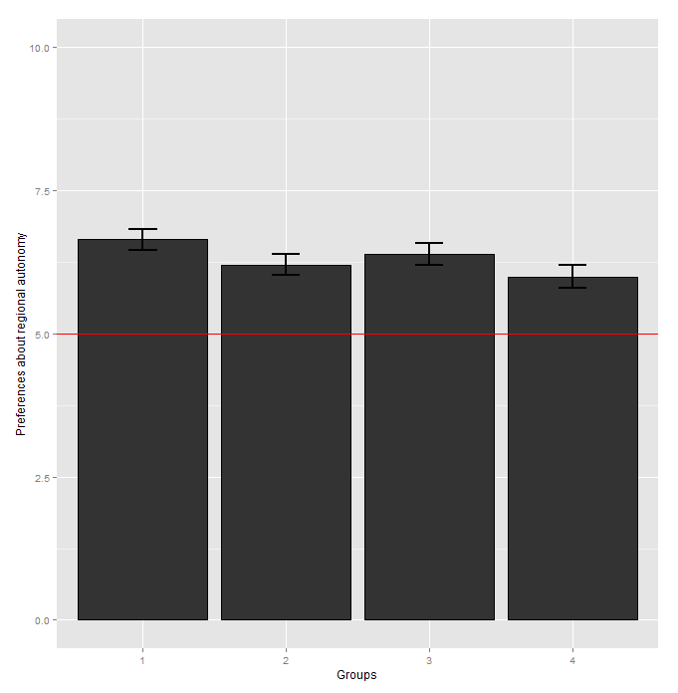

Secondly, we developed a multivariate linear regression to assess the participants’ preferences about regional autonomy. For that purpose, we controlled for other variables whose impact is acknowledged in the literature on regionalism and federalism. On the one hand, we controlled for participants’ ethno-territorial identity, relying on previous studies which demonstrated that there was a strong – albeit not straightforward – correlation between ethno-territorial identity and preferences vis-à-vis regional autonomy (Reuchamps et al., 2016; Dodeigne, 2014; Pattie, Denver, Mitchell, & Bochel, 1999). Participants that nourish a more regional identity tend to be more autonomist while participants who feel more Belgian will be more unionist. On the other hand, we integrated two variables about participants’ political knowledge and political interest. The inclusion of these variables is justified by former research that established the statistically significant effects of political knowledge and political interest on voters’ attitudes in Belgium, especially in Flanders (Deschouwer & Sinardet, 2010).
We furthermore include gender as an intervening variable because political knowledge and gender are often correlated (Mondak & Anderson, 2004) which is also verified in our data. Our assumption is that participants who are highly interested in politics and develop a conduct good command of politics are more likely to develop clear preferences about regional interest than participants who do not follow politics and with a poor knowledge of political and institutional context. Finally, our main independent variable is of course the group variable (G1, G2, G3 and G4). As a categorical variable, we took the control group as the reference category.

Table 5. Multivariate linear regression of participants’ preferences about regional autonomy – Experiment 1
 | Beta | Std. error | Pr(>|t|)
(Intercept) | 6.105 | 0.474 | 0.000 | ****
Gender | 0.258 | 0.199 | 0.196
Belgian | 0.082 | 0.043 | 0.054 | *
Walloon | -0.093 | 0.031 | 0.003 | ***
Political knowledge | -0.143 | 0.083 | 0.085 | *
Political interest | 0.124 | 0.045 | 0.006 | ***
Groups (Ref= control group)
G2 (text + picture) | -0.469 | 0.265 | 0.077 | *
G3 (picture only) | -0.248 | 0.273 | 0.365
G4 (text only) | -0.658 | 0.267 | 0.014 | **
N=481 observations
F-statistic: 3.894 on 8 and 462 DF (****)
R²= 0.063, Adjusted R²=0.047
Sig. codes: ****p<.000, ***p<.001, **p<.01, **p<.05, *p<.10

The results of the multivariate regression are given in Table 5. The most important results are that the groups that were exposed to the Tetris metaphor in the text (G2 and G4) are more autonomist than the control group, even when controlling for the statistically significant of ethno-territorial identities effects (in the expected direction), political knowledge and political interest. Although we did not expect dramatic differences, effects of the groups are substantial considering the limited gradation of the 0-10 scale. All other things being equal, participants from G2 and G4 are respectively 4.7% and 6.7% more autonomist (plus or minus 2.7%) in comparison to participants from the control group. This is, needless to say, an interesting finding for political science and federal studies: the particular way one frames federalism does seem to really matter. Participants from G3 are also more autonomist, albeit not at a statistically significant level. This confirms once again the indecisive effects of the metaphor conveyed by the picture only. Overall, it seems that presenting Belgian federalism as a Tetris has an impact on preferences about its future. This is an important finding for political science. But in linguistic terms, it remains to be demonstrated that it is really the metaphor that matters, and not simply the fact of providing information – different from the usual information – about Belgian federalism. That’s why the second experiment was set.

Experiment 2 – Both the neutral text and the Tetris text influence participants’ representation of Belgian federalism
The analyses made on the results of experiment 2 follow the same lines as the ones that have just been presented for experiment 1. Therefore, we can quickly move to the main findings and they both confirm and infirm experiment 1. The confirmation comes from the results on the six thematic dimensions. As Table 6 shows, we find the same pattern: the control group differs from the two experimental groups. The former has the ‘identirian reflex’, whereas the latter go for a more institutional account for Belgian federalism. This is in line with experiment 1.
Table 6. Percentage of the six thematic dimensions of participants’ representations of Belgian federalism by group – Experiment 2

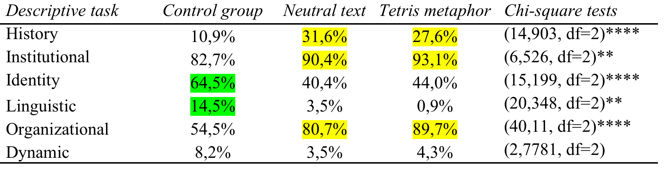
However, we do not find differences between the neutral text and the text with the Tetris metaphor.At this stage, this means that it is not the metaphor that has an impact but more generally the text, be it neutral or metaphorical. The next step of our investigation is to check whether participants’ preferences about regional autonomy are influenced by the metaphor. The results of the linear regression are presented in Table 7.

Table 7. Multivariate linear regression of participants’ preferences about regional autonomy – Experiment 2
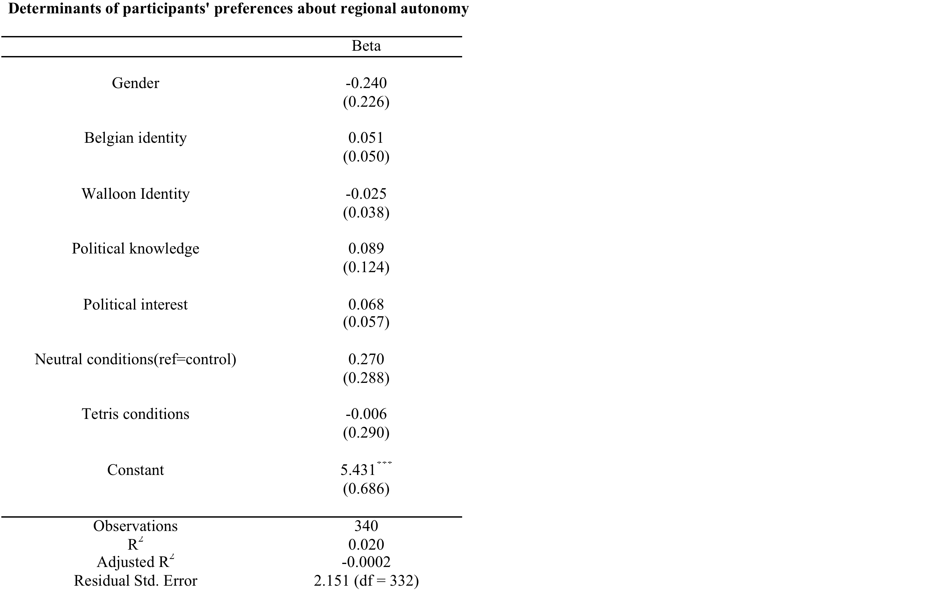

The results ofe regression show that the Tetris condition has no statistically significant effect on participants’ preferences for regional autonomy.This confirms, at this stage, that it is not the metaphor per se that has an impact but the text. We need, however, to dig it further and to take into account a possible interactive effect of political knowledge.

Experiment 1 and experiment 2 – Political knowledge matters: the less political knowledge one has, the more influence the metaphor has on preferences for regional autonomy
To make a long story short, what we seek to assess is whether a different level of political knowledge might lead to a differentiated impact of the metaphor. Since we rely on the same questions in the two experiments, we can easily and meaningfully compare them. Figure 5 and Figure 6 present the results of the interactive effects for the two experiments. On the Y-axis are plotted the marginal effects. On the X-axis is the political knowledge (‘0’ means the respondents did not have any correct answer to the political knowledge questions, whereas ‘5’ means the respondents did answer correctly all political knowledge questions) where the bar charts show the number of respondents per category. The dotted line represents where the estimates equal 0: below the line means negative effect of the interaction, above the line means positive effect of the interaction. The grey zone is the confidence interval of 95%. One thus needs to look at results where all the grey zone is below or above the dotted line; in this case, it would mean there are interactive effects of political knowledge.

Figure 5. Interactive effects of political knowledge – Experiment 1
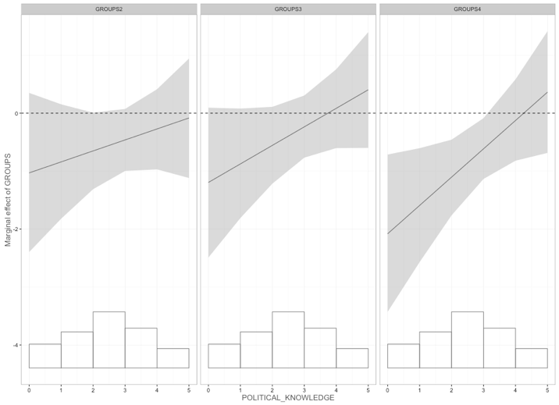

On Figure 5, we can observe there is an effect of the text condition (group 4) depending on the level of political knowledge: participants with a low level of political knowledge are more impacted by the experimental text than participants with a higher level of political knowledge. In other words, a low level of political knowledge means a greater inclination towards more regional autonomy after having read the text. We can actually give precisely the turning point: between a score of 0 and 3 on our scale of political knowledge. This is an important finding because it demonstrates that the impact is sensitive to political knowledge. What’s even more important is that Figure 6 shows similar results but only for the Tetris condition.

Figure 6. Interactive effects of political knowledge – Experiment 2
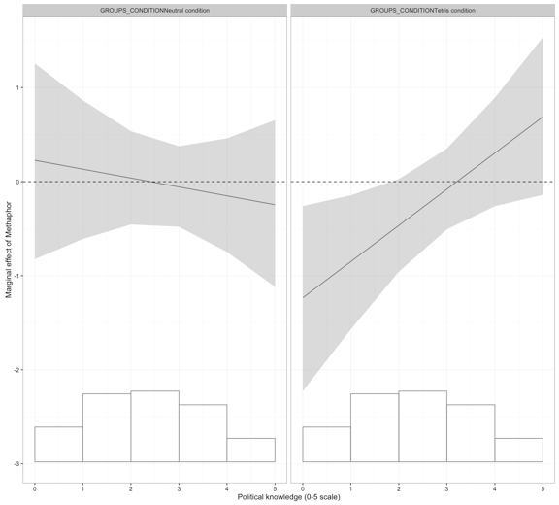
In our previous analyses, we had to conclude that we could not find any specific effect of the metaphor (in comparison with the neutral text). Yet, this finding has to be nuanced on the basis of Figure 6. Whereas there are no significant interactive effects of political knowledge in the neutral condition, there are significant interactive effects of political knowledge in the Tetris conditions. This means that respondents with a lower level of political knowledge who saw the Tetris metaphor were led to favour more regional autonomy, but it was not the case for the respondents who saw the neutral text. This therefore confirms the differentiated impact of the Tetris metaphor: it is only true for respondents with low political knowledge. It is an interesting contribution to the on-going debate about the political impact of metaphors.

Conclusion
Presenting federalism with a metaphor is not usual. In fact, metaphors are produced en masse in political discourses and in media discourses. But their potential political impact on individuals had hardly been explored hitherto. Our experimental setting relying on a real media production made of both a text and a picture demonstrated quite clearly that the way one presents federalism in general and the metaphor of Tetris in particular do impact the way we understand federalism, at least in the short term.
The results of the experiment 1 clearly point to the main effect of the textual condition. Indeed, participants who were submitted to the textual stimuli tend to behave similarly. Reading the text clearly appears to have an influence on how participants describe Belgian federalism, which is in line with the findings of the linguistic analysis of the free description task (see authors), but also appears to influence the participants’ political preferences vis-à-vis regional autonomy. However, these results should be regarded with some caution as to the exact role played by the Tetris metaphor in this process. On the one hand, considering the text is structured on this particular metaphor, one could suggest it plays a predominant role in constructing the mental representation of the text. But in the absence of a neutral version of the text, i.e. without any reference to the Tetris metaphor, this had to be established with a second experiment.
At first sight, the results of this second experiment did not show any specific impact of the Tetris metaphor, in comparison with the neutral text. While both experimental conditions confirmed the differences identified in the first experiment in comparison with the control group, there was no difference between the two experimental conditions of the second experiment. This finding was, however, to be nuanced with the introduction of interactive effects of political knowledge. These further statistical tests revealed that respondents with a lower level of political knowledge were to be more influenced by the experimental text, as they were to move more in favour of regional autonomy, and this was only the case for those respondents who saw the Tetris metaphor, and not those who saw the neutral text.
To understand under what conditions a metaphor does or does not influence individuals, future research should therefore include political knowledge questions, and look for possible interactive effects. Further research should also test which other factors play a role on framing processes. Other factors might indeed influence the framing effect of metaphors, among which aptness, that is “the degree to which a metaphor vehicle captures important features of a metaphor topic” (Thibodeau & Durgin 2011: 206) might be an important factor to explain whether a metaphor has an effect or not. This may also be a matter of extendedness, that is the degree to which a metaphorical frame is supported by several metaphors in a given text (see Krenmayr et al. 2014, Reijnierse et al., 2015). In addition to extendedness, exposure through time should be looked at since the repetition of a metaphor over time might have a long-lasting impact.
For the study of federalism and political science, this paper demonstrates that not only discourse matters but also and above all the metaphors that are brought about by discourse. A metaphor, such as the Tetris metaphor, has the potential to influence citizens’ political representations and preferences. Of course, federalism translates into political dynamics and institutions but the way these dynamics and institutions are presented is key for the citizens and their support or not. Much research still needs to be done, but this paper has made a step forward in our understanding of the complex relation between federalism and metaphor, and calls for further research on the impact of metaphors in political science.
References
Bougher, L. D. (2012). The Case for Metaphor in Political Reasoning and Cognition. Political Psychology, 33(1), 145-163.
Bowdle, B. F., & Gentner, D. (2005). The career of metaphor. Psychological Review, 112(1), 193-216.
Burgess, M. (1995). The British tradition of federalism. London: Leicester University Presses.
Burgess, M. (2006). Comparative federalism. Theory and Practice. London: Routledge.
Campbell, J., & Pedersen, O. (2001). Introduction: The Rise of Neoliberalism and Institutional Analysis. In J. Campbell & O. Pedersen (Eds.), The Rise of Neoliberalism and Institutional Analysis (pp. 1-23). Princeton: Princeton University Press.
Carver, T. & Pikalo, J. (Eds) (2008). Political Language and Metaphor: Interpreting and Changing the World. London: Routledge.
Casasanto, D. & Boroditsky, L. (2008). Time in the mind: Using space to think about time. Cognition, 106, 579-593.
Charteris-Black, J. (2011). Politicians and Rhetoric: The Persuasive Power of Metaphor [2nd edition]. London: Palgrave MacMillan.
Charteris-Black, J. (2013). Analysing Political Speeches: Rhetoric, Discourse and Metaphor. London: Palgrave MacMillan.
Cohen, J. (1960). A coefficient for agreement for nominal scales. Education and Psychological Measurement, 20(1), 37-46.
Deignan, A. (2011). Deliberateness is not unique to metaphor: A response to Gibbs. Metaphor and the Social World, 1(1), 57-60.
Deschouwer, K. (2012). The Politics of Belgium: Governing a Divided Society [2nd edition]. London: Palgrave Macmillan.
Deschouwer, K., & Sinardet, D. (2010). Langue, identité et comportement électoral. In K. Deschouwer, P. Delwit, M. Hooghe, & S. Walgrave (Eds.), Les voix du peuple. Le comportement électoral au scrutin du 10 juin 2009 (pp. 61-79). Bruxelles: Editions de l'Université de Bruxelles.
Deschouwer, K., De Winter, L., Reuchamps, M., Sinardet, D., & Dodeigne, J. (2015). Les attitudes communautaires et le vote. In K. Deschouwer, P. Delwit, M. Hooghe, P. Baudewyns, & S. Walgrave (Eds.), Décrypter l’électeur : Le comportement électoral et les motivations de vote (pp. 156-173). Louvain: Lannoo Campus.
Dodeigne, J. (2014). (Re-)Assessing Career Patterns in Multi-Level Systems: Insights from Wallonia in Belgium. Regional & Federal Studies, 24(2), 151-171.
Dunn, G. (2004). Statistical Evaluation of Measurement Errors: Design and Analysis of Reliability Studies (2nd ed.). London: Hodder Arnold.
Entman, R. M. (1993). Framing: Toward clari cation of a fractured paradigm. Journal of Communication, 43(4), 51-58.
Forceville, C.J. & Urios-Aparisi, E. (eds) (2009). Multimodal Metaphor. Berlin-New York: Mouton de Gruyter.
Gibbs, R. W. (2011). Are 'deliberate' metaphors really deliberate? A question of human consciousness and action. Metaphor and the Social World, 1(1), 26-52.
Gibbs, R. W. (2015). Does deliberate metaphor theory have a future? Journal of Pragmatics 90, 73-76.
Goatly, A. (2007). Washing the Brain: Metaphor and Hidden Ideology. Amsterdam: John Benjamins.
Gribbons, B. & Herman, J. (1997). True and quasi-experimental designs. Practical Assessment, Research & Evaluation, 5(14).
Gwet, K. L. (2010). Handbook of Inter-Rater Reliability: The definite Guide to measuring the extent of agreement among Raters. Gaithersburg: Advanced Analytics.
Johnson, M. (2010). Metaphor and cognition. In D. Schmicking & S. Gallagher (Eds.), Handbook of Phenomenology and Cognitive Science (pp. 401-414). London: Springer.
Koller, V. (2009). Missions and Empires: Religious and Political Metaphors in Corporate Discourse. In A. Musolff & J. Zinken (Eds.), Metaphor and Discourse (pp. 116-134). Houndmills: Palgrave Macmillan.
Kövecses, Z. (2010). Metaphor: A Practical Introduction [2nd edition]. New York: Oxford University Press.
Krennmayr, T., Bowdle, B. F., Mulder, G., & Steen, G. J. (2014). Economic competition is like auto racing. Building metaphorical schemas when reading text. Metaphor and the Social World, 4(1), 65-89.
Lakoff, G., & Johnson, M. (1980). Metaphors we live by. Chicago: University of Chicago Press.
Lakoff, G. & Johnson, M. (1999). Philosophy in the Flesh. New York: Basic Books.
Lakoff, G. (1996). Moral Politics: How Liberals and Conservative Think. Chicago: University of Chicago Press.
Lakoff, G. (2004). Don’t Think of an Elephant: Know your Values and Frame the Debate. White River Jct., Vt.: Chelsea Green Publishing Company.
Mondak, J. J., & Anderson, M. R. (2004). The Knowledge Gap: A Reexamination of Gender-Based Differences in Political Knowledge. The Journal of Politics, 66(2), 492-512.
Musolff, A. (2004). Metaphor and Political Discourse: Analogical Reasoning in Debates about Europe. London: Palgrave Macmillan.
Panizza, F., & Miorelli, R. (2013). Taking Discourse Seriously: Discursive Institutionalism and Post-structuralist Discourse Theory. Political Studies, 61(2), 301-318.
Pattie, C., Denver, D., Mitchell, J., & Bochel, H. (1999). Partisanship, national identity and constitutional preferences: An exploration of voting in the Scottish devolution referendum of 1997. Electoral Studies, 18(3), 305-322.
Perrez, J., & Reuchamps, M. (Eds.). (2012). Les relations communautaires en Belgique : Approches politiques et linguistiques. Louvain-la-Neuve: Academia-L'harmattan.
Perrez, J. & Reuchamps, M. (2014). Deliberate metaphors in political discourse: the case of citizen discourse. Metaphorik.de, 25, 7-41.
Perrez, J. & Reuchamps, M. (2015a). Special issue on the political impact of metaphors: Introduction. In Metaphor and the Social World, 5 (2), 165-176.
Perrez, J. & Reuchamps, M. (2015b). The “Belgian Tetris”: Assessing the political impact of metaphors on citizens’ representations of Belgian federalism. Metaphor and the Social World, 5 (2), 223-244.
Perrez, J. & Reuchamps, M. (2015c). Crazy machine or strong 'Living Apart Together' relationship? The role of metaphors in citizens' perception of Belgian federalism. Mots. Les langages du politique, 109.
Reijnierse, W.G., Burgers, C., Krennmayr, T. & Steen, G.J. (2015). How viruses and beasts affect our opinions (or not): the role of extendedness in metaphorical framing. Metaphor and the Social World 5 (2), 245-263.
Reuchamps, M. (2009). Le fédéralisme et ses deux sens - négatifs - en Belgique francophone. Revue de la Faculté de droit de l’Université de Liège, 54(4), 527-540.
Reuchamps, M. (2013). The Future of Belgian Federalism Through the Eyes of the Citizens. Regional & Federal Studies, 23(3), 353-368.
Reuchamps, M., Kavadias, D., & Deschouwer, K. (2014). Drawing Belgium: Using Mental Maps to Measure Territorial Conflict. Territory, Politics, Governance, 2(1), 30-51.
Reuchamps, M., & Perrez, J. (2012). Métaphores conceptuelles dans les discours citoyens en Belgique. In J. Perrez & M. Reuchamps (Eds.), Les relations communautaires en Belgique : Approches politiques et linguistiques (pp. 133-158). Louvain-la-Neuve: Academia-L'harmattan.
Schmidt, V. A. (2008). Discursive institutionalism: The explanatory power of ideas and discourse. Annual Review of Political Science, 11, 303-326.
Schmidt, V. A. (2009). Putting the Political Back into Political Economy by Bringing the State Back in Yet Again. World Politics, 61(03), 516-546.
Sinardet, D. (2007). Wederzijdse mediarepresentaties van de nationale andere. Vlamingen, Franstaligen en het Belgische federale samenlevingsmodel. PhD in Political science, Universiteit Antwerpen.
Steen, G.J. (2008). The paradox of metaphor: Why we need a three-dimensional model of metaphor. Metaphor and Symbol, 23 (4), 213-241.
Steen, G. J. (2011). What does 'really deliberate' really mean?: More thoughts on metaphor and consciousness. Metaphor and the Social World, 1(1), 53-56.
Steen, G.J. (2015). Developing, testing and interpreting Deliberate Metaphor Theory. Journal of Pragmatics 90, 67-72.
Steen G.J., Reijnierse, W.G. & Burgers, C (2014) When Do Natural Language Metaphors Influence Reasoning? A Follow-Up Study to Thibodeau and Boroditsky (2013). PLoS ONE 9(12): e113536.
Stemler, S. E. (2004). A comparison of consensus, consistency, and measurement approaches to estimating interrater reliability. Practical Assessment. Research & Evaluation, 9(4).
Swyngedouw, M., Abts, K., & Galle, J. (2014). Vlamingen en de communautaire kwestie. In K. Abts, M. Swyngedouw, J. Billiet, & B. Meuleman (Eds.), Vlaanderen kiest: Trends in stemgedrag en opvattingen over politiek, staatshervorming en kerk (pp. 219-244). Leuven: LannooCampus.
Thibodeau P. H., & Boroditsky L. (2011) Metaphors We Think With: The Role of Metaphor in Reasoning. PLoS ONE 6(2): e16782.
Thibodeau P. H., & Boroditsky L. (2013) Natural Language Metaphors Covertly Influence Reasoning. PLoS ONE 8(1): e52961.
Thibodeau, P. H., & Durgin, F. H. (2011). Metaphor aptness and conventionality: A processing fluency account. Metaphor and Symbol, 26(3), 206-226.

The Belgian Tetris From 1831 to 1970, Belgian politics came down to the central state, the provinces and the municipalities. Except for the powers devolved to the local authorities, the State took care of everything. In 1970, the constituent power created new institutions: communities and regions. And every state reform has been the occasion to take competences from the state (henceforth called the federal state) to redistribute them to federal authorities. This is the big Belgian Tetris, where we see the upper floor that is falling apart (decomposing), block by block, to the benefit of other authorities. In certain cases, the legislator is transferring homogeneous blocks (like education, handed over to the communities in 1989). In other cases, what is involved is just transferring some elements of a competence (this is the case with fiscality: the federal state remains competent but has assigned certain prerogatives to the federal entities). From now on, we therefore make a distinction between three types of competences. The ones that are exclusively exercised by the federal state (like Defense, for example). The ones that are exclusively exercised by the Regions and Communities (Education, Town planning, Public works, and so on). And the ones for which each power has some possibility of intervention. In the area of employment, for instance, the (federal) State is responsible for certain domains (unemployment legislation, for instance) and the Regions are in charge of other ones (training courses for unemployed people). Source: “Le Soir”, 13–14/07/13, p. 8, written by Pierre Bouillon, translated by Julien Perrez and Graham Low.

