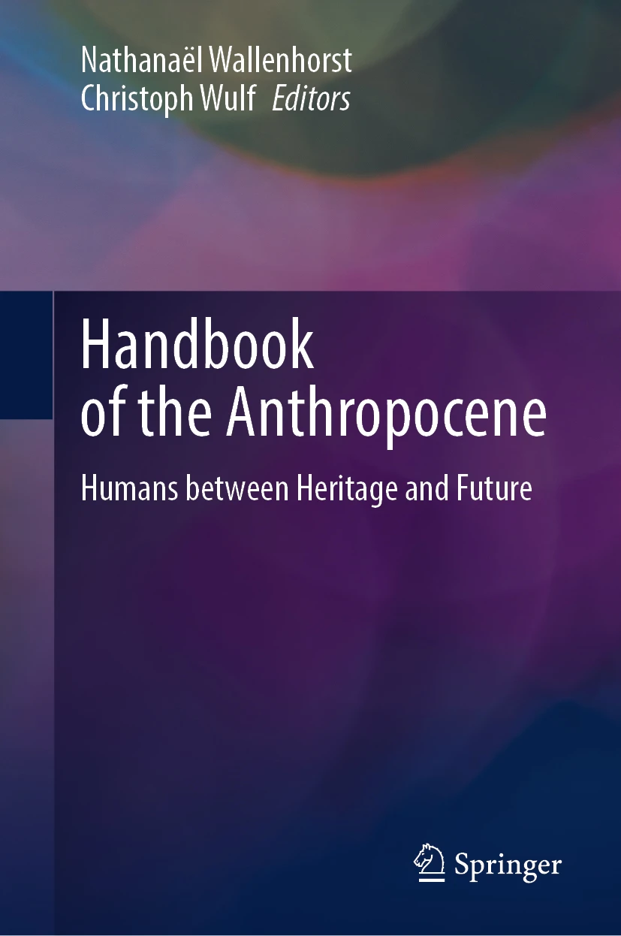




About this book
This Handbook is a collection of contributions of more than 300 researchers who have worked to grasp the Anthropocene, this new geological epoch characterised by a modification of the conditions of habitability of the Earth for all living things, in its biogeophysical and socio-political reality. These researchers also sought to define a historical and prospective anthropology that integrates social, economic, cultural and political issues as well as, of course, environmental ones. What are the anthropological changes needed to ensure that our human adventure will be able to continue in the Anthropocene? And what are the educational and political issues involved?
Anthropocene is fast becoming a widely-used term, but thus far, there been no reference work explaining the thoughts of the greatest experts of the present day on this subject (at the intersection of biogeophysical and socio-political knowledge). A scientific and political concept (but which is also the conceptual vehicle for conveying the scientific community's sense of concern), this complex term is explained by international experts as they reflect on scientific arguments taking place in earth system science, the social sciences and the humanities. What these researchers from different disciplines have in common is a healthy concern for the future and how to prepare for it in the Anthropocene and also the identification of possible anthropological changes. This Handbook encourages readers to immerse themselves in reflections on the human adventure through descriptions of our differing heritages and the future that is in the process of being written.



