A multi-corpus approach to the placement of however: Nativeness vs expertise
Maïté Dupont¹ & Sylviane Granger²
¹Centre for English Corpus Linguistics & TranSphères, UCLouvain, ²Centre for English Corpus Linguistics, UCLouvain
Abstract
While in recent years, many studies have been devoted to the frequency of connectors in second-language (L2) writing, the issue of connector placement has received scant attention. In this study we focus on the highly frequent and mobile connector however to identify L2 learners’ placement preferences. The study aims to contribute to the current debate around the notions of nativeness/non-nativeness and expertise/noviceness, and for this purpose relies on three corpora that differ in terms of nativeness and expertise. The results show that novice writers with English as a first language (L1) are not significantly different from novice writers from other L1s, both populations favouring initial positioning of however, while expert writers display more flexible positioning.
Keywords
connector, word order, expertise, nativeness, discourse

Introduction

Adverbial connectors, also referred to as (logical) connectives, link words or linking adverbials, can be defined as linguistic items that signal a logical relationship between text segments at sentence level or above. Examples include single-word items such as however and therefore and multiword units such as on the other hand and for example. Alongside other discourse features, such as stance markers and information focus structures, adverbial connectors represent a particularly tough challenge for novice writers, especially those who need to acquire good academic writing skills.
Research on connector use has been particularly active in learner corpus research (LCR), a field that investigates language produced by foreign/second language (L2) learners on the basis of large collections of electronic texts (Granger, Gilquin & Meunier, 2015). The main focus has been on the frequency of connectors and, to a lesser extent, the semantic categories they fall into (additive, contrastive, resultative, etc.). One aspect of connectors that has been largely neglected in L2 studies is their positioning in the clause or sentence. Unlike other cohesive devices such as coordinating and subordinating conjunctions, most connectors can occur in initial, medial and final positions (see example (1)).
- a. However, the project never materialized.
b. The project, however, never materialized.
c. The project never materialized, however.
While the high mobility of connectors is highlighted in most reference grammars and style guides, very little information is provided as to the reasons why one position is chosen over another. This may lead learners to think that the different positions are interchangeable, which is not the case, as each position is associated with its own discourse function(s) (Dupont, 2021; Harthan, 2022).
Most studies in LCR, whether on connectors or any other linguistic phenomenon, compare the L2 corpus with only one reference corpus, which in most cases is a corpus of novice L1 English writing (Altenberg & Tapper, 1998; Narita & Sugiura, 2006) but can also be a corpus of expert writing, usually consisting of articles published in scientific journals (Chen, 2006; Lei, 2012). Both types of corpus are referred to as ‘native’ corpora, thereby attributing to nativeness features that could well be due to the writer’s level of expertise. The only way to disentangle the impact of expertise and nativeness is to compare three corpora: a corpus of L2 writing, a corpus of novice L1 English writing and a corpus of expert writing. The few studies that have adopted this tripartite design have shown that novice writers of academic texts, whether they have English as their L1 or not, share a number of linguistic features which distinguish them from expert writers (Larsson, 2019; Marti, Yilmaz & Bayyurt, 2019; Römer, 2009). Some studies, however, have reported mixed results. Staples & Reppen (2016) find both similarities and differences between novice L1 English and L2 English writers in their use of lexico-grammatical features typical of academic writing. Leńko-Szymańska (2008) establishes overuse of connectors in both L1 English and L2 English novice writers compared with experts, but also observes marked differences between the L1 populations, with learners from some L1 backgrounds closer to experts than others.
The objective of this article is twofold. First, it aims to investigate the preferred/dispreferred positions of the adverbial connector however in a corpus of L2 learner writing and to identify the discourse functions with which they are associated. Second, it aims to contribute to the current debate around the notions of nativeness/non-nativeness and expertise/noviceness and, for this purpose, relies on three corpora that differ in terms of nativeness and expertise. In addition, with a view to assessing the potential impact of the learner’s L1, it investigates data produced by writers from a wide range of mother tongue backgrounds.
Our reasons for choosing to focus on however are that it is the most frequent connector in academic prose (Biber et al., 1999: 887) and that it is characterized by a high degree of positional flexibility (Dupont, 2021). The L2 data used consists of argumentative essay writing, a genre which, as argued by Shin (2019: 3), is “useful for evaluating the academic literacy of novice writers as well as for introducing students to the rhetorical devices of academic writing in general”.
The study seeks to answer the following three research questions:
- Does the placement of however by novice writers differ from that of expert writers? (expertise effect);
- Are there differences between the novice populations? In particular, do L1 English writers differ from novice writers from other mother tongue backgrounds? (L1 effect);
- Do L2 learners, novice L1 English writers and expert L1 English writers use however with similar or different rhetorical effects? (discourse functions).
The present article first gives an overview of connectors in learner corpus research. After a description of the data and methodology, it presents the results of the analysis of expertise and L1 effects and discourse implications. The final section offers a conclusion and pathways for future research.

Connectors in Learner Corpus Research

Numerous studies have focused on the use of adverbial connectors in corpora of L2 writers. They usually rely on data from a single L2 population, such as French (Granger & Tyson, 1996), Japanese (Narita & Sugiura, 2006), Norwegian (Rørvik & Egan, 2013), Swedish (Altenberg & Tapper, 1998), Taiwanese (Chen, 2006) and Turkish (Güneș, 2017) learners. More rarely, the investigation involves two or more L2 populations (Van Vuuren & Berns, 2018; Lenko-Szymanska, 2008).
Most studies focus on the frequency of connectors. The main trend points to a general overuse of connectors in L2 writing. Milton & Tsang (1993: 239), for example, find that “[t]here is a high ratio of overuse of the entire range of logical connectors in our students’ writing, in comparison to published English”. However, this trend is contradicted by some studies (e.g. Granger & Tyson, 1996; Rørvik & Egan, 2013) that fail to reveal any significant difference in the overall frequency of connectors. Many studies have compared frequencies not of connectors in general but of semantic categories of connectors. Granger & Tyson (1996), for example, found that French-speaking learners tended to overuse additive and appositive connectors and to underuse contrastive and resultative ones. Differences in frequency across L2 populations have also been established (Leńko-Szymańska, 2008).
One key aspect of connector use, their positioning, is unfortunately either left out of the analysis altogether or given cursory treatment, often limited to percentages of use in the different positions. Overall, studies point to overuse of sentence-initial connectors and underuse of medial positions (Altenberg & Tapper, 1998; Narita & Sugiura, 2006). Unfortunately, most researchers do not go beyond providing quantitative results and fail to address the rhetorical effects achieved by connector positioning. Narita and Sugiura (2006: 35) are aware of this weakness and point to the need “to do in-depth studies of each English connector from a functional sentence perspective prior to making EFL students aware of discourse factors affecting the positions”.
Although there is an abundance of studies of connector use in L2 writing, the results are difficult to compare for several reasons. First, the L2 learners vary in terms of mother tongue background, proficiency level, task and learning context. Second, when connector placement is addressed, the criteria used to identify the positions of connectors are often not described and prove to differ across studies. For example, while some researchers categorize connectors used after a semi-colon as sentence-initial (Han & Gardner, 2021), others consider them to be sentence-medial (Narita & Sugiura, 2006). Third, the reliability of the quantitative results is often quite weak, due to a general lack of rigorous statistical analysis.
The present study aims to address some of these issues through a rigorous analysis of the position of however in expert writing and a wide range of novice populations.

Data and methodology

Data
The placement of however is investigated in three corpora of English: (i) a corpus of L2 writing; (ii) a corpus of novice L1 English writing; (iii) a corpus of expert writing. The learner corpus is taken from the third version of the International Corpus of Learner English (Granger et al., 2020), which includes upper-intermediate to advanced learner data from 25 mother tongue backgrounds, amounting to over 5.5 million words. The following two criteria were used to select the ICLE texts for the study: (i) literary essays were excluded from the corpus; (ii) we only kept the L1 subsets which included at least 180 texts. In addition, as the Chinese subcorpus was significantly larger than the others, a random sample of c. 200,000 words was extracted for this subcorpus, so as to better approximate the size of the other subcorpora. The final corpus comprises 8,299 texts (amounting to c. 5 million words) from 24 mother tongue backgrounds, with an average length of 598 words per text. The number of words in each ICLE subset varies between c. 130,000 (ICLE-Spanish) and c. 260,000 (ICLE-Greek) words, with most subcorpora including about 200,000 words.
The American subset of the Louvain Corpus of Native Essays (LOCNESS) was used to investigate the placement of however by novice L1 English writers. LOCNESS was designed to be comparable to ICLE in terms of writing tasks and expertise in academic writing. It is made up of 175 argumentative essays written by American university students, and totals 148,704 words, with an average of 845 words per text. Finally, the expert data comes from the Multilingual Corpus of Editorials (Mult-Ed), a c. 2-million-word corpus made up of quality newspaper editorials. Mult-Ed contains over 4,000 texts, with an average of 480 words per text. A summary of the main features of each corpus is provided in Table 1.
Table 1. Main features of the ICLE, LOCNESS and Mult-Ed corpora
 | ICLE | LOCNESS | Mult-Ed
Type of texts | Argumentative essays | Argumentative essays | Newspaper editorials
Number of texts | 8,299 texts | 175 texts | 4,180 texts
Average text length | 598 words | 845 words | 480 words
Total number of words | 4,958,938 words | 148,704 words | 2,006,740 words
Although strictly academic texts – such as the academic section of the British National Corpus – are frequently chosen as an expert benchmark in learner corpus research, we opted for newspaper editorials in the present study, as they are arguably closer to ICLE and LOCNESS in terms of length, level of formality and communicative purpose. Similarly to argumentative essays, newspaper editorials are characterized by a strong argumentative tone, combined with an informational component (see Alonso Belmonte, 2007; Shin, 2019). In comparison, research articles and academic books tend to be much longer and more technical. For example, the academic prose section of the British National Corpus comprises 75 book extracts – each averaging 35,400 words – and 333 research papers, with an average length of 8,050 words per article (see Biber et al., 1999: 32). The overwhelming majority of these texts are written “for an audience with technical background knowledge” (ibid.). By contrast, as argued by Leńko-Szymańska (2008), "it can be assumed that newspaper and magazine articles, particularly press editorials […] share many features with student argumentative essays; thus they can form a sufficient base for comparison.” Accordingly, she compares the use of connectors in samples drawn from seven ICLE subcorpora, a sample taken from LOCNESS and the editorial section of the Freiburg-London-Oslo Bergen (FLOB) corpus. A similar corpus design is also found in Neff et al. (2004), who investigate stance marking in four ICLE subcorpora, the American subset of LOCNESS and editorials written by professional journalists.

Methodology
The corpus study involved four main methodological steps. All instances of however were first extracted automatically from the three corpora. For the L2 data, we used the ICLE web interface built-in concordancer. WordSmith Tools (Scott, 2012) was used for the other two corpora. The data was then disambiguated manually to weed out irrelevant instances, notably all the pre-modifying uses of however, as in (2).
- However remote the chance of a settlement with Israel may appear a decade after the Oslo Accord, it still requires a viable authority to win international support and rally its people. (Mult-Ed).
The disambiguated dataset amounts to 7,497 instances of however (out of 7,876 hits), each of which was coded for position in accordance with Dupont’s (2021) classification of connector placement. The author’s taxonomy relies on Halliday’s (2014) Systemic Functional description of thematic structure and distinguishes between five main positions, all of which are defined and illustrated in Table 2. The first position, labelled thematic 1, includes connectors which are used either at the very beginning of a T-unit or right after another connector. Thematic 2 connectors are used after a so-called ‘interpersonal theme’, i.e. an initial element conveying information about the stance of the writer vis-à-vis their message. The rhematic 1 position includes connectors used between the topical theme (i.e. typically, the subject or a fronted adjunct) and the main verb. Rhematic 2 connectors occur within the main predicate (which itself includes the verb phrase along with its complements), while rhematic 3 connectors are used after all the obligatory elements in the T-Unit.
Table 2. Summary of the five positions
Position | Description | Examples
Thematic 1 | At the beginning of the T-Unit  or after another textual theme | However, members of the royal family tend to act without thinking.  In contrast, however, Japanese participants showed no bias.
Thematic 2 | After an interpersonal theme | Worryingly, however, our survey also found that 48 per cent of the public believe Christians are afforded less protection than members of other faiths.
Rhematic 1 | Between the topical theme and the verb phrase | Russia, however, has failed to rise to the challenge of creating a real democracy.  In Utah, however, it's a different story.
Rhematic 2 | Within the predicate | Mr Adams has, however, stopped short of recommending that witnesses give information to the police.
Rhematic 3 | After all obligatory elements | The cute comparisons don't always apply, however.  This confidence was quickly diminished, however, within weeks of starting college.
A special note was also made of syntactic and punctuation errors in the use of however, such as the run-on sentence in (3). Note that in such cases, however was classified as “Thematic 1”, as position is determined by reference to the second related segment (i.e. the connector’s host sentence).
- Attempts have been made, for example to invent an equivalent for "E-mail", however, none has been generally accepted and used so far. (ICLE-HUN)
Finally, a binomial logistic regression was applied to the data to assess the influence of our two variables (i.e. expertise and L1) on the placement of however. The statistical analyses were carried out using the R statistical software (R Core Team, 2021).

Results and discussion

Expertise and L1 effects
This section examines the respective influence of writing expertise and L1 on the placement of however, thus addressing the first two research questions outlined above. Firstly, although frequency is not the focus of this paper, it is worth saying a few words about the dispersion of however across the texts in each subcorpus – as displayed in Figure 1. The sides of each box indicate the lower and upper quartiles, while the line in the middle of the box shows the median value (i.e. 50% of the data points lie on each side of this line) for each subcorpus. The red asterisk indicates the mean frequency of however per text in each subcorpus, and the black dots beyond the whiskers represent outliers. The plot shows that many novice populations – including L1 English novice writers (EN-NOV) – tend to use however more often than expert writers (EN-EXP). This is apparent from the comparison of means, but also from the fact that the plot displays no box for the expert data, suggesting that at least 75% of the texts do not contain however. Apart from the Czech, Russian and Tswana subcorpora, this pattern is not common in the novice data. On the other hand, some L1 populations (Chinese, Hungarian, Korean, Lithuanian, Polish) appear to use however especially often. The plot also indicates that L1 English novice writers behave similarly to most other novice populations. In fact, a Kruskal-Wallis test reveals no significant differences in frequency of however between L1 English novice writers and 16 out of the 24 novice learner populations in the corpus. By contrast, the difference in frequency of however in the novice subcorpora and the expert English subcorpus is statistically significant. This is partly consistent with Leńko-Szymańska (2008: 102), who reports that “the average frequency of use of connectors by native-speaking students falls in the middle range of results with some groups of learners surpassing the British students and some others lagging behind them. Professional British writers were the most reluctant to employ linking expressions in their texts”.
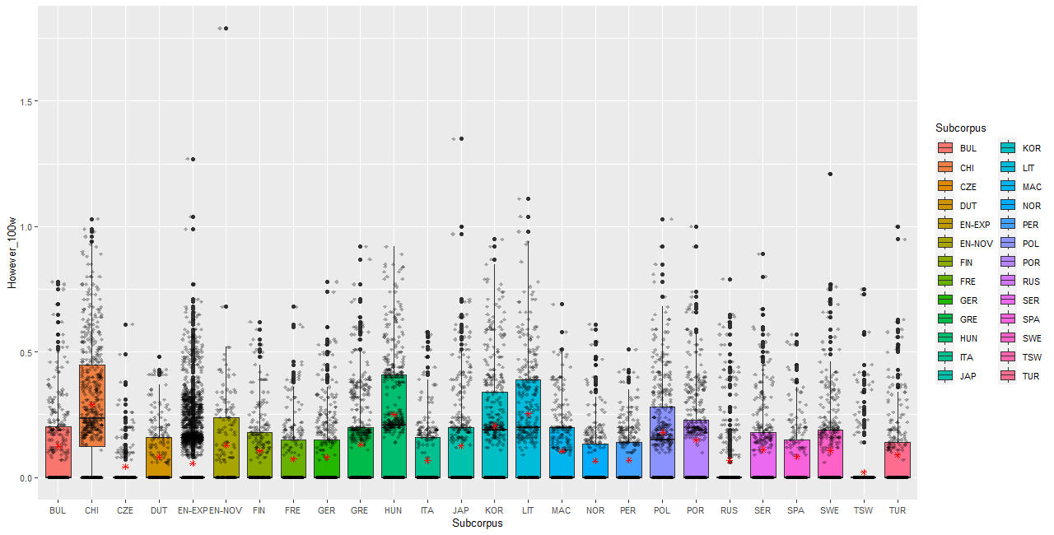
Figure 1. Frequency of however per text across subcorpora (/100 words)

The proportions of use of however in each of the five positions per corpus are displayed in Figure 2. Already at this very descriptive stage, the data seem to point clearly to a divide between novice and expert uses of however: while novice writers – whether or not they have English as their mother tongue – tend by a large majority (c. 80%) to place however in thematic 1 position, as in (4) and (5), expert writers’ preferred position for however is rhematic 1 (i.e. between the topical theme and the verb), used in roughly 50% of the cases, as in (6). The thematic 1 position is also common in Mult-Ed, but it only accounts for about a third of the occurrences.
- However, I do not think money is only important thing when getting a job. (ICLE-KOR)
- However, "the right of the people to keep and bear arms" has not been interpreted to mean any type of firearm. (LOCNESS)
- Putin, however, operates in a different moral zone. (Mult-Ed)
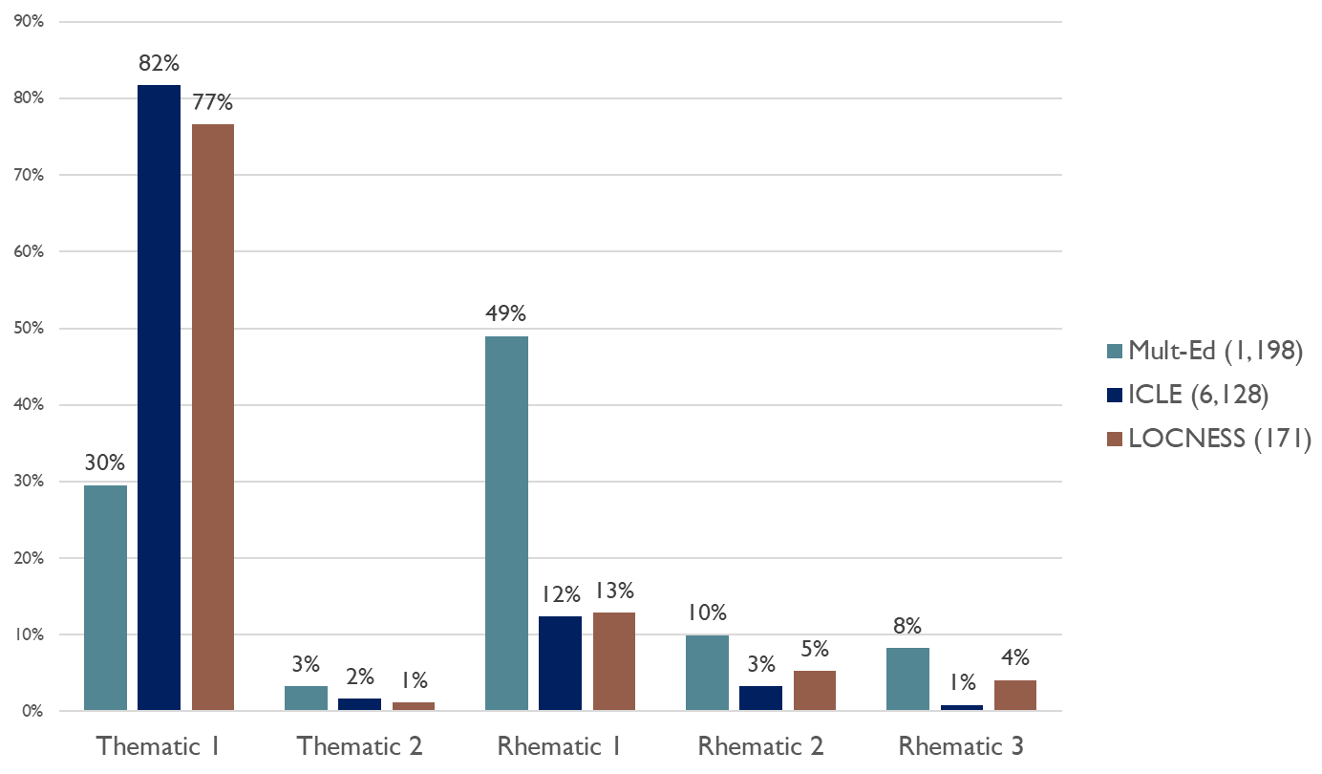
Figure 2. Breakdown of the five positions of however in Mult-Ed, ICLE and LOCNESS
The statistical significance of this preliminary result was established by applying a binomial logistic regression to the data. A binomial logistic regression aims to predict which of two categories is likely to occur in a certain context, based on a given dataset. As binomial logistic regressions only allow for two levels in the dependent variable, the thematic 2 and all the rhematic positions were grouped into a single level, against the thematic 1 category. This was justified by the fact that, while thematic 1 connectors tend to play a strictly linking role, all the other positions induce one or more rhetorical effects in addition to linking (see below for a discussion). This means that, for a given level of expertise or L1, the regression tells us whether however is more likely to occur in thematic 1 position or in another position.
More precisely, two regression models were applied to the data. The first model was run on the entire dataset, to assess the effect of expertise on connector placement, thus answering the first research question. By contrast, the second model was run on the novice data only (i.e. ICLE and LOCNESS) and was intended to clarify the influence of the writer’s mother tongue (L1) on the position of however, in relation to our second research question.
Model 1, which compares expert writers with novice writers – whatever their mother tongue – is represented graphically in Figure 3 (see Appendix 1 for the full model output). Nagelkerke’s pseudo R2 for this model is 0.2210252, which means that expertise accounts for about 22% of the variation in the positioning of however. As appears very clearly from Figure 3, and in line with the preliminary conclusions drawn from the proportions of use of each position in the three corpora (cf. Figure 2), expert writers are far less likely than novice writers to use however in thematic 1 position. The difference is statistically significant.
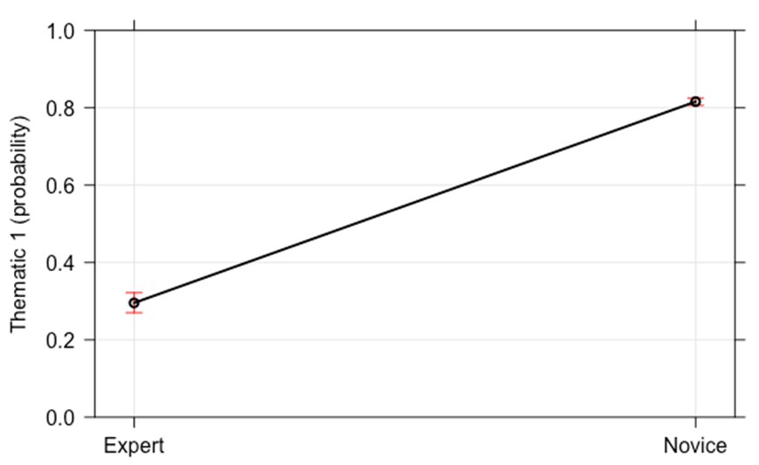
Figure 3. Regression model 1: the impact of expertise on the placement of however
The second regression model, which assesses the effect of the writer’s L1 on the placement of however in the novice data, returned a Nagelkerke’s pseudo R2 of 0.2044767, meaning that L1 explains about 20% of variation in the placement of however in this dataset (see Appendix 1 for the full model output). Figure 4 represents the predicted probability of the thematic 1 position across L1s. As can be seen from the graph, apart from the L1 Dutch and German students, who are predicted to be equally likely to select thematic 1 as one of the other positions, all the novice writers – including those with English as their mother tongue – are predicted to be (far) more likely to use the thematic 1 position than the other positions. However, the graph also reveals clear – and statistically significant – differences between L1s, with some L1 populations (e.g. Turkish, Spanish, Lithuanian, Portuguese) displaying close to a 100% probability of using however in thematic 1 position, while others have a comparatively lower probability of choosing thematic 1 – notably Dutch and German, but also Bulgarian and Swedish. The graph also clearly shows that novice L1 English writers do not differ significantly from a wide range of other novice populations. In other words, native-speaker status does not appear to be a significant factor when it comes to the placement of however. This is in line with previous research on the influence of nativeness, notably by Römer (2009) .

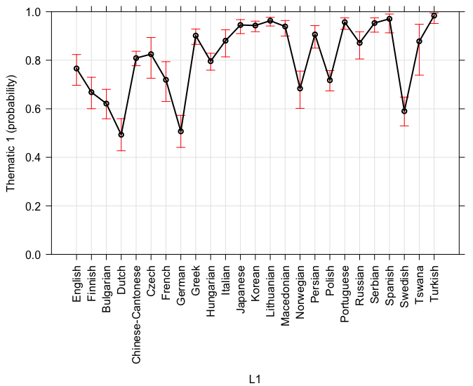
Figure 4. Regression model 2: the impact of L1 on the placement of however
In summary, while the results reveal clear differences between L1 populations, they show no clear effect of ‘nativeness’, as writers with English as their L1 did not stand out from other L1 backgrounds. These results diverge from a number of previous studies, which have consistently pointed to overuse of initial connectors in L2 English writing as compared to L1 English student essays (cf. Granger & Tyson, 1996 for French-speaking learners; Field & Yip, 1992; Leedham & Cai, 2013 for Chinese; Altenberg & Tapper, 1998 for Swedish; Narita & Sugiura, 2006 for Japanese; Ha, 2014 for Korean). Given that lexis has been demonstrated to significantly influence connector placement (e.g. Dupont, 2021; Harthan, 2022), the focus of the present study on however may explain this divergence from previous research, as most other studies examined a larger set of lexical items. In addition, a number of studies on connector placement in learner writing were carried out in the early days of learner corpus research, when thorough quantitative techniques and statistical methods were scarcely used.
In contrast to nativeness, expertise emerges as a key variable in relation to the placement of however: whereas novice writers display a marked preference for the thematic 1 position, more flexible placement patterns of however appear to be a sign of expert writing. In fact, it may well be that the significant differences in placement preferences between L2 populations are related to their proficiency level. For each learner population in the ICLE corpus, a sample of 20 essays has been rated for proficiency on the basis of the Common European Framework of Reference for Languages (see Granger et al., 2020: 11-12). In our dataset, the L2 populations which display more flexibility in the placement of however tend to score higher on the CEFR scale (e.g. Dutch, German, Bulgarian, Swedish). On the other hand, the Japanese, Korean, Spanish and Turkish learner groups, who use however in thematic 1 in almost 100% of cases, tend to display lower CEFR scores. This, along with the strong effect of expertise uncovered in Model 1, is in line with Lenker’s (2014: 33) assertion that medial placement of connectors “marks the style of ‘good writers’”.
It must be noted, however, that other possible factors may come into play. These include L1 transfer and the influence of teaching methods. In the case of Chinese, for instance, Leedham & Cai (2013) suggest that there is overuse of initial connectors in English language textbooks in China. Teaching may also partly explain the patterns found in the texts of L1 English novice writers, which display a rather strong tendency to use connectors sentence-initially, as compared with both the experts and the more proficient L2 populations. In this respect, Leńko-Szymańska (2008: 96) claims that L2 writers, especially at upper-intermediate and advanced levels, benefit from more explicit training in writing than L1 English students – including on how to use connectors. She argues that “[a]s a consequence, EFL learners at the very advanced levels can often be more skillful in writing than native students”.

Discourse implications of the placement of however
It may seem fair to ask whether diverging placement choices matter, insofar as they do not generally affect the grammatical accuracy of the sentences. Examples (7) to (10) are equally accurate, despite different placement choices for however. From a discourse point of view, however, the various placement options are far from equivalent. Previous research has shown that, while thematic 1 connectors as in (7) tend to perform a strictly linking function, “without singling out any element(s) on the sentence level for special emphasis” (Harthan 2022: 155), connectors used medially usually produce a range of rhetorical effects alongside their linking function (Lenker, 2014; Dupont, 2021; Harthan, 2022). For example, in (8), thematic 2 however does not only express a contrast between two sentences: by isolating the fronted stance marker from the rest of the sentence, it also emphasizes the attitude of the writer towards their message, stressing the special importance of the coming argument.
- In the world today many countries have an army that consists entirely of professional soldiers. However, here in Norway we have a system of military service where all Norwegian men must commend themselves to the army for a period of at least nine months. (ICLE-NOR)
- Through studying humanities, we learn about the past, and are thus able to understand the present. […] Studying humanities is also learning about and accepting other cultures. […] Most importantly, however, studies in humanoria will, as the name suggests, make us more human. (ICLE-SWE)
- American policymakers seem happy to let the dollar slide. Europeans, however, complain that the burden of adjustment has fallen disproportionately on their currency, the euro. (Mult-Ed)

- The key points of the reform are: one, that tuition fees will no longer be paid up-front, but paid back after graduation instead; and, two, that universities will be allowed to charge extra fees of up to £3,000 a year. The first part is not controversial. Up-front tuition fees are unpopular among the better-off 60 per cent of parents who have to pay them […]. Getting rid of them […] will cost about £400m a year, but that is a gap that can be bridged […] The second part of the deal, however, is controversial. (Mult-Ed).
Whether in the novice or the expert data, the most commonly used medial position is rhematic 1. For this reason, and because of the key rhetorical functions that it may fulfil, the rest of this section will focus on this slot. Rhematic 1 connectors tend to have two main, interrelated functions. On the one hand, they often “focus attention on the element(s) preceding the adverbial, often signaling a contrastive frame-setting adverbial or topic and, by implication, contrastive focus” (Harthan, 2022: 89). In (9), for example, however placed in rhematic 1 position emphasizes the contrast between the way American and European policymakers feel about the state of the dollar. Another feature of rhematic 1 connectors is that they “typically occur when the writer is breaking the thematic continuity of the text, by moving on from the discussion of one topical element to that of another” (Dupont, 2021: 338), thus emphasizing a topic shift in discourse. In (10), for instance, however is used rhematically to stress the fact that the writer is taking the discussion from the first to the second part of the deal.
In other words, connector placement choices emerge as an important rhetorical strategy for writers. Among other functions, connectors used medially help to highlight parts of a message or reinforce such argumentative moves as contrast, topic shift or stance marking – all of which prove particularly useful when writing argumentative texts (see Dupont, 2021: 356-62). Thus, while issues of connector placement may be less relevant for beginners and lower-intermediate learners, they are undoubtedly worthy of attention in more advanced curricula.
This is especially true as the data reveal that, when used by novice writers, rhematic 1 however is not always used appropriately. Alongside felicitous uses such as (11) and (12), we found inappropriate uses of this position. In (13) and (14), for example, however is used after a personal pronoun. However, while rhematic 1 connectors often highlight a topic shift, personal pronouns typically indicate topic continuity. Indeed, Harthan (2022) reports that personal pronouns are hardly ever used before rhematic 1 connectors in academic English. We found no such instances in our expert or L1 English novice corpora either, whereas there were several examples in ICLE. In these cases, thematic 1 would have been more appropriate: there is no reason to highlight a break in topic continuity by means of a rhematic 1 connector, as the topic is the same. Therefore, in addition to drawing novice writers’ attention to the possibility and the functions of positions other than thematic 1, it is important to give them clear guidance on the specific contexts in which such positions are appropriate.
- In The Netherlands chemical waste produced by photographers can be collected and processed. In many other countries, however, this is not the case. (ICLE_DUT)

- At first sight the opportunities offered in modern society appear to cover a very wide range of interests. After further reflexion, however, one might wonder how genuine these choices are. (ICLE_SWE)
- So I decided to go cycling in order to train my muscles, to get rid of the tiredness. But the minute I made the first step out of the door the heat seemed to knock me down. I, however, forced myself to fetch my bike and not to become weak and go back into my flat again. (ICLE_GER)
- Not only they were not alarmed by the death of the mountaineer Alison Hargreaves while trying to reach the top of K2, but they encourage women to undertake sport activities even if they have children because it does not mean that they are irresponsible if they practise leisure activities. They, however, admit that the death of A Hargreaves touch every woman and force them to reflect about their responsibility towards family. (ICLE_ITA)
One other inappropriate use of however that is worth briefly mentioning here is the inappropriate use of punctuation. The analysis brought out two particularly frequent types of punctuation error in the dataset. Firstly, we found a number of examples in which the commas before and/or after however were missing, as in (15) and (16). Yet according to Celce-Murcia & Larsen-Freeman (2016: 549), “[w]hen two clauses are connected by a linking adverb […], a comma is used after the linking adverb”. In addition, when connectors are used medially, “they are marked with commas both before and after” (ibid.: 550). A second common mistake in the dataset pertained to comma splices, also known as run-on sentences, as in (17) and (18). As stated in Celce-Murcia & Larsen-Freeman (2016: 549), “[c]lauses connected by linking adverbs cannot be separated with only a comma. This common writing error is known as a comma splice or sometimes a run-on sentence”. Rather, sentences connected by means of a connector need to be separated by a full stop or a semicolon. Interestingly, these two forms of incorrect punctuation appeared with roughly equivalent frequencies in the ICLE and the LOCNESS data (11% and 11.5%, respectively, for missing commas; 6% and 7.5% for run-on sentences). Such mistakes were comparatively rare in the expert corpus: we found no occurrences of however used in a run-on sentence, while less than 2% of the instances of however were missing a comma, as in (19). Thus, alongside the comparisons of the frequency and preferred positions of however, these results once again point to the influence of expertise on the use of discourse connectors in academic writing.
- However degree levels in vocational subjects, such as art and design, engineering, business studies, and hotel and catering, do not have a future. (ICLE-BUL)
- The 1980's however saw an enormous turnaround on the views on marijuana. (LOCNESS)
- Online shopping has its pros and cons, however, I believe that the demerits far outweigh the merits. (ICLE-KOR)
- Tables and charts do not make an essay that is exciting to read, however, they do help to clarify the text. (LOCNESS)
- Laws that needlessly smother innovation and initiative are the last thing Europe needs. However the growing evidence of links between chemicals and diseases means commercial activity will have to be balanced with the savings on health care that well-crafted regulation can bring about. (Mult-Ed)

Conclusion

The frequency of use of connectors by L2 learners has been widely investigated. This line of research is helpful and worth pursuing as it reveals which connectors are used too little, too much or not at all, thereby contributing to expanding learners’ repertoires. However, it is equally – if not more – important to know how connectors are used, and this aspect has been neglected in both research and teaching.
The present study focused on one key aspect of use, namely positioning, of the highly frequent connector however. The results show that expert writers prefer flexible positioning of however, whereas novice writers (regardless of L1) tend to prefer the Thematic 1 position and thereby fail to exploit the full rhetorical potential of the connector. One particularly important result of our study is that L1 English novice writers are not significantly different from novice writers from other L1s. This finding is clearly in line with Römer’s (2009: 99) observation that “when we deal with advanced-level academic writing, we actually move beyond the native/non-native distinction and that, in this context, experience or expertise is a more important aspect to consider than nativeness”. The fact that novice writers, irrespective of their L1, differ significantly from expert writers shows that writing expertise, rather than nativeness, is the key determinant when it comes to connector positioning. The learners’ L1 does have an impact, however, as some of the ICLE populations display more flexibility in connector placement than others. This may be a sign of a higher level of proficiency, but at this stage this remains a hypothesis which needs to be confirmed on the basis of a fully proficiency-rated learner corpus. In addition, it should be borne in mind that nativeness remains a key factor for a wide range of non-specifically academic phenomena, particularly morphological, grammatical and phraseological ones (Gilquin, Granger & Paquot, 2007). Our study also shows that simply giving the percentage of use in the various positions is not enough. It is essential to explore the rhetorical effects of each position so as to ensure appropriate use in context.
Our study is limited to one connector in one specific genre. In future research, it would be useful to investigate the placement of other connectors, in particular the most mobile ones such as on the other hand or by contrast. Another avenue to explore is connector placement in a wider range of texts, as connector use has been found to vary significantly across registers, genres and disciplines (Alazani, 2024; Han & Gardner, 2021; Liu, 2008). The possible impact of L1 transfer also emerges as a promising research avenue, along similar lines as Larsson et al.’s (2020) study on the placement of stance adverbs in EFL academic writing. Yet another, particularly important, research direction is that of the teaching of connectors. Cresswell (2007: 280) investigates the effect of data-driven learning (DDL) on the learners’ use of connectors and concludes that “the knowledge of variable positioning is best obtained procedurally, through reading and writing of entire texts”. We feel, however, that more experimental studies of this type are needed before truly conclusive statements can be made. In our view, mere exposure is not enough. Reading and writing must be coupled with focused consciousness-raising activities, as position flexibility and the discourse effects it generates will not simply be picked up by (all) students. This is all the more necessary as the description of connectors in EAP textbooks is rather poor, as shown by Walkova’s (2020) evaluation of 39 published EAP textbooks. In particular, as shown by Leedham & Cai’s (2013) study of the influence of teaching materials on Chinese students’ use of connectors, teaching resources tend to foreground initial positioning, which is bound to influence learner use.

References

Alanazi, Z. (2024). An exploratory analysis of linking adverbials in research articles across different disciplines. Theory and Practice in Language Studies, 14(4), 1181-1192.
Alonso Belmonte, I. (2007). Newspaper editorials and comment articles: a ‘cinderella’ genre? RAEL: revista electrónica de lingüística aplicada, (1), 1–9.
Altenberg, B., & Tapper, M. (1998). The use of adverbial connectors in advanced Swedish learner’s written English. In S. Granger (Ed.), Learner English on computer (pp. 80–93). Addison Wesley Longman.
Biber, D., Johansson, S., Leech, G., Conrad, S., & Finegan, E. (1999). Longman Grammar of Spoken and Written English. Longman.
Celce-Murcia, M., & Larsen-Freeman, D. (2016). The Grammar Book: An ESL/EFL Teacher’s Course (3rd ed.). Heinle & Heinle.
Chen, C. (2006). The use of conjunctive adverbials in the academic papers of advanced Taiwanese EFL learners. International Journal of Corpus Linguistics, 11(1), 113-130. https://doi.org/10.1075/ijcl.11.1.05che
Cresswell, A. (2007). Getting to “know” connectors? Evaluating data-driven learning in a writing skills course. In E. Hidalgo, L. Quereda, & J. Santana (Eds.), Corpora in the Foreign Language Classroom (pp. 267-287). Rodopi. https://doi.org/10.1163/9789401203906_018
Dupont, M. (2021). Conjunctive Markers of Contrast in English and French. John Benjamins. https://doi.org/10.1075/scl.99
Field, Y., & Yip, L. (1992). A Comparison of Internal Conjunctive Cohesion in the English Essay Writing of Cantonese Speakers and Native Speakers of English. RELC Journal, 23(1), 15–28. https://doi.org/10.1177/003368829202300102
Fries, P. (1994). On Theme, Rheme and discourse goals. In M. Coulthard (Ed.), Advances in Written Text Analysis (pp. 229–249). Routledge.
Gilquin, G., Granger, S., & Paquot, M. (2007). Learner corpora: the missing link in EAP pedagogy. In P. Thompson (Ed.), Corpus-based EAP Pedagogy. Special issue of Journal of English for Specific Purposes, 6(4), 319–335. https://doi.org/10.1016/j.jeap.2007.09.007
Granger, S., Dupont, M., Meunier, F., Naets, H., & Paquot, M. (2020). The International Corpus of Learner English. Version 3. Presses Universitaires de Louvain. https://doi.org/10.1017/CBO9781139649414
Granger, S., Gilquin, G., & Meunier, F. (Eds.). (2015). The Cambridge Handbook of Learner Corpus Research. Cambridge University Press. https://doi.org/10.1017/CBO9781139649414
Granger, S., & Tyson, S. (1996). Connector usage in the English essay writing of native and non-native EFL speakers of English. World Englishes,15(1), 17–27. https://doi.org/10.1111/j.1467-971X.1996.tb00089.x
Güneş, H. (2017). A corpus-based study of linking adverbials through contrastive analysis of L1/L2 PhD dissertations. International Journal of Curriculum and Instruction, 9(2), 21-38.
Ha, M. (2014). A Corpus-Based Study on Korean EFL Learners’ Use of English Logical Connectors. International Journal of Contents, 10(4), 48–52. https://doi.org/10.5392/IJoC.2014.10.4.048
Halliday, M. A. K., & Matthiessen, C. (2014). Halliday’s Introduction to Functional Grammar (4th ed.). Routledge. https://doi.org/10.4324/9780203431269
Han, C., & Gardner, S. (2021). However and other transitions in the Han CH-EN corpus. Journal of English for Academic Purposes, 51. https://doi.org/10.1016/j.jeap.2021.100984
Harthan, C. (2022). Medially-Placed Linking Adverbials in Written Academic English. Peter Lang. https://doi.org/10.3726/b19655
Larsson, T. (2019). A syntactic analysis of the introductory it-pattern in non-native-speaker and native speaker student writing. In V. Wiegand, & M. Mahlberg (Eds.), Corpus Linguistics, Context and Culture (pp. 307–338). De Gruyter. https://doi.org/10.1515/9783110489071-012
Larsson, T., Callies, M., Hasselgård, H., Laso, N. J., Van Vuuren, S., Verdaguer, I., & Paquot, M. (2020). Adverb placement in EFL academic writing: Going beyond syntactic transfer. International Journal of Corpus Linguistics, 25(2), 156-185. https://doi.org/10.1075/ijcl.19131.lar
Leedham, M., & Cai, G. (2013). Besides … on the other hand: using a corpus approach to explore the influence of teaching materials on Chinese students’ use of linking adverbials. Journal of Second Language Writing, 22(4), 374-389. https://doi.org/10.1016/j.jslw.2013.07.002
Lei, L. (2012). Linking adverbials in academic writing on applied linguistics by Chinese doctoral students. Journal of English for Academic Purposes, 11(3), 267-275. https://doi.org/10.1016/j.jeap.2012.05.003
Lenker, U. (2014). Knitting and splitting information: Medial placement of linking adverbials in the history of English. In S. E. Pfenninger, O. Timofeeva, A.-C. Gardner, A. Honkapohja, M. Hundt, & D. Schreier (Eds.), Contact, Variation, and Change in the History of English (pp. 11-38). John Benjamins. https://doi.org/10.1075/slcs.159.02len
Leńko-Szymańska, A. (2008). Non-native or non-expert? The use of connectors in native and foreign language learners’ texts. Acquisition et interaction en langue étrangère, 27, 91–108. https://doi.org/10.4000/aile.4213
Liu, D. (2008). Linking adverbials: An across-register corpus study and its implications. International Journal of Corpus Linguistics, 13(4), 491-518. https://doi.org/10.1075/ijcl.13.4.05liu
Marti, L., Yilmaz, S., & Bayyurt, Y. (2019). Reporting research in applied linguistics: The role of nativeness and expertise. Journal of English for Academic Purposes, 40, 98-114. https://doi.org/10.1016/j.jeap.2019.05.005
Milton, J., & Shuk-Ching Tsang, E. (1993). A corpus-based study of logical connectors in EFL students' writing: Directions for future research. In R. Pemberton, & E. Shuk-Ching Tsang (Eds.), Studies in Lexis. Working Papers from a Seminar (pp. 215-246). The Hong Kong University of Science and Technology Language Centre.
Narita, M., & Sugiura, M. (2006). The use of adverbial connectors in argumentative essays by Japanese EFL college students. English Corpus Studies, 13, 23-42.
Neff, J., Ballesteros, F., Dafouz, E., Martinez, F., Rica-Peromingo, J.-P., Díez, M., & Prieto, R. (2004). Formulating writer stance: A contrastive study of EFL learner corpora. In U. Connor & T. Upton (Eds.), Applied Corpus Linguistics: A Multidimensional Perspective (pp. 73-89). Brill. https://doi.org/10.1163/9789004333772_006
R Core Team. (2021). R: A language and environment for statistical computing [Computer software]. https://www.R-project.org/
Römer, U. (2009). English in academia: does nativeness matter? Anglistik: International Journal of English Studies, 20(2), 89–100.
Rørvik, S., & Egan, T. (2013). Connectors in the argumentative writing of Norwegian novice writers. In S. Granger, G. Gilquin, & F. Meunier (Eds.), Twenty Years of Learner Corpus Research: Looking back, Moving ahead (pp. 401-410). Presses universitaires de Louvain.
Scott, M. (2012). WordSmith Tools 6 [Computer software]. https://lexically.net/wordsmith/version6/
Shin, Y. K. (2019). Do native writers always have a head start over nonnative writers? The use of lexical bundles in college students’ essays. Journal of English for Academic Purposes, 40, 1–14. https://doi.org/10.1016/j.jeap.2019.04.004
Staples, S., & Reppen, R. (2016). Understanding first-year L2 writing: A lexico-grammatical analysis across L1s, genres, and language ratings. Journal of Second Language Writing, 32, 17-35. https://doi.org/10.1016/j.jslw.2016.02.002
Van Vuuren, S., & Berns, J. (2018). Same difference? L1 influence in the use of initial adverbials in English novice writing. International Review of Applied Linguistics in Language Teaching, 56(4), 427–461. https://doi.org/10.1515/iral-2016-0077
Walková, M. (2020). Transition markers in EAP textbooks. Journal of English for Academic Purposes, 46, 100874. https://doi.org/10.1016/j.jeap.2020.100874

Appendix 1
Model 1: noviceness vs expertise

Call:
glm(formula = POSITION ~ EXPERTISE, family = binomial)

Deviance Residuals:
Min 1Q Median 3Q Max
-1.8400 -0.8370 0.6377 0.6377 1.5615

Coefficients:
Estimate Std. Error z value Pr(>|z|)
(Intercept) -0.86886 0.06332 -13.72 <2e-16 ***
EXPERTISENovice 2.35835 0.07118 33.13 <2e-16 ***
---
Signif. codes: 0 ‘***’ 0.001 ‘**’ 0.01 ‘*’ 0.05 ‘.’ 0.1 ‘ ’ 1

(Dispersion parameter for binomial family taken to be 1)

Null deviance: 8702.9 on 7496 degrees of freedom
Residual deviance: 7468.7 on 7495 degrees of freedom
AIC: 7472.7

Number of Fisher Scoring iterations: 4

Nagelkerke’s Pseudo R²: 0.2210252

Confidence intervals
2.5 % 97.5 %
(Intercept) -0.994059 -0.7457564
EXPERTISENovice 2.219725 2.4988210

Model 2: L1 effects
Call:
glm(formula = POSITION ~ L1, family =

Deviance Residuals:
Min 1Q Median 3Q Max
-2.873 0.275 0.3544 0.6753 1.1892

Coefficients:
Estimate Std. Error z value Pr(>|z|)
(Intercept) 1.1863 0.1806 6.567 5.13E-11 ***
L1Finnish -0.4857 0.2344 -2.072 0.038282 *
L1Bulgarian -0.6908 0.2239 -3.086 0.002031 **
L1Dutch -1.214 0.226 -5.372 7.79E-08 ***
L1Chinese-Cantonese 0.2565 0.2055 1.248 0.211915
L1Czech 0.3643 0.3453 1.055 0.291404
L1French -0.2453 0.2758 -0.889 0.373755
L1German -1.1587 0.226 -5.127 2.94E-07 ***
L1Greek 1.0271 0.2555 4.021 5.80E-05 ***
L1Hungarian 0.1759 0.2112 0.833 0.404933
L1Italian 0.8118 0.3219 2.522 0.01167 *
L1Japanese 1.6636 0.3289 5.058 4.25E-07 ***
L1Korean 1.6217 0.271 5.985 2.16E-09 ***
L1Lithuanian 2.0695 0.3061 6.76 1.38E-11 ***
L1Macedonian 1.5499 0.3297 4.701 2.59E-06 ***
L1Norwegian -0.4166 0.2567 -1.623 0.104564
L1Persian 1.0824 0.3259 3.321 0.000896 ***
L1Polish -0.254 0.2095 -1.213 0.225214
L1Portuguese 1.9152 0.3362 5.697 1.22E-08 ***
L1Russian 0.7273 0.3105 2.343 0.019142 *
L1Serbian 1.8341 0.3708 4.946 7.58E-07 ***
L1Spanish 2.3102 0.6132 3.767 0.000165 ***
L1Swedish -0.8222 0.2202 -3.734 0.000188 ***
L1Tswana 0.7878 0.5103 1.544 0.122659
L1Turkish 2.9246 0.6093 4.8 1.59E-06 ***
---
Signif. codes: 0 ‘***’ 0.001 ‘**’ 0.01

(Dispersion parameter for binomial family taken to

Null deviance: 6014.3 on 6298 degrees
Residual deviance: 5167.6 on 6274 degrees of
AIC: 5217.6

Number of Fisher Scoring iterations: 6

> PseudoR2(x2, c("Nagelkerke"))
Nagelkerke
0.2044767
> confint(x2)
2.50% 97.50%
(Intercept) 0.8424046 1.55255783
L1Finnish -0.9508054 -0.03002906
L1Bulgarian -1.1367851 -0.25753877
L1Dutch -1.6648345 -0.77751706
L1Chinese-Cantonese -0.154914 0.65231301
L1Czech -0.2932578 1.06878556
L1French -0.7851449 0.298947
L1German -1.6094215 -0.72208873
L1Greek 0.5277141 1.53219502
L1Hungarian -0.2458991 0.5837117
L1Italian 0.1977185 1.46674578
L1Japanese 1.041423 2.33981663
L1Korean 1.0965316 2.1628114
L1Lithuanian 1.4858997 2.69301125
L1Macedonian 0.9261532 2.2274746
L1Norwegian -0.9223671 0.08596674
L1Persian 0.4630192 1.74847784
L1Polish -0.6729475 0.14984971
L1Portuguese 1.2818468 2.60971355
L1Russian 0.1322405 1.35541019
L1Serbian 1.1444992 2.61268365
L1Spanish 1.2603596 3.74921767
L1Swedish -1.2614411 -0.3968201
L1Tswana -0.1347132 1.90571722
L1Turkish 1.8845928 4.35847173

Authors’ contact details
Maïté Dupont
maite.dupont@uclouvain.be
Institut des Langues Vivantes
Traverse d’Esope 1
B-1348 Louvain-la-Neuve
Belgium

Sylviane Granger
sylviane.granger@uclouvain.be
Centre for English Corpus Linguistics (CECL)
Université catholique de Louvain
Place Cardinal Mercier 31
B-1348 Louvain-la-Neuve
Belgium

https://uclouvain.be/en/research-institutes/ilc/cecl/locness.html (last accessed 30/10/24).
The difference in average length between the texts included in LOCNESS and ICLE could arguably have an influence on the frequency of connectors. However, the main focus of the paper is on position rather than frequency.
https://uclouvain.be/en/research-institutes/ilc/cecl/mult-ed.html (last accessed 30/10/24).
A T-Unit is defined as “an independent clause together with all hypotactically related clauses which are dependent on it” (Fries 1994: 229).
Given the very limited number of instances in some of our categories (e.g. thematic 2, rhematic 3), it was undesirable to use a statistical method that could have predicted all five positions in our taxonomy (such as a multinomial logistic regression or a random forest regression).
Both models were tested for over- and underdispersion. The scores obtained were 1.000267 for Model 1 and 1.00399 for Model 2, which shows that there is no dispersion problem with either model.

