Vagus Nerve Stimulation elicits sleep EEG desynchronization and network changes in responder patients in epilepsy

Simone Vespa*ª, Jolan Heyse†, Lars Stumpp*, Giulia Liberati*, Susana Ferrao Santos*,‡, Herbert Rooijakkers ‡, Antoine Nonclercq §, André Mouraux*, Pieter van Mierlo†, Riëm El Tahry*,‡

*Institute of Neuroscience (IONS), Université Catholique de Louvain, Brussels, Belgium
†Medical Image and Signal Processing Group (MEDISIP), Ghent University, Ghent, Belgium
‡Centre for Refractory Epilepsy, Department of Neurology, Cliniques Universitaires Saint-Luc, Brussels, Belgium
§Bio, Electro and Mechanical Systems (BEAMS), Université Libre de Bruxelles, Brussels, Belgium

Original research

ªCorresponding author: Simone Vespa
E-mail: simone.vespa@uclouvain.be
Address: Avenue Mounier 53 - 1200 Bruxelles, Belgium
Telephone number: +32490390337

Running title: EEG and network changes induced by acute VNS

Key Words: Vagus nerve stimulation, functional connectivity, graph analysis, biomarkers, electroencephalography

Number of words: 233 (abstract), 4060 (main body)
Number of tables: 3
Number of figures: 10

ABSTRACT

Neural desynchronization is a key mechanism of Vagus Nerve Stimulation (VNS) action in epilepsy, and EEG synchronization measures are explored as possible response biomarkers. Since brain functional organization in sleep shows different synchrony and network properties compared to wakefulness, we aimed to explore the effects of acute VNS on EEG-derived measures in the two different states of vigilance. EEG epochs were retrospectively analyzed from twenty-four VNS-treated epileptic patients (11 responders, 13 non-responders) in calm wakefulness and stage N2 sleep. Weighted Phase Lag Index (wPLI) was computed as connectivity measure of synchronization, for VNS OFF and VNS ON conditions. Global Efficiency (GE) was computed as a network measure of integration. Ratios OFF/ON were obtained as desynchronization/de-integration index. Values were compared between responders and non-responders, and between EEG states. ROC curves and area-under-the-curve (AUC) analysis was performed for response classification. In responders, stronger VNS-induced theta desynchronization (p<0.05) and decreased GE (p<0.05) were found in sleep, but not in wakefulness. Theta sleep wPLI Ratio OFF/ON yielded an AUC of 0.825, and 79% accuracy as response biomarker, with a cut-off of 1.05. Considering all patients, the VNS-induced GE decrease was significantly more important in sleep compared to awake EEG (p<0.01). In conclusion, stronger sleep EEG desynchronization in theta band distinguishes responders to VNS therapy from non-responders. VNS-induced reduction of network integration occurs significantly more in sleep than in wakefulness.

- INTRODUCTION

Vagus Nerve Stimulation (VNS) has been effectively used for more than thirty years as adjunctive therapy in epileptic patients who are not suitable candidates or failed resective surgery. Responder rate (i.e. >50% seizure frequency reduction) increases over time, particularly within 1 to 2 years of treatment, in relationship with the presumed VNS long-term neuroplastic effects ¹. VNS also exerts an acute antiepileptic action, reflected in the beneficial effects of on-demand VNS activation, such as reduced seizure duration and severity ^{2,3}. Neural desynchronization is one of the main presumed mechanisms of the antiepileptic effects of VNS, as shown by pioneering animal studies ^{4,5}, and later witnessed by human electroencephalography (EEG) connectivity studies ^{6,7}.
Functional connectivity and network theory have been increasingly used to characterize the brain functional abnormalities of epileptic patients ^{8–10}. Neural electricity in epilepsy is characterized by elevated levels of synchronization, sign of the tendency of epileptic brain to hyper-connect in aberrant excitatory circuits ^{11–14}. Alsos, the network Global Efficiency (GE), which is a measure of the predisposition to integrate specialized information from distributed brain regions ¹⁵, was recently found to mirror the pathological epileptic network organization ¹⁶. GE proved to distinguish healthy controls from epileptic patients, who showed a significantly elevated GE in resting-state EEG. ¹⁷.
In this perspective, VNS has been proposed to act as a network therapy, which modulates brain synchrony towards a less epileptogenic state, through the so-called vagal afferent network ^{18–20}. Graph measures related to this brain network were successfully applied to define pre-operative predictors of VNS efficacy, such as network modularity and transitivity ^{21,22}. However, thus far, no biomarkers of VNS response have been found using EEG synchronization or network measures, which might be able to distinguish the therapeutic effects occurring in responders compared to non-responders.
To the best of our knowledge, it also remains unresolved whether VNS-induced neuromodulation varies depending on the state of vigilance and, consequently, depending on the background condition of neural synchronization. Patterns of higher cortical synchronization characterize NREM sleep compared to wakefulness and to REM sleep ^{23–25}. A link exists between the higher levels of brain synchronization that can be found in NREM sleep and the tendency to generate interictal epileptiform discharges and seizures, particularly in N2 sleep ^{26,27}. Indeed, common neural oscillation patterns have been described between epilepsy and NREM sleep, such as the thalamocortical relay circuits that characterize the generation of sleep spindles but also spike-wave and ictal discharges in both generalized and focal epilepsies ^{28–31}.
On these grounds, we explored VNS-induced effects on EEG during sleep and wakefulness, hypothesizing that a stronger influence might be found in sleep, where closer resemblances with the hyper-synchrony of epileptic circuitry are seen. To this end we analyzed, and compared between responders and non-responders, the acute VNS-induced changes on: i) EEG band-power, ii) functional connectivity measures of EEG synchronization and iii) network GE.

- MATERIALS AND METHODS

  - Study population
The Epilepsy Unit database of St. Luc University Hospital, Brussels, Belgium, was retrospectively searched for consecutive adult patients who: (1) received a cervical VNS implant (LivaNova, London, UK) between 2008 and 2019; (2) after VNS implant, underwent a video-EEG monitoring (at least 24 hours) with concomitant electrocardiogram (ECG); (3) had active VNS system during the video-EEG monitoring. Patients were classified as responders (R) if showing ≥50% seizure frequency reduction as compared to pre-implant condition, and as non-responders (NR) if <50% reduction, based on clinical records assessment at the moment of the EEG recordings (according to seizure diaries provided by patients or to guided anamnesis). Local Ethics Committee approval was granted (protocol 2018/07NOV/416). Clinical and medication characteristics of each patient were categorized for group-level analyses (see Supplementary Data).

  - EEG recordings and epoch selection
(Video-)EEG recordings were performed either at Saint-Luc University Hospital or at William Lennox Centre, Ottignies, Belgium, with Deltamed® system (Natus Europe, Paris, France). Signals were digitized at a sampling rate of 256 Hz. The 19 scalp electrodes of 10-20 system placement were considered for analysis. Additional ECG (Eindhoven lead I-II) and EMG deltoid recordings were available. Due to the anatomical proximity with the pulse generator, ECG traces enable the detection of stimulation artefacts produced by VNS trains, indicating the VNS ON periods ³. ECG derivations were visually screened to distinguish VNS ON and VNS OFF recording segments. If no clear distinction could be verified (e.g. due to poor quality of ECG recordings), the patient was excluded from analysis.
EEG processing was carried out in MATLAB R2018a (Mathworks, Natick, US), using both in-house scripts and the Letswave 6 toolbox (UCLouvain, Brussels, Belgium). For each patient, EEG traces were reviewed ensuring that no seizures nor ongoing status epilepticus occurred in the hour preceding the recordings, which might – as themselves or due to postictal state disturbances – significantly alter brain synchronicity. A minimum of 8 to a maximum of 10 EEG epochs during VNS ON condition and 8 to 10 epochs during VNS OFF were collected, in two different states: calm wakefulness, at a distance from clear movement periods, for the awake EEG; stage 2 (N2) NREM sleep, for the sleep EEG. Sleep scoring and epoch selection were performed upon visual analysis by a trained medical doctor (SV), using the presence of sleep spindles and/or K-complexes as determinant for the N2 stage attribution. AASM scoring could not be carried out due to the absence of required EOG and EMG specifications in the video-EEG recordings. The epochs retrieved either contained or were located in immediate proximity to distinctive N2 figures. Nonetheless, it cannot be excluded that transitional N1 or N3 periods might have partially been included in the selected EEG traces. Each epoch had 10 s length. VNS ON epochs were searched at least 3 s after the VNS train onset and -1 s before offset. VNS OFF epochs were selected at least 30 s after the VNS train offset. EEG segments containing deflections of >500 µV were automatically rejected. Epochs with noticeable eye blinking or major interictal epileptiform discharges were removed by visual analysis, and those with the lowest number of residual artefacts were selected.
EEG pre-processing was completed by re-referencing on the common average of the 19 selected EEG channels. Band-pass filtering (Butterworth 4th-order) was applied for bandwidth-restricted analyses, in the delta (0.5-4 Hz), theta (4-8 Hz), alpha (8-13 Hz), beta (13-30 Hz) and broadband frequency ranges (0.5-30 Hz). A general outline of the EEG analysis is displayed in Figure 1.

  - Band-power estimation: Hilbert analysis
We first performed a Hilbert analysis ^{32,33} to determine whether acute VNS induces EEG desynchronization (i.e. a decrease of band-power) with respect to ongoing oscillations ³⁴. Hilbert transform was applied to estimate band-power as a function of time in the different bandwidths. Relative band-power was defined as the resulting envelope amplitude of each epoch. Results were averaged for each condition (VNS ON and OFF) and state.

  - Connectivity analysis: EEG synchronization measures
We focused on the connectivity measures quantifying EEG synchronization ^{35,36}. Based on previous literature, showing that phase difference-based connectivity measures are sensitive for the acute VNS effects on EEG ^{6,37}, we addressed the measurement of weighted Phase Lag Index (wPLI). This measure was introduced by Vinck et al. as a development of the more classical Phase Lag Index (PLI) ³⁸. PLI estimates the asymmetry of the distribution of phase differences between two signals and is partially corrected for volume conduction (or leakage-corrected). wPLI proved to be more sensitive to detect true neural synchronization compared to PLI, due to the weighting of phase difference by the magnitude of the lag, which reduces the risk of bias introduced by small noise perturbations ^{39,40}. It is computed through the following equation:

$$wPLI = \frac{|E\left\{\left|Δφ\right|sgn\left(Δφ\right)\right\}|}{E\{\left|Δφ\right|\}}$$

where Δϕ is the phase difference between two given signals, E is a function computing the mean value, and sgn is a function that extracts the sign of a real number
We investigated all possible pairwise combinations of EEG signals. The values obtained for each ON or OFF epoch were then averaged separately per condition, bandwidth and state. As a desynchronization index, a wPLI Ratio OFF/ON was calculated for each channel pairing (>1 = desynchronization, <1 = synchronization), and for each patient. Connectivity matrices were built accordingly and a whole-brain degree of synchronization was estimated by averaging values across all channel pairings. In addition, we performed regional analyses by pooling specific subgroups of electrodes, and computed connectivity values restricted to those regions. Seven channel subgroups were established (Figure 2).
To assess wPLI performance compared to older EEG synchronization measures, we also computed: i) spectrum-based measures, i.e. Coherence and Imaginary Coherence ^{39,41}; ii) phase difference-based measures, i.e. PLI and Phase Locking Value (PLV) ^{35,42}. Similar values of Ratio OFF/ON were extracted for each additional connectivity measure. Further details on their computation can be found in Supplementary Data.

  - Network analysis: directed connectivity and global efficiency
A sensor-space network analysis was performed aiming to describe the impact of VNS on Global Efficiency (GE), which may represent the (pathological) tendency of the network to combine information from distributed brain regions ^{10,17}.
First, we calculated a directed functional connectivity measure, namely Partial Directed Coherence (PDC), to determine the edge values of a whole-brain directed connectome ^{17,43–45}. PDC was computed on epochs, conditions and states as described previously in Section 2.4. Graph analysis was then performed: the PDC values were related across the different brain nodes (represented by each of the 19 selected EEG electrodes). The network feature of GE was subsequently extracted for each patient (see Supplementary Data for methodological details), and a GE Ratio OFF/ON was also obtained as de-integration index.

  - Statistical analysis
Demographic and clinical characteristics of the study population were statistically compared between R and NR group, using Mann-Whitney U test or Fisher’s exact test on scalar values or contingency tables, respectively.
Two types of statistical tests were carried out on EEG results: i) paired Wilcoxon signed-rank test, between VNS OFF and ON conditions, to detect the EEG feature changes occurring at within-group level; ii) Mann-Whitney U test, between the different Ratio OFF/ON values, to compare between-groups (R vs. NR) or between-states (awake vs. sleep EEG). In addition, receiver operating characteristic (ROC) curve analysis with area-under-the-curve (AUC) estimation was performed. Different thresholds of Ratio OFF/ON values were tested as classifiers for R vs. NR classification, and for each value, sensitivity, specificity and accuracy were determined.
Multiple testing in different bandwidths and for each EEG feature was controlled using the False Discovery Rate (FDR) correction for non-parametric testing, applied to all paired and non-paired tests ⁴⁶. The number of hypotheses tested in the FDR correction was 5, i.e. the number of bandwidths. All shown p-values were FDR-corrected, and significance threshold was maintained at p < 0.05.
The correlation of relative band-power with connectivity measures was further explored, as an indicator of sensitivity to volume conduction ⁴⁷. Correlation analysis was performed, at patient level, with VNS output current and therapy duration. Ratio OFF/ON values were used for correlation. Pearson or Spearman correlations were performed depending on the distribution of data.

- RESULTS

  - Study population: demographic and clinical characteristics
Twenty-six patients were eligible for inclusion after review of our clinical database. Two patients were excluded as the VNS ON/OFF conditions could not be identified correctly. Hence, 24 patients (16 F and 8 M; 11 R and 13 NR) were finally included in the study. A comparative table on demographics and clinical features of R and NR group can be found in Table 1. No statistical significance was detected when comparing the characteristics between R and NR group. Detailed information can also be found in Supplementary Data. Table S1.

  - Hilbert analysis: band-power calculation
No significant differences were detected between R and NR group, and no significant differences across OFF vs. ON condition were detected to occur within any groups or states. Detailed results are available in Supplementary Data. Table S2.

  - Connectivity analysis: EEG synchronization measures
    - wPLI analysis
Considering the sleep EEG whole-brain synchronization (i.e. average wPLI Ratio OFF/ON), we found a greater desynchronization occurring in the R group, compared to NR group, in the theta band (mean difference R-NR = +12.8%, p= 0.038; Figure 3 and Figure 4). Other bandwidths (particularly alpha and broadband) also showed higher mean and median sleep desynchronization occurring in R than NR, but these differences were non-significant (Figure 4 and Supplementary Data. Table S3). In awake EEG, no significant differences were found between R and NR group.
We performed ROC curve analysis on the theta wPLI sleep values, for R vs. NR classification. AUC value for theta sleep wPLI Ratio OFF/ON was 0.825 (CI 0.62 - 0.96). The best classifier threshold was identified at 1.05: with a >1.05 response cut-off, sensitivity was found to be 73% (CI 39-94%), specificity = 85% (CI 66-98%), and overall accuracy 79% = (CI 58-93%) (Figure 5, Table 2).
Considering the regional subanalysis, we found significantly higher values of desynchronization in R compared to NR group in the sleep EEG theta band in the left frontal (mean difference R-NR= +25%, p= 0.037) and central region (mean difference R-NR= +17.3%, p= 0.042), as shown in Figure 6.

    - Correlation analysis: band-power and clinical characteristics
In sleep EEG, theta, alpha and beta bands showed the lowest coefficients, indicating that results in those bands might be less prone to be influenced by volume conduction issues (Figure 7). Particularly, in the theta band only PLV and COH (both leakage-uncorrected measures) showed significant correlations with band-power. For the connectivity measures, both wPLI and iCOH show lower correlation coefficients with band-power. We refer to Supplementary Data. Figure S1 for detailed results of other connectivity measures.
No significant correlations were found between wPLI Ratio OFF/ON values and VNS output current or VNS therapy duration, performed at single-patient level. Particularly, no significant association was found by linear regression for theta wPLI, neither in sleep nor awake EEG (Figure 8).

    - Network analysis: directed connectivity and global efficiency
At a within-group level in sleep EEG, as described in Figure 9, in the R group were detected significant lower values of GE in the VNS ON condition were detected in the R group, in all bandwidths (p= 0.042) except for the delta band (p= 0.1). No significant changes were detected in the NR group in sleep EEG. By contrast, for awake EEG, no differences could be found in any of the two groups. The between-group (R vs. NR) analysis did not yield significant differences, by directly comparing the GE Ratio OFF/ON values, hence GE was not found to perform accurately as a response classifier.
For the between-states analysis, after pooling all patients (R and NR) together, the values of GE Ratio OFF/ON were significantly higher in sleep compared to awake state, in all bandwidths (p<0.01 in delta, theta and beta bands, p<0.05 in alpha and broadband, Figure 10, Table 3). No significant correlation was detected between GE and either VNS output current or therapy duration (Figure 8).

- DISCUSSION

Despite three decades years of use in epilepsy, a reliable VNS response biomarker has not entered clinical practice yet. Such biomarkers could indicate that treatment is being biologically active, and could help uncover the electrophysiological mechanisms related with VNS effectiveness. Furthermore, to the best of our knowledge, no study had addressed so far how the state of vigilance might influence VNS cortical modulation. With the present study, we provide evidence that: i) sleep EEG desynchronization in the theta band distinguishes responders from non-responders; ii) wPLI Ratio OFF/ON values may be used successfully as a classifier for VNS response; iii) responders show a significant VNS-induced decrease of sleep network integration; iv) acute VNS induces a significantly stronger network reorganization in sleep compared to wakefulness.

  - EEG synchronization measures
We proved that acute VNS-induced sleep desynchronization in the theta band can distinguish responders from non-responders. Our results suggest that acute sleep neural desynchronization might reflect, at least partly, the mechanism of action of the antiepileptic effect of VNS. In this context, we propose the sleep wPLI desynchronization index for theta band (i.e. wPLI Ratio OFF/ON) as a possible VNS response biomarker. This marker could correctly classify responders and non-responders with considerably high AUC values (0.825): with a cut-off set at >1.05, accuracy values reached the best performance (sensitivity = 73%, specificity= 85%, accuracy 79%). These accuracy values stand close to those described by de Taeye et al. for P3b amplitude (values >1 µV, sensitivity= 70%, specificity= 90%), so far the sole acute VNS response biomarker previously described in the literature, in a study on 19 epileptic patients ⁴⁸.
Our results on connectivity EEG synchronization measures are in line with previous literature, which proved the usefulness of phase difference-based measures to detect VNS impact on brain connectivity. In a resting-state wakefulness study, Bodin et al. showed that lower interictal PLI values can distinguish responders from non-responders to VNS, suggesting that cumulative desynchronization could occur in R and not in NR group ³⁷. However, in relation with acute stimulation, no differences were found between the two groups. More recently, Sangare et al., in another study on awake EEG, proved that significant PLI reduction occurs in the R group, and that PLI Ratio OFF/ON (i.e. acute desynchronization) correlates with seizure reduction ⁶. Nonetheless, no classifiers could be defined as potential response biomarker based on EEG synchronization measures so far. Indeed, in the study of Sangare et al. only within-group differences could be demonstrated in wakefulness. We presume that R vs. NR differences were not pronounced enough in awake EEG to define a response biomarker based on between-group analysis, as awake EEG desynchronization may reflect less closely the therapeutic effect of VNS compared to sleep.
wPLI has been recently applied in EEG synchronization research as potentially more sensitive to detect true connectivity changes than older measures ^{49,50}. We could demonstrate that wPLI was the most sensitive index in detecting true acute VNS-induced desynchronization. Indeed, lower correlation values with relative band-power suggest that wPLI shows less proneness to volume conduction than PLI or PLV (previously used in ^{6,37}), and further supports the genuineness of the wPLI-based connectivity. Nonetheless, although non-significantly, other leakage-corrected measures (PLI, iCOH) showed similar trends of greater desynchronization occurring in responders compared to non-responders, adding robustness to our findings (see Supplementary Data. Table S3). Additionally, wPLI values in theta, alpha, and beta band did not show significant band-power correlation, supporting the interpretation that results in these bandwidths might present higher reliability ⁴⁷.

  - Topographic analysis
Our wPLI analysis proved that greater levels of theta desynchronization occur in responders over central and left frontal areas, compared to non responders. We interpret them as possibly related to a stronger VNS action in responders on key regions of the vagal afferent network.
Previous EEG studies on low-frequency (10 Hz) acute VNS in Crohn’s disease patients showed stronger effects in the theta band in the fronto-temporal left regions, supporting the hypothesis of a prevalent ipsilateral acute cortical activation ⁵¹. The stronger effects over the left frontal region observed in our study could mirror a strongermodulation in prefrontal, anterior cingular and anterior insular cortices, for which a role VNS responsiveness in epilepsy was already proposed by fMRI, EEG and MEG studies ^{22,52,53}. These regions might be directly activated via the thalamus, as indirectly supported by previous SPECT studies which showed prominent acute left thalamic activation ⁵⁴.
However, even if VNS is left-sided, its bilateral brain effects are recognized due to bilateral projections from the nucleus tractus solitarius ⁵⁵. Higher desynchronization in the central region might correspond to stronger bilateral VNS effects on somatosensory primary areas, recently identified as important targets of the afferent VNS-induced modulation ⁵⁶..
Although prudence is recommended in considering the mechanistic value of our topographic findings, due to the multiple comparisons performed and to some inter-subject variability, our results are based on a regional channel pooling rather than a channel-by-channel comparison (which would have increased drastically the number of multiple comparisons) and survived a rigorous FDR-correction. Furthermore, due to the limited size of our cohort, we could not perform a stratified subgroup analysis based on the presumed localization of the epileptogenic focus. Further studies, addressing specific groups of focal epilepsy, should investigate whether greater desynchronization over areas corresponding to the epileptogenic focus might correlate with clinical response.

  - Network analysis
We proved for the first time a significant EEG network reorganization induced by acute VNS. Previous studies attempted to identify network changes in awake EEG, by means of Minimum Spanning Tree (MST) computation, but failed to prove significant differences between responders and non-responders ^{6,57}. In particular, we demonstrated that network efficiency, whose elevated values were previously associated with epileptic brain dysfunction ¹⁷, were significantly decreased in sleep by acute VNS in responders but not in non-responders. This suggests that a decrease of network integration might reflect a modulation of epileptogenic networks towards a less pathologic organization, and that this phenomenon, occurring selectively in sleep, might be associated with the therapeutic effect of VNS.
Moreover, a tendency of VNS to modulate brain networks in sleep is supported by the between-state analysis, after pooling all patients regardless of clinical response: a consistently greater decrease of GE was detected in sleep when directly compared with wakefulness (Figure 10). It should be noted that a trending decrease of GE in sleep, although non-significant (p= 0.1), was also detected among non-responders. We may hypothesize that the decrease of integration could correspond to a network signature of the modulating VNS effect on the brain, and that the higher this decrease, the higher the impact of VNS at an antiepileptic level. The duration of VNS therapy did not appear to influence the acute VNS-induced GE changes (Figure 8). However, further exploration is justified to explore potential long-term resting-state effects of VNS on network integration, as compared to baseline measurements.

  - VNS action on epileptic and sleep oscillatory patterns
Despite several works addressed sleep architecture and breathing disorders in the light of VNS side-effects (see ^{58,59} for more extensive reviews), we report for the first time an EEG connectivity and network analysis performed in sleep upon acute VNS. Only one small study had addressed VNS effects on EEG power distribution in sleep: Rizzo et al. found chronic EEG power increase (comparing pre-to post-implantation), but no significant VNS-induced acute changes, which was confirmed by our Hilbert analysis findings ⁶⁰.
In light of our desynchronization and network analysis results, a putative link emerges between VNS neuromodulation in sleep – and subsequently on the cortical and subcortical generators of its oscillatory patterns – and its antiepileptic action. Proving a state-dependency of VNS effects might pave the way to developing new circadian stimulation strategies.
Different explanations may be given for the observed results. Neural networks typical of epilepsy, such as the thalamo-cortical circuits studied in generalized seizures and spike-wave discharge origination²⁹, were shown to mirror neural circuits of synchronization that are typical of sleep (e.g. those generating spindles in N2 sleep) ^{61,62}. It may be proposed that the more pronounced VNS-induced neuromodulation in sleep relates to a peculiar effect on thalamo-cortical connections in this state, as sleep oscillatory patterns tend to a more pro-epileptic organization. Indirect evidence to support this hypothesis is given by higher rates of clinical efficacy of VNS in generalized and spike-wave epilepsies ^{1,63} and VNS-induced thalamic and cortical activation, as seen through PET and SPECT studies ^{54,64}.
Physiological variations of vagal function might also contribute to enhanced VNS effects during sleep. It is renowned that higher vagal tone characterizes NREM sleep (especially stages N2 and N3), as shown by decreased heart-rate and blood pressure, as well as increased heart-rate variability (HRV), an indirect marker of parasympathetic activity ^{65,66}. An elevated tonic neural activity in vagal fibers might result in stronger afferent effects in sleep as compared with wakefulness, and thus in more prominent neuromodulation during this state. Further studies are needed to understand the relationship between peripheral biomarkers of vagal tone (such as HRV measures ⁶⁷), efferent VNS-induced activation (such as laryngeal evoked potentials ⁶⁸) and the observed afferent effects on brain connectivity and networks.

  - Theta band effects: functional and therapeutic implications
We successfully identified an EEG-based classifier for VNS response in the theta bandwidth. Several factors support the interpretation of theta activity modulation as a hallmark of the therapeutic action of VNS on brain electricity, and that this finding goes far beyond a coincidental statistical significance.
In past literature, theta band activity was consistently pointed out as the brain oscillation range where important VNS-induced modulation occurs: Marrosu et al. found in an early work on EEG coherence a long-term desynchronization induced after one year of therapy in the theta band only ⁶⁹. Sangare et al performed a PLI and PLV brain synchrony analysis, and theta activity was the sole bandwidth where acute desynchronization was reliably found regardless of the used metric ⁶. Ernst et al. recently demonstrated, through an electrocorticography (ECoG) study, that significant acute power spectrum reduction (i.e. single-channel desynchronization) is elicited by VNS only in the theta band ⁷.
Interestingly, theta band modulation might be a responsiveness feature shared with other neurostimulation approaches, indicating its possible role as marker of effective epileptic network disruption ⁷⁰. A recent Deep Brain Stimulation (DBS) study from Scherer et al. proved that acute theta desynchronization induced by anterior thalamic DBS in the temporal lobe is a physiological hallmark of responding patients ⁷¹.
Indeed, previous evidence in the literature highlighted the prominent role of hypersynchronous theta oscillations, particularly those reflecting thalamo-corticalcircuits active in the pathophysiology of generalized epilepsy ⁷², as well as the important disruption of theta connectivity as hallmark of focal epilepsy networks ⁷³.
Considering the pattern of brain oscillations in sleep, where theta waves are dominant in stage N1 and N2 ⁷⁴, a stronger theta modulation might signify that responders to VNS undergo a prominent modulation of the dominant cortical waves in the given analyzed stage. Sleep spindles, which were included – although non systematically – in the analyzed epochs, stretch across the upper theta/alpha band (7-14 Hz) ^{75,76}, and it could be hypothesized that the observed effect reflects at least partly an impact on the thalamocortical spindle-generating networks, which are more closely associated with circuits of epilepsy pathophysiology. Unsurprisingly, the stronger sleep desynchronizing effect seen besides the theta (-12,8%) was found in the alpha band (-8%) (Figure 3, Supplementary Data. Table S3). However, further studies could determine whether in slow-wave N3 sleep, or by analyzing sleep-spindles showing higher frequencies, a different bandwidth specificity (on delta or alpha band, respectively) would be found or not.
In conclusion, our results further suggest the modulation of pathological theta rhythms might represent a key feature of the therapeutic action of neurostimulation in epilepsy, and more specifically of VNS, and adds consistency to the search for VNS electrophysiological biomarkers in this bandwidth. This study casts new light on the particulareffects during sleep, where this modulation might mirror the prominent effect of VNS on the thalamocortical circuits shared by sleep and epileptic hypersynchrony phenomena.

  - Study limitations and future perspectives
Our study was conducted on a relatively small and heterogeneous study population, especially with respect to the duration of VNS therapy (min. 11, max. 220 months), which could not be standardized due to the retrospective nature of the study. Stratification for duration of VNS was not possible due to the limited number of participants. Nonetheless, we could demonstrate that no significant correlation existed between EEG changes and VNS therapy duration or output current (Figure 8), meaning that these variables, although uncontrolled, do not affect the entity of acute VNS-induced neuromodulation at an inter-subject level, whereas they still might have a role in chronic effects. Future prospective studies might be needed to evaluate the evolution of acute VNS afferent effects at serial time points after therapy start. Furthermore, in a future experimental setting, it would be of interest to analyze the dose-dependency of the observed EEG desynchronization. An intra-subject comparison of the induced modifications, at increasing VNS intensities, might help to define threshold and saturation levels of stimulation for obtaining the therapeutic afferent effects.
The analyzed EEG data did not include the whole range of sleep stages, but was only restricted to stage N2 sleep, which is the most abundant (40-50% of total sleep time) sleep stage and can be straightforwardly recognized even in the absence of polysomnographic recordings ⁷⁷ . A shortcoming of the present study is therefore the lack of comparison between VNS-induced desynchronization and network reorganization across different NREM or REM sleep stages. Future studies might address whether other thalamocortical oscillations typical of sleep (such as slow oscillations of N3 sleep) undergo a different VNS modulation. Furthermore, it was not possible to entirely tease out a contamination of the selected epochs by epileptiform activity: in the absence of concomitant intracranial recordings, we cannot exclude that deep epileptic discharges, despite not being seen at scalp, might have altered background EEG rhythms and synchronization.

- CONCLUSION

We demonstrated that VNS-induced EEG desynchronization in sleep distinguishes responders from non-responders to VNS for epilepsy. Theta band wPLI showed 79% accuracy as response biomarker, with a high performance as classifier (AUC = 0.825). Theta desynchronization emerges as a candidate hallmark for therapeutic effect of VNS. Moreover, responders showed a VNS-induced decrease of EEG global efficiency, which might reflect the VNS action at a network scale. Greater decrease in global efficiency was observed in sleep compared to awake EEG, where neuronal organization reflects more closely the epileptic organization. These insights might open new avenues to stimulation strategies taking into account the sleep/wake cycle.

BIBLIOGRAPHY

1. Englot DJ, Rolston JD, Wright CW, Hassnain KH, Chang EF. Rates and Predictors of Seizure Freedom With Vagus Nerve Stimulation for Intractable Epilepsy. Neurosurgery. 2016;79:345–53.
2. Boon P, Vonck K, van Rijckevorsel K, El Tahry R, Elger CE, Mullatti N, et al. A prospective, multicenter study of cardiac-based seizure detection to activate vagus nerve stimulation. Seizure. 2015;32:52–61.
3. El Tahry R, Hirsch M, Van Rijckevorsel K, Santos SF, de Tourtchaninoff M, Rooijakkers H, et al. Early experiences with tachycardia-triggered vagus nerve stimulation using the AspireSR stimulator. Epileptic Disord [Internet]. 2016;18:155–62. Available from: https://doi.org/10.1684/epd.2016.0831
4. ZANCHETTI A, WANG SC, MORUZZI G. The effect of vagal afferent stimulation on the EEG pattern of the cat. Electroencephalogr Clin Neurophysiol. 1952;4:357–61.
5. Chase MH, Nakamura Y, Clemente CD, Sterman MB. Afferent vagal stimulation: neurographic correlates of induced EEG synchronization and desynchronization. Brain Res. 1967;5:236–49.
6. Sangare A, Marchi A, Pruvost-Robieux E, Soufflet C, Crepon B, Ramdani C, et al. The effectiveness of vagus nerve stimulation in drug-resistant epilepsy correlates with vagus nerve stimulation-induced electroencephalography desynchronization. Brain Connect. 2020;10:566–77.
7. Ernst LD, Steffan PJ, Srikanth P, Wiedrick J, Spencer DC, Datta P, et al. Electrocorticography Analysis in Patients With Dual Neurostimulators Supports Desynchronization as a Mechanism of Action for Acute Vagal Nerve Stimulator Stimulation. J Clin Neurophysiol Off Publ Am Electroencephalogr Soc. 2021;
8. Ponten SC, Bartolomei F, Stam CJ. Small-world networks and epilepsy: graph theoretical analysis of intracerebrally recorded mesial temporal lobe seizures. Clin Neurophysiol. 2007;118:918–27.
9. Bullmore E, Sporns O. Complex brain networks: graph theoretical analysis of structural and functional systems. Nat Rev Neurosci. 2009;10:186–98.
10. Rubinov M, Sporns O. Complex network measures of brain connectivity: Uses and interpretations. Neuroimage [Internet]. 2010;52:1059–69. Available from: https://www.sciencedirect.com/science/article/pii/S105381190901074X
11. Schevon CA, Cappell J, Emerson R, Isler J, Grieve P, Goodman R, et al. Cortical abnormalities in epilepsy revealed by local EEG synchrony. Neuroimage. 2007;35:140–8.
12. Ortega GJ, Menendez de la Prida L, Sola RG, Pastor J. Synchronization clusters of interictal activity in the lateral temporal cortex of epileptic patients: intraoperative electrocorticographic analysis. Epilepsia. 2008;49:269–80.
13. Bartolomei F, Bettus G, Stam CJ, Guye M. Interictal network properties in mesial temporal lobe epilepsy: a graph theoretical study from intracerebral recordings. Clin Neurophysiol Off J Int Fed Clin Neurophysiol. 2013;124:2345–53.
14. Lagarde S, Roehri N, Lambert I, Trebuchon A, McGonigal A, Carron R, et al. Interictal stereotactic-EEG functional connectivity in refractory focal epilepsies. Brain. 2018;141:2966–80.
15. Latora V, Marchiori M. Efficient Behavior of Small-World Networks. Phys Rev Lett [Internet]. 2001;87:198701. Available from: https://link.aps.org/doi/10.1103/PhysRevLett.87.198701
16. Carboni M, Rubega M, Iannotti GR, De Stefano P, Toscano G, Tourbier S, et al. The network integration of epileptic activity in relation to surgical outcome. Clin Neurophysiol [Internet]. 2019;130:2193–202. Available from: https://www.sciencedirect.com/science/article/pii/S1388245719312258
17. Carboni M, De Stefano P, Vorderwülbecke BJ, Tourbier S, Mullier E, Rubega M, et al. Abnormal directed connectivity of resting state networks in focal epilepsy. NeuroImage Clin [Internet]. 2020;27:102336. Available from: https://doi.org/10.1016/j.nicl.2020.102336
18. Bartolomei F, Bonini F, Vidal E, Trebuchon A, Lagarde S, Lambert I, et al. How does vagal nerve stimulation (VNS) change EEG brain functional connectivity? Epilepsy Res. 2016;126:141–6.
19. Hachem LD, Wong SM, Ibrahim GM. The vagus afferent network: emerging role in translational connectomics. Neurosurg Focus. 2018;45:E2.
20. Workewych AM, Arski ON, Mithani K, Ibrahim GM. Biomarkers of seizure response to vagus nerve stimulation: A scoping review. Epilepsia [Internet]. 2020;61:2069–85. Available from: https://doi.org/10.1111/epi.16661
21. Babajani-Feremi A, Noorizadeh N, Mudigoudar B, Wheless JW. Predicting seizure outcome of vagus nerve stimulation using MEG-based network topology. NeuroImage Clin. 2018;19:990–9.
22. Mithani K, Mikhail M, Morgan BR, Wong S, Weil AG, Deschenes S, et al. Connectomic Profiling Identifies Responders to Vagus Nerve Stimulation. Ann Neurol. 2019;86:743–53.
23. Ferri R, Rundo F, Bruni O, Terzano MG, Stam CJ. Dynamics of the EEG slow-wave synchronization during sleep. Clin Neurophysiol Off J Int Fed Clin Neurophysiol. 2005;116:2783–95.
24. Watanabe T, Kan S, Koike T, Misaki M, Konishi S, Miyauchi S, et al. Network-dependent modulation of brain activity during sleep. Neuroimage [Internet]. 2014;98:1–10. Available from: https://www.sciencedirect.com/science/article/pii/S1053811914003590
25. Vyazovskiy V V, Delogu A. NREM and REM Sleep: Complementary Roles in Recovery after Wakefulness. Neurosci [Internet]. 2014;20:203–19. Available from: https://doi.org/10.1177/1073858413518152
26. Bazil CW, Walczak TS. Effects of sleep and sleep stage on epileptic and nonepileptic seizures. Epilepsia. 1997;38:56–62.
27. Moore JL, Carvalho DZ, St Louis EK, Bazil C. Sleep and Epilepsy: a Focused Review of Pathophysiology, Clinical Syndromes, Co-morbidities, and Therapy. Neurotherapeutics [Internet]. 2021;18:170–80. Available from: https://doi.org/10.1007/s13311-021-01021-w
28. Vanhatalo S, Palva JM, Holmes MD, Miller JW, Voipio J, Kaila K. Infraslow oscillations modulate excitability and interictal epileptic activity in the human cortex during sleep. Proc Natl Acad Sci U S A [Internet]. 2004;101:5053 LP – 5057. Available from: http://www.pnas.org/content/101/14/5053.abstract
29. Leresche N, Lambert RC, Errington AC, Crunelli V. From sleep spindles of natural sleep to spike and wave discharges of typical absence seizures: is the hypothesis still valid? Pflugers Arch [Internet]. 2011/08/23. 2012;463:201–12. Available from: https://pubmed.ncbi.nlm.nih.gov/21861061
30. Bertram EH. Neuronal circuits in epilepsy: do they matter? Exp Neurol [Internet]. 2012/02/08. 2013;244:67–74. Available from: https://pubmed.ncbi.nlm.nih.gov/22342991
31. Sinha SR. Basic mechanisms of sleep and epilepsy. J Clin Neurophysiol Off Publ Am Electroencephalogr Soc. 2011;28:103–10.
32. Bruns A. Fourier-, Hilbert- and wavelet-based signal analysis: are they really different approaches? J Neurosci Methods [Internet]. 2004;137:321–32. Available from: https://www.sciencedirect.com/science/article/pii/S0165027004001098
33. Colon E, Liberati G, Mouraux A. EEG frequency tagging using ultra-slow periodic heat stimulation of the skin reveals cortical activity specifically related to C fiber thermonociceptors. Neuroimage [Internet]. 2017;146:266–74. Available from: http://www.sciencedirect.com/science/article/pii/S1053811916306632
34. Brázdil M, Doležalová I, Koritáková E, Chládek J, Roman R, Pail M, et al. EEG Reactivity Predicts Individual Efficacy of Vagal Nerve Stimulation in Intractable Epileptics. 2019;10:1–11.
35. Lachaux J, Rodriguez E, Martinerie J, Varela FJ. Measuring Phase Synchrony in Brain Signals. 1999;208:194–208.
36. Hu L, Zhang Z. EEG Signal Processing and Feature. 2019. 1–435 p.
37. Bodin C, Aubert S, Daquin G, Carron R, Scavarda D, McGonigal A, et al. Responders to vagus nerve stimulation (VNS) in refractory epilepsy have reduced interictal cortical synchronicity on scalp EEG. Epilepsy Res. 2015;113:98–103.
38. Vinck M, Oostenveld R, Wingerden M Van, Battaglia F, Pennartz CMA. NeuroImage An improved index of phase-synchronization for electrophysiological data in the presence of volume-conduction , noise and sample-size bias. Neuroimage [Internet]. 2011;55:1548–65. Available from: http://dx.doi.org/10.1016/j.neuroimage.2011.01.055
39. Congedo M, Congedo M, Measures NS, Re- MEGT, Congedo M. Non-Parametric Synchronization Measures used in EEG and MEG To cite this version : HAL Id : hal-01868538 Non-Parametric Synchronization Measures used in EEG and MEG. 2019;
40. Choi HS, Chung YG, Choi SA, Ahn S, Kim H, Yoon S, et al. Electroencephalographic Resting-State Functional Connectivity of Benign Epilepsy with Centrotemporal Spikes. J Clin Neurol. 2019;15:211–20.
41. Guevara MA, Corsi-Cabrera M. EEG coherence or EEG correlation? Int J Psychophysiol Off J Int Organ Psychophysiol. 1996;23:145–53.
42. Stam CJ, Nolte G, Daffertshofer A. Phase lag index: assessment of functional connectivity from multi channel EEG and MEG with diminished bias from common sources. Hum Brain Mapp. 2007;28:1178–93.
43. Baccala LA, Sameshima K. Partial directed coherence: a new concept in neural structure determination. Biol Cybern. 2001;84:463–74.
44. Coito A, Plomp G, Genetti M, Abela E, Wiest R, Seeck M, et al. Dynamic directed interictal connectivity in left and right temporal lobe epilepsy. Epilepsia. 2015;56:207–17.
45. Coito A, Genetti M, Pittau F, Iannotti GR, Thomschewski A, Höller Y, et al. Altered directed functional connectivity in temporal lobe epilepsy in the absence of interictal spikes: A high density EEG study. Epilepsia. 2016;57:402–11.
46. Benjamini Y, Hochberg Y. Controlling the False Discovery Rate: A Practical and Powerful Approach to Multiple Testing. J R Stat Soc Ser B [Internet]. 1995;57:289–300. Available from: http://www.jstor.org/stable/2346101
47. Briels CT, Briels CT, Schoonhoven DN, Schoonhoven DN, Stam CJ, De Waal H, et al. Reproducibility of EEG functional connectivity in Alzheimer’s disease. Alzheimer’s Res Ther. 2020;12:1–14.
48. Taeye L De, Vonck K, Bochove M Van, Boon P, Roost D Van. The P3 Event-Related Potential is a Biomarker for the Efficacy of Vagus Nerve Stimulation in Patients with Epilepsy. 2014;612–22.
49. Hardmeier M, Hatz F, Bousleiman H, Schindler C, Stam CJ, Fuhr P. Reproducibility of Functional Connectivity and Graph Measures Based on the Phase Lag Index (PLI) and Weighted Phase Lag Index (wPLI) Derived from High Resolution EEG. PLoS One [Internet]. 2014;9:e108648. Available from: https://doi.org/10.1371/journal.pone.0108648
50. Ferri L, Chen S, Kotwas I, Giusiano B, Pizzo F, Roehri N, et al. Is beta band desynchronization related to skin conductance biofeedback effectiveness in drug resistant focal epilepsy? Epilepsy Res [Internet]. 2021;169:106528. Available from: https://www.sciencedirect.com/science/article/pii/S0920121120305799
51. Kibleur A, Pellissier S, Sinniger V, Robert J, Gronlier E, Clarençon D, et al. Electroencephalographic correlates of low-frequency vagus nerve stimulation therapy for Crohn’s disease. Clin Neurophysiol [Internet]. 2018;129:1041–6. Available from: https://www.sciencedirect.com/science/article/pii/S1388245718302360
52. Ibrahim GM, Sharma P, Hyslop A, Guillen MR, Morgan BR, Wong S, et al. Presurgical thalamocortical connectivity is associated with response to vagus nerve stimulation in children with intractable epilepsy. NeuroImage Clin. 2017;16:634–42.
53. Wostyn S, Staljanssens W, De Taeye L, Strobbe G, Gadeyne S, Van Roost D, et al. EEG Derived Brain Activity Reflects Treatment Response from Vagus Nerve Stimulation in Patients with Epilepsy. Int J Neural Syst. 2017;27:1650048.
54. Vonck K, De Herdt V, Bosman T, Dedeurwaerdere S, Van Laere K, Boon P. Thalamic and limbic involvement in the mechanism of action of vagus nerve stimulation, a SPECT study. Seizure. 2008;17:699–706.
55. Beckstead RM, Morse JR, Norgren R. The nucleus of the solitary tract in the monkey: projections to the thalamus and brain stem nuclei. J Comp Neurol. 1980;190:259–82.
56. Mithani K, Wong SM, Mikhail M, Pourmotabbed H, Pang E, Sharma R, et al. NeuroImage : Clinical Somatosensory evoked fi elds predict response to vagus nerve stimulation. NeuroImage Clin [Internet]. 2020;26:102205. Available from: https://doi.org/10.1016/j.nicl.2020.102205
57. Fraschini M, Demuru M, Puligheddu M, Floridia S, Polizzi L, Maleci A, et al. The re-organization of functional brain networks in pharmaco-resistant epileptic patients who respond to VNS. Neurosci Lett. 2014;580:153–7.
58. Jain S V, Glauser TA. Effects of epilepsy treatments on sleep architecture and daytime sleepiness: An evidence-based review of objective sleep metrics. Epilepsia [Internet]. 2014;55:26–37. Available from: https://doi.org/10.1111/epi.12478
59. Romero-Osorio Ó, Gil-Tamayo S, Nariño D, Rosselli D. Changes in sleep patterns after vagus nerve stimulation, deep brain stimulation or epilepsy surgery: Systematic review of the literature. Seizure. 2018;56:4–8.
60. Rizzo P, Beelke M, De Carli F, Canovaro P, Nobili L, Robert A, et al. Modifications of sleep EEG induced by chronic vagus nerve stimulation in patients affected by refractory epilepsy. Clin Neurophysiol [Internet]. 2004;115:658–64. Available from: https://www.sciencedirect.com/science/article/pii/S1388245703003857
61. Kostopoulos G, Gloor P, Pellegrini A, Siatitsas I. A study of the transition from spindles to spike and wave discharge in feline generalized penicillin epilepsy: EEG features. Exp Neurol. 1981;73:43–54.
62. Beenhakker MP, Huguenard JR. Neurons that Fire Together Also Conspire Together: Is Normal Sleep Circuitry Hijacked to Generate Epilepsy? Neuron [Internet]. 2009;62:612–32. Available from: https://www.sciencedirect.com/science/article/pii/S0896627309003900
63. Labar D, Nikolov B, Tarver B, Fraser R. Vagus nerve stimulation for symptomatic generalized epilepsy: a pilot study. Epilepsia. 1998;39:201–5.
64. Henry TR, Votaw JR, Pennell PB, Epstein CM, Bakay RA, Faber TL, et al. Acute blood flow changes and efficacy of vagus nerve stimulation in partial epilepsy. Neurology. 1999;52:1166–73.
65. Emilio V, B. AP, null B-L, D. PG, Ralph L, C. OW. Heart Rate Variability During Specific Sleep Stages . Circulation [Internet]. 1995;91:1918–22. Available from: https://doi.org/10.1161/01.CIR.91.7.1918
66. Miglis MG. Chapter 12 - Sleep and the Autonomic Nervous System. In: Miglis MGBT-S and ND, editor. San Diego: Academic Press; 2017. p. 227–44. Available from: https://www.sciencedirect.com/science/article/pii/B9780128040744000182
67. Hödl S, Carrette S, Meurs A, Carrette E, Mertens A, Gadeyne S, et al. Neurophysiological investigations of drug resistant epilepsy patients treated with vagus nerve stimulation to differentiate responders from non-responders. Eur J Neurol [Internet]. 2020;27:1178–89. Available from: https://doi.org/10.1111/ene.14270
68. Vespa S, Stumpp L, Bouckaert C, Delbeke J, Smets H, Cury J, et al. Vagus Nerve Stimulation-Induced Laryngeal Motor Evoked Potentials: A Possible Biomarker of Effective Nerve Activation. Front Neurosci [Internet]. 2019;13:880. Available from: https://www.frontiersin.org/article/10.3389/fnins.2019.00880
69. Marrosu F, Santoni F, Puligheddu M, Barberini L, Maleci A. Increase in 20 – 50 Hz ( gamma frequencies ) power spectrum and synchronization after chronic vagal nerve stimulation. 2005;116:2026–36.
70. Zumsteg D, Lozano AM, Wennberg RA. Mesial Temporal Inhibition in a Patient with Deep Brain Stimulation of the Anterior Thalamus for Epilepsy. Epilepsia [Internet]. 2006;47:1958–62. Available from: https://doi.org/10.1111/j.1528-1167.2006.00824.x
71. Scherer M, Milosevic L, Guggenberger R, Maus V, Naros G, Grimm F, et al. Desynchronization of temporal lobe theta-band activity during effective anterior thalamus deep brain stimulation in epilepsy. Neuroimage [Internet]. 2020;218:116967. Available from: https://www.sciencedirect.com/science/article/pii/S1053811920304535
72. Clemens B. Pathological theta oscillations in idiopathic generalised epilepsy. Clin Neurophysiol. 2004;115:1436–41.
73. Douw L, van Dellen E, de Groot M, Heimans JJ, Klein M, Stam CJ, et al. Epilepsy is related to theta band brain connectivity and network topology in brain tumor patients. BMC Neurosci. 2010;11.
74. Armitage R. The distribution of EEG frequencies in REM and NREM sleep stages in healthy young adults. Sleep. 1995;18:334–41.
75. Steriade M, McCormick DA, Sejnowski TJ. Thalamocortical oscillations in the sleeping and aroused brain. Science (80- ) [Internet]. 1993;262:679 LP – 685. Available from: http://science.sciencemag.org/content/262/5134/679.abstract
76. Timofeev I, Bazhenov M, Seigneur J, Sejnowski T. Neuronal Synchronization and Thalamocortical Rhythms in Sleep, Wake and Epilepsy. In: Noebels JL, Avoli M, Rogawski MA, Olsen RW, Delgado-Escueta A V, editors. Bethesda (MD); 2012.
77. Minecan D, Natarajan A, Marzec M, Malow B. Relationship of epileptic seizures to sleep stage and sleep depth. Sleep. 2002;25:899–904.
78. Carter G, Knapp C, Nuttall A. Estimation of the magnitude-squared coherence function via overlapped fast Fourier transform processing. IEEE Trans Audio Electroacoust. 1973;21:337–44.
79. Nolte G, Bai O, Wheaton L, Mari Z, Vorbach S, Hallett M. Identifying true brain interaction from EEG data using the imaginary part of coherency. Clin Neurophysiol Off J Int Fed Clin Neurophysiol. 2004;115:2292–307.

CONFLICT oF INTEREST
PvM is co-founder and stakeholder of Epilog NV. The authors declare no other conflict of interest.

ACKNOWLEDGMENTS
We thank Youssef Agram and Federico Lucchetti for their initial contribution to the methodology for EEG analysis.

FUNDING
SV is supported by a grant from F.R.S-FNRS (Fonds National de la Recherche Scientifique) as a Research Fellow. RET is supported by a “Fonds de Recherche Clinique” grant from Saint-Luc University Hospital. No other specific funding has supported the present publication.

CRediT authorship contribution statement
Simone Vespa: Conceptualization, Methodology, Formal analysis, Investigation, Data interpretation, Writing - original draft. Jolan Heyse: Methodology, Software, Formal analysis, Writing - review & editing. Lars Stumpp: Methodology, Software, Writing - review & editing. Giulia Liberati: Data interpretation, Writing - review & editing. Susana Ferrao Santos: Data interpretation, Writing - review & editing. Herbert Rooijakkers: Data interpretation, Writing - review & editing. Antoine Nonclercq: Conceptualization, Data interpretation, Writing - review & editing. André Mouraux: Methodology, Data interpretation, Writing - review & editing. Pieter van Mierlo: Methodology, Data interpretation, Writing - review & editing, Supervision. Riëm El Tahry: Conceptualization, Investigation, Data interpretation, Writing - review & editing, Supervision.

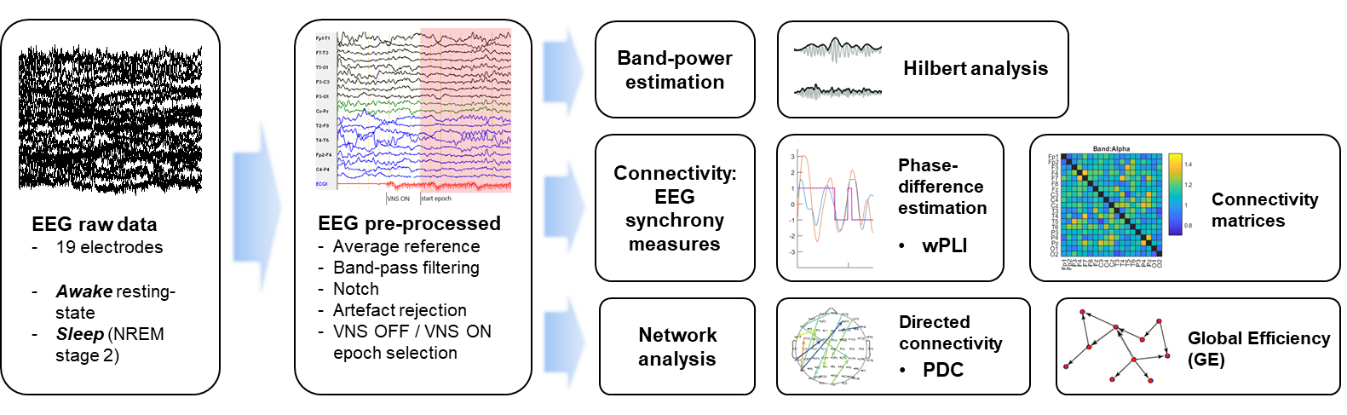
FIGURES

Figure 1 General outline of the EEG analysis. Manual marking of the onset and offset of VNS trains was performed. For each patient, 8-10 EEG epochs during VNS ON condition and 8-10 during VNS OFF condition were collected, in calm wakefulness for the awake EEG, and in stage 2 NREM sleep for the sleep EEG. Each epoch had 10 s length. VNS ON epochs were searched at least 3 s after the VNS train onset and -1 s before offset. VNS OFF epochs were selected at least 30 s after the VNS train offset. EEG pre-processing was completed by re-referencing on the common average of the 19 selected EEG channels. Additional band-pass filtering was applied, for differential bandwidths computation, and following band power, connectivity and network analysis. wPLI: weighted Phase Lag Index. PDC, Partial Directed Coherence.

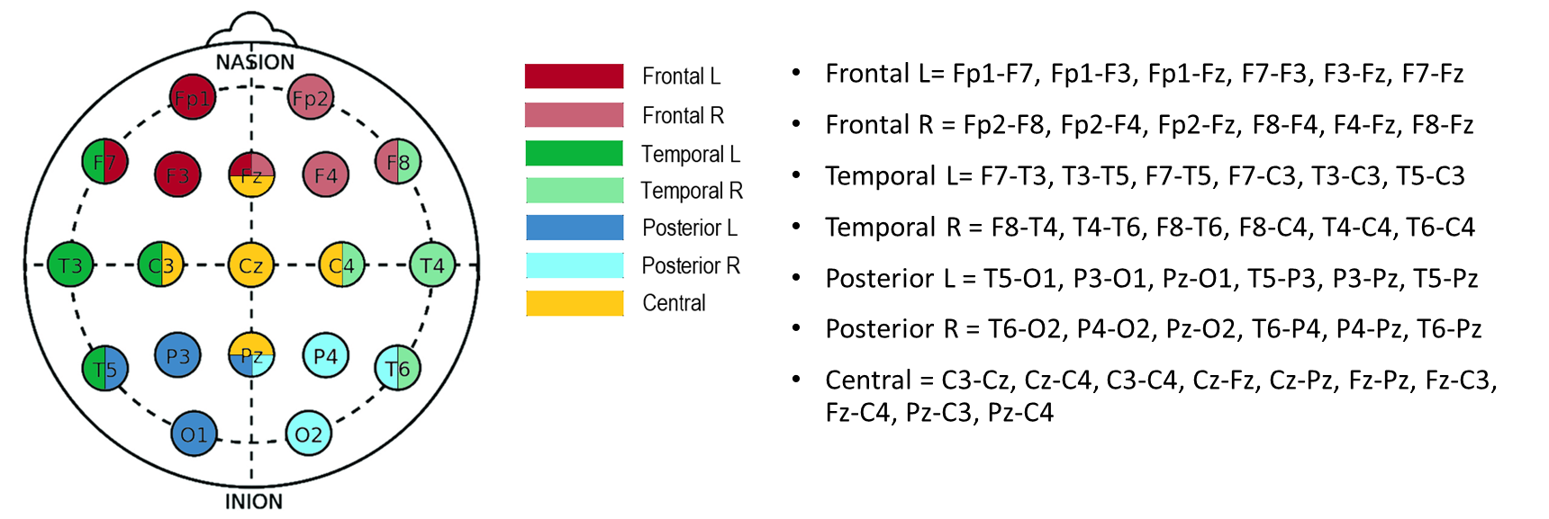

Figure 2 Regional electrode pooling for connectivity analysis. 7 different regions were defined: 3 per hemisphere plus one central region.

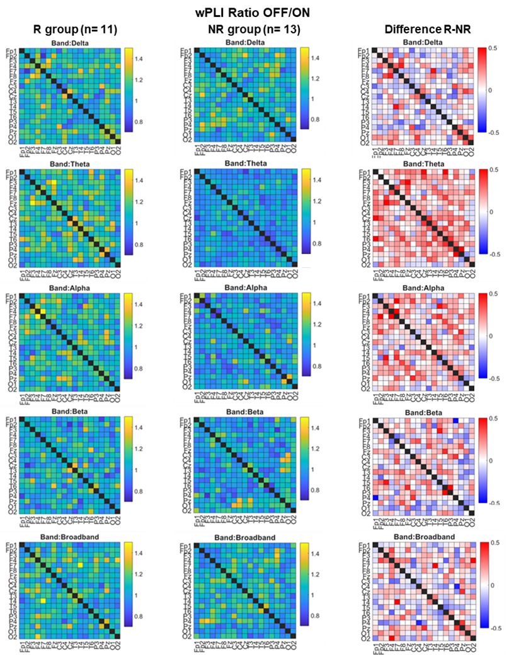
Figure 3 Connectivity matrices for wPLI Ratio OFF/ON in sleep EEG, shown at a group-level averaged values. In the right-column matrices, the difference between R and NR group is shown for each channel pairing: red colors indicate greater desynchronization occurring in the R group, blue colors in the NR group. In the theta band, the degree of whole-brain desynchronization is significantly different between the two groups. A greater theta wPLI Ratio OFF/ON in R group (i.e. red colors in the right graph) can be seen in the vast majority of channel pairings.
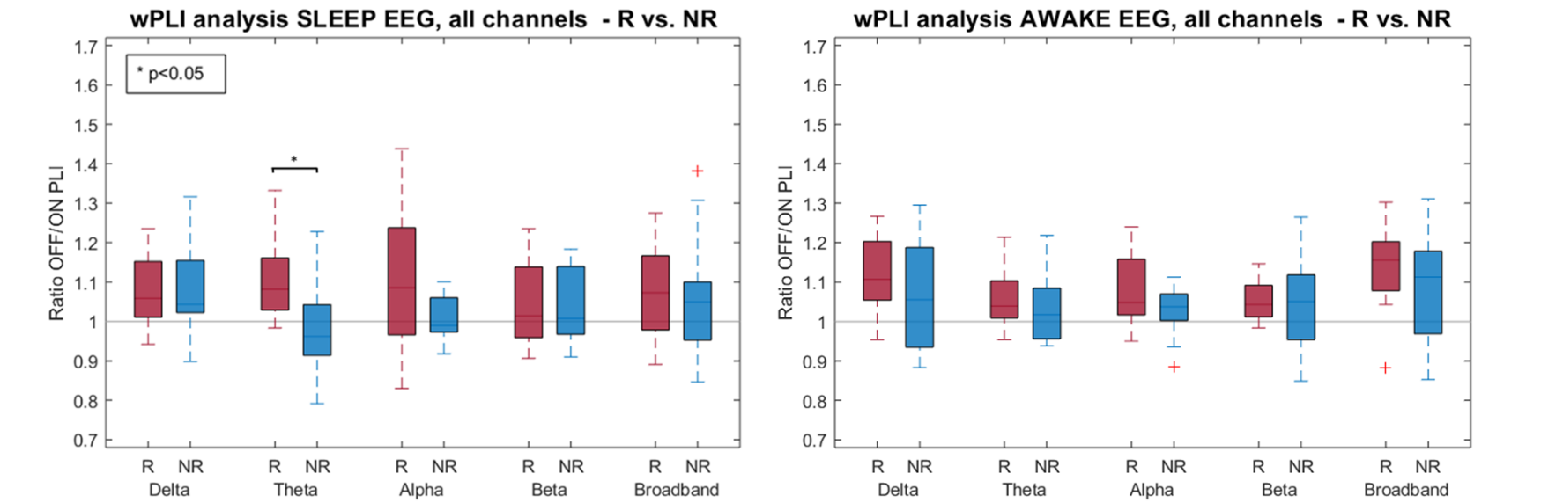
Figure 4 Boxplots showing the between-groups comparison in both sleep and awake EEG for wPLI whole-brain analysis. The grey horizontal line corresponds to the no-effect level (Ration OFF/ON = 1). Significant higher desynchronization is found in the theta band in sleep EEG,in R group (n= 11) compared to NR group (n= 13), with p= 0.038, FDR-corrected Mann-Whitney U test. Trending higher sleep desynchronization, although non-significant, was also found in alpha and broadband ranges. Despite a general desynchronization is also seen in wakefulness (as shown by median values >1), R vs. NR differences in the awake EEG are non-significant.
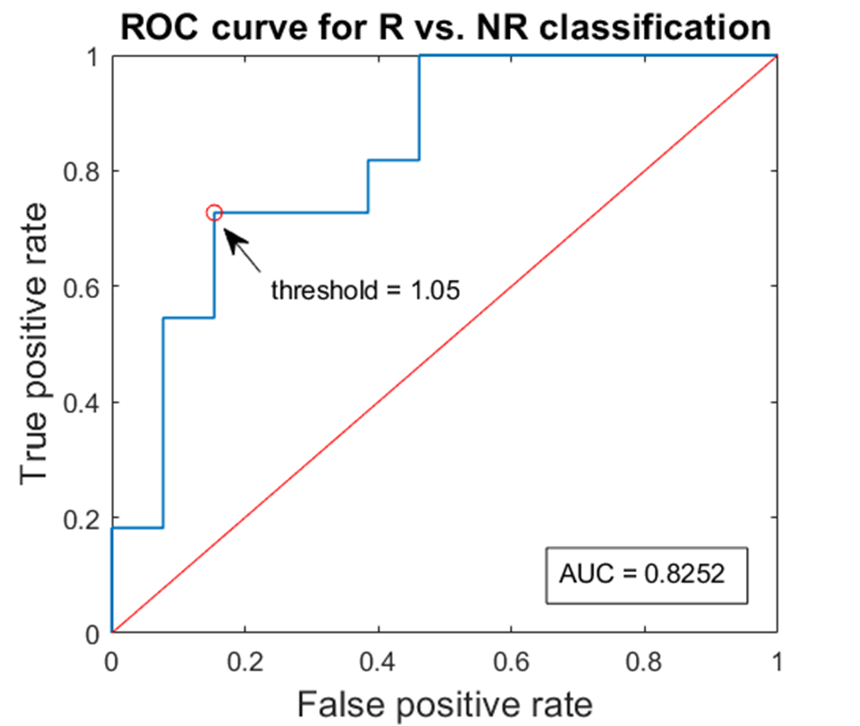
Figure 5 ROC curve analysis of theta wPLI Ratio OFF/ON in sleep, for responders (R) vs. non-responders (NR) classification. Different thresholds of the sleep theta wPLI Ratio OFF/ON are tested as classifiers for clinical response. The best performing threshold was found to be 1.05, i.e. the furthest point of the ROC curve from the random allocation of depicted by the diagonal red line. This means that, with a cut-off set at >1.05 to be classified as responder, the wPLI Ratio OFF/ON has a 73% sensitivity, 85% specificity and 79% overall accuracy as response biomarker. AUC, area-under-the-curve.
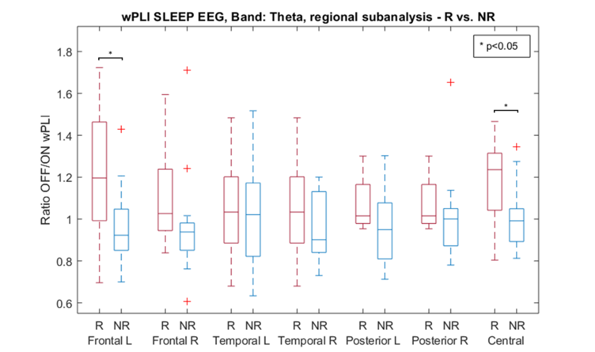
Figure 6 Boxplots showing the between-groups comparison in the theta band in sleep EEG, for wPLI regional analysis. Significant higher desynchronization is found in the left frontal and central region, in R group compared to NR group (p< 0.05, Mann-Whitney U test).

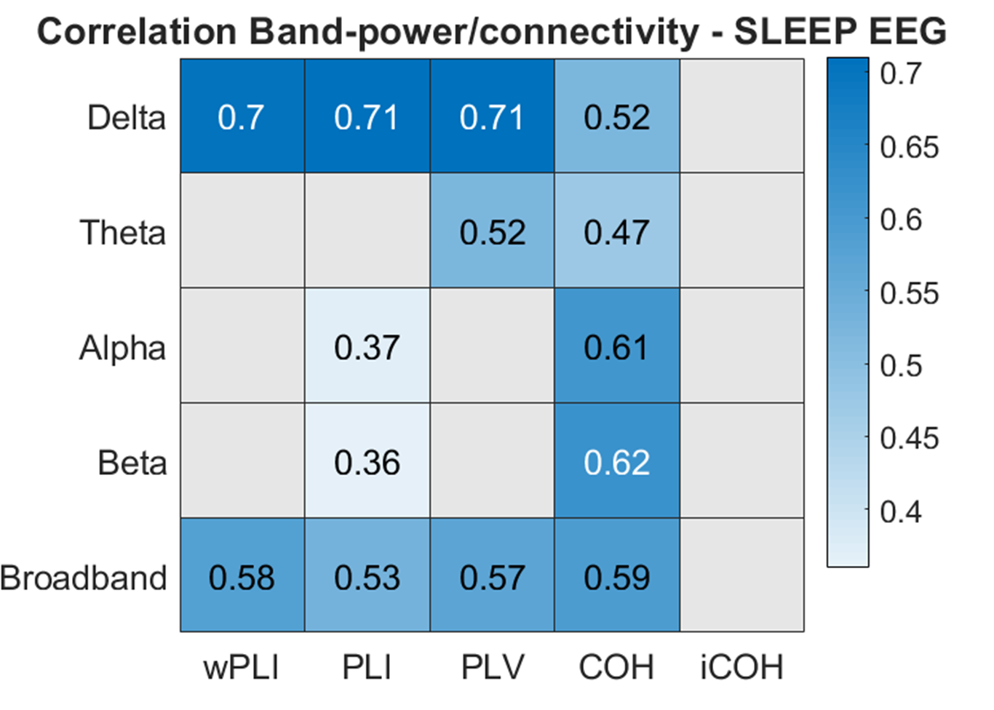
Figure 7 Correlation analysis between relative band-power and connectivity measures in sleep EEG. Theta, alpha and beta band show lower coefficients, indicating that measures in those bands are less prone to be influenced by volume conduction issues. Likewise, wPLI shows, as well as iCOH, lower correlation coefficients compared to other measure that are non-corrected for volume conduction (such as PLV and COH). Delta and broadband measurements appear reliable only for iCOH. Coefficients are expressed in ρ values. Only significant (p >0.05) values are reported.

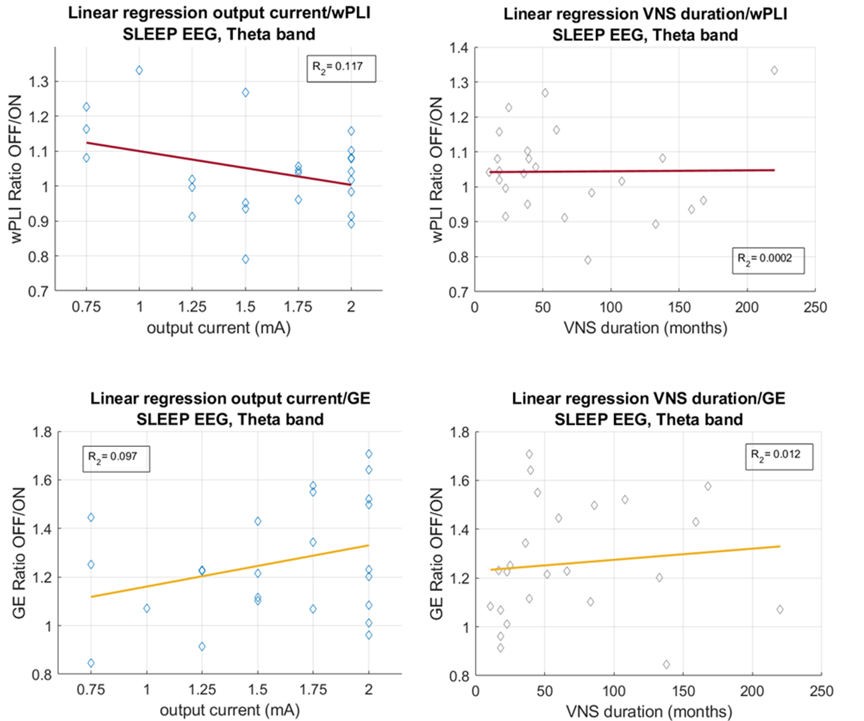
Figure 8 Correlation analysis between theta sleep wPLI and GE values with VNS output current and therapy duration, and linear regression fit. Each point in the scatter plot correspond to values of a single patient (n= 24). No significant associations (i.e. low R₂ values, p was > 0.05 for all correlation analyses) were found between higher stimulation intensities or longer durations of therapy and greater indexes of desynchronization or de-integration.

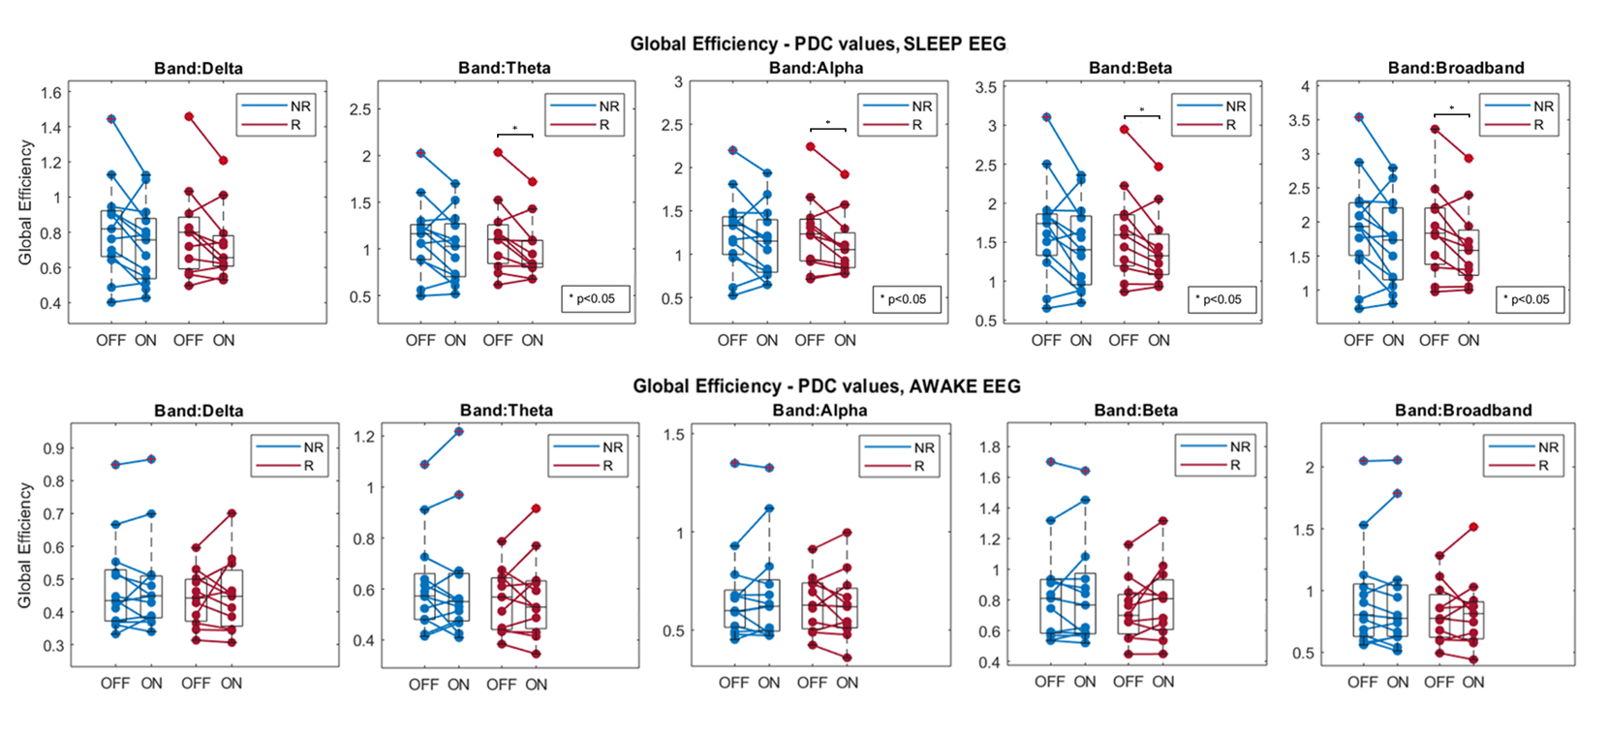
Figure 9 Paired boxplots for within-group Wilcoxon signed-rank test on Global Efficiency, as computed from PDC values. In each bandwidth, both for sleep and awake EEG, VNS OFF and VNS ON paired results are shown linked for each patient. Significant VNS ON decrease of Global Efficiency was found in sleep EEG, in theta, alpha, beta and broadband ranges, to occur only in responder (R) group but not in non-responders (NR).

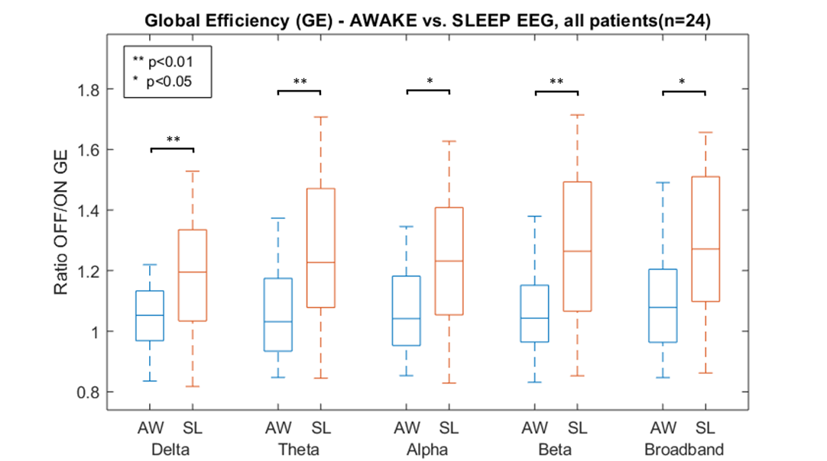
Figure 10 Between-state comparison - awake (AW) vs. sleep (SL) - for Global Efficiency (GE) values, in the five analyzed bandwidths, after pooling all patients of the study population (n= 24). Consistently higher values of GE Ratio OFF/ON (i.e. decrease of network integration during VNS ON) can be seen, throughout all frequency bands.

TABLES

Variable | R group (n= 11) | NR group (n= 13) | p-values
 | mean (SD) | mean (SD)
Sex | 4 M. 7 F | 4 M. 9 F | 1
Age | 34.1 (13.9) | 33.2 (14.6) | 0.741
Epilepsy onset age | 9.8 (9.6) | 6.5 (3.2) | 0.649
Duration VNS therapy (in months) | 67.2 (61.5) | 68.2 (56.6) | 0.82
VNS output current (mA) | 1.48 (0.51) | 1.67 (0.37) | 0.424
VNS frequency (Hz) | 25 (5) | 26.9 (3.8) | 0.51
VNS pulse width (µs) | 340.9 (126.1) | 307.7 (109.6) | 0.608
VNS duty cycle (time ON/time OFF %) | 18.1% (10.9%) | 18.4% (6.7%) | 0.424
Epilepsy type: |  |  | 0.357
Focal epilepsy | 7 | 11
Mixed/Generalized epilepsy | 4 | 2
QI range: |  |  | 1
Normal-mild impairment (IQ >55) | 9 | 10
Moderate-severe impairment (IQ<55) | 2 | 3
mean n of AEDs used | 2.6 (0.8) | 3.2 (0.7) | 0.119
n using benzodiazepines | 2/11 | 5/13 | 0.686
n using antidepressants (SSRI. SNRI. TCA) | 5/11 | 5/13 | 1
Table 1 Demographic and clinical characteristics of the study population (n= 24). Mixed epilepsy corresponds to patients presenting both focal and generalized seizures, such as structural Lennox-Gastaut Syndrome. R, responder. NR, non-responder.. SD, Standard Deviation. AEDs, Antiepileptic drugs. SSRI, serotonine-selective reuptake inhibitors. SNRI, serotonine-noradrenaline reuptake inhibitors. TCA, tricyclic antidepressants.

Theta sleep wPLI Ratio OFF/ON
Threshold |  | Sensitivity | Specificity | Overall accuracy
>1 |  | 91% (59-100%) | 54% (25-81%) | 71% (49-87%)
>1.02 |  | 82% (48-98%) | 62 (32-86%) | 71% (49-87%)
>1.04 |  | 73% (39-94%) | 69% (39-91%) | 71% (49-87%)
>1.05 |  | 73% (39-94%) | 85% (55-98%) | 79% (58-93%)
>1.08 |  | 54% (23-83%) | 85% (55-98%) | 71% (49-87%)
>1.1 |  | 45% (17-77%) | 92% (64-100%) | 71% (49-87%)
Table 2 ROC curve analysis for responders (R) vs. non-responders (NR) classification, which tests different threshold values of theta sleep wPLI Ratio OFF/ON (having as condition that R are > than threshold). The best performing cut-off was found at 1.05.

GE Ratio OFF/ON, all patients (n= 24)
(Band) | SL mean | (SD) | AW mean | (SD) | Diff. SL-AW% | p-value (FDR)
Delta | 1.203 | (0.198) | 1.041 | (0.111) | +16.2% | 0.008**
Theta | 1.260 | (0.240) | 1.062 | (0.148) | +19.7% | 0.005**
Alpha | 1.229 | (0.225) | 1.074 | (0.144) | +15.5% | 0.014*
Beta | 1.291 | (0.264) | 1.056 | (0.141) | +23.5% | 0.007**
Broadband | 1.290 | (0.250) | 1.094 | (0.167) | +19.6% | 0.015*
Table 3 Between-state analysis for Global Efficiency (GE) results. A clear higher de-integration is found in the sleep state compared to awake state, in all beandwidths. Mean values and standard deviaton are reported after averaging all patients for the values of one state. Between-state difference (mean SL values minus mean AW values) and FDR-corrected p-values for Mann-Whitney U test. SL, sleep. AW, awake. SD, standard deviation. FDR, false discovery rate.

APPENDIX

SUPPLEMENTARY MATERIALS

Equations for supplementary connectivity measures.
Phase Lag Index (PLI), ^{40,42})
$$PLI=|E\left\{sgn\left(∆φ\right)\right\}|$$
where E is a function computing the mean value, sgn extracts the sign of a real number, and Δϕ is the phase difference between two given signals.

Phase Locking Value (PLV), ³⁵
$$PLV=|E\{e^{i∆φ(t))}\}$$

Coherence (COH), ⁷⁸
$${COH}_{xy}(f)= \frac{{|P_{xy}\left(f\right)|}^{2}}{P_{xx}(f)P_{yy}(f)}$$
where P is the cross-spectrum function, f is the frequency bin, and x and y the bivariate signals.

Imaginary Coherence (iCOH), ^{39,79}
$$iCOH=\frac{|E\{imag(P_{xy}(f))\}|}{\sqrt{P_{xx}(f)P_{yy}(f)}}$$
where imag is a function extracting the imaginary part of a complex number.

Partial Directed Coherence (PDC), [Baccala et al.]
$${PDC}_{ij}\left(f\right)=\frac{{\left|A_{ij}(f)\right|}^{2}}{\sum_{k=1}^{K}{{\left|A_{kj}(f)\right|}^{2}}}$$
Where A(f) is the Fourier transform of the autoregressive coefficient matrix, the sum in the denominator normalizes PDC with respect to the total outflow of information from channel j.

Table S1. Demographic and medical characteristics of the study population
N PAT | Age | Sex | Age epilepsy onset | Epilepsy type | If Focal epilepsy, presumed EZ | Previous resective surgery | VNS implant duration (months) | Sz. Freq. reduction at EEG record | R/NR | VNS frequency (Hz) | VNS output current (mA) | VNS pulse width (µs) | duration phase ON | duration phase OFF | duty cycle | Number of AEDs | BZD treatment | Antidepressant treatment | Sleep disturbances | QI group | QI range
1 | 27 | F | 6 | Focal, Rasmussen Syndrome | Multifocal, right hemipshere | Y, R temporal anterior | 18 | 0 | NR | 30 | 1,75 | 500 | 30 | 300 | 10,00% | 4 | Y | N | N | normal-mild | >70
2 | 26 | F | 7 | Mixed Generalized and Focal, Lennox-Gastaut Syndrome | Multifocal | N | 23 | -25% | NR | 30 | 2 | 250 | 14 | 66 | 21,21% | 3 | N | N | NA | moderate-severe | 40-50/55, Encephalopathy
3 | 25 | M | 6 | Focal | Multifocal | Y, 1st: R fronto-parietal, 2nd: R temporo-insular disconnection | 83 | 50% | NR | 25 | 1,5 | 250 | 30 | 180 | 16,67% | 3 | N | N | Y, daytime sleepiness | normal-mild | 50/55-70
4 | 37 | F | 4 | Focal | Bitemporal | N | 60 | -80% | R | 20 | 0,75 | 250 | 30 | 180 | 16,67% | 2 | N | N | N | normal-mild | >70
5 | 51 | M | 7 | Focal | Parietal left | N | 168 | 0% | NR | 30 | 1,75 | 250 | 30 | 180 | 16,67% | 4 | N | Y | N | normal-mild | >70
6 | 25 | F | 2 | Focal | Temporal, Frontal left | Y, 1st: L temporal, 2nd: L frontal | 36 | 0% | NR | 30 | 1,75 | 250 | 30 | 180 | 16,67% | 2 | N | Y | NA | normal-mild | 50/55-70
7 | 27 | F | 4 | Focal | Frontal left | N | 23 | -75% | R | 25 | 1,25 | 250 | 30 | 300 | 10,00% | 2 | N | N | N | normal-mild | >70
8 | 23 | F | 11 | Focal | Multifocal | N | 45 | -90% | R | 30 | 1,75 | 500 | 30 | 108 | 27,78% | 2 | Y | N | N | moderate-severe | <40
9 | 56 | F | 36 | Focal | Temporal left | N | 86 | -50% | R | 20 | 2 | 250 | 30 | 300 | 10,00% | 3 | N | Y | N | normal-mild | >70
10 | 35 | F | 11 | Mixed Generalized and Focal | Temporal right | Y, R temporal | 18 | -50% | R | 20 | 1,25 | 250 | 30 | 180 | 16,67% | 4 | Y | Y | N | normal-mild | >70
11 | 50 | M | 15 | Focal | Temporal left | N | 138 | -100% | R | 30 | 0,75 | 500 | 30 | 300 | 10,00% | 2 | N | N | N | normal-mild | >70
12 | 35 | M | 5 | Focal | Multifocal | Y, hypothalamic amarthoma | 17 | 0 | NR | 20 | 2 | 250 | 30 | 180 | 16,67% | 3 | Y | Y | N | normal-mild | 50/55-70
13 | 53 | F | 4 | Generalized | NA | N | 40 | -50% | R | 20 | 2 | 250 | 30 | 108 | 27,78% | 2 | N | Y(trazodone) | Y | normal-mild | >70
15 | 12 | M | 1 | Mixed Generalized and Focal, Lennox-Gastaut Syndrome | Multifocal | Y, R fronto central | 18 | -60% | R | 30 | 2 | 250 | 21 | 48 | 43,75% | 3 | N | N | N | moderate-severe | estimated <40
17 | 24 | F | 1 | Focal | Multifocal | Y, R temporo-occipital | 11 | 75% | NR | 30 | 2 | 250 | 30 | 300 | 10,00% | 2 | N | Y, SSNRI | N | normal-mild | >70
18 | 58 | F | 12 | Focal | Multifocal | N | 66 | -33% | NR | 20 | 1,25 | 250 | 14 | 66 | 21,21% | 3 | N | N | N | normal-mild | >70
19 | 21 | F | 11 | Focal | Multifocal | N | 25 | 0 | NR | 25 | 0,75 | 500 | 30 | 300 | 10,00% | 4 | N | N | N | normal-mild | 50/55-70
20 | 30 | F | 6 | Generalized, Lennox-Gastaut Syndrome | NA | N | 108 | 200% | NR | 30 | 2 | 500 | 21 | 104 | 20,19% | 4 | Y | N | N | moderate-severe | 40-50/55, Encephalopathy
21 | 61 | F | 8 | Focal | Multifocal | N | 39 | -25% | NR | 25 | 1,5 | 250 | 30 | 104 | 28,85% | 3 | Y | Y, SSRI | N | normal-mild | >70
22 | 32 | M | 5 | Focal | Multifocal | N | 52 | -60% | R | 30 | 1,5 | 500 | 30 | 300 | 10,00% | 4 | N | Y | N | normal-mild | 50/55-70
23 | 27 | M | 7 | Focal | Temporal left | N | 220 | -55% | R | 30 | 1 | 500 | 30 | 300 | 10,00% | 3 | N | Y | N | normal-mild | >70
24 | 23 | F | 10 | Generalized | NA | N | 39 | -50% | R | 20 | 2 | 250 | 30 | 180 | 16,67% | 2 | N | N | N | normal-mild | >70
25 | 14 | F | 4 | Focal | Bitemporal | Y, R temporal | 159 | 100% | NR | 25 | 1,5 | 250 | 21 | 66 | 31,82% | 3 | Y | N | N | moderate-severe | 40-50-55 (2012)
26 | 35 | M | 9 | Focal | Multifocal | N | 133 | -25% | NR | 30 | 2 | 250 | 21 | 108 | 19,44% | 3 | N | N | N | normal-mild | >70

Table S2. Hilbert analysis results. Group-level mean values and standard deviation, between-group difference (mean R group minus mean NR group) and FDR-corrected p-values for Mann-Whitney U test. No significant differences in Hilbert analysis-based desynchronization or synchronization indexes were found between responders and non-responders.
Band-power Ratio OFF/ON |  | R mean | SD | NR mean | SD | Diff R-NR | p-value (FDR)
AWAKE | Delta | 0,981 | 0,139 | 1,037 | 0,092 | -5,7% | 0,297
AWAKE | Theta | 0,985 | 0,092 | 1,006 | 0,080 | -2,1% | 0,524
AWAKE | Alpha | 0,996 | 0,076 | 1,000 | 0,076 | -0,5% | 0,862
AWAKE | Beta | 1,021 | 0,053 | 1,000 | 0,096 | 2,1% | 0,562
AWAKE | Broadband | 0,985 | 0,095 | 1,025 | 0,078 | -4,0% | 0,385
SLEEP | Delta | 1,038 | 0,160 | 1,014 | 0,132 | 2,4% | 0,728
SLEEP | Theta | 0,984 | 0,099 | 0,999 | 0,099 | -1,5% | 0,862
SLEEP | Alpha | 0,973 | 0,079 | 0,996 | 0,102 | -2,4% | 0,685
SLEEP | Beta | 0,992 | 0,105 | 0,997 | 0,101 | -0,5% | 0,562
SLEEP | Broadband | 1,016 | 0,141 | 1,006 | 0,117 | 1,0% | 0,524

Table S3. Ratio OFF/ON for all connectivity measures. Group-level mean values and standard deviation, between-group difference (mean R group minus mean NR group) and FDR-corrected p-values for Mann-Whitney U test. For the volume conduction-corrected measures (wPLI, PLI and iCOH), it can be appreciated that the desynchronization index in the R group is always higher than 1 and, expect for awake iCOH in alpha and beta band, R group shows consistently higher values compared to NR. A trend of acute VNS-induce desynchronization exist in all bands in R but not in NR.
wPLI Ratio OFF/ON
 |  | R mean | R stdev | NR mean | NR stdev | Diff R - NR % | p-value (FDR)
SLEEP | Delta | 1,089 | 0,095 | 1,076 | 0,115 | 1,3% | 0,954
SLEEP | Theta | 1,113 | 0,110 | 0,985 | 0,108 | 12,8% | 0,038*
SLEEP | Alpha | 1,093 | 0,185 | 1,014 | 0,054 | 8,0% | 0,812
SLEEP | Beta | 1,047 | 0,111 | 1,022 | 0,149 | 2,5% | 0,954
SLEEP | Broadband | 1,077 | 0,127 | 1,053 | 0,154 | 2,4% | 0,954
AWAKE | Delta | 1,114 | 0,098 | 1,065 | 0,144 | 4,9% | 0,522
AWAKE | Theta | 1,055 | 0,075 | 1,031 | 0,089 | 2,4% | 0,522
AWAKE | Alpha | 1,083 | 0,095 | 1,028 | 0,065 | 5,5% | 0,522
AWAKE | Beta | 1,056 | 0,055 | 1,039 | 0,114 | 1,8% | 0,685
AWAKE | Broadband | 1,136 | 0,111 | 1,086 | 0,148 | 5,0% | 0,522
PLI Ratio OFF/ON
 |  | R mean | R stdev | NR mean | NR stdev | Diff R - NR % | p-value (FDR)
SLEEP | Delta | 1,086 | 0,102 | 1,057 | 0,127 | 2,8% | 0,812
SLEEP | Theta | 1,087 | 0,124 | 0,983 | 0,114 | 10,5% | 0,213
SLEEP | Alpha | 1,080 | 0,191 | 1,009 | 0,068 | 7,1% | 0,812
SLEEP | Beta | 1,042 | 0,124 | 1,016 | 0,155 | 2,5% | 1,000
SLEEP | Broadband | 1,067 | 0,132 | 1,046 | 0,153 | 2,1% | 0,965
AWAKE | Delta | 1,118 | 0,107 | 1,075 | 0,158 | 4,3% | 0,451
AWAKE | Theta | 1,075 | 0,097 | 1,024 | 0,094 | 5,1% | 0,451
AWAKE | Alpha | 1,090 | 0,106 | 1,023 | 0,074 | 6,7% | 0,451
AWAKE | Beta | 1,058 | 0,055 | 1,037 | 0,122 | 2,2% | 0,451
AWAKE | Broadband | 1,131 | 0,114 | 1,084 | 0,157 | 4,7% | 0,451
PLV Ratio OFF/ON
 |  | R mean | R stdev | NR mean | NR stdev | Diff R - NR % | p-value (FDR)
SLEEP | Delta | 1,024 | 0,056 | 1,014 | 0,041 | 1,1% | 0,908
SLEEP | Theta | 1,020 | 0,043 | 0,993 | 0,025 | 2,7% | 0,279
SLEEP | Alpha | 1,014 | 0,050 | 0,992 | 0,037 | 2,2% | 0,908
SLEEP | Beta | 0,997 | 0,037 | 0,990 | 0,037 | 0,7% | 0,908
SLEEP | Broadband | 1,013 | 0,054 | 1,007 | 0,044 | 0,6% | 0,908
AWAKE | Delta | 1,020 | 0,051 | 0,996 | 0,036 | 2,4% | 0,954
AWAKE | Theta | 0,990 | 0,058 | 0,989 | 0,043 | 0,1% | 0,954
AWAKE | Alpha | 1,024 | 0,062 | 1,026 | 0,038 | -0,2% | 0,954
AWAKE | Beta | 1,024 | 0,038 | 1,004 | 0,026 | 2,0% | 0,954
AWAKE | Broadband | 1,019 | 0,047 | 1,022 | 0,030 | -0,3% | 0,954
COH Ratio OFF/ON
 |  | R mean | R stdev | NR mean | NR stdev | Diff R - NR % | p-value (FDR)
SLEEP | Delta | 0,992 | 0,060 | 1,018 | 0,054 | -2,6% | 0,506
SLEEP | Theta | 0,967 | 0,045 | 0,965 | 0,071 | 0,2% | 0,954
SLEEP | Alpha | 1,014 | 0,061 | 1,012 | 0,093 | 0,2% | 0,954
SLEEP | Beta | 1,033 | 0,071 | 0,998 | 0,084 | 3,5% | 0,465
SLEEP | Broadband | 0,978 | 0,032 | 0,977 | 0,055 | 0,1% | 0,954
AWAKE | Delta | 1,031 | 0,056 | 1,021 | 0,069 | 1,0% | 0,954
AWAKE | Theta | 0,991 | 0,063 | 1,000 | 0,077 | -1,0% | 0,954
AWAKE | Alpha | 1,004 | 0,099 | 1,054 | 0,096 | -5,0% | 0,954
AWAKE | Beta | 1,043 | 0,062 | 1,019 | 0,033 | 2,4% | 0,913
AWAKE | Broadband | 0,995 | 0,038 | 1,007 | 0,044 | -1,2% | 0,954
iCOH Ratio OFF/ON
 |  | R mean | R stdev | NR mean | NR stdev | Diff R - NR % | p-value (FDR)
SLEEP | Delta | 1,111 | 0,144 | 1,051 | 0,173 | 6,0% | 0,385
SLEEP | Theta | 1,086 | 0,119 | 1,016 | 0,112 | 7,0% | 0,385
SLEEP | Alpha | 1,068 | 0,116 | 1,051 | 0,081 | 1,7% | 0,643
SLEEP | Beta | 1,089 | 0,129 | 1,080 | 0,204 | 0,9% | 0,602
SLEEP | Broadband | 1,136 | 0,154 | 1,048 | 0,145 | 8,8% | 0,385
AWAKE | Delta | 1,127 | 0,149 | 1,030 | 0,137 | 9,7% | 0,465
AWAKE | Theta | 1,085 | 0,203 | 1,084 | 0,141 | 0,2% | 0,772
AWAKE | Alpha | 1,085 | 0,145 | 1,091 | 0,111 | -0,6% | 0,772
AWAKE | Beta | 1,115 | 0,151 | 1,143 | 0,135 | -2,8% | 0,772
AWAKE | Broadband | 1,107 | 0,125 | 1,096 | 0,191 | 1,1% | 0,772

Figure S1 Correlation across the different functional connectivity (FC) measures, in sleep EEG. Coefficients are expressed in ρ values. Only significant (p >0.05) values are reported. As expectable, high collinearity between the leakage-corrected measures (between wPLI and PLI, ρ > 0.9 in all bandwidths), high collinearity between leakage-uncorrected measures (significant correlations between PLV and COH in all bandwidths) but lower collinearity when comparing corrected with uncorrected measures. Interestingly, for wPLI, relatively lower correlation coefficients with the other measures were found in the theta band: here, the sensitivity of wPLI for true connectivity might be enhanced and therefore the correlation is lower with other corrected measures, such as iCOH (non-significant correlation).
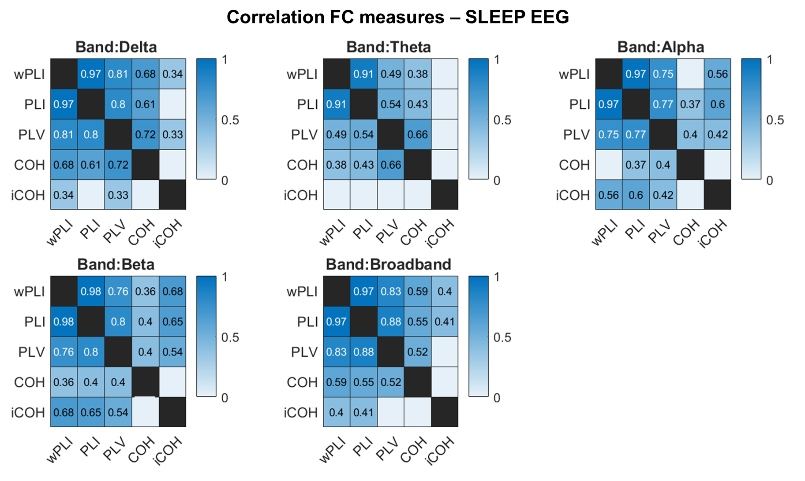

REFERENCES
1. Englot DJ, Rolston JD, Wright CW, Hassnain KH, Chang EF. Rates and Predictors of Seizure Freedom With Vagus Nerve Stimulation for Intractable Epilepsy. Neurosurgery. 2016;79:345–53.
2. Boon P, Vonck K, van Rijckevorsel K, El Tahry R, Elger CE, Mullatti N, et al. A prospective, multicenter study of cardiac-based seizure detection to activate vagus nerve stimulation. Seizure. 2015;32:52–61.
3. El Tahry R, Hirsch M, Van Rijckevorsel K, Santos SF, de Tourtchaninoff M, Rooijakkers H, et al. Early experiences with tachycardia-triggered vagus nerve stimulation using the AspireSR stimulator. Epileptic Disord [Internet]. 2016;18:155–62. Available from: https://doi.org/10.1684/epd.2016.0831
4. ZANCHETTI A, WANG SC, MORUZZI G. The effect of vagal afferent stimulation on the EEG pattern of the cat. Electroencephalogr Clin Neurophysiol. 1952;4:357–61.
5. Chase MH, Nakamura Y, Clemente CD, Sterman MB. Afferent vagal stimulation: neurographic correlates of induced EEG synchronization and desynchronization. Brain Res. 1967;5:236–49.
6. Sangare A, Marchi A, Pruvost-Robieux E, Soufflet C, Crepon B, Ramdani C, et al. The effectiveness of vagus nerve stimulation in drug-resistant epilepsy correlates with vagus nerve stimulation-induced electroencephalography desynchronization. Brain Connect. 2020;10:566–77.
7. Ernst LD, Steffan PJ, Srikanth P, Wiedrick J, Spencer DC, Datta P, et al. Electrocorticography Analysis in Patients With Dual Neurostimulators Supports Desynchronization as a Mechanism of Action for Acute Vagal Nerve Stimulator Stimulation. J Clin Neurophysiol Off Publ Am Electroencephalogr Soc. 2021;
8. Ponten SC, Bartolomei F, Stam CJ. Small-world networks and epilepsy: graph theoretical analysis of intracerebrally recorded mesial temporal lobe seizures. Clin Neurophysiol. 2007;118:918–27.
9. Bullmore E, Sporns O. Complex brain networks: graph theoretical analysis of structural and functional systems. Nat Rev Neurosci. 2009;10:186–98.
10. Rubinov M, Sporns O. Complex network measures of brain connectivity: Uses and interpretations. Neuroimage [Internet]. 2010;52:1059–69. Available from: https://www.sciencedirect.com/science/article/pii/S105381190901074X
11. Schevon CA, Cappell J, Emerson R, Isler J, Grieve P, Goodman R, et al. Cortical abnormalities in epilepsy revealed by local EEG synchrony. Neuroimage. 2007;35:140–8.
12. Ortega GJ, Menendez de la Prida L, Sola RG, Pastor J. Synchronization clusters of interictal activity in the lateral temporal cortex of epileptic patients: intraoperative electrocorticographic analysis. Epilepsia. 2008;49:269–80.
13. Bartolomei F, Bettus G, Stam CJ, Guye M. Interictal network properties in mesial temporal lobe epilepsy: a graph theoretical study from intracerebral recordings. Clin Neurophysiol Off J Int Fed Clin Neurophysiol. 2013;124:2345–53.
14. Lagarde S, Roehri N, Lambert I, Trebuchon A, McGonigal A, Carron R, et al. Interictal stereotactic-EEG functional connectivity in refractory focal epilepsies. Brain. 2018;141:2966–80.
15. Latora V, Marchiori M. Efficient Behavior of Small-World Networks. Phys Rev Lett [Internet]. 2001;87:198701. Available from: https://link.aps.org/doi/10.1103/PhysRevLett.87.198701
16. Carboni M, Rubega M, Iannotti GR, De Stefano P, Toscano G, Tourbier S, et al. The network integration of epileptic activity in relation to surgical outcome. Clin Neurophysiol [Internet]. 2019;130:2193–202. Available from: https://www.sciencedirect.com/science/article/pii/S1388245719312258
17. Carboni M, De Stefano P, Vorderwülbecke BJ, Tourbier S, Mullier E, Rubega M, et al. Abnormal directed connectivity of resting state networks in focal epilepsy. NeuroImage Clin [Internet]. 2020;27:102336. Available from: https://doi.org/10.1016/j.nicl.2020.102336
18. Bartolomei F, Bonini F, Vidal E, Trebuchon A, Lagarde S, Lambert I, et al. How does vagal nerve stimulation (VNS) change EEG brain functional connectivity? Epilepsy Res. 2016;126:141–6.
19. Hachem LD, Wong SM, Ibrahim GM. The vagus afferent network: emerging role in translational connectomics. Neurosurg Focus. 2018;45:E2.
20. Workewych AM, Arski ON, Mithani K, Ibrahim GM. Biomarkers of seizure response to vagus nerve stimulation: A scoping review. Epilepsia [Internet]. 2020;61:2069–85. Available from: https://doi.org/10.1111/epi.16661
21. Babajani-Feremi A, Noorizadeh N, Mudigoudar B, Wheless JW. Predicting seizure outcome of vagus nerve stimulation using MEG-based network topology. NeuroImage Clin. 2018;19:990–9.
22. Mithani K, Mikhail M, Morgan BR, Wong S, Weil AG, Deschenes S, et al. Connectomic Profiling Identifies Responders to Vagus Nerve Stimulation. Ann Neurol. 2019;86:743–53.
23. Ferri R, Rundo F, Bruni O, Terzano MG, Stam CJ. Dynamics of the EEG slow-wave synchronization during sleep. Clin Neurophysiol Off J Int Fed Clin Neurophysiol. 2005;116:2783–95.
24. Watanabe T, Kan S, Koike T, Misaki M, Konishi S, Miyauchi S, et al. Network-dependent modulation of brain activity during sleep. Neuroimage [Internet]. 2014;98:1–10. Available from: https://www.sciencedirect.com/science/article/pii/S1053811914003590
25. Vyazovskiy V V, Delogu A. NREM and REM Sleep: Complementary Roles in Recovery after Wakefulness. Neurosci [Internet]. 2014;20:203–19. Available from: https://doi.org/10.1177/1073858413518152
26. Bazil CW, Walczak TS. Effects of sleep and sleep stage on epileptic and nonepileptic seizures. Epilepsia. 1997;38:56–62.
27. Moore JL, Carvalho DZ, St Louis EK, Bazil C. Sleep and Epilepsy: a Focused Review of Pathophysiology, Clinical Syndromes, Co-morbidities, and Therapy. Neurotherapeutics [Internet]. 2021;18:170–80. Available from: https://doi.org/10.1007/s13311-021-01021-w
28. Vanhatalo S, Palva JM, Holmes MD, Miller JW, Voipio J, Kaila K. Infraslow oscillations modulate excitability and interictal epileptic activity in the human cortex during sleep. Proc Natl Acad Sci U S A [Internet]. 2004;101:5053 LP – 5057. Available from: http://www.pnas.org/content/101/14/5053.abstract
29. Leresche N, Lambert RC, Errington AC, Crunelli V. From sleep spindles of natural sleep to spike and wave discharges of typical absence seizures: is the hypothesis still valid? Pflugers Arch [Internet]. 2011/08/23. 2012;463:201–12. Available from: https://pubmed.ncbi.nlm.nih.gov/21861061
30. Bertram EH. Neuronal circuits in epilepsy: do they matter? Exp Neurol [Internet]. 2012/02/08. 2013;244:67–74. Available from: https://pubmed.ncbi.nlm.nih.gov/22342991
31. Sinha SR. Basic mechanisms of sleep and epilepsy. J Clin Neurophysiol Off Publ Am Electroencephalogr Soc. 2011;28:103–10.
32. Bruns A. Fourier-, Hilbert- and wavelet-based signal analysis: are they really different approaches? J Neurosci Methods [Internet]. 2004;137:321–32. Available from: https://www.sciencedirect.com/science/article/pii/S0165027004001098
33. Colon E, Liberati G, Mouraux A. EEG frequency tagging using ultra-slow periodic heat stimulation of the skin reveals cortical activity specifically related to C fiber thermonociceptors. Neuroimage [Internet]. 2017;146:266–74. Available from: http://www.sciencedirect.com/science/article/pii/S1053811916306632
34. Brázdil M, Doležalová I, Koritáková E, Chládek J, Roman R, Pail M, et al. EEG Reactivity Predicts Individual Efficacy of Vagal Nerve Stimulation in Intractable Epileptics. 2019;10:1–11.
35. Lachaux J, Rodriguez E, Martinerie J, Varela FJ. Measuring Phase Synchrony in Brain Signals. 1999;208:194–208.
36. Hu L, Zhang Z. EEG Signal Processing and Feature. 2019. 1–435 p.
37. Bodin C, Aubert S, Daquin G, Carron R, Scavarda D, McGonigal A, et al. Responders to vagus nerve stimulation (VNS) in refractory epilepsy have reduced interictal cortical synchronicity on scalp EEG. Epilepsy Res. 2015;113:98–103.
38. Vinck M, Oostenveld R, Wingerden M Van, Battaglia F, Pennartz CMA. NeuroImage An improved index of phase-synchronization for electrophysiological data in the presence of volume-conduction , noise and sample-size bias. Neuroimage [Internet]. 2011;55:1548–65. Available from: http://dx.doi.org/10.1016/j.neuroimage.2011.01.055
39. Congedo M, Congedo M, Measures NS, Re- MEGT, Congedo M. Non-Parametric Synchronization Measures used in EEG and MEG To cite this version : HAL Id : hal-01868538 Non-Parametric Synchronization Measures used in EEG and MEG. 2019;
40. Choi HS, Chung YG, Choi SA, Ahn S, Kim H, Yoon S, et al. Electroencephalographic Resting-State Functional Connectivity of Benign Epilepsy with Centrotemporal Spikes. J Clin Neurol. 2019;15:211–20.
41. Guevara MA, Corsi-Cabrera M. EEG coherence or EEG correlation? Int J Psychophysiol Off J Int Organ Psychophysiol. 1996;23:145–53.
42. Stam CJ, Nolte G, Daffertshofer A. Phase lag index: assessment of functional connectivity from multi channel EEG and MEG with diminished bias from common sources. Hum Brain Mapp. 2007;28:1178–93.
43. Baccala LA, Sameshima K. Partial directed coherence: a new concept in neural structure determination. Biol Cybern. 2001;84:463–74.
44. Coito A, Plomp G, Genetti M, Abela E, Wiest R, Seeck M, et al. Dynamic directed interictal connectivity in left and right temporal lobe epilepsy. Epilepsia. 2015;56:207–17.
45. Coito A, Genetti M, Pittau F, Iannotti GR, Thomschewski A, Höller Y, et al. Altered directed functional connectivity in temporal lobe epilepsy in the absence of interictal spikes: A high density EEG study. Epilepsia. 2016;57:402–11.
46. Benjamini Y, Hochberg Y. Controlling the False Discovery Rate: A Practical and Powerful Approach to Multiple Testing. J R Stat Soc Ser B [Internet]. 1995;57:289–300. Available from: http://www.jstor.org/stable/2346101
47. Briels CT, Briels CT, Schoonhoven DN, Schoonhoven DN, Stam CJ, De Waal H, et al. Reproducibility of EEG functional connectivity in Alzheimer’s disease. Alzheimer’s Res Ther. 2020;12:1–14.
48. Taeye L De, Vonck K, Bochove M Van, Boon P, Roost D Van. The P3 Event-Related Potential is a Biomarker for the Efficacy of Vagus Nerve Stimulation in Patients with Epilepsy. 2014;612–22.
49. Hardmeier M, Hatz F, Bousleiman H, Schindler C, Stam CJ, Fuhr P. Reproducibility of Functional Connectivity and Graph Measures Based on the Phase Lag Index (PLI) and Weighted Phase Lag Index (wPLI) Derived from High Resolution EEG. PLoS One [Internet]. 2014;9:e108648. Available from: https://doi.org/10.1371/journal.pone.0108648
50. Ferri L, Chen S, Kotwas I, Giusiano B, Pizzo F, Roehri N, et al. Is beta band desynchronization related to skin conductance biofeedback effectiveness in drug resistant focal epilepsy? Epilepsy Res [Internet]. 2021;169:106528. Available from: https://www.sciencedirect.com/science/article/pii/S0920121120305799
51. Kibleur A, Pellissier S, Sinniger V, Robert J, Gronlier E, Clarençon D, et al. Electroencephalographic correlates of low-frequency vagus nerve stimulation therapy for Crohn’s disease. Clin Neurophysiol [Internet]. 2018;129:1041–6. Available from: https://www.sciencedirect.com/science/article/pii/S1388245718302360
52. Ibrahim GM, Sharma P, Hyslop A, Guillen MR, Morgan BR, Wong S, et al. Presurgical thalamocortical connectivity is associated with response to vagus nerve stimulation in children with intractable epilepsy. NeuroImage Clin. 2017;16:634–42.
53. Wostyn S, Staljanssens W, De Taeye L, Strobbe G, Gadeyne S, Van Roost D, et al. EEG Derived Brain Activity Reflects Treatment Response from Vagus Nerve Stimulation in Patients with Epilepsy. Int J Neural Syst. 2017;27:1650048.
54. Vonck K, De Herdt V, Bosman T, Dedeurwaerdere S, Van Laere K, Boon P. Thalamic and limbic involvement in the mechanism of action of vagus nerve stimulation, a SPECT study. Seizure. 2008;17:699–706.
55. Beckstead RM, Morse JR, Norgren R. The nucleus of the solitary tract in the monkey: projections to the thalamus and brain stem nuclei. J Comp Neurol. 1980;190:259–82.
56. Mithani K, Wong SM, Mikhail M, Pourmotabbed H, Pang E, Sharma R, et al. NeuroImage : Clinical Somatosensory evoked fi elds predict response to vagus nerve stimulation. NeuroImage Clin [Internet]. 2020;26:102205. Available from: https://doi.org/10.1016/j.nicl.2020.102205
57. Fraschini M, Demuru M, Puligheddu M, Floridia S, Polizzi L, Maleci A, et al. The re-organization of functional brain networks in pharmaco-resistant epileptic patients who respond to VNS. Neurosci Lett. 2014;580:153–7.
58. Jain S V, Glauser TA. Effects of epilepsy treatments on sleep architecture and daytime sleepiness: An evidence-based review of objective sleep metrics. Epilepsia [Internet]. 2014;55:26–37. Available from: https://doi.org/10.1111/epi.12478
59. Romero-Osorio Ó, Gil-Tamayo S, Nariño D, Rosselli D. Changes in sleep patterns after vagus nerve stimulation, deep brain stimulation or epilepsy surgery: Systematic review of the literature. Seizure. 2018;56:4–8.
60. Rizzo P, Beelke M, De Carli F, Canovaro P, Nobili L, Robert A, et al. Modifications of sleep EEG induced by chronic vagus nerve stimulation in patients affected by refractory epilepsy. Clin Neurophysiol [Internet]. 2004;115:658–64. Available from: https://www.sciencedirect.com/science/article/pii/S1388245703003857
61. Kostopoulos G, Gloor P, Pellegrini A, Siatitsas I. A study of the transition from spindles to spike and wave discharge in feline generalized penicillin epilepsy: EEG features. Exp Neurol. 1981;73:43–54.
62. Beenhakker MP, Huguenard JR. Neurons that Fire Together Also Conspire Together: Is Normal Sleep Circuitry Hijacked to Generate Epilepsy? Neuron [Internet]. 2009;62:612–32. Available from: https://www.sciencedirect.com/science/article/pii/S0896627309003900
63. Labar D, Nikolov B, Tarver B, Fraser R. Vagus nerve stimulation for symptomatic generalized epilepsy: a pilot study. Epilepsia. 1998;39:201–5.
64. Henry TR, Votaw JR, Pennell PB, Epstein CM, Bakay RA, Faber TL, et al. Acute blood flow changes and efficacy of vagus nerve stimulation in partial epilepsy. Neurology. 1999;52:1166–73.
65. Emilio V, B. AP, null B-L, D. PG, Ralph L, C. OW. Heart Rate Variability During Specific Sleep Stages . Circulation [Internet]. 1995;91:1918–22. Available from: https://doi.org/10.1161/01.CIR.91.7.1918
66. Miglis MG. Chapter 12 - Sleep and the Autonomic Nervous System. In: Miglis MGBT-S and ND, editor. San Diego: Academic Press; 2017. p. 227–44. Available from: https://www.sciencedirect.com/science/article/pii/B9780128040744000182
67. Hödl S, Carrette S, Meurs A, Carrette E, Mertens A, Gadeyne S, et al. Neurophysiological investigations of drug resistant epilepsy patients treated with vagus nerve stimulation to differentiate responders from non-responders. Eur J Neurol [Internet]. 2020;27:1178–89. Available from: https://doi.org/10.1111/ene.14270
68. Vespa S, Stumpp L, Bouckaert C, Delbeke J, Smets H, Cury J, et al. Vagus Nerve Stimulation-Induced Laryngeal Motor Evoked Potentials: A Possible Biomarker of Effective Nerve Activation. Front Neurosci [Internet]. 2019;13:880. Available from: https://www.frontiersin.org/article/10.3389/fnins.2019.00880
69. Marrosu F, Santoni F, Puligheddu M, Barberini L, Maleci A. Increase in 20 – 50 Hz ( gamma frequencies ) power spectrum and synchronization after chronic vagal nerve stimulation. 2005;116:2026–36.
70. Zumsteg D, Lozano AM, Wennberg RA. Mesial Temporal Inhibition in a Patient with Deep Brain Stimulation of the Anterior Thalamus for Epilepsy. Epilepsia [Internet]. 2006;47:1958–62. Available from: https://doi.org/10.1111/j.1528-1167.2006.00824.x
71. Scherer M, Milosevic L, Guggenberger R, Maus V, Naros G, Grimm F, et al. Desynchronization of temporal lobe theta-band activity during effective anterior thalamus deep brain stimulation in epilepsy. Neuroimage [Internet]. 2020;218:116967. Available from: https://www.sciencedirect.com/science/article/pii/S1053811920304535
72. Clemens B. Pathological theta oscillations in idiopathic generalised epilepsy. Clin Neurophysiol. 2004;115:1436–41.
73. Douw L, van Dellen E, de Groot M, Heimans JJ, Klein M, Stam CJ, et al. Epilepsy is related to theta band brain connectivity and network topology in brain tumor patients. BMC Neurosci. 2010;11.
74. Armitage R. The distribution of EEG frequencies in REM and NREM sleep stages in healthy young adults. Sleep. 1995;18:334–41.
75. Steriade M, McCormick DA, Sejnowski TJ. Thalamocortical oscillations in the sleeping and aroused brain. Science (80- ) [Internet]. 1993;262:679 LP – 685. Available from: http://science.sciencemag.org/content/262/5134/679.abstract
76. Timofeev I, Bazhenov M, Seigneur J, Sejnowski T. Neuronal Synchronization and Thalamocortical Rhythms in Sleep, Wake and Epilepsy. In: Noebels JL, Avoli M, Rogawski MA, Olsen RW, Delgado-Escueta A V, editors. Bethesda (MD); 2012.
77. Minecan D, Natarajan A, Marzec M, Malow B. Relationship of epileptic seizures to sleep stage and sleep depth. Sleep. 2002;25:899–904.
78. Carter G, Knapp C, Nuttall A. Estimation of the magnitude-squared coherence function via overlapped fast Fourier transform processing. IEEE Trans Audio Electroacoust. 1973;21:337–44.
79. Nolte G, Bai O, Wheaton L, Mari Z, Vorbach S, Hallett M. Identifying true brain interaction from EEG data using the imaginary part of coherency. Clin Neurophysiol Off J Int Fed Clin Neurophysiol. 2004;115:2292–307.

