Rapid and Selective Separation of Heavy Metal Ions from Aquatic Medium using a bidentate Functionalized Hybrid Material
Afaf Oulmidi ^{1,2}, Smaail Radi ^{1,*}, Said Tighadouini ³, Luca Fusaro ⁴, Carmela Aprile ⁴, Aurelian Rotaru,⁵ Yann Garcia^{2,*}
¹ Laboratory Applied Chemistry and Environment, Department of Chemistry, Faculty of Sciences, University Mohamed I, BP 524, 60 000 Oujda, Morocco. E-mail: s.radi@ump.ac.ma
² Institute of Condensed Matter and Nanosciences, Molecular Chemistry, Materials and Catalysis (IMCN/MOST), Université catholique de Louvain, Belgium. E-mail: yann.garcia@uclouvain.be
³ Laboratory Organic Synthesis, Extraction and Valorization, Faculty of Sciences Aïn-Chock, University Hassan II, BP 20 100 Casablanca, Morocco
⁴ Unit of Nanomaterials Chemistry (CNANO), Department of Chemistry, NISM – Namur Institute of Structured Matter, University of Namur, 61 rue de Bruxelles, 5000 Namur, Belgium
⁵ Department of Electrical Engineering and Computer Science & Research Center MANSiD, “Stefan cel Mare” University, University Street, No. 13, Suceava 720229, Romania

Abstract
Low-cost mesoporous silica material, functionalized with a bidentate pyrazolyl pyridine metal acceptor and presenting a high specific surface area of 417 m²/g, was synthesized (mSi-L₃) using a two-step procedure and characterized in detail to confirm the successful covalent binding onto silica surface. Notably, mSi-L₃ exhibited strong selectivity for Pb^{II} among Cd^{II} and Cu^{II} ions, and displayed rapid metal ion removal, typically less than 10 min, from water samples.
The influence of various environmental parameters on the adsorption process, such as pH, contact time and temperature, was systematically investigated. Optimal adsorption of metal ions was achieved at pH 6, as lower pH values reduced the availability of active sites due to competitive hydronium ion presence. Kinetic studies indicated that the adsorption process adhered to the pseudo-second-order model, suggesting a chemisorption mechanism. Temperature significantly influenced the adsorption capacity, with increased temperatures enhancing metal ion removal and confirming the endothermic nature of the process. The isotherm study suggests that the Langmuir model accurately describes the adsorption process, confirming that Cu^{II}, Cd^{II} and Pb^{II} ions are adsorbed as a monolayer on the homogeneous surface of m-SiL₃ material, implying that the material has uniform adsorption sites where each metal ion occupies a distinct site without interaction with neighbouring ions. These findings underscore the importance of optimizing environmental conditions to maximize the efficiency of mSi-L₃ for heavy metal removal. Also, mSi-L₃ demonstrated excellent stability, with only a slight (∼1−3%) decrease in functional groups on its surface after multiple regeneration cycles. Extensive analytical studies conducted with real water samples provided further evidence of the stability and effectiveness of mSi-L₃ for the separation of metal trace elements of lead, copper and cadmium.

Introduction
In the face of climate change and increasing water scarcity worldwide, wastewater recycling proved to be an effective solution to address the growing water needs of the population in terms of domestic, thermoelectric, industrial, and irrigation purposes.^{[1,2]} In particular, recycling contaminated water with hazardous metal ions, especially metal trace elements, such as lead, copper, mercury, and cadmium originating from industrialization, urbanization and intensified agricultural practices offers several advantages. First, not only does it help in decreasing the gap between water demand including agriculture, industry, and domestic use, but also reduces stress on natural water sources and minimises their depletion. Secondly, it reduces contaminant discharge into the environment and protects the downstream ecosystem. Finally, it can remove non-biodegradable pollutants that represent a major threat to public health given these are toxic even at low concentrations and cause several damages such as myocardial dysfunctions, inhibition of the synthesis of haemoglobin, dysfunctions in the kidneys, damage to the central nervous system, cancers, to name but a few.^{[3,4,5]}
Therefore, many treatment methods have been developed for heavy metal removal, such as ion exchange,^{[6]} chemical precipitation,^{[7]} electrochemical reduction,^{[8]} and adsorption.^{[9]} Among these, adsorption is generally preferred for the removal of heavy metal ions due to its high efficiency, remarkable simplicity, low cost and low environmental impact.^{[10]} Activated carbon, microbial biomass, and polymeric materials,^{[11,12]} are often used as adsorbents for this approach. However, the main disadvantages of these materials are non-renewable, low selectivity, and low loading capacities.^{[13,14]} In order to remedy these limitations, some research focuses on developing hybrid materials by functionalizing inorganic supports with organic functions.^{[15]} In this approach, silica gel has gained wide popularity due to its natural abundance, high specific surface area, large pore size, low cost, high thermal and mechanical stability and well-modified surface properties as well as by the variety of synthesis methods including ultrasonic and aerogel techniques.^{[16,17a,b,c]} Therefore, the efficiency of hybrid materials in adsorbing hazardous metal ions is influenced by the properties of the ligands fixed on their surface. Amine groups are highly effective for heavy metal removal,^{[18,19]} and bidentate ligands offer additional advantages. These ligands, known as Lewis bases, donate two pairs of electrons to metal atoms, forming stable chelates with heavy metal ions. This chelation not only enhances selectivity and efficiency in metal removal but also contributes to the stability of the chelates. The stability is generally due to an increase in entropy, making these chelates more stable than their non-chelated counterparts.^{[20a,b,c]} In earlier studies, various groups of amines have been fixed on silica gel as chelating adsorbents. However, these materials still suffer from disadvantages, including long-process syntheses and low binding affinity towards divalent metals.^{[21a,b]}
To further enhance the accessibility of efficient polyamine chelating adsorption, we prepared a novel functional hybrid material containing the pyridino-pyrazole ligand (2-(5-methyl-1H-pyrazol-3-yl)pyridine) (L₃) and chloro-functionalized silica gel with high specific surface. The significance and novelty of our research lie in the development of novel and efficient hybrid adsorbent with a large surface area, which is characterized by its selectivity and efficiency in capturing heavy metals. Unlike conventional adsorbents, our material is not only renewable and highly stable over time and temperature but also features a short synthesis process, low cost, and minimal environmental impact. Additionally, our bidentate hybrid adsorbent offers greater sensitivity at low metal concentrations compared to traditional adsorption methods.
The adsorption capacity of the novel hybrid mSi-L₃ was tested for the removal of Cu^{II}, Pb^{II}, and Cd^{II} ions from both aqueous solutions and real-water samples. These metal ions were chosen due to their prevalence as hazardous environmental pollutants. Additionally, various factors affecting the adsorption process were extensively examined and discussed, including pH, checking time, kinetics, thermodynamic characteristics, selectivity, regeneration, mechanism adsorption and its practical application in real water samples. Comprehensive analytical studies of both precursor mSi-Cl and the adsorbent mSi-L₃ were conducted.
Experimental Section
Materials
All solvents and chemicals (Acros Organics and Sigma-Aldrich purity 99.5%) were of analytical grade and used without further purification. Initial silica gel spherical porous (0.03-0.2 mm) with a median pore diameter of 60 Å from Acros Organics. ¹H NMR spectroscopic data were recorded with an Avance 300 MHz Bruker spectrometer. Surfaces were characterized by Fourier-transformed infrared (FT-IR) spectroscopy using an Equinox 55 (Bruker) equipped with an ATR modulus and a MCT detector. The Bruker software OPUS was used for data treatment. Thermogravimetric analyses (TGA) were performed in O₂:N₂ (90:10) atmosphere at a heating rate of 10 °C min⁻¹ from 25 to 900 °C using 3-4 mg with a Mettler Toledo TGA/SDTA 851e analyzer. CHN analysis was performed by MEDAC Ltd. Scanning electron microscopy was performed on a FEI Nova Nano SEM 450 instrument. N₂ adsorption–desorption analyses were performed at 77 K using a volumetric adsorption analyser (Micromeritics ASAP 2020). Before the analysis, the samples were pretreated at 150°C for 16 h under reduced pressure (0.1 mbar). The BET method was applied in the P/P₀ = 0–1 range to calculate the specific surface area, and the pore size distributions were calculated from the adsorption isotherm using the BJH method. Solid-state ¹³C and ²⁹Si CP-MAS NMR spectra were recorded at r.t. using a JEOL ECZ-R spectrometer operating at 14.1T (119.2 MHz for ²⁹Si and 150.9 MHz for ¹³C) using a 3.2 mm AUTOMAS probe. The chemical shift scale was calibrated at r.t. with respect to a 3-(trimethylsilyl)-1-propanesulfonic acid sodium salt (DSS; δ= 0.0 ppm) and solid adamantane (38.48 and 29.45 ppm) for ²⁹Si and ¹³C NMR-solid state, respectively.

Batch adsorption experiments
Batch experiments were conducted under standard conditions. The effects of various parameters on the adsorption, such as the pH of the solution, contact time and temperature were investigated. Typically, 10 mg of pyridine functionalized silica was placed in flasks containing 10 mL of aqueous solution of metal salt (Pb(NO₃)₂·6H₂O, Cu(NO₃)₂·3H₂O and Cd(NO₃)₂·6H₂O) at optimal concentrations 40 mg/L. After adsorption, the solid phase was separated by filtration (0.45 μm). All measurements were performed in triplicate and the averages of the results were prepared for data analysis. The pH values of the Cu^{II}, Pb^{II} and Cd^{II} solutions were adjusted from 1 to 7 using diluted aqueous HCl or NaOH solutions. The effect of contact time was studied from 2 to 30 min at 25 °C as well as the optimum pH. The adsorption thermodynamics were investigated at four temperatures (30, 35, 40 and 45 °C) for 30 min at optimum pH. The concentration of each metal ion was determined by atomic absorption measurements and the amount of anions retained in the adsorbent phase (mg/g) was calculated by:
q_{e} = (C_{i} – C_{e}) x (V/m)
where C_{i} and C_{e} are the initial and final (equilibrium) concentrations of the anions in solution (mg/L), V is the solution volume (L), and m is the mass of adsorbent (g).
Synthesis of 2-(5-methyl-1H-pyrazol-3-yl)pyridine (L₃)
L₃ was obtained by combining three steps. Firstly, the synthesis of ethyl picolinate (L₁) from picolinic acid was carried out following a procedure reported previously.^{[22]} The resulting liquid L₁ (4 g, 26.46 mmol) was then condensed on acetone (2.14 g, 36.92 mmol) using sodium (0.91 g, 39.69 mmol) as base in anhydrous toluene. After 4 days of stirring at r.t., the colour of the solution remained yellow throughout that period. The resulting slurry was filtrated and washed with toluene, ethanol and diethyl ether and then dried in an oven at 60°C for 4h. The obtained solid was solubilised in distilled water (50 mL) and gently neutralised in bath ice using acetic acid to pH = 6. The product 3-hydroxy-1-(pyridin-2-yl)but-2-en-1-one (L₂) was filtered off and washed twice with cold water (30 mL). After vacuum desiccation, an amorphous yellow powder was obtained (m.p. 58(1) °C; 2.33 g; 54%). Pyrazol pyridine L₃ was obtained by adding gently hydrazine monohydrate (1.38 g, 27.56 mmol) on L₂ (4.48g, 27.45mmol) solubilised in methanol (10 mL). The mixture was vigorously stirred during 48 h at r.t. The mixture was then hung overnight and the precipitate freshly precipitated was recrystallized in hexane (10 mL) to give a white powder (m.p. 74(1)°C; 3.10 g; 71%). All spectra are in the ESI file.
L₁: ¹H NMR [CDCl₃ ; δ (ppm)]: 0.60 (t, J =7.2 Hz, 3H, H₁₀); 3.64 (q, J = 7.3, 1.3 Hz, 2H, H₁₁); 6.70 (m, 1H, H₁); 7.06 (m, 1H, H₆) ; 7.30 (m, 1H, H₅) ; 7.94 (m,1H, H₂). ¹³C NMR [CDCl₃; δ (ppm)]: 13.70 (1C, C₁₀); 61.00(1C, C₁₁); 124.40 (1C, C₁) ; 126.34 (1C, C₅) ; 136.49 (1C, C₆) ; 147.53 (1C, C₄); 149.16 (1C,C₂) ; 164.33 (1C, C₇).
L₂: ¹H NMR [CDCl₃; δ (ppm)]: 2.17 (s, 3H, H₁₀ _{enol}); 2.28 (s, 1H, H₁₀ _{Diketone}); 4.21(s, 2H, H₈ _{Diketone}); 6.75 (s, 1H, H₈); 7.34 (t, J = 7.6, 4.7, 1.2Hz, 1H, H₁); 7.77 (t, J = 7.8, 1.8Hz, 1H, H₆); 8.01 (d, 1H, H₅); 8.59 (m, 1H, H₂). ¹³C NMR [CDCl₃; δ (ppm)]: 26.08 (1C, C₁₀); 52.94 (1C, C₈ _{Diketone}) ; 97.30 (1C, C₈); 122.12 (1C, C₅) ; 126.23 (1C, C₁) ; 137.08 (1C, C₆) ; 149.23 (1C, C₂) ; 152.10 (1C, C₄) ; 180.86 (1C,C₇) ; 195.46 (1C,C₉). TF-IR(cm⁻ ¹): ν(OH _{linked}): 3375, ν(C=O): 1611, ν(C=C enol): 1153, ν, νCH aromatic: 856, 791, 685.
L₃: ¹H NMR [CDCl₃ ; δ (ppm)] : 2.29 (s, 3H, H₁₀), 6.51 (s, 1H, H₈), 7.14 (m, 1H, H₁), 7.65 (m, 2H, H₅₋₆), 8.56 (d, J = 5.0, 1.4Hz, 1H, H₂), 9.18 (s, 1H, H₁₂). ¹³C NMR [CDCl₃ ; δ (ppm)]: 12.75 (1C, C₁₀) ; 103.01 (1C, C₈); 120.09 (1C, C₅) ; 122.65 (1C ,C₅) ;137.02 (1C, C₆); 149.20 (1C, C₄) TF-IR (cm⁻¹): ν(=NH): 3223; ν(CH elongation): 2978; ν(C=C): 1599, 1574, 1472; aromatic: 820, 721, 641.
Synthesis of adsorbent mSi-L₃
The mesoporous silica adsorbent (mSi-L₃) was synthesized using the methodology outlined in Scheme 1. Prior to implementation, the silica gel (particle size: 0.03-0.2 mm; pore size: 60 Å) was subjected to activation by heating at 120°C for 48 h. This treatment aimed to effectively remove physisorbed water molecules present on the surface of the silica gel. The immobilization of pyrazol-pyridine ligand on mSi-Cl is carried out via a heterogeneous method, involving a two-step reaction of the solid support.
11g of activated silica gel was decentralized in dried toluene (100 mL) in a two-necked round bottom flask, then 3-chloropropyltrimethoxysilane (CPTMS) (5 mL) is gradually added into the suspension. Then, the mixture was stirred at 110°C for 24h under Ar_{(g)}. After that, a filtration system was used to collect the solid, which was then washed extensively with hot toluene (40 mL), methanol (40 mL) and purified by Soxhlet extraction with a methanol: dichloromethane (1:1) mixture for 10h to remove the remaining silylating agent. Finally, the obtained material mSi-Cl was dried under vacuum at 60°C for 6h. The target material mSi-L₃ was synthesized through the reaction of 4g of L₃ with 4g of mSi-Cl and an appropriate amount of NaOH in anhydrous toluene (50 mL) under Ar_{(g)} during 24h at 110°C. Finally, centrifugation was used to collect mSi-L₃, and then it was washed, with Soxhlet extraction apparatus for sequential reflux-extraction using methanol: dichloromethane (1:1) and vacuum dried.
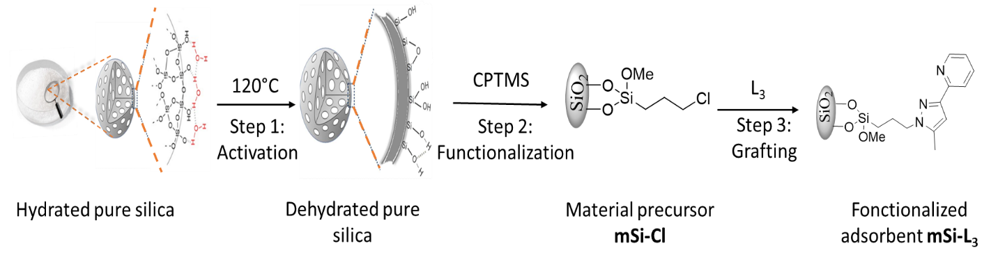
Scheme 1: Synthetic route to mSi-L₃.
Results and Discussion
Linker synthesis:
To obtain L₃, we had first to synthesize L₂ in two steps. The first step is to prepare pyridine carboxylate L₁ by esterification of the corresponding pyridinic acid. We then condensed the compound according to the Claisen reaction following the nucleophilic attack of the ester carbonyl group with acetone using sodium as a base in anhydrous toluene under middle conditions. This step yields a 1,3 keto-enol, which proceeds by removing the labile hydrogen from the diketone form, leading to the formation of an enol salt. After neutralization, the target compound is obtained in equilibrium with its diketone form (Scheme 2).
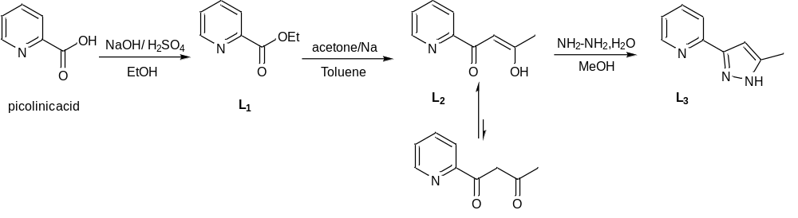
Scheme 2: Synthetic route to L₃

These tautomeric forms between 1,3 diketone pyridine and 1,3 keto-enol pyridine depend mainly on the substituents.^{[23]} When the substituents R₁ and R₂ which make up the dionine skeletons are identical, only one rapidly equilibrating cis keto-enolic form is present (Scheme 3). In this case, the enol content is 100% due to the symmetry of the two enol forms as encountered for dibenzoylmethane.^{[24a,b]} However, when R₁ ≠ R₂, three tautomeric forms are present. When R₁ is an aromatic group such as a five-membered heterocycle like pyrazole or furan or a six-membered cycle like pyridine, and R₂ is an alkyl group like in our case the mesomeric effect dominates the inductive effect.^{[25]} The resonance stabilization of the isomers predominantly favours the formation of β-keto-enols adjacent to the carbon carrying the alkyl substituent leading to the formation of our target product L₂ in major yield. This result is proved with NMR and DEPT characterized by a signal at 4.21 ppm and a small negative signal at 52.94 ppm relative to carbon (-CH₂) (See ESI), indicating the presence of the diketonic form in mixture with the enol L₂.^{[26]}
The obtained keto-enol mixture does not represent a problem for the next step in the synthesis since the reaction goes on unsubstituted hydrazine.
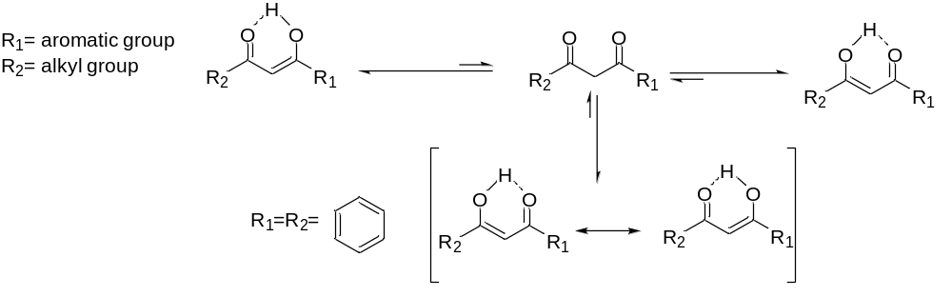
Scheme 3 : Tautomeric equilibrium when R₁ = R₂ and R₁ ≠ R₂.
Materials characterization
It was mandatory to dehydrate silica before use to unleash reactive silanol group. This was checked by FT-IR spectra with the vibration of adsorbed water molecules over the range of 3400-3500 cm⁻¹, which are engaged in strong hydrogen bonding interactions with the silanol groups present on the silica’s surface,^{[27]} that disappear after activation (Figure 1).
Successful synthesis of mSi-Cl was checked with the presence of bands at 2981, 1474, 679 cm⁻¹ , which correspond to C-H, Si-C and C-Cl vibrations, respectively.^{[28]} The immobilization of the organic ligand onto silica was confirmed by comparing FT-IR spectra of mSi-Cl with mSi-L₃, with the disappearance of the C-Cl band and the emergence of peaks at 1466 and 1389 cm⁻¹ , characteristic of υ(C=N) and υ(C-C) vibrations in the pyrazole and pyridine rings.^{[28]} Different types of silanol groups present in silica gel are also observed (Table 1). Chemical analysis for mSi-L₃ of C, 7.40; N, 1.20% showed too successful linkage of L₃ by comparison with C, 4.47% for mSi-Cl.
Table 1: FTIR characteristic vibrations for different types of silanols in activated silica
 | Silanols |  |  | Siloxanes (SiO)
FT-IR υ (cm⁻¹) | Simple | Vicinal | Geminate | Siloxanes (SiO)
FT-IR υ (cm⁻¹) | 3735 | 3650-3660 | 3740-3747 | 453-801-1068
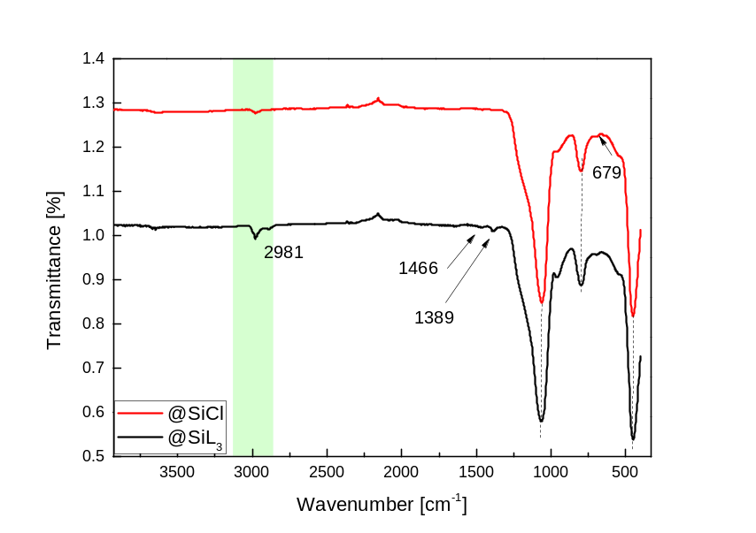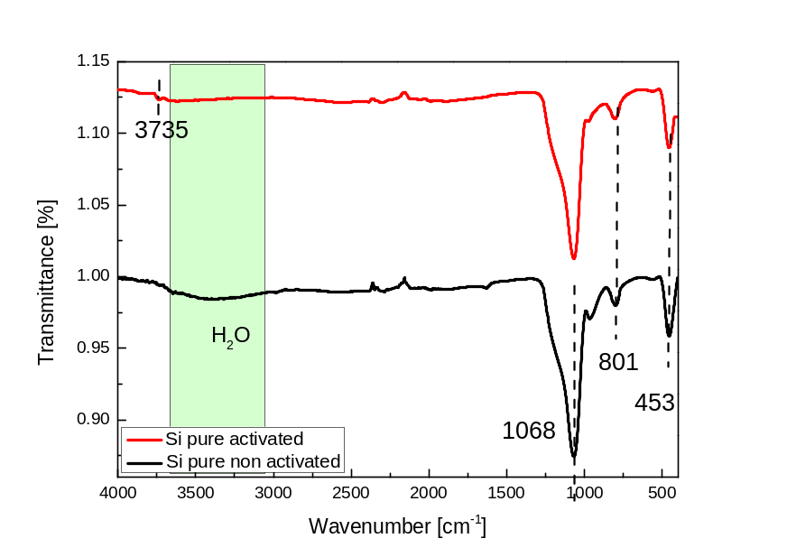

Figure 1: FTIR spectra of pure hydrated and dehydrated Si (left) and functionalized mSi-Cl, mSi-L₃ (right).

Thermal stability of the mSi-Cl precursor and hybrid material mSi-L₃ was investigated by thermogravimetric analysis and compared to pure silica gel (Figure 2). All samples exhibit a first significant mass loss that corresponds to weakly bonded water molecules from silica gel.^{[29]} It is found between 25-150°C for silica, whereas for modified samples, it is reduced in the range 25-125°C indicating that the adsorbed water onto the silica gel surface is replaced via the grafting agent.^{[30]} A second loss was observed between 150 and 800°C with 10.84% and 13.41% for mSi-Cl and mSi-L₃, respectively. The variation in high-temperature decomposition compared to unmodified silica results from the surface modification induced by the organic matrix.^{[31a,b]} Figure 2 also shows a slight weight loss for both pure SiO₂ and mSi-Cl at temperatures above 250°C, which can be attributed to the self-condensation of silanol groups into siloxanes.^{[32]}
A grafting rate of 0.80 mmol/g for mSi-Cl was derived indicating successful grafting, while the grafting rate for mSi-L₃ is slightly lower at 0.52 mmol/g. This discrepancy can be attributed to two factors: (i) the presence of a higher density of accessible pores in the empty silica matrix, and (ii) the steric hindrance imposed by the pyridine pyrazole ligand, which restricts the accessibility of all functional groups.
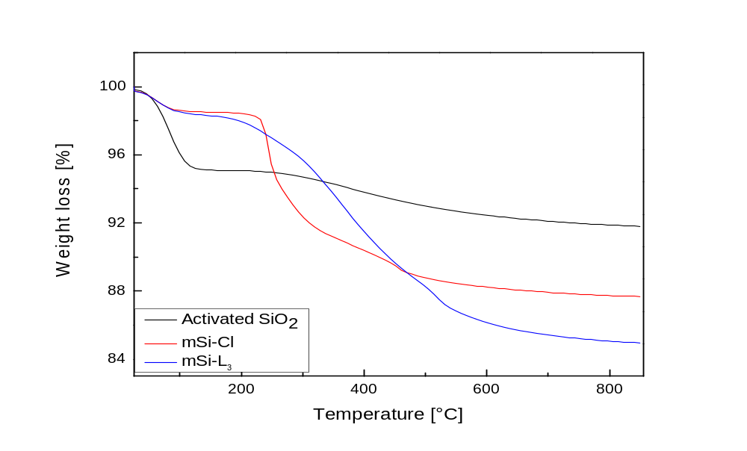
Figure 2 : Thermogravimetric curves of free silica SiO₂, mSi-Cl and mSi-L₃.
Nitrogen adsorption-desorption isotherms of mSi-Cl precursor together with mSi-L₃ adsorbent are shown in Figure 3 in comparison to the pure silica support. These samples all showed a typical isotherm of type IV with visible hysteresis loops type H2 and a steep increase in adsorption at relative pressures of 0.5–0.9 attributed to capillary nitrogen condensation, manifesting that the samples are mesoporous.^{[33a,b]} The surface areas, pore volumes and average pore size distributions for functionalized materials decrease in comparison to SiO₂ showing that the grafting was carried out on the internal surface, thus inside the pores (Table S1).
For example, the BET specific surface areas of mSi-Cl is apparently smaller than SiO₂ and decrease further for mSi-L₃: mSi-L₃ 417 m²/g < mSi-Cl 494 m²/g < SiO₂ 579 m²/g indicating the coverage of the silica surface with functional groups which blocks partially the adsorption of the molecules of nitrogen. These findings are in accordance with previous studies.^{[34]}
The silica materials employed in this study exhibit a higher surface area compared to those reported in the literature for similar applications. ^{[35a,b]}
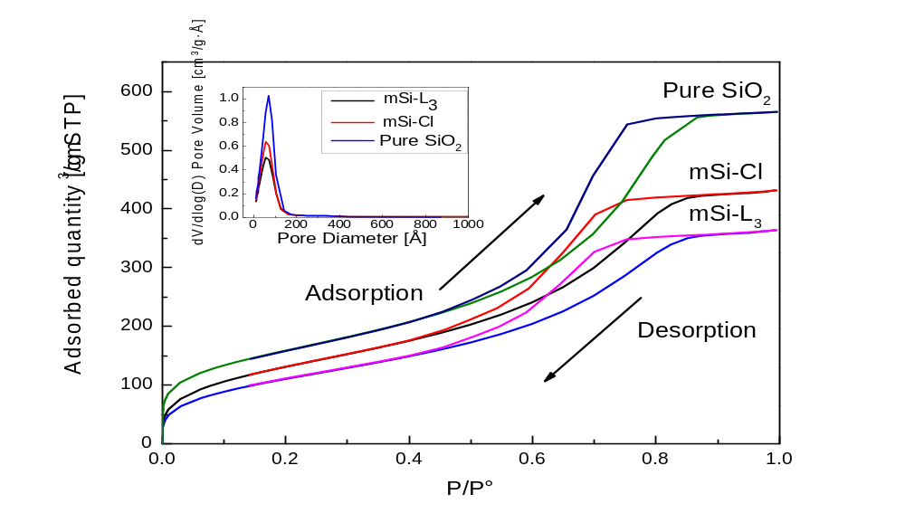
Figure 3 : Nitrogen adsorption–desorption isotherm of unmodified silica, mSi-Cl and mSi-L₃. The caption shows the pore size distribution.
The ¹³C NMR spectrum of mSi-L₃ shows the presence of organic moieties onto silica. (Figure 4). Indeed, peaks appearing at 9, 25 and 46 ppm correspond to resonance of carbon atoms in C-Si propyl skeleton, C-C, C-N spacer between L₃ and silica gel. While the methoxy group not bounded to silica gel respectively resonates at 59 ppm.^{[36]} Remaining signals are assigned to pyrazole pyridine ligand, with 15 ppm corresponding to CH₃ substituent. The peak at 104 ppm may be attributed to the carbon of pyrazole ring. In addition, the resonance of aromatic carbons related to pyridine ring appear at 122, 125 and 142 ppm, as well as the unshielded large signal centred at 149 ppm that can be assigned to C-N bonds in both rings.

Figure 4: CP-MAS TOSS Solid-state ¹³C NMR spectrum of mSi-L₃.
These findings imply that the chloride groups on the surface of mSi-Cl have been exchanged with ligand L₃ (see ESI). To provide a basis for comparison, the NMR ¹³C spectra of both mSi-L₃and the unconstrained L₃ ligand exhibit similarity, indicating the accomplishment of the surface's chemical modification.
Solid-state ²⁹Si NMR spectroscopy allowed us to distinguish silicon atoms involved in siloxane bridges, thus confirming a successful grafting. Figure 5 shows clear signals at δ = -110 ppm and δ =-100 ppm referring the presence of Q⁴ [(SiO)₄Si] and Q³ [(SiO)₃SiOH] respectively. Notably, the proximity of Q² geminated Si atoms (δ = -90 ppm) to Q³ species leads resonance lines are overlapped. Further, the signal at -65 ppm called T³ corresponds to organosilane silicon atoms linked to three bridging oxygen atoms to the central Si atom,^{[32]} and the signal at -57 ppm relates to T² units. The presence of these two signals T² and T³ confirms that the groups are covalently bonded to the silica surface.

Figure 5: CP-MAS Solid-state ²⁹Si NMR spectrum of mSi-L₃.

The morphologies of unmodified silica, mSi-Cl functionalized silica and the adsorbent mSi-L₃ were examined at different surface locations using SEM (Figure 6). The images reveal different microstructures presumably indicating an increase in surface roughness upon functionalization of silica whose surface is much smoother. Also, a significant decrease is observed in the silica-based particle size after their functionalization with 3-chloropropyltrimethoxysilane and L₃ due to partial aggregation of inorganic-organic hybrid particles. This could be reflecting a strong interaction between silica surface and the functional groups.^{[37]} These images confirm the results obtained in solid state ¹³C and ²⁹Si NMR spectroscopy revealing the coexistence of organic and inorganic networks due to the incorporation of organic molecules within silica pores leading to a homogeneous phase. On the other hand, these results strengthen the phenomenon observed in BET surface analysis that could explain the increase of the pore volume of the hybrid material mSi-L₃ compared to that of the silica gel.
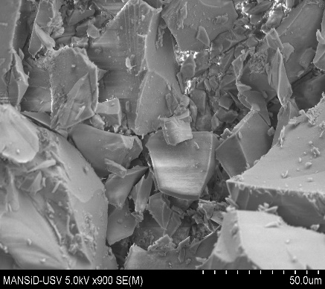
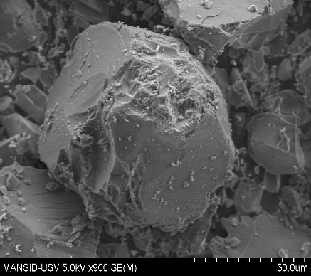
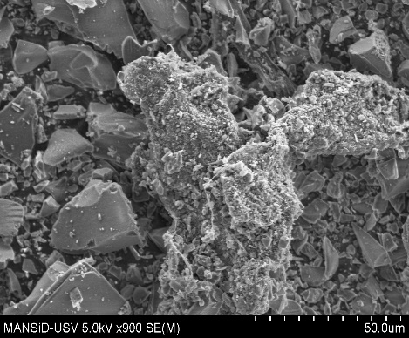
In conclusion, these results confirm the coexistence of L₃ within the pores of the highly branched silica via covalent bonds.
Pure silica (a)
mSi-Cl (b)
50.0 um
50.0 um
50.0 um
mSi-L₃ (c)
Figure 6: SEM micrographs of pure silica, precursor mSi-Cl and adsorbent mSi-L_{3.}
Adsorption studies
The adsorption performance of mSi-L₃ towards Cu^{II}, Cd^{II} and Pb^{II} was investigated by studying various factors that play a crucial role in the uptake characteristics of the adsorbent. These factors include pH, shaking time, temperature, the interference of a mixture of ions and other significant parameters.
pH effect
Concentration of hydronium ions is one of the most crucial factors in controlling the adsorption of metal ions by a given adsorbent.^{[38]} Figure 7 represents the evolution of pH ranging from 1 to 7 according to adsorption capacity. The ion removal capacity by mSi-L₃ increases with the increase in pH value, and quantitative metal uptake was observed at pH 6 for all studied cations. The removal efficiencies of all ions by mSi-L₃ were very low under strong acidic conditions. With the high hydronium concentration, the surface of the adsorbent was protonated and positively charged, which would repulse positively charged metal ions in solution.^{[39]} On the other hand, hydronium ions competed with metal ions for bonding with nitrogen active sites of pyridine-pyrazole ligand, resulting in reduced active binding sites for ion adsorption. As the pH increases, the surface is gradually deprotonated and active sites are more accessible for coordination leading to the increase of adsorption capacity for all metal ions until a maximum pH of 6 corresponding to 99% of optimal concentration used. However, when pH > 7, metal ions easily form insoluble hydroxide precipitates (e.g. M(OH)⁺, M(OH)₂, and M(OH)₃) ^{[40]}, thus the metal is difficult to be adsorbed. In this case, it was difficult to distinguish between hydrolyzed or adsorbed metal ions and the calculated adsorption capacity of adsorbents would not be exact.
Given mSi-L₃ is found to significantly capture Cu^{II}, Cd^{II} and Pb^{II} ions at pH = 6, this condition was applied for subsequent batch adsorption experiments.
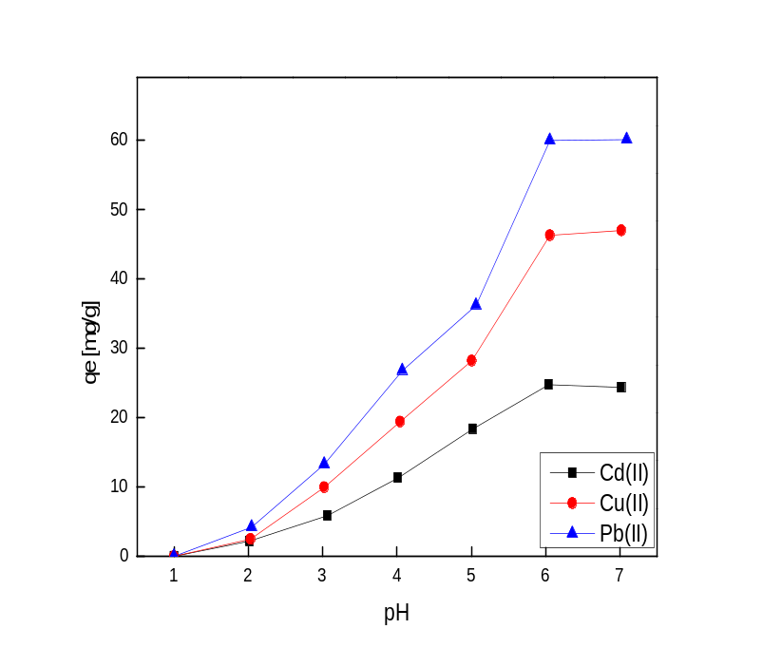
Figure 7: Effect of pH on adsorption of metals using mSi-L₃ .
Effect of contact time and adsorption kinetics
Time-dependent removal of metal ions using mSi-L₃ was investigated over a duration ranging from 2 to 30 min., employing optimized conditions previously established (at room temperature (25°C) and pH 6). Within the initial five-minutes interval, the adsorbent exhibited remarkably rapid adsorption of Cu^{II}, Cd^{II} and Pb^{II} ions, Pb^{II} being the fastest (Figure 8).
At the beginning, adsorption is rapid due to the complexation between metal ions and available active sites of the mesoporous adsorbents. After 5 min of shaking time, the adsorption efficiency varies slowly to reach equilibrium after 11 min manifesting that the adsorption site is nearly saturated. The fast removal of Cu^{II}, Cd^{II} and Pb^{II} onto mSi-L₃ compared to other silica based materials (Table 2) may be due to two reasons: (i) the large specific surface allowing metal ions to be adsorbed easily. (ii) the strong affinity for pyrazole-pyridine grafted ligand toward studied metals, specifically for Pb^{II}. After this period, there is no noticeable improvement in the metal ions capture, indicating that adsorption has reached its maximum capacity because of heightened steric hindrance on the silica surface. This saturation may result from the creation of a single layer of metal ions on the adsorbent's surface.^{[41]}
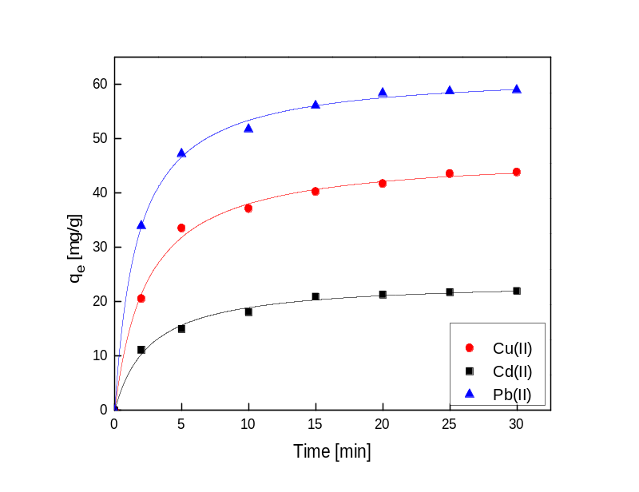
Figure 8: Effect of contact time on the adsorption of Cu^{II}, Cd^{II} and Pb^{II} onto mSi-L₃ .
Table 2: Comparison of equilibrium time of different adsorbents for the removal of Cu^{II}, Cd^{II} and Pb^{II}.
Adsorbent | Cu^{II} | Cd^{II} | Pb^{II} | Reference
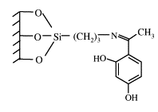 | >25 min | >25 min | >25 min | [42]
Biological adsorbent | - | 20 min | 20 min | [43]
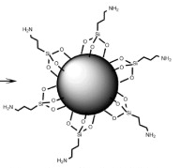 | - | 100 min | 100 min | [44]
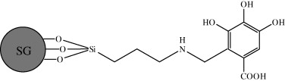 | 30 min | 30 min | 30 min | [45]
Kinetic modeling
Two kinetic models were used to explain the mechanism controlling metal-ion adsorption: the pseudo-first-order (PFO) and pseudo-second-order (PSO) models.^{[46a,b]} Experimental data were fitted according to linear form Eq. 1 and 2 of PFO and PSO, respectively.^{[47]}
ln (q_{e} - q_{t}) = lnq_{e} - K₁t (1)
t/q_{t} = t/q_{e} + 1/K₂q_{e}² (2)
where q_{t} and q_{e} are the adsorption capacity of metal ions (mg/g) vs. time and at equilibrium, respectively; K₁ (min⁻¹) and K₂ (g/mg/min) are the rate constant of the PFO and PSO, respectively (Table 3).

In contrast to the PFO model, the PSO model is more effective in describing the adsorption kinetics of Cu^{II}, Cd^{II}, and Pb^{II}, as evidenced by the higher correlation coefficients (R²) close to 1, which generally indicate a strong match between theoretical and experimental values.
As shown in Table 3, the PSO model achieves R² values of 0.994, 0.998 for Cu^{II}, Pb^{II} and Cd^{II} respectively , indicating an excellent fit to the experimental data. On the other hand, the PFO model yields lower R² values, around 0.91, suggesting it is less accurate in representing the adsorption kinetics.
To further support this conclusion, we calculated the Δq value, which represents the difference between the experimental adsorption capacity (q_{e}(exp)) and the theoretical adsorption capacities (q_{e}(theo)) calculated by the PFO and PSO models:

Δq = q_{e}(exp) − q_{e}(theo) (3)

A smaller Δq indicates better alignment between experimental and theoretical results. In our study, the Δq values show that the PSO model more accurately reflects the experimental data compared to the PFO model, as evidenced by the smaller discrepancies between the experimental and theoretical adsorption capacities. For example, the Δq for Cu^{II} was 1.978 mg/g, whereas the PFO model showed a larger deviation of 20.691 mg/g. The consistency between the Δq results and the correlation coefficients (R²) further supports that the PSO model is the more suitable fit for describing the adsorption kinetics. This points out that the retention processes may involve chemical adsorption occurring between active nitrogen sites of pyrazol-pyridine and metal ions.^{[48a]}

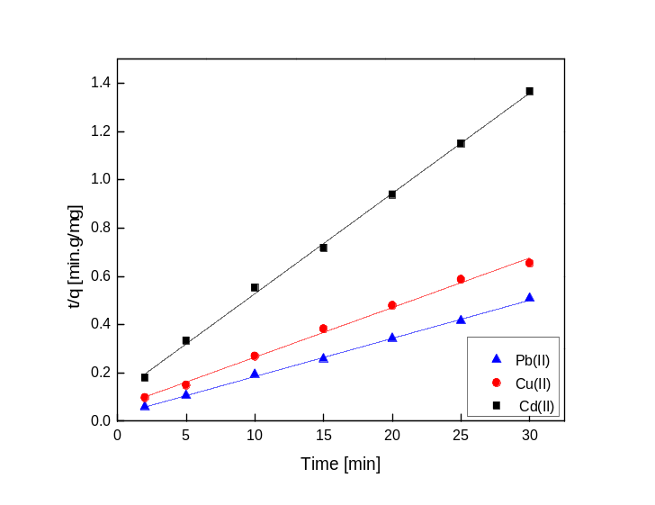
Figure 9 : Linear form of pseudo-second-order for adsorption rates of Cu^{II}, Cd^{II} and Pb^{II} onto mSi-L₃ .
Table 3: Kinetic equation constants of adsorption on mSi-L₃ .
Adsorbent | Parameters | Metals
mSi-L₃ | Parameters | Cu^{II} | Pb^{II} | Cd^{II}
mSi-L₃ | q_{e}(exp) mg/g | 46.66 | 61.91 | 22.73
mSi-L₃ | Pseudo second order (PSO)
mSi-L₃ | q_{e} (mg/g) | 48.7804 | 63.2911 | 24.0963
mSi-L₃ | K₂ (g/mg.min) | 0.0070 | 0.0092 | 0.0152
mSi-L₃ | R² | 0.994 | 0.998 | 0.998
mSi-L₃ | Slope | 0.0205 | 0.0158 | 0.0415
mSi-L₃ | Intersection | 0.0595 | 0.0271 | 0.1129
mSi-L₃ | ∆q_{e} (q_{e(exp)}-q_{e(theo)}) | 1.9781 | 1.3811 | 1.3663
mSi-L₃ | Pseudo first order (PFO)
mSi-L₃ | q_{e}(mg/g) | 25.9689 | 23.9641 | 12.0070
mSi-L₃ | Slope | -0.0793 | -0.0954 | -0.1000
mSi-L₃ | Intersection | 3.2569 | 3.1765 | 2.4855
mSi-L₃ | R² | 0.9131 | 0.9274 | 0.9527
mSi-L₃ | K₁ (min⁻¹) | 0.0793 | 0.0954 | 0.1000
mSi-L₃ | ∆q_{e} (q_{e(exp)}-q_{e(theo)}) | 20.6911 | 37.9459 | 10.7230
Error analysis
Alongside R² values and ∆q_{e} which reflect how well the PSO kinetic model fits experimental data, using other error functions can strengthen the obtained results. For instance, using (i) residual root mean square error (RMSE), (ii) sum of the squares of errors (ERRSQ) or (iii) coefficient of determination (R²). The smaller error function value, the better curve fitting^{[48b,c][17b]}
RMSE = $\sqrt{\frac{1}{n-2}\sum_{i=1}^{n}{{\left(q_{t,exp}-q_{t,cal}\right)}^{2}}}$ (4)

ERRSQ = $\sum_{i=1}^{n}{{(q_{t,cal}-q_{t,exp})}^{2}}$ (5)
R²=$\frac{{(q_{t,exp}-\overline{q_{t,cal})}}^{2}}{\sum_{i=1}^{n}{(q_{t,exp}-\overline{q_{t,cal})}+{(q_{t,exp}-q_{t,cal})}^{2}}}$ (6)
- Where q_{t,exp}​ is the experimental adsorption capacity at time t
- q_{t,cal​} is the theoretical adsorption capacity calculated using the PSO model
- n is the number of data points
To validate the obtained results, we calculated the Root Mean Square Error (RMSE) to assess the fit between the theoretical adsorption capacities predicted by the pseudo-second-order (PSO) kinetic model and the experimental capacities observed for Cu^{II}, Cd^{II} and Pb^{II} adsorption from water using the mSi-L₃ material.
The RMSE values for the PSO model were calculated using equation (4). Upon analyzing the RMSE data Pb^{II}: 1.14, Cu^{II}: 1.45 and Cd^{II}: 0.64, a low RMSE value combined with a high correlation coefficient (R²) close to 1 and a small ∆q, indicates a strong fit of the PSO kinetic model for all studied metals. This shows a good correlation between theoretical predictions and experimental results.
However, the varying RMSE values between metals highlights differences in the model’s predictive accuracy for each metal. The lower RMSE for Cd^{II} (0.64) suggests that the PSO model fits the adsorption data for Cd^{II} more accurately than for Pb^{II} and Cu^{II}. These variations do not contradict our results; rather, they underscore the complexity of adsorption processes and the influence of other parameters in the adsorption, which will be discussed in the selectivity section.
In conclusion, the combination of R², ∆q, and RMSE values confirms that the PSO model provides a good fit for the adsorption of Cu^{II}, Cd^{II} and Pb^{II} from waste water by the mSi-L₃ material.
Effect of temperature and adsorption thermodynamics
We have established above that pH and contact time exert significant control over the adsorption amount. Temperature is another factor to consider, as it impacts the quantity of metal ions adsorbed by the material. To do so, enthalpy change (ΔH°), entropy change (ΔS°) and Gibbs free energy (ΔG°) can be calculated by the following equations:
$lnK_{d}= \frac{∆S°}{R}-\frac{∆H°}{RT}$ (7)
$∆G°=-RT{lnK}_{d}$ (8)
$K_{d}= \frac{\left(C_{0}-C_{e}\right)}{C_{e}}*\frac{V}{m}$ (9)
where, R is the gas constant (8.314 J. mol⁻¹.K⁻¹), T is temperature in Kelvin, and K_{d} is the adsorption equilibrium constant, C₀ (mg L⁻¹ ) is the initial concentration of metal ion, and C_{e} (mg L⁻¹ ) is the equilibrium concentration of metal ion, V is the volume of solution and m (g) is the dosage of sorbents.
The effect of temperature on adsorption capacity of mSi-L₃ towards Cu^{II}, Cd^{II} and Pb^{II} was investigated by conducting the adsorption tests at different temperatures (30°C, 35°C, 40°C, 45°C). Accordingly, the linear plots of ln K_{d} versus 1/T(K) (Figure 10) allow the calculations of thermodynamic parameters (ΔH°, ΔS° and ΔG°) (Table 4). The positive values of ΔH° illustrate that the adsorption of Cu^{II}, Cd^{II} and Pb^{II} onto mSi-L₃ is an endothermic process. The disorder at adsorbate/adsorbent interface during the sorption process is confirmed by the positive values of ΔS° for each metal. At all temperature range ∆G° consistently shows negative values, this negativity becomes even more pronounced with increasing temperature. This clearly indicates that temperature plays a crucial role in the adsorption process. As a result, higher temperatures make the adsorption of metal ions Cu^{II}, Cd^{II} and Pb^{II} onto the material mSi-L₃ more favourable and spontaneous.^{[49a,b]}
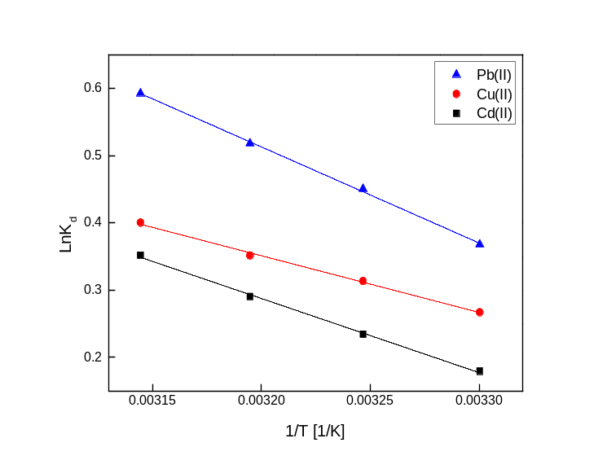
Figure 10: Effect of temperature on adsorption of metal ions onto mSi-L₃ (Conditions: V = 10 mL metal solutions, m = 10 mg of adsorbent, pH = 6, t = 30 min, T = 30°C, 35°C, 40°C and 45°C).

Table 4: Thermodynamic parameters for metal ions sorption on mSi-L₃ .

Adsorbent | Metal | Cu^{II} | Pb^{II} | Cd^{II}
mSi-L₃ | R² | 0.997 | 0.998 | 0.998
mSi-L₃ | ∆H°(kJ mol⁻¹) | 6.9627 | 12.0841 | 9.1753
mSi-L₃ | ∆S°(J mol⁻¹ K⁻¹) | 25.2008 | 42.9326 | 31.7502
mSi-L₃ | T (K)  303  308  313  318 | ∆G° (kJ. mol⁻¹)
mSi-L₃ | T (K)  303  308  313  318 | -0.6731 | -0.9244 | -0.4449
mSi-L₃ | T (K)  303  308  313  318 | -0.7991 | -1.1391 | -0.6037
mSi-L₃ | T (K)  303  308  313  318 | -0.9251 | -1.3537 | -0.7624
mSi-L₃ | T (K)  303  308  313  318 | -1.0511 | -1.5684 | -0.9212

Adsorption isotherms
The adsorption isotherm study provides insights into the transfer of adsorbate from the solution phase to the solid phase at equilibrium. To investigate the adsorption behavior of our synthesized silica material mSi-L₃ for Cu^{II}, Cd^{II} and Pb^{II} ions in water decontamination, we evaluated both Langmuir and Freundlich isotherm models.
The Langmuir adsorption model describes monolayer adsorption of the adsorbate on a homogeneous adsorbent surface,^{[49f]} which can be expressed in its linear form as:
$$\frac{C_{e}}{q_{e}}= \frac{C_{e}}{q}+ \frac{1}{qK_{L}}$$
Where q_{e} is the amount of the adsorbed solute on the adsorbent surface (mg/g), C_{e} is the equilibrium concentration of the ions in the solution (mg/L), q is the adsorption capacity at equilibrium (mg/g), K_{L} is the Langmuir adsorption constant (L/mg).

The empirical Freundlich model, which considers adsorption on an energetically heterogeneous surface and assumes different affinities for adsorption with interactions between the adsorbed molecules,^{[49f]} is represented by its linear form:
$$lnq_{e}{=lnK_{F}+ \frac{lnC_{e}}{n}}$$
where q_{e} is the adsorption capacity (mg/g), C_{e} is the equilibrium concentration (mg/L), K_{F} is the Freundlich constant (mg·g⁻¹), and n is the Freundlich constant indicating the adsorption intensity.

In our study, the Langmuir model significantly provides a better fit for the experimental data compared to the Freundlich model (Table 5). This conclusion is supported by the higher correlation coefficients (R²) with the Langmuir model (Figure S11), we obtained—0.998 for Cu^{II}, 0.998 for Pb^{II} and 0.997 for Cd^{II}. These high R² values indicate a strong linear relationship between our theoretical predictions (q (mg/g) ) and the observed adsorption data (q_{e}(exp) (mg/g)), reinforcing the model's reliability. For instance, the experimental adsorption capacities (q_{e}(exp)​) were 46.66 mg/g for Cu^{II}, 61.91 mg/g for Pb^{II}, and 22.73 mg/g for Cd^{II}, which closely matched the Langmuir model predictions of 49.35 mg/g, 63.86 mg/g, and 23.59 mg/g, respectively. In contrast, the Freundlich model yielded lower R² values—0.845 for Cu^{II}, 0.920 for Pb^{II}, and 0.922 for Cd^{II}—indicating that it does not accurately capture the adsorption dynamics in our system. The Freundlich model, with its lower R² values, suggests a less accurate description of the adsorption process in our system. As a result, the Langmuir model indicates that the adsorption of Cu^{II}, Cd^{II} and Pb^{II} ions onto the synthesized m-SiL₃ material occurs as monolayer adsorption on a homogeneous surface. This conclusion is consistent with recent studies on silica-based adsorbents for heavy metal removal.^{[50-52]}
Table 5: Isotherms parameters by linear regression method for the sorption of Cu^{II}, Cd^{II}, and Pb^{II} ions by m-SiL₃
Adsorbent | Metal | q_{e}(exp) (mg/g) | Langmuir model |  |  | Freundlich model
Adsorbent | Metal | q_{e}(exp) (mg/g) | q(mg/g) | KL  (L/mg) | R2 | KF  (mg/g) | n | R2
mSi-L₃ | Cu^{II} | 46.66 | 49.3488 | 0.1809 | 0.998 | 20.9052 | 5.2910 | 0.845
mSi-L₃ | Pb^{II} | 61.91 | 63.8569 | 0.2028 | 0.998 | 17.0201 | 3.2916 | 0.920
mSi-L₃ | Cd^{II} | 22.73 | 23.5904 | 0.3110 | 0.997 | 4.9844 | 2.1427 | 0.922

Selectivity
The competition adsorption of Cu^{II}, Cd^{II} and Pb^{II} under optimal conditions (concentration, pH, temperature) for 30 min was investigated for mSi-L₃ . A selectivity towards Pb^{II} was identified following Pb^{II} > Cu^{II} > Cd^{II} (Figure 11). The reason is presumably due to chelating force of L₃ favoured by its suitable internal cavity structure formed by its nitrogen atoms, which fits the larger ionic radius of Pb(II) (1.19 Å) compared to Cu(II) (0.73 Å) and Cd(II) (0.95 Å).^{[53]} This situation favours a stronger interaction between mSi-L₃ and Pb(II) ions, and as a result, a better selectivity. This selectivity can also be explained by the higher electronegativity and polarizability of Pb^{II}. Electronegativity, which measures an atom's ability to attract electrons in chemical bonds, is greater in Pb^{II} compared to Cu^{II} and Cd^{II}, allowing it to form stronger coordinate bonds with nitrogen atoms in the L₃ ligand. These stronger interactions are crucial for enhancing the stability of the Pb^{II}-ligand complex, thereby promoting more effective adsorption onto the mSi-L₃ surface.^{[54]}
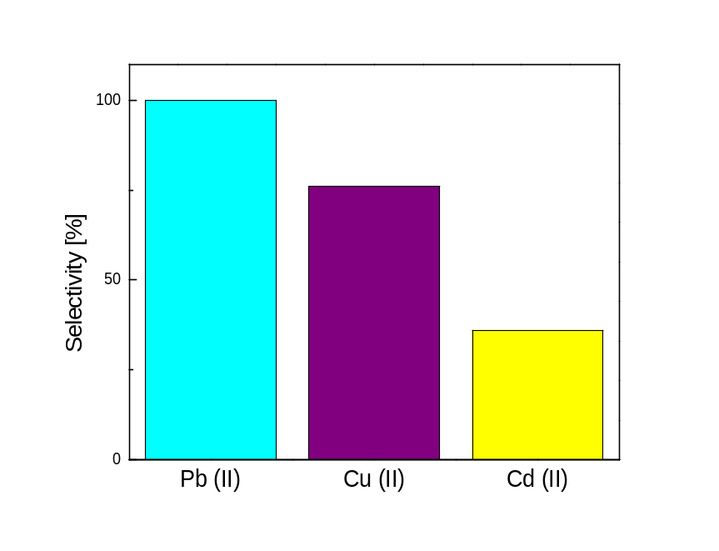

Figure 11: Selectivity of mSi-L₃ towards Cu^{II}, Cd^{II} and Pb^{II} at pH 6, contact time 30 min, 25°C.
Regeneration of the adsorbent
To increase its technology readiness level (TRL), the adsorbent should be economically efficient and reduce treatment costs at best. As a result, the adsorption process should be capable of reversibility, with the ability to reuse and regenerate the adsorbent. For that, the hybrid material mSi-L₃ has been evaluated by continuous adsorption-desorption cycles. Both regenerability and reusability of mSi-L₃ silica gel, previously loaded with metal ions Cu^{II}, Cd^{II} and Pb^{II}, were examined by washing it with 1M HCl aqueous solution for 2h. Under such conditions, the adsorbed cations were completely removed from the adsorbent surface. Then, the solid was centrifuged, neutralized by a NaOH solution, dried in vacuum and integrated into a new adsorption-desorption successive cycles. After five adsorption–desorption cycles, the adsorption capacity of Cu^{II}, Cd^{II} and Pb^{II} was still above 98% of the original value, indicating the easy regeneration of the functionalized silica gel. The adsorption capacity of mSi-L₃ however decreases with the extension of cycle time mainly to reach 97% after 5 cycles owing to the loss of some active sites.^{[55]}
The stability of the organic groups L₃ onto the solid surface was also confirmed by TGA after each cycle of adsorption-desorption between 25-800°C. Figure 12 shows that the organic matrix on the silica surface remains stable with no significant change. This result highlights the stability and the evident regeneration performance of mSi-L₃ after five cycles. Overall, these materials have reasonably good recycling and regeneration abilities.
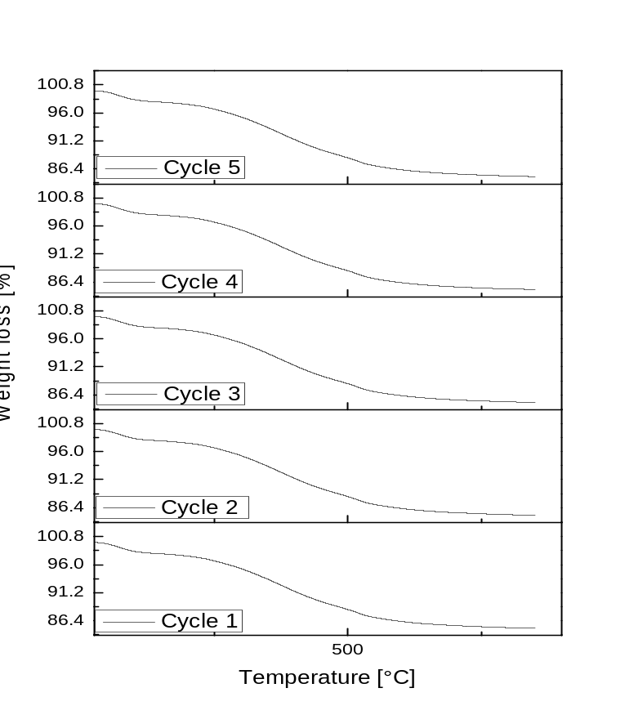
Figure 12 : Thermogravimetric curves of mSi-L₃ adsorbent after five cycles of regeneration.

Adsorption mechanism
The adsorption mechanism primarily depends on the nature of the organic matrix grafted onto silica, introducing various factors into play, including electrostatic interactions and the ionic radius of the adsorbate. In our study, we observed that the pyrazolyl-pyridine ligand exhibited significant selectivity for lead over copper and cadmium. As a result, we can describe the diffusion mechanism of these metal ions within the porous structure of mSi-L₃ into three distinct stages^{[56]} : firstly, particle external diffusion from the aqueous solution to the surface of mSi-L₃ . Secondly, particle internal diffusion as metal ions diffuse from the material surface to the interior pores; and finally, adsorption occurs through complexation with functional groups residing within the pores. These findings align seamlessly with the results obtained from kinetic tests calculated above. Notably, we observed a rapid increase in q_{e} within the first few minutes, attributed to the abundant adsorption sites on the surface of mSi-L₃. As the contact time extends, the quantity adsorbed experiences a slower evolution until reaching a state of stability, indicating the increased accessibility of active sites, likely due to steric hindrance on the adsorbent surface.
Application of mSi-L₃ for the remediation of environmental water samples
The adsorbent mSi-L₃ was applied to real water samples in order to evaluate its capacity in real conditions to remove trace elements. The water samples were collected from a Moroccan river located 100 km west of Oujda city, called Oued Za river at 34°25'13.6''N 2°52'53.5''W. All samples were collected under standard conditions (with a polyethylene bottle, filtered through a 0.45 µm nylon, 10 mg of the adsorbent with 10 mL of the samples at room temperature) and concentrations of Cu, Cd, Pb were determined by atomic absorption. The found concentrations were as follows: Cd: 0.0005 ppm, Cu: 0.0149 ppm and Pb: 0.0155 ppm. These low values might be attributed to the rainy season during the sampling, which could have influenced the ion concentrations due to elevated water levels. Therefore, in order to test the effectiveness of our adsorbent in more concentrated real water samples, samples were concentrated using 150 ppm Pb^{II}, given that this metal yielded the best performances (Fig. 12) As a result, mSi-L₃ exhibited fairly good performance, effectively removing 34% of lead, 13% of copper and all cadmium from concentrated solutions (Table 6). Thus, mSi-L₃ maintains its effectiveness and selectivity towards Pb^{II} compared to Cu^{II}, with a full removal of traces of Cd^{II} ions.
Table 6: Experimental data obtained on real water samples, doped with Pb^{II} ions.
Material | Metal ions | % elimination
mSi-L₃ | Pb^{II} | 34
mSi-L₃ | Cu^{II} | 13
mSi-L₃ | Cd^{II} | 100

Comparison with other adsorbents
mSi-L₃ adsorbent is highly effective in capturing selected heavy metals Cu^{II}, Cd^{II} and Pb^{II} in real water samples, even at low concentrations (Table 7). Notably, mSi-L₃ demonstrated a comparable cadmium adsorption capacity (23mg/g) to that reported for natural adsorbents like bamboo charcoal (12.08 mg/g) and Fe₃O₄ nanocomposites (9.52 mg/g) within a short contact time.^{[57a,b]} Furthermore, for Pb^{II} ions, mSi-L₃ exhibited a significantly higher capacity (61 mg/g) compared to commonly used commercial activated carbons, including NC-60 and RS-1301, with reported values of 25.30 mg/g and 35.43 mg/g, respectively.^{[58]} In the case of Cu^{II}, mSi-L₃ demonstrates better performances when compared to other silica materials grafted with pyrazole, e.g. in pyrazole-enol-imine-furan-substituted silica (SiNPz-Fn). Specifically, mSi-L₃ displayed an adsorption capacity of 46.66 mg/g, exceeding the 27.35 mg/g capacity recorded for SiNPz-Fn.^{[59]}
Table 7: Comparison of mSi-L₃ performances with some reported sorbents for Cu^{II} , Cd^{II} and Pb^{II} adsorption.
Adsorbents | Cd^{II} (mg/g) | Pb^{II} (mg/g) | Cu^{II} (mg/g) | Ref.
mSi-L₃ | 23 | 61 | 46 | This work
Bamboo charcoal | 12.08 | - | - | 57a
Fe₃O₄ nanocomposites | 9.52 | - | - | 57b
Commercial activated carbon NC-60 | - | 25.30 | - | 58
Commercial activated carbon RS-1301 | - | 35.43 | - | 58
Activated carbon from Sawdust | 8 | - | - | 59
Activated carbon | 6.7 | - | - | 60
Activated Carbon from Rice Straw | - | 35 | - | 61
SiNPz-Fn | - | - | 27.35 | 62
Conclusion
This study successfully developed a hybrid adsorbent, mSi-L₃, for the efficient removal of heavy metal ions from aquatic environments. The adsorbent demonstrated high adsorption capacity and selectivity for Cu^{II}, Cd^{II} and Pb^{II} ions, making it a promising green solution for contaminated water treatments. The adsorption process was found to be endothermic, and the adsorption kinetics were well-described by the pseudo-second-order model. The adsorbent also exhibited good regenerability and stability after multiple adsorption-desorption cycles, indicating its potential for practical use. The comprehensive analytical analyses confirmed the stability and effectiveness of mSi-L₃ in real water samples. Overall, this study contributes to the development and general understanding of sustainable and cost-effective solutions for water pollution control, highlighting the importance of advanced treatment technologies in addressing the global challenge of heavy metal contamination in water sources.

Author contributions
AO performed synthesis, characterization and wrote the paper with YG and SR. SR and YG both designed and managed the project. ST ran some experiments. LF and CA undertook solid state NMR studies. AR undertook SEM measurements.

Conflicts of interest
There are no conflicts to declare.
Acknowledgements
This research was supported by CNRST (PPR2-MESRSFC-CNRSTP10), the Fonds de la Recherche Scientifique-FNRS (PDR T.0095.21, CDR J.0064.23, EQP U.N027.24), the COST action CA21149. We thank ARES for a ‘mobility fellowship 2022’ allocated to A. O. The authors acknowledge the PC² platform of the University of Namur for access to solid-state NMR facility.
References
[1] G. T. Daigger, Evolving Urban Water and Residuals Management Paradigms: Water Reclamation and Reuse, Decentralization, and Resource Recovery, Water Environ Res. 81 (2009) 809-823.
[2] T. A. Larsen, S. Hoffmann, C. Lüthi, B. Truffer, M. Maurer, Emerging solutions to the water challenges of an urbanizing world, J. Sci 352 (2016) 928-933.
[3] R. Verma, P. Dwivedi, Heavy metal water pollution- A case study, Recent Research in Sci. Tech. 5 (2013) 98-99.
[4] A. Dolgormaa, C.-J. Lv, Y. Li, J. Yang, J.-X. Yang, P. Chen, H.-P. Wang, J. Huang, Adsorption of Cu(II) and Zn(II) Ions from Aqueous Solution by Gel/PVA-Modified Super-Paramagnetic Iron Oxide Nanoparticles, Molecules 23 (2018) 2982.
[5] R. Kumar, M. A. Laskar, I. F. Hewaidy, M. A. Barakat, . Modified Adsorbents for Removal of Heavy Metals from Aqueous Environment: A Review, Earth Syst. Environ 3 (2019) 83–93.
[6] Y. Liu, H. Wang, Y. Cui, N. Chen, Removal of Copper Ions from Wastewater: A Review, Int. J. Environ. Res. Public Heal. 20 (2023) 3885.
[7] S. Mauchauffe´e, E. Meux, Use of sodium decanoate for selective precipitation of metals contained in industrial wastewater, Chemosphere (2007) 763–768.
[8] C. Ahmed Basha, N.S. Bhadrinarayana, N. Anantharaman, K.M. Meera Sheriffa Begum, Heavy metal removal from copper smelting effluent using electrochemical cylindrical flow reactor, J. Hazard. Mater. 152 (2008) 71–78.
[9] S. Wan, W. Ding, Y. Wang, J. Wu, Y. Gu and F. He, Manganese oxide nanoparticles impregnated graphene oxide aggregates for cadmium and copper remediation, Chem. Eng. J. 350 (2018) 1135–1143.
[10] S. Mondal, S. Chatterjee, S. Mondal, A. Bhaumik, Thioether-Functionalized Covalent Triazine Nanospheres: A Robust Adsorbent for Mercury Removal, ACS Sustain. Chem. Eng. 7 (2019) 7353–7361.
[11] M. Machida, Y. Amano, M. Aikawa, Adsorptive removal of heavy metal ions by activated carbons, Carbon N. Y. 49 (2011) 3393.
[12] Z. Wang, K. Tan, J. Cai, S. Hou, Y. Wang, P. Jiang, M. Liang,. Asp. Silica oxide encapsulated natural zeolite for high efficiency removal of low concentration heavy metals in water, Colloids Surfaces A Physicochem. Eng 561 (2019) 388–394.
[13] Z.A. Alothman, A.W. Apblett, Metal ion adsorption using polyamine-functionalized mesoporous materials prepared from bromopropyl-functionalized mesoporous silica, J. Hazard. Mater. 182 (2010) 581–590.
[14] J.A.A. Sales, F.P. Faria, A.G.S. Prado, C. Airoldi, Attachment of 2-aminomethylpyridine molecule onto grafted silica gel surface and its ability in chelating cations, Polyhedron 23 (2004) 719–725.
[15] C.K. Liu, R.B. Bai, Q.S. Ly, Selective removal of copper and lead ions by diethylenetriamine-functionalized adsorbent: Behaviors and mechanisms, Water Res. 42 (2008) 1511–1522.
[16] S. Alasti Bonab, J. Moghaddas, M. Rezaei, In-situ synthesis of silica aerogel/polyurethane inorganic-organic hybrid nanocomposite foams: Characterization, cell microstructure and mechanical properties, Polymer 172 (2019) 27–40.
[17a] R.J. Qu, Y.Z. Niu, J.H. Liu, C.M. Sun, Y. Zhang, H. Chen, C.N. Ji, Adsorption and desorption behaviors of Pd(II) on silica-gel functionalized with ester- and amino-terminated dendrimer-like polyamidoamine polymers, React. Funct. Polym. 68 (2008) 1272–1280.
[17b] R. Rostamiana, M. Najafi, A. Abbas Rafati, Synthesis and characterization of thiol-functionalized silica nano hollow sphere as a novel adsorbent for removal of poisonous heavy metal ions from water: Kinetics, isotherms and error analysis, Chem. Eng. J. 171 (2011) 1004–1011.
[17c] A. Abbas Rafati, A. R. Afraz Borujeni, M. Najafi, A. Bagheri,
Ultrasonic/surfactant assisted of CdS nano hollow sphere synthesis and characterization, Materials Characterization 62 (2011) 94-98.
[18] A. Ahmad, S.H. Mohd-Setapar, C.S. Chuong, A. Khatoon, W.A. Wani, R. Kumar, M. Rafatullah, Recent advances in new generation dye removal technologies: novel search for approaches to reprocess wastewater, RSC Adv. 5 (2015) 30801–30818.
[19] M. Neznakomova, S. Boteva, L. Tzankov, M. Elhag, Non-woven Textile Materials from Waste Fibers for Cleanup of Waters Polluted with Petroleum and Oil Products, Earth Syst. Environ. 2 (2018) 413-420.
[20a] K.M. Kadish, K.M. Smith, R. Guilard, With Applications to Chemistry, Physics, Materials Science, Engineering, Biology and Medicine, in: Handb. Porphyr. Sci., World Scientific Publishing Company, 2016, 40, 372.
[20b] D.I. Ugwu, J. Conradie, The use of bidentate ligands for heavy metal removal from contaminated water, Environ. Adv. 15 (2024) 100460.
[20c] M. Zhang, Z. Yang, J. Su, H. Zhao, C. Xu, J. Sun, X. Liu, X. Peng, G. Sun, Y. Cui, A novel bidentate diamide ligand DODQ for the separation of uranium and rare earth ions in nitric acid medium, Hydrometallurgy 226 (2024) 106311.
[21a] N. Bicak, B. Senkal, D. Melekaslan, Poly (styrene sulfonamides) with EDTA-like chelating groups for removal of transition metal ions, J. Appl. Polym. Sci. 77 (2000) 2749–2755.
[21b] N. Mennas, S. Lahreche, F. Chouli, L. Sabantina, A. Benyoucef, Adsorption of Methylene Blue Dye by Cetyltrimethylammonium Bromide Intercalated Polyaniline-Functionalized Montmorillonite Clay Nanocomposite: Kinetics, Isotherms, and Mechanism Study. Polymers 15 (2023) 3518.
[22] G. Joao Karen, A. Romeu Videira, F. Paiva-Martins, V. Patricia, M.Pereira David, B. Andrade Paula, Homarine Alkyl Ester Derivatives as Promising Acetylcholinesterase Inhibitors,Chem. Med. Chem., 16, (2021), 3315-3325.
[23] R. Verma, P. Dwivedi, Heavy metal water pollution- A case study, Recent Research in Sci. Tech. 5 (2013) 98-99.
[24a] N. Gorodetsky, Z. Luz, Y. Mazur. Oxygen-17 Nuclear Magnetic Resonance Studies of the Equilibria between the Enol Forms of β-Diketones, J. Am. Chem. Soc. 89 (1967) 1183.
[24b] G. Allen, R. A. Dwek, An n.m.r. study of keto–enol tautomerism in β-diketones, J. Chem. Soc. (B) : Physical Organic, 1966 ,161-163.
[25] J. C. Sloop, C. L. Bumgardner, G. Washington, W. D. Loehle, S. S. Sankar. A. B. Lewis, Chem. Keto–enol and enol–enol tautomerism in trifluoromethyl-β-diketones, J. Fluorine 127 (2006) 780-786.
[26] S. Radi, S. Tighadouini, T. Ben Hadda, M. Akkurt, N. Ozdemir, M. Sirajuddin, N. Y. Mabkhot, Crystal structure of (Z)-1-(1,5-dimethyl-1H-pyrazol-3-yl)-3-hydroxybut-2-en-1-one C₉H₁₂N₂O₂, New Cryst. Struct. 231 (2016) 617-618.
[27] H. E. Bergna, DuPont, Wilmington, Am. Chem. Soc., Colloid Chemistry of Silica An Overview, 1994.
[28] T. Shen, M.L. Gao, W.L. Zang, F. Ding, J. Wang, Architecting organo silica nanosheets for regenerable costeffective organics adsorbents, Chem. Eng. J. 331 (2018) 211–220.
[29] L. Arakaki, V. Filha, A. Germano, S. Santos, M.G. Fonseca, K.S. Sousa, J.E.I. Nola, T. Arakaki. Silica gel modified with ethylenediamine and succinic acid-adsorption and calorimetry of cations in aqueous solution, Thermochim. Acta 556 (2013) 34-40.
[30] F. di Natale, V. Gargiulo, M. Alfè, Adsorption of heavy metals on silica-supported hydrophilic carbonaceous nanoparticles (SHNPs), J. Hazard. Mater. 393 (2020) 122374.
[31a] A. Shahbazi, H. Younesi, A. Badiei, Functionalized SBA-15 mesoporous silica by melamine-based dendrimer amines for adsorptive characteristics of Pb(II), Cu(II) and Cd(II) heavy metal ions in batch and fixed bed column, Chem. Eng. J. 168 (2011) 505–518.
[31b] Y. Liu, Z.M. Lou, Y. Sun, X.X. Zhou, S.A. Baig, X.H. Xu, Influence of complexing agent on the removal of Pb(II) from aqueous solutions by modified mesoporous SiO₂, Microporous Mesoporous Mater. 246 (2017) 1– 13.
[32] P. Yin, Y. Tian, Z. Wang, R. Qu, X. Liu, Q. Xu, Q. Tang. Synthesis of functionalized silica gel with poly(diethylenetriamine bis(methylene phosphonic acid)) and its adsorption properties of transition metal ions, Mater. Chem. Phys. 129 (2011) 168-175.
[33a] S.L. Li, S.Q. Li, N. Wen, D. Wei, Y.F. Zhang, Highly effective removal of lead and cadmium ions from wastewater by bifunctional magnetic mesoporous silica, Sep. Purif. Technol. 265 (2021) 118341.
[33b] Y. Tian, P. Yin, R. Qu, C. Wang, H. Zheng, Z. Yu, Removal of transition metal ions from aqueous solutions by adsorption using a novel hybrid material silica gel chemically modified by triethylenetetraminomethylenephosphonic acid, Chem. Eng. J. 162 (2010) 573–579.
[34] T. Takei, K. Mukasa, M. Kofuji, M. Fuji, T. Watanabe, M. Chikazawa, T. Kanazawa, Changes in density and surface tension of water in silica pores, Colloid Polym. Sci. 278 (2000) 475–480.
[35a] C.El Abiad, S. Radi, M. El Massaoudi, M. Lamsayah, F. Figueira, M. A. F. Faustino, M. Graça P.M.S. Neves, Nuno M.M. Moura, Porphyrin-silica gel hybrids as effective and selective copper(II) adsorbents from industrial wastewater, J. Environ. Chem. Eng. 11 (2023) 110097.
[35b] S. Tighadouini, S. Radi, M. El Massaoudi, Z. Lakbaibi, M. Ferbinteanu, Y. Garcia, Efficient and Environmentally Friendly Adsorbent Based on β-Ketoenol-Pyrazole-Thiophene for Heavy-Metal Ion Removal from Aquatic Medium: A Combined Experimental and Theoretical Study, ACS Omega 5 (2020) 17324–17336.
[36] C. El Abiad, S. Radi, M.A.F. Faustino, M.P.M.S. Graça Neves, N.M.M. Moura, Supramolecular Hybrid Material Based on Engineering Porphyrin Hosts for an Efficient Elimination of Lead(II) from Aquatic Medium, Molecules 24 (2019) 669.
[37] A. Idris, Z. Man, A.S. Maulud, M.A. Bustam, H.A. Mannan, I. Ahmed, Investigation on Particle Properties and Extent of Functionalization of Silica Nanoparticles, Applied Surf. Sci. 506 (2020) 144978.
[38] Q. Zhao, L. Ren, H. Zhou, T. Cao and P. Chen, Enhanced adsorption of Pb(II) by Al(OH)3/(PAA-CO-PAM) sub-microspheres with three-dimensional interpenetrating network structure, Chem. Eng. J. 250 (2014) 6–13.
[39] Y. Y. Huang, Y.Y. Wu, W. Ding, Q. Sun, C. Hu, B.Z. Liu, H.X. Liu, H.L. Zheng, Anion-synergistic adsorption enhances the selective removal of silver ions from complex wastewater by chitosan-coated magnetic silica core-shell nanoparticles, J. Clean. Prod. 339 (2022) 130777.
[40] Y. Li, J. He, K. Zhang, T. Liu, Y. Hu, X. Chen, C. Wang, X. Huang, L. Kong, J. Liu, Super rapid removal of copper, cadmium and lead ions from water by NTA-silica gel, RSC Adv. 9 (2019) 397-407.
[41] C. Namasivayam, K. Ranganathan, Removal of Cd(II) from wastewater by adsorption on “waste” hydroxide, Water Res. 29 (1995) 1737– 1744.
[42] A. Goswami and A. K. Singh, Silica gel functionalized with resacetophenone: synthesis of a new chelating matrix and its application as metal ion collector for their flame atomic absorption spectrometric determination, Anal. Chim. Acta. 454 (2002) 229–240.
[43] D. Li, L. Zhou, Adsorption of heavy metal tolerance strains to Pb2+ and Cd²⁺ in wastewater, Environ Sci. Pollut. Res. 25 (2018) 32156–32162.
[44] M. Najafi, Y. Yousefi, A. A. Rafati, Synthesis, characterization and adsorption studies of several heavy metal ions on amino-functionalized silica nano hollow sphere and silica gel, Sep. Purif. Technol. 85 (2012) 193–205.
[45] F. Xie, X. Lin, X. Wu and Z. Xie, Solid phase extraction of lead (II), copper (II), cadmium (II) and nickel (II) using gallic acid-modified silica gel prior to determination by flame atomic absorption spectrometry, Talanta 74 (2008) 836–843.
[46a] L. Largitte, R. Pasquier, A review of the kinetics adsorption models and their application to the adsorption of lead by an activated carbon, Review. Chem. Eng. Res. Des. 109 (2016) 495−504.
[46b] Y. Xiao, J. Azaiez, J. M. Hill, Erroneous Application of Pseudo-Second-Order Adsorption Kinetics Model: Ignored Assumptions and Spurious Correlations, Ind. Eng. Chem. Res. 57 (2018) 2705−2709.
[47a] S. Lagergren, K. Sven. kinetic rate equation on adsorption reactions, Vetenskapsakademiens Handlingar 24 (1898) 1-39.
[47b] Y.S. Ho, G. Mekay, Kinetic Models for the Sorption of Dye from Aqueous Solution by Wood, Process Saf. Environ. Prot. 76 (1998) 183-191.
[48a] S. Mao, T. Shen, Q. Zhao, T. Han, F. Ding, X. Jin, M. Gao, Selective capture of silver ions from aqueous solution by series of azole derivatives-functionalized silica nanosheets, Chinese J. Chem. Eng. 57 (2023) 319-328.
[48b] A. Bagheri, A. Yazdani, A. Abbas Rafati, Selection of better cationic surfactant for zeolite modification using surface studies and its application in the removal of anionic and cationic dyes, J. Mol. Liq. 403 (2024) 124881.
[48c] Y. Khaksarfard, A. Bagheri, A. Abbas Rafati, Synergistic effects of binary surfactant mixtures in the adsorption of diclofenac sodium drug from aqueous solution by modified zeolite, J. Colloid and Interface Sci. 644 (2023) 186-199.
[49a] K. Chen, Z. Zhang, K. Xia, X. Zhou, Y. Guo, T. Huang, Facile Synthesis of Thiol-Functionalized Magnetic Activated Carbon and Application for the Removal of Mercury(II) from Aqueous Solution, ACS Omega 4 (2019) 8568-8579.
[49b] E. C. Lima, A. Hosseini-Bandegharaei, J. Carlos Moreno-Piraján, I. Anastopoulos, A critical review of the estimation of the thermodynamic parameters on adsorption equilibria. Wrong use of equilibrium constant in the Van't Hoof equation for calculation of thermodynamic parameters of adsorption, J. Mol. Liq. 273 (2019) 425-434.
[49c] M. Açıkyıldız, A. Gürses, K. Güneş E. Şahin, Adsorption of textile dyes from aqueous solutions onto clay: Kinetic modelling and equilibrium isotherm analysis. Front. Chem. 11 (2023) 1156457.
[49d] B. Barik, A. Kumar, P.S. Nayak, L.S.K. Achary, L. Rout, P. Dash, Ionic liquid assisted mesoporous silica-graphene oxide nanocomposite synthesis and its application for removal of heavy metal ions from water, Mater. Chem. Phys. 239 (2020) 122028.
[49e] Q. Li, Y. Zhang, J. Wang, J. Chen, Adsorption of heavy metals from contaminated water using modified silica. Envir. Sci. Poll. Res. 30 (2023) 39288-39318.
[49f] M. Royanudin, Y. Utomo, S. Wonorahardjo, The application of silica-cellulose material as heavy metal adsorbent on laboratory wastewater, AIP Conf. Proceed. 2021, 2353.
[50] B. Barik, A. Kumar, P. S. Nayak, L. S. K. Achary, L. Rout, P. Dash, Ionic liquid assisted mesoporous silica-graphene oxide nanocomposite synthesis and its application for removal of heavy metal ions from water, Mater. Chem. Phys. 239 (2020) 122028.
[51] M. Royanudin, Y. Utomo, S. Wonorahardjo, The application of silica-cellulose material as heavy metal adsorbent on laboratory wastewater, AIP Conf. Proc. 2353 (2021) 030123.
[52] Q. Li, Y. Zhang, J. Wang, J. Chen, Adsorption of heavy metals from contaminated water using modified silica, Environ. Sci. Pollution Res. 30 (2023) 39288-39318.
[53] A. Ratna Kumari, K. Sobha, Removal of lead by adsorption with the renewable biopolymer composite of feather (Dromaius novaehollandiae) and chitosan (Agaricus bisporus), Environ. Techno. Innov. 6 (2016) 11-26.
[54] S. S. Batsanov, Energy electronegativity and chemical bonding, Molecules 27 (2022) 8215.
[55] Y. Z. Zhou, L. P. Luan, B. T. Tang, Y. Z. Niu, R. J. Qu, Y. Liu, W. L. Xu, Fabrication of Schiff base decorated PAMAM dendrimer/magnetic Fe3O4 for selective removal of aqueous Hg(II), Chem. Eng. J. 398 (2020) 125651.
[56] W. J. Weber, J. C. Morris, Adsorption in Heterogeneous Aqueous Systems, J. Am. Water Works Assoc. 56 (1964) 447−456.
[57a] M. Hosseinzadeh, S. Ebrahimi, S. Ali, S. Raygan, S.M. Masoudpanah, Removal of Cadmium and Lead Ions from Aqueous Solution by Nanocrystalline Magnetite Through Mechanochemical Activation, J. Ultrafine Grained and Nanostructured Materials 49 (2016) 72.
[57b] F. Y. Wang, H. Wang, J. W. Ma, Adsorption of cadmium (II) ions from aqueous solution by a new low-cost adsorbent—Bamboo charcoal, J. Hazardous Mater. 177 (2010) 300.
[58] C. Faur-Brasquet, K. Kadirvelu, P. Le Cloirec, Carbon 40 (2002) 2387−2392.
[59] N. A. Rashid, F. Y. Ahmad, H. A. Mohd, M. A. A. M. Noor, N. H. M. Noor, M. A. M. A. Rahman, Cadmium Removal from Aqueous Solutions Using Low-Cost Activated Carbon Prepared from Sawdust, J. Water Process Engin. 43 (2021) 101-108.
[60] Y. S. El-Din, M. E. Ahmed, R. M. Ramadan, M. A. El-Sayed, Adsorption of Cadmium Ions from Aqueous Solution Using Agricultural Waste-Based Activated Carbon, J. Environmental Research 204 (2022) 112-120.
[61] M. F. Noor, A. A. Shahzad, M. S. Baig, M. I. Khan, Lead Removal from Water Using Low-Cost Activated Carbon Prepared from Rice Straw, J. Environmental Chemical Engineering 11 (2023) 102-110.
[62] S. Tighadouini, S. Radi, M. Anannaz, M. Bacquet, S. Degoutin, M. Tillard, D. Eddike, H. Amhamdi, Y. Garcia, Engineering β-ketoenol structure functionality in hybrid silica as excellent adsorbent material for removal of heavy metals from water, New J. Chem. 42 (2018) 13229-13240.

