Bridging Adsorption Strengths: A Tetrazole-Pyrazole Modified MCM-41 Sorbent for High Capacity and Selective Copper Removal
Yousra Bahjou,^{[a],[b]} Smaail Radi,^{*[a]} Youssef Draoui,^{[b]} Ibrahim Allaoui, ^{[c]} Mariusz Wolff, ^{[d]} Aurelian Rotaru,^{[e]} Yann Garcia^{*[b]}
^{[a]} LCAE, Department of Chemistry, Faculty of Science, University Mohamed I, P.O. Box 524, Oujda 60 000, Morocco.
^{[b]} Institute of Condensed Matter and Nanosciences, Molecular Chemistry, Materials and Catalysis (IMCN/MOST), Université catholique de Louvain, Place Louis Pasteur 1, 1348 Louvain-la-Neuve, Belgium.
^{[c]} Materials Engineering and Sustainable Energy Laboratory, Faculty of Sciences, Abdelmalek Essaadi University, Tetouan 93002, Morocco.
^{[d]} Institut für Chemische Katalyse, Fakultät für Chemie, Universität Wien, Währinger Straße 38-42, 1090 Wien, Austria.
^{[e]} Department of Electrical Engineering and Computer Science & Research Center MANSiD, “Stefan cel Mare” University, University Street, No. 13, Suceava 720229, Romania.

E-mail: yann.garcia@uclouvain.be ; s.radi@ump.ac.ma

Abstract
In this work, we have synthesized two hybrid materials by grafting 1'-((1H-tetrazol-5-yl)methyl)-3,5,5'-trimethyl-1'H-1,3'-bipyrazole on technical-grade silica and mesoporous MCM-41. Comprehensive characterization was carried out by various methods namely scanning electron microscopy, solid-state ¹³C NMR, FT-IR and elemental analysis to determine successful functionalization and modification of the inorganic supports. Nitrogen adsorption-desorption was also assessed for textural studies. The hybrid materials were then thoroughly tested in adsorption studies for their hazardous metal ion separation efficiencies; specifically against Cu(II), Cd(II) and Pb(II). Both hybrid sorbents showed excellent performance, with silica-based and MCM-41-based, revealing adsorption capacities of 94.56 mg/g and 130.89 mg/g, respectively in Cu(II) extraction. In addition, kinetic studies also demonstrated quick uptake (over 80% in the first 15 min.), excellent selectivity, and reusability for six cycles with less than 5% efficiency loss. Cumulatively, this work presents two highly promising hybrid sorbents that bring together all the key strengths required for practical water treatment including high capacity, selective and rapid removal rate, reusability over multiple cycles with marginal performances decrease, and most importantly, a dependable experience in real-world contaminated water of up to 49% of Cu(II) removal even at trace concentrations.
Keywords: Adsorption, silica, MCM-41, copper, water treatment.

Introduction
Copper is a naturally occurring transition metal and is biologically important for the ecosystem. While copper has many assets,¹ high levels in the environment, especially in water systems, may pose risks to lifeforms.² Copper is one of the most common transition metals found in natural freshwater systems due to anthropogenic sources like mining, metal plating, industrial discharge, agrochemical runoff, and leaching from pipes containing copper.^{3,4}
Despite copper being an essential micronutrient required for enzymatic processes and physiological functions of living organisms,⁵ however, too much copper can be very harmful. Chronic exposure to excessive copper concentrations can produce a variety of health effects including gastrointestinal distress,⁶ liver and kidney damage,⁷ nervous system disorders⁸ such as Wilson’s disease; a genetic disease characterized by the accumulation of copper in tissues.⁹ In aquatic life, exposures to sublethal levels of copper can adversely affect gill function, reduce reproductive capacity, or cause fish and invertebrates to die.^{10,11} Because of the potential risks associated with excess copper concentrations, regulatory agencies have specified maximum permissible levels of copper in water. The World Health Organization (WHO) has a guideline value for copper in drinking water of 2 mg/L.¹² The Environmental Protection Agency (EPA) has a MCLG (Maximum Contaminant Level Goal) of 1.3 mg/L for copper in drinking water.¹³
Several techniques for copper removal from contaminated water, have been developed, including chemical precipitation, ion exchange, membrane processes, electrochemical removal, and so on.^{14–16} While these methods are effective at moderate to high concentrations, they often have challenges associated with removal of copper at trace levels.^{17–19} For example, chemical precipitation usually involves pH adjustments, and generates sludge.²⁰ Ion exchange resins can become ineffective in the presence of competing ions and thus having selectivity issues.²¹ Membrane processes are labor intensive, require significant energy, and are prone to fouling.²² As a result, the removal of copper at trace levels poses a challenge in real water matrices, where complex chemical backgrounds and variable conditions further challenge the process of copper removal.²³
On the other hand, adsorption has seen many optimizations and success over the last decades.^{24–28} It is a fairly straightforward method, and versatile for targeting different metal ions depending on the sorbent used. Thus, this technique is extremely effective for industrial applications especially since some adsorbents such as silica-based materials can extract heavy metals very fast and in a spontaneous manner.^{29,30} In fact, the choice of the ligand can drastically impact the performance and the functional material parameters, making the ligand-silica materials as one of the most flexible techniques and cost-effective approach for hazardous metal ions removal.^{31,32} A literature survey spanning over two decades of research on metal ion complexes synthesized using tetrazole-based ligands reveals that copper complexes are the most frequently reported, followed by cadmium complexes.³³ Notably, copper complexes appear 42% more often than those of cadmium, highlighting the strong affinity of tetrazole ligands for Cu(II) and reinforcing their potential as promising candidates for this study. Such a strong affinity can be attributed to the presence of nitrogen donor atoms capable of coordinating metal ions.
Ultimately, the main goal of this work was to synthesize new functional materials, covering all the parameters for seeking the most effective way to remove Cu(II) ions from aqueous media, including, high adsorption capacity, rapid purification, selectivity for Cu(II) even in the presence of other competing cations, reusability over multiple cycles of use without significant performance cutback, and most importantly, a reliable experience in real contaminated water samples. Our ligand choice is 1'-((1H-tetrazol-5-yl)methyl)-3,5,5'-trimethyl-1'H-1,3'-bipyrazole (HL2) which contains several electron-rich nitrogen atoms distributed between the tetrazole ring and the bipyrazole framework. The tetrazole moiety provides highly nucleophilic nitrogen centers, particularly in its deprotonated form, while the pyrazole rings contribute additional pyridinic-type nitrogen donor sites. These atoms can act cooperatively, enabling HL2 to function as a multidentate ligand and form stable chelate complexes with Cu(II).³⁴ This chelation effect enhances the thermodynamic stability of the metal–ligand interaction, while the high electron density on nitrogen atoms promotes strong binding with Cu(II), which has a known preference for nitrogen donors. As a result, the presence of multiple accessible coordination sites increases both the adsorption capacity and selectivity toward Cu(II), thereby directly contributing to the overall adsorption efficiency of the functionalized materials. The fully characterized ligand HL2 was grafted into the surface of technical-grade 60 Å silica, as well as MCM-41 in order to produce two new hybrid materials M1 and MC1, respectively. Both materials were carefully characterized using scanning electron microscopy (SEM), infrared spectroscopy (FT-IR), elemental analysis, solid state ¹³C NMR, nitrogen adsorption-desorption method. To help improve understanding of the underlying mechanism of adsorption while helping with analysis of results, the experimental data were applied to the Langmuir, Freundlich, Temkin and Sips adsorption isotherm models and also the pseudo-first-order, pseudo-second-order, and intraparticle diffusion kinetic models, all of which were discussed. In order to prove the consistency of these functional materials for hazardous metal ion separation, thermodynamic survey was also reviewed along with selectivity, reusability, and application in real contaminated water samples.

Experimental section

Materials
All experiments were carried out using double-distilled water with a conductivity of ≤ 1.5 µS/cm. Adsorption studies were carried out using batch experiments (Supporting Information). Stock solutions of metal ions were prepared from commercially available salts: Cd(NO₃)₂·6H₂O, Cu(NO₃)₂·3H₂O and Pb(NO₃)₂·6H₂O. All solvents were of analytical grade, with a purity exceeding 99.5%, and were used without further purification unless drying was required, in which case standard procedures were followed.
Two types of porous silica supports were employed in the synthesis of the hybrid materials M1 and MC1: commercial silica gel (60 Å, 70–230 mesh) and MCM-41, a hexagonal mesoporous silica with a pore volume of 0.98 cm³/g. Both silica and MCM-41 were activated in an oven for 12 h at 120 °C to remove moisture.
Atomic absorption measurements were performed using a Varian A.A. 400 spectrophotometer with an air-acetylene flame. The wavelengths used for monitoring Pb(II), Cd(II) and Cu(II) were 283.3 nm, 228.8 nm and 324.8 nm, respectively. The detection ranges for these metal ions were 1–12 ppm for Pb(II), 0.1–0.6 ppm for Cd(II) and 1–4 ppm for Cu(II). The calibration curve method was employed to quantify the metal concentrations. Calibration curves were prepared using commercially available standard metal solutions (1000 ppm) in 4% nitric acid. For real-case application, contaminated water samples were collected from Oued Za river, Ghuefait-Jerada River, Morocco, near the GPS coordinates (34.2400000, -2.4080000).
Attenuated Total Reflectance Fourier Transform Infrared (ATR-FTIR) spectra were obtained using a FT Mattson 7000 Galaxy series spectrophotometer. Elemental analyses were carried out at the Microanalytical Laboratory of the University of Vienna using a Eurovector EA 3000 CHNS elemental analyzer. Samples of 2–3.5 mg were weighed into 4 × 6 mm tin vials and measured in duplicate. Combustion and reduction temperatures were 1000 °C and 750 °C, respectively. Analytes were separated on-line by gas chromatography with helium (99.999+) as the carrier gas and detected by a thermal conductivity detector (TCD). Quantification was based on peak areas calibrated against NIST-certified reference materials analyzed repeatedly during the same run.
Thermal measurements were carried out under a 90:10 O_{2(g)}/N_{2(g)} atmosphere using a TGA Q50 V6.7 Build 203 instrument. The surface area of modified silica was determined using the BET equation. Thermoquest Sorpsomatic 1990 was used for nitrogen adsorption-desorption. SEM images were taken on an FEI-Quanta 200, and solid-state ¹³C NMR spectra were obtained using a CP MAX CXP 300 MHz instrument.

Synthesis section
1'-((1H-tetrazol-5-yl)methyl)-3,5,5'-trimethyl-1'H-1,3'-bipyrazole (HL2):³⁴ A mixture of sodium azide (0.286 g, 4.4 mmol, 1 eq.), zinc chloride (0.899 g, 6.6 mmol, 1.5 eq.), and 2-(3,5,5’-trimethyl-1’H-[1,3’-bipyrazol]-1’-yl)acetonitrile (0.541 g, 3 mmol, 1 eq.) in water (60 mL) was heated under reflux for 12 h. After cooling the suspension to room temperature, concentrated hydrochloric acid (2 mL) was added, leading to the formation of a white precipitate. The precipitate was filtered, washed with water, and dried under vacuum to yield the HL2 ligand as a white solid. Yield: 0.69 g (71%). M.p. > 260 °C. ¹H NMR (300 MHz, DMSO-d₆, δ (ppm)): 6.63 (s, 1H, NH Tetra); 6.18 (s, 1H, pz-H); 5.71 (s, 1H, pz–H); 2.56 (s, 3H, –CH₃); 2.51 (s, 2H, CH₂–Tetra); 2.14 (s, 3H, -CH₃); 1.89 (s, 3H, –CH₃). ¹³C NMR (75 MHz, DMSO-d₆): 155.90 (1C, C–NH, Tetra); 149.97 (1C, C–CH₃); 145.84 (1C, C–N); 145.27 (1C, C–CH₃); 140.75 (1C, C–CH₃); 109.38 (1C, C=C, pz); 95.72 (1C, C=C, pz); 43.87 (1C, –CH₂–Tetra); 12.65 (1C, –CH₃); 12.40 (1C, –CH₃); 11.57 (1C, –CH₃). Selected IR frequencies (KBr disc, cm⁻¹): 3137 (w), 2920 (w), 2070 (s), 1642 (m), 1553 (s). ESI-MS (+) m/z: 259.14136 (M+H)⁺.

Si-Cl: The functionalization of silica with 3-chloropropyltrimethoxysilane (CPTMS) was achieved following a modified procedure based on established literature methods.³⁵ To begin, technical-grade silica gel (2 g, 60 Å pore size, 70–230 mesh) was pretreated by heating at 120 °C in an oven for 12 h to remove any moisture. Once cooled, the activated silica was suspended in dry toluene (50 mL). Then, CPTMS (1 mL) was introduced, and the reaction mixture was refluxed under a N_{2(g)} at 110 °C for 24 h. After the reaction, the solid product was recovered by filtration and sequentially washed three times each, with toluene, methanol, and dichloromethane (5 mL per wash), and subsequently dried at 60 °C for 6 h.
MCM-41-Cl: The chloropropyl-functionalized mesoporous silica was synthesized following a method adapted in the literature.³⁶ To start, MCM-41 (2 g, pore volume: 0.98 cm³/g) was dried in an oven at 120 °C for 12 h to remove residual moisture. The dried material was then suspended in anhydrous toluene (80 mL) under N_{2(g)}. CPTMS (1 mL) was added and the mixture was refluxed. After 2 h, around 5 mL of solvent was removed by distillation, and CPTMS (2 mL) was introduced. This cycle was repeated three times, with CPTMS (4 mL) added during the final step. The reaction was allowed to proceed for 48 h. Upon completion, the solid product was filtered and washed three times, firstly with toluene, followed by methanol and dichloromethane (5 mL per wash), to be finally dried at 60 °C for 6 h.

M1: A mixture was prepared by dissolving Si-Cl (1 g) in anhydrous toluene (30 mL). To this solution, HL2 (0.25 g), triethylamine (0.16 mL) and KI (0.19 g) were added. The reaction was carried out at 110°C for 24 h under a nitrogen atmosphere. After reaction, the obtained product was filtered, then successively washed three times with 5 mL toluene, methanol and dichloromethane, before being finally dried in an oven at 60°C for 6 h.
MC1: MCM-41-Cl (1 g) was mixed with anhydrous toluene (30 mL). In addition to this mixture, HL2 (0.5 g), triethylamine (0.32 mL) and potassium iodide (0.38 g) were added. The experiment was carried out at 110°C for 48 h in a nitrogen atmosphere. The product was filtered after reaction, then washed three times with 5 mL toluene, methanol and dichloromethane. Finally, the resulting material was dried for 6 h in an oven at 60°C.

Results and Discussion

Synthesis of hybrid materials M1 and MC1
The synthesis of M1 and MC1 required two straightforward steps: a first one with functionalization of the inorganic support silica (Si) and MCM-41 with 3-chloropropyl trimethoxysilane (CPTMS). Then, the HL2 ligand,³⁴ was directly grafted in the presence of triethylamine as a base (Scheme 1). Potassium iodide was added to promote halide exchange from chloride to iodide, forming a more reactive iodo-functionalized intermediate. This increases the nucleophilicity of the surface-bound halide and facilitates the grafting of the HL2 ligand onto the silica surface. The resulting materials were carefully washed and dried. The successful functionalization and modification of Si and MCM-41 were monitored and checked by different spectroscopic methods.
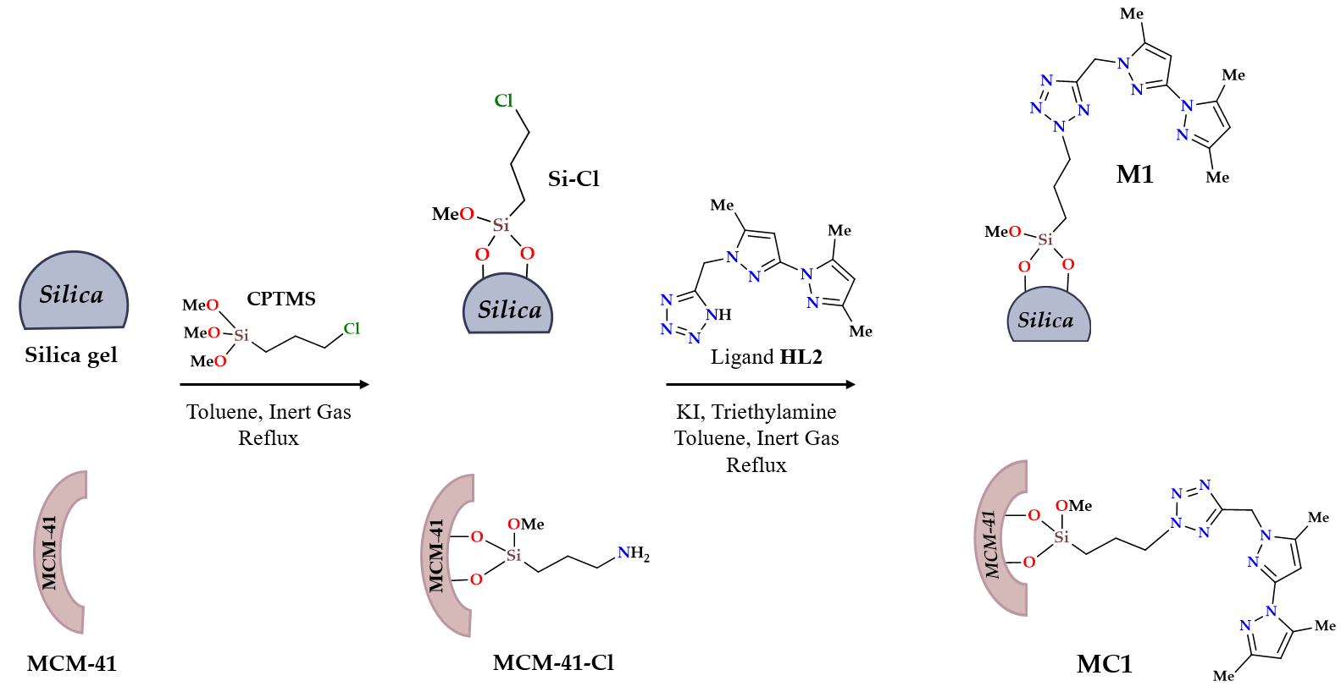
Scheme 1. Synthesis procedure of M1 and MC1 adsorbents.

Structural characterization of M1 and MC1

Infrared spectroscopy
FT-IR spectra for the hybrid materials M1 and MC1 were compared to their respective precursors (Figure 1). The spectra of the precursors Si-Cl and MCMC-41-Cl were found very slightly different to those of unmodified silica (Si) and MCM-41. MC1 has, however, slightly more intense peaks when compared to M1. We noticed that new bands assigned to characteristic vibration peaks intensity of the grafted components (i.e. HL2) are detected via their stretching vibrations of -C=N at 1555 cm⁻¹ and C=C aromatic groups at 1452 cm⁻¹. These bands are indicative of the organic units of the HL2 ligand, thus confirming their anchorage to the surfaces of silica and MCM-41.
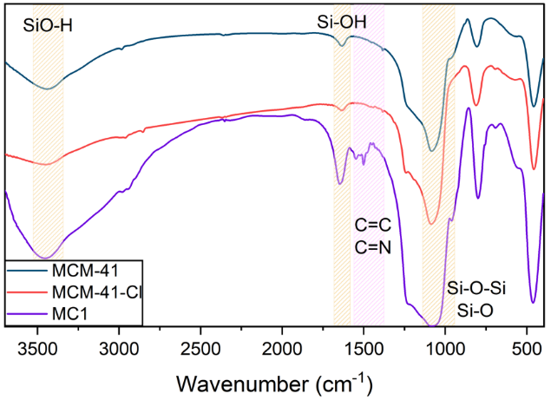
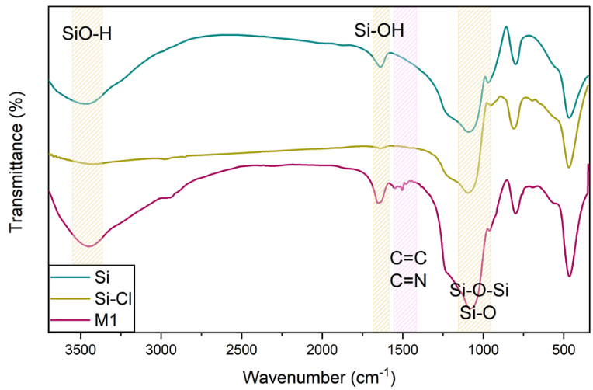

Figure 1. FT-IR spectra of M1 (Left) and MC1 (Right), and of respective precursors.

Thermogravimetric analysis
The curves for calcined silica and MCM-41 materials show two phases of degradation (Figure 2). The first phase, observed between 25 and 110 °C, is linked to the desorption of physisorbed water, as commonly reported for freshly dried or promptly characterized MCM-41 materials under well-controlled conditions.^{37,38} The second phase, at higher temperatures, is associated with the dihydroxylation of silanol groups. Total mass loss in this stage does not exceed 3.5% for both supports.^{39,40} In contrast, the curves for the functional agents Si-Cl and MCM-41-Cl show weight losses of 8.49% and 21.04 % respectively, attributed to the loss of 3-chloropropyl moieties.⁴¹ A greater weight loss of 13.33% and 27.12%, was observed respectively for the materials M1 and MC1 at higher degradation temperatures, suggesting that the degradation of organic groups present on the surface of the silica support and MCM-41 is responsible for this loss. These results indicate that the synthesized materials successfully incorporated the organic molecules and exhibit good thermal stability under elevated-temperature conditions, making them suitable for applications involving moderate to high operating temperatures. Moreover, the material MC1 lost significantly more mass than M1, nearly double the weight loss, which highlights the potential of MCM-41 and its large specifical surface that allows for more room for modification and thus more organic contents.
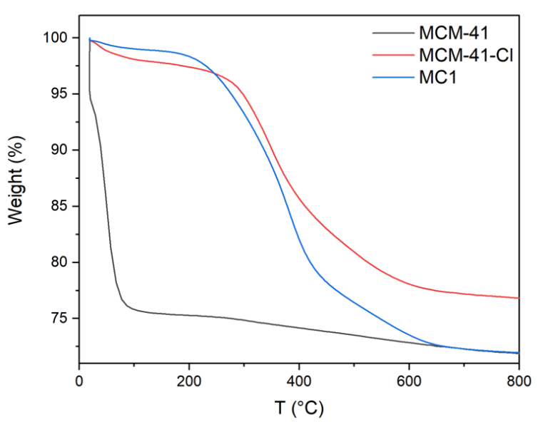
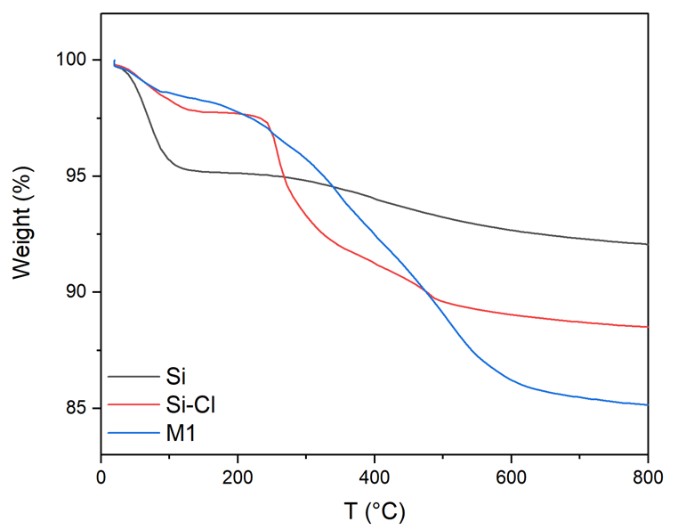

Figure 2. TGA analysis of M1 (Left) and MC1 (Right), and of respective precursors.

Elemental analysis
Elemental analysis could confirm ligand incorporation on silica gel and MCM-41 (Table S1). Indeed, functionalization with the chlorosilane precursor resulted in clear increase in carbon content with 4.73 and 9.47% for Si-Cl and MCM-41-Cl, respectively. These changes confirm successful grafting of the chlorosilane onto both surfaces. Upon introduction of the HL2 ligand, the nitrogen percentage increased too with 3.36 and 4.38 for M1 and MC1, respectively.
The grafting rate (Table S2) was next determined to quantify the incorporated organic matter on to silica using the carbon content (%C) extracted from Table S1, as well as the following formula.⁴²
$τ=\frac{\left(\text{C\% ×}{\text{10}}^{\text{3}}\right) }{\left(\text{12×100×}n_{C}\right) }$(1)
where nC represents the number of carbon atoms in the grafted fraction.

Grafting rates are significantly higher in MCM-41 based materials than in silica-based materials, due to the large specific surface area of the mesoporous MCM-41, which promotes higher grafting density.

Textural properties
Figure 3 illustrates the nitrogen adsorption-desorption isotherms for silica, MCM-41, and their derivatives. The specific surface area and total pore volume were calculated using the BET equation and the BJH method (Table 1). All materials displayed type IV isotherms with a hysteresis loop, indicating that the ordered mesoporous structure was maintained.⁴³ After functionalizing silica and MCM-41, the specific surface area decreased from 580.31 m²/g (Si) to 490.50 m²/g (Si-Cl) and from 793.77 m²/g (MCM-41) to 701.49 m²/g (MCM-41-Cl). Likewise, the total pore volume decreased from 0.56 cm³/g (Si) to 0.44 cm³/g (Si-Cl) and from 0.82 cm³/g (MCM-41) to 0.54 cm³/g (MCM-41-Cl). Notably, MCM-41 had a significantly higher surface area than unmodified silica. The ligand-modified materials M1 and MC1 exhibited lower specific surface areas than their solid supports, a result of the incorporation of organic groups, which also caused a reduction in pore volumes.
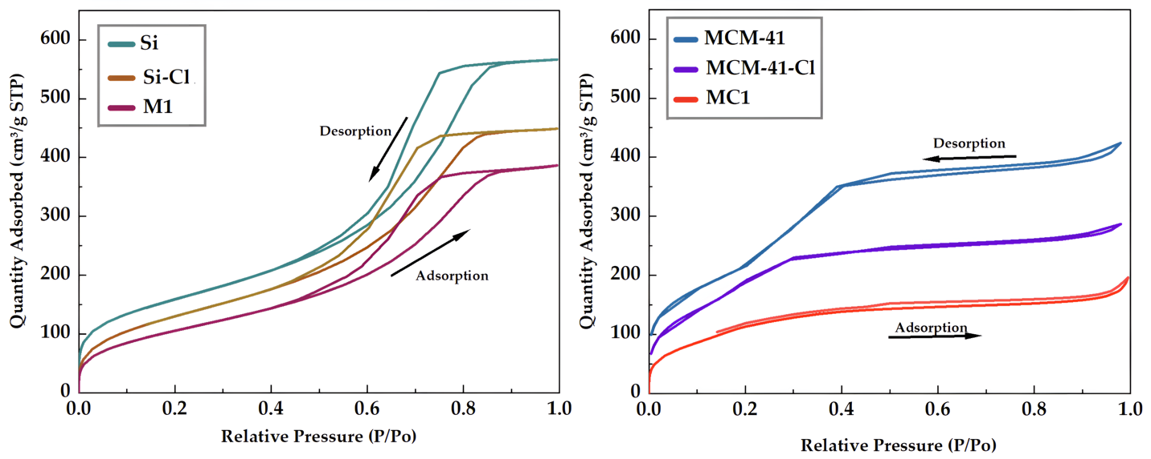
Figure 3. N_{2(g)} adsorption isotherms of Si, Si-Cl, M1, MCM-41, MCM41-Cl and MC1.

Table 1. Textural Properties of the adsorbents.
Materials | S_{BET} area  (m²/g) | Pore volume  (cm³/g)
Si | 580.31 | 0.56
Si-Cl | 490.50 | 0.44
M1 | 396.35 | 0.39
MCM-41 | 793.77 | 0.82
MCM-41-Cl | 701.49 | 0.54
MC1 | 443.51 | 0.31

Solid state ¹³C NMR
The solid state ¹³C NMR analysis provided insights into the materials under investigation (Figure 4). The signals observed at 9.34, 16.65 and 42.22 ppm in Si-Cl and MCM-41-Cl were attributed to the propyl carbons of the silane chain, while the signal at 57 ppm corresponded to the unsubstituted methoxy group, confirming the successful functionalization of silica and MCM-41 with CPTMS. Further signals in the 90-160 ppm range were identified for the materials M1 and MC1, corresponding to carbon atoms in the ligands. Additionally, a peak around δ~ 54 ppm, linked to the carbon directly bonded to the tetrazole group, confirmed the grafting mode of the hybrid materials (Figure 4).
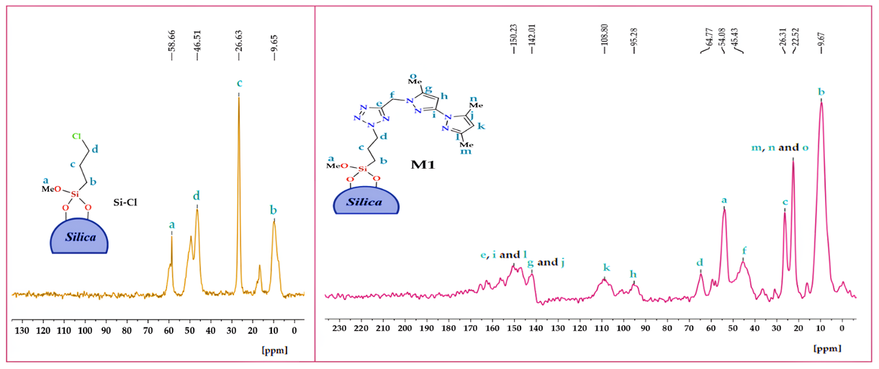
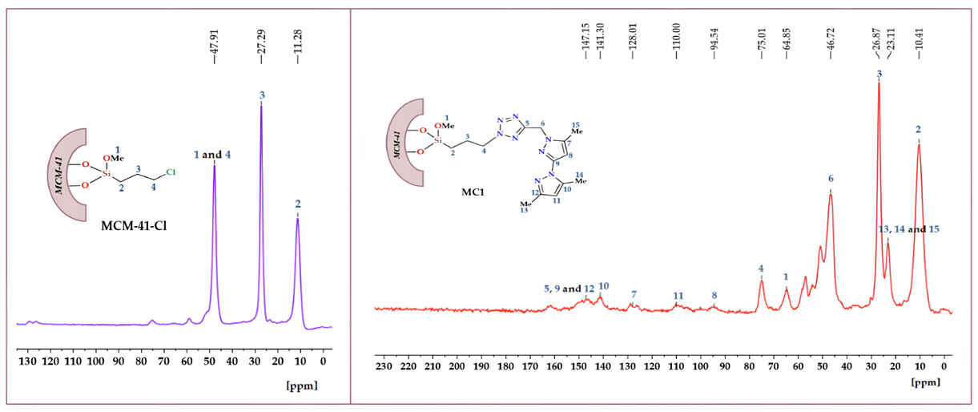
Figure 4. ¹³C NMR spectra of Si-Cl, MCM-41-Cl, M1 (Top) and MC1 (Bottom).

Morphology of the surface
A scanning electron microscope (SEM) was used to examine the morphological changes resulting from the functionalization and modification of the silica surface. Figure 5 presents SEM images of M1 and MC1, along with their precursors, both functionalized (Si–Cl and MCM-41–Cl) and non-functionalized (Si and MCM-41). The native silica (Si) shows a relatively smooth surface, but after functionalization it becomes noticeably rougher. For M1, this roughness can be attributed to the presence of the organic HL2 ligand attached through CPTMS, which leads to a denser and more irregular surface coverage. In contrast, MCM-41 exhibits a cottony and hazy texture typical of its mesoporous structure.⁴⁴ Upon functionalization with CPTMS, this hazy appearance decreases in MCM-41–Cl, indicating a modification of the surface morphology. After further modification with HL2, the resulting MC1 displays agglomerated spherical particles, a well-known feature of mesoporous materials, confirming the successful grafting process.
Figure 5. SEM images of M1, MC1 and their precursors.

Adsorption study
In order to validate the reliability of the adsorbent M1 and MC1, both of these materials were subjected to a full and comprehensive adsorption study in order to confirm consistency in all parameters including the effect of initial concentration, stirring time, temperature, pH, selectivity, and reusability. Furthermore, to confirm swift performance in real contaminated scenarios, both materials were utilized in real contaminated water samples taken from du Oued Za (Ghuefait-Morocco). Parameters are discussed individually and the results fitted to adsorption isotherm as well as kinetic models in to provide a better understanding of the mechanism occurring between the sorbent/sorbate.

Effect of metal ions initial concentrations
The adsorption capacity of a material is a key indicator of its performance, particularly in water purification applications. In this experiment, we evaluated the effect of the initial concentrations of selected metal ions, Cu(II), Cd(II) and Pb(II) on the total adsorption capacity of the hybrid materials M1 and MC1. Concentrations were varied from 10 mg/L to 370 mg/L while maintaining other parameters fixed (2 h stirring time, a temperature of 298 K and a pH 6.0). The results are presented in Figure 6, where C_{e} (mg/L) represents the equilibrium concentration and q_{e} (mg/g) corresponds to the amount of metal ions adsorbed.
Both materials demonstrated positive adsorption behavior across all tested metal ions, with a particularly high affinity for copper. The maximum adsorption capacities for Cu(II) reached 94.56 mg/g for M1 and 130.89 mg/g for MC1. This enhanced performance is primarily attributed to the HL2 ligand, which exhibits strong coordination affinity towards copper.³⁴ The difference in performance between M1, based on standard silica gel, and MC1, based on MCM-41, can be explained by the higher specific surface area of MCM-41 and the greater grafting efficiency, as determined in the analytical section. Moreover, MC1 showed nearly twice the adsorption capacity of M1 for Cd(II) and Pb(II), further highlighting its superior efficiency. The mechanism can be explained by coordination bonding between the nitrogen donor atoms of the pyrazole and tetrazole groups, which are also capable of forming stable complexes with Cd(II) and Pb(II).⁴⁵⁻⁴⁷
To gain deeper insight into the adsorption mechanism, the data were fitted using four nonlinear isotherm models: Langmuir, Freundlich, Temkin, and Sips. The equations for these models are summarized in Table 2, while Table 3 lists the corresponding adsorption parameters and correlation coefficients (R²). Based on the R² values, which exceeded 0.990 in both materials, the Langmuir model provided a good fit. Although the Sips model gave a slightly better fit, the Langmuir model was chosen to estimate the maximum adsorption capacity and to allow direct comparison with literature data. The Langmuir model assumes monolayer adsorption on a uniform surface, which is a reasonable approximation for these surface-functionalized silica materials, while the Sips model confirms the presence of some surface heterogeneity. This suggests a predominantly monolayer adsorption process occurring on the material surface, a finding that is consistent with the surface-functionalized nature of these silica-based materials.⁴⁸ As expected, the adsorption values eventually reached saturation with increasing metal ion concentration, aligning well with trends reported in the literature for similar systems.⁴⁹
This experiment was also essential for determining the optimal concentration of each metal ion, defined as the concentration at which the maximum adsorption capacity was achieved under the effect of the initial concentration. This value was then fixed and used in the subsequent experiments (Table 4).
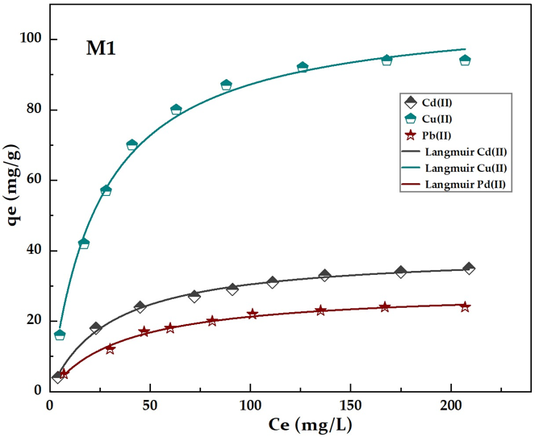
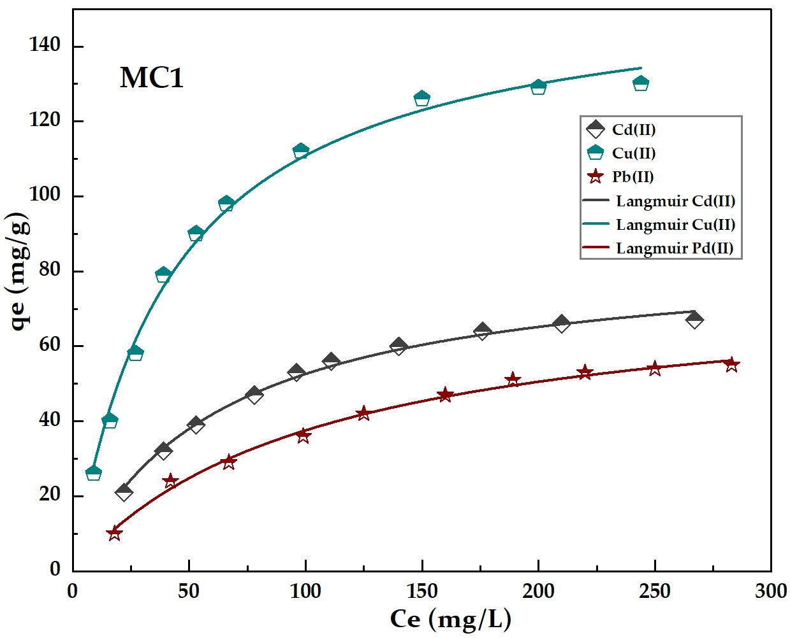
Figure 6. Langmuir isotherm adsorption fitting of metal ions from aqueous solutions on M1 (left) and MC1 (right). Adsorption conditions: 10 mg of materials in 10 mL of an aqueous solution containing each metal ion at a concentration ranging from 10 to 380 ppm, at a temperature of 298 K, pH fixed at 6.0 and 2 h of stirring time.
Table 2. Adsorption isotherm nonlinear equation.
Isotherm Model | Equations | References
Langmuir | $$q_{e}=\frac{K_{L}Q_{L}C_{e}}{1+K_{L}C_{e}} (2)$$ | ⁵⁰
Freundlich | $q_{e}=K_{F}{C_{e}}^{1/n_{F}} (3)$ | ⁵¹
Temkin | $$q_{e}=B_{T}\ln{(A_{T}C_{e})} (4)$$ | ⁵²
Sips | $$q_{e}=\frac{K_{S}Q_{S}{C_{e}}^{1/n_{S}}}{1+K_{S}{C_{e}}^{1/n_{S}}} (5)$$ | ⁵³
C_{e}: Equilibrium concentration of metal in solution (mg/L); q_{e}: Amount of metal adsorbed per unit mass of adsorbent (mg/g); Q_{L}: Maximum adsorption capacity in the Langmuir model (mg/g); K_{L}: Langmuir constant related to adsorption energy (L/mg); K_{F}: Adsorption capacity in the Freundlich model ((mg/g).(L/mg)^{1/n}); n_{F}: Adsorption intensity in the Freundlich model; B_{T}: Temkin constant related to adsorption heat (mg/g) (B_{T} = RT/b_{T}); b_{T}: Temkin isotherm constant ((J/mol).(g/mg)); A_{T}: Temkin equilibrium binding constant (L/mg), representing maximum binding energy; Q_{S}: Maximum adsorption capacity in the Sips model (mg/g); K_{S}: Sips equilibrium constant (L/mg); 1/n_{S}: Sips model exponent.
Table 3. Parameters of Langmuir, Freundlich, Temkin, and Sips isotherm adsorption models
and their correlation coefficient R².
Materials | Metals | Adsorption model
Materials | Metals | Langmuir |  |  | Freundlich |  |  | Temkin |  |  | Sips
Materials | Metals | Q_{L} | K_{L} | R² | n_{F} | K_{F} | R² | B_{T} | A_{T} | R² | n_{S} | Q_{S} | K_{S} | R²
M1 | Cd(II) | 39.70 | 0.032 | 0.995 | 2.823 | 5.64 | 0.942 | 7.91 | 0.407 | 0.977 | 1.035 | 39.55 | 0.034 | 0.996
M1 | Cu(II) | 108.92 | 0.040 | 0.993 | 3.112 | 18.79 | 0.898 | 22.51 | 0.417 | 0.971 | 1.481 | 106.17 | 0.071 | 0.996
M1 | Pb(II) | 29.05 | 0.027 | 0.991 | 2.793 | 3.90 | 0.929 | 6.04 | 0.310 | 0.979 | 1.017 | 29.00 | 0.028 | 0.991
MC1 | Cd(II) | 85.59 | 0.015 | 0.994 | 2.563 | 8.27 | 0.937 | 19.93 | 0.107 | 0.712 | 1.580 | 81.43 | 0.032 | 0.997
MC1 | Cu(II) | 157.19 | 0.023 | 0.993 | 2.670 | 18.27 | 0.922 | 36.02 | 0.154 | 0.778 | 1.482 | 151.32 | 0.044 | 0.996
MC1 | Pb(II) | 77.22 | 0.009 | 0.993 | 2.056 | 3.78 | 0.967 | 16.81 | 0.074 | 0.648 | 1.099 | 75.44 | 0.011 | 0.993

Table 4. The optimal concentration of each metal ions used.
Material | Metal ion | Optimal concentration (mg/L)
M1 | Cu(II) | 220
M1 | Cd(II) | 168
M1 | Pb(II) | 122
MC1 | Cu(II) | 270
MC1 | Cd(II) | 238
MC1 | Pb(II) | 234

Effect of shaking time
The speed and spontaneity with which an adsorbent removes heavy metals are critical factors, especially in industrial applications where fast processing is essential. In this study, both materials (M1 and MC1) were evaluated for their adsorption kinetics by stirring them in metal ion solutions for varying durations, ranging from 5 to 60 min. All other experimental parameters were kept constant, using the optimal concentration established in previous tests. Figure 7 illustrates the quantity of metal ions adsorbed (qt, in mg/g) as a function of contact time (t, in min).
The results clearly show that both adsorbents exhibit rapid adsorption rates, with a sharp increase during the first 15 min. Remarkably, within this short period, M1 and MC1 were able to remove over 80% of Cu(II) relative to their maximum adsorption capacities. Beyond 20 min, the rate of adsorption slowed, eventually plateauing around 30 min, indicating that equilibrium had been reached. These findings highlight the efficiency of both materials in quickly removing heavy metals from aqueous solutions, making them strong candidates for practical industrial use.
To better understand the underlying mechanism, the experimental data were fitted to three kinetic models: pseudo-first-order, pseudo-second-order, and intraparticle diffusion. The corresponding nonlinear equations are summarized in Table 5, and the extracted kinetic parameters, along with the correlation coefficients, are provided in Table 6. Among the models tested, the pseudo-second-order model showed the best fit to the data, with the highest R² values. This suggests that the adsorption process is primarily governed by chemisorption, which aligns with our expectations: metal ions likely form coordination bonds with the HL2 ligands grafted onto the surface of the support materials.
The intraparticle diffusion model was also applied to further analyze the adsorption kinetics, and the corresponding qt vs. t plots are presented in the Supporting information (Figure S1). The relatively low correlation coefficients (R² values mostly below 0.9) indicate that this model alone does not adequately describe the adsorption mechanism. In addition, the intercept (C) values were clearly different from zero, which suggests that intraparticle diffusion is not the only rate-limiting step, and that boundary layer (film) diffusion also plays a role in controlling the overall adsorption process.
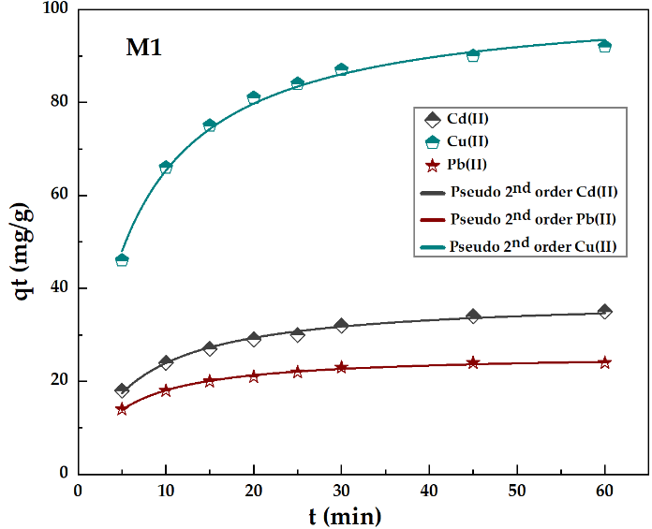
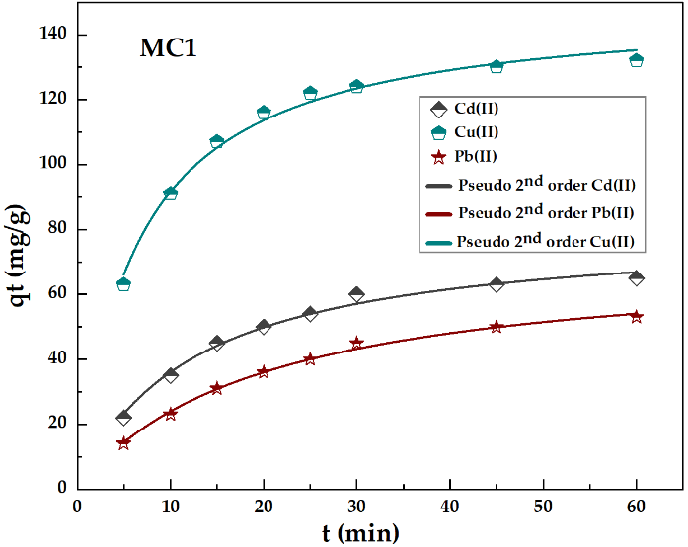
Figure 7. Effect of stirring time on the adsorption rate of MC1 (left) and MC1 (right). Adsorption conditions: 10 mg of materials in 10 mL of an aqueous solution containing each metal ion at their optimal concentration, with pH 6.0 and a temperature of 298 K for time ranging between 5 min and 60 min. Experimental adsorption data fitted using the pseudo 2nd order model.
Table 5. Non-linear kinetic models
Isotherm Model | Equations | References
Pseudo 1st order | $$q_{t}=Q_{1}\left(1-e^{-K_{1}t}\right) (6)$$ | ⁵⁴
Pseudo 2nd order | $$q_{t}=\frac{K_{2}{Q_{2}}^{2}t}{1+K_{2}Q_{2}t} \left(7\right)$$ | ⁵⁵
Intraparticle diffusion | $$q_{t}=K_{id}t^{1/2}+C (8)$$ | ⁵⁶
Q₁ and Q₂: pseudo-first-order and pseudo-second-order equilibrium concentration respectively (mg/g); q_{t}: amount adsorbed (mg/g); t: time (min). K₁ and K₂: rate constant of pseudo-first-order and pseudo-second-order, respectively (min^{–1}); K_{id}: diffusion rate constant (mg min^{1/2} g^{–1}); C: constant (mg/g)

Table 6. Kinetic parameters of pseudo-first order, pseudo-second order, and intraparticle diffusion models and their correlation coefficient R².
Materials | Metals | Kinetic model
Materials | Metals | Pseudo 1st order |  |  | Pseudo 2nd order |  |  | Intraparticle diffusion
Materials | Metals | Q_{e} | K₁ | R² | Q_{e} | K₂ | R² | C | K_{id} | R²
M1 | Cd(II) | 33.01 | 0.128 | 0.921 | 38.02 | 0.044 | 0.993 | 14.39 | 2.943 | 0.907
M1 | Cu(II) | 89.12 | 0.132 | 0.982 | 102.32 | 0.001 | 0.993 | 40.88 | 7.599 | 0.810
M1 | Pb(II) | 23.06 | 0.158 | 0.158 | 25.98 | 0.008 | 0.995 | 12.35 | 1.735 | 0.851
MC1 | Cd(II) | 64.26 | 0.074 | 0.931 | 80.59 | 0.001 | 0.990 | 11.93 | 7.718 | 0.891
MC1 | Cu(II) | 130.48 | 0.125 | 0.968 | 149.44 | 0.001 | 0.990 | 54.55 | 11.597 | 0.807
MC1 | Pb(II) | 56.31 | 0.047 | 0.943 | 72.10 | 0.001 | 0.995 | 1.68 | 7.202 | 0.949

Effect of temperature
Studying thermodynamic parameters, namely enthalpy (ΔH), entropy (ΔS), and Gibbs free energy (ΔG), offers a deeper understanding of how the adsorbent behaves under varying temperatures. These values help clarify whether the adsorption process is spontaneous and whether it benefits from temperature changes. A positive ΔH value indicates that the process is endothermic, meaning that higher temperatures favor adsorption. On the other hand, a negative ΔH indicates an exothermic reaction. ΔS reflects the level of disorder at the solid-liquid interface: a positive value suggests increased randomness, while a negative one indicates a more ordered system. As for ΔG, a negative value confirms that the adsorption occurs spontaneously, whereas a positive ΔG indicates the opposite.
To assess these thermodynamic aspects, adsorption experiments were carried out at three different temperatures: 298 K, 308 K, and 318 K, while maintaining optimal metal ion concentrations and 30 min of stirring time, with the pH fixed at 6.0. The thermodynamic values were calculated using a method based on Zhou’s approach:⁵⁷
$$K=K_{d} x M_{adsorbate} x (9)$$
$$lnK=-\frac{H}{RT}+\frac{S}{R} (10)$$
$$G=H-TS (11)$$
Where K_{d} (L/g) is the distribution coefficient, K the equilibrium constant, γ the activity coefficient, and R (8.314 J·mol⁻¹·K⁻¹) the universal gas constant.
Table 7 summarizes the resulting ΔH, ΔS, and ΔG values, which were derived from the linear plot of lnK versus 1/T shown in Figure 8. The positive enthalpy change confirms the endothermic nature of the process, consistent with the observed increase in adsorption at higher temperatures. Additionally, the positive entropy value indicates an increase in randomness at the adsorbent–solution interface. This can be attributed to the partial desolvation of hydrated metal ions during adsorption, leading to the release of structured water molecules into the bulk solution and an overall increase in degrees of freedom. Such behavior is characteristic of endothermic adsorption processes, where energy input facilitates the disruption of ordered solvation shells and promotes stronger interactions between the adsorbent and metal ions. Most importantly, the negative ΔG values across all temperatures confirm that the process is spontaneous, even under ambient conditions. Furthermore, the fact that ΔG becomes more negative as temperature increases indicates that adsorption becomes increasingly favorable with heat, likely due to improved accessibility of active sites on the material's surface.
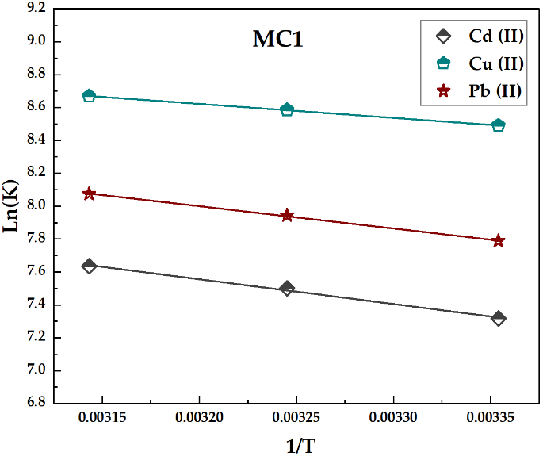
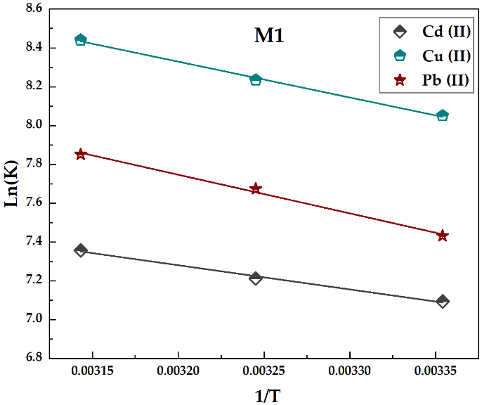
Figure 8. Effect of temperature on metal ions sorption by M1 and MC1. Adsorption conditions: 10 mg of materials in 10 mL of an aqueous solution containing the metal ion at their optimal concentration, with pH fixed at 6.0, for 30 min of stirring time, and at temperatures 298, 308 and 318 K.
Table 7. Thermodynamic parameters of M1 and MC1.
Materials | Metals | Thermodynamic parameters
Materials | Metals | ∆H° (kJ.mol⁻¹) | ∆S° (kJ.K⁻¹.mol⁻¹) | ∆G° (kJ.mol⁻¹)
 |  |  |  | 318 K | 308 K | 298 K
M1 | Cd(II) | 10.36564 | 0.09369 | -19.44 | -18.50 | -17.56
M1 | Cu(II) | 15.31528 | 0.11813 | -22.26 | -21.08 | -19.90
M1 | Pb(II) | 16.55602 | 0.11738 | -20.78 | -19.61 | -18.44
MC1 | Cd(II) | 12.54508 | 0.10296 | -20.21 | -19.18 | -18.15
MC1 | Cu(II) | 7.05586 | 0.09426 | -22.93 | -21.99 | -21.04
MC1 | Pb(II) | 11.27575 | 0.10259 | -21.36 | -20.33 | -19.31

Effect of solution pH
This section explores how the pH of the solution influences metal ion adsorption. Both materials, M1 and MC1, showed a similar response to changes in pH (Figure 9). Below pH 4.0, adsorption efficiency dropped significantly, by 48% for M1 and 44% for MC1. This decline can be attributed to the increasing concentration of H⁺ ions, which can affect the surface charge of the adsorbent and influence how metal ions behave in solution. Additionally, these protons can compete with metal ions for binding to the active sites, reducing the formation of metal-ligand complexes. As anticipated, the highest adsorption was recorded at pH 6.0. However, above pH 7.0, metal ions tend to form insoluble hydroxide precipitates (e.g., M(OH)⁺, M(OH)₂, and M(OH)₃).⁵⁸ This precipitation, caused by the alkaline environment, makes it difficult to distinguish between hydrolyzed and adsorbed metal ions, thereby disrupting the adsorption process and leading to an inaccurate calculation of the adsorption capacity of the adsorbents. These observations are consistent with findings reported in similar adsorption studies.^{59–61}
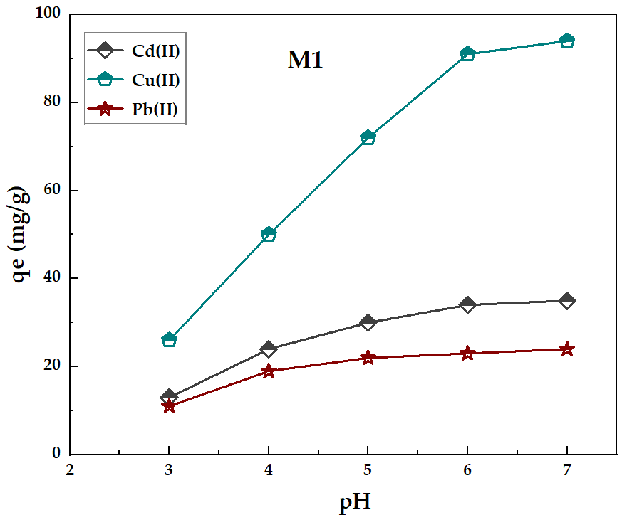
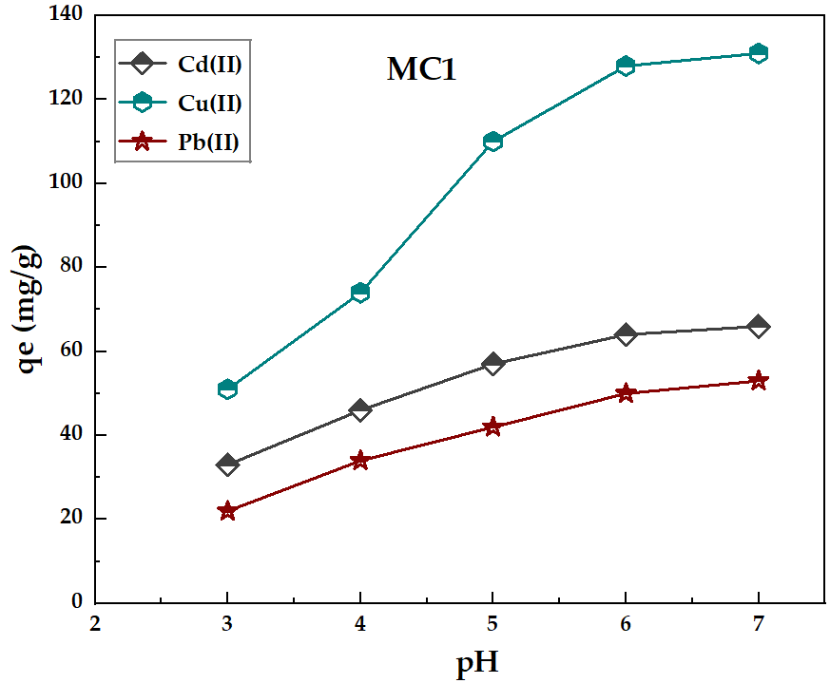
Figure 9. pH impact on the adsorption capacity of M1 and MC1. Adsorption conditions: 10 mg of materials in 10 mL of an aqueous solution containing each metal ion at their optimal concentration, with a pH ranging from 3.0 to 7.0 for 30 min of stirring time and a 298 K temperature.

Selectivity survey
The ability of a material to selectively capture specific transition metals is a key advantage for many targeted applications. One standout benefit of surface-functionalized silica is that it can be tailored using organic ligands designed to bind particular metal ions. This flexibility makes such materials highly adaptable, with the organic moieties playing a crucial role in enhancing selectivity. In this experiment, both adsorbents were tested using a mixed solution containing all three metal ions: Cu(II), Cd(II) and Pb(II) in similar concentrations (Figure 10). The mixture was prepared to reflect the highest adsorption potential for copper. For M1, the metal ion solution had a concentration of 220 mg/L for each ion, while MC1 was tested with 270 mg/L of each.
The findings indicate that both adsorbents retained a strong affinity for Cu(II), even when other competing metal ions were present at similar concentrations. M1 achieved an uptake of 65 mg/g, corresponding to approximately 69% of its previously recorded maximum capacity. Likewise, MC1 demonstrated even greater performance, adsorbing 92 mg/g of Cu(II), which represents around 71% of its highest measured capacity. The distribution coefficient (K_{d}) and selectivity coefficient (K), calculated using Eqs. (11) and (12)⁶² (Table 8), clearly demonstrate that both M1 and MC1 exhibit higher selectivity toward Cu(II) in the presence of competing ions. For M1, the calculated selectivity coefficients (K = 1.780 for Cd(II) and 4.148 for Pb(II)) are all greater than 1, which indicates that Cu(II) is preferentially adsorbed over both Cd(II) and Pb(II). The higher the K value, the stronger the selectivity toward Cu(II), confirming that M1 favors Cu(II) uptake even under competitive conditions.
More importantly, MC1 shows enhanced selectivity toward Cu(II), with increased K values of 2.842 for Cd(II) and 6.040 for Pb(II). These higher coefficients further reinforce that MC1 has an even stronger discrimination toward Cu(II) compared to M1. Thus, the elevated K values unambiguously confirm that Cu(II) remains the most selectively adsorbed ion for both materials, with MC1 exhibiting the most pronounced selectivity.
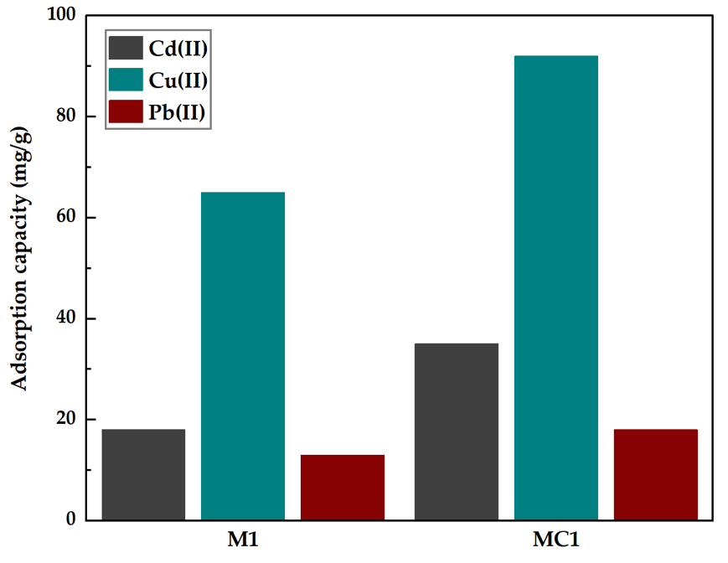
Figure 10. Effect of the presence of other metal ions on the adsorption efficiency of M1 and MC1 to extract Cu(II): Adsorption conditions: 10 mg of materials in 10 mL of an aqueous solution containing a mixture of the three metal ions at the optimal concentration, with pH fixed at 6.0, 30 min of stirring time, and at 298 K.

${ K}_{d }= \frac{q_{0}}{C_{e}} =\frac{\left(C_{0 }- C_{e}\right)V}{C_{e}m} (12)$
$K = \frac{K_{d({Cu}^{2+})}}{K_{d(coexisting-ions)}} (13)$
where C₀ and C_{e} (mg/L) are the initial and equilibrium concentrations of heavy metal ions, V (mL) is the volume of the heavy metal ions solution and m (mg) is the weight of the adsorbents, K_{d} and K represent distribution coefficient and selectivity coefficient, respectively.
Table 8. Selectivity coefficient of M1 and MC1.
M1 |  |  |  |  |  |  | MC1
Coexisting ions |  | q_{e} | C_{e} |  | K_{d} | K | Coexisting ions |  | q_{e} |  |  | C_{e} | K_{d} |  |  |  |  |  | K
Cu(II) | 54 |  |  | 166 | 0.325 | - | Cu(II) |  | 121 |  |  | 149 | 0.812 |  |  |  |  | -
Cd(II) | 34 |  |  | 186 | 0.183 | 1.780 | Cd (II) 60 |  |  |  | 210 |  |  | 0.286 |  | 2.842
Pb(II) | 16 |  |  | 204 | 0.078 | 4.148 | Pb(II) | 32 |  | 238 |  |  |  |  | 0.134 |  | 6.040

Regeneration and Reutilization
In industrial applications, cost-efficiency is a key factor, and the ability to regenerate and reuse an adsorbent plays a major role in reducing overall expenses. Beyond the economic benefits, reusability also enhances the sustainability and environmental friendliness of the material. For this reason, it is essential to evaluate how well the material performs over several cycles and determine whether it can withstand repeated use or if it is limited to single-use applications. Fortunately, coordination bonds between metal ions and the functional groups can often be disrupted under acidic conditions. Based on this principle, nitric acid (4%) was selected to desorb the metal ions and assess whether the material retains its performance after regeneration.
Figure 11 displays the adsorption capacity of metal ions over six consecutive cycles of usage. Overall, both adsorbents had less than 5% efficiency loss across these multiple sequences. This makes them highly durable for intense and repeated usage. The minimal efficiency loss is mainly attributed to the protonation of active coordination sites during washing with the acidic solution.

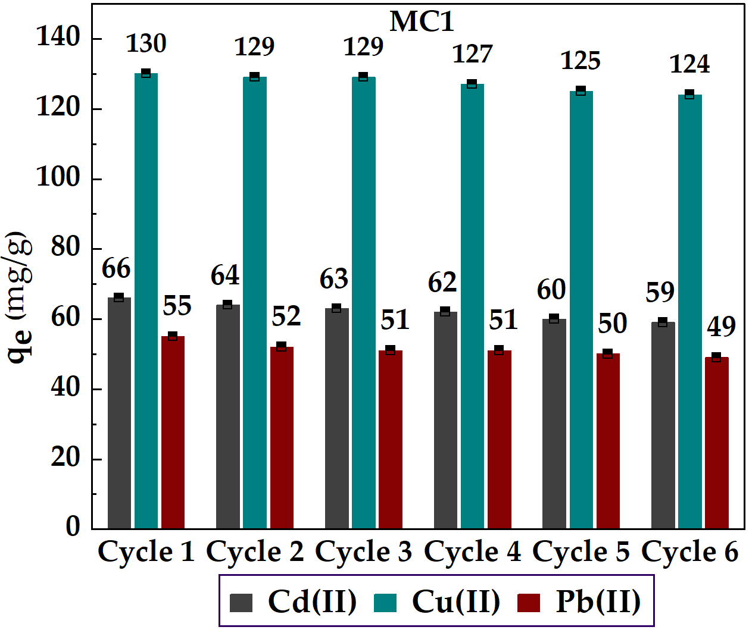
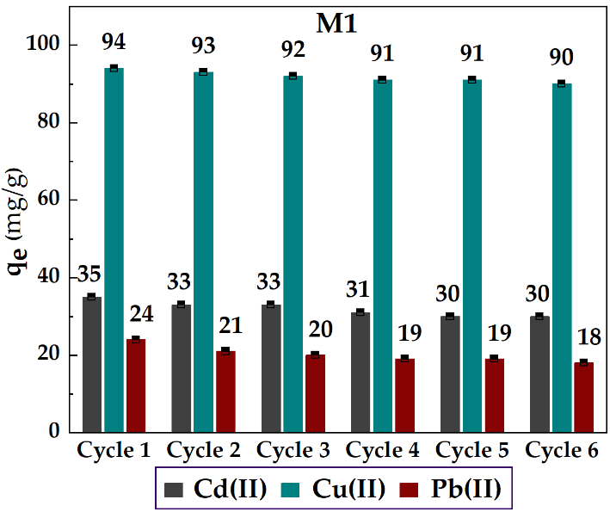

Figure 11. Regeneration performances of M1 and MC1 over six cycles of metals extractions. Under the adsorption conditions of 10 mg of materials in 10 mL of an aqueous solution containing metal ion at their optimal concentration, with pH fixed at 6.0, 30 min of stirring time, and a temperature of 298 K. After each cycle the material was recovered after being washed with 4% nitric acid.

Removal of hazardous metal ions in real contaminated water
In order to assess the trustworthiness of our hybrid materials, it is mandatory to test them in real water sample scenarios. For this purpose, we took a sample from a known contaminated river affected by industrial and agricultural activities which is located at Oued Za, Ghuefait-Jerada River, Morocco, near the GPS coordinates (34.2400000, -2.4080000). Samples were analysed before and after treatment with M1 and MC1. Table 9 outlines the concentrations found (mg/L), the adsorption capacity of both metals (mg/g), as well as adsorption percentages.
Both materials proved effective adsorption performances in extracting Cu(II) not only at very low concentrations, but even in the presence of other potential alkaline ions and organic matter, with MC1 being superior in terms of performance reaching 49%, which corresponds to half of the initial Cu(II) content. It should be noted that other competing alkaline cations such as potassium and sodium may also interfere with adsorption, while natural organic matter can further hinder metal uptake, as shown in previous studies reported in the literature.^{30,63} Additionally, variations in pH and ionic strength in the river matrix may further influence the speciation and mobility of Cu(II), thereby affecting its interaction with the adsorbent. Nevertheless, this experiment still proved the reliability of these materials to perform well under real world water scenarios, which is an outstanding feature since removing transition metals at low concentrations is always challenging and there are very few examples of materials that can accomplish that.
Table 9. Metal ions removal from Oued Za, Ghuefait-Jerada River, Morocco
Adsorbent | Metal | Concentration found (mg/L) | Adsorption capacity (mg/g) | Adsorption percentages (%)
M1 | Cd(II) | 2.43 | 0.40 | 16
M1 | Cu(II) | 10.67 | 3.56 | 33
M1 | Pb(II) | 8.56 | 1.82 | 21
MC1 | Cd(II) | 2.43 | 0.63 | 26
MC1 | Cu(II) | 10.67 | 5.21 | 49
MC1 | Pb(II) | 8.56 | 2.14 | 25

Adsorption capacity comparison study with the literature
Table 10 presents a comparison between the adsorption capacities of the newly developed hybrid materials, M1 and MC1, and those of some of the most efficient Cu(II) adsorbents reported in the literature. With removal capacities of 94.56 mg/g for M1 and 130.89 mg/g for MC1, both materials clearly outperform many of the previously reported systems, particularly those based on silica. Moreover, these two materials also showed better efficiency compared to the commercial sorbent “Lewatit TP-207 (L-207)” which is universally used in various industrial applications. Although, some adsorbents based on carbon nanofibers or crosslinked chitosan exhibit a higher adsorption capacity for Cu(II), this does not undermine the excellent performance of our materials. In contrast to carbon-based nanomaterials, the proposed silica-based hybrids offer several practical advantages, including a more controlled and homogeneous pore structure, which facilitates uniform functionalization and reproducible adsorption behavior. Additionally, silica supports such as MCM-41 are easier to synthesize and functionalize under mild conditions, avoiding the more complex and energy-intensive preparation routes often associated with carbon nanofibers. Furthermore, the surface chemistry of silica allows for more stable and well-defined grafting of functional ligands, enhancing selectivity toward target metal ions. From an application perspective, silica materials also exhibit better dispersibility in aqueous media and a lower tendency to aggregate, improving the accessibility of active sites during adsorption. In addition, silica-based materials are generally more cost-effective and scalable than carbon nanofibers, as they rely on inexpensive precursors and well-established synthesis routes, making them more suitable for large-scale water treatment applications. Thanks to these characteristics, M1 and MC1 represent promising candidates for the removal of heavy metals from contaminated water. Their remarkable efficiency highlights a new standard in Cu(II) extraction by combining several key advantages: high adsorption capacity, fast and selective uptake, reusability, and strong performance even when tested on real contaminated water samples.
Table 10. Comparative table of adsorption capacity of M1 and MC1 versus solid adsorbent in the literature.
Material | Adsorption capacity (mg/g) | Reference
M1 | 94.56 | This work
MC1 | 130.89 | This work
3-glycidoxypropyl-Silica | 90.25 | ⁶⁴
Pyridine-2,6-dicarbaldehyde | 120.65 | ²⁹
Polyethyleneimine methylene  phosphonic acid-Silica | 85.69 | ⁶⁵
Multi-carboxyl-Silica | 50.80 | ⁶⁶
β-Ketoenol-bipyridine | 131.82 | ⁶⁷
β-ketoenol-pyridine-furan | 32.15 | ⁶⁸
Porphyrin | 19.07 | ⁶⁹
SBA-15-3-Aminopropyltrimethoxy-  silane | 69.00 | ⁷⁰
Commercial Lewatit TP-207 (L-207) | 68.50 | ⁷¹
Carbonaceous nanofibers | 204.00 | ⁷²
Crosslinked chitosan (TPP) | 200.00 | ⁷³

Conclusion
In summary, both M1 and MC1 were first characterized using different spectroscopic techniques, which proved the successful integration of HL2 into the surface of silica and MCM-41 respectively. Furthermore, the removal of Cu(II) revealed outstanding characteristics with MC1 presenting a capacity of 130.89 mg/g, outperforming M1 (94.56 mg/g) by a large margin, thanks to the larger surface area supplied by the MCM-41 framework. Adsorption was also extremely quick, with more than 80% of the Cu(II) adsorbed in the first 15 min, a potential asset for real-world water-cleaning applications. Both materials also showed excellent selectivity for Cu(II) even in the presence of other metals, demonstrating their efficiency in more complex systems. What is even more fascinating is that the materials persisted over six cycles of adsorption/desorption with only a reduction of around 5% in efficiency. To top it off, these findings were confirmed when applied to contaminated real water samples, demonstrating an increase of time readiness level of this technology. These hybrid materials check all the boxes: capacity, rate, selectivity, recyclability, and real-world performance, and therefore make them potentially well-qualified candidates for Cu(II) removal at the industrial scale.

ASSOCIATED CONTENT
Supporting Information
The Supporting Information is available free of charge on the ACS Publications website. Adsorption study, Intraparticle diffusion model fitting.

AUTHOR INFORMATION
Notes
The authors declare no competing financial interest

ACKNOWLEDGMENTS
This research was supported by CNRST (PPR2-MESRSFC CNRSTP10), the Fonds de la Recherche Scientifique-FNRS (PDR T.0095.21, CDR J.0064.23, EQP U.N027.24) and ARES (stipendium for Y. B.). We thank L. Fusaro and C. Aprile (UNamur) for recording solid-state NMR spectra.

REFERENCES
(1) Guérette, C. -D.; Panaritis, C., Pahija, E.; Couillard, M.; Bussaraporn P.; Shadbahr, J.; Bensebaa, F.; Patience, G. S.; Boffito, D. C. Cu on Co Improves C5+ Selectivity in the Fischer–Tropsch Synthesis. Ind. Eng. Chem. Res. 2025, 64, 9542-9557.
(2) Taylor, A. A.; Tsuji, J. S.; Garry, M. R.; McArdle, M. E.; Goodfellow, W. L.; Adams, W. J.; Menzie, C. A. Critical Review of Exposure and Effects: Implications for Setting Regulatory Health Criteria for Ingested Copper. Environ. Manag. 2020, 65, 131–159.
(3) Liu, W.; Moran, C. J.; Vink, S. Quantitative Risk-Based Approach for Improving Water Quality Management in Mining. Environ. Sci. Technol. 2011, 45, 7459–7464.
(4) Cruz, C.; Reyes, A.; Jeldrez, R. I.; Cisternas, L. A.; Kraslawski, A. Using Partial Desalination Treatment To Improve the Recovery of Copper and Molybdenum Minerals in the Chilean Mining Industry. Ind. Eng. Chem. Res. 2019, 58, 8915–8922.
(5) Jung, H.; Kim, J.; Inaba, Y.; Moutushi, T. T.; Castaldi, M. J.; West, A. C.; Banta, S. Overexpression of AcoP in Acidithiobacillus ferrooxidans for Enhanced Copper Reclamation. ACS EST Engg. 2023, 3, 1468–1475.
(6) Santos, N.; Alarcon, J. F.; Ahumada, M. Understanding the Toxicity of Metal-Based Nanomaterials: Current Insights, Challenges, and Future Directions. ACS Materials Lett. 2025, 7, 2547–2564.
(7) Lai, I. K.; Klaren, W. D.; Li, M. Wels, B.; Simmons, D. L.; Olivier, A. K.; Haschek, W. M.; Wang, K.; Ludewig, G.; Robertson, L. W. Does Dietary Copper Supplementation Enhance or Diminish PCB126 Toxicity in the Rodent Liver? Chem. Res. Toxicol. 2013, 26, 634–644.
(8) Gale, J.; Aizenman, E. The Physiological and Pathophysiological Roles of Copper in the Nervous System. Eur. J. Neurosci. 2024, 60, 3505–3543.
(9) Giampietro, R.; Spinelli, F.; Contino, M.; Colabufo, N. A. The Pivotal Role of Copper in Neurodegeneration: A New Strategy for the Therapy of Neurodegenerative Disorders. Mol. Pharma. 2018, 15, 808–820.

(10) Filgueiras, M. F.; Novotná, M.; Galiová, M. V.; Luna, A. S.; Santos de Gois, J. A Straightforward Method for Copper Determination in Fish Samples via Direct Solid Sample Analysis Line-Source GFAAS. ACS Omega 2025, 10, 10017–10022.
(11) Dang, F.; Wang, W.-X., Raibow, P. S. Unifying Prolonged Copper Exposure, Accumulation, and Toxicity from Food and Water in a Marine Fish. Environ. Sci. Technol. 2012, 46, 3465–3471.
(12) Olivares, M.; Pizarro, F.; Speisky, H.; Lönnerdal, B.; Uauy, R. Copper in Infant Nutrition: Safety of World Health Organization Provisional Guideline Value for Copper Content of Drinking Water. J. Pediatr. gastroenterol. Nutr. 1998, 26, 251–257.
(13) Fitzgerald, D. Safety Guidelines for Copper in Water. Am. J. Clin. Nutr. 1998, 67, 1098S-1102S.
(14) Chu, S.; Feng, X.; Liu, C.; Wu, H.; Liu, X.; Advances in Chelating Resins for Adsorption of Heavy Metal Ions. Ind. Eng. Chem. Res. 2022, 61, 11309–11328.
(15) Ebbers, B.; Ottosen, L. M.; Jensen, P. E. Comparison of Two Different Electrodialytic Cells for Separation of Phosphorus and Heavy Metals from Sewage Sludge Ash. Chemosphere 2015, 125, 122–129
(16) Wu, H.; Wang, W.; Huang, Y.; Han, G.; Yang, S.; Su, S.; Sana, H.; Peng, W.; Cao, Y.; Liu, J. Comprehensive Evaluation on a Prospective Precipitation-Flotation Process for Metal-Ions Removal from Wastewater Simulants. J. Hazard. Mater. 2019, 371, 592–602.
(17) Zhu, Y.; Fan, W.; Zhou, T.; Li, X. Removal of Chelated Heavy Metals from Aqueous Solution: A Review of Current Methods and Mechanisms. Sci. Total Environ. 2019, 678, 253–266.
(18) Zamora-Ledezma, C.; Negrete-Bolagay, D.; Figueroa, F.; Zamora-Ledezma, E.; Ni, M.; Alexis, F.; Guerrero, V. H. Heavy Metal Water Pollution: A Fresh Look about Hazards, Novel and Conventional Remediation Methods. Environ. Technol. Innov. 2021, 22, 101504.
(19) Qasem, N. A. A.; Mohammed, R. H.; Lawal, D. U. Removal of Heavy Metal Ions from Wastewater: A Comprehensive and Critical Review. Clean Water 2021, 4, 36.
(20) Benalia, M. C.; Youcef, L.; Bouaziz, M. G.; Achour, S.; Menasra, H. Removal of Heavy Metals from Industrial Wastewater by Chemical Precipitation: Mechanisms and Sludge Characterization. Arab. J. Sci. Eng. 2022, 47, 5587–5599.
(21) Ali, A.; Sadia, M.; Azeem, M.; Ahmad, M. Z.; Umar, M.; Ul Abbas, Z. Ion Exchange Resins and Their Applications in Water Treatment and Pollutants Removal from Environment: A Review: Ion Exchange Resins and Their Applications. FBT 2023, 12–19.
(22) Feng, B.; Fang, Z.; Hou, J.; Ma, X.; Huang, Y.; Huang, L. Effects of Heavy Metal Wastewater on the Anoxic/Aerobic-Membrane Bioreactor Bioprocess and Membrane Fouling. Bioresour. Technol. 2013, 142, 32–38.
(23) Ab Hamid, N. H.; Bin Mohd Tahir, M. I. H.; Chowdhury, A.; Nordin, A. H.; Alshaikh, A. A.; Suid, M. A.; Nazaruddin, N. ‘Izzah; Nozaizeli, N. D.; Sharma, S.; Rushdan, A. I. The Current State-Of-Art of Copper Removal from Wastewater: A Review. Water 2022, 14, 3086.
(24) Radi, S.; El Abiad, C.; Carvalho, A.P.; Santos, S.M.; Faustino, M. A. F.; Neves, M.G. P.M.S.; Moura, N.M.M. An efficient hybrid adsorbent based on silica-supported amino penta-carboxylic acid for water purification. J. Mater. Chem. A 2018, 6,13096 – 13109.
(25) Chakraborty, R.; Asthana, A.; Singh, A. K.; Jain, B.; Susan, A. B. H. Adsorption of Heavy Metal Ions by Various Low-Cost Adsorbents: A Review. Int. J. Environ. Anal. Chem. 2022, 102, 342–379
(26) Rajendran, S.; Priya, A. K.; Senthil Kumar, P.; Hoang, T. K. A.; Sekar, K.; Chong, K. Y.; Khoo, K. S.; Ng, H. S.; Show, P. L. A Critical and Recent Developments on Adsorption Technique for Removal of Heavy Metals from Wastewater-A Review. Chemosphere 2022, 303, 135146.
(27) Shahrashoub, M.; Bakhtiari, S. The Efficiency of Activated Carbon/Magnetite Nanoparticles Composites in Copper Removal: Industrial Waste Recovery, Green Synthesis, Characterization, and Adsorption-Desorption Studies. Micropor. Mesopor. Mat. 2021, 311, 110692.
(28) Jumina; Priastomo, Y.; Setiawan, H. R.; Mutmainah; Kurniawan, Y. S.; Ohto, K. Simultaneous Removal of Lead(II), Chromium(III), and Copper(II) Heavy Metal Ions through an Adsorption Process Using C-Phenylcalix[4]Pyrogallolarene. Material. J. Environ. Chem. Engin. 2020, 8, 103971.
(29) El-Massaoudi, M.; Radi, S.; Lamsayah, M.; Tighadouini, S.; Séraphin, K. K.; Kouassi, L. K.; Garcia, Y. Ultra-Fast and Highly Efficient Hybrid Material Removes Cu(II) from Wastewater: Kinetic Study and Mechanism. J. Clean. Prod. 2021, 284, 124757.
(30) Draoui, Y.; Radi, S.; El Mahdaoui, A.; El Massaoudi, M.; Rotaru, A.; Garcia, Y.; Do Amparo F. Faustino, M.; Da Graça P. M. S. Neves, M.; Moura, N. M. M. Tailoring Selectivity and Efficiency: Pyrazolyl-1H-1,2,4-Triazole MCM-41 and Silica Hybrid Materials for Efficient Cadmium(II) Removal from Water. Environ. Sci. Pollut. Res. 2025, 32, 10984–11003.
(31) El Abiad, C.; Radi, S.; El Massaoudi, M.; Lamsayah, M.; Figueira, F.; Faustino, M. A. F.; Neves, M. G. P. M. S.; Moura, N. M. M. Porphyrin-Silica Gel Hybrids as Effective and Selective Copper(II) Adsorbents from Industrial Wastewater. J. Environm. Chem. Engin. 2023, 11, 110097.
(32) Faghihian, H.; Nourmoradi, H.; Shokouhi, M. Removal of Copper (II) and Nickel (II) from Aqueous Media Using Silica Aerogel Modified with Amino Propyl Triethoxysilane as an Adsorbent: Equilibrium, Kinetic, and Isotherms Study. Desalin. Water Treat. 2014, 52, 305–313.
(33) Kang, X.-M.; Tang, M.-H.; Yang, G.-L.; Zhao, B. Cluster/Cage-Based Coordination Polymers with Tetrazole Derivatives. Coord. Chem. Rev. 2020, 422, 213424.
(34) Bahjou, Y.; Radi, S.; El Massaoudi, M.; Draoui, Y.; Adarsh, N. N.; Miras, H. N.; Ferbinteanu, M.; Robeyns, K.; Ouahhoud, S.; Benabbes, R.; Hultzsch, K. C.; Wolff, M.; Garcia, Y. High Inhibition for a CoII Tetrazole Bi‐pyrazole Dinuclear Complex against Fusarium Oxysporum f. Sp. Albedinis. Eur. J. Inorg. Chem. 2024, 27, e202300634.
(35) Sales, J. A. A.; Faria, F. P.; Prado, A. G. S.; Airoldi, C. Attachment of 2-Aminomethylpyridine Molecule onto Grafted Silica Gel Surface and Its Ability in Chelating Cations. Polyhedron 2004, 23, 719–725.
(36) De Lima, A. L.; Mbengue, A.; San Gil, R. A. S.; Ronconi, C. M.; Mota, C. J. A. Synthesis of Amine-Functionalized Mesoporous Silica Basic Catalysts for Biodiesel Production. Catal. Today 2014, 226, 210–216.
(37) Wang, L., Han, X., Li, J., Qin, L., & Zheng, D. Preparation of modified mesoporous MCM-41 silica spheres and its application in pervaporation. Powder technology 2012, 231, 63-69.
(38) Nkinahamira, F., Su, T., Xie, Y., Ma, G., Wang, H., & Li, J. High pressure adsorption of CO2 on MCM-41 grafted with quaternary ammonium ionic liquids. Chemical Engineering Journal 2017, 326, 831-838.
(39) Pérez-Quintanilla, D.; Sánchez, A.; Del Hierro, I.; Fajardo, M.; Sierra, I. Preparation, Characterization, and Zn²⁺ Adsorption Behavior of Chemically Modified MCM-41 with 5-Mercapto-1-Methyltetrazole. J. Colloid. Interface Sci. 2007, 313, 551–562.
(40) Zhang, Y.; Qu, R.; Sun, C.; Wang, C.; Ji, C.; Chen, H.; Yin, P. Chemical Modification of Silica-Gel with Diethylenetriamine via an End-Group Protection Approach for Adsorption to Hg(II). Appl. Surf. Sci. 2009, 255, 5818–5826.
(41) Zhang, J.; Jiang, P.; Shen, Y.; Zhang, W.; Li, X. Molybdenum(VI) Complex with a Tridentate Schiff Base Ligand Immobilized on SBA-15 as Effective Catalysts in Epoxidation of Alkenes. Micropor. Mesopor. Mat. 2015, 206, 161–169.
(42) Cousinié, S.; Mauline, L.; Gressier, M.; Kandibanda, S. R.; Datas, L.; Reber, C.; Menu, M. J. Bulk or surface grafted silylated Ru(ii) complexes on silica as luminescent nanomaterials. New J. Chem. 2012, 36, 1355-1367.

(43) Branton, P.J.; Hall, P.G.; Treguer, M.; Sing, K.S.W. Adsorption of carbon dioxide, sulfur dioxide and water vapour by MCM-41, a model mesoporous adsorbent. J. Chem. Soc., Faraday Trans. 1995, 91, 2041-2043.
(44) Yan, B.; Li, Y.; Zhou, B. Covalently Bonding Assembly and Photophysical Properties of Luminescent Molecular Hybrids Eu–TTA–Si and Eu–TTASi–MCM-41 by Modified Thenoyltrifluoroacetone. Micropor. Mesopor. Mat. 2009, 120, 317–324.
(45) Lin, X. Y.; Gong, L. Z.; Liu, Y. M.; Liu, M. Y.; Liu, X. Z. Manganese (II), lead (II) and cadmium (II) coordination complexes containing a tetrazole-based acylamide ligand: synthesis and the influence of the metal ions on the structures. Crystal Structure Communications. 2018, 74, 139-145.
(46) Kowalik, M.; Masternak, J.; Kazimierczuk, K.; Khavryuchenko, O. V.; Kupcewicz, B.; Barszcz, B. Lead (II) coordination polymers with imidazole-4-and pyrazole-3-carboxylate isomeric linkers: Structural diversity and luminescence properties. J. Solid State Chem. 2018, 266, 100-111.
(47) Choe, S.; Lee, H.; Nayab, S. Diverse coordination geometry of cobalt (II), zinc (II), and cadmium (II) complexes comprising N, N‐bis (1H‐pyrazol‐1‐yl) methyl) amines derivatives: Synthesis, structures, and ring opening polymerization of rac‐lactide. Applied Organometallic Chemistry 2021, 35, e6204.
(48) Vasudevan, M.; Sakaria, P. L.; Bhatt, A. S.; Mody, H. M.; Bajaj, H. C. Effect of concentration of aminopropyl groups on the surface of MCM-41 on adsorption of Cu²⁺. Ind. Eng. Chem. Res. 2011, 50, 11432-11439.
(49) Deng, J.; Li, X.; Wei, X.; Liu, Y.; Liang, J.; Song, B.; Shao, Y.; Huang, W. Hybrid Silicate-Hydrochar Composite for Highly Efficient Removal of Heavy Metal and Antibiotics: Coadsorption and Mechanism. Chem. Eng. J. 2020, 387, 124097.
(50) Langmuir, I. The constitution and fundamental properties of solids and liquids. J. Am. Chem. Soc. 1916, 38, 2221–2295.
(51) Freundlich, H. Über Die Adsorption in Lösungen. Zeit. Phys. Chem. 1907, 57, 385–470.
(52) Temkin, M. I.; Pyzhev, V. Kinetics of Ammonia Synthesis on Promoted Iron Catalysts. Acta Physiochim. URSS. 1940, 12, 217–222.
(53) Sips, R. On the Structure of a Catalyst Surface. J. Chem. Phys. 1948, 16, 490–495.
(54) Limousin, G.; Gaudet, J.-P.; Charlet, L.; Szenknect, S.; Barthes, V.; Krimissa, M. Sorption isotherms: A review on physical bases, modeling and measurement. Appl. Geochem. 2007, 22, 249–275.
(55) Ho, Y. S.; McKay, G. Pseudo-Second Order Model for Sorption Processes. Process Biochem. 1999, 34, 451–465.
(56) Weber, W. J.; Morris, J. C. Kinetics of Adsorption on Carbon from Solution. J. Sanit. Eng. Div. 1963, 89, 31–59.
(57) Zhou, X.; Zhou, X. The unit problem in the thermodynamic calculation of adsorption using the langmuir equation. Chem. Engin. Commun. 2014, 201, 1459–1467.
(58) Li, Y.; He, J.; Zhang, K.; Liu, T.; Hu, Y.; Chen, X.; Liu, J. Super rapid removal of copper, cadmium and lead ions from water by NTA-silica gel. RSC Adv. 2019, 9, 397-407.

(59) Radi, S.; Toubi, Y.; El-Massaoudi, M.; Bacquet, M.; Degoutin, S.; Mabkhot, Y. N. Efficient Extraction of Heavy Metals from Aqueous Solution by Novel Hybrid Material Based on Silica Particles Bearing New Schiff Base Receptor. J. Mol. Liq. 2016, 223, 112–118.
(60) Tighadouini, S.; Radi, S.; Bacquet, M.; Degoutin, S.; Zaghrioui, M.; Jodeh, S.; Warad, I. Removal Efficiency of Pb(II), Zn(II), Cd(II) and Cu(II) from Aqueous Solution and Natural Water by Ketoenol–Pyrazole Receptor Functionalized Silica Hybrid Adsorbent. Sep. Sci. Techn. 2017, 52, 608–621.
(61) El Abiad, C.; Radi, S.; Faustino, M.; Neves, M.; Moura, N. Supramolecular Hybrid Material Based on Engineering Porphyrin Hosts for an Efficient Elimination of Lead(II) from Aquatic Medium. Molecules. 2019, 24, 669.
(62) Ma, Z.; Li, F.; Jia, A.; Zhang, X.; Wang, Y. Facile synthesis of EDTA grafted 3D spherical-chain porous silica with high capacity for rapidly selective adsorption of Cu (II) from aqueous solutions. J. Porous Mater. 2021, 28, 299-310.
(63) Oulmidi, A.; Radi, S.; Tighadouini, S.; Fusaro, L.; Aprile, C.; Rotaru, A.; Garcia, Y. Rapid and selective separation of heavy metal ions from aquatic medium using a bidentate functionalized hybrid material. Colloids Surf. A: Physicochem. Eng. Asp. 2025, 704, 135462.
(64) Tighadouini, S.; Roby, O.; Radi, S.; Lakbaibi, Z.; Saddik, R.; Mabkhot, Y. N.; Almarhoon, Z. M.; Garcia, Y. A Highly Efficient Environmental-Friendly Adsorbent Based on Schiff Base for Removal of Cu(II) from Aqueous Solutions: A Combined Experimental and Theoretical Study. Molecules 2021, 26, 5164.
(65) Olgun, A.; Atar, N. Equilibrium, Thermodynamic and Kinetic Studies for the Adsorption of Lead(II) and Nicke (II) onto Clay Mixture Containing Boron Impurity. J. Industr. Eng. Chem. 2012, 18, 1751–1757.
(66) Li, M.; Li, M.; Feng, C.; Zeng, Q. Preparation and Characterization of Multi-Carboxyl-Functionalized Silica Gel for Removal of Cu(II), Cd(II), Ni(II) and Zn(II) from Aqueous Solution. Applied Surf. Sci. 2014, 314, 1063–1069.
(67) Radi, S.; Tighadouini, S.; Bacquet, M.; Degoutin, S.; Garcia, Y. New Hybrid Material Based on a Silica-Immobilised Conjugated β-Ketoenol-Bipyridine Receptor and Its Excellent Cu(II) Adsorption Capacity. Anal. Methods 2016, 8, 6923–6931.
(68) Tighadouini, S.; Radi, S.; Elidrissi1, A.; Haboubi, K.; Bacquet, M.; Degoutin, S.; Zaghrioui, M.; Garcia, Y. Removal of toxic heavy metals from river water samples using a porous silica surface modified with a new β-ketoenolic host. Beilstein J. Nanotechnol. 2019, 10, 262–273
(69) Radi, S.; El Abiad, C.; Moura, N.M.M.; Faustino, M.A.F.; Neves, M.G.P.M.S. New hybrid adsorbent based on porphyrin functionalized silica for heavy metals removal: Synthesis, characterization, isotherms, kinetics and thermodynamics studies, J. Hazard. Mater. 2019, 370, 80-90.
(70) Badruddoza, A. Z. M.; Tay, A. S. H.; Tan, P. Y.; Hidajat, K.; Uddin, M. S. Carboxymethyl-β-Cyclodextrin Conjugated Magnetic Nanoparticles as Nano-Adsorbents for Removal of Copper Ions: Synthesis and Adsorption Studies. J. Hazard. Mater. 2011, 185, 1177–1186.
(71) Morcali, M.H., Zeytuncu, B., Baysal, A., Akman, S., Yucel, O., 2014. Adsorption of copper and zinc from sulfate media on a commercial sorbent. J. Environ. Chem. Eng. 2014, 2, 1655-1662.
(72) Ding, C.; Cheng, W.; Wang, X.; Wu, Z.-Y.; Sun, Y.; Chen, C.; Wang, X.; Yu, S.-H. Competitive Sorption of Pb(II), Cu(II) and Ni(II) on Carbonaceous Nanofibers: A Spectroscopic and Modeling Approach. J. Hazard. Mater. 2016, 313, 253–261.
(73) Cao, Z.; Ge, H.; Lai, S. Studies on Synthesis and Adsorption Properties of Chitosan Cross-Linked by Glutaraldehyde and Cu(II) as Template under Microwave Irradiation. Eur. Polym. J. 2001, 37, 2141–2143.
TOC

