Tensile properties of nuclear structural metallic alloys deduced from three-point bend testing
David Bermúdez Parra*^{1,2}, Dmitry Terentyev^{2,3}, Alexander Bakaev², Chih-Cheng Chang², Francisco Miranda^{1,2}, David Garoz⁴, Thomas Pardoen^{1,5}
1. Institute of Mechanics, Materials and Civil Engineering (iMMC), Université Catholique de Louvain, Louvain-la-Neuve, Belgium
2. Institute for Nuclear Energy Technology, Belgian Nuclear Research Centre (SCK CEN), Mol, Belgium
3. Ghent University, Department of Materials, Textiles and Chemical Engineering, Ghent, Belgium
4. Instituto de Fusión Nuclear (IFN-GV), Universidad Politécnica de Madrid, Madrid, España
5. WEL Research Institute, Avenue Pasteur 6, Wavre, Belgium
E-mail: david.bermudez.parra@sckcen.be ; david.bermudez@uclouvain.be

Abstract
Miniaturization is essential to assess irradiation effects on nuclear structural materials. This work investigates the relationship between miniaturized tensile and three-point bend (3PB) geometries to determine whether bending specimens can provide reliable tensile plastic flow and fracture properties. A set of nuclear structural materials relevant to Gen IV fission and fusion reactors are considered, including EUROFER97, CuCrZr, 316LN, Inconel 600 and Titanium. A method based on a reference flexural stress is assessed, as adapted from previous investigations on tungsten. The work is further supported by finite element simulations, performed to link the flexural stress-strain response in 3PB tests to the yield stress in uniaxial tension. An inverse approach relying on J2 plasticity and on the Gurson-Tvergaard-Needleman ductile damage model, is used to simulate both tensile and bending experiments, in order to determine the stress–strain distributions, evolution of the plastic strain fields, and to investigate the fracture mechanisms. Robust flexural/tensile correlations were obtained for EUROFER97, CuCrZr and 316L; while limitations were identified for rate-sensitive or strongly anisotropic materials. The 0.2% offset yield stress is well predicted, and further discussed for all metals, although varying widely in terms of crystalline microstructures.

Keywords
Miniaturized, Tensile tests, Three-point bend tests, Inverse FEM, Gurson model, metals

- Introduction
The determination of the mechanical properties of the metallic alloys used in nuclear components is a prime requirement for structural design and safety assessment [1]. The extraction of mechanical properties after irradiation ageing is constrained by the limited availability of irradiation volumes and high cost. In this context, the miniaturization of test specimens is critical both for current nuclear reactors (for life extension), and for future Generation IV fission and fusion systems [2]. Miniaturized specimens should enable systematic mechanical characterization, allowing multiple irradiation conditions to be tested while facilitating post-irradiation examination through lower induced radioactivity. By now, considerable efforts have been devoted to tensile specimen miniaturization [3,4], while other technics such as Small Punch Test (SPT) [5,6], or fracture toughness [7,8] have been explored. Three-point bend (3PB), in this framework, offers a series of advantages combining geometrical simplicity with direct access to plastic constitutive properties, described as in this work.
Uniaxial tensile testing using miniaturized specimens is widely applied for the extraction of plastic properties of metallic materials as well as of fracture strain, including the evaluation of neutron irradiation effects [9–12]. There has been an effort of the material science community [10,12–15] on the development and validation of a simplified tensile geometry with shapes that are well suited for high-temperature, high-pressure, and irradiation environments, that enable efficient packing, and improved compatibility with irradiation facilities. Within this framework [12,16,17], it was shown that, for fusion-relevant materials like steels and tungsten, non-standard miniaturized tensile specimens can be used to reliably obtain key mechanical properties.
Three-point bend tests appear as an alternative approach for characterizing the mechanical properties of structural materials. Miniaturized 3PB relies on a simplified bar-shaped specimen geometry that can be scaled-down to half of the size of a matchstick. Previous work [18] applied this type of geometry to assess the ductile-to-brittle transition temperature of tungsten grades, showing good correlation with conventional fracture toughness testing, validating the geometry as good reliable screening tool. 3PB geometry offers a number of important practical advantages: specimen preparation is straightforward, no gripping fixtures are required, and remote handling (critical consideration for hot-cell test of activated samples). These attributes make miniaturized 3PB specimens attractive for the primary screening of the mechanical properties (i.e. yield strength, work hardening rate, fracture strain) as it requires much less irradiation volume and offers easier (i.e. faster and cheaper) handling as compared to standardized tensile and fracture toughness testing. However, a number of limitations of the 3PB test must be acknowledged as well, namely: the flexural stress–strain curve extracted from bending test cannot be directly converted into a hardening law, since the non-uniform stress state (in addition of opposite sides) across the specimen cross-section and progressive plastic yielding prevents direct conversion. Bridging this gap between flexural and uniaxial tensile response therefore requires dedicated post-processing methods, which are not fully established in the open literature for extracting uniaxial tensile properties from 3PB data for metallic materials, representing a gap that the present work aims to address.
In a preceding study, Bakaev et al. [16] demonstrated the feasibility of extracting uniaxial tensile properties from miniaturized 3PB specimens, with the methodology validated on two ITER-specification tungsten grades serving as baseline materials for the European (W-IGP) and Chinese (W-CFETR) fusion programs. Both unirradiated and neutron-irradiated conditions were considered. The tests were performed on miniaturized tensile specimens alongside miniaturized 3PB samples of 1 × 1 × 12 mm³, and the correlation between the flexural stress–strain response and the uniaxial tensile yield stress was established through dedicated FEM simulations. On this basis, an empirical ratio of reference flexural stress to yield stress of 1.64 ± 0.06 was derived, enabling a straightforward extraction of the 0.2% uniaxial yield stress directly from the 3PB test. Furthermore, an inverse FEM subroutine, coupling ANSYS Mechanical APDL with Python and incorporating the Voyiadjis yield stress model [19] and the Voce work hardening model [20], was developed to perform multi-curve fitting of 3PB test data, yielding a set of constitutive material parameters allowing the reconstruction of the true stress–strain curve.
In the present work, we extend this methodology to a broader set of common nuclear structural metals for fusion and fission [21]. Specifically, the mechanical derivation of uniaxial properties using bending specimens is studied for high-Cr ferritic martensitic steel EUROFER97, copper-chromium-zirconium (CuCrZr) of ITER specification, nickel-based super alloy Inconel600, austenitic stainless steel 316LN, and Titanium. Following the earlier developed method [16], the inverse FEM analysis is likewise applied here to rationalize the experimental bending results and to substantiate any proposed flexural-to-tensile conversion ratio across the wider class of materials at room and elevated test temperature.
The paper is organized as follows: Section 2 provides information on investigated materials and methods used, Section 3 contains the results and its discussion, which is subdivided into two sub-chapters: (i) reference tensile tests and basic information on the microstructure; (ii) three-point bending tests and extraction of yield stress from those using experimental and FEM means. Section 4 provides the conclusions. To ensure the completeness of the present study, part of the experimental results and description of the FEM methodology is placed in Appendices.
- Methodology
  - Materials
A representative range of structural and functional alloys considered for in-vessel and blanket components was chosen. The materials studied include both precipitation-hardened and solid-solution strengthened alloys, enabling the analysis of different mechanisms controlling plastic deformation and strengthening EUROFER97 (Fe-9Cr), a reduced activation ferritic-martensitic (RAFM) steel developed as a structural material for blanket components of ITER and DEMO [22]. Cr content provides microstructural stability and oxidation resistance, while its design combines minimizing the production of long-lived radioactive isotopes under neutron irradiation, low swelling and good creep and fatigue resistance [23,24]. CuCrZr is a copper alloy that combines high thermal conductivity with good mechanical strength and high-temperature stability. It is the reference material for heat sinks in the ITER and DEMO diverter [25–27]. Stainless steel 316L is an austenitic steel widely used in GEN III and GEN IV reactor due to its good corrosion resistance, high ductility, and greater resistance to radiation embrittlement compared to ferritic steels [28]. Inconel 600 is a nickel-based alloy with excellent resistance to oxidation and high-temperature corrosion. Historically used in nuclear reactor components such as steam generator piping, it maintains mechanical strength and chemical stability under severe conditions [29]. Finally, Titanium grade 2, which with its precipitation hardened alloys like Ti-6Al-4 V, are commonly used in marine and transportable small-scale nuclear plants [30].
The basic information on the chemical composition is provided in Table 1. The materials studied were supplied in the form of plates, blocks and rods, and all the samples were cut by Electrical Discharge Machining (EDM) from the bulk materials.
Table 1. List and chemical composition of studied materials.
Material | Specific information | Chemical composition, wt.% | Crystal structure
EUROFER97 | Batch 3 (ID 36), Rolled and Tempered Plate. | Fe (base), Cr (8.9%), W (1.07%), C (0.12%), Mn (0.46%), V (0.2%), Ta (0.15%) | BCC/BCT
CuCrZr | Rolled and Tempered Plate (no HRP) | Cu (base), Cr 0.8%, Zr 0.1%, Fe<0.8%, Si<0.1% | FCC
316L | SA240 TP316L, Block | Fe (base), Cr (17%), Ni (11%), Mo (2%), Mn | FCC
Inconel 600 | Rod, forged and annealed | Ni (base) 72%, Cr 15%, Fe 8%, C<0.15%, Mn<1%, Si<0.5%, Cu<0.5% | FCC
Titanium gr2 | Rod, forged | Ti (base-pure), C (0.01%), O (0.16%), N (0.02%), H (0.0016%), Fe (0.13%) | HCP
  - Experimental procedures
Two types of mechanical tests were performed on miniaturized specimens and then simulated with inverse FE modelling. The tests were performed with an environmental furnace operated in air atmosphere, incorporated onto an Instron 1362 universal mechanical testing machine equipped with a 5 kN Instron static load cell installed on the machine frame. The studied conditions included: room temperature (RT) and 300 ᵒC, representing the typical operating range of pressurized water reactors. The test temperature was measured with a thermocouple located close to the specimen, with measurement range for the applied thermocouple calibrated from −196 ᵒC up to 600 ᵒC. In order to ensure homogeneous distribution of temperature over the entire specimen and its holder, the target temperature was held for at least 10 min before starting the test.
Uniaxial tensile tests were performed using a flat miniaturized dog-bone shaped geometry specimens depicted in Figure 1a. A specifically designed holder (see Figure 2a) was used to ensure homogeneity in stress distribution. The overall length of the specimens is 16 mm with a gauge length, L₀, of 5.20 mm. The initial cross section area, S₀, of the samples was 1.60 mm² (1.60 mm × 1.00 mm). Note that the gauge length to width ratio was equal to 3.25, which is close to the ASTM E8/E8M [31] standard value of 4. Tests were performed at strain rate of 6.40∙10⁻⁴ s⁻¹ (equivalent to a crosshead displacement rate of 0.20 mm/min). During the test, the load (F) versus the crosshead displacement were continuously recorded. The gauge length elongation (ΔL) was obtained from machine displacement, and the engineering strain is calculated as:
$$ε_{eng}=\frac{∆L}{L_{0}}.$$ | (1)
The engineering stress is defined as:
$$σ_{eng}=\frac{F}{S_{0}}.$$ | (2)
The Yield Stress (YS) is determined using 0.2% offset plastic strain. The Ultimate Tensile Strength (UTS) is calculated as the maximum engineering stress attained in uniaxial tension. A true average tensile fracture stress can be calculated by dividing the force at fracture F_{f} with the final (i.e. measured after the test) cross-section area of the specimen as S_{f}.
Miniaturized bending specimens were tested using the three-point bending configuration, as shown in Figure 2b and Figure 2c. The length of the specimen is 12 mm, and both width and height are equal to 1 mm, as shown in Figure 1c. The tests were performed at a constant (flexural) strain rate of 10⁻³ s⁻¹, equivalent to a displacement rate of crosshead speed of 0.723 mm/min. The design of the test set-up follows the ASTM standard E290 [32] with a diameter of the three pins equal to 2.5 mm, and the span between the lower pins equal to 8.5 mm. The load deflection response has been measured during the test. The flexural strain is determined as:
$ε_{FL}=\frac{6Dd}{L^{2}}$ , | (3)
where D is the deflection of the specimen, d is the sample thickness (along the TD direction), and L is the supporting span of the lower pins (L = 8.5 mm in our case). The flexural stress is calculated using the ASTM E290 [32] standard as follows:
$σ_{FL}=\frac{3PL}{2bd^{2}}$ , | (4)
where P is the force acting on the top head and b is the size of the specimen along the ND direction (1 mm).
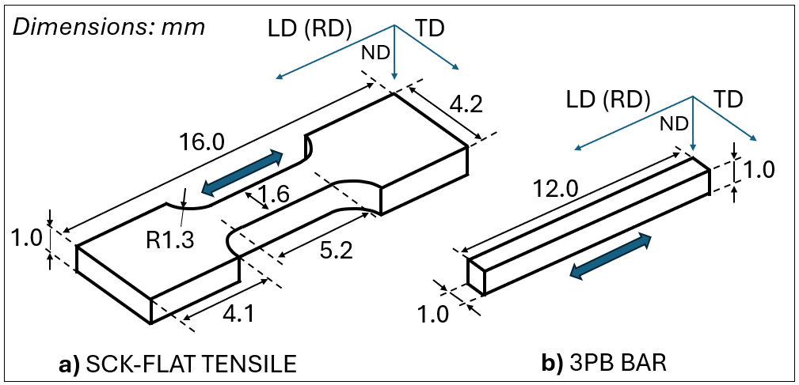
Figure 1. Dimensions of a) uniaxial tensile miniaturized samples designed at SCK CEN and b) 3PB miniaturized bars. The loading direction (LD) corresponds to the rolling direction (RD).
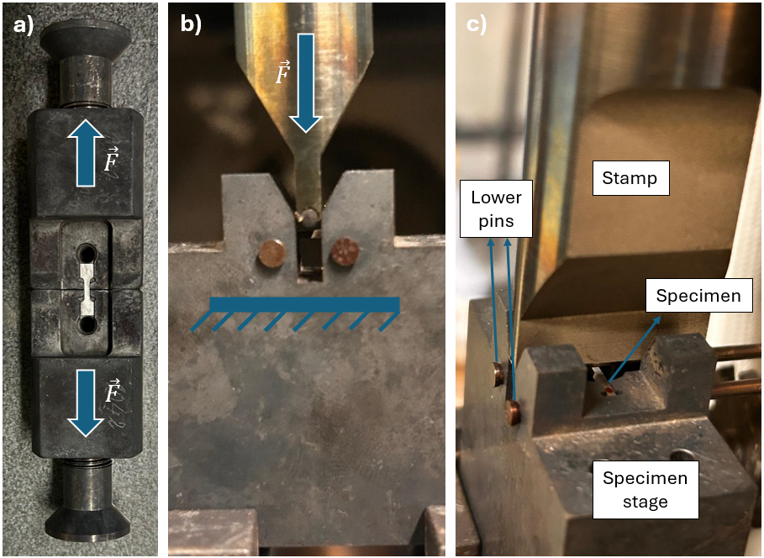
Figure 2. a) tensile test grippers; b) three-point bending test jig; c) 3PB specimen installed on the test jig and bending stamp.
Prior to performing mechanical tests, the microstructure of all alloys was examined using a JEOL JSM-6610 SEM-EBSD equipment. The EBSD specimens were prepared using 220# - 1200# sandpaper and then polished using diamond suspensions (6 µm, 3 µm, 1 µm, and 0.25 µm) and finally polished by colloidal silica suspension. The EBSD data was processed and analyzed using the EDAX OIMTM software.
- Results and discussion
  - Reference tensile properties
    - Mechanical characterization of uniaxial experiments
The uniaxial tensile tests were conducted in accordance with ASTM E8/E8M standard [18], ensuring reproducibility and reliability of results. The main properties extracted following the standard procedures were the yield strength, ultimate tensile strength (Eq. 2), the uniform elongation (UE) and the reduction of area (RA), which provides an additional measure of ductility, true fracture strain, ε_{f}, and true fracture stress, σ_{f}. At least 3 reproducible tests were made per material and condition.
Figure 3 shows that the tensile tests performed at room and elevated temperature reveal clear differences among the five alloys as a consequence of their crystal structures. At room temperature, Face-Centered Cubic (FCC) alloys 316L and Inconel 600 exhibits high elongation and pronounced gradual strain hardening. CuCrZr, despite being FCC, shows lower elongation while maintaining high fracture stress. Ferritic-martensitic EUROFER97 exhibits high strength but limited uniform elongation, which can be attributed to restricted dislocation associated to its refined microstructure. For EUROFER97, essential behavior as a Body-Centered Cubic (BCC) is assumed, since the Body-Centered Tetragonal (BCT) distinction of tempered martensite is irrelevant at the macroscopic level given the very low interstitial content, and that all its associated characteristics are in accordance with the BCC crystalline structure behavior: temperature sensitivity, well-defined DBTT, screw dislocation control, and flow asymmetry [33,34]. HCP Titanium exhibits intermediate elongation while retaining relatively high strength, reflecting the more limited number of slip systems compared with FCC alloys. With increasing temperature, most alloys (EUROFER97, CuCrZr, 316L) experienced a 15–20% reduction in yield and tensile strength as a result of enhanced dislocation mobility, in agreement with literature [26,35,36]. Titanium shows an even larger strength reduction. In contrast, Inconel 600 displays Dynamic Strain Ageing (DSA), causing serrated flow stress and a slight increase in yield strength. This effect may be associated with the Portevin–Le Chatelier (PLC) effect, which has been reported for the material and similar grades of nickel-based alloy [37,38]. These differences in temperature sensitivity explain the variations observed in bending behavior discussed later. A summary of mechanical properties is presented in Figure 4.
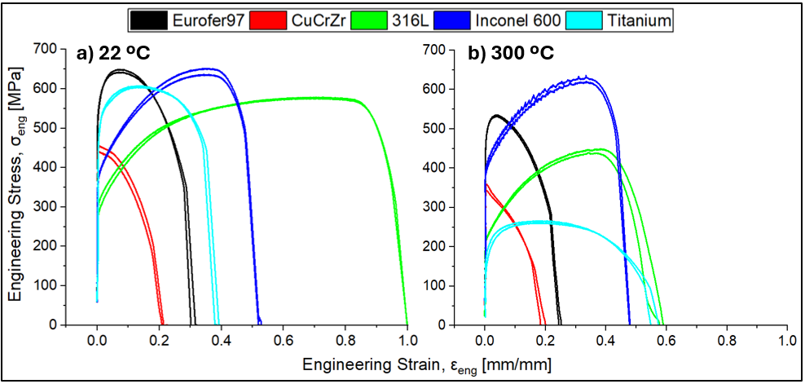
Figure3. Engineering Stress-Strain curves for the studied materials at RT (a) and 300 °C (b).
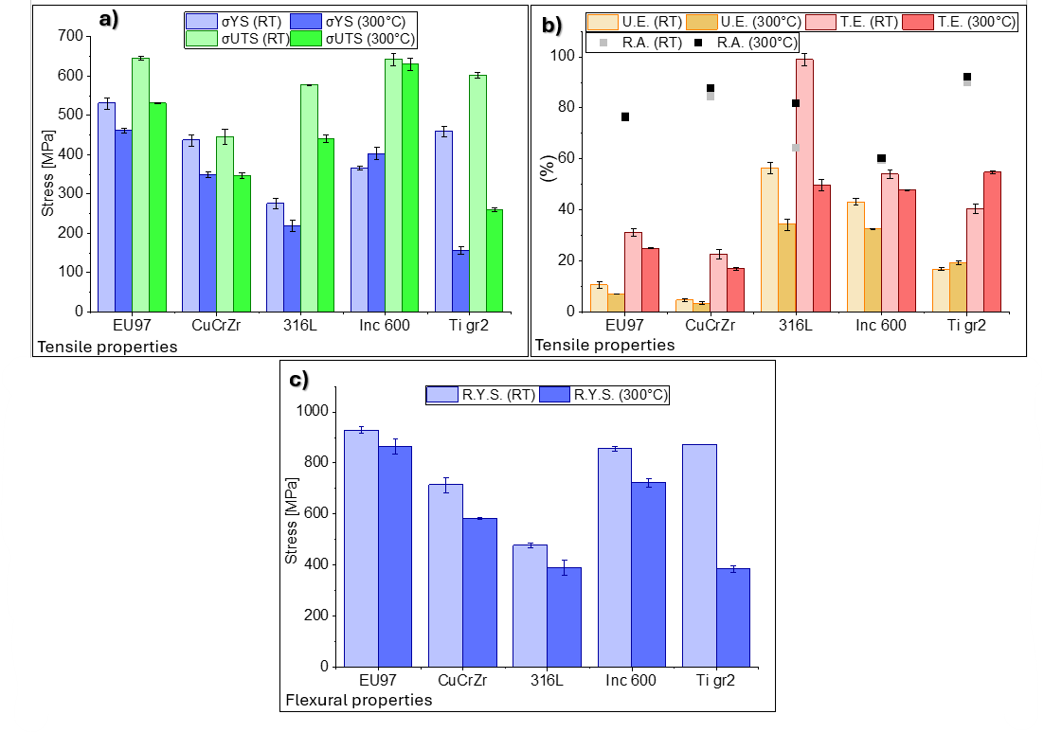
Figure 4. Tensile and flexural mechanical results: a) and b) panels show tensile mechanical properties (yield and ultimate tensile stress, reduction of area, and uniform and total elongation), while c) panel shows the reference flexural stress extracted from the bending tests described in section 3.2.
    - EBSD analysis
Previous to EBSD analysis, fracture surfaces were analyzed to confirm all materials fail in fully ductile mode with heterogenous rupture surface. Details can be consulted in Appendix A: SEM analysis of the fracture surface.
High-angle misorientation threshold of ≥15° was used for distinguishing grain boundaries. Figure 5a exhibits for the EUROFER97 a fine tempered martensitic microstructure with equiaxed grains of approximately 7 µm, which is the result of the normalization and tempering heat treatment. Comparable fraction of Low-Angle Grain Boundaries (LAGB, 1–15°) and High-Angle Grain Boundaries (HAGB, 15–180°) was found, each accounting for approximately 40% of the total boundary population. The high fraction of LAGBs reflects the substructure of prior austenitic grains subdivided by martensitic laths [39], and indicates the presence of a marked dislocation substructure, while HAGBs act as effective barrier to dislocation motion. This deformed microstructure contributes to the high strength of the material, while limiting dislocation mobility and, consequently, reducing the ductility.
Figure 5b shows that CuCrZr exhibits equiaxed grains with an average size of approximately 28 µm and a slight preferential ⟨001⟩ crystallographic orientation, which favors high Schmid factors on multiple {111}⟨110⟩ slip systems simultaneously, promoting multiple slip activity [40], thus causing mechanical anisotropy. A high fraction of LAGBs (60%) and a low density of HAGB (33%) were observed, suggesting the presence of a pronounced sub-grain structure associated with recovery processes. Some twins can be observed within several grains and may contribute to strengthening by acting as additional barriers to dislocation motion. Although precipitates cannot be resolved in the present EBSD analysis, their presence is well documented in literature [26,41,42]
Figure 5c belongs to 316L steel which exhibits an austenitic microstructure. This is consistent with FCC microstructure due to the presence of equiaxed grains, of approximately 54 µm, and annealing twins are present within the grains [40]. This may contribute to strain hardening during deformation. The heterogeneous grain size distribution and irregular grain morphology suggest a grain-grown microstructure, consistent with industrial thermomechanical processing conditions. No pronounced crystallographic texture is observed. Inconel 600, in Figure 5d, exhibits larger and more heterogeneous grains with an average grain size of approximately ~85 µm. Annealing twins are also present, what could be a cause of promoting ductility but slightly reducing strength. Some partially elongated grains can be observed, likely associated with prior thermomechanical processing during rod form fabrication. The titanium EBSD map was unreliable due to its HCP structure, so its mechanical behavior was interpreted from known HCP deformation characteristics [43] and EBSD maps published in open literature [44,45]: as shown in Figure 5e, titanium exhibits an equiaxed HCP microstructure with an average grain size of approximately 20 µm in the flow plane. Grain boundaries are predominantly high-angle (θ > 15°), with minor internal orientation gradients within grain interiors, suggesting a low dislocation substructure density.
Additionally, EBSD analysis permits to evaluate validity of SSTT samples. Microstructure of the studied materials widely homogenous in all materials. According to ASTM E8/E8M tensile standard, for miniaturized specimens, the smallest cross section of the miniature specimen shall have at least ten grains, which is widely achieved in all materials. For bending, standard ASTM E290 has not addressed yet validity for miniaturized specimens, but taking E8/E8M as a reference, bending samples with 1 mm² are taken to be valid.

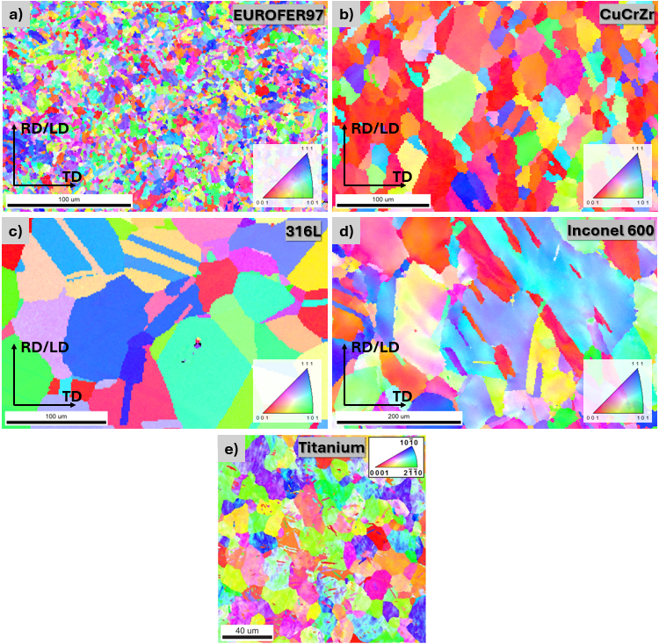
Figure 5. EBSD Inverse pole figure map of materials in as-received condition: a) EUROFER97, b) CuCrZr, c) 316L, d) Inconel 600, e) Titanium Grade 2 done by M.J. Qarni et al. in [44].
  - Extraction of yield stress from 3PB experimental results via empirical correlation
    - Determination of reference flexural stress
The method proposed by Bakaev et al. [16] was adopted. In order to extract the yield stress from the flexural stress–strain curve, this approach defines the reference point as the stage during bending at which the plastic zones initiated at the tensile and compressive surfaces extend through the specimen thickness and converge near the mid-plane (fully plastic bending), which maximizes the tested volume while minimizing work-hardening effects. The experimental flexural stress–strain curve is first plotted. To determine the reference stress, see Figure 6, a tangent is then drawn to the curve beyond a prescribed flexural strain threshold (≈0.5% for tungsten [16]). The first intersection between the tangent and the experimental curve is defined as the reference flexural stress, σ_{ref}. Bakaev et al. further validated this approach via FEM (for further FEM methodology consult Appendix B: FE model and Appendix C: FE procedure) , showing that local yielding initiates before any global nonlinearity is visible in the flexural curve. For the sample geometry used in this work, the initial plastic volume is very small (<0.5 mm³), and global nonlinearity only appears once it grows to approximately 1.5–2 mm³. These observations confirm that the onset of local yielding occurs significantly before any measurable deviation from linearity appears in the global flexural response. Consequently, curve-based methods alone underestimate the true onset of plastic deformation, whereas an inverse FEM approach provides a more physically meaningful and precise correlation between flexural and yield stresses determined in tension.
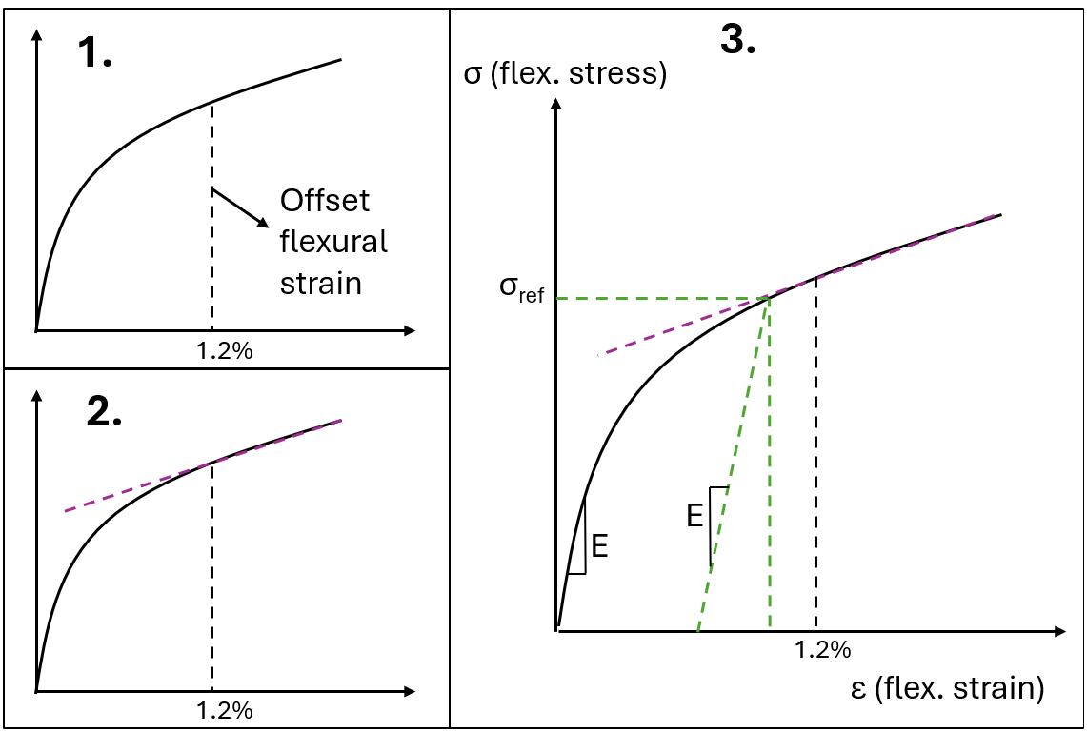
Figure 6. Determination of the flexural elastic limit (σ_{ref}) using the reference flexural stress
While the methodology is maintained in the present work, the flexural strain threshold requires adaptation for the studied alloys. To identify an appropriate strain threshold for the present material set, a parametric FEM study was performed evaluating the evolution of the plastic volume in the critical stressed zone (central 1x1x1.6 mm³ of the beam) and the maximum equivalent plastic strain (ε_{EQ}), indicative of work hardening effect. The plastic deformation volume was defined as the total volume of elements exhibiting accumulated equivalent plastic strain in the FE model. The study covered flexural strains between 0.4% and 2.0% for all five materials at both room temperature and 300 °C. Since all materials except CuCrZr exhibited significant strain hardening after yielding, minimizing ε_{EQ} was considered a key criterion in the threshold selection. At 0.5% flexural strain (see Figure 7), the plastically deformed volume considerably varies across test materials, ranging from just 0.014 mm³ for titanium at RT to 0.506 mm³ for 316L at 300 °C, with equivalent plastic strains between 0.03% and 1.08%. Intermediate cases further illustrate the need for the threshold redefinition of ductile materials at RT with stiffness lower than tungsten: CuCrZr at RT shows a plastic volume of only 0.104 mm³ with a ε_{EQ} of 0.21%, while Inconel 600 at RT reaches 0.424 mm³ but with a ε_{EQ} of 0.71%, and EUROFER97 at RT has 0.277 mm³ of plastically deformed volume with a ε_{EQ} of 0.37%. In all cases, the plastic zone remains confined to a small and unrepresentative fraction of the specimen, and not all the materials develop a stable or consistent plastic volume at this strain level.
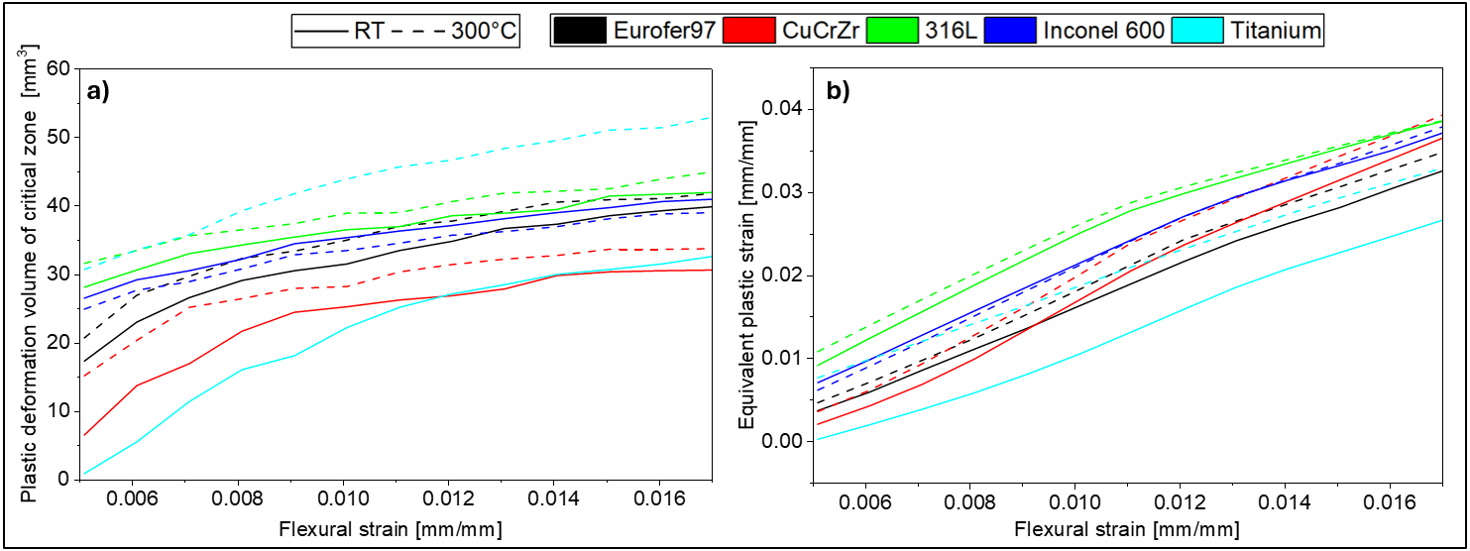
Figure 7. Parametric study for the determination of the Reference Flexural Strain based on a) plastic deformation volume of critical zone and b) equivalent plastic strain.
Based on the parametric study, a flexural strain of 1.2% was identified as the most suitable threshold for the investigated materials. A simultaneous stabilization of the plastic volume growth rate while still-moderate equivalent plastic strain levels are attained. At the selected strain level, the plastic zone transitions from localized surface yielding to a more distributed and representative deformation state can be observed, while strain hardening effects remain limited. Furthermore, the convergence of the different material responses at this point suggests that the criterion becomes less sensitive to the specific crystal structure and hardening behavior of each alloy. At this point, plastically deformed volume has reached values between 0.430 mm³ and 0.747 mm³ for the highest and lower curves, representing ~27-47% of the critically stressed zone. Maximum ε_{EQ} across all materials remains below 3.1% (ranging from 1.59% for titanium at RT to 3.06% for 316L at 300 °C), confirming that the accumulated work hardening in the plastically deformed volume is still limited at this reference point. Beyond 1.2% of flexural strain, while the plastic volume continues to grow, the ε_{EQ} increases more rapidly, progressively increasing the work hardening contribution and compromising the validity of the direct comparison with the uniaxial yield stress. Therefore, a flexural strain threshold of 1.2% provides the best compromise between achieving a sufficiently representative plastically deformed volume and limiting the influence of strain hardening. This value was consequently adopted as the reference condition for all materials and testing temperatures considered in this study.
    - Correlation between yield stress and reference flexural stress
All specimens were bent up to approximately 12.5% flexural strain, corresponding to the maximum displacement allowed by the jig’s geometry without fracture. However, only mechanical data up to a 5% of flexural strain was considered for mechanical analysis, as to this strain it’s sufficient to capture yielding and work hardening, and beyond this level influence of pin-sample pair friction corrupts the bending test outgoing result. At least 3 reproducible tests were made per material and condition. Representative force-deflection curves for all materials and testing conditions are presented in Figure 8. EUROFER97 and Inconel 600 exhibit similar responses to strain with the highest flexural stiffness and strength. EUROFER97 shows an early strain hardening saturation, particularly at elevated temperature, with only slight strength reduction, consistent with the response appreciated from tensile test, typical of ferritic steels. Inconel 600 displayed strong strain hardening at RT, whereas at 300 °C, the yielding decreased but strain hardening increased. The PLC/DSA effect found in tension was not evident in bending, likely due to strain gradients and mixed stress states disturbing solute–dislocation interactions. CuCrZr exhibits intermediate strength and limited strain hardening, again consistent with a precipitate-strengthened microstructure. Only minor reduction in strength is observed at 300 °C, suggesting that precipitation strengthening remains effective within the investigated temperature range. 316L displays moderate flexural stress and stable strain hardening at both temperatures, reflecting the stability of its FCC austenitic microstructure. Titanium shows high yield strength and pronounced strain hardening at RT but underwent substantial softening at 300 °C, in agreement with the trend observed in uniaxial tensile testing. Bending response behavior closely followed tensile behavior of each material, with temperature-dependent differences governed by crystal structure and deformation mechanisms.
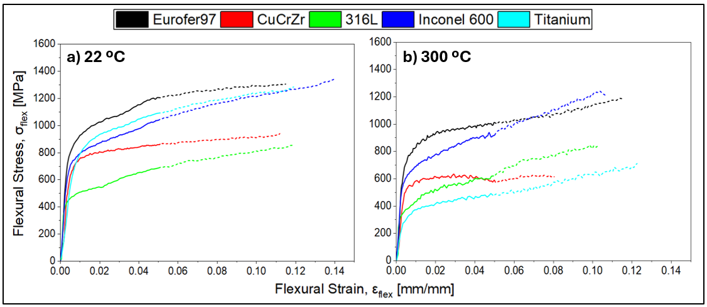
Figure 8. Flexural engineering stress-strain curves for the studied materials at RT (a) and 300 °C (b). Solid line indicates data used for evaluation.
The determination of a flexural-to-tensile yield stress ratio provides a direct means of assessing the relationship between both types of testing methodologies, and of analyzing possible dependencies. Taking as a reference the value obtained for tungsten at various temperatures as well as tested after neutron irradiation (1.64±0.06 [16]), equivalent ratios were determined for all investigated materials. The value of σ_{ref}/σ_{tensile} ratio, where σ_{tensile} refers to the tensile yield stress, was calculated for each condition using the mean yield stress determined in tension experimentally:
$$R_{mat,℃}=\frac{\sum_{i=1}^{n}{\frac{σ_{ref,i}}{\overline{σ_{tensile}}}}}{n},$$ | (5)
The ratios obtained at room temperature and 300 °C were subsequently averaged to obtain a representative value for each material:
$$R_{mat}=\frac{{ R}_{mat at RT}+{ R}_{mat at 300 ℃}}{2}.$$ | (6)
The correlations are summarized in Figure 9. Stable and reproducible values were obtained for EUROFER97 (1.85 ± 0.08), CuCrZr alloy (1.66 ± 0.08) and 316L austenitic stainless steel (1.75 ± 0.09), indicating that the correlation is independent of temperature withing the investigated range. In general terms, for FCC alloys, the mobility laws automatically satisfy Schmid's law; that is, plastic deformation begins on the crystallographic plane with the highest Schmid factor when the stress resolved on that plane reaches a constant critical value, independent of the slip plane orientation, the load direction, and the local stress state [46,47]. This directly implies tension-compression symmetry in FCC metals. Regarding BCC metals, it has been found that the yield criterion for the onset of crystallographic plasticity involves stress components other than the shear stress parallel to the slip direction, as a consequence of the non-planar core of the ⟨111⟩ screw dislocations that control the plastic deformation of BCC crystals [48]. However, in fine-grained BCC polycrystals with random texture, such as EUROFER97, non-Schmid effects could be statistically averaged over the orientation distribution, resulting in a virtually symmetric macroscopic tension-compression behavior. In this context, similarity between EUROFER97 and 316LN suggests comparable stress distribution and development of plasticity in bending (at low strain). The copper alloy exhibits a lower ratio due to its lower stiffness and a more gradual elastic-plastic transition. This favors a larger widespread plastic deformation throughout the material volume during bending and reduces the relative increase in flexural stress compared to tensile stress.
Inconel 600 exhibits a ratio of 1.99 ± 0.28, with a significant temperature dependence. This behavior can be attributed to the onset of Dynamic Strain Ageing (DSA) at 300 °C. Under uniaxial tensile loading, the plastic deformation is sufficient to activate DSA, leading to an apparent stabilization of the yield stress between room temperature and 300 °C. Under bending, however, plastic strain in the tensile region of the specimen is not large enough to trigger DSA, resulting in a reduction of the flexural yield stress with temperature. For HCP metals, the predominant mechanism responsible for the strength differential effect is mechanical twinning [46], which leads to lower yield stresses in compression than in tension. Titanium exhibited the highest ratio (2.23 ± 0.30) and also showed a marked temperature dependence. The increase in the flexural-to-tensile ratio at elevated temperature suggests that bending and tensile tests are affected differently by thermal softening. The non-uniaxial stress state in bending, the contribution of compressive deformation mechanisms, and the inherent geometric constraint of the 3PB configuration may reduce the apparent temperature sensitivity of the flexural yield stress compared with uniaxial tension. It should also be noted that no significant visco-plastic effects are expected for EUROFER97, CuCrZr and 316L. At 300 °C, only Inconel 600 and Ti Grade 2 may exhibit a deformation response dependent on strain-rate kinetics, associated with DSA in the former and thermally activated deformation mechanisms in the HCP structure of the latter, with activated prismatic and pyramidal slip systems which raise up the ductility of the material [43].
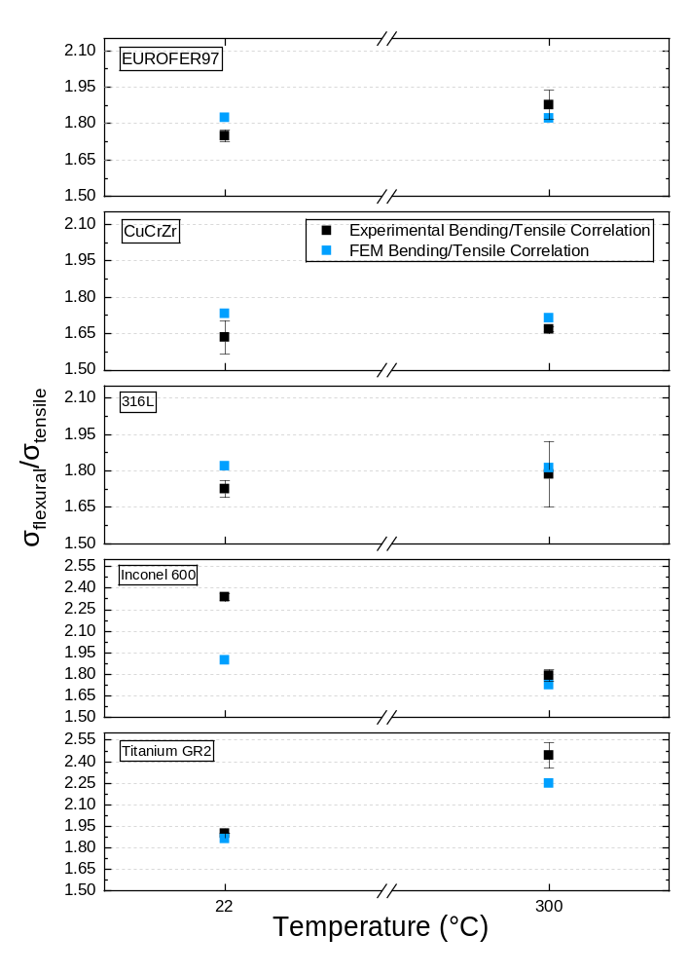
Figure 9. Correlation between Bending Reference Flexural Stress and Tensile Yield Stress for the studied materials.
The uncertainty of each flexural-to-tensile ratio was determined through a standard error propagation accounting for the uncertainty on the experimentally determined yield stress:
$$∆R_{i}=R_{i}\frac{∆σ_{t}}{σ_{t}}.$$ | (7)
For EUROFER97, CuCrZr, and 316L, where the ratio was found to be stable with temperature, measurements from both temperatures were combined using a weighted mean. The total uncertainty was calculated as:
$$∆R_{total}=\sqrt{\frac{1}{\sum_{i}{1/∆R_{i}^{2}}}+σ_{ratio}^{2},}$$ | (8)
where σ_{ratio} accounts for the experimental scatter across all ratio measurements for one material. For Inconel 600 and titanium, the ratio indicates a pronounced temperature dependence. In these cases, calculating a single weighted average would suppress the physical variability between considered conditions. Therefore, the reported values correspond to the arithmetic means of all measurements together with their standard deviations, which more accurately reflects the dispersion and temperature sensitivity of the correlation coefficient.
    - Critical assessment of the flexural-to-tensile correlation
FE models of the tensile and bending tests were calibrated using the tensile experimental curves and subsequently validated against the bending results, providing a mechanical basis for the adopted yield criterion and the flexural–tensile correlation beyond a purely empirical adjustment. Details of the inverse FEM calibration procedure, including the identification of the hardening law and GTN damage parameters from the tensile tests, are provided in Appendix C. Figure 10 a and b compare the experimental and simulated engineering stress–strain curves. The calibrated GTN model accurately reproduces the tensile response up to UTS (≥95% accuracy) and captures the post-necking softening and fracture. The model also successfully predicts the bending response (Figure 10 c and d), reproducing the experimental flexural–tensile correlations for most materials. Good agreement was obtained for EUROFER97, CuCrZr, and 316L, whereas the discrepancies observed for Inconel 600 and Ti Grade 2 at 300 °C are attributed to material-specific deformation mechanisms not captured by the isotropic model.
Table 2 summarizes the empirical and FEM-derived flexural-to-tensile ratios alongside the corresponding YS extraction errors for all studied materials. For EUROFER97, CuCrZr, and 316L, both approaches yield comparable ratios and low extraction errors (below 6%), with the empirical correlation performing slightly better in most cases.
Notably, the inverse FEM approach does not systematically improve the accuracy of yield stress extraction for these materials, which is consistent with the findings of Bakaev et al. [10] for unirradiated tungsten grades, where no significant improvement was observed when applying inverse FEM over the empirical ratio. Given its simplicity and similar accuracy, the empirical ratio is therefore the recommended approach for these materials. Hence, for the above discussed materials, one can claim an accuracy of 2 to 6% for the extraction of the yield stress from the 3PB test using either inverse FEM or directly empirical ratio.
For Inconel 600 and titanium Grade 2, both methods show a significant error (above 11%), consistent with the temperature-dependent scatter identified in Section 3.2.2. In these cases, neither approach provides a reliable value for the ratio, and material- and temperature-specific values should be considered instead.
Table 2. Average error on yield stress extracted from 3PB tests using the empirical ratio.
 | Exp. Correlation | Exp. YS extraction error (%) | FEM Correlation | FEM YS extraction error  (%)
Eurofer97 | 1.85 ± 0.08 | 3.50 | 1.82 ± 0.00 | 3.39
CuCrZr | 1.66 ± 0.08 | 1.71 | 1.72 ± 0.01 | 4.14
316L | 1.75 ± 0.08 | 3.71 | 1.81 ± 0.00 | 5.68
Inconel 600 | 1.99 ± 0.28 | 11.79 | 1.81 ± 0.12 | 11.27
Titanium gr2 | 2.23 ± 0.30 | 11.71 | 2.06 ± 0.27 | 16.05

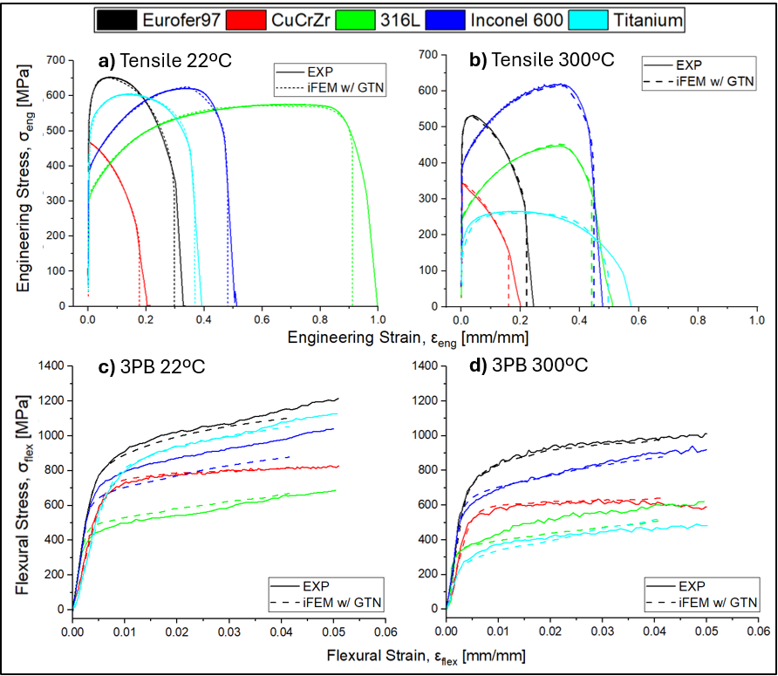
Figure 10. Experimental (solid lines) vs FEM obtained stress-strain curves. Upper figures a) and b) show FEM tensile curves with applied GTN damage model (dash lines) stress-strain curves at room temperature and 300 °C, while lower pictures, c) and d) show FEM (dash lines) flexural stress-strain curves at room temperature and 300 °C.
The selection of J2 plasticity (von Mises) implies the assumption of an isotropic material, and the absence of tension–compression asymmetry ($σ_{tens}^{y}=σ_{comp}^{y}$) or crystallographic anisotropy; therefore, the bending/tensile ratio predicted by FEM remains consistent with temperature. This is why the plasticity model is suitable for materials exhibiting approximately isotropic plastic deformation, negligible tension–compression asymmetry, and conventional monotonic strain hardening (EUROFER97, CuCrZr, and 316L). For Inconel 600, predicting the effects of DSA is not possible since the classical J2 model cannot capture solute-dislocation diffusion kinetics nor does it include strain rate-dependent hardening. A strain rate-dependent visco-plastic model like Perzyna or Johnson-Cook would be necessary. In the case of titanium, this material has tension-compression asymmetry, a strong dependence on crystallographic orientation [49], and activation of prismatic and pyramidal systems at 300 °C. A J3-dependent yield criterion (such as modified Drucker–Prager or Cazacu–Barlat) could partially improve the prediction by introducing sensitivity to the third invariant, capturing tension–compression asymmetry, and better representing multiaxial stress states in bending, which may enhance the bending/tensile ratio prediction for titanium.
  - Extension to irradiated EUROFER97: preliminary assessment via FEM
To evaluate the extensibility of the proposed correlation to irradiated conditions, isotropic hardening laws for neutron-irradiated EUROFER97 at RT and 300 °C, derived from uniaxial tensile data using SCK-flat miniaturized specimens, reported in [13], were implemented with the FE framework described in Appendices B and C. Bending simulations were performed under identical mesh, contact and boundary conditions as for the unirradiated case and the flexural-to-tensile ratio was extracted for irradiated case. Figure 11 compares the FEM-predicted ratio for irradiated EUROFER97 with the experimental unirradiated ratio. The FEM-predicted ratios for irradiated EUROFER97 are insignificantly lower than the unirradiated value and displaying negligible temperature sensitivity, although being present irradiation hardening and reduction in strain hardening capacity. The predicted ratio for RT is close to the bound of the proposed correlation for EUROFER97 (1.85 ± 0.08), being 1.75, while for 300 °C, 1.78, it complies. This indicates on a preliminary and general way that the flexural-to-tensile relationship for EUROFER97 is comparatively to the irradiation condition considered in [13], providing basis for the ongoing extension of this methodology to irradiated 3PB testing campaigns.
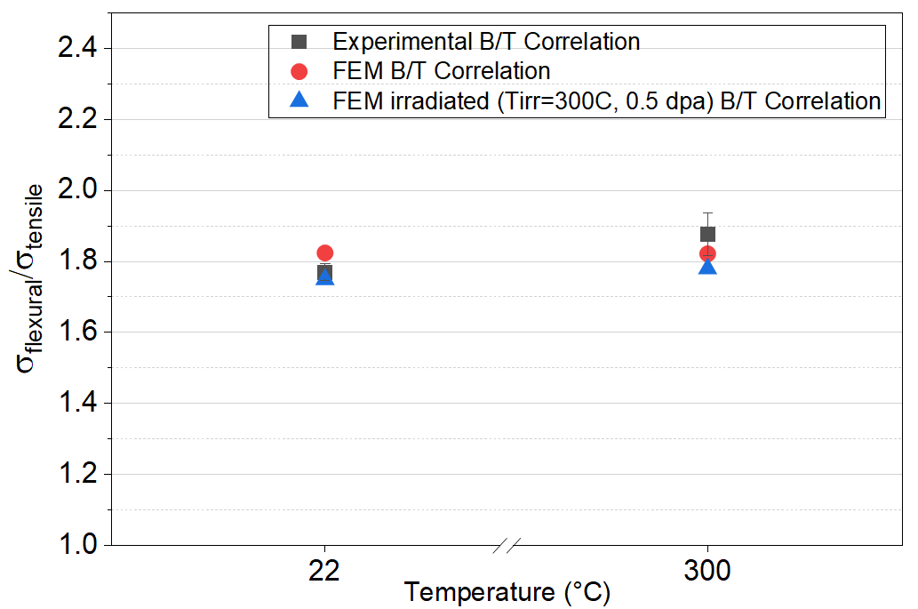
Figure 11. Bending/Tensile (B/T) yield stress ratio for EUROFER97: experimental unirradiated and FEM-predicted non-irradiated and irradiated ratios, at RT and 300 °C.
- Conclusions
In this work, the applicability of miniaturized 3PB specimens for the extraction of uniaxial tensile properties has been systematically assessed across a set of common structural materials relevant to fusion and fission applications. Mechanical testing was performed at room temperature and 300 °C using miniaturized tensile and 3PB specimens. An empirical flexural-to-tensile correlation was established for each studied material, and an inverse FE framework incorporating either the isotropic J2 plasticity or the Gurson-Tvergaard-Needleman damage model was developed and validated against experimental data obtained here. The main conclusions are as follows:
1. A physically meaningful reference flexural stress was identified from the 3PB stress–strain curves and correlated with the conventional 0.2% offset tensile yield stress. Compared with the value previously adopted for tungsten (0.5% flexural strain), a threshold of 1.2% flexural strain was found to be more appropriate for the materials investigated in this study. FEM simulations demonstrated that this criterion provides a sufficiently extended plastically deformed volume while maintaining limited strain hardening, thereby enabling a robust correlation with the initial yield point.
2. Stable flexural-to-tensile ratios were obtained for EUROFER97 (1.85 ± 0.08), CuCrZr (1.66 ± 0.08) and 316L (1.75 ± 0.09). For these alloys, the correlation is independent of test temperature and is primarily governed by geometry and elastic–plastic transition, allowing the yield stress to be estimated from 3PB data with errors below 4%. As for Inconel and Ti, issues related to strain rate-dependence or strongly anisotropic microstructure are identified. Therefore, the flexural-to-tensile ratio turns out to be material- and temperature dependent in the case of Inconel and Ti.
3. The inverse FEM methodology reproduced with high accuracy, both tensile and 3PB experimental responses for all studied materials. The simulations allowed quantification of the stress and strain fields (including both compressive and tension regions for bending tests), and the plastic zone evolution, providing a mechanistic explanation for the experimentally observed differences between materials and test conditions.
4. The GTN ductile damage model was successfully calibrated for all five studied materials at RT and 300 °C. The calibrated models accurately reproduced the post-necking deformation and fracture behavior. Good agreement with experimentally measured reduction of area values was obtained for EUROFER97, 316L and Inconel 600. Larger discrepancies observed for CuCrZr and Titanium were attributed to material anisotropy and crystallographic effects respectively, which are not captured by the isotropic GTN formulation.
Overall, the combination of miniaturized 3PB testing and FEM-based inverse analysis provides a practical route for extracting tensile properties while substantially reducing the required material volume compared with conventional tensile testing. The methodology is therefore attractive for applications involving irradiated materials, where sample/material availability is limited and experimental costs are high. The present results demonstrate that reliable yield-stress correlations can be established for a broad range of engineering alloys, while also identifying the limitations of this method for rate-dependent and/or strongly anisotropic materials.
- Acknowledgment
This work has been carried out within the framework of the EUROfusion Consortium, funded by the European Union via the Euratom Research and Training Programme (Grant Agreement No. 101052200— EUROfusion). Views and opinions expressed are however those of the author(s) only and do not necessarily reflect those of the European Union or the European Commission. Neither the European Union nor the European Commission can be held responsible for them.

- References
[1] W. D. Callister, D.G. Rethwisch, Materials Science and Engineering: An Introduction, 10th Edition, John Wiley & Sons (Wiley)., 2018.
[2] V. Karthik, K.V. Kasiviswanathan, B. Raj, Miniaturized Testing of Engineering Materials, CRC Press (Taylor & Francis), Boca Raton, 2016. https://doi.org/10.1201/9781315372051.
[3] A. Zinovev, C.-C. Chang, J. Van Eyken, E. Gaganidze, D. Terentyev, Effect of neutron irradiation to 0.7 and 1.4 dpa on the tensile mechanical properties and microstructure of EUROFER97 steel, Science Talks 6 (2023) 100214. https://doi.org/10.1016/j.sctalk.2023.100214.
[4] K. Kumar, A. Pooleery, K. Madhusoodanan, R.N. Singh, A. Chatterjee, B.K. Dutta, R.K. Sinha, Optimisation of thickness of miniature tensile specimens for evaluation of mechanical properties, Materials Science and Engineering: A 675 (2016) 32–43. https://doi.org/10.1016/j.msea.2016.08.032.
[5] Z. Li, D. Terentyev, S. Holmström, T. Pardoen, Small punch test size reduction to enable high flux irradiation, Journal of Nuclear Materials 604 (2025). https://doi.org/10.1016/j.jnucmat.2024.155491.
[6] D. Finarelli, M. Roedig, F. Carsughi, Small punch tests on austenitic and martensitic steels irradiated in a spallation environment with 530 MeV protons, Journal of Nuclear Materials 328 (2004) 146–150. https://doi.org/10.1016/j.jnucmat.2004.04.320.
[7] X. (Frank) Chen, M. Serrano, R. Hernández, D. Lu, M.A. Sokolov, S.M. Gonzalez De Vicente, Y. Katoh, Influence of fatigue precracking and specimen size on Master Curve fracture toughness measurements of EUROFER97 and F82H steels, Nuclear Materials and Energy 34 (2023). https://doi.org/10.1016/j.nme.2023.101393.
[8] M. Sánchez, S. Cicero, M. Kirk, E. Altstadt, W. Server, M. Yamamoto, Using Mini-CT Specimens for the Fracture Characterization of Ferritic Steels within the Ductile to Brittle Transition Range: A Review, Metals (Basel). 13 (2023). https://doi.org/10.3390/met13010176.
[9] P. Zheng, R. Chen, H. Liu, J. Chen, Z. Zhang, X. Liu, Y. Shen, On the standards and practices for miniaturized tensile test – A review, Fusion Engineering and Design 161 (2020). https://doi.org/10.1016/j.fusengdes.2020.112006.
[10] M.N. Gussev, R.H. Howard, K.A. Terrani, K.G. Field, Sub-size tensile specimen design for in-reactor irradiation and post-irradiation testing, Nuclear Engineering and Design 320 (2017) 298–308. https://doi.org/10.1016/j.nucengdes.2017.06.008.
[11] A. Bakaev, D. Terentyev, A. Zinovev, E.E. Zhurkin, Irradiation hardening of advanced tungsten grades: An experimental and inverse finite element method study, Int. J. Refract. Metals Hard Mater. 105 (2022). https://doi.org/10.1016/j.ijrmhm.2022.105839.
[12] T. Nozawa, H. Sakasegawa, X. Chen, T. Kato, J.W. Geringer, Y. Katoh, H. Tanigawa, Non-contact strain evaluation for miniature tensile specimens of neutron-irradiated F82H by digital image correlation, Fusion Engineering and Design 157 (2020). https://doi.org/10.1016/j.fusengdes.2020.111663.
[13] C.C. Chang, D. Terentyev, A. Bakaev, A. Zinovev, D. Del Serra, P. Verleysen, T. Pardoen, Application of mini-flat and cylindrical test specimens to extract hardening law and ductility of neutron irradiated Eurofer97, Fusion Engineering and Design 216 (2025). https://doi.org/10.1016/j.fusengdes.2025.115072.
[14] I. Scheider, W. Brocks, A. Cornec, Procedure for the Determination of True Stress-Strain Curves From Tensile Tests With Rectangular Cross-Section Specimens, J. Eng. Mater. Technol. 126 (2004) 70–76. https://doi.org/10.1115/1.1633573.
[15] H. Liu, Y. Shen, S. Yang, P. Zheng, L. Zhang, A comprehensive solution to miniaturized tensile testing: Specimen geometry optimization and extraction of constitutive behaviors using inverse FEM procedure, Fusion Engineering and Design 121 (2017) 188–197. https://doi.org/10.1016/j.fusengdes.2017.07.016.
[16] A. Bakaev, D. Terentyev, A. Zinovev, C.C. Chang, C. Yin, V.A. Bakaev, E.E. Zhurkin, Application of sub-miniaturized bending tests to extract tensile properties from neutron-irradiated metallic alloys, Journal of Nuclear Materials 558 (2022). https://doi.org/10.1016/j.jnucmat.2021.153320.
[17] C. Yin, D. Terentyev, T. Pardoen, A. Bakaeva, R. Petrov, S. Antusch, M. Rieth, M. Vilémová, J. Matějíček, T. Zhang, Tensile properties of baseline and advanced tungsten grades for fusion applications, Int. J. Refract. Metals Hard Mater. 75 (2018) 153–162. https://doi.org/10.1016/j.ijrmhm.2018.04.003.
[18] C. Yin, D. Terentyev, T. Zhang, S. Nogami, S. Antusch, C.C. Chang, R.H. Petrov, T. Pardoen, Ductile to brittle transition temperature of advanced tungsten alloys for nuclear fusion applications deduced by miniaturized three-point bending tests, Int. J. Refract. Metals Hard Mater. 95 (2021). https://doi.org/10.1016/j.ijrmhm.2020.105464.
[19] G.Z. Voyiadjis, F.H. Abed, Microstructural based models for bcc and fcc metals with temperature and strain rate dependency, Mechanics of Materials 37 (2005) 355–378. https://doi.org/10.1016/j.mechmat.2004.02.003.
[20] E. Voce, The relationship between stress and strain for homogeneous deformations, Journal of the Institute of Metals 74 (1948).
[21] F. Arbeiter, E. Diegele, U. Fischer, A. Garcia, A. Ibarra, J. Molla, F. Mota, A. Möslang, Y. Qiu, M. Serrano, F. Schwab, Planned material irradiation capabilities of IFMIF-DONES, Nuclear Materials and Energy 16 (2018) 245–248. https://doi.org/10.1016/j.nme.2018.05.026.
[22] V. Barabash, A. Peacock, S. Fabritsiev, G. Kalinin, S. Zinkle, A. Rowcliffe, J.W. Rensman, A.A. Tavassoli, P. Marmy, P.J. Karditsas, F. Gillemot, M. Akiba, Materials challenges for ITER - Current status and future activities, Journal of Nuclear Materials 367-370 A (2007) 21–32. https://doi.org/10.1016/j.jnucmat.2007.03.017.
[23] A. Bhattacharya, S.J. Zinkle, J. Henry, S.M. Levine, P.D. Edmondson, M.R. Gilbert, H. Tanigawa, C.E. Kessel, Irradiation damage concurrent challenges with RAFM and ODS steels for fusion reactor first-wall/blanket: A review, JPhys Energy 4 (2022). https://doi.org/10.1088/2515-7655/ac6f7f.
[24] L. Stratil, F. Siska, H. Hadraba, I. Dlouhy, Modeling of Ductile Tearing for RAFM Steel Eurofer97, Procedia Materials Science 3 (2014) 1155–1160. https://doi.org/10.1016/j.mspro.2014.06.188.
[25] Jeong-Ha You, Copper matrix composites as heat sink materials for water-cooled divertor target, Nuclear Materials and Energy 5 (2015) 7–18. https://doi.org/https://doi.org/10.1016/j.nme.2015.10.001.
[26] K. Zhang, E. Gaganidze, M. Gorley, Development of the material property handbook and database of CuCrZr, Fusion Engineering and Design 144 (2019) 148–153. https://doi.org/10.1016/j.fusengdes.2019.04.094.
[27] S.H. Goods, J.D. Puskar, Solid state bonding of CuCrZr to 316L stainless steel for ITER applications, Fusion Engineering and Design 86 (2011) 1634–1638. https://doi.org/10.1016/j.fusengdes.2010.12.051.
[28] F.A. Garner, M.B. Toloczko, B.H. Sencer, Comparison of swelling and irradiation creep behavior of fcc-austenitic and bcc-ferritic/martensitic alloys at high neutron exposure, Journal of Nuclear Materials 276 (2000) 123–142. https://doi.org/10.1016/S0022-3115(99)00225-1.
[29] V. Perovic, A. Perovic, G. Weatherly, A. Brennenstuhl, Microstructure and Microchemistry of Inconel 600 STEAM Generator Tubing, Microscopy and Microanalysis 6 (2000) 356–357. https://doi.org/10.1017/S1431927600034279.
[30] I. V. Gorynin, A.S. Oryshchenko, V.P. Leonov, V.I. Mikhailov, I.A. Schastlivaia, Titanium Application in Marine Engineering and Nuclear‐Power Engineering, in: Proceedings of the 13th World Conference on Titanium, Wiley, 2016: pp. 1797–1805. https://doi.org/10.1002/9781119296126.ch302.
[31] ASTM, ASTM E8/E8M: Standard Test Methods for Tension Testing of Metallic Materials, (2024). https://doi.org/10.1520/E0008_E0008M-24.
[32] ÁSTM, ASTM E290 - 14: Standard Test Methods for Bend Testing of Material for Ductility, (2014). https://doi.org/10.1520/E0290-14.
[33] R. Klueh, D. Harries, High-Chromium Ferritic and Martensitic Steels for Nuclear Applications, ASTM International100 Barr Harbor Drive, PO Box C700, West Conshohocken, PA 19428-2959, 2001. https://doi.org/10.1520/MONO3-EB.
[34] R. Bonadé, P. Mueller, P. Spätig, Fracture toughness behavior in the ductile-brittle transition region of the tempered martensitic Eurofer97 steel: Experiments and modeling, Eng. Fract. Mech. 75 (2008) 3985–4000. https://doi.org/10.1016/j.engfracmech.2008.01.016.
[35] E. Gaganidze, F. Gillemot, I. Szenthe, M. Gorley, M. Rieth, E. Diegele, Development of EUROFER97 database and material property handbook, Fusion Engineering and Design (2018) 9–14. https://doi.org/https://doi.org/10.1016/j.fusengdes.2018.06.027.
[36] S. Ivanov, R. Mendagaliev, S. Samoilov, A. Akhmedianov, N. Lebedeva, I. Udin, G. Turichin, Temperature dependence of tensile mechanical properties and work hardening behavior in direct laser deposited austenitic stainless steel 316L, Mater. Today Commun. 39 (2024). https://doi.org/10.1016/j.mtcomm.2024.108613.
[37] S.H. Hong, H.Y. Kim, J.S. Jang, H. Kuk, Dynamic Strain Aging Behavior of Inconel 600 Alloy, Superalloys (1996) 401–407.
[38] P. Maj, J. Zdunek, J. Mizera, K.J. Kurzydlowski, B. Sakowicz, M. Kaminski, Microstructure and strain-stress analysis of the dynamic strain aging in inconel 625 at high temperature, Metals and Materials International 23 (2017) 54–67. https://doi.org/10.1007/s12540-017-6264-1.
[39] M. Duerrschnabel, U. Jäntsch, R. Gaisin, M. Rieth, Microstructural insights into EUROFER97 batch 3 steels, Nuclear Materials and Energy 35 (2023). https://doi.org/10.1016/j.nme.2023.101445.
[40] G. E. Dieter, Mechanical metallurgy, Third Edition, McGraw-Hill Education, New York, 1986.
[41] Y. Luo, X. Liu, L. Huang, Y. Wu, S. Zhao, H. Zhang, G. Yu, M. Liu, J. He, J. Liu, Y. Fang, Unveiling the microstructure evolution and the short-time tensile creep behavior in the CuCrZr alloy, Mater. Charact. 216 (2024). https://doi.org/10.1016/j.matchar.2024.114305.
[42] I.S. Batra, G.K. Dey, U.D. Kulkarni, S. Banerjee, Microstructure and properties of a Cu-Cr-Zr alloy, Journal of Nuclear Materials 299 (2001). https://doi.org/https://doi.org/10.1016/S0022-3115(01)00691-2.
[43] Peter M. Anderson, John P. Hirth, Jens Lothe, Theory of Dislocations, 3rd Edition, Cambridge University Press, 217AD.
[44] M.J. Qarni, G. Sivaswamy, A. Rosochowski, S. Boczkal, On the evolution of microstructure and texture in commercial purity titanium during multiple passes of incremental equal channel angular pressing (I-ECAP), Materials Science and Engineering: A 699 (2017) 31–47. https://doi.org/10.1016/j.msea.2017.05.040.
[45] Y.J. Chen, Y.J. Li, J.C. Walmsley, S. Dumoulin, P.C. Skaret, H.J. Roven, Microstructure evolution of commercial pure titanium during equal channel angular pressing, Materials Science and Engineering: A 527 (2010) 789–796. https://doi.org/10.1016/j.msea.2009.09.005.
[46] W.F. Hosford, T.J. Allen, Twinning and directional slip as a cause for a strength differential effect, Metallurgical Transactions 4 (1973) 1424–1425. https://doi.org/10.1007/BF02644545.
[47] E. Schmid, W. Boas, Plasticity of Crystals, F. A. HUGHES & CO. LIMITED, London, 1935.
[48] R. Gröger, A. G. Bailey, V. Vitek, Multiscale modeling of plastic deformation of molybdenum and tungsten: I. Atomistic studies of the core structure and glide of 1/2<111> screw dislocations at 0 K, Acta Mater. 56 (2008).
[49] P. Lin, Y. Hao, B. Zhang, S. Zhang, C. Chi, J. Shen, Tension-compression asymmetry in yielding and strain hardening behavior of CP-Ti at room temperature, Materials Science and Engineering: A 707 (2017) 172–180. https://doi.org/10.1016/j.msea.2017.09.042.
[50] A.L. Gurson, Continuum Theory of Ductile Rupture by Void Nucleation and Growth: Part I—Yield Criteria and Flow Rules for Porous Ductile Media, J. Eng. Mater. Technol. 99 (1977) 2–15. https://doi.org/10.1115/1.3443401.
[51] V. Tvergaard, Influence of voids on shear band instabilities under plane strain conditions, Int. J. Fract. 17 (1981) 389–407. https://doi.org/10.1007/BF00036191.
[52] V. Tvergaard, A. Needleman, Analysis of the cup-cone fracture in a round tensile bar, Acta Metallurgica 32 (1984) 157–169. https://doi.org/10.1016/0001-6160(84)90213-X.
[53] T.S. Byun, K. Farrell, M. Li, Deformation in metals after low-temperature irradiation: Part II - Irradiation hardening, strain hardening, and stress ratios, Acta Mater. 56 (2008) 1056–1064. https://doi.org/10.1016/j.actamat.2007.10.056.
[54] C.C. Chang, D. Terentyev, A. Bakaev, A. Zinovev, D. Del Serra, P. Verleysen, T. Pardoen, On the equivalence of mini-flat and cylindrical tensile geometries to extract hardening law and ductility of Eurofer97, Fusion Engineering and Design 194 (2023). https://doi.org/10.1016/j.fusengdes.2023.113717.
[55] C.C. Chu, A. Needleman, Void Nucleation Effects in Biaxially Stretched Sheets, J. Eng. Mater. Technol. 102 (1980) 249–256. https://doi.org/10.1115/1.3224807.
[56] J. Faleskog, X. Gao, C.F. Shih, Cell model for nonlinear fracture analysis – I. Micromechanics calibration, Int. J. Fract. 89 (1998) 355–373. https://doi.org/10.1023/A:1007421420901.
[57] A. Kaniadakis, J.P. Crété, P. Longère, Description of void coalescence by internal necking/shearing within XFEM via a micromechanical 3D volumetric cohesive zone model (μ-VCZM), J. Mech. Phys. Solids 202 (2025). https://doi.org/10.1016/j.jmps.2025.106176.
[58] T. Pardoen, J.W. Hutchinson, An extended model for void growth and coalescence, J. Mech. Phys. Solids 48 (2000) 2467–2512. www.elsevier.com/locate/jmps.
[59] W. Cai, Z. Zhou, X. Qian, D. Cao, S. Li, L. Zhu, H. Hu, Numerical Study on Ductile Failure Behaviours of Steel Structures under Quasi-Static Punch Loading, J. Mar. Sci. Eng. 11 (2023). https://doi.org/10.3390/jmse11061197.
[60] X. Pan, X. Wu, K. Mo, X. Chen, J. Almer, J. Ilavsky, D.R. Haeffner, J.F. Stubbins, Lattice strain and damage evolution of 9-12%Cr ferritic/martensitic steel during in situ tensile test by X-ray diffraction and small angle scattering, in: Journal of Nuclear Materials, 2010: pp. 10–15. https://doi.org/10.1016/j.jnucmat.2010.07.003.
[61] Y.-M. Hu, M.-Z. Chen, Y. Xiao, J. Xiao, X. Tan, Q. Tang, Y.-E. Zhou, T.-S. Cui, Parameters Determination of GTN Model and Damage Analysis of Aluminum Alloy 6016 Sheet Metal, in: International Conference on Material Science and Application (ICMSA 2015, 2014. https://doi.org/10.2991/icmsa-15.2015.73.
[62] Z.L. Zhang, C. Thaulow, J. Ødegård, A complete Gurson model approach for ductile fracture, Eng. Fract. Mech. 67 (2000) 155–168. https://doi.org/10.1016/S0013-7944(00)00055-2.

Appendix A: SEM analysis of fracture surface
SEM fractographic analysis further confirms predominance of ductile fracture mechanisms in all materials. SEM micrographs (Figure A.1 and Figure A.2 for RT and 300 ᵒC, respectively) reveal predominantly ductile fracture at all testing temperatures, characterized by ductile dimpling which indicate micro-void nucleation, growth, and eventual coalescence. The observations were taken in central fracture regions, where stress triaxiality is expected to be the highest and where cracking is expected to initiate. In FCC alloys (316L, Inconel 600, CuCrZr), typical dimpled rupture surfaces are found at both temperatures. Fracture morphology consisted of a combination of equiaxed ductile dimples and elongated shear dimples, indicating significant plastic deformation prior to failure. This behavior is particularly pronounced in 316L and Cu alloy, consistent with their relatively high ductility. For Cu alloy at RT equiaxed dimples are observed in the high-triaxiality central region, whereas the surrounding low-triaxiality areas are dominated by shear fracture features. The marked difference in deformation mechanisms across the fracture surface may indicate anisotropic plastic deformation of the material. EUROFER97 exhibits fine and uniformly distributed dimples reflecting its refined martensitic microstructure. This fracture characteristics remained unchanged between RT and 300 ᵒC test temperature. Titanium displays mixed features: deep dimples at RT indicating extensive plasticity, and larger dimples at 300 °C, most likely due to enhanced slip activity. Significant differences in void morphology, size distribution, and fracture surface roughness were observed depending on alloy type and test temperature.
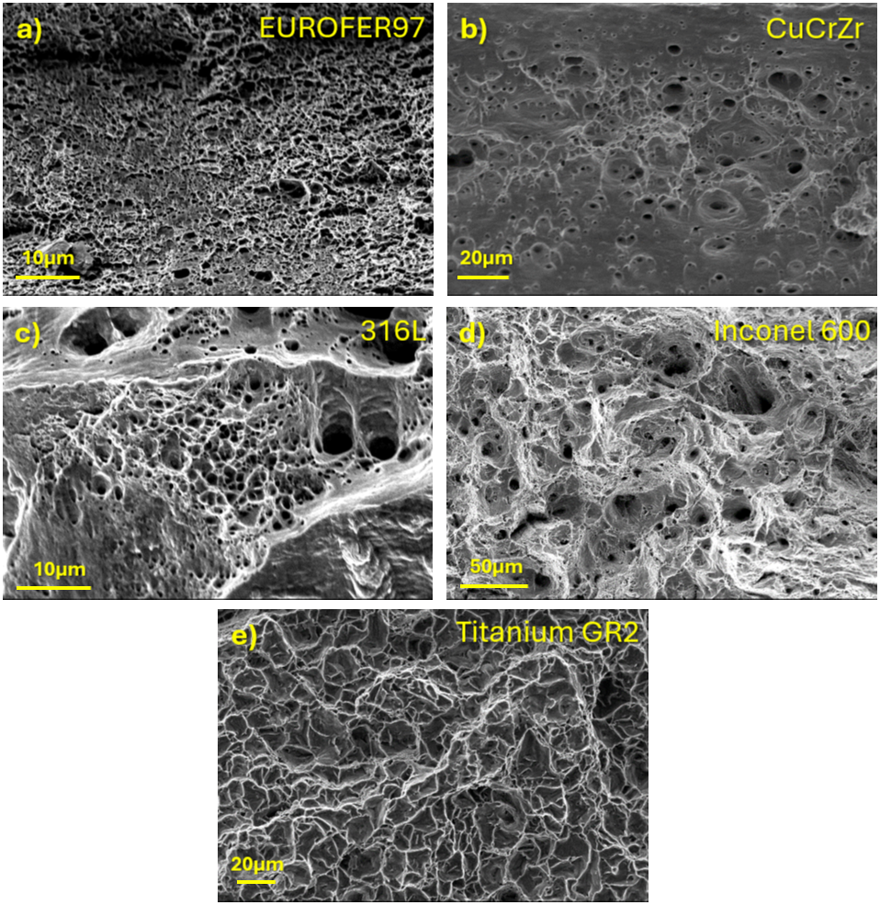
Figure A.1. SEM micrographs of fracture surfaces at the localization of maximum triaxiality area for materials tested at RT.
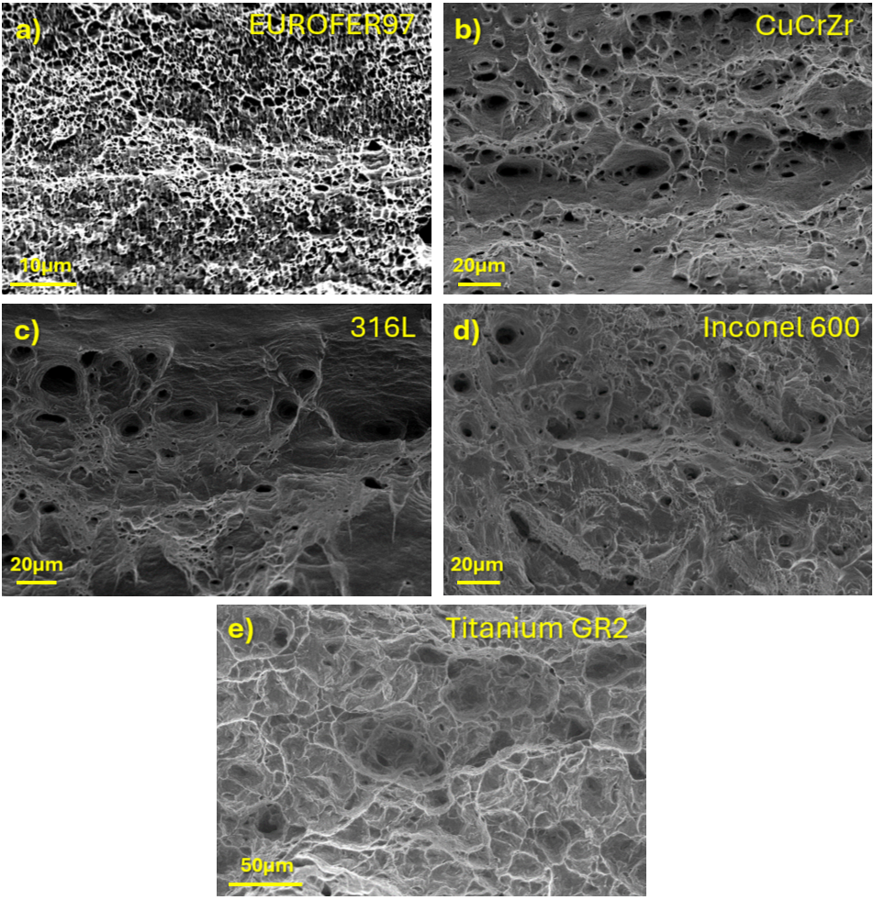
Figure A.2. SEM micrographs of fracture surfaces at the localization of maximum triaxiality area for materials tested at 300 ᵒC.
Appendix B: FE model
FE simulations were performed using the commercial software ANSYS Mechanical 2024 R1 with the Static Structural module. The tensile and 3PB test specimen models were prepared according to the experimental specimen dimensions described in Figure 1. A dedicated mesh study was conducted for both tensile and bending specimens following a convergence analysis. The geometry of the tensile specimen was generated by exploiting symmetry and modelling 1/8 of the specimen. The model consisted of 8.0 x 10⁴ hence quadratic hexahedral 3D SOLID186 elements and 3.5 x 10⁵ nodes, using a variable mesh size with elements of 0.015 mm in the fracture zone and 0.1 mm in the rest of the specimen (see Figure B.1 a and b). Similarly, the 3PB geometry was generated by modelling 1/4 of the setup using symmetry. It consisted of 4.0 x 10⁴ quadratic 3D SOLID186 elements and 1.3 x 10⁴ nodes with a mesh size of 0.15 mm for specimen, stamp and holder pins (see Figure B.1 c). For reference point identification the 3PB test model was made of 1.0 x 10⁴ quadratic 3D SOLID186 elements and 5.3 x 10⁴ nodes using a 0.075 mm element sizes. As from previous studies [16], both the loading and support pins were assumed to be rigid bodies. The contact between the specimen and the support and loading pins was modeled using a frictionless condition supported by a systematic FE sensitivity analysis varying the friction coefficient. All FE models were implemented in ANSYS Mechanical Workbench using a Static Structural analysis.
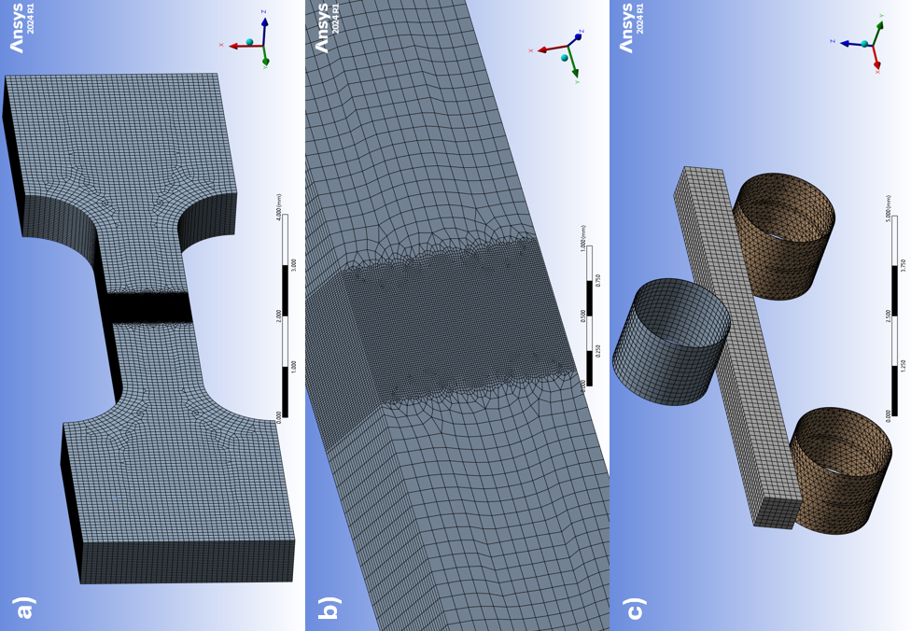
Figure B.1. FEM models for: a) and b) tensile test, and c) 3PB tests.
Appendix C: FE procedure
Material behavior was modeled using J2 elastoplastic flow theory with isotropic hardening. Isotropic hardening laws with linear evolution from UTS until fracture point were obtained by converting experimental data to a true stress-true strain curve on flat tensile specimens. Only first half of the post-necking stress-strain curve has been taken into consideration for extraction of material properties given that the plastic deformation in the second half of it is largely controlled by other processes like nucleation and growth of voids Gurson–Tvergaard–Needleman theory [50–52]. Raw engineering stress–strain curve is first corrected for preload offset and machine compliance. The resulting curve is then converted into true stress–true strain as follows:
$$σ=\frac{F}{S_{i}}=\frac{F}{S_{0}}\left(1+ε_{eng}\right)=σ_{eng}\left(1+ε_{eng}\right),$$ | (C.1)
$$ε=\int_{L_{o}}^{L}{\frac{dL}{L}=\ln\left(\frac{L}{L_{0}}\right)=ln\left(1+ε_{eng}\right)}.$$ | (C.2)
These expressions are valid until necking starts. The true equivalent plastic strain was subsequently extracted from the total strain to establish the hardening law $σ_{y}({\overset{ˉ}{ε}}^{p})$ up to the necking point. Beyond this, the true fracture stress and strain are estimated from the measured fracture surface area as:
$$σ_{f}=\frac{F_{f}}{S_{f}},$$ | (C.3)
$$ε_{f}=\ln\left(\frac{L_{f}}{L_{0}}\right).$$ | (C.4)
The hardening law is further assumed linear from UTS to fracture. This approximation has already been analyzed in different studies with good approximation [53]. The σ_{f} serves as an initial guess, and the slope is subsequently adjusted by fitting the simulated engineering S–S curve to the experimental one, yielding the corrected hardening law. [54]
Elastic constants used in this word are provided in Table C.1. Poisson ratio was maintained constant at 0.3. Poisson ratio was maintained constant at 0.3.
Table C.1. Young Module values used in FEM analysis for the studied materials
 | Young Modulus (GPa)
 | RT | 300 ᵒC
EUROFER97 | 217 | 199
CuCrZr | 125 | 119
316L | 196 | 180
INCONEL600 | 214 | 199
Titanium | 103 | 88

Ductile fracture in metals is governed by the sequential mechanisms of microvoid nucleation, growth, and coalescence. Gurson introduced in 1977 a yield function accounting for the presence of an isolated spherical void in a rigid-perfectly plastic von Mises matrix [50]. However, the original model was found to overestimate the load-carrying capacity of voided materials. To address this, Tvergaard introduced phenomenological adjustment parameters (q1 and q2) into the yield function [51], and later supplemented it with a description of the abrupt load-carrying capacity loss at realistic void volume fractions, coupled with a phenomenological nucleation law of Chu and Needleman [52,54]. The resulting Gurson-Tvergaard-Needleman (GTN) model has become one of the most widely adopted frameworks for simulating ductile failure in metallic materials. The yield surface is expressed as:
$$f\left(σ,σ_{y}\right)={\left(\frac{σ_{eq}}{\overline{σ}}\right)}^{2}+2f^{*}q_{1}\cosh\left(\frac{3}{2}\frac{q_{2}σ_{h}}{\overline{σ}}\right)-1-\left(q_{1}f^{*2}\right)=0,$$ | (C.5)
where σ_{eq}, $\overline{σ}$, and σ_{h} are the von Mises equivalent stress, the matrix flow stress, and the hydrostatic stress, respectively. The effective void volume fraction (VVF), $f^{*}$, introduced by Tvergaard and Needleman to phenomenologically capture the accelerated porosity evolution during coalescence, is defined as:
$$f^{*}=\left\{\begin{aligned}f if f≤f_{c} \\ f_{c}+\frac{f_{n}^{*}-f_{c}}{f_{f}-f_{c}}\left(f-f_{c}\right) if { f}_{c}<f<f_{c} \end{aligned}\right.,$$ | (C.6)
where $f^{*}$ is the true VVF, $f_{c}$is the critical VVF at the onset of coalescence, $f_{f}$ is the VVF at final fracture, and $f_{u}^{*}=1/q_{1}$, is the value at which the material loses all load-bearing capacity [55]. The total void volume fraction evolution is decomposed as the sum of nucleation of new voids to the growth of existing voids:
$$\dot{f}={\dot{f}}_{nucleation}+{\dot{f}}_{growth},$$ | (C.7)
where the nucleation term is the rate of the void nucleation with respect to the average effective plastic strain rate of the matrix material ${\dot{ε}}_{eq}^{pl}$, proposed by Chu and Needleman [54], and it follows a strain-controlled Gaussian distribution:
$${\dot{f}}_{nucleation}=A{\dot{ε}}_{eq}^{pl},$$ | (C.8)
$$A\left(\overline{ε}\right)=\frac{f_{n}}{S_{n}\sqrt{2π}}exp{\left[-\frac{1}{2}\left(\frac{\overline{ε}-ε_{N}}{S_{n}}\right)\right]}^{2},$$ | (C.9)
with $f_{N}$being the VVF of voids generated by nucleation, $ε_{N}$ the mean nucleation strain, and $S_{N}$ its standard deviation. The growth term is derived from plastic incompressibility of the matrix, and it’s controlled by the rate of the growth of existing void with respect to the trace of the macroscopic plastic strain rate tensor, ${\dot{ε}}_{kk}^{p}$:
$${\dot{f}}_{growth }=\left(1-f\right){\dot{ε}}_{kk}^{p}.$$ | (C.10)
In the general case, the GTN model requires calibration of eight parameters q₁, q₂, f₀, f_{N}, ε_{N}, S_{N}, f_{c}, f_{F}. However, q₁ and q₂ can be adjusted based on FE void cell simulations as a function of the hardening parameters [56,57], while f_{c} and f_{f} can be avoided when using advanced coalescence criteria [58].The following assumptions were taken for the GTN parameters with the idea to keep the approach as simple as possible: (a) q₁ and q₂ Tvergaard parameters were fixed after [51], where Tvergaard performed void cell calculations on moderate hardening materials containing periodically distributed voids and found that q₁ = 1.5, q₂ = 1 closely match experimental and numerical results; (b) f₀ was set as 0 relaying on the fact that a very low initial void volume fraction can be assumed as a result of the manufacturing processes. Also for some well-known materials as EUROFER97 or 316L, a very low initial porosity is reported in the literature [24,59]; (c) For parameters ε_{N} and S_{N} Pan et al. [60] showed that the onset of the void nucleation often occurs after some degree of plastic deformation. The UTS is selected as a first approximation for S_{N} and ε_{N} is set equal to the strain at UTS.
The most influential parameters for the present study are f_{N}, f_{C} and f_{f} where f_{N} is the total volume fraction of voids that can potentially be generated by nucleation during plastic deformation, fc is the critical void volume fraction at which the voids begin to coalesce, and f_{f} is the void volume fraction at failure (loss of load-carrying capacity). A sensitivity study of the influence of these parameters on the numerical engineering stress-strain curve was done, along with the comparison with other works [59,61,62]. In the context of this calibration procedures and assumptions, f_{N} was found to be the most influential parameter, as it has a direct impact on the post-necking final failure process (slope of unloading behavior). In contrast, ​ f_{c} and f_{f} primarily affect the point at which failure initiates.
The calibration of the GTN damage parameters is typically performed through an inverse FEM procedure. The model response is iteratively fitted to experimental results: an initial set of parameters is assumed, e.g. f_{N} = 0.00055 for EUROFER97 [24]. The simulated response, usually in terms of stress–strain curves, is then compared with the corresponding experimental data. The parameter f_{N}, which governs void nucleation, is primarily calibrated to reproduce the post-necking softening response, while ε_{N} is kept fixed as explained before, meaning that f_{N} also compensates for the uncertainty in the nucleation strain. Subsequently, the critical void fraction f_{c} is calibrated to reproduce the point at which coalescence initiates, typically identified by a position of the stress drop on the experimental curve. Finally, the parameter f_{f} is tuned to capture the final stage of material softening and fracture. This iterative process is repeated until a satisfactory agreement between the simulated and experimental curved is achieved, ensuring that the calibrated parameters accurately reflect the material’s damage evolution under the considered loading conditions. Note that the value of f_{f} would be different if a different mesh size is used due to the inherent mesh dependency during this phase.
The calibrated parameters are summarized in Table C.2..
Table C.2. Calibrated porosity GTN parameters.
GTN parameters [RT / 300 °C]
 | EUROFER97 B3 | CuCrZr | 316L SS | INCONEL600 | Titanium GR2
f_{N} | 0.0005 / 0.0005 | 0.0004 / 0.0004 | 0.0020 / 0.0010 | 0.0030 / 0.0030 | 0.0010 / 0.0080
f_{c} | 0.180 / 0.180 | 0.100 / 0.120 | 0.020 / 0.020 | 0.010 / 0.030 | 0.250 / 0.150
f_{f} | 0.220 / 0.220 | 0.200 / 0.200 | 0.155 / 0.200 | 0.180 / 0.060 | 0.300 / 0.250
Predicted RA shows good agreement with experiments for EUROFER97, 316L, and Inconel 600, as can be appreciated from Table C.3, validating the calibration process. Discrepancies for CuCrZr were attributed to processing-induced anisotropy, which renders the plastic response directionally dependent, a feature that cannot be captured by J2 flow theory. This is reflected in the fractographic analysis (see Figure 8a and Figure 8b), where the central region of the specimen is dominated by void growth and coalescence while the outer region exhibits shear-driven fracture, highlighting the inability of the isotropic constitutive model to reproduce the correct balance between these two failure mechanisms. Discrepancy for titanium is linked to HCP crystallography, and orientation-dependent deformation not captured by the isotropic GTN formulation.
Table C.3. Reduction of gauge cross section area after tensile test (%) deduced by experiment (SEM) and FEM simulation.
 | RT |  | 300 °C
 | SEM | FEM | SEM | FEM
EUROFER97 | 77 | 83 | 76 | 79
CuCrZr | 90 | 72 | 88 | 72
316L | 85 | 82 | 82 | 73
Inconel 600 | 64 | 65 | 60 | 64
Titanium GR2 | 60 | 82 | 92 | 92

