Introduction and background
Women’s fertility is well documented globally. Although data quality is not always optimal and the wealth of information varies significantly across countries, estimates of women’s fertility are available and regularly updated for all countries in the world (United Nations Population Division 2017). Fertility differentials, e.g., by education, are also generally well known through surveys, censuses, and civil registration systems. Female fertility transitions are also fairly well described in most countries. On the other hand, information on male fertility is much less common (Bledsoe et al. 2000; Coleman 2000; Greene and Biddlecom 2000; Zhang 2011). How many children do men have in their lives? At what ages do they have their children? How has male fertility changed over time, and what can we expect in the coming decades? These questions remain unanswered in many countries, especially in developing countries.
This lack of information on male fertility reflects the focus on women’s fertility in data-collection efforts (Andro and Desgrées du Loû 2009; Goldscheider and Kaufman 1996; Greene and Biddlecom 2000). If the aim is to count births, this choice to focus on women can be justified by a better quality of information and by a more precise and limited definition of the population of childbearing age among women, as well as, in some settings, a greater availability of women to respond to surveys (Coleman 2000; Greene and Biddlecom 2000). But limiting data collection to women leads to ignoring the specificities of men’s reproductive behaviour, or to assume that men’s fertility levels, patterns and changes do not differ significantly from women.
Despite the relative lack of research, empirical evidence on patterns and levels of male fertility has been produced in a variety of contexts (Brouard 1977; Donadjé 1992; Dudel and Klüsener 2016; Estee 2004; Keilman et al. 2014; Kuczynski 1932; Lognard 2010; Nordfalk et al. 2015; Paget and Timæus 1994; Pison 1986; Ratcliffe et al. 2000; Tragaki and Bagavos 2014). From these studies, it is well established that the age pattern of male fertility is different from that of women: the curves of age-specific fertility rates look similar, but the age span is larger among men, and the rates are typically lower at young ages and higher at higher ages among men (Paget and Timæus 1994). The level of fertility also varies with gender. In low-fertility settings, total fertility rates (TFRs) among men and women tend to be close to each other, and slightly lower among men (Dudel and Klüsener 2016; Estee 2004; Zhang 2011). In specific circumstances affecting gender balance (e.g., wars, high male or female migration), TFRs may be very different between men and women. For instance, male fertility was substantially higher than female fertility in France in the 1920s, after World War I, reflecting the shortage of men (Brouard 1977; Coleman 2000; Kuczynski 1932). In high fertility settings, research conducted in polygynous societies has shown that TFRs can be much higher among men than among women (Donadjé 1992; Pison 1986; Ratcliffe et al. 2000). Pison (1986) found a TFR of 11.2 children among male Bande Fulani in Senegal in the late 1970s–early 1980s (6.7 among women), and Ratcliffe et al. (2000) found a TFR of 12.0 in rural Gambia in the mid-1990s (6.8 among women). Mean ages at fatherhood are also much higher than mean ages at childbearing in these populations.
While differences between male and female fertility have been documented in a variety of contexts, there is little or no published information on age-specific male fertility rates for many countries of the world. Comparative studies are to a large extent limited to developed and emerging countries, using data from the United Nations Demographic Yearbook. For instance, Zhang’s (2011) extensive analysis of male fertility levels across 43 countries included only one country from sub-Saharan Africa (Mauritius). In developing countries, and especially in sub-Saharan Africa, demographic accounts of male fertility are rare and are mainly available at the local or regional level (Donadjé 1992; Pison 1986; Ratcliffe et al. 2000).
While trends in male fertility are even less documented (Dudel and Klüsener 2018a; Vallin and Caselli 2001), existing research does show a few key findings. First, the ratio of male to female total fertility tends to decrease during the course of the fertility transition (Coleman 2000). Parish registers from Bejsce (Poland) show that male total fertility was around 20% higher than female fertility during much of the nineteenth century but was lower than female fertility by the second half of the twentieth century (Keilman et al. 2014). Brouard’s description of male and female fertility trends over the twentieth century in France also illustrates this decreasing ratio of male to female fertility (Brouard 1977). In Taiwan, Zhang (2011) showed that male total fertility, which was roughly 20% higher than female fertility in the 1970s, had declined faster than female fertility and was close to female fertility by the early 2000s. Finally, a recent research by Dudel and Klüsener (2018a) on male and female fertility trends since the 1970s in 14 European countries shows that male fertility is lower than female fertility in recent periods, but was higher in several countries in the 1970s (e.g. Spain, Italy). Although these pieces of research are limited to a few countries, they suggest that male fertility declined faster than female fertility. However, very little is known on changes in male fertility during the fertility transition in most countries, and especially in developing countries. At what pace does male fertility decline, how different are fertility declines among men and women, and what can these differences tell us regarding the dynamics of the fertility transition?
The aim of this paper is to provide a broad overview of male fertility around the world and over time, and to identify the factors leading to differences between male and female fertility levels and trends. In the first section, the data and methods are presented. Next, a general portrait of male fertility in about 160 countries is drawn for the recent period (circa 2011). Male and female fertility are compared in these countries, and the demographic factors associated with differences between genders are highlighted. In the final section, we focus on the systematic shift in the relationship between male and female fertility over the course of the demographic transition. Using retrospective estimates and population projections, we show that male fertility, which is higher than female fertility in high fertility settings, decreases faster than female fertility and goes below it by the end of the fertility transition. Some implications of these results and the interest in combining male and female fertility data in studying the fertility transition are discussed in the conclusion.

Data and methods
Lack of data has often been mentioned as a key reason for the limited number of studies on male fertility. Yet, the data that does exist has been largely untapped (Schoumaker 2017). Three main sources of data are available to measure male fertility: vital statistics, surveys, and censuses.
Male age-specific fertility rates computed from vital statistics are regularly published in the United Nations Demographic Yearbook for about 70 (mainly Western) countries (United Nations 2017). These rates are obtained by dividing the numbers of births classified by age groups of fathers over a one-year period by the number of men at mid-year by age groups. These estimates may be affected by several factors. First, the age of the father may be unknown. In most countries where rates are estimated from vital statistics, the percentage of births with unknown age of father is low (lower or equal to 5% in half of the countries), but it is higher than 15% in about 10 countries (see Table A in supporting material). To compute male age-specific fertility rates, these births to fathers of unknown age are distributed across the age groups “in accordance with the distribution of births by age of father prior to the calculation of the rates” (United Nations 2017, 389). This approach performs well when the percentage of births with the father’s age missing is below 20% (Dudel and Klüsener 2018b), as is the case in most countries. Secondly, male age-specific fertility rates are sometimes only available for births within marriage (Austria, Belarus, Japan, Switzerland). In these few cases, the male age-specific fertility rates were adjusted upward, using the ratio of the total number of births (obtained from data among women) to the number of births within marriage. This is identical to the approach used to redistribute births to fathers of unknown age; however, given the larger percentage of births concerned in three of these countries (Austria, Belarus and Switzerland), this may lead to a slight overestimation of the mean age at fatherhood because married fathers are on average older than unmarried fathers. Third, in the few developing countries where vital statistics were used to estimate male fertility (Cuba, Venezuela, Turkey, Philippines, Panama, El Salvador, Uruguay, Costa Rica), undercoverage of births may lead to underestimation of fertility, though this is expected to be limited, as the coverage of births is estimated to be at least 90% complete in all the countries but Venezuela. In some of these countries, estimating the denominator for the computation of rates may also be an issue, especially when the census is old, leading to either overestimation or underestimation of male fertility. Finally, male fertility rates may be affected by international migration when men do not live in the country where the births are recorded. This issue is discussed in the following section, as it may also affect estimates from surveys and censuses. In summary, these rates are expected to be reliable in most countries; in countries with a high percentage of age of father missing, the mean age at fatherhood is likely to be a little overestimated. In a few countries, however, estimates of TFR and mean age at fatherhood should be treated as orders of magnitude rather than exact values (see Table A in supporting material).
A second approach to measure male age-specific fertility rates relies on data from household surveys and censuses. The data collected on living children and their biological fathers make it possible to estimate male fertility using the own-children method (Dharmalingam 2004; Schoumaker 2017). The own-children method is used in this paper to compute male age-specific fertility rates between 15 and 79 for the last five years in close to 100 countries in Africa, Asia, and Central and South America with Demographic and Health Surveys (DHS), Multiple Indicators Clusters Surveys (MICS), Pan Arab Program Project for family Health (PAPFAM) surveys, and censuses. This allows for coverage of a much wider spectrum of countries than those covered by vital statistics.
With DHS, as well as with most MICS and similar surveys (e.g., PAPFAM), the own-children method consists of (1) linking surviving children to their fathers if they live in the same household, (2) imputing father’s age for children who could not be matched to their father (those not living in the same household), (3) reverse-surviving children to estimate the number of births by age groups of fathers, and (4) computing male age-specific fertility rates by dividing the number of births by exposure (Schoumaker 2017). Linking children with their father is straightforward if children and fathers live in the same household, as the information allowing the linkage is collected for each child. Reverse-survival of children is also usually direct with these surveys, as survival data are available from birth histories collected among women. In the classical own-children method, adults are also reverse-survived to take into account the fact that some children may be born to fathers deceased by the time of the survey. With the DHS and with most MICS, reverse-survival of adult men is not necessary; in these surveys, information on the survival status of the father is available, and only children with surviving fathers are used for the computation of fertility rates (Schoumaker 2017). With censuses and some MICS, life-table data from World Population Prospects (United Nations Population Division 2017) are used to reverse-survive men if the survival status of the father is not available, and are used to reverse-survive children when no full birth history is available in the women’s survey.
A systematic comparison of three approaches to compute male age-specific fertility rates indicates that the own-children method provides trustworthy estimates male fertility in developing countries (Schoumaker 2017). Yet, these estimates have a number of limitations. First, they rely on the reporting of children in surveys and censuses; in case of underreporting of children, fertility will be underestimated. This is not specific to male fertility, and it also affects female fertility estimates using the own-children method since the same number of children is used to estimate male and female fertility. Secondly, the percentage of unmatched children is much higher for fathers than for mothers, and as a result the age of the father is missing for a substantial number of cases. On average, the percentage of unmatched children (aged less than five) is 25% in the censuses and surveys we use, and it is over 60% in several Southern African countries (Namibia, South Africa, Botswana, Swaziland). This is partly due to mortality, but it mainly reflects the fact that surviving fathers often do not live in the same household as their children (see Table A in supporting material). For this reason, we do not assume that the age pattern of fertility is similar for fathers of matched children and for fathers of unmatched children. We use a conditional approach, where the age of the father at birth for the unmatched children is imputed using information on the age of the mother at birth. This leads to lower mean ages at fatherhood than when the mother’s age is not taken into account in the imputation process. However, the difference is limited in most cases, and is at most one year in Southern African countries (see Table A in supporting material). The male TFR is also slightly affected by the imputation method (reaching a maximum of 0.2 children in Namibia). Thirdly, and potentially more importantly, international migration may also influence male fertility estimates. The standard approach assumes that the fathers of unmatched children do not live abroad. However, in contexts where a substantial share of the male adult population lives abroad without their children, the own-children estimates may be biased upward, since the children are included in the numerator and their fathers are not included in the denominator. Some MICS offer useful information to evaluate the sensitivity of male fertility estimates to this issue and to correct fertility estimates. In 11 surveys used in this paper, a question is included indicating whether the father of the children lived abroad. The percentage of children aged less than five whose father lives abroad varies from 0.1% (Palestine) to 18.8% (Nepal). A simple way to correct fertility rates for international migration is to remove the children whose father is abroad from the computation of these rates. This leads to fertility rates that are lower by a factor roughly equal to the percentage of children whose father is abroad. In the case of Nepal, the TFR under the standard approach is estimated to be equal to 3.4, but 2.8 when accounting for outmigration of fathers (see Table A in supporting material). The Nepalese situation is exceptional because of the high percentage of fathers living abroad. In most cases, the impact should be limited, as illustrated with data from the other countries with available information on fathers living abroad. Nevertheless, one should keep in mind that in countries with high outmigration, male fertility may be overestimated. Finally international immigration of fathers may also be an issue for estimating male fertility, both using vital statistics and with the own-children method. The case of Qatar is used to illustrate the impact of large numbers of male immigrants on estimated male fertility. According to the United Nations Demographic Yearbook, the male TFR in Qatar was 0.6 in 2010. This very low TFR reflects the large numbers of temporary male immigrants, many of whom live in labor camps, and whose family usually remains in their country of origin. These immigrants in labor camps, which represent roughly half of Qatar’s population (Ministry of Development Planning and Statistics 2016), are included in the denominator of the rates, but their children—living in the home country—are not counted in the numerators. The 2012 MICS, which did not cover populations living in labor camps, leads to a much higher estimate for the male TFR in Qatar (2.6 children), indicating the sensitivity of male fertility estimates in this context (see Table A in supporting material). Qatar and the other Gulf countries are extreme cases because of the very large numbers of temporary workers. In most cases, however, immigration should lead to a limited underestimation of fertility, which may in fact be partly compensated by outmigration. In summary, rates estimated from surveys and censuses may be affected by several issues and are not error-free, but are expected in most cases to provide trustworthy estimates.
In total, estimates of male age-specific fertility are available for 163 countries, most of them from surveys (86) or vital statistics (68), and the rest from censuses or from an indirect method in China (see supporting material, Table A and Figure S1). Data on female fertility are obtained for the same countries with the same data sources and methods. These rates are used to compute TFRs for men and women, and mean age at childbearing and at fatherhood. TFRs are obtained by summing age-specific fertility rates (multiplied by 5) over the 15–79 age range among men, and over the 15–49 age range among women. Mean age at childbearing and mean age at fatherhood are averages of central ages of age groups, weighted by age-specific fertility rates. Estimates refer on average to the year 2011, and 90% of these estimates refer to a year between 2006 and 2014 (see Table A in supporting material).
Fertility trends were also estimated in 69 countries with DHS data; selected results are presented for nine countries from different parts of the world and with varying fertility levels and trends. The own-children method is used to compute male age-specific fertility rates by calendar year for the 15 years preceding the surveys. When available, data from several surveys are pooled to cover a long period (around 30 years in many countries), to limit fluctuations due to small numbers and to attenuate the impact on estimates of data-quality problems (see supporting material for a description of the method and its illustration in the case of Zimbabwe). Finally, in the last part of the paper, population projections from the United Nations World Population Prospects (2017) are used in combination with assumptions on the age pattern of male fertility to evaluate trends in male total fertility rates until 2100 in selected countries.

Male fertility around the world: From 1 to 13 children, and between 29 and 46 years on average
Figure 1a shows the male TFRs circa 2011 for 163 countries. While the average number of children per woman varies across countries from about 1 child to 8 children, variations in male fertility are much more pronounced. In European countries, it is between 1 and 2 children on average, and is generally close to female fertility. Male fertility is especially low in Southern and Eastern Europe, averaging around 1.2 children, while countries in Western and Northern Europe usually have between 1.7 and 2.1 children per man, as in North America, Australia, and New Zealand. Variations are more pronounced in Asia, with very low fertility levels in Japan and South Korea (around 1.2 children), but with substantially higher fertility in some countries, such as Pakistan (5.1), Iraq (5.5), and Afghanistan (6.9). In Central and South America, male fertility is overall lower than in Asia, but variations are also noticeable, ranging from fewer than 2 children (Cuba, Chile, Costa Rica) to more than 5 (Haiti). Finally, sub-Saharan Africa has by far the highest levels of male fertility. Of the 43 sub-Saharan countries for which data are available, half have a male TFR above 8.5 children, and the male TFR is greater than 10 children in a quarter of the countries. The highest fertility rates are found in Niger and South Sudan (more than 13 children), and more generally in the Sahel countries. Only four countries from sub-Saharan Africa (Botswana, Lesotho, Namibia, South Africa) have fewer than 6 children per man. Such very high fertility levels among men in sub-Saharan Africa are the norm rather than the exception, and are consistent with those found at the local level in the few studies in sub-Saharan Africa (Donadjé 1992; Pison 1986; Ratcliffe et al. 2000). They are also consistent with completed fertility measured in men’s surveys in the DHS (Blanc and Gage 2000; Johnson and Gu 2009).
[Figure 1]
Mean ages at fatherhood also vary considerably across countries (Figure 1b), from 28.5 years (China) to more than 45 years (Gambia, Guinea-Bissau). Variations are much larger among men than among women, for who the mean age at childbearing varies from around 26 years (India, Armenia) to 33 years (Libya). Among men, fertility is especially late (mean age at fatherhood over 40 years) in many sub-Saharan African countries, particularly in the Sahel region where polygyny is frequent and male fertility is very high. In contrast, the mean age at fatherhood is between 30 and 36 years in most countries outside Africa, and is overall slightly higher in most European countries than in Asia and in the Americas.

Differences between men and women are often substantial
In most Western countries, where fertility is low, male fertility is slightly lower than female fertility by a few percent (Figure 2). These fertility differences, most of the time smaller than 0.1 children, are usually insignificant. They apply to around one-third of the 163 countries. In contrast, male fertility is higher than female fertility in about two-thirds of the countries, and is in fact much higher in a large number of countries, those where the fertility transition is not yet complete. In half of the countries, male fertility is at least 15% higher than female fertility, and it is at least 50% higher in 30 countries, most of them in sub-Saharan Africa. Bahrain and Qatar are two outliers, where male fertility is much lower than female fertility because of the large number of male immigrants. As discussed before, when immigrants living in labour camps are not taken into account, as in the Qatar MICS, male fertility is closer to and higher than female fertility.
In all the 163 countries, men also have their children later than women (Figure 3), and in some cases much later and until very high ages. Among the countries listed here, the mean age at fatherhood is on average 35 years, compared to 29 years for the mean age at childbearing. The smallest gaps (2 years) are found in Asia (Japan, China, Turkmenistan), and the largest gaps (around 16 years) in sub-Saharan Africa (Gambia, Guinea-Bissau). As discussed below, these age differences at childbearing and at fatherhood are key to understanding differences between male and female fertility. They are also obviously related to differences in age at forming union between men and women: on average, men are older than their partners in virtually all countries of the world, and differences in age at first union are highest in West African countries (Mignot 2010).
[Figure 2]
[Figure 3]
Series of age-specific fertility rates illustrate more clearly the different reproductive experiences among men and women (Figure 4). In Senegal, fertility rates present great contrasts, and peaks occur at different stages of the life cycle. Men start their reproductive lives significantly later than women, and continue to have children well beyond the age of 50. Age-specific fertility rates for men reach very high levels in their early 40s, while the peak fertility rate for women is between the ages of 25 and 29. In this case, the mean age at fatherhood (44 years) is 14 years higher than the mean age at childbearing, and the TFR is twice as high among men (11.0 children) as among women (5.3 children). Outside sub-Saharan Africa, differences between men and women are generally less pronounced, as illustrated by the situations in Haiti and France. In France, age at fatherhood is on average three years later than age at childbearing, and TFRs are equal (2.0 children). Haiti is an intermediate case, with a six-year difference between mean age at fatherhood and mean age at childbearing (37 vs. 31 years), and a male TFR almost 50% higher than female (5.1 vs. 3.5 children).
[Figure 4]

Understanding differences between male and female fertility
The fact that men’s fertility may be so different from that of women may be surprising. How can the TFR for men reach 12 or 13 children but that of women be at around 6 children for the same country? The discrepancies between male and female fertility have been discussed by various authors, with some research dating back to the 1930s and 1940s (Karmel 1947; Kuczynski 1932; Pison 1986; Vincent 1946). In a nutshell, these differences in fertility are related to differences in the ages at which women and men have children, and to differences in the number of men and women at these ages, i.e. the shape of the population pyramid (Coleman 2000; Pison 1986; Schoumaker 2017; Vallin and Caselli 2001).
In real populations, the shape of the population pyramid reflects (past) fertility and mortality conditions and sex ratio at birth, as well as international migration. In some cases, excess male mortality or sex-selective migration may lead to large sex imbalances at reproductive ages, and to differences between male and female fertility (Brouard 1977; Kuczynski 1932). In contrast, substantial male immigration will lead to a surplus of men, and will be associated with lower male fertility (Keilman et al. 2014). However, the major factor in explaining differences in male and female fertility around the world is the combination of the difference between age at fatherhood and age at childbearing, and the stage of the demographic transition of the country, i.e. whether younger cohorts are more numerous than older cohorts.
Figure 5 shows that the difference between age at fatherhood and age at childbearing is indeed a key factor in accounting for the variations in the ratio of male to female fertility across the 163 countries (r=0.86; r=0.91 without Qatar and Bahrain). In sub-Saharan Africa, male TFRs are often 1.5 to 2 times greater than female TFRs, and age differences are close to or greater than 10 years. In Western countries, age differences vary between 2 and 4 years, and the ratio of male to female TFR is often lower than one. Part of this strong correlation is due to the association between age difference between partners and the shape of the population pyramid. Countries in sub-Saharan Africa have not only the highest age differences between partners but also the youngest age structures. In contrast, Western countries combine low age differences between partners and older age structures. Both factors are thus at play in the differences between male and female TFRs, as will be demonstrated in the case of stable populations. The effect of international migration is visible in some countries where the ratio is much lower than expected from the age difference (e.g. in Bahrain and Qatar, with large male immigration), or higher than expected in countries with large male outmigration, as in Nepal with the DHS. In contrast, estimates correcting for international migration (either in Nepal or Qatar) are more in line with other estimates.
[Figure 5]

Exploring differences between male and female fertility in stable populations
The stable population model offers a convenient way of understanding the demographic mechanisms generating the differences between male and female fertility in the absence of migration, and to evaluate the consequences of the demographic transition for these differences. The stable population is a population that emerges if age-specific fertility rates and age-specific mortality rates remained unchanged, and if net migration is zero at all ages. In a stable population, the shape of the age and sex structure is constant, as is the growth rate. Male age-specific fertility rates will also be constant and consistent with female fertility rates, i.e., will they lead to the same number of births and the same population growth rate.
In a stable population, i.e, after the population has reached stability, the ratio of the male total fertility rate (TFR^{M}) to the female total fertility rate (TFR^{F}) can be approximated in the following way (Schoumaker 2017):
${\frac{{\text{TFR}}^{\text{M}}}{{\text{TFR}}^{\text{F}}}}^{}\text{≈}\frac{\text{1}}{\text{SRB}}\text{∙}\frac{p(MAC)}{p(MAF)}\text{∙}\text{exp}\left(\text{r∙}\left({\text{T}}^{\text{M}}-{\text{T}}^{\text{F}}\right)\right)$ (Eq. 1)
Where SRB is the sex ratio at birth (ratio of male births to female births), p(MAC) and p(MAF) are the survival probabilities from birth to the mean age at childbearing (women) and at fatherhood (men), r is the population growth rate, and T^{M} and T^{F} are the mean lengths of generation for men and women, which are closely related to the mean age at fatherhood and mean age at childbearing (Preston et al. 2001). The ratio of male to female total fertility (in a stable population) is closely approximated with Eq. 1 in low- and medium-fertility contexts, and well approximated in high-fertility contexts.
The ratio of male to female total fertility in a stable population is thus estimated as the product of three factors that determine the number of men relative to women at the ages at which they have their children. First, the sex ratio at birth is usually greater than 1 (around 1.05), and contributes to a larger number of men, i.e., to a larger denominator of fertility rates. It depresses male fertility rates compared to female fertility rates by a factor equal to 1/SRB. Secondly, the survival probability to the mean age at fatherhood among men will be smaller than the survival probability to the mean age at childbearing among women, both because male mortality is usually higher than female mortality and because age at fatherhood is later than age at childbearing. This contributes to a smaller number of men at reproductive ages, and thus to higher male fertility rates. Third, if the population growth rate is positive and if men have their children later than women (higher mean length of generation), the number of men will be smaller than the number of women from younger cohorts. It will also contribute to higher male fertility. In contrast, in stable populations with negative growth rates, this third element will contribute to lower male fertility.
Table 1 illustrates the weight of these three factors in a few stable populations corresponding to various demographic conditions. The first example corresponds roughly to the stable equivalent population of Senegal in the 1950s. The second refers to the same country 60 years later, with improved survival rate and a higher growth rate. The third is based on Haiti around 2010, the fourth uses data from the United States around 2010, and the fifth uses data from China. The last three lines show the ratio of the male TFR to the female TFR computed in three ways: (1) directly from the observed values in the stable population, (2) using Eq. 1, and (3) using Eq. 1 but replacing the difference between the mean lengths of generation by the difference between MAF and MAC (more easily computed). In the first example from Senegal, male fertility is roughly 70% higher than female fertility, resulting from the large difference between age at fatherhood and age at childbearing, combined with high mortality (and correspondingly large sex differences in survival) and a fairly high growth rate. In the second Senegalese example, the male TFR is around 50% higher than the female TFR; this is to large extent explained by the combination of the high growth rate and the large difference between age at fatherhood and age at childbearing; in contrast, difference in survival plays a more limited role. In Haiti, the male TFR in the stable equivalent population is about 10% greater than the female TFR, resulting both from differences in survival between men and women, and the positive growth rate combined with a substantial difference between age at fatherhood and age at childbearing. The US example presents a situation with a small difference between age at fatherhood and age childbearing and a negative intrinsic growth rate, leading to a male TFR lower than the female TFR. Even with a slightly positive growth rate, the higher number of male children at birth would lead to lower male fertility compared to female fertility. Finally, the Chinese situation illustrates the influence of a higher-than-usual sex ratio at birth (1.1), combined with a small age difference between partners, a high survival rate and a negative growth rate. In this context, the male TFR is expected to be 10% lower than the female TFR.
[Table 1]
Eq. 1 and examples from Table 1 show that differences between male and female fertility are thus a logical consequence of these demographic characteristics, and that changes in these demographic characteristics will necessarily lead to changes in the ratio of male to female fertility. In the course of the demographic transition, some changes may have opposite effects—as illustrated by the case of Senegal—but in the long run, diminishing growth rates, improvement in survival, and decreasing differences between age at fatherhood and age at childbearing are expected to lead to shifts in the relationship between male and female fertility. This question is addressed in section 6.

The role of polygyny
Although union patterns are not explicitly included in Eq. 1, differences between male and female fertility are of course related to unions (Bledsoe et al. 2000; Coleman 2000; Pison 1986). More specifically, large differences between male and female fertility will often be accompanied by polygyny.
At the micro-level, the lack of detailed marital histories and birth histories among men make it difficult to link marital status and fertility over the life course (Blanc and Gage 2000). There is, however, clear evidence that polygyny is associated with higher completed fertility among men (Blanc and Gage 2000; Bledsoe et al. 2000). At the macro-level, Figure 6 shows, for 43 countries with available data on polygyny in DHS, the relationship between the male–female ratio in the TFR (left side of Eq. 1) and the percentage of women in a union that are in a polygynous union. The strong correlation (r=0.80) between these two variables clearly illustrates that polygyny is relevant for understanding the differences. Countries with large male to female fertility ratios, such as Gambia, Chad, Burkina Faso, and Senegal, all have a large share of women in polygynous unions (around 40% or more). In contrast, countries with low percentages of women in polygynous unions (e.g., Egypt, India, Cambodia, with 2–3% of women declaring being in a polygynous union) show smaller male-female fertility ratios.
Polygyny is possible precisely because of the large age difference between partners in a growing population (Pison 1986), the same demographic conditions that lead to much larger male fertility rates compared to female. It is thus not surprising to find that large differences between male and female fertility are correlated with polygyny, even if polygyny is not a necessary condition for such large differences (Field et al. 2016). Yet, similar ratios of male to female fertility can be found for very different levels of polygyny. For instance, male fertility is around 70% higher than female fertility in both Ethiopia and Mali, but levels of polygyny are 10% in Ethiopia and 35% in Mali. Polygyny is thus relevant, but does not entirely explain these differences, and other mating patterns can be associated with these differences.
[Figure 6]

From higher male fertility to higher female fertility?
How do male and female fertility evolve over the course of the fertility transition? Eq. 1 shows that the ratio between male and female fertility is expected to decrease considerably over time, with the diminishing of the population growth rate and the improvement of survival rates, even if age differences between partners do not narrow. Decreasing age differences between partners, a common observation during the demographic transition (Mignot 2010), should accelerate the shift from a male to a female higher fertility. What is the evidence, and what can be expected in the coming decades?
The own-children method was used to reconstruct male and female fertility trends over several decades in 69 countries with DHS data. Trends in the ratio of male to female fertility are computed to evaluate the convergence of male and female fertility. We find that convergence between male and female fertility is not widespread; in fact, in many countries, it has not begun, or has begun only slowly. To be sure, some countries have witnessed a rapid decline in the ratio of male to female fertility. But overall, large differences between male and female fertility tend to persist in developing countries, especially in sub-Saharan Africa.
Figure 7 (a–c) illustrates changes in male–female fertility ratios in nine countries. In the first group of countries (Indonesia, Peru, Cambodia, Figure 7a), the ratio of male to female fertility has declined over recent decades, and convergence is nearly attained. The decline in male fertility has been especially pronounced in Cambodia since the 1990s (see Figure S3 in supporting material for trends in male and female total fertility rates). In these three countries, age at fatherhood has also decreased faster than age at childbearing, and the gap has narrowed from around six to four years in Peru and Cambodia, and from eight to five years in Indonesia. The second group includes three African countries (Zimbabwe, Ghana, Namibia) that started their transition later, but where the ratio of male to female fertility has been clearly decreasing. Male fertility has declined faster than female fertility but remains substantially higher by roughly 50%. The faster decline among men also is partly the reflection of the shrinking difference between mean age at fatherhood and mean age at childbearing. For instance, in Ghana, this difference decreased by three years since the late 1970s; in contrast, in Namibia, it has remained fairly stable. In the third group of countries (Senegal, Guinea, Niger), where polygyny is high and fertility has not declined or only slightly so, male fertility remains much higher than female fertility, and the ratio of male to female fertility has been stable or has decreased very slightly. In these countries, the difference between mean age at fatherhood and mean age at childbearing has also been quite stable, at around 14 to 15 years in Senegal and Guinea, and 12 years in Niger.
Reconstructed trends also show that not only may the speed of fertility decline be faster among men than women, the trend may to some extent diverge between genders. For instance, the recent stalls in female fertility in Namibia and Zimbabwe are not visible among men (Figure S3 in supporting material). Such differences in fertility trends between men and women, highlighted in some historical studies (Brouard 1977; Dharmalingam 2004), may result from anomalies in the age structure. For instance, a temporary deficit of women relative to men at reproductive ages may lead to a stall in female fertility while male fertility continues to decline. While these differences are not huge—and the reasons for these differences have not been explored here—they suggest it is worth looking at both male and female fertility in analyses of the causes of fertility stalls.

[Figure 7]

Will male fertility ultimately be lower than female fertility, and at what point can we expect this to happen? To answer these questions, we simulate trends in male fertility for three countries (Niger, Zimbabwe, Indonesia), to measure the long-term trend in the ratio of male to female fertility (see supporting material for fertility estimates and for a spreadsheet allowing replication of these results).
The medium variant from World Population Prospects (United Nations Population Division 2017) is used from 2015 to 2100. Female fertility rates are projected to decline from 2015 to 2100, and mortality rates are also projected to decrease over this period. In these projections, net migration is low and only slightly influences the age structure. The total number of births for each 5-year period between 2015 and 2100 and the population by 5-year age groups and by sex every 5 years are obtained from this projection. Since male age-specific fertility rates (and the TFR) should generate the same number of births as those obtained with the projected female rates, and since the population of men by age is available from the projection, one need only define a series of proportionate age-specific male fertility rates (that add up to 1) to estimate the male TFR (see appendix 1 for details). The male TFR is obtained with the following formula:
${TFR}^{m}\left(t\right)=\frac{B\left(t\right)}{\sum_{x=15}^{79}{f_{x}^{0m}\left(t\right).M_{x}^{}\left(t\right)}}$ [Eq. 2]
Where $B\left(t\right)$ is the annual number of births during period t, $f_{x}^{0m}\left(t\right)$are proportionate age-specific male fertility rates at age x during period t, and $M_{x}^{}\left(t\right)$ is the number of men aged x at mid period t. The number of births $B\left(t\right)$and the number of men $M_{x}^{}\left(t\right)$ are known from the projection.
For each of the three countries, we devise three scenarios regarding the trend in the mean age at fatherhood: (1) constant, (2) decreasing, or (3) increasing. Proportionate age-specific fertility rates are interpolated linearly between 2015 and 2100 (see spreadsheet in supporting material for details). The age pattern of male fertility for the starting year comes from the most recent DHS in the country, and the target pattern comes from another country with higher or lower mean age at fatherhood. The female ages at childbearing only slightly change in the United Nations projections.
Figure 8 shows the ratios of male to female fertility in Niger, Zimbabwe, and Indonesia. These simple simulations show a few key findings. First, as expected, male fertility is currently much higher than female fertility in Niger and in Zimbabwe, and close to female fertility in Indonesia, as found with the own-children method and DHS data (Figure S3 in supporting material). Secondly, male fertility will decline faster than female fertility in the three countries and should ultimately end up very close to female fertility. Third, convergence is not expected to start immediately in Niger, but rather somewhere between 2025 and 2030, and male fertility will remain substantially higher than female fertility in Niger well beyond 2050 and is expected to remain higher even in 2100. Male fertility should be lower than female fertility in Indonesia by around 2035, but it should also remain higher than female fertility in Zimbabwe for much of the coming century. Fourth, the decrease in the ratio of the male to the female TFR will depend on changes in the age pattern of fertility, and will be faster if men have their children younger on average, especially in Niger where the population growth rate is high and male fertility is late. In contrast, at lower levels of fertility, changes in the age pattern of fertility will have a more limited impact on the speed of decline in the ratio of male to female fertility. Fifth, even with a constant age pattern of male fertility or an increasing mean age at fatherhood, the male TFR will decrease faster than the female TFR, and the difference will narrow considerably over time. The trend is thus inexorable, even if changes in union patterns can slow it down or accelerate it.
[Figure 8]

Discussion and conclusion
Male and female fertility are very different in many countries of the world and, overall, male fertility is much more diverse than female fertility. While they are very close in Western countries, contributing to the impression that measuring fertility only among women may be “sufficient”, the most common pattern around the world is one of higher fertility among men. Male fertility is also always later than female fertility, and sometimes much later. In sub-Saharan Africa, reproductive experiences strongly differ, with a host of possible implications, in terms of investment in parenting, orphanhood, and children’s health (Bledsoe et al. 2000; Nybo Andersen and Urhoj 2017).
These differences between male and female total fertility are largely endogenous, i.e., they are a logical consequence of differences in age at which men and women have their children, and of differences in numbers of men and women at these ages which—in stable populations—mainly reflect population growth and differences in mortality across gender. One of the implications of these large differences between male and female fertility is that it should come as no surprise that male and female fertility preferences are also different. Ideal family size is often higher among men, especially in sub-Saharan Africa (Ezeh et al. 1996). But such differences in ideal family size between genders need not imply that they are incompatible (Field et al. 2016). Simply put, it is perfectly possible for men to desire 10 children and have 10 by the end of their reproductive lives, and for women to desire five children and have five.
Fertility trends show that male and female fertility have become very similar in countries that have almost completed their fertility transition (e.g., Cambodia, Peru, Indonesia) and that male fertility has been decreasing faster than female fertility in mid-transition countries (e.g., Ghana, Zimbabwe, Namibia). On the other hand, male fertility has remained much higher than female fertility in countries that have not started or just started their transition (e.g., Niger, Senegal, Guinea). Yet, male fertility is projected to decrease faster than female fertility. This is a logical consequence of the change in the age structure during the fertility transition. In the short run, the ratio of male to female fertility may increase. But in the long run, male fertility will decline faster than female fertility, and will ultimately be a little lower too. Simulations illustrate that this shift will be faster if the difference between age at fatherhood and age at childbearing decreases, i.e., if age at fatherhood decreases faster than age at childbearing. The gap between male and female ages at reproduction indeed tends to narrow during the demographic transition, as does the age difference between partners (Mignot 2010), and we may thus expect that decline in male fertility will take the fast track. However, this decline could be delayed by increasing differences between age at fatherhood and age at childbearing. Analyzing trends in age differences between men and women may provide insights into resistance to changes in male fertility and, more broadly, institutions such as polygyny that are correlated with high male fertility.
Male and female fertility trends may also tell complementary stories. Recent stalls in female fertility in Zimbabwe and Namibia, for instance, are not clearly visible through male fertility data (Figure 3 in supporting material). These differences in fertility trends illustrate that male and female fertility may follow different paths. Such diverging trends between male and female fertility are related to the age structures of these populations, and point to causes of fertility stalls (e.g., shortages of men) that have not been explored so far. For instance, part of these stalls may be an “adaptation” of female fertility to irregularities in age structures among men. Estimates of past male and female fertility also suggest that male fertility may start changing before female fertility. Identifying early signs of fertility changes among men could also contribute to enriching the description and understanding of fertility transitions.
All in all, reproductive experiences can vary substantially across gender, and using both male and female fertility data gives a more complete description of fertility experiences and transitions. There are clearly two fertility transitions, one for women and one for men. These transitions are closely related, but are nevertheless clearly different and lead to a major shift from a male ‘advantage’ to a female ‘advantage’ in terms of fertility. Whether this leads to changes in gender relations is another story, but this shift, and the increasing similarity in fertility levels and patterns between genders, provides a background that may have implications beyond fertility. The interpretation of these results from an evolutionary perspective is beyond the scope of this paper, but they may be relevant to some questions addressed in this field (Coleman 2000; Sear et al. 2016).
This paper has focused on male fertility rates and mean ages at fatherhood. However, existing data also offer other possibilities that have been little exploited, be it for describing male fertility with greater detail (e.g., with parity progression ratios) or for estimating male fertility determinants. Using these data would allow the exploration of fertility changes from new perspectives, hopefully improving the understanding of fertility transitions.

References
Allison, Paul. 2001. Missing Data. Quantitative Applications in the Social Sciences 136. Thousand Oaks: SAGE.
Andro, Armelle, and Annabel Desgrées du Loû. 2009. “La place des hommes dans la santé sexuelle et reproductive : Enjeux et difficultés.” Autrepart 52(4): 3–12.
Blanc, Ann, and Anastasia Gage. 2000. “Men, polygyny, and fertility over the life-course in sub-Saharan Africa.” In Fertility and the Male Life-cycle in the Era of Fertility Decline, edited by Caroline Bledsoe, Susana Lerner, and Jane Guyer, 163–87. New York: Oxford University Press.
Bledsoe, Caroline, Jane Guyer, and Susana Lerner. 2000. “Introduction.” In Fertility and the Male Life-cycle in the Era of Fertility Decline, edited by Caroline Bledsoe, Susana Lerner, and Jane Guyer, 1–26. New York: Oxford University Press.
Brouard, Nicolas. 1977. “Evolution de la fécondité masculine depuis le début du siècle.” Population 32(6): 1123–1158.
Coleman, David. 2000. “Male fertility trends in industrial countries: Theories in search of some evidence.” In Fertility and the Male Life-cycle in the Era of Fertility Decline, edited by Caroline Bledsoe, Susana Lerner, and Jane Guyer, 29–60. New York: Oxford University Press.
Dharmalingam, Arunachalam. 2004. “Reproductivity.” In The Methods and Materials of Demography, edited by Jacob Siegel and David Swanson, 429–54. New York: Elsevier.
Donadjé, Florentin. 1992. “Nuptialité et fécondité des hommes au Sud-Bénin : faits et opinions.” Cahiers Québécois de Démographie 21(1): 45–65.
Dudel, Christian and Sebastian Klüsener. 2016. “Estimating male fertility in eastern and western Germany since 1991: A new lowest low?” Demographic Research 35(53): 1549–60.
Dudel, Christian and Sebastian Klüsener. 2018a. “A comparative perspective on male fertility in 14 high-income countries.” Poster presented at the Meeting of the Population Association of America, Denver.
Dudel, Christian and Sebastian Klüsener. 2018b. “Estimating men’s fertility from vital registration data with missing values”. Population Studies, DOI: 10.1080/00324728.2018.1481992.
Estee, Sharon. 2004. “Natality – Measures based on vital statistics.” In The Methods and Materials of Demography, edited by Jacob Siegel and David Swanson, 371–405. New York: Elsevier.
Ezeh, Alex, Michka Seroussi, and Hendrik Raggers. 1996. Men’s Fertility, Contraceptive Use and Reproductive Preferences. DHS Comparative Studies 18. Calverton: Macro International.
Field, Erica, Vera Molitor, Alice Schoonbroodt, and Michèle Tertilt. 2016. “Gender gaps in completed fertility.” Journal of Demographic Economics 82(2): 167–206.
Goldscheider, Frances and Gayle Kaufman. 1996. “Fertility and commitment: Bringing men back in.” Population and Development Review 22 (Supplement: Fertility in the United States: New Patterns, New Theories): 87–99.
Greene, Margaret and Ann Biddlecom. 2000. “Absent and problematic men: Demographic accounts of male reproductive roles.” Population and Development Review 26(1): 81–115.
Johnson, Kiersten and Yuan Gu. 2009. Men’s Reproductive Health: Findings from Demographic and Health Surveys, 1995–2004. Comparative Report 27, Calverton: ICF Macro.
Karmel, Peter. 1947. “The Relations between male and female reproduction rates.” Population Studies 1(3): 249–74.
Keilman, Nico, Krzysztof Tymicki, and Vegard Skirbekk. 2014. “Measures for human reproduction should be linked to both men and women.” International Journal of Population Research 2014, Article ID 908385.
Kuczynski, Robert. 1932. Fertility and Reproduction: Methods of Measuring the Balance of Births and Deaths. New York: Falcon Press.
Lognard, Mary-Odile. 2010. “L’évolution de la fécondité masculine en Belgique de 1939 à 1995.” In Histoire de la population de la Belgique et de ses territoires, edited by Thierry Eggerickx and Jean-Paul Sanderson, 527–46. Louvain-la-Neuve: Presses universitaires de Louvain.
Mignot, Jean-François. 2010. “L’écart d’âge entre conjoints.” Revue française de sociologie 51(2): 281–320.
Ministry of Development Planning and Statistics. 2016. “Table 8: Population by place of residence at the census night and gender”, Doha, Qatar. http://www.mdps.gov.qa/en/statistics/Statistical% 20Releases/Population/Population/2016/Population_social_1_2016_AE.xls
Nordfalk, Francisca, Ulla Hvidtfeldt, and Niels Keiding. 2015. “TFR for males in Denmark: Calculation and tempo-correction.” Demographic Research 32(52): 1421–34.
Nybo Andersen, Anne-Marie and Stine Kjaer Urhoj. 2017. “Is advanced paternal age a health risk for the offspring?” Fertility and Sterility 107(2): 312–18.
Paget, William and Ian Timæus. 1994. “A relational Gompertz model of male fertility: Development and assessment.” Population Studies 48(2): 333–40.
Pison, Gilles. 1986. “La démographie de la polygamie.” Population 41(1): 93–122.
Preston, Samuel, Patrick Heuveline, and Michel Guillot. 2001. Demography: Measuring and Modeling Population Processes. Oxford: Blackwell.
Ratcliffe, Amy, Allan Hill, and Gijs Walraven. 2000. “Separate lives, different interests: Male and female reproduction in the Gambia.” Bulletin of the World Health Organization 78(5): 570–79.
Schoumaker, Bruno. 2017. “Measuring male fertility rates in developing countries with Demographic and Health Surveys: An assessment of three methods.” Demographic Research 36(28): 803–50.
Sear, Rebecca, David Lawson, Hillard Kaplan, and Mary Shenk. 2016. “Understanding variation in human fertility: what can we learn from evolutionary demography?” Philosophical Transactions of the Royal Society B: Biological Sciences 371(1692), 20150144.
Tragaki, Alexandra and Christos Bagavos. 2014. “Male fertility in Greece: Trends and differentials by education level and employment status.” Demographic Research 31(6): 137–60.
United Nations. 2017. United Nations Demographic Yearbook 2016. New York: United Nations. https://unstats.un.org/unsd/demographic-social/products/dyb/
United Nations Population Division. 2017. World Population Prospects: The 2017 Revision. New York: United Nations. http://esa.un.org/unpd/wpp/
Vallin, Jacques and Graziella Caselli. 2001. “Le remplacement de la population.” In Démographie : analyse et synthèse. I. La dynamique des populations, edited by Graziella Caselli, Jacques Vallin, and Guillaume Wunsch, 403–19. Paris: INED/PUF.
Vincent, Paul. 1946. “De la mesure du taux intrinsèque d’accroissement naturel dans les populations monogames. ” Population 1(4): 699–712.
Zhang, Li. 2011. Male Fertility Patterns and Determinants. Dordrecht: Springer Netherlands.

Appendix 1. Obtaining the male total fertility rate from projected births, number of men, and proportionate age-specific fertility rates.
The sum of the product of male age-specific fertility rates during year t and of the number of men by age at mid-year gives the number of births during year t.
$B\left(t\right)=\sum_{x=15}^{79}{f_{x}^{m}\left(t\right).M_{x}^{}\left(t\right)}$ [Eq. A1]
Where $B\left(t\right)$ is the number of births during year t, $f_{x}^{m}\left(t\right)$are the age-specific male fertility rates at age x during year t, and $M_{x}^{}\left(t\right)$ is the number of men aged x at mid-year t. The number of births $B\left(t\right)$and the number of men $M_{x}^{}\left(t\right)$ are known from the population projection.
If we define the age pattern of male fertility with proportionate age-specific fertility rates that add up to 1, we have
$\sum_{x=15}^{79}{f_{x}^{0m}\left(t\right)=1}$ [Eq. A2]
Age-specific male fertility rates are equal to the product of proportionate age-specific rates and the male total fertility rate.
$f_{x}^{m}\left(t\right)= {TFR}^{m}\left(t\right).f_{x}^{0m}\left(t\right)$ [Eq. A3]
Replacing the age-specific male fertility rates in Eq. A1 by Eq. 3, we obtain
$B\left(t\right)={TFR}^{m}\left(t\right)\sum_{x=15}^{79}{f_{x}^{0m}\left(t\right).M_{x}^{}\left(t\right)}$ [Eq. A4]
And the male total fertility rate is equal to
${TFR}^{m}\left(t\right)=\frac{B\left(t\right)}{\sum_{x=15}^{79}{f_{x}^{0m}\left(t\right).M_{x}^{}\left(t\right)}}$ [Eq. A5]

Table 1: Effects of sex ratio at birth, survival, population growth, and differences in age at fatherhood and age at childbearing on ratios of male to female fertility in stable populations
 | Senegal | Senegal | Haiti | USA | China
 | 1950–1955 Stable equivalent population | 2010–2015 Stable equivalent population | 2010–2015 Stable equivalent population | 2010–2015 Stable equivalent population | 2010–2015  Stable equivalent population
Mean age at childbearing (MAC) | 28.6 | 30.2 | 30.2 | 28.7 | 26.9
Mean age at fatherhood (MAF) | 45.2 | 44.1 | 37.0 | 31.7 | 28.5
MAF – MAC | 16.6 | 13.9 | 6.8 | 3.0 | 1.6
Sex ratio at birth | 1.05 | 1.05 | 1.05 | 1.05 | 1.10
Mean length of generation—women (T^{F}) | 27.3 | 29.2 | 29.7 | 28.8 | 27.0
Mean length of generation—men (T^{M}) | 42.4 | 41.3 | 35.9 | 31.7 | 28.6
T^{M} – T^{F} | 15.1 | 12.1 | 6.2 | 2.9 | 1.6
Growth rate of the stable population | 2.17% | 2.73% | 0.93% | –0.35% | –1.08%
Survival probability to MAC: p(MAC) | 0.545 | 0.910 | 0.866 | 0.987 | 0.982
Survival probability to MAF: p(MAF) | 0.426 | 0.844 | 0.806 | 0.972 | 0.975
1/SRB | 0.952 | 0.952 | 0.952 | 0.952 | 0.909
P(MAC)/p(MAF) | 1.279 | 1.078 | 1.075 | 1.015 | 1.005
exp(r.(T_{m} – T_{f})) | 1.389 | 1.429 | 1.065 | 0.990 | 0.984
Female TFR | 6.80 | 5.00 | 3.13 | 1.88 | 1.60
Male TFR | 11.51 | 7.34 | 3.41 | 1.80 | 1.44
Male TFR/ Female TFR (observed) | 1.692 | 1.468 | 1.091 | 0.957 | 0.900
Male TFR/ Female TFR (from Eq. 1) | 1.640 | 1.428 | 1.084 | 0.957 | 0.898
Male TFR/ Female TFR (from Eq. 1)  using MAF – MAC instead of T_{m} – T_{f} | 1.746 | 1.500 | 1.091 | 0.957 | 0.898
Note: The mean length of generation is computed by dividing the logarithm of the net reproduction rate by the growth rate (Preston, Heuveline, and Guillot 2001). The net reproduction rate is computed separately among men and women.

Figure 1: Male total fertility rates and mean ages at fatherhood in 163 countries circa 2011
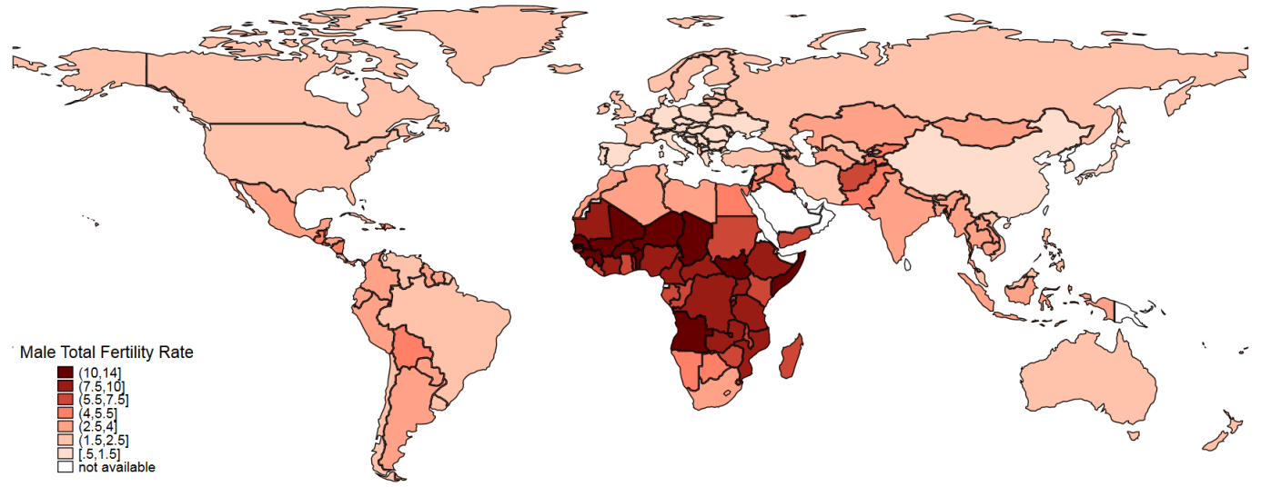
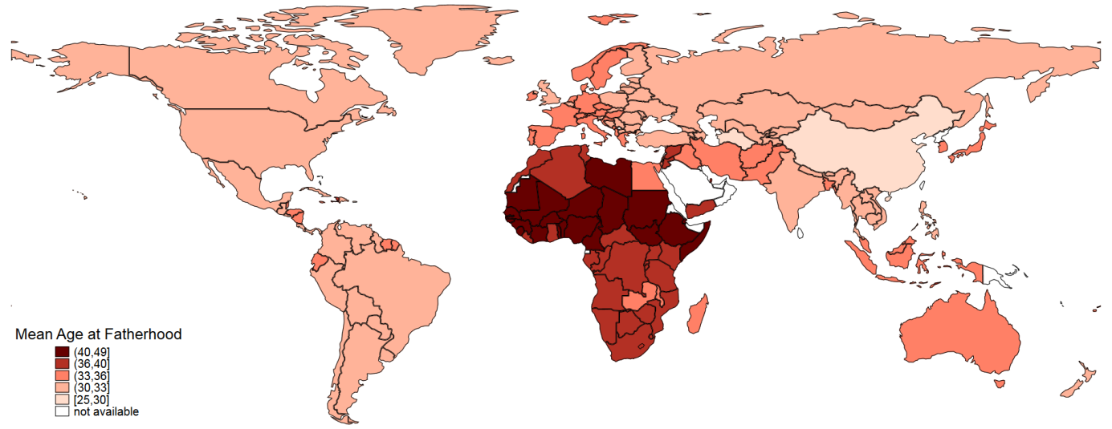
Data: United Nations Demographic Yearbook 2016 (United Nations 2017) and author’s computation from data from DHS, MICS, and PAPFAM surveys and censuses. For China, the TFR is obtained from Keilman et al. (2014), and the mean age at fatherhood was computed using the 2000 census.

Figure 2: Comparison of male and female total fertility rates circa 2011 (163 countries)
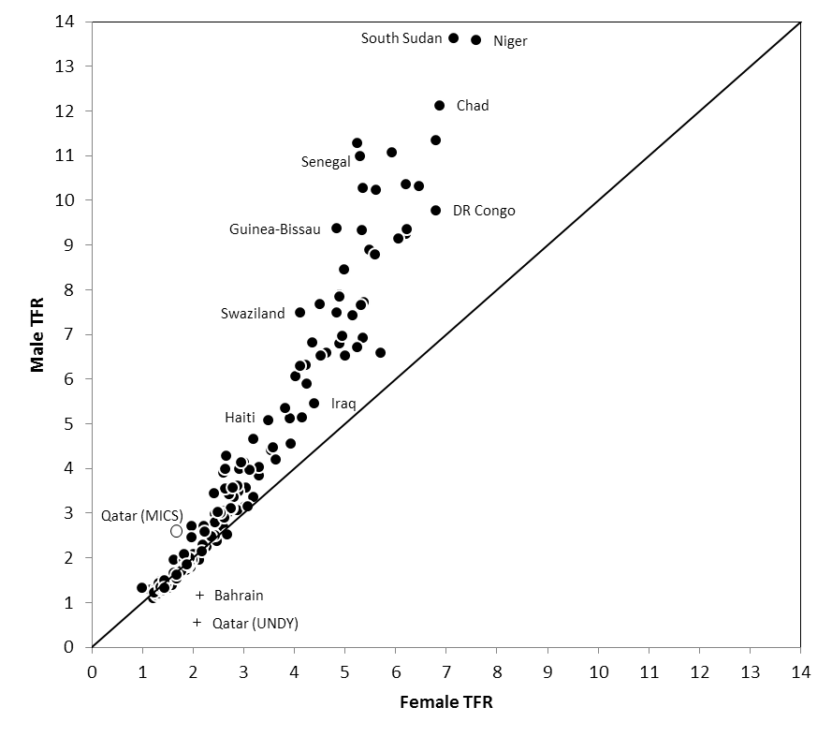
Data: United Nations Demographic Yearbook 2016 (United Nations 2017) and author’s computation from data from DHS, MICS, and PAPFAM surveys and censuses. For China, estimates are obtained from Keilman et al. (2014). Two separate estimates for Qatar are presented, one from the 2012 MICS (O), the other from the United Nations Demographic Yearbook 2016 (+). The estimate from Bahrain is also presented with (+), to highlight the fact that it is likely to be underestimated because of high male immigration.
Figure 3: Comparison of mean age at childbearing (women) and mean age at fatherhood (men) circa 2011 (163 countries)
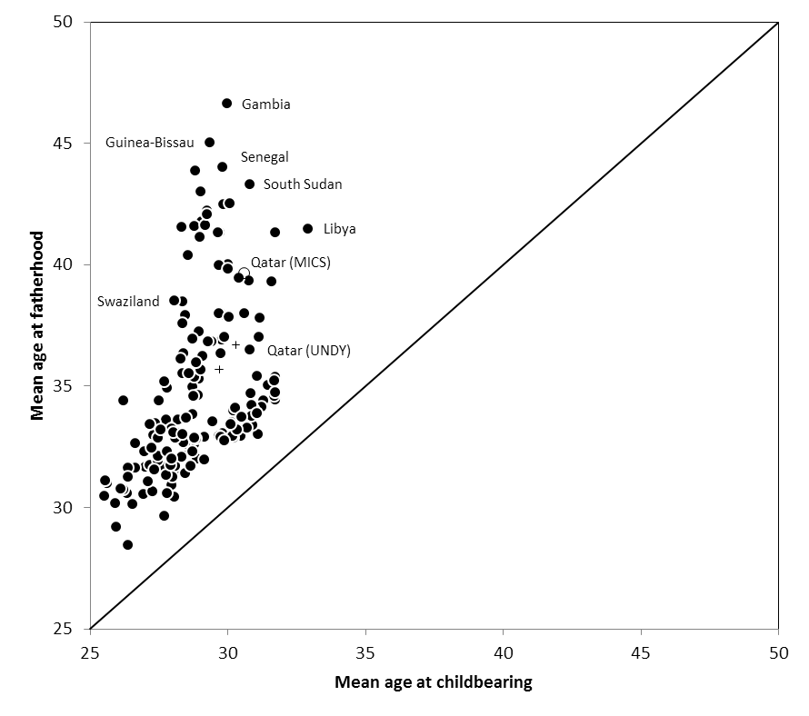
Data: United Nations Demographic Yearbook 2016 (United Nations 2017) and author’s computation from data from DHS, MICS, and PAPFAM surveys and censuses. Estimates from China come from the 2000 census. Two separate estimates for Qatar are presented, one from the 2012 MICS (O), the other from the United Nations Demographic Yearbook 2016 (+). The estimate from Bahrain is also presented with (+).

Figure 4: Comparison of male and female age-specific fertility rates in Senegal, Haiti and France.
Male TFR : 11.0
Female TFR : 5.3

Mean age at fatherhood: 44.0
Mean age at childbearing: 29.8

Male TFR : 5.1
Female TFR : 3.7

Mean age at fatherhood: 37.0
Mean age at childbearing: 30.0

Male TFR : 2.0
Female TFR : 2.0

Mean age at fatherhood: 33.5
Mean age at childbearing: 30.1

Data: United Nations Demographic Yearbook for France (United Nations 2017) and author’s computation from DHS data for Senegal and Haiti.
Figure 5 : Relationship between the ratio of male TFR to female TFR and the difference between mean age at fatherhood and mean age at childbearing, circa 2011 (163 countries)
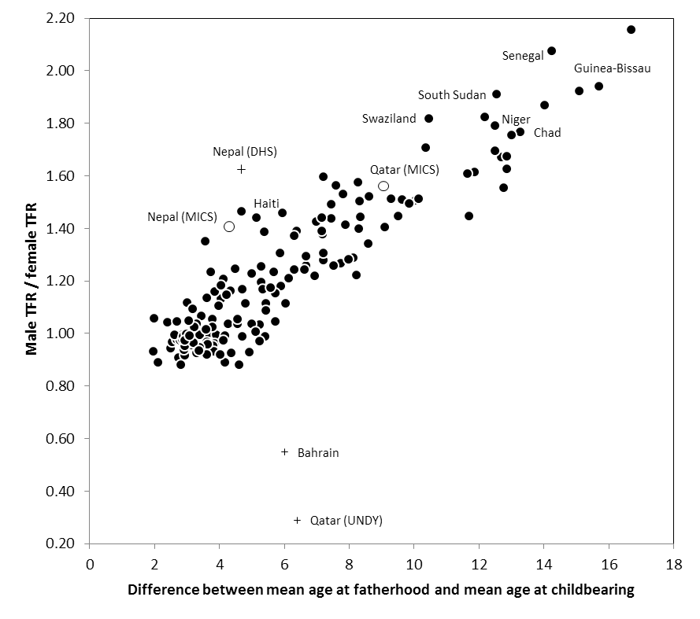
Data: United Nations Demographic Yearbook 2016 (United Nations 2017) and author’s computation from data from DHS, MICS, and censuses. Two separate estimates for Qatar are presented, one from the 2012 MICS (O), the other from the United Nations Demographic Yearbook 2016 (+).Two separate estimates for Nepal are also presented, one from the 2011 MICS, correcting for international migration (O), the other from the 2008 DHS (+). The estimate from Bahrain is also presented with (+).

Figure 6: Relationship between male–female fertility ratio and polygyny in 43 countries
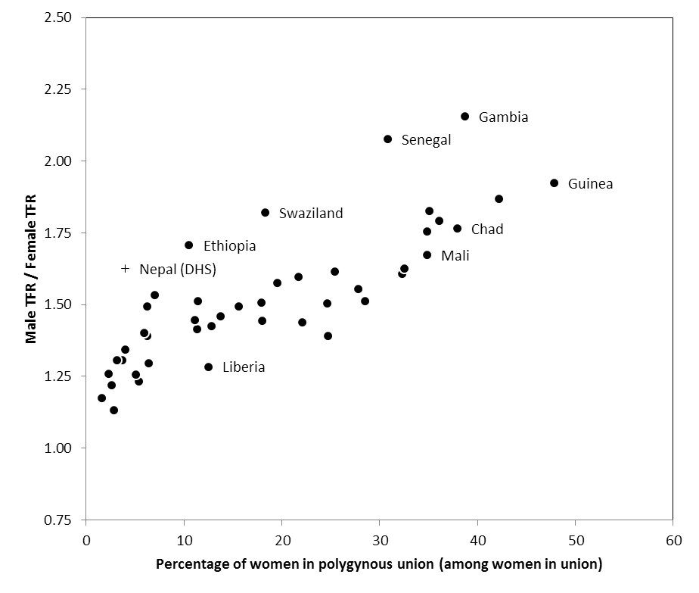
Data: Author’s computation from DHS data.

Figure 7: Trends in the ratio of male to female TFR since the 1970s in nine countries.
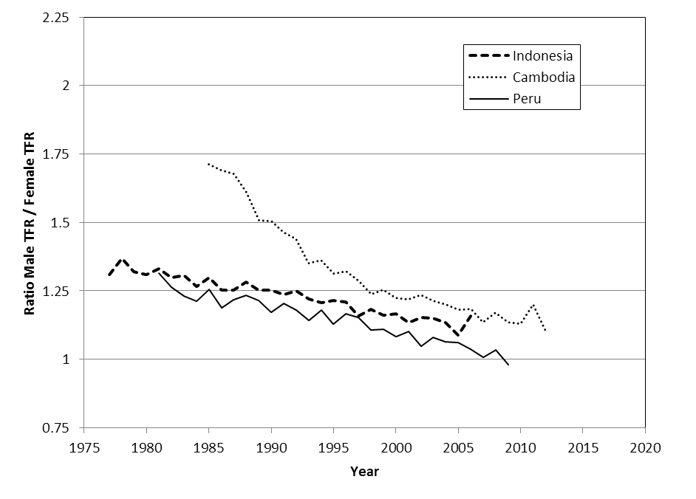
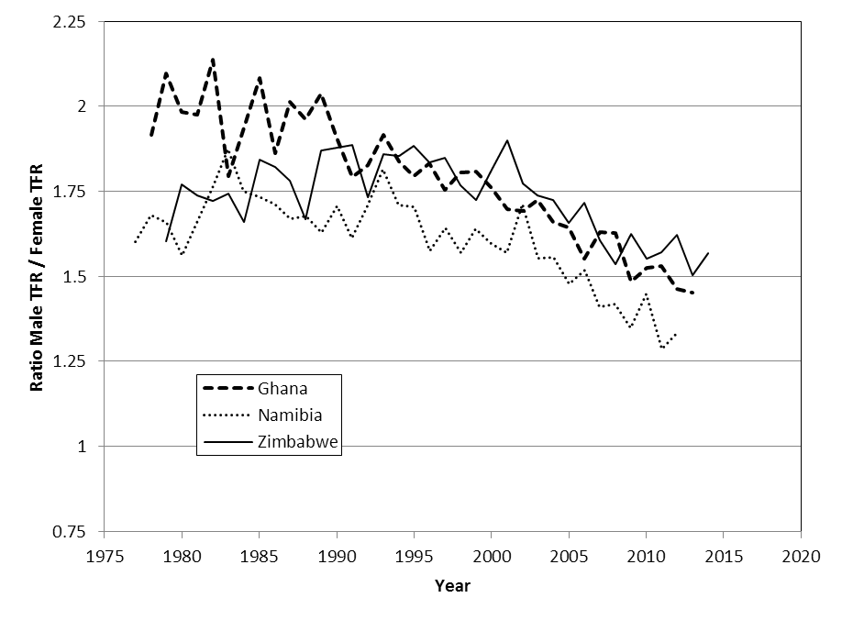
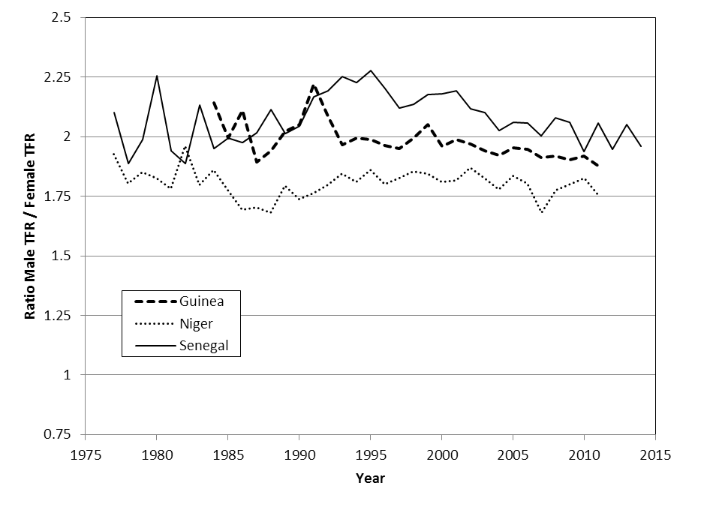
Data: Author’s computation from DHS data (own-children method).
Figure 8: Projected ratio of male TFR to female TFR in Niger, Zimbabwe, and Indonesia, 2015–2100.
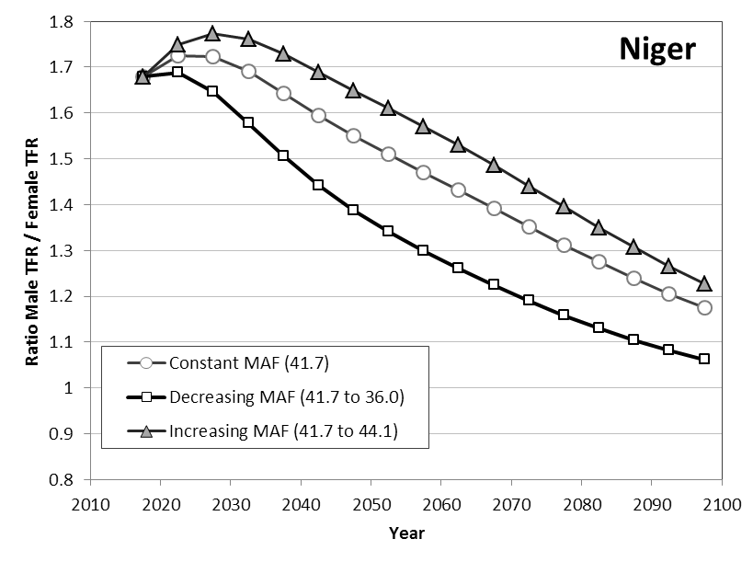
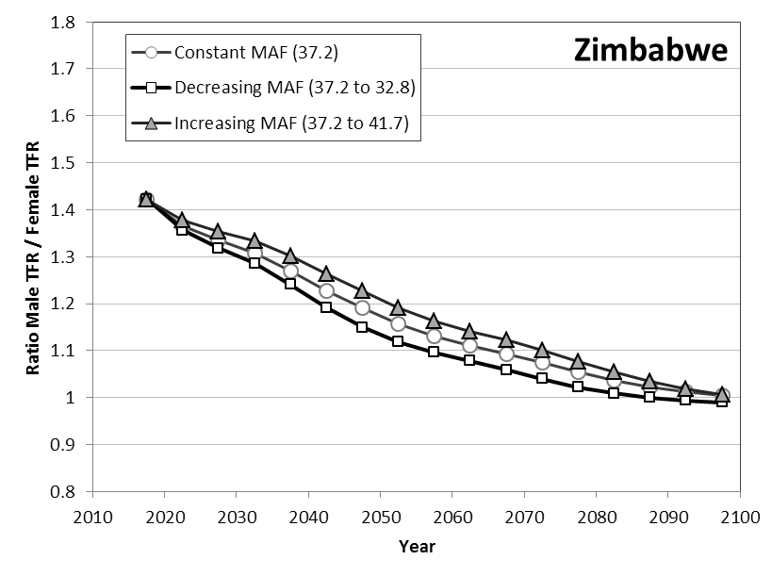
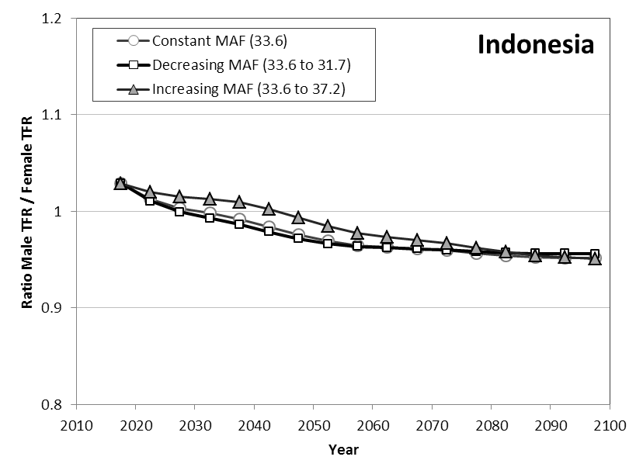
Data: Author’s computation with World Population Prospects data (United Nations Population Division 2017) and age patterns of male fertility based on DHS and UNDY data.

Dudel and Klüsener (2018b) suggest that a conditional approach may be preferable, in which the births are distributed using the age distribution of fathers conditional on maternal age. However, the published data does not allow for use of the conditional approach, and the traditional (unconditional) approach is sufficient for our purposes.
Simulations by Dudel and Klüsener (2018b) suggest the bias on the mean age at fatherhood is around 1 year, and the bias on the TFR is negligible.
We assume that survival is independent of father’s age. If survival is lower among children from older fathers, male fertility rates at higher ages would be underestimated, and overestimated at lower ages. This may lead to a slight underestimation of the mean age at fatherhood, but the impact on the total fertility rate will be small.
In the rare cases of unknown survival status of the father, it is imputed randomly.
In doing so, we assume that the fertility of deceased men is equal to the fertility of surviving men. In most cases, this assumption has a small impact on recent fertility, given the small percentage of children aged 0–4 with deceased fathers. Simulations indicate that estimating male fertility using only children of surviving fathers usually leads to a slight underestimation of the male TFR by around 1%, resulting from the fertility among deceased men being usually higher. In some extreme cases, as in Lesotho (where 8.9% of children have a deceased father), the underestimation is more substantial (around 7%). This issue is further discussed in the supporting material.
Random hot-deck imputation is used (Allison 2001). Random imputation is performed 10 times, and 10 series of age-specific male fertility rates are computed. Average fertility rates based on the 10 series are reported.
This is similar to the approach used for deceased fathers, and assumes that the fertility of international migrants is similar to that of non-migrants.
This issue is not specific to the own-children method and also potentially affects estimates from vital statistics.
In this paper data are available for only two Gulf countries (Qatar and Bahrain). These data are highlighted in the figures as they are clear outliers. In the case of Qatar, we use both the UNDY and the MICS estimates, except in the maps, where only MICS estimates are used.
Male fertility is even lower in some Gulf countries when immigration is not accounted for in the estimation.
Demographic and Health Surveys allow similar comparisons for completed fertility (the mean number of children ever born at the end of reproductive life) among men and women. However, men are often interviewed up to ages 55–59, and occasionally to ages 60–64, so that completed fertility is underestimated among men in countries where fertility is substantial beyond these ages (e.g., in Senegal; see below). Yet, completed fertility is significantly higher among men than among women in most countries, except where fertility is low (results not shown).
In contrast, in non-stable populations, male and female age-specific fertility rates observed at a given time may lead to different intrinsic growth rates, as discussed in the two-sex problem (Karmel 1947; Vincent 1946). Before the population has reached stability, constant age-specific female fertility rates will be accompanied by non-constant age-specific male fertility rates. In the stable population, however, both sets of rates will remain unchanged.
Eq. 1 relies on the assumption that the survival function decreases linearly over the age range of reproduction. While this assumption is benign among women, this is not the case among men if fertility extends well beyond age 50. In low- and moderate-fertility settings, the ratio obtained with Eq. 1 is very close to the true ratio; in countries where male fertility is high and late, Eq. 1 still provides a good estimation of this ratio. A spreadsheet in the supporting material allows comparing the true ratio of male TFR to female TFR in a stable population with the approximation from Eq. 1 for stable equivalent populations from any country and any period between 1950 and 2010.
We focus on differences in the mean age at which men and women have their children, but differences in variance of age patterns of fertility between men and women may also influence differences between male and female TFRs. In growing populations, a larger age span tends to slightly decrease the total male fertility compared to fertility with the same mean age at fatherhood. In low fertility settings, differences in variance have a very limited impact. In Eq. 1, the differences in variance of the age at fatherhood and age at childbearing are in fact included in the mean lengths of generation, which are different for two age patterns of fertility with the same mean age at fatherhood and mean age at childbearing but with different variances.
In year 2100, the female fertility rate is projected to reach 1.82 children in Indonesia, 1.83 in Zimbabwe, and 2.48 in Niger (see fertility trends in supporting material, Figure 4).
The target age patterns come from the following countries: Canada in 2009 (mean age at fatherhood equal to 32.8), Malawi in 2013 (36.0), Niger in 2010 (41.7), Senegal in 2010 (44.1) and the United States of America in 2012 (31.7).

