Quantification of uncertainty in zero-flow pressure approximation

Martin Prignon^{*1}, Arnaud Dawans², and Geoffrey van Moeseke¹

1 UCLouvain  Place de l’Université, 1  1348 Louvain-la-Neuve, Belgium  * martin.prignon@uclouvain.be | 2 Entreprises Jacques Delens  Avenue du Col-vert, 1  1170 Watermael Boitsfort, Belgium

Abstract

Multiple authors stated that, when performing fan pressurization test, Ordinary Least Square (OLS) method should not be used as a regression technique anymore. However, alternative methods require first to quantify components of uncertainty in pressure and air flow rate measurements. This work aims at quantifying the uncertainty in zero-flow pressure approximation, which is mainly due to short-term fluctuation of wind speed and direction. This has been done by statistically analysing the uncertainty indicator of 40 zero-flow pressure tests performed on 30 different units on eight different sites in Brussels.
First, the analysis showed that this uncertainty could be reduced by increasing the period of measurement used to compute zero-flow pressure approximation. Second, it shows that the standard deviation of zero-flow pressure measurements was the variable with the most significant impact on the quality of the zero-flow pressure approximation. Third, it provides three different linear models to predict uncertainty as a function of different variables.
This study experienced some limitations due to the available sample of tested units. These limitations lead to important further work: the validation of the model on another sample of buildings and its adaptation if needed. Further work should also focus on integrating these results on the uncertainty in envelope pressure measurements and on the uncertainty in airtightness estimation of the building.

Keywords

Airtightness measurement; Uncertainty; Zero-flow pressure; Fan pressurization test.

Introduction

To be reliable, a measured quantity should always be given with its uncertainty. When performing a fan pressurization test, the uncertainty is often given as a function of the scattering of the data around the linear model obtained with an Ordinary Least Square (OLS) method. However, multiple authors stated that the uncertainty estimated with OLS was not reliable in the case of airtightness measurements because the method neglects uncertainty in pressure measurements [1-3]. Therefore, other regression techniques should be used such as the Iterative Weighted Least Square (IWLS) [3, 4] or the Weighted Line of Organic Correlation (WLOC) [2]. These methods require quantifying uncertainty in pressure and air flow rate measurements.

One of the main sources of uncertainty is the fluctuation of reading in the pressure measurements due to variation in weather conditions [5]. ISO 9972:2015 requires the measurement of inside and outside temperature, and of wind speed (in Beaufort scale), but none of them are used in the calculation to deal with fluctuations in weather conditions [6]. In practice, pressure induced by weather conditions is handled in ISO 9972:2015 by measuring the zero-flow pressure (i.e., the pressure when there is no pressure induced by the fan). However, zero-flow pressure can be measured only when the fan is not working. Therefore, it has to be approximated during the test. This approximation goes along with an uncertainty: the uncertainty in zero-flow pressure approximation ($u\left(∆p_{0,a}\right)$).

ISO 9972:2015 [6] defines the zero-flow pressure during the test as the average of at least 10 zero-flow pressure measurements in 30 seconds before and after the fan pressurization test. Although ISO 9972:2015 does not impose requirements on maximum wind speed, it imposes requirements on zero-flow pressure. In fact, the operator has to measure the average of negative and positive values before ($∆p_{01,-}$ and $∆p_{01,+}$) and after ($∆p_{02,-}$ and $∆p_{02,+}$) the test. To be valid, none of these values should be higher than 5 Pa or lower than -5 Pa. In this study, all the tests are valid regarding these requirements.

In a previous work, we developed a method to quantify uncertainty due to zero-flow approximation based on a series of 30 tests performed on the same apartment [7]. Although the results of that work were useful, they could not be generalized since only one unit was tested. This study aims at finding a mathematical relation to predict uncertainty in zero-flow pressure approximation based on 40 zero-flow pressure tests performed on 30 different buildings.

Methodology

The Zero-Flow Pressure Test

Delmotte used the zero-flow pressure test for the first time in 2017 [2]. This test consists in measuring the zero-flow pressure every second during three successive periods: two approximation periods and one fictitious period (Figure 1). The two approximation periods correspond to the zero-flow pressure measurements used to compute the zero-flow pressure approximation in a traditional fan pressurization test. In his work, Delmotte considered periods of 30 seconds while in this work two periods of 120 seconds are considered. This is because this paper focuses also on how the duration of approximation periods affects the uncertainty. The fictitious period corresponds to the time a fan pressurization test would take in practice. In this research, a fictitious period of 600 seconds is considered, to remain consistent with the work of Delmotte.

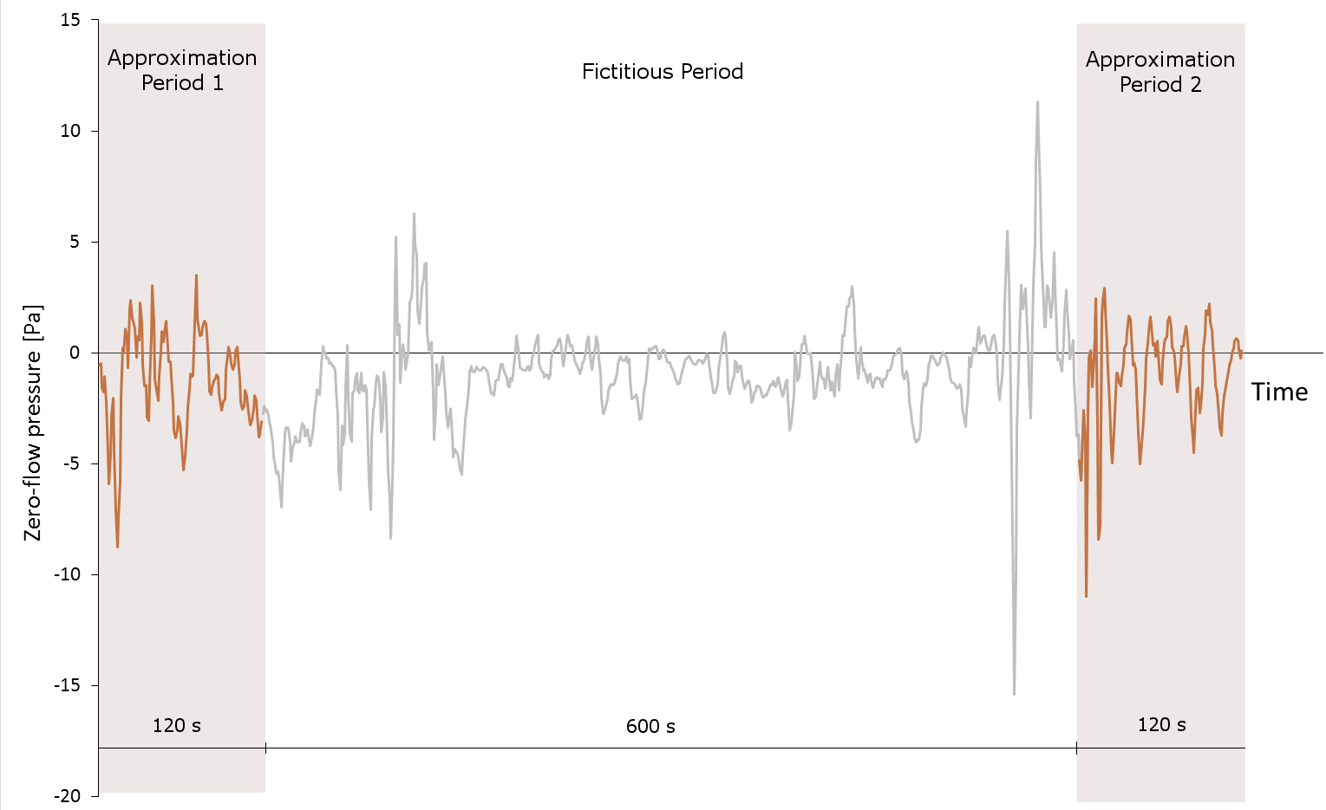
Figure 1: Illustration of the three successive periods of a zero-flow pressure test

The zero-flow pressure approximation is computed based on measurements made during the approximation periods according to ISO 9972:2015. Then, the zero-flow pressure approximation is compared to the zero-flow pressure measured every second during the fictitious period. The “uncertainty indicator” ($ε$) is the average of the difference between approximated and measured zero-flow pressure (Equation 1).

$ε=\frac{\sum_{i=1}^{600}{\left|∆p_{0,i}-∆\tilde{p_{0}}\right|}}{600}$ | (1)

Where $∆p_{0,i}$ is the zero-flow pressure measured every second ($i$) during the fictitious period and $∆\tilde{p_{0}}$ is the zero-flow pressure approximation based on measurements made during approximation periods.

Tests Description

In this research, 40 zero-flow pressure tests were performed on 30 different units (10 units experienced the same test twice, under different weather conditions), in eight different sites in Brussels (Belgium). The four pie charts in Figure 2 represent the repartition of four different variables among the 30 different units tested: the type of unit measured, the storey where the test was performed, the volume of the unit and the type of construction. It is important to point out that, there is only one non-residential unit (school). In addition, almost all tests (38) were performed on new constructions and only five units have a volume larger than 500 m³. These limitations related to the sample are tackled in the conclusion section.

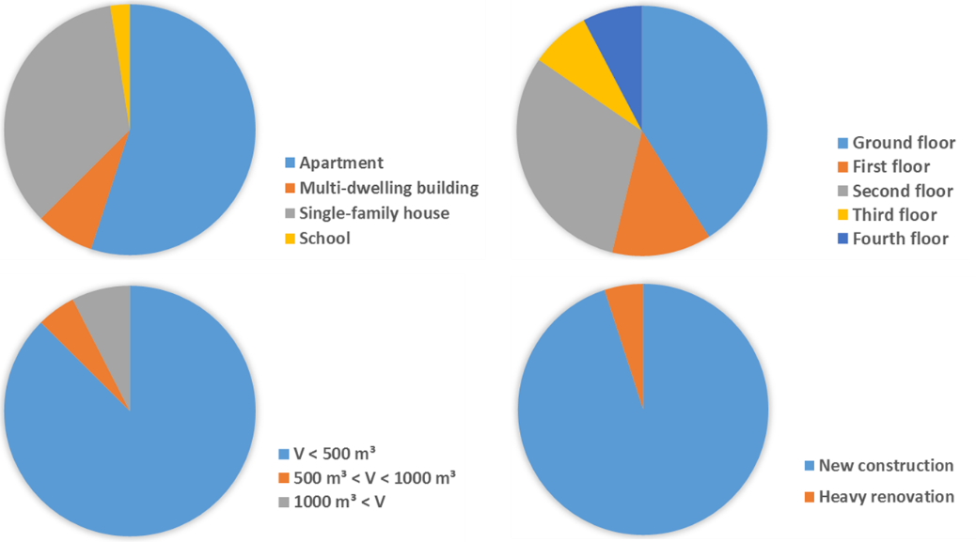
Figure 2: Repartition of the sample of units tested regarding four variables: type of units, storey of the measurement, volume of the unit and type of construction

Multiple operators performed the measurements using different DG-700 manometers from TEC conservatory. According to the manufacturer, the maximum permissible error for these manometers is the maximum between $0.15$ Pa and 1% of the reading, while it has a resolution of 0.1 Pa [8]. All of these were calibrated for the last time at least one year before the test. In this study, operators were asked to place pressure taps at the same place they would for a typical fan pressurization test.

Variables analysed

For each test, 7 different variables are investigated. $∆p_{0,a}$ (in Pa) is the value of the zero-flow pressure approximation computed according to ISO 9972:2015 [6]: it is the average of zero-flow pressure measured during first ($∆p_{0,1}$) and second ($∆p_{0,2}$) approximation periods. $∆$ (in Pa) is the difference between $∆p_{0,1}$ and $∆p_{0,2}$. $σ$ (in Pa) is the standard deviation of the zero-flow pressure measurements (both $∆p_{0,1}$ and $∆p_{0,2}$ combined). $w$ is the wind speed (in km/h) and is obtained from the closest weather station available. $V$ (in m³) is the volume of the unit. $s$ is the storey where the measurement is taken. $∆T$ (in °C) is the difference between inside and outside temperature during the test. All these variables were tested for four different durations of approximation periods: 30 seconds, 60 seconds, 90 seconds and 120 seconds.

The wind speed is the only variable that was not directly available on site during the test. However, it was still considered in the variables because of its well-known impact on the pressure measurement uncertainty [5, 9]. The distance between the closest weather station and the site varied between 300 and 1500 meter, and the data used is the average of one hour of wind speed measurement. These weather stations are often located on the roof of a building and, therefore, do not take into account the surroundings of the tested unit. However, this study is not interested in the physical impact of wind speed and wind pressure on uncertainty, but in a quantification of uncertainty based on data available during a fan pressurization test.

Statistical analysis

The statistical analysis aims at finding variables with the most significant impact on the uncertainty indicator ($ε$ – Equation 1) and at deducing a relation between the uncertainty indicator and these variables.

In the previous section, duration period was considered differently from other variables. This is because of the dependency implied by the experimental design: four duration periods are computed for each dataset while other variables only have one value for each dataset. Therefore, the impact of duration period cannot be deduced the same way as other variables. When data are nested (the duration of approximation periods are nested within the different tests), Multi-Level Modelling (MLM) should be used [10]. The use of MLM in zero-flow pressure tests was deeply investigated in our previous work [7]. However, in this work the objective of MLM is to investigate if different models should be used for different approximation methods, and it can be answered simply by assessing the need for MLM.

MLM is needed when there is large intraclass correlation (ICC) (> 0.45) [11] and when the design effect is higher than 2 [12]. ICC can be defined as the proportion of uncertainty indicator variation that occurs across tests [13] and is computed using Equation 2. $τ_{00}$ is the variation of uncertainty indicator between tests, and $σ²$ is the average of uncertainty indicator variation for different periods within each test. The design effect quantifies how the dependence of data affects the estimate of standard error: it provides the multiplier to be applied to the standard error to take the nested structure of the data into account. It is computed using Equation 3 with $n_{c}$ the number of different periods measured by test [13, 14].

$ICC=τ_{00}/(τ_{00}+σ^{2})$ | (2)
$Design Effect=1+\left(n_{c}-1\right)*ICC$ | (3)

In this study, $τ_{00}$ is $0.79$, $σ²$ is $0.07$ and $n_{c}$ is $4$. Therefore, $ICC$ is $0.92$ and Design effect is $3.76$ and MLM is needed. This means that classic statistical tools cannot be used to study the impact of approximation period duration on the uncertainty indicator because of the nested structure of data.

The seven other variables are not nested in a hierarchical structure. Therefore, the statistical analysis can be made with classical statistical tool such as multiple regression. It aims at finding the linear combination of variables that matches as much as possible the uncertainty indicator [15]. A multiple regression provides a coefficient for each variable in the linear model, but it also provides information on the statistical significance of these variables (p-values) and the quality of the fitting of the model (multiple $R^{2}$). Multiple $R²$ can be interpreted as the $R²$ in a simple regression: it is the amount of variance in the outcome (i.e., the uncertainty indicator) explained by the model [15].

Results

Duration of approximation periods

Figure 3 shows the bar graph of the uncertainty indicator of the 40 tests for the four different duration of approximation periods. The period of 30 seconds is slightly worse than other periods, but all results remain in the same order of magnitude.

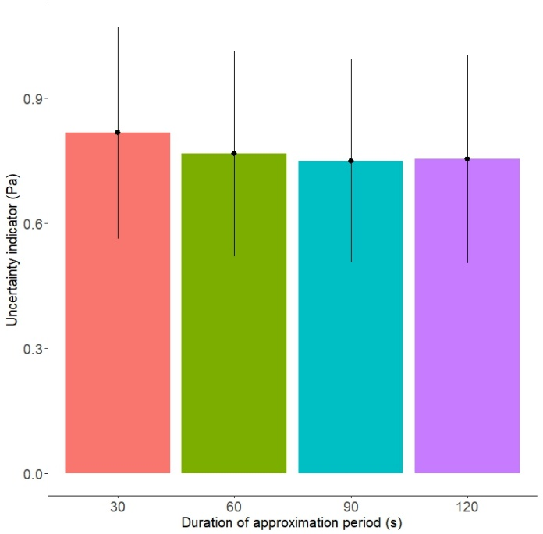
Figure 3: Bar graph of the 40 uncertainty indicators computed for the four different approximation periods

Table 1 presents the difference in means of uncertainty indicator for the four duration and the statistical significance of this difference. These were obtained using pairwise Wilcoxon rank-sum test with Bonferroni correction. Wilcoxon rank-sum test was used because datasets follow a distribution significantly different from normal (Shapiro-Wilk $=0.82, p<0.001$), and Bonferroni correction was used because multiple comparisons were performed on the same dataset.

Table 1: Results of the comparison using pairwise Wilcoxon rank-sum test with Bonferroni correction.
Results are highly significant (***), significant (**), slightly significant (*) or non-significant (^{N.S.})
vs | 30 | 60 | 90
60 | 0.04 *
90 | 0.06 ** | 0.02 ^{N.S.}
120 | 0.05 * | 0.01 ^{N.S.} | -0.01 ^{N.S.}

Results show that only the comparisons including 30 second periods are statistically significant (30vs90) or slightly significant (30vs60 and 30vs120). Other comparisons are statistically non-significant.

Multiple Regression

The first multiple regression (Table 2) shows that two variables have no significant impact on the uncertainty indicator, whatever the duration: the difference of approximation in the first and in the second duration period ($∆$) and the temperature difference between inside and outside the unit during the test ($∆T$). Variables having the most significant impact are the standard deviation of the zero-flow pressure measurements ($σ$) and the wind speed ($w$). The statistical significance of some variables ($∆p_{0,a}$, $w$, $V$ and $s$) depends on the duration of the approximation periods.

Table 2: Results of the multiple regression applied on all variables (7) for the four durations.
Variables | Period 30 |  | Period 60 |  | Period 90 |  | Period 120
Intercept | -1.2 e-00 | ** | -1.3 e-00 | ** | -1.2 e-00 | ** | -1.4 e-00 | **
$${∆P}_{0,a}$$ | 2.9 e-01 | ** | 1.3 e-01 | ^{N.S.} | 1.2 e-01 | ^{N.S.} | 1.0 e-01 | ^{N.S.}
$$∆$$ | -3.1 e-01 | ^{N.S.} | -3.1 e-01 | ^{N.S.} | -3.0 e-01 | ^{N.S.} | -3.1 e-01 | ^{N.S.}
$$σ$$ | 1.1 e-00 | *** | 9.5 e-01 | *** | 9.6 e-01 | *** | 8.8 e-01 | ***
$$w$$ | 7.4 e-02 | *** | 7.3 e-02 | ** | 6.0 e-02 | ** | 6.9 e-02 | **
$$V$$ | 1.3 e-04 | ** | 1.4 e-04 | ** | 1.2 e-04 | * | 1.3 e-04 | *
$$s$$ | 8.6 e-02 | ^{N.S.} | 1.0 e-01 | ^{N.S.} | 1.0 e-01 | * | 1.3 e-01 | *
$$∆T$$ | 8.9 e-04 | ^{N.S.} | -3.7 e-03 | ^{N.S.} | -2.0 e-03 | ^{N.S.} | 5.9 e-03 | ^{N.S.}
Multiple $R²$ | 0.77 |  | 0.79 |  | 0.76 |  | 0.75
$p<0.001$ (***) is highly significant, $p<0.01$ (**) is significant, $p<0.05$ (*) is slightly significant and $p>0.05$ (^{N.S.}) is not significant.

Conclusions on the statistical significance of the volume and the storey should be drawn carefully. Regarding the storey ($s$), it is important to keep in mind that the zero-flow pressure was measured higher than the fourth floor only once. Similar study performed on high-rise buildings would probably give different results since wind speed magnitude and surroundings would be different. In addition, in high-rise buildings, stack effect has a huge impact on the zero-flow pressure. Regarding the volume ($V$), only five units have a volume larger than 500 m³. Similar study performed on large-volume units could lead to different conclusions.

The second multiple regression (Table 3) confirms the first one: similar fitting is obtained when removing the two non-significant variables (multiple $R²$ between 0.73 and 0.74). The most significant variables are still $σ$ and $w$. The coefficients can be used to define a mathematical relation between the uncertainty indicator and these five variables. Equation 4 gives this relation in the case of 30-second approximation periods.

$ε=-1.2+0.30*{∆p}_{0,a}+0.85*σ+0.07*w+1.3 e^{-4}*V+0.12*s$ | (4)

Table 3: Results of the multiple regression applied on main variables, including wind speed (5) for the four durations.
Variables | Period 30 |  | Period 60 |  | Period 90 |  | Period 120
Intercept | -1.2 e-00 | ** | -1.3 e-00 | ** | -1.2 e-01 | ** | -1.4 e-00 | ***
$${∆p}_{0,a}$$ | 3.0 e-01 | ** | 1.3 e-01 | ^{N.S.} | 1.3 e-01 | ^{N.S.} | 1.2 e-01 | ^{N.S.}
$$σ$$ | 8.5 e-01 | *** | 7.8 e-01 | *** | 8.1 e-01 | *** | 7.7 e-01 | ***
$$w$$ | 7.4 e-02 | *** | 6.9 e-02 | ** | 6.2 e-02 | ** | 7.3 e-02 | ***
$$V$$ | 1.3 e-04 | ** | 1.4 e-04 | ** | 1.2 e-04 | * | 1.2 e-04 | *
$$s$$ | 1.2 e-01 | * | 1.2 e-01 | * | 1.3 e-01 | * | 1.5 e-01 | **
Multiple $R²$ | 0.74 |  | 0.73 |  | 0.74 |  | 0.73
$p<0.001$ (***) is highly significant, $p<0.01$ (**) is significant, $p<0.05$ (*) is slightly significant and $p>0.05$ (^{N.S.}) is not significant.

In the third multiple regression (Table 4), the wind speed is removed from the variables since it is the only one that is not directly available during a fan pressurization test. The impact of the standard deviation is found highly significant, but other terms are almost all found not significant. $∆p_{0,a}$ is found slightly significant in the case of 30-second approximation periods only. The third multiple regression shows a larger decrease of the fitting quality (multiple $R²$ between 0.62 and 0.64). Equation 5 provides a mathematical relation between uncertainty indicator and multiple variables for approximation periods of 30 seconds.

$ε=0.04+0.27*{∆p}_{0,a}+1.1*σ+8.6 e^{-5}*V+0.04*s$ | (5)

Table 4: Results of the multiple regression applied on main variables, without wind speed (4) for the four durations.
Variables | Period 30 |  | Period 60 |  | Period 90 |  | Period 120
Intercept | 3.8 e-02 | ^{N.S.} | -8.5 e-02 | ^{N.S.} | -1.7 e-02 | ^{N.S.} | -1.8 e-01 | ^{N.S.}
$${∆p}_{0,a}$$ | 2.7 e-01 | * | 9.9 e-02 | ^{N.S.} | 9.9 e-02 | ^{N.S.} | 9.2 e-02 | ^{N.S.}
$$σ$$ | 1.1 e-00 | *** | 9.9 e-01 | *** | 1.0 e-00 | *** | 9.7 e-01 | ***
$$V$$ | 8.6 e-05 | ^{N.S.} | 1.0 e-04 | ^{N.S.} | 7.8 e-05 | ^{N.S.} | 6.9 e-05 | ^{N.S.}
$$s$$ | 4.3 e-02 | ^{N.S} | 5.3 e-02 | ^{N.S.} | 7.0 e-02 | ^{N.S.} | 7.7 e-02 | ^{N.S.}
Multiple $R²$ | 0.64 |  | 0.63 |  | 0.66 |  | 0.62
$p<0.001$ (***) is highly significant, $p<0.01$ (**) is significant, $p<0.05$ (*) is slightly significant and $p>0.05$ (^{N.S.}) is not significant

The last multiple regression shows that a simple linear model including only the standard deviation of the measurements as a predictor provides still good fitting (multiple $R²$ between 0.55 and 0.61). The mathematical relation is highly simplified (Equation 6).

$ε=0.11+0.98*σ$ | (6)

Table 5: Results of the multiple regression applied on standard of the measurement only for the four durations.
Variables | Period 30 |  | Period 60 |  | Period 90 |  | Period 120
Intercept | 1.1 e-01 | ^{N.S.} | 5.4 e-02 | ^{N.S.} | -3.1 e-02 | ^{N.S.} | -3.3 e-02 | ^{N.S.}
$$σ$$ | 9.8 e-01 | *** | 9.5 e-01 | *** | 9.6 e-01 | *** | 9.3 e-01 | ***
Multiple $R²$ | 0.55 |  | 0.57 |  | 0.61 |  | 0.57
$p<0.001$ (***) is highly significant, $p<0.01$ (**) is significant, $p<0.05$ (*) is slightly significant and $p>0.05$ (^{N.S.}) is not significant

Although multiple $R²$ has a clear meaning (i.e., the amount of variance explained by the model), it can be sometimes difficult to visualize what it practically means. Figure 4 shows the predicted vs. the real uncertainty indicator for the three cases when considering approximation periods of 30 seconds. The predicted values are obtained when applying equation 4, 5 and 6, while the real values are the data used to develop the models. The difference in multiple $R²$ values is probably due to the tests with high value of uncertainty indicator. Indeed, the three points with high measured uncertainty indicator are better predict with the first model (Equation 4) than with the second (Equation 5) and the third (Equation 6) model.

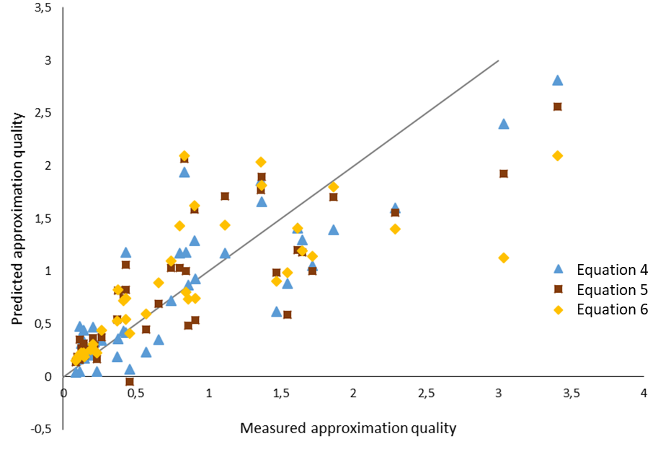
Figure 4: Representation of the predicted vs. measured uncertainty indicator for the three models

Discussion

It was shown in a previous work that the zero-flow pressure measured during the fictitious period follows a normal distribution [7]. In normal distributions, each measurement has a Z-score that is its distance from the mean, expressed in standard deviation [15]. It is computed with equation 7 where X is the measurement, and $μ\left(∆p_{0}\right)$ and $σ\left(∆p_{0}\right)$ are respectively the average and the standard deviation of the zero-flow pressure measurements during the fictitious period.
$Z_{score}=\frac{X-μ}{σ}$ | (7)
Since $ε$ is the average of the difference between approximated and real zero-flow pressure, it is reasonable to assume that $∆p_{0}-ε/2$ and $∆p_{0}+ε/2$ are the lower and the upper limit of the interval containing 50% of the zero-flow pressure measured during the fictitious period. For these limits Z-scores are respectively -0.675 and +0.675, and equations 8 and 9 can be used to link uncertainty indicator and standard deviation.
$0.675=\frac{\left(∆p_{0,a}+ε/2\right)-∆p_{0}}{σ\left(∆p_{0}\right)}$ | (8) | $-0.675=\frac{\left(∆p_{0,a}-ε/2\right)-∆p_{0}}{σ\left(∆p_{0}\right)}$ | (9)
The zero-flow pressure approximation ($∆p_{0,a}$) is assumed to be equal to the average of the zero-flow pressure measurements made during the fictitious period ($∆p_{0}$). This hypothesis is only valid because short-term wind fluctuations are already taken into account in $ε$ and because long-term wind and temperature fluctuations are considered by taking the average of pre- and post- test zero-flow pressure measurements. In fact, without these wind and temperature fluctuations, zero-flow pressure is expected to remain constant during the 14 minutes.

Since fan pressurization measurement during fictitious period follows a normal distribution, the uncertainty in zero-flow pressure approximation ($u\left(∆p_{0,a}\right)$) is given by the standard deviation of zero-flow pressure ($σ\left(∆p_{0}\right)$). Therefore, uncertainty in zero-flow approximation is given as a function of the uncertainty indicator only (Equation 10).
$u\left(∆p_{0,a}\right)=σ\left(∆p_{0}\right)=ε/1.35$ | (10)
In practice, each pressure difference – airflow couple is the average of multiple measurements. In addition, when performing a test, the operator often tires to record a measure when wind fluctuations are low. These actions reduce the impact of wind fluctuations and decrease the uncertainty due to zero-flow pressure approximation. Therefore Equation 9 should be considered as an upper limit.

Conclusion

This work is a step in the quantification of uncertainties in pressure measurements by quantifying uncertainty due to zero-flow pressure approximation ($u\left(∆p_{0,a}\right)$). Main findings in this research are:
- Uncertainty in pressure measurement is not negligible, and only regression methods that take into account uncertainty in pressure measurements should be used (e.g., Iterative Weighted Least Square (IWLS) or Weighted Line of Organic Correlation (WLOC) instead of Ordinary Least Square (OLS)).
- Zero-flow pressure should be measured during more than 30 seconds before and after the test to reduce uncertainty due to zero-flow pressure approximation.
- When performing IWLS or WLOC methods, $u\left(∆p_{0,a}\right)$ should be computed using equation 9 combined with equation 4, 5 or 6 (depending on the data available).
Some limitations should be acknowledged before generalizing results. First, this research is limited by the dataset. As explained in the methodology section, the dataset contains only two renovations, five units with volume larger than 500 m³, one non-residential building and one building with more than four stories. Second, the dataset was entirely used to create the model and none of them was used to validate the model.

Therefore, further work should focus on the validation of the suggested models and, if needed, on their adaptation for large-volume and high-rise units. Moreover, other components of uncertainty, their propagation and the correlation between different components should also be investigated.

Acknowledgements

Authors want to thank the company Jacques Delens for its mobilization in this work and the availability of their construction sites. This work is part of the “AirPath50” project funded by INNOVIRIS.

References

1. Prignon, M., A. Dawans, and G. van Moeseke, Uncertainties in airtightness measurements: regression methods and pressure sequences, in 39th AIVC-7th TightVent & 5th venticool Conference Smart ventilation for buildings. 2018.
2. Delmotte, C. Airtightness of Buildings - Considerations regarding the Zero-Flow Pressure and the Weighted Line of Organic Correlation. in 38th AIVC Conference "Ventilating healthy low-energy buildings". 2017. Nottingham, UK.
3. Okuyama, H. and Y. Onishi, Reconsideration of parameter estimation and reliability evaluation methods for building airtightness measurement using fan pressurization. Building and Environment, 2012. 47: p. 373-384.
4. ISO/TS-28037, ISO TS 28037:2010 - The determination and use of straight-line calibration functions.
5. Sherman, M. and L. Palmiter, Uncertainties in fan pressurization measurements, in Airflow performance of building envelopes, components, and systems. 1995, ASTM International: Philadelphia, USA. p. 266-283.
6. ISO-9972, NBN EN ISO 9972:2015 - Performance thermique des bâtiments - Détermination de la perméabilité à l'air des bâtiments - Méthode de pressurisation par ventilateur (ISO 9972:2015) CEN, Brussels, Belgium. 2015.
7. Prignon, M., et al., A Method to Quantify Uncertainties in Airtightness Measurements: Zero-Flow and Envelope Pressure. Energy and Buildings, 2019.
8. TEC, Operating Instruction for the DG-700 Pressure and Flow Gauge. 2012: The Energy Conservatory.
9. Carrié, F.R. and V. Leprince, Uncertainties in building pressurisation tests due to steady wind. Energy and Buildings, 2016. 116: p. 656-665.
10. Rasbash, J., et al., A User's Guide to MLwiN. 2015, University of Bristol: Centre for Multilevel Modelling.
11. Julian, M.W., The Consequences of Ignoring Multilevel Data Structures in Nonhierarchical Covariance Modeling. Structural Equation Modeling: A Multidisciplinary Journal, 2001. 8(3): p. 325-352.
12. Muthén, B.O. and A. Satorra, Complex Sample Data in Structural Equation Modeling. Sociological Methodology, 1995. 25: p. 267-316.
13. Peugh, J.L., A practical guide to multilevel modeling. Journal of School Psychology, 2010. 48(1): p. 85-112.
14. Hayes, A.F., A Primer on Multilevel Modeling. Human Communication Research, 2006. 32(4): p. 385-410.
15. Field, A., J. Miles, and Z. Field, Discovering Statistics Using R. 2012, London: SAGE Publications Ltd. 957.

