The role of MOOC forum discussion tasks in learners' cognitive engagement

Abstract

Background
Forums in massive open online courses (MOOCs) enable written exchanges on course content; hence, they can potentially facilitate learners' cognitive engagement. Given the myriad of MOOC forum messages, this engagement is commonly analysed automatically through the linguistic features of the messages. Assessing linguistic features of learners' forum messages involves consideration of the learning tasks. MOOC forum discussion tasks, however, have not been previously considered.

Objective and Method
This study explores the effects of MOOC forum discussion tasks on learners' cognitive engagement. Based on the structure of observed learning outcomes (SOLO) taxonomy, we manually annotate distinct levels of cognitive engagement encouraged in forum discussion tasks and displayed by learners in messages starting discussions (i.e., thread starters). We study the linguistic features of thread starters in relation to the pedagogical design of the discussion tasks. Additionally, we use random-forest modelling to identify the linguistic and task-related features that help to categorise learners' cognitive engagement according to SOLO levels.

Results
Manual analysis showed that learners' thread starters mainly reflect surface SOLO levels and include few academic words and cohesive language. Random-forest modelling showed that these linguistic features, together with the SOLO levels encouraged in the discussion tasks, played an important role in identification of learners' cognitive engagement.

Major Takeaways
Our results highlight the importance of the pedagogical design of MOOC forum tasks in helping learners engage cognitively. Our study also contributes to the empirical evidence that learners' linguistic choices can afford insights into the quality of their cognitive engagement.

Keywords
Cognitive engagement, MOOC discussion forums, SOLO taxonomy

1. Introduction
“I don't know”, wrote Thimothée in a forum asking his opinion about Nestlé and its corporate social responsibility. Like him, several learners also expressed a lack of knowledge or a vague idea about the company (i.e., surface understanding). In contrast, other learners presented arguments supporting or criticising the company's actions (i.e., deeper level of understanding). Studies analysing the quality of learners' understanding in the forums of massive open online courses (MOOCs) consistently report that most learners state facts, express opinions, or ask questions. Only a few compare and contrast ideas or build on previous contributions. In other words, learners mostly display surface understanding in MOOC forums (Galikyan et al., 2021; Tawfik et al., 2017; Wang et al., 2015).
Due to the plethora of MOOC forum messages, automated approaches analysing the linguistic features of the messages are required to study the quality of learners' understanding (O'Riordan et al., 2016). Researchers using these approaches have asserted that specific cognitive processes (e.g., asking questions, expressing opinions, etc.) are characterised by distinctive features (e.g., Dowell et al., 2015; Kovanovi_c et al., 2016; O'Riordan et al., 2020). Simply put, learners' linguistic choices can reflect, to some extent, their level of understanding and the quality of their cognitive engagement (Tenbrink, 2020). Nevertheless, the linguistic features of learners' discourse can be significantly affected by the pedagogical design of learning tasks (Skehan & Foster, 1997). Therefore, the analysis of linguistic features in MOOC forum messages needs to consider the design of forum discussion tasks. Such design, however, has not been critically considered.
Previous studies assessing learners' cognitive engagement in MOOC forums have used taxonomies and frameworks that reflect different aspects of cognition (O'Riordan et al., 2020). This study employs the structure of observed learning outcomes (SOLO) taxonomy (Biggs & Collis, 1989). Unlike other taxonomies, SOLO can serve to identify not only surface to deep levels of cognitive engagement displayed by learners in forum messages, but also the levels encouraged by instructors in the forum discussion task. We focus on the initial messages posted (referred to as thread starters), and examine the linguistic features that characterise specific SOLO levels. We analyse these features in relation to the pedagogical design of the forum discussion tasks. We also develop a model to facilitate the automatic identification of learners' cognitive engagement based on the linguistic features of the messages and the features related to the design of the forum discussion task. This study contributes thus to better understanding the role that the design of MOOC forum discussion tasks plays in learners' cognitive engagement.

2. Literature Review
MOOC forums are social as well as pedagogical tools that afford text-based communication. For Stephens-Martinez et al. (2014), the highest value of these forums lies in their potential to engage learners cognitively; that is, to use cognitive processes in order to learn concepts, study the learning material, and increase their knowledge of the course content (Newmann et al., 1992; Richardson & Newby, 2006). Indeed, through cognitive processes such as asking and answering questions, sharing ideas, or negotiating meaning, learners can gain deep understanding of the course content (Palloff & Pratt, 2007; Vai & Sosulski, 2015); however, this rarely occurs. Although engagement in MOOC forums is positively correlated with course completion and good grades, deep levels of cognitive engagement are scarce (Anderson et al., 2014; Gillani & Eynon, 2014; Jiang et al., 2015; Wise & Cui, 2018). This has raised concerns about the effectiveness of MOOC forums as pedagogical tools (Alario-Hoyos et al., 2016; Cohen et al., 2019).
In MOOC forums, learners' cognitive engagement is generally analysed through the messages posted. As a psychological effort, cognitive engagement is a construct that cannot be measured directly (Fredricks et al., 2004). Instruments such as self-report scales, classroom observations, and teacher ratings are commonly used to capture this construct (S. Li, 2021). However, for several authors, the most reliable way for learners to communicate their thoughts and allow inferences about the quality of their cognitive engagement is through their use of language (Ireland & Henderson, 2014; Tausczik & Pennebaker, 2010). Language enables reasoning and reflective thinking, as well as the organisation of thoughts (Bier, 2015; Vygotsky, 1978). Thus, the language used in MOOC forum messages can reveal, to some extent, the quality of learners' cognitive engagement.
To examine learners' cognitive engagement in MOOC forum messages, researchers ought to analyse the language used and the structure of ideas (Tenbrink, 2020). The linguistic complexity and structure of forum messages can reflect different cognitive processes (Beukeboom, 2014; Carroll, 2007; Van Swol et al., 2016). For example, according to Bloom's (1956) taxonomy of educational objectives, when learners only use descriptive language, they engage at a surface level because they do not interpret or extrapolate information. Conversely, when learners analyse and relate concepts, they use cohesive language and complex sentences, which can reflect complex and abstract thinking (Apps, 2006). Bloom's taxonomy is often used to analyse learners' cognitive engagement in MOOC forums (Li et al., 2023; Wong et al., 2016; Xu et al., 2021). Though well known, this taxonomy does not establish an epistemological basis for classifying learners' cognitive processes (Pring, 1971).

2.1 The SOLO Taxonomy
The SOLO taxonomy, developed by Biggs and Collis (1989), arguably provides a more appropriate framework to analyse learners' cognitive engagement. SOLO hierarchically organises cognitive processes into five levels of cognitive engagement. The lowest level, prestructural, reflects a lack of understanding. At this level, learners do not understand information and miss the point. In the following levels, called unistructural and multistructural, learners' cognitive engagement reflects surface understanding. In these levels, learners structure ideas in an unorganised, repetitive, or oversimplified manner. They perform simple cognitive tasks (e.g., state facts, express opinions, etc.) and use basic terminology without connecting information (i.e., their ideas lack cohesion). Although learners might use cohesive language, it is used as a form of knowledge-telling, that is, expressing ideas without evaluating their significance (Bereiter & Scardamalia, 1987).
As learners move to higher levels, relational and extended abstract, they make mental connections that allow them to analyse and relate information, explain concepts in terms of cause and effect, or extend the ideas presented in the course. The shift from a multistructural to a relational SOLO level implies a qualitative change in understanding. Quantitatively, SOLO considers the number of concepts or ideas expressed. Qualitatively, this taxonomy analyses whether concepts or ideas are connected or extended. This is portrayed in Figure 1, where hexagons represent ideas and the way the hexagons are structured represents how ideas are isolated, connected, or extended into new insights. The connection of ideas indicates whether learners can “see the woods or just isolated trees” (Biggs & Tang, 2011, p. 89).

Figure 1
The structure of observed learning outcomes taxonomy.

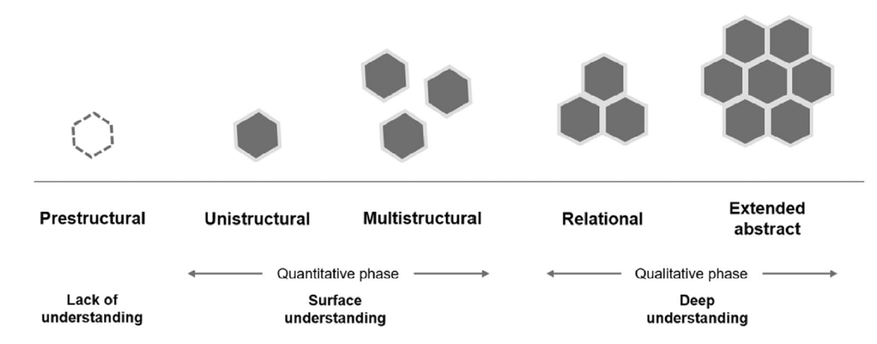

Note. Although learners can show a prestructural level of cognitive engagement, it is not a level that instructors intend for learners to achieve.

As explained by Biggs and Collis (1989), SOLO shows how knowledge is structured. In contrast to Bloom's taxonomy, SOLO is a research-based taxonomy that “classifies learning outcomes in terms of their structural quality, which makes the taxonomy useful for defining levels of understanding” (Biggs & Tang, 2011, p. 81). Because it classifies learning outcomes, SOLO can serve not only to assess learners' cognitive engagement, but also to specify such levels in the design of learning tasks. Thus, this taxonomy is useful to examine the level of cognitive engagement required in MOOC forum discussion tasks.

2.2 Cognitive engagement in MOOC forums
Given the myriad of MOOC forum messages, researchers employ automated approaches to analyse the language used and the structure of ideas in MOOC forums (O'Riordan et al., 2016). Automated approaches facilitate the analysis of massive amounts of textual data by recognising linguistic features (such as word count or the presence of abstract and cohesive language) and computing their relative frequency. Nonetheless, linguistic features alone do not indicate the quality of learners' cognitive engagement. Therefore, these features need to be interpreted using learning taxonomies or frameworks that classify cognitive processes into different stages or levels. The frameworks and linguistic features previously used to study learners' engagement in MOOC forums can be seen in Table 1.

Table 1
Previously studied linguistic features of learners' cognitive engagement in forums.

Authors and year | Cognitive framework | Tool(s) | Linguistic features
Authors and year | Cognitive framework | Tool(s) | Overall words and  sentences |  |  |  |  |  |  | Specialised vocabulary |  |  |  | Cohesive, abstract, & interactive language
 |  |  | 01 | 02 | 03 | 04 | 05 | 06 |  | 07 | 08 | 09 |  | 10 | 11 | 12 | 13
Oztok et al. (2013) | Social constructivism | LIWC and the Academic Word List | X |  |  |  | X |  |  | X |  | X
Joksimović et al. (2014) | Community of Inquiry | LIWC and  Coh-Metrix | X |  | X |  |  | X |  |  |  |  |  | X | X
Wen et al. (2014) | N/P | LIWC |  |  |  |  |  | X |  |  |  | X |  |  |  | X
Dowell et al. (2015) | N/P | Coh-Metrix |  |  |  |  |  |  |  |  |  |  |  | X |  | X
Wang et al. (2015) | ICAP framework | N/P |  |  |  |  |  |  |  |  | X |  |  | X |  |  | X
Kovanović et al. (2016) | Community of Inquiry | LIWC and  Coh-Metrix | X | X | X | X | X | X |  |  |  |  |  | X |  |  | X
Wong et al. (2016) | Bloom’s taxonomy | LIWC |  |  |  |  |  |  |  |  |  | X
Neto et al. (2018) | Community of Inquiry | LIWC | X |  | X | X |  |  |  |  | X |  |  | X |  |  | X
Moore et al. (2019) | Community of Inquiry | LIWC |  |  |  |  |  |  |  |  |  | X
Barbosa et al. (2020) | Community of Inquiry | LIWC and  Coh-Metrix | X |  | X |  |  | X |  |  | X |  |  | X |  |  | X
O’Riordan et al. (2020) | Bloom’s taxonomy and the Community of Inquiry | LIWC | X |  |  |  |  | X
Z. Liu, et al. (2022) | N/P | LIWC |  |  |  |  |  |  |  |  |  | X |  |  | X

Note. N/P refers to information not provided (i.e., not clearly stated in the study). The X shows the features that were found important for assessing the quality of learners’ cognitive engagement. ICAP stands for Interactive, Constructive, Active, and Passive. LIWC stands for Linguistic Inquiry Word Count.

Overall words and sentences Specialised vocabulary Cohesive, abstract, & interactive language
⁰¹ Word count ⁰⁷ Academic vocabulary ¹⁰ Cohesive language (e.g., causality and discrepancy words)
⁰² Sentence count ⁰⁸ Course-related words ¹¹ Tentative language (e.g., maybe, perhaps, guess)
⁰³ Words per sentence ⁰⁹ Cognition-related words ¹² Abstract language
⁰⁴ Lexical diversity ¹³ Interactive language (e.g., question marks)
⁰⁵ Reading ease scores
⁰⁶ First-person sing. pronouns

As Table 1 shows, the most prominent linguistic feature frequently found to characterise different levels of learners' cognitive engagement was the number of words in the messages (i.e., word count). Joksimovic et al. (2014) found that surface levels of cognitive engagement are characterised by fewer words and tentative language (e.g., maybe, guess, etc.). Conversely, at deeper levels, MOOC forum messages generally contain abstract and cohesive language (Dowell et al., 2015). Other linguistic features have not been found important for identifying learners' cognitive engagement or have been scarcely studied. This is the case, for example, for sentence count, lexical diversity (i.e., the ratio of unique words to the total number of words), and academic vocabulary.

Table 1 also shows that previous studies mainly used Coh-metrix (Graesser et al., 2004) and Linguistic Inquiry and Word Count (LIWC, Pennebaker et al., 2015) to capture the linguistic features of forum messages. Coh-metrix uses features such as word overlap and reading ease scores to compute cohesion. Cohesion shows how texts are linguistically connected, that is, how different ideas are grammatically and semantically related (Bublitz, 2011; Halliday & Hasan, 1976). Thus, cohesion metrics can not only reveal how learners organise their ideas, but also serve to determine the cognitive complexity of the messages (Tausczik & Pennebaker, 2010). LIWC, on the other hand, identifies specific words from its built-in dictionary. LIWC words are organised in pre-established categories, such as cognitive or social processes. LIWC cognitive words have been found to reflect how learners differentiate and integrate opposing ideas or analyse the cause of an event (Pennebaker & Francis, 1996; Tausczik & Pennebaker, 2010).
Coh-metrix and LIWC have been used to study learners' cognitive engagement mainly through the lens of the Community of Inquiry (CoI) framework. The CoI focuses on socially constructed knowledge (Swan, 2019). This framework analyses cognitive engagement as it unfolds through the exploration and resolution of conflicting ideas (Garrison et al., 2000); therefore, it is useful to analyse discussions. MOOC forum discussions, however, are scarce. Most discussion threads resemble monologues due to the lack of response. In addition, in the few discussions that occur, learners rarely explore ideas, negotiate meaning, or resolve cognitive conflicts (Brinton et al., 2014; Huang et al., 2014; Poquet & Dawson, 2016; Tawfik et al., 2017). According to Chen et al. (2020), these cognitive processes might be triggered by the specific features of the messages starting a discussion. In this study, we refer to these messages as thread starters. Thus, it is important to focus on thread starters to understand how learners may (or may not) socially construct knowledge.
Despite their importance, research on MOOC forum thread starters is scarce. Notable exceptions include Sun et al. (2016) and Ntourmas et al. (2019, 2023), who studied linguistic features such as question marks to analyse when learners asked for help and built supervised classification models to identify if thread starters required a response, were related to the course content, or made course logistics inquiries. Most MOOC studies have focused on forum discussions (e.g., Brinton et al., 2014; Cui & Wise, 2015; He et al., 2018; Lan et al., 2019; Lin et al., 2018; Wong et al., 2016). Although we agree that the analysis of discussions is crucial to understand the social construction of knowledge, we also posit that thread starters require particular analysis for two main reasons. First, they can trigger, hinder, and shape subsequent replies (Chen et al., 2020; Wise et al., 2017). Second, they occur in direct response to a forum discussion task and, as such, their linguistic features are directly influenced by the level of cognitive engagement required in MOOC forum discussion tasks.

2.3 MOOC forum discussion tasks
Learning tasks communicate to learners “what they are to do and how they are to do it” (Rink, 1994, p. 270). From a psycholinguistic perspective, learning tasks can influence learners' linguistic activity (Skehan & Foster, 1997). The quality of learners' classroom talk is closely related to the nature of the learning task (Bennett & Dunne, 1991). In a recent review of MOOC studies, Huang et al. (2023) found that overall course features including duration, delivery mode (self-paced vs. instructor-paced), and instructional paradigm (connectivism, behaviourism, etc.) can significantly affect learners' engagement. Research on MOOC forums has pointed to a possible relation between the quality of learners' cognitive engagement and the design of the forum discussion tasks (Galikyan et al., 2021; Liu, Mu, et al., 2022). However, previous studies assessing learners' cognitive engagement in MOOC forums have not considered the design of discussion tasks.
Depending on their design, MOOC forum discussion tasks can invite learners to engage in discussions that are related or non-related to the course content (Brinton et al., 2014). Content-related discussion tasks encourage different cognitive processes. In contrast, forums for non-content-related discussions, such as those for personal introductions, course feedback, or technical issues do not demand cognitive effort. Therefore, the analysis of learners' cognitive engagement needs to focus on forums for content-related discussions. Designing content-related discussion tasks involves applying pedagogical models that specify the cognitive processes and the conditions under which those processes can help learners achieve intended learning outcomes (Conole & Fill, 2005; Koper & Olivier, 2004). As such, the pedagogical design of content-related MOOC forum discussion tasks includes both the cognitive processes that learners are invited to use (e.g., express opinions, analyse and relate information, etc.) and the intended learning outcomes of the pedagogical task, associated with different levels of cognitive engagement.

2.4 The current study
From a social constructivist perspective, learners build understanding not only from discussions with peers, but also thanks to the educational experience facilitated by the pedagogical design of a learning task. Thus, it is important to study the role that MOOC forum discussion tasks play in the quality of learners' cognitive engagement (inferred through the linguistic features of their thread starters). The current study does exactly that. Based on SOLO, we examine the level of cognitive engagement that MOOC learners display in relation to the level of cognitive engagement encouraged by MOOC forum discussion tasks. We identify the linguistic features that characterise each SOLO level as well as the linguistic and task-related features that are important for the automatic identification of surface to deep levels of cognitive engagement. Our research questions are:

RQ1. What SOLO levels do learners' thread starters display in relation to the pedagogical design of content-related MOOC forum discussion tasks?

RQ2. What are the linguistic features of thread starters according to their SOLO level?

RQ3. To what extent can the linguistic features of thread starters and task-related features of MOOC forums help to predict the quality of learners' cognitive engagement based on the SOLO taxonomy?

3. Methods
In this section, we provide a description of our data set, the features extracted from the thread starters, and the analysis we conducted to answer our research questions.

3.1 Analysis of the forum and task-related features extracted
The data for this study came from the edX MOOC “communicating corporate social responsibility (CSR)”. This is a course in the area of management studies taught in English. The course was divided into six learning weeks (i.e., units) delivered in a self-paced mode, which grants learners immediate access to all forums as soon as the course starts. We first inspected the MOOC to identify the forum discussion tasks. Then, we differentiated content-related from other types of forum discussion tasks. We focused on content-related forum discussion tasks (N = 18) because other forums such as those for personal introductions or course-logistics issues were not relevant for the analysis of learners' cognitive engagement.

We used manual content analysis (Krippendorff, 2013) to analyse the pedagogical design of the discussion tasks; that is, to identify the cognitive processes and SOLO levels of cognitive engagement encouraged. Our unit of analysis was the pedagogical task, understood as the instructions given to learners regarding how they should engage in the forums (Rink, 1994). After coding the data, we conducted semi-structured interviews with the MOOC instructors to corroborate and enrich our manual coding. In these interviews, MOOC instructors were asked what the intended learning outcomes of each forum were. After the interviews, we grouped the forums according to the cognitive processes that they encouraged, which reflected specific SOLO levels. The forum groups, together with the number of thread starters that they included, are shown in Table 2.

Table 2
Forum groups and thread starters posted in each group.

Forum groups based on cognitive processes | SOLO level encouraged | Total forums | Thread starters analysed
Group 1: Ask questions | Unistrutural | 3 | 89
Group 2: Express opinions | Uni- and Multistructural | 4 | 569
Group 3 : Analyse content | Relational | 10 | 224
Group 4: Create materials | Extended Abstract | 1 | 19
Total |  | 18 | 901

As shown in Table 2, we created four groups of forums. The first group included forums inviting learners to ask questions about the learning material previously presented (i.e., videos, readings, etc.). The pedagogical task in one such forum read: “Do you have any comments or questions about those videos? Please share them below”. Thus, arguably, these forums did not encourage a SOLO level beyond unistructural. The second group instructed learners to express their opinions, which can involve addressing single or multiple aspects of the content. Thus, in this group, thread starters could display unistructural or multistructural SOLO levels. Group 3 invited learners to analyse, compare, or criticise course content. These cognitive processes belong to a relational SOLO level. The last group of forums invited learners to create or design learning material (e.g., create a mind map). Here, thread starters at an extended abstract level could be expected to occur.
It is important to mention that the ordering of the forum groups does not represent the organisation of the forums within the MOOC. For instance, forums inviting learners to ask content-related questions (Group 1) occurred at the end of every learning week. Similarly, forums inviting learners analyse course content (Group 3) did not occur until the second learning week. Forum organisation is important because forums placed at the beginning of a MOOC generate a significantly higher number of messages than forums near the end of the course (Clow, 2013).
The task-related features analysed were the forum group in which thread starters were posted (coded as “FoCo01”) and the SOLO level encouraged by the forum discussion tasks (coded as “FoCo02”). As explained in Section 3.3, these two features are part of the pedagogical design of content-related forum discussion tasks. These features reflect the cognitive processes that learners are invited to use and the intended learning outcomes of the pedagogical task, associated with different levels of cognitive engagement. It is important to mention that FoCo01 and FoCo02 are, to some extent, co-dependent, because when instructors invite learners to display a specific cognitive process (e.g., express opinions), a specific SOLO level is usually intended. However, we believe that both variables are necessary to represent the pedagogical design of MOOC discussion forum tasks.

3.2 Manual analysis of thread starters
The total number of thread starters retrieved across the 18 forums was 1683. We randomly selected about 50% of the thread starters in each group and analysed them manually to identify the SOLO levels that they displayed. As shown in Table 2, the total number of thread starters analysed was 901. For this analysis, two independent coders (one of the authors and an external researcher) coded the data using a fully-crossed design; that is, both coders coded all the data (Wirtz, 2020). Neither coder was involved in the design of the discussion tasks. To analyse the thread starters, the coders used the SOLO descriptors described in Biggs and Tang (2011, pp. 87-90). Thread starters were coded from 1 to 5 according to their level of cognitive engagement (1 = prestructural, 2 = unistructural, 3 = multistructural, 4 = relational, and 5 = extended abstract). Coding was mutually exclusive; that is, every thread starter was categorised with a single SOLO level. As suggested by Henri (1992), our unit of analysis was the whole thread starter.

We used intra-class correlational (ICC) analysis in SPSS using a mixed-effects model with absolute agreement to determine inter-rater reliability. The average ICC was 0.871 with a 95% confidence interval from 0.852 to 0.887, which represents good agreement according to Cicchetti (1994). Discrepancies mainly occurred between adjacent SOLO levels, for example, between unistructural and multistructural or multistructural and relational, but never between prestructural and extended abstract. Discrepancies were resolved through discussion and consensus.
Although forum discussion tasks encouraged specific cognitive processes, learners could display any process. For example, a forum asking learners to express their opinions arguably seeks to engage learners at a unistructural or multistructural SOLO level. However, learners might express a lack of knowledge or share personal reflections together with their opinions, which would correspond to prestructural and relational SOLO levels, respectively. The distribution of thread starters per SOLO level is presented in the Results section of this paper.

3.3 Linguistic features extracted from thread starters
We used Anthony's (2016) TagAnt to tag all words according to their part of speech (POS). This allowed us to distinguish different uses of the same word and identify words correctly (e.g., study used as a noun or as a verb). After POS-tagging, we used LIWC and a computer programme that we developed to identify and extract 46 linguistic features from thread starters (see Table 3). We included different accepted spellings for word extraction in order to avoid favouring specific spelling conventions (e.g., analyse over analyze). This also allowed more inclusive representation of MOOC learners. The linguistic features extracted were chosen based on the features that previous empirical studies have found to characterise different cognitive processes (e.g., Dowell et al., 2015; Joksimovic et al., 2014; see also Table 1). We considered the percentage (%) and the presence or absence of these linguistic features. The features extracted, together with short descriptions, are shown in Table 3.

Table 3
Linguistic features extracted from thread starters.

Overall words and sentences
 | # | Code | Description
 | 01 | WoSe01 | Total number of words (i.e., word count)
 | 02 | WoSe02 | Total number of unique words (i.e., non-repeated words)
 | 03 | WoSe03 | Average number of words per sentence
 | 04 | WoSe04 | Lexical diversity (ratio of unique words to the total number of words)
 | 05 | WoSe05 | Total number of sentences
 | 06 | WoSe06 | Total number of first-person singular pronouns (i.e., “I”)
 | 07 | WoSe07 | Presence of first-person singular pronouns
 | 08 | WoSe08 | % first-person singular pronouns
Specialised vocabulary
 | Academic vocabulary
 | 09 | AcVo01 | % academic vocabulary based on WoSe01
 | 10 | AcVo02 | % academic vocabulary based on WoSe02
 | 11 | AcVo03 | Presence of academic vocabulary
 | Linguistic Inquiry and Word Count (LIWC) cognitive words
 | 12 | Liwc01A | % all LIWC cognitive process words
 | 13 | Liwc01B | Presence of all LIWC cognitive process words
 | 14 | Liwc02A | % LIWC insight words (used to add nuance to a statement)
 | 15 | Liwc02B | Presence of LIWC insight words
 | 16 | Liwc03A | % LIWC causation words (used to analyse the cause of an event)
 | 17 | Liwc03B | Presence of LIWC causation words
 | 18 | Liwc04A | % LIWC discrepancy words (used to express lack of agreement)
 | 19 | Liwc04B | Presence of LIWC discrepancy words
 | 20 | Liwc05A | % LIWC tentative words (used to express uncertainty)
 | 21 | Liwc05B | Presence of LIWC tentative words
 | 22 | Liwc06A | % LIWC certainty words (used to express certainty)
 | 23 | Liwc06B | Presence of LIWC certainty words
 | 24 | Liwc07A | % LIWC differentiation words (used to express differences)
 | 25 | Liwc07B | Presence of LIWC differentiation words
Cohesive, interactive, and rhetorical language
 | Cohesive language
 | 26 | CoAd1A | Total number of conjunctive adverbs
 | 27 | CoAd1B | Presence of conjunctive adverbs
 | 28 | CoAd1C | % conjunctive adverbs
 | Interactive language
 | 29 | InLa01 | Presence of question marks
 | Rhetorical function words
 | 30 | RhFu1A | Total words expressing cause and effect
 | 31 | RhFu1B | Presence of words expressing cause and effect
 | 32 | RhFu1C | % words expressing cause and effect
 | 33 | RhFu2A | Total words comparing similarities and differences
 | 34 | RhFu2B | Presence of words comparing similarities and differences
 | 35 | RhFu2C | % words comparing similarities and differences
 | 36 | RhFu3A | Total words used to add information
 | 37 | RhFu3B | Presence of words used to add information
 | 38 | RhFu3C | % words used to add information
 | 39 | RhFu4A | Total words used to express a personal opinion
 | 40 | RhFu4B | Presence of words expressing a personal opinion
 | 41 | RhFu4C | % words expressing a personal opinion
 | 42 | RhFu5A | Total words used to give examples
 | 43 | RhFu5B | Presence of words used to give examples
 | 44 | RhFu5C | % words used to give examples
 | 45 | RhFu6A | Aggregated rhetorical functions (RhFu1, RhFu2, RhFu3, RhFu4, and RhFu5)
 | 46 | RhFu6B | Presence of aggregated rhetorical functions

Note. Unless indicated otherwise, all percentages (%) are based on the total number of words.

3.3.1 Overall words and sentences. Our programme extracted features such as word count, unique word count, and sentence count that could provide a general overview of the thread starters.

3.3.2 Academic vocabulary. This feature provides insight into the words used to organise scientific discourse and build the rhetoric of academic texts. To identify academic vocabulary, we used Paquot's (2010) Academic Keyword List (AKL). This list includes 930 potential academic words that often appear in academic contexts, but are uncommon in other contexts. The word coverage of the AKL is considerably greater than the coverage of other academic lists (e.g., Coxhead, 2000; Gardner & Davies, 2014). Moreover, the words from the AKL were extracted based on keyness; that is, their frequency in academic texts was statistically significant when compared to their frequency in a larger corpus (Costas, 2018).

3.3.3 LIWC cognitive words.We used the LIWC tool (Pennebaker et al., 2015) to identify words from its cognitive process category. This category organises words into six sub-categories, namely, insight, causation, discrepancy, tentativeness, differentiation, and certainty. LIWC provides percentages for the words found in each sub-category.

3.3.4 Cohesive language. Cohesive language was operationalised though conjunctive adverbs (e.g., however, therefore, in addition). These adverbs, composed of a single word or a sequence of words, join linguistic units (e.g., sentences) and can reflect the writer's opinion regarding the relationship between two units of discourse (Quirk et al., 1985). We included 90 conjunctive adverbs retrieved from Heino (2010).

3.3.5 Interactive language. In line with previous studies (e.g., Kovanovic et al., 2016; Sun et al., 2016; Wang et al., 2015), we used question marks to identify interactive language.

3.3.6 Rhetorical function words. Several words and word combinations from the AKL have been found to provide a semantic-pragmatic skeleton for academic texts, fulfilling important rhetorical and organisational functions in academic discourse. We refer to these words as rhetorical function words. We used the AKL's rhetorical function words to analyse the presence and percentage of five different rhetorical functions (see Table 3, items 30–46).

An example of linguistic and task-related features extracted from part of a thread starter in a MOOC forum can be seen in Figure 2. This example serves only to illustrate the identification of several linguistic and task-related features. Word count (WoSe01) and unique words (WoSe02) are based on the part of the thread starter shown.

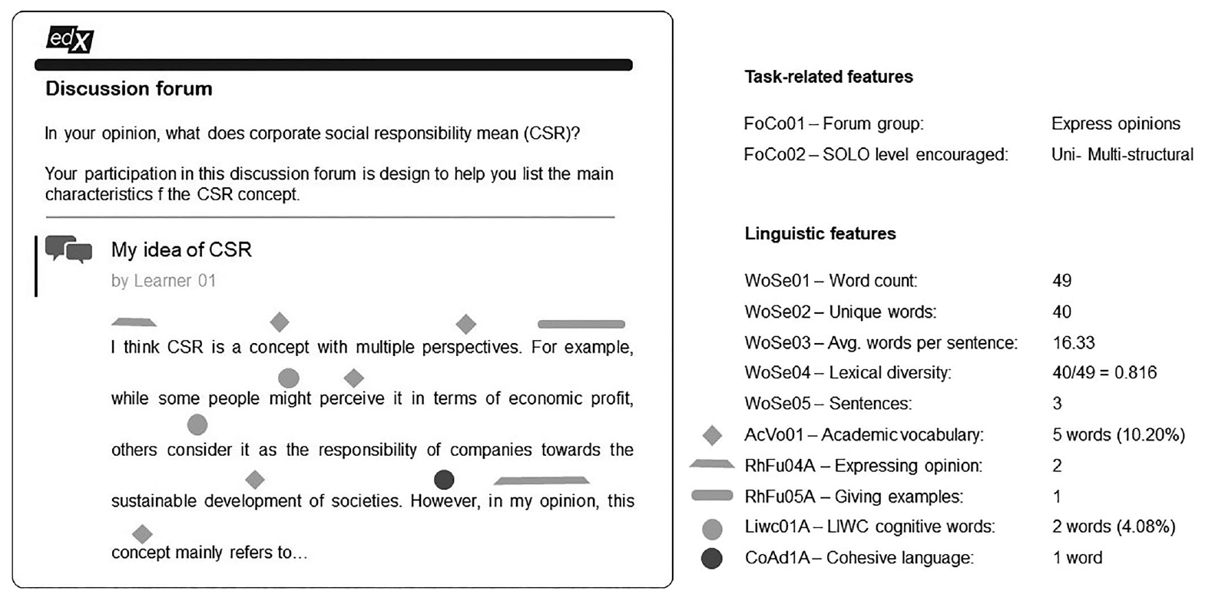

3.4 Data analysis method
Given the categorical and continuous nature of our data, we used random forests (Breiman, 2001) to investigate the extent to which task-related and linguistic features contribute to the prediction of SOLO levels of cognitive engagement in thread starters. This approach takes a random selection of features to construct an N-number of decision trees. Then, it makes a prediction about the SOLO level of cognitive engagement based on the output of the majority of trees. Since each decision tree is constructed using a random subset of features, the trees are relatively uncorrelated, which increases accuracy.
As explained in Section 3.1, the task-related features used in this study are, to some extent, co-dependent. Variable co-dependence (i.e., multicollinearity), however, does not affect random-forest analysis because every decision tree is constructed from a random set of features. If two variables are strongly correlated, as explained by Chavent et al. (2021), one of the variables may be disregarded “without degrading the performance of the model” (p. 569).
For random-forest analysis, we split the data into two sets: a training set used to create our model and a test set to evaluate the performance of the model. To split the data, we randomly selected 80% of the thread starters for each SOLO level to create the training set (n = 718 thread starters), while the other 20% left in each category (n = 183 thread starters) served to evaluate the final performance of the model. Random forests analysis also provides information about the importance of the linguistic and task-related features in predicting different SOLO levels.
Variable importance was calculated by computing a mean decrease in impurity (MDI). MDI counts the number of times that individual trees use a feature to split a node (i.e., to make a decision). Then, it sums the splits across all trees that include the feature, in proportion to the number of samples it splits. We build random forests using seven randomly sampled linguistic and task-related features at each split (mtry = 7). In total, we constructed 4000 decision trees (ntree = 4000). Given the few instances of thread starters coded as extended abstract (n = 24), we recoded these thread starters and grouped them with relational thread starters (Group 3). All statistical analyses were performed with R (R Core Team, 2020) and the Party package (Strobl et al., 2008).

4. Results
In this section, we present descriptive statistics used to answer RQ1 and RQ2. We also present the results of the random-forest analysis conducted to answer RQ3.

RQ1. What SOLO levels do learners' thread starters display in relation to the pedagogical design of content-related MOOC forum discussion tasks?

Results from our manual analysis revealed that the majority of thread starters displayed unistructural and multistructural levels of cognitive engagement (27.41% and 29.41%, respectively). However, the percentage of thread starters at a unistructural level in forums within Group 1 and Group 3 was generally lower in comparison to the percentage of thread starters at multistructural and relational levels in these groups. Similarly, in Forum18, which invited learners to create learning material, only 5.26% of thread starters were at a unistructural level. In this forum, 42.11% of thread starters displayed an extended abstract level, which was the level of cognitive engagement required by the forum discussion task. Thread starters at this level were scarce in other forums. Surprisingly, though, a high percentage of thread starters at a prestructural level were also found in Forum18. Thread starters at a prestructural SOLO level were scarce or inexistent in other forums, except for Forum05, which contained 56.99% of thread starters at this level (114 out of 200). These results can be seen in Table 4.

Table 4
SOLO levels in MOOC forum thread starters per forum group.

 |  | Total  thread  starters | SOLO level displayed
Group 1:  Ask questions |  | Total  thread  starters | Prestructural | Unistructural | Multistructural | Relational | Extended  Abstract
Forum01 |  | 42 | 3 | 10 | 11 | 15 | 3
Forum02 |  | 30 | 2 | 8 | 12 | 8 | 0
Forum03 |  | 17 | 0 | 4 | 7 | 6 | 0
 | Sub-total | 89 | 5 | 22 | 30 | 29 | 3
 | Percentage |  | 6.62 | 24.72 | 33.71 | 32.58 | 3.37
Group 2:
Express opinions
Forum04 |  | 206 | 18 | 50 | 72 | 60 | 6
Forum05 |  | 200 | 114 | 46 | 30 | 10 | 0
Forum06 |  | 96 | 2 | 50 | 20 | 22 | 2
Forum07 |  | 67 | 2 | 33 | 17 | 15 | 0
 | Sub-total | 569 | 136 | 179 | 139 | 107 | 8
 | Percentage |  | 23.90 | 31.46 | 24.43 | 18.80 | 1.41
Group 3:
Analyse content
Forum08 |  | 40 | 0 | 8 | 12 | 15 | 5
Forum09 |  | 26 | 0 | 6 | 14 | 6 | 0
Forum10 |  | 23 | 0 | 3 | 15 | 5 | 0
Forum11 |  | 16 | 1 | 2 | 10 | 3 | 0
Forum12 |  | 17 | 0 | 2 | 6 | 9 | 0
Forum13 |  | 16 | 0 | 2 | 8 | 6 | 0
Forum14 |  | 25 | 1 | 6 | 8 | 10 | 0
Forum15 |  | 21 | 0 | 5 | 4 | 12 | 0
Forum16 |  | 21 | 1 | 6 | 9 | 5 | 0
Forum17 |  | 19 | 0 | 5 | 10 | 4 | 2
 | Sub-total | 224 | 3 | 45 | 96 | 75 | 5
 | Percentage |  | 1.34 | 20.09 | 42.86 | 33.84 | 2.23
Group 4:
Create materials
Forum18 |  | 19 | 9 | 1 | 0 | 1 | 8
 | Percentage |  | 47.37 | 5.26 | 0.00 | 5.26 | 42.11
Total |  | 901 | 153 | 247 | 265 | 212 | 24
Percentage |  |  | 16.98 | 27.41 | 29.41 | 23.53 | 2.66

RQ2. What are the linguistic features of thread starters according to their SOLO level?

Results showed that the average number of words, sentences, and conjunctive adverbs (among other linguistic features) increased as thread starters displayed deeper levels of cognitive engagement. For example, thread starters at a prestructural SOLO level consisted of an average of 16.37 words (SD = 12.62) occurring in 1.52 (SD = 0.87) sentences. Thread starters at an extended abstract level, however, included an average of 159.45 words (SD = 87.41) in 8.42 (SD = 3.42) sentences. The average counts and percentages for the linguistic features can be seen in Table 5. This table, however, does not include dichotomous linguistic features such as presence of first-person singular pronouns or academic vocabulary (WoSe07 and AcVo03 respectively). Dichotomous features are presented next.

Table 5
Linguistic features of massive open online courses forum thread starters per structure of observed learning outcomes (SOLO) level.

 |  | SOLO levels of learners’ cognitive engagement
 |  | Prestructural |  | Unistructural |  | Multistructural |  | Relational |  | Extended  Abstract
Total thread starters |  | 153 |  | 247 |  | 265 |  | 212 |  | 24
Overall words and sentences |  | Mean | SD | Mean | SD | Mean | SD | Mean | SD | Mean | SD
WoSe01 | Word count | 16.37 | 12.62 | 29.37 | 15.36 | 75.35 | 37.72 | 117.58 | 62.08 | 159.45 | 87.41
WoSe02 | Unique words | 14.52 | 9.59 | 25.04 | 11.72 | 55.12 | 22.46 | 78.49 | 32.19 | 101.12 | 47.26
WoSe03 | Words per sent. | 11.59 | 7.79 | 18.83 | 8.90 | 23.22 | 11.55 | 23.73 | 10.20 | 28.69 | 18.00
WoSe04 | Lexical diversity | 93.65% | 7.94% | 88.17% | 8.36% | 75.65% | 7.81% | 69.82% | 8.15% | 66.82% | 7.66%
WoSe05 | Total sentences | 1.52 | 0.87 | 1.79 | 1.07 | 4.17 | 2.28 | 6.38 | 3.58 | 8.42 | 3.42
WoSe06 | First-pers. pron. | 1.10 | 1.01 | 0.79 | 1.08 | 1.40 | 1.86 | 2.04 | 1.96 | 1.96 | 2.37
WoSe08 | % WoSe06 | 7.24 | 6.09 | 2.29 | 2.88 | 1.91 | 2.39 | 1.78 | 1.58 | 1.24 | 1.12
Academic vocabulary
AcVo01 | % (based on WoSe01) | 2.33 | 5.48 | 4.85 | 4.44 | 5.67 | 3.34 | 4.78 | 2.56 | 4.56 | 2.12
AcVo02 | % (based on WoSe02) | 2.47 | 5.56 | 5.44 | 4.94 | 7.09 | 3.93 | 6.38 | 3.31 | 6.54 | 3.22
LIWC cognitive words
Liwc01A | % Cog. processes | 17.13 | 9.03 | 14.28 | 8.04 | 14.10 | 5.29 | 14.59 | 4.66 | 11.80 | 3.82
Liwc02A | % Insight | 4.72 | 5.56 | 3.83 | 3.84 | 3.40 | 2.45 | 3.38 | 2.01 | 3.19 | 1.51
Liwc03A | % Causation | 0.85 | 2.55 | 4.15 | 4.93 | 3.46 | 2.45 | 3.25 | 2.00 | 2.79 | 1.21
Liwc04A | %f Discrepancy | 0.79 | 2.02 | 1.10 | 2.43 | 1.35 | 1.74 | 1.61 | 1.77 | 1.68 | 1.36
Liwc05A | % Tentative | 2.40 | 4.31 | 2.11 | 3.13 | 2.66 | 2.35 | 2.81 | 2.02 | 2.12 | 1.99
Liwc06A | % Certainty | 4.15 | 6.78 | 1.42 | 2.79 | 1.43 | 1.62 | 1.55 | 1.44 | 1.35 | 1.20
Liwc07A | % Differentiation | 5.29 | 7.31 | 2.77 | 3.67 | 3.21 | 2.52 | 3.66 | 2.35 | 2.19 | 1.83
Cohesive language
CoAd1A | Total conj. adverbs | 0.18 | 0.45 | 0.19 | 0.46 | 0.51 | 0.76 | 1.45 | 1.34 | 2.13 | 2.15
CoAd1C | % conjunctive adv. | 0.93 | 2.65 | 0.61 | 1.73 | 0.73 | 1.09 | 1.36 | 1.24 | 1.16 | 1.05
Rhetorical function words
RhFu1A | Total cause and effect | 0.06 | 0.26 | 0.13 | 0.40 | 0.31 | 0.62 | 0.58 | 0.94 | 0.63 | 1.01
RhFu1C | % cause and effect | 0.24 | 1.36 | 0.44 | 1.47 | 0.44 | 0.92 | 0.48 | 0.79 | 0.29 | 0.47
RhFu2A | Total similar. & differ. | 0.10 | 0.34 | 0.29 | 0.58 | 0.78 | 0.97 | 1.26 | 1.35 | 1.25 | 1.51
RhFu2C | % similar. & differ. | 0.77 | 2.97 | 1.03 | 2.28 | 1.05 | 1.30 | 1.12 | 1.28 | 0.67 | 0.77
RhFu3A | Total adding info. | 0.44 | 0.84 | 0.87 | 0.97 | 2.55 | 2.25 | 3.85 | 2.89 | 6.04 | 3.88
RhFu3C | % adding info. | 1.87 | 3.39 | 3.11 | 3.67 | 3.27 | 2.33 | 3.23 | 1.84 | 4.02 | 2.13
RhFu4A | Total express opinions | 0.04 | 0.19 | 0.15 | 0.36 | 0.25 | 0.50 | 0.57 | 0.79 | 0.63 | 0.92
RhFu4C | % express opinions | 0.28 | 2.14 | 0.60 | 1.61 | 0.37 | 0.77 | 0.54 | 0.78 | 0.42 | 0.60
RhFu5A | Total giving examples | 0.00 | 0.00 | 0.02 | 0.15 | 0.11 | 0.43 | 0.26 | 0.66 | 0.29 | 0.69
RhFu5C | % giving examples | 0.00 | 0.00 | 0.07 | 0.47 | 0.14 | 0.55 | 0.23 | 0.59 | 0.16 | 0.42

Note. Unless indicated otherwise, all percentages (%) are based on the total number of words.

As Table 5 shows, while prestructural thread starters contained an average of 0.18 conjunctive adverbs (SD = 0.45), thread starters at relational and extended abstract levels included an average of 1.45 (SD = 1.34) and 2.13 (SD = 2.15) conjunctive adverbs, respectively. Nevertheless, the increase in conjunctive adverbs could be caused by a few thread starters containing a high number of conjunctive adverbs (i.e., outliers). Thus, to compare thread starters in each SOLO level, we calculated percentages based on dichotomous linguistic features (i.e., the features not included in Table 5). This helped us determine the total percentage of thread starters that contained a specific linguistic feature. Percentages are presented in Figures 3, 4, and 5.

Figure 3
Percentages of thread starters per structure of observed learning outcomes level with certain linguistic features
.
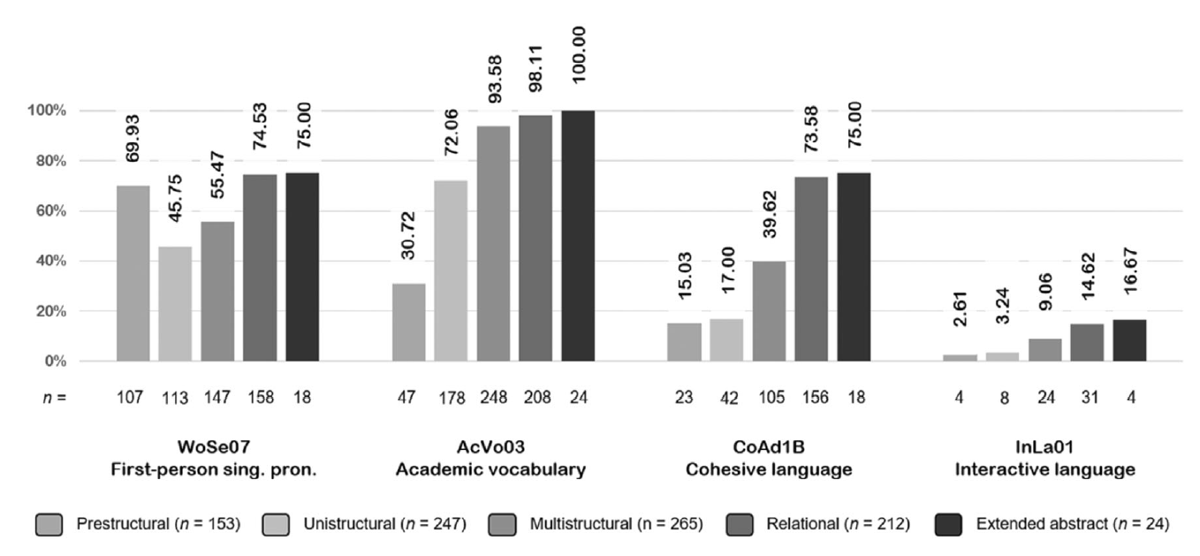

Figure 4
Percentage of thread starters per structure of observed learning outcomes level with linguistic inquiry and word count (LIWC) features.
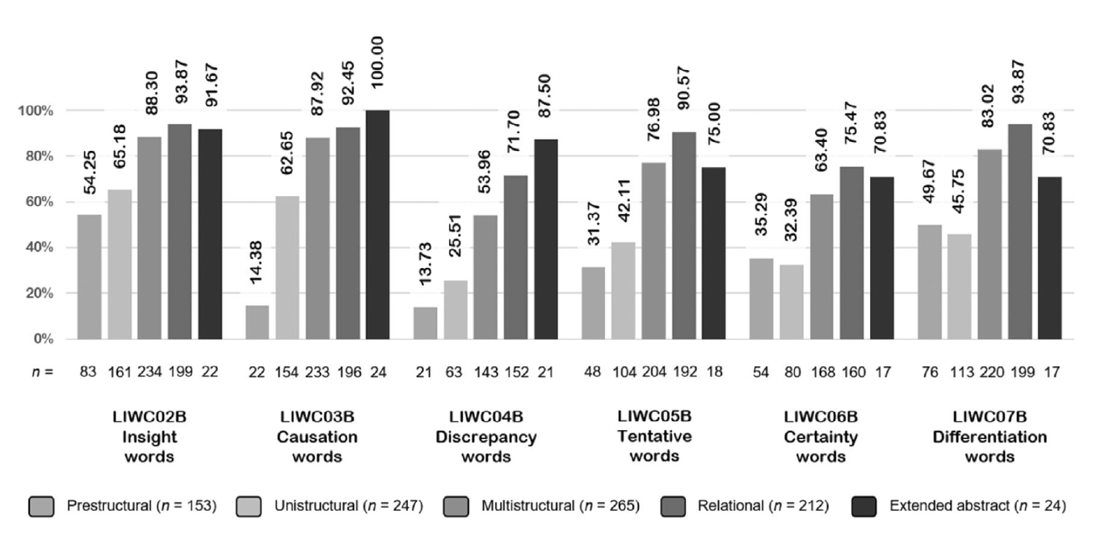

Figure 5
Percentage of thread starters per structure of observed learning outcomes level with rhetorical functions.

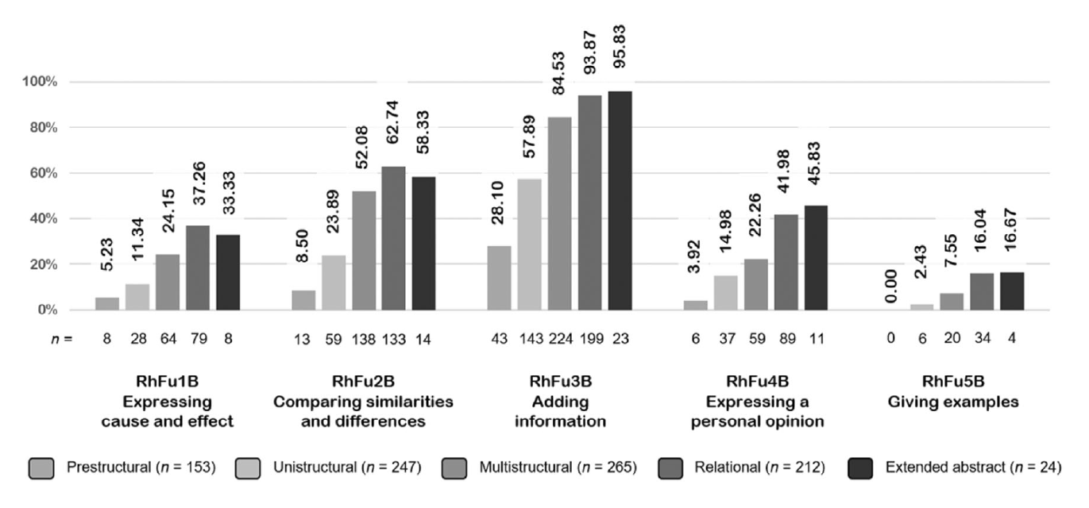

Figure 3 shows that 15.03% (23 out of 153) of thread starters coded as prestructural included cohesive language (i.e., at least 1 conjunctive adverb). However, 75% (18 out of 24) of extended abstract thread starters included cohesive language. Likewise, while only 30.72% of prestructural thread starters (n = 47) contained words from the Academic Keyword List (i.e., academic vocabulary), all thread starters at an extended abstract SOLO level contained academic vocabulary. Similar tendencies can be seen in Figures 4 and 5 for other linguistic features, namely, LIWC cognitive processes and AKL rhetorical functions.

RQ3. To what extent can the linguistic features of thread starters and task-related features of MOOC forums help to predict the quality of learners' cognitive engagement based on the SOLO taxonomy?

As explained in Section 3.4, random-forest analysis used 183 thread starters to evaluate the final performance of the model. Our model reached a classification accuracy of 0.7 (baseline = 0.26). The confusion matrix in Table 6 shows the number of thread starters correctly identified, as well as the precision, sensitivity, and specificity percentages for each SOLO level of cognitive engagement.

Table 6
Confusion matrix for random-forest analysis accuracy.

 | SOLO levels of cognitive engagement
 | Prestructural | Unistructural | Multistructural | Relational and Extended abstract | Precision %
Prestructural | 23 | 3 | 1 | 0 | 85.19
Unistructural | 9 | 42 | 5 | 0 | 75.00
Multistructural | 0 | 5 | 34 | 19 | 58.62
Reational and Extended abstract | 0 | 0 | 13 | 29 | 69.05
Total | 32 | 50 | 53 | 48
Sensitivity (recall) % | 71.88 | 84.00 | 64.15 | 60.42
Specificity % | 97.35 | 89.47 | 81.54 | 90.37

Note. This model was built from 20% of our data (183 thread starters). The numbers in the grey areas represent the number of thread starters correctly identified as belonging to the appropriate SOLO level coded.

As Table 6 shows, the sensitivity of the approach, that is, the proportion of thread starters correctly identified, was on average 70.11% (min = 60.42%, max = 84.00%). The specificity of the approach, the proportion of true negatives, was always higher than 81.54%. True negatives, in this context, indicate that thread starters not manually coded as unistructural, for example, were also not identified as belonging to this level. Therefore, our model not only accurately captured SOLO levels, but also appropriately recognised thread starters that did not show a specific level. Misclassification errors occurred between adjacent levels. For example, thread starters manually coded as prestructural were sometimes misclassified as unistructural, but never as relational or extended abstract.
We used variable importance scores (MDI) to identify the linguistic and task-related features that were important for the appropriate classification and prediction of thread starters at specific SOLO levels. As explained in Section 3.4, these scores measure the size of the effect that a predictor has on the response variable (Gries, 2020). The most important variables are displayed in Figure 6.

Figure 6
Relative importance of linguistic and task-related features.

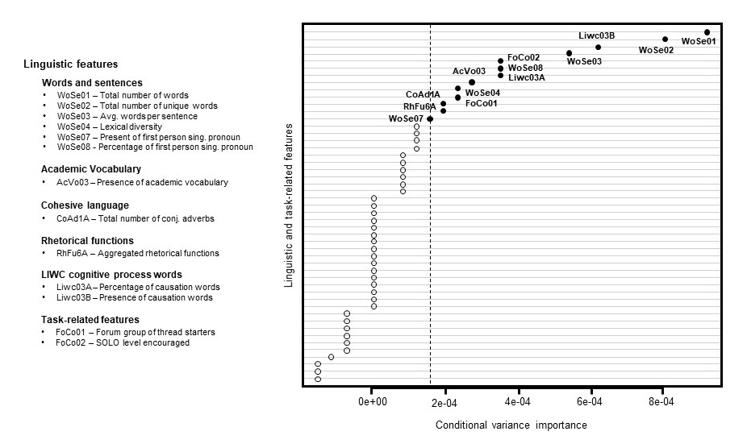

Note. Features that were not found important for the classification are not mentioned.

Figure 6 shows that both the cognitive processes that MOOC forum discussion tasks encouraged (FoCo02) and the SOLO levels related to those processes (FoCo01) significantly contributed to predicting the quality of learners' cognitive engagement. Regarding linguistic features, the total number of words (WoSe01) was the most important feature. Other features, such as the number of unique words (WoSe02), the average words per sentence (WoSe03), the presence of academic vocabulary (AcVo03), and the lexical diversity (WoSe04) of thread starters also contributed to predicting different SOLO levels. Similarly, the presence (or absence) and percentage of first-person singular pronouns (WoSe07 and WoSe08, respectively) contributed to the random-forest prediction. The only LIWC-related linguistic features that were important for the prediction of SOLO levels were the presence (or absence) and percentage of causation words (Liwc03B and Liwc03A). Likewise, the total number of conjunctive adverbs (CoAd1A) also helped to predict different levels of learners' cognitive engagement.

5. Discussion
This study sought to identify the role that MOOC forum discussion tasks play in the quality of learners' cognitive engagement. We focused on thread starters and argued that the automatic evaluation of cognitive engagement in MOOC forums should not rely solely on linguistic features, but should also consider the pedagogical design of the forum discussion task. To support our claim, we used the SOLO taxonomy to analyse the levels of cognitive engagement that learners displayed in thread starters (RQ1) and identified the linguistic features of thread starters at each SOLO level (RQ2). We studied these levels in relation to the pedagogical design of the forum discussion tasks. We also used random-forest modelling to identify the linguistic and forum task-related features that helped to predict learners' SOLO levels of cognitive engagement. We discuss the results of our study below.
In response to RQ1, we found that learners mostly displayed surface-level understanding, which is consistent with the findings of previous studies (e.g., Anderson et al., 2014; Gillani & Eynon, 2014; Jiang et al., 2015; Wise & Cui, 2018). However, when considering the pedagogical design of the forum discussion tasks, we noticed that learners displayed the level of cognitive engagement that was required in the task. For instance, thread starters in forums inviting learners to express opinions displayed mostly unistructural and multistructural levels. Similarly, thread starters in forums designed to analyse course content mostly displayed multistructural and relational levels. This shows that the quality of learners' cognitive engagement was aligned with the intended learning outcomes of the forum discussion tasks.
Nevertheless, this alignment did not occur in forums encouraging learners to ask questions for clarification. Those forums promoted a unistructural SOLO level, yet learners mainly engaged at multistructural and relational levels, which shows that they put a higher cognitive effort than required. Similarly, in the forum inviting learners to engage at an extended abstract, learners posted thread starters not only at the intended level, but also at a prestructural level. Reflecting upon the possible reasons for this misalignment, we believe it is important to consider aspects such as the position of the forums within the course and the support provided in the tasks to help learners reach the intended outcomes.
Regarding their position within the course, the number of thread starters in forums encouraging a relational level was low, arguably because these forums were organised in the second learning week of the course. Research has shown that learners' participation in MOOC forums starts to decline after the first learning week (Brinton et al., 2014). Clow (2013) named this phenomenon the “funnel of participation” (p. 185) because, like in a funnel, a massive number of learners are active at the beginning of the course, but their activity drastically decreases by the end. More than half of the forums (10 out of 18) invited learners to engage at a relational SOLO level, yet there was a maximum of 40 thread starters (min = 16) in these forums. In contrast, the four forums inviting learners to express their opinion received a significantly higher number of thread starters (max = 200, min = 67). Two of these forums were organised during the first learning week.
The support given (or lack thereof) to help learners reach learning outcomes is also likely to play an important role in the level of cognitive engagement that learners display. For example, 33.84% of thread starters in forums designed to analyse course content reached the intended learning outcome (i.e., a relational level). However, most thread starters (42.86%) displayed a multistructural SOLO level. It is possible that forums did not provide enough support to help learners engage at the required level. Recent research has shown that MOOC forums encouraging different cognitive processes provide scanty guidance to help learners explore different perspectives or relate ideas (Rivera et al., 2023). Without proper guidance, learners might struggle to engage at the cognitive level required and achieve the intended learning outcomes of the pedagogical task.
Moving on to RQ2, we found that the number of words is an important linguistic feature for predicting the quality of learners' cognitive engagement. This result is also consistent with previous studies (e.g., Joksimovic et al., 2014; O'Riordan et al., 2020). However, this study adds that the number of words increases as learners show deeper SOLO levels (i.e., relational and extended abstract). In addition, our results show that thread starters at relational and extended abstract levels included not only more words, but also a higher percentage of academic vocabulary and cohesive language. Thus, the number of words in a forum message should only be considered an initial indicator of quality in learners' cognitive engagement. The nature of the words (e.g., academic vs. non-academic) also needs to be considered to better capture the psychological effort that learners put into learning.
Lastly, in response to RQ3, variable importance scores revealed that the two features capturing the pedagogical design of MOOC forum discussion tasks significantly contributed to predicting different SOLO levels of learners' cognitive engagement. Although the classification accuracy of our model was similar to that found in previous studies (e.g., Kovanovic et al., 2016; Wang et al., 2015), this study advances our knowledge of the role that the pedagogical design of MOOC forum discussion tasks plays in the extent to which learners engage cognitively in MOOC forum discussions. This indicates the importance of designing MOOC forum tasks to facilitate cognitive engagement.

To sum up, this study reproduced previous results concerning the poor quality of learners' cognitive engagement in MOOC discussion forums (Galikyan et al., 2021; Tawfik et al., 2017; Wang et al., 2015). However, this study considered the cognitive processes and SOLO levels encouraged in forum discussion tasks. By doing so, we show that learners' engagement is closely aligned with the design of the discussion tasks. In simple words, MOOC forums facilitating surface-level cognitive engagement mainly receive messages at those levels. In addition, although learners may strive to engage at deeper levels, without proper guidance, they might fail to reach the intended learning outcome. Thus, this study empirically shows that, for identifying the quality of learners' cognitive engagement in MOOC forums, it is important to analyse such engagement in relation to the intended learning outcomes of the forum discussion task.

5.1 Limitation and future dimensions
This study used the SOLO taxonomy to identify different levels of learners' cognitive engagement. Although SOLO has been used to measure learning outcomes across many disciplines, the levels at which this taxonomy classifies cognitive engagement have been criticised. Chan et al. (2002), for instance, found that learners' responses at a multistructural SOLO level varied in quality; hence, they proposed sub-categories within the different levels to minimise ambiguity. In this study, despite the good inter-rater agreement value reached, discrepancies when coding the messages also occurred when grading adjacent SOLO levels, which supports the idea of adding subcategories to improve reliability. Future studies could use more nuanced levels or a different learning taxonomy.
We started this paper by mentioning that Thimothée wrote “I don't know” in response to a forum discussion task. Although we considered this phrase to indicate a lack of understanding portraying a prestructural SOLO level, for Liu, Xing, et al. (2022), such a phrase represents confusion, associated with emotional engagement. According to D'Mello and Graesser (2014), confusion is both a cognitive and emotional state. This highlights the multidimensional nature of engagement and the interwoven relationship among its cognitive, social, behavioural, and emotional dimensions (Fincham et al., 2019). Although this study focused on cognitive engagement, as Deng et al. (2020) showed, a multidimensional approach can help us better understand the factors that might help learners engage or disengage from the course. Future research could thus develop models that integrate several dimensions of engagement. This could provide a more holistic understanding of MOOC learners' engagement in discussion forums.
This study analysed a single MOOC. This substantially limits the generalisability of our findings. Thus, a broader scope of courses is necessary to improve the model and better understand the cognitive engagement of MOOC learners in discussion forums. Finally, we operationalised pedagogical design on the basis of the cognitive processes and intended learning outcomes encouraged in the pedagogical task. However, as we previously mentioned, guidance to help learners engage with the course content could also affect the quality of the cognitive engagement that learners display. Thus, future studies could integrate other task-related features that could shed some light on learners' cognitive activity in MOOC discussion forums. Notwithstanding the limitations of our work, we believe that it indicates the importance of analysing learners' cognitive engagement in relation to the pedagogical design of MOOC forum discussion tasks.

6. Conclusion
This interdisciplinary research contributes to the empirical evidence that the linguistic features of MOOC forum messages, when understood within the lens of a learning taxonomy, can be used to identify distinct levels of cognitive engagement. Learners' linguistic activity in MOOC forums, however, can be strongly influenced by the pedagogical design of the forum discussion tasks. Therefore, the major contribution of this study concerns the inclusion of task-related features in the analysis of learners' cognitive engagement. We have shown that, to understand MOOC learners' cognitive engagement, studies need to consider the pedagogical design of MOOC forum discussion tasks. Furthermore, by changing the focus from social to individual cognition, we open the door for future studies to analyse how thread starters facilitate or hinder the social construction of knowledge.

Acknowledgements
The study was conducted non-intrusively after the course had finished. We express our gratitude to the MOOC instructors and the Louvain Learning Lab, the centre in charge of the development of MOOCs at UCLouvain, for their support in conducting this study. Similarly, we thank Prof. Bernadette Charlier for her insights to the study and Marie de Radriguès for her help coding the data. Last, but not least, a word of gratitude to the Support en Méthodologie et Calcul Statistique (SMCS) for their support with the random forest analysis.

Funding information
This research was funded by Collective Research Initiatives (ARC) grant No. 19/24-099. The ARC was not involved in the development of this paper.

Conflict of interest
The authors declare no conflict of interest.

References

Alario-Hoyos, C., Muñoz-Merino, P. J., Pérez-Sanagustín, M., Parada, G., & Parada, H. (2016). Who are the top contributors in a MOOC? Relating participants' performance and contributions. Journal of Computer Assisted Learning, 32, 232–243. https://doi.org/10.1111/jcal.12127
Anderson, A., Huttenlocher, D., Kleinberg, J., & Leskovec, J. (2014). Engaging with massive online courses. In Proceedings of the 23rd international conference on world wide web (pp. 687–698). Association for Computing Machinery. https://doi.org/10.1145/2566486.2568042
Anthony, L. (2016). TagAnt (1.2.0) (computer software). Waseda University.
Apps, J. (2006). Abstract thinking. In S. Loue & M. Sajatovic (Eds.), Encyclopedia of aging and public health (pp. 67–69). Springer. https://doi.org/10.1007/978-0-387-33754-8_2
Barbosa, G., Camelo, R., Cavalcanti, A., Miranda, P., Mello, R., Kovanovic, V., & Gasevic, D. (2020). Towards automatic cross language classification of cognitive presence in online discussions. In Proceedings of the tenth international conference on learning analytics & knowledge (pp. 605–614). Association for Computing Machinery. https://doi.org/10.1145/3375462.3375496
Bennett, N., & Dunne, E. (1991). The nature and quality of talk in cooperative classroom groups. Learning and Instruction, 1(2), 103–118. https://doi.org/10.1016/0959-4752(91)90021-Y
Bereiter, C., & Scardamalia, M. (1987). The psychology of written composition. Erlbaum.
Beukeboom, C. (2014). Mechanisms of linguistic bias: How words reflect and maintain stereotypic expectancies. In J. Forgas, O. Vincze, & J. László (Eds.), Sydney symposium of social psychology (pp. 313–330). Psychology Press.
Bier, A. (2015). An exploration of the link between language and cognition — From Vygotsky's socio-cultural theory to CLIL. Educazione Linguistica Language Education, 4(1), 71–84. https://doi.org/10.14277/2280-6792/124
Biggs, J., & Collis, K. (1989). Towards a model of school-based curriculum development and assessment using the SOLO taxonomy. Australian Journal of Education, 33(2), 151–163. https://doi.org/10.1177/168781408903300205
Biggs, J., & Tang, C. (2011). Teaching for quality learning at university (4th ed.). Open University Press.
Bloom, B. (1956). A taxonomy of educational objectives: The classification of educational goals. Handbook I: The cognitive domain. McKay.
Breiman, L. (2001). Random forests. Machine Learning, 45(1), 5–32. https://doi.org/10.1023/A:1010933404324
Brinton, C., Chiang, M., Jain, S., Lam, H., Liu, Z., & Wong, F. (2014). Learning about social learning in MOOCs: From statistical analysis to generative model. IEEE Transactions on Learning Technologies, 7(4), 346–359. https://doi.org/10.1109/TLT.2014.2337900
Bublitz, W. (2011). Cohesion and Coherence. Discursive Pragmatics, 8, 37–49. https://doi.org/10.1075/hoph.8.03bub
Carroll, D. (2007). Patterns of student writing in a critical thinking course: A quantitative analysis. Assessing Writing, 12(3), 213–227. https://doi.org/10.1016/j.asw.2008.02.001
Chan, C., Tsui, M., Chan, M., & Hong, J. (2002). Applying the structure of the observed learning outcomes (SOLO) taxonomy on student's learning outcomes: An empirical study. Assessment & Evaluation in Higher Education, 27(6), 511–527. https://doi.org/10.1080/0260293022000020282
Chavent, M., Lacaille, J., Mourer, A., & Olteanu, M. (2021). Handling correlations in random forests: Which impacts on variable importance and model interpretability? (paper presentation). European symposium on artificial neural networks, computational intelligence, and machine learning, Bruges, Belgium. https://hal.archives-ouvertes.fr/hal-03483385
Chen, G., Lo, C., & Hu, L. (2020). Sustaining online academic discussions: Identifying the characteristics of messages that receive responses. Computers & Education, 156, 103938. https://doi.org/10.1016/j.compedu.2020.103938
Cicchetti, D. (1994). Guidelines, criteria, and rules of thumb for evaluating normed and standardized assessment instruments in psychology. Psychological Assessment, 6(4), 284–290. https://doi.org/10.1037/1040-3590.6.4.284
Clow, D. (2013). MOOCs and the funnel of participation. In Proceedings of the third international conference on learning analytics and knowledge (pp. 185–189). Association for Computing Machinery. https://doi.org/10.1145/2460296.2460332
Cohen, A., Shimony, U., Nachmias, R., & Soffer, T. (2019). Active learners' characterization in MOOC forums and their generated knowledge. British Journal of Educational Technology, 50, 177–198. https://doi.org/10.1111/bjet.12670
Conole, G., & Fill, K. (2005). A learning design toolkit to create pedagogically effective learning activities. Journal of Interactive Media in Education, 2005(1), 9. https://doi.org/10.5334/2005-8
Costas, G. (2018). Keyness analysis: Nature, metrics, and techniques. Routledge.
Coxhead, A. (2000). A new academic word list. TESOL Quarterly, 34(2), 213–238.
Cui, Y., & Wise, A. (2015). Identifying content-related threads in MOOC discussion forums. In Proceedings of the second (2015) ACM conference on learning (pp. 299–303). Association for Computing Machinery. https://doi.org/10.1145/2724660.2728679
Deng, R., Benckendorff, P., & Gannaway, D. (2020). Linking learner factors, teaching context, and engagement patterns with MOOC learning outcomes. Journal of Computer Assisted Learning, 36(5), 688–708. https://doi.org/10.1111/jcal.12437
D'Mello, S., & Graesser, A. (2014). Confusion. In R. Pekrun & L. Linnenbrink-Garcia (Eds.), Handbook of emotions and education (pp. 289–310). Routledge.
Dowell, N., Skrypnyk, O., Joksimovic, S., Graesser, A., Dawson, S., Gasevic, D., Hennis, T., de Vries, P., & Kovanovic, V. (2015). Modeling learners' social centrality and performance through language and discourse. In C. Romero & M. Pechenizkiy (Eds.), Proceedings of the 8th International Conference on Educational Data Mining (pp. 250–257). International Educational Data Mining Society.
Fincham, E., Whitelock-Wainwright, A., Kovanovic, V., Joksimovic, S., van Staalduinen, J.-P., & Gasevic, D. (2019). Counting clicks is not enough: Validating a theorized model of engagement in learning analytics. In Proceedings of the 9th International Conference on Learning Analytics & Knowledge (pp. 501–510). Association for Computing Machinery. https://doi.org/10.1145/3303772.3303775
Fredricks, J., Blumenfeld, P., & Paris, A. (2004). School engagement: Potential of the concept, state of the evidence. Review of Educational Research, 74(1), 59–109.
Galikyan, I., Admiraal, W., & Kester, L. (2021). MOOC discussion forums: The interplay of the cognitive and the social. Computers & Education, 165, 104133. https://doi.org/10.1016/j.compedu.2021.104133
Gardner, D., & Davies, M. (2014). A new academic vocabulary list. Applied Linguistics, 35(3), 305–327.
Garrison, D., Anderson, T., & Archer, W. (2000). Critical inquiry in a text-based environment: Computer conferencing in higher education. The Internet and Higher Education, 2(2–3), 87–105. https://doi.org/10.1016/S1096-7516(00)00016-6
Gillani, N., & Eynon, R. (2014). Communication patterns in massively open online courses. The Internet and Higher Education, 23, 18–26.
Graesser, A., McNamara, D., Louwerse, M., & Cai, Z. (2004). Coh-Metrix: Analysis of text on cohesion and language. Behavior Research Methods, Instruments, & Computers, 36(2), 193–202. https://doi.org/10.3758/BF03195564
Gries, S. (2020). On classification trees and random forests in corpus linguistics: Some words of caution and suggestions for improvement. Corpus Linguistics and Linguistic Theory, 16(3), 617–647. https://doi.org/10.1515/cllt-2018-0078
Halliday, M., & Hasan, R. (1976). Cohesion in English. Longman.
He, C., Ma, P., Zhou, L., & Wu, J. (2018). Is participating in MOOC forums important for students? A data-driven study from the perspective of the super network. Journal of Data and Information Science, 3(2), 62–77. https://doi.org/10.2478/jdis-2018-0009
Heino, P. (2010). Adverbial connectors in advanced EFL learners' and native speakers' student writing [unpublished doctoral dissertation]. Stockholm University. https://urn.kb.se/resolve?urn=urn:nbn:se:su:diva-40674
Henri, F. (1992). Computer conferencing and content analysis. In A. R. Kaye (Ed.), Collaborative learning through computer conferencing (Vol. 90, pp. 117–136). Springer. https://doi.org/10.1007/978-3-642-77684-7_8
Huang, H., Jew, L., & Qi, D. (2023). Take a MOOC and then drop: A systemic review of MOOC engagement patterns and dropout factor. Heliyon, 9(4), e15220. https://doi.org/10.1016/j.heliyon.2023.e15220
Huang, J., Dasgupta, A., Ghosh, A., Manning, J., & Sanders, M. (2014). Superposter behavior in MOOC forums. In Proceedings of the first ACM conference on learning@scale (pp. 117–126). Association for Computing Machinery. https://doi.org/10.1145/2556325.2566249
Ireland, M., & Henderson, M. (2014). Language style matching, engagement, and impasse in negotiations. Negotiation and Conflict Management Research, 7, 1–16. https://doi.org/10.1111/ncmr.12025
Jiang, Z., Zhang, Y., Liu, C., & Li, X. (2015). Influence analysis by heterogeneous network in MOOC forums: What can we discover? In C. Romero & M. Pechenizkiy (Eds.), Proceedings of the 8th International Conference on Educational Data Mining (pp. 242–249). International Educational Data Mining Society.
Joksimovic, S., Gasevic, D., Kovanovic, V., Adesope, O., & Hatala, M. (2014). Psychological characteristics in cognitive presence of communities of inquiry: A linguistic analysis of online discussions. The Internet and Higher Education, 22, 1–10. https://doi.org/10.1016/j.iheduc.2014.03.001
Koper, R., & Olivier, B. (2004). Representing the learning design of units of learning. Educational Technology & Society, 7(3), 97–111.
Kovanovic, V., Joksimovic, S., Waters, Z., Gasevic, D., Kitto, K., Hatala, M., & Siemens, G. (2016). Towards automated content analysis of discussion transcripts: A cognitive presence case. In Proceedings of the 6th International Conference on Learning Analytics & Knowledge (pp. 15–24). Association for Computing Machinery. https://doi.org/10.1145/2883851.2883950
Krippendorff, K. (2013). Content analysis: An introduction to its methodology (3rd ed.). SAGE Publications.
Lan, A., Spencer, J., Chen, Z., Brinton, C., & Chiang, M. (2019). Personalised thread recommendation for MOOC discussion forums. In M. Berlingerio, F. Bonchi, T. Gärtner, N. Hurley, & G. Ifrim (Eds.), Machine learning and knowledge discovery in databases.Lecture notes in computer science (11052). Springer. https://doi.org/10.1007/978-3-030-10928-8_43
Li, J., Li, L., Zhu, Z., & Shadiev, R. (2023). Research on the predictive model based on the depth of problem-solving discussion in MOOC forum. Education and Information Technologies, 28, 13053–13076. https://doi.org/10.1007/s10639-023-11694-9
Li, S. (2021). Measuring cognitive engagement: An overview of measurement, instruments and techniques. International Journal of Psychology and Educational Studies, 8(3), 63–76. https://doi.org/10.52380/ijpes.2021.8.3.239
Lin, F., Huimin, L., Shenglan, L., Guochao, L., & Sen, L. (2018). Automatic feature learning for MOOC forum thread classification. In Proceedings of the 3rd International Conference on Big Data and Computing (pp. 65–70). Association for Computing Machinery. https://doi.org/10.1145/3220199.3220201
Liu, B., Xing, W., Zeng, Y., & Wu, Y. (2022). Linking cognitive processes and learning outcomes: The influence of cognitive presence on learning performance in MOOCs. British Journal of Educational Technology, 53(3), 1459–1477. https://doi.org/10.1111/bjet.13193
Liu, Z., Mu, R., Yang, Z., Peng, X., Liu, S., & Chen, J. (2022). Modeling temporal cognitive topic to uncover learners' concerns under different cognitive engagement patterns. Interactive Learning Environments, 31, 7196–7213. https://doi.org/10.1080/10494820.2022.2063904
Moore, R., Oliver, K., & Wang, C. (2019). Setting the pace: Examining cognitive processing in MOOC discussion forums with automatic text analysis. Interactive Learning Environments, 27(5–6), 655–669. https://doi.org/10.1080/10494820.2019.1610453
Neto, V., Rolim, V., Ferreira, R., Kovanovic, V., Gasevic, D., Lins, R. D., & Lins, R. (2018). Automated analysis of cognitive presence in online discussions written in Portuguese. In V. Pammer-Schindler, M. Pérez-Sanagustín, H. Drachsler, R. Elferink, & M. Scheffel (Eds.), Lifelong technology-enhanced learning (pp. 245–261). Springer. https://doi.org/10.1007/978-3-319-98572-5_19
Newmann, F., Wehlage, G., & Lamborn, S. (1992). The significance and sources of student engagement. In F. Newmann (Ed.), Student engagement and achievement in American secondary schools (pp. 11–39). Teachers College Press.
Ntourmas, A., Avouris, N., Daskalaki, S., & Dimitriadis, Y. (2019). Comparative study of two different MOOC forums posts classifiers: Analysis and generalizability issues. In Proceedings of the 10th International Conference on Information. Intelligence, Systems and Applications. IEEE.
Ntourmas, A., Daskalaki, S., Dimitriadis, Y., & Avouris, N. (2023). Classifying MOOC forum posts using corpora semantic similarities: A study on transferability across different courses. Neural Computing & Applications, 35, 161–175. https://doi.org/10.1007/s00521-021-05750-z
O'Riordan, T., Millard, D., & Schulz, J. (2016). How should we measure online learning activity? Research in Learning Technology, 24, 30088. https://doi.org/10.3402/rlt.v24.30088
O'Riordan, T., Millard, D., & Schulz, J. (2020). Is critical thinking happening? Testing content analysis schemes applied to MOOC discussion forums. Computer Applications in Engineering Education, 27(4), 690–709. https://doi.org/10.1002/cae.22314
Oztok, M., Zingaro, D., Brett, C., & Hewitt, J. (2013). Exploring asynchronous and synchronous tool use in online courses. Computers & Education, 60(1), 87–94. https://doi.org/10.1016/j.compedu.2012.08.007
Palloff, R., & Pratt, K. (2007). Building online learning communities: Effective strategies for the virtual classroom. John Wiley & Sons.
Paquot, M. (2010). Academic vocabulary in learner writing: From extraction to analysis. Continuum.
Pennebaker, J., Booth, R., Boyd, R., & Francis, M. (2015). Linguistic inquiry and word count: LIWC2015. Pennebaker Conglomerates, 1-25.
Pennebaker, J., & Francis, M. (1996). Cognitive, emotional, and language processes in disclosure. Cognition and Emotion, 10(6), 601–626. https://doi.org/10.1080/026999396380079
Poquet, O., & Dawson, S. (2016). Untangling MOOC learner networks. In Proceedings of the 6th International Conference on Learning Analytics & Knowledge (pp. 208–212). Association for Computing Machinery. https://doi.org/10.1145/2883851.2883919
Pring, R. (1971). Bloom's taxonomy: A philosophical critique II. Cambridge Journal of Education, 1(2), 83–91. https://doi.org/10.1080/0305764710010205
Quirk, R., Greenbaum, G., Leech, G., & Svartvik, J. (1985). A comprehensive grammar of the English language. Longman.
R Core Team. (2020). R: A language and environment for statistical computing. R Foundation for Statistical Computing.
Richardson, J., & Newby, T. (2006). The role of students' cognitive engagement in online learning. American Journal of Distance Education, 20(1), 23–37. https://doi.org/10.1207/s15389286ajde2001_3
Rink, J. (1994). Task presentation in pedagogy. Quest, 46(3), 270–280. https://doi.org/10.1080/00336297.1994.10484126
Rivera, D., Frenay, M., & Swaen, V. (2023). The learning design of MOOC discussion forums: An analysis of forum instructions and their role in supporting the social construction of knowledge. Technology, Knowledge and Learning. https://doi.org/10.1007/s10758-023-09670-w
Skehan, P., & Foster, P. (1997). Task type and task processing conditions as influences on foreign language performance. Language Teaching Research, 1(3), 185–211. https://doi.org/10.1177/136216889700100302
Stephens-Martinez, K., Hearst, M., & Fox, A. (2014). Monitoring MOOCs: Which information sources do instructors value? In Proceedings of the first ACM conference on learning@scale (pp. 79–88). Association for Computing Machinery. https://doi.org/10.1145/2556325.2566246
Strobl, C., Boulesteix, A., Kneib, T., Augustin, T., & Zeileis, A. (2008). Conditional variable importance for random forests. BMC Bioinformatics, 9, 307. https://doi.org/10.1186/1471-2105-9-307
Sun, C., Li, S., & Lin, L. (2016). Thread structure prediction for MOOC discussion forum. In W. Che, Q. Han, H. Wang, W. Jing, S. Peng, J. Lin, G. Sun, X. Song, H. Song, & Z. Lu (Eds.), Social Computing. Communications in Computer and Information Science (pp. 92–104). Springer. https://doi.org/10.1007/978-981-10-2098-8_13
Swan, K. (2019). Social construction of knowledge and the community of inquiry framework. In I. Jung (Ed.), Open and distance education theory revisited. Springer. https://doi.org/10.1007/978-981-13-7740-2_7
Tausczik, Y., & Pennebaker, J. (2010). The psychological meaning of words: LIWC and computerized text analysis methods. Journal of Language and Social Psychology, 29, 24–54.
Tawfik, A., Reeves, T., Stich, A., Gill, A., Hong, C., McDade, J., Pillutla, V., Zhou, Z., & Giabbanelli, P. (2017). The nature and level of learner–learner interaction in a chemistry massive open online course (MOOC). Journal of Computing in Higher Education, 29(3), 411–431. https://doi.org/10.1007/s12528-017-9135-3
Tenbrink, T. (2020). Cognitive discourse analysis: An introduction. Cambridge University Press.
Vai, M., & Sosulski, K. (2015). Essentials of online course design: A standards-based guide. Routledge.
Van Swol, L., Prahl, A., Kolb, M., Lewis, E., & Carlson, C. (2016). The language of extremity: The language of extreme members and how the presence of extremity affects group discussion. Journal of Language and Social Psychology, 35(6), 603–627. https://doi.org/10.1177/0261927X16629788
Vygotsky, L. (1978). Mind in society: The development of higher psychological processes. Harvard University Press.
Wang, X., Yang, D., Wen, M., Koedinger, K., & Rosé, C. (2015). Investigating how students' cognitive behaviour in MOOC discussion forums affect learning gains. In C. Romero & M. Pechenizkiy (Eds.), In Proceedings of the 8th International Conference on Educational Data Mining (pp. 226–233). International Educational Data Mining Society.
Wen, M., Yang, D., & Rosé, C. (2014). Linguistic reflections of student engagement in massive open online courses. In Proceedings of the 8th International AAAI Conference on Weblogs and Social Media (pp. 525–534). Association for the Advancement of Artificial Intelligence.
Wirtz, M. (2020). Interrater reliability. In V. Zeigler-Hill & T. K. Shackelford (Eds.), Encyclopedia of personality and individual differences (pp. 2396–2399). Springer. https://doi.org/10.1007/978-3-319-24612-3_1317
Wise, A., & Cui, Y. (2018). Unpacking the relationship between discussion forum participation and learning in MOOCs: Content is key. In Proceedings of the 8th international conference on learning analytics and knowledge (pp. 330–339). Association for Computing Machinery. https://doi.org/10.1145/3170358.3170403
Wise, A., Cui, Y., Jin, W., & Vytasek, J. (2017). Mining for gold: Identifying content-related MOOC discussion threads across domains through linguistic modeling. The Internet and Higher Education, 32, 11–28. https://doi.org/10.1016/j.iheduc.2016.08.001
Wong, J., Pursel, B., Divinsky, A., & Jansen, B. (2016). Analyzing MOOC discussion forum messages to identify cognitive learning information exchanges. In Proceedings of the Association for Information Science and Technology, 52, 1–10. https://doi.org/10.1002/pra2.2015.145052010023
Xu, J., Luo, K., Chen, H., & Lu, Y. (2021). Analysis of the interaction quality of MOOC based on Bloom's taxonomy of educational objectives. In IEEE international conference on educational technology (pp. 278–283). IEEE. https://doi.org/10.1109/ICET52293.2021.9563154

