Effect of thermal neutron shielding on the irradiation hardening and recrystallization of tungsten
Francisco Miranda^{1,2}*, Aleksandr Zinovev², Dmitry Terentyev^{2,3}, Alexey Stankovskiy², Shuhei Nogami⁴, Philipp Lied^{5,6}, Carsten Bonnekoh⁶, Kim Verbeken³, Thomas Pardoen^{1,7}
¹Institute of Mechanics, Materials and Civil Engineering (iMMC), Université catholique de Louvain (UCLouvain), Louvain-la-Neuve, Belgium
²SCK CEN, Mol, Belgium
³Ghent University, Department of Materials, Textiles and Chemical Engineering, Ghent, Belgium
⁴A.L.M.T. Corp., Thermal Management Division, 8-21-1, Ginza, Chuo-ku, Tokyo, Japan
⁵FusionCatalyst, Karlsruhe, Germany
⁶Karlsruhe Institute of Technology (KIT), Institute for Applied Materials, Karlsruhe, Germany
⁷WEL Research Institute, Wavre, Belgium

Abstract
Several tungsten grades were irradiated at 400 °C, 800 °C, and 1100 °C to a dose of 0.84 dpa using an artificially tailored neutron spectrum in the BR2 reactor. The irradiated materials includes ITER specification grades, one advanced pure tungsten grade, a W0.5ZrC particle-reinforced grade, and two potassium-doped grades. A 0.5 mm gadolinium shield was employed to suppress the thermal neutron component of the BR2 spectrum, producing a less lethargic neutron spectrum that reduces the tungsten transmutation rate to 0.5 at.% Re/dpa, significantly lower than in unshielded BR2 spectrum where it was over 2 at.% Re/dpa.
The objective of this work is to investigate the influence of the reduced thermal neutron fraction on post-irradiation mechanical properties, assessed via room-temperature Vickers hardness and elevated-temperature tensile testing. The lower transmutation rate of tungsten into rhenium and osmium leads to reduced irradiation hardening compared to previous BR2 and HFIR campaigns conducted without thermal neutron shielding. One of the pure tungsten grades, demonstrates superior post-irradiation mechanical properties, probably because of its specific manufacturing process. A warm rolled potassium-doped grade performs better than all the other materials of this study, as a result of strong crystallographic texture and high initial dislocation density, which seems to promote property retention under neutron irradiation for the preferred orientation. Furthermore, fractographic analysis of tensile specimens reveals irradiation-enhanced recrystallization, a consequence of the reduced transmutation rate under this spectrum.
These findings underscore the critical role of neutron spectrum tailoring for assessing and benchmarking the radiation response of tungsten-based materials in the context of fusion applications.

Introduction
Tungsten (W) is the primary plasma-facing material (PFM) selected for ITER’s divertor and first wall [1,2] and remains the leading candidate for plasma-facing components in future fusion power plants such as DEMO [3,4]. A set of exceptional properties (high melting point, low sputtering yield, and good thermal conductivity) makes it ideal for withstanding the extreme conditions in a fusion environment [5]. Despite these advantages, significant challenges must be addressed. The body-centered cubic (BCC) crystal structure imparts intrinsic brittleness, prior to irradiation the ductile to brittle transition temperature (DBTT) is usually reported at temperatures below 250 °C [6–9]. Neutron irradiation induces microstructural changes such as formation of voids and dislocation loops and precipitation of transmutation products. These changes lead to swelling, exacerbate tungsten’s intrinsic brittleness by increasing the ductile-to-brittle transition temperature and degrade thermal conductivity [10–13]. These irradiation-induced effects accumulate over time, progressively deteriorating mechanical performance and increasing the risk of failure under operational conditions.
Understanding the evolution of tungsten’s microstructure and mechanical properties under neutron irradiation has been of interest since the 1960’s [14,15]. However, in the absence of a dedicated fusion-relevant neutron source such as IFMIF-DONES [16], irradiation studies on fusion materials rely on material testing reactors (MTRs) [10,17,18]. These fission reactors, typically exhibit a strongly thermalized neutronic spectrum, which differs significantly from the fast spectrum expected in a fusion reactor. This discrepancy introduces challenges for the interpretation of irradiation effects for fusion conditions.
Previous experiments in reactors such as HFIR, JMTR, and JOYO have demonstrated that solid transmutation of tungsten into rhenium (Re) and osmium (Os) plays a dominant role in hardening and embrittlement [19–21]. This transmutation is driven by radiative capture reactions and consequent beta decays of the products, which are more probable at lower neutron energies, especially below ~1 eV. Consequently, irradiation in mixed-spectrum reactors like HFIR, JMTR or BR2 leads to transmutation rates significantly higher than those predicted for a fusion spectrum, where the fraction of solid transmutation products is much lower [22].
In current fusion power plant designs, the primary neutron source will be the deuterium-tritium (D-T) reaction, emitting 14.1 MeV neutrons which also leads to gaseous transmutation of H₂ and He [23], although this transmutation can be considered as negligible [24]. These fast neutrons will first interact with plasma-facing components and gradually lose energy through successive collisions with structural materials, resulting in a predominantly fast neutron spectrum at the PFM location. Therefore, accurate characterization of tungsten under conditions approximating this spectrum is essential. Additionally, plasma facing components will experience steep thermal gradients during operation, extreme temperatures on the plasma-facing side and near-coolant temperatures on the opposite face. This wide range of operating temperatures must be considered in irradiation studies, with particular attention to the 400 °C–1100 °C range, where recrystallization is slow prior to irradiation [25,26] but can be enhanced by radiation-induced processes [26,27].
In this study we made use of gadolinium (Gd) shielding to cut the thermal neutrons of the BR2 spectrum, thus being closer to a fusion relevant irradiation experiment. The thickness of this shielding was calculated so that the transmutations into Re and Os after irradiation at the BR2 reactor were equal to those expected for ITER. This work therefore presents a unique insight into the effects of a custom neutronic spectrum on the material properties of tungsten, in particular the hardness and the recrystallization of the materials are studied. Embrittlement is evaluated by doing tensile tests at temperatures above the pre-irradiation DBTT.

Materials and methodology
Six materials were irradiated: two ITER specification commercially available grades and four lab scale grades. Three pure tungsten grades were studied, namely: “IGP” (Plansee SE) in the form of a rod with a 35 mm side square cross section and “IGW” (A.L.M.T. Corp.) provided in the form of a 12 mm thick plate, which are the two commercially available tungsten grades. Additionally, lab scale pure tungsten grade “TP”, manufactured at A.L.M.T. Corp. and supplied to Tohoku University is also studied. This material was provided as a 7 mm thick plate. On top of the pure tungsten grades, three advanced tungsten grades were also studied: two K-doped grades “TK”, manufactured at A.L.M.T. Corp. and supplied to Tohoku University as a 7 mm thick plate, and “KIT”, manufactured by Plansee SE as a warm rolled 2.3 mm thick plate (indicating a potentially higher level of rolling deformation than TK) and supplied to Karlsruhe Institute of Technology. The KIT plate has a similar K-content with 47 ppm than commercially available K-doped W sheets from Plansee SE (internally labelled as “WVM”), however, it represents a warm rolled preproduction state with lower degree of deformation and without optimization for properties like DBTT or creep behaviour. Similar K-doped sheets with higher degree of deformation have been investigated thoroughly in the past [28–30]. Finally, the particle-reinforced composite material W0.5ZrC (ISSP, China) manufactured by hot rolling [31] and supplied as a 12 mm thick plate, was also irradiated. All materials are tested along their most favourable orientation (i.e. rolling direction) except for the W0.5ZrC composite which, for this study, was tested in the transversal orientation, thus not having its grains aligned with the main loading direction.
The irradiation campaign consisted of three capsules, with nominal irradiation temperatures of 400 ℃, 800 ℃ and 1100 ℃. The irradiation temperature is obtained by combination of the neutronics calculations using MCNP6.3 [32] and thermal analysis using ANSYS ® Fluent. The required irradiation temperature on the sample is achieved by the thermal balance of the heat generation and heat evacuation via the gas gap on the wall of the capsule, which is then cooled. The irradiation temperature is defined by the design (i.e. position of the capsule in the reactor, information on the neutron and gamma fluxes) and the typical variation of the temperature during the irradiation is about ±(5–10)%. The specimens were shielded from the thermal neutron flux by a layer of gadolinium. The selection of this material arises from the comparison of relevant properties, namely the thermal neutron capture cross section, the melting point and galvanic compatibility with the experimental setup. As seen in Figure 1 a), Gd has the highest thermal neutron capture cross section of all stable elements and a safe melting point for the current experiments. Additionally, Gd allows for the use of a relatively thin shield layer which is beneficial given the limited irradiation volume of current facilities. A 0.5 mm thick shield is enough to replicate the transmutation rate of W expected in a fusion power plant of about 0.5 at. % Re/dpa [21,33–36], the exact transmutation rate of a component will depend on its position inside the reactor since the neutron spectrum varies between different positions of the first wall and the divertor [24,35,36]. Since each nucleus of gadolinium can only, in practice, absorb one neutron, the effectiveness of this shielding decreases with increasing irradiation dose, thus the neutron spectrum, seen by the irradiated specimens, evolves as shown in Figure 1 b). The fast part of the spectrum responsible for the displacement damage (somewhat above ~0.1 MeV) is unaffected by the shielding. Thus, the tungsten specimens were inserted inside a tungsten holder, which was surrounded by a 0.5 mm gadolinium tube, a schematic of the capsule setup is presented in Figure 1 c). The burn-up of the shielding, the consumption of the Gd layer, limits this experiment to the obtained 0.84 dpa (this corresponds to 5 cycles for the 400 ℃ and to 3 cycles for the 800℃ and 1100 ℃, with each cycle taking 21 days), which were calculated using MCNP6.3 [32] and a threshold displacement energy of 55 eV, while the transmutation rate was calculated using the ALEPH2 code of SCK CEN and available databases [37–41]. For reference previous experiments, where Gd shielding was not used, show transmutation rates of about 2-10 at. % Re at 1 dpa [17,20,21,42–44].
a)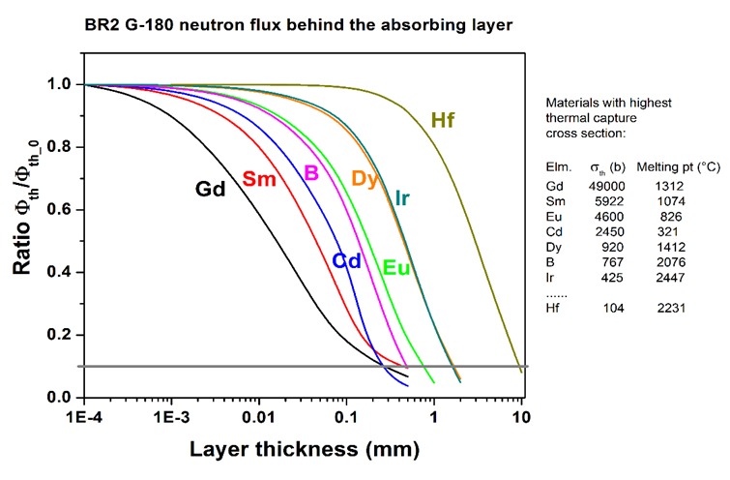 | b)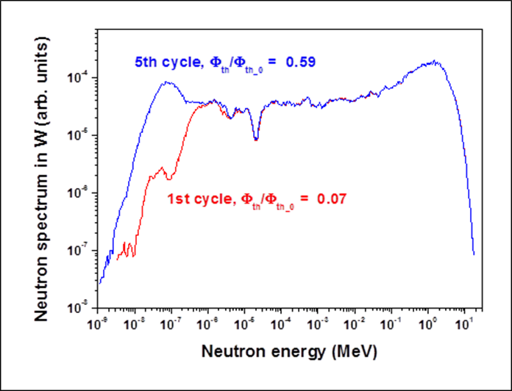
c)
Figure 1: a) Ratio of thermal neutron flux over total flux on a selected position in the BR2 reactor with variable shield thickness for different considered materials. Thermal neutron capture cross section and melting point are also highlighted as part of the selection process. b) Modification of the spectrum after 1st and 5th cycle in the target channel for the 400 ℃ irradiation condition. A dose of 1 dpa would be reached after 5 cycles. c) Schematic of the capsule setup used for the irradiation campaign presented on this work.
The specimens used for the irradiation campaign have a sub-miniaturized flat geometry as shown in Figure 2 a). This geometry is selected since it allows for a better use of the limited irradiation volume, as seen on the scheme presented in Figure 2 b), giving a higher data output per irradiation campaign than standard-sized dog bone specimens. The total length is equal to 16 mm, the gauge length is 5.2 mm, and the effective cross-sectional area is 1.6 mm² (1.6 mm width × 1 mm thickness). The gauge length to width ratio equal to 3.25 closely approximates the ASTM E8M-24 standard, which recommends a ratio of 4 for flat specimens [45].
The influence of specimen thickness on mechanical properties is considered negligible when the grain size is significantly smaller than the thickness, typically less than one-tenth, ensuring that each cross section represents a statistically valid volume element [46,47]. This implies that each cross section contains hundreds of grains, thereby providing a representative mechanical response and minimizing the influence of individual grain orientations or edge effects.
a)
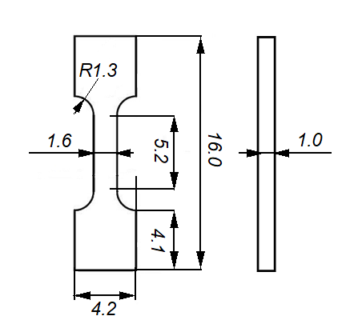
b) 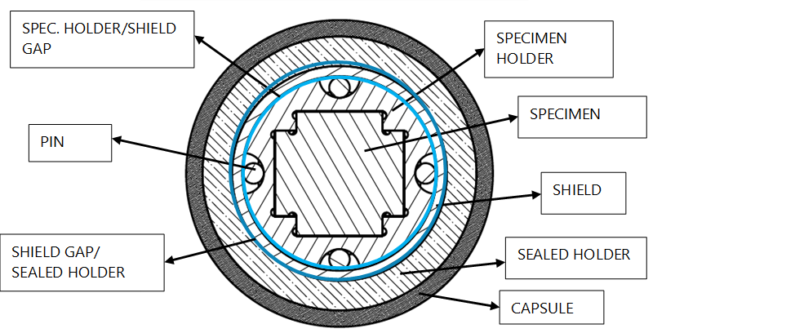
Figure 2: a) Schematics of sub-miniaturized flat tensile specimens (dimensions in mm). b) Plane scheme showcasing the structure of the capsule and the position of the tensile specimens, represented by the shaded central area.
Tensile tests were performed in air at 570 ± 5 ℃. A 5 kN load cell was used for all tests, and a preload of 100 N, around 62.5 MPa for nominal dimensions, was applied to ensure proper alignment of the specimen and to eliminate gaps in the loading train before testing. The tests were carried out at constant displacement rates of 0.2 mm/min, corresponding to a nominal strain rate of 6.4 × 10⁻⁴ s⁻¹.
In order to minimize measurement uncertainty, the testing bench was calibrated and qualified according to ASTM standards prior to the experiments. The load was recorded using a strain gauge-based load cell, while displacement was measured via the actuator, corresponding to the piston movement. Although this method does not directly measure strain within the gauge section, the engineering curves are corrected considering the machine compliance. As described in [48], in order to compensate the machine compliance contribution to the total displacement, the elastic displacement component of each data point from the raw data (u_{tot}) is replaced by the value calculated using the elastic modulus E adopted from the literature. The equation to account for machine compliance is described as: u = u_{tot} – F/K + (F*L)/(E*S), where u is the displacement of the test specimen associated with the gauge length L, F is the load, K is the elastic slope of the raw load-total displacement curve, and S is the area of cross section in the gauge zone.
The mechanical properties were defined as follows: the yield strength (YS) was determined at 0.2% plastic strain offset from the linear elastic region, the ultimate tensile strength (UTS) is the maximum engineering stress, and the fracture stress (FS) is the last registered load value before fracture over the final cross section, thus representing true FS.
Before carrying out the tensile test, Vickers hardness is measured using a load of 5 kgf (HV5) on the grip section of the tensile specimen. Six indents are performed for each specimen. Reference hardness is measured on non-irradiated specimens giving the possibility to address the hardness increase due to neutron irradiation.
Fracture surfaces were examined using scanning electron microscopy (SEM; JEOL-JSM7100) at an accelerating voltage of 20 kV, spot size of 50 nm with secondary electron detector, and a working distance of 20 mm. The characterization focused on identifying features such as cleavage facets, cracks, and intergranular fracture patterns as well as recrystallization-related indicators such as anomalous equiaxed grains or enlarged grains.

Results and discussion

Microstructure
Figure 3 shows the initial microstructure of each material in the non-irradiated state. The inverse pole figure maps provide key microstructural insights into these materials. Firstly, all of them exhibit a strong preferential orientation as seen by the maps and secondly, their grains are small enough compared to the specimen size, which can, therefore, be considered a representative volume element of the investigated materials. The rolling or longitudinal direction is denoted as RD, the transversal direction as TD and the short transversal - thickness of the original plate - as ND. The inverse pole figure maps of W0.5ZrC and IGW have been published previously in [49] and [9] respectively.
The two commercial tungsten products, IGW and IGP, present the largest grains. However, their grain morphology is quite different with IGP having more elongated carrot-like grains, while IGW has a typical pancake-like grain structure [50].
Both TP and TK materials exhibit a similar grain structure, as both plates followed similar manufacturing routes. The grains are elongated along the rolling direction and present a high aspect ratio between their length and width. The K-doped plate shows smaller grains which are compatible with the expected grain refinement produced by the potassium doping [51].
The heavily deformed KIT plate presents highly deformed grains in the characterized plane here presented. Nevertheless, these highly distorted grains present clear preferential directions as a consequence of the warm rolling that was used to produce the original plate [28]. An additional IPF map obtained across the thickness of the original plate is presented for this material in Figure 4, showing the highly deformed grains on a different plane as the one presented for Figure 3f.
Finally, the W0.5ZrC shows a fine grain size and a homogeneous carbide distribution is expected [31].

a)  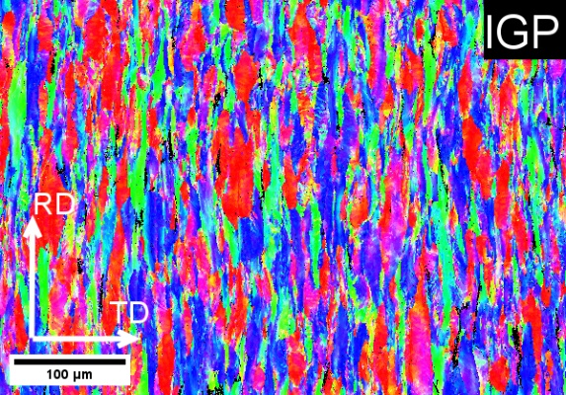 | b)  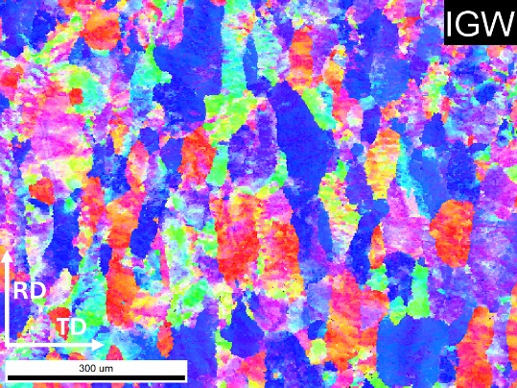
c)  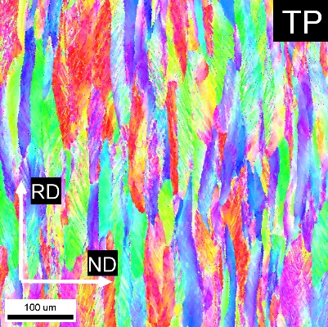 | d)  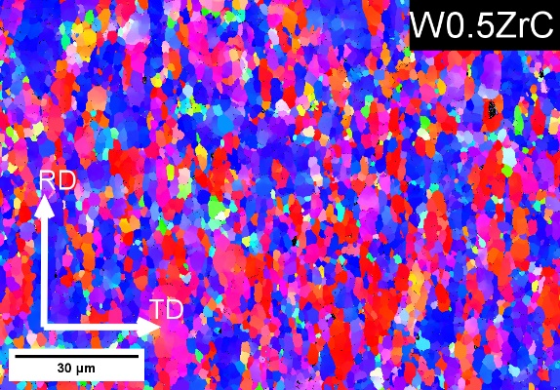
e)  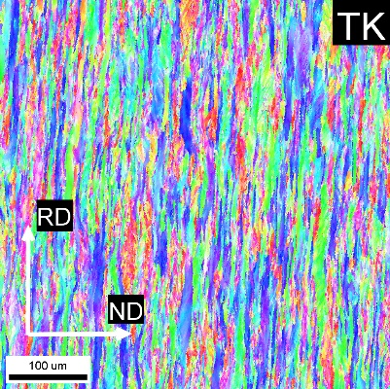 | f)  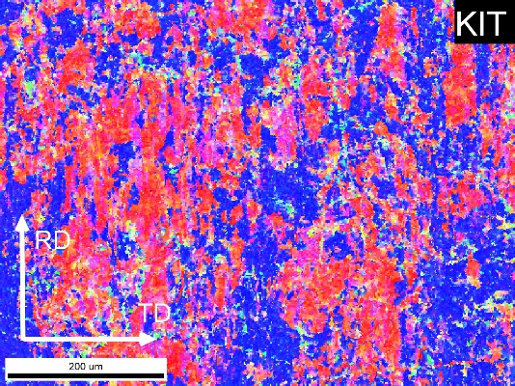
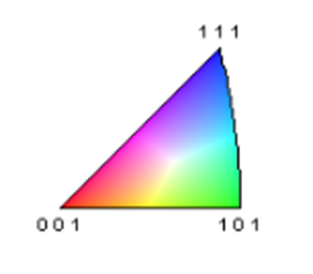
Figure 3: Inverse pole figure maps showing the morphology of the tested orientation for each material. IPFs correspond to materials as follows: a) IGP, b) IGW, c) TP, d) W0.5ZrC, e) TK and f) KIT. a), b), d) and f) are ND inverse poles figures while c) and e) are TD inverse poles figures.

Figure 4: TD inverse pole figure map across the thickness of the original KIT warm rolled plate.

Room temperature Vickers hardness
Reference hardness values were obtained by performing a six-indent Vickers pattern (HV5) on the grip section of non-irradiated flat tensile specimens. The corresponding HV5 values for each material are compared in Figure 5.Two commercially available tungsten grades (IGP and IGW) exhibit lower hardness compared to the lab-scale products. This result is expected, as their coarser grain structure provides less grain boundary strengthening [52,53]. Meanwhile, the W0.5ZrC alloy shows higher hardness at room temperature prior to irradiation, which is attributed to the presence of hard ZrC precipitates within the tungsten matrix [54]. Additionally, the KIT material exhibits the highest hardness which is attributed the high degree of deformation by the warm rolling manufacturing process and its fine and highly deformed microstructure.
After irradiation, hardness was measured using the same indent pattern and load as for the reference condition. The mean HV5 values are presented in Figure 5. On average, the largest increase in room-temperature hardness occurs after irradiation at 400 °C. At this irradiation temperature, defect mobility is limited, and recovery processes are minimal, allowing irradiation-induced defects to accumulate. The primary contributors to hardening under these conditions are dislocation loops and transmutation products forming as fine precipitates [43,55].
For specimens irradiated at 800 °C and 1100 °C, the microstructural evolution becomes complex. At these temperatures, the formation, diffusion, and coalescence of voids play a major role. Additionally, radiation-enhanced diffusion promotes defect recovery and lowers the effective recrystallization temperature [26,27]. Evidence of irradiation-induced recrystallization at 800 °C (as shown in fractography later on) explains the smaller hardness increase. At 1100 °C, the dominant defects are large voids formed by coalescence of point defects generated during displacement cascades. These voids can be decorated with Re and Os precipitates, as reported in the literature [11,43,44] explaining the generally larger HV5 compared to the present 800 °C condition.
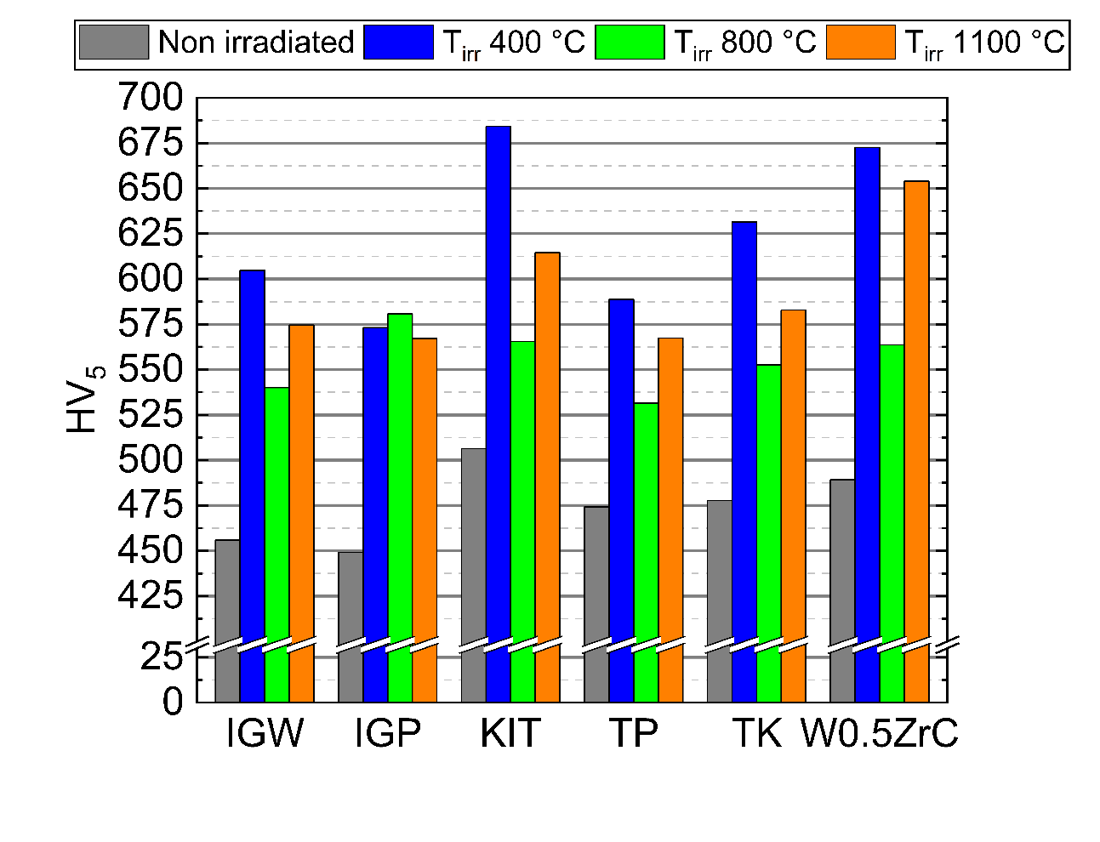
Figure 5: HV5 reference values of non-irradiated state (grey) compared with HV5 after irradiation at 400 °C (blue), 800 °C (green) and 1100 °C (orange),
To contextualize these results, Figure 6 compares the hardness change for IGP tungsten with data from previous irradiation campaigns across a wide range of temperatures and doses. The current campaign shows a lower hardness increase than any previously reported trend for BR2 [10,56,57] and HFIR without thermal neutron shielding [58], regardless of irradiation temperature. This suggests a reduced transmutation rate and a smaller number of Re and Os precipitates, consistent with the less lethargic neutron spectrum used in this study, and the fact that such precipitates are known to significantly contribute to raising the hardness of tungsten [19,20,59,60].
Figure 6: Change of hardness ΔHV associated to irradiation from the present test campaign compared with previous irradiations done at BR2 [10,56,57], and at HFIR [58].

Tensile tests
All uniaxial tensile tests were carried at 570 °C, the engineering curves are classified as follows: “Brittle” when the material does not exhibit plastic deformation, “Ductile no necking” when plastic flow is activated but no plastic localization before fracture, “Ductile with necking” when the material exhibits plastic localization before fracture, “Ductile with early necking” when the strain localization appears right after the YS, and “—” indicating that a load exceeding the fracture stress was applied during handling. This classification is shown for each material and condition in Table 1.
Table 1: Summary of the characteristics of the stress-strain curves at 570 °C.
T_{irr} [°C] | IGP | IGW | TP | TK | KIT | W0.5ZrC
Non-irradiated | Ductile with early necking | Ductile with early necking | Ductile with early necking | Ductile with early necking | Ductile with early necking | Ductile with early necking
400 | Brittle | Brittle | Brittle | Brittle | Brittle | Brittle
800 | Brittle | — | Brittle | — | Brittle | Brittle
1100 | Ductile with necking | Ductile no necking | Ductile no necking | Ductile no necking | Ductile with necking | Brittle

Another important parameter to consider for the brittle materials is the fracture stress, since embrittlement is severe in pure tungsten as previously reported by various authors [20,61,62]. The summary of the true FS of each specimen is shown in Table 2. These values are highly stochastic and based on one single specimen, as it is well known that for brittle materials a Weibull based model must be used [63,64]. Nevertheless, this analysis further indicates the weakening of the materials irradiated at 800 °C.
Table 2: True fracture stress (MPa) of each material after irradiation at 400 °C, 800 °C and 1100 °C (tested at 570 °C). The final cross section was adjusted based on microscopic inspection of the fracture surface.
T_{irr} [°C] | IGP | IGW | TP | TK | KIT | W0.5ZrC
400 | 587 | 590 | 906 | 708 | 1320 | 618
800 | 667 | — | 337.5 | — | 990 | 583
1100 | 1136 | 1010 | 903 | 1148 | 1346 | 841

The stress-strain curves associated to a ductile behaviour are shown in Figure 7. For the non-irradiated reference tests, all materials exhibit early necking which is consistent with previous reports on similar tungsten grades where the deformed grains showed a relatively strong crystallographic texture[49]. The main deformation mechanism is in-grain plastic deformation, which leads to the “necked to edge” grains visible in Figure 8 and Figure 9, the deformation occurs by dislocation glide and multiplication and is limited by the size of individual grains. While inter-grain deformation is driven by the pile up of dislocations against the grain boundaries, with possible absorption by the grain boundaries. In this scenario, triple junction grain boundaries act as stress concentrators [49].
Moreover, the effect of neutron irradiation on uniform elongation is clearly reflected on the stress-strain curves. Neutron irradiation introduces a high density of defect clusters that act as strong obstacles to dislocation motion. The resulting reduction in dislocation mobility would promote a more homogeneous distribution of plasticity during the early stages of deformation. This suppression of strain localization would delay the onset of geometric instability, thereby postponing the early necking seen on the non-irradiated state. Additionally, the hardening of the materials after irradiation is also noticeable from the stress-strain curves after irradiation at 1100 °C. Hardening comes from irradiation induced defects, which increase the energy necessary for the dislocation motion and thus increase the yield strength of the material. Nevertheless, these, in principle favourable changes on the mechanical properties of the material, come with a major drawback. Previous studies on tungsten have shown that the irradiation induced embrittlement drives the DBTT of the material [10,48] to temperatures that are in the operating range of components such as the divertor monoblocks which poses a risk for component design [64,65]. Here, this severe embrittlement is evident by the fact that no material from the two lower irradiation temperature capsule shows ductile behaviour at 570 °C; and even for the highest irradiation temperature – exhibiting some degree of ductility – the total elongation and the reduction of area of the specimens are considerably lower than for the non-irradiated state.
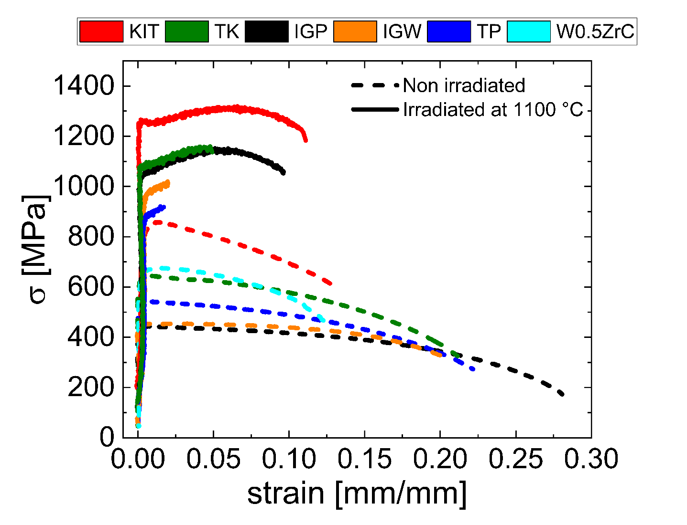
Figure 7: Engineering stress-strain curves of materials showing plastic deformation after irradiation (solid lines) at 1100 °C and reference non-irradiated curves (dash lines). Test temperature 570 °C.
After irradiation IGP shows the highest YS, UTS and strain at fracture of all pure tungsten grades, while KIT exhibits the highest YS, UTS and strain at fracture overall, after irradiation. These grades have in common that their grains are highly deformed with the favourable orientation being the one tested in this work. Additionally, these materials are the only ones showing plastic strain localization before fracture. These are indications that strong textures and high initial dislocation density enhance property retention under irradiation. All this highlights the importance of the initial microstructure, which can be engineered via different manufacturing processes.

Fractography
The fracture surface of each specimen has been carefully analysed, and the general aspect is presented in Figure 8. The fracture surface analysis was focused on the identification of brittle fracture features such as cleavage facets, cracks, or intergranular fracture patterns, and ductile features like necking of individual grains, as well as recrystallized grain morphologies which might be the result of phenomena like sub-grain coalescence. The recrystallization features are seen in the materials from the capsule with T_{irr} = 800 °C. Meanwhile, the materials irradiated at 1100 °C are the only materials exhibiting ductile features.
 | Nonirradiated | T_{irr} = 400 °C | T_{irr} = 800 °C | T_{irr} = 1100 °C
IGP | 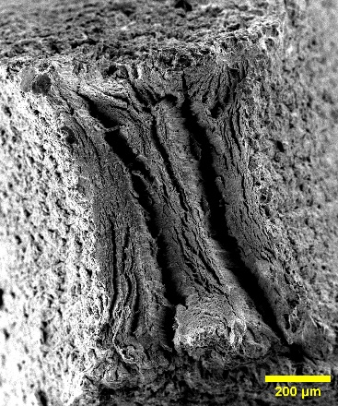 | 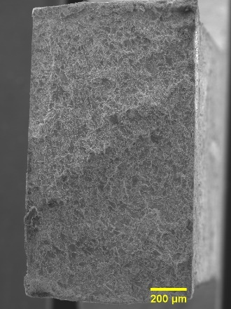 | 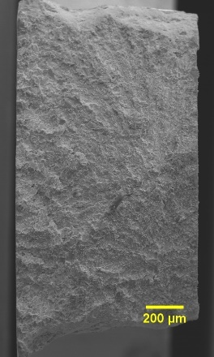 | 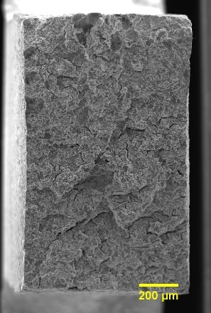
IGW | 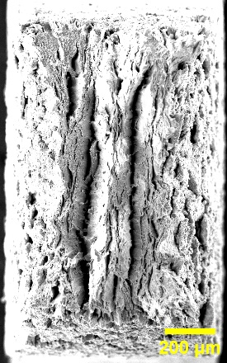 | 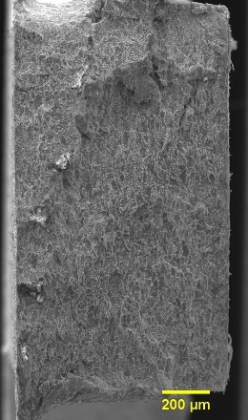 | 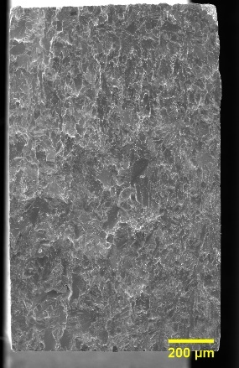 | 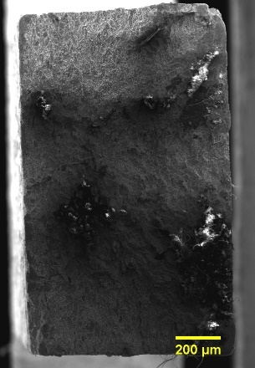
TP | 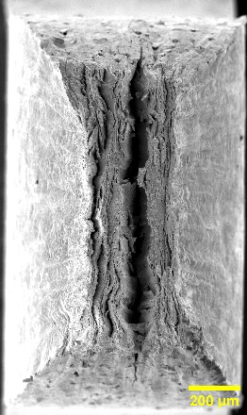 | 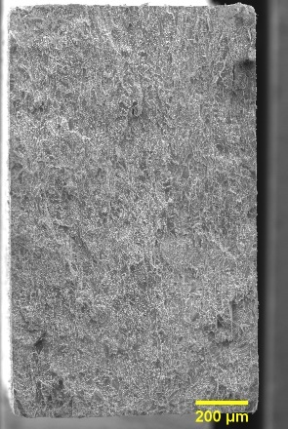 | 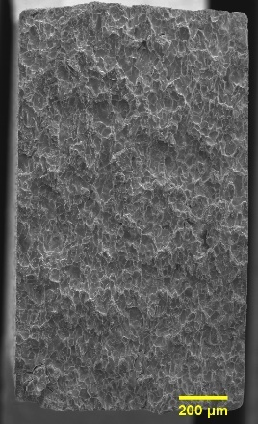 | 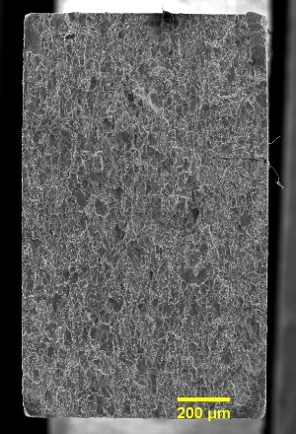
TK | 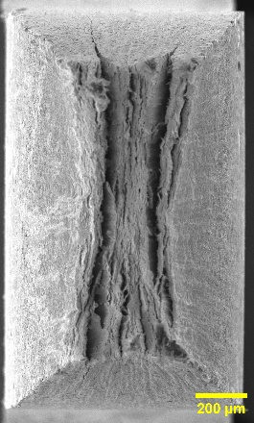 | 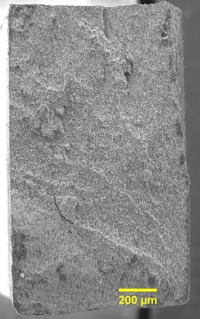 | 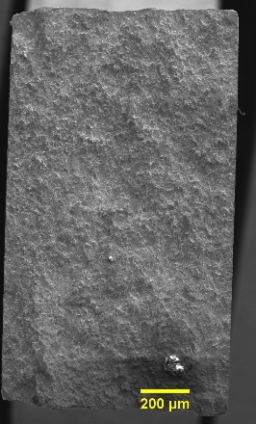 | 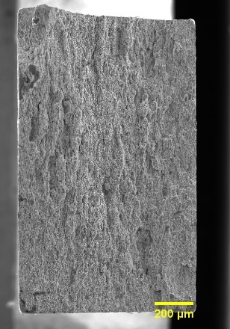
KIT | 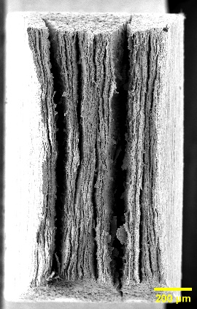 | 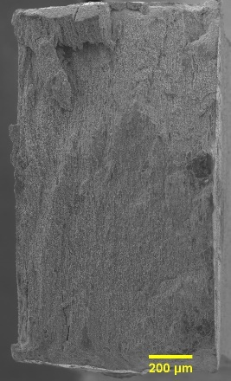 | 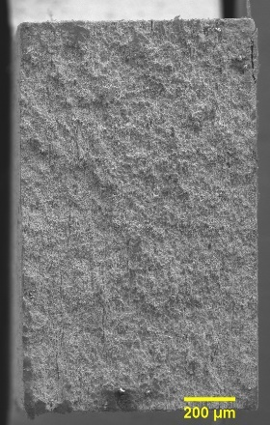 | 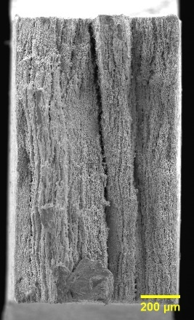
W0.5ZrC | 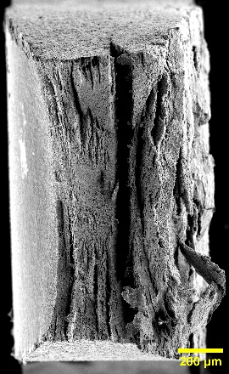 | 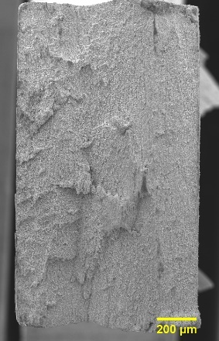 | 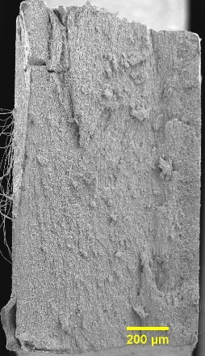 | 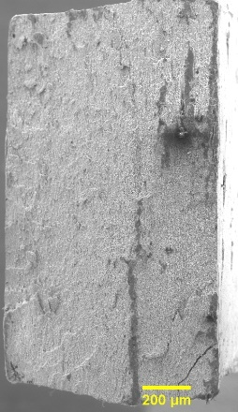
Figure 8: Fracture surface of every tested specimen on this work. Columns represent irradiation condition while rows represent materials.
From the fracture surfaces presented in Figure 8, we can categorize the fracture modes into three categories: brittle fracture, ductile fracture and recrystallization-controlled fracture (which is also brittle). The corresponding features on the fracture surfaces are shown in detail in the subsequent sub sections.

Non irradiated specimens
The detail of the non-irradiated fracture surface is presented in Figure 9. For the five materials that were tested along their most favourable orientation, a clear “internal edge-type necking” pattern of individual grains is seen. This feature is the more noticeable the higher the deformation level of the material during manufacturing. These patterns and figures have already been reported and are typically found in commercially available tungsten products, like plates or rods, when undergoing ductile fracture [44,47].
For the W0.5ZrC particle-reinforced composite, the features are slightly different since the alloy was tested along its transversal orientation. Even so, it is possible to distinguish internal necking of individual grains.
The fracture surface of all the six materials can be categorized as representative of ductile fracture, for tungsten, where the main feature is plasticity of individual grains instead of classical dimples that are found on different metals after coalescence of microvoids.
a)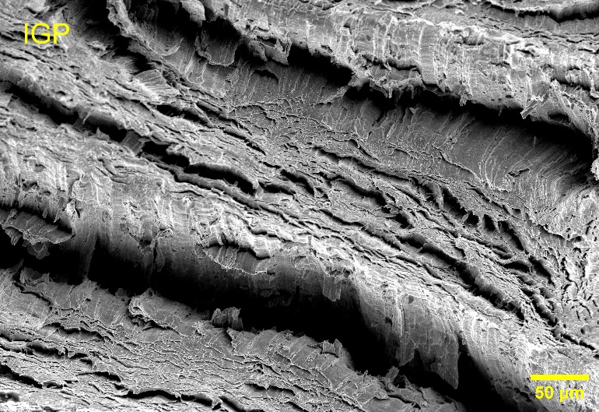 | b)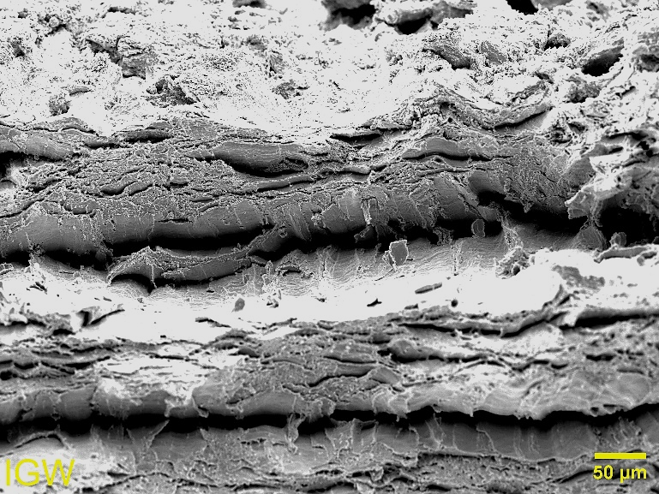
c)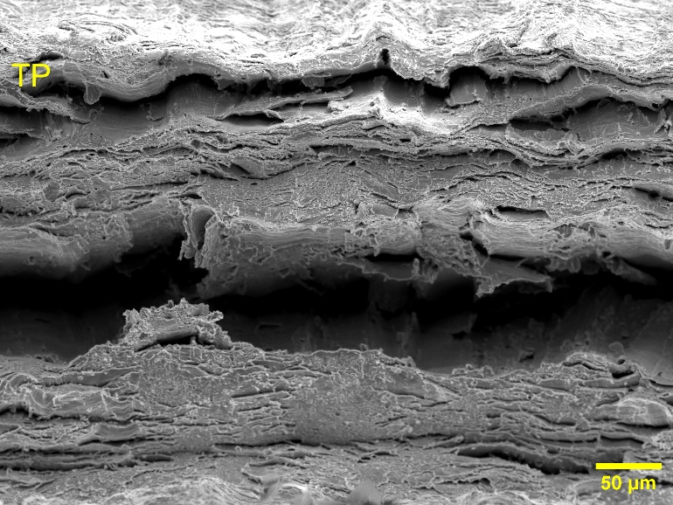 | d)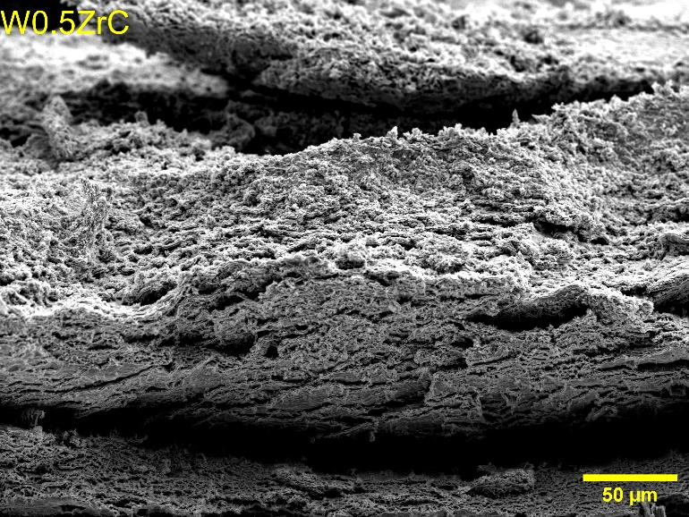
e)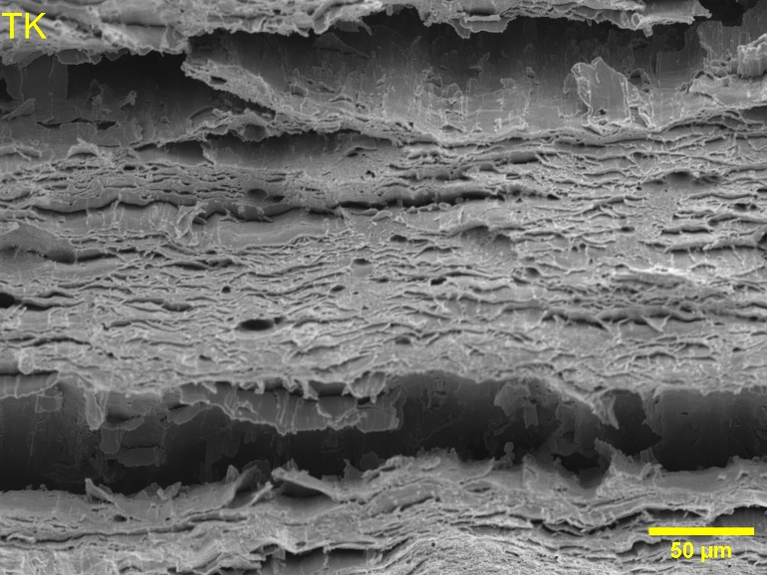 | f)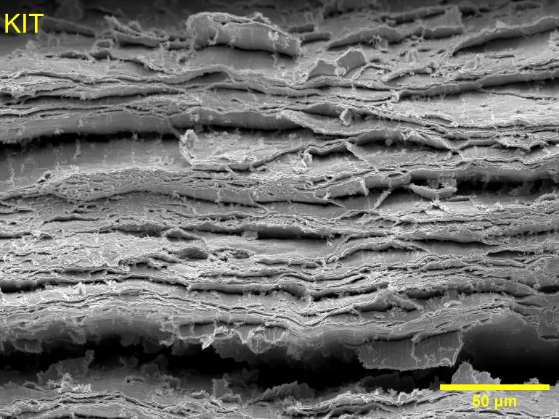
Figure 9: Fracture surface details of all materials after tensile testing at 570 °C, non-irradiated condition. Fracture surfaces correspond to materials as follows: a) IGP, b) IGW, c) TP, d) W0.5ZrC, e) TK and f) KIT.

Specimens irradiated at 400 °C
After irradiation at 400 °C, all specimens were found to fail in a brittle manner, but with some differences in the mechanism. Details of the fracture surface are presented in Figure 10. Both commercial materials (IGP and IGW) show mainly transgranular cleavage fracture with some smaller intergranular features indicating that the crack is deflected through subgrain boundaries. As to the lab-scale grades, KIT and W0.5ZrC fracture mainly by transgranular cleavage, while the fracture surfaces of TP and TK exhibit both transgranular and intergranular features. Transgranular cleavage means that the crack propagated easily through the grain following certain crystallographic planes. Intergranular features indicate that the crack propagates through grain boundaries, these features can be seen on the fracture surface details. This is associated with the large increase in the stress required for plastic deformation due to irradiation-induced defect clusters, which accumulate at 400 °C as point defects and have sufficient mobility to cluster but insufficient mobility to annihilate at grain boundary sinks [66,67]. As a consequence, neutron irradiation raises the barrier for dislocation glide in the bulk matrix [18], making intergranular crack propagation energetically favourable relative to transgranular cleavage.
a)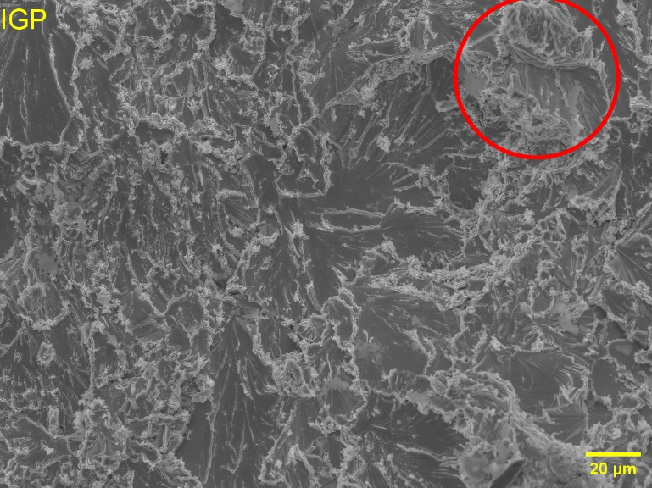 | b)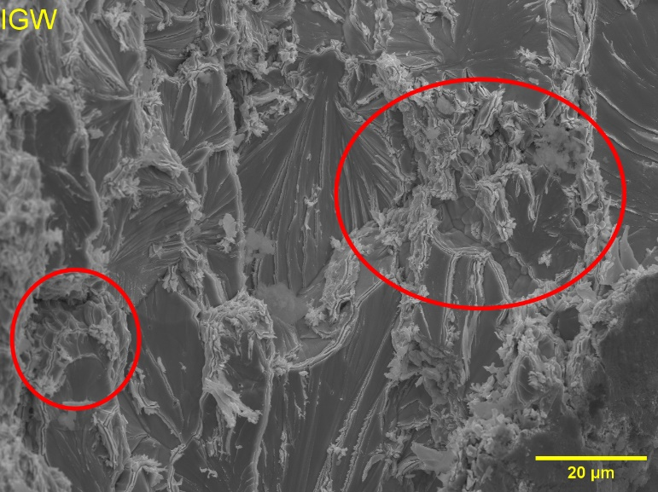
c)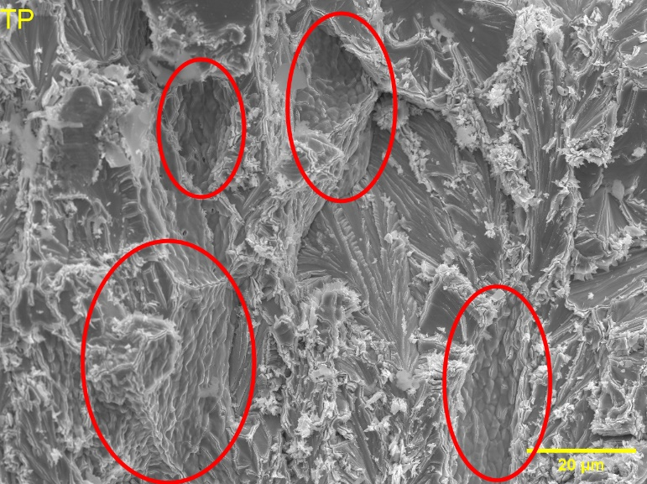 | d)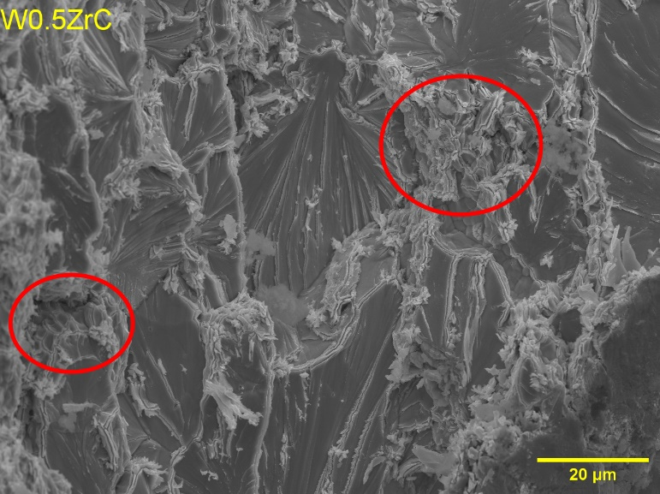
e)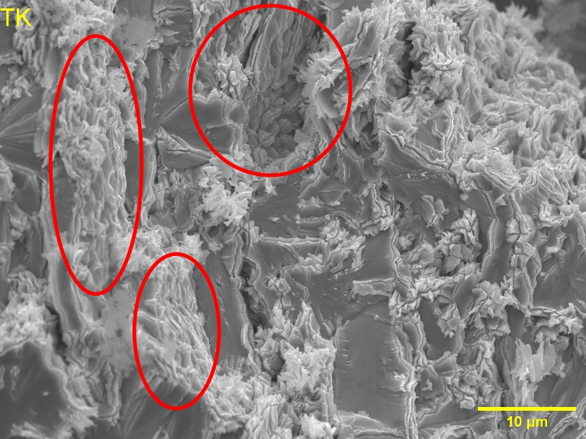 | f)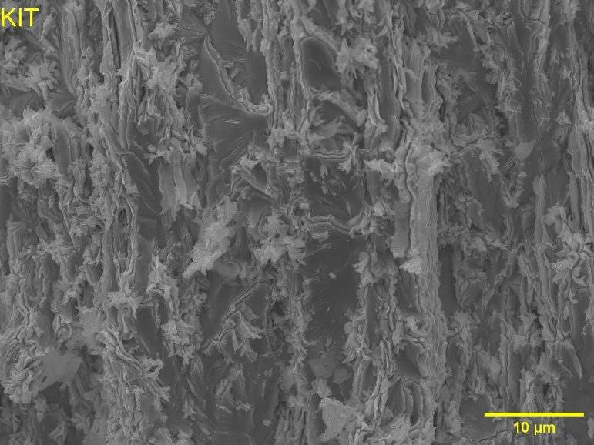
Figure 10: Fracture surface details of all materials after tensile testing at 570 °C, T_{irr} = 400 °C. Red areas indicate regions where intergranular features are observed. Fracture surfaces correspond to materials as follows: a) IGP, b) IGW, c) TP, d) W0.5ZrC, e) TK and f) KIT.

Specimens irradiated at 800 °C
From the six materials, two broke during handling (IGW and TK) while all other specimens cracked in a brittle manner when tested at 570 °C. Representative details of the fracture surfaces of all these specimens are presented in Figure 11, where the blue areas indicate features characteristic of recrystallization. The fracture surfaces of IGP and IGW keep being dominated by transgranular cleavage, nevertheless the presence of secondary cracks and some intergranular features becomes evident. All lab-scale materials show clear recrystallization over significant portions of the fracture surface; these features suggest that irradiation-enhanced diffusion is decreasing the incubation time required for the recrystallization process to initiate at 800 °C. Considering that the materials were irradiated for 63 days (1512 h), the literature suggests that thermally driven mechanisms alone are insufficient to account for this process at such temperature [25,27]. Additionally, clear intergranular fracture follows the newly formed grain boundaries. It is known that Re delays the recrystallization of pure and K-doped tungsten [68], but, in this irradiation campaign, the transmutation rate of W into Re is lower than in prior experiments because of the gadolinium shielding and the lower fluence of thermal neutrons. At 800 °C, tungsten is expected to experience its irradiation swelling peak [69] where thermal mobility of vacancies allows for the formation of voids and at the same time recovery mechanisms are still limited. Under these conditions, the formation of voids, which are known to be decorated by Re precipitates during irradiation [20,43,60,70], can retain a limited amount of Re in the bulk, thus not allowing for Re to pin the grain boundaries and making faster recrystallization of the material possible.
a)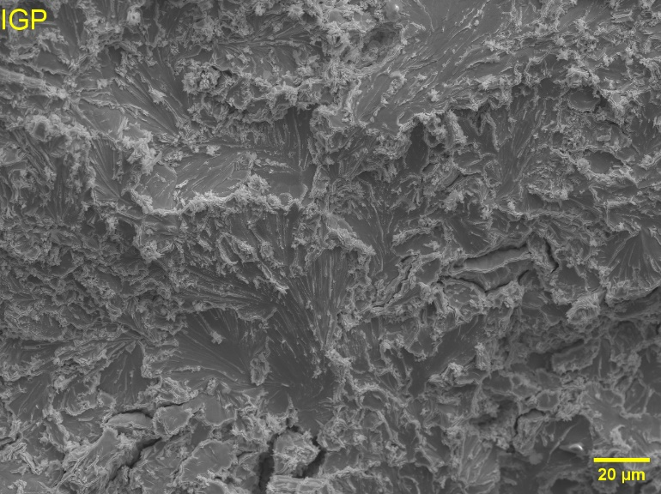 | b)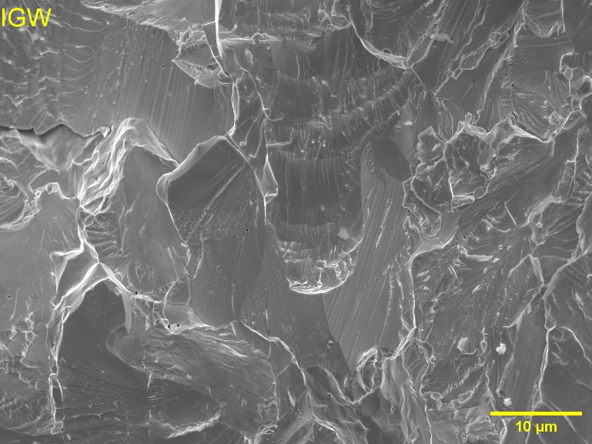
c)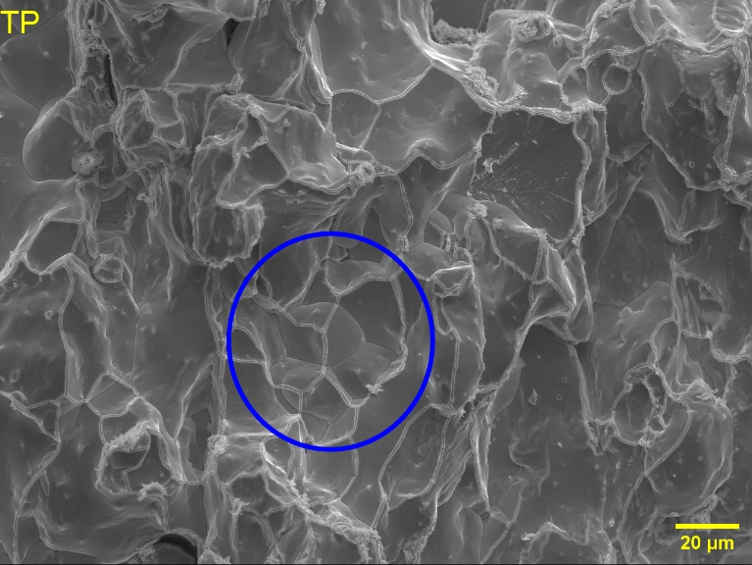 | d)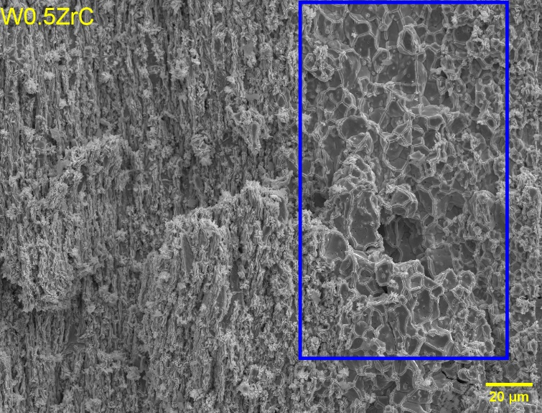
e)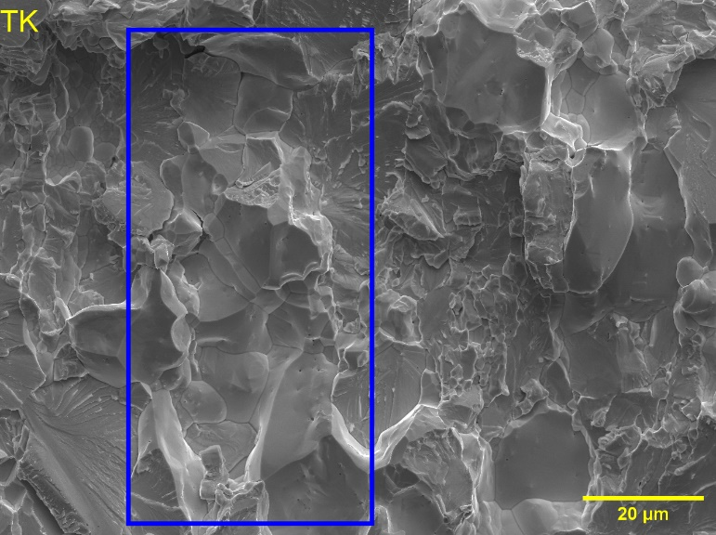 | f)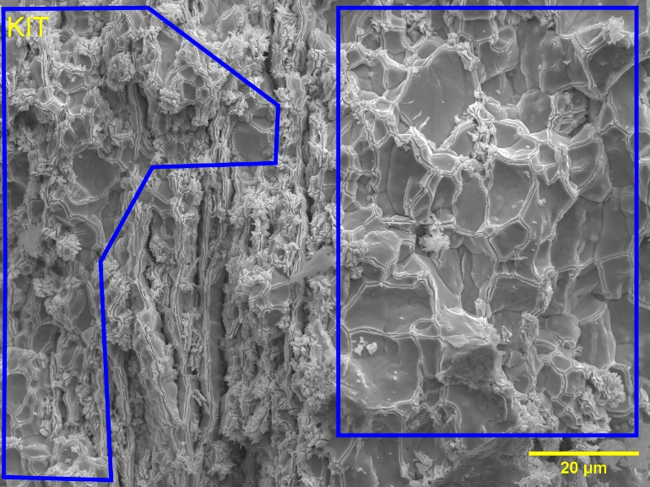
Figure 11: Fracture surface details of all materials after tensile testing at 570 °C, T_{irr} = 800 °C. Blue areas indicate regions where severe recrystallization took place, equiaxed and enlarged grains are observed. Fracture surfaces correspond to materials as follows: a) IGP, b) IGW, c) TP, d) W0.5ZrC, e) TK and f) KIT.

Specimens irradiated at 1100 °C
Finally, for the capsule irradiated at 1100 °C almost all specimens were found to crack in a ductile manner except for the W0.5ZrC which was not tested in its most favourable orientation. Details of the fracture surfaces are presented in Figure 12. Unlike the materials irradiated at 800 °C, there are no clear signs of recrystallization on the fracture surfaces. The main difference relating the interaction of Re with voids under these conditions is that at 1100 °C larger voids are expected due to more extensive growth and coalescence. However, at the same time, diffusion allows for recombination of defects and thus the total volume of voids decreases. This would mean that Re is not retained in the bulk of the grain as strongly as at 800 °C, leading to more Re at the grain boundaries, as such decreasing grain boundary mobility and allowing for a better resistance to recrystallization.
Both IGP and KIT showed macroscopic necking during tensile testing, and their fracture surfaces show necking of individual grains. Since KIT is manufactured as a plate, it is possible to observe the layered microstructure with the plastically deformed grains. However, since IGP is manufactured as a rod, this layered pattern is not present. Additionally, IGP exhibits some transgranular cleavage on its largest grains.
IGW, TP and TK all showed ductility but no necking during tensile testing, and their fracture surfaces are different from those of IGP and KIT. IGW exhibits mainly transgranular fracture features while TP has a mixed pattern surface with intergranular and transgranular features. On the other hand, TK exhibits all three fracture characteristics, necking of individual grains, intergranular fracture and transgranular cleavage of the largest grains.
In the case of W0.5ZrC, the higher specific area as a result of the fracture process allows for easier oxide formation, since tests were performed in air. The oxide layer that formed on the specimen fracture surface makes it impossible to distinguish any feature related to the crack propagation. Nevertheless, no necking of individual grains is found to take place since this material did not show macroscopic plastic deformation.
a) 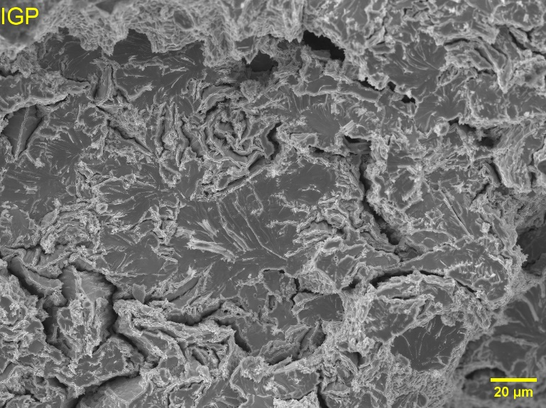 | b) 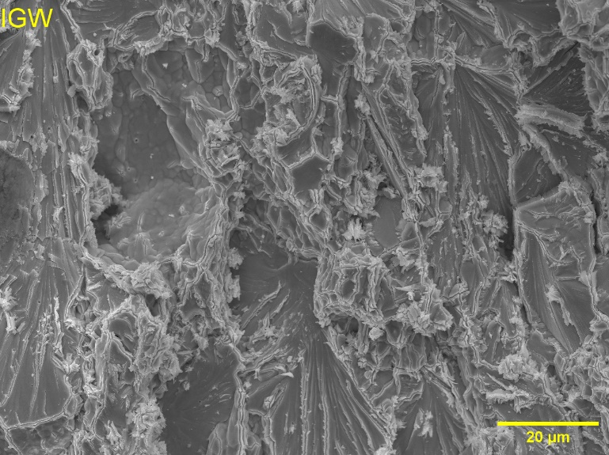
c) 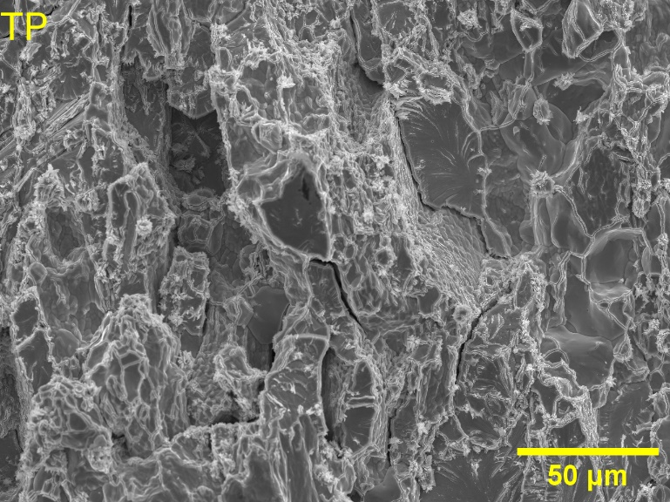 | d)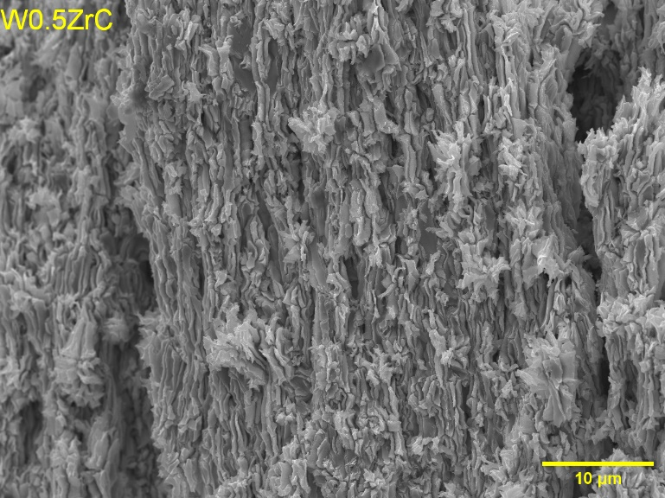
e)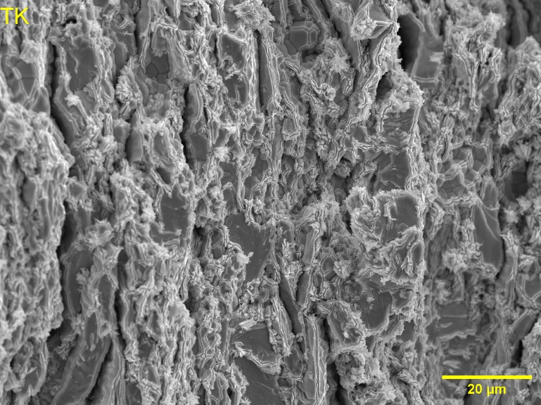 | f)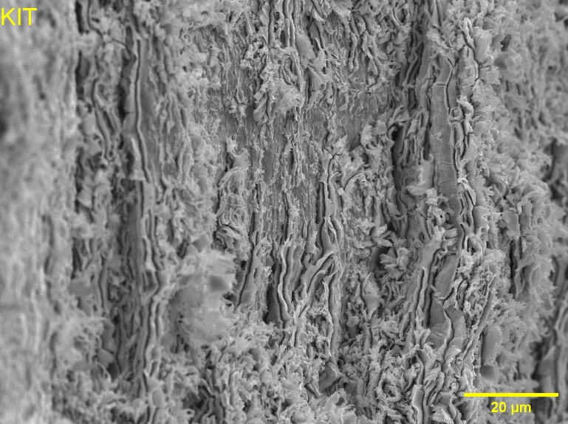
Figure 12: Fracture surface details of all materials after tensile testing at 570 °C, T_{irr} = 1100 °C. Fracture surfaces correspond to materials as follows: a) IGP, b) IGW, c) TP, d) W0.5ZrC, e) TK and f) KIT.

Conclusions
Several tungsten grades were irradiated at 400 °C, 800 °C, and 1100 °C to a dose of 0.84 dpa under a custom, less lethargic, neutron spectrum, achieved by using 0.5 mm gadolinium shield to suppress the thermal component of the BR2 reactor spectrum, thus achieving a transmutation rate of 0.5 at. % Re/dpa (instead of 2at%). Post-irradiation characterization included hardness measurements (at room temperature) and tensile tests conducted at 570 °C. Fracture surfaces of all tested specimens were systematically analysed to assess fracture mechanisms. The key findings are as follows:
- Irradiation under a tailored neutron spectrum, achieved by gadolinium shielding in BR2, results in lower Vickers hardness compared to the former irradiation campaigns performed on BR2 and HFIR reactors where thermal neutron shielding was not used. This reduction is attributed to the decreased transmutation rate of tungsten, which limits the formation of Re and Os precipitates, as well as it limits the impact of Re and Os on the accumulation of lattice defects (voids, dislocations loops) responsible for significant increase of hardness in unshielded tungsten.
- All grades irradiated at 400 °C and 800 °C exhibit brittle behaviour when tested at 570 °C, characterized by transgranular cleavage and a non-negligible fraction of intergranular fracture. In contrast, specimens irradiated at 1100 °C show at least some degree of plastic deformation, with KIT, IGP and TK showing necking of individual grains, when tested at 570 °C. Additionally, all observed materials except KIT exhibit transgranular cleavage with minimal intergranular fracture. This is consistent with defect recovery through enhanced diffusion at high temperature.
- At 400 °C, the material’s hardening and embrittlement are due to the formation of defects due to the neutron irradiation, mainly dislocation loops that are not recovered at low irradiation temperature. The increase of hardness is lower as compared to the previously reported irradiation conditions in which a higher rate of transmutation into Re and Os occurred. This suggests that Re and Os can exacerbate the accumulation of dislocation loops.
- At 800 °C, near the swelling peak, although considerable hardening could have been expected for all materials, low hardening and signs of recrystallization were found. This together with the expected low concentration of Re on the grain boundaries, due to both the decoration of nanovoids and less lethargic neutronic spectrum, indicate that radiation-enhanced recrystallization is taking place on these materials.
- At 1100 °C, the voids are expected to grow by absorption of vacancies, meaning that there should be a smaller number of voids and thus less Re precipitates retained at tungsten matrix. Thus, Re transmutation would lead to the segregation of Re at the grain boundaries allowing for a higher resistance to recrystallization than at 800 °C.
- Irradiation at 1100 °C leads to larger increase of hardness than at 800 °C. Still, the materials irradiated at 800 °C showed brittle fracture while almost all materials irradiated at 1100 °C exhibited a ductile behaviour when tested at 570 °C. This can be explained by the recovery of in-grain lattice damage (i.e. dislocation loops and voids) enhanced by high temperature during the irradiation.
- Irradiation enhanced diffusion and Re interaction with the defects generated as a consequence of the displacement cascades after neutron scattering apparently play an important role on the recrystallization of these materials under long exposure to high temperature and neutron flux.
The results and insights derived from this irradiation campaign underscore the importance of conducting advanced experiments under attenuated neutron spectra to correspond to the transmutation rates expected under fusion conditions. Such conditions are essential for accurately assessing the performance of plasma-facing materials, particularly tungsten and its alloys, where transmutation driven by thermal neutron capture can mask other irradiation-induced effects. By minimizing thermal neutron contributions, these campaigns enable a clearer understanding of defect evolution, microstructural stability, and mechanical property evolution under fusion relevant conditions. Future studies on the irradiated materials should focus on deep microstructural analysis using TEM and atom probe tomography, to address the effects of transmutation products. Mechanical tests at higher temperatures for the materials that are brittle at 570 °C are also planned as the next step to assess the DBTT shift.

Acknowledgements
This work has been carried out within the framework of the EUROfusion Consortium, funded by the European Union via the Euratom Research and Training Programme (Grant Agreement No. 101052200 — EUROfusion). Views and opinions expressed are however those of the author(s) only and do not necessarily reflect those of the European Union or the European Commission. Neither the European Union nor the European Commission can be held responsible for them.

References

[1] R.A. Pitts, X. Bonnin, F. Escourbiac, H. Frerichs, J.P. Gunn, T. Hirai, A.S. Kukushkin, E. Kaveeva, M.A. Miller, D. Moulton, V. Rozhansky, I. Senichenkov, E. Sytova, O. Schmitz, P.C. Stangeby, G. De Temmerman, I. Veselova, S. Wiesen, Physics basis for the first ITER tungsten divertor, Nuclear Materials and Energy 20 (2019) 100696. https://doi.org/10.1016/J.NME.2019.100696.
[2] R.A. Pitts, A. Loarte, T. Wauters, M. Dubrov, Y. Gribov, F. Köchl, A. Pshenov, Y. Zhang, J. Artola, X. Bonnin, L. Chen, M. Lehnen, K. Schmid, R. Ding, H. Frerichs, R. Futtersack, X. Gong, G. Hagelaar, E. Hodille, J. Hobirk, S. Krat, D. Matveev, K. Paschalidis, J. Qian, S. Ratynskaia, T. Rizzi, V. Rozhansky, P. Tamain, P. Tolias, L. Zhang, W. Zhang, Plasma-wall interaction impact of the ITER re-baseline, Nuclear Materials and Energy 42 (2025) 101854. https://doi.org/10.1016/J.NME.2024.101854.
[3] J.H. You, E. Visca, T. Barrett, B. Böswirth, F. Crescenzi, F. Domptail, M. Fursdon, F. Gallay, B.E. Ghidersa, H. Greuner, M. Li, A. V. Müller, J. Reiser, M. Richou, S. Roccella, C. Vorpahl, European divertor target concepts for DEMO: Design rationales and high heat flux performance, Nuclear Materials and Energy 16 (2018) 1–11. https://doi.org/10.1016/J.NME.2018.05.012.
[4] T.R. Barrett, G. Ellwood, G. Pérez, M. Kovari, M. Fursdon, F. Domptail, S. Kirk, S.C. McIntosh, S. Roberts, S. Zheng, L. V. Boccaccini, J.H. You, C. Bachmann, J. Reiser, M. Rieth, E. Visca, G. Mazzone, F. Arbeiter, P.K. Domalapally, Progress in the engineering design and assessment of the European DEMO first wall and divertor plasma facing components, Fusion Engineering and Design 109–111 (2016) 917–924. https://doi.org/10.1016/J.FUSENGDES.2016.01.052.
[5] G. Pintsuk, Tungsten as a Plasma-Facing Material, Comprehensive Nuclear Materials 4 (2012) 551–581. https://doi.org/10.1016/B978-0-08-056033-5.00118-X.
[6] E. Tarleton, S.G. Roberts, Dislocation dynamic modelling of the brittle–ductile transition in tungsten, Philosophical Magazine 89 (2009) 2759–2769. https://doi.org/10.1080/14786430902992619.
[7] C. Yin, D. Terentyev, T. Zhang, S. Nogami, S. Antusch, C.C. Chang, R.H. Petrov, T. Pardoen, Ductile to brittle transition temperature of advanced tungsten alloys for nuclear fusion applications deduced by miniaturized three-point bending tests, Int. J. Refract. Metals Hard Mater. 95 (2021). https://doi.org/10.1016/j.ijrmhm.2020.105464.
[8] T.L. Johnston, R.G. Davies, N.S. Stoloff, Slip character and the ductile to brittle transition of single-phase solids, Philosophical Magazine 12 (1965) 305–317. https://doi.org/10.1080/14786436508218873.
[9] F. Miranda, A. Zinovev, K. Poleshchuk, D. Terentyev, C. Yin, K. Verbeken, T. Pardoen, Temperature- and strain rate-dependent plastic deformation of ITER specification tungsten, Int. J. Refract. Metals Hard Mater. 139 (2026) 107811. https://doi.org/10.1016/J.IJRMHM.2026.107811.
[10] D. Terentyev, C.C. Chang, C. Yin, A. Zinovev, X.F. He, Neutron irradiation effects on mechanical properties of ITER specification tungsten, Tungsten 3 (2021) 415–433. https://doi.org/10.1007/s42864-021-00105-6.
[11] M. Klimenkov, U. Jäntsch, M. Rieth, H.C. Schneider, D. Terentyev, W. Van Renterghem, Effect of irradiation parameters on defect evolution in neutron irradiated tungsten, Journal of Nuclear Materials 607 (2025) 155673. https://doi.org/10.1016/J.JNUCMAT.2025.155673.
[12] D. Terentyev, M. Rieth, G. Pintsuk, J. Riesch, A. Von Müller, S. Antusch, K. Mergia, E. Gaganidze, H.C. Schneider, M. Wirtz, S. Nogami, J. Coenen, J.H. You, A. Zinovev, W. Van Renterghem, Recent progress in the assessment of irradiation effects for in-vessel fusion materials: Tungsten and copper alloys, Nuclear Fusion 62 (2022). https://doi.org/10.1088/1741-4326/ac4062.
[13] T. Hwang, A. Hasegawa, K. Tomura, N. Ebisawa, T. Toyama, Y. Nagai, M. Fukuda, T. Miyazawa, T. Tanaka, S. Nogami, Effect of neutron irradiation on rhenium cluster formation in tungsten and tungsten-rhenium alloys, Journal of Nuclear Materials 507 (2018) 78–86. https://doi.org/10.1016/j.jnucmat.2018.04.031.
[14] K. Lacefield, J. Moteff, J.P. Smith, Neutron radiation damage in tungsten single crystals, Philosophical Magazine 13 (1966) 1079–1081. https://doi.org/10.1080/14786436608213157.
[15] R.C. Rau, J. Moteff, R.L. Ladd, Comparison of microstructure with mechanical properties of irradiated tungsten, Journal of Nuclear Materials 24 (1967) 164–173. https://doi.org/10.1016/0022-3115(67)90005-0.
[16] D. Bernardi, A. Ibarra, F. Arbeiter, F. Arranz, M. Cappelli, P. Cara, J. Castellanos, H. Dzitko, A. García, J. Gutiérrez, W. Królas, F. Martin-Fuertes, G. Micciché, A. Muñoz, F.S. Nitti, T. Pinna, I. Podadera, J. Pons, Y. Qiu, R. Román, The IFMIF-DONES Project: Design Status and Main Achievements Within the EUROfusion FP8 Work Programme, Journal of Fusion Energy 41 (2022). https://doi.org/10.1007/s10894-022-00337-5.
[17] M. Akiyoshi, L.M. Garrison, J.W. Geringer, H. Wang, A. Hasegawa, S. Nogami, Y. Katoh, Thermal diffusivity of irradiated tungsten and tungsten-rhenium alloys, Journal of Nuclear Materials 543 (2021). https://doi.org/10.1016/j.jnucmat.2020.152594.
[18] X. Hu, T. Koyanagi, M. Fukuda, N.A.P.K. Kumar, L.L. Snead, B.D. Wirth, Y. Katoh, Irradiation hardening of pure tungsten exposed to neutron irradiation, Journal of Nuclear Materials 480 (2016) 235–243. https://doi.org/10.1016/j.jnucmat.2016.08.024.
[19] M. Fukuda, N.A.P. Kiran Kumar, T. Koyanagi, L.M. Garrison, L.L. Snead, Y. Katoh, A. Hasegawa, Neutron energy spectrum influence on irradiation hardening and microstructural development of tungsten, Journal of Nuclear Materials 479 (2016) 249–254. https://doi.org/10.1016/j.jnucmat.2016.06.051.
[20] Y. Katoh, L.L. Snead, L.M. Garrison, X. Hu, T. Koyanagi, C.M. Parish, P.D. Edmondson, M. Fukuda, T. Hwang, T. Tanaka, A. Hasegawa, Response of unalloyed tungsten to mixed spectrum neutrons, Journal of Nuclear Materials 520 (2019) 193–207. https://doi.org/10.1016/j.jnucmat.2019.03.045.
[21] L.M. Garrison, Y. Katoh, J.W. Geringer, M. Akiyoshi, X. Chen, M. Fukuda, A. Hasegawa, T. Hinoki, X. Hu, T. Koyanagi, E. Lang, M. McAlister, J. McDuffee, T. Miyazawa, C. Parish, E. Proehl, N. Reid, J. Robertson, H. Wang, PHENIX U.S.-Japan Collaboration Investigation of Thermal and Mechanical Properties of Thermal Neutron–Shielded Irradiated Tungsten, Fusion Science and Technology 75 (2019) 499–509. https://doi.org/10.1080/15361055.2019.1602390.
[22] L.R. Greenwood, F.A. Garner, Transmutation of Mo, Re, W, Hf, and V in various irradiation test facilities and STARFIRE, Journal of Nuclear Materials 212–215 (1994) 635–639. https://doi.org/10.1016/0022-3115(94)90136-8.
[23] Q. Zhao, Z. Zhang, M. Huang, X. Ouyang, Effects of transmutation elements in tungsten, Comput. Mater. Sci. 162 (2019) 133–139. https://doi.org/10.1016/j.commatsci.2019.03.002.
[24] M.R. Gilbert, S.L. Dudarev, S. Zheng, L.W. Packer, J.-Ch. Sublet, An integrated model for materials in a fusion power plant: transmutation, gas production, and helium embrittlement under neutron irradiation, Nuclear Fusion 52 (2012) 083019. https://doi.org/10.1088/0029-5515/52/8/083019.
[25] S. Wang, B. Chuilon, A. Barth, J. Farrington, Consideration of tungsten recrystallization in plasma facing components design, Fusion Engineering and Design 200 (2024) 114162. https://doi.org/10.1016/J.FUSENGDES.2024.114162.
[26] C. Yin, G. Zhang, Z. Wang, Z. Chen, S. Mao, M.Y. Ye, Neutron irradiation-induced recrystallization simulation for tungsten in nuclear fusion device, Int. J. Refract. Metals Hard Mater. 121 (2024) 106635. https://doi.org/10.1016/J.IJRMHM.2024.106635.
[27] H. Gietl, T. Koyanagi, X. Hu, M. Fukuda, A. Hasegawa, Y. Katoh, Neutron irradiation-enhanced grain growth in tungsten and tungsten alloys, J. Alloys Compd. 901 (2022) 163419. https://doi.org/10.1016/J.JALLCOM.2021.163419.
[28] P. Lied, C. Bonnekoh, W. Pantleon, M. Stricker, A. Hoffmann, J. Reiser, Comparison of K-doped and pure cold-rolled tungsten sheets: As-rolled condition and recrystallization behaviour after isochronal annealing at different temperatures, Int. J. Refract. Metals Hard Mater. 85 (2019) 105047. https://doi.org/10.1016/J.IJRMHM.2019.105047.
[29] P. Lied, W. Pantleon, C. Bonnekoh, S. Bonk, A. Hoffmann, J. Reiser, M. Rieth, Comparison of K-doped and pure cold-rolled tungsten sheets: Tensile properties and brittle-to-ductile transition temperatures, Journal of Nuclear Materials 544 (2021). https://doi.org/10.1016/j.jnucmat.2020.152664.
[30] P. Lied, W. Pantleon, C. Bonnekoh, M. Dürrschnabel, C. Bienert, A. Hoffmann, J. Reiser, M. Rieth, Comparison of K-doped and pure cold-rolled tungsten sheets: Microstructure restoration in different temperature regimes, Int. J. Refract. Metals Hard Mater. 113 (2023) 106198. https://doi.org/10.1016/J.IJRMHM.2023.106198.
[31] Z.M. Xie, R. Liu, S. Miao, X.D. Yang, T. Zhang, X.P. Wang, Q.F. Fang, C.S. Liu, G.N. Luo, Y.Y. Lian, X. Liu, Extraordinary high ductility/strength of the interface designed bulk W-ZrC alloy plate at relatively low temperature, Sci. Rep. 5 (2015). https://doi.org/10.1038/srep16014.
[32] J. Kulesza, T. Adams, J. Armstrong, S. Bolding, F. Brown, J. Bull, T. Burke, A. Clark, R. Forster III, J. Giron, T. Grieve, C. Josey, R. Martz, G. McKinney, E. Pearson, M. Rising, C. Solomon Jr., S. Sriram, T. Trahan, C. Weaver, S. Wilson, A. Zukaitis, MCNP® Code Version 6.3.1 Theory & User Manual, Los Alamos, NM (United States), 2024. https://doi.org/10.2172/2372634.
[33] G. Federici, W. Biel, M.R. Gilbert, R. Kemp, N. Taylor, R. Wenninger, European DEMO design strategy and consequences for materials, Nuclear Fusion 57 (2017) 092002. https://doi.org/10.1088/1741-4326/57/9/092002.
[34] M.E. Sawan, Transmutation of Tungsten in Fusion and Fission Nuclear Environments, Fusion Science and Technology 66 (2014) 272–277. https://doi.org/10.13182/FST13-717.
[35] M.R. Gilbert, S.L. Dudarev, D. Nguyen-Manh, S. Zheng, L.W. Packer, J.C. Sublet, Neutron-induced dpa, transmutations, gas production, and helium embrittlement of fusion materials, Journal of Nuclear Materials 442 (2013) S755–S760. https://doi.org/10.1016/J.JNUCMAT.2013.03.085.
[36] M.R. Gilbert, K. Arakawa, Z. Bergstrom, M.J. Caturla, S.L. Dudarev, F. Gao, A.M. Goryaeva, S.Y. Hu, X. Hu, R.J. Kurtz, A. Litnovsky, J. Marian, M.C. Marinica, E. Martinez, E.A. Marquis, D.R. Mason, B.N. Nguyen, P. Olsson, Y. Osetskiy, D. Senor, W. Setyawan, M.P. Short, T. Suzudo, J.R. Trelewicz, T. Tsuru, G.S. Was, B.D. Wirth, L. Yang, Y. Zhang, S.J. Zinkle, State of the art, gaps, and prospects in fusion materials theory and modelling, Journal of Nuclear Materials 625 (2026) 156512. https://doi.org/10.1016/j.jnucmat.2021.153113.
[37] A. Stankovskiy, G. Van den Eynde, Advanced Method for Calculations of Core Burn-Up, Activation of Structural Materials, and Spallation Products Accumulation in Accelerator-Driven Systems, Science and Technology of Nuclear Installations 2012 (2012) 1–12. https://doi.org/10.1155/2012/545103.
[38] M.J. Norgett, M.T. Robinson, I.M. Torrens, A proposed method of calculating displacement dose rates, Nuclear Engineering and Design 33 (1975) 50–54. https://doi.org/10.1016/0029-5493(75)90035-7.
[39] A.J.M. Plompen, O. Cabellos, C. De Saint Jean, M. Fleming, A. Algora, M. Angelone, P. Archier, E. Bauge, O. Bersillon, A. Blokhin, F. Cantargi, A. Chebboubi, C. Diez, H. Duarte, E. Dupont, J. Dyrda, B. Erasmus, L. Fiorito, U. Fischer, D. Flammini, D. Foligno, M.R. Gilbert, J.R. Granada, W. Haeck, F.-J. Hambsch, P. Helgesson, S. Hilaire, I. Hill, M. Hursin, R. Ichou, R. Jacqmin, B. Jansky, C. Jouanne, M.A. Kellett, D.H. Kim, H.I. Kim, I. Kodeli, A.J. Koning, A.Yu. Konobeyev, S. Kopecky, B. Kos, A. Krása, L.C. Leal, N. Leclaire, P. Leconte, Y.O. Lee, H. Leeb, O. Litaize, M. Majerle, J.I. Márquez Damián, F. Michel-Sendis, R.W. Mills, B. Morillon, G. Noguère, M. Pecchia, S. Pelloni, P. Pereslavtsev, R.J. Perry, D. Rochman, A. Röhrmoser, P. Romain, P. Romojaro, D. Roubtsov, P. Sauvan, P. Schillebeeckx, K.H. Schmidt, O. Serot, S. Simakov, I. Sirakov, H. Sjöstrand, A. Stankovskiy, J.C. Sublet, P. Tamagno, A. Trkov, S. van der Marck, F. Álvarez-Velarde, R. Villari, T.C. Ware, K. Yokoyama, G. Žerovnik, The joint evaluated fission and fusion nuclear data library, JEFF-3.3, The European Physical Journal A 56 (2020) 181. https://doi.org/10.1140/epja/s10050-020-00141-9.
[40] D.A. Brown, M.B. Chadwick, R. Capote, A.C. Kahler, A. Trkov, M.W. Herman, A.A. Sonzogni, Y. Danon, A.D. Carlson, M. Dunn, D.L. Smith, G.M. Hale, G. Arbanas, R. Arcilla, C.R. Bates, B. Beck, B. Becker, F. Brown, R.J. Casperson, J. Conlin, D.E. Cullen, M.A. Descalle, R. Firestone, T. Gaines, K.H. Guber, A.I. Hawari, J. Holmes, T.D. Johnson, T. Kawano, B.C. Kiedrowski, A.J. Koning, S. Kopecky, L. Leal, J.P. Lestone, C. Lubitz, J.I. Márquez Damián, C.M. Mattoon, E.A. McCutchan, S. Mughabghab, P. Navratil, D. Neudecker, G.P.A. Nobre, G. Noguere, M. Paris, M.T. Pigni, A.J. Plompen, B. Pritychenko, V.G. Pronyaev, D. Roubtsov, D. Rochman, P. Romano, P. Schillebeeckx, S. Simakov, M. Sin, I. Sirakov, B. Sleaford, V. Sobes, E.S. Soukhovitskii, I. Stetcu, P. Talou, I. Thompson, S. van der Marck, L. Welser-Sherrill, D. Wiarda, M. White, J.L. Wormald, R.Q. Wright, M. Zerkle, G. Žerovnik, Y. Zhu, ENDF/B-VIII.0: The 8th Major Release of the Nuclear Reaction Data Library with CIELO-project Cross Sections, New Standards and Thermal Scattering Data, Nuclear Data Sheets 148 (2018) 1–142. https://doi.org/10.1016/j.nds.2018.02.001.
[41] A.Y. Konobeyev, U. Fischer, S.P. Simakov, Atomic displacement cross-sections for neutron irradiation of materials from Be to Bi calculated using the arc-dpa model, Nuclear Engineering and Technology 51 (2019) 170–175. https://doi.org/10.1016/J.NET.2018.09.001.
[42] E. Gaganidze, A. Chauhan, H.C. Schneider, D. Terentyev, B. Rossaert, J. Aktaa, Effect of irradiation temperature on the fracture-mechanical behaviour of tungsten irradiated to 1 dpa, Journal of Nuclear Materials 556 (2021) 153200. https://doi.org/10.1016/J.JNUCMAT.2021.153200.
[43] M. Dürrschnabel, M. Klimenkov, U. Jäntsch, M. Rieth, H.C. Schneider, D. Terentyev, New insights into microstructure of neutron-irradiated tungsten, Sci. Rep. 11 (2021). https://doi.org/10.1038/s41598-021-86746-6.
[44] M. Klimenkov, M. Dürrschnabel, U. Jäntsch, P. Lied, M. Rieth, H.C. Schneider, D. Terentyev, W. Van Renterghem, Microstructural analysis of W irradiated at different temperatures, Journal of Nuclear Materials 572 (2022). https://doi.org/10.1016/j.jnucmat.2022.154018.
[45] Test Methods for Tension Testing of Metallic Materials, (2024). https://doi.org/10.1520/E0008_E0008M-24.
[46] P. Jung, A. Hishinuma, G.E. Lucas, H. Ullmaier, Recommendation of miniaturized techniques for mechanical testing of fusion materials in an intense neutron source, Journal of Nuclear Materials 232 (1996) 186–205. https://doi.org/10.1016/S0022-3115(96)00394-7.
[47] A. Kohyama, K. Hamada, H. Matsui, Specimen size effects on tensile properties of neutron-irradiated steels, Journal of Nuclear Materials 179–181 (1991) 417–420. https://doi.org/10.1016/0022-3115(91)90113-L.
[48] C. Yin, D. Terentyev, T. Zhang, R.H. Petrov, T. Pardoen, Impact of neutron irradiation on the strength and ductility of pure and ZrC reinforced tungsten grades, Journal of Nuclear Materials 537 (2020) 152226. https://doi.org/10.1016/j.jnucmat.2020.152226.
[49] C. Yin, D. Terentyev, T. Pardoen, A. Bakaeva, R. Petrov, S. Antusch, M. Rieth, M. Vilémová, J. Matějíček, T. Zhang, Tensile properties of baseline and advanced tungsten grades for fusion applications, Int. J. Refract. Metals Hard Mater. 75 (2018) 153–162. https://doi.org/10.1016/j.ijrmhm.2018.04.003.
[50] D. Terentyev, C. Yin, C.C. Chang, Z. Chen, S. Mao, M. Ye, Anisotropy in tensile properties of ITER-conformant and cross-rolled tungsten grades, Fusion Engineering and Design 222 (2026) 115457. https://doi.org/10.1016/j.fusengdes.2025.115457.
[51] S. Nogami, S. Watanabe, J. Reiser, M. Rieth, S. Sickinger, A. Hasegawa, Improvement of impact properties of tungsten by potassium doping, Fusion Engineering and Design 140 (2019) 48–61. https://doi.org/10.1016/j.fusengdes.2019.01.130.
[52] E.J. Pavlina, C.J. Van Tyne, Correlation of Yield Strength and Tensile Strength with Hardness for Steels, J. Mater. Eng. Perform. 17 (2008) 888–893. https://doi.org/10.1007/s11665-008-9225-5.
[53] E.O. Hall, The Deformation and Ageing of Mild Steel: III Discussion of Results, Proceedings of the Physical Society. Section B 64 (1951) 747–753. https://doi.org/10.1088/0370-1301/64/9/303.
[54] Y. Zhou, Y.-S. Che, C. Wang, R. Liu, S.-F. Wen, Selective laser melting high-performance ZrC-reinforced tungsten composites with tailored microstructure and suppressed cracking susceptibility, Tungsten 3 (2021) 72–88. https://doi.org/10.1007/s42864-021-00076-8.
[55] K. Iroc, D. Terentyev, W. Van Renterghem, D. Schryvers, Microstructural analysis and mechanical implications of neutron-irradiated ITER-grade tungsten, Fusion Engineering and Design 222 (2026) 115466. https://doi.org/10.1016/J.FUSENGDES.2025.115466.
[56] W. Van Renterghem, K. Iroc, D. Terentyev, S. Antusch, M. Rieth, Microstructural changes induced in advanced tungsten grades under high temperature neutron irradiation, Int. J. Refract. Metals Hard Mater. 122 (2024) 106718. https://doi.org/10.1016/J.IJRMHM.2024.106718.
[57] D. Terentyev, C. Yin, A. Dubinko, C.C. Chang, J.H. You, Neutron irradiation hardening across ITER diverter tungsten armor, Int. J. Refract. Metals Hard Mater. 95 (2021). https://doi.org/10.1016/j.ijrmhm.2020.105437.
[58] C. Yin, G. Bonny, D. Terentyev, Anisotropy in the hardness of single crystal tungsten before and after neutron irradiation, Journal of Nuclear Materials 546 (2021). https://doi.org/10.1016/j.jnucmat.2020.152759.
[59] A. Hasegawa, M. Fukuda, S. Nogami, K. Yabuuchi, Neutron irradiation effects on tungsten materials, Fusion Engineering and Design 89 (2014) 1568–1572. https://doi.org/10.1016/J.FUSENGDES.2014.04.035.
[60] T. Tanno, A. Hasegawa, J.C. He, M. Fujiwara, S. Nogami, M. Satou, T. Shishido, K. Abe, Effects of transmutation elements on neutron irradiation hardening of tungsten, Mater. Trans. 48 (2007) 2399–2402. https://doi.org/10.2320/MATERTRANS.MAW200722.
[61] D. Terentyev, M. Wirtz, T.W. Morgan, T. Nozawa, A. Zinovev, C.C. Chang, K. Poleshchuk, J. Elenbaas, Comparative study of ITER conform tungsten grades exposed to high heat flux and neutron irradiation damage, Fusion Engineering and Design 200 (2024). https://doi.org/10.1016/j.fusengdes.2024.114200.
[62] E. Gaganidze, A. Chauhan, H.C. Schneider, D. Terentyev, G. Borghmans, J. Aktaa, Fracture-mechanical properties of neutron irradiated ITER specification tungsten, Journal of Nuclear Materials 547 (2021) 152761. https://doi.org/10.1016/J.JNUCMAT.2020.152761.
[63] M. Jetter, J. Aktaa, Probabilistic analysis of cleavage fracture in commercial polycrystalline tungsten, Journal of Nuclear Materials 565 (2022). https://doi.org/10.1016/j.jnucmat.2022.153757.
[64] J.H. You, I. Komarova, Probabilistic failure analysis of a water-cooled tungsten divertor: Impact of embrittlement, Journal of Nuclear Materials 375 (2008) 283–289. https://doi.org/10.1016/J.JNUCMAT.2008.01.009.
[65] M. Fursdon, J.H. You, Towards reliable design-by-analysis for divertor plasma facing components—Guidelines for inelastic assessment (part II: irradiated), Fusion Engineering and Design 160 (2020). https://doi.org/10.1016/j.fusengdes.2020.111831.
[66] T. Koyanagi, N.A.P.K. Kumar, T. Hwang, L.M. Garrison, X. Hu, L.L. Snead, Y. Katoh, Microstructural evolution of pure tungsten neutron irradiated with a mixed energy spectrum, Journal of Nuclear Materials 490 (2017) 66–74. https://doi.org/10.1016/J.JNUCMAT.2017.04.010.
[67] X. Hu, T. Koyanagi, M. Fukuda, Y. Katoh, L.L. Snead, B.D. Wirth, Defect evolution in single crystalline tungsten following low temperature and low dose neutron irradiation, Journal of Nuclear Materials 470 (2016) 278–289. https://doi.org/10.1016/J.JNUCMAT.2015.12.040.
[68] K. Tsuchida, T. Miyazawa, A. Hasegawa, S. Nogami, M. Fukuda, Recrystallization behavior of hot-rolled pure tungsten and its alloy plates during high-temperature annealing, Nuclear Materials and Energy 15 (2018) 158–163. https://doi.org/10.1016/J.NME.2018.04.004.
[69] J. Matolich, H. Nahm, J. Moteff, Swelling in neutron irradiated tungsten and tungsten-25 percent rhenium, Scripta Metallurgica 8 (1974) 837–841. https://doi.org/10.1016/0036-9748(74)90304-4.
[70] X. Hu, C.M. Parish, K. Wang, T. Koyanagi, B.P. Eftink, Y. Katoh, Transmutation-induced precipitation in tungsten irradiated with a mixed energy neutron spectrum, Acta Mater. 165 (2019) 51–61. https://doi.org/10.1016/j.actamat.2018.11.032.

