X-ray based 3D histology of heart valves using microfocus computed tomography and contrast-enhanced computed tomography
Pestiaux Camille^{1,2} *, Quirynen Louise¹, Beauloye Christophe², Vanoverschelde Jean-Louis², Pyka Grzegorz^{1,2}, Kerckhofs Greet^{1 ,2,3,4}
- Institute of Mechanic, Materials, and Civil Engineering, UCLouvain, Belgium
- Institute of Experimental and Clinical Research, UCLouvain, Belgium
- Dept. Materials Science and Engineering, KU Leuven, Belgium
- Prometheus, Division of Skeletal Tissue Engineering, KU Leuven, Belgium
*Speaker : camille.pestiaux@uclouvain.be

Introduction
Heart and heart valves are complex organs and tissues that would highly benefit from 3D imaging techniques for the analysis of their composition and microstructural organization. Indeed, for thin membrane-liked tissues such as heart valves, 2D sectioning and anisotropic resolution, typically resulting from 2D classical histological assessment, are important limitations to obtain a complete and quantitative characterization of their microstructure. Ex vivo microfocus X-ray computed tomography (microCT) has already been recognized as a powerful technique to image mineralized tissues in 3D [1]. When combined with the use of contrast-enhancing staining agents (CESAs), referred to as contrast-enhanced computed tomography (CECT), it also allows the visualization of soft tissues [2]. In this study, we optimized microCT and CECT to characterize the composition and microstructure of healthy and diseased heart valves in 3D.

Materials and Methods
High-resolution microCT was applied on human calcific stenotic aortic valves to obtain a quantitative characterization of the calcifications within the extracellular matrix (ECM). Hafnium-substituted Wells-Dawson polyoxometalate (Hf-WD POM), a new non-invasive CESA, was used to apply CECT at higher resolution on the stenotic samples to allow the simultaneous visualization of calcifications and soft tissue constituents such as collagen and elastin. The results were validated with 2D classical histology.

Results and Conclusion
High-resolution microCT allowed to quantify the volume ratio of calcification with the heart valve leaflets (Fig1A-C). Moreover, for the first time, different levels of density were visualized within the calcifications (Fig1B). Finally, we determined the size and spatial distribution of the calcifications, which was not possible with 2D classical histology. Hf-WD POM-based CECT enabled to distinguish collagen from elastin within the ECM, as confirmed 2D classical histology (Fig1D-E). Micro-calcifications were also visualized within a less densely packed ECM (Fig1D). This demonstrates the potential of optimized microCT and CECT to improve the 3D characterization of healthy and diseased heart valves. In the future, it would help to improve the knowledge on the development of such heart valve diseases as well as on the native microstructure of healthy heart valves.

References
[1] Rawson et al., BMC Biol, 18:21;
[2] de Bournonville et al., Contrast Media Mol Imaging, 2019.
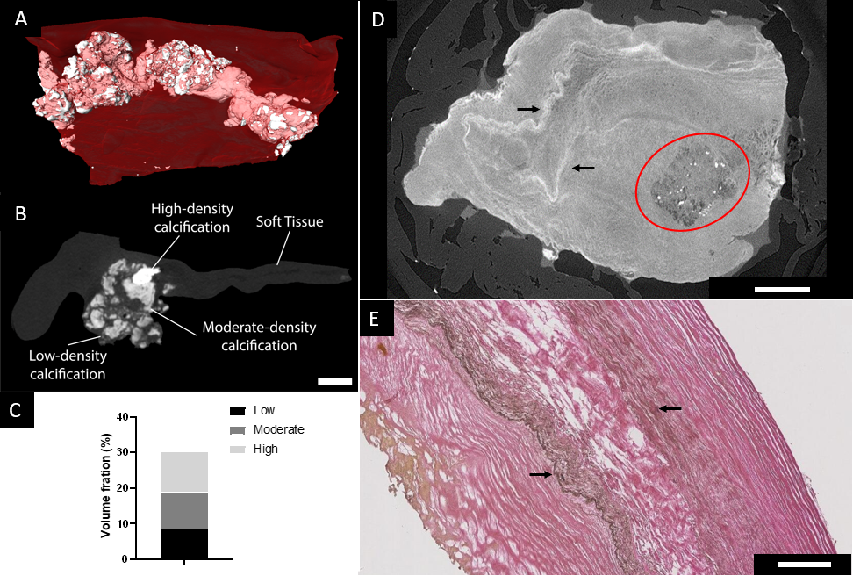
Figure 1. (A-C) Ex vivo microCT applied to a human stenotic aortic valve leaflet, A: 3D rendering of soft tissue (red) and calcifications (white), B: ortho-slice with the 3 levels of density (scale bar = 1 mm), C: volume fraction of the 3 levels of density in the leaflet; (D) Ex vivo CECT section of a human stenotic aortic valve, microcalcifications are surrounded by a red circle (scale bar = 1mm); (E) HE stained section (scale bar = 0.2 mm), elastin fibers are highlighted by black arrows in D and E.

