Developing psychoanalytic case conceptualization skills through didactic teaching:
A randomized controlled trial
Abstract
Objective. Time-limited didactic interventions have been shown to be effective in developing “generic” case conceptualization skills. The objective of this study is to test whether similar interventions can be used to develop case conceptualization skills that are “specific” to a treatment modality.
Method. University psychology students were randomized to a target (n = 62) or a control group (n = 62). The target group received a training on psychoanalytic case conceptualization skills based on the newly-developed operators model. The control group received a training on generic case conceptualization skills based on the well-established 5 Ps model.
Results. The students’ self-efficacy for case conceptualization significantly increased in both groups. However, students in the target group reported a significantly greater increase in psychoanalytic case conceptualization skills and in their ability to make clinical inferences. The teaching method, as well as the case conceptualization models, were acceptable to students. However, the 5 Ps model was significantly more acceptable to students than the operators model.
Conclusions. This is the first RCT to provide evidence that psychoanalytic case conceptualization skills can be developed through didactic teaching and that they constitute a specific set of skills that are not developed by learning generic case conceptualization skills.
Key words: case conceptualization, therapist skills, training, didactic teaching, psychoanalysis
Word count: 13840

Clinical or Methodological Significance of this Article
In this study, we tested a novel educational intervention aimed at developing the psychoanalytic case conceptualization skills of university psychology students through didactic teaching methods. The intervention was acceptable to students as well as effective in increasing their psychoanalytic case conceptualization skills, self-efficacy for case conceptualization, and capacity to make clinical inferences, as opposed to summarizing the clinical material in a descriptive way.

Developing psychoanalytic case conceptualization skills through didactic teaching:
A randomized controlled trial
One of the challenges of becoming a therapist is learning to make sense of the information that a patient brings through their words and actions. It requires a particular set of conceptual skills to be able to make order within the various and often confusing elements that form a clinical case. When these skills are systematically applied to the case material, they can lead to the development of a hypothetical explanation of the factors that are causing and maintaining a patient’s difficulties. This hypothetical explanation is known as a Case Conceptualization (CC) or case formulation. Although a CC is always provisional and in need of revision, it holds a central place in the whole therapeutic endeavor. Its purpose, in fact, is to orient the treatment by guiding the therapist in addressing the factors that have been identified as contributing to the patient’s difficulties.
The relevance of CC skills for everyday clinical practice explains why they are considered a core competency for therapists (Division of Clinical Psychology, 2011; Eells, 2022). Yet, despite the widely acknowledge importance of CC skills, concern has been raised about the level of competence demonstrated in this area by therapists, including qualified ones (Caspar et al., 2004; McClain et al., 2004; Misch, 2000). One of the strategies to address this deficit may be to design and implement new educational interventions aimed at developing CC skills. These interventions could be delivered by agencies involved in the training of therapists, such as private institutions offering psychotherapy courses or universities offering degrees in clinical or counselling psychology. Importantly, such interventions should not only be designed and implemented, but also rigorously tested in order to ensure that they are effective in developing CC skills as well as acceptable to students (i.e., capable of meeting their learning needs).

Developing generic versus specific CC skills
The educational approaches to the development of CC skills may be divided into two main categories. Didactic approaches aim to develop CC skills through teaching methods where the students have a relatively passive role, such as frontal lectures, workshops, or pen-and-paper exercises. Experiential approaches, on the other hand, aim to develop CC skills through more immersive methods, such as clinical supervision, role-playing, or computer-based simulation (Caspar et al., 2004; Osborn et al., 2004; Page et al., 2008). Although a combination of the two is likely to yield the best results, in the present study our focus will be on didactic teaching methods. This is because we are interested in the possibility of teaching CC skills to future therapists in the same way in which most other subjects are taught to them in the standard university curriculum: i.e., through a didactic presentation to a larger or smaller class.
In the literature, one of the most studied didactic interventions to develop CC skills is one in which mental health professionals are taught a framework known as the “biopsychosocial” or “5 Ps” model (Abbas et al., 2012; Brown et al., 2018; Guerrero et al., 2003; Kendjelic and Eells, 2007; McClain et al., 2004; Minoudis et al., 2013). The 5 Ps model is a trans-theoretical framework that invites therapists to complement their analysis of a patient’s “presenting problems” with the identification of four aetiological factors: “precipitating factors” are the factors that triggered the onset of the most recent health episode or the request for help; “predisposing factors” are the factors that increased the patient’s vulnerability to the development of their problems; “perpetuating factors” are the factors that are maintaining the patient’s problems in the present; and “protective factors” are the patient’s strengths and resources. In a biopsychosocial perspective, factors are seen as likely to be genetic, intrapsychic, as well as environmental (Weerasekera, 1996).
Didactic interventions based on the 5 Ps model have been tested through empirical studies, including two Randomized Controlled Trials (RCTs). In a first RCT, Kendjelic and Eells (2007) allocated therapists to a target (n = 20) or a control group (n = 23). Therapists in the target group received a 2-hr training based on the 5 Ps model, while those in the control group received no training. Results showed an improvement in the use of the model and in the overall quality of the CCs produced by the therapists at an outpatient clinic. In another RCT, Abbas et al. (2012) allocated therapists to a target (n = 12) or a control group (n = 12). Therapists in the target group received a 45-min training based on the 5 Ps model, while those in the control group received “teaching as usual.” Results showed a significant improvement in the CC skills of the therapists in the target group based on a pre/post-test exercise with clinical vignettes. The participants reported also significantly higher scores in their confidence for carrying out CCs and in their appreciation for both the teaching method and the CC model.
These studies are encouraging, since they provide evidence that CC skills can be effectively developed through time-limited didactic interventions. However, they present some limitations. Besides low sample size, methodological limitations include a lack of pre-test assessment or an active control intervention in the RCT by Kendjelic and Eell (2007), or the fact that participants were not blind to group assignation in the RCT by Abbas et al. (2012). Furthermore, these previous studies focused only on the development of “generic” CC skills: i.e., skills that are not associated to any specific treatment modality. However, in everyday clinical practice, therapists typically conceptualize cases through the lens of a specific treatment modality (Eells, 2022). Psychoanalytic and cognitive-behavioral therapists, for instance, have different ways of drawing clinical inferences when conceptualizing a case (Roussos et al., 2007; see also Schacht and Black, 1985).
For these reasons, it would be important to test whether didactic interventions can be used to develop not only generic, but also “specific” CC skills: i.e., skills that are demonstrated by therapists who are competent in a certain treatment modality. In this study, in particular, our focus will be on the development of psychoanalytic CC skills. With this term, we indicate CC skills that are demonstrated by therapists who are competent in modalities such as Freudian, object relations, Jungian, or Lacanian psychoanalysis or psychoanalytic therapy. On the other hand, we differentiate between such a “psychoanalytic” approach to CC (Messer & Wolitzky, 2007) and approaches associated to manualized or time-limited “psychodynamic” therapies (e.g., Luborksy’s, 1997).

Developing psychoanalytic CC skills by teaching public theories
Psychoanalytic education is traditionally based on three pillars: personal therapy, clinical supervision, and theoretical seminars. Of these three, the properly didactic component of training takes place during the seminars, and largely focuses on the teaching of psychoanalytic public theories (International Psychoanalytic Association, 2023). “Public theories” are formal theories that have been officially accepted by the psychoanalytic community of reference (Canestri, 2006). They include meta-psychological theories, such as Freud’s structural model; developmental theories, such as Klein’s theory of the depressive and schizoparanoid positions; or nosological theories, such as the Lacanian system of structural diagnosis. The assumption underlying this didactic approach is that, to be able to carry out a “good” psychoanalytic CC, trainee therapists need to become knowledgeable about such theories. This assumption reflects also in the fact that the best-known didactic resources available on the subject of psychoanalytic CC largely focus on the teaching of public theories (e.g., McWilliams, 1999); or that the few empirical studies aimed at developing psychoanalytic CC skills through didactic methods have focused on the teaching of one or another set of public theories (e.g., object relations theory; Ivey, 2006).
However, the main limitation of this approach is that there is little evidence that competent analytic therapists actually conceptualize cases by applying public theories to the clinical material. Instead, when examining the reality of clinical practice, they seem to engage in a different and much more complex set of information processing strategies. Peterfreund (1975), for instance, suggested that competent analytic therapists conceptualize the clinical material by relying implicitly on various “working models.” He contrasted the bottom-up use of these models to the top-down application of public theories, which is characteristic of less competent therapists and leads to “cliché” psychoanalytic formulations (p. 86). Similarly, Arnold (2006) and Ivey (2000) argued that the process by which competent analytic therapists conceptualize the clinical material is a complex one, consisting in the implicit use of a number of strategies. When these are abdicated in favor of the simple application of public theories, the result are “preconceived,” “jargon-laden” (Arnold, 2006, p. 757), or “stereotyped” psychoanalytic formulations (Ivey, 2000, p. 30).
From a pedagogical point of view, a gap thus seems to exist between the public theories that trainee therapists are taught as part of their training, and the reality of everyday practice. In order to fill this gap, according to Sandler (1983), analytic therapists build a variety of “partial theories, models or schemata” in their preconscious, as they grow more competent with experience (p. 38). And it is these implicit models, rather than public theories, that allow them to achieve “a better fit” with the clinical material (p. 38; see also Parsons, 1992). But if this is so, then, as Sandler (1983) provocatively asks, why continuing to teach trainees some of the most obscure public theories, as if these had any “direct relevance” to everyday practice (p. 37)? As evidence accumulates that competent analytic therapists do not conceptualize the clinical material by applying public theories, but by relying implicitly on a variety of models and strategies (cf. Canestri 2006, 2012), then a change in the way psychoanalytic CC is taught can be envisioned.
This change would be to teach – not necessarily in place of public theories, but at least in addition to them – the very information processing strategies that competent analytic therapists seem to use: i.e., to teach explicitly what a trainee would go on to develop implicitly anyway. However, the main obstacle in the way of implementing this change is that we still know very little about what these “conceptual skills” of analytic therapists actually consist of (Storck et al., 2021). Empirical studies in psychotherapy research, in fact, have been conducted on the CCs of analytic therapists (Eells et al., 2005, 2011). However, these studies typically take a deductive approach to data analysis, in the sense that they code the CCs according to variables that have been derived on the basis of a review of the literature (for instance, by differentiating a priori between “intuitive” or “cognitive-analytical” strategies; Caspar, 1997). Yet, in order to answer the question of what the conceptual skills of analytic therapists consist of, an inductive, rather than deductive approach, would be needed, by which new variables are generated from the data themselves (Hinkin, 1995).
In this sense, a greater insight into the question of what the conceptual skills of analytic therapists consist of can be obtained by reviewing a different stream of literature, which has favored the in-depth examination of excerpts of analytic sessions, in an attempt to formalize the logic of psychoanalytic clinical inference (e.g., Ramzy, 1974; Wolitzky, 2007). From these studies, a convergence emerges on a few conceptual skills that seem to be specifically used by analytic therapists in their everyday practice. Examples include the ability to think in terms of “patterns,” i.e., elements in the clinical material that tend to repeat, such as a theme in a patient’s verbalizations (Arnold, 2006, p. 759; Meehl, 1983; Petefreund, 1975, p. 89); or the ability to think in terms of “clues,” i.e., seemingly minor elements that are unusual or step out of the ordinary, such as a lapsus in a patient’s verbalizations (Arnold, 2006, p. 757; Ginzburg, 1980; Peterfreund, 1975, p. 84).

Developing psychoanalytic CC skills by teaching the operators
“Thinking in patterns” or “thinking in clues” are just two examples of the conceptual skills that competent analytic therapists seem to mobilize in their practice, and which do not consist in the application of any particular set of public theories. However, what would be needed is a more systematic description of the variety of skills that characterize the psychoanalytic approach to CC. To this end, in a recent study, we developed a model of psychoanalytic clinical reasoning based on the observation of competent analytic therapists at work [citation removed for masked review]. Twelve supervisors from different analytic schools of thought were recruited (e.g., Freudian, Lacanian, Jungian), who had an average of 27 years of clinical experience and an official training role in an analytic institution. Using an interpersonal process recall procedure, the supervisors were asked to record a session with one of their supervisees. Then, an interview was organized during which the recording of the session was played back in its entirety and the supervisor was instructed to stop it whenever they remembered having gone through a significant conceptual or reflective process. The supervisor was then asked to explain that process in as much detail as possible.
Data were analyzed using a procedure informed by Bion’s “theory of functions” (1962). To illustrate how the procedure worked, let us take an example from our dataset. During one of the supervision sessions, the supervisee presented the case of a patient who had always been exceptionally dedicated to her work as a nurse, but who had recently developed a severe burnout. The patient’s condition was so impairing that her parents had to drive her to the therapist’s office. During the retrospective interview, the supervisor explained that, upon listening to these first elements of the clinical material, she had already formulated a thought in her mind. The thought was that the patient had gone through a transformation: from caring completely for others (as in her work as a nurse), to being completely cared for by others (as in her current state of dependence).
In this example, the supervisor, as a competent analytical therapist, was able to start “ordering” the little clinical information available. In particular, the supervisor took a first inferential step in her CC by linking together two elements of the clinical material: i.e., the fact that the patient had always been a dedicated nurse, and the fact that she now needed to be driven to the therapist’s office. To formalize inferential steps such as this one, our procedure consists in taking conceptual operations and removing from them the content that comes from the case at hand, to focus only on the form. In this case, for instance, the procedure worked by spelling out the form of the operation as the mental act of noticing the conversion of an element of the clinical material (the patient’s caring for others) into its opposite (the patient’s need for care from others). The form of an operation – which states the mental act that has been carried out by an analytic therapist, but “emptied” of its particular content – is what Bion (1962) calls a “function.”
After identifying operations and spelling out their underlying function, the next step in our data analytic procedure was to group functions into “families.” A family of functions was defined as a set of functions responding to the same core idea. To illustrate, while coding the transcripts, we found that competent analytic therapists engaged in a variety of mental acts: not only noticing the conversion of an element of the clinical material into its opposite, but also, for instance, taking an element of the clinical material (e.g., a proposition uttered by the patient) and turning it into its opposite (e.g., considering that the opposite might be true), or positing that one thing and its opposite might be true at the same time – and so on. These different functions, although not identical, can be said to have something in common, which we identified in the core idea of the opposites, and were therefore grouped in the same family. In this way, through a consensual qualitative approach, we identified 12 families of functions that seemed to be implicitly used by most or all of the participants in our sample, regardless of their school of thought.
We call these families of functions the “operators” of psychoanalytic clinical reasoning. In particular, among the 12 operators that were identified, we make a distinction in our model between conceptual and reflective operators. Conceptual operators are used prevalently for the purpose of mentally manipulating the clinical material (e.g., selecting elements, linking them together, interpreting them in a new way), while reflective operators are used prevalently for regulating the position or posture of the therapist. Since the topic of the present study is CC, we are going to focus only on the 6 conceptual operators. These were named in our model the Dialectical, Symbolic, Investigative, Formal, Genealogical, and Dynamic operators. Table 1 reports the core idea for each operator and a non-exhaustive list of functions within each family.
Table 1.
The Six Conceptual Operators, their Core Ideas, and Examples of Functions within Each Family.
Operator | Core idea | Examples of functions in each family
Dialectical | Opposites | - noticing the conversion of an element of the clinical material into its opposite  - taking an element of the clinical material and turning it into its opposite  - positing that one thing and its opposite are true at the same time
Symbolic | Metaphors | - interpreting a literal element of the clinical material in a figurative way  - interpreting an external element as the representation of an internal one  - attending to the metaphors that are appearing in the clinical material
Formal | Patterns | - noticing the recurrence of an element of the clinical material  - extracting a commonality between two seemingly unrelated elements  - noticing the temporal contiguity between two seemingly unrelated events
Investigative | Clues | - attending to elements that are out of the ordinary (by excess or deficiency)  - attending to minor details that might accidentally reveal a “hidden truth”  - interpreting an element as a distraction for what is “really” going on
Genealogical | Origins | - interpreting a present element as the re-activation of a past one  - tracing an element back to the place or time whence it originated  - attending to the first element in a series as the most important one
Dynamic | Forces | - attending to where a person’s general investment or interest lies  - attending to emotionally-charged elements of the clinical material  - hypothesizing some motive force underlying a particular behavior

The operators model confirms some of the insights coming from the previous literature. For instance, the Formal and Investigative operators respond to the conceptual skills that were referred to above as “thinking in pattern” and “thinking in clues,” respectively. However, the model also goes beyond the existing literature, by providing for the first time an empirically-grounded description of the variety of CC skills that are used by competent analytic therapists. Furthermore, from a pedagogical point of view, the operator model has the advantage of lending itself to become the basis of a training module in which students train their psychoanalytic CC skills by applying the operators to the clinical material. To illustrate how this may work, let us take a vignette that we created on the basis of a published case study (Cornelis et al., 2017) (Box 1).
Box 1.
Vignette example.
Chris is a 26-years-old white man. He works as a salesman at a wholesale business. He enters therapy with complaints of “anxiety attacks” triggered by fear of dying from heart failure. The attacks prompted Chris to consult his GP, who referred him to a psychologist. Initially, Chris found this insulting, feeling that he had “not been taken seriously.” He stresses that his “bodily sensations” are “real,” not “imagined.”
Chris had his first attack four months ago, while on a business trip to Dubai. The “worst thing” about this attack was that nobody spoke his “mother tongue.” Since then, the attacks have started to occur daily and in a variety of contexts, “without any reason.” Since the attacks can strike “anytime, anywhere,” Chris is continually in a state of uncertainty. He frequently monitors the “normality” of his heart rate. He feels he is not “in control” over his “bad thoughts,” which are “continually lingering on hospitals and diseases.”
Chris reports also “agitation” when others interfere with his well-organized schedule. Every morning, as he wakes up, he pictures “an image of the perfect day.” When something unforeseen occurs (e.g., slow traffic, long queues at the supermarket, new deadline at work), he gets impatient. Chris’ “corked up” frustration causes him to “explode” at some point, by reacting coldly or aggressively to others (e.g., by loudly blowing the horn of his car). Chris’ agitation, in addition to his other symptoms, interferes with his ability to carry out his daily routine. This leads to bad moods and “a feeling of not being able to handle the future.”
For fear of facing “misunderstandings,” Chris hides his difficulties from his colleagues and puts on the impression of a “strong man.” The only person with whom he can “drop the pretense” and be himself is his girlfriend Anna. Whenever Chris has an attack, he immediately reports it to her. Anna’s “job” is to reassure him about the “absurdity” of his fears. Chris finds Anna supportive, but since she has never had an attack herself, he thinks that she “can never really understand.”
The attacks are “the one thing I cannot properly explain to her,” in an otherwise “perfect” relationship. Chris and Anna moved in together one week before the trip to Dubai. Chris is aware that he has “never been treated with so much love” and is “afraid to lose” Anna by doing something that would make her “want to leave.” Anna is a bit tired of Chris needing help all the time. She thinks that his attacks are related to his “bottling up.” She prompts him to talk about himself and share his thoughts and feelings. But Chris finds this “annoying,” as he never knows what to say.
Chris’s relationship with his parents was “the opposite” of the one he has now with Anna. Growing up, whenever Chris spoke to his parents about fears he had about his body sensations, they never “took him seriously.” On one occasion, what they thought was a “regular cold” turned out to be “terrible pneumonia.” As a result of his parents’ behavior, he has long since stopped confiding in them.

Note. In quotes are the words of the patient.

On the basis of this vignette, the students may exercise their psychoanalytic CC skills by applying the operators. For instance, they might use the Dialectical operator to notice how Chris, for someone who is always in control, occasionally seems to lose all control (noticing the conversion of an element into its opposite). Using the Symbolic operator, they might interpret that the “mother tongue” that Chris talks about refers not only to the fact that the people spoke Arabic, but also that no one could really understand him (interpreting a literal element in figurative way). Using the Formal operator, they might notice that the expression “being taken seriously” is used twice by Chris, with reference to his GP and his parents (noticing the recurrence of an element). Using the Investigative operator, they might find the word “job” a bit odd, used as it is by Chris in the context of an intimate relationship (noticing elements that are unusual or out of the ordinary). Using the Genealogical operator, they might interpret Chris’ anxiety attacks as a re-surfacing of his childhood experiences (interpreting a current element as the reactivation of a past one). Or using the Dynamic operator, they might attend to Chris’ emotional reaction to the GP, wondering what he found so “insulting” about the referral (attending to emotionally-charged elements).
These are just examples to give an idea of how, using the operators model, students can be guided in carrying out operations that, chained together, can lead to a psychoanalytic CC. Importantly, by conceptualizing a case like Chris’ through a specific model like the operators model, the students would arrive at a CC that is quite different from the one that they would arrive at by using a generic model like the 5 Ps model. In the former case, the CC would be recognizably more “psychoanalytic.” But not because of its content: i.e., the fact that the CC contains jargon-laden language that can be explicitly linked to psychoanalytic public theories. Rather, because of its form: i.e., the fact that the CC is developed through conceptual operations that use the same functions as the ones that competent analytic therapists implicitly rely on in their practice.

Objective
The aim of this study is to test whether psychoanalytic CC skills can be developed through didactic teaching. To do so, we used an experimental design comparing two educational interventions that were delivered to university psychology students. Both interventions were aimed at developing CC skills and used the same didactic teaching methods. However, they were based on different CC models: the target intervention was based on the operators model, and the control intervention was based on the 5 Ps model. The 5 Ps model was chosen as a control intervention for two reasons: first, because students are not expected to develop psychoanalytic CC skills by learning such a generic model; and second, because it is one of the most widely taught CC models, and therefore a form of “teaching as usual.”
Our hypotheses focused on the effectiveness and acceptability of the educational interventions. In terms of effectiveness, we hypothesized that there would be: a significant pre/post increase in the students’ psychoanalytic CC skills in the target, but not in the control group (H1); a significant pre/post increase in the overall quality of the students’ CCs in both groups (H2); and a significant pre/post increase in the student’ self-efficacy for CC in both groups (H3). Self-efficacy was included as a variable since it is widely used as a “subjective” outcome measure in studies testing the effectiveness of clinical skill trainings with university students (Hill et al., 2014). In terms of acceptability, we hypothesized that the teaching method would be equally acceptable to students in both groups, since it was the same (H4). On the other hand, we were interested exploratorily in what CC model would be most acceptable to students, but we formulated no hypotheses in this regard.

Methods
A multicenter RCT was run in two sessions. The first session took place in March 2022 at the Université catholique de Louvain (UCLouvain) in Belgium and involved a cohort of 90 students who were randomly allocated to a target (n = 46) or a control group (n = 44). The second session took place in May 2022 at the Université de Lorraine in France and involved a cohort of 34 students randomly allocated to a target (n = 16) or a control group (n = 18). In both sessions, participants in the target and control groups were tested on the same day, but at different times. On the first session at UCLouvain, the target intervention was delivered in the morning and the control intervention in the afternoon. To control for the effect of morning fatigue or other confounding variables associated to the time of the day, the order was inverted on the second session. Each session lasted a total of 4h, inclusive of a 30’’ pre-test, a 2h training, and a 30’’ post-test, plus the time for the entry/feedback questionnaires and for breaks in between activities.
The real aim of the study was hidden to students in two ways. First, students were told that we wanted to test two equally valid CC models, to see which one was most effective and acceptable. Thus, they were not aware that a target intervention was being tested against a control one. Second, students were blind to the psychoanalytic nature of the target intervention. Participants in both groups were told that the CC model that they were being taught was used by therapists from different treatment modalities. This was made possible by the fact that the operators model can be taught using a descriptive language that makes no reference to psychoanalytic jargon (see Table 1). At no point, during the target intervention, concepts explicitly associated to psychoanalysis were used (e.g., “unconscious,” “defense mechanisms,” “transference”). In this way, we wanted to control for the influence of (positive or negative) prejudices about psychoanalysis that might have influenced the target intervention’s effectiveness and acceptability.

Participants
An a priori power analysis was conducted using G*Power 3.1. Medium effect sizes (f = .25) were expected on the basis of previous studies (Abbas et al., 2012; Kenjelic & Eels, 2007). With a significance criterion of .05 and 80% power, the minimum sample size needed to detect medium effects is 98 participants for a mixed Analysis of Variance (ANOVA). Thus, the obtained sample size of 124 psychology students (62 in each group) was considered more than adequate.
As it can be seen from Table 2, participants were prevalently female psychology students at bachelor-level, especially in the second year. The majority (62.1%) did not have any previous clinical experience; and those who did, typically had gained it through curricular internships, which involve the shadowing of qualified therapists more frequently than a direct contact with patients. The majority of participants (69.4%) were recruited through a participant pool associated to the course “Research Methodology” at UCLouvain, and received credits for their participation.
Neither at UCLouvain nor at the University of Lorraine, students receive any training in psychotherapy as part of their psychology degree. However, they learn about the different treatment modalities at a theoretical level (e.g., cognitive-behavioral therapy, psychoanalysis). In both universities, students also have courses on psychopathology and diagnostics, during which they receive some basics of CC in the sense of a formulation complementing the DSM-5 diagnosis. However, neither university has a stand-alone course on CC in the broader sense of developing an understanding of the clinical material – neither in its generic nor in its specific form. The participants’ prior knowledge about CC, as well as their prior knowledge of and consonance with different treatment modalities, have also been included in Table 2 (for a description of how these variables were measured, see “Measures”).

Table 2
Socio-demographic Characteristics and Descriptive Statistics of Participants.
Characteristic | Target group |  |  |  | Control group |  |  |  | Full sample
Characteristic | n |  | % |  | n |  | % |  | n |  | %
Gender  Female  Male | 52  10 |  | 83.9  16.1 |  | 52  10 |  | 83.9  16.1 |  | 104  20 |  | 83.9  16.1
Education  Bachelor 1st year  Bachelor 2nd year  Bachelor 3rd year  Master 1st year  Master 2nd year | 9  41  6  2  2 |  | 14.5  66.1  9.7  3.2  3.2 |  | 12  34  7  5  4 |  | 19.4  54.8  11.3  8.1  6.5 |  | 21  75  13  7  6 |  | 16.9  60.5  10.5  5.6  4.8
Clinical experience ª  Shadowing therapists  Treating patients | 14  9 |  | 22.6  14.5 |  | 15  9 |  | 24.2  14.5 |  | 29  18 |  | 23.4  14.5
University  UCLouvain  Lorraine | 46  16 |  | 74.2  25.8 |  | 44  18 |  | 71  29 |  | 90  34 |  | 72.6  27.4
Native French speaker | 55 |  | 88.7 |  | 57 |  | 91.9 |  | 112 |  | 90.3
Course credits ^{b} | 44 |  | 71 |  | 42 |  | 67.7 |  | 86 |  | 69.4
 | M | SD |  | Range | M | SD |  | Range | M | SD |  | Range
Age | 22.8 | 6.2 |  | 19–49 | 21.5 | 4.1 |  | 19–42 | 22.2 | 5.2 |  | 19–49
Average university grade ^{c} | 13.4 | 1.7 |  | 10–17.5 | 13 | 1.7 |  | 10–16 | 13.2 | 1.7 |  | 10–17.5
Knowledge  Cognitive-behavioral  Psychoanalytic  Person-centered  Systemic | 3.1  3  2.9  2.8 | 1.1  1.1  1.1  1.1 |  | 1–5  1–5  1–5  1–5 | 3.3  3.4  3.3  3.4 | 1  1  1.1  1 |  | 1–5  1–5  1–5  1–5 | 3.2  3.2  3.1  3.1 | 1  1.1  1.1  1.1 |  | 1–5  1–5  1–5  1–5
Consonance  Cognitive-behavioral  Psychoanalytic  Person-centered  Systemic | 3.2  2.5  3.3  3.3 | 1.1  1.1  1  1 |  | 1–5  1–5  1–5  1–5 | 3.4  2.8  3.5  3.6 | 1.1  1.2  1  1 |  | 1–5  1–5  1–5  1–5 | 3.3  2.7  3.4  1 | 1.1  1.2  1  1 |  | 1–5  1–5  1–5  1–5
Prior knowledge about CC | 2.7 | 1 |  | 1–5 | 2.6 | 1 |  | 1–5 | 2.6 | 1 |  | 1–5

Note. N = 124 (n = 62 for each condition).
ª Reflects the number and percentage of participants answering “yes” to this question.
^{b} Reflects the number and percentage of students who received course credits for participating in the study.
^{c} The average grade is on a scale from 0 to 20.

Vignettes
In addition to Chris’ vignette (Box 1), which was used in the RCT for training purposes, two vignettes were created for pre- and post-assessment. The patients’ fictitious names are “Edith” and “Tara.” These assessment vignettes were created on the basis of the ad verbatim transcripts from the first three sessions of a psychoanalytic therapy. Edith’s and Tara’s cases were selected since they are matched on a number of variables (both patients being middle-aged women who are receiving treatment for chronic depression by the same therapist). All vignettes have a similar word count (661 for Tara, 637 for Edith, and 621 for Chris). Each vignette includes 6-7 paragraphs covering domains of the patient’s life such as symptoms, context of referral and first therapy session, work, intimate relationships, and childhood. The vignettes were written in such a way that both the operators and the 5 Ps models could be applied to them (see Supplemental material 1).

Procedure
A participant information sheet was circulated among students. Students were aware that, by agreeing to take part in the study, they would be randomly assigned to “Group A” or “Group B” and that both groups would receive a CC skills training on the same day, but at different times: Group A in the morning (9 a.m. to 1 p.m.) and Group B in the afternoon (2 p.m. to 6 p.m.). To increase motivation, students were informed that there would be a prize draw for all those who completed the study. One student out of 10 in each group would have the chance to win a €25 voucher for a local retail chain. To enroll in the study, the students had to email [1st author], who would communicate to them the group to which they had been assigned. Each newly-enrolled student was assigned to Group A or B on the basis of a block randomization sequence obtained through an online resource (www.sealedenvelope.com). A total of 174 students enrolled. Yet, after randomization, 50 participants (25 in each group) dropped out. In most cases, drop out was due to incompatibility between the research experience and the schedule of university classes.
On the day of the experience, students randomly picked a slip of paper from a box. On each slip, a unique participant code had been printed twice. The students were asked to tear the slip in two halves, put one half in a second box, and keep the other half with them. In this way, students could be identified throughout the trial while protecting their anonymity, and the second box was used for the prize draw at the end of the study. On each desk, a training folder had been placed which contained – in both groups – an informed consent form, an entry questionnaire, the pre- and post-test vignettes, the training vignette, a note-taking worksheet, and the feedback questionnaire. To control for the possible influence of differences between the two assessment vignettes, half of the folders in each group contained Tara’s case as the pre-test vignette and Edith’s as the post-test vignette; for the other half, the order was reversed. The folders had been distributed on the desks alternating one with Edith’s case as pre-test and one with Tara’s. However, since students sat unevenly, 54% ended up having Edith as the pre-test vignette and 46% Tara, as opposed to 50/50.
As the research experience began, [3rd author] gave to the students an overview of the activities planned for the day. Then, she invited them to sign the informed consent form in their folder. These forms were collected separately from all other documents to ensure anonymity. Then, students were given 5 min to complete the entry questionnaire. Next, students were invited to take out of their folder the vignette that had “pre-test” on it (either Edith or Tara). The assignment, which was reported also on the top of the answer sheet, was read out loud by [3rd author]:
Formulate some hypotheses about the elements involved in this clinical case. What do you think are the most important elements? What links or interpretations can be made from them? Be aware that there are no “right” or “wrong” answers. You can write your answer as a continuous text or in bullet points. In the latter case, please do not write only key words, but try to walk us through your reasoning process.
Students had 30 min to complete the task. After the pre-test, they were given a 10-min break. At their return, the training module started. Students were given a 10-min break also at the half and at the end of the training module. At their return, they were given 5 min to complete the feedback questionnaire. Next, they were given 30 min to complete the post-test exercise (either Tara or Edith). Finally, the prize draw was carried out. A few days after the research experience, students were debriefed via email, and the aim of the study was revealed to them. Students were given the possibility to request the teaching materials of both the target and control intervention.

Training module
The training module was supported by a PowerPoint presentation and divided in three parts. Part I (10 min) was identical in both groups. It was delivered by [2nd author] and consisted of a general introduction to the topic of CC. At the end of Part I, [2nd author] asked the students to take out of their folder the training vignette (“Chris”). Students were given 5 min to read it.
Part II (1h and 40 min) was delivered jointly by [1st author] and [2nd author]. This is the part that differed in the target and control group, as it focused on the operators or the 5 Ps model. [1st author] started by introducing the model. Then, each component was presented separately. In the operators model, the components are the 6 operators; in the 5 Ps model, they are the 5 Ps. Every component was given 15 min, except the first component in the 5 Ps model (“presenting problems”) which, to equalize for the difference in the number of components in the two models (6 versus 5), was given 30 min. To teach the components, we used a method known as case-based analogical reasoning with cueing (Speicher et al., 2012). Our adaptation of the method is illustrated hereafter using the Dialectical operator as an example of component.
First, [1st author] introduced the component by telling a story. To introduce the Dialectical operator, for example, the Zen story of the Taoist farmer was told. This story illustrates in a narrative form the continuous transformation of things into their opposite. As such, it provides an appropriate introduction to the Dialectical operator as the conceptual skill of thinking in opposites. After the story, the Dialectical operator was presented in more abstract terms, and a non-exhaustive list of functions within that family was explained (cf. Table 1). Then, a reasoning exercise was proposed based on a movie scene. For instance, to exercise the Dialectical operator, an extract from the movie “Venus in Fur” was shown (Polanski, 2013). The students were told that they were going to be shown a scene in which several elements would change into their opposites, and they were asked to note down as many as they could on their worksheet. After the 5 min-extract, [2nd author] asked the students to give 2-3 examples of what they had noted, and gave feedback. Then, he proposed a non-exhaustive list of “solutions,” i.e., conceptual operations that could have been carried out by applying the Dialectical operator to that scene. For instance, in the case of Venus in fur, a dialectical operation consisted in noticing how the extract started with an actress begging a director to audition her, and ended with him begging her to stay (noticing a conversion into the opposite). After going through all the solutions, students were asked to do the same exercise with Chris’ vignette. What conceptual operations could be carried on this clinical material using the Dialectical operator? Once again, [2nd author] took 2-3 answers from the students and gave feedback. Then, he showed a list of “solutions” and explained them one by one. Examples of conceptual operations carried out on the training vignette using the Dialectical operator included, for instance, noting how Anna is the only one who can understand Chris, and yet at the same time she “can never really understand” (noticing that one thing and its opposite might be true at the same time).
The same didactic method was used with every other component from the two CC models. The only difference between the two conditions was that in the control group the students were not asked to do any “thinking” while watching the movie scene. Rather, they were told that the scene would illustrate the aetiological factor that had just been presented. For instance, the opening scene from “Falling Down” (Schumacher, 1993) was used to illustrate the second component, “precipitating factors.” After showing the scene, [2nd author] briefly commented on the role of stress as a precipitating factor in mental health problems. Then, in order to have the students in the control group engage in a comparable cognitive effort as the one undertaken by the students in the target group, a “quiz” was proposed to them instead. [2nd author] asked a specific question relative to the aetiological factor in question (e.g., “What is one of the most common precipitating factors for manic episodes?​”). Then, just as in the target group, he took 2-3 answers from the students before providing some solutions derived from the scientific literature (e.g., “sleep deprivation”).
Finally, in Part III (15 min), [2nd author] made a summary of how the various components of each model could be “pieced together” to produce a comprehensive CC of Chris’ case. Then, the training ended with some general recommendations adapted from Eells et al. (1998). Students were taught that, regardless of the CC model that they used, three criteria were important for a “good” CC: degree of inference (going beyond the information that is already available in the vignette), precision of language (using a language that is tailored to the patient’s unique situation); and comprehensiveness (integrating different domains from the patient’s story). To conclude, a final request was made. To ensure that coders would be blind to group assignation when coding the CCs, students were asked not to mention the name of the components of the CC model in their post-test CC (e.g., “dialectical operator,” “precipitating factor”). Rather, they were asked to use the CC model to stimulate their thinking, but then to spell out their reasoning process in extenso.

Measures
Entry questionnaire. This questionnaire collected sociodemographic and background data such as the students’ age, sex, first language, university year, average grade, and clinical experience. The questionnaire also included some scales to measure potentially confounding variables. In particular, the students’ prior knowledge about CC was assessed on a 5-point Likert scale (from “Strongly agree” to “Strongly disagree”). The four items were “I already know what CC is,” “I already have experience carrying out CCs,” “I already have received one or more trainings on CC,” and “I already know one or more models of CC.” Cronbach’s alpha for this scale was .85. The student’s prior knowledge of treatment modalities was assessed on a 5-point Likert scale (from “I feel I don’t know it all” to “I feel I know it very well”). The four modalities considered were cognitive-behavioral, psychoanalytic, humanistic/person-centered, and systemic. Similarly, to assess the students’ personal consonance with each modality, a 5-point Likert scale was used (from “Not at all consonant with me” to “Very consonant with me”). Finally, in the entry questionnaire, the students’ self-efficacy for CC was assessed using a 10-point Likert scale, going from 0 (“No confidence”) to 9 (“Complete confidence”). The scale was adapted from Hill et al. (2014) to the task of CC by using four items which all began with the incipit “If I am presented with a clinical case, I feel capable of…”, followed by: “identifying the most important elements,” “making meaningful links between elements,” “formulating hypotheses or interpretations,” and “developing a global understanding.” Cronbach’s α for this scale at pre-test was .92. The scale was re-administered in the feedback questionnaire. Cronbach’s α at post-test was .90.
Overall quality. To assess the quality of CCs, we used the Case Formulation Content Coding Manual (CFCCM; Eells et al., 1998). The CFCCM is one of the mostly robustly tested measures for quality of CCs (Bucci et al., 2016). It has two sections. The first section is used to assess generic CC skills; the second one is used to assess the quality of CCs according to a series of ratings. In this study, since we were not concerned with the effectiveness of the control intervention, we used only the second section. In particular, we coded the CCs according to the three quality ratings that were taught to students in Part III of the training module: degree of inference (the extent to which a student makes links, hypothesis, or interpretations, as opposed to summarizing the information in a descriptive way); precision of language (the extent to which a student uses a language that is tailored to the patient, as opposed to a stereotypical language that would apply to any patient); and comprehensiveness (the extent to which a student integrates several domains of the patient’s life, as opposed to developing their CC around a single aspect). Each quality rating was assessed on a 5-point Likert scale, from 0 (“Not at all inferential/precise/comprehensive”) to 4 (“Highly”). The 248 CCs that students produced at pre- and post-test were coded independently by two clinical psychologists who were blind to group assignation and pre/post status. Coders calculated the Intraclass Correlation Coefficients (ICCs) every 10-20 CCs to monitor progress. Disagreements were resolved through discussion and a consensus score was arrived at. The final ICCs (two-way mixed effects, absolute agreement, single measures) for Tara’s vignette were .87 for degree of inference, .84 for precision of language, and .89 for comprehensiveness. In Edith’s vignette, they were .90 for degree of inference, .86 for precision of language, and .90 for comprehensiveness. Since all quality ratings had positive correlations with each other that were significant at the .01 level, a sum score was calculated for overall quality (0–12). Cronbach’s α for the sum score was .78 at pre-test and .68 at post-test.
Psychoanalytic CC skills. Since there is no validated scale to measure psychoanalytic CC skills (Bucci et al., 2016), we developed one for use in this RCT called the Psychoanalytic Operators Coding Sheets (POCS-6; see Supplemental material 2). For each of the 6 operators, a coding sheet was created based on Tara’s and Edith’s vignettes, for a total of 12 coding sheets. Each coding sheet contains a list of conceptual operations that can be carried out on the vignette using that particular operator. The list was developed a priori to help coders determine what they should take as evidence of the use of a certain operator. Coders count the number of operations that the student has carried out in their CC and, on this basis, give a score for each of the 6 operators using a 5-point scale: 0 (“absent”), 1 (“slightly present”), 2 (“moderately present”), 3 (“highly present”), and 4 (“exceptionally present”). Absent corresponds to 0 operations carried out using that operator. Exceptionally present corresponds to 4 or more operations. The 248 CCs were independently coded by [1st author] and [3rd author]. Coders calculated the ICCs every 10-20 CCs to monitor progress. Disagreements were resolved through discussion and a consensus score was arrived at. The ICCs (two-way mixed effects, absolute agreement, single measures) for Tara’s vignette were .83 for Dialectical, .83 for Symbolic, .75 for Formal, .86 for Investigative, .72 for Genealogical, and .76 for Dynamic. For Edith’s vignette, they were .73 for Dialectical, .75 for Symbolic, .86 for Formal, .74 for Investigative, .82 for Genealogical, and .81 for Dynamic. Since the scores for the operators had positive correlations with each other that were significant at the .01 level, a sum score was calculated for overall psychoanalytic CC skills (0–24). Cronbach’s α for the sum score was .78 at pre-test and .77 at post-test.
Feedback questionnaire. In the feedback questionnaire, students were asked to evaluate both the didactic teaching method and the CC model. The acceptability of the didactic teaching method was measured on a 5-point Likert scale (from “Strongly disagree” to “Strongly agree”). The four items were: “I found this teaching method stimulating,” “I find that this teaching method facilitated my learning process,” “I have appreciated the didactic teaching materials (slides, movie extracts, vignettes),” and “Globally, I am satisfied with this teaching method.” Cronbach’s alpha for this scale was .80. The acceptability of the CC model was measured on a 5-point Likert scale (from “Strongly disagree” to “Strongly agree”). The four items were: “I have found this model interesting at a theoretical level.” “I have found this model useful at a practical level,” “I think this is a good model for carrying out a CC,” and “Globally, I am satisfied with this model.” Cronbach’s alpha for this scale was .87. Finally, feedback was collected from participants with two open-ended questions: “Are there any aspects of the training module that you have particularly appreciated and would like to mention?” and “Are there any aspects of the training module that you think should be improved and would like to mention?”.

Data analysis
To test H1, H2, and H3, mixed ANOVAs were run using time (pre, post) as within-subject independent variable and group (target, control) as between-subject independent variable, and the scores on the outcome variables (operators, quality ratings, self-efficacy) as dependent variables. Whenever the analyses yielded significant results, they were repeated including as covariate any continuous variable that was significantly related to the outcome variable at pre-test.
When checking the residuals of the outcome variables for normality, most of them failed the Shapiro-Wilk test. Descriptive analysis showed the data to be right-skewed. Transformation of data was ruled out to preserve the qualitative meaning of the scores. Instead, considering that ANOVA is robust to violations of normality, especially with moderate sample sizes and equal sample size in both conditions, we decided to report the results of the parametric tests anyway. However, to increase the reliability of our findings in light of the violation of normality, separate nonparametric independent samples tests (Kruskal-Wallis) and dependent samples tests (Friedman) were run to check between and within-group differences on the outcome variables, respectively. The results of these nonparametric tests confirmed the results from the mixed model ANOVA (see Supplementary material 3). Data were analyzed with SPSS 27. Significance level was set at .05. There were no missing data in terms of CCs. The consensus scores from the CFCCM and the POCS-6 were used in the analyses. Since our study involved the testing of an intervention through a series of planned comparisons between a target and a control group, we decided not to make corrections for multiple comparisons.

Results
There were no significant differences between the participants in the target and control groups in terms of age, gender, competence in the French language, receipt of course credits as incentive, university year, clinical experience, prior knowledge about CC, or consonance with the various treatment modalities. The two groups significantly differed only in their knowledge about two modalities – psychoanalysis, F(1, 122) = 5.83, p = .021, and systemic therapy, F(1, 121) = 9.69, p = .002 – with the control group being slightly more knowledgeable in both cases (Table 2). At pre-test, no significant differences between groups were found on any of the outcome variables (psychoanalytic CC skills, quality ratings, self-efficacy for CC). The average CC word count in the full sample was 238.4 at pre-test (SD = 76.50, range 55–467) and 228.4 at post-test (SD = 74.55, range 81–392), with no significant differences between the groups at either pre or post-test.

Psychoanalytic CC skills
In the full sample at pre-test, the students attained means in the use of the operators that go from a minimum of .35 for the Dialectical operator (SD = .60) to a maximum of 2.02 for the Dynamic operator (SD = 1.29), corresponding to psychoanalytic CC skills in the “slightly” to “moderately present” range. As reported in Table 3 and shown in Figure 1, the students in the target group had a pre/post increase in the use of all the operators, while the students in the control group had a decrease in the use of all but one operator (Formal). The results for the mixed ANOVAs run separately for each operator reveal a significant interaction between time and group for three operators out of six: namely, the Dialectical, Investigative, and Dynamic operators. As shown in Table 4, for the Dialectical operator, there was a significant interaction between time and group, with a large effect size. The main effect of group was also significant, with a large effect size, and so was the main effect of time, with a small effect size. For the Investigative operator, there was a significant interaction between time and group, with a large effect size. The main effect of group was also significant, with a medium effect size, while the main effect of time was nonsignificant. For the Dynamic operator, there was a significant interaction between time and group, with a small-to-moderate effect size. The main effect of group was also significant, with a small-to-moderate effect size, while the main effect of time was nonsignificant.
As concerns the sum score for psychoanalytic CC skills, the students in the target group increased from 8.10 to 10.35, while those in the control group decreased from 7.71 to 6.58 (Table 3). The results for the mixed ANOVA (Table 4) show that the interaction between time and group was significant, with a medium-to-large effect size. The main effect of group was also significant, with a moderate effect size, while the main effect of time was nonsignificant. The analysis was repeated including as covariates university grade and prior knowledge about CC. The interaction between time and group remained significant, with a medium-to-large effect size, Wilks’ Lambda = .89, F(1, 116) = 14.68, p < .001, η_{p}² = .11. The main effect of group remained significant, F(1, 116) = 8.01, p = .006, η_{p}² = .07, and the main effect of time remained nonsignificant, Wilks’ Lambda = 1.00, F(1, 116) = .03, p = .86, η_{p}² < .01.

Overall quality
In the full sample at pre-test, the students attained a mean of 1.89 for degree of inference (SD = 1.14), 1.73 for precision of language (SD = 1.24), and 1.90 for comprehensiveness (SD = 1.17), corresponding to average or slightly below-average ratings of CC quality. As reported in Table 3 and shown in Figure 1, the students in the target group had a pre/post increase on all of the quality ratings, while the students in the control group had a decrease on all ratings but one (Comprehensiveness). However, as reported in Table 4, the results for the mixed ANOVA with the sum score for quality ratings as dependent variable show that the main effects for time and group were nonsignificant, as was their interaction.
The only significant effect was found on the interaction between time and group for the degree of inference, with a small-to-medium effect size. As shown in Table 3, the students in the target group had a pre/post increase in the degree of inference from a mean of 1.87 to one of 2.05, while those in the control group had a decrease from 1.90 to 1.65. The analysis was repeated including as covariate university average grade. The interaction between time and group remained significant, with a small-to-medium effect size, Wilks’ Lambda = .97, F(1, 116) = 4.30, p = .04, η_{p}² = .04. The main effect of time remained nonsignificant, Wilks’ Lambda = 1.00, F(1, 117) = .01, p = .93, η_{p}² < .01, and so did the main effect of group, F(1, 117) = .33, p = .57, η_{p}² = .01.

Self-efficacy
In the full sample at pre-test, the students reported a mean of 5.11 (SD = 1.66) for their self-efficacy for CC, corresponding to an average or slightly above-average confidence in their ability to conceptualize a case. As reported in Table 3 and shown in Figure 1, both the students in the target group and those in the control group had a pre/post increase in their self-efficacy scores, going from 5.10 to 6.40 and from 5.10 to 6.60, respectively. The results for the mixed ANOVA show that there was a significant main effect of time on the self-efficacy scores, with a very large effect size (Table 4). The main effect of group, on the other hand, was not significant, and neither was the interaction between time and group. The analysis was repeated including as covariates university year and prior knowledge about CC. The main effect of time on remained significant, with a very large effect size, Wilks’ Lambda = .62, F(1, 118) = 71.00, p < .001, η_{p}² = .38. The main effect of group remained nonsignificant, F(1, 118) = .09, p = .79, η_{p}² = < .01, and so did the interaction between time and group, Wilks’ Lambda = .98, F(1, 118) = 2.44, p = .12, η_{p}² = .02.

Acceptability
Finally, there were no statistically significant differences between the target and control group in terms of the acceptability of the teaching method, F(1, 121) = .16, p = .69, η² = < .01. The teaching method was rated as acceptable with a mean of 4.5 in the full sample (SD = 0.4, range 3-5), corresponding to a mid-point between “Agree” and “Strongly agree” on the Likert scale.
On the other hand, a statistically significant difference was found in the acceptability of the CC models, with a medium-to-large effect size, F(1, 122) = 15.65, p < .001, η² = .115. In particular, the 5 Ps model was rated as highly acceptable, with a mean score of 4.4 (SD = .52, range 2.5–5), while the operator was rated only as acceptable, with a mean score of 4 (SD = .61, range 2–5).
Table 3
Means, Standard Deviations, and Range for the Outcome Variables in the Target and the Control Group.
Outcome variables | Target (n = 62) |  |  |  |  |  | Control (n = 62)
Outcome variables | Pre-test |  |  | Post-test |  |  | Pre-test |  |  | Post-test
Outcome variables | M | SD | Range | M | SD | Range | M | SD | Range | M | SD | Range
Psychoanalytic CC skills
Dialectical | 0.40 | .66 | 0–3 | 1.05 | .98 | 0–4 | 0.31 | 0.53 | 0–2 | 0.23 | 0.49 | 0–2
Symbolic | 1.10 | 1.07 | 0–4 | 1.32 | 1.13 | 0–4 | 0.98 | 1.14 | 0–4 | 0.85 | 0.96 | 0–4
Formal | 1.66 | 1.14 | 0–4 | 1.87 | 1.19 | 0–4 | 1.34 | 0.92 | 0–3 | 1.48 | 0.95 | 0–4
Investigative | 1.35 | 1.19 | 0–4 | 2.15 | 1.30 | 0–4 | 1.52 | 1.16 | 0–4 | 1.06 | 0.94 | 0–3
Genealogical | 1.52 | 1.17 | 0–4 | 1.82 | 1.09 | 0–4 | 1.60 | 1.34 | 0–4 | 1.47 | 1.01 | 0–4
Dynamic | 2.06 | 1.28 | 0–4 | 2.15 | 1.25 | 0–4 | 1.97 | 1.32 | 0–4 | 1.48 | 1.00 | 0–4
Overall | 8.10 | 4.68 | 0–22 | 10.35 | 4.63 | 1–21 | 7.71 | 4.51 | 0–16 | 6.58 | 3.44 | 0–16
Quality ratings
Degree of inference | 1.87 | 1.17 | 0–4 | 2.05 | 1.15 | 0–4 | 1.90 | 1.11 | 0–4 | 1.65 | 0.94 | 0–4
Precision of language | 1.69 | 1.20 | 0–4 | 1.82 | 0.97 | 0–4 | 1.76 | 1.29 | 0–4 | 1.68 | 0.86 | 0–4
Comprehensiveness | 1.94 | 1.05 | 0–4 | 2.08 | 1.23 | 0–4 | 1.85 | 1.29 | 0–4 | 2.11 | 1.04 | 0–4
Overall | 5.50 | 2.72 | 0–11 | 5.95 | 2.63 | 0–11 | 5.52 | 3.19 | 0–12 | 5.44 | 2.24 | 1–11
Self-efficacy | 5.10 | 1.80 | 0–8.8 | 6.40 | 1.20 | 3–9 | 5.10 | 1.50 | 1.3–8.3 | 6.60 | 1.20 | 3–9

Table 4
Mixed ANOVA results.
Outcome variables | Main effects and interaction | Wilks’ Lambda | F(1, 122) | p | η_{p}²
Psychoanalytic CC skills
Dialectical | Time  Group  Time x Group | .90  .85 | 12.99  22.39  21.47 | < .001*  < .001*  < .001* | .01  .16  .15
Symbolic | Time  Group  Time x Group | 1.00  .98 | .16  .05  .98 | .69  .05  .15 | < .01  .03  .02
Formal | Time  Group  Time x Group | .98  1.00 | 2.36  5.50  .08 | .13  .021*  .78 | .02  .04  < .01
Investigative | Time  Group  Time x Group | .99  .87 | 1.40  9.39  18.84 | .24  .003*  < .001* | .01  .07  .13
Genealogical | Time  Group  Time x Group | .97  .98 | .49  .65  2.96 | .49  .42  .09 | < .01  < .01  .02
Dynamic | Time  Group  Time x Group | .98  .97 | 2.15  4.94  4.21 | .15  .028*  .042* | .02  .04  .03
Overall | Time  Group  Time x Group | .99  .89 | 1.71  10.24  15.38 | .19  .002*  < .001* | .01  .08  .11
Overall quality
Degree of inference | Time  Group  Time x Group | 1.00  .97 | .14  1.27  4.05 | .71  .26  .046* | < .01  .01  .03
Precision of language | Time  Group  Time x Group | 1.00  .99 | .04  .07  .83 | .83  .07  .37 | < .01  < .01  < .01
Comprehensiveness | Time  Group  Time x Group | .98  1.00 | 2.70  .02  .21 | .10  .89  .65 | .02  < .01  < .01
Overall | Time  Group  Time x Group | 1.00  .99 | .51  .37  1.05 | .48  .55  .31 | < .01  < .01  < .01
Self-efficacy | Time  Group  Time x Group | .47  .99 | 135.48  .32  .88 | < .001*  .57  .35 | .53  < .01  < .01

*p < .05.

Figure 1
Line Graphs Showing the Mixed ANOVA Results with 95% Confidence Intervals.
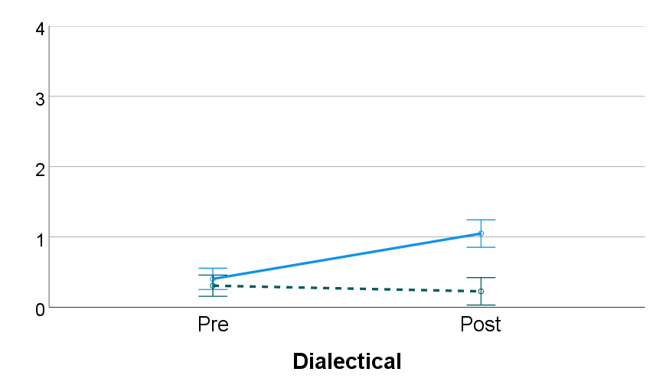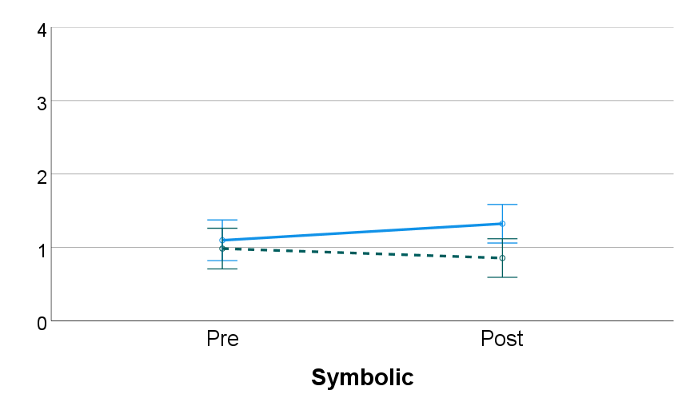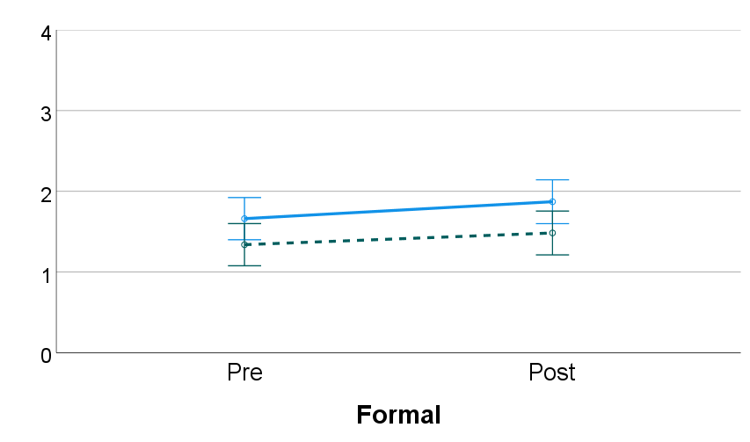
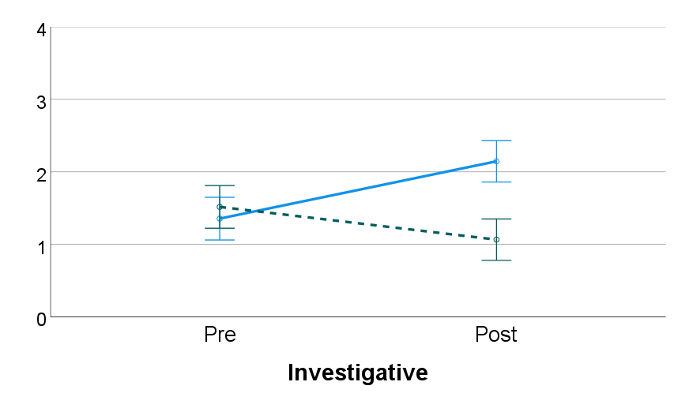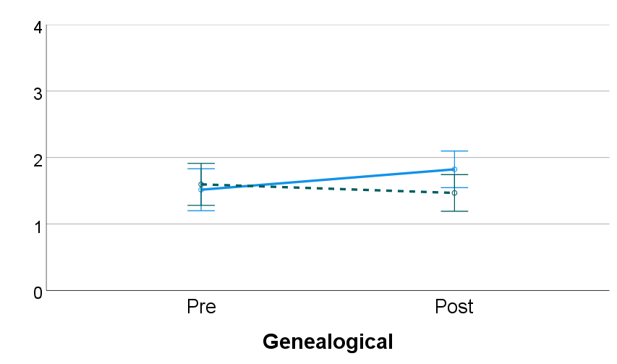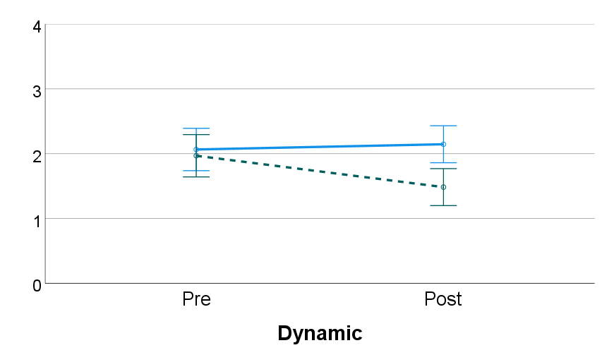

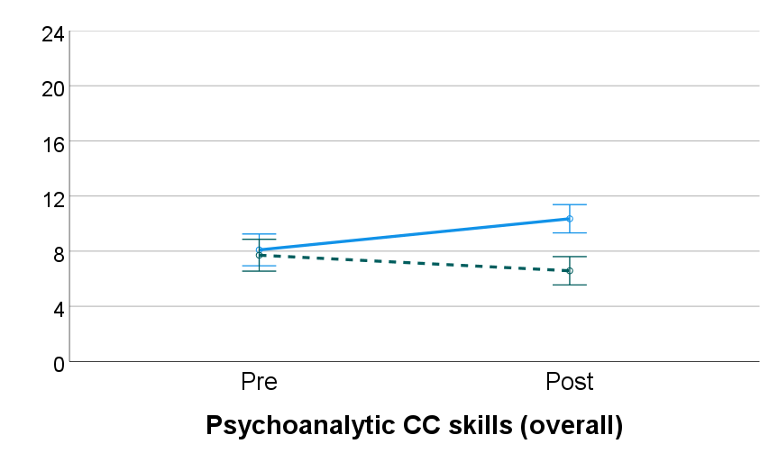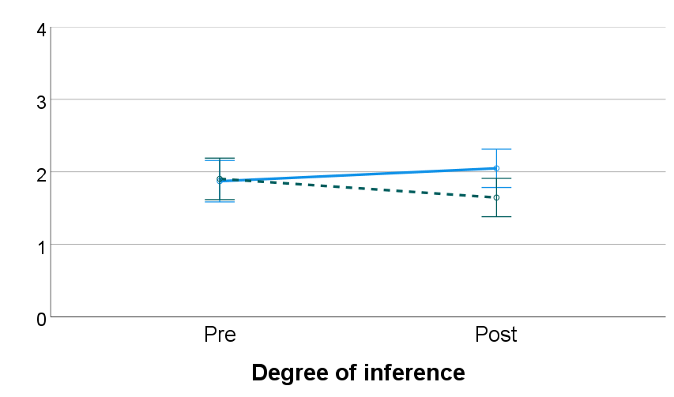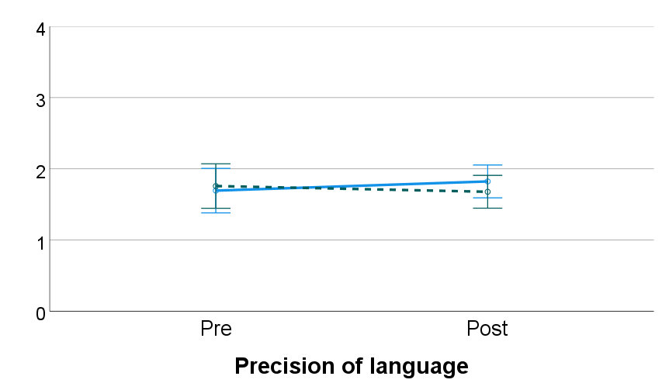
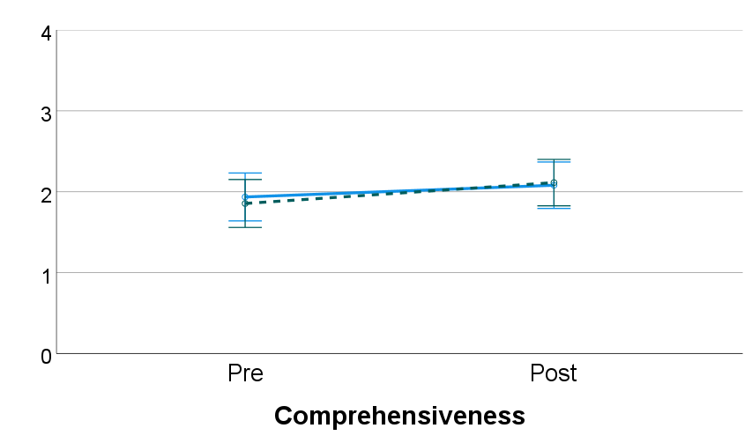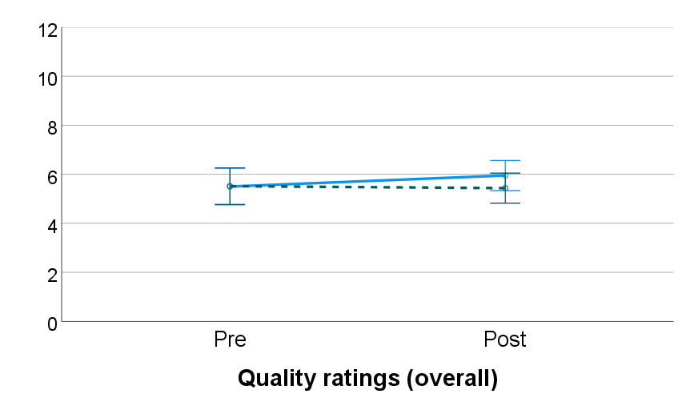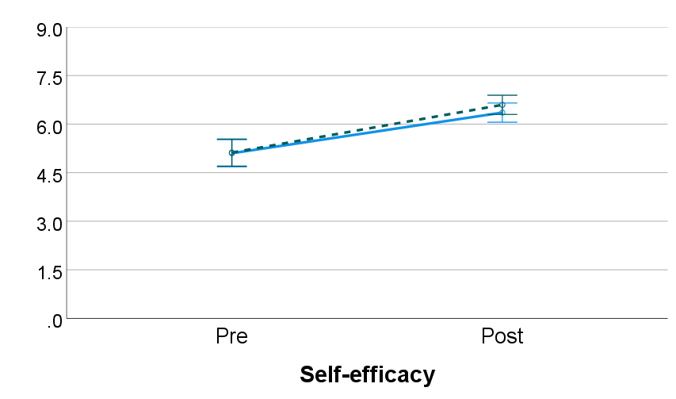

Note. Straight line = target group, dashed line = control group.

Discussion
Our first hypothesis (H1) was confirmed. The target intervention was effective in developing psychoanalytic CC skills. In particular, a significant effect was found on 3 operators out of 6 (Dialectical, Investigative, and Dynamic) and on the sum score for this outcome variable. This finding suggests that psychoanalytic CC skills can be effectively developed through didactic teaching, and that they constitute a specific set of conceptual skills that are not developed by learning generic CC skills. In fact, while the students in the control group started out with a comparable level of psychoanalytic CC skills as those in the target group, their skills not only did not increase pre/post, but they actually decreased. Since this decrease cannot be attributed to fatigue (for fatigue would have been present in both groups), then it may be better explained by assuming that the students in the control group simply learnt to focus on different aspects of the clinical material and to apply different skills. In this way, these students may have developed generic CC skills (although these were not assessed in our study), but not psychoanalytic ones.
In line with previous studies about generic CC skills (Abbas et al., 2012; Kendjelic & Eells, 2007), our RCT shows that a time-limited intervention can effect a significant change in specific CC skills as well. However, caution is required in interpreting this change, for various reasons. First, the change effected by the training may be of short duration. As there was no follow-up assessment in our study, we have no way of knowing how long the change in the students’ CC psychoanalytic skills was maintained after the post-test. It might be that a 2-hr intervention is sufficient to produce a detectable but ephemeral change in psychoanalytic CC skills, and that more training is needed for a durable one. In fact, it is reasonable to assume that real competence in psychoanalytic CC skills requires prolonged training, for “like any complex skill … competent case formulation is learned over time” (Ivey, 2006, p. 327). This idea reflects in the fact that, through the feedback questionnaire, many students expressed the feeling that they would have been better able to integrate the CC skills, had the training been conducted over multiple sessions. To meet this learning need, future research should explore the possibility of teaching psychoanalytic CC skills through spaced, as opposed to massed, education.
Second, the change effected by the training may not generalize to real practice. In everyday practice, therapists are required to conceptualize a case by thinking “on their feet,” while at the same time maintaining a relationship with the patient. In this sense, training CC skills through pen-and-paper exercises based on clinical vignettes may not sufficiently prepare students for the reality of clinical practice. To increase the external validity of our training, a solution might be to integrate didactic with experiential teaching methods, since all complex clinical skills are best taught “via a combination of didactics, experiential learning, and supervision” (Robillard et al., 2021, p. 1). Furthermore, a future version of our training module may integrate the other 6 operators of psychoanalytic clinical reasoning, which are used by competent analytic therapists precisely to monitor the reflective positioning that they are adopting whilst carrying out the conceptual work. Reflective operators lend themselves particularly well to being taught using experiential methods.
Finally, the change effected by the training may not reflect a real gain in competence. A student may learn to carry out certain conceptual operations merely out of an application of didactic instructions, and not because they feel spontaneously drawn to, as a competent analytic therapist would in their practice. This may lead to question whether an increased use of operators necessarily reflects a real gain in competence in psychoanalytic CC skills. This concern is a legitimate one; yet, it should be weighed against the fact that a certain “mechanization” of practice is typical of the early phases of skills acquisition (Dreyfus, 3004). All novices go through a phase where they explicitly think about the rules that they are applying, and thus operate a bit “like a computer following a program” (p. 177). Yet, at the same time, we expect that the students, by gaining further competence, will be able to move beyond this stage, and learn to rely on the rules implicitly, thus gaining in naturalness and creativity. This change in the process of skills acquisition is favored by repeated exercise and situated learning, as per our two previous points.
Moving on to our other hypotheses, the one about the quality of CCs (H2) was not confirmed. The overall quality of CCs did not increase significantly in either group. This finding can be explained by the fact that only a minor part of the training module (Part III) was dedicated to a discussion of the quality criteria. In contrast, Kendjelic and Eells (2007), who devoted a larger part of their training to this topic, found a pre/post increase in overall quality. This finding suggests that, for overall quality to increase, students need to be taught about quality criteria in addition to whatever CC model they are being taught.
However, a significant interaction of time and group was found on degree of inference. The students in the target group had an increase in their ability to formulate links or interpretations, while those in the control group had a decrease. This finding suggests that an increased use of the operators may translate into a greater inferential activity, as evidenced also by the strong positive correlation that was found at post-test between psychoanalytic CC skills and degree of inference, r(124) = .74, p < .001. In contrast, learning to use the 5 Ps model may translate not so much in an inferential activity, but in a classificatory one. In fact, the 5 Ps model has been criticized for leading therapists to categorize the clinical information into “boxes” (recognizing now this element as a protective factor, now this other element as a predisposing factor, and so on), but without really making any link between elements or interpreting them in a new way (Toews, 1993; see also Bucci et al., 2016, p. 526). This limitation is also acknowledged by Kendjelic and Eells (2007) and Abbas et al. (2012) who, for this reason, in their versions of the 5 Ps model, stress the importance of going beyond a simple “list” of factors, by identifying a mechanism that integrates them.
Our third hypothesis concerning self-efficacy (H3) was confirmed. The students’ self-efficacy significantly increased in both groups, regardless of the CC model that they were taught. The fact that the students’ confidence in carrying out CCs can be developed through time-limited interventions may be an argument in favor of including this kind of teaching format in the university curriculum. However, at the same time, the fact that the increase in the student’s self-efficacy was not accompanied by a corresponding increase in the overall quality of CCs points to the importance of using “objective” measures of competence in CC (such as the CFCCM or the POCS-6) alongside “subjective” ones, such as the self-report assessment of the students’ CC skills.
Finally, H4 was also confirmed. The teaching method was deemed acceptable by both groups, with no significant differences between them. This finding suggests that, regardless of the CC model, the didactic teaching method that we used, which involved the use of stories, movies, and vignettes, was an appropriate way of teaching CC skills to university psychology students. As revealed by the open-ended comments in the feedback questionnaires, particularly appreciated by students was the use of movies. This finding confirms previous research suggesting that the use of commercial films is particularly suited to teach CC (Misch, 2000; Warren et al., 2010). As for the CC models, we found that the operators and the 5 Ps model were both acceptable, but that the 5 Ps model was significantly more acceptable. This finding may be explained by the fact that the operators model is a more complex CC model that, as such, gives little cognitive closure to students who approach it for the first time. In contrast, the 5 Ps is simpler and may therefore give students a sense of mastery more quickly. Furthermore, the 5 Ps model, as a well-established and widely taught CC model, may be more consistent with what the students have been taught in other courses. If so, then a greater exposure to the operators model in the future may increase its acceptability.

Limitations of the study
We have already noted several limitations of the present study, such as the time-limited nature of the intervention or the lack of ecological validity of exercises based on clinical vignettes. Besides these, a few more are worth mentioning.
First, it is not clear to what degree our sample reflects our target population. Most of our participants, in fact, do not have any clinical experience. It may be that more experienced trainees would not stand to benefit in an equally effective way from the training that we proposed. Furthermore, it is not clear whether our participants are “future therapists” either, for students in psychology may go on to pursue also non-clinical careers, such as research or human resources. Nonetheless, the reason why we chose university psychology students as our population is that, both in Belgium and in France, a master’s degree in psychology is the gateway to a clinical career. Not only it is sufficient for practicing as clinical psychologists in these countries (unlike other countries where a doctorate might be needed), but it is also a requirement for accessing psychotherapy training, which is open, in addition to licensed psychologists, only to a few other healthcare professionals, such as medical doctors. Therefore, although the universities in which the RCT was conducted do not have official statistics about the career trajectories of their students, it is likely that the majority of our participants will in fact go on to pursue a clinical career.
Secondly, the validity of our operationalization of psychoanalytic CC skills may be questioned. In particular, a major limitation is that the POCS-6 takes a purely quantitative approach to the measurement of psychoanalytic CC skills, by counting the conceptual operations that have been carried out by students. Yet, it remains unclear whether, from a clinical point of view, more conceptual operations are necessarily better than fewer ones. On the contrary, perhaps few but particularly “deep” or “accurate” operations may be more effective after all. However, the problem with taking a qualitative approach to the measurement of psychoanalytic CC skills is that it would require having some standards for what constitutes a “deep” or “accurate” psychoanalytic inference. A possible approach to such a challenging task may be to ask senior analysts to provide a series of inferences on the basis of Tara’s or Edith’s vignette, and to use them as benchmark.
Finally, a limitation regards the risk of allegiance bias. Both the target and the control interventions were designed and delivered by [1st author] and [2nd author], while [3rd author] assisted with practical aspects. However, [1st author] is also the one who was involved, together with [3rd author], in the coding of the students’ CCs using the POCS-6. In light of this overlap between teaching and evaluating, it is conceivable that a bias might have unconsciously played a role in favor of finding an effect for the target intervention. However, in this regard, it should be noted that the students’ CCs were transcribed in such a way that, while coding with the POCS-6, [1st author] and [3rd author] were blind to whether the CC was pre or post-test, or whether it was coming from the target or control group; furthermore, as noted, to preserve the coders’ blindness, students were explicitly instructed to avoid mentioning the language of the model in their CCs. Finally, it should also be noted that the coding with the CFCCM was conducted entirely by two psychologists who had no implication in the design of the RCT and who were not aware of the author’s hypotheses.
To compensate for the above limitations, our RCT should be repeated in the future with some modifications. Participants should be practicing therapists, and the training should be delivered to them through spaced education. Over the course of 3 months, for instance, therapists may be invited to deliberately practice their CC skills through weekly exercises. This extended version of the training should focus on the teaching of reflective as well as conceptual operators, and integrate didactic with experiential methods. The evaluation of the therapists’ CC skills should be based not on vignettes, but on the therapists’ thinking about real cases from their caseload. To that purpose, methods such as reflective journals or the “think aloud” paradigm (Eells et al., 2011) may be used to collect the therapists’ reflections. Yet, a more sophisticated system than the POCS-6 would be needed to code the data for the therapist’s use of the operators. Finally, a follow-up assessment should be added to monitor the maintenance of the skills in the medium and long term.

Conclusions
This is the first RCT to provide evidence that psychoanalytic CC skills can be developed through time-limited interventions using didactic teaching methods. Our target intervention was shown to be acceptable to university psychology students as well as effective in developing their psychoanalytic CC skills, self-efficacy, and capacity to draw inferences, as opposed to summarizing the clinical material in a descriptive way.
As noted, the change that can be effected by such brief interventions is bound to be modest. The acquisition of real competence in psychoanalytic CC is a complex process that requires repeated exercise and an integration of experiential as well as didactic teaching methods. Yet, at the same time, our RCT shows that it is possible to train psychoanalytic CC skills, and that these constitute a specific set of skills that is not developed by learning generic CC skills.
The implications of the present study are not limited to the training of analytic therapists. As a generic components model of psychoanalytic CC, in fact, the operators model describes conceptual skills that are used not only across analytic schools (e.g., Freudian, Jungian, Lacanian), but that may in principle be used also by non-analytic therapists. To give but one example, “dialectical thinking” is a skill that is valued also in dialectical behavioral therapy, and is believed to increase the competence of trainee therapists in dealing with challenging clinical situations (Robillard et al., 2021). Furthermore, the present study may be of interest to therapists from other modalities since it presents a general method for operationalizing, teaching, and measuring CC skills which makes them amenable to research, while not discounting their complexity.

Ethics
Ethical approval was obtained on 19/01/2022 from the Ethics Committee of the [removed for masked review] (ID code: [removed for masked review]).

Funding
This work was carried out with the support of a doctoral scholarship by [removed for masked review] of the [removed for masked review].

Disclosure statement
The authors declare that they have no competing interests.

References
Abbas, M., Walton, R., Johnston, A., & Chikoore, M. (2012). Evaluation of teaching an integrated case formulation approach on the quality of case formulations: Randomised controlled trial. Psychiatrist, 36(4), 140–145. https://doi.org/10.1192/pb.bp.110.033746
Arnold, K. (2006). Reik's theory of psychoanalytic listening. Psychoanalytic Psychology, 23(4), 754–765. https://doi.org/10.1037/0736-9735.23.4.754
Bion, W. R. (1962). Learning from Experience. London: Karnac.
Brown, S., Beeley, C., Patel, G., & Völlm, B. (2018). Training probation officers in case formulation for personality disordered offenders. Criminal Behaviour and Mental Health, 28(1), 50-60.
Bucci, S., French, L., & Berry, K. (2016). Measures assessing the quality of case conceptualization: A systematic review. Journal of Clinical Psychology, 72(6), 517–533. https://doi.org/10.1002/jclp.22280
Canestri, J. (2006). Psychoanalysis: From Practice to Theory. Chichester: Wiley.
Canestri, J. (2012). Putting Theory to Work: How Are Theories Actually Used in Practice? London: Karnac.
Caspar, F., Berger, T., & Hautle, I. (2004). The right view of your patient: A computer-assisted, individualized module for psychotherapy training. Psychotherapy: Theory, Research, Practice, Training, 41(2), 125–135. https://doi.org/10.1037/0033-3204.41.2.125
Caspar, F. (1997). What goes on in a psychotherapist's mind?. Psychotherapy Research, 7(2), 105-125. https://doi.org/10.1080/10503309712331331913
Cornelis, S., Desmet, M., Van Nieuwenhove, K. L., Meganck, R., Willemsen, J., Inslegers, R., & Feyaerts, J. (2017). Interactions between obsessional symptoms and interpersonal ambivalences in psychodynamic therapy: An empirical case study. Frontiers in Psychology, 8, 960. https://doi.org/10.3389/fpsyg.2017.00960
Division of Clinical Psychology (2011). Good Practice Guidelines on the Use of psychological formulation. Leicester, United Kingdom: British Psychological Society.
Dreyfus, S. E. (2004). The five-stage model of adult skill acquisition. Bulletin of science, technology & society, 24(3), 177-181. https://doi.org/10.1177/0270467604264992
Eells, T. D. (Ed.). (2022). Handbook of psychotherapy case formulation (3rd ed.). Guilford.
Eells, T. D., Kendjelic, E. M., & Lucas, C. P. (1998). What’s in a case formulation? Development and use of a content coding manual. Journal of Psychotherapy Practice and Research, 7(2), 144–153. PMCID: PMC3330487.
Eells, T. D., Lombart, K. G., Kendjelic, E. M., Turner, L. C., & Lucas, C. (2005). The quality of psychotherapy case formulations: A comparison of expert, experienced, and novice cognitive-behavioral and psychodynamic therapists. Journal of Consulting & Clinical Psychology, 73, 579-589.
Eells, T. D., Lombart, K. G., Salsman, N., Kendjelic, E. M., Schneiderman, C. T., & Lucas, C. (2011). Expert reasoning in psychotherapy case formulation. Psychotherapy Research, 21, 385-399.
Ginzburg, C. (1980). Morelli, Freud and Sherlock Holmes: clues and scientific method. History workshop, 9:5–36.
Guerrero, A. P., Hishinuma, E. S., Serrano, A. C., & Ahmed, I. (2003). Use of the mechanistic case diagramming technique to teach the biopsychosocial-cultural formulation to psychiatric clerks. Academic Psychiatry, 27(2), 88-92. https://doi.org/10.1176/appi.ap.27.2.88
Hill, C. E., Spangler, P. T., Jackson, J. L., & Chui, H. (2014). Training undergraduate students to use insight skills: Integrating the results of three studies. The Counseling Psychologist, 42(6), 800–820. https://doi.org/10.1177/0011000014542602
Hinkin, T. R. (1995). A review of scale development practices in the study of organizations. Journal of management 21:967–988.
International Psychoanalytic Association (2023). The three training models. Available at : https://www.ipa.world/en/Training/3models.aspx
Ivey, G. (2000). A listening-formulating model for psychoanalytic psychotherapy. Psychotherapy: Theory, Research, Practice, Training, 37(1), 22–35. https://doi.org/10.1037/h0087743
Ivey, G. (2006). A method of teaching psychodynamic case formulation. Psychotherapy: Theory, Research, Practice, Training, 43(3), 322–336. https://doi.org/10.1037/0033-3204.43.3.322
Kendjelic, E. M., & Eells, T. D. (2007). Generic psychotherapy case formulation training improves formulation quality. Psychotherapy: Theory, Research, Practice, Training, 44(1), 66–77. https://doi.org/10.1037/0033-3204.44.1.66
Luborsky, L. (1997). The core conflictual relationship theme: A basic case formulation method. In T. D. Eells (Ed.), Handbook of psychotherapy case formulation (pp. 58–83). Guilford.
McClain, T., O’Sullivan, P. S., & Clardy, J. A. (2004). Biopsychosocial formulation: recognizing educational shortcomings. Academic Psychiatry, 28(2), 88-94. https://doi.org/10.1176/appi.ap.28.2.88
McWilliams, N. (1999). Psychoanalytic case formulation. Guilford.
Meehl, P. E. (1983). Subjectivity in psychoanalytic inference: The nagging persistence of Wilhelm Fliess's Achensee question. In Minnesota Studies in the Philosophy of Science: Vol. X, Testing Scientific Theories, ed. J. Earman. Minneapolis: University of Minnesota, pp. 349–411.
Messer, S. B., & Wolitzky, D. L. (2007). The psychoanalytic approach to case formulation. In T. D. Eells (Ed.), Handbook of psychotherapy case formulation (2nd ed., pp. 67–104). Guilford.
Minoudis, P., Craissati, J., Shaw, J., McMurran, M., Freestone, M., Chuan, S. J., & Leonard, A. (2013). An evaluation of case formulation training and consultation with probation officers. Criminal Behaviour and Mental Health, 23(4), 252-262.
Misch, D. A. (2000). Psychosocial formulation training using commercial films. Academic Psychiatry, 24(2), 99-104. https://doi.org/10.1176/appi.ap.24.2.99
Osborn, C. J., Dean, E. P., & Petruzzi, M. L. (2004). Use of simulated multidisciplinary treatment teams and client actors to teach case conceptualization and treatment planning skills. Counselor Education and Supervision, 44(2), 121-134. https://doi.org/10.1002/j.1556-6978.2004.tb01865.x
Page, A. C., Stritzke, W. G., & Mclean, N. J. (2008). Toward science‐informed supervision of clinical case formulation: A training model and supervision method. Australian Psychologist, 43(2), 88-95. https://doi.org/10.1080/00050060801994156
Parsons, M. (1992). The refinding of theory in clinical practice. The International Journal of Psycho-Analysis, 73(1), 103.
Peterfreund, E. (1975). How does the analyst listen? On models and strategies in the psychoanalytic process. Psychoanalysis & Contemporary Science 4:59–101.
Polanski, R. (Director). (2013). Venus in Fur [Film]. Mars Distribution.
Ramzy, I. (1974). How the mind of the psychoanalyst works: An essay of psychoanalytic inference. International Journal of Psychoanalysis, 55(4), 543–550.
Robillard, C. L., Dixon-Gordon, K. L., & Turner, B. J. (2022). Teaching dialectical thinking to enhance graduate trainees’ competence in outpatient psychotherapy for adolescents experiencing suicidal thoughts and behaviors. Canadian Psychology / Psychologie canadienne, 63(3), 392–404. https://doi.org/10.1037/cap0000297
Roussos, J. A., lissin, L. B., & De Duarte, A. L. (2007). The importance of the theoretical framework in the formulation of clinical inferences in psychotherapy. Psychotherapy Research, 17(5), 535–543.
Sandler, J. (1983). Reflections on some relations between psychoanalytic concepts and psychoanalytic practice. International Journal of Psychoanalysis, 64(1), 35-45.
Schacht, T. E., & Black, D. A. (1985). Epistemological commitments of behavioral and psychoanalytic therapists. Professional Psychology: Research and Practice, 16(2), 316. https://doi.org/10.1037/0735-7028.16.2.316
Schumacher, J. (Director). (1993). Falling Down [Film]. Warner Bros.
Speicher, T. E., Bell, A., Kehrhahn, M., & Casa, D. J. (2012). Case-based analogical reasoning: a pedagogical tool for promotion of clinical reasoning. Athletic Training Education Journal, 7(3), 129-136. https://doi.org/10.4085/0703129
Storck, T., Volkert, J., Brauner, F., & Sell, C. (2021). Psychotherapeutische Arbeitsmodelle in unterschiedlichen Verfahren: Skizze einer konzeptvergleichenden Psychotherapieforschung [Working models of psychotherapy across different orientations: Sketch of comparative conceptual psychotherapy research]. Forum der Psychoanalyse: Zeitschrift für klinische Theorie & Praxis, 37(2), 149–163. https://doi.org/10.1007/s00451-021-00435-8
Toews, J. A. (1993). Case formulation in psychiatry: Revitalizing an ailing art. The Canadian Journal of Psychiatry, 38(5), 344-344. https://doi.org/10.1177/070674379303800511
Warren, J., Stech, M., Douglas, K., & Lambert, S. (2010). Enhancing case conceptualization through film: The addiction web. Journal of Creativity in Mental Health, 5(3), 228-242. https://doi.org/10.1080/15401383.2010.507663
Weerasekera, P. (1996). Multiperspective case formulation. Krieger.
Wolitzky, D. L. (2007). The role of clinical inference in psychoanalytic case formulation. American journal of psychotherapy, 61(1), 17-36.

