DIFFERENT FORMS OF COHOUSING IN BRUSSELS :
DIVERSITY IN TERMS OF COLLABORATION AND OPENNESS

Emmanuelle Lenel
Université Saint-Louis – Bruxelles, Centre d’études sociologiques, 43 blvd. du Jardin Botanique, B-1000 Brussels, Belgium
e-mail: emmanuelle.lenel@usaintlouis.be

François Demonty
Université Saint-Louis – Bruxelles, Centre d’études sociologiques, 43 blvd. du Jardin Botanique, B-1000 Brussels, Belgium
e-mail: francois.demonty@usaintlouis.be

Abstract

Brussels faces a growing housing challenge and an increasing polarization between poor, middle and prosperous areas. To meet this double challenge, urban planning supports production of housing mainly in the poorer central areas but for “middle income”. How do different forms of collaborative housing that emerged in this context contribute locally to social cohesion? Relying on a qualitative methodology based on field studies and interviews we will mainly focus, firstly, on the relevant aspects to differentiate those forms and their contribution to social cohesion (means of access to housing, process of making housing, target population, materiality…). Secondly, we will consider the social and material ways those forms integrate the neighborhood and how it can create opportunities for relations with their neighborhood. By doing so, we aim to specify the collaborative notion, adding aspects that are less known in the literature (Tummers, 2015), as participation to the development of residential environment.

Keywords : Brussels cohousing - collaborative - openness to neighborhood - residential choice

Introduction

Our communication will deal with the development in Brussels of different forms of cohousing projects. We aim to specify the differences between four studied cohousing projects with respect to several dimensions. We will pay careful attention to one dimension on which these housing projects vary among others, namely the degree reached in terms of collaboration in both the process of making and managing the housing project. We want to point out the different variations that the collaborative dimension takes in these projects and how it can provide a support for the cohousing collective to actively take part in the local life of their neighborhood, and even to position themselves as an initiator of new dynamics. By doing so, we aim to specify the collaborative notion, adding aspects that are less known in the literature.

The content of this paper is based on field studies of four housing projects and interviews with inhabitants and promoters. These four housing projects have in common to be cohousing projects mainly in terms of the arrangement of spaces. Indeed, they all present private housing units articulated around common spaces. But, as we will see it more in details later, they also present important differences in terms of the typical "target" population of the housing product, the tenure status (property vs. renting), the materiality (arrangement of spaces), and the process of, first, making and, then, managing the housing project (community-led, property company-led or association-led housing) which indicates differences in the degree of collaboration that one can associate to each project.

These four cohousing projects are 1° L'Echappée, a community-led cohousing, 2° L'Ilot Picard, a property company-led cohousing, 3° Palais 36, a solidarity cohousing and 4° L'Ecluse, a housing based on the principle of the community land trust. But before presenting these four cohousing projects, we will highlight the multifaceted housing challenge that Brussels faces.

Housing challenge in Brussels

Firstly, the Brussels housing market is highly polarized, and that is linked to a polarization of the urban territory between poor, middle and prosperous areas. The prosperous area is located south-east of the city. The poor area, where workers and immigrated populations are concentrated, lies in the city-center, along the canal of Brussels. The middle area, where mostly employees and officials live, lies on the western periphery of the city (cf. map 1).

This socio-economic structuration of Brussels has historical roots. At first, the industrial activity and the demographic growth of the 19th and early 20th century allowed the expansion of the city beyond its first crown. Then, deindustrialization and the linked phenomenon of suburbanization in the 1960s and 1970s largely contributed to emptying the central industrial neighbourhoods of their inhabitants who gained social rise, and being replaced by the precarious immigrant workers who settled there. At the same time, the already very rich neighborhoods of the south-east welcomed the development of the international function of Brussels and an international elite of European officials.

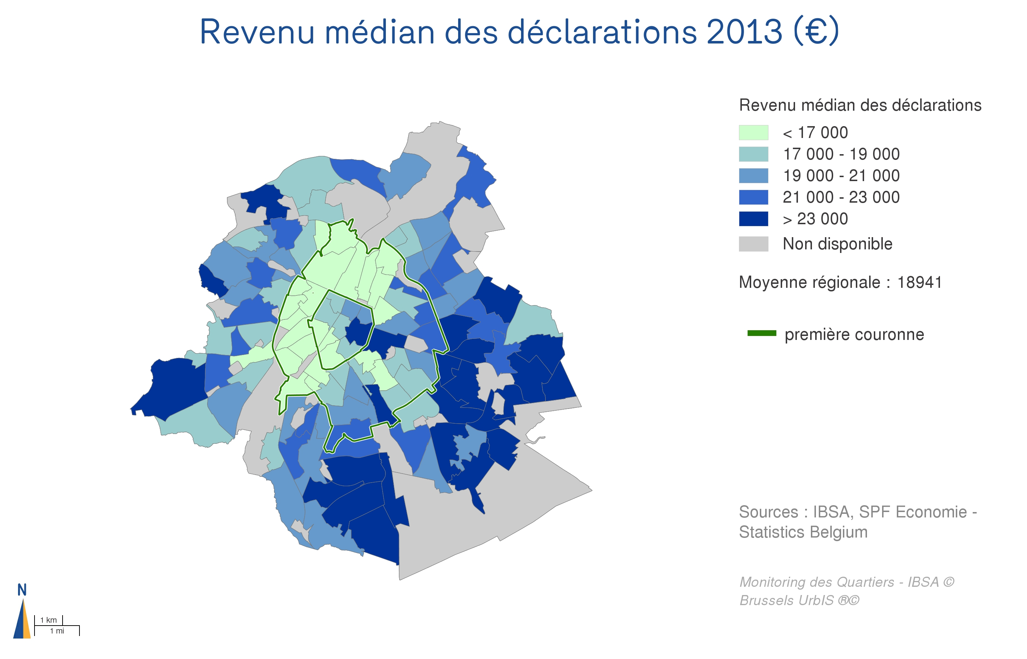

Map 1. Median income tax returns in Brussels-Capital Region, 2013

This polarization has increased in recent years. This can be mainly explained by the presence in the poor areas of many social housing units, of which the traditional clientele has been heavily impoverished since the 1980s (Debossere and Willaert, 2005). Another explanation is the continuation of the suburbanization movement since the 1990s, thanks to the desire for home ownership and a clean, safe and secure environment, especially for middle-class families with children. So, Brussels housing market is presently highly polarized between south-east airy neighbourhoods where housing isn’t affordable for low and middle incomes and central dense neighbourhoods where housing stock is old and deteriorated, and the residential environment unattractive.

Secondly, Brussels faces a lack in housing supply. Figures show for the present situation a quantitative gap between the produced housing supply and the increasing number of private households on the territory, around 5000 units per year (since 2001), meanwhile the produced housing supply is around 3800 units per year (since 2003). Moreover, demographic forecasts stress the future crucial importance of this housing challenge by predicting a 12.5% increase in the global population of Brussels by 2030, and even much more in its poor areas. This means that Brussels will need approximately 40 000 additional housing units by 2030 (Dessouroux et al., 2016).

Thirdly, there is an important increase in property prices, especially in the central neighbourhoods, which is linked to the urban planning policies that support housing production since the 1990s but mainly in these poor central areas (where population growth is the highest) and mainly targeting the middle-income households. This urban policy's orientation aims officially to meet the double challenge of housing and socio-spatial segregation. But this policy also fostered the arrival in these neighborhoods of real estate investors and young people with high education who value the assets of urban centrality, and who can afford this new housing supply (Van Criekingen, 2006). Some people see in these evolutions gentrification in progress. In any case, the decline in the rate of ownership in recent years suggests increasing difficulties in acquiring housing in Brussels for low and middle-income households.

Cohousing in Brussels

In this specific context, not only public actors but also real estate developers, associations and citizen communities develop new housing projects, particularly in the central and poor areas of Brussels, to produce qualitative and affordable housing for low and middle-income households. A growing part of them are cohousing units, initiated to promote active and direct participation of the inhabitants in the design and/or the management of their living environment and project, as a way to respond not only to the housing crisis but "to several ‘crises’ of modernity" (Iorio, 2015, p. 97): economic crisis, crisis of the city as an integrated entity, environmental crisis and, as we will see, crisis of family structures.

Though these cohousing new projects share an ideal of collaboration between residents, that can be built together, serving a common ideal (way of life and values) and/or sharing everyday arrangements (common spaces and resources, living in a community) (Korpela, 2012), only some of them can be associated to the category of collaborative housing if we define it as “a group of people [that] co-produce their own housing in full or part in collaboration with established providers” (Czischke, 2017, p. 7).

About the integration of cohousing communities into their local environment, in the way they are usually perceived, the “underlying expectations are that they interact positively with the neighbourhood” (Tummers, 2015, p. 14). As we said previously, this paper will be the opportunity to discuss the social, legal (through the tenure status) and material conditions for the cohousing to have and maintain such openness. We will also consider different ways in which the collective can fit into the neighbourhood. Then we will highlight the relevant aspects to differentiate these forms of cohousing in terms of collaboration and openness.

Four case studies

The community-led cohousing L'Echappée

L'Echappée is one of many community-led cohousing projects that have emerged on the territory of Brussels since the beginning of the 2000s. We can talk in this case of a cohousing with a strong collaborative dimension since the process of its making was characterized by a collaboration of households who joined together intentionally to form a group in order to create this housing project themselves.

L'Echappée is located in a quite residential part of a neighbourhood of Brussels called "Vieux Laeken Est". This neighbourhood is characterized by a young population – around 30% of people younger than 17 years old in 2014 – and by a high unemployment rate, around 33% in 2012.

We observed that the question of the integration or the openness of the housing project into and to its environment (the street, the neighbourhood...) is often an important matter for community-led cohousing collectives. It can be partially linked to the social characteristics of the target population that chooses this kind of way of living. Indeed, while the households interested in cohousing show differences in terms of their incomes and economic situations, they are generally characterized by a certain homogeneity in terms of level of education (high), lifestyles and values. The portion of a social class concerned here is sometimes referred to in the French speaking literature as les nouvelles classes moyennes (the "new middle classes") (Bourdieu, 1979) or la petite bourgeoisie intellectuelle (the "intellectual petty bourgeoisie") (Garnier, 2010). One of the characteristics of this social group pointed out by different authors (Bidou, 1984; Bacqué and Vermeersch, 2007) is the will to have socially rich exchanges with the local environment in which they live (their street, their neighbourhood...) and also to open their private space, and doing so, to develop a specific way of thinking the boundary between private and public – or common – spaces.

While these discussions among community-led cohousing inhabitants can reveal differences in points of view about the level of openness that the group should reach, yet they show that the collectives question themselves on this dimension of their project and are really conscious of the risks (mainly gentrification, socio-spatial segregation and the possible "bad image" that they would suffer from) of such a massive arrival of new comers in a neighbourhood which doesn't necessarily share the same socio-economic characteristics.

So L'Echappée, as many other cohousing collectives that we met, discusses and thinks about ways to fit into the local environment in which they are living or at least not to be perceived by the neighbourhood inhabitants as an "upper middle-class ghetto".

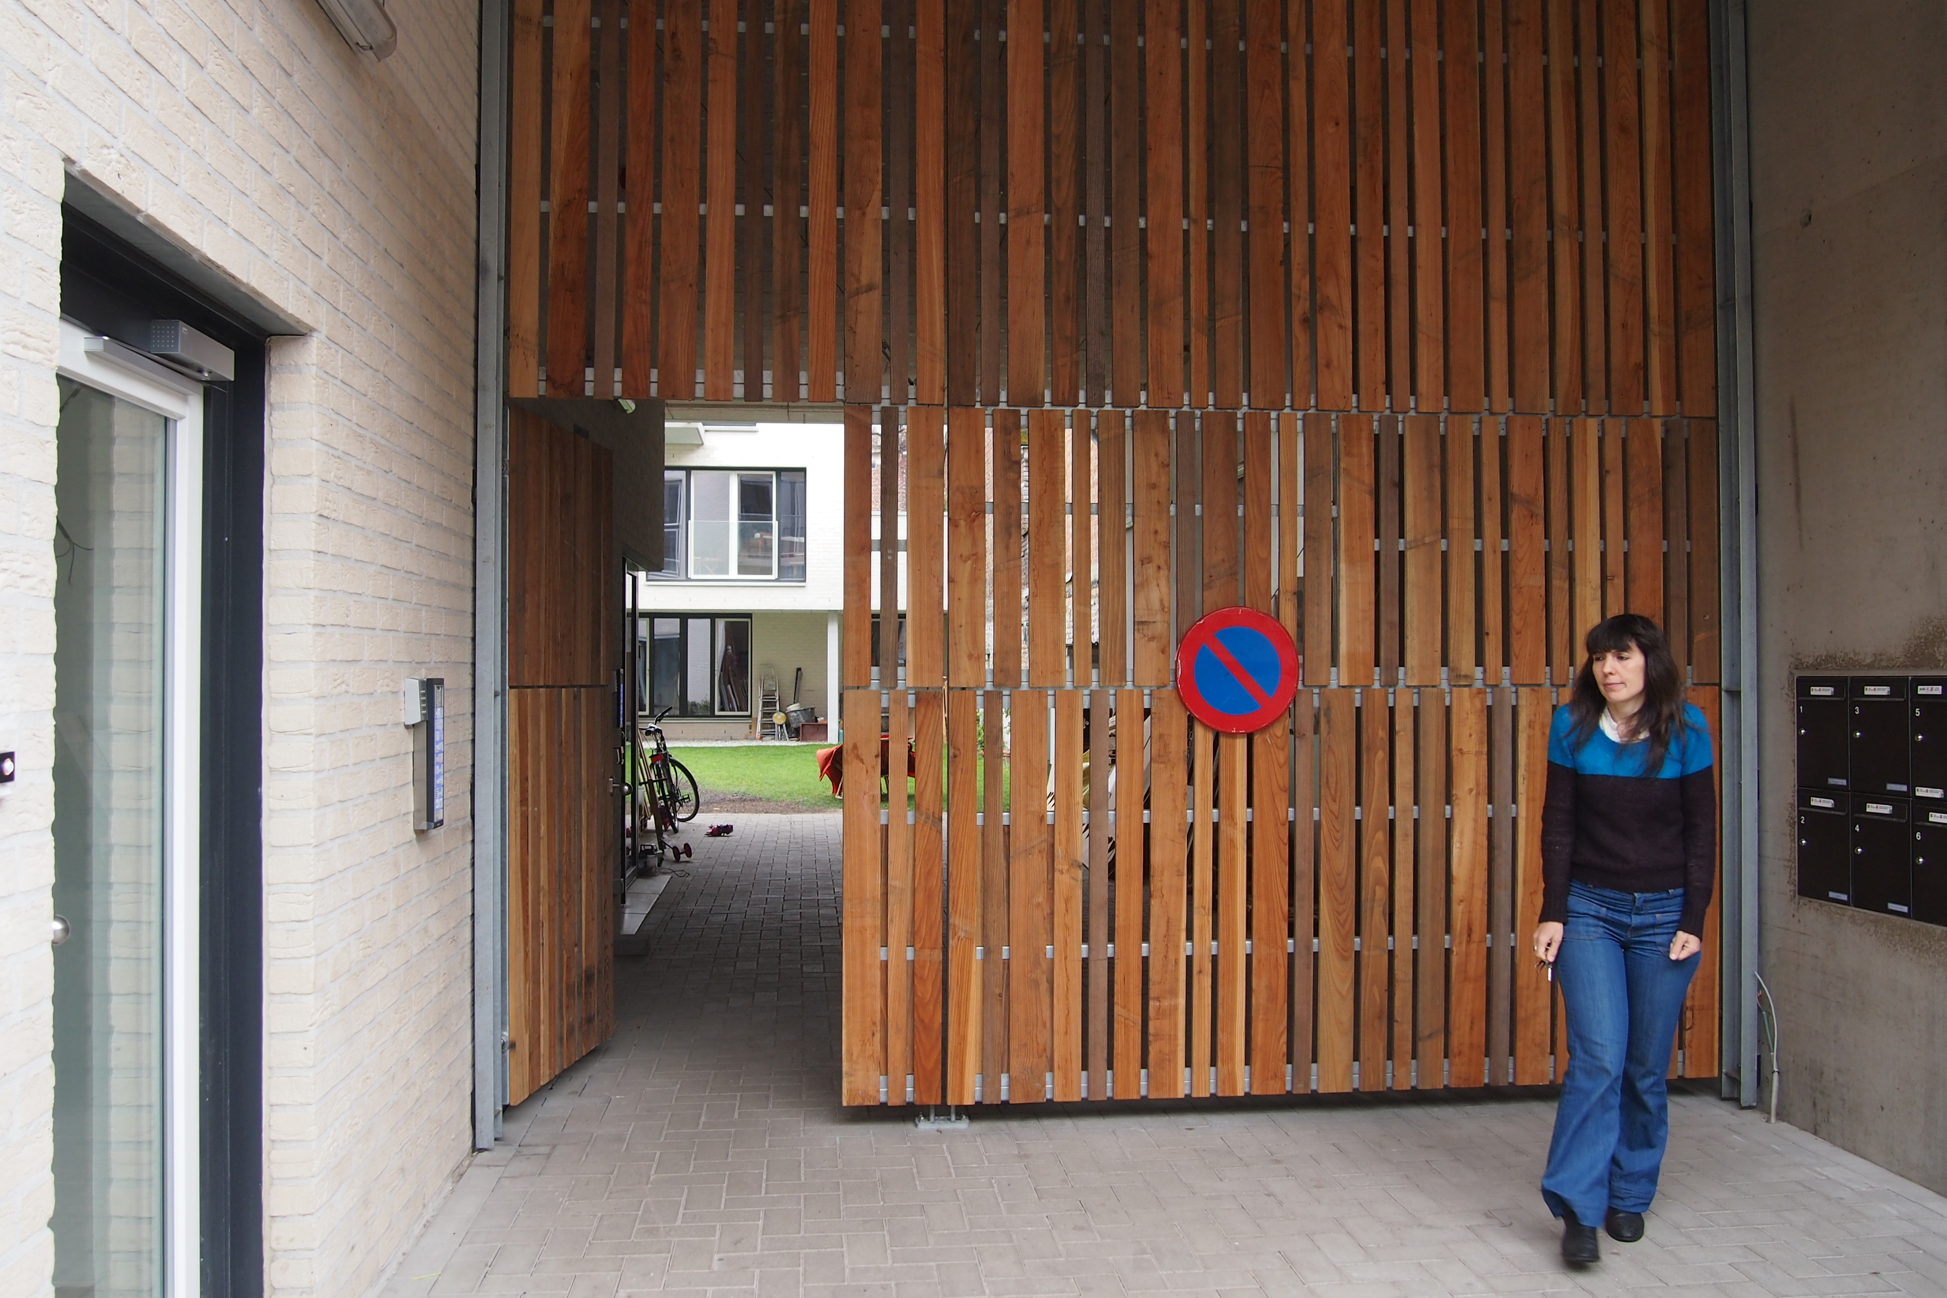
Image 1 : Entrance gate of L'Echappée (streetview)

Firstly, to do so the group worked from an architectural point of view. Even if the housing project can't be defined as very open to the outside from an architectural point of view, the group still made the choice of a wooden gate to allow the passer-by to have a partial view on the common inner garden and moreover they decided not to put curtains on the ground floor window to let the passer-by have a view on the common room (cf. Image 1).

Secondly, L'Echappée collective has thought from the beginning of its creation about the best ways to interact with the neighbourhood inhabitants and to try to develop "quality" local interactions. Some of the inhabitants already had an involvement in socio-cultural associations that work in the neighbourhood before they settled in while others started to engage in local associations after moving in the cohousing. There is nothing very surprising for them in getting involved in socio-cultural associations and, by doing so, showing a quite strong political engagement because it is also a characteristic that can be associated to the typical population living in collaborative cohousing projects.

Besides, showing an engagement in the existing local socio-cultural sector, L'Echappée collective also tries to operate as a positive actor of the neighbourhood. But being aware of the potential gentrifier's image they could be labeled with, rather than acting alone to implement changes in their local environement, they try to work with the neighbourhood inhabitants in a form of participatory approach. To illustrate this with a precise example, we can mention that shortly after settling in, the Echappée inhabitants found the street a bit dangerous because of the absence of speed limit devices. Instead of trying to "impose" changes by contacting directly the local authorities to question them about this problem, the group decided to go door to door and ask their neighbours what they were expecting and dreaming for their street and their neighbourhood. It resulted in a paper-model of the neighbourhood with all the post-it stickers on which the inhabitants – adults and children – wrote their ideas to improve their neighbourhood.

Another example of a practice that L'Echappée considers as a way to open to the neighbourhood is to lend their common room from time to time to local associations. To facilitate this practice, the collective had already thought in designing the space to put a door that allows outsiders to directly enter the common room wihtout entering the other parts of the cohousing. Here again we can see how the group imagined the interactions with the neighbourhood already in the reflections that led to the architectural conception and the space design.

Finally, we can say that for a community-led cohousing collective such as L'Echappée one important issue is to find the good balance between an appropriate level of openness to the neighbourhood and the preservation of the need for group's privacy and every family's privacy. The expectations might differ among the inhabitants and the group needs to discuss and find a good compromise between openness and closure.

The property company-led cohousing Ilot Picard

Ilot Picard is a rental cohousing located in a quite residential neighbourhood called “Quartier Maritime“ in the district of Molenbeek-Saint-Jean. This neighbourhood is close and similar to the one of L’Echappée: its population is also quite young (around 30% of people younger than 17 years old in 2014) and characterized by a high unemployment rate (around 33% in 2012).

This cohousing is led by a property company called Urbani which is active in Brussels (and Belgium) since the 1980s. Urbani’s business is designing, developing and managing sustainable and user-friendly real estate for rental in a partnership with the tenants. The 19 households arrived at the autumn 2016, after the renovation and construction, so in fact, as we will see, the partnership only concerns the management of common areas (a party room, a laundry and a big garden) and more generally the housing management (community living).

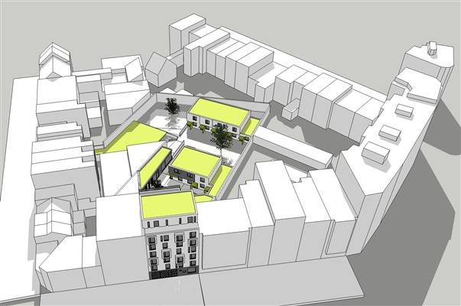

Image 3: Îlot Picard

The target population has globally the same social characteristics than the one of L’Echapée: middle- and high-income highly qualified households, interested in local integration and community links with their neighbours. But since they are tenants, the inhabitants of Ilot Picard do not have any long-term project to insert into the neighbourhood. For a lot of them, renting a flat with a conventional three-year lease in this cohousing was a choice of opportunity, corresponding at the time to their lifestyle and values and to a transitional stage of their biographical trajectory (first job, divorce). The rental cohousing allows them to stabilize first their personal situation before building a sustainable (co)housing project.

Although Urbani’s core business is not social but economic, it has the purpose to contribute to local development by focusing on the environmental dimension and qualitative architecture of its housing. Urbani thought how to fit Ilot Picard into the local environment and worked on the architectural dimension “to open up the project to the neighbourhood” in two classical ways. Firstly, the promoter chose a gate that allows the passer-by to have a partial view on the inner garden. Secondly, they designed a room on the ground floor accessible from the street to be rented for a local service activity, such as a nursery.

Paradoxically, for the tenants, the material closure of Ilot Picard (cf. image 3) is both a positive element, as a source of tranquillity (safety of children playing in the garden, noise street cut, protection against vandalism), and a negative one, fearing to be perceived as a social and greenery “oasis” (Tummers, 2015) in this quite poor neighbourhood. This probably corresponds to a common class-attitude concerning the openness of the private space (Bidou, 1984) that we also observed at L’Echapée but, at the same time, it reveals the priority given by them to the inner social cohesion (or the inhabitants’ community). Indeed, in a period of lower family insertion, having socially rich exchanges with other inhabitants of Ilot Picard is more important than integrating the neighbourhood and interacting with the other neighbours. So, some of them do activities together as having a drink in the garden and collaborating on everyday management of the housing (garbage cans, garden maintenance, lost linen, etc.) but any of these activities are “neighbourhood-turned”. They also organise a monthly collective dinner for the inhabitants, that serves both to get to know each other better and to discuss things to manage collectively.

At the same time, this relative closure of the inhabitants' community appears to be a factor contributing to the collaborative management of the housing. It seems to help to get up a community that was not pre-existing to the cohousing and to appropriate collectively the tools made available to them by Urbani for this purpose. In particular, to carry out the communitarian project independently, Urbani gave them common spaces located in strategic transit areas to favour the interactions, proposed a specific mean of communication (Amitié Internet) and offers permanent support from Habitat et Participation, specialized in the follow-up of cohousing project. In the same way, Urbani constituted a tenants' general assembly. Finally, the material and social closure of this cohousing seem to contribute to the group consolidation, which is a priority for the inhabitants and a necessity, from their point of view, to be collectively a real partner of Urbani in the management of the housing.

The solidary cohousing Palais 36

Palais 36 is another rental cohousing, but much smaller (9 inhabitants) and with a very different target population than Ilot Picard. This cohousing is located in a multicultural, poor (unemployment rate around 34% in 2012), quite young (around 26% of people younger than 17 years old in 2014) and animated neighbourhood called “Chaussée de Haecht“ in the district of Schaerbeek. Despite its target population comes from all over Brussels Region, the inhabitants have quite the same social characteristics than the population of the neighbourhood: half of them are foreigners and most lived before in a situation of great precariousness (homeless, refugee…).

Indeed, this cohousing project was born of the collective work of three associations working with poor people and supported by public subsidies. The first one is the owner of the building, the Centre Familial de Bruxelles (CFB) offering services to people with disabilities and to the elderly. The CFB had the idea of this cohousing project and assumed the renovation works of the building. The second one is The Agence Schaerbeekoise Immobilière Sociale (ASIS) which is an agency in charge of social rental management. The third one is Habitat et Humanisme (H&H), an association that renovates and manages housing to be inhabited by people with low incomes. Its mission in this project is to follow-up the community living.

Moreover, it is an intergenerational cohousing that aims to offer not only good housing conditions but also social links and solidarity between elderly and young people. The initial purpose of the project was to contribute to local social development by responding to some material and social difficulties of poor isolated elderly people of the neighbourhood rather than being a positive actor in the neighbourhood. However, the population of Palais 36 has in fact geographic origins larger than this, for reasons that we will see below.

Convinced that spaces arrangement can play the role of facilitator in the social interactions between the inhabitants of Palais 36, the owner decided to include common spaces in the renovation project. So, the house is composed of four independent units for elderly people, a common unit with private bedrooms for three young roommates, a common living room with a kitchen and a common garden. The common kitchen serves for communitarian activities as dinners or meetings but also for everyday needs of the roommates. By this specific space arrangement, the CFB and H&H hope to facilitate the interactions and community living between young people and the elderly.

So, the collaborative dimension of this housing project has been initiated and framed by the CFB and mostly H&H, while ASIS is satisfied with its rental management mandate. The idea of H&H is to involve the inhabitants in the housing management, giving them some initial tools as common spaces, a charter and a collective follow-up to carry out the project independently in an empowerment approach. For example, it is expected from the inhabitants to discuss and redefine in the future the charter that they signed when they entered the house, to accord it with their own vision of the project.

Nevertheless, the selection process of the inhabitants – that moved in in June 2017 – could possibly have negative consequences both on the community living and on the openness to the neighbourhood. Indeed, the modalities of the candidate selection was the result of a negotiation between the 3 primary stakeholders (Czischke, 2017). Despite a clear definition of each partner’s role, as mentioned before, and its legitimacy, there are some contradictions between their respective missions. On the one hand, ASIS has rules that oblige it to offer housing, following the chronological order on the waiting list, to people who meet the social conditions required and come from all over Brussels Region (and not only the neighbourhood). On the other hand, H&H wanted to target people "who would be interested in entering into a community project" and with an “openness capacity”, as key factors in the success of the housing project. So, this stakeholder regrets that the "selection decision " was entirely in the hands of ASIS, considering that candidate selection is also part of its mission (the community living follow-up). Furthermore, H&H considers that the appropriation of the community project by the inhabitants supposes a preliminary period before their settlement to strengthen the group, which was not allowed by the usual rules of ASIS.

The result of the negotiation on the candidate selection matter is that most of the tenants finally selected are not anchored in the neighbourhood. Some of them even have social or cultural apprehension in relation to it, and most of them have commercial and social uses in other neighbourhoods. They have also personal and material difficulties that could be obstacles to active participation in the solidary housing project. In fact, the inhabitants moved in Palais 36 because this renovated beautiful house was the first proposition they received from ASIS or another similar social rental agency, but neither for the housing project nor for the neighbourhood. Moreover, the young tenants contracted a specific short lease of maximum 18 months (contrat d’occupation précaire et temporaire) that doesn't allow them to build a long-term involvement in the housing project.

The Community Land Trust L'Ecluse

The housing project L'Ecluse relies on the legal principle of the Community Land Trust (CLT). To sum up the idea, it is a way for households with quite low incomes to have access to property. In a city like Brussels where one observes a gradual raise in rents (which is unfortunately not proportional to the global raise in incomes) and a lack of social housing, community land trust can be an interesting complementary solution to provide sustainable housing to poorer households.

The housing project L'Ecluse was born of the collective work of several associations and supported by public subsidies. Following the community land trust "philosophy", the associations try to encourage the involvement of the inhabitants for instance by organizing workshops on different themes such as the different aspects of being owner or positive things that could be implemented in the neighbourhood. The association Convivence specialized in the follow-up of the families of inhabitants while the association La Rue focuses on the links between L'Ecluse inhabitants and the neighbourhood.

About the collaborative dimension of this housing project, we can say that it has been initiated and framed by the associations who created L'Ecluse. But their idea has been from the beginning to involve the inhabitants a maximum and give them the tools to carry out the project independently in an empowerment approach.

The associations' hope and will for consolidated interactions between L'Ecluse inhabitants and the neighbourhood has to face a divergence in the points of view on that aspect of the project among the inhabitants. Indeed, while some of the inhabitants are eager to engage more in their local environment, others saw the CLT mainly as an opportunity to have access to affordable property and show therefore less interest in involving in the collective project.

Concerning these divergences, convinced that materiality – through spaces and their arrangement – can play a facilitator role in the social interactions between the inhabitants of the housing project and between the cohousing collective and the neighbourhood, some of the inhabitants regret that the project doesn't include a common room which could have precisely played this facilitator role.

Cross-analysis of the four cohousing cases

In this paper, we tried to point out the different variations that the collaborative dimension takes in four different cases of cohousing. Collaboration can be observed between the housing inhabitants and the potential project initiator(s) but what we were mainly interested in here was the collaboration between the inhabitants themselves. In our opinion, collaboration can intervene at two different moments of a cohousing project. First of all, a housing project can be defined as more or less collaborative depending on “user involvement in the provision of resident’s own housing”, as Czischke (2017) shows it in her continuum-model going through the levels of "resident's consultation" at "entrepreunatrial exit" (or self-provided housing). What we suggest is that the second step of a cohousing project, namely the daily management of the housing itself (management of the common spaces, of the organization of daily life and the direction given to the collective project) can also be characterized by different degrees and forms of collaboration.

Firstly, our cross-analysis of the chosen cohousing cases pointed towards three predominant dimensions which turn out to have an impact on the degree and form of collaboration, on the daily management of the housing itself, that characterize a cohousing project.

These decisive dimensions that we have identified are :

1° The way the group formed and the main reasons of the inhabitants' residential choice: does the group pre-exist the creation of the housing (cfr. L'Echappée) or not? Were the households’ residential choices globally "positive" choices and linked to the valuation of a specific way of living (cfr. L'Echappée and L'Ilot Picard) or were the residential choices of the inhabitants in general mainly driven by financial or other binding reasons (cfr. Palais 36 and L'Ecluse)? And therefore, the question is also if the inhabitants' choice of the cohousing is more "idealistic" or more "pragmatic" (Tummers, 2015)? The last two questions can be related to our thoughts on the socio-economic characteristics of the typical "target" population of the different cohousing projects, as far as the values associated to the cohousing (social and spatial openness, alternative economic organisation, ecology) are globally shared by the new middle classes.

2° The tenure status: the fact that the inhabitants are "classical" tenants (cfr. L'Ilot Picard), "classical" owners (cfr. L'Echappée), tenants under special legal forms of lease (cfr. Palais 36) or owners under a special form of property (cfr. L'Ecluse) can also have an impact on the collaborative dimension of the cohousing project. The different legal forms framing the tenure status can each create a different relationship between the inhabitant and his/her housing and also between the inhabitant and the collective in which he/she is placed. Mainly the sustainability of ownership status can support a long-term relationship to time that can facilitate the involvement of the inhabitant and collaboration within the group.

3° The materiality of spaces: the fact that the cohousing project includes (cfr. L'Echappée and L'Ilot Picard) or not (cfr. L'Ecluse) sufficient common spaces or at least well thought flow spaces is also a dimension that has an impact on the possibility for the cohousing collective to develop its collaborative vocation.

Secondly, we suggest that these three dimensions and through them, the degree and the form of collaboration in the daily management of the housing project has also an impact, by strengthening the collective, on its capacity to open the cohousing to the neighbourhood. Indeed, living in a cohousing by choice and not mainly because of financial problems, knowing that, as an owner, you will probably stay longer in your housing and so in the same neighbourhood, or benefitting from common spaces that can easily be open to the outside, all of these create conditions that can reinforce the group's capacity to open their cohousing to the neighbourhood. Moreover, we think that it is a two-step process. First of all, reinforcing the group as such and further, use it as a basis for an opening to the outside.

But, let us specify that to be effective, this capacity should also be accompanied by a will of the leading group, property company or association(s) to reinforce the integration of the cohousing in its neighbourhood and to make it become a collective actor that could have an impact on its residential environment. As we highlighted it in this paper, the space devoted to opening up to the neighbourhood can be an element to symbolize this true will of openness.

References

Bacqué M.-H. and Vermeersch S. (2007) Changer la vie? Les classes moyennes et l’héritage de Mai 68. Éditions de l’Atelier, Ivry-sur-Seine.

Bidou C. (1984) Les aventuriers du quotidien. Presses Universitaires de France, Paris.

Bourdieu P. (1979) La Distinction : Critique sociale du jugement. Les Editions de Minuit, Paris.

Czischke D. (2017) Collaborative housing and housing providers: towards an analytical framework of multi-stakeholder collaboration in housing co-production, International Journal of Housing Policy.

Debossere P. and Willaert D. (2005) Atlas des Quartiers de la population de la région de Bruxelles-Capitale au début du 21ème siècle. Ministère de la Région de Bruxelles-Capitale.

De Maesschalck T., De Rijck and Heylen V. (2015) Au-delà de la frontière. Relations socio-spatiales entre Bruxelles et le Brabant flamand, Brussels Studies, 84.

Dessouroux C., Bensliman R., Bernard N., De Laet S., Demonty F., Marissal P. and Surkyn J. (2016) Note de synthèse BSI. Le logement à Bruxelles : diagnostic et enjeux, Brussels Studies, 99, www.brusselsstudies.be.

Garnier J.-P. (2010) Une violence éminemment contemporaine : Essais sur la ville, la petite bourgeoisie intellectuelle et l’effacement des classes populaires. Agone, Marseille.

Iorio A. (2015) "Le cohousing : un nouveau mode d'habiter ? Réflexions à partir des projets émergents de cohabitat italiens", in L Costes (eds.), "Habiter. Ou vivre autrement ?", Socio- anthropologie.32, Publications de la Sorbonne, Paris.

Korpela S. (2012) Casa Malta : A Case Study of a Contemporary Co-Housing Project in Helsinki, Built Environment, 38 (3).

Tummers L. (2015) The Re-Emergence of Self-Managed Co-Housing in Europe: A Critical Review of Co-Housing Research, Urban Studies 53 (10).

Van Criekingen M. (2006) Que deviennent les quartiers centraux à Bruxelles? Des migrations sélectives au départ des quartiers bruxellois en voie de gentrification, Brussels Studies, www.brusselsstudies.be.

