The impact of “e-atmospherics” on physical stores

Ingrid PONCIN,

Université Catholique de Louvain, LSM

ingrid.poncin@uclouvain-mons.be

UCL, 151, Chaussée de Binche, 7000 Mons

Contact author: Tel.: 0032 477 196068

Mohammed Slim BEN MIMOUN,

SKEMA-Univ Lille Nord de France

m.slim_benmimoun@skema.edu

SKEMA, Avenue W. Brandt, 59777 Euralille

Abstract
Marketing literature abounds with discussions of the importance of environmental and atmospheric variables for determining the consumer shopping experience. Through a field a study conducted in a toy brand flagship store, this research studies the effects of using two technologies in a physical toy store (magic mirror with augmented reality, interactive game terminals) on holistic perceptions of store atmospherics, affective reactions, and perceived shopping values, which should have consequences for satisfaction and patronage intentions. These results offer an initial exploration of the effect of new technologies on shopping experiences in physical stores; they confirm that digital in-store technologies and generalized multichannel consumer behaviors reduce boundaries between classical in-store atmospherics and e-atmospherics
Key words: atmospherics, e-atmospherics; in-store technologies; augmented reality, shopping value
- Introduction
Nearly 40 years after Kotler (1973) noted the importance of the retail atmosphere for purchase decisions, marketing literature has affirmed the importance of a range of environmental and atmospheric variables. Atmospherics can induce an environment that attracts customers to a particular location and enhance their purchase behaviors (Bitner, 1992). Turley and Milliman (2000) and Baker et al. (2002) together list more than 60 empirical studies that establish this relationship between store atmospherics and consumer behavior. In reference to environmental psychology work by Mehrabian and Russell (1974), most researchers assume that shoppers’ emotional states mediate the link between the store atmospherics and consumer behavior. In addition, Dailey (2004) highlights the importance of e-atmospherics for online purchases and demonstrates that the conditions Kotler (1973) proposes also apply to e-atmospherics. In Eroglu, Machleit, and Davis’s (2003) model, e-atmospherics affect online store consumer behaviors, similar to the effect of offline atmospherics.
As noted in the call for this special issue (Pantano, 2013), the past decade has seen increasing interest in the application of innovative technologies in retail domains to improve physical points of sale. Experiential aspects of new digital technologies in the store may attract more customer to visit the point-of-sales and eventually increasing sales. Bodhani (2013) observed that leading retailers are turning to these technologies to drive sales, customer relationship and to improve the shopping experience. Moreover recent developments in the form of technologies (e.g., interactive terminals, augmented reality, smartphone applications) and cross-channel marketing strategies seem to have reduced the boundaries between physical atmospherics and e-atmospherics (Krafft and Mantrala, 2010; Shankar et al., 2011). Pantano and Viassone, (2013, p.2) observed “a huge deal of effort in the development of the best technology for improving the traditional points of sale such as interactive displays and smart mirrors”. Hence, shopper marketing, and especially the embracing of technology innovations, emerge as a key managerial practice (Shankar et al., 2011). Bodhani (2012) investigated how digital technologies can reinvent the retail shopping and concluded that stores will become a place for brand and consumer experience and new technologies. Previous researches tested the effect of some of these technologies in retailing contexts (Pantano and Naccarato 2010; Pantano and Servidio 2012; Clodfelter 2010) but not with an atmospherics perspective.
Thus a pertinent question arises: How can new technologies be integrated into physical store atmospherics? To address this question, we consider the effects of two technologies, adopted by a brick-and-mortar toy store (i.e., a magic mirror with augmented reality and interactive game terminals), on consumers’ holistic perceptions of the store’s atmospherics. We also investigate their affective reactions and perceived shopping values, which enables us to delineate the consequences for satisfaction and patronage intentions.
Our results show that new technologies such as a magic mirror with augmented reality and an interactive game terminals impact on store atmosphere perceptions and on shopping experiences and on positive affective reactions. In particular, a magic mirror with augmented reality offers strong positive benefits in terms of satisfaction and patronage intentions. The findings of the present confirm that digital in-store technologies reduce boundaries between classical in-store atmospherics and e-atmospherics and yield important insights and implications for marketers and retailers.
- Background
  - Store atmospherics and e-atmospherics
Store atmospherics are essential for any retailing strategy, because they help create a buying context that encourages consumer purchase behaviors. Along with several contemporary pioneers (Kotzan and Evanson, 1969; Cox, 1970; Curhan, 1972;), Kotler (1973) initiated research into store atmospherics and their impact on the consumer behavior. He introduced the term “atmospherics,” to refer to variables that characterized the store atmosphere (Turley and Milliman, 2000). Specifically, Kotler (1973, p.48) defines atmospherics as “the conscious designing of space to create certain effect in buyers” and “the effort to design buying environments to produce specific emotional effects in the buyer that enhance his purchase probability.” Milliman and Fugate (1993, p. 68) adjust this definition to refer to an atmospheric variable as “any component within an individual’s perceptual field which stimulates one’s senses and thus affects the total experience of being in a given place at a given time,” such as ambient smell, background music, color, and crowding. Baker (1986) proposes a three-dimensional classification of store atmospherics. In turn, building on an extensive review of atmospherics literature, Turley and Milliman (2000) instead suggest five broad categories. (See figure 1)
Insert figure 1
Compared with Baker’s (1986) classification, this five-part categorization adds external variables. It also subdivides ambience factors into external and general internal variables.
Following a research tradition devoted to offline store atmospherics, Dailey (2004, p. 796) defines web atmospherics as the “conscious designing of web environments to create positive affect and/or cognitions in surfers in order to develop positive consumer responses.” Different models have sought to adapt store atmospherics to the web environment (Eroglu et al. 2003; Dailey, 2004). As in research on brick-and-mortar atmospherics, most models predict that web atmospherics variables determine online consumers’ behavior by affecting their emotional reactions and cognitions. In addition, by establishing a parallel of Baker’s (1986) three dimensions of offline atmospherics with the characteristics of websites, Gharbi et al. (2002) measure web atmospherics on four dimensions: telepresence, vividness, technical interactivity, and social interactivity. Allagui and Msaad (2006) adopted similar approaches; their conceptual frameworks include taxonomies of web atmospheric cues. They establish a parallel between Baker’s (1986) classification of offline atmospherics and digital or web atmospherics.
We take an opposite tack and introduce digital technology as a potentially influential element of offline atmospherics. In reference to Turley and Milliman’s (2000) classification of store atmospherics, we consider digital technology a point-of-purchase and decoration variable. In this line, Pantano and Di Pietro (2012) argue that technology based innovation can in fact make traditional stores more attractive and aesthetically appealing, thus influencing consumer’s shopping behavior. Bodhani (2012) observed that recent developments in advanced interactive technology are changing shoppers’ behavior and expectations. These technologies are used to enhance the customer shopping experience in-store and reflect what shoppers will see in the future.
With this research, we accordingly focus on how digital technology might affect shopping experiences in terms of both value and affective reactions and thus how it can determine satisfaction and patronage intentions.
  - Shopping values
Since the introduction of the concept of experiential value in marketing literature by Holbrook and Hirschman (1982), this idea has attracted substantial attention from marketers. Some researchers highlight the usefulness of measuring the perceived value experienced from a complete shopping experience, because of the important role it plays in predicting purchase behavior and achieving sustainable competitive advantages. Holbrook’s (1999) typology of experiential perceived values features three axes: (1) intrinsic or extrinsic, (2) self- or other-oriented, and (3) active or reactive.
Babin et al. (1994) further summarize the extrinsic–intrinsic dichotomy of perceived values with two dimensions: utilitarian and hedonic. First, utilitarian value is created extrinsically and directed toward a task or product. The search for utility implies that an objective that is external to the interaction between consumer and product, such as increasing task performance (Van der Heijden, 2004). In our study context, utilitarian shopping value implies that the consumer regards the store as one in which he or she can find essential items or obtain a specific outcome, quickly and without problems. A utilitarian shopping experience is driven by instrumental concerns. Second, the hedonic value dimension is created intrinsically and in the pursuit of pleasure. Holbrook and Hirschman (1982) and MacInnis and Price (1987) report that the consumers often seek pleasure and fun from an activity, such as shopping, rather than its consequences or extrinsic results. The hedonic value dimension thus is more subjective and personal than its utilitarian counterpart and results more from fun and playfulness than from task completion (Holbrook and Hirschman 1982; Babin et al. 1994). In line with Rayburn and Voss (2013), we anticipate that an up-to-date image of a retailer enhances perceived hedonic shopping value. This up-to-date image might result, for instance, from introduction of new digital technologies in the point-of-purchase (Bodhani, 2012, Pantano and Viassone, 2013, Pantano et al. 2013). Moreover, innovation in retail tends to shift the thinking from solely focusing on “products” sold to “services” provided that enrich the store and shopping experience (Zott and Amit, 2012).
Although previous research suggests that shopping value might be affected by store atmospherics (Eroglu et al. 2003) and that patronage intentions and satisfaction depend on shopping value (Babin et al., 1994; Yüksel, 2007; Carpenter, 2008), the relationships of hedonic and utilitarian value with customers’ holistic evaluations of the retail atmosphere have not been convincingly established. Rayburn and Voss (2013) even call for research that assesses whether hedonic and utilitarian shopping values mediate the effects of atmospheric perceptions on outcomes such as customer satisfaction and patronage intentions.

  - Emotions and store atmospherics
An effective store design appeals to human senses, such as sight, hearing, smell, and touch (Dunne and Lusch, 2008). However, some researchers assert that retailers also must create atmospherics that influence thoughts and feelings. Mehrabian and Russel (1974) effectively established that individual perceptions of and behavior within a given environment result from the emotional states created by that environment. According to the stimulus–organism–response (S-O-R) paradigm, environmental stimuli affect three basic emotional states, known as PAD (pleasure–displeasure, arousal–non arousal, and dominance–submissiveness), which in turn affect approach or avoidance behaviors. Building on Russell and Pratt (1980), pleasure refers to the extent to which a person feels good in the environment; arousal relates to the extent to which the person feels stimulated or excited by it. Donovan and Rossiter (1982) affirm this model in a retail environment by revealing that store-induced pleasure is positively associated with willingness to buy. They also observe that dominance does not relate significantly to approach or avoidance responses. Rather, the two dimensions of pleasure and arousal sufficiently explain consumers’ emotional responses to an environment (Donovan and Rossiter, 1982; Russell and Pratt, 1980).
Using this framework, several authors (Baker et al. 1992; Donovan et al. 1994; Kaltcheva and Weitz, 2006) have explored how retail stores might affect the emotional states and subsequent purchasing behaviors of consumers (Ballantine et al. 2010). Hui and Bateson (1991) observe that a crowded retail environment reduces consumers’ pleasure. Baker et al. (1992) note that ambient cues, such as lighting and music, together with social cues, such as number and friendliness of employees in the retail environment, directly affect respondents’ pleasure. According to Yoo et al. (1998), facilities and product assortment enhance consumers’ pleasant emotions. Beatty and Ferrell (1998) also argue that the positive emotions elicited by atmospheric stimuli can lead to unplanned purchases. Mattila and Wirtz (2001) specify that when the arousal qualities of scent and music match, customers’ pleasure increases, and Groeppel-Klein (2005) observes that the store atmosphere evokes arousal reactions that attract consumers. Moreover, Puccinelli (2006) recognizes that people who are in a good mood before shopping have better perceptions of the products and spend more, so marketers should use sensory stimuli that positively influence consumers’ moods, leading to more spending. Rayburn and Voss (2013) conceive of the atmosphere itself as a facilitator of positive or negative affective arousal, which in turn influences hedonic and utilitarian shopping value and the proportion of the customer’s business directed toward a specific retailer (Babin and Attaway, 2000). Kim et al. (2007) observed that richer technology leads to higher enjoyment. Wang (2012) underlined the important role played by enjoyment while using these innovations. In turn, Pantano and Servidio (2012) consider enjoyment as positively related to user’s satisfaction with some specific technologies. Because most design activity in a retail store focuses on developing positive affect, we consider the positive affective reactions that consumers feel during their shopping experience.
3. Research model
To determine the impact of digital technologies (magic mirror with augmented reality, interactive game terminals) in a physical toy store, we propose a model with eight hypotheses related to the effect of usage of an in-store technology on holistic perceptions of the store atmosphere, shopping values, positive emotion, satisfaction, and behavioral intentions (see figure 2). In this case, we regard the perceived overall atmosphere as “the overall impression of the store’s atmosphere as a pleasant or unpleasant place to shop” (Rayburn and Voss, 2013, p. 401), such that it constitutes the most holistic response a consumer should have toward a store’s atmospherics.
Insert figure 2 about here
In an editorial for a special issue devoted to the impact of new technologies in retailing, Pantano (2010, p. 171) stresses that “the advanced technologies such as virtual and augmented reality, RFID, biometric technology, 3D scanning are capable to improve consumers experience, as well as to provide fast and useful information on their behavior.” Thus, in line with the definition of atmospherics presented by Milliman and Fugate (1993, p. 68), we consider advanced technologies (augmented reality technologies, game terminals) as part of the store’s atmospherics, whose usage should have a positive impact on overall store atmosphere perceptions. Formally,
H1: The usage of in-store advanced technologies has positive impacts on overall store atmosphere perceptions.
According to Davis and Hodges (2012), the shopping environment, and therefore the perceived store atmosphere, is the key determinant of in-store shopping values. Ben Mimoun et al. (2010) indicate that overall stimulating aspects of a shopping environment affect positively hedonic value. Rayburn and Voss (2013) demonstrate empirically that shopping value depends directly on perceived overall atmosphere. In accordance with these findings, we propose the following hypothesis:
H2: Improved overall perceptions of the store atmosphere enhance shopping value.
Literature on store atmospherics (Baker et al. 1992; Donovan et al. 1994; Kaltcheva and Weitz, 2006) also indicates that improving atmospheric elements implies pleasure and positive emotions for the shopper. Thus, we expect that improved perceptions of the overall store atmosphere have a particularly positive impact on positive emotions, such that :
H3: Improved perceptions of the overall store atmosphere enhance positive emotions.
Previous research also has demonstrated that perceived value relates strongly to satisfaction (Carpenter and Moore, 2009; Magni et al. 2010; Bernardo et al. 2012; Gupta and Kim 2010; Shobeiri et al. 2013). Precisely, we note the well-established, positive relationship between perceived shopping value and satisfaction (Kim et al. 2012). Yoo et al. (2010) demonstrate that shopping values have a positive effect on customer satisfaction. Similarly, Shobeiri et al. (2013) consider that offering better shopping values improves customer satisfaction. Thus we propose:
H4. Perceived shopping value has a positive effect on customer satisfaction.
Bolton and Drew (1991), Chang and Wild (1994), Parasuraman and Grewal (2000), and Turel et al. (2007) show that perceived value constitutes one of the most significant determinants of intentions to adopt a behavior or a technology. In retailing literature, perceived value is strongly linked to postpurchase consumer behaviors, including satisfaction, word of mouth, and loyalty, repurchase, and repatronage intentions (Carpenter and Moore, 2009; Magni et al. 2010; Kim et al. 2012; Bernardo et al. 2012). Babin et al. (1994) postulate that shopping value positively influences approach intentions. Magni et al. (2010) also indicate that when perceived value is lower, customers are more likely to switch to competitors to increase their perceived value. Turel et al. (2010) indicate that perceived value exerts a positive impact on behavioral intentions (e.g., purchase, repatronage, positive electronic word of mouth). Therefore, we expect a positive relationship between perceived shopping value and patronage intentions.
H5. Perceived shopping value relates positively to consumers’ behavioral intentions.
Various prior results link affective reactions to consumer satisfaction (Oliver 1993; Vanhamme 2004). Bharadwaj et al. (2009) affirm that redesigning the environment and introducing advanced technologies can enhance customer satisfaction. Hence Kim et al. (2008) posit a potential relationship between enjoyment, store environment and customer satisfaction. We argue further that perceived store atmosphere, through perceived value and positive emotion, increase satisfaction as well. As a complement to H4, we therefore hypothesize:
H6. Positive affective reactions have a positive effect on customer satisfaction.
As Vieira (2013) summarizes, previous studies have suggested a significant influence of overall retail atmospherics on consumers’ shopping behaviors and on store patronage intentions. Such findings support a positive relationship between positive emotions and purchase (Babin et al. 2013). Babin and Attaway (2000) acknowledge that emotions affect consumers’ repeated patronage (i.e., future visits and future buying). We expect to observe this linkage in our study as well. Building on Groeppel-Klein’s (2005) work, we argue that emotions help explain buying behavior and patronage intentions.
H7. Positive affective reactions positively affect customer patronage intentions.
Finally, improving customer satisfaction appears essential for increasing customer revisits, repurchases, and recommendations to others (Gupta and Kim 2010; To et al. 2007). Therefore, we address the relationship between customer satisfaction and patronage intentions:
H8. Customer satisfaction is positively associated with customer patronage intentions.
To verify the research model in figure 2, we studied a brick-and-mortar toy store that implemented two different technologies (magic mirror with augmented reality and interactive game terminal) that were congruent with the global image of the store brand, as recommended by Michon et al. (2005). To measure perceptions of the retail store atmosphere, we followed Rayburn and Voss (2013) and adopted a holistic view, such that we consider the influence on the dependent variables, namely, satisfaction and patronage intentions. However, we also integrate the findings from atmospherics literature and therefore account for the possible mediating effects of perceived value and emotions.
4. Methodology
To test our research hypotheses, we conducted a field study in a toy brand’s flagship store. Data has been collected inside the store from 165 parents accompanied by their children.
4.1 Participants and procedure
The field study was conducted over the course of a week during March 2012, in a toy brand’s flagship store. The questionnaires, administered inside the store through electronics tablets, were completed by 165 parents accompanied by children between 2 and 10 years of age. Parents accompanied by children are the main target of both studied technologies. Indeed, adults that are alone don’t use the technologies and the targeted children are too young to come alone to the store. Hence the run-through of the two studied technologies request the interaction between parents and their children. We obtained 140 valid questionnaires. 18% of the respondents were male and 82% were female.
We identified three different shopping situations: for the first situation children accompanied by their parents used no technology in store; for the second situation they used only the magic mirror with augmented reality (consisting in a mirror with augmented reality that allows the user to try different costumes of princess, pirates and knights); for the third situation they used only the interactive game terminal (consisting in a big game terminal allowing the user(s) to play solo-games or multiplayers games). The two technologies (see the Appendix) were new to the store, so none of the children or their parents had opportunities to observe or test the digital technology previously.

4.2 Measurement scales
A questionnaire was developed building on the literature review. The questionnaire included 27 items: 20 items on shopping value, emotions, perceived store atmosphere, patronage intention and satisfaction which were measured using, a five-point Likert scale (1 strongly disagree; 5 strongly agree), and 7 items on consumer profile, including gender, age and innovativeness.
The questionnaire scales not only had demonstrated validity and reliability in previous research but also indicated satisfactory psychometric characteristics during our study. The different details for each scale about the number of dimensions and items and the reliability measures are presented in table 1.
Insert table 1
5. Findings and discussion
We used analysis of variance (ANOVA) in SPSS 18 to test the direct effects of the use of the new technologies on holistic perceptions of the store atmosphere, perceived value, and positive emotional reactions. As our data is coming from a field study with the main factor (usage of new technologies) containing three modalities (no usage of technology, usage of the magic mirror and usage of the interactive game terminal), ANOVA seem to be the most adequate data analysis method to test the effect of the main factor consisting in the usage of new technologies (factor with tree modalities) on perception of store atmosphere and value and on positive emotional reactions (scale variables).
The ANOVA indicated significant, positive effects of the use of new technologies on the holistic perceptions of the store atmosphere (F=3.490; p < 0.05), shopping value (F=2.518; p < 0.05), and positive emotions (F=4.041; p < 0.01) (see figure 3), in accordance with H1. Furthermore, the positive effects of the use of the augmented reality mirror on perceptions of the store atmosphere, shopping values, and positive emotions were more powerful than the effects of the use of the game terminals (see figure 3).
Insert Figure 3
Using regressions in SPSS 18, we tested for the predicted direct effect of perceived atmosphere on positive emotions and shopping value. The results showed that the holistic perceived atmosphere successfully predicted the positive emotions (adjusted R² = 0.449, ß = 0.670; p < 0.001) and shopping values (adjusted R² = 0.421, ß = 0.652; p < 0.001), in support of H2 and H3, respectively. The regression results also indicated a positive, significant effect of shopping value on satisfaction (adjusted R² = 0.732, ß = 0.310; p < 0.001) and patronage intentions (adjusted R² = 0.425; ß = 0.223; p < 0.05), in support of H4 and H5. Additional regression results revealed a positive, significant effect of positive emotion on satisfaction (adjusted R² = 0.732, ß = 0.589; p < 0.001) and behavioral intentions (adjusted R² = 0.425, ß = 0.466; p < 0.001), validating H6 and H7, respectively. Finally, we found a positive, significant effect of satisfaction (adjusted R² = 0.556, ß = 0.748; p < 0.001) on patronage intentions. Thus, our data supported H8. These results are particularly interesting because, as advised by Rayburn and Voss (2013), we measured the retail atmosphere holistically. We observed direct impacts on both positive emotions and shopping values in these field data.
In addition to validation of research hypotheses, different mediating roles also held interest. In line with Zhao et al.’s (2010) recommendations, we tested the mediation effects using the macro proposed by Preacher and Hayes (2004). The results of Sobel tests resulting from this procedure are available in tables 2 and 3. First, the results indicate that the impact of the atmosphere on satisfaction was mediated by positive emotions and shopping values (table 2).
Insert table 2
Second, a mediating role of satisfaction (between shopping value and patronage intention and between emotion and patronage intention) also arose (table 3). Therefore, the results of the different Sobel tests supported all the expected mediating effects of shopping value, emotion, and satisfaction.
Insert table 3
5. Conclusion
New digital technologies has been seen during the last decade as a way for improving the traditional points-of-sales in order to attract more customers and to increase sales. “The huge availability of advanced technologies that could be introduced in points of sale and consumers interests towards new systems which are able to support and enhance shopping experience (Chiu et al. 2010) forces retail-oriented firms to innovate for maintaining and increasing the business profitability” (Pantano and Viassone, 2013, p.1), atmosphere and shopping experience.
Our research focuses specifically on the impact of two technologies, a magic mirror with augmented reality and an interactive games terminal. Our results show a positive effect of both technologies on the holistic perceptions of store atmosphere, positive emotions and shopping value. In particular, a magic mirror with augmented reality offered stronger positive benefits. The field data also show a direct effect of perceived atmosphere on positive emotions and shopping value and behavioral intentions. Hence, our results confirm that, similar to other atmospheric variables, technology is an important element for constructing an appealing store atmosphere, even for brick-and-mortar stores. In this research, we address the retail atmosphere in a holistic sense, rather than in terms of its distinct attributes (Rayburn and Voss, 2013). In this sense, we highlight the need to consider holistically shopping experiences across multiple channels. We also observe a mediating role of shopping values and positive emotions between atmosphere and satisfaction in this setting. This result is particularly interesting to understand the role of atmospherics in the store and shopping experiences. Moreover, the data indicate that the introduction of digital technologies and consequently the enhanced shopping experience increase the level of satisfaction and the positive patronage and recommendation intentions. Our results emphasize the importance of considering new technologies by store managers as a tool to improve customer satisfaction and patronage. They represent an initial exploration of the effect of new technologies on shopping experiences in physical stores. Moreover they indicate that the increasing uses of digital technologies in stores effectively reduce the boundaries between classical in-store atmospherics and e-atmospherics.
According to Holbrook and Hirschman (1982), retail environments operate as playful resources when they facilitate consumers’ pursuit of play. By focusing on the effect of playful technologies on shopping experience, this study offers a response to the call for more research on consumers’ playful projects (Arnould, 2005). Van der Heijden (2004) and Turel et al. (2010) differentiate between playful and more utilitarian technologies and indicate that adoption of these two different categories of technologies obeys to different types of motivations and conducts to different consequences. As Kim et al. (2007), we observed that respondents exposed to a higher level of interactivity, expressed higher levels of shopping enjoyment, and more positive online store perceptions. Although we chose to test the effect of playful technologies on shopping experiences, it also would be interesting to test the influences of more utilitarian technologies (e.g., interactive search terminals, biometric payment systems) to determine whether and how they might contribute to improving perceptions of the store
From a managerial point of view, our results provide a better understanding of new retail tools capable of enriching the consumer in-store experience. This information might be used to develop new efficient in-store shopper marketing strategies (Shankar et al., 2011, Pantano and Servidio, 2012). As already noted by Baker et al. (2002), shoppers respond favorably to well-designed innovations in store atmospherics and design. Innovative technologies in the shop might also be an opportunity for retailers to gear their stores more toward shoppers’ needs than before, as advised by Shankar et al. (2011). A correct application of the technology-based innovations will change the concept of the point of sale, add value to physical products and in-store experience for clients (Pantano and Viassone, 2013). Managers would be well advised to plan carefully when they implement technologies to enhance store atmospheric perception. For example, new technologies such as personal mobile devices or augmented technologies appear poised to be increasingly important in stores. Our study suggests that managers should investigate their interactions with other atmospheric elements, both in stores and online, to determine the effects on perceptions of the holistic atmosphere. Our work is not exempt from limitations that suggest avenues for further research. Firstly, the respondents sample is mainly composed of women and the size is limited. Additionally, only parents were interviewed and not the children. A study comparing the response of adults and children is an interesting following to fully understand the impact of these technologies on consumer experience. Secondly, the impact of both technologies was studied independently of other atmospherics. In the future, studying the interaction between technologies and other atmospheric factors such as lighting or social factors as to be considered as a priority. Furthermore, our study took place in a toy brand’s flagship store that is a playful environment by essence; it will be interesting to verify if we obtain similar results in less playful environment. We also recommend that further research focus on individual difference variables that could influence consumers’ responses to digital technologies in retail settings. For example, consumers’ locus of control, personality type, or comfort with advanced technologies likely exert unique effects across different channels.

REFERENCES
Allagui, A., M'saad, B., 2006. Caractéristiques des sites web marchands, états émotionnels et comportements des acheteurs sur internet: résultats d'une étude exploratoire. Proceedings of the annual conference of the Administrative Sciences Association of Canada (ASAC) 26, 52-66
Arnould, E., 2005. Animating the big middle, Journal of Retailing, 81, 2, 89–96.
Babin, B.J., Darden, W.R., Griffin, M., 1994. Work and/or fun: measuring hedonic and utilitarian shopping value. Journal of Consumer Research, 20, 1, 644–656.
Babin, B.J., Attaway, J.S., 2000. Atmospheric affect as a tool for creating value and gaining share of customer. Journal of Business Research, 49, 2, 91–99.
Babin B., Griffin M., Borges A., Boles J. 2013. Negative emotions, value and relationships: Differences between women and men, Journal of Retailing and Consumer Services, 20, 471–478
Baker, J., 1986. The Role of the Environment in Marketing Services: The Consumer Perspective, The Service Challenge: Integrating for Competitive Advantage, eds. Y.A. Czepiel, C.A. Congram and J. Shanaham, Chicago: American Marketing Association, 79-84.
Baker, J., Parasuraman, A., Grewal, D, Voss, G. B., 2002. The Influence of multiple store environment cues on perceived merchandise value and patron- age intentions. Journal of Marketing, 66, 2, 120–141.
Ballantine, P. , Jack, R., Parsons A.G. 2010. Atmospheric cues and their effect on the hedonic retail experience. International Journal of Retail and Distribution Management, 38, 8, 641-653.
Beatty, S. E., Ferrell M.E., 1998. Impulse Buying: Modeling Its Precursors, Journal of Retailing, 74 2, 169–91.
Ben Mimoun, M. S., Ouvry, M., Poncin, I., 2010. Beyond place sharing, the shopping experience of tourists and natives: the case of the Medina of Sousse, Proceeding of Academy of Marketing Science: cultural perspective conference.
Bernardo, M., Marimon, F., del Mar Alonso-Almeida, M., 2012. Functional quality and hedonic quality: A study of the dimensions of e-service quality in online travel agencies, Information and Management, 49 , 7-8, 342–347.
Bharadwaj, N., Walker Naylor, R., Hofstede, F., 2009. Consumer response to and choice of customized versus standardized systems. International Journal of Research in Marketing 26,3, 216–227.
Bitner, M.J. 1992. Servicescapes: the impact of physical surroundings on customers and employees. Journal of Marketing, 56, 2, 57-71.
Bodhani, A, 2012. Shops offer the e-tail experience. Engineering and Technology, 7, 5, 46-49.
Bodhani, A., 2013. Getting a purchase on AR, Engineering and Technology, 8, 4, 46-49.
Bolton, R.N., James, H.D., 1991. A Longitudinal Analysis of the Impact of Service Changes on Customer Attitudes, Journal of Marketing, 55, 1, 1-10.
Carpenter, J.M., 2008. Consumer shopping value, satisfaction and loyalty in discount retailing. Journal of Retailing and Consumer Services, 15, 5, 358-363
Carpenter, J. M., Moore, M., 2009. Utilitarian and hedonic shopping value in the US discount sector, Journal of Retailing and Consumer Services, 16, 1, 68–74
Chang, T.Z.,Wild, A.R., 1994. Price, product information, and purchase intention: an empirical study. Journal of the Academy of Marketing Science, 22, 1, 16-27.
Chiu, Y-TH, Fang S-C, Tseng C-C., 2010. Early versus potential adopters. Exploring the antecedents of use intention in the context of retail service innovations. International Journal of Retail and Distribution Management, 38, 5, 443-459.
Clodfelter, R., 2010. Biometric technology in retailing: Will consumers accept fingerprint authentication ?, Journal of Retailing and Consumer Services, 17, 3, 181-188.
Cox, K., 1970. The Effect of Shelf Space Upon Sales of Branded Products. Journal of Marketing Research 7, February, 55–58.
Curhan, R., 1972. The Relationship Between Shelf Space and Unit Sales in Supermarkets. Journal of Marketing Research. 9, November, 406–412.
Dailey, L., 2004. Navigational web atmospherics: Explaining the influence of restrictive navigation cues. Journal of Business Research. 57, 7, 795-803.
Davis, L., Hodges, N., 2012. Consumer shopping value: An investigation of shopping trip value, in-store shopping value and retail format. Journal of Retailing and Consumer Services 19, 229–239.
Donovan, R.J., Rossiter, J.R., 1982. Store atmosphere: an environmental psychology approach. Journal of Retailing 58, 1, 34–51.
Donovan, R.J., Rossiter, J.R., Marcoolyn, G., and Nesdale, A. 1994. Store Atmosphere and Purchasing Behavior. Journal of Retailing, 70, 283–294.
Dunne, P., Lusch, R. (2008), Retailing, 6th Edition, Thomson, Melbourne.
Eroglu, S.A., Machleit, K.A., Davis, L.M. 2003. Empirical testing of a model of online store atmospherics and shopper responses. Psychology and Marketing. 29, 2, 139-150
Gharbi, J., Ettiss. S., Ben Mimoun M. S. 2002. Impact de l'atmosphère sur la performance des sites Web commerciaux. Actes de la journée de recherche sur le e-marketing.
Groeppel-Klein, A., 2005. Arousal and consumer in-store behavior. Brain Research Bulletin 67, 428–437.
Gupta S., Kim H-W., 2010. Value-Driven Internet Shopping: The Mental Accounting Theory Perspective, Psychology and Marketing, 27, 1, 13-35.
Holbrook, M.B., Hirschman, E.C., 1982. The experiential aspect of consumption: consumer fantasies, feelings, and fun. Journal of Consumer Research, 9, 2, 132–140.
Holbrook, M.B., 1999. Consumer Value: A Framework for Analysis and Research. New York, NY: Routledge.
Hui, M.K., Bateson, J. E. G., 1991. Perceived Control and the Effects of Crowding and Consumer Choice on the Service Experience. Journal of Consumer Research 18, September, 174–184.
Kim, J., Fiore, A., Lee, H.H., 2007. Influences of online store perception, shopping enjoyment, and shopping involvement on consumer patronage behavior towards an online retailer. Journal of Retailing and Consumer Services, 14, 95-107.
Kim, H.Y, Kim, Y-K., 2008. Shopping enjoyment and store shopping modes : the moderating influence of chronic time pressure. Journal of Retailing and Consumer Services, 15, 410-419.
Kim, C., Galliers, R.D., Shin, N., Ryoo, J., Kim, J., 2012. Factors influencing Internet shopping value and customer repurchase intention, Electronic Commerce Research and Applications, 11, 4, 374–387.
Kaltcheva, V.D., Weitz, B.A., 2006. When should a retailer create an exciting store environment. Journal of Marketing 70 (1), 107–118.
Kotler, P., 1973. Atmospherics as a Marketing Tool. Journal of Retailing. 49, 4, 48-64.
Kotzan, J.A., Evanson, R.V.,1969. Responsiveness of Drug store Sales to Shelf Space Allocations. Journal of Marketing Research. 6, November, 465–469.
Krafft, M., Mantrala, K. M. 2010. Retailing in the 21st Century: Current and Future Trends. 2nd Edition. Springer.
MacInnis, D.J., Price, L., 1987. The Role of Imagery in Information Processing: Review and Extensions. Journal of Consumer Research, 13, March, 473-491
Magni, M., Taylor, M.S., Venkatesh, V., 2010. ‘To play or not to play’: A cross-temporal investigation using hedonic and instrumental perspectives to explain user intentions to explore a technology, International Journal of Human-Computer Studies, 68, 9, 572-588.
Mattila, A., Wirtz ,J., 2001. Congruency of scent and music as a driver of in-store evaluations and behavior. Journal of Retailing 77, 273–289.
Mehrabian, A., Russell, J. 1974. An Approach to Environmental Psychology, MIT Press, Cambridge, MA.
Michon, R., Chebat, J.C., Turley, L.W., 2005. Mall atmospherics: the interaction effects of the mall environment on shopping behavior. Journal of Business Research, 58, 5, 576–583.
Milliman, R.E., D.L. Fugate, 1993. Atmospherics as an emerging influence in the design of exchange environments. Journal of Marketing, 3, Spring/Summer, 66-74.
Oliver, R.L, 1993. Cognitive, affective and attributes bases of the satisfaction response. Journal of Consumer Research, 20, December, 418-430
Pantano, E.,2010. New technologies and retailing: Trends and directions. Journal of Retailing and Consumer Services, 17, 171–172.
Pantano, E., Naccarato, G., 2010. Entertainment in retailing: The influences of advanced technologies. Journal of Retailing and Consumer Services, 17, 3, 200-204.
Pantano, E., Servidio, R., 2012. Modeling innovative points of sales through virtual and immersive technologies. Journal of Retailing and Consumer Services, 19, 3, 279-286.
Pantano, E., 2013, call for paper Special Issue of Journal of Retailing and Consumer Services On Innovation management in Retailing: from consumer perspective to corporate strategy
Pantano, E. Iazzolino G., Migliano G.,2013. Obsolescence risk in advanced technologies for retailing: a management perspective. Journal of Retailing and Consumer Services, 20, 225-233.
Pantano, E., Viassone M., 2013. Demand pull and technology push perspective in technology-based innovations for the points of sale: the retailer evaluation. Journal of Retailing and Consumer Services, in press
Parasuraman, A., Grewal, D., 2000. The impact of technology on the quality-value-loyalty chain: A research agenda, Journal of the Academy of Marketing Science, 28, 1, 168-174.
Preacher, K. J., Hayes, A. F. 2004. SPSS and SAS procedures for estimating indirect effects in simple mediation models. Behavior Research Methods, Instruments, and Computers, 36, 717-731.
Puccinelli, N. 2006. Putting Your Best Face Forward: The Impact of Customer Mood on Salesperson Evaluation. Journal of Consumer Psychology, 16, 2, 156-162.
Puccinelli, N., Goodstein, R.C., Grewal, D., Price, R., Raghubir, P., Stewart, D., 2009. Customer Experience Management in Retailing: Understanding the Buying Process, Journal of Retailing, 85,1, 15-30.
Rayburn, S.W., Voss, K.E., 2013. A model of consumer’s retail atmosphere perceptions, Journal of Retailing and Consumer Services, 20, 4, 400-407.
Russell, J. A., Pratt G. A., 1980. A Description of the Affective Quality Attributed to Environments," Journal of Personality and Social Psychology, 38, August, 311-322.
Shankar, V., Inman, J.J., Mantrala M., Kelley E. ,Rizley R. 2011. Innovations in shopper marketing: current Insights and Futures research Issues. Journal of Retailing, 87, 1, S29-S42
Shobeiri, S., Laroche, M., Mazaheri, E., 2013. Shaping E-retailer’s Website Personality: The importance of Experiential Marketing. Journal of Retailing and Consumer Services, 20, 1, 102-110.
To, P., Liao, C., Lin, T. 2007. Shopping motivations on Internet: a study based on utilitarian and hedonic value. Technovation , 27, 12, 774–784.
Turel, O., Serenko, A., Bontis, N., 2007. User acceptance of wireless short messaging services: Deconstructing perceived value, Information and Management, 44, 63–73.
Turel, O., Serenko, A., Bontis, N. 2010. User acceptance of hedonic digital artifacts:
A theory of consumption values perspective. Information & Management, 47, 53–59
Turley, L.W., Milliman, R.E., 2000. Atmospheric effects on shopping behavior: a review of the experimental evidence. Journal of Business Research 49, 2, 193–211.
Van der Heijden, H. 2004. User acceptance of hedonic information systems. MIS Quarterly, 28, 4., 695-704.
Vanhamme, J.,2004. La surprise et son influence sur la satisfaction des consommateurs: synthèses des recherches et implications managériales. Revue Française du Marketing, 197, 41-60.
Vieira, V.A.,2013. Stimuli–organism–response framework: a meta-analytic review in the store environment .Journal of Business Research, 66 ,9, 1420-1426.
Wang L.C., Baker J., Wagner J.A.,Wakefield K., 2007. Can a retail web site be social ? Journal of Marketing. 71, 3, 143-157.
Wang, MC-H, 2012. Determinants and consequences of consumer satisfaction with self-service technology in retail setting. Managing Service quality, 22, 2, 128-144
Yoo, C., Park, J., MacInnis, D.J. 1998. Effects of store characteristics and in-store emotional experiences on store attitude. Journal of Business Research, 42, 3,253-63.
Yoo, W., Lee Y., Park J., 2010. The role of interactivity in e-tailing: creating value and increasing satisfaction. Journal of Retailing and Consumer Services, 17, 2, 89-96
Yüksel, A., 2007, Tourist shopping habitat: effects on emotions, shopping value and behaviours, Tourism Management, 28, 1, February, 58-69
Zhao, X., J. G. Lynch, Jr., Chen, Q., 2010. Reconsidering Baron and Kenny: Myths and Truths about Mediation Analysis. Journal of Consumer Research, 37, August, 197-206.
Zott, C., Amit, R. 2012. Creating Value Through Business Model Innovation. MIT Sloan Management Review, 53, 3, 41-49.

Baker (1986) | Ambient factors | Design factors |  | Social factors
Atmospherics | Scent, music, noise, lighting, cleanliness, temperature… | Fixtures, allocation of floor space, traffic flow | Product displays, point-of-purchase displays, posters | Persons present in the store both customers and service personnel, quality of the interactions | Store front, surrounding areas, building architecture…
Turley and Milliman (2000) | General Internal variable | Layout and design variables | Point-of-purchase and decoration variables | Human variables | External variables
Figure 1 - Atmospherics classification

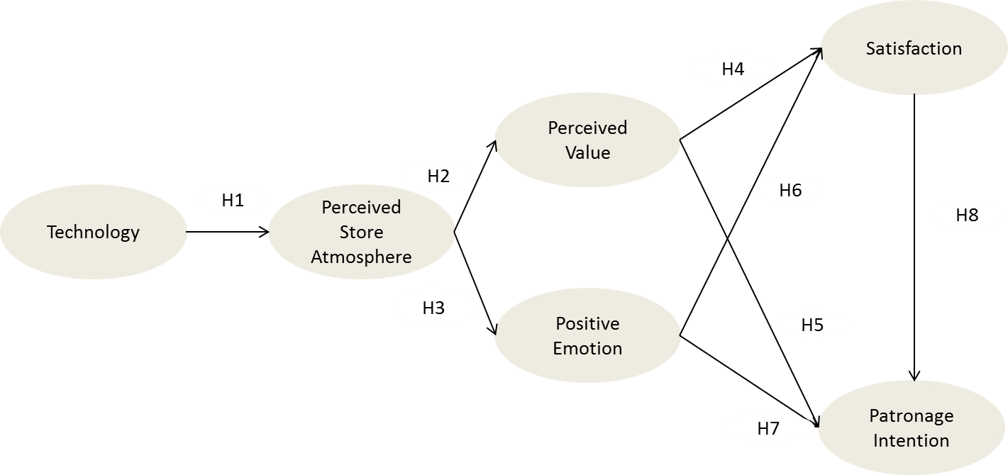
Figure 2: Research model

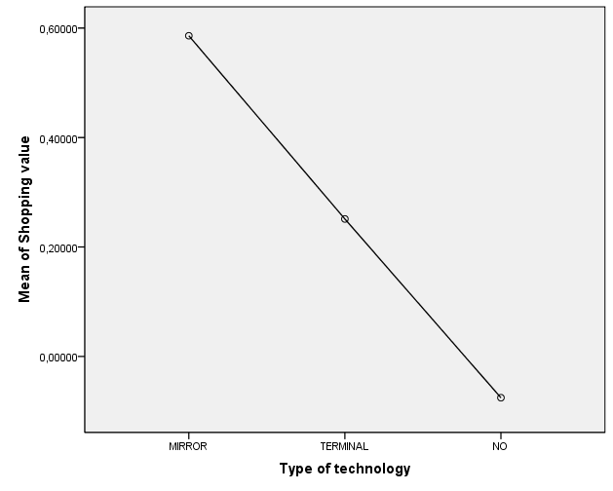 | 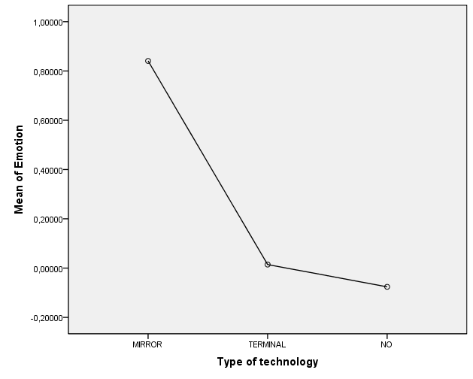
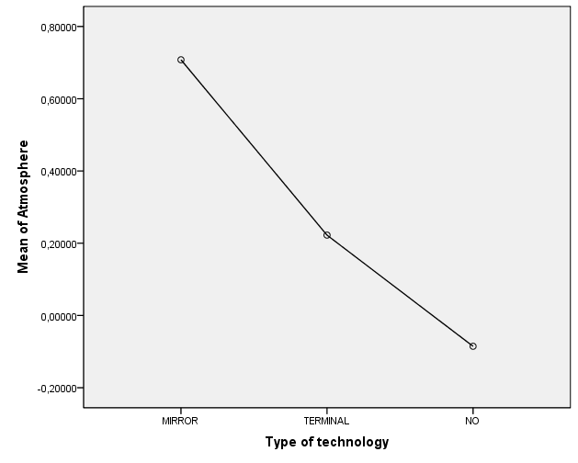
Figure 3: Effects of technology on store atmosphere perceptions, shopping value, and positive emotion

Variables | Source | Items
Shopping value | Allard et al. (2009) | 5 items, 62% explained variance, α = .84
Emotions | Adapted from Mehrabian and Russel (1974) | 6 items, 81% explained variance, α = .95
Perceived store atmosphere | Adapted from Yüksel (2007) | 4 items, 71% explained variance, α = .86
Patronage intentions | Adapted from Wang et al. (2007) | 3 items, 58% explained variance, α = .65
Satisfaction | Adapted from Wang et al. (2007) | 3 items, 90% explained variance, α = .91
Table 1: Measurement scales

Variable | Z | p
Emotion | 7.53177364 | .000
Value | 6.57807041 | .000
Table 2: Sobel test results for shopping value and emotion mediation effects

Variable | Z | p
Satisfaction–positive emotions | 5.72460328 | .000
Satisfaction–shopping value | 5.69135375 | .000
Table 3: Sobel test results for satisfaction mediation effects

Appendix
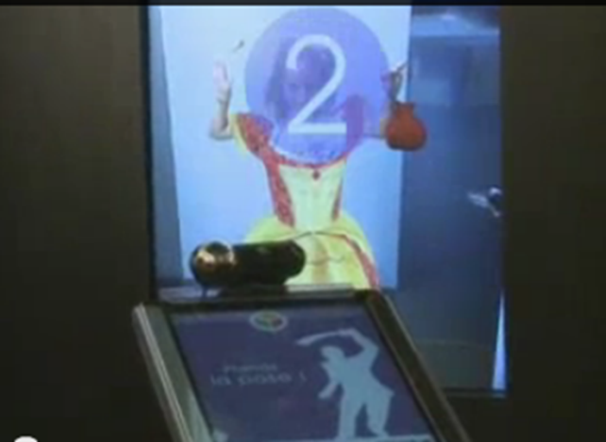 | 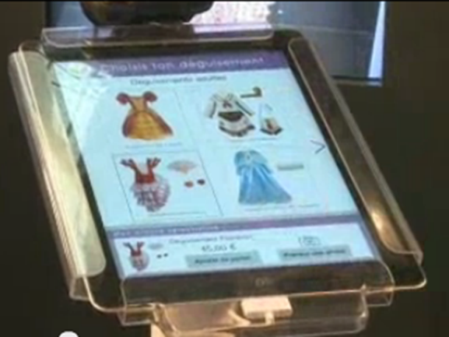
Magic mirror with augmented reality

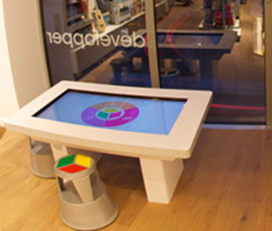
Interactive game terminal

