The financial impact of green transformation-based competencies:
Does Green IS play just a supporting role?

Antony Paulraj
NEOMA Business School
Department of Information Systems, Supply Chain Management & Decision Support
59 rue Pierre Taittinger, Reims, France
Email: antony.paulraj@neoma-bs.fr

Christopher Rajkumar
Xavier Institute of Management and Entrepreneurship
Hosur Rd, Electronic City Phase II, Electronic City,
Bengaluru, Karnataka 560100.
Mobile - +91 9884792272
E-mail: christopher@xime.org

Vaidyanathan Jayaraman
SP Jain School of Global Management
Academic City, Dubai, UAE
E-mail: vaidy.jayaraman@spjain.org

Constantin Blome
Lancaster University Leipzig
Leipzig, Germany
&
Louvain School of Management / CORE
UCLouvain
Louvain-la-Neuve, Belgium.
Email: C.blome@lancaster.ac.uk

ABSTRACT
Competencies such as product stewardship and pollution prevention are essential for a firm’s pursuit of environmental sustainability. Yet, not all firms willingly develop these competencies. Among others, firms that have a strong entrepreneurial orientation are better placed to adopt product stewardship and pollution prevention. Additionally, the implementation of green information systems (Green IS) could significantly moderate the effect of these competencies on the firm’s financial performance. Against this backdrop, a competency-based model is proposed to conjecture the role that Green IS could play in strengthening the influence of entrepreneurial orientation (resource-based competency) on product stewardship and pollution prevention (green transformation-based competencies) as well as the effect of these green transformation-based competencies on financial performance. We test a moderated mediation model using data collected from US manufacturing firms. While we hypothesize Green IS to play a supporting role, interestingly, our results seem to suggest that it is rather pivotal when it comes to the development of green transformation-based competencies.

MANAGERIAL RELEVANCE STATEMENT
To be a good corporate citizen, firms and their managers must invest equally in society and the environment. Specifically, the results from our research suggest that managers view compliance with sustainability requirements as an opportunity rather than a threat. Rather than a burden on the bottom line, becoming environmentally friendly can reduce costs and increase revenues. Against this backdrop, managers must acknowledge the importance of Green IS in creating sustainable business systems. Green IS can play a dominant dual role in a firm's environmental management as it can augment the effect of sustainability practices such as product stewardship and pollution prevention on financial performance. On a related note, proactive environmental management requires that businesses work with governments, universities, industry associations, and environmental groups to incorporate technologies that prevent environmental problems at the source. Additionally, from a purely policy standpoint, regulators, stakeholders, and policymakers must demand that firms disclose their sustainable initiatives, including those related to Green IS.

Keywords: Green transformation-based competencies, product stewardship, pollution prevention, Green IS, financial performance.

1. Introduction
For over two decades, the topic of environmental sustainability has been studied extensively within business management. Operations and supply chain management researchers have examined different practices, including environmental quality standards adoption [1], lean production and environmental performance [2, 3], supply chain flexibility, and green operations [4, 5], and, more broadly, sustainable supply chains [6-9]. Apart from studying the effect of green supply chain practices on environmental and economic performance [8, 10-13], scholars have also highlighted the need to consider key moderating factors when it comes to the impact of drivers on green practices as well as the subsequent performance impacts of green practices [14-20].
We contribute to this line of inquiry given that very little research has focused on the potential role of a diverse set of moderators when it comes to the relationship between green drivers and green practices, as well as between green practices and performance [19, 20]. While many studies have focused on the role of various moderators, including traceability, firm size, industry, and past performance [17, 19, 20], only a handful of researchers have tried to study the moderating role of Green IS [18, 21-23]. Advocating a close fit between green supply chain management practices and Green IS implementation, Yang, et al. [23] and Yang, et al. [22] investigate how Green IS can support green business processes by bringing together elements such as technologies, systems, and users, thereby providing superior benefits to firms. Using a case study approach, Hanelt, et al. [21] contend that Green IS can play a key support role when it comes to the impact of green innovations on organizational performance. Highlighting that green supply chain management practices need not always lead to higher organizational performance, Esfahbodi, et al. [18] study the contingent role of Green IS on the effect of green supply chain management practices on environmental and economic performance improvements. While all these studies focus only on the practices – performance link, Esfahbodi, et al. [18] find mixed results pertaining to the moderating role of Green IS. Therefore, we investigate how the supporting role of Green IS will change if we focus on the drivers – green practices link instead. With this belief, we extend this line of research by empirically testing the complementary (supporting) role of Green IS within the broader conceptualization of drivers – practices – performance context [20].
We draw upon the competency-based perspective, which proposes that firm competencies – resources, skills, and capabilities – can enable organizations to develop as well as implement performance-enhancing strategies [24, 25]. While our base model linking resource-based competency (entrepreneurial orientation), green transformation-based competencies (product stewardship and pollution prevention), and financial performance is well established within the competency-based argument, the main ambition of our research is to specifically evaluate the research question “What role does Green IS play within the broader competency-based perspective?” We adhere to the dynamic competency view [26, 27] and showcase Green IS as a complementary resource that can play an instrumental role in the development of dynamic green transformation-based competencies. Green IS may reduce intra-firm causal ambiguity related to green product and process competencies [28, 29], and, in doing so, hold a greater potential to improve financial performance by leveraging the relationship between organizational competencies and competitive advantage [30, 31]. Overall, the dynamic competency view suggests that Green IS can be more than a passive input and can be actively leveraged by firms to achieve proactive sustainability goals [32].
Our conceptualization of a “support” role of Green IS is warranted in light of the generally inconclusive performance impacts of IS reported in the extant literature [33, 34]. From a resource based view, only those resources and capabilities that cannot be easily duplicated by competitors could provide a sustained competitive advantage [35]. A firm that can “undertake somewhat risky ventures and is first to come up with proactive innovations, thereby beating competitors to the punch” (Miller 1983: 771) can achieve this goal. In this vein, we consider entrepreneurial orientation as part of a competency-based framework that provides the guiding framework within which an organization can achieve sustainable value creation through innovation, risk-taking, and proactivity [37]. In summary, our conceptualization acknowledges that entrepreneurial orientation is the fulcrum around which green transformation-based competencies could be developed. We also assert that Green IS can serve as a strong support mechanism in enhancing the relationship between these competencies and financial performance.
The hypothesized relationships were tested using survey data collected from 241 U.S. manufacturing firms. After assessing non-response and common methods bias, we ensured that our measurement items were valid and reliable. We used regression models to assess the significance of the hypotheses. The mediation, moderation, as well as moderated mediation effects were assessed using the bootstrapping approach outlined by Preacher, et al. [38]. Three of the four hypothesized relationships were found to be supported by our results. Green IS was found to positively moderate the effect of entrepreneurial orientation on product stewardship and the effect of entrepreneurial orientation on pollution prevention. In the case of moderated mediation effects, Green IS was found to enhance financial performance by strengthening the influence of entrepreneurial orientation on product stewardship and by not strengthening the influence of entrepreneurial orientation on pollution prevention.
By testing the proposed hypotheses, our paper makes several contributions at the interface of operations management and information systems [39, 40]. We contend that our results extend past research [18, 21-23] and shed new light on the contingent role of Green IS in improving the financial impact of green transformation-based competencies. We find Green IS to positively moderate the effect of entrepreneurial orientation on green transformation-based competencies. Additionally, though an increase in entrepreneurial orientation resulted in a significant increase in both product stewardship and pollution prevention, these effects were found to be significant only when Green IS was greater than a threshold value. Interestingly, our results suggest that Green IS can play more than a supporting role when it comes to environmental sustainability. Our results also suggest that Green IS enhances financial performance by strengthening the influence of entrepreneurial orientation on green transformation-based competencies. In doing so, our study also confirms the dual role that Green IS can play in a firm’s green supply chain initiatives.
2. Theoretical Framework and Hypotheses Development
2.1 Organizational Competencies and Sustained Competitive Advantage
In this study, we follow Lado and Wilson [24] and define organizational competencies as “firm-specific resources and capabilities that enable the organization to develop, choose, and implement value-enhancing strategies.” This study focuses on two key types of competencies – resource-based competencies and transformation-based competencies – proposed by Lado, et al. [41]. Resource-based competencies consist of tangible and intangible assets that could give firms a sustainable competitive advantage [41]. From a resource-based competency perspective, competitive advantage is achieved by focusing on exploiting the firm’s internal characteristics [42] that include key actions taken by the organization. A firm’s entrepreneurial orientation is reflected in its willingness to take risks, product-market innovation, adaptiveness, and proactiveness. It is also reflected in the processes and procedures that firms can adopt. An entrepreneurial orientation could also play a crucial role in acquiring and mobilizing specialized resources, even for activities where the outcomes are unknown. It reflects the willingness of firms to break away from tradition and venture into the unknown [37, 43]. Therefore, we view entrepreneurial orientation as a resource-based competency that infuses proactiveness, innovativeness, and risk-taking into the firm’s processes, structures, and decision-making [44].
Transformation-based competencies refer to the “organizational capabilities required to convert inputs into outputs” (Lado et al., 1992: 85). The management literature has proposed a diverse set of transformation-based competencies spanning from lean manufacturing to operational excellence as well as sustainable initiatives. These competencies help firms to improve their efficiency, effectiveness, and flexibility, and to ultimately, gain a competitive advantage. But as envisioned by Hart (1995: 991), competitive advantage in the current era will often be “rooted in capabilities that facilitate environmentally sustainable economic activity”. Accordingly, product stewardship and pollution prevention, which are concerned with designing, developing, as well as producing outputs that satisfy the needs of customers as well as other stakeholders, can be considered essential transformation-based competencies.
In this study, we follow Hart [45] and Hart and Dowell [46] and consider product stewardship and pollution prevention as two key environmentally oriented strategic competencies that are essential to offer the end customer a sustainable product or service. These adhere to the norms of transformation-based competencies as they are concerned with the design, development, as well as production of the output [41]. Additionally, these are tacit and causally ambiguous in that they signify a complex set of capabilities, including diverse stakeholder engagement, higher-order learning, and continuous innovation that integrates new materials, technologies as well as ways of doing [47, 48]. Given that these competencies are embedded in organizational routines that are idiosyncratic, historical as well as path-dependent, they could also be a source of long-lasting competitive advantage for the firm [24]. In the next section, we provide a summary of the model that we’ve adopted in our study.
2.2 The Base Model
Before hypothesizing the role of Green IS, we briefly review the competency-based model of environmental management that is adopted in our study. The base model follows extant literature [41] in suggesting that resource-based competencies can enable green transformation-based competencies which in turn could lead to superior firm performance (excluding the moderating effect of Green IS). We do not include any formal hypotheses for studying the link between resource-based competencies, transformation-based competencies, and firm performance. At the same time, we formally discuss the literature that supports the relationships between these three concepts before providing the theoretical arguments for our proposed hypotheses.
[Insert Figure 1 about here]
The myriad of existing environmental problems challenges organizations to proactively innovate rather than merely complying with existing environmental regulations and engaging in monitoring activities [45]. This has compelled firms to develop resources internally and to create new concepts of environmentally-oriented competencies (in our case, product stewardship and pollution prevention) that can likely provide a competitive advantage [16, 47, 48]. To achieve competitive advantage through the pursuit of challenging and risky initiatives, resource-based competencies such as entrepreneurial orientation need to be carefully nurtured within organizations. This would include, among others, a strong cultural emphasis on innovation and R&D, a bold innovative product development approach, and a strong inclination for projects with high risk. Such an entrepreneurial orientation could be instrumental in the development of green transformation-based competencies including product stewardship and pollution prevention.
Only those organizations that have an entrepreneurial orientation will dare to go beyond mere compliance with environmental norms and seek first-mover advantage through the development of green transformation-based competencies that can address the challenges posed by the natural environment [37]. Entrepreneurial orientation is of particular importance given that the development of green transformation-based competencies is often challenging and would require coordination across diverse stakeholders [49-51]. More importantly, given that firms with a strong entrepreneurial orientation would consider their interaction with the natural environment as an opportunity rather than a threat, they will also have an increased proclivity to develop green transformation-based competencies.
Given their ability to offer competitive advantage, product stewardship initiatives that address environmental issues through innovative product design are receiving significant attention from firms [49, 52]. The development of new environmentally oriented products and services signals that a firm is a green entity. Therefore, environmentally conscious firms usually focus on environmentally oriented processes and content changes with the goal of developing products that align with various sustainable development principles [13, 52]. Firms also incorporate design decisions that avoid environmentally hazardous components [53]. Advanced and complicated techniques, such as life cycle assessment, are incorporated to determine as well as negate the environmental impact that a product could have over its useful life and beyond [54, 55]. Design for the environment is an important component of such an analysis; it involves making the considerations of the natural environment an integral part of the design and manufacturing of products [56].
Product stewardship is a transformation-based competency that can enable firms to gain long-lasting competitive advantage through the ability to transform inputs into outputs [46, 47, 49, 57]. Specifically, Kleindorfer, et al. [58] go to the extent of suggesting that firms that introduce sustainable innovations in product design could enjoy first mover advantage and gain a myriad of competitive benefits. For example, 3M has made process changes to eliminate toxic waste. Proctor and Gamble has reformulated their product and process design to successfully use recycled material in their products. Realizing the strategic preemptive nature of product stewardship, many leading companies, including Ford, HP, Clorox, GM, and Whirlpool, have also integrated green aspects into product design [49, 52]. Numerous studies have shown that product stewardship could lead to superior firm performance [18, 20, 49, 52, 59, 60].
Apart from product stewardship, firms can also reduce and minimize their environmental impact through the adoption of proactive pollution prevention strategies [5, 13]. In addition to the reduction of emissions and waste, pollution prevention also encompasses design changes as well as other innovations related to the production processes involved [45]. The first step for most companies is to make the shift from pollution control (cleaning up waste and removing hazardous materials after they have been created) to pollution prevention (focusing on minimizing and eliminating waste and hazardous materials before they are created). Pollution prevention requires the total involvement of employees and continuous improvement strategies to reduce emissions rather than investment in expensive end-of-pipe pollution control technology [61]. More importantly, it also requires close coordination and integration across the different functions within a firm [47]. Following the guidelines of Hart [45], we conceptualize pollution prevention as a second-order factor that includes both green process design and waste reduction initiatives.
Firms can gain significant competitive advantage through the development of pollution prevention competencies [18, 20, 22, 23, 46, 47]. Apart from reducing the cost of pollution control devices, pollution prevention may also increase market-related performance such as improved image, customer satisfaction, and extent of green products [62]. Tsoulfas and Pappis [63] indicate that pollution prevention can lead to the efficient use of energy, water, and by-products. Walton, et al. [64] and Zhu and Cote [65] observe that firms that embrace pollution prevention strategies could generate environmental performance while subsequently cutting costs and reducing environmental impacts. For example, the “pollution prevention pays” program by 3M as well as the “waste reduction always pays” program by Dow have given considerable cost savings for the respective firms [62].
2.3 The Role of Green IS
By being proactive, willing to take risks, and innovative, an organization can influence the efforts that employees devote to managing green initiatives. These initiatives can include substituting polluting and hazardous materials, focusing on waste and noise pollution reduction, and controlling emissions and discharges. Entrepreneurial orientation as a resource-based competency is critical for green transformation-based competencies such as product stewardship and pollution prevention to be successful and to subsequently result in better organizational practices. While the effect of entrepreneurial orientation on green transformation-based competencies is quite intuitive as per the competency-based perspective [41], we postulate that this relationship could be significantly enhanced by having Green IS [66, 67] that can further augment green transformation-based competencies.
Green IS is essential for monitoring and managing firms’ environmental impacts along with the ensuing financial risks as well as benefits [68]. IS can collect, store, manage, and analyze pertinent environmental data, thereby positively influencing the role that entrepreneurial orientation can play in enabling green transformation-based competencies [32, 69]. Such capabilities offered by Green IS could help firms in sensemaking as well as decision making [66, 70]. Through Green IS, firms can easily contend with the various complexities that are inherent in product stewardship and pollution prevention strategies [49, 51]. Specifically, any strategy that embraces the natural environment and societal considerations must deftly balance the needs of the diverse set of performance objectives as well as stakeholders [50]. By enabling firms to capture, process, and analyze information, Green IS can subsequently help firms to better understand the intricacies as well as the performance impacts of product stewardship and pollution prevention. This can facilitate transparency when it comes to material, production processes, and performance outcomes [18]. In other words, Green IS could bring fundamental changes in business processes related to sustainability initiatives [66]. Therefore, while entrepreneurial orientation is the fulcrum around which such green transformation-based competencies could be developed, Green IS can actively complement an organization’s entrepreneurial orientation to (1) dynamically sense the opportunities and threats related to green transformation-based competencies, (2) seize the ability to mobilize the right resources to address the opportunities and threats, and (3) engage in the transformation within the context of green transformation-based competencies [26, 71-73]. The potential supporting role of Green IS is adequately illustrated in extant research [18, 21-23, 74-76]. Taken together, extant anecdotal research supports our contention that Green IS can moderate the positive effect that entrepreneurial orientation can have on green transformation-based competencies such as product stewardship and pollution prevention. Accordingly, we propose the following hypotheses:
H_{1a}: Green IS will moderate the relationship between entrepreneurial orientation and product stewardship.

H_{1b}: Green IS will moderate the relationship between entrepreneurial orientation and pollution prevention.

The integration of considerations about the natural environment adds further complexity to the organizational processes [49]. Given the intricate interdependencies among the different performance domains, firms often find it difficult to determine the impact that changes in production processes might have on these diverse, often conflicting, performance domains. In comparison to pollution prevention, product stewardship is considered to be much more comprehensive [46]. The inherent complexity and ambiguity in understanding the actions-outcome relationships within product stewardship is further attenuated by the active involvement of numerous stakeholders with diverse needs [50]. Thus, product stewardship, as well as pollution prevention, could be considered causally ambiguous even for the firms that try to adopt such practices [35, 77]. While it is important for these green transformation-based competencies to be causally ambiguous to prevent imitation by competitors, firms can neither learn nor successfully develop such competencies if they fail to understand the multiplexed performance implications of their actions [50, 78]. While inter-firm causal ambiguity is essential for achieving competitive advantage, intra-firm causal ambiguity could prevent factor mobility and make it difficult for firms to gain an advantage from green transformation-based competencies [25, 28, 29, 35]. In other words, as suggested by the dynamic competency view, sensing, seizing, and transforming in the case of green competencies will also involve higher-order activities to reach the lofty goals of sustainability [26, 71-73].
Accordingly, following the dynamic competency view, we contend that in addition to the moderating role that Green IS plays in enhancing the relationship between entrepreneurial orientation and green transformation-based competencies, it can also perform a bigger role in enhancing firm performance by minimizing the intra-firm causal ambiguity related to these competencies. Given that the Green IS can ensure that technical aspects can be effectively combined with other skills – people and organizational [73], it has the unique ability to help firms analyze and untangle the complex actions-outcome relationships pertaining to product stewardship and pollution prevention through the collection and synthesis of related data [18, 76]. Specifically, given its ability to enable new practices and processes that support organizational environmental performance, IS is an important weapon in the arsenal of organizations [79]. Within a sustainable manufacturing environment, IS can help standardize, monitor, capture, and utilize data that could facilitate energy efficiencies as well as product enhancements [76, 80]. Unused resources, energy inefficiency, and emissions are all waste that contribute to environmental inefficiency; firms that actively adopt Green IS are in a better position to identify as well as eliminate such inefficiencies in their processes [18]. Additionally, Green IS can also facilitate a broader understanding of existing materials, technologies, and processes, thereby helping organizations to sense opportunities and problems in the product and production systems. In essence, Green IS can help to seize the opportunity to successfully mitigate any detrimental effect of intra-firm causal ambiguity related to these green transformation-based competencies [77, 78, 81]. Grounded with the dynamic competency view, we conjecture the following hypotheses that represent moderated mediation relationships.
H_{2a}: Green IS will enhance financial performance by strengthening the influence of entrepreneurial orientation on product stewardship.

H_{2b}: Green IS will enhance financial performance by strengthening the influence of entrepreneurial orientation on pollution prevention.

3. Research Methodology
3.1 Sampling and Data Collection
As our study aspires to test theoretically motivated hypotheses, a survey research design was considered appropriate [82]. The target sampling frame for this study was obtained from the Institute of Supply Management (ISM). Since ISM is the largest association of supply management professionals in the USA, numerous studies within operations and supply chain management have utilized ISM for the target sampling frame [83-85]. The sampling frame included 3,000 members of ISM working in U.S. manufacturing firms covering multiple SIC codes (20, 28, 34, 35, 36, 37, 28, and 39). Given that our study focuses on green transformation-based competencies – product stewardship and pollution prevention, the context of manufacturing firms is the most appropriate [18, 19]. We sought responses from senior purchasing/supply chain management executives (e.g., senior vice presidents, vice presidents, and directors); this was appropriate as our survey covered questions on the firm as well as on relationship-specific issues. The various factors that were included in the survey instrument were measured using multiple items that were drawn from past empirical studies. These items were captured using a 5-point Likert scale with anchors of either “strongly disagree” to “strongly agree” or “much worse” to “much better.” In the case of supplier-related factors, we suggested the respondents answer based on their top one or two key suppliers; respondents used the dollar amount and/or importance of materials purchased to select the key suppliers. Before creating an online version of the survey, we conducted a pre-test of the questionnaire using eight supply chain professionals as well as academics. Based on the feedback received, some minor modifications were made to the survey questionnaire.
Given that we did not have the email addresses of the respondents from ISM, we initially mailed a cover letter along with a consent form to 1,500 respondents who were randomly selected from the initial sampling frame of 3000 ISM members. The cover letter clearly articulated that the respondents would be included in the study only if they consented to participate. The cover letter also guaranteed the confidentiality of the respondents and the firms that they worked in. The survey items focused specifically on assessing the perception of the respondents on various practices within their firm. Through these approaches, our research ensured that it abided by the ethical considerations of survey research [86]. The respondents had the option to either consent to participate in the survey or provide some basic information about their unwillingness to participate in the survey. If willing to participate, the respondents also had the option to choose how the survey should be delivered to them (i.e., either as a link through email or regular mail). While 30 of these surveys were returned as undelivered, we received 580 consent forms from the remaining 1470 potentially delivered surveys. While 305 respondents indicated their willingness to participate, 275 respondents declined participation. This resulted in an effective sample size of 1195 (1470 – 275). Most of the willing respondents chose to use an online survey, though some requested a paper version of the survey. We received a total of 241 complete responses, which resulted in an effective response rate of 20.17%; the response rate increased to 79% if we only considered participants who were willing to participate in our study. The final sample size, as well as response rate, is considered adequate as it is comparable to other empirical studies within the operations and supply chain management [87-90].

Though we included only senior executives in our initial sampling frame, we wanted to ensure the key respondent issue through additional efforts. We included two Likert-scale questions (where 1 = ‘not at all’ and 5 = ‘significantly’) that asked the respondents how knowledgeable they were with the questions included in the survey as well as how confident they were in answering the questions. The response to these questions (average answer 3.97 and 4.04, respectively) demonstrates that our respondents were key respondents. Additionally, close to 65% of our respondents were senior purchasing executives (president, vice president, and director) in their organization, and approximately 57% of respondents had over 20 years of experience in supply chain management, indicating that they do possess the required knowledge as well as experience to participate in our survey. Apart from their extensive experience, most of our respondents worked for medium to large firms; 58% worked in firms with 1000 or more employees. When it came to annual sales volume, we found the responding firms to be evenly distributed, with the gross income of 23% of the firms being below $100 million while that of 18% of the firms being over $10 billion. In addition to covering a wide range of manufacturing firms in terms of firm size, the proportion of industries covered in our final sample was found to be in line with the initial sampling frame. Therefore, we can safely conclude that our final sample was representative of the different sectors of manufacturing firms that we had wanted to study.
3.2 Survey Instrument Design and Validation
The measurement items for the theoretical constructs in our model were developed based on past research. The construct of entrepreneurial orientation was measured using a six-item scale that captured the extent to which the firm takes risks, innovates, and acts proactively [91]. The construct of product stewardship was captured using a six-item scale that comprised questions taken from past research. [13, 47, 92]; these items captured the extent to which sustainability considerations were included in the design of the products. Pollution prevention includes two first-order constructs – green process design and waste reduction. While the five-item green process design scale measured whether the firms design, monitor, and improve their process to improve the environmental friendliness of their production processes [47, 92], the five-item waste reduction scale measured the extent to which firms reduce waste, material and resource usage [13, 92]. The seven-item Green IS scale was developed based on past research [40]. The measurement items captured the extent of the adoption of information systems to help in (1) selecting cleaner transportation methods, (2) tracking environmental information, and (3) providing customers and suppliers with information about environmental management. Finally, the three-item financial performance scale included indicators that focused on the improvements along with return on assets, profit as a percentage of sales, and net income before tax [10, 93].
We included multiple control variables in the models tested. Researchers suggest that firm size can have a significant impact on the development of green transformation-based competencies as well as on the firm’s financial performance. Therefore, we included firm size as one of the controls [30]. It was measured in comparison to the largest competitor; the respondents were asked to answer the question “when compared to our firm’s largest competitor, our firm size is:”. We also included market share as a control variable; the extent of market share could be a key predictor of motivation to develop green transformation-based competencies [94]. The respondents were asked to answer the question “when compared to our firm’s largest competitor, our market share is:”. Finally, we also controlled for the intensity of competition in the major product line of the responding firm; as competition intensity increases, firms would be encouraged to seek first-mover advantages offered by environmental sustainability [95]. The intensity of competition was captured with the Likert-scale question “in your major product/product line, the intensity of competition is high”; the end points for this question were “1 = not at all” and “5 = significant”.
3.2.1 Non-response Bias
Initially, we assessed non-response bias by comparing early and late respondents [96]; late respondents could be used as a proxy for non-respondents as they responded only after a delay or multiple reminders. The 241 responses were categorized as early or late based on when the surveys were submitted/received; 131 responses were categorized as early, while the remaining 110 responses were categorized as late. Apart from company size, we also randomly selected 10 indicators to be compared between the two groups. Group comparison tests did not reveal any differences at the 95% confidence level between the early and late respondents. Furthermore, we collected information on firm size (annual sales volume and number of employees) from 200 randomly selected non-responding firms. The demographic information of these firms was combined with our sample to represent the population mean. The population mean was compared to the sample (i.e., 241 responding firms); the group comparison tests performed did not reveal any significant differences at p < 0.05. These results also clearly suggest that our final sample was representative of our initial sampling frame.
3.2.2 Common Method Variance
Since we used a single respondent from each responding firm, we took various procedural (prior to collecting data) and methodological (after collecting data) steps to minimize common method variance (CMV). Before collecting data, we incorporated some procedural approaches to eliminate potential bias to common methods. First, we tried to eliminate the bias to commonalities by anchoring the performance-related indicators differently than other indicators. Second, we eliminated acquiescence bias by providing verbal anchors for the mid-point of the 5-point Likert scale used to measure all items [97, 98]. After collecting data, we also used two different methodological approaches to test for CMV. First, we conducted the Harman’s single-factor test using the confirmatory factor analysis approach [97]. The fit indices of the single factor model (NNFI = 0.80; CFI = 0.82; RMSEA = 0.19) were significantly worse than the hypothesized measurement model (NNFI = 0.96; CFI = 0.96; RMSEA = 0.07). Second, we used the marker variable technique [99]. The marker variable was proxied using the second-smallest positive correlation among the survey items. For all statistically significant zero-order correlations, we adjusted them by partialling out the marker variable correlation coefficient [100]. All statistically significant zero-order correlations remained significant after this procedure, suggesting that the method effects are not a concern.
3.2.3 Measurement Instrument

Since our theoretical constructs were latent in nature, we tested for the reliability and validity of the measurement items before testing the proposed hypotheses [84]. Table 1 includes details pertaining to coefficient alpha, coefficient omega, standardized item loadings, composite reliability (CR), and average variance extracted (AVE); Table 2 presents the summary statistics and bivariate correlations. We used both coefficient alpha and coefficient omega to assess the reliability [101]. As evident from Table 1, both coefficient alpha and coefficient omega were above 0.80. Alternatively, scholars also recommend studies to report the confidence intervals for these reliability coefficients [102]; in our case, we find the lower limit of the confidence interval of all constructs to be over 0.70; the lowest value was for financial performance (coefficient alpha: LL = 0.74; coefficient omega: LL = 0.76). We also considered the compositive reliability values; all composite reliability of all constructs surpassed the cut-off value of 0.70. This establishes the reliability of all measurement indicators. Convergent validity of the indicators was established by evaluating the item loadings and their significance. All retained indicators had loadings of more than 0.50 [30]. We conducted additional tests to assess the discriminant validity of the measurement items. First, we adopted the Fornell and Larcker [103] approach. As given in Table 2, the correlation coefficient of each pair of constructs was found to be lower than the square root of the individual AVE values. We also assessed the heterotrait-monotrait (HTMT) ratio of correlations; as suggested by Henseler, et al. [104], this method is considered to be robust in comparison to the Fornell and Larcker [103] approach. The HTMT values ranged from 0.10 to 0.80; none of the values were over the threshold of 0.85. These results provide support for the discriminant validity of the measurement items. During this process, we eliminated three indicators.
[Insert Tables 1 and 2 about here]
3.2.4 Analysis & Results
Our hypothesized model tests for direct, mediation, as well as moderation effects. Therefore, the multiple regression approach was an appropriate approach to test the proposed hypotheses [82]. Table 3 provides the results of the different regression models evaluated. Since our hypotheses involved interaction effects, we mean-centered the variables before creating the interaction terms with the ambition of minimizing non-essential multicollinearity [105]. We used the Breush-Pagan test to check all models for heteroskedasticity; in the case of models that had a significant Breush-Pagan test, we used robust standard errors to test for significance. H_{1a} and H_{1b} hypothesized the moderating effect of Green IS. While models M1 and M3 evaluated the direct effect of entrepreneurial orientation on product stewardship and pollution prevention, respectively, models M2 and M4 evaluated the moderating effect of Green IS on these two direct effects, respectively. Models M5 through M7 report the effects of product stewardship and pollution prevention on financial performance; these results were provided as a basis for testing the moderated mediation effects. As evident from Table 3, we found Green IS to positively moderate the effect of entrepreneurial orientation on (1) product stewardship (β = 0.15; t = 2.68; p < 0.01) and (2) pollution prevention (β = 0.12; t = 2.15; p < 0.05), thereby providing support for hypotheses H_{1a} and H_{1b}.
Additionally, we wanted to shed a more nuanced light on the moderation effects that we had tested. Therefore, following the guidelines provided by Preacher, et al. [38] and Preacher and Hayes [106], we assessed the conditional indirect effects of entrepreneurial orientation on product stewardship and pollution prevention at different levels of Green IS. Numerous studies have adopted this approach to assess the presence of conditional indirect effects [107-110]. The bias-corrected confidence bands for the conditional effects were developed using the bootstrapping approach [38]. The confidence bands for the conditional indirect effects of entrepreneurial orientation on product stewardship and pollution prevention are presented in Figure 2. Though an increase in entrepreneurial orientation resulted in a significant increase in product stewardship (refer to Panel A in Figure 2) as well as pollution prevention (refer to Panel B in Figure 2), these effects were found to be significant only when Green IS was greater than a threshold value; as evident from Figure 2, the threshold value was higher for of pollution prevention.
The remaining two hypotheses (H_{2a} and H_{2b}) represent moderated mediation effects. We tested the moderated mediation using the procedure outlined by Preacher, et al. [38]. First, we used a bootstrapping approach to evaluate whether product stewardship and pollution prevention mediated the effect of entrepreneurial orientation on financial performance measures. As per this test, the mediation effect is significant if the 95% confidence interval of the indirect effect does not include zero [111]. The bootstrapping method is considered far better than the widely used Baron and Kenny [112] approach as well as the Sobel test [106, 111]. While the mediating effect of product stewardship (95% CI = 0.0030 – 0.0695) was found to be statistically significant, the mediating effect of pollution prevention (95% CI = -0.0037 – 0.0471) was not significant. Overall, while one mediation effect was significant, the other was insignificant.
[Insert Table 3 and Figures 2 and 3 about here]
The bias-corrected confidence bands for the conditional indirect effects of entrepreneurial orientation are presented in Figure 3. As given in Figure 3, there is a positive conditional indirect effect of entrepreneurial orientation on financial performance. More interestingly, the indirect effect of entrepreneurial orientation is significant only when Green IS surpassed a threshold value. The moderated mediation index for product stewardship was found to be significant (index = 0.02003; 95% CI = 0.0007 to 0.0669). Even though the mediation effect of pollution prevention was insignificant, we found the moderated mediation index of pollution prevention (index = 0.01997; 95% CI = 0.0008 to 0.0614) to be significant. Based on these results, we could conclude that Green IS should be over the threshold value for entrepreneurial orientation to have a significant effect on financial performance through product stewardship and pollution prevention. In other words, our results find support for hypothesis H_{2a} and only partial support for H_{2b} (as the mediation effect was insignificant).
3.2.5 Effect Size and Practical Significance
In addition to statistical significance, we also assessed the practical significance of our results [113]. While partial eta-squared (η²) values are used predominantly in social sciences, there is a higher chance that it might be biased when the sample size is small. Therefore, scholars suggest research to report the omega-squared (Ω²) values as well [114]. Please refer to Table 3 for these statistics reflecting practical significance. In social sciences research, the value for η² ranges between 0.01 (small effect) and 0.09 (large effect) [115]. In the case of product stewardship, the effect size of Green IS (M2: η² = 0.285; Ω² = 0.280) seemed to be significantly higher than the effect size of entrepreneurial orientation (M2: η² = 0.028; Ω² = 0.023). A similar result was evident in the case of pollution prevention as well; the effect size of Green IS (M4: η² = 0.479; Ω² = 0.475) seemed to be significantly higher than the effect size of entrepreneurial orientation (M4: η² = 0.005; Ω² = 0.000). Additionally, in models M2 and M4, the interaction effects of Green IS seemed to have a small to medium effect on product stewardship (M2: η² = 0.032; Ω² = 0.027) and pollution prevention (M4: η² = 0.024; Ω² = 0.019) respectively. In essence, these results suggest that Green IS might play more than just a supporting role in developing green transformation-based competencies.
4. DISCUSSION AND IMPLICATIONS
While considerable research effort has been dedicated to studying the performance implications of green supply chain practices, scholars have increasingly suggested the importance of studying the contingent effect of a diverse set of moderators on the effect of drivers and green supply chain practices and the subsequent effect on performance measures [14, 17, 19, 20]. Within this broader inquiry, the contingent supporting effect of Green IS has also been explored, though to a limited extent [18, 21-23]. These studies specifically focus on the moderating effect of Green IS on the relationship between green supply chain practices and performance. While Hanelt, et al. [21], Yang, et al. [22] and Yang, et al. [23] find the moderating effect of Green IS to be positive, Esfahbodi, et al. [18] find mixed results. These mixed results prompt a need to test the key supporting role of Green IS on the link between drivers - green practices [20]. With this belief, we extend this line of research by empirically testing the potential complementary (supporting) role of Green IS within the broader conceptualization of drivers – practices – performance context [20]. Specifically, we not only conjecture but also find support for the contingent role of Green IS on the driver – practices link. Through a moderated mediation model, we also show that Green IS can influence the financial performance of firms by supporting the entrepreneurial orientation of the focal firms; as opposed to past studies [18, 21-23], we focus on the financial performance of the focal firms. The results of our study not only clarify its “key enabler” role when it comes to green transformation-based competencies but also reinforce the ideology that information systems do matter. Our results demonstrate that Green IS could serve as a significant source of competitive advantage by enabling firms to realize the full potential of green transformation-based competencies [116].
4.1 Research Implications
Interestingly, our results suggest that Green IS could play more than a support role when it comes to the development of green transformation-based competencies. Apart from statistical significance, Green IS was found to have a significantly higher practical significance when compared to that of the highly-touted role of entrepreneurial orientation; the effect size of Green IS (product stewardship – η² = 0.285; pollution prevention – η² = 0.479) was at least ten-fold higher than the effect size of entrepreneurial orientation (product stewardship – η² = 0.028; pollution prevention – η² = 0.005). While entrepreneurial orientation is seen as a pivotal force in the development of organizational competencies, it seems that such an orientation might not, by itself, be sufficient in the development of green transformation-based competencies. We conjecture that this could be attributed to the fact that the commercial success of green transformation-based competencies is still widely debated [117]. By facilitating the collection, categorization, and synthesis of information [76], Green IS can help firms to decipher the complex actions-outcome aspects of green transformation-based competencies. In other words, it can play an instrumental role in reducing the intra-firm causal ambiguity, thereby helping firms not only increase factor mobility but also realize the full potential of green transformation-based competencies [25, 28, 35]. Overall, adhering to the tenets of the dynamic competency view, our results clearly suggest that Green IS can facilitate sensing, seizing, and transforming within the context of green transformation-based competencies [26, 71-73], thereby leading to competitive advantage.
Our second implication is the evidence that we provide on the conditional effect of Green IS on a firm’s financial performance through the positive moderation of the driver – green transformation-based competencies links. We find Green IS to have a considerably higher moderation effect on the path from entrepreneurial orientation to product stewardship (η² = 0.032) as opposed to the path to pollution prevention (η² = 0.024). On the contrary, the direct effect of Green IS on pollution prevention (η² = 0.479) seems to be considerably higher when compared to the direct effect on product stewardship (η² = 0.285). Additionally, when compared to the conditional effect of entrepreneurial orientation on pollution prevention, the conditional effect of entrepreneurial orientation on product stewardship is significant at lower levels of Green IS (Figure 2); a similar pattern is evident when it comes to the conditional effect of entrepreneurial orientation on firm performance (Figure 2). The stronger direct effect of Green IS on pollution prevention suggests that product stewardship is a more complex competency [45]. While lower levels of Green IS are sufficient to assist with “low-hanging fruits” such as pollution prevention [45, 118], firms need higher investments in Green IS to gain performance benefits from advanced green practices. The increased complexity inherent in product stewardship seems to showcase the instrumental role that Green IS could play in not only understanding the actions-outcome relationships but also mitigating the intra-firm causal ambiguity related to product stewardship [25, 28, 35]. Overall, our results suggest that Green IS could enhance the performance benefits that firms could gain from proactive green transformation-based competencies. This is a key finding because scholars have also raised concerns over the positive effect of green initiatives on firm-level performance [18]. Overall, our findings clearly suggest that Green IS can be a value-adding initiative that has a positive moderating influence on product stewardship, pollution prevention, as well as on a firm’s financial performance.
4.2 Managerial and Policy Implications
Sustainability is not a burden on bottom lines; in fact, becoming environmentally friendly has been shown to reduce costs and increase revenues. Managers should realize that Green IS could be a major driving force in creating sustainable business systems. As indicated by our results, Green IS can play a very dominant dual role in a firm’s environmental management: it not only moderates the path from entrepreneurial orientation to product stewardship and pollution prevention but also enhances financial performance by strengthening the influence of entrepreneurial orientation on product stewardship and pollution prevention. Accordingly, Green IS must be viewed as an opportunity to enhance profitability. Proactive environmental management requires that businesses work together with governments, universities, industry associations, and environmental groups to seek efficient solutions to environmental problems and to incorporate technologies that prevent environmental problems at the source.
From a policy standpoint, regulators, stakeholders, and policymakers need to demand that firms disclose their sustainable initiatives, including those related to Green IS. Governments can encourage a much wider adoption of Green IS by providing tax incentives and rebates. Regulatory bodies such as the EPA and other external stakeholders (NGOs, associations) can play a critical role by encouraging disclosure of information related to greenhouse gas emissions. To be a good corporate citizen, firms must invest equally in society and the environment. Unfortunately, the initial steps taken by firms on the long journey towards sustainability are driven by regulations. Sometimes, these codes and policies are more stringent than most laws that are in place in different countries, particularly when they apply to cross-border business. However, firms must view such compliances as opportunities rather than threats. Leveraging IS to produce environmentally friendly goods/services could very well constitute a huge opportunity for managers in the history of sustainable business.
4.3 Limitations and Directions for Future Research
Now, we discuss the limitations of our research with the ambition of providing future research opportunities. First, our study extended research on the moderating role of Green IS in influencing the drivers – practices – performance link. Future research can also adopt the broader conceptualization of drivers – practices – performance links [20] to investigate the supporting role of Green IS within the purview of environmental, social, as well as economic performance measures. Second, the use of cross-sectional data limits our ability to provide a richer conceptualization of the relationship between entrepreneurial orientation, product stewardship, pollution prevention, and performance. Re-evaluating our hypotheses using longitudinal data would help in testing the causal inter-relationships between these constructs as well as the key supporting role of Green IS. Third, we collected data from a single respondent perspective (To perform IRR, we picked a random sample of 20 firms and administered the survey to a second respondent). Future research can use dyadic data from multiple respondents to validate our results. Our measures of financial performance, entrepreneurial orientation, and green transformation-based competencies are based on perceptual data from managers. While such self-reported measures are prone to social desirability bias, it is also plausible that the firms that did not respond might have perceived themselves not to be environmentally responsible. Clearly, such companies might only react when their legal and social legitimation is threatened by governmental and stakeholder interference. As future research, it would be interesting to empirically analyze whether adopting a reactive strategy would lead to profitable firm performance.

REFERENCES
[1] C. J. Corbett and D. A. Kirsch, "Response to “Revisiting ISO 14000 diffusion: A new ”look“ at the drivers of certification”," Production and Operations Management, vol. 13, no. 3, pp. 268-271, 2004, doi: 10.1111/j.1937-5956.2004.tb00511.x.
[2] S. G. Azevedo, H. Carvalho, S. Duarte, and V. Cruz-Machado, "Influence of green and lean upstream supply chain management practices on business sustainability," IEEE Transactions on Engineering Management, vol. 59, no. 4, pp. 753-765, 2012.
[3] M. S. Kaswan, R. Rathi, J. A. G. Reyes, and J. Antony, "Exploration and investigation of green lean six sigma adoption barriers for manufacturing sustainability," IEEE Transactions on Engineering Management, 2021.
[4] Y. Liu, Y. Zhang, L. Batista, and K. Rong, "Green operations: What's the role of supply chain flexibility?," International Journal of Production Economics, vol. 214, pp. 30-43, 2019.
[5] C. Rusinko, "Green manufacturing: An evaluation of environmentally sustainable manufacturing practices and their impact on competitive outcomes," IEEE Transactions on Engineering Management, vol. 54, no. 3, pp. 445-454, 2007.
[6] R. Guo, H. L. Lee, and R. Swinney, "Responsible sourcing in supply chains," Management Science, vol. 62, no. 9, pp. 2722-2744, 2016.
[7] J. D. Linton, R. Klassen, and V. Jayaraman, "Sustainable supply chains: An introduction," Journal of Operations Management, vol. 25, no. 6, pp. 1075-1082, 2007, doi: 10.1016/j.jom.2007.01.012.
[8] A. Paulraj and C. Blome, "Plurality in environmental supply chain mechanisms: Differential effects on triple bottom line outcomes," International Journal of Operations and Production Management, vol. 37, no. 8, pp. 1010-1030, 2017.
[9] M. Zhang, Y. K. Tse, J. Dai, and H. K. Chan, "Examining green supply chain management and financial performance: Roles of social control and environmental dynamism," IEEE Transactions on Engineering Management, vol. 66, no. 1, pp. 20-34, 2017.
[10] P. Rao and D. Holt, "Do green supply chains lead to competitiveness and economic performance?," International Journal of Operations and Production Management, vol. 25, no. 9, pp. 898-916, 2005, doi: 10.1108/01443570510613956.
[11] A. Paulraj, "Understanding the relationships between internal resources and capabilities, sustainable supply management and organizational sustainability," Journal of Supply Chain Management, vol. 47, no. 1, pp. 19-37, 2011, doi: 10.1111/j.1745-493X.2010.03212.x.
[12] S. Li, V. Jayaraman, A. Paulraj, and K.-c. Shang, "Proactive environmental strategies and performance: Role of green supply chain processes and green product design in the Chinese high-tech industry," International Journal of Production Research, vol. 54, no. 7, pp. 2136-2151, 2016.
[13] Q. Zhu and J. Sarkis, "Relationships between operational practices and performance among early adopters of green supply chain management practices in Chinese manufacturing enterprises," Journal of Operations Management, vol. 22, no. 3, pp. 265-289, 2004.
[14] F. Montabon, M. Pagell, and Z. Wu, "Making sustainability sustainable," Journal of Supply Chain Management, vol. 52, no. 2, pp. 11-27, 2016.
[15] F. Ye, G. Huang, Y. Zhan, and Y. Li, "Factors mediating and moderating the relationships between green practice and environmental performance: Buyer–supplier relation and institutional context," IEEE Transactions on Engineering Management, vol. 70, no. 1, pp. 142-155, 2021.
[16] Y. Yi, S. Zeng, H. Chen, and J. J. Shi, "When does it pay to be good? A meta-analysis of the relationship between green innovation and financial performance," IEEE Transactions on Engineering Management, vol. 70, no. 9, pp. 3260-3270, 2023.
[17] R. Geng, S. A. Mansouri, and E. Aktas, "The relationship between green supply chain management and performance: A meta-analysis of empirical evidences in Asian emerging economies," International Journal of Production Economics, vol. 183, pp. 245-258, 2017.
[18] A. Esfahbodi, Y. Zhang, Y. Liu, and D. Geng, "The fallacy of profitable green supply chains: The role of green information systems (GIS) in attenuating the sustainability trade-offs," International Journal of Production Economics, vol. 255, p. 108703, 2023.
[19] P. D. Cousins, B. Lawson, K. J. Petersen, and B. Fugate, "Investigating green supply chain management practices and performance: The moderating roles of supply chain ecocentricity and traceability," International Journal of Operations and Production Management, vol. 39, no. 5, pp. 767-786, 2019.
[20] G. J. Micheli, E. Cagno, G. Mustillo, and A. Trianni, "Green supply chain management drivers, practices and performance: A comprehensive study on the moderators," Journal of Cleaner Production, vol. 259, p. 121024, 2020.
[21] A. Hanelt, R. Bohnsack, D. Marz, and C. Antunes Marante, "A systematic review of the literature on digital transformation: Insights and implications for strategy and organizational change," Journal of Management Studies, vol. 58, no. 5, pp. 1159-1197, 2021.
[22] Z. Yang, J. Sun, Y. Zhang, and Y. Wang, "Peas and carrots just because they are green? Operational fit between green supply chain management and green information system," Information Systems Frontiers, vol. 20, no. 3, pp. 627-645, 2018.
[23] Z. Yang, J. Sun, Y. Zhang, and Y. Wang, "Perceived fit between green IS and green SCM: Does it matter?," Information & Management, vol. 56, no. 7, p. 103154, 2019.
[24] A. A. Lado and M. C. Wilson, "Human resource systems and sustained competitive advantage: A competency-based perspective," Academy of Management Review, vol. 19, no. 4, pp. 699-727, 1994, doi: 10.2307/258742.
[25] R. Reed and R. J. DeFillippi, "Causal ambiguity, barriers to imitation, and sustainable competitive advantage," Academy of Management Review, vol. 15, no. 1, pp. 88-102, 1990.
[26] D. Teece and G. Pisano, "The dynamic capabilities of firms: An introduction," Industrial and Corporate Change, vol. 3, no. 3, pp. 537-556, 1994.
[27] W. C. Bogner, H. Thomas, and J. McGee, "Competence and competitive advantage: Towards a dynamic model," British Journal of Management, vol. 10, no. 4, pp. 275-290, 1999.
[28] A. W. King, "Disentangling interfirm and intrafirm causal ambiguity: A conceptual model of causal ambiguity and sustainable competitive advantage," Academy of Management Review, vol. 32, no. 1, pp. 156-178, 2007.
[29] A. W. King and C. P. Zeithaml, "Competencies and firm performance: Examining the causal ambiguity paradox," Strategic Management Journal, vol. 22, no. 1, pp. 75-99, 2001.
[30] A. Paulraj, A. A. Lado, and I. J. Chen, "Inter-organizational communication as a relational competency: Antecedents and performance outcomes in collaborative buyer–supplier relationships," Journal of Operations Management, vol. 26, no. 1, pp. 45-64, 2008.
[31] T. C. Powell and A. Dent-Micallef, "Information technology as competitive advantage: The role of human, business, and technology resources," Strategic Management Journal, vol. 18, no. 5, pp. 375-405, 1997.
[32] X. Ning and J. Khuntia, "The Hierarchy of Green Information Systems Capability in Organizations to Enhance and Ensure Green Performance: An Operant Resources Perspective," Communications of the Association for Information Systems, vol. 53, no. 1, p. 3, 2023.
[33] N. G. Carr, "IT doesn’t matter," Harvard Business Review, vol. 81, no. 5, pp. 41–49, 2003.
[34] F. J. Mata, W. L. Fuerst, and J. B. Barney, "Information technology and sustained competitive advantage: A resource-based analysis," MIS Quarterly, vol. 19, no. 4, pp. 487-505, 1995, doi: 10.2307/249630.
[35] S. A. Lippman and R. P. Rumelt, "Uncertain imitability: An analysis of interfirm differences in efficiency under competition," The Bell Journal of Economics, vol. 13, no. 2, pp. 418-438, 1982, doi: 10.2307/3003464.
[36] D. Miller, "The correlates of entrepreneurship in three types of firms," Management Science, vol. 29, no. 7, pp. 770-791, 1983.
[37] J. Wiklund and D. Shepherd, "Knowledge‐based resources, entrepreneurial orientation, and the performance of small and medium‐sized businesses," Strategic Management Journal, vol. 24, no. 13, pp. 1307-1314, 2003.
[38] K. J. Preacher, D. D. Rucker, and A. F. Hayes, "Addressing moderated mediation hypotheses: Theory, methods, and prescriptions," Multivariate Behavioral Research, vol. 42, no. 1, pp. 185-227, 2007, doi: 10.1080/00273170701341316.
[39] A. Malhotra, N. P. Melville, and R. T. Watson, "Spurring impactful research on information systems for environmental sustainability," MIS Quarterly, vol. 37, no. 4, pp. 1265-1274, 2013.
[40] R. T. Watson, M.-C. Boudreau, and A. J. Chen, "Information systems and environmentally sustainable development: Energy informatics and new directions for the IS community," MIS Quarterly, pp. 23-38, 2010.
[41] A. A. Lado, N. G. Boyd, and P. Wright, "A competency-based model of sustainable competitive advantage: Toward a conceptual integration," Journal of Management, vol. 18, no. 1, pp. 77-91, 1992, doi: 10.1177/014920639201800106.
[42] G. Hamel and C. K. Prahalad, "Competing for the future," Harvard Business Review, vol. 72, no. 4, pp. 122-128, 1994.
[43] J. Wiklund, "The sustainability of the entrepreneurial orientation—performance relationship," Entrepreneurship Theory and Practice, vol. 24, no. 1, pp. 37-48, 1999.
[44] J. G. Covin and D. P. Slevin, "Strategic management of small firms in hostile and benign environments," Strategic management journal, vol. 10, no. 1, pp. 75-87, 1989.
[45] S. Hart, "A natural-resource-based view of the firm," Academy of Management Review, vol. 20, no. 4, pp. 986-1014, 1995, doi: 10.2307/258963.
[46] S. L. Hart and G. Dowell, "Invited editorial: A natural-resource-based view of the firm: Fifteen years after," Journal of Management, vol. 37, no. 5, pp. 1464-1479, 2011.
[47] J. A. Aragón-Correa and S. Sharma, "A contingent resource-based view of proactive corporate environmental strategy," Academy of Management Review, vol. 28, no. 1, pp. 71-88, 2003, doi: 10.5465/AMR.2003.8925233.
[48] S. Sharma and H. Vredenburg, "Proactive corporate environmental strategy and the development of competitively valuable organizational capabilities," Strategic Management Journal, vol. 19, no. 8, pp. 729-753, 1998.
[49] R. M. Dangelico, P. Pontrandolfo, and D. Pujari, "Developing sustainable new products in the textile and upholstered furniture industries: Role of external integrative capabilities," Journal of Product Innovation Management, vol. 30, no. 4, pp. 642-658, 2013, doi: 10.1111/jpim.12013.
[50] J. Hall and H. Vredenburg, "Managing stakeholder ambiguity," Sloan Management Review, vol. 47, no. 1, pp. 11-13, 2005.
[51] S. Matos and J. Hall, "Integrating sustainable development in the supply chain: The case of life cycle assessment in oil and gas and agricultural biotechnology," Journal of Operations Management, vol. 25, no. 6, pp. 1083-1102, 2007, doi: 10.1016/j.jom.2007.01.013.
[52] R. Dangelico and D. Pujari, "Mainstreaming green product innovation: Why and how companies integrate environmental sustainability," Journal of Business Ethics, vol. 95, no. 3, pp. 471-486, 2010, doi: 10.1007/s10551-010-0434-0.
[53] Q. Zhu, J. Sarkis, J. J. Cordeiro, and K.-H. Lai, "Firm-level correlates of emergent green supply chain management practices in the Chinese context," Omega, vol. 36, no. 4, pp. 577-591, 2008, doi: 10.1016/j.omega.2006.11.009.
[54] D. W. Pennington et al., "Life cycle assessment Part 2: Current impact assessment practice," Environment International, vol. 30, no. 5, pp. 721-739, 2004.
[55] G. Rebitzer et al., "Life cycle assessment: Part 1: Framework, goal and scope definition, inventory analysis, and applications," Environment International, vol. 30, no. 5, pp. 701-720, 2004.
[56] G. Allenby, Industrial Ecology. New York, NY: Prentice Hall, 1993.
[57] P. H. Driessen, B. Hillebrand, R. A. Kok, and T. M. Verhallen, "Green new product development: The pivotal role of product greenness," IEEE Transactions on Engineering Management, vol. 60, no. 2, pp. 315-326, 2013.
[58] P. R. Kleindorfer, K. Singhal, and L. N. Wassenhove, "Sustainable operations management," Production and Operations Management, vol. 14, no. 4, pp. 482-492, 2005, doi: 10.1111/j.1937-5956.2005.tb00235.x.
[59] A. Agarwal, F. C. Giraud-Carrier, and Y. Li, "A mediation model of green supply chain management adoption: The role of internal impetus," International Journal of Production Economics, vol. 205, pp. 342-358, 2018.
[60] A. Paulraj, C. Rajkumar, C. Blome, and M. Faruquee, "The rugged landscape of product stewardship: Does it invoke the double-edged effect of knowledge acquisition?," Supply Chain Management: An International Journal, 2023.
[61] N. Roome and F. Wijen, "Stakeholder power and organizational learning in corporate environmental management," Organization Studies, vol. 27, no. 2, pp. 235-263, 2006.
[62] B. Smart, Beyond compliance-a new industry view of the environment. Washington, DC: World Resources Institute, 1992.
[63] G. T. Tsoulfas and C. P. Pappis, "Environmental principles applicable to supply chains design and operation," Journal of Cleaner Production, vol. 14, no. 18, pp. 1593-1602, 2006.
[64] S. V. Walton, R. B. Handfield, and S. A. Melnyk, "The green supply chain: Integrating suppliers into environmental management processes," International Journal of Purchasing and Materials Management, vol. 34, no. 1, pp. 2-11, 1998.
[65] Q. Zhu and R. P. Cote, "Integrating green supply chain management into an embryonic eco-industrial development: A case study of the Guitang Group," Journal of Cleaner Production, vol. 12, no. 8-10, pp. 1025-1035, 2004.
[66] S. Seidel, J. Recker, and J. Vom Brocke, "Sensemaking and sustainable practicing: Functional affordances of information systems in green transformations," MIS Quarterly, pp. 1275-1299, 2013.
[67] S. Watts, "Electronic integration of CSR reporting systems for stakeholder responsiveness," in Management Decision Americas Conference on Information Systems, 2016, p. 3.
[68] T. A. Jenkin, J. Webster, and L. McShane, "An agenda for ‘Green’information technology and systems research," Information and Organization, vol. 21, no. 1, pp. 17-40, 2011.
[69] P. Weill and J. Ross, "A matrixed approach to designing IT governance," Sloan Management Review, vol. 46, no. 2, p. 26, 2005.
[70] T. Butler, "Compliance with institutional imperatives on environmental sustainability: Building theory on the role of Green IS," Journal of Strategic Information Systems, vol. 20, no. 1, pp. 6-26, 2011, doi: 10.1016/j.jsis.2010.09.006.
[71] P. Mikalef and A. Pateli, "Information technology-enabled dynamic capabilities and their indirect effect on competitive performance: Findings from PLS-SEM and fsQCA," Journal of Business Research, vol. 70, pp. 1-16, 2017.
[72] R. Torres, A. Sidorova, and M. C. Jones, "Enabling firm performance through business intelligence and analytics: A dynamic capabilities perspective," Information and Management, vol. 55, no. 7, pp. 822-839, 2018.
[73] D. Steininger, P. Mikalef, A. Pateli, and A. Ortiz de Guinea, "Dynamic capabilities in information systems research: A critical review, synthesis of current knowledge, and recommendations for future research," Journal of the Association for Information Systems, vol. 23, no. 2, pp. 447-490, 2022.
[74] R. T. Watson, M.-C. Boudreau, A. Chen, and M. Huber, "Green IS: Building sustainable business practices," in Information Systems: A Global Text, T. Watson Richard Ed. Athens, GA: Global Text Project, 2008, pp. 1-17.
[75] S. Elliot, "Transdisciplinary perspectives on environmental sustainability: A resource base and framework for IT-enabled business transformation," MIS Quarterly, vol. 35, no. 1, pp. 197-236, 2011, doi: 10.2307/23043495.
[76] N. P. Melville, "Information systems innovation for environmental sustainability," MIS Quarterly, vol. 34, no. 1, pp. 1-21, 2010, doi: 10.2307/20721412.
[77] S. Konlechner and V. Ambrosini, "Issues and trends in causal ambiguity research: A review and assessment," Journal of Management, vol. 45, no. 6, pp. 2352-2386, 2019.
[78] V. Ambrosini and C. Bowman, "Reducing causal ambiguity to facilitate strategic learning," Management Learning, vol. 36, no. 4, pp. 493-512, 2005.
[79] K. Marett, R. F. Otondo, and G. S. Taylor, "Assessing the effects of benefits and institutional influences on the continued use of environmentally munificent bypass systems in long-haul trucking," MIS Quarterly, pp. 1301-1312, 2013.
[80] K. Iyengar, J. R. Sweeney, and R. Montealegre, "Information technology use as a learning mechanism: The impact of IT use on knowledge transfer effectiveness, absorptive capacity, and franchisee performance," MIS Quarterly, vol. 39, no. 3, pp. 615-642, 2015.
[81] L. Mulotte, P. Dussauge, and W. Mitchell, "Does pre‐entry licensing undermine the performance of subsequent independent activities? Evidence from the global aerospace industry, 1944–2000," Strategic Management Journal, vol. 34, no. 3, pp. 358-372, 2013.
[82] J. F. Hair, "Multivariate data analysis: An overview," in International Encyclopedia of Statistical Science, M. Lovric Ed. Berlin, Heidelberg: Springer Berlin Heidelberg, 2011, pp. 904-907.
[83] A. J. Van Weele and E. M. Van Raaij, "The future of purchasing and supply management research: About relevance and rigor," Journal of Supply Chain Management, vol. 50, no. 1, pp. 56-72, 2014.
[84] I. J. Chen and A. Paulraj, "Towards a theory of supply chain management: the constructs and measurements," Journal of Operations Management, vol. 22, no. 2, pp. 119-150, 2004.
[85] C. W. Craighead, G. T. M. Hult, and D. J. Ketchen Jr, "The effects of innovation–cost strategy, knowledge, and action in the supply chain on firm performance," Journal of Operations Management, vol. 27, no. 5, pp. 405-421, 2009.
[86] E. Singer, "Risk, benefit, and informed consent in survey research," Survey Research, vol. 35, no. 2-3, pp. 1-6, 2004.
[87] S. Ambulkar, J. Blackhurst, and S. Grawe, "Firm's resilience to supply chain disruptions: Scale development and empirical examination," Journal of Operations Management, vol. 33, pp. 111-122, 2015.
[88] D. Rexhausen, R. Pibernik, and G. Kaiser, "Customer-facing supply chain practices—The impact of demand and distribution management on supply chain success," Journal of Operations Management, vol. 30, no. 4, pp. 269-281, 2012.
[89] C. Bode, S. M. Wagner, K. J. Petersen, and L. M. Ellram, "Understanding responses to supply chain disruptions: Insights from information processing and resource dependence perspectives," Academy of Management Journal, vol. 54, no. 4, pp. 833-856, 2011.
[90] D. Prajogo, A. Nair, and P. Castka, "The effects of external auditors and certification bodies on the operational and market-oriented outcomes of ISO 9001 implementation," IEEE Transactions on Engineering Management, vol. 69, no. 4, pp. 1447-1458, 2020.
[91] G. T. Lumpkin and G. G. Dess, "Clarifying the entrepreneurial orientation construct and linking it to performance," Academy of Management review, vol. 21, no. 1, pp. 135-172, 1996, doi: 10.5465/AMR.1996.9602161568.
[92] J. González-Benito and Ó. González-Benito, "Environmental proactivity and business performance: an empirical analysis," Omega, vol. 33, no. 1, pp. 1-15, 2005, doi: 10.1016/j.omega.2004.03.002.
[93] S. Narayanan, V. Jayaraman, Y. Luo, and J. M. Swaminathan, "The antecedents of process integration in business process outsourcing and its effect on firm performance," Journal of Operations Management, vol. 29, no. 1-2, pp. 3-16, 2011, doi: 10.1016/j.jom.2010.05.001.
[94] W. Boulding and R. Staelin, "A look on the cost side: Market share and the competitive environment," Marketing Science, vol. 12, no. 2, pp. 144-166, 1993.
[95] S. E. Khilji, T. Mroczkowski, and B. Bernstein, "From Invention to Innovation: Toward Developing an Integrated Innovation Model for Biotech Firms *," Journal of Product Innovation Management, vol. 23, no. 6, pp. 528-540, 2006, doi: 10.1111/j.1540-5885.2006.00222.x.
[96] S. G. Rogelberg and J. M. Stanton, "Introduction - Understanding and dealing with organizational survey nonresponse," Organizational Research Methods, vol. 10, no. 2, pp. 195-209, 2007.
[97] P. M. Podsakoff, S. B. Mackenzie, J.-Y. Lee, and N. P. Podsakoff, "Common method biases in behavioral research: A critical review of the literature and recommended remedies," Journal of Applied Psychology, vol. 88, no. 5, pp. 879-903, 2003.
[98] R. Tourangeau, L. J. Rips, and K. Rasinski, The psychology of survey response. Cambridge, UK: Cambridge University Press, 2000.
[99] N. K. Malhotra, S. S. Kim, and A. Patil, "Common method variance in IS research: A comparison of alternative approaches and a reanalysis of past research," Management Science, vol. 52, no. 12, pp. 1865-1883, 2006, doi: 10.1287/mnsc.1060.0597.
[100] M. K. Lindell and D. J. Whitney, "Accounting for common method variance in cross-sectional research designs," Journal of Applied Psychology, vol. 86, no. 1, pp. 114-121, 2001.
[101] L. Deng and W. Chan, "Testing the difference between reliability coefficients alpha and omega," Educational and Psychological Measurement, vol. 77, no. 2, pp. 185-203, 2017.
[102] T. Raykov and P. E. Shrout, "Reliability of scales with general structure: Point and interval estimation using a structural equation modeling approach," Structural Equation Modeling: A Multidisciplinary Journal, vol. 9, no. 2, pp. 195-212, 2002.
[103] C. Fornell and D. Larcker, "Evaluating structural equation models with unobservable variables and measurement error," Journal of Marketing Research, vol. 18, no. 1, pp. 39-50, 1981.
[104] J. Henseler, C. Ringle, and M. Sarstedt, "A new criterion for assessing discriminant validity in variance-based structural equation modeling," Journal of the Academy of Marketing Science, vol. 43, no. 1, pp. 115-135, 2015.
[105] D. K. Dalal and M. J. Zickar, "Some common myths about centering predictor variables in moderated multiple regression and polynomial regression," Organizational Research Methods, vol. 15, no. 3, pp. 339-362, 2012.
[106] K. J. Preacher and A. F. Hayes, "Asymptotic and resampling strategies for assessing and comparing indirect effects in multiple mediator models," Behavior Research Methods, vol. 40, no. 3, pp. 879-891, 2008.
[107] D. Prajogo, C. Mena, and M. Chowdhury, "The role of strategic collaborations and relational capital in enhancing product performance–a moderated-mediated model," International Journal of Operations and Production Management, vol. 41, no. 3, pp. 206-226, 2021.
[108] M. Faruquee, A. Paulraj, and C. A. Irawan, "The dual effect of environmental dynamism on proactive resilience: can governance mechanisms negate the dark side?," Production Planning & Control, pp. 1-18, 2023.
[109] X. Xie, Y. Wu, and C. B.-G. Tejerob, "How responsible innovation builds business network resilience to achieve sustainable performance during global outbreaks: An extended resource-based view," IEEE Transactions on Engineering Management, 2022.
[110] M. Christofi, H. Khan, N. Zahoor, E. Hadjielias, and S. Tarba, "Digital transformation of SMEs: The role of entrepreneurial persistence and market sensing dynamic capability," IEEE Transactions on Engineering Management, 2023.
[111] X. Zhao, J. G. Lynch Jr, and Q. Chen, "Reconsidering Baron and Kenny: Myths and truths about mediation analysis," Journal of Consumer Research, vol. 37, no. 2, pp. 197-206, 2010.
[112] R. M. Baron and D. A. Kenny, "The moderator-mediator variable distinction in social psychological research: Conceptual, strategic, and statistical considerations," Journal of Personality and Social Psychology, vol. 51, no. 6, pp. 1173-1182, 1986, doi: 10.1037/0022-3514.51.6.1173.
[113] A. N. Kiss, D. Libaers, P. S. Barr, T. Wang, and M. A. Zachary, "CEO cognitive flexibility, information search, and organizational ambidexterity," Strategic Management Journal, vol. n/a, no. n/a, 2020/06/02 2020, doi: 10.1002/smj.3192.
[114] A. P. Field, Discovering statistics using IBM SPSS Statistics, 4th ed. ed. London: London : SAGE, 2013.
[115] J. Cohen, Statistical power analysis for the behavioral sciences, 2nd Edition ed. Hillsdale, NJ: Erlbaum, 1988.
[116] G. Ray, W. A. Muhanna, and J. B. Barney, "Competing with IT: The role of shared IT-business understanding," Communications of the ACM, vol. 50, no. 12, pp. 87-91, 2007.
[117] K. White, D. J. Hardisty, and R. Habib, "The elusive green consumer," Harvard Business Review, no. July-August, 2019.
[118] S. L. Hart and G. Ahuja, "Does it pay to be green? An empirical examination of the relationship between emission reduction and firm performance," Business Strategy and the Environment, vol. 5, no. 1, pp. 30-37, 1996.

TABLE 1: Reliability and Validity

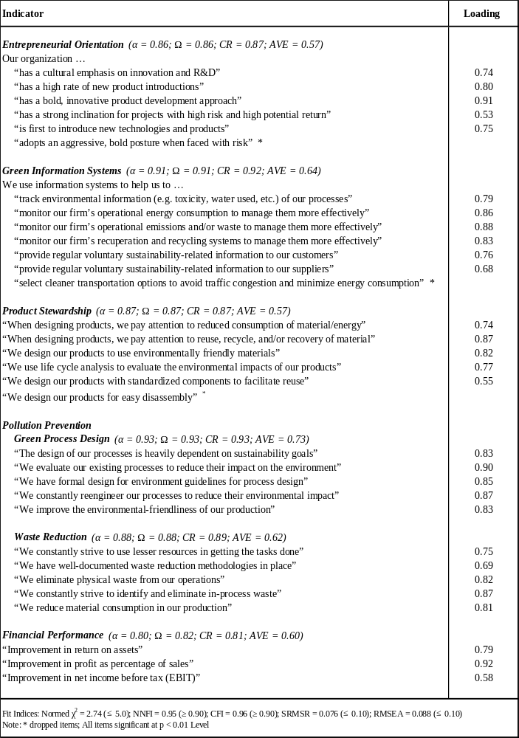
TABLE 2: Descriptive Statistics and Correlation

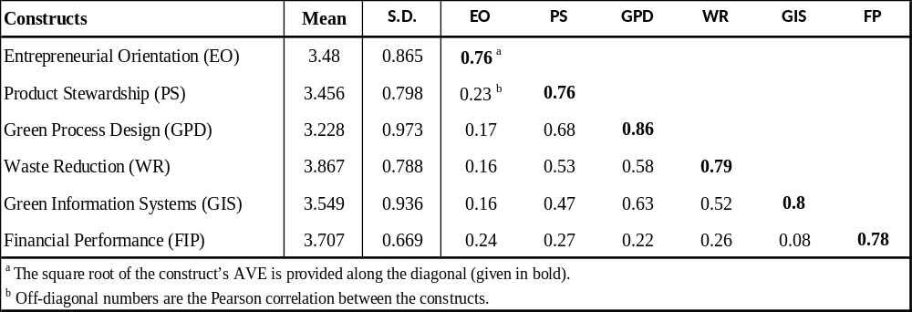

TABLE 3: Regression results

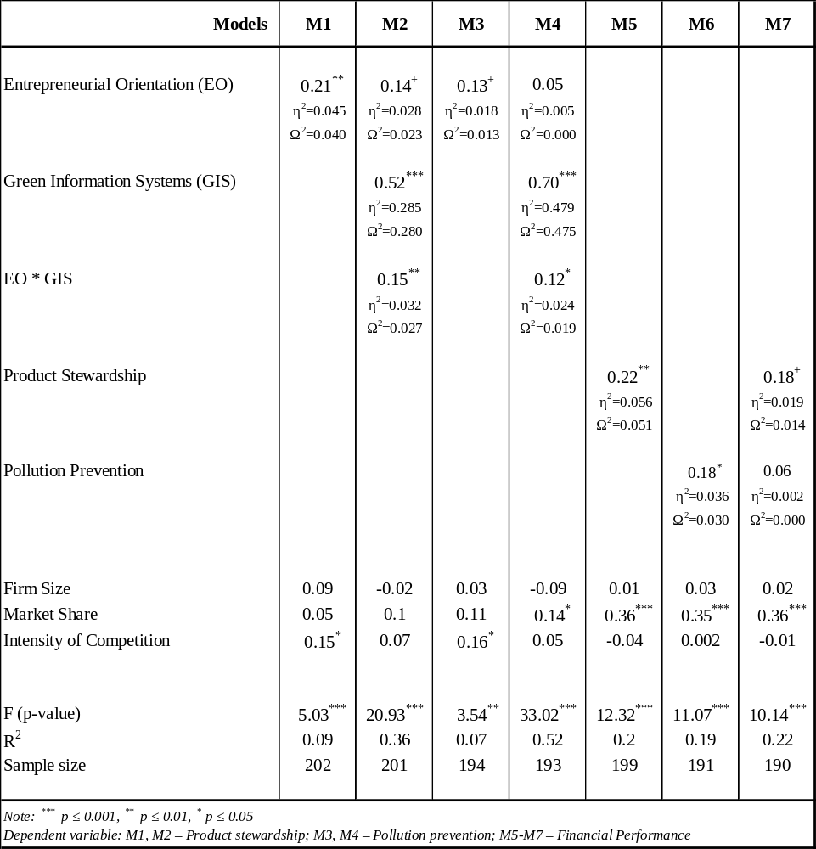
FIGURE 1: Hypothesized Model
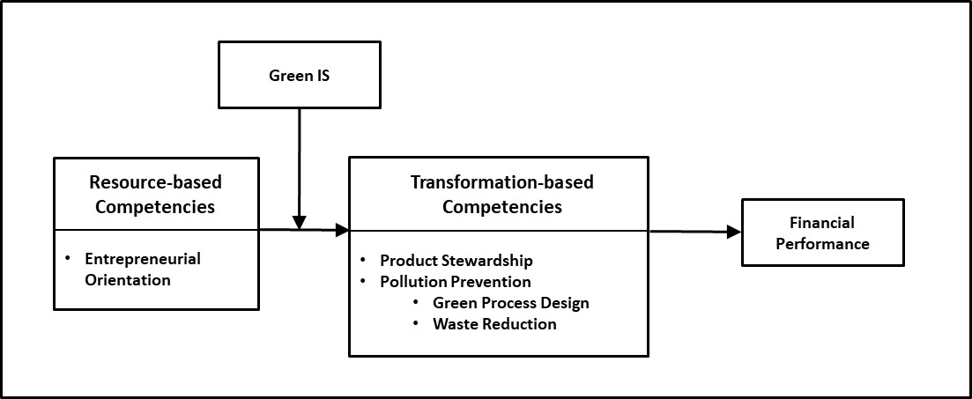

FIGURE 2: Conditional effect of entrepreneurial orientation at different levels of Green IS
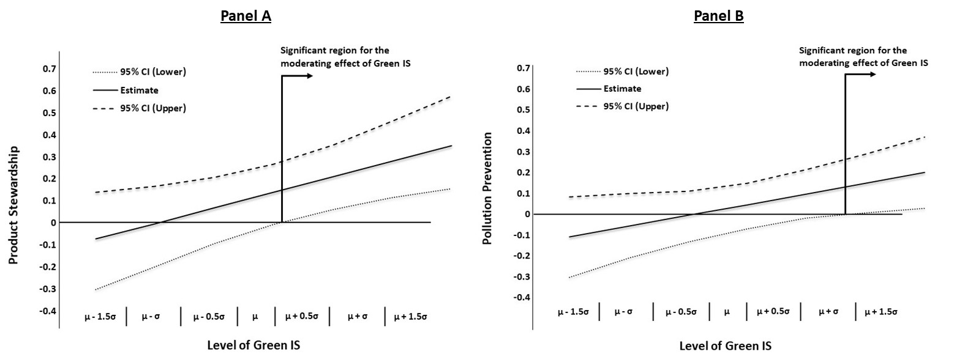

FIGURE 3: Conditional indirect effect of entrepreneurial orientation on performance at different levels of Green IS
