Author's note

This is the post-print version (i.e., peer-reviewed including revisions) of the following article: Geers, L., Vannuscorps, G., Pesenti, M., & Andres, M. (2021). Selective interference of hand posture with grasping capability estimation. Experimental Brain Research. The published version of the article is available via its DOI : doi.org/10.1007/s00221-021-06264-9

Title
Selective interference of hand posture with grasping capability estimation

Author information :
Laurie Geers, Psychological Sciences Research Institute, Université catholique de Louvain
Gilles Vannuscorps, Psychological Sciences Research Institute and Institute of Neuroscience, Université catholique de Louvain
Mauro Pesenti, Psychological Sciences Research Institute and Institute of Neuroscience, Université catholique de Louvain
Michael Andres, Psychological Sciences Research Institute and Institute of Neuroscience, Université catholique de Louvain

Running head : Action capability estimation

Correspondence concerning this article should be addressed to Laurie Geers or Michael Andres, Psychological Sciences Research Institute, Université catholique de Louvain, Place Cardinal Mercier, 10, 1348 Louvain-la-Neuve, Belgium. E-mail: laurie.geers@uclouvain.be or michael.andres@uclouvain.

Abstract
Previous studies have shown that judgments about how one would perform an action are affected by the current body posture. Hence, judging the capability to grasp an object between finger and thumb is influenced by their aperture at the time of the judgment. This finding can be explained by a modification of the internal representation of one’s hand through the effect of sensorimotor input. Alternatively, the influence of grip aperture might be mediated by a response congruency effect, so that a “less” vs. “more” open grip would bias the judgment toward a “less” vs. “more” capable response. To specify the role of sensorimotor input in prospective action judgments, we asked participants to estimate their capability to grasp circles between index and thumb while performing a secondary task that requires them to squeeze a ball with these two fingers (precision grip) or with a different hand configuration (palm grip). Experiment 1 showed that participants underestimated their grasping capability when the squeezing task involved the same grip as the judged action (precision grip) and their estimates were bound to the relative size of objects as revealed by size-contrast illusions (Ebbinghaus). Experiment 2 showed that the grip reduction caused by the squeezing task also interfered with the discrimination of large numbers in magnitude judgments, but this incongruency effect was only observed for the palm grip. The dissociated effects of the two grips in graspability and numerical judgments indicate that sensorimotor input may affect the perceived ability to grasp objects, independently of response congruency, by modifying the representation of the hand in action.

Keywords: grasping; numerical cognition; multisensory integration; body scheme; dorsal stream

Declarations
Funding: This work was supported by grant 1.A325.17 from the Fonds National de la Recherche (FRS-FNRS, Belgium) and by grant ARC21/26-112 from the Fédération Wallonie Bruxelles (Belgium).
Conflicts of interest/Competing interests: We declare that the research was conducted in the absence of any commercial or financial relationship that could be construed as a potential conflict of interest.
Availability of data and material: We will make the data supporting our results publicly available on the Open Science Framework (OSF) upon acceptance of the present manuscript. A temporary view-only link has been created to make them available for peer review: https://osf.io/62nau/?view_only=b05160e791f045c7b48c7fb2dd5300ff.
Code availability (software application or custom code): The code generated during the current study is available from the corresponding author on reasonable request.

Estimating one’s capability to perform an action is a fundamental aspect of human adaptive behavior as it allows action calibration to be computed, anticipatively, at no cost for the effector system. For instance, anticipating that a mug of tea is out of reach or too big to be grasped safely with one hand typically triggers the search of alternative response options, such as making a step forward or lifting the cup with both hands, which will, in turn, be evaluated for their capacity to achieve the expected outcome before any effort is produced (Johnson 2000).
Previous studies have shown that prospective judgments about one’s capability to perform an action are influenced by the biomechanical constraints associated with this action. For instance, reachability judgments (i.e., judging whether one would be capable to reach an object) are sensitive to the motor constraints imposed by the posture in which the reaching would be done (e.g., reaching while standing vs. sitting) or by the environment (e.g., texture and height of the surface, weights fixed on the wrist, etc.; Carello, Grosofsky, Reichel, Solomon & Turvey 1989; Gabbard, Cordova & Lee 2010; Rochat & Wraga 1997). We have recently shown that graspability judgments (i.e., judging whether one would be capable to grasp an object), but not perceptual size judgments (i.e., judging whether the object is larger than another object), are influenced by the grip aperture at the time of the judgment. Participants under- vs. overestimated their capability to grasp circles between their index finger and thumb when performing a concurrent motor task that implied squeezing vs. spreading these fingers (Geers, Pesenti & Andres 2018). Such interference is particularly intriguing because, by definition, one’s potential to grasp an object is a generalized skill (i.e., true for all objects), depending on fixed motor parameters (i.e., one’s maximal grip aperture) and, hence, does not change whether the hand is open or closed at the time one makes the judgment. Indeed, if one’s maximal achievable grip aperture is 13 cm, all objects that are 13 cm or less in diameter are graspable in the absence of any constraint, and it should not matter whether one’s index finger and thumb are pressed together or spread apart before initiating the movement. It is thus remarkable that graspability judgments are influenced by sensorimotor information that is irrelevant to estimate one’s general capability to grasp.
Before a precise description of the role of sensorimotor information can be proposed, the question of how hand representations are mapped to perceptual object representations in graspability judgments remains to be elucidated. Anticipating the success of an action requires the features of the targeted object to be compared with the body capabilities (Gibson, 1979). Hence, graspability judgments require comparing object size relative to the internal representation of one’s hand. Previous studies have shown that the internal representation of one’s hand is influenced by its posture: pressing the fingers together decreases the perceived hand size compared to when fingers are spread apart (Longo, 2015; Tamè, Dransfield, Quettier & Longo 2017). At the brain level, these changes are reflected in the somatotopy of finger representations that show greater overlap when then hand is closed than when it is open (Hamada & Suzuki 2003; 2005; Stavrinou et al. 2006). These findings support a sensorimotor account of the underestimation bias observed in graspability judgments when squeezing a ball between finger and thumb: the squeezing action would lead participants to underestimate their grasping capability because the current sensorimotor input inclines them to represent their hand as being smaller (Geers et al. 2018). However, the relationship between the effect of sensorimotor input and the representation of the hand in action remains to be investigated. In particular, it is unclear whether the underestimation of one’s ability to grasp objects between finger and thumb is due to sensorimotor input affecting the representation of the precision grip formed by these two fingers or to a general modification of the internal hand representation due to the squeezing action. Moreover, numerical cognition studies suggest that closing vs. opening movements can instantiate the protethic dimension of “less” vs. “more” (Steven 1975), leading to incongruency effects in magnitude judgments when the movement type and the binary response are assigned to a different polarity along the less-more dimension. For instance, observing the closure or opening of a precision grip respectively slowed down the discrimination of large or small numbers (Badets & Pesenti 2010) and biased random number generation towards small or large values (Badets, Bouquet, Ric & Pesenti 2012; Badets & Pesenti 2011; Grade, Badets & Pesenti 2017). A similar bias was observed when the precision grip was replaced by a full hand or mouth opening/closing action, but to a lesser extent, suggesting that the more an action refers to object prehension, the stronger the bias (Grade et al. 2017). This lends plausibility to a polarity congruency account of the underestimation bias caused by the action of squeezing during graspability judgments. This account extends the polarity correspondence principle, which states that a structural similarity in the coding of an irrelevant stimulus and a binary response is sufficient to explain congruency effects, without implying sensorimotor or conceptual processes (Proctor and Cho, 2006). In the case of action capability judgment, the squeezing movement would evoke the representation of “less” (in opposition to “more”) and bias the participant’s judgment to the congruent response “uncapable” (in opposition to “capable”). The comprehension of the role of sensorimotor processes in graspability judgments is thus obstructed by the possibility that it might be mediated by congruency effects resulting from the structural similarity between the coding of the grip aperture and the response alternatives.
This issue is further complicated by the uncertainty about the metrics used to represent object size in graspability judgments. Regarding the execution of real grasps, a long-standing theoretical position emphasizes the need for optimal hand-object interactions to compute veridical size estimates, without being influenced by the context (Goodale & Milner 1992). Accordingly, several studies have shown that action, unlike perception, is resistant to visual illusions stemming from the contrast between the target and the surrounding objects. For instance, it has been shown that the grip aperture adopted to grasp a disc is calibrated on the actual size of the disc, without being influenced by surrounding elements creating the Ebbinghaus illusion (i.e., small or large surrounding circles leading participants to perceive the central disc as larger or smaller; Aglioti, De Souza & Goodale 1995; Haffenden & Goodale 1998; 2000). However, other studies did find an effect of size-contrast illusions on grasping, suggesting that action might also integrate relative size estimates (Franz, Gegenfurtner, Bülthoff & Fahle 2000; Kopiske, Bruno, Hesse, Schenk & Franz 2016; Franz & Gegenfurtner 2008). These divergent results prevent firm conclusions to be drawn about the object metrics underlying action. Moreover, previous research has mainly focused on the executive aspects of action. The question of whether the off-line processing of action, such as grasping capability estimation, is based on absolute object sizes or subjective values reflecting the way it is perceived in a given visual context has received less attention.
The present study aims to investigate how sensorimotor, cognitive and perceptual processes contribute to predicting one’s capability to grasp an object. In particular, it investigates whether concurrent motor tasks affect graspability judgments through the effect of sensorimotor input on the internal representation of the hand in action (i.e., sensorimotor account) or through the response bias caused by the overlap of the movement representation and the binary judgment on a less-more dimension (i.e., polarity congruency account). In Experiment 1, we asked participants to estimate their capability to grasp circles of different sizes between their index finger and thumb, while performing a concurrent motor task that required to squeeze a ball between index finger and thumb of each hand (i.e., precision grip) or between the two hand palms (i.e., palm grip). As both grips refer to prehension, the polarity congruency account predicts that the squeezing action, whether it is performed with a precision or a palm grip, should bias graspability judgments towards the “uncapable" response, leading to an underestimation of grasping capability relative to a control condition where the hands are at rest. An effect of the precision grip – but not the palm grip – is only compatible with a sensorimotor account as it would indicate that the motor task effectively affect participants' judgment by modifying the representation of the grip implied in the judged action. In order to investigate the metrics used to represent object size in graspability judgments, we also manipulated the relative size of the target circle, while preserving its actual size by using the Ebbinghaus illusion as described in a previous study (Geers et al. 2018). Experiment 2 was designed to further assess the plausibility of the polarity congruity account as an alternative to the sensorimotor account proposed to account the results of Experiment 1. In particular, we wanted to exclude that the precision grip could have a greater potential to evoke the less-more dimension due to its greater typicality for grasping small objects in everyday life (Grade et al 2017). To do so, we asked participants to compare two-digit Arabic numbers to 45, while squeezing a ball with a precision grip, palm grip or while keeping hands at rest. Response latencies (RLs) to compare numbers to a reference offer a sensitive measure commonly used to evaluate the processing of small and large magnitudes (e.g., De Smedt & Gilmore 2011; Girelli, Lucangeli & Butterworth 2000). If squeezing with a precision grip is more strongly associated with the less-more dimension, it should have a stronger effect on the number comparison task than the palm grip. In particular, it should slow down the comparison of numbers larger than the standard due to a conflict between the small magnitude associated with the reduced grip and the large magnitude assigned to the number in the course of the numerical judgment (Badets & Pesenti 2010).

Experiment 1

Methods

Participants
Twenty-two French-speaking undergraduate students (18 females; mean age ± standard deviation [SD]: 22.9 ± 7.3 years) of the Université catholique de Louvain, Belgium, participated in this experiment in exchange for course credits. All participants were right-handed and had a normal or corrected-to-normal vision. They were unaware of the hypotheses been tested and gave their written informed consent before the experiment. The study was performed in accordance with the ethical standards established by the Declaration of Helsinki and was approved by the local Ethical Committee. Sample size was defined according to the results of previous experiments (Geers et al., 2018) showing that at least 16 participants are required to observe a true effect of the concurrent motor task (d = .69), in the context of the size-contrast illusion, with an 80% power using a one-tailed pairwise contrast (α = 0.05).

Apparatus and stimuli
We used the same apparatus and stimuli as in Experiment 2 and 3 of Geers and colleagues (2018). The stimuli were displayed on a vertical screen (225 x 210 cm) by a projector (MP7740, 3M United States) placed behind the screen with a resolution of 1,280 x 1,024 pixels, 1 pixel corresponding to 0.19 cm, and 1 cm corresponded to 0.76° of visual angle (Figure 1A). A chin rest was used to keep a 75 cm distance between the screen and the participants’ head throughout the experiment. A voice-key was fixed on the chin rest to record RLs. The experiment was controlled with E-prime 2 software (Schneider, Eschman & Zuccolotto 2002).
The stimuli consisted of Ebbinghaus displays constituted of central and peripheral circles with varying size. The size of the central circle (i.e., target) differed by -5, -3, -2, -1, 0, +1, +2, +3 or +5 cm with respect to the maximum grip aperture (MGA) measured prior the experiment using wooden rods ranging from 9 to 20 cm. The MGA was given by the longest bar the participant could grasp between the index finger and thumb so that the lateral surfaces of the bar were covered by the fingertips (mean MGA ± SD: 11.9 ± 1.3 cm). The size of the surrounding circles was (1) twice as small as the central circle, (2) twice as large as the central circle or (3) identical to the central circle. In the two first displays, the central circle is typically perceived as larger and smaller, respectively, than its actual size. They are referred hereafter as the small and large illusory displays. The latter display was used as a control not inducing any illusion. To avoid simulated obstacle avoidance to be responsible for a potential effect of the illusion, the distance between the target and the surrounding circles always corresponded to the size of the target (Figure 1B; Haffenden & Goodale 2000; but see also Franz, Bülthoff & Fahle 2003).

Task and procedure
We used the same graspability judgment task as Geers and colleagues (2018) consisting in judging whether one would be capable to grasp the central circle of an Ebbinghaus display between index finger and thumb, without actually grasping it. Each trial consisted of a fixation cross displayed at the center of the screen for 500ms followed by an Ebbinghaus display. Participants were required to indicate as quickly and accurately as possible whether they judged the target as graspable or not by responding “yes” or “no” aloud. At response onset, the stimulus disappeared. The experimenter then encoded the response and the next trial began 1500 ms later. Participants had to perform the graspability judgment while (1) keeping their hands flat on the table (i.e., rest), (2) while squeezing simultaneously two 7-cm foam balls, one between the index finger and thumb of the left hand and one between the index finger and thumb of the right hand (i.e., precision grip), and (3) while squeezing a 7-cm foam ball between their two hands fully open, with the palms facing each other, and the fingers pointing forward (i.e., palm grip). For the precision and palm grips, the instructions emphasized the need to keep a constant pressure on the ball in order to fit the gap formed by two iron bars placed next to the hands (Figure 1C). The distance between the two iron bars was adapted so that the aperture of the precision and palm grip was equivalent. The order of the motor conditions was counterbalanced across participants. Hands were kept under a cardboard surface during the entire experiment making them invisible to the participants. A webcam was used to allow the experimenter to monitor that the concurrent motor tasks were properly performed. The participants performed six practice trials before taking two blocks of trials for each of the three motor conditions. A block consisted of 81 trials presented in a random order resulting from the nine possible sizes for central circle combined with each of the three Ebbinghaus displays, repeated three times.

Data analysis
Trials where the voice key triggered due to coughs or external noises were discarded from any further analysis (2.35% of the dataset). Trials where the voice key failed to trigger (11.6% of the dataset) were discarded from the RLs analysis. The data of one participant were excluded because this participant responded “yes” whichever the size of the target circle, suggesting a difficulty to make a reliable judgment even for extreme values (i.e., 5 cm smaller or larger than the MGA). We first investigated whether the motor conditions were of equal difficulty by conducting an ANOVA on the median RLs with the motor condition (rest, precision grip vs. palm grip) as within-subject factors. Participants’ estimates of grasping capability were then analyzed with a generalized linear mixed model (GLMM), using the glmer function of the R lme4 package (Bates, Maechler, Bolker & Walker 2015). The advantage of GLMM is that they allow conducting a logistic regression model in a within-subject design (by adding participant as random intercept in the model). We applied a model on yes/no responses with the motor condition (rest, precision grip vs. palm grip), the illusion (small, neutral vs. large), the target size (-5, -3, -2, -1, +0, +1, +2, +3 vs. +5 cm, relative to MGA), and their interaction as fixed effects. The model also included a by-subject random intercept. The model parameters were estimated by Laplace approximation and statistically tested with Wald’s χ2. Post-hoc pairwise contrasts were performed with Bonferroni correction (emmeans package version 1.3.5.1; Lenth, Singmann, Love, Buerkner & Herve 2019). The points of subjective equality (PSE), that is the target size for which the probability to respond “yes” was 50%, were obtained for each condition and illusory display from the intercept (B0) and the slope (B1) revealed by the GLMM using the formula B0*condition / B1.

Results
The ANOVA on RLs revealed no significant effect of the motor condition, F(2,40) = 1.32, p = .278, ƞ 2= .27. Mean RLs (± standard error [SE]) for grasping judgments was 827 ± 52 ms when hands were at rest, 797 ± 48 ms when squeezing one ball with a precision grip and 809 ± 44 ms when squeezing with a palm grip.
The GLMM analysis on graspability judgment responses showed a significant effect of size, χ2(1, 21) = 1891.00, p < .001, with the rate of affirmative responses decreasing when size increased. There was also a main effect of the motor condition, χ2(2, 21) = 51.16, p < .001. Post hoc pairwise contrasts indicated that the probability of affirmative response was significantly smaller for the precision grip (.36 ± .09) than for the rest condition (.46 ± .10), β = -0.53, SE = 0.10, z.ratio = -5.31, p < .001, and for the palm grip (.48 ± .10), β = -0.64, SE = 0.10, z.ratio = -6.29, p < .001. There was no significant difference between the rest condition and palm grip, β = -0.10, SE = 0.09, z.ratio = -1.04, p = .8925. The mean PSE (± SE) for the precision grip, palm grip and rest conditions were equal to -0.45 (± 0.37), -0.02 (± 0.35), and -0.04 (± 0.35) cm, respectively. The GLMM analysis also showed a significant main effect of the illusion, χ2(2, 21) = 436.68, p < .001. Post hoc pairwise contrasts indicated that, compared to the neutral display (.36 ± .11), the probability of affirmative response was significantly smaller for the large illusory display (.22 ± .09), β = 0.68, SE = 0.10, z.ratio = 6.67, p < .001, and significantly larger for the small illusory display (.71 ± .10), β = 0.68, SE = 0.10, z.ratio = 6.67, p < .001. The mean PSE (± SE) for the large, neutral and small illusory displays were equal to -0.80 (± 0.32), -0.34 (± 0.33) and 0.64 (± 0.35) cm, respectively. The interaction between motor condition and illusion was not significant, χ2(4) = 6.08, p = .192 (Figure 2).

Experiment 2

Methods

Participants
A new sample of thirty undergraduate students (29 females, mean age ± SD: 21.5 ± 1.9 years) of the Université catholique de Louvain, Belgium, participated in this experiment in exchange for course credits. Three of them were left-handed. All had a normal or corrected-to-normal vision. They were unaware of the hypotheses being tested and gave their written informed consent before the experiment. The experiment was performed in accordance with the ethical standards established by the Declaration of Helsinki and was approved by the local Ethical Committee. A sample size analysis showed that 27 participants are required to observe a RLs difference of 20 ± 40 ms (d = .5) between the motor interference condition and the control rest condition with an 80% power using a one-tailed pairwise contrast (α = .05).

Apparatus and stimuli
The participant sat in front of a 27-inch LCD screen on which the stimuli were displayed with a resolution of 1,920 x 1,080 pixels. A chin rest was used to keep the distance between the screen and the participants’ head at 75 cm throughout the experiment. A microphone was fixed on the chin-rest to record RLs. The experiment was run with PsychoPy2 (Peirce et al. 2019).
We used the same set of stimuli as in the study of Salvaggio and colleagues (2019). The stimuli consisted of all Arabic numbers ranging from 20 to 70, except 45 used as a reference for the comparison task, and displayed on the screen with a size of 2° of visual angle. Numbers smaller and larger than 45 were divided into three categories of distance: numbers from 20 to 29 and from 61 to 70 were considered far from the reference, numbers from 30 to 39 and from 51 to 61 considered at a medium distance, and numbers from 40 to 45 and from 46 to 50 considered close to the reference. Each number was presented twice per task, except for the close numbers, which were half as many and therefore repeated four times.

Task and procedure
Each trial started with a fixation square displayed at the center of the screen for 500 ms followed by an Arabic number displayed for 2 s. Participants were required to say aloud as quickly and accurately as possible whether the number was “smaller” or “larger” than 45. The response was encoded online by the experimenter before the next trial began. The inter-trial interval was 500 ms. Participants were required to perform one block of trials for each of the motor conditions described in Experiment 1. The order of the tasks was counterbalanced across participants. One block consisted of 120 trials resulting from the combination of three distance categories (close, medium, far) and two magnitude categories (smaller, larger than the reference), with 20 trials per combination.

Data analysis
The data of two participants were removed before the analysis due to a technical problem with the microphone. The RLs data of the remaining participants were analyzed after excluding trials with noises, coughs or microphone failures (0.25% of the dataset), where participants answered erroneously (1.2% of the dataset), and where the RL deviated by more than 2 standard deviations from the mean of the participant data (6.38 % of the dataset). To investigate the effect of the motor condition, numerical magnitude and numerical distance on number processing, we computed a linear mixed model (LMM), using the lmer function of the R lme4 package (Bates et al. 2015) with the participant as random intercept, and numerical category (smaller vs. larger), numerical distance (close, medium vs. far), motor condition (rest, precision grip vs. palm grip), and their interaction as fixed factors. The numerical distance effect characterized by faster responses to numbers far from rather than close to the reference was used as a signature of the access to number magnitude (Dehaene, Dupoux & Mehler, 1990; Moyer & Landauer, 1967). Post hoc paired sample contrast were corrected for multiple comparisons with Bonferroni correction.

Results
The linear mixed-model revealed a main effect of numerical distance, χ2(2,28) = 256.58, p < .001. Post hoc paired contrast showed that RLs increased as numerical distance decreased. In particular, participants were significantly slower to respond to numbers at a close distance (765 ± 23 ms) than numbers at medium (730 ± 22 ms), β = 24, SE = 2.29, z.ratio = 10.47, p < .001, and far distances (718 ± 21 ms), β = 36, SE = 2.28, z.ratio = 15.77, p < .001, and slower to respond to numbers at a medium than at a far distance, β = 12, SE = 2.25, z.ratio = 5.34, p < .001 . There was also a significant effect of numerical magnitude, χ2(1,28) = 19.22, p < .001, embedded in a significant numerical magnitude by numerical distance interaction, χ2(2,28) = 9.35, p < .001. Post hoc pairwise contrasts computed across numerical category indicated that the distance effect was smaller for numbers larger than the reference than for numbers smaller than the reference. In particular, responses to large numbers at a far distance (716 ± 3 ms) from the reference were not significantly faster than large numbers at a medium distance (721 ± 3 ms), β = 36, SE = 2.28, z.ratio = 15.77, p < .001, while all other contrasts were significant (all p < .001; Figure 3). More importantly, the analysis also showed a significant effect of the motor condition, χ2(2,28) = 19.35, p < .001, that significantly interacted with numerical magnitude, χ2(2,28) = 11.64, p < .001. Post hoc pairwise contrasts showed that squeezing a ball slowed down the comparison on numbers larger than the reference, but this was only true for the palm grip (750 ± 21 ms) compared to the rest condition (727 ± 24 ms), β = 15, SE = 3.19, z.ratio = 4.77, p < .001, and to the precision grip condition, β = 14, SE = 3.21, z.ratio = 4.48, p < .001 . No difference was found between the precision grip and the rest conditions, t(27) = 0.25 , p = .803. The responses to numbers smaller than the reference were not affected by the motor conditions, all p-values > .629 (Figure 4).

General discussion
The primary goal of this study was to test the hypothesis that sensorimotor input may affect the perceived ability to grasp an object by modifying the representation of the hand in action. Experiment 1 showed that participants underestimated their capability to grasp an object between their index finger and thumb when they simultaneously performed a squeezing movement with a precision grip, but not when they performed it with a palm grip. This finding suggests that subjective estimates of grasping capability are bound to sensorimotor input from the effectors involved in the judged action. Experiment 2 assessed the plausibility of the polarity congruency account as an alternative to the sensorimotor account of the effect observed in Experiment 1. We tested whether the effect of squeezing on graspability judgments could be explained by a response bias emerging from the similar coding of the movement and the binary judgment on a less-more dimension (i.e. less/more open vs. less/more capable). To do so, we looked at the influence of the precision and palm grips on the processing of numerical magnitude assessed through a standard number comparison task. We found that only the palm grip slowed down magnitude comparison, in particular when numbers were larger than the reference. Hence, squeezing a ball with a precision grip was detrimental to graspability judgments, but not to the semantic processing of large numbers, whereas the opposite pattern was observed when squeezing a ball with a palm grip. These dissociated effects indicate that the influence of the precision grip on graspability judgments cannot be explained by response biases such as those mediating the effect of the palm grip on number comparison. We can thus safely conclude that graspability judgments are specifically influenced by sensorimotor information about the current state of the concerned effectors. Furthermore, we have replicated the observation that graspability judgments are strongly biased by the size-contrast illusion created by surrounding circles smaller or larger than the target circle (Geers et al. 2018). This finding indicates that not only sensorimotor estimates relative to grip size but also visual estimates relative to object size are tied to the environmental constraints.
The effect of the precision grip on graspability judgments is in line with a previous study showing that squeezing a ball between finger and thumb affects judgments about one’s capability to reach an object placed at a certain distance (Grade, Pesenti & Edwards 2015). In this study, motor interference was inferred from increased RLs. These observations are typically interpreted as reflecting an interference of the concurrent motor task with the mental simulation of the concerned action required to make this judgment, in line with the literature showing high similarities between prospective action judgments and action execution (e.g., Carello et al. 1989; Frak et al. 2001; Johnson 2000). However, effects on response speed are subject to alternative interpretations, such as an increase of cognitive demands that would slow down performance. Our study evidenced a change in estimated grasping capability. More specifically, participants underestimated their grasping capability when squeezing a ball between their index finger and thumb. This finding goes beyond the observation of increased RLs. First, the underestimation bias cannot be assigned to increased cognitive load because the precision grip did not increase response speed when squeezing a ball. Second, the underestimation bias was not due to participants adopting a more conservative strategy because we have previously shown that it could be turned into an overestimation bias by asking participants to spread their fingers apart rather than to squeeze a ball (Geers et al. 2018). Third, the underestimation bias was specific to the grip implied by the graspability judgment (i.e., a precision grip) as no bias was observed when the motor condition required participants to squeeze the ball using a different hand gesture (i.e., a palm grip). It is worth noting that the two grip conditions somehow differed regarding the amount of haptic sensation: palm grip was associated with a larger contact surface than the precision grip. While it has been shown that the nature of touch sensation can lead to cognitive biases (e.g., Ackerman, Nocera & Bargh 2010), there is, to our best knowledge, no evidence that these cognitive biases increase with contact surface. Even so, we found that the underestimation bias was specific to the motor task implying the least surface contact (i.e., squeezing the object between the fingertip of the index and thumb), which would contradict the hypothesis that the amount of touch sensation would determine motor interference. On all other aspects (e.g., nature of the touch sensation, grip size and thus deformation imposed to the ball, and lateralization of the effectors) the two grips were equivalent. Hence, the most plausible account is that the perceived ability to grasp objects between finger and thumb is selectively influenced by sensorimotor information about the actual state of these effectors.
An intriguing aspect of our study is that graspability judgments are influenced by sensorimotor information that is irrelevant to estimate one’s action capability. The current opening of one’s hand should not be taken into account to emit a judgment about a generalized skill that is true for all objects and depends on fixed motor parameters (i.e. one’s maximal grip aperture). In principle, a representation that specifies the size and shape of the hand provides sufficient information to make such judgment, but this kind of representation is also known to play a role in mediating the position sense of the human hand (Longo & Haggard 2010). In the context of precision grasping for instance, it is essential that postural information (i.e. the joints angle) is combined with size information (i.e. the length of each finger) to estimate the distance between fingers and adjust the grip aperture accordingly. This intimate relationship between internal hand representation and postural change might explain why the squeezing task affected graspability judgments even though current grip aperture was not relevant for the task. An alternative explanation is that the squeezing task led participants to perceive the judged action as more effortful than in the condition where they kept their hands flat. Several studies suggest that prospective action judgments involve a mental simulation process whereby the effectors are first represented in their actual position and these representations are then transformed to fit the orientation/size of the target object (Frak et al. 2001; Johnson 2000). Data showed that response times reflected the spatial extent of the assumed transformation and the participants’ choices systematically favored the transformation that was the least awkward biomechanically (Johnson 2000). In other studies, Proffitt and colleagues showed that the physiological potential of the participants, or the anticipation of a greater physical effort, could modify their perception of spatial distances, slopes or object sizes (e.g., Bhalla & Proffitt 1999; Proffitt, Stefanucci, Banton & Epstein 2003; Witt & Proffitt 2005). On this ground, one could assume that the underestimation of grasping capabilities resulted from an increase of effort appraisal. Grasping movements (and thus their simulation) require opening the hand wide before scaling it down to object size (Jeannerod, Paulignan, Weiss 1998). This might be perceived as more effortful when fingers are pressed together than when the hand is open. The anticipated effort could thus lead participants to perceive the objects as larger than they are. However, we have previously shown that squeezing a ball has no effect on the perceived object size (Geers et al., 2018). Moreover, the reported effects on distance and slope perception have been shown to be largely dependent on experimental demands (Durgin et al. 2009; Durgin, Klein, Spiegel, Strawser & Williams, 2012). More globally, the idea that high-level cognitive processes, such as mental appraisal of effort, can modulate perceptual processes has been strongly challenged (Firestone & Scholl 2015). Hence, the most plausible explanation for the underestimation bias we observed is that sensorimotor information about the relevant effectors modified the internal representation of the hand – not the object – and thereby influenced graspability judgments.
Our results also show that grasping estimates are bound to the relative size rather than the veridical size of objects. The so-called Ebbinghaus illusion is known to affect perceptual judgments leading participants to consider the central circle as smaller vs. larger when surrounded by large vs. small circles. The effect of the illusion on action execution remains debated, but we have shown that it might extend to prospective action judgments: participants underestimate their grasping capability when the circle is surrounded by small circles and overestimate their grasping capability when it is surrounded by large circles. Graspability judgments are thus influenced, on the one hand, by the sensorimotor information about the current grip aperture and, on the other hand, by the visual information about the context. The weight given to these different sources of information is unclear. In Experiment 1, their effects were additive, but in our previous study (Geers et al. 2018), they were found to interact with each other so that underestimation was particularly marked when the target circle was perceived as larger than it actually was. In any case, the joint influence of grip aperture and visual context implies that perceptual and sensorimotor processes work together to support prospective action judgments.
Finally, our study leads to the original finding that the grip reduction caused by the action of squeezing between two fully open hands, with the palms facing each other, interferes with the discrimination of large numbers in numerical magnitude comparison. Several studies have reported semantic-to-motor interactions such as numbers influencing the kinematics of action (e.g., Andres, Davare, Pesenti, Olivier, & Seron 2004; Lindemann, Abolafia, Girardi, & Bekkering 2007; Andres, Ostry, Nicol & Paus 2008; Moretto & di Pellegrino 2008). Conversely, it has been shown that hand actions influence number-related judgments, for instance, by increasing sensitivity to number magnitude (Anobile, Arrighi, Togoli & Burr 2016; Anobile, Domenici, Togoli, Burr & Arrighi 2019; Ranzini et al. 2011). The present results show that the execution of a closing movement may directly interfere with the processing of large numbers. To our best knowledge, this finding has been restricted to action observation so far, and to small-magnitude numbers (usually < 10; Badets et al. 2012; Badets & Pesenti 2010; 2011; Grade et al. 2017). Our results thus provide additional evidence for the existence of motor-to-semantic interactions linking action and number magnitude. The effect of the palm grip on the processing of large numbers shows that the polarity congruency account is plausible. However, this account cannot explain the underestimation of grasping capabilities observed when squeezing with a precision grip. The double dissociation of the effect of the precision vs. palm grip on graspability vs. numerical judgments suggests that the sensorimotor information relative to hand posture influences estimated grasping capability independently of the biases caused by structural similarity between the coding of the movement type and the response alternatives. It is worth noting that the precision grip had been observed to affect numerical judgments in several other studies (Andres et al. 2004; Badets & Pesenti 2010; Badets et al. 2012; Badets & Pesenti 2011; Grade et al. 2017; Lindemann et al. 2007; Wood & Fisher 2008). In contrast with previous studies, we did not study the crosstalk between motor and numerical magnitude processes from stimulus-response compatibility effects, but we measured its direct consequences on the ability to compare numbers. We can exclude that the specific effect of the palm grip is explained by the amount of motor interference since it was matched across conditions by asking participants to perform both grips with both hands. However, future research is necessary to elucidate by which processes the processing of numbers in a comparison task is specifically affected by a hand motor task that involves a palm grip.
In conclusion, our results provide firm evidence that predicting one’s motor capability is automatically tied to the state of the perceptual and sensorimotor systems at the time the mental representation of capability is formed. Perceptual information about the visual environment and sensorimotor information about the current posture of the effectors both influence prospective action judgments even though irrelevant or detrimental for judging one’s ability to grasp objects. Moreover, our results add on previous findings showing that the execution of an unrelated grasping action can influence number processing, providing direct evidence for the existence of motor-to-number interactions.

Figure 1.
Experimental set-up. (A) In Experiment 1, the stimuli were projected from behind onto a wide screen. Participants were seated in front of the screen and had to keep their hands under cardboard surfaces in such a way that they could not see them. (B) The Ebbinghaus displays used in Experiment 1 with small surrounding circles making the central circle appear larger (i.e., large display) on the left, large surrounding circles making the central circle appear smaller (i.e., small display) at the center, and with surroundings of the same size than the central circle not inducing any illusion (i.e., neutral display) on the right. (C) Motor conditions of Experiments 1 and 2. Participants performed the graspability judgment (Experiment 1) or number comparison (Experiment 2) task while squeezing a foam ball between the index finger and thumb of each hand (left), squeezing a foam ball between their two palms in neutral position (i.e., open palm, no extension or flexing; center), or keeping hands at rest (right). In the two squeezing conditions, participants had to keep constant pressure on the ball such that the grip formed by the fingers/hands over the ball, fitted into the gap formed by two vertical iron bars placed next to the hands.
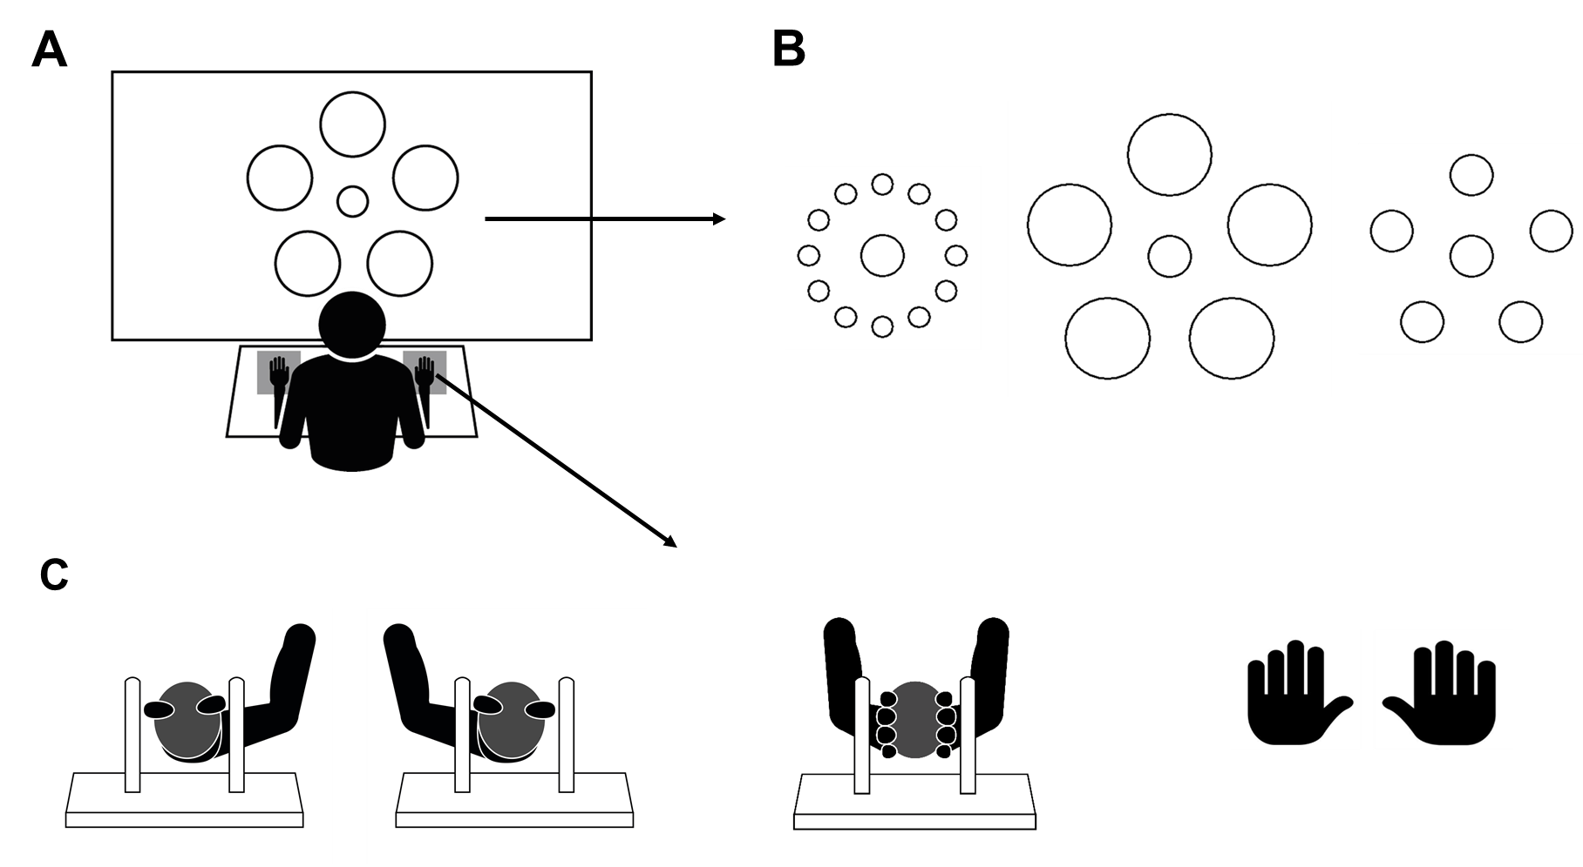

Figure 2
Effect of the motor condition (A & B) and Ebbinghaus illusion (C & D) on estimates of grasping capability in Experiment 1. The two graphs in the upper part of the figure represent the cumulative data. The dots represent the average rate of affirmative response (y-axis) as a function of the difference between the actual size of the central circle and the size of the maximum grip aperture (MGA) of the participant (x-axis). Solid lines represent the predicted values obtained by means of logistic regression. The two graphs in the lower part of the figure represent the mean rate of affirmative responses. Error bars represent standard errors corrected fort within-subject designs (Cousineau 2005).
**p-values < .001 corrected for multiple comparisons
* p-values < .05 corrected for multiple comparisons
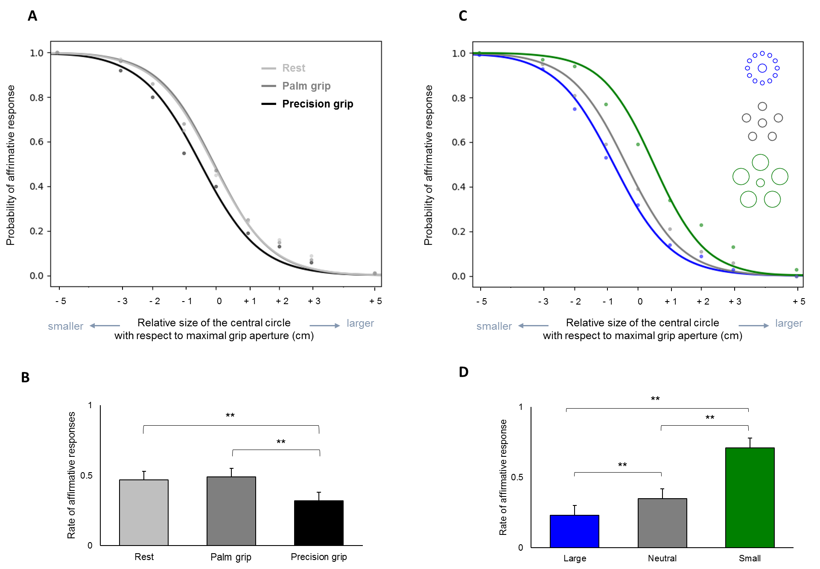

Figure 3.
Numerical distance effect for numbers smaller and larger than the reference in Experiment 2. Mean RLs (expressed in ms) are displayed for each numerical category and distance. Error bars represent standard errors corrected for within-subject designs (Cousineau 2005).
**p-values < .001 corrected for multiple comparisons
* p-values < .05 corrected for multiple comparisons
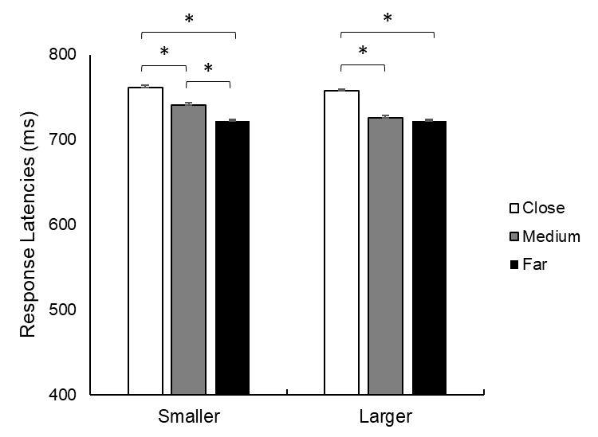

Figure 4.
Effect of the motor conditions on numbers smaller and larger than the reference in Experiment 2. Mean RLs (expressed in ms) for numbers smaller and larger than the standard are expressed for each motor condition. Error bars represent standard errors corrected for within-subject designs (Cousineau 2005).
**p-values < .001 corrected for multiple comparisons
* p-values < .05 corrected for multiple comparisons
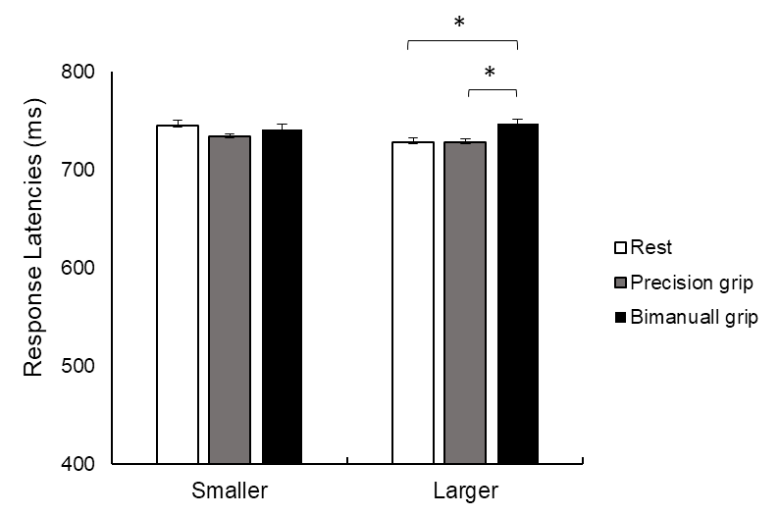

References
Ackerman, J. M., Nocera, C. C., & Bargh, J. A. (2010). Incidental haptic sensations influence social judgments and decisions. Science, 328(5986), 1712-1715. doi: 10.1126/science.1189993
Andres, M., Davare, M., Pesenti, M., Olivier, E., & Seron, X. (2004). Number magnitude and grip aperture interaction. Neuroreport, 15(18), 2773-2777. doi: http://dx.doi.org/10.1007/s00221-012-3145-1
Andres, M., Ostry, D. J., Nicol, F., & Paus, T. (2008). Time course of number magnitude interference during grasping. Cortex: A Journal Devoted to the Study of the Nervous System and Behavior, 44(4), 414-419. doi: http://dx.doi.org/10.1016/j.cortex.2007.08.007
Badets, A., & Pesenti, M. (2010). Creating number semantics through finger movement perception. Cognition, 115(1), 46-53. doi: https://doi.org/10.1016/j.cognition.2009.11.007
Badets, A., & Pesenti, M. (2011). Finger-number interaction: An ideomotor account. Experimental Psychology, 58(4), 287-292. doi: http://dx.doi.org/10.1027/1618-3169/a000095
Badets, A., Bouquet, C. A., Ric, F., & Pesenti, M. (2012). Number generation bias after action observation. Experimental brain research, 221(1), 43-49. doi: https://doi.org/10.1007/s00221-012-3145-1
Bhalla, M., & Proffitt, D. R. (1999). Visual–motor recalibration in geographical slant perception. Journal of experimental psychology: Human perception and performance, 25(4), 1076-1096. doi: https://doi.org/10.1037/0096-1523.25.4.1076
Carello, C., Grosofsky, A., Reichel, F. D., Solomon, H. Y., & Turvey, M. T. (1989). Visually perceiving what is reachable. Ecological psychology, 1(1), 27-54. doi: https://doi.org/10.1207/s15326969eco0101_3
Castiello, U. (2005). The neuroscience of grasping. Nature Reviews Neuroscience, 6(9), 726-736. doi: http://dx.doi.org/10.1038/nrn1744
De Smedt, B., & Gilmore, C. K. (2011). Defective number module or impaired access? Numerical magnitude processing in first graders with mathematical difficulties. Journal of experimental child psychology, 108(2), 278-292.
Dehaene, S., Dupoux, E., & Mehler, J. (1990). Is numerical comparison digital? Analogical and symbolic effects in two-digit number comparison. Journal of experimental Psychology: Human Perception and performance, 16(3), 626. doi: https://doi.org/10.1037/0096-1523.16.3.626
Durgin, F. H., Baird, J. A., Greenburg, M., Russell, R., Shaughnessy, K., & Waymouth, S. (2009). Who is being deceived? The experimental demands of wearing a backpack. Psychonomic Bulletin & Review, 16(5), 964-969.
Durgin, F. H., Klein, B., Spiegel, A., Strawser, C. J., & Williams, M. (2012). The social psychology of perception experiments: hills, backpacks, glucose, and the problem of generalizability. Journal of Experimental Psychology: Human Perception and Performance, 38(6), 1582.
Firestone, C., & Scholl, B. J. (2015). Can you experience ‘top-down’effects on perception?: The case of race categories and perceived lightness. Psychonomic bulletin & review, 22(3), 694-700. doi: https://doi.org/10.3758/s13423-014-0711-5
Frak, V., Paulignan, Y., & Jeannerod, M. (2001). Orientation of the opposition axis in mentally simulated grasping. Experimental Brain Research, 136(1), 120-127. doi: https://doi.org/10.1007/s002210000583
Franz, V. H., Bülthoff, H. H., & Fahle, M. (2003). Grasp effects of the Ebbinghaus illusion: obstacle avoidance is not the explanation. Experimental Brain Research, 149(4), 470-477. doi: https://doi.org/10.1007/s00221-002-1364-6
Franz, V. H., & Gegenfurtner, K. R. (2008). Grasping visual illusions: Consistent data and no dissociation. Cognitive neuropsychology, 25(7-8), 920-950. doi: https://doi.org/10.1111/1467-9280.00209
Franz, V. H., Gegenfurtner, K. R., Bülthoff, H. H., & Fahle, M. (2000). Grasping visual illusions: No evidence for a dissociation between perception and action. Psychological Science, 11(1), 20-25. doi: https://doi.org/10.1111/1467-9280.00209
Gabbard, C., Cordova, A., & Lee, S. (2007). Examining the effects of postural constraints on estimating reach. Journal of Motor Behavior, 39(4), 242-246. doi: https://doi.org/10.3200/JMBR.39.4.242-246
Geers, L., Pesenti, M., & Andres, M. (2018). Visual illusions modify object size estimates for prospective action judgements. Neuropsychologia, 117, 211-221. doi: https://doi.org/10.1016/j.neuropsychologia.2018.06.003
Girelli, L., Lucangeli, D., & Butterworth, B. (2000). The development of automaticity in accessing number magnitude. Journal of experimental child psychology, 76(2), 104-122.
Goodale, M. A., & Milner, A. D. (1992). Separate visual pathways for perception and action. Trends in neuroscience, 15(1), 20-25. doi:10.1016/0166-2236(92)90344-8
Grade, S., Badets, A., & Pesenti, M. (2017). Influence of finger and mouth action observation on random number generation: an instance of embodied cognition for abstract concepts. Psychological research, 81(3), 538-548. doi: https://doi.org/10.1007/s00426-016-0760-7
Grade, S., Pesenti, M., & Edwards, M. G. (2015). Evidence for the embodiment of space perception: concurrent hand but not arm action moderates reachability and egocentric distance perception. Frontiers in psychology, 6, 862. doi: https://doi.org/10.3389/fpsyg.2015.00862
Haffenden, A. M., & Goodale, M. A. (2000). Independent effects of pictorial displays on perception and action. Vision Research, 40(10-12), 1597-1607. doi: http://dx.doi.org/10.1016/S0042-6989(00)00056-0
Jeannerod, M., Paulignan, Y., & Weiss, P. (1998). Grasping an object: one movement, several components. Sensory guidance of movement, 5-20.
Johnson, S. H. (2000). Thinking ahead: the case for motor imagery in prospective judgements of prehension. Cognition, 74(1), 33-70. doi: https://doi.org/10.1016/S0010-0277(99)00063-3
Kopiske, K. K., Bruno, N., Hesse, C., Schenk, T., & Franz, V. H. (2016). The functional subdivision of the visual brain: Is there a real illusion effect on action? A multi-lab replication study. cortex, 79, 130-152. doi: https://doi.org/10.1016/j.cortex.2016.03.020
Lindemann, O., Abolafia, J. M., Girardi, G., & Bekkering, H. (2007). Getting a grip on numbers: Numerical magnitude priming in object grasping. Journal of Experimental Psychology: Human Perception and Performance, 33(6), 1400-1409. doi: http://dx.doi.org/10.1037/0096-1523.33.6.1400
Longo, M. R. (2015). Posture modulates implicit hand maps. Consciousness and Cognition, 36, 96-102. doi: https://doi.org/10.1016/j.concog.2015.06.009
Longo, M. R., & Haggard, P. (2010). An implicit body representation underlying human position sense. Proceedings of the National Academy of Sciences, 107(26), 11727-11732.
Mark, L. S. (1987). Eyeheight-scaled information about affordances: A study of sitting and stair climbing. Journal of Esxperimental Psychology: Human Perception and Performance, 13(3), 361-370. doi: http://dx.doi.org/10.1037/0096-1523.13.3.361
Moretto, G., & di Pellegrino, G. (2008). Grasping numbers. Experimental Brain Research, 188(4), 505-515. doi: http://dx.doi.org/10.1007/s00221-008-1386-9
Peirce, J., Gray, J. R., Simpson, S., MacAskill, M., Höchenberger, R., Sogo, H., ... & Lindeløv, J. K. (2019). PsychoPy2: Experiments in behavior made easy. Behavior research methods, 51(1), 195-203. doi: https://doi.org/10.3758/s13428-018-01193-y
Pesenti, M., Thioux, M., Seron, X., & De Volder, A. (2000). Neuroanatomical substrates of arabic number processing, numerical comparison, and simple addition: A PET study. Journal of Cognitive Neuroscience, 12(3), 461-479. doi: http://dx.doi.org/10.1162/089892900562273
Proctor, R. W., & Cho, Y. S. (2006). Polarity correspondence: a general principle for performance of speeded binary classification tasks. Psychological bulletin, 132(3), 416-442. doi: 10.1037/0033-2909.132.3.416
Proffitt, D. R., Stefanucci, J., Banton, T., & Epstein, W. (2003). The role of effort in perceiving distance. Psychological Science, 14(2), 106-112. doi: https://doi.org/10.1111/1467-9280.t01-1-01427
Ranzini, M., Lugli, L., Anelli, F., Carbone, R., Nicoletti, R., & Borghi, A. M. (2011). Graspable objects shape number processing. Frontiers in human neuroscience, 5, 147. doi: https://doi.org/10.3389/fnhum.2011.00147
Rochat, P., & Wraga, M. (1997). An account of the systematic error in judging what is reachable. Journal of Experimental Psychology: Human Perception and Performance, 23(1), 199–212. doi: https://doi.org/10.1037/0096-1523.23.1.199
Salvaggio, S., Masson, N., & Andres, M. (2019). Eye position reflects the spatial coding of numbers during magnitude comparison. Journal of Experimental Psychology: Learning, Memory, and Cognition, 45(10), 1910-1921. doi: http://dx.doi.org/10.1037/xlm0000681
Schneider, W., Eschman, A., & Zuccolotto, A. (2002). E-Prime: User's guide. Psychology Software Incorporated.
Simon, O., Mangin, J. F., Cohen, L., Le Bihan, D., & Dehaene, S. (2002). Topographical layout of hand, eye, calculation, and language-related areas in the human parietal lobe. Neuron, 33(3), 475-487. doi: https://doi.org/10.1016/S0896-6273(02)00575-5
Stevens, S. S. (1975). Psychophysics: Introduction to its perceptual, neural, and social prospects. New York: Wiley
Tamè, L., Dransfield, E., Quettier, T., & Longo, M. R. (2017). Finger posture modulates structural body representations. Scientific reports, 7(1), 1-9.
Warren, W. H., Jr., & Whang, S. (1987). Visual guidance of walking through apertures: Body-scaled information for affordances. Journal of Experimental Psychology: Human Perception and Performance, 13(3), 371-383. doi: http://dx.doi.org/10.1037/0096-1523.13.3.371
Witt, J. K., & Proffitt, D. R. (2005). See the ball, hit the ball. Psychological Science, 16(12), 937-938.
Witt, J. K., & Proffitt, D. R. (2008). Action-specific influences on distance perception: A role for motor simulation. Journal of Experimental Psychology: Human Perception and Performance, 34(6), 1479-1492. doi: http://dx.doi.org/10.1037/a0010781
Wood, G., & Fischer, M. H. (2008). Numbers, space, and action--from finger counting to the mental number line and beyond. Cortex: A Journal Devoted to the Study of the Nervous System and Behavior, 44(4), 353-358. doi: http://dx.doi.org/10.1016/j.cortex.2008.01.002

