Linkage of routinely collected NHS data from primary and secondary care to evaluate liaison mental health services: challenges and lessons learned.

*Elspeth Guthrie¹ e.a.guthrie@leeds.ac.uk 0000-0002-5834-6616

Chris Smith

Sam Relton. s.d.relton@leeds.ac.uk

Daniel Romeu danielromeu@doctors.org.uk

Andrew Walker² andrew.walker@nihr.ac.uk

Peter Trigwell³ peter.trigwell@nhs.net

Robert West¹ r.m.west@leeds.ac.uk 0000-0001-7305-3654

Farag Shuweidi¹ f.shuweihdi@leeds.a.cuk

Peter Trigwell. Peter.trigwell@nhs.net

Alan Quirk. Alan.quirke@rcpsych.ac.uk
Mike Crawford⁴ M.crawford@imperial.ac.uk 0000-0003-3137-5772

Matt Fossey⁵ Matt.fossey@anglia.ac.uk

Jenny Hewison¹ j.hewison@leeds.ac.uk 0000-0003-3026-3250

Carolyn Czoski Murray¹ C.J.czoskimurray@leeds.ac.uk 0000-0001-7742-2883
Claire Hulme⁶ C.T.Hulme@exeter.ac.uk 0000-0003-2077-0419
Sandy Tubeuf⁸. sandy.tubeuf@uclouvain.be 0000-0001-9001-1157
Sonia Saraiva s.a.saraiva@leeds.ac.uk

Allan House¹ a.o.house@leeds.ac.uk 0000-0001-8721-8026

*Corresponding author

- Leeds Institute of Health Sciences, University of Leeds. Leeds. UK.
- Clinical Research Network National Coordinating Centre, National Institute of Health Research Clinical Research Network, Leeds
- National Inpatient Centre for Psychological Medicine, Leeds and York Partnership NHS Foundation Trust. Leeds. UK.
- Department of Brain Sciences, Faculty of Medicine, Imperial College, London. UK
- Veterans and Families Institute for Military Research, Faculty of Health, Social Care and Education. Anglia Ruskin University. Chelmsford. UK.
- Faculty of Health & Life Sciences, University of Exeter, UK.
- College Centre for Quality Improvement. Royal College of Psychiatrists, London. UK.
- Institute of Health and Society (IRSS) and Institute of Economic and Social Research (IRES), Université catholique de Louvain, Belgium

Abstract
Background
Liaison mental health services provide mental healthcare to patients in acute hospital settings. Although the results of local evaluations suggest such services can be cost-effective, this is not supported by evidence from a small number of randomised controlled trials which have evaluated specific components of liaison delivery. Evaluation of liaison services is challenging due to their heterogenous organisation and delivery, high case throughput and varied patient case mix and may be best conducted using routinely collected NHS data. We aimed to link routinely collected NHS data from primary and secondary care to evaluate hospital-based liaison mental health services in England.
Methods
We designed and enacted a methodology to link routinely collected NHS data from: i) Hospital Episode Statistics (HES) – a database controlled by NHS Digital, and ii) ResearchOne – a primary care database controlled by The Phoenix Partnership (TPP). Patient pseudonyms were generated by the data controllers and used by NHS Digital to: i) communicate to TPP those patients for whom data was required from ResearchOne, and ii) generate mappings between source-specific identifiers used to reference patients in the data from HES and ResearchOne.
Results
Obtaining approvals for the steps prespecified in the methodological protocol took required 907 days. Enactment following approvals required 385 days. Data supplied from HES contained 181,063 patients from 6 hospitals (μ=30,177, σ=28,875.86) who matched the inclusion and exclusion criteria. Data supplied from ResearchOne contained 33,666 (18.6%) of these patients from the 6 hospitals (μ=5,611, σ= 5,206.59).
Discussion
Time required for approvals and enactment was attributable to slowness of data handling processes within each data holder and to resolution of technical and
organisational queries between them stakeholders. Variation in number of patients for which data was supplied between databases and between hospitals was attributable to coding inconsistencies and to the limited intersection of patient populations between databases and variation in recording practices between hospitals. Although it is technically feasible to link primary and secondary care data, the current system is challenging, complicated, unnecessarily bureaucratic, extremely time consuming and costly.

Keywords: Liaison mental health services; liaison psychiatry; retrospective evaluation; data linkage.

Contents list
To do
Plain Language Summary
To do.

Background and Introduction
Liaison mental health services provide assessment and treatment for people with co-existing physical and mental health problems (1-4). In the UK, such services are generally based in an acute hospital setting. There has been a recent expansion of liaison mental health services in England such that all acute hospitals with an emergency department now have a liaison mental health team (). Liaison services have the potential to improve both the quality of care and overall outcomes for people with mental and physical health problems. However, research evidence relating to the cost-effectiveness of liaison mental health teams, as opposed to the individual interventions used within those services, is currently limited (5-8). Several small-scale local evaluations have shown that liaison services may result in large cost savings, primarily by reducing length of stay of acute hospital in-patients (), but the research methodology in these studies is weak with most employing retrospective evaluation of hospital data for the year before and after the service was introduced. A recent re-evaluation using more robust methods examined changes in length of stay in an acute hospital in comparison with a similar acute hospital that did not have a liaison service during the study period. An interrupted time series analysis showed a reduction in length of stay in both hospitals during the same periods of time with no evidence for any specific effect of the liaison service (). The original evaluation only focused on the hospital with the liaison service and attributed the fall in length of stay in the hospital to the effect of the service (), even though it was most evident in patients who had not had any direct contact with the service and had been underway before establishment of the service.

A recent systematic review of the effectiveness of consultation-liaison psychiatry service models identified only 8 trials, all of which were at least 10 years old, and none of which reflected usual clinical practice (). All trials recruited patients who had been identified by some sort of screening process which is not routine practice in the UK, four excluded patients who had severe cognitive impairment or were unable to provide informed consent, six trials excluded patients with severe physical illness and three excluded patients who had expressed suicidal thoughts. The most common clinical problems referred to liaison mental health teams in the UK are co-morbid physical and mental health problems, self-harm and cognitive impairment (sonia). The authors of the systematic review concluded that all the trials had methodological limitations and there was no evidence of effectiveness.

Although there are other more modern models of delivering care than the consultation model (in which the patient is referred directly to the liaison team from acute hospital staff), the same difficulties in evaluating heterogeneous services on a national basis still apply. There is one very large trial (n>3500 participants) of a model of liaison psychiatry called proactive integrated consultation-liaison psychiatry (patients are identified proactively on admission and reviewed on a daily basis), which is funded by NIHR (Health Services Delivery Research Programme 15/11/16) and is currently being evaluated for its impact on length of stay of older patients on acute medical wards (The HOME Study). The trial has yet to report and will provide valuable information regarding the impact of this model on a subset of patients seen by liaison services, but it will not be able to determine the overall effectiveness of liaison services for all the patients they currently assess and treat. Most medium to large sized liaison services see over 100 patients per week; just over half of these patients (55%) are seen on acute medical wards and one third are assessed in the emergency department. Of those assessed on acute wards, a significant proportion are working age adults.

Liaison teams vary in their staff composition, working practices, relations with other mental health teams, policies such as responses times, hours of coverage and location (ward or ED based) ()(Walker). A randomised controlled trial may not be the best vehicle for the evaluation of routine clinical services as the internal validity of a trial becomes increasingly compromised by the heterogeneity of the intervention under study and the external validity is compromised as even cluster designs necessarily have to exclude many patients who would routinely be referred to and assessed by clinical services. The analysis of routine collected clinical NHS data, which is not predicated on individual patient consent or ability to speak English and can accommodate heterogeneity of service delivery provides an alternative and better opportunity to evaluate NHS services, using all relevant patient data. In addition, a randomised controlled trial would not be practicable due to the number of hospitals and patients required to account for the heterogeneity in service delivery, and the issues discussed above.

A robust evaluation of the impact of liaison mental health services requires the ability to: i) identify patients attending specific hospitals, ii) characterise these patients with respect to their physical and mental health, iii) determine the interaction of these patients with primary and secondary care services, and iv) identify outcomes for these patients beyond the immediate spell in hospital.

We determined to conduct a large-scale study based on the analysis of routinely collected NHS data. The intended study was part of the LP-MAESTRO (9) programme of research funded by the National Institute of Health and Care Research to evaluate the cost-effectiveness and efficiency of liaison mental health services in acute hospital settings. The aim of the present study was to evaluate the impact of liaison mental health services on the outcomes of patients in acute hospital settings.

Data that are relevant to the evaluation of health services are routinely collected by healthcare professionals. However, the collection of such data is not centralised and data are collected independently by the relevant different organisation and only those variables required by each specific service are collected. Consequently, data collected by different NHS organisations varies in its coverage of patient populations and its view of the health and healthcare of these populations. Moreover, organisations are subject to variation in the format and quality of data collected, and the processes by which data may be provided for purposes beyond care, including research. Several organisations in the UK collate standardised subsets of the data collected by individual organisations and provide a single point of access to these data for research purposes. However, such databases are themselves subject to limitations in their coverage of patient populations and their view of health and healthcare. We determined that no single organisation could provide the data required to evaluate the impact of liaison mental health services and that linkage of data from different organisations was required.

This paper describes the challenges we faced in being able to link primary and secondary care data. Since we began this project other researchers have reported severe difficulties in data linkage and have described the system as ‘incredibly complex, arduous and slow, stifling innovation and delaying scientific progress’. (Taylor) Our aim is to describe the barriers we experienced in being able to access the data we required to conduct our analyses in a timely fashion. There are important lessons to be learned from our experience which we will detail below.

Aim
To use routinely collected NHS data to construct care pathways for the main target populations of liaison psychiatry services, and to estimate outcomes and costs associated with care.

Objectives
To compare the outcomes and costs for patients admitted to hospital and seen by a liaison mental health service compared with:
- a patient group who was admitted to the same hospital in the same study period but not seen by the liaison service
- a patient group who was admitted to a different hospital without a liaison mental health service in the same study period.
All three patient groups would be matched on patients’ characteristics determined from primary and secondary care.

Methods
Study Design
The study was a retrospective cohort study. For each hospital with a liaison service, patient groups admitted to hospital and seen by the hospital liaison mental health service would be compared with a patient group at the same hospital not seen by the liaison service and another patient group at a separate hospital with no liaison mental health service during the study period. We intended to match all patient groups on characteristics determined from primary and secondary care data and compare outcome for certain marker conditions which are commonly assessed by liaison services (such as physical-mental comorbidity, acute behavioural disturbance, cognitive impairment/dementia) in different liaison mental health services and configurations. Cost of care pathways for patients referred to liaison mental health services and the matched comparison patient groups and the main determinants of those costs over 12 months after an index hospital episode would then be estimated.

Data Sources
Routinely collected NHS data from primary and secondary care were required to construct care pathways. Secondary care data was required to determine those patients attending specific hospitals and to determine whether the patient was seen by a liaison mental health service (if applicable). Primary and secondary care data were required to characterise these patients with respect to their physical and mental health, determine their interaction with primary and secondary care services, and identify their outcomes beyond the immediate spell in hospital.

Secondary care data required by the study are collected by the organisations that operate acute hospitals and that provide liaison mental health services within these hospitals. Primary care data required by the study are collected by the organisations that provide general practice services. Extraction of data from these individual organisations was not practicable for this study. Data would need to be extracted not only from the different organisations that operate acute hospitals and liaison mental health services to be studied, but also from the different organisations that operate the general practice services to which each patient attending a hospital may be registered. For each hospital, each patient may be registered to one of many different organisations that provide general practice services, which may not be located within the immediate local area of the hospital. It would therefore be a significant challenge to simply determine a priori the set of organisations from which data would need to be extracted. Moreover, each organisation in primary and secondary care would be subject to variation in the format and quality of data collected, and the processes by which this data may be provided for research purposes.

Several organisations in the UK collate standardised subsets of data collected by different
organisations and provide a single point of access to these databases for research purposes. We determined such databases would provide a practicable source of routinely collected NHS data for the study.

Hospital Episode Statistics (HES) [10] is a database controlled by NHS Digital [11] that contains data that are routinely collected in secondary care and relate to emergency department, inpatient and outpatient episodes for patients at hospitals in England. Data within HES could be used to determine those patients attending specific hospitals, to characterise those patients with respect to certain aspects of their physical and mental health, to determine their interactions with secondary care services, and to determine certain outcomes. Episodes represent discrete periods of care under a particular consultant and a spell is composed of one or more episodes – for example when a patient is transferred from a medical to a surgical team for treatment or from ICU to a lower-intensity medical ward.

Patients seen by a liaison mental health service cannot be reliaby determined from HES. A new episode is not generated - the patient remains in the care of the acute hospital consultant - and contact with a different consultant-led team in liaison psychiatry is not represented within an episode. Data relating to interaction of patients with liaison mental health services are collected in the clinical databases of the individual organisations that provide these services. We determined that these clinical databases would provide the only practicable source of routinely collected NHS data from which to determine those patients who were seen by a liaison mental health service.

Our plan was to initially focus on the linkage of primary and secondary care data to construct care pathways for patients attending hospitals without a liaison psychiatry service (one of the control groups described above), before moving onto to hospitals with a liaison mental health service. This paper describes this process, which became so challenging that we were unable to move on to request data from organisations that provide liaison mental health services.

ResearchOne [12] is a database controlled by The Phoenix Partnership [13] that contains data that is routinely collected in primary care provided by organisations using the SystmOne clinical information system [14]. SystmOne (34%) and EMIS [REF] (56%) are the most prevalent clinical information systems used by organisations in general practice [15]. No specific information was available a priori regarding the intersection of patient populations between HES and ResearchOne. Based on the prevalence of SystmOne use by organisations in primary care, we expected that a sufficient number of patients with episodes in the HES data for the specific hospitals to be studied would have data relating to their primary care collected by organisations that use SystmOne and contained within the ResearchOne database.

Clinical Practice Research Datalink (CPRD) [16] is a database controlled by the Medicines and Healthcare Regulatory Authority (MHRA) [17] that contains data that is routinely collected in primary care which, at the time of research design, was collected by organisations using the Vision clinical information system [20]. CPRD now offers CPRD Aurum (18) which includes patient data collected by organisations in primary care that use the RMIS clinical information system (19). CPRD also provides access to linked data from HES and other sources, including the Office of National Statistics, for a subset of patients whose primary care data is included. We considered the use of CPRD, but due to the limited number of organisations whose primary care data were included in CPRD at the time of research design, and the geographical distribution of these organisations, we determined that use of ResearchOne was likely to result in the supply of primary care data for a larger proportion of the study population than CPRD.

Population
Patients were included in the study population if they had an A&E attendance or inpatient admission to one of 11 hospitals without a liaison psychiatry service between 1st April 2013 and 31st March 2014 (Index Period) for which they were aged 18 or over. At the time we started the study none of these 11 hospitals had a liaison mental health service, although all now have a service due to the recent expansion in liaison services in England. Patients were excluded from the study population if they had registered a Type 2 objection [21] with NHS Digital to prevent their identifiable data from any health and social care settings being released [22]. NHS Digital selected the study population by applying this inclusion/exclusion criteria to emergency department attendances and inpatient admissions recorded as episodes within HES.

Data Items
Data items to be included for each patient in the study population were those determined by the research team to be necessary and sufficient for analysis. No patient identifiable data [23] were included in the data required by the research team.

For patients included in the study population, the following data items were selected for inclusion from HES for the period from 1st April 2012 to 31st March 2015 (Index Period +/- 1 year):
- Episodes from HES (Accident and Emergency) [24]. For each episode, data items relating to the following were included: i) attendance; ii) diagnoses; iii) investigations; iv) treatments; v) socioeconomic status; and vi) provider, vii) demographics.
- Episodes from HES (Admitted Patient Care) [25]. For each episode, data items relating to the following were included: i) admission; ii) critical care; iii) cause; iv) diagnoses; v) procedures; vi) specialty; vii) discharge; viii) spell; ix) provider; x) demographics; xii) legal status of patient; xiii) psychiatric care and status; and xiv) socioeconomic status.
- Episodes from HES (Outpatient) [26]. For each episode, data items relating to the following were included: i) appointment; ii) referral; iii) diagnoses; iv) procedures; v) specialty; vi) provider; vii) demographics; and viii) socioeconomic status.

For patients included in the study population whose data relating to primary care are included in ResearchOne specific data items relating to the following were selected for inclusion from ResearchOne for the period prior to 31st March 2015:
• Demographics and socioeconomic status
• Selected primary care events including: i) coded diagnoses/observations that relate to
selected co-morbidities; ii) prescriptions and repeated prescriptions for selected drugs iii) non-coded referrals; iv) appointments and v) practice registrations.

Data relating to primary care are included in ResearchOne for patients where: i) the patient is registered to a General Practice that used the SystmOne clinical information system, ii) the General Practice has opted into ResearchOne and iii) the patient has not individually opted-out of ResearchOne. Further information regarding the consent model for ResearchOne can be founded in the Database Protocol [27]. Definitions were based on those provided in the Quality Outcomes Framework (QOF) Business Rules previously published by Primary Care Commissioning and now published by NHS Digital [28], and included the following co-morbidities: Asthma; Atrial Fibrillation; Blood Pressure; Cancer; Cardiovascular Disease; Coronary Heart Disease; Chronic Kidney Disease; Chronic Obstructive Pulmonary Disease; Dementia; Depression; Diabetes; Epilepsy; HF; Hypertension; Learning Disability; Psychosis, Schizophrenia or Bipolar-Affective Disorder; Obesity; Osteoporosis; Peripheral Arterial Disease; Palliative Care; Rheumatoid Arthritis; Smoking; Stroke or Transient Ischaemic Attack. The selected drugs were defined using chapters in the British National Formulary (BNF) and included the following drugs (Corresponding BNF chapter shown in brackets): Hypnotics and anxiolytics (4.1); Drugs used in psychoses and related disorders (4.2); Antidepressant drugs (4.3); CNS stimulants and drugs used for attention deficit hyperactivity disorder (4.4), Drugs used in the treatment of obesity (4.5); Drugs used in nausea and vertigo (4.6); Analgesics (4.7); Drugs used in substance dependence (4.10); Drugs for dementia (4.11).

Linkage
Linkage was required to enable data items relating to the same patient in HES and ResearchOne to be determined. No persistent link exists between HES and ResearchOne and, to our knowledge, no linkage methodology had been previously enacted between the two databases. We worked with NHS Digital and The Phoenix Partnership to design a methodology that would: i) be able to link data from HES and ResearchOne for the study, ii) be acceptable to the data controllers from a technical and organisational perspective, and iii) be consistent with legal and ethical frameworks applicable to the use of routinely collected NHS data for research purposes (in the absence of individual patient consent).

Patients are referenced by source-specific identifiers in HES and ResearchOne. Different identifiers are used to reference the same patient in HES and ResearchOne. No persistent mapping exists or indeed is feasible ex-post between these source-specific identifiers. Data from HES and ResearchOne is therefore completely disjoint based on these source-specific identifiers alone. Linkage requires a mapping to be established between these source-specific identifiers. NHS Digital and TPP require access to at least one common data item for each patient that can be used to establish this mapping.
Moreover, any data item used for this purpose must demonstrate sufficient quality (e.g. completeness) to ensure the integrity of the resultant linkage.

NHS number [29] is widely used to reference patients by organisations in acute settings in England. For example, 97% of inpatient activity has an associated NHS number [30]. We therefore determined that NHS number would provide a sufficiently robust basis on which to establish the mapping between source-specific identifiers. However, information containing an NHS number is considered identifiable [31]. To protect the privacy of patients, their personal data, and the confidentiality of their information, we sought to design a methodology that did not require the disclosure of patient identifiable data by the data controllers. Instead, pseudonyms are generated from NHS numbers by the data controllers and these pseudonyms are used to generate a mapping between source-specific identifiers.

Figure 1 here

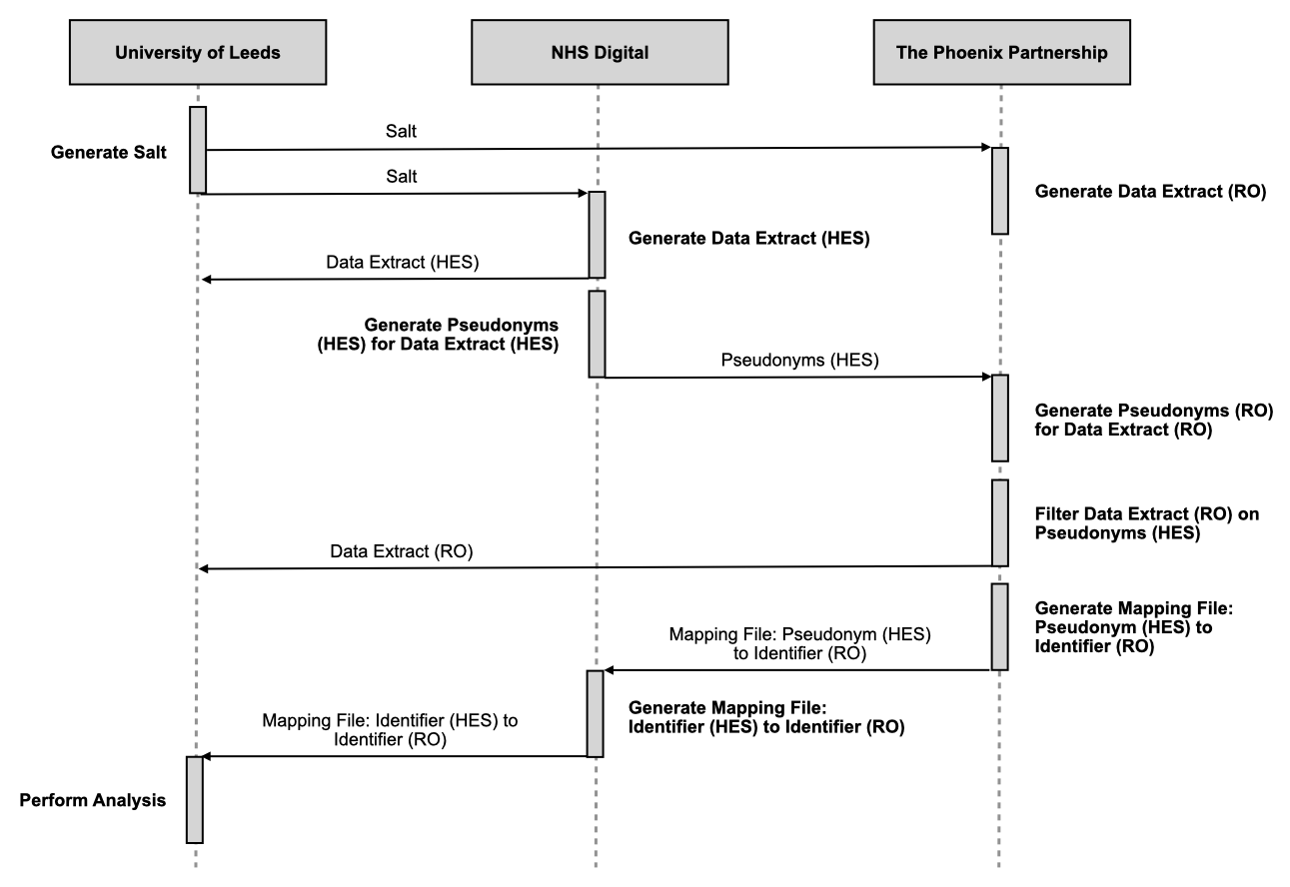
Figure 1: A summary of the key data flows and processing activities of the methodology

Figure 2 shows a summary of the key data flows and processing activities of the methodology. Linkage is undertaken by NHS Digital (32), in accordance with recommendations provided in the Caldicott Review: information governance in the health and acre system document published by the National Data Guardian [32]. NHS Digital and TPP generate two unique references for each patient in their databases: (1) a pseudonym – generated by applying a one-way cryptographic hash function (SHA-512) to an input that comprises a cryptographic salt and the NHS number and (2) a source-specific identifier. For a patient with a given NHS number, NHS Digital and TPP will generate the same pseudonym but a different source-specific identifier. Both the pseudonym and source specific identifier generated for each patient are specific to the study. Pseudonyms are then used by NHS Digital to: (1) communicate to TPP those patients for whom data are required from ResearchOne and (2) generate mappings between different source-specific identifiers for each patient. NHS Digital and TPP provide the required data items to the research team at the University of Leeds, including only the source-specific identifier as the unique reference for each patient. Mappings generated by NHS Digital are then provided to the research team and used to enable data items relating to the same patient across databases to be determined.

Infrastructure
Infrastructure provided by the Leeds Institute of Clinical Trials Research (LICTR) [33] at the University of Leeds was used for the study. Information security standards defined in the Data Security and Protection Toolkit [34] have been met by the infrastructure (REF: ECC0010) and the Data Sharing Framework Contract [35] between the University of Leeds and NHS Digital (REF: CON-315426-K3W7R) includes the use of this infrastructure.

Agreed project-specific terms for processing activities involving NHS Digital were defined in a Data Sharing Agreement [36] established between the University of Leeds and NHS Digital. Agreed project specific terms for data flows and processing activities involving The Phoenix Partnership were defined in the ResearchOne Data Request Form [37] provided to The Phoenix Partnership by the University of Leeds and approved by the ResearchOne Project Committee [38], and in a Data Processing Agreement established between the University of Leeds and The Phoenix Partnership.
Data flows between organisations were performed using one of the following secure data transfer services:
- Secure File Transfer (SFT): Provided by LICTR and used for data flows between University of Leeds and The Phoenix Partnership.
- Secure Electronic File Transfer (SEFT) Service [39]: Provided by NHS Digital and used for data flows between University of Leeds and NHS Digital, and between The Phoenix Partnership and NHS Digital.

Approvals
Approval for this work was planned from Research Governance at the Sponsor (University of Leeds). Ethical approval would then be sought from an NHS Research Ethics Committee (REC) [40] at the Health Research Authority (HRA) [41] to ensure consistency with applicable ethical frameworks for medical research, including the Declaration of Helsinki [42]. Additionally, an application would be made to the Confidentiality Advisory Group (CAG) [43] at the HRA to obtain (if applicable) support under Section 251 of the NHS Act 2006 [44].

Application to Confidentiality Advisory Group (CAG) was based on the following rationale
Due to the number of hospitals and patients required and the potential lack of mental capacity at the time of service contact, individual patient consent would not be practicable. Processing of confidential patient information requires consent or another appropriate legal basis, such as support under Section 251 of the NHS Act 2006, to ensure that there is no breach of confidentiality under common law. Pseudonymised data requests that go through the Data Access Request Service (DARS) [45] process at NHS Digital are considered to be compliant with the Information Commissioner’s Office Code of Practice on Anonymisation [22, 46]. ResearchOne has received a favourable ethical opinion as a research database from an NHS Research Ethics Committee (REF: 11/NE/0184) and received a decision from the National Information Governance Board that Section 251 support is not required as there is no disclosure of identifiable data [47]. On this basis, data provided individually from HES and ResearchOne would appear not to fulfil the definition of confidential patient information and would therefore not require Section 251 support to process in the absence of individual patient consent. This work requires linkage of data from HES and ResearchOne. Linkage was designed to use patient pseudonyms generated by NHS Digital and TPP from NHS numbers and communicated by NHS Digital and TPP only (see Linkage section). Application to CAG was to ensure due diligence in relation to the proposed linkage methodology; seeking an independent authoritative view on whether the processing activities and data flows of the methodology would be considered to require Section 251 support and, if so, obtaining such support through CAG. Approvals from the Information Asset Owner for HES and Independent Group Advising on the Release of Data (IGARD) [48] at NHS Digital and from the ResearchOne Project Committee [38] at TPP would then be underpinned by the approvals/decisions from the Sponsor and the HRA. Enactment of the methodology would follow approval from these bodies at NHS Digital and TPP. Ordering of approvals at NHS Digital that we present in the Summary diagram (Figure 2) is based on information published by the Data Access Request Service (DARS) [49] at the time of report preparation. Published ordering differs from the ordering evident in project-specific correspondence and documentation from NHS Digital, in which it appears that IGARD approval precedes Information Asset Owner (IAO) approval. Figure 2 shows a summary of the envisaged progression of approval processes.

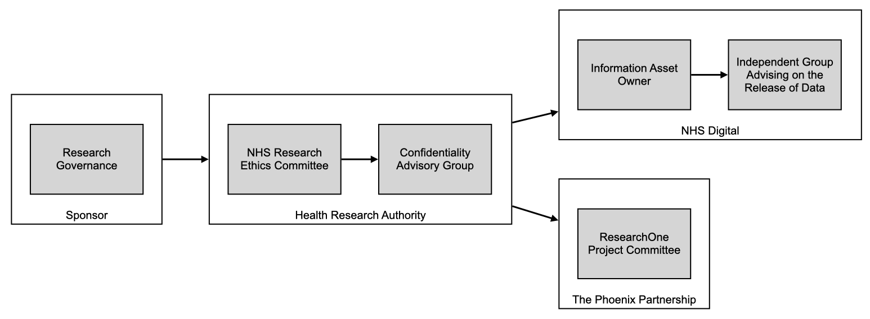
Figure 2: A summary of the envisaged progression of approval processes.

Results

Approvals
The study received: i) approval from Research Governance at the Sponsor, ii) a favourable ethical opinion from NHS REC (North of Scotland) (REF: 16/NS/0025), iii) management permission from a subset of NHS trusts (n=6) which manage the hospitals (n=8) whose patients were to be included in the study population, iv) a decision from the Confidentiality Advisory Group at the Health Research Authority that Section 251 support was not required ‘on the basis that there is no disclosure of patient identifiable data without consent’ (REF: 16/CAG/0037), v) approval from the IGARD at NHS Digital, vi) approval from IAO for HES at NHS Digital and vii) approval from ResearchOne Project Committee at The Phoenix Partnership. Approvals took required 907 days in total. Figure 3 summarises the progression of the approval process.

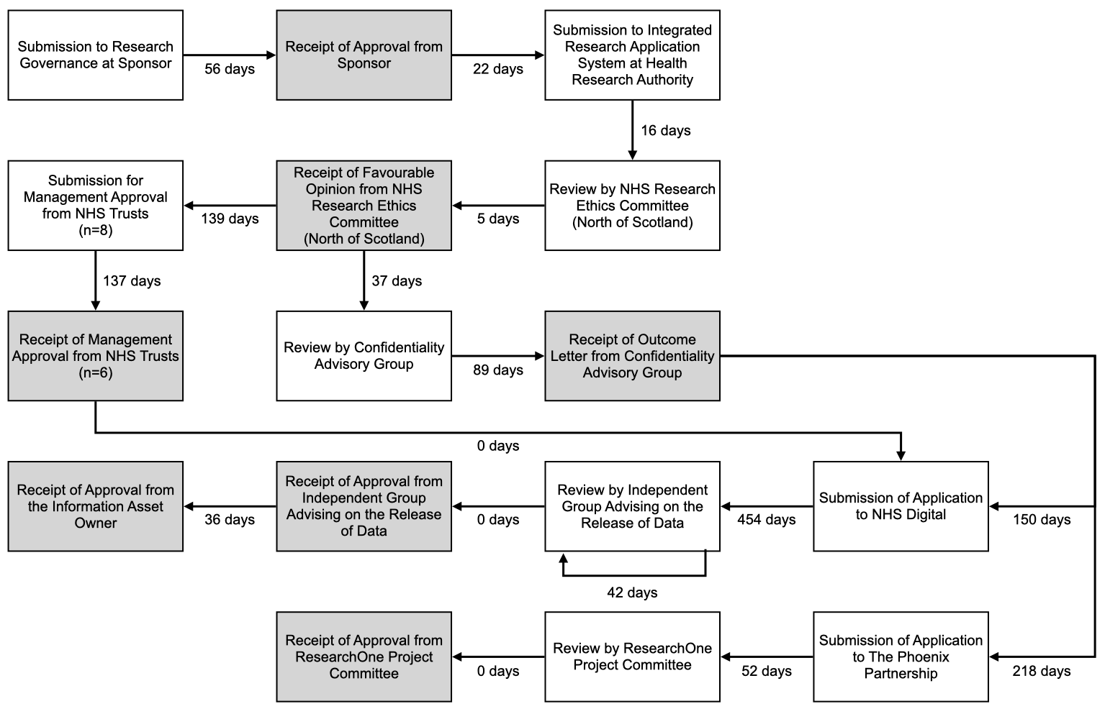
Figure 3: A summary of the progression of the approval processes and the associated time periods

Favourable opinion from NHS REC (North of Scotland) was contingent on management permission from the NHS trusts (n=8) which manage the hospitals (n=11) whose patients were to be included in the study population. Requests for management permission were submitted to the NHS Trusts following receipt of the outcome from the CAG. Management permission was received from a subset of trusts (n=6) by a stated deadline and the study proceeded based on a subset of the hospitals only (n=8).

Following application to TPP, 52 days elapsed before approval by the ResearchOne Project
Committee. TPP supplied an approval date of April 2017. An indicative date of 15th April 2017 was used to calculate the period of 52 days. Review and approval by the ResearchOne Project Committee was assumed to take place on the same date. Following submission of application to NHS Digital for data from HES [REF: NIC-77953], 454 days elapsed before the application was reviewed by IGARD. Delays were attributable to the resolution of technical and organisational queries raised by NHS Digital in their consideration of the application, including: i) the process of pseudonym generation, ii) the data flows
involved in the linkage methodology, iii) the organisation with legal responsibility for ResearchOne, iv) the data controller and data processor responsibilities for organisations involved in the linkage methodology, and iv) the data storage locations for University of Leeds and The Phoenix Partnership. NHS Digital noted that the linkage methodology was a ‘first of type’ and took the application to IGARD for advice prior to submission for review by IGARD. Following review by IGARD, further information was requested from the project team, which was subsequently supplied and a recommendation to approve the application was provided in subsequent IGARD meeting.

Following approval from IGARD and the IAO, a Data Sharing Agreement was established between the University of Leeds and NHS Digital. 118 days elapsed between approval from the IAO and signature of the Data Sharing Agreement by the University of Leeds. Delay was attributable to the University of Leeds awaiting required information from The Phoenix Partnership.

Enactment
Figure 4 shows a summary of the progression enactment processes and associated time periods. Following establishment of a Data Sharing Agreement between the University of Leeds and NHS Digital, the methodology progressed to enactment in which the defined processing activities were undertaken by the University of Leeds, NHS Digital and The Phoenix Partnership. NHS Digital generated pseudonyms for patients in the cohort using a Salt File generated and supplied by the University of Leeds. Incorrect pseudonyms were generated by NHS Digital and supplied to TPP on two occasions, which resulted in no matches being found within ResearchOne. On the first occasion, NHS Digital applied an incorrect hashing algorithm (SHA-256). On the second occasion, NHS Digital used an incorrect format for the input to the hashing algorithm. NHS Digital determined that
the HES data supplied to the University of Leeds had to be re-supplied following the first occasion, but not following the second occasion. Following the second occasion, NHS Digital re-generated the pseudonyms using the correct hashing algorithm and values in the correct input format and resupplied to TPP. Receipt of a valid set of pseudonyms from NHS Digital by TPP required 313 days.

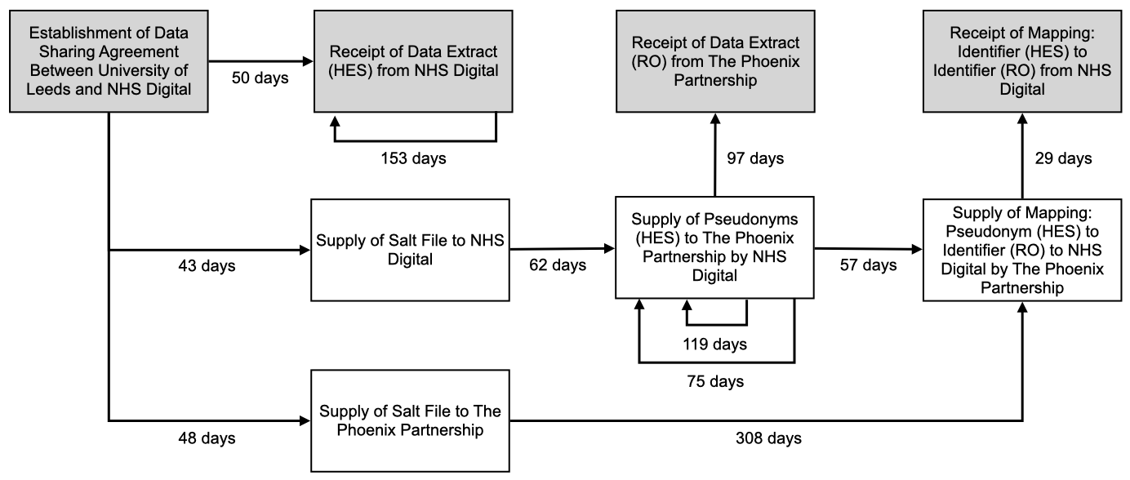
Figure 4: A summary of the progression of the enactment processes and the associated time
periods
Following supply of a valid set of pseudonyms, TPP were able to match pseudonyms with those generated for patients in ResearchOne. TPP generated and supplied a file to NHS Digital which mapped these pseudonyms to corresponding source-specific identifiers from ResearchOne. NHS Digital used the file to generate a file which mapped source-specific identifier in HES to source-specific identifier in ResearchOne. This mapping file was supplied by NHS Digital to the University of Leeds. TPP then supplied the data extract from ResearchOne to University of Leeds. Enactment took 385 days in total.

 | Hospital Episode Statistics | ResearchOne
 | n | n | %
Number of Patients | 181,063 | 33,666 | (18.6)
Hospital of index event
Hospital A | 89,755 | 13,202 | (14.7)
Hospital B | 31,312 | 7,057 | (22.5)
Hospital C | 30,154 | 11,069 | (36.5)
Hospital D | 21,181 | 2,219 | (10.5)
Hospital E | 8,517 | 101 | (1.2)
Hospital F | 144 | 18 | (12.5)
Hospital G | 0 | 0 | (0)
Hospital H | 0 | 0 | (0)

Table 1 A Summary of the number of patients who matched the required criteria from Hospital Episode Statistics and ResearchOne

Table 1 summarises the data supplied from HES and ResearchOne. Data supplied from HES contained 181,063 patients from 6 hospitals (μ=30,177, σ=28,875.86) who matched the required criteria (see Patient Population). Data supplied from ResearchOne contained 33,666 (18.6%) of these patients from the 6 hospitals (μ=5,611, σ= 5,206.59). For two hospitals (G and H), no patients who matched the required criteria could be determined.

In response to a follow up query about low rates of case identification, NHS Digital determined the probable cause for this result to be the use of the Provider Code (5 character) (PROCODE5) field [24, 25, 50, 51] to determine the hospital associated with an episode. NHS Digital advised that the use of both the Provider Code (5 Character) (PROCODE5) field and the Site Code of Treatment (SITETRET) field [25, 50, 51] would likely yield a higher number of patients for each hospital, including those for which no patients with an index event were determined.

Due to the impact on project timescales, we determined that this change to the data specification would not be feasible. After considerable discussion with NIHR and a further delay because of the COVID-19 pandemic, it was decided not to proceed with the analysis of the data we held from the 6 hospital sites. Such an analysis would have been proof that the data linkage we were attempting could be achieved but its value in terms of the overall outcomes we wished to achieve was limited. We therefore proceeded to destroy the data we had obtained and a certificate of destruction was signed by the University of Leeds investigators and data management staff on 15th July 2021.

Discussion

Our objective was to design and enact a methodology for linking routinely collected NHS data from
primary and secondary care to evaluate hospital-based liaison psychiatry services in England. We designed and enacted a methodology to link routinely collected NHS data from HES and ResearchOne. No persistent link exists between these two databases and, to our knowledge, no linkage methodology had been previously enacted between the two databases. Linkage of these databases using the described methodology represented at the time a ‘first of type’ linkage of routinely collected NHS data from primary and secondary care in England.

Linkage of routinely collected NHS data has the potential to extend the patient populations, time periods and dimensions of health and healthcare that can be considered within research studies. Linkage of data from HES and ResearchOne in this study provides a view across primary and secondary care for a subset of patients defined by their attendance at, or admission to, a specific set of hospitals in England within a defined time period. Linkage of data from HES and ResearchOne and appropriate use of similar linkage methodologies between other databases, has the potential to move research studies beyond those research questions that can be answered using data from the small number of databases between which persistent linkages already exist. For example, CPRD and HES.

Linkage of routinely-collected NHS data using the methodology described has advantages for the privacy of patients, the protection of their personal data and the confidentiality of their information. No patient identifiable data is communicated between organisations or received by the research team and linkage is undertaken by NHS Digital (in accordance with national guidance). Linkage is also transient and purpose-specific [52], enabling the benefits and risks of linkage and subsequent analysis, along with the ethical and legal implications, to be appropriately scrutinised by the relevant bodies within the context of a specific project.

Lessons Learned
Significant challenges have been encountered in the approvals and enactment of the methodology. Coordination between multiple organisations at a technical and a governance level was a challenge. Different organisations and organisational units required information to be presented at different levels of granularity, with different emphases, and in adherence to different presentational formats. Timely provision of this information was also contingent on successful traversal of complex organisational structures and internal processes over which we had no control. Moreover, the governance processes that drive decision making within organisations are subject to change in both definition and interpretation over time. Delays in provision of information have the potential to cause further delays. Moreover, technical issues can arise when processing activities must be performed by different organisations in a specific manner, as demonstrated by the issues with pseudonym generation at NHS Digital. Absence of published information relating to the number of patients that can be expected from each database at the unit
of analysis (hospital) and relating to the quality of fields on which cohort selection is determined means that the feasibility of proposed analyses may only be determinable once data has been received. Given the resources required by the approvals and enactment, such uncertainty currently represents a significant risk for research projects.

We are not the only group of researchers to encounter significant delays and difficulties with data access and linkage. Taylor and colleagues (2020) reported it taking them 2.5 years to be able to link a series of databases to study outcomes for congenital heart disease. To link 5 relevant datasets, they were required to produce 47 documents at the application stage for 11 data controllers or departments which were submitted 162 times in total. Although similar study information was requested for each application, each required different wording, structure and detail.

The biggest barriers to realising the full potential of data linkage as a powerful research tool are gaining and maintaining public trust and reducing the cost, delays and inefficiencies in how data linkage is carried out (Harron). The necessities of linking primary and secondary data during the COVID-19 pandemic to facilitate research and rapid transfer of knowledge led to the development of such initiatives as OpenSafely and the British Heart Foundation’s CVD-COVID-UK consortium.

Accessible and functional pathways are required to enable projects to adopt research methodologies based on the linkage of routinely collected NHS data that aim to protect the privacy of patients, their personal data, and the confidentiality of their information. In the absence of such pathways, there is a risk that such methodologies will not be adopted by researchers. This may lead to a detrimental impact on the rights of patients and the quality of research designs, processes and outputs. Improved knowledge and skills are required to develop more effective and efficient processes and structures to support research governance across all stakeholder organisations, including academic institutions,
data providers and approval/advisory bodies.

Researchers who are planning to apply for funding for a data linkage study need to consider the following when developing their application. Several of these issues were highlighted by Taylor et al, but were also experienced by ourselves.
- Budget to access the data sets – it is difficult to anticipate the final costs of access to a database as limited information is usually available on line prior to completion of a full application which cannot be started until funding has been received for the research. Although applications are for the full length of a project, annual data sharing extensions are required which involve additional costs. Taylor and colleagues reported that in the case of NHS Digital, even one additional field request could result in a charge equal to that of the original data extraction.
- Complexity – data request forms vary across different datasets some of which are more suitable for requests for data in relation to randomised controlled trials, rather than large data projects. Streamlining and standardising data request forms across different organisations, whilst maintaining robust data governance procedures commensurate with the Data Protection Act 2018 would reduce time delays.
- Process delays – we encountered numerous complex process delays which have major cost implications for any research study. Most grant applications are for periods of 3 years during which it is not feasible at present to conduct complete data linkage processes and carry out planned data analyses. Underestimation of the time involved in acquiring linked data also results in costs for the research programme as researchers employed to conduct data analyses cannot carry out this work until the data are securely acquired.
- Delays lead to further delays – a delay in one part of the acquisition process leads to delays in other parts of the system.
- Bureaucracy – each time research staff working on the project are recruited, some data sharing agreements have to be updated. Minor changes can take weeks to be processed.
- Fear of legal misstep – failure to comply with the Data Protection Act 2018 and potentially incur a costly fine means that some data controllers require excessive safeguards before agreeing to release data when sufficient safeguards are in place.
- Acquiring data – once all approvals are in place, it can still take at least 6 months to acquire the data.
- Hard to spot small mistakes in the data request process that have major implications for the data which is supplied – 2 out of the 8 hospitals for which we requested data were supplied with empty data fields, due to a misunderstanding about the different ways and data fields which HES uses to record hospital site.
- Staff morale – what seem to be insurmountable delays results in low staff morale as there is inevitable pressure to meet funding deadlines and also a desire to conduct the research which has been planned.
- Career progression and institutional reputational damage – failure to complete or even start a planned programme of research due to delays beyond the control of the research team impacts upon the career progression of middle grade researchers who are employed on the project who are not able to publish as widely or influentially as they would have planned. The Sponsor may also be at risk of reputation damage.

Conclusions
We conclude that routinely collected NHS data from primary care and secondary care available in ResearchOne and HES can be linked using the methodology described. However, the time required for approvals and enactment, the variation exhibited in the supplied data, and the unpredictability of these factors during research design currently limit the viability of such linkage for timely and robust evaluation of health services. Current processes need to be streamlined and standardised with designated clear response times for the different organisations.

Acknowledgments
To do
Funding This project is funded by the National Institute for Health Research (NIHR)
Health Services and Delivery Research (HS&DR) programme (project reference
13/58/08).

Ethics approval Individual patient consent will not be feasible for this study.
Favourable ethical opinion has been obtained from the NHS Research Ethics
Committee (North of Scotland) (REF: 16/NS/0025) for Work Stream 2 (phase 1) of
the Liaison psychiatry—measurement and evaluation of service types, referral
patterns and outcomes study. The Confidentiality Advisory Group at the Health
Research Authority determined that Section 251 approval under Regulation 5 of the
Health Service (Control of Patient Information) Regulations 2002 was not required
for the study ‘on the basis that there is no disclosure of patient identifiable data
without consent’ (REF: 16/CAG/0037).

Publications List
H

In preparation

Romeu D, Guthrie E, House A Staff experiences of liaison mental health services following implementation of CORE 24 informed by service user preferences.

References
1. Aitken P, Lloyd G, Mayou R, et al. A history of liaison psychiatry in the UK. BJPsych Bull
2016;40:199-203.
2. Lipowski ZJ. Consultation-liaison psychiatry: the first half century. Gen Hosp Psychiatry
1986;8:305-15.
3. Mayou R. The history of General Hospital psychiatry. Br J Psychiatry 1969;155:764-76.
4. Schwab JJ. Consultation-liaison psychiatry: a historical overview. Psychosomatics 1989;30:245-
54.
5. Andreoli PBdeA, Citero VdeA, Mari JdeJ. A systematic review of studies in the cost-effectiveness
of mental health consultation-liaison interventions in general hospitals. Psychosomatics
2004;44;499-507.
6. Hosaka T, Aoki T, Watanabe T, et al. General Hospital psychiatry from the perspective of medical
economics. Psychiatry Clin Neurosci 199;53;449-53.
7. R Ruddy, House A. Meta-review of high-quality systematic reviews of interventions in key areas
of liaison psychiatry. Br J Psychiatry 2005;187;109-20.
8. Wood R, Wand APF. The effectiveness of consultation-liaison psychiatry in the General Hospital
setting: a systematic review. J Psychosom Res 2014;76:175-92.
National Institute for Health Research (NIHR). Liaison psychiatry: measurement and evaluation
of service types, referral patterns and outcomes (LP-MAESTRO), 2020. Available:
https://www.journalslibrary.nihr.ac.uk/programmes/hsdr/135808 [Accessed 18th October 2020]
10. NHS Digital. Hospital Episode Statistics (HES), 2020. Available: https://digital.nhs.uk/data-andinformation/
data-tools-and-services/data-services/hospital-episode-statistics [Accessed 18th
October 2020].
11. NHS Digital, 2020. Available: https://digital.nhs.uk [Accessed 18th October 2020].
12. The Phoenix Partnership. ResearchOne, 2020. Available: http://www.researchone.org [Accessed
18th October 2020].
13. The Phoenix Partnership, 2020. Available: https://www.tpp-uk.com [Accessed 18th October
2020]
14. The Phoenix Partnership. SystmOne, 2020. Available: https://www.tppuk.
com/products/systmone [Accessed 18th October 2020].
15. Kontopantelis E, Stevens RJ, Helms PJ, et al. Spatial distribution of clinical computer systems in
primary care in England in 2016 and implications for primary care electronic medical records
databases: a cross-sectional population study. BMJ Open 2018;9:e020738.
16. Medicines & Healthcare products Regulatory Agency. Clinical Practice Research Datalink, 2020.
Available: https://www.cprd.com [Accessed 18th October 2020].
17. Medicines & Healthcare products Regulatory Agency, 2021. Available:
https://www.gov.uk/government/organisations/medicines-and-healthcare-productsregulatory-
agency [Accessed 27th January 2021].
18. Medicines & Healthcare products Regulatory Agency. Clinical Practice Research Datalink.
Primary Care Data for Public Health Research, 2021. Available: https://cprd.com/primary-care
[Accessed 27th January 2021].
19. Egton Medical Information Systems. EMIS web, 2020. Available:
https://www.emishealth.com/products/emis-web. [Accessed 18th October 2020]
20. Cegedim Healthcare Solutions. GP IT Solution. Available: https://info.visionhealth.co.uk/gpsolution
[Accessed 27th January 2021].
21. Health and Social Care Information Centre. Patient Objections Management for General Practices
in England, 2020. Available:
https://www.gov.uk/government/uploads/systme/uploads/attachment_data/file/469290/Data
-Provision-Notice_Patient_Objections_Management_19.10.15.pdf [Accessed 18th October 2020].
22. NHS Digital. How the national opt-out affects data released by NHS Digital, 2020. Available:
https://digital.nhs.uk/services/data-access-request-service-dars/how-the-national-data-optout-
affects-data-released-by-nhs-digital [Accessed 18th October 2020].
23. Health and Social Care Information Centre. Obtaining consent for patient identifiable and/or
sensitive data, 2020. Available: http://content.digital.nhs.uk/media/12053/Obtaining-consentfor-
patient-identifiable-and-or-sensitive-data-V2-
050613/pdf/obtaining_consent_for_patient_identifiable_and_or_sensitive_data_V2_050613.p
df [Accessed 18th October 2020].
24. NHS Digital. HES Data Dictionary – Accident and Emergency, 2020. Available:
https://digital.nhs.uk/binaries/assets/legacy/pdf/3/l/hes_data_dictionary_-
_accident_and_emergency.pdf [Accessed 18th October 2020].
25. NHS Digital. HES Data Dictionary – Admitted Patient Care, 2020. Available:
https://digital.nhs.uk/binaries/content/assets/legacy/pdf/1/c/hes_data_dictionary_-
_admitted_patient_care.pdf [Accessed 18th October 2020].
26. NHS Digital. HES Data Dictionary – Outpatients, 2020. Available:
https://digital.nhs.uk/binaries/content/assets/legacy/pdf/4/i/hes_data_dictionary_-
_admitted_patient_care.pdf [Accessed 18th October 2020].
27. The Phoenix Partnership. ResearchOne – Database Protocol, 2020. Available:
http://www.researchone.org/wp-content/uploads/2013-08/TPP-Research-
Database_Protocol_V1.4.pdf [Accessed 18th October 2020].
28. NHS Digital. Quality Outcomes Framework (QOF), enhanced services and core contract extraction
specifications, 2021. Available: https://digital.nhs.uk/data-and-information/data-collectionsand-
data-sets/data-collections/quality-and-outcomes-framework-qof [Accessed 27th January
2021].
29. NHS Digital. What is an NHS number?, 2020. Available: https://www.nhs.uk/using-thenhs/
about-the-nhs/what-is-an-nhs-number [Accessed 29th October 2020]
30. Health and Social Care Information Centre. Methodology for creation of the HES Patient ID
(HESID), 2015. http://www.hscic.gov.uk/media/1370/HES-Hospital-Episode-Statistics-
Replacement-of-the-HES-patient-ID/pdf/HESID_Methodology.pdf [Accessed 24th November
2015]
31. Health Research Authority. CAG Frequently Asked Questions, 2021.
https://www.hra.nhs.uk/documents/223/cag-frequently-asked-questions-1.pdf [Accessed 27th
January 2021].
32. National Data Guardian. Caldicott review: Information governance in the health and social care
system, 2020. Available: https://www.gov.uk/government/publications/the-informationgovernance-
review [Accessed 18th October 2020].
33. University of Leeds. Leeds Institute of Clinical Trials Research, 2020. Available:
https://medicinehealth.leeds.ac.uk/leeds-institute-of-clinical-trials-research [Accessed 18th
October 2020].
34. NHS Digital. Data Security and Protection Toolkit, 2020. Available:
https://www.dsptoolkit.nhs.uk [Accessed 18th October 2020].
35. NHS Digital. Data Sharing Framework Contract, 2021. Available:
https://digital.nhs.uk/binaries/content/assets/websiteassets/
services/dars/data_sharing_framework_contract_v2.01_demo.pdf [Accessed 27th
January 2021].
36. NHS Digital. Data Sharing Agreement, 2021. Available:
https://digital.nhs.uk/binaries/content/assets/websiteassets/
services/dars/nhs_digital_approved_edition_2_dsa_demo.pdf [Accessed 27th January
2021].
37. The Phoenix Partnership. ResearchOne. Expression of Interest/Data Request Form, 2021.
http://www.researchone.org/wp-content/uploads/2014/05/EoI_and_DataRequest_V6.doc
[Accessed: 27th January 2021].
38. The Phoenix Partnership. ResearchOne. ResearchOne Project Committee, 2021.
http://www.researchone.org/project-committee/ [Accessed: 27th January 2021].
39. NHS Digital. Secure Electronic File Transfer. Available: https://digital.nhs.uk/services/transferdata-
securely [Accessed 18th October 2020].
40. Health Research Authority. Research Ethics Service and Research Ethics Committees. Available:
https://www.hra.nhs.uk/about-us/committees-and-services/res-and-recs [Accessed 18th
October 2020].
41. Health Research Authority, 2020. Available: https://www.hra.nhs.uk [Accessed 18th October
2020].
42. World Medical Association. WMA Declaration of Helsinki – Ethical Principles for Medical
Research involving Human Subject, 2020. Available: https://www.wma.net/policies-post/wmadeclaration-
of-helsinki-ethical-principles-for-medical-research-involving-human-subjects
[Accessed 18th October 2020].
43. Health Research Authority. Confidentiality Advisory Group, 2020. Available:
https://www.hra.nhs.uk/about-us/committees-and-services/confidentiality-advisory-group
[Accessed 18th October 2020].
44. HM Government. National Health Service Act 2006, 2020. Available:
http://www.legislation.gov.uk/ukpga/2006/41/contents [Accessed 18th October 2020].
45. NHS Digital. Data Access Request Service (DARS), 2020. Available:
https://digital.nhs.uk/services/data-access-request-service-dars [Accessed 18th October 2020].
46. Information Commissioner’s Office. Anonymisation: managing data protection risk – code of
practice, 2020. Available: https://ico.org.uk/media/1061/anonymisation-code.pdf [Accessed
18th October 2020].
47. The Phoenix Partnership. ResearchOne – Ethics, 2020. Available:
http://www.researchone.org/ethics [Accessed 18th October 2020].
48. NHS Digital. Independent Group Advising on the Release of Data, 2020. Available:
https://digital.nhs.uk/about-nhs-digital/corporate-information-and-documents/independentgroup-
advising-on-the-release-of-data [Accessed 18th October 2020].
49. NHS Digital. Data dissemination – the Data Access Request Service, 2021. Available:
https://digital.nhs.uk/data-and-information/data-insights-and-statistics/data-disseminationthe-
data-access-request-service-team [Accessed 27th January 2021].
50. NHS Digital. HES Data Dictionary – Accident and Emergency, 2021. Available:
https://digital.nhs.uk/binaries/content/assets/website-assets/data-and-information/data-toolsand-
services/data-services/hospital-episode-statistics/hes-data-dictionary/dd-ae_v12.pdf
[Accessed 27th January 2021].
51. NHS Digital. HES Data Dictionary – Admitted Patient Care, 2021. Available:
https://digital.nhs.uk/binaries/content/assets/website-assets/data-and-information/data-toolsand-
services/data-services/hospital-episode-statistics/hes-data-dictionary/dd-apc_v12.pdf
[Accessed 27th January 2021].
52. Smith C, Hewison J, and House A. Designing a privacy-preserving protocol to support transient
and purpose-specific data linkages. International Journal of Population Data Science
2017;1(1):353.

