The role of ongoing oscillation in pain perception: Absence of modulation by a concomitant arithmetic task

Chiara Leu¹*, Arthur Courtin^{1,3}, Céline Cussac¹, Giulia Liberati^{1,2}

¹Institute of Neuroscience, Université catholique de Louvain, Brussels, Belgium
²Psychological Sciences Research Institute, Université catholique de Louvain, Louvain-la-Neuve, Belgium
³Center of Functionally Integrative Neuroscience, Aarhus University, Aarhus, Denmark

*Corresponding author. Chiara Leu, Institute of Neuroscience (IONS), Université
catholique de Louvain, 53 Avenue Mounier, 1200 Bruxelles, Belgium.
Email : chiara.leu@uclouvain.be

Abstract
Sustained nociceptive stimuli have been shown to modulate the amplitude of ongoing neural oscillations in the theta, alpha and beta frequency bands at the frequency of stimulation, suggesting a relationship between these ongoing oscillations and pain perception. Yet, whether these ongoing oscillations are actually related to the pain experience remains unclear. If it were the case, then cognitive processes that are known to affect pain intensity should also affect these ongoing oscillations. To this end, we used electroencephalography (EEG) to investigate whether distraction – an attentional state known to affect pain perception – also modulates the amplitude of these neural oscillations. More specifically, we hypothesized that performing an unrelated arithmetic task during sustained nociceptive stimulation would lead to a decrease in the modulations of ongoing oscillations exerted by the stimulation. To assess the selectivity of this modulation for nociception, we compared the modulations of ongoing oscillations exerted by sustained periodic thermonociceptive and non-nociceptive vibrotactile stimulation (0.2 Hz, 75 s), while participants were either asked to solve an unrelated arithmetic task (distraction task) or received no specific instruction (baseline). The intensity of perception was significantly reduced by the arithmetic task in both the thermonociceptive and the vibrotactile modality, and the sustained periodic stimulation elicited a periodic response at the frequency of stimulation in both modalities. However, the distraction task did not show a differential effect for the two stimulation modalities in any of the frequency bands. The fact that, unlike pain perception, these oscillations did not appear to be affected by the task suggests that they are dissociable from pain perception. Whether a different task (leading to a stronger degree of distraction) could lead to different results is unclear.
Keywords: nociception, pain, neural oscillations, frequency-tagging
- Introduction
Painful thermonociceptive stimuli have been shown to modulate ongoing EEG oscillations within different frequency bands (Dowman et al., 2008 ; Huishi Zhang et al., 2016). However, whether these modulations actually reflect pain-specific activity is still debated (Huishi Zhang et al., 2016 ; Ploner et al., 2017). Ongoing neural oscillations arise from fluctuations of brain activity, which cycle and interact at different frequencies and spatial scales (Buzsáki & Draguhn, 2004). One of the key functions of these oscillations might be to strengthen the connectivity between synchronously oscillating neurons (Akam & Kullmann, 2014 ; Fries, 2015), thus possibly integrating the sensory, cognitive, and affective components of pain. Moreover, it has been suggested that the oscillatory status of key brain areas could be related to pain perception and therefore pinpoint to a crucial role of ongoing oscillations in the experience of pain (Mayhew et al., 2013 ; Ohara et al., 2008).
Previous scalp electroencephalography (EEG) (Colon et al., 2017 ; Guo et al., 2020) and intracerebral EEG (Liberati et al., 2019) studies have shown that sustained periodic thermonociceptive stimuli induce a modulation of ongoing EEG oscillations at the frequency of stimulation. More specifically, Colon et al. (2017) reported that ultra-slow (0.2 Hz) and long-lasting (75 s) periodic thermonociceptive stimulation elicited a consistent periodic phase-locked EEG response at the frequency of stimulation and at its harmonics, as well as a periodic modulation of the amplitudes of theta, alpha, and beta band ongoing oscillations. By recording intracerebral EEG activity from the insula of patients undergoing a presurgical evaluation of focal epilepsy and using the same stimulation parameters, Liberati et al. (2019) observed that sustained periodic thermonociceptive stimulation exerted modulations of theta and alpha ongoing oscillations at the frequency of stimulation, which were predominant in the posterior insula. Importantly, these modulations were not observed in response to sustained periodic non-nociceptive vibrotactile stimuli, suggesting that they may be preferentially related to nociception and/or to the perception of pain within the insula.
If the modulations of ongoing oscillations exerted by nociceptive stimuli are actually related to pain perception and are relatively close to the end of the chain of neural events leading to this perception, a modulation of the perception intensity, caused for example by a cognitive state change, should be accompanied by a congruent change in the modulation of ongoing oscillations. The effects of top-down modulators on pain perception are well known (Bantick et al., 2002 ; Miron et al., 1989 ; Shipp, 2004 ; Torta et al., 2017), and distraction from the nociceptive input (e.g. by a highly attention-demanding task) has been shown to reduce subjective pain perception in a large number of studies (Eccleston, 1995 ; Eccleston & Crombez, 1999 ; Torta et al., 2017 ; Tracey et al., 2002). A similar decrease in amplitude during distraction was observed for event-related potentials (ERPs) (Beydoun et al., 1993 ; Boyle et al., 2008 ; Qiu et al., 2002), but whether non-phase locked responses (i.e. event related ongoing oscillation synchronization or desynchronization) are modulated in a similar way is unclear. Additionally, a slow and sustained stimulation paradigm might control for biases related to stimulus saliency and arousal, which normally interfere with ERPs investigations.
To clarify this, we investigated whether the decrease in pain perception caused by an attention-demanding task concomitant to a sustained periodic thermonociceptive stimulation would be matched by a decrease in the modulation of ongoing oscillations exerted by the stimulation. Furthermore, to probe whether there is a preferential relationship between these oscillation modulations and pain perception, we used both sustained non-nociceptive vibrotactile and sustained nociceptive heat stimulations and compared the results obtained for both modalities. Based on Eccleston (1995) and Torta et al. (2017), we hypothesized that (1) diverting the attention from both nociceptive and vibrotactile stimulation would lead to a decrease in perceived intensity of stimulation. In parallel, based on previous findings from our group (Colon et al., 2017 ; Liberati et al., 2019), we hypothesized (2) that both the thermonociceptive and vibrotactile stimuli would elicit a periodic EEG activity at the frequency of stimulation and at its harmonics in the different frequency bands. Moreover, we hypothesized (3) that thermonociceptive stimuli would exert a greater modulation of ongoing oscillations in the alpha, beta and theta frequency bands, at the frequency of stimulation and its harmonics, compared to vibrotactile stimuli. Finally, we hypothesized (4) that the distraction condition would lead to a smaller modulation of ongoing oscillations exerted by thermonociceptive and vibrotactile stimuli, as compared to the baseline condition.
- Methods
We report how we determined our sample size, all data exclusions, all inclusion/exclusion criteria, whether inclusion/exclusion criteria were established prior to data analysis, all manipulations, and all measures in the study. Since this study was submitted as a Registered Report, all analysis steps were defined prior to data collection. The OSF stage I publication can be found under the following link: https://osf.io/4nbsc. All anonymized study raw data, analysis codes and pre-processing pipelines have been uploaded to the public archive of Harvard Dataverse under the following link: https://doi.org/10.7910/DVN/YNRKQH.
  - Participants
25 healthy participants (between 18 and 35 years old) were recruited via an established website and remunerated with 20 € for the duration of the experiment (approximately 2h). A detailed description of the sample size calculation can be found in the Supplementary Materials. One participant had to be removed from the data set due to artifacted EEG signals. The remaining participants (n=24) were 23 ± 3.4 (mean ± sd) years old and 7 participants were male.
Exclusion criteria were established prior to data analysis and included any neurological diseases, psychiatric disorders or any recent trauma of the upper limbs on direct questioning. Additionally, the intake of paracetamol, nonsteroidal anti-inflammatory drugs (NAIDs), or acetylsalicylic acid within 12 hours before the assessment led to the exclusion of the participants. Only right-handed participants were included in the investigation. All participants gave written informed consent prior to the beginning of the assessment and were informed that they could withdraw from the experiment at any given time.
All procedures were performed in accordance with the relevant guidelines and regulations. The local Research Ethics Committee approved all experimental procedures (Commission d’Ethique Hospitalo-Facultaire Saint-Luc UCLouvain, B403201316436).
  - Thermonociceptive stimulation
A thermal cutaneous stimulator (TCS II, QST.Lab, Strasbourg, France) with the T03 probe, which is set with 15 micro Peltier elements (each ~7.7 mm²) whose temperature can vary at rates of up to 300°C/s, was used to deliver sustained periodic thermonociceptive stimuli (0.2 Hz) on the right volar forearm (Mulders et al., 2020) (Figure 1). The stimulation probe weights 440 g and has a flat 30-mm diameter surface. The temperature of stimulation varied between baseline temperature (35°C) and 50°C in a sinusoidal manner over a duration of 5 s per cycle (Figure 1). It has been shown that periodic thermonociceptive stimulation at 0.2 Hz frequency predominantly activates unmyelinated C-fibers, generating a reliable periodic EEG response with a high signal-to-noise ratio (Colon et al., 2017). Previous investigations have shown more inconsistent and weaker responses using a higher frequency of stimulation (Mouraux et al., 2011). Each sustained periodic stimulation comprised 15 stimulation cycles, lasting at total of 75 seconds per stimulus, as in Liberati et al. (2019) and Mulders et al. (2020). Inter-stimulus-intervals were variable and self-paced by the experimenter to allow participants to provide intensity ratings as well as to give responses to an arithmetic task. The thermode was displaced after each trial to avoid habituation or sensitization.
  - Vibrotactile stimulation
Sustained periodic vibrotactile stimuli were delivered via a recoil-type vibrotactile transducer driven by a standard audio amplifier (Haptuator, Tactile Labs Inc., Canada), positioned between the fingertips of the index and the thumb of the dominant hand (Figure 1). The vibrations consisted in a 251 Hz sine wave whose amplitude was periodically modulated at a frequency of 0.2 Hz (15 cycles, each lasting 5 s, for a total of 75 s) (Figure 1). We chose this type of stimulation because, despite being non-nociceptive and non-painful, it is generally perceived as highly intense, which makes it a suitable comparison to investigate whether the observed modulations might be preferential for pain perception.
  - Experimental tasks
During the distraction task, participants were asked to solve an arithmetic task unrelated to the stimulation, to distract them from the thermonociceptive stimuli. Starting from a 3-digit number (e.g. 754), they had to subtract the number 7 continuously and report their final value at the end of the trial (Dowman et al., 2008 ; Plaghki et al., 1994 ; Schulz et al., 2019). Answer accuracy was tracked to ensure compliance. The number from which participants had to subtract changed for each trial. The 20 numbers (10 trials for each modality) were generated prior to data gathering using a random numbers generator within the limits of 100 and 999. The numbers were the same for every participant but randomized in their order of appearance during the experiment. In baseline (as opposed to distraction) condition, participants did not receive any specific instructions.
  - Experimental Procedure
In this within-subject study design protocol, participants were seated comfortably in a chair, and received thermonociceptive and vibrotactile stimulation on their right (dominant) arm. Before the beginning of the experiment, each participant was exposed to a familiarization trial (i.e. 1 periodic heat stimulation and 1 periodic vibrotactile stimulation) on their non-dominant side. The stimulations for each modality were divided into two different blocks (i.e. distraction task and baseline, see 1.6), with a short break in-between the blocks and modalities. The order of the blocks and modalities was randomized across participants. To mask any noise that could be generated by the haptuator, white noise was delivered to the participants during all stimulation sessions.
    - Rationale for numbers of trials
The EEG recordings of a recent investigation by Mulders et al. (2020) were examined to assess whether a reduced number of trials (compared to the trial set used in said investigation) would still lead to a measurable modification of ongoing neural oscillations. This specific dataset was chosen because the used stimulation paradigm closely resembled the proposed paradigm. Mulders et al. (2020) also investigated periodic neural responses and the modulation of ongoing oscillations, elicited by very similar sustained stimuli compared to the proposed paradigm. Additionally, the investigation followed a 2 x 2 design, similar to the modality and condition parameters of the proposed paradigm.
The EEG recordings were analyzed using the Letswave7 (http://www.letswave.org/) toolbox in MATLAB (2020b MathWorks). To find the minimal amount of trials necessary to record a reliable modulation of ongoing neural oscillations, the filtered and averaged trials (following the method of Mulders et al. (2020)) were reduced from originally 12 to 6, 8 and 10 trials respectively. For each scenario, the phase-locked response as well as the modulation in the different frequency bands were analyzed. Phase-locked responses were found for all 3 sub-trials at the frequency of the stimulation (0.2 Hz), using a t-test against 0 (p<0.0001). Similar results were found for the different frequency bands modulations (theta: 4-8 Hz, alpha: 8-12 Hz, beta: 12-30 Hz, gamma: 30-50 Hz). These results show that a reduction in trials is feasible without loss in the ability to detect the response of interest. Thus, 10 trials were included in each condition, to reduce the number of trials while keeping a safety margin for the assessment (e.g. in case some epochs would have needed to be discarded in the analysis process due to artifacts).
  - Behavioral measures
Participants were instructed to rate the average of the perceived intensity of each stimulus on a visual analog scale (VAS) (using a 10 cm ungraduated sliding ruler) at the end of each trial (i.e. after the full 15 cycles). The left extremity of the VAS was labeled ‘no perception’ and the right extremity was labelled ‘the most intense stimulation you can imagine’. Additionally, after each trial they were asked whether they perceived the stimulus as painful.
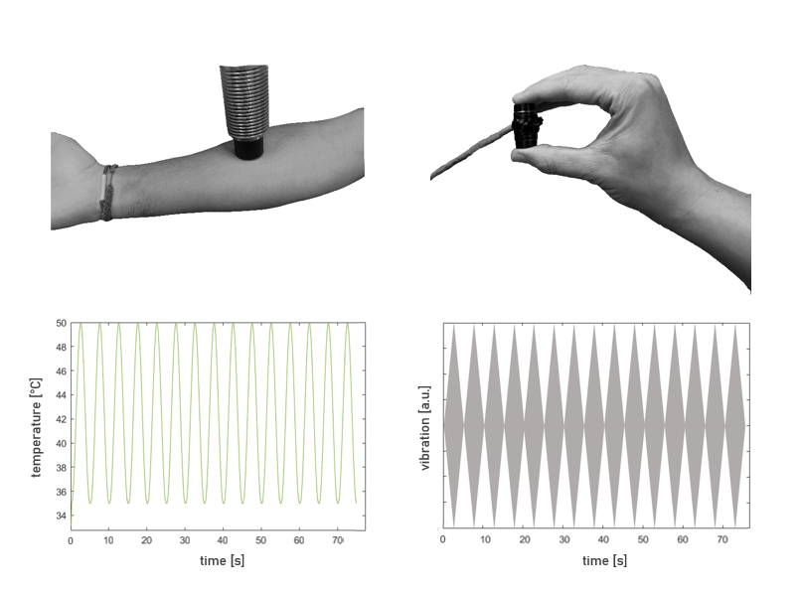
Figure 1: Experimental procedure. Two conditions were applied in two different stimulation modalities (left: thermonociceptive, right: vibrotactile). The stimuli were applied in a sustained periodic manner, at a frequency of 0.2 Hz over a duration of 75 s (i.e. 15 cycles of 5 s) per trial. One representative trial is shown for each modality. 10 trials were applied per condition (i.e. distraction / baseline) and modality. Both modality and condition were randomized across participants. The thermonociceptive stimuli were applied using a thermal cutaneous stimulator (TCS II, QST.Lab, Strasbourg, France), placed on the right volar forearm of the participants. The vibrotactile stimuli were applied using a haptuator (Haptuator, Tactile Labs Inc., Canada), which was held between the fingertips of the index finger and the thumb of the right hand.; a.u., arbitrary amplitude unit.

  - EEG recordings
Electroencephalographic (EEG) activity was recorded using an elastic electrode-cap with 64 active, pre-amplified Ag-AgCl electrodes (BioSemi, Netherlands), arranged according to the international 10-10 system and re-referenced to the average activity recorded from all electrodes. The direct-current offset was kept below 30 mV during electrode placement. Eye movements were recorded using two additional electrodes, one pasted to one of the zygomatic processes and the other between the eyebrows. The BioSemi ActiView software was used to store the recorded signal for offline analyses.
  - EEG analyses
An illustration summarizing the EEG data pre-processing can be found in the supplementary material (Supplementary Figure 1).
    - Analysis of the phase-locked periodic response
The EEG recordings were analyzed using the Letswave7 (www.letswave.org) toolbox in MATLAB (2020b The MathWorks). To characterize the response to the different stimulation paradigms, a frequency-tagging (Regan, 1989) analysis approach was used. This approach is based on the notion that periodic stimuli elicit a periodic surge in neural activity, leading to a periodic EEG response in the EEG at the frequency of stimulation (Colon, Nozaradan, et al., 2012 ; Mouraux et al., 2011). Using the periodicity of the stimulus allows us to differentiate between neural responses related to the applied stimulus and other ongoing activity (Colon, Nozaradan, et al., 2012). A tonic stimulation would not allow to do this as easily.
As in previous investigations performed in our lab (Colon et al., 2014 ; Colon et al., 2017 ; Colon, Nozaradan, et al., 2012 ; Liberati et al., 2019 ; Mouraux et al., 2011 ; Mulders et al., 2020), the assessment of the periodic modulation of the EEG responses was done by obtaining the filtered EEG recordings using a Butterworth high-pass filter (0.05 Hz) to remove slow drift and a 50 Hz notch filter to eliminate power line noise a that frequency. Then, the recordings were segmented into epochs of 0-75s relative to the onset of the stimulation. Artifacts due to eye movements were removed using a validated method based on Independent Component Analysis (Fast ICA algorithm) (Hyvarinen & Oja, 2000).
After pre-processing (including filtering and ocular artefact removal using ICA decomposition), trials with an amplitude change larger than ± 500 µV (Colon et al., 2014) on any of the electrodes were excluded. We defined a priori that participants with less than 8 remaining trials would be excluded. No participant had to be excluded using this rule.
Then, the segmented waveforms were averaged for each subject and condition. The resulting average waveforms of 75 s were transformed in the frequency domain using a discrete Fourier transform (FFT) (Frigo & Johnson, 1998). Finally, the residual noise was partially removed from the signal amplitude over the entire spectrum by subtracting – at each electrode and at each frequency bin– the average amplitude of the signal measured at 2-5 neighboring frequencies (Mouraux et al., 2011). The noise-subtracted amplitudes was then used to analyze the EEG data in the frequency domain. The entire electrode set was taken into account. For further analysis, the electrode with the largest amplitude at the frequency of stimulation across conditions was chosen.
    - Analysis of the modulation of ongoing oscillations
Frequency-tagging of ongoing oscillations (FT-OO) is a novel method to analyze the effect of sustained sinusoidal thermonociceptive stimulation on the modulation of ongoing oscillations assessed by scalp EEG (Colon et al., 2017). This analysis technique allows to isolate neural activity related to the applied stimulus (Colon, Nozaradan, et al., 2012) and has since been successfully used to identify cortical responses to sustained thermonociceptive stimulation generally or in specific frequency bands using scalp EEG (Colon et al., 2014 ; Colon et al., 2017 ; Colon, Nozaradan, et al., 2012 ; Mulders et al., 2020), as well as intracerebral EEG (Liberati et al., 2019).
To assess whether the different conditions would induce a periodic modulation of the amplitude of ongoing neural oscillation within different frequency bands (theta: 4-8 Hz, alpha: 8-12 Hz, and beta: 12-40 Hz), the signal envelopes within these frequency bands had to be estimated. In order to achieve this, the filtered, segmented and ICA-treated EEG signal described above were additionally filtered using a band-pass 4th order Butterworth filter for each specific frequency band. The estimates of the envelopes of the signal were computed using a Hilbert transform. The next steps correspond to the procedure described above; the envelopes were averaged across trials, and the frequency transforms were computed using a discrete Fourier transform. The entire electrode set was taken into account and for each frequency band, the electrode with the largest amplitude at the frequency of stimulation in the baseline condition was selected for further analysis. The same electrode was used in the distraction condition to have an adequate measure of the change between the conditions.
Electrodes of interest were determined at group level and were likely to vary for the different modalities/frequency bands. Based on previous results, high phase-locked activity was expected in regions of interest such as central-parietal regions (contralateral to stimulated side) for vibrotactile stimulation, e.g. C3 (Colon et al., 2014) and central electrodes for thermonociceptive stimulation, e.g. Cz/ FCz / CPz (Colon et al., 2014 ; Colon et al., 2017 ; Mulders et al., 2020). Non-phase locked responses were expected to be located primarily in the central-parietal regions contralateral to the stimulated side for the alpha and beta frequency bands and more centrally for the theta band (Colon et al., 2017 ; Mulders et al., 2020)).
Potential differences induced by distraction were considered as well. It has been suggested that cortical interactions between the posterior medial frontal cortex (pMFC) and the lateral prefrontal cortex (LPFC) facilitate cognitive control (Ridderinkhof et al., 2004). Specifically, theta phase synchronization between pMFC and LPFC has been linked to the communication between cognitive monitoring and attention-related brain network, while alpha phase synchronization seems to relay this information to more posterior (sensorimotor) areas (Clayton et al., 2015). Yet, we did not believe that the proposed frequency-tagging approach would be able to capture these responses in higher order regions, since the distraction task is intrinsically non-periodical.
  - Statistical Analysis
Statistical analysis were done using R Statistical Software (Version 4.1.0, R Core Team 2021) and MATLAB (2020b The MathWorks). The significance level for the behavioral analysis and LMMs was set at p<0.05. The LMM was fitted using REML and the significance of the results was tested using a Kenward-Roger approximation, which has been shown to produce adequate type 1 error rates also for smaller sample sizes (Luke, 2017). In case of a non-normal distribution of the data set, a log-transform was applied to the EEG data (i.e. amplitudes at the frequency of interest (FOI, aggregated harmonics at the frequency of stimulation and its harmonics)) to conform the data to the assumption of normality. This is a frequently used linear transformation, aiming at transforming right-skewed data into a more normal (gaussian) form (Bland & Altman, 1996 ; Healy, 1993). The log transformed values were used in each of the LMM’s, since a non-normal distribution was found for all EEG data. The original amplitude values were used to display meaningful amplitudes in the figures.
    - Behavioral data
To test for differences in task performance during thermonociceptive and vibrotactile stimulation, a paired t-test was used. Potential differences in performance between gender were assessed with a Welch Two Sample t-test for each modality.
To validate hypothesis (1), we assessed the effect of condition and modality (independent variables (IV)) on perceived stimulus intensity (dependent variable (DV)), by using a linear mixed model (LMM). The factors “condition” (two levels: baseline, distraction) and “modality” (two levels: thermonociceptive, vibrotactile) were included as fixed effects and “subject” as a random effect accounting for the variation of the regression model intercept across participants.
Intensity rating ~ condition + modality + modality:condition + (1|subject)
We expected the intensity rating to be lower for the distraction condition compared to the baseline condition for both stimulation modalities. If this had not been the case, we would have concluded that the task failed to distract the participants.
    - Phase-locked response
To investigate hypothesis (2), non-parametrical statistical tests were applied to assess (for each condition / modality combination) whether the magnitude of the aggregated amplitudes at the frequency of interest was significantly larger than zero. Aggregation was done by summing up the amplitudes of the signal at the frequency of stimulation and its first 199 harmonics. This specific number was chosen since it includes all the harmonics up to the frequency of 40 Hz, which is the highest frequency analyzed in this investigation. A right tailed multi-sensor cluster-based permutation test using Wilcoxon signed-rank test as statistic was used to evaluate the periodic response against zero, allowing for non-normality of the dataset and controlling type 1 error rate inflation due to the multiple testing (the median being compared to 0 at each of the 64 channels). To account for multiple testing, a Bonferroni correction was applied to the Wilcoxon signed-rank test, reducing the significance level to 0.0125 by dividing alpha by the number of modality/condition pairs. The threshold of the cluster-based permutation was also set to 0.0125, and 2000 permutations of the dataset were computed. The multi-sensor analysis was set so that each channel has 4 neighbors on average (equals a threshold of 0.161).
Based on the findings of Colon et al. (2017); Mulders et al. (2020) and Liberati et al. (2019), we expected that the amplitude of the EEG signal at the frequency of stimulation would have been significantly greater than zero for both modalities. If we would not have found a periodic modulation of the EEG signal, then the basic assumption of this investigation that sustained periodic stimuli lead to a periodic modulation of the EEG signal at the frequency of stimulation would not be met and hence the data would not be useful for analysis.
To investigate hypothesis (4), we analyzed the periodic response of the obtained noise-subtracted aggregated signal amplitudes (DV), using an LMM analysis; with 2 factors for “modality” (thermonociceptive, vibrotactile) and for “condition” (baseline, distraction) as fixed factors (IV). “Subject” was added as a random factor, to account for the variation of the regression model intercept across participants.
amplitude ~ condition + modality + modality:condition + (1|subject)
We expected to see a similar periodic response for both modalities. We further expected a smaller response for distraction condition than for baseline condition.
    - Modulation of ongoing oscillations
To assess whether there was a significant periodic modulation of ongoing oscillations in the different frequency bands at the frequency of stimulation (hypothesis 2), the aggregation procedure and statistical test described in the previous section were also applied to the frequency spectrum of the theta, alpha and beta band envelopes. We expected that the amplitude of the EEG signal at the frequency of stimulation would be modulated for both the thermonociceptive modality and the vibrotactile modality in all frequency bands (Colon et al., 2017 ; Liberati et al., 2019).
To investigate hypotheses (3) and (4), we assessed the effect of the different modalities and conditions on the modulation of ongoing oscillations in the different frequency bands (DV), by using an LMM; with 2 factors for “modality” (thermonociceptive, vibrotactile) and “condition” (baseline, distraction) as fixed factors (IV). “Subject” was added as a random factor, to account for the variation of the regression model intercept across participants.
For each frequency band of interest (theta, alpha and beta) there was a separate model to account for differences in electrode activation between the frequency bands and to ensure sufficient statistical power.
amp_mod_theta ~ modality + condition + modality:condition + (1|subject)
amp_mod_alpha ~ modality + condition + modality:condition + (1|subject)
amp_mod_beta ~ modality + condition + modality:condition + (1|subject)
Consistently with the findings of Liberati et al. (2019), we expected a significantly greater modulation in the alpha and theta frequencies exerted by sustained thermonociceptive stimulation compared to vibrotactile stimulation. Furthermore, we expected a greater modulation at the frequency of stimulation for the beta frequency in the thermonociceptive modality (Colon et al., 2017). Moreover, we expected that, for both modalities, the distraction task would lead to a smaller amplitude at the frequency of stimulation compared to baseline.
    - Outliers
Subjects who failed to complete the experiment would have been excluded from the analysis. However, all participants were able to complete the experiment.
Artifacts due to blinking or eye movements were removed according to the procedure described in 2.9.1. Outliers in the extracted data were assessed using the least-squares method. Therefore, data points that were over 3 standardized residuals away from 0 were removed after fitting the LMM if they violated assumptions (linearity, normality) or influenced the results disproportionally. These data points (participants) were not replaced. The assumption of normality was assessed both visually by QQ-plot as well as using a Shapiro Wilkinson test for a quantitative result. Additionally, the influence of data points identified as potential outliers on the data set was tested using Cook’s Distance [D], which is a measure of how much all the fitted values change if one data point is being removed from the data set. The larger the calculated D, the more influential the data point (Cook, 1977). Data points with a D larger than 1 were considered influential and were removed from the data set.

Results
  - Behavioral response
    - Task performance
One participant had to be removed from the data set due to an artifact. The median of correct answers during thermonociceptive stimulation was 6 ± 2.25 (median ± interquartile range), while 6 ± 2.25 were correct during vibrotactile stimulation. An illustration of the task performance can be found in the supplementary materials (Supplementary Figure 2).
There was no difference between the modalities or conditions for task performance (t(23)=-0.569, p=0.575). Despite our best efforts, we were unable to recruit a gender-balanced sample size. Nevertheless, no differences in performance were found based on gender (thermonociceptive: t(10.475)=-0.672, p=0.516; vibrotactile: t(7.917)=-0.790, p=0.453).
    - Intensity perception
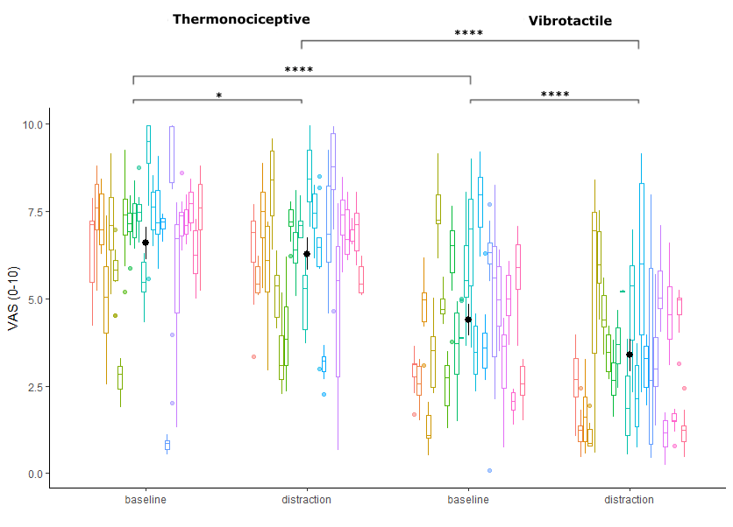
Participants never perceived the vibrotactile stimuli as painful, while they rated the thermonociceptive stimuli as painful in 70.42% of the baseline condition trials and 57.08% of the trials during the arithmetic task. Ratings of perceived intensity of stimulation for thermonociceptive and vibrotactile stimuli differed significantly (main effect of modality: F(933,1) = 533.004, p < 0.001). The distraction task led to significantly lower pain ratings in both modalities compared to baseline (Figure 2) (main effect of condition: F(933,1) = 36.153, p<0.001). A significant effect of interaction between condition and modality was observed, showing that the distraction task led to a stronger reduction in perceived stimulation intensity during vibrotactile stimulation than thermonociceptive stimulation (main effect of interaction: F(933,1) = 10.114, p=0.002; pairwise comparison, vibrotactile baseline vs distraction p<0.001, thermonociceptive baseline vs distraction p=0.046).
Figure 2: Rating of perceived intensity on a Visual Analog Scale (VAS) for both modalities and conditions. Ratings were collected at the end of each trial. Each color indicates a subject. The black dot represents the model group mean and the vertical lines represent the model .95 confidence interval for each group. The results of the linear mixed model (rating ~ modality + condition + modality : condition + (1|subject)) are represented: p<0.05: *, p<0.0001: ****.

  - EEG recordings
One participant had to be excluded from the data set because the EEG recordings were contaminated by artifacts. Figures displaying the spectra for each frequency band and condition/modality can be found in the Supplementary Materials (Supplementary Figure 5).
    - Phase-locked Response
A periodic modulation of the EEG signal at the frequency of simulation and its harmonics was recorded in both stimulation modalities and in both conditions. The electrode with the highest Wilcoxon test statistic (W) across conditions for thermonociceptive stimulation was FC2 (W= 4.243). Pz was the electrode with the largest Wilcoxon test statistic at the FOI for vibrotactile stimulation (W=4.271) (Figure 3).
A significant difference was found between the thermonociceptive and vibrotactile stimulation for the comparison of electrodes FC2 and Pz. The vibrotactile stimuli led to an overall larger modulation at the FOI compared to thermonociceptive stimulation. No differences were found between the conditions (Figure 4, Table 1).
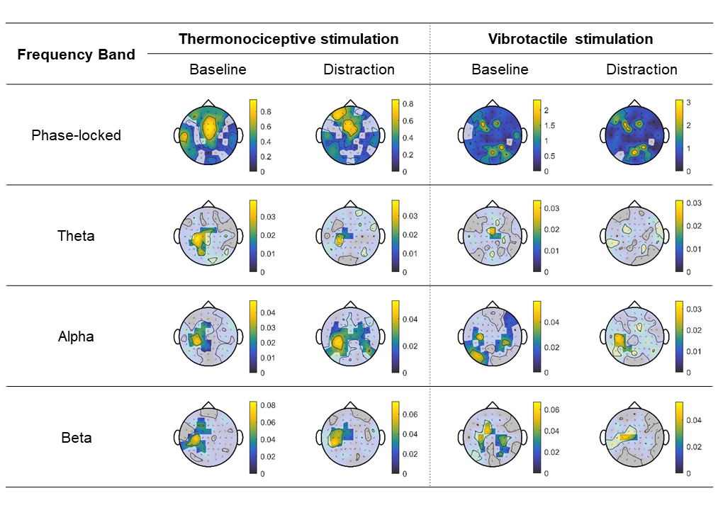
Figure 3: Group-level median topographies. Shaded areas correspond to electrodes which did not show periodic activity at the frequency of stimulation (based on multi-sensor cluster-based permutation Wilcoxon one-sample t-tests).

 | Electrode (t, v) | Modality |  |  |  | Condition |  |  | Modality : Condition
 |  |  | F-value (df) |  | p-value |  | F-value (df) | p-value | F-value (df) | p-value
Phase-locked Response | FC2, Pz |  | 7.71 (69,1) |  | 0.007 |  | 0.6144 (69,1) | 0.436 | 0.808 (69,1) | 0.372
Theta | C3, C2 |  | 4.799 (69,1) |  | 0.032 |  | 2.048 (69,1) | 0.157 | 0.063 (69,1) | 0.802
Alpha | C3, CP4 |  | 11.814 (69,1) |  | 0.001 |  | 0.985 (69,1) | 0.324 | 1.739 (69,1) | 0.192
Beta | CP3, F1 |  | 12.207 (69,1) |  | <0.001 |  | 1.665 (69,1) | 0.201 | 0.389 (69,1) | 0.535
Table 1: Result of the LMM following the formula amplitude ~ modality * condition + (1|subject). A Kenward-Roger approximation was used for the significance levels. t = electrode with highest activity identified for thermonociceptive stimulation, v = electrode with highest activity identified for vibrotactile stimulation; df= degrees of freedom.
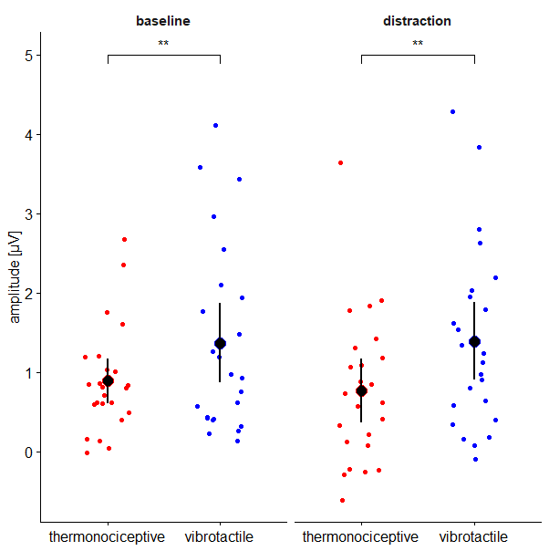
Figure 4: Amplitudes of the aggregated harmonics at the FOI of the respective electrode of interest for the phase-locked response. Electrodes of interest: FC2 for thermonociceptive stimuli, Pz for vibrotactile stimuli. baseline = no task, distraction = arithmetic task during stimulation. Each colored point represents one subject, while the black point represents the mean and the 95% confidence interval for this group. LMM: **: p<0.01.

    - Modulation of Ongoing Oscillations
The topographic distribution of the median periodic modulation of EEG at the frequency of interest and of the multi-sensor cluster-based permutation right-tailed Wilcoxon signed-rank test can be seen in Figure 3 for all tested frequency bands.
In the theta frequency band, the aggregated harmonics showed a periodic modulation at the FOI larger than zero for both modalities. The electrode with the highest test statistic was C3 (W = 3.44) for thermonociceptive stimulation and C2 (W=2.73) for vibrotactile stimulation. No periodic response was detected for vibrotactile stimulation during the arithmetic task.
In the alpha frequency band, the electrode of interest was identified as C3 for thermonociceptive (W = 4.014) and CP4 for vibrotactile stimulation (W = 3.786). A periodic response significantly larger than zero was found for both conditions in both modalities.
CP3 was the electrode with the highest activity across the aggregated harmonics for thermonociceptive (W = 4.043) and F1 for vibrotactile stimulation (W = 3.84) in the beta frequency band. A significant periodic response was found for all conditions and modalities.
The LMM showed a significant difference in amplitude of the aggregated harmonics at the FOI between the modalities for the theta, alpha and beta frequency band (Figure 5, Table 1). No differences were detected between baseline condition and the arithmetic task in any of the tested frequency bands (Table 1).
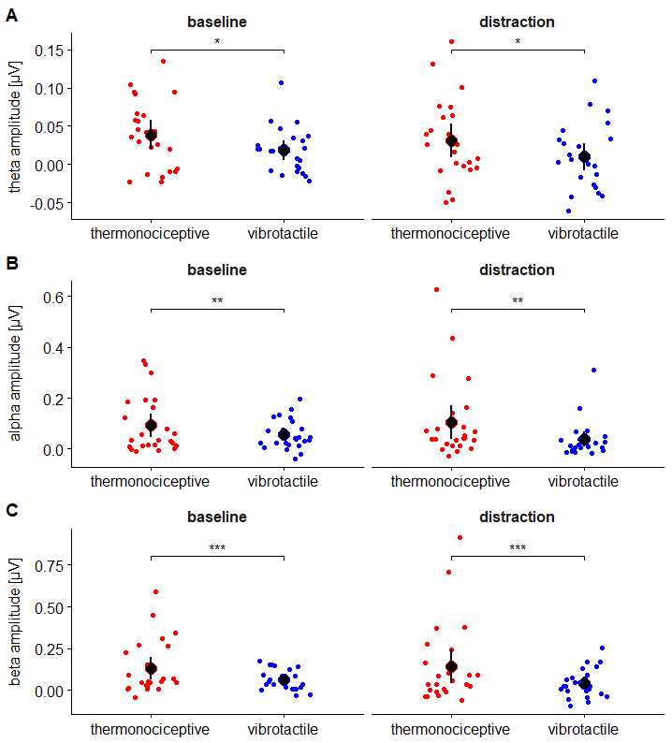
Figure 5: Amplitudes of the aggregated harmonics at the FOI for the respective electrode of interest of each frequency band. A: theta frequency band (4-8 Hz), comparing electrode C3 (thermonociceptive) and C2 (vibrotactile). B: alpha frequency band (8-12Hz), comparing electrodes C3 and CP4. C: beta frequency band (12-40 Hz), comparing electrodes CP3 and F1. baseline = no task, distraction = arithmetic task during stimulation. Each colored point represents one subject, while the black point represents the mean and the 95% confidence interval for this group. LMM: *: p<0.05, **: p<0.01, ***: p<0.001

  - Exploratory Analyses
    - Additional Linear Mixed Models
As the electrodes selected according to the pre-registered methods differed significantly between modalities and as this may lead to comparison of qualitatively different EEG activity for both modalities, we also fitted LMM’s using the thermonociceptive baseline electrode with highest activity as electrode of interest for both modalities. These electrodes correspond to the regions of interest which were pre-defined in the stage 1 submission of this registered report. The results of this exploratory analysis also showed a significant difference between the modalities for all tested electrodes, but no effect of condition in any of them (Table 2). One subject had to be removed from the phase-locked analysis as their value was detected as outlier.
Frequency band | Statistical Test | Electrode | Difference modalities | Difference conditions
Phase-locked | Wilcox | FC2
Phase-locked | LMM |  | F(66,1) = 6.501; p=0.013 | F(66,1) = 0.032;  p= 0.860
Theta | Wilcox | C3
Theta | LMM |  | F(69,1)=5.553;  p=0.021 | F(69,1)=0.495;  p=0.484
Alpha | Wilcox | C3
Alpha | LMM |  | F(69,1) = 11.573; p=0.001 | F(69,1) = 0.512; p=0.477
Beta | Wilcox | CP3
Beta | LMM |  | F(69,1) = 13.176 ; p<0.001 | F(69,1)=3.2328; p=0.077
Table 2: Exploratory analysis. Results of the LMM following the formula amplitude ~ modality * condition + (1|subject), for electrodes that corresponded to the pre-selected regions of interest as well as the thermonociceptive baseline results of the Wilcoxon signed-rank test.

    - Post-hoc power analysis
To investigate whether the failure to show any difference between the conditions in the LMM could be explained by a lack of statistical power, we used the same computational model that was initially used to calculate the sample size based on previous studies (α = 0.02) but, this time, using the data of our experiment. Figures illustrating the relationship between power and sample size based on the computational model can be found in the supplementary materials (Supplementary Figure 3). We found that to observe an effect on the phase-locked response, sufficient power (p>0.9) could be reached after 10 subjects for the factor modality. In contrast, the power for the factor condition did not change depending on the number of subjects, staying lower than 0.05. Similar results were observed for the different frequency bands, of which only the beta band showed a power level that rose steadily with the number of participants. Nevertheless, more than 400 participants would be necessary to reach a power level of 0.9 for the factor condition in the beta frequency band. Similarly, the power for the interaction between condition and modality would not reach sufficient power until more than 100 participants would be recruited for the phase-locked response. Even though steadily increasing with the number of participants, sufficient power in the theta and beta frequency bands for the interaction effect would have merely been reached after recruiting approximately 400 participants. Only the alpha band had a marginally higher effect and would have needed 200 participants for sufficient statistical power. This suggest that the attention modulation intervention we used leads to inexistent or extremely weak effects which are difficult to capture with our response of interest.
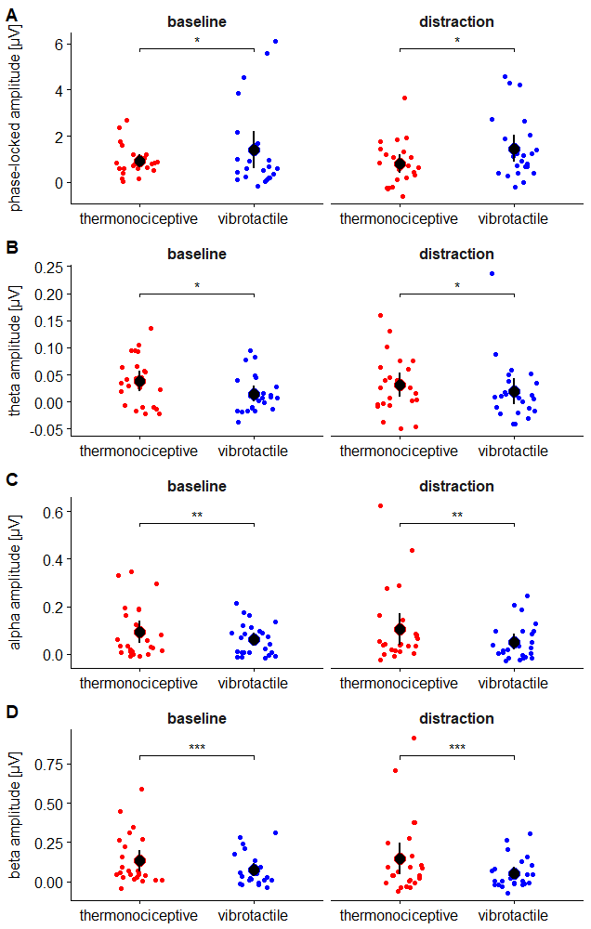
Figure 6: Exploratory analysis. Amplitudes of the aggregated harmonics at the FOI for the respective electrode of interest of each frequency band. A: phase-locked response, electrode FC2. B: theta frequency band (4-8 Hz), electrode C3. C: alpha frequency band (8-12Hz), electrode C3. D: beta frequency band (12-40 Hz), electrode CP3. baseline = no task, distraction = arithmetic task during stimulation. Each colored point represents one subject, while the black point represents the mean and the 95% confidence interval for this group. LMM: *: p<0.05, **: p<0.01, ***: p<0.001
- Discussion
Regardless of modality, stimuli delivered during the arithmetic task were rated lower than those delivered during the baseline condition blocks. These results confirm our expectations on the effect of the arithmetic task (hypothesis 1) and establish that the positive control for the factor condition was met. Interestingly, differences across modalities could be observed, i.e. a smaller effect of the arithmetic task on thermonociceptive stimulation ratings compared to vibrotactile stimulation ratings, potentially reflecting differences in the ability of the two modalities to capture attention. Additionally, thermonociceptive stimulation was perceived as significantly more intense than vibrotactile stimulation, regardless of the condition.
A periodic phase-locked response as well as a periodic modulation of oscillatory activity in all frequency bands was elicited by both stimuli, establishing that the positive control for modality was met. The LMMs did not show an effect of the arithmetic task on any of the investigated EEG responses for any of the stimulation modalities. It thus appears that both the phase-locked response and the ongoing oscillations amplitude modulation can be dissociated from the intensity of perception. These results diverge from our main hypothesis that the arithmetic task would lead to a reduction of the ongoing oscillation amplitude modulation by the stimuli which would mirror the reduction of the intensity ratings.
Following the procedure in the stage 1 submission of this registered report, we compared electrodes showing the strongest activation for each modality / frequency band combination. This led to comparing signals recorded from different regions that likely corresponded to the activation of (at least partially) different brain generators, making it more difficult to interpret the results. Thus, we decided to add an exploratory analysis, in which we compared the neural activity at the same electrode for both stimulation modalities. Interestingly, this approach did not change the results, as the same effects were found for the exploratory analyses as in the original analysis.
There are multiple possible explanations for our findings. First, it could be that there is truly no effect of distraction (i.e. diverting attention) on ongoing neural oscillations modulation by thermal and vibrotactile stimuli because they do not reflect processing of these stimuli. Second, ongoing oscillations modulation could be involved in the perception of these stimuli, but at a stage of processing preceding that at which distraction acts. Both these explanations are in conflict with previous evidence that pain-related alpha suppression indexes stimulus intensity / sensation magnitude (Nickel et al., 2022) and is minimized during a distraction task (compared to attention on pain and baseline condition) (Peng et al., 2014). Of note, Schulz et al. (2015) did also not find a relationship between alpha activity and the perception of pain during the application of tonic thermonociceptive stimuli. Finally, it could be that, even though there was an effect of the arithmetic task, its size was too small for it to be picked up by our statistical tests. If we postulate the existence of an effect, based on Peng et al. (2014), our inability to detect it could be related to the specific implementation of the arithmetic task used in this experiment not leading to a large enough effect size, the specific EEG read-outs used in this experiment being too variable (regardless of intervention) to allow detection of small effect sizes, or both.
Importantly, despite promising results in the previously conducted pilot study (detailed in the supplementary materials, Supplementary Figure 4), the arithmetic task led to much smaller thermal stimuli intensity rating changes than expected. Post-hoc power calculations revealed that the effect of the task (i.e. factor condition) on these ratings was indeed extremely small and that a much larger (and unreasonable) sample size would have been necessary to achieve the target statistical power (.9). For most of the EEG signal comparisons, the power level did not even change with increasing sample sizes, indicating that, in our data, the effect of this factor, if existent, is too small to be distinguished from the spontaneous variability of the signal. It is unclear whether a different task (inducing a higher cognitive load / larger effect of distraction) would lead to different results. The results of Peng et al. (2014) seem to suggest it could, despite the fact that their task (counting backwards every 3 seconds from a randomly chosen 4-digit number, for a duration of 5 minutes) was not that different from ours. Similarly, Schulz et al. (2019) found a strong effect of the same counting task as used in the present study on a behavioral level as well as in brain activity measured using fMRI. Yet, it should be considered that the stimuli used in this investigation substantially differ from ours both in duration as well as in stimulus type. Moreover, effects on fMRI signal do not necessarily equate effects measurable in EEG recordings.
Notably, the effect of the arithmetic task was not the same for the two stimulation modalities. While it had a significant but moderate effect on the perception of the thermonociceptive stimuli, the task was much more effective in reducing perception intensity during vibrotactile stimulation. One possible reason for this difference is the intrinsic saliency (i.e., the ability of a stimulus to capture attention) (Yantis, 2008) of painful stimuli. Pain is generally considered to be an alarm signal which alerts us of a potentially harmful event and is therefore a sensation towards which the human brain will always allocate attention (Eccleston & Crombez, 1999). Therefore, vibrotactile and painful stimuli eliciting similar perception magnitude could still be expected to have different saliencies, that of the painful stimulus outweighing that of the vibrotactile stimulus. This difference in saliency could then lead to differences in the way the perceived intensity of a stimulus is modulated by distraction, painful stimuli being more resistant to it than vibrotactile stimuli. Alternatively, this difference in the effects of the arithmetic task could be related to the absolute magnitude of the perception elicited by the stimuli: stimuli which are perceived more strongly in the baseline condition could be more resistant to distraction, as their absolute magnitude is, in itself, more attention-grabbing. Since the thermal stimuli were rated as significantly more intense than the vibrotactile stimuli, regardless of the condition, it is not possible to differentiate these two possible explanations. This confound also precludes interpretation of the cross-modality difference in the amplitude of oscillatory activity in the various frequency bands investigated in this study. To disentangle the effect of saliency on the modulation of ongoing oscillations, future investigations should be conducted, modulating the saliency of one stimulation modality (e.g., introducing an oddball within the sustained periodic stimulation) and assessing its effect on the modulation of ongoing neural oscillations.
Whereas the phase-locked response evoked by thermal stimulation matched the topography previously observed by (Colon et al., 2017 ; Mulders et al., 2020), the phase-locked response to vibrotactile stimuli were less lateralized than expected (Colon, Legrain, et al., 2012 ; Colon et al., 2014) and instead were rather widespread over the scalp. This discrepancy could stem from the significantly lower stimulation frequency used in this experiment, compared to previous frequency tagging experiments investigating vibrotaction (e.g. 6 Hz and 13 Hz in Colon, Legrain, et al. (2012)).
Liberati et al. (2019) observed that, whereas sustained periodic thermonociceptive stimuli led to a periodic modulation of theta band activity in the insular cortex (using intracerebral EEG), sustained periodic vibrotactile stimuli did not. In the present study, vibrotactile stimuli elicited a periodic modulation of theta frequency band activity, suggesting that the apparent selectivity of this frequency band for thermonociceptive stimuli in the insula does not generalize to scalp EEG. The observation that vibrotactile stimuli can lead to modulation of scalp EEG theta band activity is also supported by another study from our group (Courtin, 2022).
Conclusion
The magnitude of the modulation of neural oscillations at the frequency of interest did not differ between the baseline condition and the distraction condition for any of the frequency bands, suggesting that the arithmetic task, which decreased intensity of perception, did not affect the amplitude of the ongoing oscillations modulation by the sensory stimuli. Therefore, subjective intensity of perception and the modulation of pain-related ongoing oscillation measured by scalp EEG appear to be dissociable. These findings, however, should be interpreted with caution. Although the arithmetic task significantly reduced the subjective intensity of perception during the stimulation for both the thermonociceptive and the vibrotactile modalities, the effect was smaller than predicted based on our pilot study. Hence, it cannot be excluded that a task with a stronger distraction effect would lead to effects that could not be captured in the present study.
Significant differences were found in the modulation of ongoing oscillations between thermonociceptive and vibrotactile stimulation. To clarify whether the observed modality differences are mainly an effect of the stimulus saliency or truly a preferential modulation exerted by thermonociceptive stimuli, further investigations should address the effect of stimulus saliency on the periodic modulation of the ongoing oscillations.

Hypotheses table
Question | Hypothesis | Sampling plan (e.g. power  analysis) | Analysis plan | Interpretation given different outcomes
Behavioral response
(1) Does distraction change the level of perceived stimulus intensity during nociceptive stimulation? | Diverting attention from the nociceptive stimulation will lead to a decrease in stimulus intensity perception rating. | See below | LMM:  intensity rating ~ modality + condition + modality:condition + (1|subject)  - DV: intensity rating  - IV: condition, modality  - random coefficient: subject | Positive control: If the ratings for perceived intensity are lower during distraction, the arithmetic task has achieved its purpose. If not, we fail to meet the positive control for the task efficacy (i.e. condition).
Time locked, phase locked response
(2) Does ultra-slow sustained periodic stimulation using different modalities elicit a periodic neural response? | Both thermonociceptive stimuli and vibrotactile stimuli will elicit an increase of EEG power at the frequency of stimulation and at its harmonics. | To reach a statistical power of 0.9 with an alpha of 0.02, 25 participants will be enrolled. Calculations are based on power simulations using the simr package in R (Green & MacLeod, 2016). | Multi-sensor cluster-based permutation Wilcoxon signed-rank test of aggregated and averaged amplitudes at FOIs. | Positive control: A periodic response shows that the stimulation paradigm induces the expected neural activity. If this is not the case, the basic assumption for this investigation is not met.
(4) Does distraction change the modulation of ongoing oscillations in the frequency domain? | Diverting attention from nociceptive stimulation will lead to a smaller modulation of ongoing oscillations as compared to baseline condition. | See above | LMM:  amp ~ modality + condition + modality:condition + (1|subject)  - DV: amplitude  - IV: condition, modality  - random coefficient: subject | A change in modulation of oscillations induced by distraction which corresponds to the change in intensity rating would indicate a connection between perceived pain and ongoing oscillations.  A modulation which does not correspond to the intensity ratings would indicate that the processing of perceived pain and oscillations are probably not correlated.
Time locked, non-phase locked response
(2) Does ultra-slow sustained periodic stimulation using different modalities elicit a periodic neural response in the different frequency bands? | Both modalities will induce a periodic response in the different frequency bands. | See above | Cluster-based permutation and Wilcoxon signed-rank test of aggregated and averaged amplitudes at FOIs in the different frequency bands†.  † one test for each frequency band (theta, alpha, beta) | A modulation at the frequency of stimulation indicates that sustained periodic stimulation leads to a periodic response also in the different frequency bands (Colon et al., 2017). If the modalities differ from each other, it indicates that thermo-nociceptive stimuli might be processed functionally different than vibrotactile stimuli (based on Liberati et al. (2019).
(3) Does ultra-slow sustained periodic thermonociceptive stimulation differentially affect ongoing oscillations compared to vibrotactile stimulation? | Thermonocicep-  tive stimuli will exert a greater modulation of ongoing oscillations in the alpha, beta and theta frequency bands, at the frequency of stimulation, compared to vibrotactile stimuli. | See above | LMM:  amp_mod_frequ-ency_band† ~ modality + condition + modality:condition + (1|subject)  - DV: amplitude  - IV: condition, modality  - random coefficient: subject  † one model for each frequency band (theta, alpha, beta) | A modulation specifically in the alpha and theta frequency band would show that the results of Liberati et al. (2019) are generalizable for scalp EEG (non-insula specific). No difference would indicate that the differential modulation is selective for the insula.
(4) Does distraction change the modulation of ongoing oscillations in the time-frequency domain ? | Diverting attention from nociceptive stimulation will lead to a smaller modulation of ongoing oscillations, as compared to baseline. | See above | LMM:  amp_mod_frequ-ency_band† ~ modality + condition + modality:condition + (1|subject)  - DV: amplitude  - IV: condition, modality  - random coefficient: subject  † one model for each frequency band (theta, alpha, beta) | A change in modulation of oscillations induced by distraction which corresponds to the change in intensity rating would indicate a connection between perceived pain and ongoing oscillations (in the specific frequency bands).  A modulation which does not relate to the intensity ratings would indicate that the processing of perceived pain and oscillations might happen independently from each other.
FOI: frequency of interest; DV: dependent variable; IV: independent variable; LMM: linear mixed model; amp: amplitude of phase-locked neural response; amp_mod_frequency_band: amplitude of non-phase locked neural response for each frequency band (theta, alpha, beta).

Acknowledgment
This study was supported by the FRIA doctoral grant of Chiara Leu by the Belgian Fund for Scientific Research (F.R.S.–FNRS). Arthur Courtin was also supported by a FRIA doctoral grant at the time of the data acquisition. We wish to thank the NOCIONS Lab for fruitful discussion, and the CATL team of the Université catholique de Louvain for technical assistance. We are also grateful to the “Plateforme technologique de Support en Methodologie et Calcul Statistique” (SMCS) of the Université catholique de Louvain, and in particular to Lieven Desmet for statistical advice.

List of Supplementary Material
- Supplementary Materials 1: Sample size calculation
- Supplementary Figure 1: Data processing pipeline
- Supplementary Figure 2: Arithmetic task performance
- Supplementary Figure 3: Post-hoc power calculation
- Supplementary Figure 4: Pilot study
- Supplementary Figure 5: Spectra for each condition/modality and frequency band in the frequency domain

Bibliography

Akam, T., & Kullmann, D. M. (2014). Oscillatory multiplexing of population codes for selective communication in the mammalian brain. Nature Reviews Neuroscience, 15(2), 111-122. https://doi.org/10.1038/nrn3668
Bantick, S. J., Wise, R. G., Ploghaus, A., Clare, S., Smith, S. M., & Tracey, I. (2002). Imaging how attention modulates pain in humans using functional MRI. Brain, 125(2), 310-319. https://doi.org/10.1093/brain/awf022
Beydoun, A., Morrow, T. J., Shen, J. F., & Casey, K. L. (1993). Variability of laser-evoked potentials: attention, arousal and lateralized differences. Electroencephalography and Clinical Neurophysiology/Evoked Potentials Section, 88(3), 173-181. https://doi.org/https://doi.org/10.1016/0168-5597(93)90002-7
Bland, J. M., & Altman, D. G. (1996). Statistics Notes: Transforming data. BMJ, 312(7033), 770. https://doi.org/10.1136/bmj.312.7033.770
Boyle, Y., El-Deredy, W., Martínez Montes, E., Bentley, D. E., & Jones, A. K. P. (2008). Selective modulation of nociceptive processing due to noise distraction. Pain, 138(3), 630-640. https://doi.org/https://doi.org/10.1016/j.pain.2008.02.020
Buzsáki, G., & Draguhn, A. (2004). Neuronal Oscillations in Cortical Networks. Science, 304(5679), 1926-1929. https://doi.org/10.1126/science.1099745
Clayton, M. S., Yeung, N., & Cohen Kadosh, R. (2015). The roles of cortical oscillations in sustained attention. Trends in Cognitive Sciences, 19(4), 188-195. https://doi.org/https://doi.org/10.1016/j.tics.2015.02.004
Colon, E., Legrain, V., & Mouraux, A. (2012). Steady-state evoked potentials to study the processing of tactile and nociceptive somatosensory input in the human brain. Neurophysiologie Clinique/Clinical Neurophysiology, 42(5), 315-323. https://doi.org/https://doi.org/10.1016/j.neucli.2012.05.005
Colon, E., Legrain, V., & Mouraux, A. (2014). EEG Frequency Tagging to Dissociate the Cortical Responses to Nociceptive and Nonnociceptive Stimuli. Journal of Cognitive Neuroscience, 26(10), 2262-2274. https://doi.org/10.1162/jocn_a_00648
Colon, E., Liberati, G., & Mouraux, A. (2017). EEG frequency tagging using ultra-slow periodic heat stimulation of the skin reveals cortical activity specifically related to C fiber thermonociceptors. NeuroImage, 146, 266-274. https://doi.org/https://doi.org/10.1016/j.neuroimage.2016.11.045
Colon, E., Nozaradan, S., Legrain, V., & Mouraux, A. (2012). Steady-state evoked potentials to tag specific components of nociceptive cortical processing. NeuroImage, 60(1), 571-581. https://doi.org/https://doi.org/10.1016/j.neuroimage.2011.12.015
Cook, R. D. (1977). Detection of Influential Observation in Linear Regression. Technometrics, 19(1), 15-18. https://doi.org/10.1080/00401706.1977.10489493
Courtin, A. (2022). Catching cold: exploration of the human perception of innocuous cold using chemical sensitization, EEG and psychophysics
Dowman, R., Rissacher, D., & Schuckers, S. (2008). EEG indices of tonic pain-related activity in the somatosensory cortices. Clinical Neurophysiology, 119(5), 1201-1212. https://doi.org/10.1016/j.clinph.2008.01.019
Eccleston, C. (1995). Chronic pain and distraction: An experimental investigation into the role of sustained and shifting attention in the processing of chronic persistent pain. Behaviour Research and Therapy, 33(4), 391-405. https://doi.org/https://doi.org/10.1016/0005-7967(94)00057-Q
Eccleston, C., & Crombez, G. (1999). Pain demands attention: A cognitive–affective model of the interruptive function of pain. Psychological Bulletin, 125(3), 356-366. https://doi.org/10.1037/0033-2909.125.3.356
Fries, P. (2015). Rhythms for Cognition: Communication through Coherence. Neuron, 88(1), 220-235. https://doi.org/https://doi.org/10.1016/j.neuron.2015.09.034
Frigo, M., & Johnson, S. G. (1998, 15-15 May 1998). FFTW: an adaptive software architecture for the FFT. Proceedings of the 1998 IEEE International Conference on Acoustics, Speech and Signal Processing, ICASSP '98 (Cat. No.98CH36181),
Green, P., & MacLeod, C. J. (2016). SIMR: an R package for power analysis of generalized linear mixed models by simulation. Methods in Ecology and Evolution, 7(4), 493-498. https://doi.org/https://doi.org/10.1111/2041-210X.12504
Guo, Y., Bufacchi, R. J., Novembre, G., Kilintari, M., Moayedi, M., Hu, L., & Iannetti, G. D. (2020). Ultralow-frequency neural entrainment to pain. PLoS biology, 18(4), e3000491. https://doi.org/10.1371/journal.pbio.3000491
Healy, M. J. (1993). Data transformations. Arch Dis Child, 69(2), 260-264. https://doi.org/10.1136/adc.69.2.260
Huishi Zhang, C., Sohrabpour, A., Lu, Y., & He, B. (2016). Spectral and spatial changes of brain rhythmic activity in response to the sustained thermal pain stimulation. Human Brain Mapping, 37(8), 2976-2991. https://doi.org/https://doi.org/10.1002/hbm.23220
Hyvarinen, A., & Oja, E. (2000). Independent component analysis: algorithms and applications. Neural Netw, 13(4-5), 411-430. https://doi.org/10.1016/s0893-6080(00)00026-5
Liberati, G., Algoet, M., Santos, S. F., Ribeiro-Vaz, J. G., Raftopoulos, C., & Mouraux, A. (2019). Tonic thermonociceptive stimulation selectively modulates ongoing neural oscillations in the human posterior insula: Evidence from intracerebral EEG. NeuroImage, 188, 70-83. https://doi.org/https://doi.org/10.1016/j.neuroimage.2018.11.059
Mayhew, S. D., Hylands-White, N., Porcaro, C., Derbyshire, S. W. G., & Bagshaw, A. P. (2013). Intrinsic variability in the human response to pain is assembled from multiple, dynamic brain processes. NeuroImage, 75, 68-78. https://doi.org/10.1016/j.neuroimage.2013.02.028
Miron, D., Duncan, G. H., & Bushnell, C. M. (1989). Effects of attention on the intensity and unpleasantness of thermal pain. Pain, 39(3), 345-352. https://doi.org/10.1016/0304-3959(89)90048-1
Mouraux, A., Iannetti, G. D., Colon, E., Nozaradan, S., Legrain, V., & Plaghki, L. (2011). Nociceptive Steady-State Evoked Potentials Elicited by Rapid Periodic Thermal Stimulation of Cutaneous Nociceptors. The Journal of Neuroscience, 31(16), 6079-6087. https://doi.org/10.1523/jneurosci.3977-10.2011
Mulders, D., de Bodt, C., Lejeune, N., Courtin, A., Liberati, G., Verleysen, M., & Mouraux, A. (2020). Dynamics of the perception and EEG signals triggered by tonic warm and cool stimulation. PLOS ONE, 15(4), e0231698. https://doi.org/10.1371/journal.pone.0231698
Nickel, M. M., Tiemann, L., Hohn, V. D., May, E. S., Gil Ávila, C., Eippert, F., & Ploner, M. (2022). Temporal–spectral signaling of sensory information and expectations in the cerebral processing of pain. Proceedings of the National Academy of Sciences, 119(1), e2116616119. https://doi.org/doi:10.1073/pnas.2116616119
Ohara, S., Crone, N. E., Weiss, N., Kim, J. H., & Lenz, F. A. (2008). Analysis of synchrony demonstrates that the presence of “pain networks” prior to a noxious stimulus can enable the perception of pain in response to that stimulus. Experimental Brain Research, 185(2), 353-358. https://doi.org/10.1007/s00221-008-1284-1
Peng, W., Hu, L., Zhang, Z., & Hu, Y. (2014). Changes of Spontaneous Oscillatory Activity to Tonic Heat Pain. PLOS ONE, 9(3), e91052. https://doi.org/10.1371/journal.pone.0091052
Plaghki, L., Delisle, D., & Godfraind, J. M. (1994). Heterotopic nociceptive conditioning stimuli and mental task modulate differently the perception and physiological correlates of short CO2 laser stimuli. Pain, 57(2), 181-192. https://doi.org/https://doi.org/10.1016/0304-3959(94)90222-4
Ploner, M., Sorg, C., & Gross, J. (2017). Brain Rhythms of Pain. Trends in Cognitive Sciences, 21(2), 100-110. https://doi.org/https://doi.org/10.1016/j.tics.2016.12.001
Qiu, Y., Inui, K., Wang, X., Tran, T. D., & Kakigi, R. (2002). Effects of attention, distraction and sleep on CO2 laser evoked potentials related to C-fibers in humans. Clinical Neurophysiology, 113(10), 1579-1585. https://doi.org/https://doi.org/10.1016/S1388-2457(02)00216-X
Regan, D. (1989). Human brain electrophysiology. Evoked potentials and evoked magnetic fields in science and medicine.
Ridderinkhof, K. R., Ullsperger, M., Crone, E. A., & Nieuwenhuis, S. (2004). The Role of the Medial Frontal Cortex in Cognitive Control. Science, 306(5695), 443-447. https://doi.org/doi:10.1126/science.1100301
Schulz, E., May, E. S., Postorino, M., Tiemann, L., Nickel, M. M., Witkovsky, V., Schmidt, P., Gross, J., & Ploner, M. (2015). Prefrontal gamma oscillations encode tonic pain in humans [Article]. Cerebral Cortex, 25(11), 4407-4414. https://doi.org/10.1093/cercor/bhv043
Schulz, E., Stankewitz, A., Witkovský, V., Winkler, A. M., & Tracey, I. (2019). Strategy-dependent modulation of cortical pain circuits for the attenuation of pain. Cortex, 113, 255-266. https://doi.org/10.1016/j.cortex.2018.12.014
Shipp, S. (2004). The brain circuitry of attention. Trends in Cognitive Sciences, 8(5), 223-230. https://doi.org/https://doi.org/10.1016/j.tics.2004.03.004
Torta, D. M., Legrain, V., Mouraux, A., & Valentini, E. (2017). Attention to pain! A neurocognitive perspective on attentional modulation of pain in neuroimaging studies. Cortex, 89, 120-134. https://doi.org/https://doi.org/10.1016/j.cortex.2017.01.010
Tracey, I., Ploghaus, A., Gati, J. S., Clare, S., Smith, S., Menon, R. S., & Matthews, P. M. (2002). Imaging Attentional Modulation of Pain in the Periaqueductal Gray in Humans. The Journal of Neuroscience, 22(7), 2748. https://doi.org/10.1523/JNEUROSCI.22-07-02748.2002
Yantis, S. (2008). The Neural Basis of Selective Attention: Cortical Sources and Targets of Attentional Modulation. Current Directions in Psychological Science, 17(2), 86-90. https://doi.org/10.1111/j.1467-8721.2008.00554.x

