Fe(II) Complexes Incorporating Anthracene-2-Sulfonate Anion: Unraveling Photodimerization Potential and Spin Crossover Behavior
Mengmeng Wang,¹ Youssef Draoui,¹ Koen Robeyns,¹ Jyoti Yadav,² Zongsu Han,³ Mariusz Wolff,⁴ Dominik Maskowicz,⁵ Aurelian Rotaru,⁶ Dawid Pinkowicz,² Miroslaw Sawczak,⁵ Rafał Jendrzejewski,⁵ and Yann Garcia*^{,1}
¹ Institute of Condensed Matter and Nanosciences Molecular Chemistry, Materials and Catalysis (IMCN/MOST) Université catholique de Louvain, Place L. Pasteur 1, 1348 Louvain-la-Neuve, Belgium
² Faculty of Chemistry, Jagiellonian University, Gronostajowa 2, 30-387 Kraków, Poland
³ Department of Chemistry, Texas A&M University, College Station, Texas 77843, United States
⁴ Institute of Functional Materials and Catalysis, Faculty of Chemistry, University of Vienna, Währinger Straße 38-42, Wien 1090, Austria
⁵ Photophysics Department, The Szewalski Institute of Fluid-Flow Machinery, Polish Academy of Sciences, Fiszera 14, 80-231 Gdańsk, Poland
⁶ Department of Electrical Engineering and Computer Science & Research Center MANSiD Stefan cel Mare University, University Street, No. 13, Suceava 720229, Romania
KEYWORDS: Spin crossover, anthracene-2-sulfonate, photodimerization, Fe(II) coordination complex.
ABSTRACT: Integrating photoactive anions into spin crossover systems offers a promising route toward light-controlled modulation of spin states, enhancing the utility of these materials in photo-spin information storage. In this study, we report the synthesis and characterization of a novel Fe(II) salt, [Fe(H₂O)₆](2-As)₂, incorporating anthracene-2-sulfonate (2-As⁻) as the counter anion, which holds the potential to undergo solid-state photodimerization under favorable packing conditions. Utilizing this salt as a precursor, three mononuclear Fe(II) complexes were successfully synthesized: [Fe(2-pic)₂(2-As)₂] (1, 2-pic = pyridin-2-ylmethanamine), [Fe(2,6-hdp)₂](2-As)₂ (2, 2,6-hdp = 2,6-bis((E)-1-hydrazineylideneethyl) pyridine), and [Fe(3-bpp)₂](2-As)₂·2MeOH·H₂O (3, 3-bpp = 2,6-di(pyrazol-3-yl) pyridine). Magnetic susceptibility measurements and ⁵⁷Fe Mössbauer spectroscopy reveal that complexes 1 and 2 remain in high-spin and low-spin states, respectively, over the 4-400 K range. Complex 3 exhibits low-spin state in the solvated form but undergoes gradual and incomplete spin crossover behavior with a small thermal hysteresis centered at ~290 K upon desolvation. Single crystal X-ray diffraction indicates that the 2-As⁻ anion adopts a face-to-edge stacking mode rather than the face-to-face arrangement required for solid state photoreactivity. However, the extensive hydrogen bonding observed around the sulfonate groups suggests a viable crystal-engineering strategy to modulate anthracene stacking and enable future photoinduced spin-state switching.
Introduction: Stimuli-responsive molecular materials are receiving increasing attention for their potential applications in data storage, sensing, molecular electronics and display technologies.¹⁻⁵ Among them, spin crossover (SCO) compounds, particularly Fe(II)-based systems, are of great interest due to their ability to reversibly switch between high-spin (HS) and low-spin (LS) states in response to external stimuli, such as temperature, pressure, or light, accompanied by pronounced changes in magnetic, optical, electronic, and structural properties.⁶⁻¹⁰ While thermally induced SCO remains the most common, light-induced spin-state control offers distinct advantages, including remote actuation, low power consumption, and spatial/temporal precision.¹¹⁻¹⁴ The light induced excited spin state trapping (LIESST) effect is a classic example of light-triggered spin crossover; however, its functionality is typically restricted to cryogenic temperatures, limiting practical applications.¹⁵⁻¹⁷ To address this challenge, recent studies have focused on incorporating photoresponsive ligands or counterions into Fe(II) complexes. These components can undergo structural transformations upon light irradiation, thereby modulating the ligand field and triggering spin-state changes at or near room temperature. Such phenomena are referred to as ligand-driven light induced spin change (LD-LISC),^{18,19} and anion-driven light-induced spin change (AD-LISC), respectively.²⁰⁻²² Photochromic groups such as azobenzenes, stilbenes and diarylethenes have been widely incorporated into different ligands for achieving LISC.²³⁻²⁵ In contrast, anthracene derivatives, known for their reversible [4+4] photocycloaddition,²⁶⁻²⁹ remain largely underexplored in SCO systems. Achieving photodimerization of anthracene would require a co-facial stacking arrangement with an intermolecular distance shorter than 4.2 Å, which represents one of the major experimental challenges when the anthracene groups are dispersive in the crystal lattice. Therefore, precise control over the packing of anthracene units through crystal engineering is essential to exploit the potential of anthracene photoactivity in SCO materials. In this study, we functionalized the anthracene moiety as the 2-anthracene sulfonate (2-As⁻) anion to enable its integration into diverse cationic Fe(II) SCO systems. This approach allows the investigation of its packing behavior in the solid state and its influence on SCO properties of Fe(II) cationic complexes (Scheme 1).
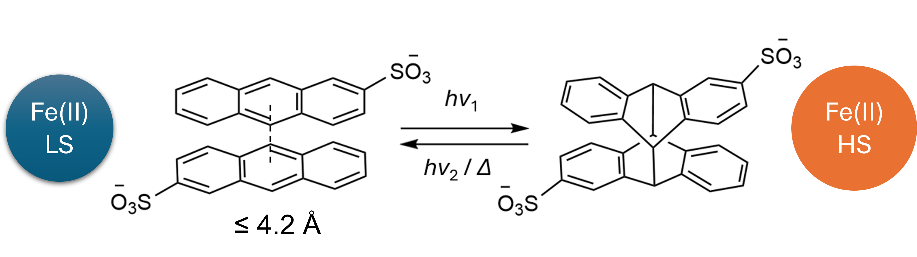
Scheme 1. Conceptual illustration of an anion-driven, light-induced spin-state switching mechanism, in which photodimerization of closely packed 2-As⁻ anions (≤ 4.2 Å) trigger the interconversion between LS and HS Fe(II) states.
We first synthesized a new Fe(II) salt with 2-As⁻ as anion, [Fe(H₂O)₆](2-As)₂, which served as a precursor for three mononuclear Fe(II) complexes: [Fe(2-pic)₂(2-As)₂] (1, 2-pic = pyridin-2-ylmethanamine), [Fe(2,6-hdp)₂](2-As)₂ (2, 2,6-hdp = 2,6-bis((E)-1-hydrazineylideneethyl) pyridine), and [Fe(3-bpp)₂](2-As)₂·2MeOH·H₂O (3, 3-bpp = 2,6-di(pyrazol-3-yl) pyridine). Magnetic susceptibility and ⁵⁷Fe Mössbauer spectroscopy revealed that 1 and 2 remain in HS and LS states, respectively, across 4-400 K. In contrast, 3 exhibits solvato-sensitive spin state change, showing LS state with lattice solvent molecules and gradual and incomplete SCO behavior with a small thermal hysteresis centered near 290 K upon desolvation. Single crystal X-ray diffraction revealed that the anthracene units of 2-As⁻ adopt a face-to-edge arrangement stabilized by CH···π interactions, rather than a co-facial π···π stack, thus precluding [4+4] photodimerization. In addition, abundant hydrogen bonding was observed between the sulfonate group of 2-As⁻ anion and either the Fe(II) framework or the lattice solvent molecules, which likely play an important role in directing the packing of the 2-As⁻ anion,^{30,31} suggesting that crystal engineering strategies, such as the introduction of hydrogen-bond-directing ligands, co-crystallized templates could be employed to promote co-facial π···π stacking of anthracene moieties in future anthracene-based LISC materials.^{32,33}
Results and discussion
Synthesis and crystal structures
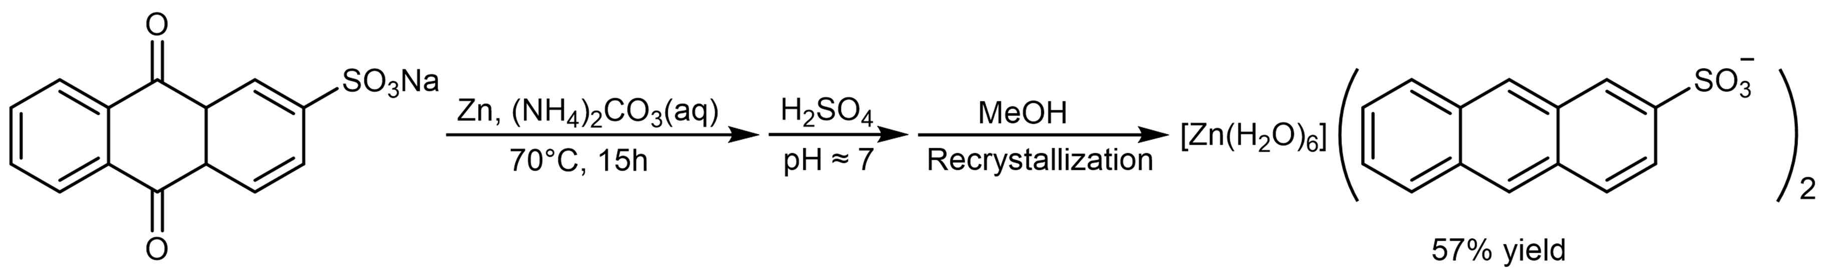
Scheme 2. Synthesis of [Zn(H₂O)₆](2-As)₂.
The synthesis began with the reduction of sodium anthraquinone 2-sulfonate by Zn in an aqueous (NH₄​)₂​CO₃​ solution.³⁴ After filtration to remove residual Zn and Zn²⁺ salts, the filtrate was neutralized with sulfuric acid, leading to the precipitation of the zinc salt of 2-As⁻, [Zn(H₂O)₆](2-As)₂ (Scheme 2).
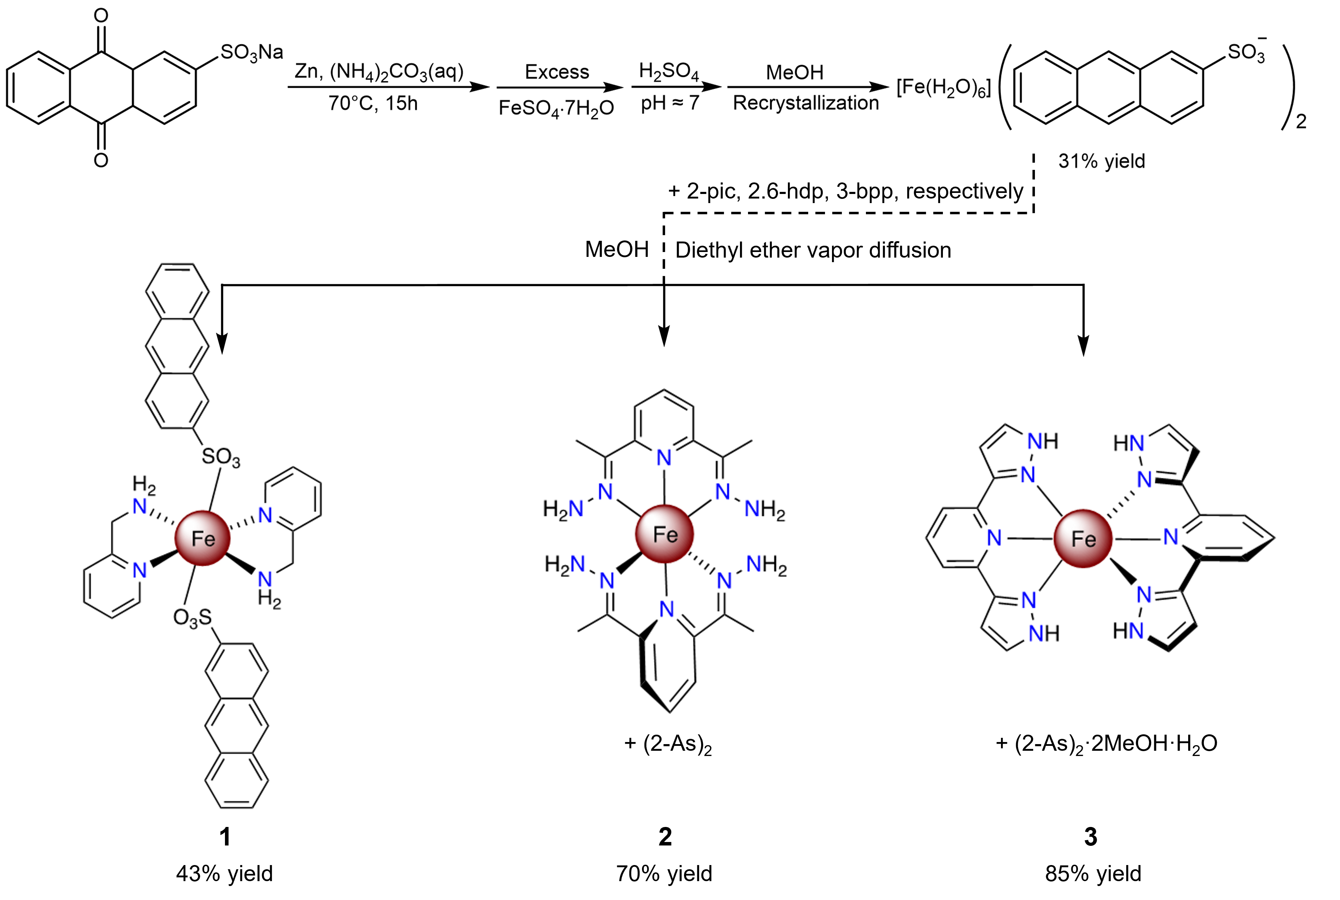
Scheme 3. Synthetic route of the metal salt, [Fe(H₂O)₆](2-As)₂ and coordination complexes 1-3.
For the synthesis of the Fe²⁺ salt, [Fe(H₂O)₆](2-As)₂, the same procedure was carried out, except that an excess of FeSO₄·7H₂O was added prior to the addition of H₂SO₄. The formation of the iron salt was favored by the excess Fe²⁺ ions and by the generally lower solubility of hydrated Fe(II) salts compared to their isostructural Zn(II) analogues.³⁵
Complexes 1-3 were then synthesized by reacting the [Fe(H₂O)₆](2-As)₂ salt with three different ligands, 2-pic, 2,6-hdp, and 3-bpp (Figures S1-S3) as illustrated in Scheme 3. The resulting complexes were characterized by single crystal and powder X-ray diffraction (SCXRD/PXRD), elemental analysis (EA), thermogravimetric analysis (TGA) and Fourier transform infrared spectroscopy (FT-IR), confirming their high purity and structural integrity (Figures S4-S6). Crystallographic parameters and selected bond lengths and angles for [Fe(H₂O)₆](2-As)₂ and 1-3 are summarized in Tables S1-S3. [Fe(H₂O)₆](2-As)₂ crystallizes in the monoclinic space group P2₁/n, with the asymmetric unit containing half of the [Fe(H₂O)₆]²⁺ cation and one 2-As⁻ anion (Figure S7). Six H₂O molecules coordinate to the Fe(II) ion, forming an octahedral coordination geometry (Figure 1a). The Fe-O bond lengths range from 2.086(4) to 2.123(4) Å at 297 K, consistent with a HS octahedral Fe(II) centre (Tables S2).³⁶ In the crystal structure, the [Fe(H₂O)₆]²⁺ cations and 2-As⁻ anion are arranged in alternating layers (Figure 1b, Figures S8 and S9). The [Fe(H₂O)₆]²⁺ cations form 2D hydrogen-bonded networks through interactions between the coordinated water molecules and the sulfonate groups of the surrounding 2-As⁻ anions (Figure 1c and Figure S10). All three sulfonate O atoms engage in hydrogen bonds with adjacent water molecules with O(H)···O distance in the range of 2.736(6)-2.846 (6) Å. The 2-As⁻ anions adopt a face-to-edge packing arrangement of anthracene units, stabilized by CH···π interactions (Figures 1d and Table S4). The absence of effective π···π stacking is likely attributable, at least in part, to the dominance of hydrogen bonding interactions, which significantly influence the overall crystal packing.
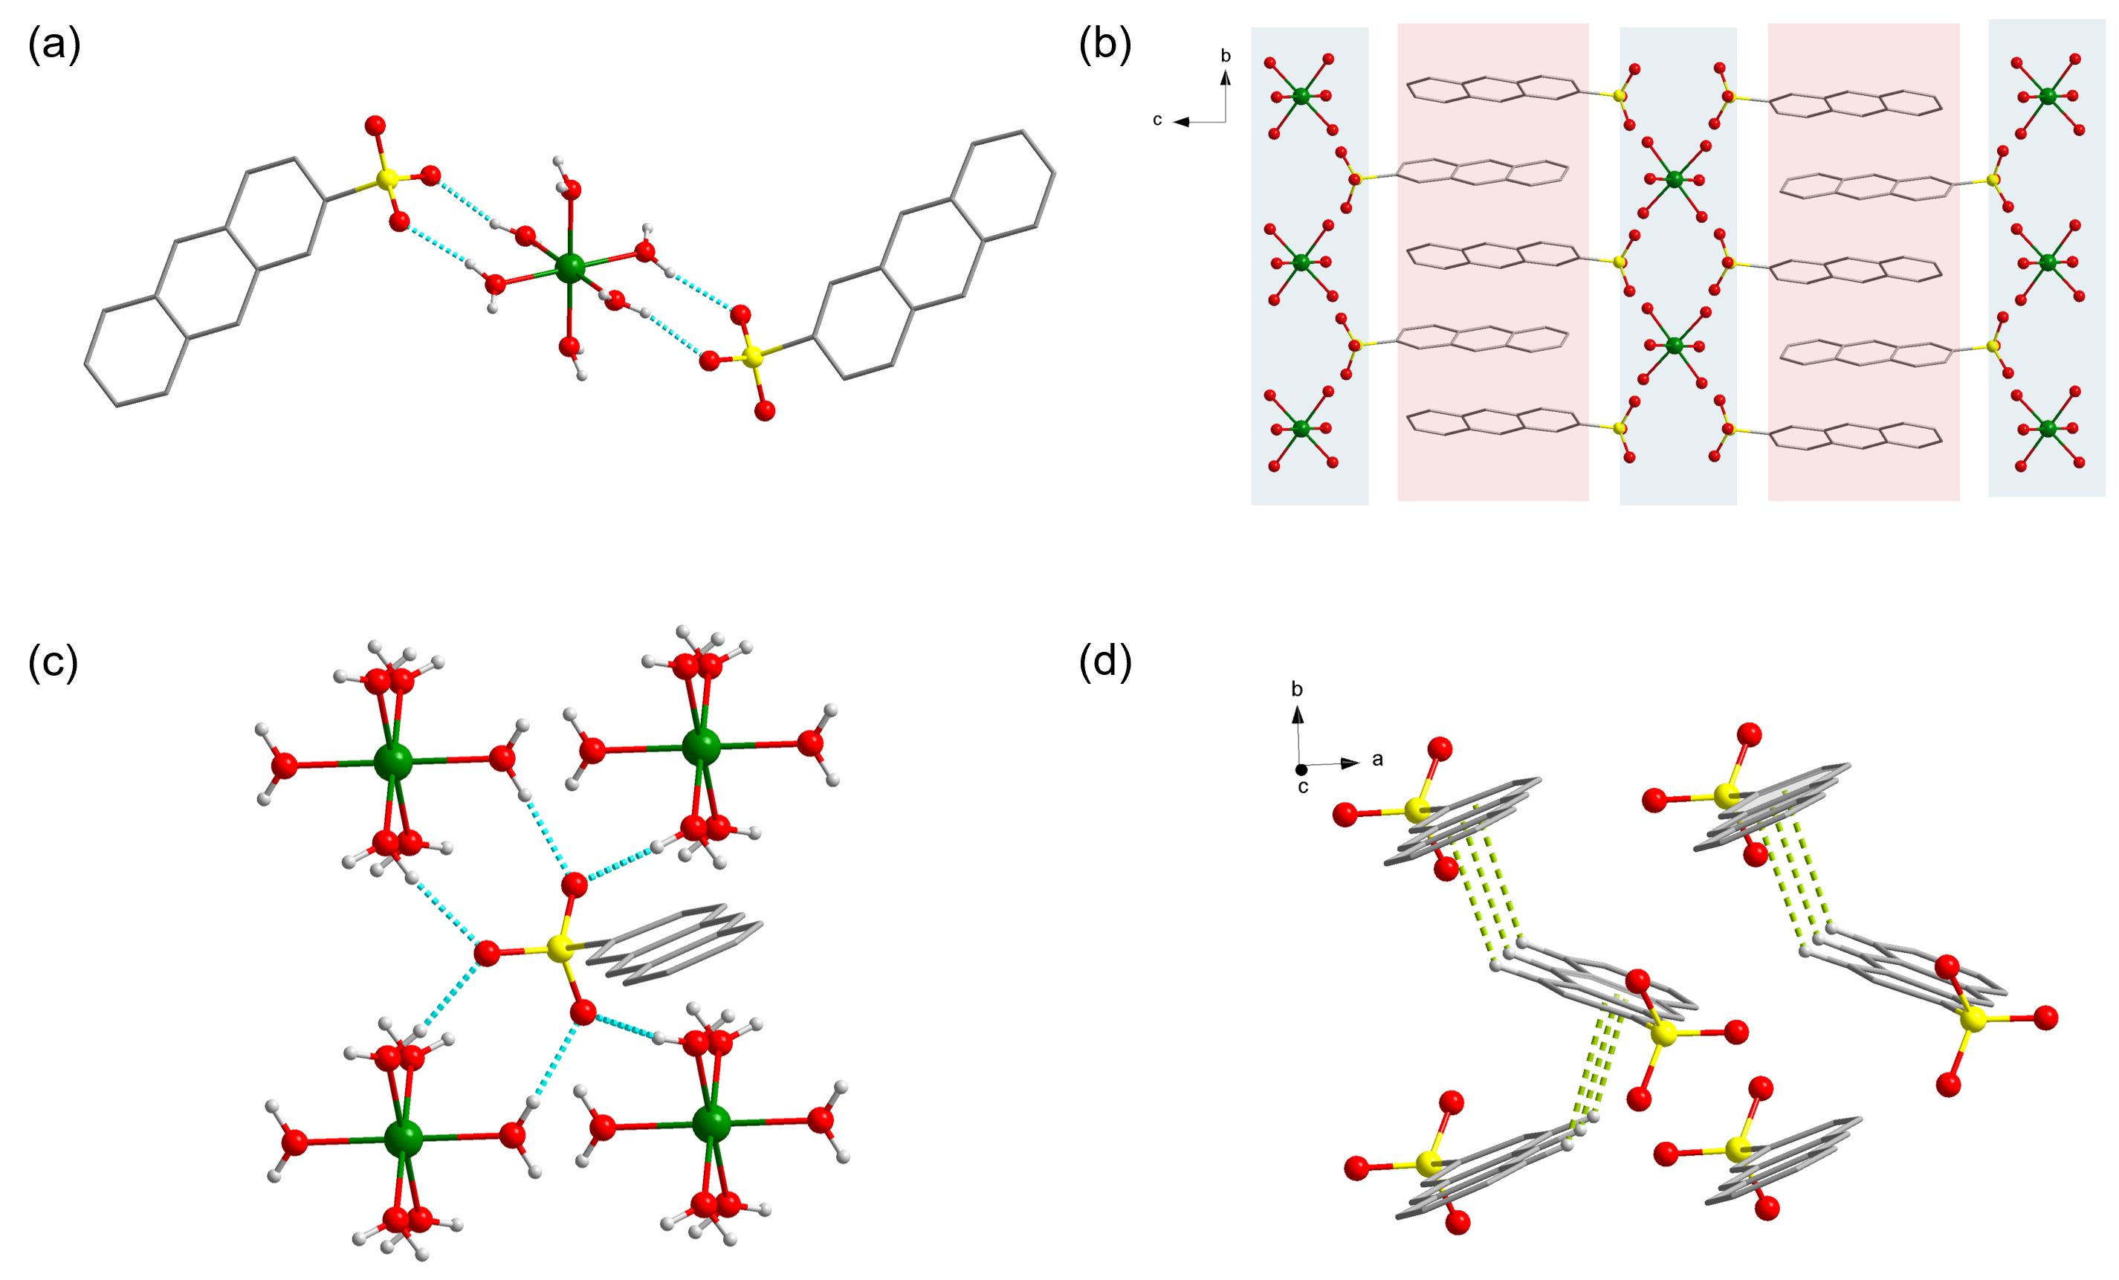
Figure 1. (a) Molecular structure of [Fe(H₂O)₆](2-As)₂; (b) Molecular packing; (c) Hydrogen bonding interactions around the 2-As⁻ anion; (d) CH···π interactions between anthracene moieties. Some hydrogen atoms are omitted for clarity. Color code: Fe (green), C (dark gray), O, (red), N (blue), S (yellow), H (light gray). The colored polygons highlight the molecular packing, emphasizing the layered distribution of the 2-As⁻ anions and metal cations.
Complex 1 crystallizes in the monoclinic space group P2₁/c and contains two crystallographically independent Fe(II) centers exhibiting slightly different coordination geometries (Figure S12 and Figure 2a). Each Fe(II) ion is coordinated by two bidentate 2-pic ligands through four N donors from the pyridine and amine groups in the equatorial plane, and by two sulfonate O atoms from two 2-As⁻ anion in the axial positions, resulting in a distorted FeN₄O₂ octahedral geometry. Fe2 exhibits positional disorder involving sulfonate O atoms. Single crystal X-ray diffraction data collected at room temperature revealed Fe-N bond lengths ranging from 2.0679(18) to 2.1501(18) Å, and Fe-O bond lengths ranging from 2.23(5) to 2.353(4) Å, consistent with a HS state for both Fe(II) centers (Table S2).³⁷ The two Fe(II) centers are arranged alternatively, forming a one-dimensional (1D) chain through hydrogen-bonding interactions between sulfonate and amine groups, with a Fe(II)···Fe(II) distance of 7.6770(1) Å (Figure S13). These 1D chains are aligned in a head-to-head configuration with respect to the anthracene moieties (Figure 2b, Figures S14 and S15). Many hydrogen bonds are observed around the sulfonate O atoms, including C(H)···O contacts in the range of 2.73(4)-3.43(5) Å and N(H)···O interactions between 2.79(4) and 3.110(5) Å (Figure 2c and Figure S16). The adjacent anthracenes units adopt a face-to-edge packing mode stabilized by CH···π interactions (Figure S17, Figure 2d and Table S5). Attempts to isolate a fully ligated [Fe(2-pic)₃](2-As)₂ complex by employing an excess of 2-pic ligand over the iron salt were unsuccessful. A similar situation was reported in a series of heteroleptic Fe(II) complexes including 3,5-dimethyl-1-(20-pyridyl)-pyrazole (DMPP) and aromatic sulfonate ligands, where Et₂O was considered to play an important role in altering the self-assembly pathway, favoring the formation of a more stable [Fe(DMPP)₂X₂] coordination environment.³⁸
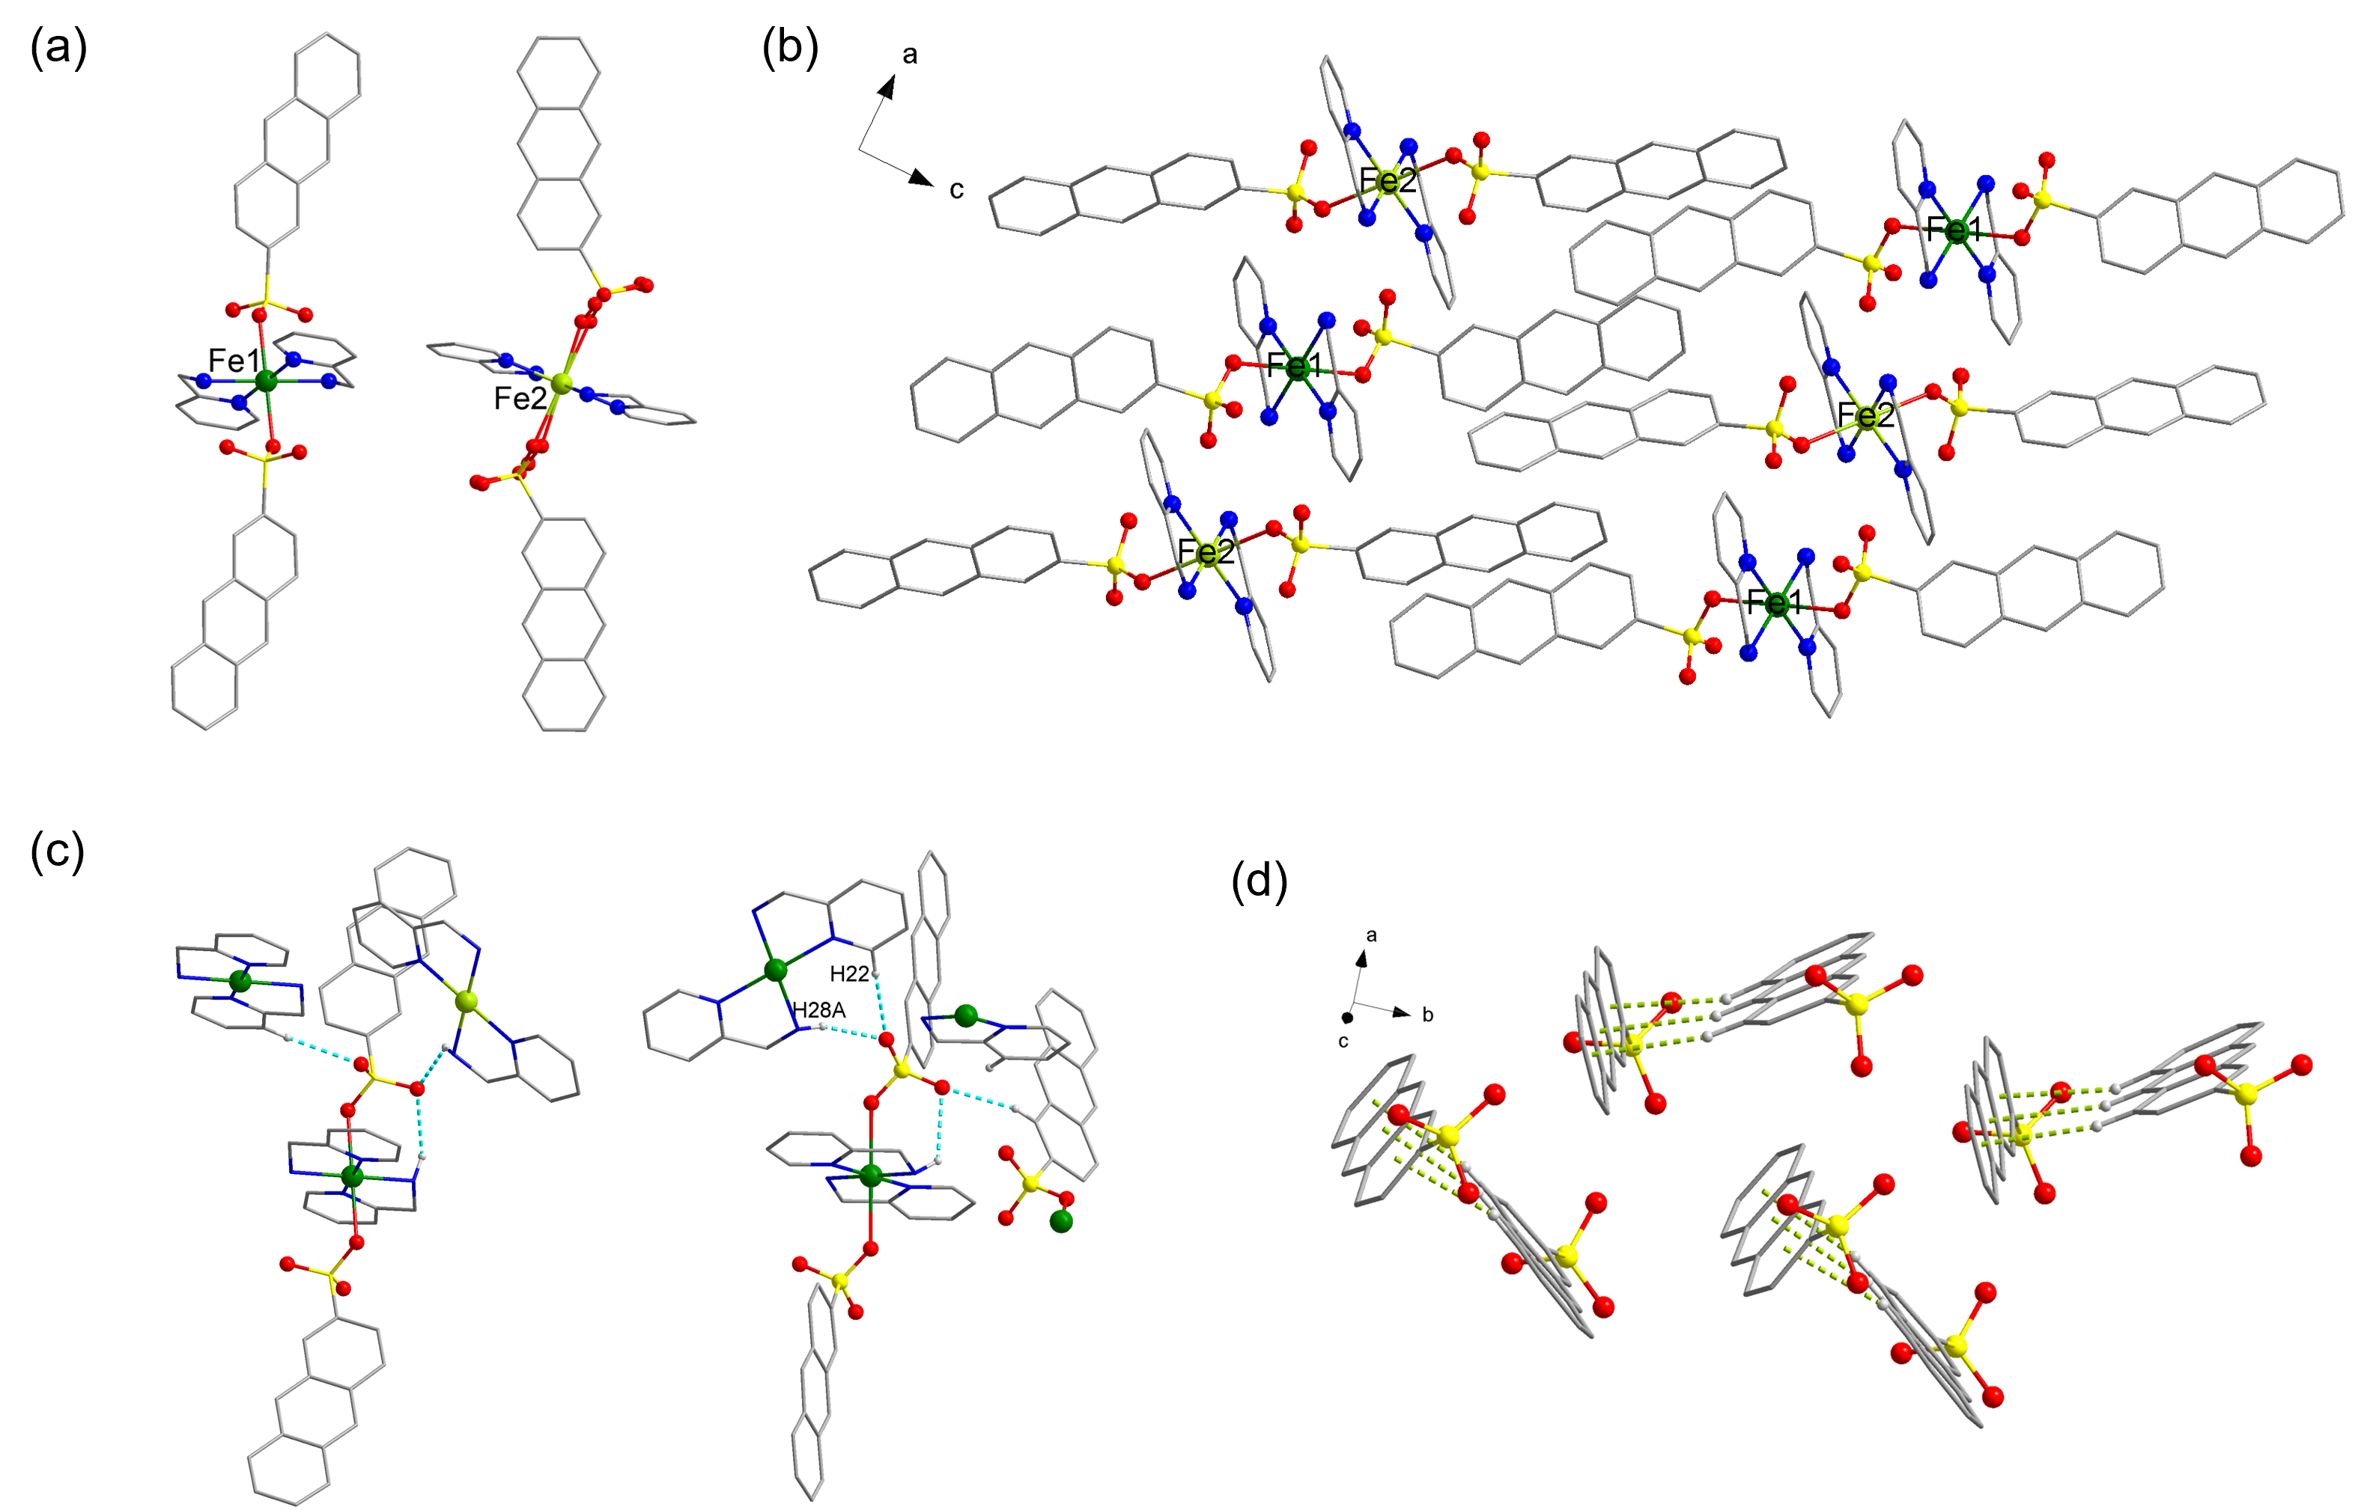
Figure 2. (a) Molecular structure of 1; (b) Molecular packing; (c) Hydrogen bonding interactions around 2-As⁻ anion; (d) CH···π interactions between anthracene moieties. Some hydrogen atoms are omitted for clarity. Color code: Fe (green and lime), C (dark gray), O, (red), N (blue), S (yellow), H (light gray).
Complex 2 crystallizes in the monoclinic space group P2₁/n, featuring one crystallographically unique Fe(II) center coordinated by two tridentate 2,6-hdp ligands in a pseudo-octahedral FeN₆ geometry. Two uncoordinated 2-As⁻ anions act as counterions to balance the charge (Figure 3a). At 150 K, the Fe-N_{pyridine} bonds are1.897(3) and 1.898(3) Å, while the Fe-N_{hydrazone} bonds range from 1.970(3) to 2.011(3) Å, consistent with a LS configuration of the Fe(II) center (Table S2).³⁷ When viewed along the crystallographic b axis, the [Fe(2,6-hdp)₂]²⁺ cations and 2-As⁻ anions form alternating strips (Figure 3b, Figures S18 and S19). Extensive hydrogen bonding is observed around the sulfonate O atoms, with C(H)···O distances ranging from 2.899(4)-3.254(5) Å and N(H)···O contacts between 2.829(4) and 3.282(4) Å (Figure 3c and Figure S20). The adjacent anthracene units exhibit a slipped face-to-edge CH···π arrangement (Figure S21, Figure 3d and Table S6). Besides intrinsic interactions between anthracene moieties-such as CH···π attraction and π···π repulsion,³⁹ the hydrogen bonding network surrounding the sulfonate groups likely contributes to the spatial organization of the 2-As⁻ anions within the crystal lattice.
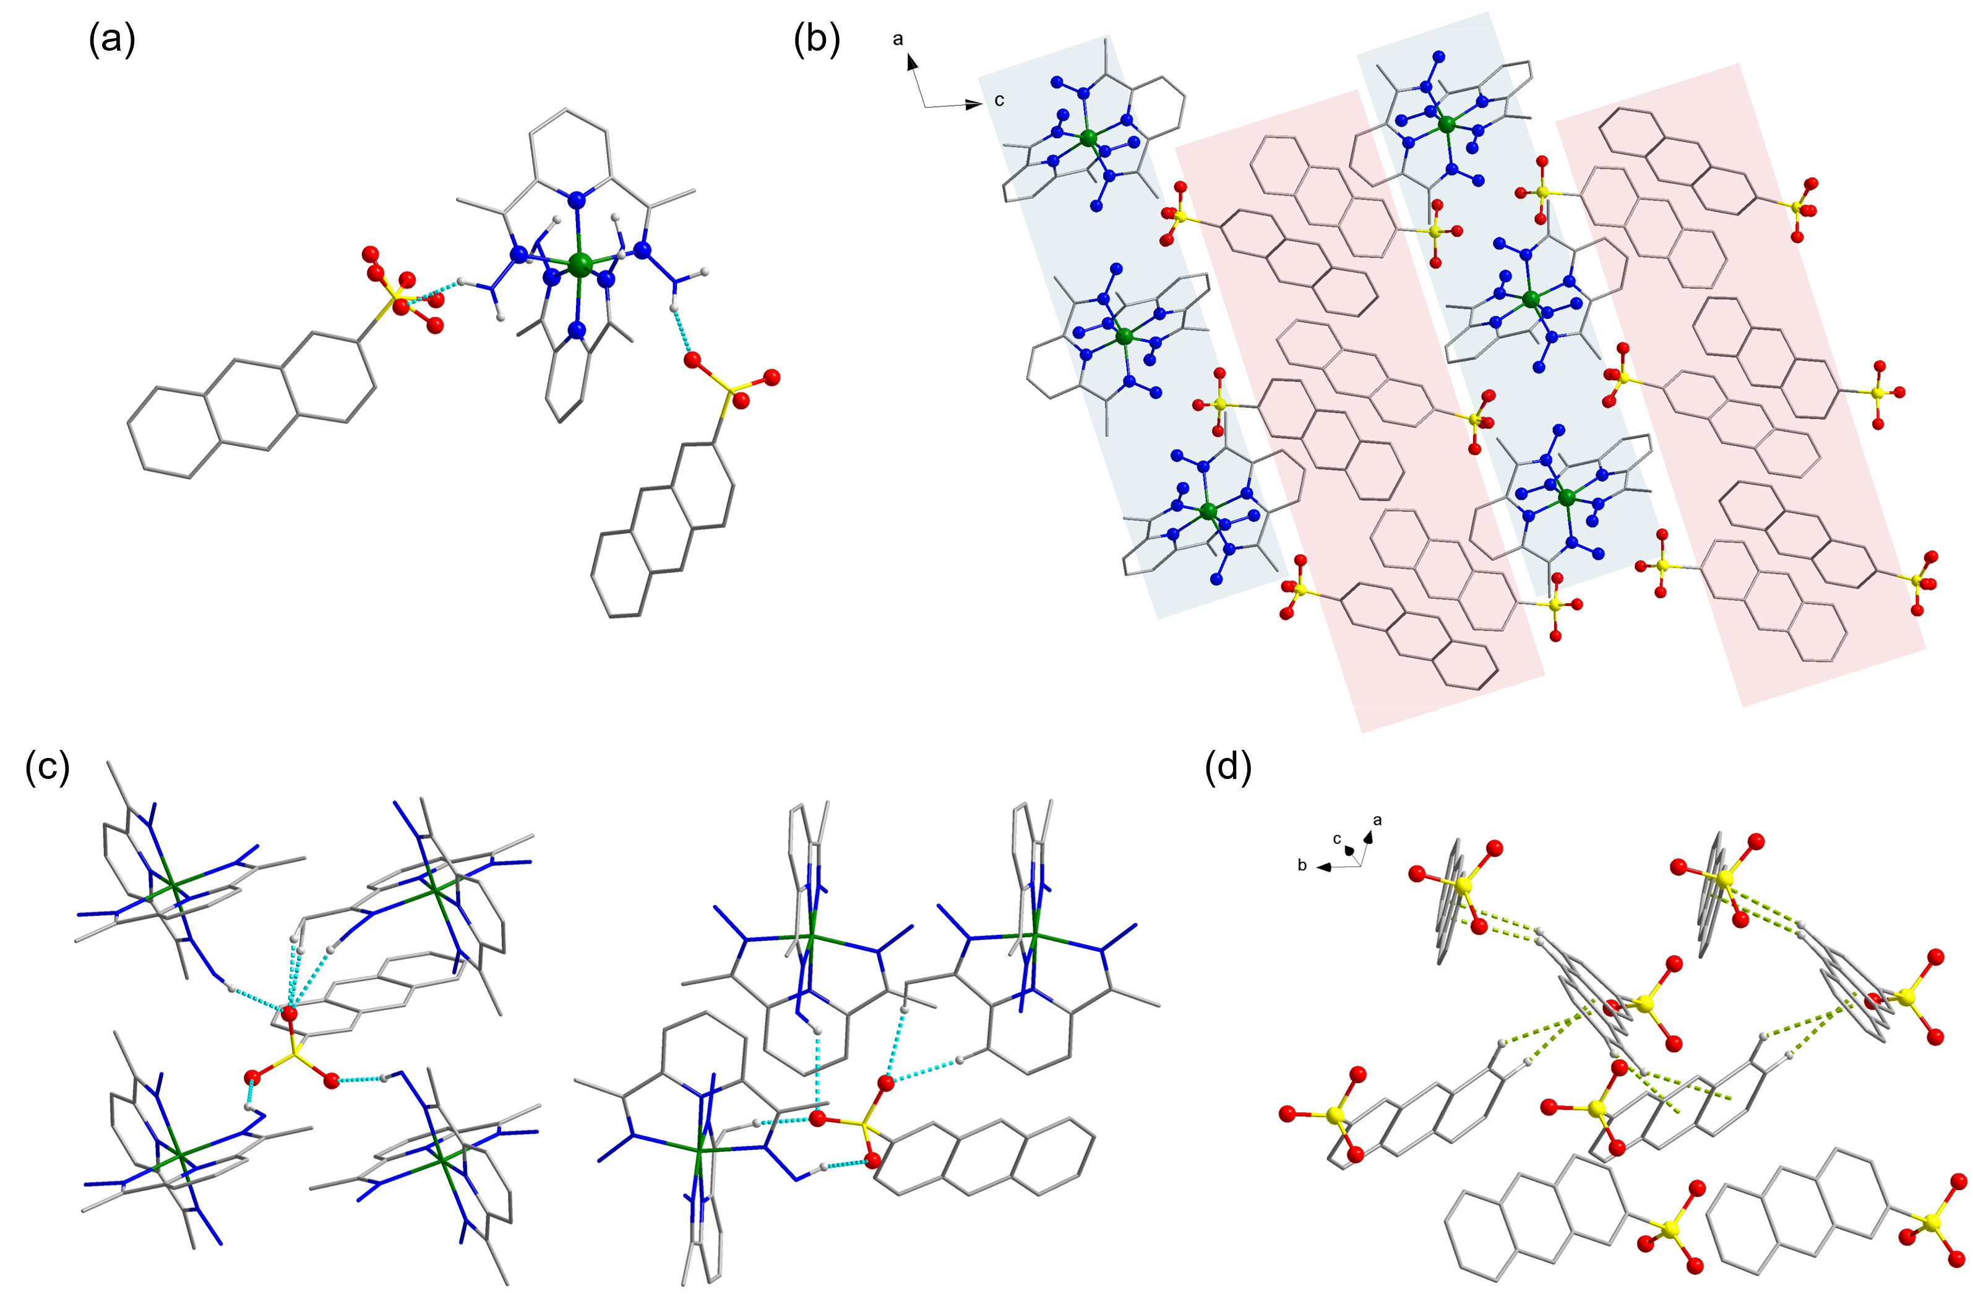
Figure 3. (a) Molecular structure of 2; (b) Molecular packing; (c) Hydrogen bonding interactions around 2-As⁻ anion; (d) CH···π interactions between anthracene moieties. Some hydrogen atoms are omitted for clarity. Color code: Fe (green), C (dark gray), O, (red), N (blue), S (yellow), H (light gray). The colored polygons highlight the molecular packing, illustrating the belt-like distribution of the 2-As⁻ anions and metal cations.
Complex 3 crystallizes in the monoclinic space group P2₁/n. The asymmetric unit comprises one Fe(II) center coordinated by two tridentate 3-bpp ligands, two 2-As⁻ counter anions, and approximately two lattice MeOH and one water molecule according to TGA and elemental analysis (Figure 4a). The Fe(II) ion adopts a pseudo-octahedral geometry, coordinated by six N atoms. At 110 K, the Fe-N_{pyridine} bond lengths are 1.930(6) and 1.935(7) Å, while the Fe-N_{pyrazole} distances range from 1.964(8) to 1.991(7) Å, consistent with an LS configuration.³⁷ When viewed along the crystallographic b axis, the [Fe(3-bpp)₂]²⁺ cations form hexagonal frames with 2-As⁻ anions situated within them (Figure 4b, Figures S22 and S23). Extensive hydrogen bonding is observed around the sulfonate group of 2-As⁻ anions with C(H)···O distances ranging from 2.869(10) to 3.265(13) Å, N(H)···O contacts between 2.654(13) and 2.722(10) Å, and O(H)···O interactions of 2.682(15) and 2.701(11) Å (Figure 4c and Figure S24). Interestingly, the uncoordinated pyrazole N atoms of the two 3-bpp ligands exhibit different hydrogen bonding behavior. In one ligand, both uncoordinated pyrazole N atoms interact with lattice MeOH, which subsequently hydrogen-bond to 2-As⁻ anions. In the other ligand, the uncoordinated N atoms form direct hydrogen bonds with 2-As⁻ anions. Such hydrogen bonding involving uncoordinated pyrazole sites has been reported to play a crucial role in modulating SCO behavior of [Fe(3-bpp)₂]²⁺ complexes, particularly in relation to the influence of varying lattice solvents.⁴⁰⁻⁴⁴ The adjacent anthracene units adopt a slipped face-to-edge CH···π packing motif (Figure S25, Figure 4d and Table S7).
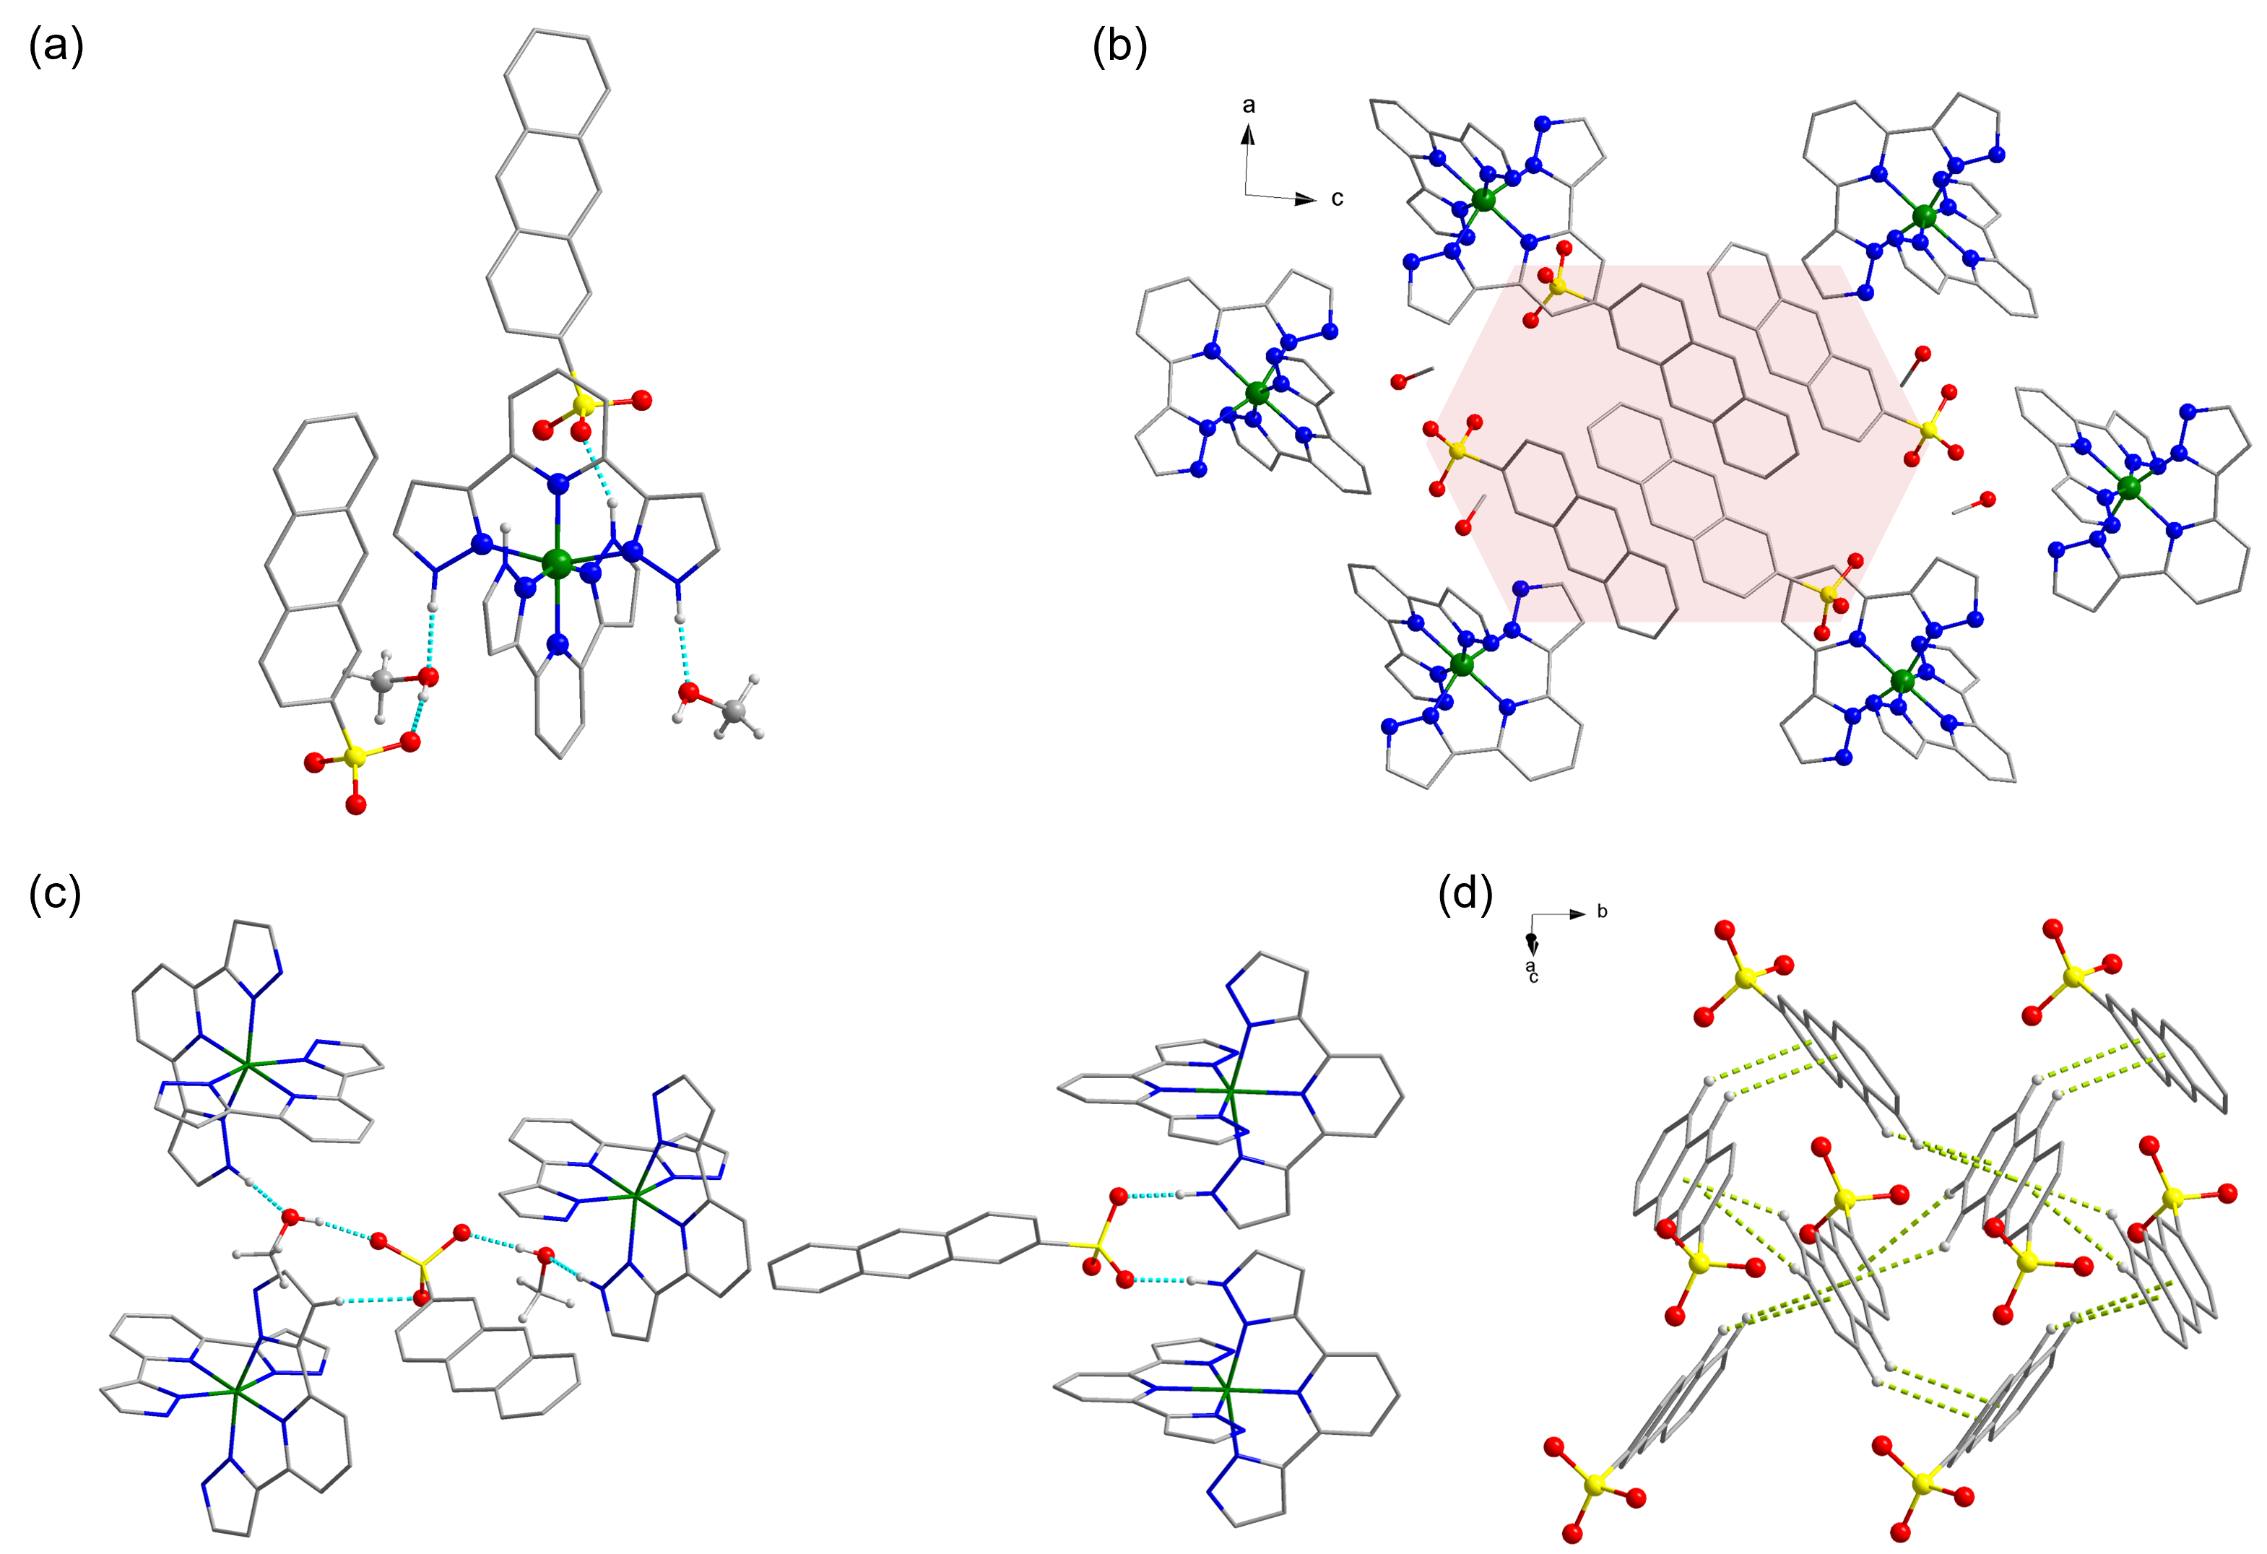
Figure 4. (a) Molecular structure of 3; (b) Molecular packing; (c) Hydrogen bonding interactions around 2-As⁻ anion; (d) CH···π interactions between anthracene moieties. Some hydrogen atoms are omitted for clarity. Color code: Fe (green), C (dark gray), O, (red), N (blue), S (yellow), H (light gray). The colored polygon highlights the molecular packing, delineating the region occupied by 2-As⁻ anions within the hexagonal frames formed by the [Fe(3-bpp)₂]²⁺ cations.
⁵⁷Fe Mössbauer spectroscopic studies
The ⁵⁷Fe Mössbauer spectra of [Fe(H₂O)₆](2-As)₂ and complexes 1-3 at 298 K are shown in Figure 5, with hyperfine parameters summarized in Table 1. All spectra were analyzed using least-squares fitting of Lorentzian doublets via Recoil software,⁴⁵ and isomer shifts (δ) are referenced to α-Fe at 298 K. For [Fe(H₂O)₆](2-As)₂, the spectrum is characterized primarily by a HS Fe(II) doublet (in red) accounting for 94.3% of the absorption area with isomer shift of δ = 1.27(1) mm s⁻¹, and a quadrupole splitting of ΔE_{Q} = 3.16(2) mm s⁻¹, accompanied by a minor doublet (orange, 5.7%) arising from Fe(III) species with δ = 0.35(1) mm s⁻¹ and ΔE_{Q} = 0.33(2) mm s⁻¹. The small Fe(III) contribution is consistent with partial oxidation of the hydrated Fe(II) cation, as previously observed for [Fe(H₂O)₆](psca)₂·2H₂O (psca = p-sulfocinnamic acid).³⁶ The Mössbauer spectra of 1-3 each fit well to a single quadrupole doublet. Complex 1 exhibits δ = 1.01(1) mm s⁻¹ and ΔE_{Q} = 3.1(1) mm s⁻¹, consistent with a HS Fe(II) in an N₂O₄ coordination environment.^{38,46} In contrast, 2 shows δ = 0.16(1) mm s⁻¹ and ΔE_{Q} = 0.96(3) mm s⁻¹, while 3 in its solvated form gives δ = 0.30(1) mm s⁻¹, ΔE_{Q} = 0.69(2) mm s⁻¹, both indicative of LS Fe(II) in pseudo-octahedral FeN₆ environment.⁴⁷⁻⁴⁹ To investigate the effect of solvent loss, complex 3 was desolvated by heating (400 K, 1 h) under dynamic vacuum on a Schlenk line. The resulting material was loaded into a sample holder in a glove box and then measured by Mössbauer spectroscopy at 298 K (Figure 5e). The resulting spectrum was fitted with three quadrupole doublets. Two outer components correspond to distinct HS Fe(II) sites (red: δ = 1.06(2) mm s⁻¹, ΔE_{Q} = 2.38(4) mm s⁻¹, 54%; pink: δ = 0.79(6) mm s⁻¹, ΔE_{Q} = 2.35(1) mm s⁻¹, 12%), while the central doublet (blue) represents a LS Fe(II) fraction with δ = 0.33(3) mm s⁻¹, ΔE_{Q} = 0.71(6) mm s⁻¹ (34%). These values closely parallel those reported for the solvent-free [Fe(bpp)₂](PF₆)₂,⁴¹ confirming that desolvation promotes a partial conversion of LS Fe(II) to HS Fe(II). The coexistence of two HS doublets indicates the emergence of two crystallographically distinct HS Fe(II) environments after solvent removal. The dissymmetry of the lines observed for [Fe(H₂O)₆](2-As)₂, 1, 3, and desolvated 3 is due to texture, as a result of preferential orientation of crystallites respective to the gamma beam.⁵⁰
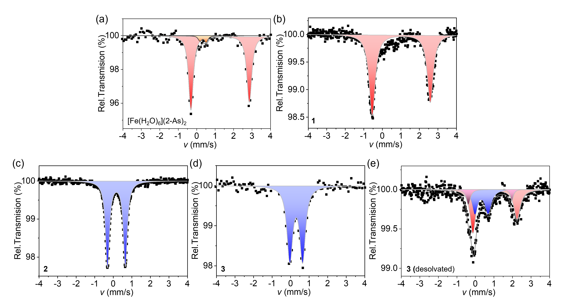
Figure 5. ⁵⁷Fe Mössbauer spectra of [Fe(H₂O)₆](2-As)₂ (a), 1 (b), 2 (c), 3 (d), and desolvated complex 3 (e) at 298 K.
Table 1. ⁵⁷Fe Mössbauer parameters for [Fe(H₂O)₆](2-As)₂, 1-3 and desolvated complex 3 at 298 K. Isomer shift (δ) is given with respect to metallic α-Fe. Γ/2 = half width of the lines.
Compound | T (K) | Spin state | Mössbauer parameters
Compound | T (K) | Spin state | δ (mm s⁻¹) | ΔE_{Q} (mm s⁻¹) | Γ/2 | Fraction (%)
[Fe(H₂O)₆](2-As)₂ | 298 | Fe(II) HS | 1.27(1) | 3.16(2) | 0.14(1) | 94.3
[Fe(H₂O)₆](2-As)₂ | 298 | Fe(III) HS | 0.35(1) | 0.33(2) | 0.13(1) | 5.7
1 | 298 | Fe(II) HS | 1.01(1) | 3.13(1) | 0.19(1) | 100
2 | 298 | Fe(II) LS | 0.16(1) | 0.96(3) | 0.13(1) | 100
3 | 298 | Fe(II) LS | 0.30(1) | 0.69(2) | 0.17(1) | 100
3 (desolvated) | 298 | Fe(II) HS1 | 1.06(2) | 2.38(4) | 0.21(7) | 54
3 (desolvated) | 298 | Fe(II) HS2 | 0.79(6) | 2.35(1) | 0.10(1) | 12
3 (desolvated) | 298 | Fe(II) LS | 0.33(3) | 0.71(6) | 0.21(7) | 34

Magnetic property characterization
Magnetic susceptibility data were collected for complexes 1-3 under a dc field of 1000 Oe (Figure 6a). At 400 K, the χ_{M}T values are 3.50 cm³mol⁻¹K for 1 and ~0 cm³mol⁻¹K for 2, which are characteristic of HS and LS mononuclear Fe(II) complexes, respectively, The theoretical spin-only χ_{M}T value for S = 2 HS Fe(II) ion is 3.0 cm³mol⁻¹K, while experimental observed values typically lie in the range of 3.2-3.5 cm³mol⁻¹K due to spin-orbit contributions. In contrast, an S = 0 LS Fe(II) center is expected to be diamagnetic, with χ_{M}T ≈ 0 cm³·mol⁻¹·K,⁵¹ consistent with the results from Mössbauer spectroscopy recorded at 298 K (Figure 5b and Figure 5c). Upon cooling, 1 exhibits a very gradual decrease in χ_{M}T down to approximately 45 K, followed by a sharp drop to 4 K. This latter behavior is attributed to zero-field splitting (ZFS) effect of HS Fe(II) ions, arising from octahedral distortions.⁵² In contrast, 2 maintains χ_{M}T values close to zero throughout the whole temperature range investigated, consistent with a diamagnetic LS state. Particular care was taken when measuring the magnetic properties of 3, as this complex is sensitive to lattice solvents loss. The crystals were placed intact (without griding) into a borosilicate tube containing a small amount of mother liquor, then flame-sealed under vacuum. Due to the presence of low-boiling diethyl ether in the solvent mixture, the maximum measurement temperature was limited to 340 K to avoid tube rupture. The χ_{M}T data measured between 300 K-10 K-340 K show that solvated 3 remains in the LS state with χ_{M}T ≈ 0 cm³mol⁻¹K below 300 K and an onset of SCO occurring above 300 K (Figure 6b). These results are consistent with the Mössbauer spectrum recorded at room temperature. To investigate the effect of desolvation, the same sample was subsequently filtered and transferred to a polypropylene capsule, enabling in situ drying within the magnetometer chamber. The sample was heated under vacuum at 400 K for 1 h, and the sample chamber was purged to remove the solvent vapors. After this procedure, the χ_{M}T at 400 K increased significantly to 3.13 cm³mol⁻¹K (Figure 6c), indicating that most Fe(II) centers adopt the HS configuration. Cooling the sample results in a gradual decrease of χ_{M}T to 1.6 cm³mol⁻¹K at 80 K, corresponding to roughly half of the Fe(II) centers converted to the LS state, indicating an incomplete SCO behavior. The steeper decline at lower temperatures arises from ZFS effects of the HS species. Considering the Mössbauer results of the desolvated complex 3, which indicate the presence of two nonequivalent HS Fe(II) sites, it is reasonable to propose that this partial spin conversion arises because one Fe(II) site undergoes a HS to LS transition, whereas the other retains the HS state. Upon warming, a narrow thermal hysteresis loop was observed around 290 K (Figure S26), indicative of lattice solvent-dependent SCO behavior, consistent with other examples of the [Fe(3-bpp)₂]²⁺ family, where SCO is highly sensitive to the lattice environment.⁴²⁻⁴⁴ Structural analysis indicates that the lattice MeOH molecules form hydrogen bonds with uncoordinated pyrazole N atoms, thereby reinforcing the ligand field strength around Fe(II) ion and stabilizing the LS state. Upon solvent loss, this hydrogen bonding network is disrupted, reducing the ligand field strength and promoting SCO.^{42,53,54} The gradual SCO behavior might be related to the weakening of cooperation interaction because the loss of lattice solvents destroy the hydrogen bond network.⁵⁵ This hysteresis may arise from residual lattice mediated cooperativity, possibly involving hydrogen bonding interactions between the 2-As⁻ anion and [Fe(3-bpp)₂]²⁺ cation.⁵⁶⁻⁵⁸
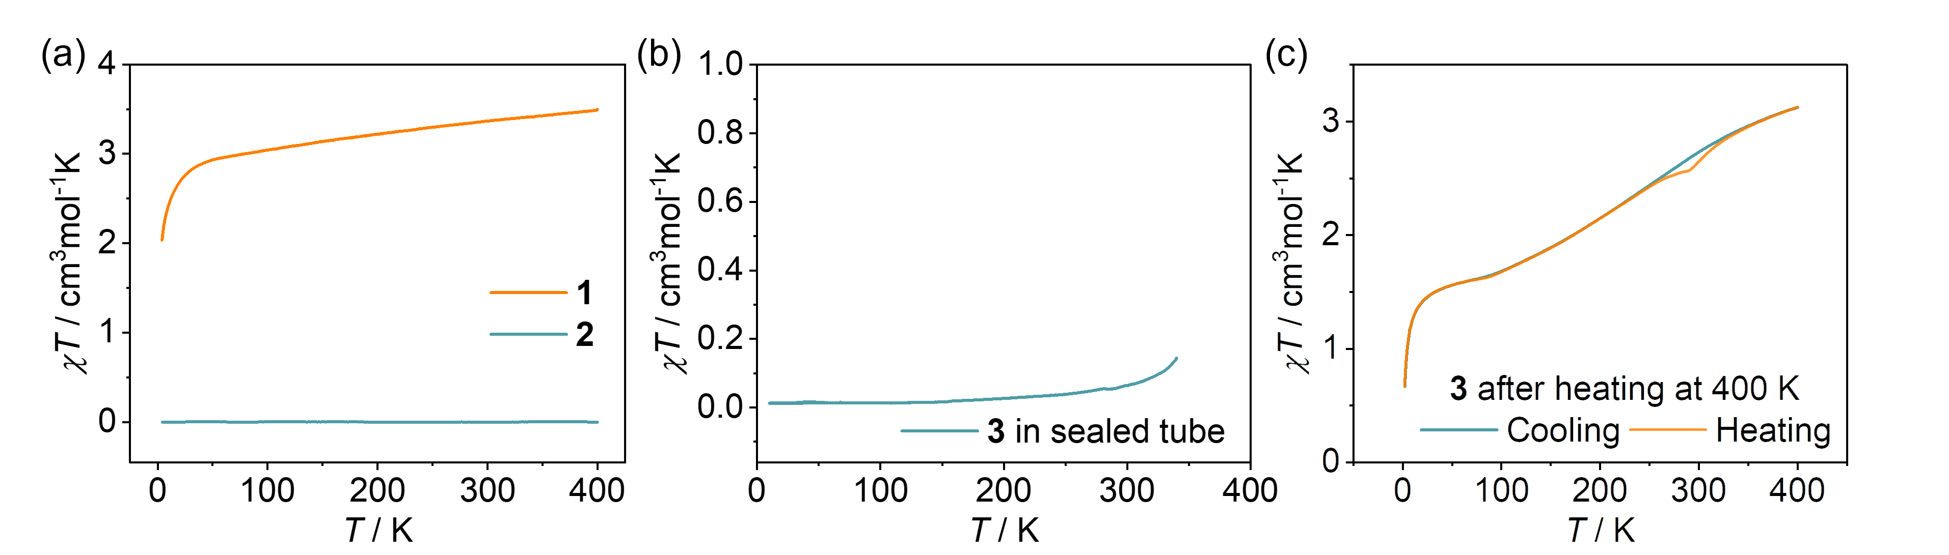
Figure 6. χ_{M}T vs. T for 1-3 under 1000 Oe dc field.
Diffuse reflectance spectroscopy
Variable-temperature diffuse reflectance spectroscopy (DRS) data of freshly prepared complex 3 were recorded in the temperature range of 303-453 K under a He_{(g)} flow (Figure 7) to prevent potential oxidation on warming. Upon heating, the two broad absorption bands centered at ca. λ = 452 and 540 nm at 303 K decrease notably, supporting the thermally induced spin-state change from LS to HS (ESI). Upon subsequent programmed cooling, a gradual and partial recovery of the absorption bands was observed, indicating incomplete reversibility of the spin transition. A spin transition curve, γ_{HS}(T), was derived from the relative intensity change at λ = 425 nm (Figure 7c) and shows good qualitative agreement with magnetic measurements, with minor discrepancies attributed to the surface-sensitive nature of the optical technique.
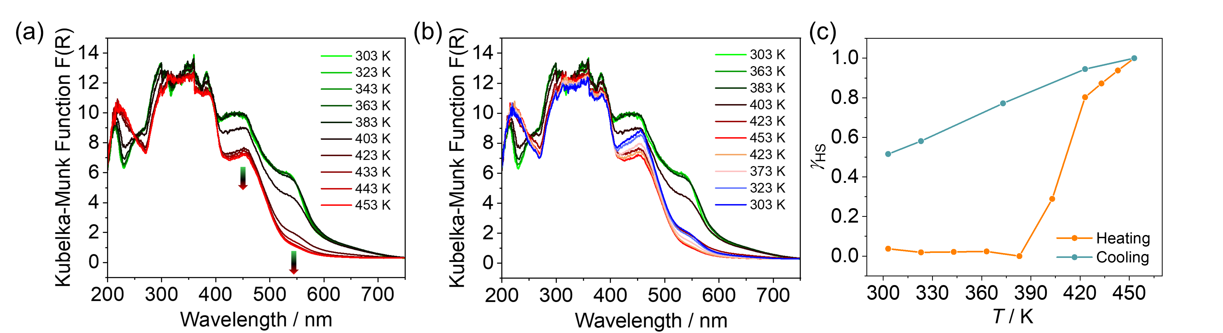
Figure 7. Temperature-dependent UV-vis diffuse reflectance spectra of freshly prepared single crystals of 3. (a) Spectra recorded upon heating from 303 K to 453 K. (b) Spectra recorded upon heating from 303 K to 453 K followed by cooling back to 303 K. (c) Spin transition curves γ_{HS}(T) derived from the temperature-dependent UV-vis diffuse reflectance data by absorption bond at λ = 425 nm.
Optical microscopy
Temperature-dependent optical microscopy was employed to visualize morphological and color changes accompanying the SCO process in single crystals of 3 (Figure 8). Upon heating above room temperature, the crystal gradually changed color from red to yellow and developed visible cracks at elevated temperatures, consistent with solvent loss and a LS-to-HS transition. Upon cooling, partial color recovery was observed. However, the original appearance was not fully restored, indicating partial structural irreversibility, in agreement with the DRS results (Figure 7b).
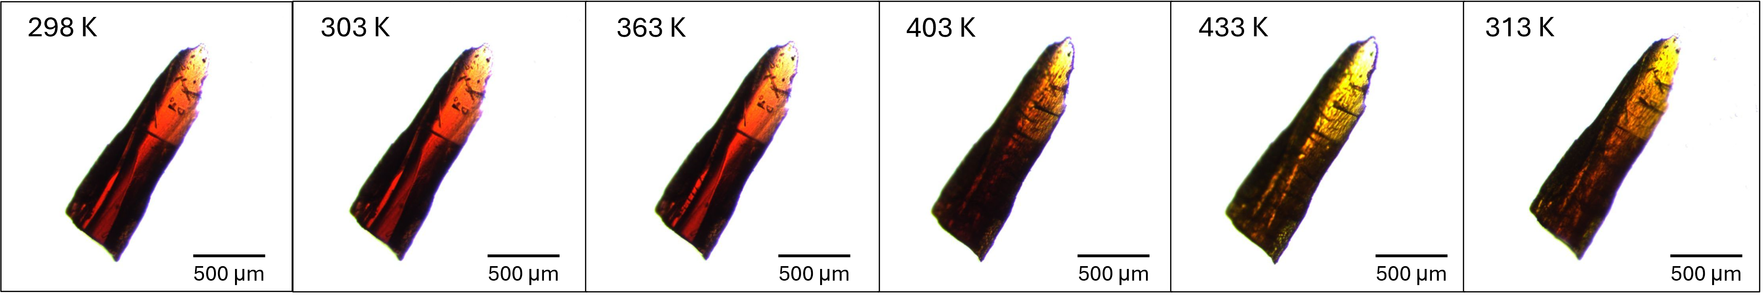
Figure 8. Optical micrographs of a single crystal of 3 at various temperatures during the heating and cooling processes.
Raman spectroscopy
Variable-temperature Raman spectroscopy performed on desolvated complex 3 upon cooling from 400 to 200 K also serves as supporting evidence for the SCO behavior (ESI and Figure S27).
Conclusions
In this study, we report the synthesis and structural characterization of a new Fe(II) salt [Fe(H₂O)₆](2-As)₂, incorporating 2-As⁻ as the counter anion for the first time. This salt serves as a versatile precursor for the construction of Fe(II) coordination complexes containing 2-As⁻, with potential application in anthracene-based anion-driven light-induced spin change via photocyclization. Three new Fe(II) complexes [Fe(2-pic)₂(2-As)₂] (1), [Fe(2.6-hdp)₂](2-As)₂ (2), and [Fe(3-bpp)₂](2-As)₂·2MeOH·H₂O (3) were successfully synthesized and characterized. Magnetic susceptibility, ⁵⁷Fe Mössbauer spectroscopy, and single crystal X-ray diffraction reveal that 1 and 2 retain the high-spin and low-spin states, respectively, across the 4-400 K temperature range. Magnetic measurement combining with UV-vis diffuse reflectance spectroscopy and optical microscopy indicates that 3 exhibits a low-spin state in the presence of lattice solvents, and after removal of these solvents, a gradual and incomplete spin crossover occurs, accompanied by a small thermal hysteresis centered at approximately 290 K. Structural analysis indicates that the anthracene moieties adopt a face-to-edge packing motif stabilized by CH···π interactions. Additionally, extensive hydrogen bonding involving the sulfonate group of 2-As⁻ was observed, which likely plays a role in modulating the spatial arrangement of anthracene units in the solid state. Although none of the current complexes exhibit suitable geometry for photodimerization of the anthracene units, the results provide valuable insights into the supramolecular behavior of 2-As⁻ as a counter anion and its impact on the spin crossover properties of [Fe(3-bpp)₂]²⁺. Beyond H···π and π···π interactions governed by aromatic stacking mode (e.g. edge-to-face or face-to-face), hydrogen bonding involving the sulfonate group appears to be a key factor influencing anthracene packing. Future efforts will focus on crystal engineering strategies to modulate the packing of 2-As⁻ anions and promote favorable π···π stacking interactions of anthracene units for enhanced photoreactivity. Possible approaches include the introduction of hydrogen-bond-directing co-ligands to establish robust supramolecular interactions with the sulfonate group, as well as the incorporation of sterically demanding co-ligands to influence the spatial orientation and preorganization of the anthracene moieties. Additionally, tuning the solvent environment or employing templating agents during crystallization may enable better control over the relative positioning of anthracene rings, ultimately paving the way for achieving controlled photodimerization and light-induced spin-state switching.
Accession Codes
CCDC 2489374-2489378 include the supplementary crystallographic data and can be downloaded free of charge from The Cambridge Crystallographic Data Centre via www.ccdc.cam.ac.uk/structures.
ASSOCIATED CONTENT
Supporting Information. Synthetic details, materials and method, NMR spectra, crystal structures, crystallographic table, and tables containing bond distances and angles, IR, PXRD, TGA, Raman peaks. The Supporting Information is available free of charge at xxx.

AUTHOR INFORMATION
Corresponding Author
*Yann Garcia
Email: yann.garcia@uclouvain.be
Author Contributions
M. W. performed all syntheses, carried out routine characterization, analyzed the data, and wrote the manuscript. Y.D. contributed to data discussion and manuscript revision. K.R and Z.H. performed single-crystal X-ray diffraction measurements and structure refinement. A. R., J. Y. and D. P. carried out magnetic measurements. M. Wolff performed elemental and mass spectrometry analyses, data acquisition, and manuscript review & editing. D. M., M. S. and R. J. conducted Raman spectroscopy. All authors discussed the results and approved the final manuscript.
Notes
Any additional relevant notes should be placed here.
ACKNOWLEDGMENT
This work was supported through the Fonds De La Recherche Scientifique—FNRS (PDR T.0095.21, FC 53249, CDR J.0064.23, EQP U.N027.24 and PINT-BILAT-M PAS Poland), and UEFSCDI through the project number PNIII-P1-1.1-TE-2019-2194 (Contract No: TE 123/2020). The authors gratefully acknowledge the Mass Spectrometry Center, Faculty of Chemistry, University of Vienna.

REFERENCES
[1] McConnell, A. J.; Wood, C. S.; Neelakandan, P. P.; Nitschke, J. R. Stimuli-responsive metal-ligand assemblies. Chem. Rev. 2015, 115, 7729-7793.
[2] Sun, H.; Liu, S.; Lin, W.; Zhang, K. Y.; Lv, W.; Huang, X.; Huo, F.; Yang, H.; Jenkins, G.; Zhao, Q.; Wei, H. Smart responsive phosphorescent materials for data recording and security protection. Nat. Commun. 2014, 5, 3601.
[3] Li, W.; Sun, L.; Liu, C.; Rotaru, A.; Robeyns, K.; Singleton, M. L.; Garcia, Y. Supramolecular Fe^{II}₄L₄ cage for fast ammonia sensing. J. Mater. Chem. C 2022, 10, 9216-9221.
[4] Wang, M.; Han, Z.; Wang, K.; Zhao, B.; Sun, T.; Wu, Y.; Cheng, P.; Shi, W. Confinement of p-xylene in the pores of a bilanthanide metal-organic framework for highly selective recognition. Angew. Chem. Int. Ed. 2024, 63, e202318722
[5] Yan, D.; Wang, Z.; Zhang, Z. Stimuli-responsive crystalline smart materials: from rational design and fabrication to applications. Acc. Chem. Res. 2022, 55, 1047-1058.
[6] Meng, Y. S.; Liu, T. Manipulating spin transition to achieve switchable multifunctions. Acc. Chem. Res. 2019, 52, 1369-1379.
[7] Gütlich, P.; Gaspar, A. B.; Garcia, Y. Spin state switching in iron coordination compounds. Beilstein J. Org. Chem. 2013, 9, 342-391.
[8] Zhang, Y.; Torres-Cavanillas, R.; Yan, X.; Zeng, Y.; Jiang, M.; Clemente-León, M.; Coronado, E.; Shi, S. Spin crossover iron complexes with spin transition near room temperature based on nitrogen ligands containing aromatic rings: from molecular design to functional devices. Chem. Soc. Rev. 2024, 53, 8764-8789.
[9] Resines-Urien, E.; Fernandez-Bartolome, E.; Martinez-Martinez, A.; Gamonal, A.; Piñeiro-López, L.; Costa, J. S. Vapochromic effect in switchable molecular-based spin crossover compounds. Chem. Soc. Rev. 2023, 52, 705-727.
[10] Garcia, Y.; Robert, F.; Naik, A. D.; Zhou, G.; Tinant, B.; Robeyns, K.; Michotte, S.; Piraux, L. Spin transition charted in a fluorophore-tagged thermochromic dinuclear iron(II) complex. J. Am. Chem. Soc. 2011, 133, 15850-15853.
[11] Ohkoshi, S.; Imoto, K.; Tsunobuchi, Y.; Takano, S.; Tokoro, H. Light-induced spin-crossover magnet. Nat. Chem. 2011, 3, 564-569.
[12] Delgado, T.; Tissot, A.; Guénée, L.; Hauser, A.; Valverde-Muñoz, F. J.; Seredyuk, M.; Real, J. A.; Pillet, S.; Bendeif, E.; Besnard, C. Very long-lived photogenerated high-spin phase of a multistable spin-crossover molecular material. J. Am. Chem. Soc. 2018, 140, 12870-12876.
[13] Köbke, A.; Gutzeit, F.; Röhricht, F.; Schlimm, A.; Grunwald, J.; Tuczek, F.; Studniarek, M.; Longo, D.; Choueikani, F.; Otero, E.; Ohresser, P.; Rohlf, S.; Johannsen, S.; Diekmann, F.; Rossnagel, K.; Weismann, A.; Jasper-Toennies, T.; Näther, C.; Herges, R.; Berndt, R.; Gruber, M. Reversible coordination-induced spin-state switching in complexes on metal surfaces. Nat. Nanotechnol. 2020, 15, 18-21.
[14] Li, X.; Belmouri, N. E. I.; Sy, M.; Wolff, M.; Rotaru, A.; van Terwingen, S.; Maskowicz, D.; Sawczak, M.; Jendrzejewski, R.; Boukheddaden, K.; Garcia, Y. Three-Step Spin Crossover in a Pseudo-3D Hofmann Type Complex Originating from Anisotropic Supramolecular Interactions. J. Am. Chem. Soc. 2026, 10.1021/jacs.5c17863
[15] Nakaya, M.; Ohtani, R.; Lindoy, L. F.; Hayami, S. Light-induced excited spin state trapping in iron(III) complexes. Inorg. Chem. Front. 2021, 8, 484-498.
[16] Unruh, D.; Homenya, P.; Kumar, M.; Sindelar, R.; Garcia, Y.; Renz, F. Spin state switching of metal complexes by visible light or hard X-rays. Dalton Trans. 2016, 45, 14008.
[17] García-López, V.; Palacios-Corella, M.; Cardona-Serra, S.; Clemente-León, M.; Coronado, E. Spin-crossover iron(II) complex showing thermal hysteresis around room temperature with symmetry breaking and an unusually high T(LIESST) of 120 K. Chem. Commun. 2019, 55, 12227-12230.
[18] Khusniyarov, M. M. How to switch spin-crossover metal complexes at constant room temperature. Chem.-Eur. J. 2016, 22, 15178-15191.
[19] Brachňaková, B.; Šalitroš, I. Ligand-driven light-induced spin transition in spin crossover compounds. Chem. Pap. 2018, 72, 773-798.
[20] Kumar, V.; Rotaru, A.; Garcia, Y. Room temperature light induced spin state switching in a Fe^{II} coordination polymer featuring a photo responsive anion. J. Mater. Chem. C 2022, 10, 14128-14134.
[21] Kumar, V.; Garcia, Y. In 'Mössbauer spectroscopy: applications in chemistry and materials science'. Wiley VCH 2024, chapter 10, 271-289.
[22] Kumar, V.; Ghosh, A. C.; Draoui, Y.; Wang, M.; Van Hecke, K.; Rotaru, A.; Garcia, Y. Thermally induced Fe^{II} spin crossover hybrid complex incorporating para-sulfocinnamic acid. Eur. J. Inorg. Chem. 2025, 28, e202400753.
[23] Xie, K.-P.; Ruan, Z.-Y.; Lyu, B.-H.; Chen, X.-X.; Zhang, X.-W.; Huang, G.-Z.; Chen, Y.-C.; Ni, Z.-P.; Tong, M.-L. Guest-driven light-induced spin change in an azobenzene loaded metal-organic framework. Angew. Chem. Int. Ed. 2021, 60, 27144-27150.
[24] Boillot, M.-L.; Roux, C.; Audière, J.-P.; Dausse, A.; Zarembowitch, J. Ligand-driven light-induced spin change in transition-metal complexes: selection of an appropriate system and first evidence of the effect, in Fe^{II}(4-styrylpyridine)₄(NCBPh₃)₂. Inorg. Chem. 1996, 35, 3975-3980.
[25] Rösner, B.; Milek, M.; Witt, A.; Gobaut, B.; Torelli, P.; Fink, R. H.; Khusniyarov, M. M. Reversible photoswitching of a spin-crossover molecular complex in the solid state at room temperature. Angew. Chem. Int. Ed. 2015, 54, 12976-12980.
[26] Salzillo, T.; Venuti, E.; Femoni, C.; Della Valle, R. T.; Tarroni, R.; Brillante, A. Crystal structure of the 9-anthracene-carboxylic acid photochemical dimer and its solvates by X-ray diffraction and Raman microscopy. Cryst. Growth Des. 2017, 17, 3361-3370.
[27] Bai, S.; Ma, L.-L.; Yang, T.; Wang, F.; Wang, L.-F.; Hahn, F. E.; Wang, Y.-Y.; Han, Y.-F. Supramolecular-induced regiocontrol over the photochemical [4 + 4] cyclodimerization of NHC- or azole-substituted anthracenes. Chem. Sci. 2021, 12, 2165-2171.
[28] Bouas-Laurent, H.; Castellan, A.; Desvergne, J.-P.; Lapouyade, R. Photodimerization of anthracenes in fluid solution: structural aspects. Chem. Soc. Rev. 2000, 29, 43-55.
[29] Tamagaki, S.; Fukuda, K.; Maeda, H.; Mimura, N.; Tagaki, W. Complexation and photodimerization of anthracene-2-sulfonate in the presence of per-6-aminocyclodextrins. J. Chem. Soc., Perkin Trans. 2 1995, 2, 389-393.
[30] Shaikh, S. R.; Gawade, R. L.; Dabke, N. B.; Dash, S. R.; Vanka, K.; Gonnade, R. G. Crystal engineering for intramolecular π-π stacking: Effect of substitution of electron-donating and electron-withdrawing groups on the molecular geometry in conformationally flexible sulfoesters and sulfonamides. CrystEngComm. 2024, 26, 3557-3573.
[31] Jaime-Adán, E.; Hernández-Ortega, S.; Toscano, R. A.; Germán-Acacio, J. M.; Sánchez-Pacheco, A. D.; Hernández-Vergara, M.; Barquera, J. E.; Valdés-Martínez, J. Competition of hydrogen bonds, halogen bonds, and π-π interactions in crystal structures. Exploring the effect of one atom substitution. Cryst. Growth Des. 2024, 24, 1888-1897.
[32] Yao, Z.-F.; Wang, J.-Y.; Pei, J. Control of π-π stacking via crystal engineering in organic conjugated small molecule crystals. Cryst. Growth Des. 2018, 18, 7-15.
[33] Bora, P.; Saikia, B.; Sarma, B. Regulation of π···π stacking interactions in small molecule cocrystals and/or salts for physiochemical property modulation. Cryst. Growth Des. 2018, 18, 1448-1458.
[34] Acquavella, M. F.; Evans, M. E.; Farraher, S. W.; Nevoret, C. J.; Abelt, C. J. Synthesis of a water-soluble dicyanoanthracene as a cap for .beta.-cyclodextrin. J. Org. Chem. 1994, 59, 2894-2897.
[35] Linke, W. F. Solubilities: Inorganic and metal-organic compounds. American Chemical Society: Washington, DC, 1958.
[36] Kumar, V.; Fusaro, L.; Aprile, C.; Robeyns, K.; Garcia, Y. [2 + 2] photodimerization of sulfonate derivative of trans-cinnamic acid: kinetics study using solid state ¹³C NMR and hybrid material inclusion. Cryst. Growth Des. 2020, 20, 7850-7861.
[37] Taylor, M. G.; Yang, T.; Lin, S.; Nandy, A.; Janet, J. P.; Duan, C.; Kulik, H. J. Seeing is believing: Experimental spin states from machine learning model structure predictions. J. Phys. Chem. A 2020, 124, 3286-3299.
[38] Kumar, V.; El-Massaoudi, M.; Radi, S.; Van Hecke, K.; Rotaru, A.; Garcia, Y. Iron(II) coordination pyrazole complexes with aromatic sulfonate ligands: the role of ether. New J. Chem. 2020, 44, 13902-13912.
[39] Hino, Y.; Matsuo, T.; Hayashi, S. Structural phase transitions in anthracene crystals. ChemPlusChem 2022, 87, e202200157.
[40] Halcrow, M. A. Recent advances in the synthesis and applications of 2,6-dipyrazolylpyridine derivatives and their complexes. New J. Chem. 2014, 38, 1868-1882.
[41] Sugiyarto, K.; Craig, D.; Rae, A.; Goodwin, H. Structural, magnetic and Mössbauer spectral studies of salts of bis [2,6-bis(pyrazol-3-yl)pyridine] iron(II)-A spin crossover system. Aust. J. Chem. 1994, 47, 869-890.
[42] Barrett, S. A.; Kilner, C. A.; Halcrow, M. A. Spin-crossover in [Fe(3-bpp)₂][BF₄]₂ in different solvents-A dramatic stabilisation of the low-spin state in water. Dalton Trans. 2011, 40, 12021-12024.
[43] Djemel, A.; Stefanczyk, O.; Desplanches, C.; Kumar, K.; Delimi, R.; Benaceur, F.; Ohkoshi, S.-I.; Chastanet, G. Switching on thermal and light-induced spin crossover by desolvation of [Fe(3-bpp)₂](XO₄)₂·solvent (X = Cl, Re) compounds. Inorg. Chem. Front. 2021, 8, 3210-3221.
[44] Craig, G. A.; Roubeau, O.; Aromí, G. Spin state switching in 2,6-bis(pyrazol-3-yl)pyridine (3-bpp) based Fe(II) complexes. Coord. Chem. Rev. 2014, 269, 13-31.
[45] Lagarec, K.; Rancourt, D. G. Recoil, Mössbauer Spectral Analysis Software for Windows 1.0, Department of Physics, University of Ottawa, Canada, 1998.
[46] Haynes, J. S.; Rettig, S. J.; Sams, J. R.; Thompson, R. C.; Trotter, J. Structural, magnetic, and spectroscopic studies of tetrakis(pyridine) complexes of iron(II) sulfonates. Can. J. Chem. 1986, 64, 429-441.
[47] Sugiyarto, K. H.; Weitzner, K.; Craig, D. C.; Goodwin, H. A. Structural, magnetic and mössbauer studies of bis(2,6-bis(pyrazol-3-yl)pyridine)iron(II) triflate and its hydrates. Aust. J. Chem. 1997, 50, 869-874.
[48] Jornet-Mollá, V.; Giménez-Saiz, C.; Vieira, B. J. C.; Waerenborgh, J. C.; Romero, F. M. Temperature dependence of desolvation effects in hydrogen-bonded spin crossover complexes. Dalton Trans. 2021, 50, 2536-2544.
[49] Wang, M.; Wolff, M.; Yadav, J.; Pinkowicz, D.; Garcia, Y. Desolvation-driven thermal spin crossover in a Fe(II) complex incorporating the anthracene-2-sulfonate Anion. Interactions 2025, Conference Proceedings ICAME HYPERFINE 2025.
[50] Gütlich, P.; Garcia, Y. Mössbauer Spectroscopy: Elegance and versatility in chemical diagnostics. J. Phys. Conf. Ser. 2010, 217, 012001.
[51] Janetzki, J. T.; Brown, D. S.; Daumann, F.; Ismail, I. H.; Gable, R. W.; Hay, M. A.; Mulder, R. J.; Starikova, A. A.; Weber, B.; Giansiracusa, M. J.; Boskovic, C. Thermal- and light-induced valence tautomerism with a concerted spin transition in an iron tris(diimine) complex. Chem. Sci. 2025, 16, 5857-5867.
[52] Boca, R. Zero-field splitting in metal complexes. Coord. Chem. Rev. 2004, 248, 757-815.
[53] Jornet-Mollá, V.; Rodríguez-Tarrazó, M. I.; Dolz-Lozano, M. J.; Giménez-Saiz, C.; Romero, F. M. Hydrogen-bonded assemblies of iron(II) spin crossover complexes. Dalton Trans. 2024, 53, 7848-7856.
[54] Giménez-López, M. del C.; Clemente-León, M.; Giménez-Saiz, C. Unravelling the spin-state of solvated [Fe(bpp)₂]²⁺ spin-crossover complexes: structure-function relationship. Dalton Trans. 2018, 47, 10453-10462.
[55] Zhao, S.-Z.; Liu, C.; Zhang, H.-Z.; Zhou, H.-W.; Zhang, S.-Y.; Qin, C.-Y.; Li, Y.-H.; Tang, C.; Wang, S. Solvent effects on the spin crossover properties of manganese(III) (sal-n-1,5,8,12) complexes. Eur. J. Inorg. Chem. 2024, 27, e202400073.
[56] Clemente-León, M.; Coronado, E.; Giménez-López, M. C.; Romero, F. M.; Asthana, S.; Desplanches, C.; Létard, J.-F. Structural, thermal and photomagnetic properties of spin crossover [Fe(bpp)₂]²⁺ salts bearing [Cr(L)(ox)₂]⁻ anions. Dalton Trans. 2009, 8087-8095.
[57] Jornet-Mollá, V.; Giménez-Saiz, C.; Yufit, D. S.; Howard, J. A. K.; Romero, F. M. A reversible hydrogen-bond isomerization triggered by an abrupt spin crossover near room temperature. Chem. Eur. J. 2021, 27, 740-750.
[58] Clemente-León, M.; Coronado, E.; Giménez-López, M. C.; Romero, F. M. Structural, thermal, and magnetic study of solvation processes in spin-crossover [Fe(bpp)₂][Cr(L)(ox)₂]₂·nH₂O complexes Inorg. Chem. 2007, 46, 11266-11276.

For Table of Contents Use Only
Fe(II) Complexes Incorporating Anthracene-2-Sulfonate Anion: Unraveling Photodimerization Potential and Spin Crossover Behavior
Mengmeng Wang,¹ Youssef Draoui,¹ Koen Robeyns,¹ Jyoti Yadav,² Zongsu Han,³ Mariusz Wolff,⁴ Dominik Maskowicz,⁵ Aurelian Rotaru,⁶ Dawid Pinkowicz,² Miroslaw Sawczak,⁵ Rafał Jendrzejewski,⁵ and Yann Garcia*^{,1}

TOC graphic

