As if grammar, discourse and prosody don’t interact: A comparative study of hypothetical manner clauses in English and Dutch
Wout Van Praet¹, Liesbeth Degand¹, & An Van linden²
UCLouvain¹ & ULiège²

Abstract
This study examines hypothetical manner (HM) clauses in spoken English and Dutch. In both languages, HM clauses can assume different levels of grammatical and discursive (in)dependence, and different semantic-pragmatic functions. This study examines whether the grammatical-discursive configurations that English and Dutch allow for are associated with different prosodic profiles. To this end, the study investigates not just prosodic integration of the clause in the same intonation unit as the main/previous clause, but also potential pitch resets (or downsteps) at the start of the clause, average amount of pausing before the clause, and the pitch contour with which the clause is uttered. The study finds that, while syntactic status and semantic-pragmatic function interact, syntactic status is generally the better predictor of the prosodic realisation of the clause. Among syntactically independent clauses, few differences are found between discursively independent clauses (‘stand-alone insubordinates’) and discursively dependent ones (‘dependency shifts’). We argue, therefore, that these two clause types are similar from a communicative viewpoint, both marking ‘fresh starts’ in the discourse. Finally, the many observed similarities between English and Dutch indicate that meaningful generalisations can be made about the interactions between grammatical, discursive and prosodic profiles, at least for the two languages under investigation.

Keywords: clause-combining; hypothetical manner clauses; subordination, insubordination; prosody

Introduction

This paper studies hypothetical manner clauses in English and Dutch, examining their prosodic realisation and how this relates to their grammatical status, on the one hand, and their discursive function, on the other hand. The focus will be specifically on clauses introduced by as if in English, e.g., (1), and its counterpart alsof in Dutch, e.g., (2).

- They look at me as if I’m stupid. (British National Corpus, henceforth BNC)
- Lilan zwaaide met Jeans ansichtkaart alsof het een waaier was.
Lilan waved with Jean’s postcard as.if it a fan was
(Corpus Gesproken Nederlands, henceforth CGN)
‘Lilan waved Jean’s postcard as if it was a fan.’

Dutch and English are closely related yet distinct languages that lack a systematic comparison of hypothetical manner clauses. By analysing both languages, we aim to demonstrate a systematic relationship between clause-combining and the interplay of prosodic, grammatical and discursive features. This analysis will offer deeper insights into clause dependency, including insubordination, enhancing our understanding of its underlying mechanisms.
In both English and Dutch, hypothetical manner clauses (henceforth, HM clauses) can appear in different dependency configurations. For instance, while the HM clauses in (1) and (2) are subordinate and therefore dependent on a main clause, the examples in (3) and (4) show insubordination, i.e., “the conventionalized main clause use of what, on prima facie grounds, appear to be formally subordinate clauses” (Evans 2007: 369).

- As if we haven’t got enough on our plate! (BNC)
- Alsof meisjes geen band kunnen plakken. (CGN)
As.if girls no tyre can paste
‘As if girls can’t fix a tyre.’

Insubordinate clauses differ from subordinate ones at three levels of linguistic organisation. At the grammatical level, insubordinate clauses do not serve a grammatical role vis-à-vis a main clause structure, which subordinate clauses do. For instance, in (1) and (2), the HM clauses function as optional adjuncts expressing a circumstance of manner. At the pragmatic level, insubordinate clauses have their own illocutionary force, which subordinate clauses lack. Finally, at the discursive level, insubordinate clauses can be understood in isolation, while the subordinate clauses in (1) and (2) only make sense in relation to their main clauses.
The delimitation of the categories of subordination and insubordination, however, has come under debate, and it is increasingly accepted that dependency is not a binary but a cline on which multiple levels of dependency can be distinguished (e.g., Foley and Van Valin 1984: 264; Hopper and Traugott 1993: 176; Smessaert et al. 2005; Verstraete 2007). Foley and Van Valin (1984: 264), for instance, propose a hierarchy of clause-combining, according to which subordinate clauses can be integrated with a matrix at three functional levels: the nucleus (verb level), core (within the clause), and periphery (outside the simple clause). Hopper and Traugott (1993: 176–177) suggest that the system of clause-combining forms a continuum, from ‘subordination’ (embedding) over ‘hypotaxis’ to ‘parataxis’ (coordination). The intermediate category, hypotaxis (i.e., adverbial subordination), itself also displays “a continuum from looser-to-tighter integration” (Hopper and Traugott 1993: 177), so that dependency can effectively be seen as a matter of degree. The same idea of dependency, or clause integration, as a gradable concept is also found in Smessaert et al. (2005), who also argue for a “continuum ranging from close proximity to and dependency on the verbal predicator […] to complete absence of such connectedness” (Smessaert et al. 2005: 508).
Though HM clauses have not been studied in great detail, existing descriptions of their different uses do indeed show that a classification of HM clauses requires more nuance than a simple subordination/coordination dichotomy allows for. For English, as if-clauses have been described by a handful of authors (e.g., López-Couso and Méndez-Naya 2012a, 2012b; Brinton 2014; Bledin and Srinivas 2020, 2023). In these studies, adverbial HM clauses are taken as the basic use, both synchronically and diachronically, e.g., (5). This use falls under what Hopper and Traugott (1993) refer to as ‘hypotaxis’, so the dependency of the HM clause on the matrix is ‘intermediate’.

- He carries on as if he loves the job. (BNC)

More strongly dependent are complementational HM clauses, e.g., (6). As recognition criteria of their complement status López-Couso and Méndez-Naya (2012b: 316) point to their obligatoriness (e.g., ???I fucking looked) and the failure to move them to front position (e.g., ???As if I was dead, I fucking looked).

- I fucking looked as if I was dead. (BNC)

For Dutch, the same recognition criteria have been proposed to distinguish between alsof-clauses that “depend on the verb in the matrix” vs. those that do not (Haeseryn et al. 1997: 1263, translated from Dutch). Haeseryn et al. (1997) specify that the relevant distinction is not strictly between complements and adverbials, but rather between arguments of the verb and adjuncts. Indeed, they observe that the use of HM clauses as (obligatory) arguments is more similar to the complement use than to the optional adjunct use, in terms of both obligatoriness and preposability (or fronting), e.g., (7).

- Je moet nu niet doen alsof je niets gehoord hebt.
You must now not do as.if you nothing heard have
(Haeseryn et al. 1997: 1263)
‘Don’t act as if you haven’t heard anything.’

The fact that (obligatory) argument clauses co-occur with a limited set of verbs both in English (e.g., act as if, behave as if) and in Dutch (e.g., doen alsof ‘do as if’, zich gedragen alsof ‘behave as if’) is evidence that these clauses are integrated at the level of the verb (cf. Foley and Van Valin’s [1984] ‘nucleus’) rather than at the clause-level.
At the other end of the cline, independent uses of HM clauses have been recognised as well (e.g., López-Couso and Méndez-Naya 2012a; Brinton 2014; Bledin and Srinivas 2020; Looij and Minnaert 2019), though coverage of them remains limited, especially for Dutch. Among the independent uses, the insubordinate clause type illustrated in (3) and (4) above has received most attention. For English, López-Couso and Méndez-Naya (2012a) suggest that these clauses have “the illocutionary force of an exclamation” (López-Couso and Méndez-Naya 2012a: 181), which fits in a long tradition to treat these clauses as exclamatives (e.g., Fowler 1965: 37; Dancygier and Sweetser 2005: 217–219, 229; Brinton 2014; Bledin and Srinivas 2020). Brinton (2014: 101) describes “monoclausal” HM clauses as expressing ‘denial of an assumption’, triggering polarity reversal: either “an affirmative assumption is being denied and a negative asserted” or “a negative assumption is being denied and a positive asserted” (Brinton 2014: 101). She further adds that these clauses also have an ‘exclamative-evaluative’ function, whereby “the speaker, through the emotive quality of the construction, solicits the hearer’s agreement to the clause asserted” (Brinton 2014: 101). Similar meanings have been attributed to the insubordinate alsof-construction in Dutch, e.g., (8).

- Kun je nagaan hoezeer types als Beatrice op types als mij
Can you reckon how.much types like Beatrice on types like me
neerkijken. Alsof ik een nazi ben. (Looij and Minnaert 2019: 363)
down.look. As.if I a nazi am.
‘Do you reckon how much types like Beatrice look down on types like me. As if I’m [a] nazi.’

Looij and Minnaert (2019) describe the meaning of such clauses as ‘negating/emotive’. Their function is, they claim, (inter)subjective and argumentative: the speaker “tries to convince others that it is (for instance) frustrating or funny that people could think that ‘X’ is really the case” (Looij and Minnaert 2019: 366, translated from Dutch). Hence, like Brinton (2014) for English, Looij and Minnaert (2019) recognise for Dutch that the insubordinate HM construction does not just deny that ‘X’ is the case but it “always gives an evaluation of the fact that people could think that ‘X’ is the case” (Looij and Minnaert 2019: 362, translated from Dutch).
Finally, Looij and Minnaert (2019) also recognise a second kind of syntactically independent alsof-clause, which they label as ‘comparative’, e.g., (9). The function of independent ‘comparative’ clauses like (9) is “descriptive” (or representational), rather than intersubjective: “they give a description of something that resembles reality” (Looij and Minnaert 2019: 367) and, unlike in the ‘negating/emotive’ clause-type, there is no implication that the description is not valid (Looij and Minnaert 2019: 366).

- Kijk die Diederik Samsom nou toch eens zingen! Alsof er een last
Look that Diederik Samsom now even once sing! As.if there a burden
van hem af is gevallen. (Looij and Minnaert 2019: 361)
from him off is fallen.
‘Look at that Diederik Samsom sing! As if a weight is lifted off his shoulders.’

Looij and Minnaert (2019) argue that the ‘comparative alsof-construction’ is also a case of insubordination, as it involves “the independent use of a free-standing subclause” (Looij and Minnaert 2019: 359, translated from Dutch). For English, López-Couso and Méndez-Naya (2012a: 181) likewise found cases where the HM clause “occurs on its own”, but rather than interpreting them as insubordinates, they claim that they “can be understood as depending on an elided matrix of the kind it is/seems/appears/looks, etc.”, e.g., (10).

- Everybody these days has to be something. Conservative, Socialist, Communist, as though you must belong to some party to have any opinion worth calling an opinion. (López-Couso and Méndez-Naya 2012a: 181)

Moreover, in their analysis of “descriptive” as if-clauses, Bledin and Srinivas (2023: 110) observe that these clauses can not just express hypothetical comparison (or, as they call it, ‘perceptual resemblance’) but also hypothetical cause, e.g., (11).

- Phineas made a jaunty pirouette, as if to tell the onlookers that, though bent, he was not yet broken. (COCA, as cited in Bledin and Srinivas 2023: 110)

In such cases, Bledin and Srinivas (2023: 110) suggest, the speaker “speculat[es] about its motive [i.e., for the situation described in the main/previous clause] by bringing this probable cause to a hearer’s attention.” Unlike Looij and Minnaert (2019), however, Bledin and Srinivas (2023) do not treat these causal uses, nor the descriptive-comparative ones, as insubordinate. Instead, they contend that these clauses should be interpreted as “adjuncts merged [with the main/previous clause] after the full main clause proposition has been formed” (Bledin and Srinivas 2023: 111).
The question of whether the (more) independent uses of descriptive-comparative and/or causal HM clauses like the ones in (9), (10) and (11) should be considered insubordinate or not relates to the larger issue of the delimitation of the category of insubordination in general. Some authors take a broad view of insubordination, allowing for some degree of discursive dependence (e.g., Kaltenböck 2016; Gras and Sansiñena 2017; Sansiñena 2019). They distinguish, then, between ‘self-contained’ vs. ‘pragmatically dependent’ insubordination (Sansiñena 2019) or between ‘stand-alone’ vs. ‘elaborative’ insubordination (Kaltenböck 2016). Other authors argue that full discursive independence is a necessary prerequisite for insubordination (e.g., Mithun 2008; D’Hertefelt and Verstraete 2014; D’Hertefelt 2018). Instead, they suggest that syntactically free-standing clauses that are discursively dependent on another clause – like the underlined examples in (9), (10) and (11) – are cases of ‘dependency-shift’ (e.g., D’Hertefelt 2018), in which the dependency scope of the subordinate clause has shifted from the syntactic level to the discourse one.
One angle from which to approach this question is to look at the prosodic realisation of the different dependency configurations of the HM clauses. Indeed, previous studies advanced that prosody is a crucial factor distinguishing insubordination from subordination (e.g., Schwenter 1996, 2016; Debaisieux 2016; Gras 2016; Kaltenböck 2016; Elvira-García et al. 2017). For instance, insubordinate and other semi-independent uses of subordinate clauses are found to be distinguishable based on the intonation contour, or tone, with which they are uttered (e.g., Schwenter 2016; Elvira-García et al. 2017): for Spanish, this leads Elvira-García et al. (2017) to conclude that “intonation acts as an acoustic cue for the level of syntactic dependence of a construction” (Elvira-García et al. 2017: 29). Moreover, in studies that look at the different dependency levels among subordinate clauses, prosody has also been advanced as an indicator of the level of dependency, or syntactic integration, of the subclause vis-à-vis the matrix (e.g., Smessaert et al. 2005: 498; Verstraete 2007: Chapter 3; Debaisieux 2016). More specifically, syntactic integration is thought to be reflected in the prosodic integration of the subordinate clause with the main clause. Still, the assumption that prosodic factors signal dependency relations is too often taken for granted, often without firm empirical verification. Moreover, though it is claimed that prosody reflects different degrees of (in)dependence, it is unclear if this means that different syntactic distinctions (e.g., complementation vs. adverbial subordination, subordination vs. insubordination) are manifested through different prosodic factors. Or do the same prosodic factors give expression to the assumed cline, or continuum, of syntactic dependency?
In this paper, we aim to investigate if the different levels of syntactic integration, and the different meanings that have been recognised for HM clauses, are reflected in the prosodic realisation of these clauses in spoken English and Dutch. In other words, does prosody interact with the level of syntactic dependence of the ‘subordinate’ clause on another clause, and, if so, which prosodic factors are relevant in signalling syntactic integration? Second, to what extent do the different meanings recognised for HM clauses correlate with the syntactic dependency configurations and, possibly, with different prosodic profiles? Can we find, for instance, an attraction between these meanings and specific syntactic patterns? Finally, how do the two closely related languages studied compare when it comes to the interactions between syntax, semantics/pragmatics, and prosody? Are the interactions language-specific or can meaningful generalisations be made?
The structure of this paper is as follows. In Section 2, we outline how the data for this study were compiled and then analysed. In Section 3, we describe the results of the syntactic, semantic-pragmatic, and prosodic analyses. In Section 4, we discuss what the implications of the results are for our understanding of the interactions between syntax, semantics/pragmatics, and prosody for clause-combining in English and Dutch. Finally, Section 5 concludes this paper by summarising the main findings.

Data and methodology

The study in this paper is grounded in analyses of spoken data from the ‘British National Corpus’ (BNC) for English and the ‘Corpus Gesproken Nederlands’ (CGN) for Dutch. Both corpora consist of a range of genres, including mostly spontaneous natural conversations, but also lectures, news broadcasts, interviews, sports commentaries, parliamentary debates, business meetings, read speech, etc. The corpora are, therefore, similar in terms of the types of spoken data they include, though they may differ with regard the relative frequencies of data per genre (of which no information is given in the metadata of the two corpora).
In a first step, we extracted, from the spoken subsections of the BNC and the CGN, all hits for as if (n=683) and alsof (n=1,036). These subsets were narrowed down to the data for which audio material was readily available in SketchEngine, for the BNC, and in OpenSoNaR, for the CGN. For the Dutch data, sound files were available for all the recordings; but for the English data, only 225 hits were accompanied by audio material in SketchEngine. From the resulting datasets (n=225 for English and n=1,036 for Dutch), we then excluded irrelevant hits: for instance, combinations of comparative as ADJ/ADV as + conditional if (e.g., you were as cool as if you were out for a stroll), interrupted examples, wrong transcriptions and, specifically for Dutch, hits where alsof does not introduce a clause (e.g., ze doet tenminste alsof ‘at least she pretends’). This narrowed down the data to 161 hits from the BNC and 1,016 hits from the CGN. To ensure feasibility of the prosodic analyses, we took a random sample of 250 examples from the CGN dataset. Finally, some of the data had to be excluded due to bad quality of some of the audio material. Ultimately, we therefore ended up with 156 useful hits for English and 247 hits for Dutch.
For the data analysis, three coding schemes were used. First, the syntactic scheme, presented in Table 1, assesses the level of syntactic (in)dependence of the HM clause, based on (i) its obligatoriness (i.e., can it be omitted without changing the meaning of the process in the matrix), (ii) the possibility of pronominal proportionality (i.e., substitution of the subordinate clause by a proform with the same function), e.g., (12a), (iii) clefting, e.g., (12b), and (iv) preposability (i.e., can it be placed before the matrix and, if so, does it, in Dutch, trigger subject-finite inversion), e.g., (12c) and (13).

- He walks around as if he owns the place. (BNC)
- How does he walk around? – He walks around like that.
- It’s as if he owns the place that he walks around.
- ??As if he owns the place, he walks around.
- En alsof dat niet genoeg was, belde de burgemeester. (CGN)
And as.if that not enough was, called the mayor.
‘And as if that wasn’t enough, the mayor called.’

These features have been proposed in previous studies (e.g., Smessaert et al. 2005; Verstraete 2007) as recognition criteria to differentiate between close syntactic integration, weak syntactic integration, and non-integration. Firstly, closely integrated clauses function as arguments of the verb: they are obligatory in that they cannot be omitted without changing the meaning of the main clause. These include complements of copular verbs (e.g., It’s as if he vanished) and (obligatory) arguments (e.g., He treats them as if they’re his personal friends). These clauses also allow for proportionality (e.g., How do they treat them?; He treats them that way/like that) and clefting (e.g., It’s as if they’re his personal friends that he treats them). These clauses are generally not preposed to their matrix, except under the right pragmatic conditions (Quirk et al. 1985: 51; Haeseryn et al. 1997: 1263); without these conditions, preposability of strongly dependent clauses is awkward (e.g., ?As if they’re his personal friends he treats them). At the second level, of weak dependence, we find optional adjuncts (e.g., They look at me as if I’m stupid), which can be omitted without changing the meaning of the matrix and are generally more easily preposable than complements or (obligatory) arguments, as noted by Quirk et al. (1985: 51) for English and Haeseryn et al. (1997: 1263) for Dutch. They also typically allow for proportionality (e.g., How did they look at me?) and clefting (e.g., It’s as if I’m stupid that they look at me). For a clause to be coded as weakly dependent, it needed to be omissible and allow for at least one of the three additional tests. The third level, finally, brings together all syntactically non-integrated clauses. These can be cases of dependency shift (e.g., The sea’s very upset, as if it can’t decide to ebb or flow.) or insubordination (e.g., As if you need it.). They are, therefore, omittable, and they do not allow for proportionality or clefting. Since they are syntactically non-integrated in another clause, they can also not be ‘preposed’ to it (in the sense that they cannot occur in the left-periphery of that clause). In principle, and discourse restrictions permitting, they can, like any other coordinated or juxtaposed clauses, switch positions with the clause preceding them, but then this re-ordering would not, in Dutch, trigger subject-finite inversion in the second clause.

Table 1. Syntactic coding scheme
Value | Operationalisation
Strong dependence | + obligatory [Dutch/English]  + clefting [Dutch/English]  + proportionality [Dutch/English]  –/+ preposability [Dutch/English]  + subject-finite inversion (when preposed to matrix) [Dutch]  e.g., I don't feel as if I've learnt an awful lot.
Weak dependence | – obligatory [Dutch/English]  –/+ clefting [Dutch/English]  –/+ proportionality [Dutch/English]  –/+ preposability [Dutch/English]  + subject-finite inversion (when preposed to matrix) [Dutch]  e.g., But they crack on as if you were something, somebody very special.
Independence | – obligatory [Dutch/English]  – clefting [Dutch/English]  – proportionality [Dutch/English]  – preposability [Dutch/English]  – subject-finite inversion of following clause [Dutch]  e.g., This might sound funny as the times gone on. Almost as if we can go on forever.

Second, the semantic-pragmatic scheme, outlined in Table 2, looks at the possible meanings of the clause, as described in previous studies (López-Couso and Méndez-Naya 2012a, 2012b; Brinton 2014; Looij and Minnaert 2019; Bledin and Srinivas 2020, 2023). On the basis of the literature review in Section 1, four meanings can, roughly, be distinguished, which will be referred to here as follows: (i) hypothetical manner, (ii) hypothetical qualification, (iii) hypothetical cause, and (iv) denial of assumption. Importantly, the semantic-pragmatic scheme was coded independently of the syntactic scheme. Therefore, while the meaning of ‘hypothetical cause’, for instance, was discussed in Section 1 in the context of independent clauses, it can, in principle, be found in any syntactic configuration.

Table 2. Semantic-pragmatic coding scheme
Value | Operationalisation
Hypothetical manner | Is the HM clause used to describe the manner in which the event takes place (i.e., does it describe how a process is performed or how it occurs)?  e.g., He walks around as if he owns the place.  [see also examples (1), (2), (5), (7) and (9) above]
Hypothetical cause | Does the HM clause speculate about possible causes of an event, that is, is the situation described in the HM clause potentially real?  e.g., I feel a bit dizzy ... As if I need new glasses or something.  [see also example (11) above]
Hypothetical qualification | Is the HM clause used to make a qualification of a state or event based on a comparison with an imagined, unreal situation? (There is no speculation about the situation in the HM clause being potentially real. Moreover, the qualification describes what something is like, not how some event or process unfolds.)  e.g., I put some Vicks on my chest last night and it felt as if it was burning.  [see also examples (6) and (10) above]
Denial of assumption | Is the HM clause used to the deny the literally coded proposition in the HM clause? (That is, the clause has an assertive function, involving polarity reversal.)  e.g., Me getting drunk. As if I would, dear!  [ see also examples (3), (4) and (8) above]

Finally, the prosodic scheme, presented in Table 3, probes for prosodic features potentially correlating with the different levels of syntactic dependence and/or the potential meanings of the clause. The four features studied here are: prosodic integration, pitch onset level, pausing, and pitch contour or tone.

Table 3. Prosodic coding scheme.
Value | Operationalisation
Prosodic integration | Is the HM clause preceded and followed by an IU boundary, as defined in the ToBI system for English and the ToDI system for Dutch?
Pitch onset level | Pitch difference, in semitones, between the onset of the HM clause and the end of the previous IU. Measured in Praat, based on fundamental frequency. (Relevant only if the HM clause is preceded by an IU boundary and if it does not initiate a new turn.)
Pausing | Time interval, in milliseconds, between the start of the HM clause and the end of the previous utterance (whether produced by the same speaker or an interlocutor).
Tone | What is the pitch contour with which the HM clause is uttered?  English Fall, Rise, Fall-rise, Rise-fall, Level  Dutch Fall, Delayed fall, Rise, Fall-rise, Level

First, prosodic integration of the HM clause in the same intonation unit (IU) as the main/previous clause has been proposed as a factor signalling closer integration of the subordinate clause with its matrix (e.g., Smessaert et al. 2005; Verstraete 2007). This is operationalised by analysing whether the HM clause is preceded by an intonation unit boundary or not, following the conventions of the ToBI system for English (e.g., Silverman et al. 1992; Beckman et al. 2005) and the ToDI system for Dutch (Gussenhoven 2005). In both models, IU boundaries are identified by the presence of a boundary tone, or major pitch movement, that marks the end of the pitch contour associated with the IU. The disjuncture in pitch movement may be further accompanied by lengthening of the syllables at the end of the IU, by pausing, and/or variations in intensity (perceived as loudness). In the transcriptions, IU boundaries are indicated, numerically, by means of a so-called ‘break index’ (BI) of 4. For instance, in Figure 1, the HM clause almost as if we can go on forever begins and ends with an IU boundary, which is annotated, on the third tier below the spectrogram, by the BI 4. This means that the HM clause is prosodically non-integrated, as it is uttered on a separate IU.

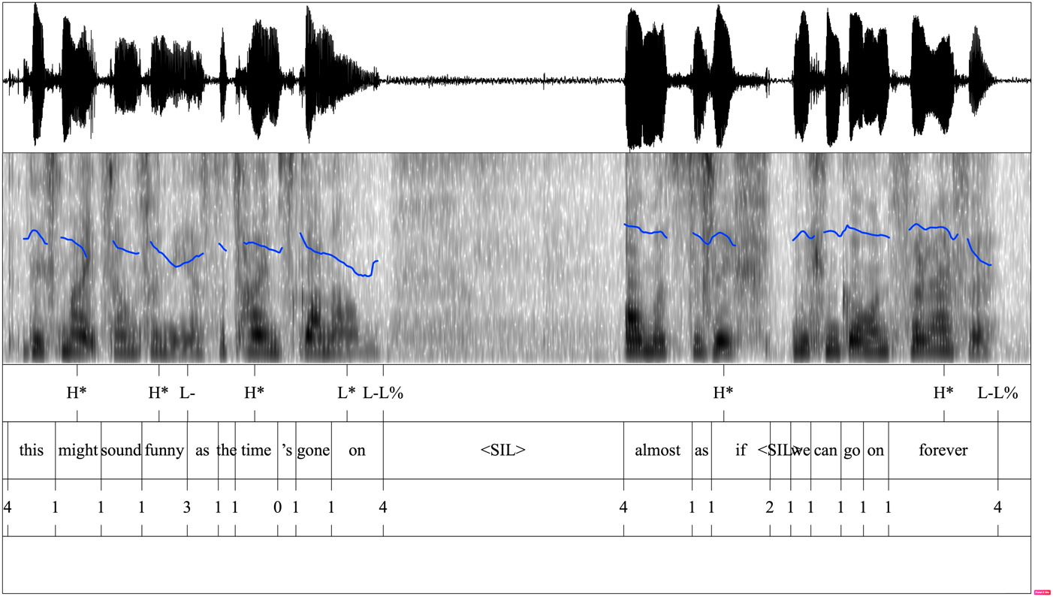
Figure 1. Example of a ToBI transcription, including the visualisation of the pitch curve (in blue)

In addition to IU boundaries, ToBI, but not ToDI, also distinguishes ‘minor’ intonational phrase boundaries within the IU, so-called ‘intermediate phrase (ip) boundaries’ (Veilleux et al. 2006: Chapter 8). They are recognised, acoustically and perceptually, by ‘minor’ pitch movements, or ‘phrase tones’, which mark disjunctures in the pitch movement smaller than the IU boundaries but greater than ordinary word boundaries. In the ToBI model, ip boundaries are annotated by a BI of 3 (for instance, between funny and as in Figure 1). However, since ToDI, unlike ToBI, annotates only IU boundaries, and not ip boundaries, the coding scheme will only consider the first, not the second, for reasons of comparability.
Second, even if a subordinate clause and its matrix are uttered on separate IUs, they can be uttered on the same declination line – i.e., the gradual lowering of the pitch over consecutive IUs to a final low on the final IU – as the previous IU(s), signalling that they cohere as two parts of one message (Tench 2011: 182). In such cases, the consecutive IUs may form what is called a ‘paratone’, i.e., a phonological paragraph, which “tend to be shorter than [written] paragraphs and may often be more equivalent to extended sentences” (Tench 2011: 182). This factor is operationalised by quantifying the difference in pitch between the onset of the (first) IU of the HM clause and the end of the previous IU, whereby positive values indicate that the pitch level of the onset of the HM clause is higher than the pitch level at the end of the previous IU; negative values signal that the pitch level of the HM clause’s onset is lower. These measures are taken using Praat (based on fundamental frequency in Hz), which are then converted to semitones. Results from experimental studies suggest that a difference of 1.5 semitones is sufficient to create an impression of a difference in pitch (Rietveld and Gussenhoven 1985: 304), while a difference of at least 3 semitones can be reliably considered to play a meaningful role in communication (’t Hart 1981). To illustrate this, in Figure 1 the pitch at the onset of the HM clause (almost as if we can go on forever) is 271 Hz, while pitch at the end of the previous IU (i.e. of the matrix this might sound funny as the time’s gone on) is (182 Hz). This difference of 89 Hz corresponds to a difference of 6.89 semitones. The positive value indicates that the pitch is higher at the start of the HM clause than at the end of the previous IU. Additionally, the difference is bigger than 3 semitones and, hence, counts as a clearly noticeable step-up in pitch.
Third, not just prosodic boundary placement but also pausing has been proposed as a factor contributing to the assumed ‘comma intonation’ by which a weakly dependent or independent clause is marked off from the previous clause (Smessaert et al. 2005: 498). Pauses typically, but not necessarily, occur after IU boundaries (as is the case in Figures 1 and 2), so that the presence of a pause, to some extent, intersects with the prosodic boundary placement. However, what we are interested in here is not just the presence of a pause, but more importantly the length of the pause. Hence, we calculated, in Praat, the time interval, if any, between the HM clause and the main/previous clause (in milliseconds). In Figure 1, for instance, the interval between the matrix and the HM clause is 1,444 ms. Generally, the weaker the link between the HM clause and the preceding clause, the longer the average time interval between them will be: that is, pauses are more likely to occur before free-standing clauses, and we can assume that they will also, in such cases, tend to be longer than before a dependent clause.
The last prosodic factor we are interested in is the pitch contour with which the HM clause is uttered, more specifically the ‘tone’ or direction of the pitch contour. This was operationalised by looking at the combination of the final pitch accent in the IU and the boundary (and phrasal) tone. From this combination the direction of the pitch contour can be interpreted into the following tonal categories for each language: fall, rise, fall-rise, rise-fall, and level for English, and fall, delayed, rise, fall-rise, and level for Dutch. For instance, in Figure 1, the HM clause ends in H*L-L% (i.e., a high pitch accent, followed by a low phrasal and boundary tone), or in other words in a fall. By contrast, in Figure 2, the HM clause alsof ze hierop hadden gewacht (‘as if they had been waiting for this’) ends in L*H H%, which realises a rising tone (as shown by the rising pitch curve).

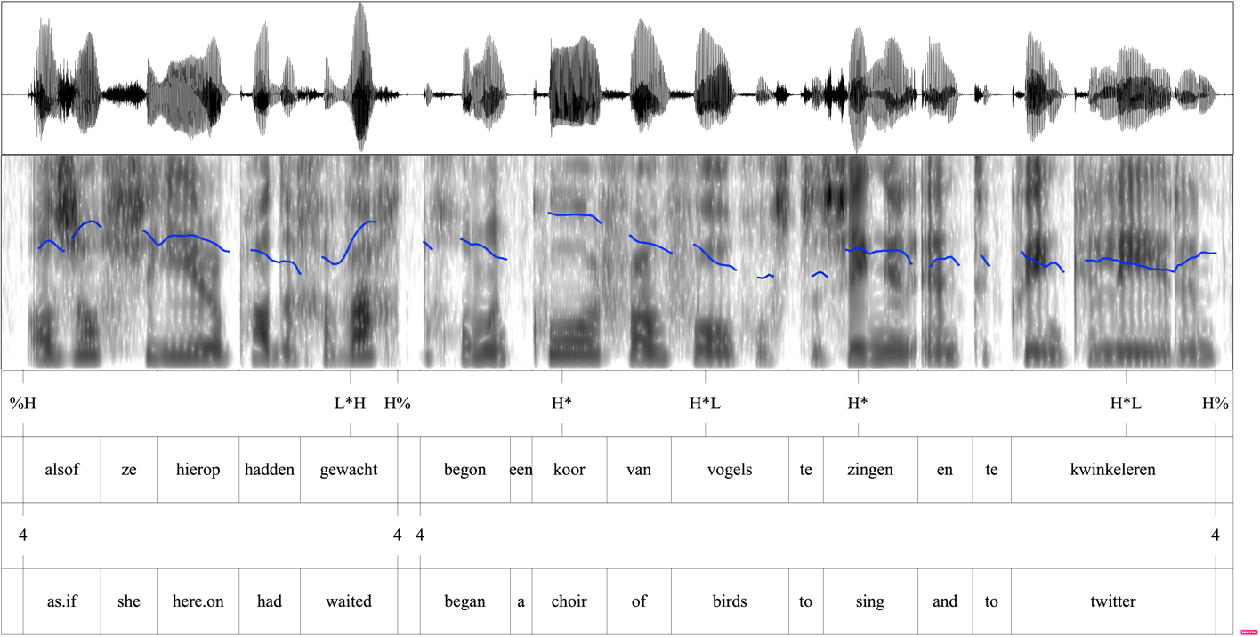
Figure 2. ToDI transcription, with a visualisation of the pitch curve (in blue)

Tones can have various functions, including the difference between the “equal” vs. “unequal” status of two conjuncts (Halliday and Matthiessen 2004: 373–374), the “meaning-function” (cf. pragmatic function) of a clause (e.g. Gras and Elvira-García 2021: 244), or attitudinal meanings (Halliday 1967: 40–47; Collins and Mees 2003: 247). The analysis of tone allows us to examine whether these predictions – that is, that tone is used to reflect the difference in status between independent and subordinate clauses (Halliday 1967), or more specific ‘local’ meanings associated with a construction (such as contradiction, irony, which would appear to resonate with the function of ‘denial of assumption’) – are borne out for the data in this study of English and Dutch HM clauses.

Results

This section outlines the results from the grammatical and semantic-pragmatic analyses, as well as the prosodic analyses of HM clauses, in English and Dutch. First, we briefly describe the distribution of the data according to the syntactic and semantic-pragmatic parameters, and interactions between them, in Section 3.1. Then, we examine if the prosodic realisations of the HM clauses interact with those parameters in Section 3.2.

The interaction between syntactic dependency and semantic-pragmatic function

In our datasets, strong correlations are found between syntactic (in)dependence and semantic-pragmatic function, both for English (χ²(6, N=156)=116, p < 0.001; Cramer’s V: 0.61) and for Dutch (χ²(6, N=247)=154.07, p < 0.001; Cramer’s V: 0.558) (cf. Table 4, Figure 3). The standardized residuals indicate that the effect is mostly due, in both English and Dutch, to the concentration of ‘denial of assumption’ in syntactically independent clauses (r=4.37 and r=5.88 respectively) as well as to high frequency of ‘(hypothetical) manner’ with weakly dependent clauses (r=6.42 and r=6.14 respectively). Still, while the data are overall similarly distributed in English and Dutch, some notable divergences between the two languages can be observed.

Table 4. Frequency of semantic functions per syntactic dependency status for English and Dutch
English
 |  | Strong |  |  | Weak |  |  | Independent
 | Manner | 7 | (13%) |  | 39 |  | (93%) | 8 |  | (14%)
 | Qualification | 27 | (48%) |  | 3 |  | (7%) | 17 |  | (29%)
 | Cause | 22 | (39%) |  | 0 |  |  | 15 |  | (26%)
 | Denial | 0 |  |  | 0 |  |  | 18 |  | (31%)
 | Total | 56 (100%) |  |  | 42 (100%) |  |  | 58 (100%)
Dutch
 |  | Strong |  |  | Weak |  |  | Independent
 | Manner | 44 | (49%) |  | 35 |  | (92%) | 5 |  | (4%)
 | Qualification | 29 | (32%) |  | 2 |  | (5%) | 34 |  | (29%)
 | Cause | 17 | (19%) |  | 1 |  | (3%) | 18 |  | (15%)
 | Denial | 0 |  |  | 0 |  |  | 62 |  | (52%)
 | Total | 90 (100%) |  |  | 38 (100%) |  |  | 119 (100%)

Dutch (n=247)

English (n=156)

Figure 3. The distribution of functional types across the levels of syntactic dependence

In both languages, strongly dependent clauses often give a (counterfactual) ‘qualification’, e.g., (14), or conjecture on the potential ‘cause’ for a proposition, e.g., (15).

- Het is net alsof je een Microsoftcursus krijgt van Steve Jobs. (CGN)
It is just as.if you a Microsof.course get from Steve Jobs.
‘It’s just as if you’re getting a Microsoft course from Steve Jobs.’
- It sounds as if they’re in the back garden or something. (BNC)

Where the two languages differ is in the frequency of expressions of ‘manner’ in strongly dependent clauses. In Dutch, ‘manner’ occurs in 49% of the strongly dependent clauses, e.g., (16); whereas in English, it only accounts for 13%, e.g., (17). (Indeed, the standardized residuals for the chi-square tests suggest that ‘manner’ occurs less frequently than expected in strongly dependent clauses in English (r=-2.81), but more frequently than expected in Dutch (r=2.42).) This is due specifically to the Dutch collocation doen alsof (literally ‘do as if’) being remarkably frequent, which is not the case for its English counterpart act as if.

- Nou doet ie weer net alsof ie alsof ie alles kan. (CGN)
Now does he again just as.if he as.if he everything can
‘Now, he’s acting again just as if he as if he can do everything.’
- We act as if we belong to Jesus Christ. (BNC)

In both languages, weakly dependent clauses almost exclusively express ‘manner’, e.g., (18).

- Spreken mensen u nog aan alsof u de burgemeester bent, meneer
Speak people you still to as.if you the mayor are, mister
Michel? (CGN)
Michel?
‘Do people still address you as if you’re the mayor, mister Michel?’

Syntactically independent clauses, finally, are functionally diverse, both in English and in Dutch. Still, the two languages differ on two counts. First, syntactically independent clauses are much more frequent in Dutch (119 attestations, or 48%) than in English (58 attestations, or 37%). Second, in English there seems to be no one function that stands out quantitatively. In Dutch, however, ‘denial of assumption’ is, with 62 attestations (or 52%), the main function found with syntactically independent clauses, followed by ‘qualification’ (34 attestations, or 29%). Moreover, while all four of the functional types are attested at the level of syntactic independence (in both languages), they do differ in terms of discursive (in)dependence. Syntactically non-integrated clauses expressing ‘manner’ all take the form of ‘post-modifying’ constructions. These function as a sort of increment, “continu[ing] on an assertion that was seemingly ‘complete’ already” (D’Hertefelt 2018: 172), e.g., (19). Often, they provide a reformulation of a manner argument or manner adjunct in the prior clause, e.g. normal in (19).

- Just behave normal. As if you don’t know it’s there. (BNC)

Independent clauses expressing qualification, e.g. (20), or a cause, e.g. (21), take the form of a dependency shift: here, the HM clauses does not reformulate an element of the prior clause but, instead, it comments on what the situation in the prior clause seems like, or what the possible cause of that situation is.

- It was the type of house you looked into it and you expected to see cobwebs you know, sort of fustiness. (Pause) As if a window had never been opened for years and years and years. (BNC)
- Iedere stap heeft nu een duidelijke echo. Alsof haar achtervolger het
Every step has now a clear echo. As.if her stalker it
niet langer nodig vindt om haar stiekem te volgen. (CGN)
no longer necessary finds to her secretly to follow.
‘Every step now has a clear echo. As if her stalker no longer finds it necessary to follow her secretly.’

Finally, the functional type of ‘denial of assumption’ is found exclusively at the level of syntactic independence, both in English and in Dutch. This function is expressed by ‘stand-alone’ insubordinate clauses, e.g., (22). That is, unlike the other syntactically independent clauses discussed here, these clauses are meaningful in isolation and, hence, do not depend on the surrounding discourse for their interpretation.

- Alsof mij dat wat uitmaakt. (CGN)
As.if me that something matters.
‘As if it matters to me.’

In summary, a strong correlation is observed between syntactic dependence and semantic-pragmatic function in both English and Dutch. While overall similar tendencies are found in the two languages, Dutch differs from English in two important ways. First, while in English ‘manner’ is found almost exclusively with weakly dependent clauses (i.e., optional adjuncts), Dutch has a considerably higher frequency of strongly dependent clauses expressing ‘manner’ (namely (obligatory) complements/arguments). Second, ‘denial of assumption’ is, in both languages, expressed solely through syntactically independent clauses, but the frequency of this function is much higher in Dutch than in English. We will come back to this last observation in Section 4.

Prosodic correlates

In this section, we turn to the prosodic realisations of the HM clauses and investigate if the four prosodic factors of interest – i.e., prosodic integration (Section 3.2.1), pitch excursion (Section 3.2.2), pausing (Section 3.2.3), and tone (Section 3.2.4) – correlate with the syntactic form and/or the semantic-pragmatic function of the clause.

Prosodic integration

The first prosodic factor is whether or not the HM clause is prosodically integrated with the main/previous clause: is the HM clause uttered with the main, or previous, clause as forming one IU? Following the ToBI and ToDI conventions for prosodic transcription of spoken English and Dutch, this boils down to the question whether or not the start of the HM clause coincides with an IU boundary.
Between syntactic dependency levels, we find considerable differences in prosodic integration of the HM clause with the previous clause in both English (χ²(2, N=156)= 98.824, p < 0.001; Cramer’s V: 0.796) and Dutch (χ²(2, N=247)=130.91, p < 0.001; Cramer’s V: 0.728) (see Figure 4). The standardized residuals show that the effect is due, in both languages, to the high frequency of prosodic integration with strongly dependent clauses (r=5.67 for English and r=6.63 for Dutch) vs. the high frequency of non-integration with independent ones (r=4.16 for English and r=4.66 for Dutch).

Figure 4. Prosodic integration vs. non-integration per syntactic dependency level

Across English and Dutch, there is a clear tendency for strongly dependent clauses to be uttered on the same IU as their main clause, while independent clauses are almost always uttered on a separate IU. In both languages, weakly dependent clauses (i.e., optional adjuncts) fall in between these two extremes, with the choice between prosodic integration vs. non-integration being more balanced. Functionally, this corresponds to what Verstraete (2007) calls the distinction between ‘bound’ vs. ‘free’ subordination. Bound subordinate clauses are prosodically integrated with their matrix and, hence, are presented as essential – discursively, not grammatically – to the message in the matrix, with which they form one single unit of information. Free subordinate clauses, by contrast, are uttered on a separate IU from their matrix, so that they are presented as forming a separate information unit (or series of units), adding extra information to the message in the matrix.
Still, English and Dutch differ in how pronounced these general tendencies are. In Dutch, for instance, the tendency for strongly dependent clauses to be prosodically integrated is weaker (77%) than in English (95%). Moreover, in weakly dependent clauses, the choice between integration and non-integration is more equally divided in Dutch (respectively 45% vs. 55%) than in English (respectively 33% vs. 67%). The likelihood of syntactically independent clauses being uttered on a separate IU, however, are roughly equal in English (97%) and Dutch (99%).
In a second instance, we want to know if the choice between the four semantic-pragmatic types has an influence on the choice for prosodic integration vs. non-integration (cf. Figure 5).

Figure 5. Prosodic integration vs. non-integration per semantic-pragmatic function

In both English (χ²(3, N=156)=20.722, p < 0.001; Cramer’s V: 0.364) and Dutch (χ²(3, N=247)=62.658, p < 0.001; Cramer’s V: 0.504), we do find associations between semantic-pragmatic function and prosodic integration. The standardized residuals indicate that the effect is mainly due to the fact that clauses expressing ‘denial of assumption’ are always uttered on a separate IU (r=2.51 for English and r=3.45 for Dutch). For Dutch, they also point to a particularly high frequency of prosodic integration with ‘manner’ clauses (r=4.30). In all other cases (i.e., for ‘qualification’ and ‘cause’ in English and Dutch, as well as for ‘manner’ in English), there appears to be no special preference for integration or non-integration. A likely explanation for these interlinguistic differences is that ‘manner’ clauses are more often strongly dependent in Dutch (52%) than in English (13%). In addition, clauses expressing ‘qualification’ or ‘cause’ are more often strongly dependent in English (i.e., 57% and 59% respectively) than in Dutch (i.e., 45% and 47% respectively).
The importance of syntactic dependency over semantic-pragmatic function is confirmed by a conditional inference tree (Hothorn et al. 2006) in which syntactic dependency, semantic-pragmatic function, as well as language (i.e., English vs. Dutch) are all included as possible predictor variables (cf. Figure 6).

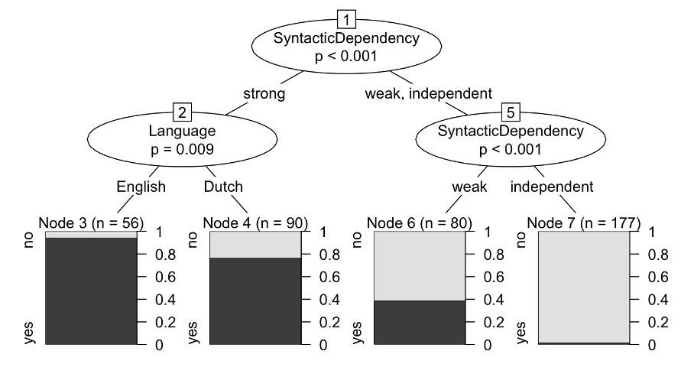
Figure 6. Conditional inference tree for prosodic integration (yes) vs. non-integration (no)

The model in Figure 6 allows us to draw a number of conclusions. Firstly, it suggests that semantic-pragmatic function plays no meaningful role in predicting the choice for prosodic integration vs. non-integration, which is attributable instead to syntactic dependence. Secondly, the model predicts that the primary distinction, when it comes to prosodic integration, is between strongly dependent clauses – which are most likely to be integrated with the previous clause – and the other dependency statuses. Only in a second instance do we see a further meaningful differentiation between the other two dependency statuses, due to independent clauses being almost exclusively uttered on a separate IU from the previous clause. Moreover, the model also points to a significant difference between English and Dutch when it comes to the integration of strongly dependent clauses (p=0.009): while both languages share a tendency for these clauses to be prosodically integrated, the tendency is much more pronounced in English than in Dutch. It is meaningful, however, that the difference between the two languages only comes in a second instance. This means that the conclusions drawn for syntactic dependence, and semantic-pragmatic function, generalise over English and Dutch.

Pitch onset level

In this section, we study the pitch level of the onset of the HM clause, more precisely how much it deviates from the pitch level with which the previous clause, when uttered on a separate IU by the same speaker, ends. This factor, measured in semitones, provides an indication of whether the HM clause follows the same pitch declination as the previous IU or, instead, starts with a pitch reset or downstep. This factor is relevant only for HM clauses that are not prosodically integrated with a matrix, that is, the ones that are uttered on a separate IU (n=87 for English and n=160 for Dutch), excluding the ones that initiate a new speaker turn (n=16 for English and n=10 for Dutch). Excluding also the examples for which Praat could not read the onset pitch level, we ended up with 69 examples for English and 143 for Dutch.
First, the mean pitch differences per syntactic dependency level are given, in semitones, in Table 5 for both English and Dutch.

Table 5. Average difference in pitch level in semitones between onset of HM clause and end of previous IU per syntactic dependency level
 | English (n=69) |  | Dutch (n=143)
Strong dependence | -2.07 | (sd=3.52, n=3) | -0.51 | (sd=2.73, n=21)
Weak dependence | 0.88 | (sd=3.13, n=27) | -0.18 | (sd=4.22, n=19)
Independence | 2.72 | (sd=5.56, n=39) | 3.53 | (sd=4.64, n=103)

The averages in Table 5 suggest that syntactic dependency has an influence on the pitch level of the onset of the HM clause, with independent clauses starting with a pitch reset, while strongly and weakly dependent clauses roughly follow the (declining) pitch of the previous IU. For English, however, a one-way ANOVA did not indicate that there are significant differences between the three syntactic dependency levels (F(2, 66)=2.289, p=0.109), which was confirmed by a Tukey post-hoc test. For Dutch, by contrast, the ANOVA did reveal significant variation across syntactic dependency levels (F(2, 140)=15.16, p < 0.001). A Tukey post-hoc test revealed that it is particularly syntactic independence that differs from the other two levels (i.e., p < 0.001 for strong dependence vs. independence and p = 0.002 for weak dependence vs. independence), while between strong and weak dependence no significant difference is found (p=0.60)).
Similarly, for the semantic-pragmatic function of the HM clauses, one-way ANOVAs suggested there was no significant variation for the English data (F(3, 65)=1.039, p=0.381), whereas the Dutch data did yield a significant result (F(3, 139)=5.417, p = 0.001) (Table 6).

Table 6. Average difference in pitch level in semitones between onset of HM clause and end of previous IU per semantic-pragmatic function
 | English (n=69) |  | Dutch (n=143)
Manner | 1.28 | (sd=3.62, n=29) | -0.10 | (sd=5.28, n=29)
Qualification | 0.92 | (sd=4.96, n=18) | 3.04 | (sd=4.58, n=42)
Cause | 2.73 | (sd=6.64, n=13) | 0.87 | (sd=3.39, n=23)
Denial of Assumption | 3.86 | (sd=4.65, n=9) | 3.75 | (sd=4.59, n=49)

As we can see in Table 6, there is a much higher pitch reset for the clauses expressing ‘denial of assumption’ than for the other functions in both English and Dutch. For the English data, the p-value for the ANOVA (p=0.381) indicates that it cannot be ruled out that the observed average pitch reset with ‘denial’ clauses is due to chance (given their low numbers, i.e., n=9). For Dutch, the results are more convincing: the significant results from the ANOVA are confirmed by a Tukey post-hoc test, which found that the relevant differences are between the functions of manner, on the one hand, and qualification (p=0.026) and denial of assumption (p=0.003), on the other hand. Other one-to-one differences between the functions were not significant.
A conditional inference tree certifies, however, that only syntactic dependency status, but not semantic-pragmatic function or language-specific differences, is a meaningful predictor of pitch reset (Figure 7).

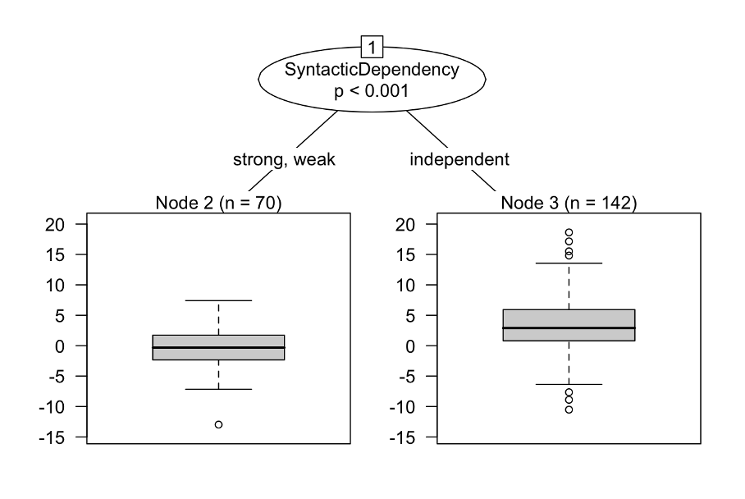
Figure 7. Conditional inference tree for the difference in pitch level (in semitones)

The absence of semantic-pragmatic function in the conditional inference tree suggests that its observed effect in Dutch (see Table 6) is probably due to its correlation with syntactic dependency status. The model further indicates that the meaningful difference for syntactic dependency is between independent vs. dependent clauses only. This is the case across the two languages studied, with no meaningful differences found between English and Dutch.

Pauses

The third factor of interest is the amount of time that passes between the beginning of the HM clause and the end of the previous clause (whether produced by the same or another speaker). In other words, is there a pause between the HM clause and the previous clause, and if so, what is the average length of the pause? For simplicity, we will henceforth use the shorthand ‘pre-onset pausing’ when discussing this factor.
As shown in Table 7, in both English and Dutch, average pre-onset pausing increases as the level of syntactic dependence decreases. One-way ANOVAs for each language revealed that the variation in the length of the pauses (in ms) is significant in both English (F(2, 153)=14.46, p < 0.001) and Dutch (F(2, 244)=47.08, p < 0.001). Tukey post-hoc tests indicate that it is particularly the syntactically independent clauses that differ significantly from the other two clause types, in both languages (with p < 0.001 in all cases). Between strongly and weakly dependent clauses, no significant difference was found, neither in English (p=0.96) nor in Dutch (p=0.44).

Table 7. Time interval (ms) between HM clause and previous clause per syntactic dependency level
 | English as if (n=156) | Dutch alsof (n=247)
Strong dependence | 49.45 (sd=219, n=56) | 18.42 (sd=80, n=90)
Weak dependence | 93.30 (sd=241, n=42) | 126.05 (sd=229, n=38)
Independence | 768.90 (sd=1,255, n=58) | 603.86 (sd=633, n=119)

Across the four functional types, we also find significant differences in pre-onset pausing. Two tendencies stand out in Table 8: on the one hand, clauses expressing ‘denial of assumption’ have a much longer pre-onset pause than other clauses; on the other hand, clauses expressing ‘manner’ tend to start almost immediately after the main/previous clause, leaving only a very small average pre-onset pause.

Table 8. Time interval (ms) between HM clause and previous clause per semantic-pragmatic function
 | English as if (n=156) | Dutch alsof (n=247)
Manner | 99.27 (sd=274, n=54) | 71.73 (sd=173, n=84)
Qualification | 239.80 (sd=496, n=47) | 316.30 (sd=513, n=65)
Cause | 498.18 (sd=1,313, n=37) | 263.43 (sd=430, n=36)
Denial of Assumption | 901.13 (sd=1,220, n=18) | 681.26 (sd=699, n=62)

But while ANOVAs suggested that the variation between the functions is significant in English (F (3, 152)=5.021, p=0.002) and Dutch (F (3, 243)=19.51, p < 0.001), the effect of semantic-pragmatic function was, again, not confirmed by the findings from the conditional inference tree (Figure 8).

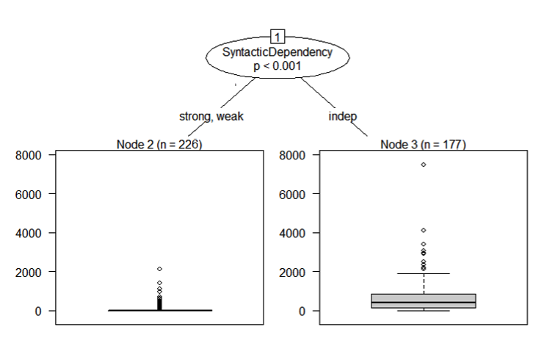
Figure 8. Conditional inference tree for average pause (in ms) before HM clauses

Instead, as for prosodic integration and for pitch reset, the only meaningful predictor of average pause length is syntactic dependency. The model confirms the significance of the distinction between independent clauses, on the one hand, and dependent clauses, on the other. Together with the findings in Section 3.2.2, this leads us to conclude that pitch onset level and pre-onset pausing point to a binary distinction between syntactically dependent vs. independent clauses, whereas prosodic integration (Section 3.2.1) pointed to syntactic dependency as a scalar category. We will come back to the implications of these findings in Section 4.

Pitch contour

Finally, while the previous three prosodic factors all provided some indication of the intonational separation (or absence thereof) of the HM clause vis-à-vis the preceding clause, the fourth factor – pitch contour – provides some measure of the status that the speaker assigns to the information in the IU. Tone (or pitch contour) being polyfunctional, this can be in terms of epistemic status (e.g., with falls signalling certainty vs. rises uncertainty) (e.g., Halliday 1967: 40–47), speaker attitude (e.g., English rise-falls signalling ‘challenges’ and ‘impressedness’, English and Dutch fall-rises ‘contrastiveness’ and ‘disagreement’, see for instance Collins and Mees 2003: 247), or discourse status (e.g., falls signal finality, rises non-finality, incompleteness, see for instance Halliday 1967 and Collins and Mees 2003).
When it comes to the tone with which the HM clause is uttered, we do indeed find some variation between the different levels of syntactic dependency (cf. Figure 9).

Figure 9. The choice of tone contour of the HM clause per syntactic dependency level

As can be seen in Figure 9, the results differ somewhat between English and Dutch. A distinction between four tones yielded a significant result for English (p=0.004, Fisher Exact Test) but not for Dutch (p=0.05, Fisher Exact Test), even if the p-value for the Dutch data was just above the threshold for significance. At a more general level, a binary contrast between falling and rising tones (i.e., (delayed) falls and/or rise-falls, on the one hand, and rises and fall-rises, on the other hand) did point to significant variation across syntactic levels in both languages. In English (χ²(2, N=156)=8.1324, p=0.01714; Cramer’s V: 0.228), the frequency of rising tones increases as the level of syntactic dependency decreases. The standardised residuals indicate that the strength of the difference between observed and expected values is small (as they do not go below -2 or beyond 2), and that the effect is due entirely to the sparseness of rises with strongly dependent clauses and to the relatively high frequency of rises with independent clauses. The latter is, in turn, due to the particular frequency of fall-rises, as shown in Figure 9. In Dutch (χ²(2, N=247)=10.884, p=0.004; Cramer’s V: 0.21), by contrast, the opposite happens: as clauses become syntactically more independent, their preference for falling tones becomes more pronounced. The standardised residuals specify that the effect is, again, due to the frequency of rises, which is higher than expected with strongly dependent clauses (r=2.06) vs. lower with independent clauses (r=2.06). Together, these findings suggest that, in Dutch, the frequency of rising tones is genuinely influenced by the syntactic dependency status of the clause; whereas, in English, the significant findings are likely due to the unexpectedly high frequency of fall-rises with independent clauses.
Across the four semantic-pragmatic functions, significant differences in the choice for falling vs. rising tones are found as well, both for English (p=0.023, Fisher Exact Test) and for Dutch (χ²(3, N=247)=12.383, p=0.006; Cramer’s V: 0.224) (cf. Figure 10). (The numbers for the four specific tones, across the semantic-pragmatic functions, were too small for a reliable statistical test.)

Figure 10. The choice of tone contour of the HM clause per semantic-pragmatic function

In English, the difference is entirely due to clauses expressing ‘denial of assumption’ being significantly more likely than the other functional types to be uttered with a final fall-rise (44%) (even though the small numbers for ‘denial of assumption’ caution against drawing firm conclusions). ‘Denial of assumption’ being exclusively expressed by independent (insubordinate) clauses, this explains why we saw a higher incidence of rising tones with syntactically independent clauses in English. These findings tentatively suggest that English insubordinate ‘denial’ clauses seem to attract a particular tonal contour, namely fall-rises. Their meaning potential of signalling ‘contradiction’ (Liberman and Sag 1974) and ‘doubt, correction, appeal to the listener to reconsider’ (Collins and Mees 2003: 257) aligns, indeed, with the function of ‘denial of assumption’, which, in addition to its meaning of refutation, has been associated with an ‘exclamative-evaluative’ function (Brinton 2014) and even ‘sarcasm’ (Bledin and Srinivas 2020: 86). In Dutch, by contrast, ‘denial of assumption’ does not have as clear a preference for a particular tonal contour, though we do see high frequencies of both falls (58%) and delayed falls (32%). The meaning associated with delayed falls has, to the best of our knowledge, not been described. Collins and Mees (2003: 278–279), however, describe two prosodic patterns for Dutch that can be found with both falls and delayed falls. First, (delayed) falls can combine with a so-called ‘climbing head’, in which each stressed syllable following the onset marks an upward step in pitch ‘climbing’ towards the nuclear accent: this pattern “is emotively marked, and may be associated with impatience, surprise, etc.” (Collins and Mees 2003: 279). Second, (delayed) falls can be realised as ‘sharp drops’ (i.e., from high immediately to low), which are associated with “exasperation, irritation, correction, impatience” (Collins and Mees 2003: 278). It could be that the function of ‘denial’ invites such expressions of impatience/irritation, though further research into the realisation of the falls with ‘denial’ is needed to confirm this.
To weigh the predictive value of syntactic dependency and semantic-pragmatic function in English and Dutch, we fed the two variables into two conditional inferences trees, one per language. This is because tonal choices signal different meanings in different languages, and while the tone contours may be similar in the two languages, they may function differently. The two models are given in Figure 11 for English and Figure 12 for Dutch.

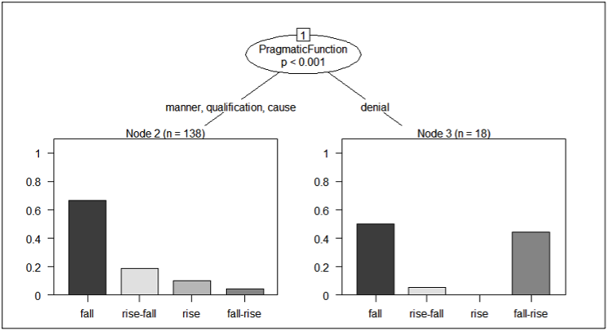
Figure 11. Conditional inference tree for tonal choices in English
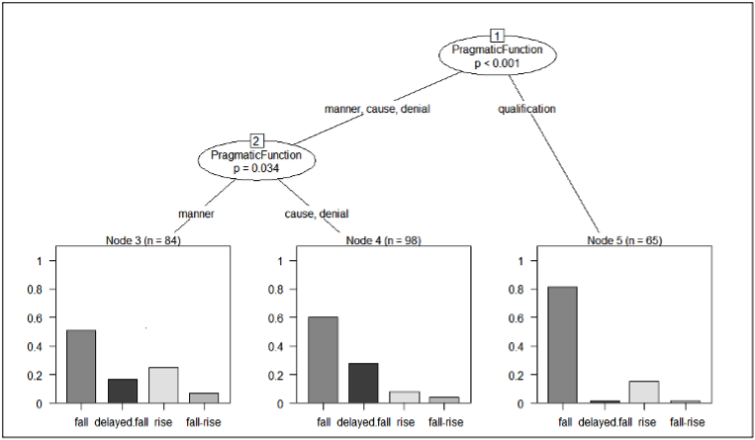
Figure 12. Conditional inference tree for tonal choices in Dutch

The models in Figure 11 and Figure 12 indicate that, for choice of tone, semantic-pragmatic function is the main predictor in both languages, weighing heavier than the effect of syntactic dependency, which does not figure in either model. For English, there is a neat distinction between denial and the other functions, due to the first using fall-rises significantly more frequently than the other functions. For Dutch, the picture is more complex. First, qualification stands out from the other functions for its strong preference for falls. Second, manner is separated from cause and denial based on minor but significant variations (p=0.034): with manner, rises are slightly more frequent, while delayed falls are more frequently used with denial (and cause). Between cause and denial, the differences – such as the more frequent use of delayed falls with denial – are not significant.
In consequence, the analysis of tonal choices yielded mixed results. While we found an effect, in both languages, for the interaction between syntactic dependency status and the choice between falling vs. rising tones, the evidence that syntactic status is a meaningful predictor of tonal choices was weak, at least in our data. Instead, semantic-pragmatic function yielded more compelling findings. In English, in particular, it appears that the function of ‘denial’ attracts fall-rises, even if the unmarked tonal choice, namely falls, was used slightly more frequently. The other semantic-pragmatic functions in English all favour falls. In Dutch, all functions have a general preference for falls as well. The variations we did find were minor (e.g., slightly higher frequency of rises with ‘manner’, and a weak attraction of ‘denial’ to delayed falls). All in all, the findings indicate that, in all likelihood, tonal choices are the product of a complex interplay of various factors, of which semantic-pragmatic function is only one. The results were most convincing for the function of ‘denial’, the meaning of which seems to accord, more or less, with the meaning(s) expressed by a particular tonal contour in each language, namely fall-rises in English and delayed falls in Dutch.

To sum up the findings from Section 3, we found a strong influence of syntactic dependency status on prosodic integration, the pitch level of the onset of the HM clause, and the average pre-onset pausing. While the first factor distinguished primarily between strong dependence and the other levels, the second and third factor were affected mainly by the difference between independent and dependent clauses. Finally, given the correlations between syntactic dependency and semantic-pragmatic function, the effects found for semantic-pragmatic function were largely attributable to the syntactic pattern through which they were expressed. The only exception was the tone choices, with ‘denial of assumption’ having a special preference for fall-rises in English and, to a lesser degree, for delayed falls in Dutch. The implications of these results will be discussed in Section 4.

Discussion

In this section, we argue that the results from the prosodic analyses of HM clauses in English and Dutch demonstrate that, in the two languages, prosody serves as a cue for the dependency status of these clauses. The findings show that prosodic integration, more specifically IU segmentation, correlates with a multilevel classification of syntactic dependency, thus standing out as the main prosodic predictor of a dependency cline. While pitch reset and pre-onset pausing also correlated with syntactic dependency, these factors only differentiated between dependent vs. independent clauses, thus highlighting this distinction as the most meaningful one on the dependency cline. Finally, in line with previous findings (e.g., Elvira-García et al. 2017), we found that tonal choices can provide cues for distinguishing ‘stand-alone’ insubordinate clauses from other (semi-)independent clauses.
First, in both English and Dutch, prosodic integration stands out as a clear index of the syntactic integration of the HM clause in the main clause. It is the sole factor that testifies to a cline of syntactic dependency, distinguishing not just between dependent and independent clauses but also between strongly and weakly dependent ones. The findings suggest that, at the opposite ends of the cline, the syntactic status of strongly dependent clauses and of independent ones both entail a particular information status. That is, the grammatical function of strongly dependent clauses is such that it makes the information in the clause essential to the message conveyed in the matrix. This is coded prosodically by the integration of the HM clause in the same IU as the matrix. By contrast, since independent clauses serve no grammatical function in another clause, they also do not contribute essential information to that clause. This is reflected in their forming a separate IU, indicating that they constitute a distinct unit of information. The fact that weakly dependent clauses allow for a freer choice between prosodic integration vs. non-integration signals that their information status is ambivalent. This corroborates Verstraete’s (2007) point that the meaning potential of these clauses includes two forms of subordination, namely ‘bound’ and ‘free’ subordination. This distinction coincides, Verstraete (2007) argues, with the choice between prosodic integration vs. non-integration respectively. The prosodic integration of bound subordinate clauses with their matrix signals that they fall within the scope of the interpersonal elements of the main clause. That is, despite being grammatically optional, the speaker signals that the adverbial clause is essential for the validity of the proposition in the matrix, and it can even serve as the information focus of that proposition (Verstraete 2007: Chapter 3). For instance, in (23), the speaker does not just mean to say that ‘you just fucking carry on’ but more importantly that this is done ‘as if nothing had happened’.

- you just fucking carry on as if nothing had happened# (BNC)

With free subordination, by contrast, the proposition in the matrix is truth-valued regardless of the information in the adverbial clause, e.g., (24). From a discursive viewpoint, the HM clause enhances the message in the main clause, adding noteworthy but supplementary detail.

- you make commitments for next year# as if money had gonna be no object# (BNC)

However, evidence from our data suggests that, contra Verstraete (2007), the distinction between bound and free subordination cannot be made to rest solely and entirely on prosodic integration. This is demonstrated by the example in (25).

- Ge moet het ook niet zien# alsof dat gij# alleen die wijn moet gaan
You must it also not see# as.if that you# alone that wine must go
produceren# voor uzelf alleen he# (CGN)
produce# for yourself alone hey#
‘You also shouldn’t look at it as if you alone will have to produce that wine only for yourself, you know’

Here, the HM clause and its matrix are segmented into separate (series of) IUs. The scope of the negation in the matrix, however, indicates that the HM clause nonetheless provides information that is judged to be essential for the validity of the assertion: the speaker does not mean to say that the hearer ‘shouldn’t look at it’ but rather that they shouldn’t look at it in the manner described in the HM clause. While syntactic dependency is an important factor, IU segmentation may also be motivated by other factors, for instance production phenomena or rhetorical effect. This also explains why some non-typical prosodic behaviour is found with strongly dependent clauses, as well as independent ones. For instance, in (26), the strongly dependent HM clause is uttered on two separate IUs, each of which contributes information essential to the assertion being made. The choice to place the subordinate clause in a separate (series of) IUs allows the speaker to bring into focus that what is expressed in the HM clause is merely appearance (lijkt, ‘seems’), not fact.

- Dan lijkt het# alsof er die openheid# - nie mag zijn# (CGN)
Then seems it# as.if there that openness# - not can be#
‘It seems then as if there can’t be that openness.’

Therefore, while IU segmentation correlates with syntactic dependency, prosodic integration does not code syntactic integration. Instead, syntactic dependency influences the likelihood of prosodic integration of a dependent clause with its matrix, but it is ultimately the speaker who decides how to segment an utterance into IUs. This is based on their assessment of the communicative import of the information in the utterance to the development of the discourse. The information status of the dependent clause vis-à-vis its matrix (i.e., contributing essential vs. non-essential information) may set preferences for prosodic integration or non-integration, but these can be overridden for special purposes, such as the speaker’s wish to highlight not one but multiple pieces of information in the sentence (e.g. lijkt ‘seems’, openheid ‘openness’, and mag ‘can’ in [26]). However, this override only works in one direction, illustrated in (25) and (26); information deemed non-essential to the speech act realized by the main clause is never conveyed in prosodically integrated clauses.
Second, the findings for pitch onset level and pre-onset pausing show, we argue, that the most salient distinction on the cline of syntactic dependency is that between syntactically independent and dependent clauses, which show distinct discursive profiles. Evidence from the data indicates that independent clauses are typically uttered with a pitch reset at the start of the clause. As is well-known, pitch resets are used to signal topic-shifts, or ‘fresh starts’ – which is attested in a range of languages, including English and Dutch (see, for instance, Sluijter and Terken 1993; Wichmann 2000: 105; O’Grady 2017: 201–202) – whereas mid-register pitch is interpreted as “the addition of information within a pre-established frame” (O’Grady 2017: 202). Therefore, the reset with which syntactically independent clauses begin can be seen as initiating a new discourse segment, marking a departure from what was said before. This is visualised in the ToDI transcription in Figure 13, which gives the pitch curve in the spectrogram below, and a visualisation of the intensity (loudness) in the oscillogram on top, of the syntactically independent clause in (27).

- Laat maar zitten# alsof ik zoveel vrije tijd heb# (CGN)
Let but sit# as.if I so.much free time have#
‘Never mind. As if I’ve got so much spare time.’
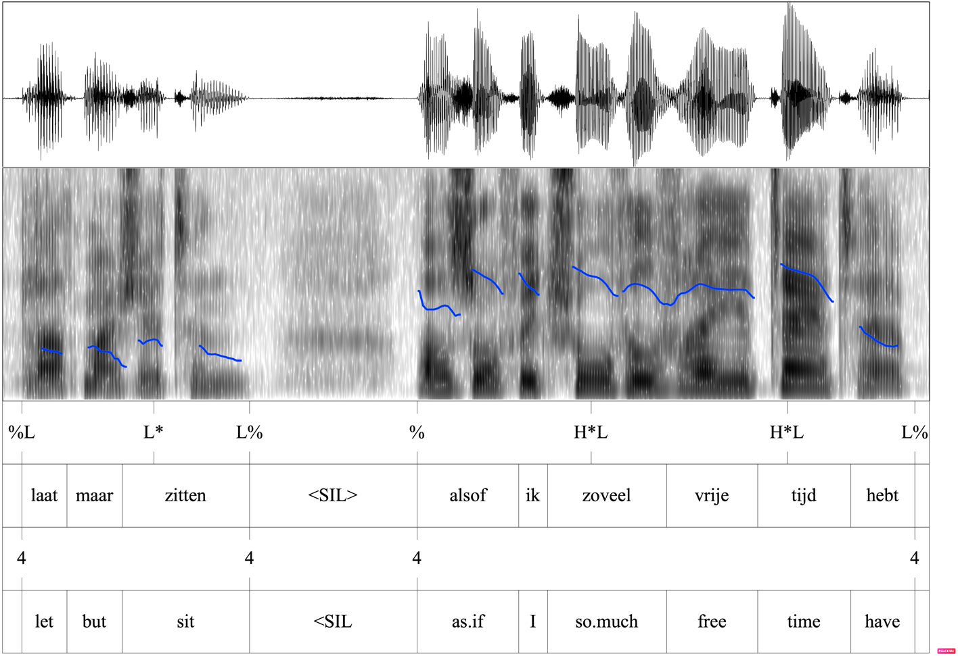
Figure 13. ToDI transcription, with the pitch curve (in blue), for example (27)

The shift in the discourse development at the start of independent clauses can be contrasted not just with strongly dependent clauses but also with weakly dependent clauses. The fact that the pitch level at the onset of syntactically dependent clauses hooks up with the pitch level of the previous IU is indicative of the discourse dependence of these clauses on their matrix. Rather than marking a ‘fresh start’, dependent clauses elaborate on the information in the matrix, on which they are not only syntactically but also discursively dependent. The optional adjunct clause in (28) illustrates this, with the onset of the clause being uttered on approximately the same pitch level as the end of the previous IU, as can be seen from the pitch curve (in blue) in the spectrogram in Figure 14.

- Ulla Werbrouck en Gella Vandecaveye# vloekten, stampten en huilden#
Ulla Werbrouck and Gella Vandecaveye# cursed, stomped and cried#
alsof Elvis Presley# een tweede keer gestorven was# (CGN)
as.if Elvis Presley# a second time died was#
‘Ulla Werbrouck and Gella Vandecaveye were cursing, stomping, and crying, as if Elvis Presley had died a second time.’

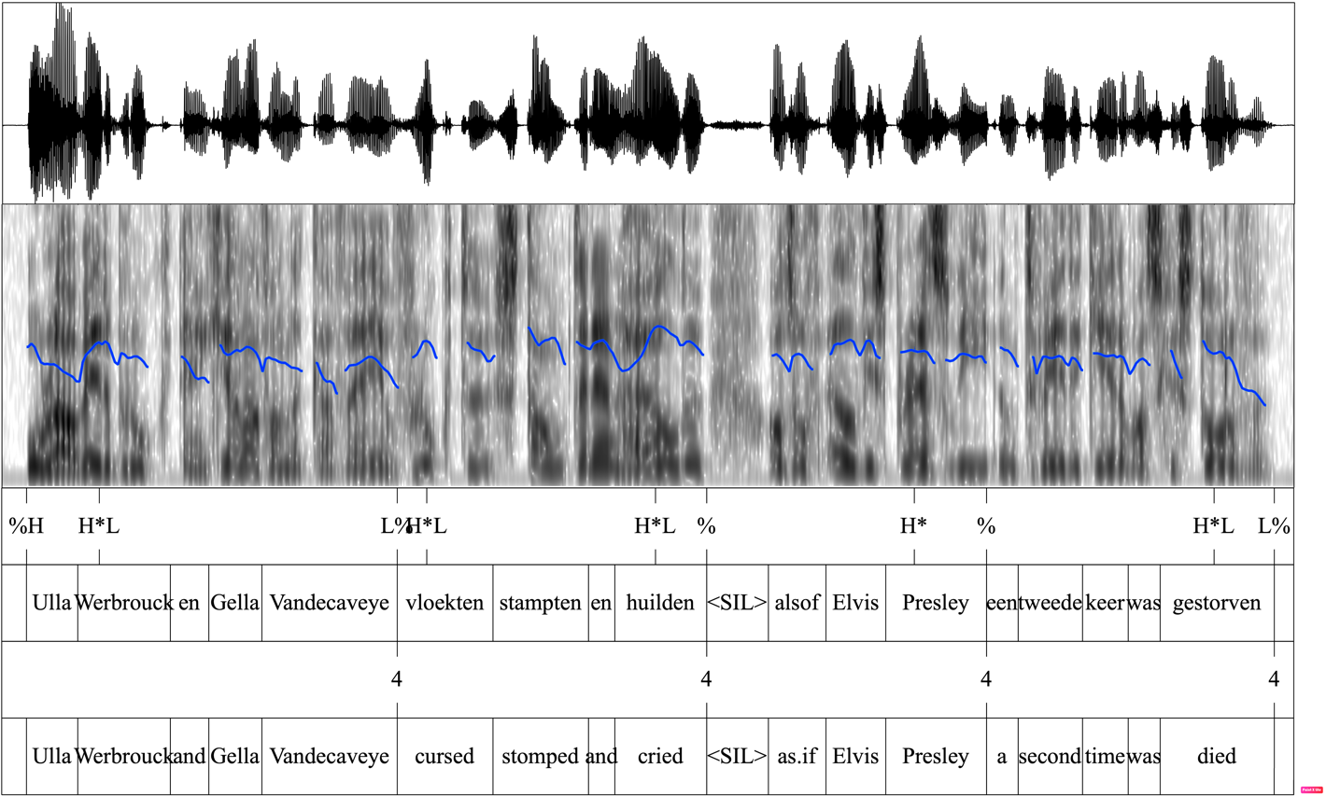
Figure 14. ToDI transcription, with the pitch curve (in blue), for example (28)

Interestingly, the evidence from both pitch reset and pausing suggests there is little variation between semantic-pragmatic functions when syntactic dependency status is controlled for. This goes against our expectation that, among the category of syntactically independent clauses, prosodic realisation would point to a finer distinction between ‘stand-alone’ insubordination and other (semi-)independent clauses, variously described as ‘dependency shifts’ (Günthner 1999; Verstraete 2007; D’Hertefelt 2018), ‘elaborative insubordination’ (Kaltenböck 2016), ‘pragmatically dependent insubordination’ (Gras and Sansiñena 2017). Unlike ‘stand-alone’ insubordination (or insubordination proper), cases of dependency shift, or elaborative insubordination, are always discursively dependent on the previous clause, or the previous context. This is illustrated by the dependency shift expressing ‘cause’ in Figure 15: the HM clause in (29) is not syntactically integrated with the previous clause, but it does give a discursive elaboration on the information that the speaker ‘feels something in their stomach’ by speculating on the potential cause for this.

- Ik voel het vooral in mijn buik# Alsof het een beetje verteert. (CGN)
I feel it mostly in my stomach# As.if it a bit digests.
‘I feel it mostly in my stomach. As if it’s digesting a bit.’

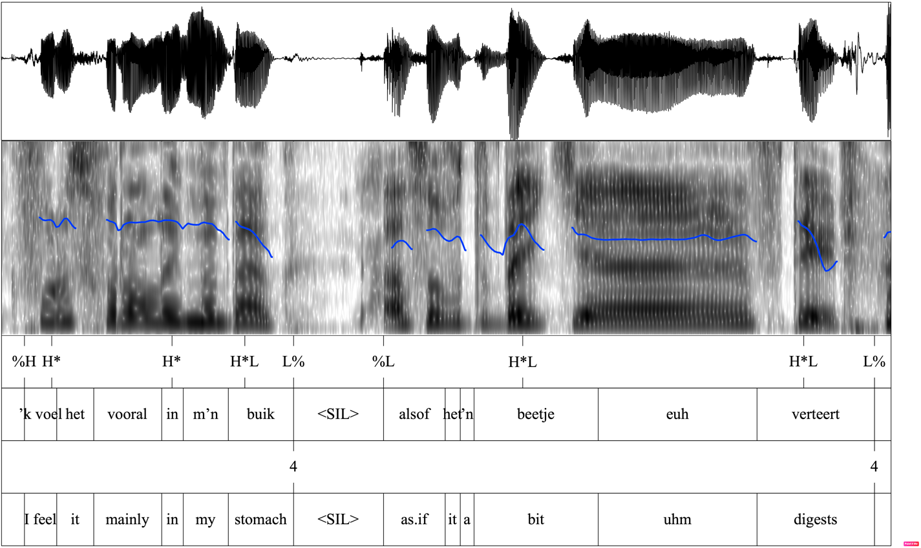
Figure 15. ToDI transcription, with the pitch curve (in blue), for example (29)

Whereas dependency shifts can be seen as a kind of increment – i.e. “a nonmain-clause continuation of a speaker’s turn after the speaker has come to what could have been a completion point” (Ford et al. 2002: 16) – ‘stand-alone’ insubordinate HM clauses are discursively independent of the previous discourse segment. That is, they do not take up the information in the previous discourse segment to expand on it but, instead, initiate a new segment, typically in reaction to the previous discourse, e.g. (30).

- Spreker 1. uhm oeh wat een vies wijntje, oh wat heb ik nou weer
Speaker 1. uhm oeh what a dirty wine, oh what have I now again
gekocht? Oh, dat ga ‘k nooit meer kopen. Oh bah, ‘t lijkt wel
bought? Oh, that go I never more buy. Oh ehw, it looks well
motorolie.
motor.oil.
‘uhm urgh what a dirty wine, oh what did I buy now? Oh, I’m never gonna buy that again. Urgh, it seems almost motor oil.’
Spreker B. <gelach> Alsof je dat wel eens ophebt. (CGN)
Speaker B. <laughter> As.if you that well once on.have
‘As if you’d ever have that.’

The fact, then, that pitch onset level and pre-onset pausing do not point to major differences between these two types of syntactically independent clauses suggests that the two are judged, by speakers, to be fairly similar when it comes to their contribution to the development of the communication. That is, while dependency shifts and stand-alone insubordination interact differently with the previous text, both push the discourse forward in an unpredictable way. Therefore, from a communicative viewpoint, both clause types are realised as autonomous units making their own contribution to the development of the communication. This could be seen as an argument to treat dependency shifts as a form of insubordination, be it an ‘elaborative’ or ‘discursively dependent’ one.
Finally, tone, or pitch contour, did provide some (tentative) evidence for a distinction between stand-alone insubordination and dependency shifts. In both English and Dutch, stand-alone insubordinate HM clauses – i.e., the ones expressing ‘denial of assumption’ – seemed to attract a particular tone, namely fall-rises in English and delayed falls in Dutch. This is linked to the ‘expressive’ function of insubordinate HM clauses, also described as ‘emotive’ (Looij and Minnaert 2019, for Dutch) or ‘exclamative’ (Brinton 2014, for English). Looij and Minnaert (2019: 362), for instance, suggest that Dutch insubordinate alsof-constructions like (30) are used to signal either amusement or frustration vis-à-vis the negated assumption. For English, Brinton (2014: 91, 96) lists meanings like ‘disbelief’, ‘derision’, and ‘irony’. The fact that, in neither language, the insubordinate construction takes one fixed intonation contour is in line with the findings by Gras and Elvira-García (2021: 244), for Spanish, that it is not the grammatical pattern itself that triggers the use of a particular contour, but the semantic-pragmatic function (i.e., the meaning-in-context of the clause). In other words, the insubordinate ‘denial’ construction does not have a fixed intonation contour but, instead, invites meanings that are conventionally expressed by certain tones (e.g., the fall-rise expressing contradiction or an ‘appeal to reconsider’ in English). The other functions – manner, qualification, and cause – did not invite a special tone contour and were typically uttered with a fall, which is the unmarked tonal choice in both English and Dutch. Only with ‘manner’ – specifically in Dutch – did we find a somewhat higher occurrence of rises.
In sum, in this section, we have tried to show that while prosodic integration reflects a cline of syntactic dependency, prosodic factors like pitch onset level and pre-onset pausing point to a binary contrast between syntactically dependent vs. independent clauses. Moreover, when syntactic dependency was controlled for, semantic-pragmatic function did not appear to influence prosodic realisation in any major way. One exception was the tone contour with which the HM clause was uttered, with insubordinate clauses, expressing denial of assumption, attracting a particular contour both in English and in Dutch. This was linked to the ‘expressive’ function of stand-alone insubordinate clauses, in contrast with ‘elaborative’ clauses, or dependency shifts, where no special preferences for a tone contour were observed. Other than this, no major prosodic differences were found between insubordinate clauses and dependency shifts.

Conclusion

This paper examined the prosodic realisation of hypothetical manner clauses in English and Dutch. Starting from the observation that these clauses are polyfunctional – viz. they can enter into different dependency relations and can assume different functions – this study wanted to investigate if the syntactic dependency status and/or the semantic-pragmatic function of these clauses is reflected in the way they are uttered in spoken English and Dutch. To this end, four prosodic factors were analysed: (i) the prosodic integration of the HM clause in the same intonation unit as the main/previous clause, (ii) the average difference in pitch level between the onset of the HM clause, if uttered on a separate IU, and the end of the previous IU, (iii) the average time interval between the start of the HM clause and what precedes it (i.e., the rest of the matrix or a previous clause), and (iv) the pitch contour of the HM clause.
The study found that syntactic dependency status was the best overall predictor of prosodic integration, average onset pitch, and pausing. Prosodic integration interacts with syntactic dependency, in that strongly dependent clauses tend to be grouped together, almost exclusively, with their matrix in one IU. They contrast as such with both syntactically independent clauses – which are almost always uttered in a separate IU – and weakly dependent clauses – which allow for a meaningful choice between integration vs. non-integration. With respect to the latter, we nuanced Verstraete’s (2007) generalization that the difference between integration vs. non-integration coincides with the difference between bound and free subordination. Specifically, we found that this generalization can be overridden in one direction: information deemed essential to the speech act realized by the main clause may sometimes be conveyed in prosodically non-integrated clauses for special communicative purposes. Onset pitch and pausing, in turn, interacted with syntactic dependency in a different way, pointing only to a difference between dependent vs. independent clauses. Pitch resets – i.e., step-ups in pitch level at the start of an IU – typically mark the start of a new ‘paratone’ (e.g. Wichmann 2000; Tench 2011: 182), signalling a shift, in the discourse, to a new topic or subtopic. As Tench (2011) suggests, paratones can be interpreted as grouping together different IUs as forming one “extended sentence” (Tench 2011: 182). The fact that resets are more likely to occur at the start of syntactically independent clauses, therefore, suggests that they typically initiate a new development in the discourse, setting them apart from the previous clause(s). This point was further demonstrated by the increased likelihood of pausing before independent clauses.
Contrary to our expectations, few differences were found between the four semantic-pragmatic functions when syntactic dependency was controlled for. The fact that, among syntactically independent clauses, no major differences were found between the functions suggests that dependency shifts and (stand-alone) insubordinate clauses are typically presented as contributing to the discourse development in similar ways, despite their differences in discursive (in)dependence. That is, while dependency shifts elaborate on the prior discourse and insubordinate clauses react to it, both are presented as new developments in the discourse after a point of completion was reached at the end of the previous clause. One factor where the distinction between dependency shifts and insubordinate clauses did play a significant role was choice of tone. Unlike dependency shifts (or other HM clauses), insubordinate clauses, expressing denial of assumption, were found to invite a particular pitch contour, namely fall-rises in English and, to a lesser extent, delayed falls in Dutch. Following Gras and Elvira-García (2021), we attributed this to the correspondence between the meaning potential of these pitch contours and the (attitudinal) meanings associated with the insubordinate ‘denial’ construction.
In relation to the contrastive nature of this study, little variation was found between English and Dutch in the general prosodic patterns correlating with syntactic/discursive (in)dependence. This can point either to the close correspondence between English and Dutch or to the possibility that prosodic factors like integration, pitch resets and pausing serve similar functions across closely related languages.
Finally, from a more general, methodological perspective, this study showed that prosody is a multi-faceted phenomenon that requires a comprehensive approach. As detailed above, we investigated four different prosodic factors, and they each led to distinct observations and conclusions. Specifically, prosody was showcased as involving several ‘formal’ aspects of linguistic units that serve to co-signal two types of ‘meaning-bearing’ aspect, namely syntagmatic relations between clauses on the one hand – through the factors of prosodic integration, pitch reset and pre-onset pausing – and semantic-pragmatic function of hypothetical manner clauses on the other, through the factor of tone. We hope that our methodology will prove fruitful to the study of other phenomena as well.

Data repository
The dataset underlying this article can be found on the ULiège Dataverse, the institutional FAIR data repository of the University of Liège: https://doi.org/10.58119/ULG/3VC5EX.

Acknowledgements
The research reported on in this article was made possible by the research grant ‘How do grammar and discourse interact? Answers from subordination, coordination and insubordination’ (PDR T.0065.20) (promoters: Liesbeth Degand and An Van linden), awarded by the F.R.S.-FNRS. We sincerely thank the two anonymous referees for their very substantial reports, making many helpful suggestions to improve this study.

References
Beijering, Karin, Gunther Kaltenböck & María Sol Sansiñena (eds.). 2019. Insubordination: Central issues and open questions. Berlin: De Gruyter Mouton.
Beckman, Mary, Julia Hirschberg & Stefanie Shattuck-Hufnagel. 2005. The original ToBI system and the evolution of the ToBI framework. In Sun-Ah Jun (ed.), Prosodic models and transcription: Towards prosodic typology, 9–54. Oxford: Oxford University Press.
Bledin, Justin & Sadhwi Srinivas. 2020. Exclamatory as ifs. Proceedings of Sinn und Bedeutung 24(1). 84–101.
Bledin, Justin & Sadhwi Srinivas. 2023. Descriptive as ifs. Linguistics and Philosophy 46. 87–134.
Brinton, Laurel. 2014. The extremes of insubordination: Exclamatory as if! Journal of English Linguistics 42(2). 93–113.
Collins, Beverley & Inger Mees. 2003. The phonetics of English and Dutch. London: Brill.
Dancygier, Barbara & Eve Sweetser. 2005. Mental spaces in grammar: Conditional constructions. Cambridge: Cambridge University Press.
Debaisieux, Jeanne-Marie. 2016. Toward a global approach to discourse uses of conjunctions in spoken French. Language Sciences 58. 79–94.
D’Hertefelt, Sarah. 2018. Insubordination in Germanic: A typology of complement and conditional constructions. Berlin: Mouton de Gruyter.
D’Hertefelt, Sarah & Jean-Christophe Verstraete. 2014. Independent complement constructions in Swedish and Danish: Insubordination or dependency shift? Journal of Pragmatics 60. 89–102.
Elvira-García, Wendy, Paolo Roseano & Ana María Fernández Planas. 2017. Prosody as a cue for syntactic dependency: Evidence from dependent and independent clauses with subordination marks in Spanish. Journal of Pragmatics 109. 29–46.
Foley, William & Robert Van Valin. 1984. Functional syntax and universal grammar. Cambridge: Cambridge University Press.
Fowler, H.W. 1965. A dictionary of modern English usage. Oxford: Clarendon.
Gras, Pedro. 2016. Revisiting the functional typology of insubordination: Que-initial sentences in Spanish. In Nicholas Evans & Honoré Watanabe (eds.), Insubordination, 113–144. Amsterdam: John Benjamins.
Gras, Pedro & Wendy Elvira-García. 2021. The role of intonation in Construction Grammar: On prosodic constructions. Journal of Pragmatics 180. 232–247.
Gras, Pedro & María Sol Sansiñena. 2017. Exclamatives in the functional typology of insubordination: Evidence form complement insubordinate constructions in Spanish. Journal of Pragmatics 115. 21–36.
Günthner, Susanne. 1999. Entwickelt sich der Konzessivkonnektor obwohl zum Diskursmaker? Grammatikalisierungstendenzen im gesprochenen Deutsch. Linguistische Berichte 180. 409–444.
Gussenhoven, Carlos. 2005. The transcription of Dutch intonation. In Sun-Ah Jun (ed.), Prosodic models and transcription: Towards prosodic typology, 118–145. Oxford: Oxford University Press.
Haeseryn, Walter, Kirsten Romijn, Guido Geerts, Jaap de Rooij & Maarten van den Toorn (eds.). 1997. Algemene Nederlandse spraakkunst. Groningen & Leuven: Wolters-Noordhoff.
Halliday, M.A.K. 1967. Intonation and grammar in British English. The Hague: Mouton.
Halliday, M.A.K. & Christian Matthiessen. 2004. Introduction to functional grammar. London: Hodder Arnold.
Hopper, Paul & Elizabeth Closs Traugott. 1993. Grammaticalization. Cambridge: Cambridge University Press.
Hothorn Torsten, Kurt Hornik Kurt & Achim Zeileis. 2006. Unbiased recursive partitioning: A conditional inference framework. Journal of Computational and Graphical Statistics 15(3). 651–674.
Kaltenböck, Gunther. 2016. On the grammatical status of insubordinate if-clauses. In Gunther Kaltenböck, Evelien Keizer & Arne Lohmann (eds.), Outside the clause: Form and function of extra-clausal constituents, 341–377. Amsterdam: John Benjamins.
Liberman, Mark & Ivan Sag. 1974. Prosodic form and discourse function. Papers from the tenth regional meeting, Chicago Linguistic Society, 416–427. Chicago: Chicago Linguistic Society.
Looij, Matthijs & Diana Minnaert. 2019. Alsof ik nazi ben!: Emotie en ontkenning in de Nederlandse alsof-X-constructie. Nederlandse Taalkunde 23(3). 359–369.
López-Couso, María José & Belén Méndez-Naya. 2012a. On the use of as if, as though, and like in Present-Day English complementation structures. Journal of English Linguistics 40(2). 172–195.
López-Couso, María José & Belén Méndez-Naya. 2012b. On comparative complementizers in English: Evidence from historical corpora. In Nila Vázquez-González (ed.), Creation and use of English corpora in Spain, 309–333. Newcastle-upon-Tyne: Cambridge Scholars.
Mithun, Marianne. 2008. The Extension of Dependency Beyond the Sentence. Language 84(1). 69–119.
O’Grady, Gerard. 2017. Theme and prosody: Redundancy or meaning making? English Text Construction 10(2). 274–297.
Quirk, Randolph, Sidney Greenbaum, Geoffrey Leech & Jan Svartvik. 1985. A comprehensive grammar of the English language. London: Longman.
Silverman, Kim, Mary Beckman, John Pitrelli, Mari Ostendorf, Colin Wightman, Patti Price, Janet Pierrehumbert & Julia Hirschberg. 1992. TOBI: A standard for labeling English prosody. Proceedings of the 2nd International Conference on Spoken Language Processing (ICSLP 92). 867–870.
Sansiñena, María Sol. 2019. Patterns of (in)dependence. In Karin Beijering, Gunther Kaltenböck & María Sol Sansiñena (eds.), Insubordination: Theoretical and empirical issues, 199–239. Berlin & Boston: Walter de Gruyter.
Schwenter, Scott. 1996. The pragmatics of independent si-clauses in Spanish. Hispanic Linguistics 8. 316–351.
Schwenter, Scott. 2016. Independent si-clauses in Spanish: Functions and consequences for insubordination. In Nicholas Evans & Honoré Watanabe (eds.), Insubordination, 89–112. Amsterdam: John Benjamins.
Smessaert, Hans, Bert Cornillie, Dagmar Divjak & Karel van den Eynde. 2005. Degrees of clause integration: From endotactic to exotactic subordination in Dutch. Linguistics 43(3). 471–529.
Tench, Paul. 2011. Transcribing the sound of English. Cambridge: Cambridge University Press.
Veilleux, Nanette, Stefanie Shattuck‑Hufnagel & Alejna Brugos. 2006. 6.911 Transcribing prosodic structure of spoken utterances with ToBI. MIT OpenCourseWare, https://ocw.mit.edu.
Verstraete, Jean-Christophe. 2007. Rethinking the coordinate-subordinate dichotomy: Interpersonal grammar and the analysis of adverbial clauses in English. Berlin & New York: Mouton de Gruyter.
Wichmann, Anne. 2000. Intonation in text and discourse: Beginnings, middles and ends. Harlow: Longman.

Despite the acceptance that dependency forms a cline, there is disagreement over whether this cline should be conceived of as a continuum that allows for degrees of dependency (e.g., Hopper and Traugott 1993; Smessaert et al. 2005) or as a taxonomy, or hierarchy, with different (distinct) levels of dependency (e.g., Foley and Van Valin 1984; Verstraete 2007).
Note that this final factor is not dependent on the first factor, namely prosodic integration. While the presence of a prosodic boundary necessarily entails the presence of a tone, the direction of the tone (i.e., falls, rises, etc.) does not in itself affect IU segmentation.
A chi-square test comparing prosodic integration of strongly dependent clauses in English vs. Dutch indicates that the difference between the two languages is significant (χ²(1, N=146)=6.865, p=0.009).
For English, a Tukey post-hoc test indicated that the relevant differences are between ‘denial’, on the one hand, and ‘manner’ (p=0.003) and ‘qualification’ (p=0.022), on the other hand. For Dutch, the relevant differences were between ‘denial’ and all other functions (each yielding p < 0.001), and between ‘qualification’ and ‘manner’ (p=0.01).
If the HM clause is itself segmented into multiple IUs, the tone of the final IU is taken into consideration, since it is the final tone that signals the status of the clause. Similarly, if the HM clause is prosodically integrated with a preceding main clause, it is the tone of the entire IU that is taken into consideration.
The small numbers for some tones, especially fall-rises, did not allow for a reliable chi-square test in either English or Dutch, so that a Fisher Exact Test was used instead.
The low numbers for ‘denial’ do not allow for a reliable chi-square test; hence, we used a Fisher Exact Test instead.
In the following examples, we indicate IU boundaries with the symbol #. The nuclear accent is indicated in bold.
Example (25) is taken from a lecture. The segmentation of the utterance into multiple (relatively small) IUs may, therefore, be motivated by the speaker’s intention to facilitate comprehension by reducing the production speed and dividing the utterance into small chunks that can be processed by the listeners more easily.

