On the equivalence of mini-flat and cylindrical tensile geometries to extract hardening law and ductility of Eurofer97

ChihCheng Chang^{a,b*}, Dmitry Terentyevª, Alexander Bakaev^{c}, Aleksandr Zinovevª , Daniele Del Serra^{a,} Patricia Verleysen^{d}, Thomas Pardoen^{b}

ª Structural Materials Group, Institute of Nuclear Materials Science, SCK•CEN, 2400 Mol, Belgium
^{b} Institute of Mechanics, Materials and Civil Engineering, UCLouvain, 1348 Louvain-la-Neuve, Belgium
^{c} Nuclear Engineering Office, Institute of Nuclear Materials Science, SCK•CEN, 2400 Mol, Belgium
^{d} Department of Electromechanical, Systems and Metals Engineering, Ghent University, 9052
Ghent, Belgium

Keywords: GTN model, Eurofer97, geometry effect, SSTT, stress triaxiality, ductile fracture

Abstract
Properties extracted from uniaxial tension provide fundamental information about the strength and ductility as the first input for the structural analysis, conventionally performed by means of finite element computations. In recent years, there has been a growing interest in evaluating the mechanical properties of materials using small specimens, especially in the nuclear industry due to limited volumes available in test facilities and limitations on wastes. The application of miniaturized flat sample geometries offers a number of advantages in terms of exposure to irradiation or extraction of samples using modern tools. However, the applicability of flat geometries should be validated.
Here, the equivalence and interchangeability of miniaturized flat and cylindrical tensile samples for the extraction of the tensile properties are investigated by using a combined experimental-computational study. The emphasis is put on the determination of the post-necking properties. The experiments involve uniaxial tensile tests on Eurofer97 steel at various technologically relevant temperatures. Finite element (FE) simulations are performed with the parameters of a Gurson-type constitutive law including damage, identified based on the experimental data. For the flat tensile samples, the FE simulations reproduce the experimental data with an accuracy exceeding 95% attained for such important parameters as total elongation, reduction of area, and fracture strength. The application of the FE modelling to predict the tensile properties of cylindrical samples yields an accuracy between 80 and 95%. The reasons for the reduced accuracy are discussed and ascribed to a difference in the stress triaxiality distribution and, as a result, an overestimation of the fracture strain in the cylindrical geometry.

1. Introduction
Reduced Activation Ferritic-Martensitic (RAFM) steels such as Eurofer97 have been developed to avoid long-term radiative decay [1]. This is a major motivation for their selection as the structural material for fusion reactors e.g. for the test blanket module in DEMO [2]. The application of Eurofer97 still requires the completion of the qualification tests, validation of the design rules, and full integration in the RCC-MRx design code [3], selected for the construction of ITER and its in-vessel components, which will operate during the nuclear phase. Particular attention is drawn to the assessment of neutron irradiation effects, which must be accounted for the ageing of in-vessel components, since it is known that Eurofer97 steel exhibits a reduction of the ductility under irradiation at 300-350 °C [4-7].
The studies cited above highlight that already at relatively low irradiation doses (2-3 dpa), the uniform elongation of Eurofer97 steel is reduced to zero, such that the necking initiates immediately after the onset of plastic yielding. Correspondingly, the currently existing design strategy must account for the remaining residual ductility measured during the post-necking deformation. Given that Eurofer97 will be applied as the main structural material for the breeder blanket [2], specific design rules [8] related to the structural integrity of these components will be assessed based on the mechanical properties and in particular the ductility. Since the breeder blanket will be subject to complex loading conditions, including internal pressure, thermal stress, and electromagnetic loads, brittle fracture and exhaustion of ductility will impose a serious risk given the overall reduction of the ductility under neutron irradiation. This is why the investigation of tensile properties of Eurofer97 under neutron irradiation remains an important activity on the research agenda of fusion materials.
Due to extensive costs and limited volumes available in material test reactors or dedicated fusion irradiation facilities (IFMIF, DONES [9, 10]), the development of miniaturized specimen standards and/or protocols dedicated specifically to fusion materials is on the agenda of the European fusion programme [3]. The present contribution focuses on the usage of flat mini-tensile sample geometry, as it offers a much better payload for test reactors, and hence poses a direct economic gain. However, since the geometry affects the local stress triaxiality during necking, the magnitude of important properties, such as total elongation and stress at fracture, depends on the particular cross-section. Correspondingly, the equivalence and conservatism related to ductility, especially in the post-necking deformation mode, and fracture stress obtained with flat versus cylindrical geometries need to be demonstrated for as-received and as-irradiated conditions. Special emphasis on the post-necking deformation is made here because in the case of materials operating in a harsh nuclear environment such as one expected in fusion reactors, the ageing under operation leads to the total loss of the uniform elongation. Furthermore, the true stress – true strain relationship will need to be defined using miniaturized specimens with limited access to the instrumentation i.e. clip gauge, which imposes another challenge. Application of flat sample geometry with rectangular cross-section implies further uncertainties as explained below.
The hardening law of a material describes how the plastic yield surface changes during plastic deformation. From the onset of necking, hardening properties can no longer be derived directly from the force-displacement measured during the tensile test. Indeed, during necking, the deformation is no longer homogeneous across the sample gauge section and local information about the geometry and section reduction of the neck is needed to deduce the true stress and strain. Studies were performed using digital image correlation (DIC) to capture the true stress-strain curve after necking [11-14]. But the restrictions of DIC and the currently lacking standard limit the test conditions for which it can be applied. Furthermore, DIC imposes challenges at higher test temperatures, speckling the desired pattern on miniaturized samples is not straightforward, etc. Other studies used the Bridgman correction developed for cylindrical samples to extract hardening data from the post-necking deformation region of the force-displacement curve [15]. The procedure requires knowledge of the evolution of the radius R of the neck section and the radius a of the neck curvature. However, obtaining reliable values is difficult since the proper position of the neck measuring equipment is random in a smooth specimen. Le Roy has presented an empirical relationship between a and R where a is the minimum cross-section radius and R is the necking curvature radius, and the equivalent strain in the minimum cross-section for cylindrical samples [16]. For flat geometries, several researchers proposed various modified equations based on the Bridgman correction [17-20]. However, some questions remain about the non-uniform flow process from the onset of diffuse necking to the onset of localized necking. For Eurofer97, the true stress–strain curves obtained by DIC and Bridgman correction were reported in [21]. It was observed that the post-necking behavior is quasi-linear till large strains up to fracture. Hence, in the present work, a linearly increasing hardening law is adopted from the ultimate tensile strength to the true fracture point. In order to avoid the approximation associated to Bridgman and Le Roy-type corrections, the tests are simulated by the FE method using an iterative approach [22-24]. In the simulations, post-necking deformation, void damage, and fracture are considered. Then, the data are applied to rectangular and cylindrical specimens to validate and demonstrate their conservativeness. The method is applied to Eurofer97 steel which is the baseline structural material for the tritium breeder blanket to be installed on ITER and DEMO.

2. Material and methods

2.1 Experimental

2.1.1 Material

Eurofer97 is a RAFM steel. The chemical composition of Eurofer97 tested in this work is given in Table 1. The plate is the 4th batch of Eurofer97 with the ID number 79. The dimensions of the plate are 2345 x 1000 x 36mm after hot rolling. The heat treatments (heat number 988608) applied by the producer included normalization at 980°C for 45 minutes and tempering at 740°C with 18cm/min cycle time.
Table 1. Chemical composition of Eurofer97 batch 4 (wt.%)
C | Si | P | S | Ni | Cr | Mo | V | Ta | W | Ti | Cu | Nb | Al | B |  | Co
0.09 | 0.019 | 0.002 | 0.003 | 0.01 | 8.6 | 0.002 | 0.2 | 0.12 | 1 | 0.001 | 0.005 | 0.001 | 0.0001 | 0.0009 |  | 0.03

2.1.2 Tensile testing
Uniaxial tensile tests were performed using an INSTRON model 1362 coupled with a 100 kN load cell and the air furnace is able to heat up to 600 °C. All the tensile tests were performed according to ASTM E8/E8M to generate the tensile properties of the studied material.
In this study, two types of miniaturized tensile samples were tested, one with a flat geometry, and the other one with a cylindrical geometry as shown in Fig. 1(a). Fig. 1(b) and Fig. 1(c) provide the technical drawings of the flat and cylindrical sample with the unit of millimetre, respectively. The tests were performed at RT, 300°C, 350°C, and 450°C under a strain rate of $2.78×{10}^{-4}$/s for both geometries.

(a) | (b) | (c)
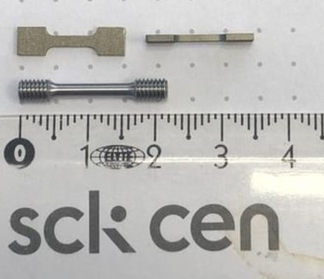 | 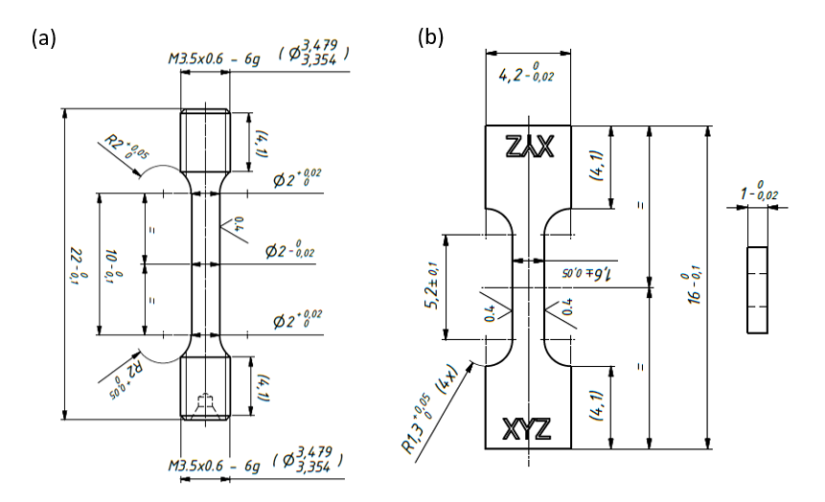
Fig. 1. Geometries of the tensile test samples (a) photos of the samples ; (b) drawing of flat tensile sample and (c) drawing of cylindrical tensile sample.

2.2 FEM procedure
In order to perform the FE simulations, the commercial software ANSYS Workbench 2022 R2 was used. To describe the mechanical behaviour of Eurofer97, an elasto-plastic material model accounting for void-driven ductile damage was used. Plasticity was modelled by adopting Gurson plasticity with isotropic hardening. The Gurson-Tvergaard-Needleman (GTN) model was used to describe the nucleation, growth, and coalescence of voids, as a step towards, next, addressing the irradiation effects (introducing radiation-induced defects) on the drop of fracture strain. The GTN model is a built-in function in ANSYS workbench, hence it offers a flexible and validated tool to be used for the analysis of complex shape components and loading conditions in a controlled computational environment. The material behaviour in ANSYS is described through providing Young’s modulus, Poisson’s ratio, density, and hardening law. Section 2.2.1 starts with the extraction of the hardening law by converting experimental data to a true stress-true strain curve on flat tensile specimens. A brief introduction to the GTN model and the corresponding set of parameters entering the GTN function is given in Section 2.2.2.

2.2.1 Hardening law
The raw engineering stress-strain (S-S) curve is first corrected for the offset of the relative position of preloading of the sample. Machine compliance is also eliminated from the total displacement, leading to the relevant engineering stress-strain curve as shown in Fig. 2(a). Then, the machine compliance cleaned (MCC) engineering S-S response is converted into true stress–true strain curve using Eq. (1) and Eq. (2) as shown in Fig. 2(b). These equations are valid until the ultimate tensile strength (UTS) point and accordingly the first part of the hardening law shown in Fig. 2(c) is obtained till the necking point. Next, the true fracture point is determined by measuring the fracture surface area and using Eq. (3) and Eq. (4) the true fracture stress and true fracture strain are estimated. Then, the hardening law is assumed to be a linear function from the UTS until the true fracture point as shown in Fig. 2(d). However, due to the complicated fracture mechanism during fracture, there is an uncertainty about the fracture strength. Hence, the calculated $σ_{true fracture}$ will be the initial guess for the ${\overline{σ}}_{fracture }$. By changing the slope (i.e. adjusting the fracture stress), the best fit of the engineering S-S curve from the FE simulation to the experimental one can be found. The “corrected slope” (hardening law) is shown for each test temperature in Fig. 4(b) in section 3.
$$σ_{true}= σ_{engineering}\left(1+ε_{engineering}\right),$$ |  |  |  | (1)
$$ε_{true}= \ln\left(1+ε_{engineering}\right),$$ |  | (2)
$$σ_{true fracture}= \frac{F_{fracture}}{A_{fracture}},$$ | (3)
$$ε_{true fracture}= \ln\left(\frac{A_{original}}{A_{fracture}}\right),$$ |  |  | (4)

(a) | 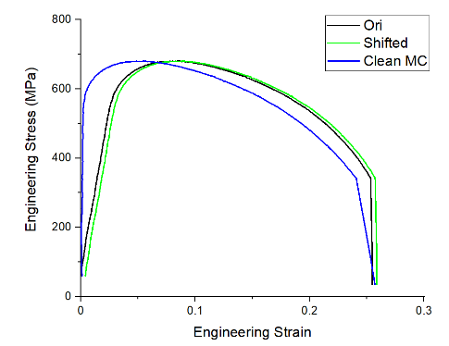
(b) | 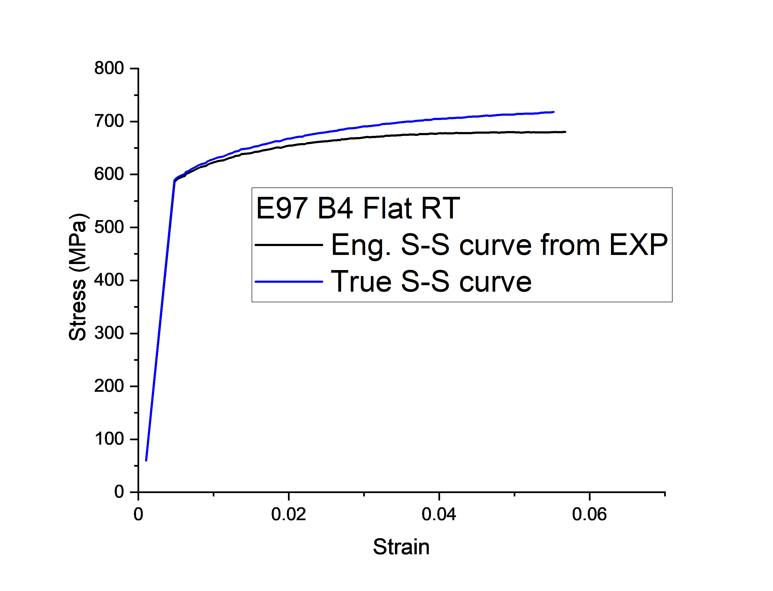
(c) | 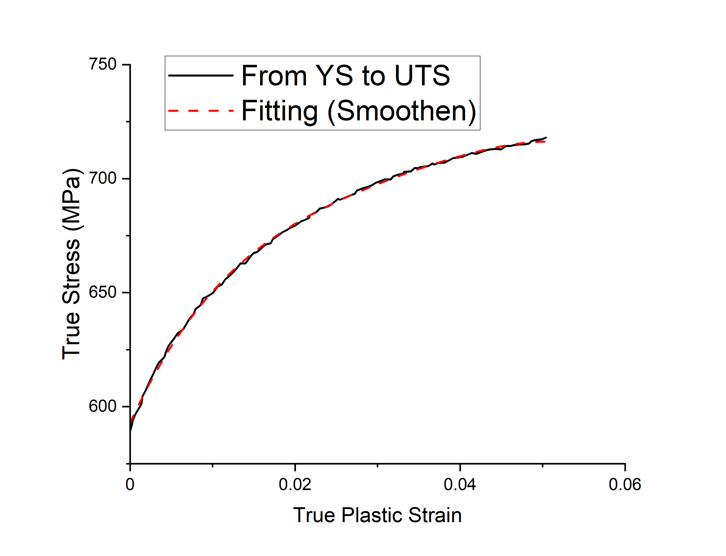
(d) | 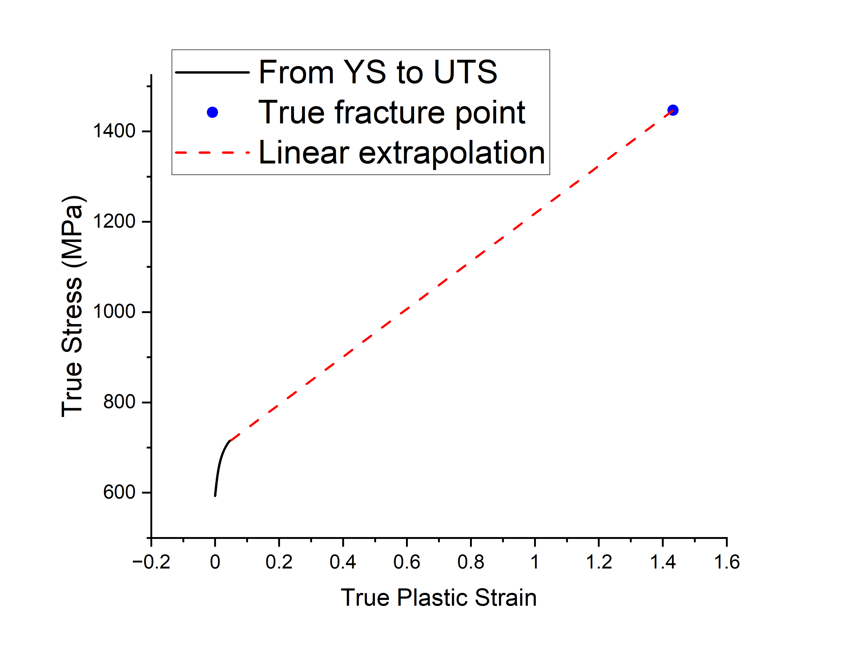
Fig. 2. Different steps followed to determine the hardening law: (a) post-processing of experimental data, (b) converting engineering S-S curve into true S-S curve, (c) smoothen the true S-S curve, and (d) linear extrapolation from UTS to fracture point.

2.2.2 Gurson-Tvergaard-Needleman (GTN) model

Ductile fracture in metals is generally the result of the nucleation, growth, and coalescence of microvoids. Gurson proposed a model in 1977 which describes the yield function considering an isolated spherical void in an ideal-plastic Mises material [25]. Later on, due to some inconsistencies in the original Gurson model compared to void cell simulations, Tvergaard and Needleman modified and introduced new adjustment parameters into the original Gurson model [26]. Then, Tvergaard and Needleman in 1984 [27] further supplemented the Gurson model with a phenomenological law of the loss of load-carrying capacity at a realistic void volume fraction relying on Chu and Needleman’s empirical law for void nucleation [28]. The modified yield function is commonly called Gurson –Tvergaard–Needleman (GTN) model. This model has been successfully applied to simulate deformation-induced damage in ductile metallic materials, such as Eurofer97 steel. The yield surface of the GTN model is given
$∅= {\left[\frac{σ_{eq}}{\overline{σ}}\right]}^{2}+2q_{1}f^{*}cosh\left[\frac{3q_{2}σ_{m}}{2\overline{σ}}\right]-1-{\left(q_{1}f^{*}\right)}^{2}$, | (5)
where $σ_{eq}, \overline{σ},$and$σ_{m}$ are the von Mises equivalent stress, the flow stress of the matrix material, and the hydrostatic pressure, respectively; $f^{*}$ is the effective void volume fraction (VVF) proposed by Tvergaard and Needleman. The function is defined as:
$$f^{*}= \left\{\begin{aligned}f, f≤f_{c}, \\ f_{c}+\frac{f_{u}^{*}-f_{c}}{f_{F}-f_{c}}\left(f-f_{c}\right), f_{c}<f<f_{F,}\end{aligned}\right.$$ | (6)
where$f$ is the true VVF, $f_{c}$ is the critical VVF corresponding to the onset of void coalescence, $f_{f}$ is the threshold for the loss of load-carrying capacity (i.e. physically speaking the moment at which microvoid coalescence ends resulting in full loss of load-bearing capacity). The evolution law of the volume fraction $f$ consists of two terms: one associated to the nucleation of new voids and one to the growth of existing voids, as:
$\dot{ f}={\dot{f}}_{nucleation}+{\dot{f}}_{growth}$, | (7)
where ${\dot{f}}_{nucleation}$ is the rate of the void nucleation with respect to the average effective plastic strain rate of the matrix material ${\dot{ε}}_{eq}^{pl}$ was proposed by Chu and Needleman [28], in the following form
${\dot{f}}_{nucleation}=A{\dot{ε}}_{eq}^{pl}$, | (8)
$$A\left(\overline{ε}\right)=\frac{f_{n}}{S_{n}\sqrt{2π}}exp{\left[-\frac{1}{2}\left(\frac{\overline{ε}-ε_{N}}{S_{n}}\right)\right]}^{2},$$ |  | (9)
where the parameter A is a Gaussian distribution, $f_{n}$ is the total nucleated VVF, $\overline{ε}$ is the equivalent plastic strain of matrix material, and $ε_{N}$ and $S_{n}$ are the mean value of the Gaussian distribution of the nucleation strain and standard deviation, respectively.
and ${\dot{f}}_{growth}$ is the rate of the growth of existing void with respect to the trace of the macroscopic plastic strain rate tensor ${\dot{ε}}_{kk}^{p}$, which writes
${\dot{f}}_{growth}=(1-f){\dot{ε}}_{kk}^{p}$. | (10)
In total, the GTN model has eight parameters ($q_{1}, q_{2},f_{0}, f_{N, } ε_{N}, S_{N}, f_{c}, f_{F}$) which must be calibrated for a studied material, knowing that the value of $q_{1}, q_{2}$ have already been identified (see Faleskog [29])
Fig. 3 shows the total procedure for this study which can be considered as the inverse FEM analysis.

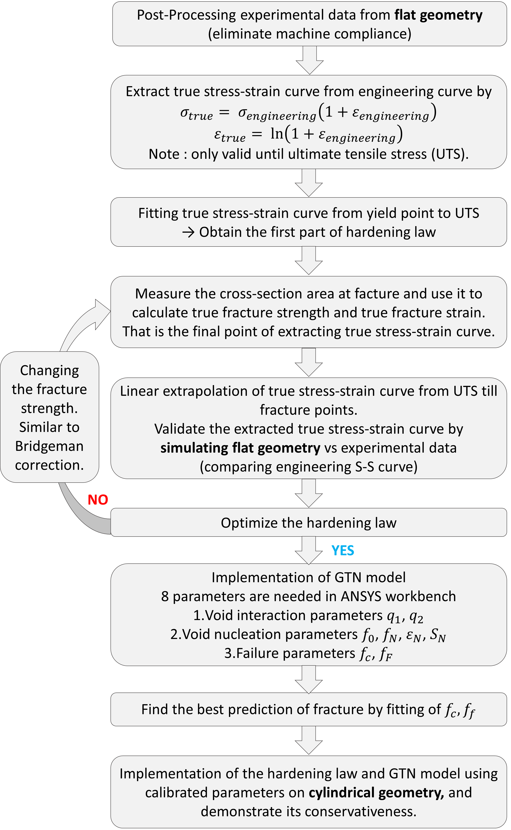

Fig. 3. Scheme of FEM procedure by inverse analysis.

3. Results and discussion

3.1 FEM results with the simplified method

The simplified method means, as explained in section 2.2.1, the proposed method of extracting hardening law which is relatively simple since no special equipment (DIC) is needed. Fig. 4(a) shows that FE results with the usage of the corrected hardening law extracted by the proposed simplified method demonstrate good agreement with experimental curves for each test temperature. The comparison of the original hardening laws to the corrected hardening laws were shown in Fig. 4(b). The corrected hardening laws are all lower than the original ones because $σ_{tensile}$ is larger than $\overline{σ}$ during necking. The next step is to capture fracture behaviour using the GTN model.
(a)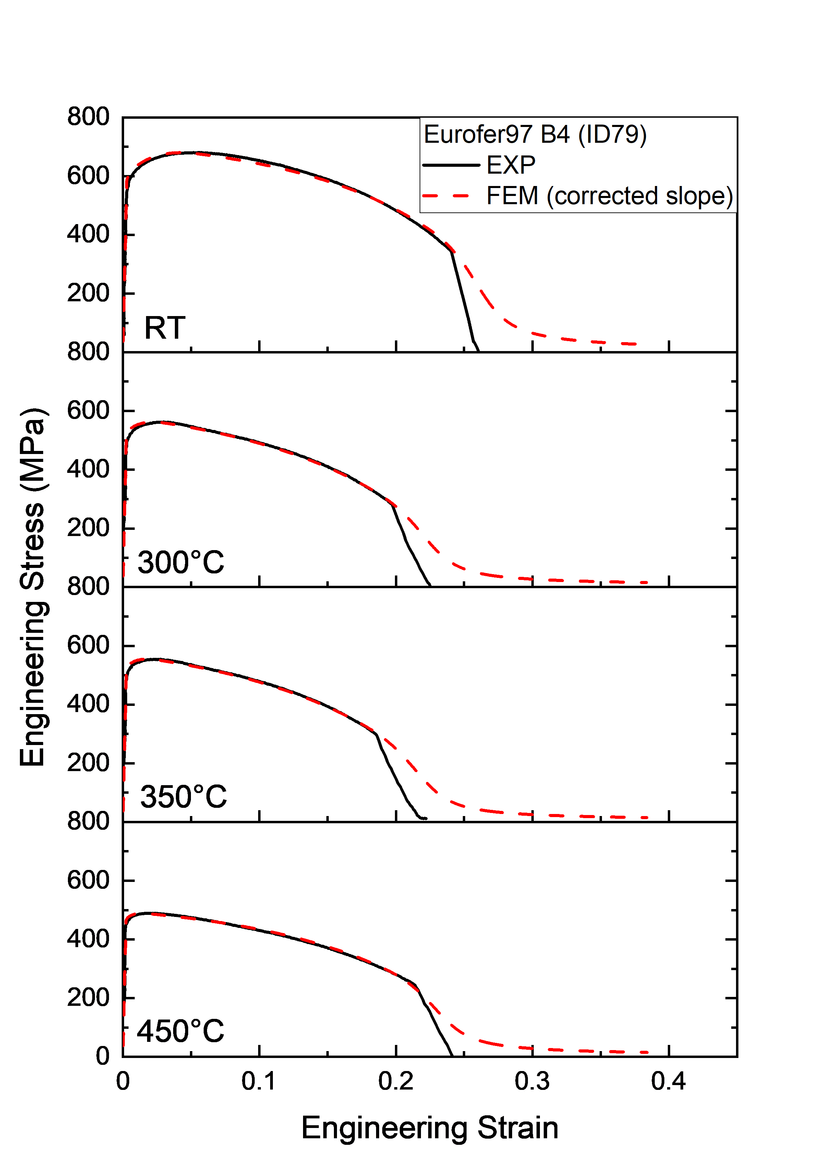 | (b) 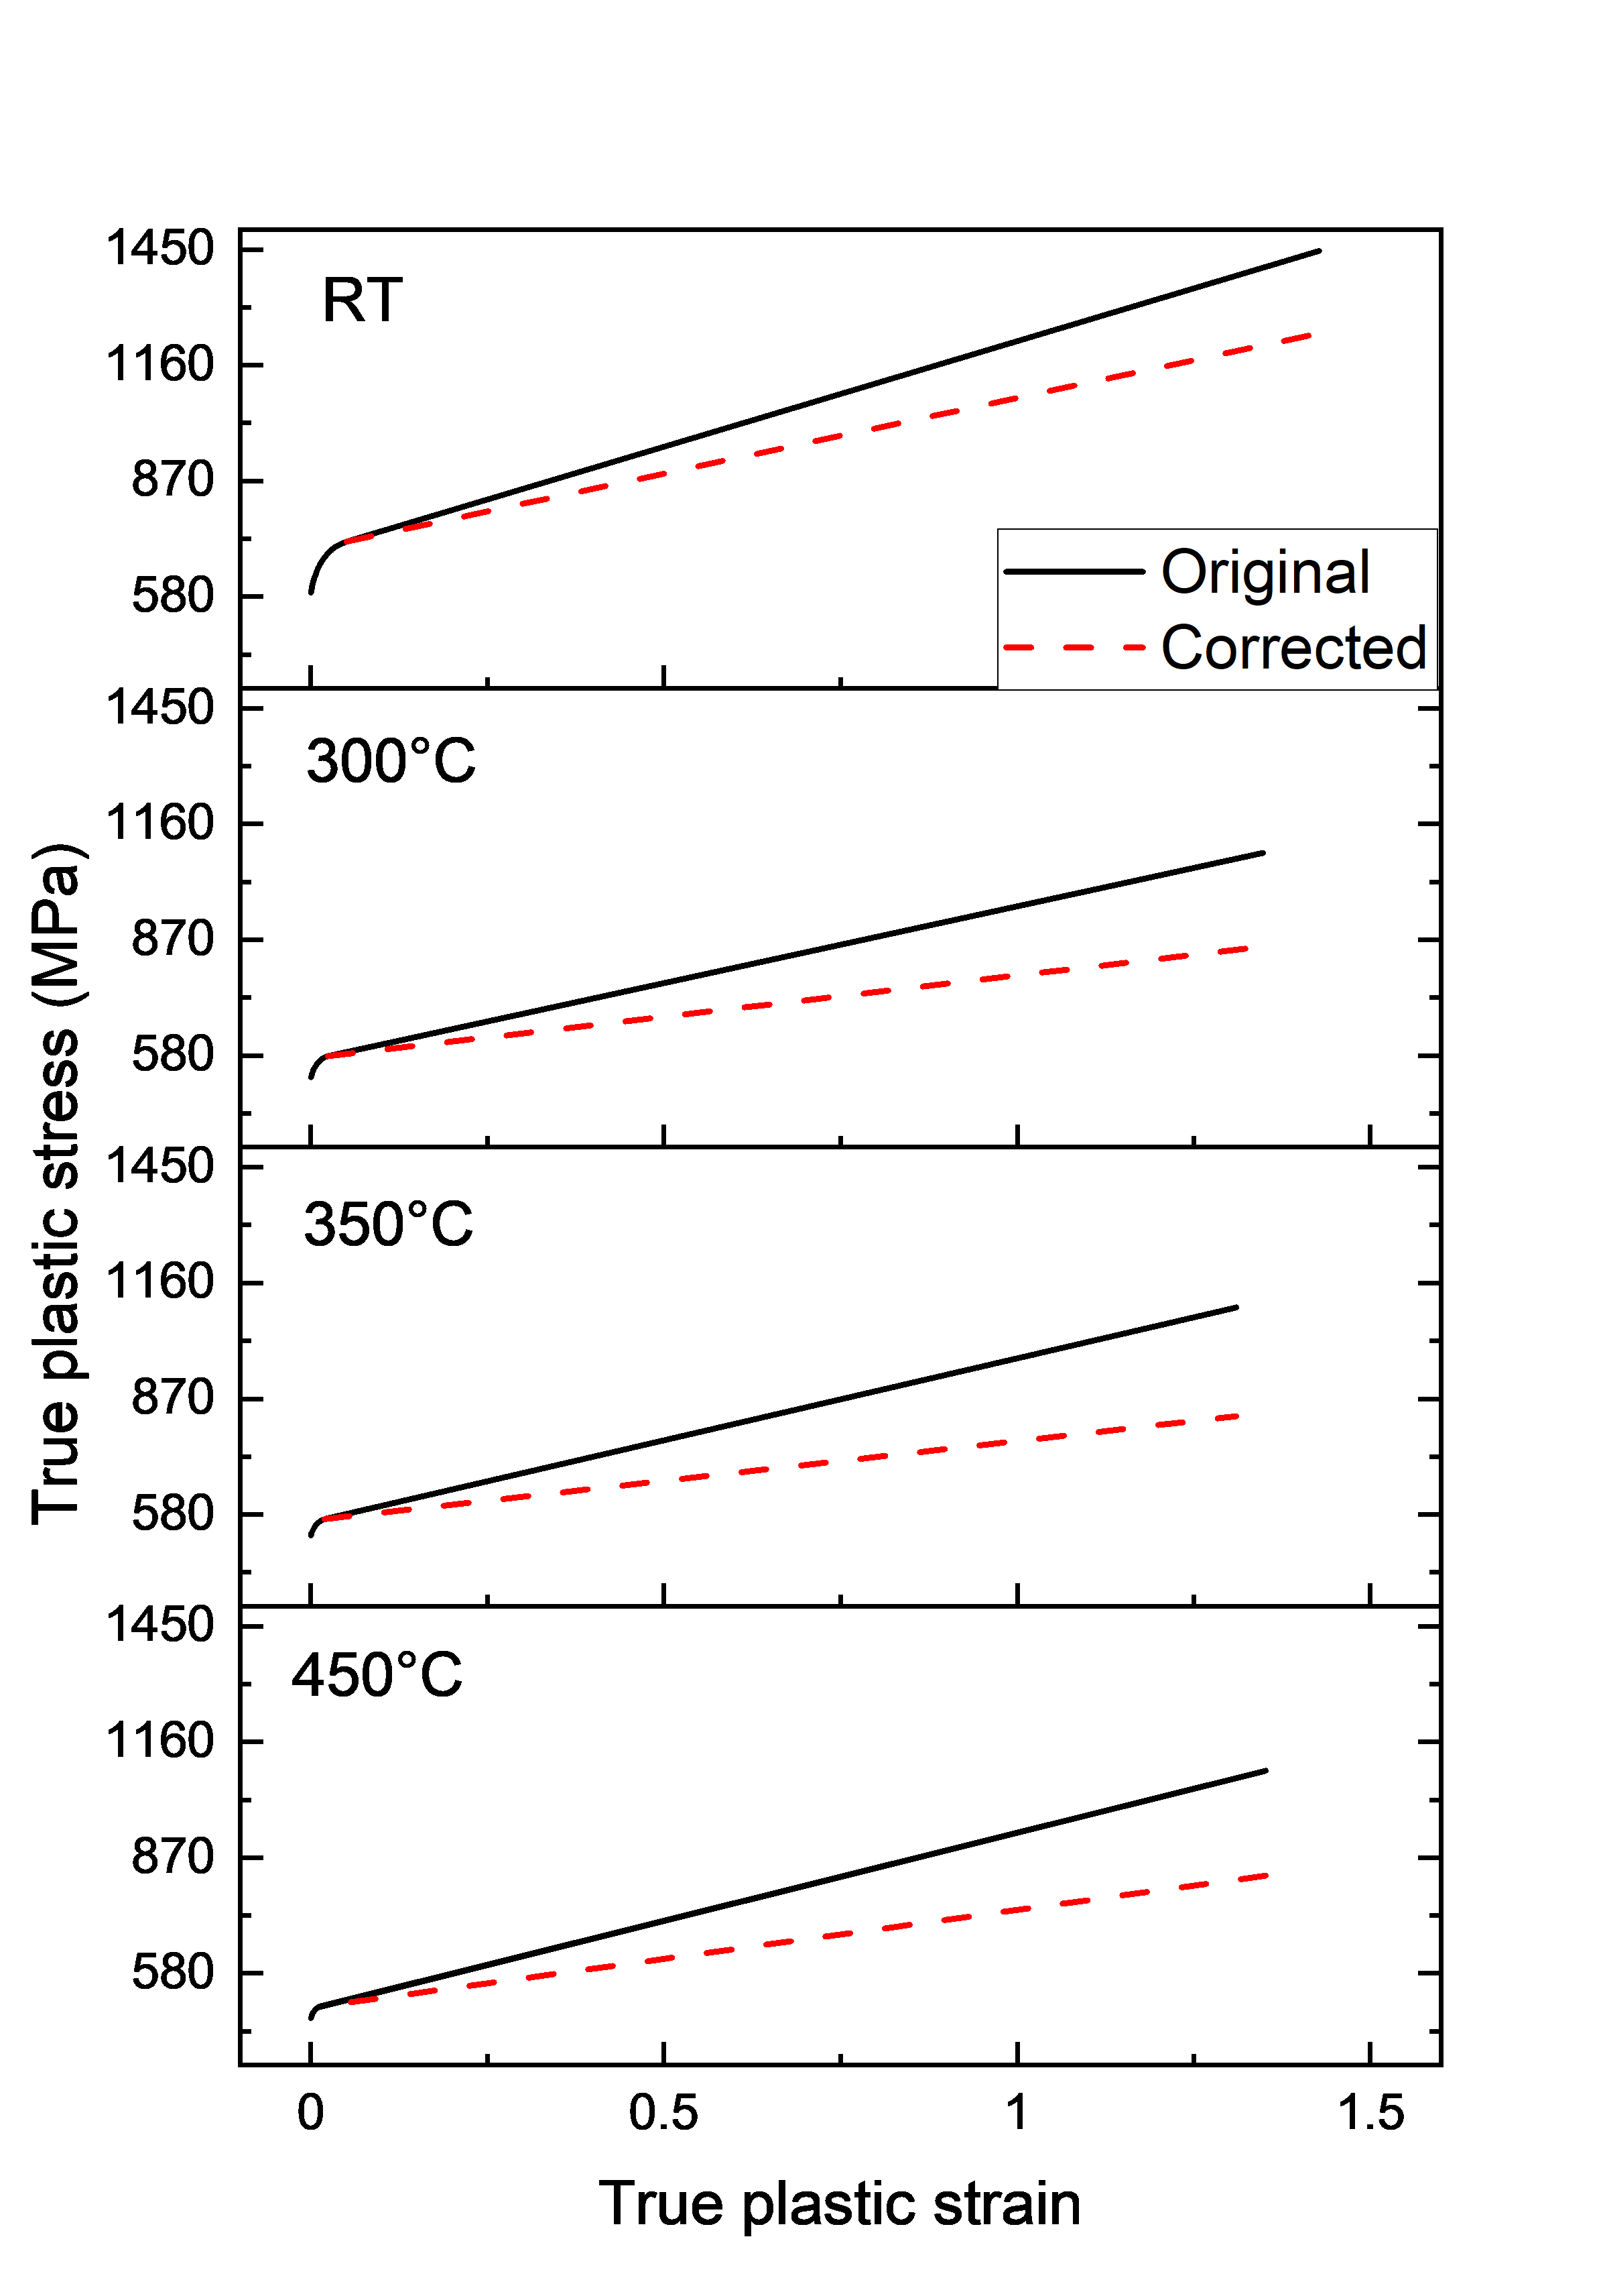
Fig. 4. (a) Eng. S-S curves obtained from FEM (dashed) compared to experimental curves (solid) at different test temperatures (b) original hardening laws and corrected hardening laws of studied material at different test temperatures

3.2 FEM results with GTN model (flat geometry)

This section explains how the GTN parameters were obtained and demonstrates the FEM results compared to the experimental data. The GTN parameters are material and temperature-dependent values. A brief rationale for the initial guess and calibration of the GTN parameters is provided first.

Calibration of GTN parameters
- For $q_{1}$ and $q_{2}$, Tvergaard et al. [26] performed void cell calculations on moderate hardening materials containing periodically distributed voids and found that $q_{1}=1.5$, $q_{2}=1$closely match experimental and numerical results.
- For $f_{0}$, very low initial void volume fraction was reported [30, 31] for Eurofer97 and $f_{0}=0$ is assumed.
- For $f_{N}$, void nucleation mode occurs by decohesion of the interface matrix/particle as explained by Stratil et al. [30] who measured the void volume fraction beneath the fracture surface for Eurofer97. The reported value of 0.00055 is used in this study since the studied material and test conditions are essentially similar.
- For $ε_{N}$ and $S_{N}$, Pan et al. [32] showed that the onset of the void nucleation often occurs after some degree of plastic deformation. The UTS is selected as a first approximation and $ε_{N}$ is set equal to the strain at UTS.
- Values of $f_{c}$ and $f_{F}$, are the main fitting parameters in this study, and these are to be determined based on the best fit to the experimental S-S curves.
The most influential parameters for the present study are $f_{c}$ and $f_{F}$ where $f_{c}$ is the critical void volume fraction at which the voids begin to coalesce and $f_{F}$ is the void volume fraction at failure (loss of load-carrying capacity). The goal of calibrating the GTN parameters is to get 95% or better prediction accuracy (PA) at the fracture point for the flat geometry, where PA is the ratio between FEM and experimental result in percentage. To reveal the dependence of f_{c} and f_{F} on the test temperatures, we have considered two scenarios. The first one (S1) is to use the best set for $f_{c}$ and $f_{F}$ defined at RT for all test temperatures, and the second one (S2) is to modify the set for $f_{c}$ and $f_{F}$ to meet the target at elevated temperatures. The calibrated parameters are summarized in Table 2.
Fig. 5(a) compares the engineering S-S curves from FEM (dashed) to experimental ones (solid) by using S1 GTN parameters. The GTN predictions capture the fracture point very well. Fig. 6 shows the fracture surface area predicted by FEM with the S1 GTN parameter set compared to the experimental values, demonstrating a fair agreement. In Table 3, a detailed comparison of total elongation (TE), reduction of area (RA), and fracture strength (FS) values obtained by FEM and experiments are reported. The prediction accuracy of TE, RA, and FS values is above 90%. At 350 °C, the prediction accuracy of the fracture strength is below 95 %. So we further tune up the $f_{c}$ and $f_{F}$ parameters to better predict for the tensile data at 350 °C. Table 2 summarized a new set of parameters called S2. The re-fitted values of f_{c} and f_{F} are much lower than those of S1. After the re-fit, the PA of FS increased from 93.5 % to 95.1 %. We can also notice that the total elongation decreases with increasing temperature, and the minimum occurs at 350 °C. This phenomenon has already been observed and reported in [5]. The reason for this decrease in ductility might be related to the diffusion of interstitial impurities (mostly carbon) which affects the slip of dislocations leading to so-called dynamic strain ageing as well as formation of the solute atmospheres overall suppressing the freedom of cross-slip which leads to the localized deformation along the most active slip planes. The increase of the total elongation at further increased temperature (450ºC) can be explained by the enhancement of dislocation mobility due to de-trapping from the interstitial impurities. Another reason for the change of the $f_{c}$ and $f_{F}$ is that void coalescence is known to be directly influenced by strain hardening capacity as shown by advanced studies on this phenomenon[33-36]. Further investigation on the optimization of GTN parameters needs to be done to capture the dynamics strain ageing effect and provide a rationale for the validation of$f_{c}$ and $f_{F}$ with temperature. Also, in this study, the $q$ values were fixed at all test temperatures. However, the $q$ values are found to exhibit weak or strong dependence on the hardening exponent according to Faleskog’s study [29] depending on the test temperature range. In the case of Eurofer97, the dependence of $q$ values requires a separate study which will be reported elsewhere.
Table 2. Summary of calibrated GTN parameters
Scenario | $$q_{1}$$ | $$q_{2}$$ | $$q_{3}$$ | $$f_{0}$$ | $$f_{N}$$ | $$ε_{N}$$ |  | $$S_{N}$$ |  | $$f_{c}$$ |  | $$f_{F}$$
S1 | 1.5 | 1 | 2.25 | 0 | 0.00055 | RT | 0.057 | RT | 0.01 | 0.18 |  | 0.22
 |  |  |  |  |  | 300°C | 0.03 | 300°C | 0.01
S2 |  |  |  |  |  | 350°C | 0.025 | 350°C | 0.01 | RT | 0.18 | RT | 0.22
 |  |  |  |  |  |  |  |  |  | 300°C | 0.18 | 300°C | 0.22
 |  |  |  |  |  | 450°C | 0.016 | 450°C | 0.01 | 350°C | 0.088 | 350°C | 0.105
 |  |  |  |  |  |  |  |  |  | 450°C | 0.18 | 450°C | 0.22

(a) | 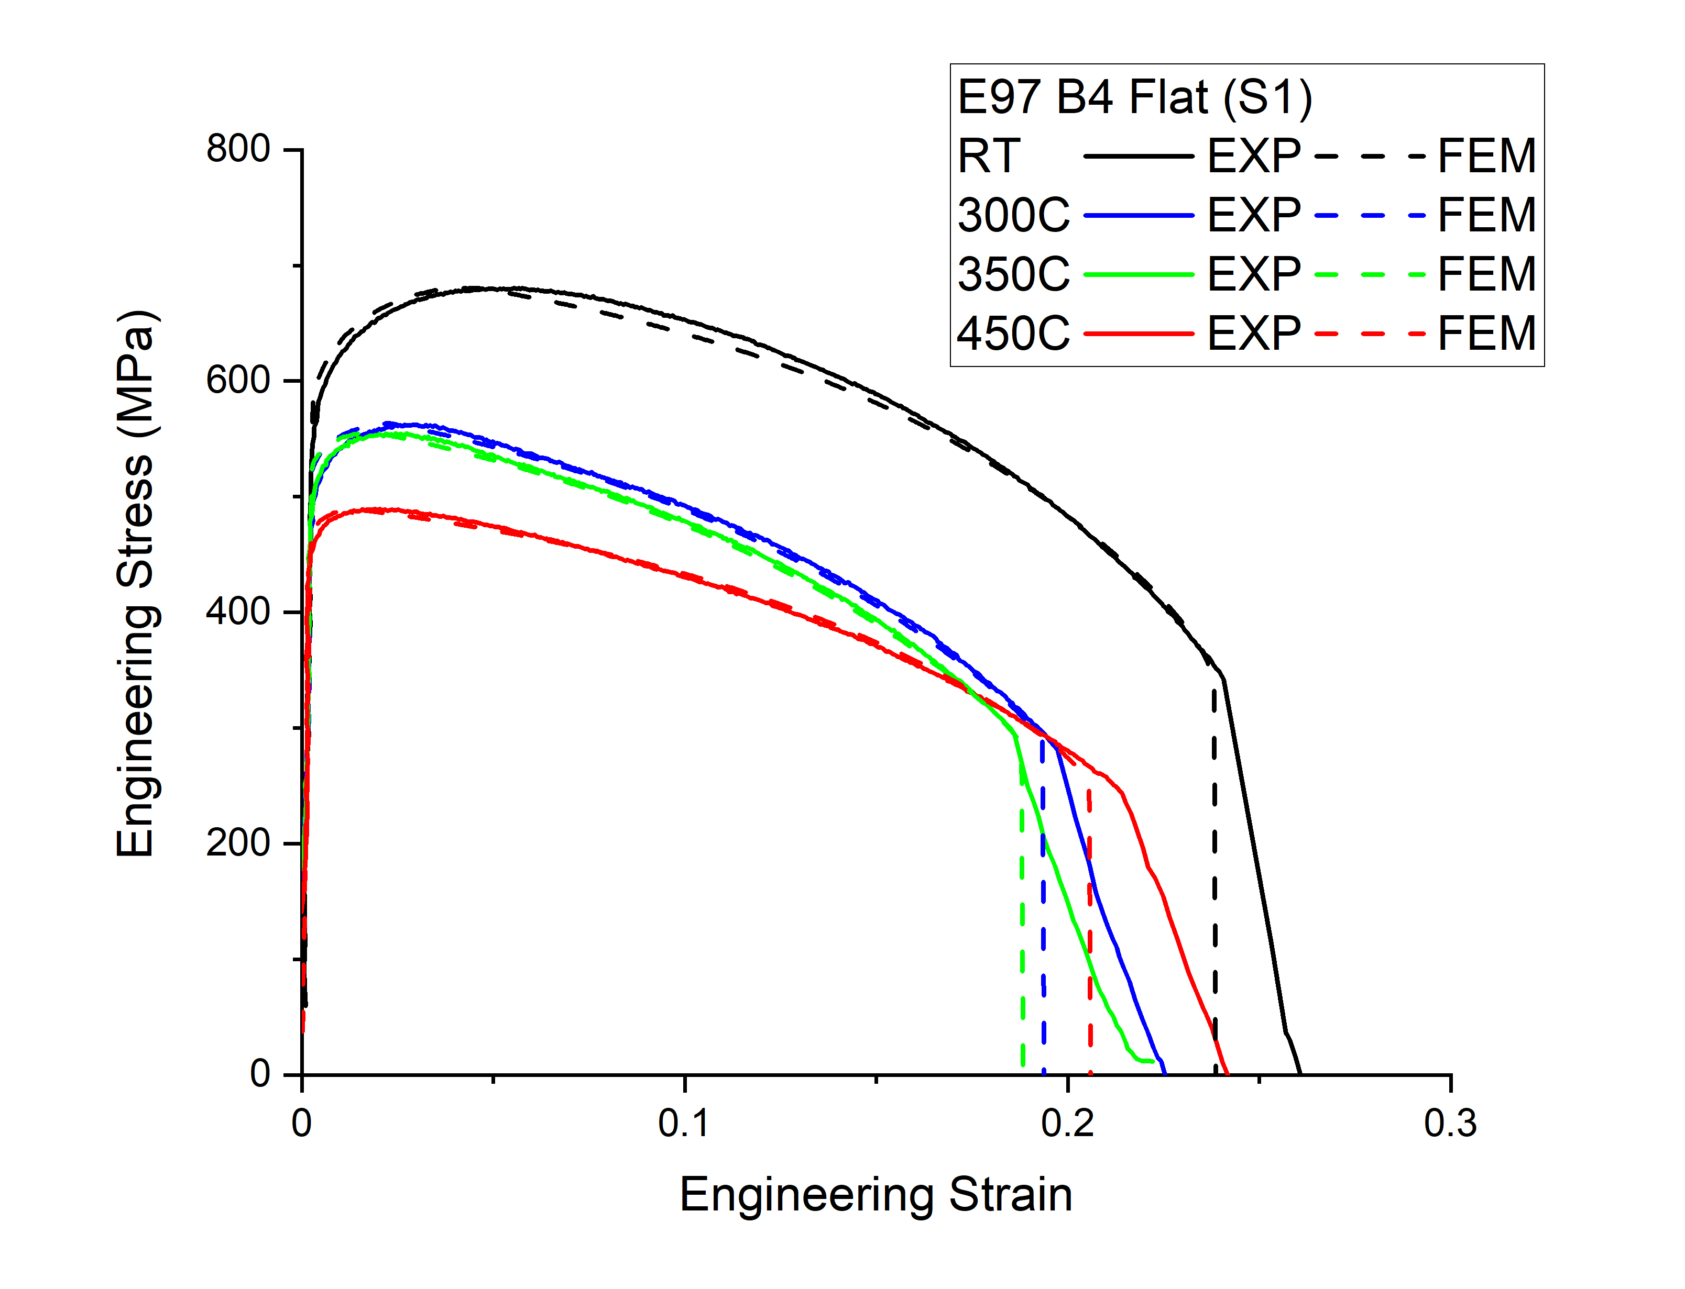
(b) | 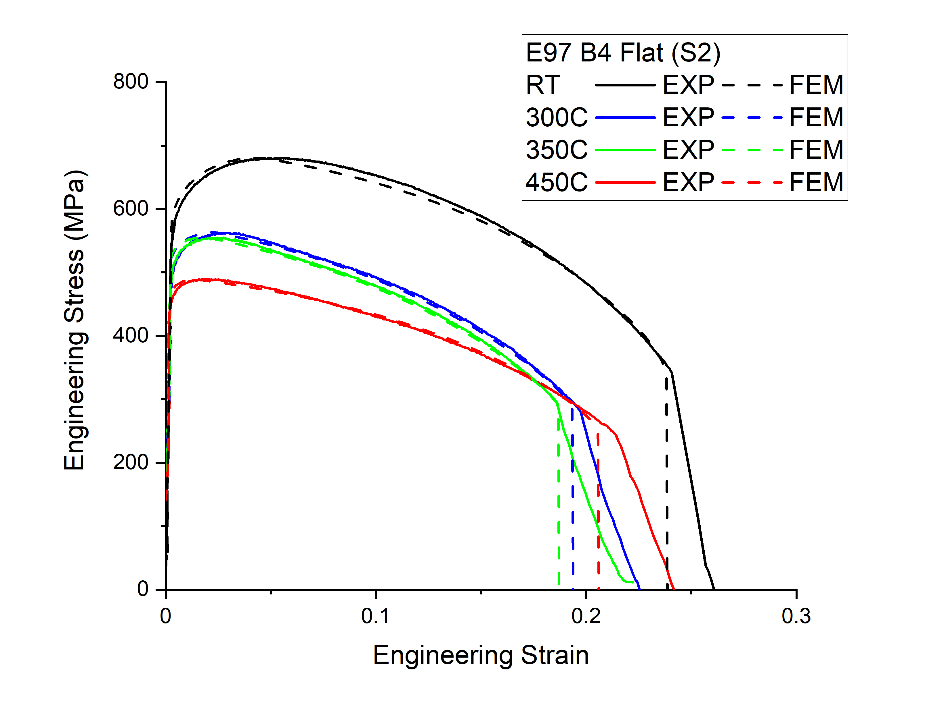
Fig. 5. Engineering S-S curve from FEM compared to experimental curves by using GTN parameters from
(a) S1 (b) S2

(a) | (b)
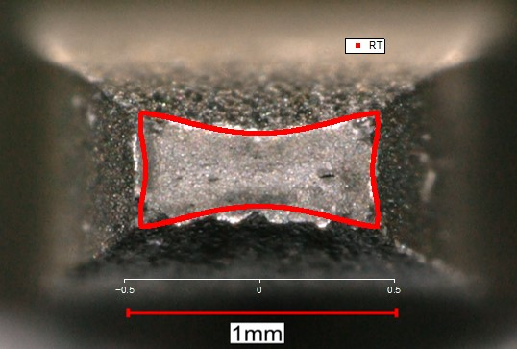 | 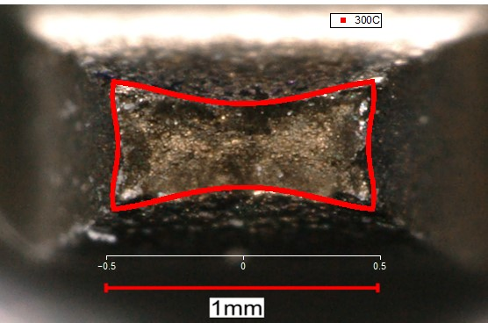
(c) | (d)
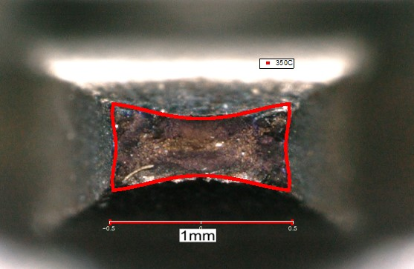 | 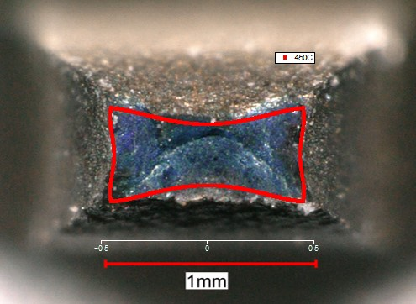
Fig. 6. Comparison of the reduction of area for flat samples from FEM (red line) and test samples. (a) RT (b) 300 °C (c) 350 °C (d) 450 °C

Table 3. Comparison of total elongation (TE), reduction of area (RA), fracture strength (FS) and prediction accuracy (PA) in flat geometry as obtained by FEM and experiment.
GTN parameter set | Temp. | TE |  |  | RA |  |  | FS
 |  | EXP | FEM | PA | EXP | FEM | PA | EXP | FEM | PA
S1 | RT | 24.1 | 23.9 | 99.2 | 77.5 | 77.7 | 99.8 | 1522.2 | 1535.4 | 99.1
S1 | 300°C | 19.7 | 19.4 | 98.3 | 75.6 | 72.8 | 96.3 | 1150.1 | 1174.1 | 97.9
S1 | 350°C | 18.6 | 18.8 | 98.8 | 73.3 | 72.2 | 98.6 | 1102.1 | 1030.3 | 93.5
S1 | 450°C | 21.4 | 20.6 | 96.1 | 74.2 | 75.4 | 98.4 | 943.5 | 930.0 | 98.6
S2 | RT | 24.1 | 23.9 | 99.2 | 77.5 | 77.7 | 99.8 | 1522.2 | 1535.4 | 99.1
S2 | 300°C | 19.7 | 19.4 | 98.3 | 75.6 | 72.8 | 96.3 | 1150.1 | 1174.1 | 97.9
S2 | 350°C | 18.6 | 18.7 | 99.7 | 73.3 | 72.2 | 98.5 | 1102.1 | 1048.5 | 95.1
S2 | 450°C | 21.4 | 20.6 | 96.1 | 74.2 | 75.4 | 98.4 | 943.5 | 930.0 | 98.6

3.3 FEM simulation of cylindrical geometry using parameters extracted from flat geometry
As a next step, the same constitutive laws (hardening law and GTN parameters (S1, S2)) as extracted from the flat sample test data were applied to simulate tensile tests with cylindrical geometry to evaluate the prediction accuracy of this approach. Fig. 7(a) and Fig. 7(b) show the comparison of the engineering S-S curves from FEM (dashed) to experimental ones (solid) by using S1 and S2 GTN parameters, respectively. Fig. 8 shows the fracture surface area in FEM with S1 GTN parameters compared to experimentally tested samples for the cylindrical geometry. Detailed comparison of TE, RA and FS obtained from FEM to experimental data are reported in Table 4. For total elongation and reduction of area, prediction accuracies for both studied cases were all above 92%. However, the prediction accuracy is only above 81% on the fracture strength. This is the result of the overestimation of the fracture surface. Even though the percentage (reduction of area) is similar, the value of the fracture area from FEM can exceed the experimental one by 20%. The main reason might be due to the different stress triaxiality distribution within these two geometries. Fig. 9 shows the stress triaxiality distribution of the fracture surface at RT from FEM simulation in two geometries. The maximum stress triaxiality is higher in the flat geometry (1.58) compared to the cylindrical geometry (1.35) and is more concentrated around the centre in the cylindrical sample while it is more spread out in the flat geometry. The effect of stress triaxiality is included in the GTN model. However, the accuracy of the GTN model at low stress triaxiality is not very good as it does not include void shape effects, e.g. [34, 37-39]. At low stress triaxiality, the void aspect ratio changes very significantly. The remedy is to use an extension that accounts for void shape. Further investigation on the correlation between the best $f_{c}$ and $f_{F}$ for flat and cylindrical geometry should be done.

(a) | 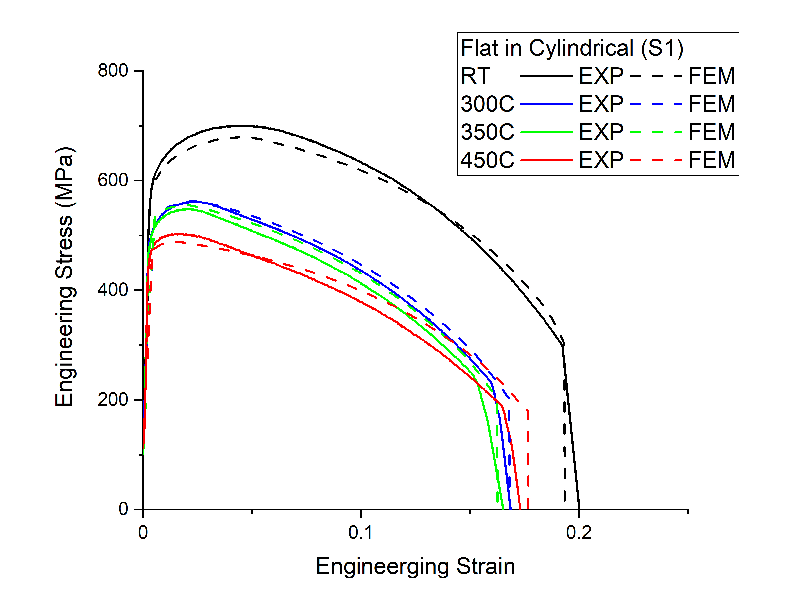
(b) | 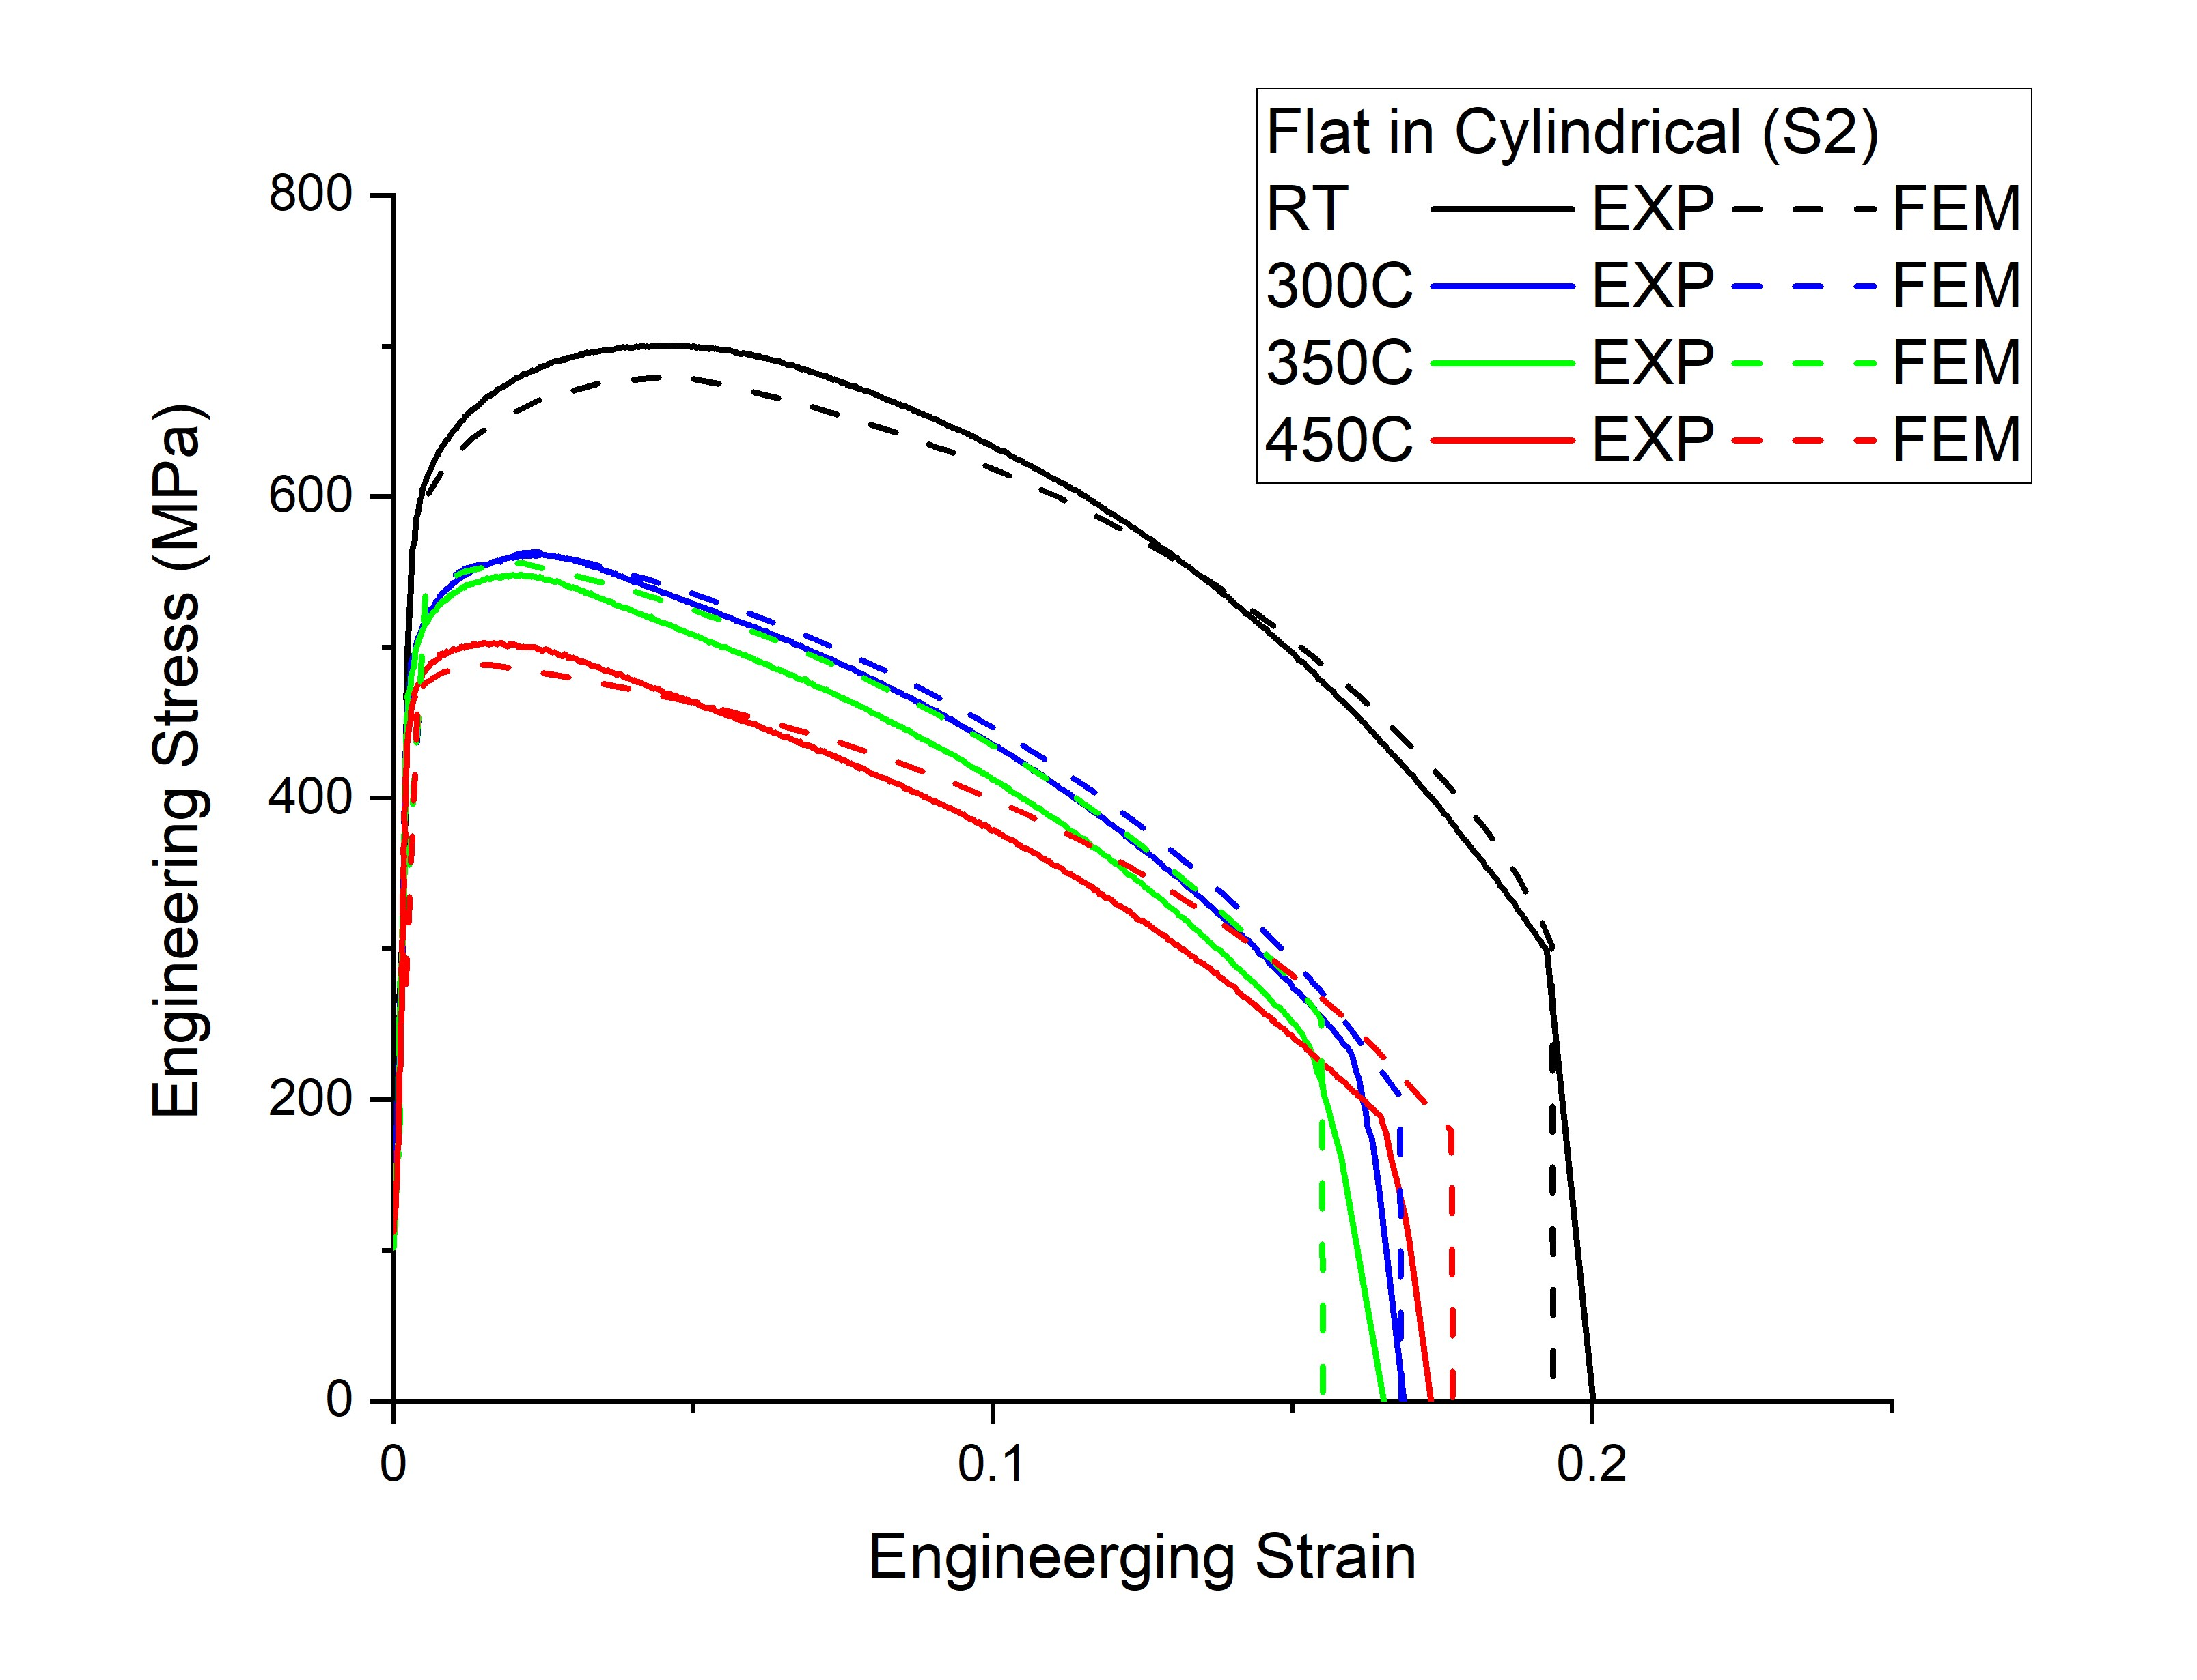
Fig. 7. Engineering S-S curve from FEM compared to experimental curves by using the constitutive law extracted from flat (a) S1 (b) S2 in cylindrical geometry.

(a) | (b)
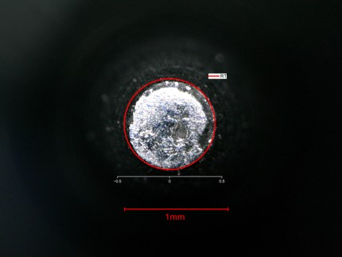 | 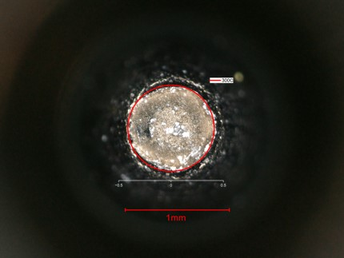
(c) | (d)
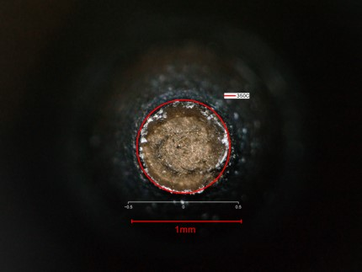 | 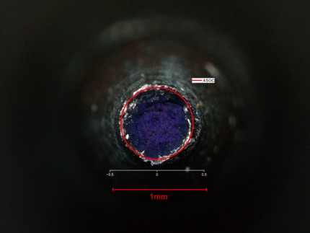
Fig. 8. Comparison of the reduction of area for cylindrical samples from FEM (red line) and tested samples. (a) RT, (b) 300 °C, (c) 350 °C, (d) 450 °C.

Table 4. Comparison of total elongation (TE), reduction of area (RA), fracture strength (FS) and prediction accuracy (PA) in cylindrical geometry obtained from FEM with experimental data.
 | Temp. | TE |  |  | RA |  |  | FS
 |  | EXP | FEM | PA | EXP | FEM | PA | EXP | FEM | PA
S1 | RT | 19.2 | 19.3 | 99.6 | 84.6 | 81.1 | 95.8 | 1942.7 | 1603.6 | 82.5
S1 | 300°C | 16.0 | 16.3 | 98.1 | 84.4 | 82.9 | 98.2 | 1461.1 | 1184.7 | 81.1
S1 | 350°C | 15.3 | 16.2 | 93.7 | 82.4 | 82.2 | 99.7 | 1347.9 | 1139.8 | 84.6
S1 | 450°C | 16.5 | 17.7 | 92.9 | 83.5 | 85.2 | 97.9 | 1143.9 | 1216.4 | 93.7
S2 | RT | 19.2 | 19.3 | 99.6 | 84.6 | 81.1 | 95.8 | 1942.9 | 1603.6 | 82.5
S2 | 300°C | 16.0 | 16.3 | 98.1 | 84.4 | 82.9 | 98.2 | 1461.1 | 1184.7 | 81.1
S2 | 350°C | 15.3 | 15.5 | 98.6 | 82.4 | 76.8 | 93.2 | 1347.9 | 1095.0 | 81.2
S2 | 450°C | 16.5 | 17.7 | 92.9 | 83.5 | 85.2 | 97.9 | 1143.9 | 1216.4 | 93.7

(a) | 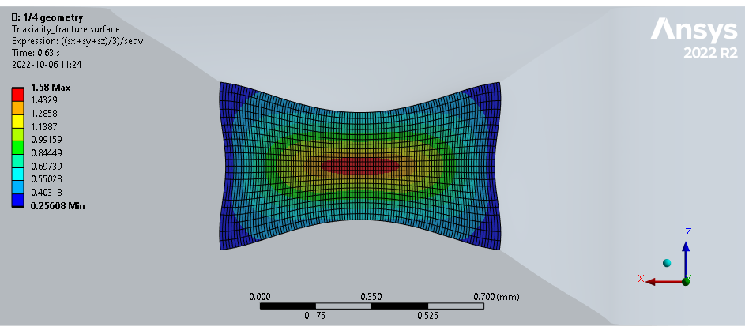
(b) | 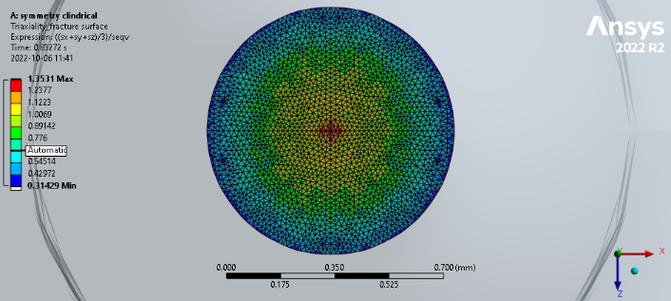
Fig. 9. Stress triaxiality distribution at fracture in (a) flat and (b) cylindrical geometry at RT.

4. Summary and conclusions

In this work, a simplified method for obtaining the true stress–strain curve using experimental tensile data is proposed. The method utilizes an assumption that the post-necking true stress increases linearly from UTS up to the fracture point. This approach is used in combination with the GTN damage model whose parameters are adjusted to achieve a good agreement between FEM and experimental tensile data for the elongation and area of reduction at the fracture point. The procedure was applied to a flat geometry to find the best set of constitutive laws at different test temperatures. The FEM results, in terms of total elongation, reduction of area, and fracture strength, show a good agreement with the experimental data for all studied temperatures. The final goal of this study is to assess the conservatism of applying the same set of constitutive laws to simulate the tensile test for the cylindrical geometry and see how accurate it is compared with the experimental data. In case of sufficiently good agreement, flat tensile samples could be considered interchangeable with cylindrical ones, at least for the investigated material in the studied temperature range.
Based on the obtained results and discussion, the following statements can be made on the interchangeability of cylindrical and flat tensile samples for the derivation of the tensile properties at the post-necking deformation stage:
- FE simulations based on Gurson plasticity properly reproduce experimental S-S curves for the flat geometry by assigning a linear increase of the true stress from UTS up to true fracture stress.
- The fracture point can be predicted using the modified set of GTN parameters with a prediction accuracy above 90% for the most important post-necking tensile characteristics, namely: area reduction, total elongation and fracture stress. The prediction accuracy exceeds 90% at all test temperatures for the flat geometry. The fracture points predicted using fixed $f_{c}$ and $f_{f}$ as determined by RT tests already have a good agreement with experimental data obtained at elevated temperatures. However, the $f_{c}$ and $f_{f}$ are in general temperature-dependent parameters, in the case of Eurofer97 apparently the temperature sensitivity is weak up to 350°C.
- The hardening law and the set of GTN parameters extracted from the test database using flat samples give a higher deviation in the prediction of the fracture point for cylindrical tensile samples due to the differences in stress triaxiality distribution.
- The implementation of the simplified method and derivation of the constitutive laws for neutron-irradiated samples is the next step. Also, the validity of the method up to the upper operational temperature of Eurofer97, i.e., 550 °C, will be investigated by a combined FEM and experimental study.
Acknowledgments
This work has been carried out within the framework of the EUROfusion Consortium and has received funding from the Euratom research and training programme 2014-2018 and 2019-2020 under grant agreement No 633053. The views and opinions expressed herein do not necessarily reflect those of the ITER Organization or of the European Commission. The work was partially supported by FOD fusion grant.

Reference

1. Lindau R, Moslang A, Rieth M, Klimiankou M, Materna-Morris E, Alamo A, et al. Present development status of EUROFER and ODS-EUROFER for application in blanket concepts. Fusion Eng Des. 2005;75-79:989-96.
2. Federici G, Biel W, Gilbert MR, Kemp R, Taylor N, Wenninger R. European DEMO design strategy and consequences for materials. Nucl Fusion. 2017;57(9).
3. Pintsuk G, Diegele E, Dudarev SL, Gorley M, Henry J, Reiser J, et al. European materials development: Results and perspective. Fusion Eng Des. 2019;146:1300-7.
4. Lucon E, Chaouadi R, Decreton M, editors. Mechanical properties of the European reference RAFM steel (EUROFER97) before and after irradiation at 300 degrees C. 11th International Conference on Fusion Reactor Materials (ICFRM); 2003 Dec 07-12; Kyoto, JAPAN.
5. Lucon E, Vandermeulen W. Overview of the tensile properties of EUROFER in the unirradiated and irradiated conditions. Journal of Nuclear Materials. 2009;386-88:254-6.
6. Gaganidze E, Petersen C, Materna-Morris E, Dethloff C, Weiss OJ, Aktaa J, et al. Mechanical properties and TEM examination of RAFM steels irradiated up to 70 dpa in BOR-60. Journal of Nuclear Materials. 2011;417(1-3):93-8.
7. Gaganidze E, Aktaa J. Assessment of neutron irradiation effects on RAFM steels. Fusion Eng Des. 2013;88(3):118-28.
8. Tavassoli AA, Touboul F. Austenitic stainless steels, status of the properties database and design rule development. Journal of Nuclear Materials. 1996;233:51-61.
9. Knaster J, Chel S, Fischer U, Groeschel F, Heidinger R, Ibarra A, et al. IFMIF, a fusion relevant neutron source for material irradiation current status. Journal of Nuclear Materials. 2014;453(1-3):115-9.
10. Bernardi D, Arbeiter F, Cappelli M, Fischer U, Garcia A, Heidinger R, et al. Towards the EU fusion-oriented neutron source: The preliminary engineering design of IFMIF-DONES. Fusion Eng Des. 2019;146:261-8.
11. Kamaya M, Kawakubo M. A procedure for determining the true stress-strain curve over a large range of strains using digital image correlation and finite element analysis. Mech Mater. 2011;43(5):243-53.
12. Zhu FP, Bai PX, Zhang JB, Lei D, He XY. Measurement of true stress-strain curves and evolution of plastic zone of low carbon steel under uniaxial tension using digital image correlation. Opt Laser Eng. 2015;65:81-8.
13. Li JR, Yang GB, Siebert T, Shi MF, Yang L. A method of the direct measurement of the true stress-strain curve over a large strain range using multi-camera digital image correlation. Opt Laser Eng. 2018;107:194-201.
14. Nozawa T, Sakasegawa H, Chen X, Kato T, Geringer JW, Katoh Y, et al. Non-contact strain evaluation for miniature tensile specimens of neutron-irradiated F82H by digital image correlation. Fusion Eng Des. 2020;157.
15. Bridgman PW. Studies in large plastic flow and fracture. 1st ed. New York: McGraw-Hill; 1952. x, 362 pages p.
16. Leroy G, Embury JD, Edward G, Ashby MF. A Model of Ductile Fracture Based on the Nucleation and Growth of Voids. Acta Metall Mater. 1981;29(8):1509-22.
17. Ling Y. Uniaxial True Stress-Strain after Necking. AMP Journal of Technology. 1996;5:37-48.
18. Zhang ZL, Hauge M, Odegard J, Thaulow C. Determining material true stress-strain curve from tensile specimens with rectangular cross-section. Int J Solids Struct. 1999;36(23):3497-516.
19. Scheider I, Brocks W, Cornec A. Procedure for the determination of true stress-strain curves from tensile tests with rectangular cross-section specimens. J Eng Mater-T Asme. 2004;126(1):70-6.
20. Choung JM, Cho SR. Study on true stress correction from tensile tests. J Mech Sci Technol. 2008;22(6):1039-51.
21. Mahler M, Aktaa J. Approach for J-R curve determination based on sub-size specimens using a triaxiality dependent cohesive zone model on a (ferritic-martensitic) steel. Eng Fract Mech. 2015;144:222-37.
22. Pardoen T, Delannay F. Assessment of void growth models from porosity measurements in cold-drawn copper bars. Metallurgical and Materials Transactions A. 1998;29(7):1895-909.
23. Nielsen KL, Pardoen T, Tvergaard V, de Meester B, Simar A. Modelling of plastic flow localisation and damage development in friction stir welded 6005A aluminium alloy using physics based strain hardening law. Int J Solids Struct. 2010;47(18):2359-70.
24. Marteleur M, Leclerc J, Colla M-S, Nguyen V-D, Noels L, Pardoen T. Ductile fracture of high strength steels with morphological anisotropy, Part I: Characterization, testing, and void nucleation law. Eng Fract Mech. 2021;244:107569.
25. Gurson AL. Continuum Theory of Ductile Rupture by Void Nucleation and Growth .1. Yield Criteria and Flow Rules for Porous Ductile Media. J Eng Mater-T Asme. 1977;99(1):2-15.
26. Tvergaard V. Influence of Voids on Shear Band Instabilities under Plane-Strain Conditions. Int J Fracture. 1981;17(4):389-407.
27. Tvergaard V, Needleman A. Analysis of the Cup-Cone Fracture in a Round Tensile Bar. Acta Metall Mater. 1984;32(1):157-69.
28. Chu CC, Needleman A. Void Nucleation Effects in Biaxially Stretched Sheets. J Eng Mater-T Asme. 1980;102(3):249-56.
29. Faleskog J, Gao XS, Shih CF. Cell model for nonlinear fracture analysis - I. Micromechanics calibration. Int J Fracture. 1998;89(4):355-73.
30. Stratil L, Siska F, Hadraba H, Dlouhy I. Modeling of ductile tearing for RAFM steel Eurofer97. Proc Mat Sci. 2014;3:1155-60.
31. Samal MK, Seidenfuss M, Roos E, Dutta BK, Kushwaha HS. Experimental and numerical investigation of ductile-to-brittle transition in a pressure vessel steel. Mat Sci Eng a-Struct. 2008;496(1-2):25-35.
32. Pan XA, Wu XL, Mo K, Chen XA, Almer J, Ilavsky J, et al. Lattice strain and damage evolution of 9-12%Cr ferritic/martensitic steel during in situ tensile test by X-ray diffraction and small angle scattering. Journal of Nuclear Materials. 2010;407(1):10-5.
33. Pardoen T, Brechet Y. Influence of microstructure-driven strain localization on the ductile fracture of metallic alloys. Philosophical Magazine. 2004;84(3-5):269-97.
34. Pardoen T. Numerical simulation of low stress triaxiality ductile fracture. Computers & Structures. 2006;84(26):1641-50.
35. Lecarme L, Tekog˜lu C, Pardoen T. Void growth and coalescence in ductile solids with stage III and stage IV strain hardening. International Journal of Plasticity. 2011;27(8):1203-23.
36. Nguyen V-D, Pardoen T, Noels L. A nonlocal approach of ductile failure incorporating void growth, internal necking, and shear dominated coalescence mechanisms. Journal of the Mechanics and Physics of Solids. 2020;137:103891.
37. Pineau A, Benzerga AA, Pardoen T. Failure of metals I: Brittle and ductile fracture. Acta Materialia. 2016;107:424-83.
38. Benzerga AA, Leblond J-B. Ductile Fracture by Void Growth to Coalescence. In: Aref H, Giessen Evd, editors. Advances in Applied Mechanics. 44: Elsevier; 2010. p. 169-305.
39. Keralavarma SM, Benzerga AA. A constitutive model for plastically anisotropic solids with non-spherical voids. Journal of the Mechanics and Physics of Solids. 2010;58(6):874-901.

