New iron sensors for the detection of toxic industrial chemicals

Yann Garcia ¹

Institute of Condensed Matter and Nanosciences (IMCN/MOST), UCLouvain, Place Louis Pasteur 1, 1348 Louvain-la-Neuve, Belgium

Abstract
In recent years, more attention has been focused on the efficient detection of chemical pollutants, especially small volatile organic compounds (VOCs) and hazardous gases (HGs), using various electronic sensors. This area is really growing given the current challenges in highly toxic molecules detection in our daily life, including viruses. In particular, the detection of relatively volatile molecules at room temperature, is challenging at low concentration levels, and there is therefore a need to develop new sensitive sensors.
From many years, we have been constructing iron coordination polymers with azole based ligands,¹ for which intriguing spin crossover properties were disclosed.² We have recently identified a new colorimetric chemosensor of formula [Fe(H₂btm)₂(H₂O)₂]Cl (1) (H₂btm = di(1H-tetrazol-5-yl)methane), able to detect at real time, and with a high selectivity and ultra-sensitivity, 14 different VOCs and HGs.³ In particular amines, which are detected rather quickly (< 10 min) and with a very high sensitivity. The detection is accompanied by significant and fast colour changes detectable by the naked-eye at ambient conditions. But not only, since the detection can be achieved using simple and intuitive standard chemometric means with a handful smartphone-based analytical method. The crystal lattice of 1 reconstructs after adsorbing VOCs vapours, reconstruction which is accompanied by a spin state and a colour change. In addition to its high thermal stability (up to 170 °C), the colorimetric sensor showed excellent reusability by consecutive 7 cycles of adsorption–desorption. This sensor is low-cost, environmentally friendly, easy to use, and shows excellent and fast detection performances. Such features offer attractive prospects for 1 which could be used for in-field detection and food safety control in environmental conditions. We recently extended this material to new materials showing improved performances,⁴⁻⁶ which I will review in this talk.

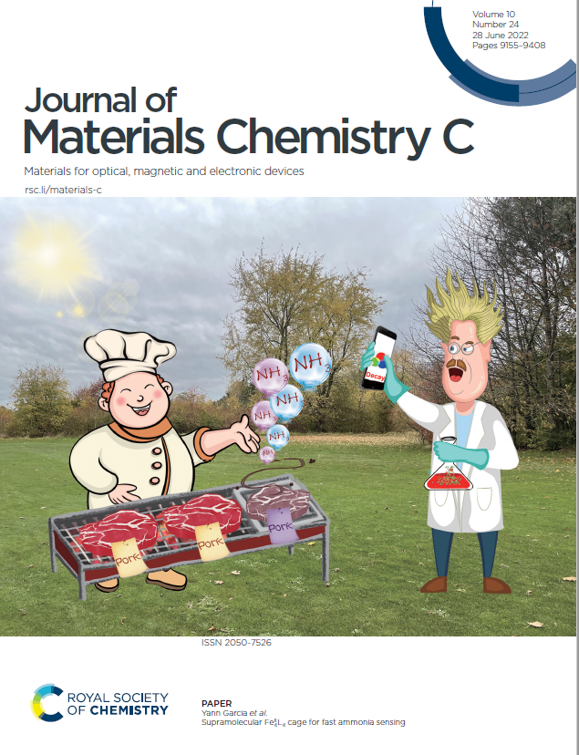
Recent Publications
- Y. Garcia, Adv. Inorg. Chem. 76 (2020) 121.
- W. Li, C. Liu, J. Kfoury, J. Oláh, K. Robeyns, M. L. Singleton,
S. Demeshko, F. Meyer, Y. Garcia, Chem. Commun. 58 (2022) 11653.
- L. Sun, A. Rotaru, K. Robeyns, Y. Garcia, Ind. Eng. Chem. Res. 60 (2021) 8799.
- W. Li, L. L. Sun, C. Liu, A. Rotaru, K. Robeyns, M. L. Singleton, Y. Garcia, J. Mater. Chem. C 10 (2022) 9216. Hot paper. Front cover.
- L. Sun, A. Rotaru, Y. Garcia, J. Hazardous Mater. (437) 2022 129364. IMCN news.
- L. Sun, W. Li, Y. Garcia, 'Mössbauer Spectroscopy: Applications in Chemistry and Materials Science'. Wiley VCH 2023.

Biography
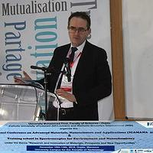 | Prof. Yann Garcia develops new sensors for various applications in material science using coordination compounds. He was awarded his doctorate in Jan. 1999 with the highest distinction at ICMCB-CNRS. He has published more than 280 papers with several cover pages of top chemistry journals, 13 book chapters in Inorganic Chemistry, a Wiley-VCH book on Mössbauer spectroscopy and two patents. h-index = 57 (14317 citations, GScholar, April 2023). He is associate editor of the Mössb. Eff. Ref. Data J. (CAS) and Chem. Synth. (OAE Pub, China). Since 2007, he chairs the Mössbauer French Speaking Society (www.gfsm.fr), and is IBAME vice chair (IBAME.org) of the International Mössbauer community since 2021. He promotes the development of chemistry at the highest level, among the next generation of Morrocan chemists. He co-chaired the International Conference on Advanced Materials, Nanosciences and Applications (ICAMANA 2019 Oujda and 2022 LLN) and two training schools on Nanochemistry.  Email: yann.garcia@uclouvain.be

