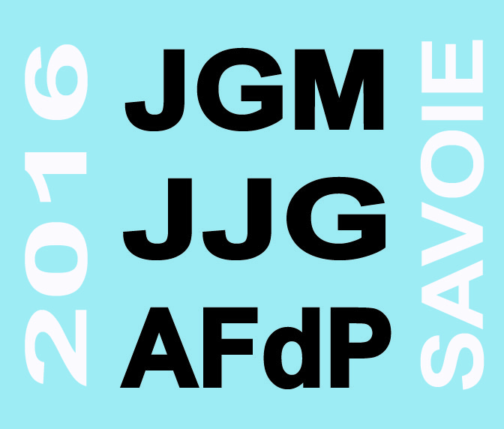
18th Joint Geomorphological Meeting
27th of June 2016 – Chambéry, France
Solicited oral communication

Anthropogenic Disturbances to Geomorphic Processes. New insights from cultural landscapes in the Western Mediterranean.
Veerle VANACKER ⁽¹⁾, Jerome SCHOONEJANS ⁽¹⁾, Yolanda AMEIJEIRAS-MARIÑO ⁽²⁾, S. OPFERGELT ⁽²⁾, Marcus CHRISTL ⁽³⁾

⁽¹⁾ Georges Lemaitre Centre for Earth and Climate Research, Earth & Life Institute, Université catholique Louvain, Belgium, ⁽²⁾Environmental Sciences, Earth & Life Institute, Université catholique Louvain, Belgium, ⁽³⁾ Ion Beam Physics Laboratory, ETH-Zurich, Switzerland
Veerle.vanacker@uclouvain.be

Abstract
Human-induced land cover changes are causing important adverse effects on the ecological services rendered by mountain ecosystems, and the number of case-studies of the impact of humans on soil erosion and sediment yield has mounted rapidly. Anthropogenic disturbance of natural vegetation can profoundly alter the physical, chemical and biological processes within soils. Rapid removal of topsoil during intense farming can result in an imbalance between soil production through chemical weathering and physical soil erosion, with direct implications on nutrient cycling, soil fertility and agricultural production.

In this talk, I will discuss new data on soil production, physical soil erosion and long-term denudation for ecosystems with strong anthropogenic disturbances. A particular focus is given to the Western Mediterranean region, as it is now commonly reported as the European region that is most affected by land degradation, and where desertification has become a major environmental, economical and political issue.

