Arterial grafts: in depth characterization of structure and mechanical properties
Lisa Leyssens¹, Natalia Béjar Ayllόn¹, Heleen Fehervary³, Valérie Lacroix⁶, Nele Famaey³, Greet Kerckhofs^{1,2,4,5,6}
1. Institute of Mechanics, Materials, and Civil Engineering, UCLouvain, Belgium; 2. Dept. Materials Science and Engineering, KU Leuven, Belgium; 3. Dept. Mechanical Engineering, KU Leuven, Belgium; 4. Prometheus, Division of Skeletal Tissue Engineering, KU Leuven, Belgium; 5. Skeletal Biology and Engineering Center, KU Leuven, Belgium; 6. Institute of Experimental and Clinical Research, UCLouvain, Brussels, Belgium.
Introduction
According to the World Health Organization, cardiovascular diseases are the number one cause of death globally [1]. In order to treat complications, proper surgical actions must be undertaken. In the case of Peripheral Arterial Disease, the blood vessel tending to calcify and occlude, one of the options is to perform arterial bypass surgery [2]. Bypasses are made using autologous vessels or prosthetic vascular conduits. The limited availability of healthy autologous blood vessels has led to the use of synthetic polymeric material [3]. The mechanical properties of the prosthetic grafts are however quite different from the autologous grafts. While the mechanical strength often provides an appropriate behavior, the existing compliance and biocompatibility mismatch can still cause several complications.
Materials, methods and results
Three types of synthetic grafts, Dacron, Gore-Tex and Vectra, were characterized, as well as native tissue. For the 3D structural characterization, high-resolution microCT was used (see figure 1). Strain-controlled planar biaxial tensile testing was used for the mechanical characterization. Regarding the native tissue, 3D visualization of rat aortas was possible in an unprecedented manner: we were able to distinguish the three different tissue layers and to highlight the elastic lamella thanks to our in-house developed contrast agents. For the synthetic grafts, a full 3D analysis was performed, highlighting important microstructural differences between the different graft materials. More specifically, for Dacron and Gore-Tex, a longitudinal orientation of the matrix was observed, providing a higher failure resistance in this direction. Dacron presented a corrugated structure, similar to the homograft lumen, which provides longitudinal elasticity. Vectra is composed of a foam in which a wire and a sheet are embedded, providing elasticity and a uniform distribution of the stresses. The forces registered from the mechanical test demonstrated a large anisotropy in Dacron, Gore-Tex and the homograft. The anisotropy in Vectra was lower compared to the others. Viscoelasticity in Dacron, Gore-Tex and the homograft samples was measured. Dacron and Gore-Tex presented a low resistance to deformation in the longitudinal direction.
Conclusion
In this study, we were able to define a cluster of experiments with which the structural and mechanical properties of different graft materials in comparison with the native artery can be defined. The characterization methods that were developed in this work can also be applied to tissue engineered vascular grafts.
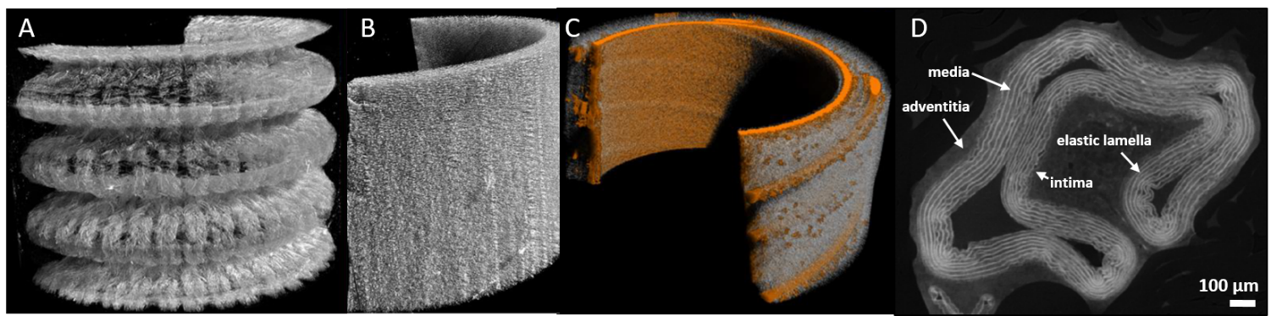
Figure 1: 3D microCT-based renderings of (A) Dacron, (B) Gore-Tex, and (C) Vectra grafts and (D) a native rat aorta. A,B and C are samples of 1x1cm

References:
[1] WHO. Cardiovascular diseases, 17 Mai 2017. (Accessed October 5, 2018)

[2] Lacroix V, PhD diss., UCLouvain, 2014

[3] Ravi S, et al., Vascular. 2009;17 Suppl 1(Suppl 1):S45–S54. doi:10.2310/6670.2008.00084

