Supplementary material

Interface temperature during electromagnetic pulse welding via precipitate kinetics
J. S. Li¹, T. Sapanathan^{1, 2, *}, R.N. Raoelison^{1, 3}, Z. Zhang⁴, X. G. Chen⁴, D. Marceau⁴, A. Simar², M. Rachik¹
¹ Sorbonne universités, Université de technologie de Compiègne, laboratoire Roberval, FRE 2012 CNRS, Centre de recherche Royallieu, CS 60319, 60203 Compiègne cedex, France
² UCLouvain, Institute of Mechanics, Materials and Civil Engineering, 1348 Louvain-la-Neuve, Belgium
³ Université de Bourgogne Franche-Comté - UTBM, Laboratoire Interdisciplinaire Carnot de Bourgogne, UMR 6303 CNRS, 90100 Belfort, France
4 Aluminium Research Centre - REGAL, University of Quebec at Chicoutimi, Chicoutimi, QC, G7H 2B1, Canada

*Corresponding author: Thaneshan Sapanathan (email: thaneshan.sapanathan@uclouvain.be)

This file includes supplementary details of;
Fig. S1 – TEM micrographs of base material ----------------------------------------------------------- Page 2
Table S1 – The evolution of precipitates vs temperature in different welding cases----------------Page 3

Fig. S1 shows the original precipitates within the AA6061-T6 matrix. TEM observations of the base metal (BM) reveal needle-shaped precipitates and dispersoids. Energy dispersive X-ray (EDX) analysis indicates these dispersoids are Mn and Cr enriched (4.85% Mn, 4.94% Cr), and thus, they correspond to typical dispersoids as previously reported by other researchers [1, 2]. Regarding the nano-sized needle-shape precipitates, they usually form within 6XXX series aluminum alloys and are responsible for the alloy hardening. They are commonly referred to as the β″ phase [3, 4]. EDX results indeed confirmed they are Mg and Si rich.
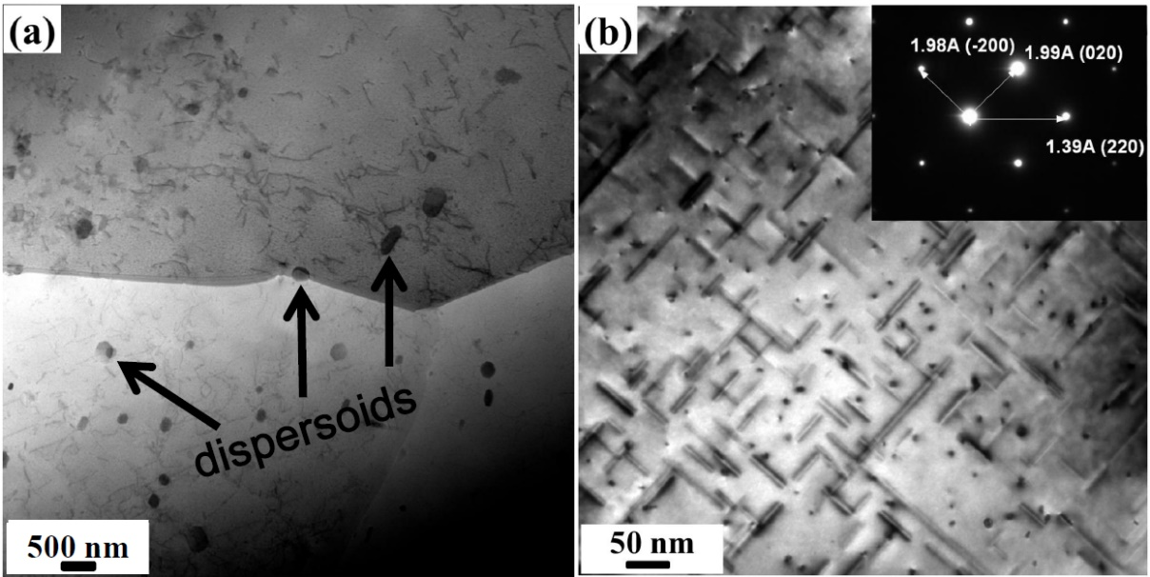
Fig. S1. (a) Bright-field (BF) TEM micrographs of AA6061-T6 in the as-received condition showing dispersoids (indicated by the black arrows); (b) Selected area electron diffraction (SAED) patterns in the matrix in AA6061-T6 showing β″ precipitates at higher resolution (SAED along [001] direction).

Welding Sample  [discharge voltage, initial air gap] | Identified zone | Precipitate dissolution | Transformation | Formation (area fraction %) | Temperature range ( °C )*
Sample 1  [6.5kV, 3mm] | IZ | β″ and βʹ dissolution | β″→βʹ, βʹ→β | βʹ+β (1.02%) | 360-500℃
Sample 1  [6.5kV, 3mm] | AZ | β″ dissolution | β″→βʹ | βʹ (0.19%) | 250-360℃
Sample 2  [7.5kV, 4mm] | IZ | β″ and βʹ dissolution | β″→βʹ, βʹ→β | βʹ+β (1.65%) | 360-500℃
Sample 2  [7.5kV, 4mm] | AZ | β″ dissolution | β″→βʹ | βʹ (0.24%) | 250-360℃
Sample 3  [8.5kV, 4mm] | IZ | β″ and β’ dissolution | β″→βʹ, βʹ→β | βʹ+β (0.09%) | 360-500℃
Sample 3  [8.5kV, 4mm] | IZ | β dissolution | β dissolution | βʹ+β (0.09%) | ＞500°C
Sample 3  [8.5kV, 4mm] | AZ | β″ dissolution | β″→βʹ | βʹ (0.77%) | 250-360℃
Table S1: The evolution of precipitates vs temperature in interface zone (IZ), shear and heat affected zone (AZ) for different welding cases.
*Temperature range based on [4-6].

References
[1] F. Hichem, G. Rebai, Appl. Phys. A. Mater. Sci. Process. 119 (2015) 285–289.
[2] K. Strobel, E. Sweet, M. Easton, J.F. Nie, M. Couper, Mater. Sci. Forum. 654–656 (2010) 926–929.
[3] D. Maisonnette, M. Suery, D. Nelias, P. Chaudet, T. Epicier, Mater. Sci. Eng. A. 528 (2011) 2718–2724.
[4] J. A. Vargas, J. E. Torres, J. A. Pacheco, R. J. Hernandez, Mater. Des. 52 (2013) 556–564.
[5] V. Malin, Weld Res Supl 74 (1995) 305-318.
[6] A. Simar, Y. Bréchet, B. de Meester, A. Denquin, T. Pardoen, Mater. Sci. Eng. A. 486 (2008) 85–95.

