Thermally Induced Fe^{II} Spin Crossover Hybrid Complex Incorporating Para-Sulfocinnamic Acid
Varun Kumar, ^{[a]} Ashta C. Ghosh,^{[a]} Youssef Draoui, ^{[a]} Mengmeng Wang, ^{[a]} Kristof van Hecke,^{[b]} Aurelian Rotaru, ^{[c]} and Yann Garcia*^{[a]}
[a] Dr. V. Kumar, Dr. A. C. Ghosh, Dr. Y. Draoui, Dr. M. Wang, Prof. Dr. Y. Garcia,
Institute of Condensed Matter and Nanosciences
Molecular Chemistry, Materials and Catalysis (IMCN/MOST)
Université catholique de Louvain, Place L. Pasteur 1, 1348 Louvain-la-Neuve, Belgium
E-mail: yann.garcia@uclouvain.be
[b] Prof. Dr. K. Van Hecke
XStruct, Department of Chemistry, Ghent University
Krijgslaan 281-S3, 9000 Ghent, Belgium
[c] Prof. Dr. A. Rotaru
Department of Electrical Engineering and Computer Science & Research Center MANSiD
Stefan cel Mare
University, University Street, No. 13, Suceava 720229, Romania

Abstract: Anion-Driven Light-Induced Spin Change (AD-LISC) enables multifunctional materials to switch magnetic states with light, enhancing potential applications in data storage, sensors, and molecular electronics, by improving spin state control by integrating photoactive anions. In this study, we report the synthesis and characterization of new mononuclear Fe^{II} coordination complex, [Fe(3-bpp)₂](psca)₂∙solvent (1∙X) as determined by single-crystal X-ray diffraction. The structure incorporates para-sulfocinnamic acid (psca), non-coordinated anion as well as unidentified disorded solvent molecules (X). TGA analysis confirmed the presence of 2.5 water molecules as solvent in the crystal lattice after exposure to air. Moreover, ⁵⁷Fe Mössbauer spectroscopy and magnetic susceptibility measurements (SQUID) reveals a mixture of high-spin and low-spin states in 1∙2.5H₂O, with a predominance of low-spin sites at room temperature. The desolvated form 1 shows a gradual spin crossover behaviour centred around the room temperature region. Additionally, single crystal X-ray diffraction, evaluated according to Schmidt's criteria for [2 + 2] photodimerization, revealed that 1∙X does not satisfy the spatial requirements for photodimerization; accordingly, no colour change was noticed upon UV light exposure.
Introduction
The integration of inorganic and organic functionalities to create multifunctional hybrid materials is an attractive research area, driven by the development of new properties beyond their inherent characteristics. ^{[1–3]} By combining distinct qualities of organic and inorganic components, materials with enhanced or novel features such as improved stability, catalytic performance, and responsiveness to external stimuli have been developed. ^{[4–6]} This approach has led to advancements in electronics, biomedicine, optoelectronics and environmental remediation. ^{[7–10]} Coordination compounds serve as key examples, as they maintain the properties of their constituents while introducing new behaviours from their interactions. Their structural versatility makes them ideal candidates for applications requiring specific reactivity, selectivity or environmental responsiveness, positioning them as a prominent focus in multifunctional material design. ^{[10–14]}
Fe^{II} spin crossover (SCO) compounds represent a notable class of coordination compounds that alternate between high-spin (HS) and low-spin (LS) states in response to stimuli like temperature, light and pressure.^{[15–17]} This reversible transition modifies their physical properties, such as color, magnetic moment, and geometry, enabling applications in sensor technologies, data storage and optical switches.^{[18–23]} Thermally induced SCO materials have gained tremendous attention for their valuable temperature-sensitiveness applications, such as thermochromic and thermomagnetic sensors for safety and monitoring.^{[24,25]} Their bistable spin states are also useful in data storage and memory, with tunable transition temperatures enhancing their potential in smart coatings, environmental sensing and thermal actuators.^{[26]}

To achieve SCO in Fe^{II} compounds, heterocyclic ligands with nitrogen donor atoms are commonly used due to their optimal ligand field strength. In this context, we selected the 3-bpp ligand (2,6-di(pyrazol-3-yl)pyridine), which is known to generate the required ligand field to induce SCO behaviour. The tridentate 3-bpp ligand typically forms stable mononuclear Fe^{II} complexes [Fe(3-bpp)₂]²⁺ together with counter-anions, a configuration ideal for observing the SCO effect.^{[27–28]} Another reason for selecting the [Fe(3-bpp)₂]²⁺ coordination complex is that it readily forms in single-crystalline form, through a template effect,^{[29]} allowing precise crystal structure determination.^{[30]} Additionally, the cationic [Fe(3-bpp)₂]²⁺ framework can host a range of non-coordinated anions, from simple inorganic species to more complex cyanometallates, enhancing its versatility in SCO studies.^{[28,31–33]} In fact, the SCO behaviour of these compounds was shown to be strongly influenced by the nature of the counter-anions and solvent molecules present in the structure. For instance, in a systematic study of [Fe(3-bpp)₂]A₂⋅nH₂O complexes (where A = BF₄⁻, NCS⁻, NCSe⁻, I⁻), Sugiyarto et al. demonstrated that the choice of anion significantly affects the thermal SCO behaviour, with each anion producing distinct spin transition characteristics.^{[28]} With the aim to produce an hybrid functional material, we delved into the [2 + 2] photodimerization of sulfonate derivatives of trans-cinnamic acid, showcasing their potential as counter-anions to initiate an Anion Driven Light Induced Spin Change (AD-LISC) which could allow indirect spin state photo control.^{[34]} In a significant advancement, we prepared a novel Fe^{II} based coordination polymer that incorporates para-sulfocinnamic acid (psca) as a counter-anion.^{[35]} Remarkably, this complex demonstrated light-induced spin state switching at room temperature in the solid state, underscoring its potential as a groundbreaking material in the field of SCO applications. This work not only highlighted the innovative use of sulfonate derivatives but also paved the way for further exploration of dynamic materials capable of responding to external stimuli.^{[35]}

Considering the existing literature, the primary objective of the present account was to synthesize a novel [Fe(3-bpp)₂]²⁺ coordination complex with psca as a counter-anion. In addition, the inclusion of psca not only enhances the compatibility with cationic moieties due to the sulfonate group’s permanent negative charge^{[36]} but also serves as a foundation to explore photophysical properties of this newly emerged coordination complex. Thus, this work centres on the synthesis and characterization of new mononuclear Fe^{II} complex [Fe(3-bpp)₂](psca)₂∙solvent (1∙X). This study covers the synthesis, characterization with detailed analyses of its crystal structure, magnetic properties, and the effects of UV irradiation in the solid form.
Results and Discussion
Synthesis
The standard method for synthesizing Fe^{II} coordination compounds with heterocyclic ligands and non-coordinated sulfonate anions typically involves the initial synthesis of a hexaaqua iron(II) complex.^{[37]} In such salt structure, six water molecules are coordinated directly to the Fe^{II} centre, while the sulfonate anions remain as external, non-coordinated entities. These water molecules can be readily substituted by other ligands, such as nitrogen-donor heterocycles,^{[37-39]} making hexaaqua iron(II) complexes versatile precursors for constructing various coordination compounds. In this study, in order to bring Fe^{II} into association with psca, we synthesized the following salt, [Fe(H₂O)₆](psca)₂⋅2H₂O,^{[34]} as a precursor for the target coordination complex. On the other hand, the 3-bpp molecule intended to replace coordinated H₂O molecules in [Fe(H₂O)₆](psca)₂⋅2H₂O was also prepared following a literature report. ^{[40]}

To synthesize the target compound (Scheme 1), [Fe(H₂O)₆](psca)₂⋅2H₂O and the tridentate molecule 3-bpp were combined in a 1:2 molar ratio. Upon mixing methanolic solutions of the freshly prepared precursors with 3-bpp, the reaction mixture turned red instantly, with the colour intensifying over time. The mixture was then stirred at 40°C for 45 min, to ensure the reaction proceeded to completion. To promote crystallization, diethyl ether was slowly vapour-diffused into the solution,^{[41]} yielding red rectangular crystals of 1∙X (X = disordered solvent molecules), ideal for crystal structure analysis.

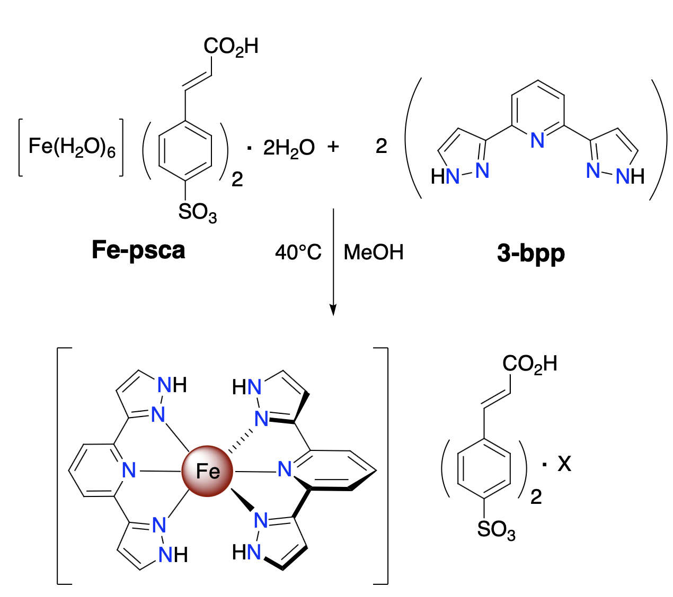
Scheme 1. Synthetic route of 1∙X.
Crystal structure
1∙X was characterized by X-ray diffraction by flash cooling single-crystals at 100 K immediately, after being extracted from the mother liquor. It crystallizes in the P2₁/c space group. The asymmetric unit consists of one Fe^{II} ion, two 3-bpp ligands and two psca molecules, as illustrated in Figure 1(a). The Fe^{II} centre is coordinated in an Fe-N₆ octahedral arrangement, where each tridentate 3-bpp ligand binds through its three nitrogen atoms from the pyridine and pyrazole rings. The pyridine rings occupy the octahedron’s apical positions. Outside the coordination sphere, two psca molecules serve as counter-anions. Each 3-bpp ligand adopts a planar structure, intersecting at an angle of 86°, a typical coordination geometry where the planar molecules align nearly perpendicularly at ~90°.^{[42]} The Fe^{II} ion exhibits a highly distorted octahedral coordination geometry, with distortion parameters Σ = 96.7° and Θ = 316.5°.^{[43]} The Fe-N bond lengths range from 1.93 to 1.98 Å, suggesting a predominant low-spin (LS) state for 1 at 100 K, the temperature used during collection of X-ray diffraction data. Further octahedral geometry parameters are provided in Table 1. ^{[44]} Co-crystallized (and highly disordered) solvent molecules were detected, but could neither be identified nor modelled.

The unit cell is shown in Figure 1(b). The shortest distance between the nearest vinyl bonds of psca molecules (C29-C30 to C38-C39) is 5.44 Å, exceeding the 4.2 Å limit required for photodimerization.^{[45]} Consequently, the spatial arrangement of psca anions in 1∙X does not satisfy Schmidt’s topochemical criteria for [2+2] photodimerization due to their unfavourable positioning. ^{[46,47]} In fact, no colour change was observed after irradiation with UV light which further proves the unsuccessful photodimerization. All distances between the closest vinyl bonds are indicated in Figure 1 (b).

Figure 2 shows the crystal packing of 1∙X along the b-axis. The [Fe(3-bpp)₂]²⁺ coordination spheres align along the b-axis, separated by psca molecules positioned between them. When viewed along the c-axis, four psca molecules are situated between two [Fe(3-bpp)₂]²⁺ units. Due to the large size of the 3-bpp ligands, the molecules maintain spacing to reduce steric repulsions, which also contributes to the larger distance between psca vinyl bonds, preventing photodimerization.
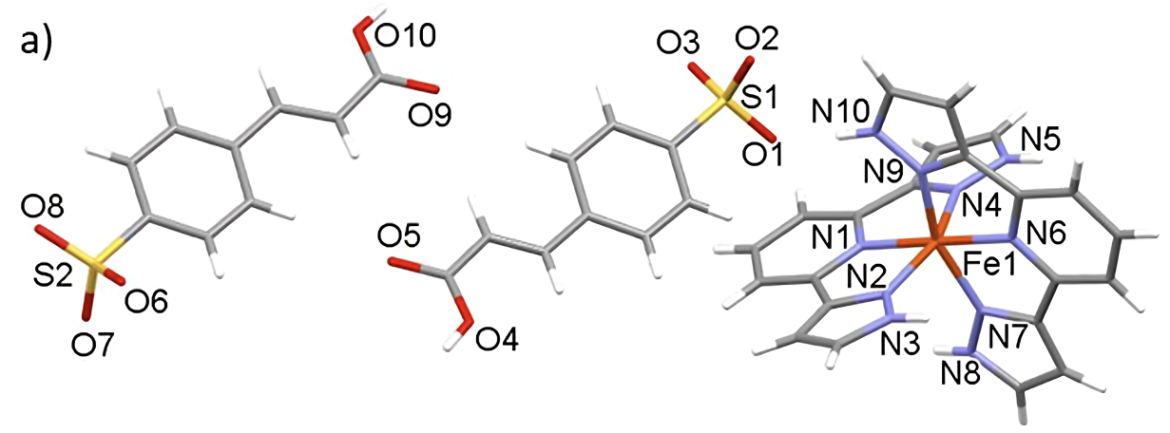
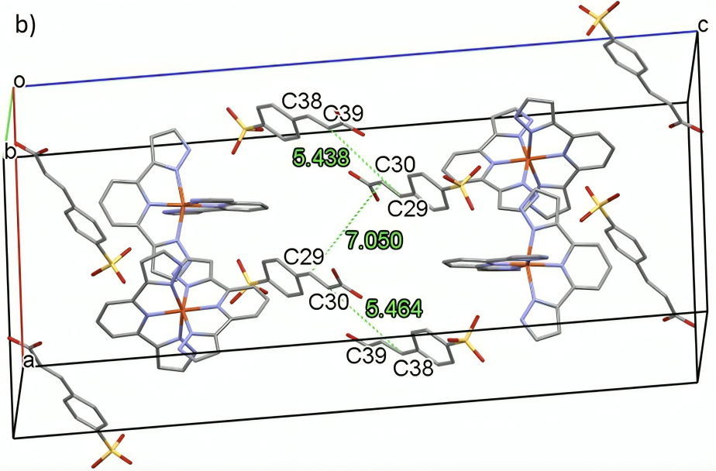
Figure 1. Crystal structure of 1∙X. (a) Asymmetric unit, (b) unit cell with marked distances between photodimerizable vinyl bonds. Hydrogen atoms are omitted for clarity in (b). Colour code: Fe (orange), N (blue), C (dark grey). O (red), S (yellow), H (light grey).
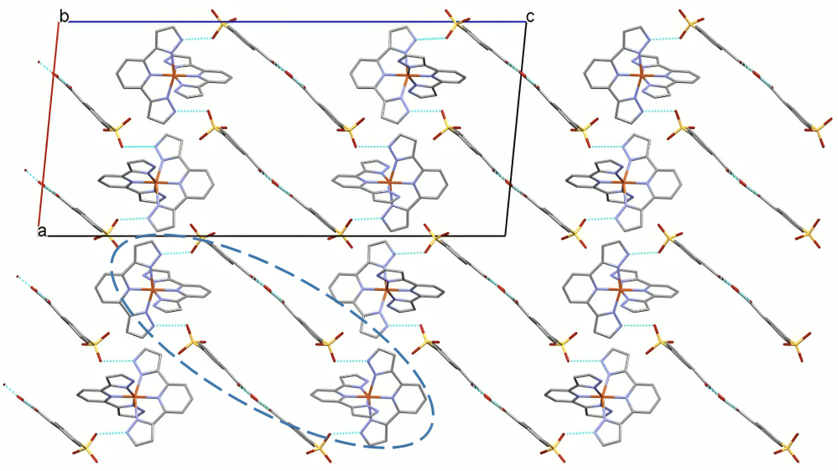
Figure 2. Crystal packing of 1∙X, when viewed down the b-axis. Hydrogen bonds are marked in cyan colour. Hydrogen atoms were omitted for clarity.
Compared to [Fe(H₂O)₆](psca)₂⋅2H₂O, which has smaller H₂O ligands, 1∙X has a more open structure, allowing psca molecules to pack closely enough in [Fe(H₂O)₆](psca)₂⋅2H₂O to eventually meet the photodimerization criteria. Hydrogen bonding involves two psca molecules, connected via carboxylic groups, bridging two Fe^{II} ions along with 3-bpp ligands. Only one 3-bpp ligand from each coordination sphere participates in hydrogen bonding, limiting the network to two Fe^{II} centres, with D-H···A bond distances between 2.63(3) - 2.72(3) Å (Table 2). Due to large molecular distances, no π-π or C-H···π interactions were observed.
Table 1. Bon distances (Å) and angles (°) of the octahedral coordination sphere in 1∙X.
Bond distance (Å) |  | Bond angle (°)
Fe1-N1 | 1.94 | N7-Fe1-N2 | 94.5
Fe1-N2 | 1.99 | N2-Fe1-N6 | 101.3
Fe1-N4 | 1.98 | N6-Fe1-N9 | 79.0
Fe1-N6 | 1.93 | N9-Fe1-N4 | 92.9
Fe1-N7 | 1.97 | N4-Fe1-N1 | 79.1
Fe1-N9 | 1.97 | N1-Fe1-N7 | 100.1
Table 2. Hydrogen bonding parameters of 1∙X.
D-H···A | Molecular interaction | D-H  (Å) | H···A (Å) | D···A  (Å) | ∠D-H-A ( ̊ )
O(4)--H(4A)···O(9) | Inter | 0.85(3) | 1.81(3) | 2.650 (4) | 172(4)
N(8)--H(8)···O(7) | Inter | 0.88(2) | 1.85(2) | 2.716 (3) | 166(4)
N(10)--H(10)···O(1) | Inter | 0.89(1) | 1.85(1) | 2.72 (3) | 171(4)
O(10)--H(10B)···O(5) | Inter | 0.85(3) | 1.78(3) | 2.632 (4) | 177(4)
Next, single crystals of 1∙X were exposed to air. The crystals degeneration was observed quickly after separation from the mother liquor, indicating the possible loss of lattice solvents. Upon exposure in the air, water molecules might get into the crystal lattice, which is further investigated by thermogravimetric analysis (TGA), CHN, ⁵⁷Fe Mössbauer spectroscopy and SQUID analysis.
Thermogravimetric analysis (TGA)
The TGA curve for the sample after exposure to air (Figure 3) was measured with a temperature cycle from 298 K to 473 K at 5 K/min to assess the number of associated water molecules. After reaching 473 K, the temperature was lowered back to 298 K at the same rate and held constant for 60 min. to monitor potential rehydration.^{[38]} All measurements were performed in air. Starting at 320 K, rapid mass loss, reaching a total of 4.8% by 408 K, which corresponds to ca. 2.5 water molecules was observed, thus confirming the formula [Fe(3-bpp)₂](psca)₂∙2.5H₂O (1∙2.5H₂O). During the cooling cycle, no significant mass gain was observed, indicating 1 does not rehydrate after water loss, unlike other reported [Fe(3-bpp)₂]²⁺ complexes.
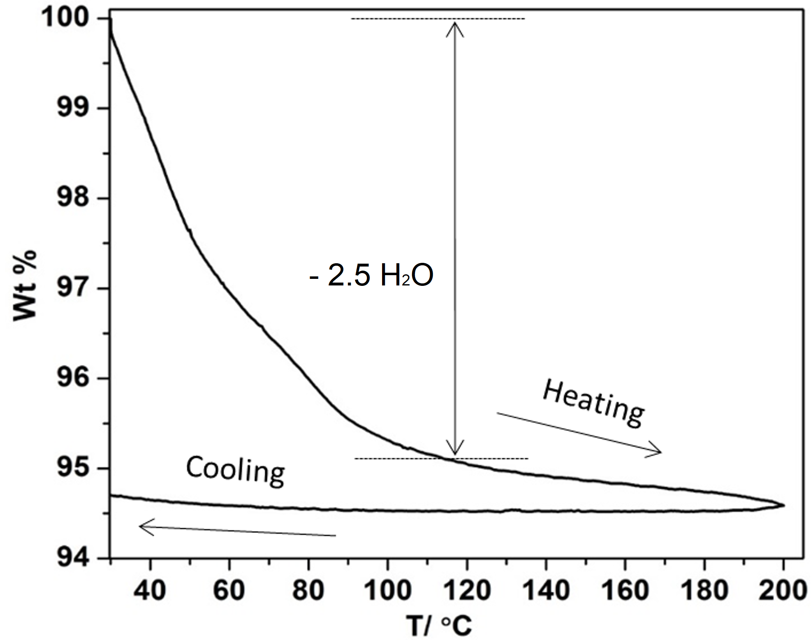
Figure 3. TGA curve to determine solvent content
⁵⁷Fe Mössbauer spectroscopy
⁵⁷Fe Mössbauer spectra of 1∙2.5H₂O were recorded at 78 K and 293 K (Figure 4). These were fitted to the sum of Lorentzian lines by a least-squares refinement using Recoil 1.05 Mössbauer Analysis Software^{[48]} to leads to hyperfine parameters listed in Table 3. At 293 K, a major doublet (highlighted in blue) with an isomer shift of δ = 0.38 mm/s and quadrupole splitting of ΔE_{Q} = 0.65 mm/s is observed, characteristic of LS Fe^{II} ions. Additionally, a secondary doublet (highlighted in red) with δ = 1.12 mm/s and ΔE_{Q} = 2.95 mm/s is found, representing Fe^{II} HS ions in an FeN₆ environment. Hyperfine parameters align with previous Mössbauer reports for [Fe(3-bpp)₂]²⁺ complexes,^{[28,31,32]} where the large quadrupole splitting of the HS doublet arises from valence contributions to the electric field gradient, linked to the distorted octahedral geometry around Fe^{II}. Meanwhile, the LS doublet’s quadrupole splitting results from lattice contributions.^{[49,50]} The fitting analysis indicates that ~22% of Fe^{II} sites are HS, and ~78% are LS, confirming that LS Fe^{II} species predominate in 1∙2.5H₂O at room temperature. These values need however to be taken with caution given that Lamb Mössbauer factors of both spin states were not evaluated, and that vacuum conditions of the samples tested for Mössbauer spectrum and magnetic data are different, thus preventing any precise comparison of spin populations with SQUID data.

Meanwhile, the Mössbauer spectrum recorded at 78 K closely resembles the one at 293 K, showing two distinct doublets (in red and blue) corresponding to Fe^{II} HS and LS states, with hyperfine parameters listed in Table 3. The proportion of Fe^{II} sites in the LS state, however, increases to ~85%, while the HS occupancy drops to ~15%. This shift is the signature of a gradual and partial CO behaviour occurring in 1∙2.5H₂O, on cooling below room temperature, as also suggested by the SQUID analysis (Fig. 5). The persistence of HS states at 77 K indicates that 1∙2.5H₂O undergoes an incomplete thermal spin transition, as found in several Fe^{II} mononuclear complexes.^{[51-54]}

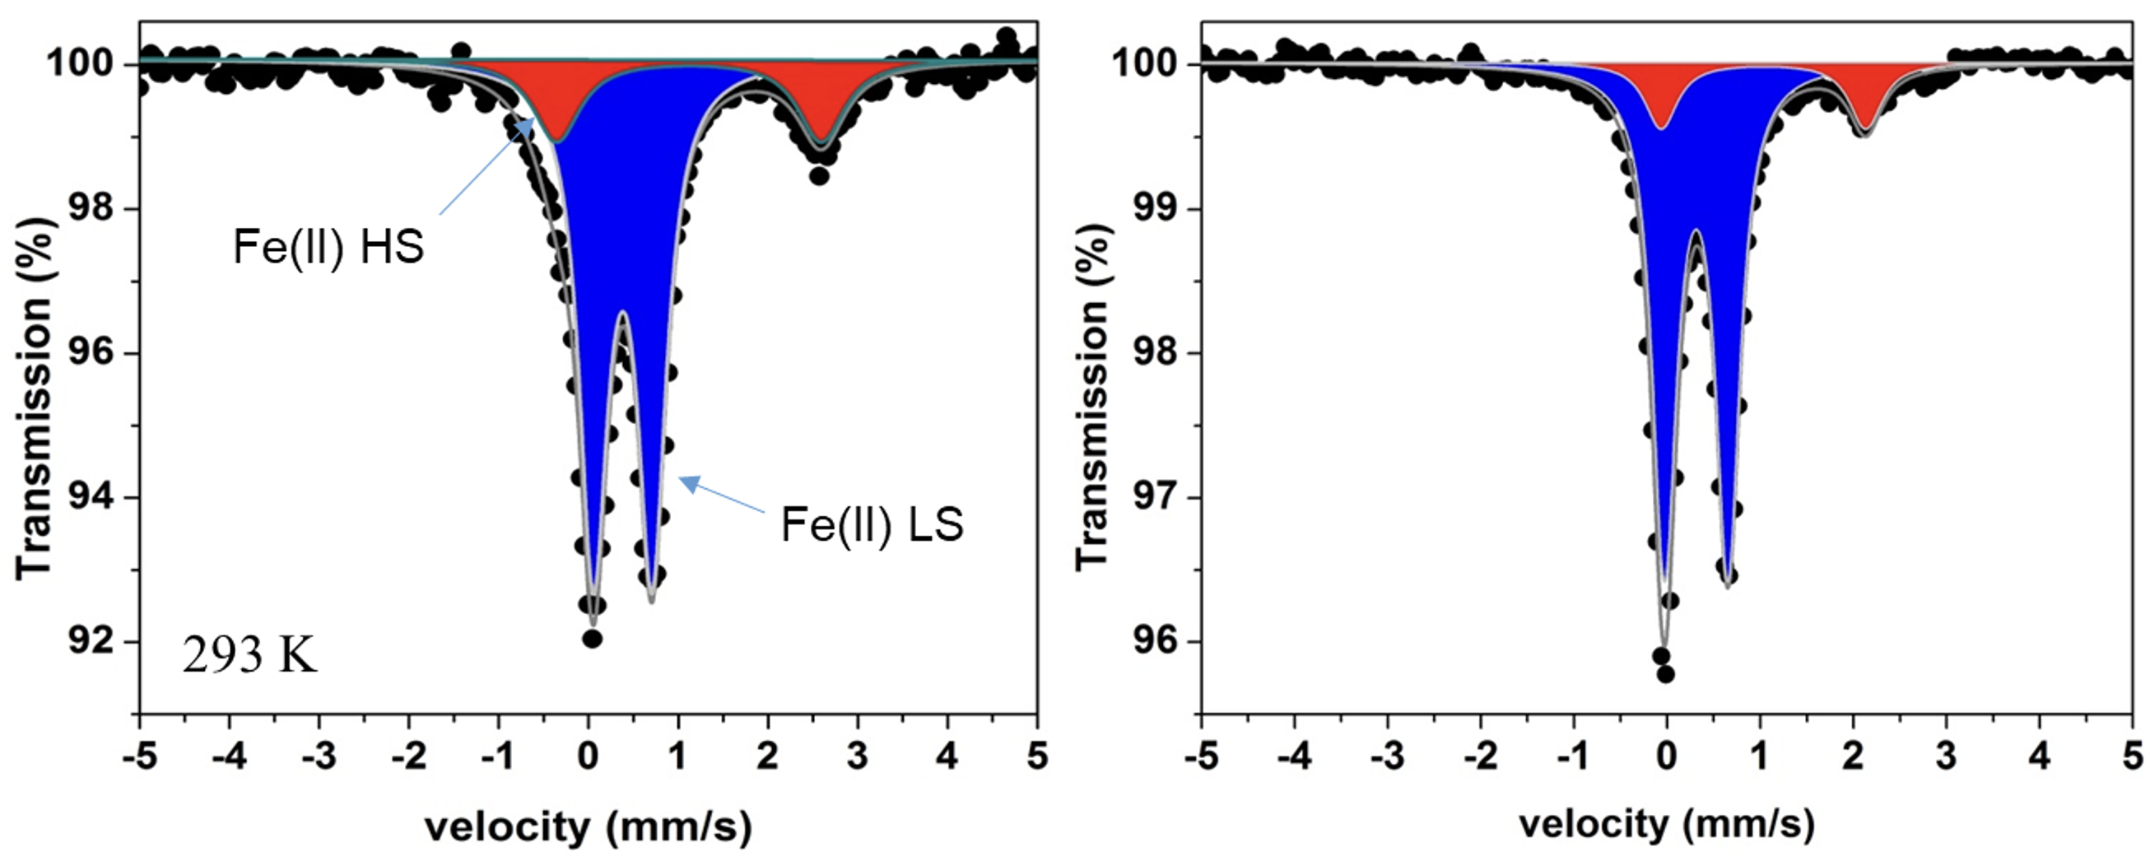

Figure 4. ⁵⁷Fe Mössbauer spectrum of 1∙2.5H₂O at room temperature (left) and 78 K (right).
Table 3. ⁵⁷Fe Mössbauer parameters for 1∙2.5H₂O at 78 K and 298 K. Isomer shift (δ) are given with respect to metallic α-Fe. Γ/2 = half width of the lines.
Temperature (K) | Sites | δ  (mm/s) | ΔE_{Q}  (mm/s) | Γ/2  (mm/s) | Fraction  (%)
293 | Fe^{II} HS  Fe^{II} LS | 1.12(1)  0.38(2) | 2.95(1)  0.65(5) | 0.25(1)  0.19(3) | 21.6  78.4
78 | Fe^{II} HS  Fe^{II} LS | 1.03(1)  0.31(1) | 2.19(1)  0.68(3) | 0.23(2)  0.19(2) | 15.3  84.7

SQUID Magnetometry
Figure 5 displays the magnetic susceptibility measurements for 1∙2.5H₂O, conducted over the temperature range of 4 K to 400 K. The measurements were taken in three sequences: (i) 298 K to 4 K to 400 K (pathways 1 and 2); (ii) 400 K to 4 K to 400 K (pathways 3 and 4); and (iii) 400 K to 4 K to 400 K.

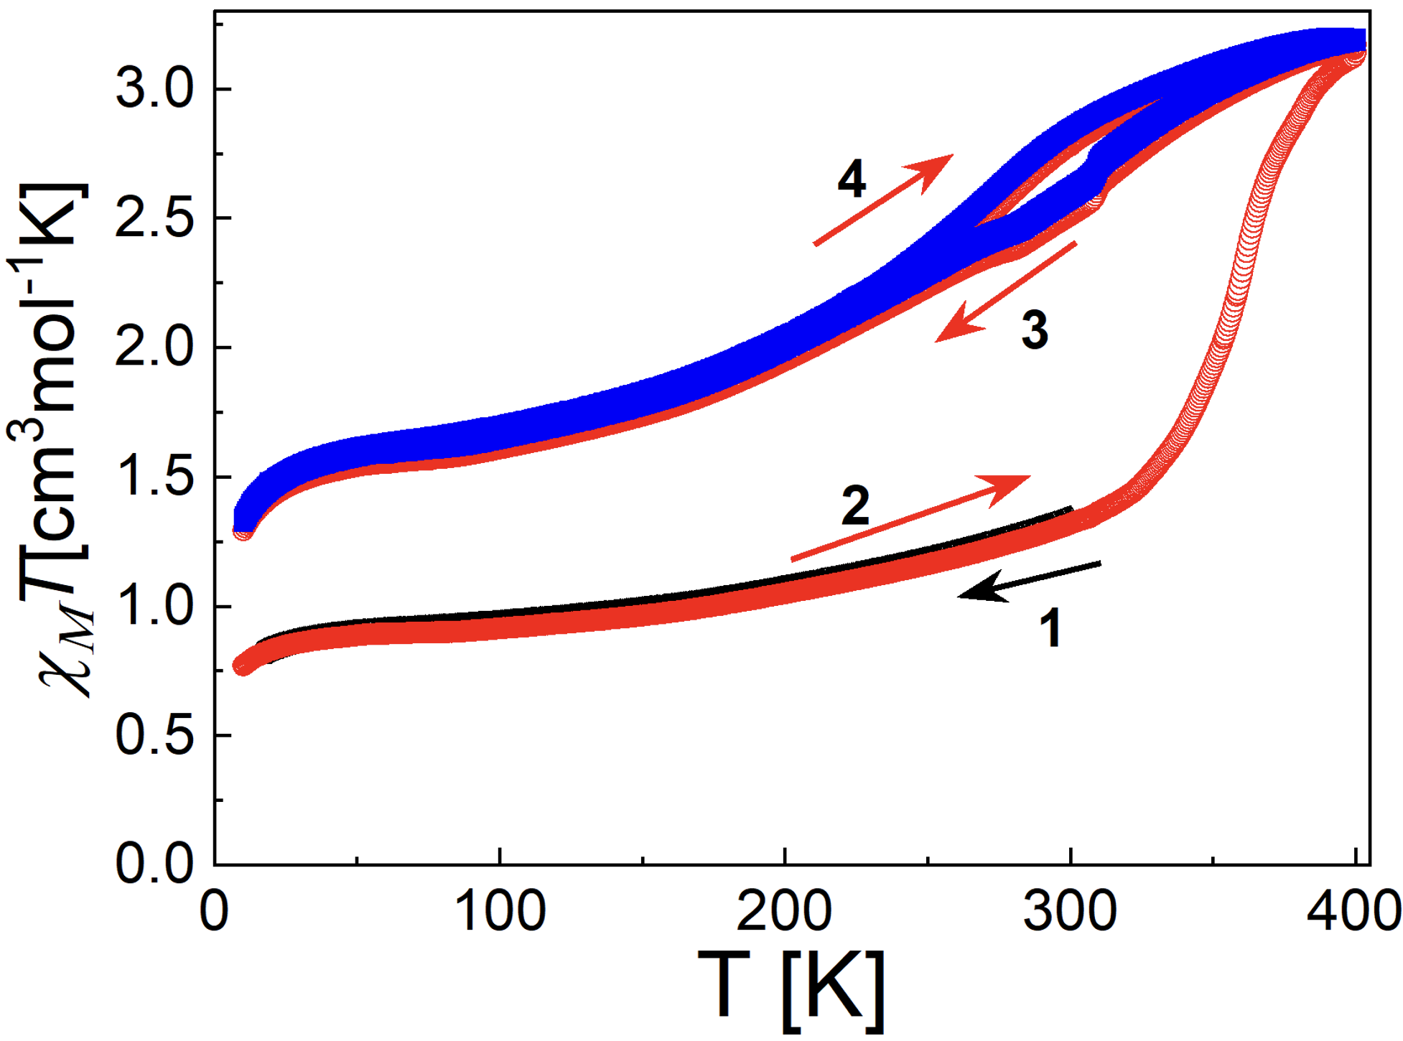Figure 5. χ_{M}T vs. T plot for 1∙2.5H₂O with indicated thermal sequences and pathways, from 1 to 4.
In the first measurement sequence, susceptibility data indicate that 1∙2.5H₂O at room temperature is a mixture of HS and LS states, with LS states prevailing, which is consistent with the Mössbauer spectral data. As the temperature drops, the gradual decrease in the χ_{M}T product shows that LS state occupancy increases with cooling. Below 50 K, a decline in χ_{M}T suggests zero-field splitting from Fe^{II} ions, due to octahedral distortions.^{[55]} When the temperature rises from 4 K to 400 K, a steady increase in the χ_{M}T product, above 300 K, indicates that HS states become more favourable at higher temperatures, reaching a value of 3.1 cm³ K mol⁻¹ at 400 K. This sharp rise is attributed to the loss of lattice solvents as indicated by TGA analysis, which leads to more HS occupation.
In the second temperature sequence, both cooling to 4 K and warming back to 400 K exhibit gradual SCO behaviour, accompanied by a hysteresis loop, centred around the room temperature region. The small hysteresis loop indicates that there might be small amount of cooperative interactions remaining between spin switching molecules after losing lattice solvents during heating. The χ_{M}T product does not drop to zero at any temperature, given that 1∙2.5H₂O undergoes, on cooling, a partial thermal spin transition, as suggested by low-temperature Mössbauer results. Partial spin transitions are frequently observed in Fe^{II} complexes after solvent loss,^{[39,56]} as a result of the creation of defects in the crystal lattice.
The apparent discrepancy between magnetic properties of 1∙2.5H₂O revealing an incomplete SCO and the crystal structure of 1∙X showing LS ions at 100 K is due to the fact that for the crystal structure determination, crystals were flash cooled immediately, after being extracted from the mother liquor, thus keeping all solvents molecules, which favour in this case the LS state.

Experimental section
Material and instruments
All solvents and chemicals were sourced from standard suppliers, were of analytical grade and used as received without further purification. The compound 2,6-di(pyrazol-3-yl)pyridine (3-bpp) was synthesized following an established method,^{[40]} as well as the precursor [Fe(H₂O)₆](psca)₂⋅2H₂O.^{[34]} Elemental analysis (C, H, and N) was conducted at MEDAC Ltd, UK. Single crystal X-ray diffraction (XRD) data for 1∙X were obtained at 100 K on a Rigaku Oxford Diffraction SuperNova, Dual Source, Cu at zero, diffractometer, equipped with an Atlas CCD detector, using ω scans and MoK_{α} radiation (λ = 0.71073 Å). Magnetic susceptibility measurements of 1∙2.5H₂O were performed on a MPMS3 SQUID magnetometer (Quantum Design Inc.) in DC mode, applying a 1000 Oe field with a 2 K/min temperature rate. Magnetic data were corrected for both sample holder and diamagnetic effect. ⁵⁷Fe Mössbauer spectra were recorded at room temperature in transmission geometry mode with a constant acceleration mode conventional WissEl Mössbauer spectrometer equipped with a ⁵⁷Co(Rh) radioactive source, a Reuter Stokes proportional counter detector and a CMCA-550 multichannel analyzer. Data were also recorded at 78 K using an Elscint Ltd spectrometer operating in transmission geometry. Samples were sealed in pure aluminum foil and mounted on an Oxford instrument nitrogen bath cryostat. All isomer shifts are given related to α-Fe at room temperature, used as a reference. TGA were performed in air (100 mL/min) at the heating rate of 5° C/min from 298 to 408 K using a Mettler Toledo TGA/SDTA 851e analyzer.
Synthesis
Synthesis of 1∙X: 0.422 g (2 mmol) of 3-bpp was first dissolved in hot methanol (5 mL). A separate solution of 0.654 g (1 mmol) of [Fe(H₂O)₆](psca)₂⋅2H₂O was dissolved in hot methanol (20 mL) and then added to the 3-bpp solution. Upon addition, the reaction mixture turned red instantly. This mixture was stirred at 40°C for 45 min. After stirring, diethyl ether was introduced through vapor diffusion into the mixture. Over the course of 2-3 days, red rectangular crystals formed and were collected for further analysis. Yield 0.45 g (46%), Anal. Calc. for C₄₀H₃₂FeN₁₀O₁₀S₂, 2.5H₂O: C, 49.14; H, 3.81; N, 14.33. Found: C, 48.89; H, 3.78; N, 13.91, indicating the formation of 1∙2.5H₂O

Single crystal X-ray diffraction
Data reduction and integration were carried out using CrysAlisPRO software from Rigaku Oxford Diffraction, ^{[57]} which includes an absorption correction feature. The structures were solved by Direct Methods, SHELXT, ^{[58]} and refined by full-matrix least squares minimization on F² using SHELXL2014/7.^{[59]} Complex 1∙X was processed using Olex2 software^{[60]} as a graphical user interface. Non-hydrogen atoms were refined anisotropically, while hydrogen atoms were placed in calculated positions and refined in riding mode, with isotropic temperature factors fixed at 1.2 times U_{eq} of the parent atoms (1.5 for hydroxyl groups). CCDC 2402810 contains the supplementary crystallographic data for this paper. These data can be obtained free of charge from The Cambridge Crystallographic Data Centre via www.ccdc.cam.ac.uk/structures.

Conclusion
In this study, we successfully synthesized and characterized the novel mononuclear Fe^{II} complexes [Fe(3-bpp)₂](psca)₂∙solvent incorporating para-sulfocinnamic acid (psca) as a non-coordinated anion. 1∙2.5H₂O shows a very gradual SCO behaviour over the range 4-300 K. After desolvation, a gradual but hysteretic transition centred around the room temperature region is observed. Unlike [Fe(H₂O)₆](psca)₂⋅2H₂O, 1∙X does not exhibit photodimerization, due to the greater distances between psca molecules, which did not meet Schmidt’s criteria for photodimerization. These findings provide however valuable insights into the spatial arrangements of psca in Fe^{II} complexes with differing sizes, from smaller [Fe(H₂O)₆]²⁺ spheres to larger [Fe(3-bpp)₂]²⁺ ones. This structural understanding provides a solid foundation for the next phase of synthetic design of Fe^{II} coordination complexes displaying the Anion Driven Light Induced Spin Change.

Acknowledgements
This research was supported by the Fonds de la Recherche Scientifique-FNRS (PDR T.0095.21, CDR J.0064.23, FC 53249). KVH thanks the Research Foundation – Flanders (FWO) (project G0A8723N) for funding. AR thanks UEFSCDI for the financial support through the project number PNIII-P1-1.1-TE-2019-2194 (Contract No: TE 123/2020).
Keywords: Spin crossover • Fe^{II} coordination complexes • hysteresis • solid state photoreactivity • photodimerization.
[1] H. Yao, F. Zhang, G. Zhang, H. Luo, L. Liu, M. Shen, Y. Yang, J. Chem. Eng. 2018, 334, 2547–2557.
[2] M. S. Saveleva, K. Eftekhari, A. Abalymov, T. E. L. Douglas, D. Volodkin, B. V. Parakhonskiy, A. G. Skirtach, Front. Chem. 2019, 7, 179.
[3] G. Cavallaro, S. Micciulla, L. Chiappisi, G. Lazzara, J. Mater. Chem. B 2021, 9, 594–611.
[4] D. D. Kumar, A. V. Arasu, Renew. Sustain. Energy Rev. 2018, 81, 1669–1689.
[5] M. Mohammadi, M. Khodamorady, B. Tahmasbi, K. Bahrami, A. Ghorbani-Choghamarani, Ind. Eng. Chem. Res. 2021, 97, 1–78.
[6] L. Ren, X. Xu, Y. Du, K. Kalantar-Zadeh, S. X. Dou, Mater.Today 2020, 34, 92–114.
[7] Z. Ren, J. Yang, D. Qi, P. Sonar, L. Liu, Z. Lou, G. Shen, Z. Wei, Adv. Mater. Technol. 2021, 6, 2000889.
[8] R. Sanchis-Gual, M. Coronado-Puchau, T. Mallah, E. Coronado, Coord. Chem. Rev. 2023, 480, 215025.
[9] J. Sun, Y. Choi, Y. J. Choi, S. Kim, J. Park, S. Lee, J. H. Cho, Adv. Mater. 2019, 31, 1803831.
[10] S. Radi, C. E. Abiad, N. M. M. Moura, M. A. F. Faustino, M. G. P. M. S. Neves, J. H azard. Mater. 2019, 370, 80–90.
[11] N. Lehnert, E. Kim, H. T. Dong, J. B. Harland, A. P. Hunt, E. C. Manickas, K. M. Oakley, J. Pham, G. C. Reed, V. S. Alfaro, Chem. Rev. 2021, 121, 14682–14905.
[12] Y. Draoui, S. Radi, Y. Bahjou, A. Idir, A. El Mahdaoui, A. Zyad, H. N. Miras, M. Ferbinteanu, A. Rotaru, Y. Garcia, RSC Adv. 2023, 13, 36158–36167.
[13] T. Rasheed, F. Nabeel, Coord. Chem. Rev. 2019, 401, 213065.
[14] J. Malinowski, D. Zych, D. Jacewicz, B. Gawdzik, J. Drzeżdżon, IJMS 2020, 21, 5443.
[15] Y. Zhang, R. Torres-Cavanillas, X. Yan, Y. Zeng, M. Jiang, M. Clemente-León, E. Coronado and S. Shi, Chem. Soc. Rev., 2024, 53, 8764–8789.
[16] P. Gütlich, A. B. Gaspar and Y. Garcia, Beilstein J. Org. Chem., 2013, 9, 342–391.
[17] Y. Wang, J. Ying, Z. Zhou, J. Sun, T. Wen, Y. Zhou, N. Li, Q. Zhang, F. Han, Y. Xiao, P. Chow, W. Yang, V. V. Struzhkin, Y. Zhao, H. Mao, Nat. Commun. 2018, 9, 1914.
[18] B. Benaicha, K. Van Do, A. Yangui, N. Pittala, A. Lusson, M. Sy, G. Bouchez, H. Fourati, C. J. Gómez-García, S. Triki, K. Boukheddaden, Chem. Sci. 2019, 10, 6791–6798.
[19] L. Sun, A. Rotaru, Y. Garcia, J. Hazardous Mater. 2022, 437, 129364
[20] W. Li, L. Sun, C. Liu, A. Rotaru, K. Robeyns, M. L. Singleton, Y. Garcia
J. Mater. Chem. C 2022, 10, 9216 - 9221.
[21] K. S. Kumar, M. Ruben, Coord. Chem. Rev. 2017, 346, 176–205.
[22] K. Rajendiran, S. T. Yoganandham, S. Arumugam, D. Arumugam, K. Thananjeyan, J. Mol. Liq. 2021, 321, 114793.
[23] Y. Garcia, F. Robert, A. D. Naik, G. Zhou, B. Tinant, K. Robeyns, S. Michotte, L. Piraux, J. Am. Chem. Soc. 2011, 133, 15850-15853.
[24] V. Jornet‐Mollá, C. Giménez‐Saiz, D. S. Yufit, J. A. K. Howard, F. M. Romero, Chem. Eur. J. 2021, 27, 740–750.
[25] O. G. Shakirova, L. G. Lavrenova, Crystals 2020, 10, 843.
[26] J. E. Angulo-Cervera, M. Piedrahita-Bello, B. Martin, S. E. Alavi, W. Nicolazzi, L. Salmon, G. Molnár, A. Bousseksou, Mater. Adv. 2022, 3, 5131–5137.
[27] M. A. Halcrow, New J. Chem. 2014, 38, 1868–1882.
[28] K. Sugiyarto, D. Craig, A. Rae, H. Goodwin, Aust. J. Chem. 1994, 47, 869.
[29] F. Robert, A. D. Naik, B. Tinant, Y. Garcia, Inorg. Chim. Acta 2012, 380, 104-113.
[30] M. A. Halcrow, Coord. Chem. Rev. 2005, 249, 2880–2908.
[31] K. H. Sugiyarto, W.-A. McHale, D. C. Craig, A. D. Rae, M. L. Scudder, H. A. Goodwin, Dalton Trans. 2003, 2443.
[32] K. H. Sugiyarto, M. L. Scudder, D. C. Craig, H. A. Goodwin, Aust. J. Chem. 2000, 53, 755.
[33] K. H. Sugiyarto, K. Weitzner, D. C. Craig, H. A. Goodwin, Aust. J. Chem. 1997, 50, 869.
[34] V. Kumar, L. Fusaro, C. Aprile, K. Robeyns, Y. Garcia, Cryst. Growth Des. 2020, 20, 7850–7861.
[35] V. Kumar, A. Rotaru, Y. Garcia, J. Mater. Chem. C, 2022, 10, 14128–14134.
[36] P.-L. Jacquemin, K. Robeyns, M. Devillers, Y. Garcia, Chem. Commun. 2014, 50, 649–651.
[37] Y. Garcia, P. J. Van Koningsbruggen, R. Lapouyade, L. Fournès, L. Rabardel, O. Kahn, V. Ksenofontov, G. Levchenko, P. Gütlich, Chem. Mater. 1998, 10, 2426–2433.
[38] P. J. Van Koningsbruggen, Y. Garcia, E. Codjovi, R. Lapouyade, O. Kahn, L. Fournès, L. Rabardel, J. Mater. Chem. 1997, 7, 2069–2075.
[39] X.-H. Zhao, S.-L. Zhang, D. Shao, X.-Y. Wang, Inorg. Chem. 2015, 54, 7857–7867.
[40] Y. Lin, S. A. Lang, J. Heterocycl. Chem. 1977, 14, 345–347.
[41] V. Kumar, M. El Massaoudi, S. Radi, K. Van Hecke, A. Rotaru, Y. Garcia,
New J. Chem. 2020, 44, 13902 - 13912.
[42] M. Clemente-León, E. Coronado, M. C. Giménez-López, F. M. Romero, Inorg. Chem. 2007, 46, 11266–11276.
[43] R. Ketkaew, Y. Tantirungrotechai, P. Harding, G. Chastanet, P. Guionneau, M. Marchivie, D. J. Harding, Dalton Trans. 2021, 50, 1086–1096.
[44] S. Xue, Y. Guo, A. Rotaru, H. Müller-Bunz, G. G. Morgan, E. Trzop, E. Collet, J. Oláh, Y. Garcia, Inorg. Chem. 2018, 57, 9880–9891.
[45] M. D. Cohen, G. M. J. Schmidt, F. I. Sonntag, J. Chem. Soc. 1964, 2000.
[46] G. M. J. Schmidt, J. Chem. Soc. 1964, 2014.
[47] G. M. J. Schmidt, Pure Appl. Chem. 1971, 27, 647–678.
[48] K. Lagarec, D. G. Rancourt, University of Ottawa, Ottawa, ON, 1998.
[49] P. Gütlich, Y. Garcia, J. Phys.: Conf. Ser. 2010, 217, 012001.
[50] ‘Mössbauer Spectroscopy: Applications in Chemistry and Materials Science'. Eds. Y. Garcia, J. Wang, T. Zhang. Wiley VCH 2024.
[51] F.-L. Yang, B. Li, T. Hanajima, Y. Einaga, R.-B. Huang, L.-S. Zheng, J. Tao, Dalton Trans. 2010, 39, 2288.
[52] V. A. Money, C. Carbonera, J. Elhaïk, M. A. Halcrow, J. A. K. Howard, J.F. Létard, Chem. Eur. J. 2007, 13, 5503–5514.
[53] A. Oulmidi, S. Radi, A. Idir, A. Zyad, I. Kabach, M. Nhiri, K. Robeyns, A. Rotaru, Y. Garcia, RSC Adv. 2021, 11, 34742 - 34753.
[54] Y. Draoui, S. Radi, Y. Bahjou, A. Idir, A. El Mahdaoui, A. Zyad, H. N. Miras, M. Ferbinteanu, A. Rotaru, Y. Garcia, RSC Adv. 2023, 13, 36158 – 36167.
[55] R. Boča, Coord. Chem. Rev. 2004, 248, 757–815.
[56] F.-X. Shen, Q. Pi, L. Shi, D. Shao, H.-Q. Li, Y.-C. Sun, X.-Y. Wang, Dalton Trans. 2019, 48, 8815–8825.
[57] A. Technologies, CrysAlis PRO, Version 1.171. 37.35, Agilent Technologies UK Ltd Yarnton, England, 2014.
[58] G. M. Sheldrick, Acta Crystallogr. A 2015, 71, 3–8.
[59] G. SHELXT, Acta Crystallogr. C 2015, 71, 3–8.
[60] O. V. Dolomanov, L. J. Bourhis, R. J. Gildea, J. A. K. Howard, H. Puschmann, J Appl Crystallogr. 2009, 42, 339–341.

Entry for the Table of Contents

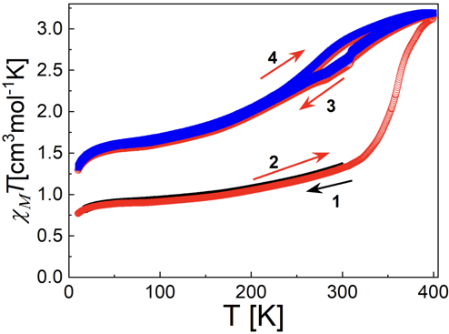

This study examines a Fe^{II} complex, [Fe(3-bpp)₂]²⁺, incorporating a switchable counteranion. This new hybrid complex presents a thermally induced spin crossover behaviour occurring near the room temperature region. Insights into spin-state control and photodimerization, are derived.

