Short-Term Memory Binding tasks to diagnose preclinical Alzheimer’s disease
Lara Huyghe¹, Lisa Quenon¹, Yasmine Salman¹, Lise Colmant^{1,2}, Thomas Gérard^{1,4}, Vincent Malotaux¹, Laurence Dricot¹, Renaud Lhommel^{1,4}, Adrian Ivanoiu^{1,2}, Bernard Hanseeuw^{1,2,3}

- Institute of Neuroscience (IoNS), UCLouvain, Brussels, Belgium
- Neurology Department, Saint-Luc University Hospital, Brussels, Belgium
- Radiology Department, Massachusetts General Hospital, Harvard Medical School, Boston, USA
- Nuclear Medicine Department, Saint-Luc University Hospital, Brussels, Belgium
Background: The ability to distinguish very close objects, supported by the medial temporal lobe (MTL), is impaired from the preclinical stage in carriers of familial Alzheimer’s disease (AD). We aimed to investigate whether this capacity is also altered from the preclinical stage in sporadic AD.
Methods: Sixty-eight older adults underwent a [F18]-MK6240 tau-Positron Emission Tomography (PET) to quantify tau burden in the MTL (entorhinal cortex, hippocampus, parahippocampus) and computerized tests assessing the capacity to discriminate very close objects: Conceptual-Matching-Test (CMT) and Visual-Short-Term-Memory-Binding-Test (VSTMBT). In CMT, the participant is asked to judge whether a word and an image presented simultaneously represent the same concept. In VSTMBT, the participant has to determine whether a set of 2 or 3 shapes are identical to the set presented before a blank retention interval of 900ms. The shapes are white (Shape-Only-Condition) or colored (Binding-Condition). We calculated the accuracy score (AS) and the mean reaction time (RT) for each condition. Participants were classified in three diagnostic groups based on Aβ status and standard neuropsychological assessment: Aβ-CN (n=35); Aβ+CN (n=16), and Aβ+MCI (n=17). Aβ status was determined using either cerebrospinal fluid or [F18]-Flutemetamol PET.
Results: The AS was lower in Aβ+CN than in Aβ-CN participants in both tests while Aβ+CN and Aβ+MCI did not differ (Table.1+Fig.1). In CMT, the RT was longer in Aβ+CN than in Aβ-CN but not in VSTMBT. Performance on these tests was significantly associated with MTL tauopathy when considering the entire sample (even after controlling for age and education), and also when considering CN subjects (Aβ-CN and Aβ+CN) for VSTMBT only. Finally, in CMT, there was no interaction between condition and tau-PET signal whereas in VSTMBT, there was an interaction between condition and tau such that tauopathy was more associated to performance in the Binding-Condition than in the Shape-Only-Condition (Table.2).
Discussion: Impairment in the ability to distinguish similar objects was evidenced since the preclinical stage of AD. Performance was related to tau burden in the MTL, suggesting Memory Binding Tasks are more sensitive to MTL tau than standard episodic memory tests, such as the FCSRT used to define CN in our cohort.

Table 1 : Difference in AS and RT between groups
 | Aβ- CN | Aβ+ CN | Aβ+ MCI | p-value | Post-hoc
Accuracy CMT (%) | 91.13 (5.45) | 87.34 (6.99) | 83.26 (7.66) | <0.001 | Aβ- CN > Aβ+ CN ~ Aβ+ MCI
Accuracy VSTMBT (%) | 87.63 (6.24) | 81.25 (7.88) | 78.81 (7.52) | <0.001 | Aβ- CN > Aβ+ CN ~ Aβ+ MCI
Average RT CMT (ms) | 1271.32 (227.21) | 1439.72 (186.64) | 1441.70 (251.16) | 0.014 | Aβ- CN < Aβ+ CN ~ Aβ+ MCI
Average RT VSTMBT (ms) | 1711.12 (418.66) | 1969.23 (618.69) | 2086.47 (390.17) | 0.016 | Aβ- CN ~ Aβ+ CN < Aβ+ MCI

Figure 1: Boxplot of reaction time and accuracy score in CMT and VSTMBT
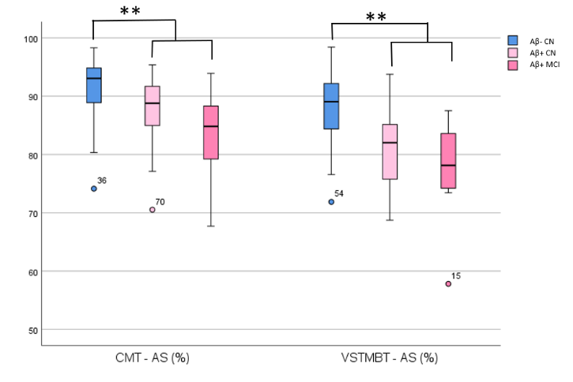
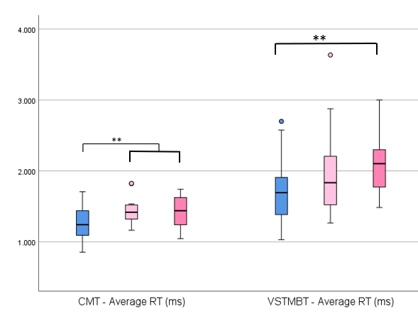
Table 2: Effects of MTL tau burden on accuracy, in all sample and in all CN subjects
 | CMT Accuracy
 | p-value | η²
All sample
MTL Tau-PET signal | 0.033 | 0.071
Aβ- CN and Aβ+ CN
MTL Tau-PET signal | 0.302 | 0.022
 | VSTMBT Accuracy |  | VSTMBT Accuracy Shape-Only Condition |  | VSTMBT Accuracy Binding Condition
 | p-value | η² | p-value | η² | p-value | η²
All sample
MTL Tau-PET signal | 0.001 | 0.158 | 0.040 | 0.067 | <0.001 | 0.253
Aβ- CN and Aβ+ CN
MTL Tau-PET signal | 0.004 | 0.161 | 0.017 | 0.111 | <0.001 | 0.245

