Stimulation of the dorsolateral prefrontal cortex modulates brain cue reactivity to reward (un)availability

Cortex - https://linkinghub.elsevier.com/retrieve/pii/S0010945223000837

Damien Brevers^{1,2}, Chris Baeken^{3,4,5,6}, Stefanie De Smet⁴, Beatriz Catoira³, Sara De Witte⁴, Qinghua He⁷, Pierre Maurage¹, Laimi Schulze-Steinen², Guillaume Sescousse⁸, Claudia Vila Verde², Claus Vögele², Joël Billieux^{9,10}

¹ Louvain for Experimental Psychopathology research group (LEP), Psychological Sciences Research Institute (IPSY), UCLouvain, Louvain-la-Neuve, Belgium.
² Institute for Health and Behaviour, Department of Behavioural and Cognitive Sciences, University of Luxembourg, Esch-sur-Alzette, Luxembourg
³ Department of Psychiatry University Hospital (UZBrussel), Brussels, Belgium
⁴ Ghent Experimental Psychiatry (GHEP) Lab, Ghent, Belgium
⁵ Department of Head and Skin, Ghent University Hospital, Ghent University, Ghent, Belgium
⁶ Eindhoven University of Technology, Department of Electrical Engineering, Eindhoven, the Netherlands
⁷ Faculty of Psychology, Southwest University, 2 Tiansheng Rd, Chongqing, China
⁸ Lyon Neuroscience Research Center - INSERM U1028 - CNRS UMR5292, PSYR2 Team, University of Lyon, Lyon, France
⁹ Institute of Psychology, University of Lausanne, Lausanne, Switzerland
¹⁰ Centre for Excessive Gambling, Lausanne University Hospitals (CHUV), Lausanne, Switzerland

Corresponding author
Damien Brevers, PhD, Psychological Sciences Research Institute, UCLouvain, Louvain-la-Neuve, Belgium, e-mail: damien.brevers@uclouvain.be
ABSTRACT
Brain imaging studies have shown that stimulation of the left dorsolateral prefrontal cortex (dlPFC), which plays a pivotal role in high-order cognitive control processes, modulates brain reactivity to reward-related cues. Nevertheless, the impact of contextual factors such as reward availability (the reward that is depicted in the cue exposure task) on such modulation effect remains unclear. Here we tested whether a single session of high-frequency repetitive transcranial magnetic stimulation (HF-rTMS) over the left dlPFC differently impacts brain reactivity to cues signalling either availability or unavailability of a sports betting opportunity. Employing a within-subject design (verum versus sham HF-rTMS) among thirty-two frequent sports bettors, we first observed that, as compared to the sham condition, verum HF-rTMS modulated brain reactivity to game cues prior to being made (un)available for betting, through simultaneous increases (posterior insula and caudate nucleus) and decreases (occipital pole) in brain activation. Second, verum HF-rTMS led to increased ventral striatal activity towards cues available for betting but did not modulate brain response to cues unavailable for betting. Taken together, these findings demonstrate that transient stimulation of the left dlPFC led to a general modulation in brain activity in responses to cues, and that this effect is only partly dependent on cues signalling for reward (un)availability.

Keywords: rTMS; fMRI; cue reactivity; reward availability; dorsolateral prefrontal cortex; ventral striatum.

INTRODUCTION
Nowadays, there is an abundance of possibilities for digitalized forms of leisure and appetitive behaviors (e.g., online series watching, online shopping, online betting). As a consequence, it is possible to engage in online rewarding activities at any time and place. Among these new types of digital opportunities, sports betting is becoming increasingly popular, in particular in adolescents and young adults (Flayelle et al., in press). Merely perceiving a related cue in the environment has the potential, therefore, to trigger associated behaviors (e.g., glancing over a sport games schedule and then “betting” on one team). Accordingly, the environmental exposure to sport cues signalling the availability of a sport betting opportunity (i.e., the fact that the individual has the opportunity to bet on the sport event) should bind perception to more advanced reward-based decision-making processes (Brevers et al., 2019).
Evidence for the impact of reward availability on how individuals process information comes from functional magnetic resonance imaging (fMRI) studies on cue reactivity. A key finding reported in this literature is that brain responses are more strongly sensitized by pictures of food (Blechert et al., 2016), alcohol drinks (Claus et al., 2011), cigarettes (McBride et al., 2006; Wilson et al., 2006, 2012), and cocaine (Prisciandaro et al., 2014) if the substance is made available for consumption after cue exposure, rather than not (for a review, see Jasinska et al., 2014). Increases in brain activation in response to such stimuli can be found in many brain structures and networks, but have been especially shown for mesocorticolimbic and fronto-striatal brain pathways (Courtney et al., 2016; Devoto et al., 2020; Jasinska et al., 2014; Wilson et al., 2004; Yalachtov et al., 2012).
There is evidence that brain stimulation over the dorsolateral prefrontal cortex prefrontal cortex (dlPFC) modulates brain cue reactivity to reward availability (Hayashi et al., 2013; Li et al., 2017; Yang et al., 2017). The dlPFC is a key region for updating goal representations based on context information (Barch et al., 2003; D'Esposito et al., 1995; D'Esposito et al., 2000), which can be (de)sensitized through the use of brain stimulation techniques (Brunoni & Vanderhasselt, 2014). It has been suggested that when exposed to reward-related cues the dlPFC is involved in encoding the subjective value of a reward and to process it in relation to other information, such as reward availability and outcomes, in order to allow for reward-based decision-making (George & Koob, 2010, 2013). In other words, cue reactivity to reward-related stimuli can be biased up or down based on reward availability.
Supporting evidence for this assumption comes from Hayashi and colleagues (2013) who found that cue-induced smoking craving was drastically lowered by transiently deactivating the left DLPFC through a single session of low-frequency repetitive transcranial magnetic stimulation (rTMS). These authors also observed that the self-reported urge to smoke was greater when smoking was directly allowed after an fMRI session involving smoking cue exposure. Critically, patterns of brain activity linked to smoking urge (i.e., activation in the medial orbitofrontal cortex, OFC, and ventral striatum, as well as functional connectivity between left dlPFC and OFC), were attenuated by reducing the activity of the left dlPFC, but only when participants were informed that cigarettes will be made available after the fMRI session. Studies not including a reward availability component to their smoking cue exposure paradigm (i.e., passive viewing of substance-related cues, during or after, the dlPFC stimulation session; Li et al., 2017; Yang et al., 2017) report opposite results: activating the left dlPFC (using a single session of high-frequency rTMS; Li et al., 2017, or anodal transcranial direct current stimulation, tDCS; Yang et al., 2017) was associated to a reduction of subjective craving and translated into reduced cue reactivity in the superior frontal gyrus, the left middle frontal gyrus (Yang et al. 2017), and decreased resting state functional connectivity in the orbitofrontal cortex (Li et al., 2017).
Taken together, these findings suggest that the effect of dlPFC stimulation is sensitive to reward availability. Specifically, low-frequency rTMS decreases brain reactivity to cues signaling reward availability (Hayashi et al., 2013) and high-frequency decreases brain reactivity to reward-related cues but that were not linked to reward availability (Li et al., 2017). Accordingly, the impact of dlPFC stimulation could differ between cues signaling the availability versus the unavailability of the reward. Moreover, high-frequency rTMS over the dlPFC was found to adjust cognitive control according to dynamic changes of the environment (e.g., Pulopulos et al., 2022). We thus decided to target the left dlPFC, as this region is viewed as playing a key role in modulating the pattern of activation within limbic reward brain circuits during cue reactivity (Hayashi et al., 2013).
The present study tested this hypothesis by measuring the impact of a single session of HF-rTMS over the left dlPFC on subsequent brain reactivity to reward (un)availability. In order to test our hypothesis, and in line with our previous work (Brevers et al., 2021), we decided to focus on online betting, which is on the rise from an international perspective and increasingly more ubiquitous among adolescents and young adults (Brevers et al., 2022). Moreover, in contrast to behaviors involving buying, eating, sexuality, or consuming substances, sports betting does not show sensory-specific satiety effects (i.e., a declining satisfaction with repeated consumption of reward), as it involves (cumulative) monetary rewards. This specific characteristic of sport betting makes it particularly relevant for an implementation in experimental tasks alternating experimental cue reactivity conditions on a trial-per-trial basis. Against this background, we capitalized on a cue exposure paradigm where we manipulated the reward availability component through a design that made sport events available or not for betting. This procedure not only involved being exposed to salient cues, but also triggers high-order decision-making process (i.e., reflecting on whether or not to select the game for betting during available betting). In our previous work using a similar task, we observed an extended activation cluster, encompassing left dlPFC activation, when contrasting cues available for betting against cues non-available for betting (Brevers et al., 2021). This pattern further reinforces our decision to focus on the left dlPFC, as this brain region is established to play a central role in maintaining and updating comprehensive representations of task context through the encoding of relevant stimulus features (Mansouri et al., 2009). Importantly, the peak coordinates of left dlPFC activation (i.e., observed when comparing cues available for betting against cues non-available for betting) was used to define the TMS target in the present study (see the rTMS procedure section for details). Moreover, when contrasting non-available and available betting options, we showed higher activation in the OFC and the ventral striatum, in line with fMRI studies highlighting the key role of these two cerebral regions for processing available rewards (Lopatina et al., 2015; McDanaol et al., 2014), discrepancy between expected and experienced reward value (Chumbley et al., 2014; Horward & Kahnt, 2017; O’Doherty et al., 2003; Stalnaker et al., 2015), as well as the prediction of future choice opportunity (Leotti & Delgaddo, 2011; Wang et al., 2021).
Our study design thus proposes an ecologically valid paradigm (i.e., using cues representing real upcoming sport events) allowing for the investigation of the effects of stimulation of the left dlPFC on the dynamic changes related to the opportunity to bet. We employed a within-subject design (sham versus verum stimulation) and hypothesized that, as compared to sham, a single session of high–frequency rTMS will differentially modulate brain activity in response to betting availability vs unavailability (i.e., an interaction effect). We also made additional assumptions regarding the directionality of this interaction effect: high-frequency rTMS would increase reactivity to available betting (hypothesis 1a), and/or decrease brain activity to cues non-available for betting (hypothesis 1b).

METHODS and MATERIALS

Participants
Thirty-five football (i.e., soccer) fans participated in this study (34 males, mean age 26.83 years, SD = 6.23, range: 19-43). The sample size was determined based on the higher sample size employed by previous brain stimulation studies on cue reactivity (N = 32 in Yang et al., 2017). All participants gave written informed consent to the experimental procedure, which was approved by the institutional review boards of Ghent University and the University of Luxembourg. In total, 32 participants (31 males, 1 female) completed the full experiment (64 sessions in total) whose data were used for analyses. Participants’ recruitment and flow chart is further detailed in supplementary materials.
rTMS procedure
After signing the informed consent form and receiving instructions on the whole study protocol, each participant underwent high-resolution T1-weighted MRI to be used for TMS targeting (176-slice MPRAGE structural sequence; 1mm slice thickness; TI = 900ms; TR = 2250ms; TE = 4.18ms; flip angle 9°; see Figure S1 in supplementary materials for a graphical depiction of the study design). The TMS target in the left dlPFC (Montreal Neurological Institute space coordinates: x,y,z = -38, 35, 34; see Figure S2 for a graphical representation of the TMS target; see also Figure S3 for the location of the TMS target overlaid on each participant’s T1-weighted MRI scan) was defined based on peak coordinates from our previous study (Brevers et al., 2021) where a significant left dlPFC activation was observed across all participants for the whole brain contrast “available minus non-available betting conditions” (see Figure S2 in supplementary materials). This rTMS target is close to the reward availability sensitive left DLPFC locus identified by Hayashi et al. (2013; x, y, z = –30, 36, 42).
Before each rTMS session, the point on the scalp overlaying the participant’s target was identified using the high-resolution T1-image. The TMS target was located in native space by using non-invasive frameless stereotactic apparatus (BrainSight, Rogue Research, see supplementary material for additional details). Next, the individual resting motor threshold (rMT) was identified by repeatedly applying single pulse TMS on the left motor cortex in relation to the right abductor brevis muscle. If a single pulse TMS generated a movement, the percentage of intensity was lowered until no movement could be registered. Specifically, rMT was operationalized as the minimum TMS intensity necessary to yield a motor response in the right abductor pollicis brevis muscle in 5 out of 10 successive attempts. The rMT intensity varied from 43% to 72% (M = 61.71, SD = 6.9).
After having determined the rMT, a figure-eight TMS coil was positioned for either verum or sham TMS on the aforementioned target point and fixed on a tripod attached to the participant’s chair to hold it steady during the stimulation. Participants reclined in an rTMS treatment chair with fixed head positioning. The reclining position and design of the chair (e.g., head support) ensured comfort and stability for the participant. Furthermore, all participants were closely monitored for movements during the rTMS sessions. Experimenters delivering stimulation knew about the specific hypotheses of the study and ensured that the procedure was strictly identical for sham and verum conditions. The order of the sham and verum sessions were randomized, each session being separated by 7 days. The stimulation was delivered with participants blind to conditions (verum or sham). Specifically, participants were informed that the study aimed to stimulate a region called the lDLPFC, and that they would receive a real form of rTMS as well as a sham form that mimics the feeling of rTMS, without the actual brain stimulation. They were also informed that they would not know which condition they receive until the end of their involvement in the study. Participants were not informed about the specific hypotheses of the study.
For the high-frequency (i.e., verum) rTMS session, we used a Magstim high-speed magnetic stimulator (Magstim Company Limited, Minneapolis, USA), connected to a 70 mm Double Air Film figure-of-eight-formed coil held tangentially to the skull and placed at a 45-degree orientation (anterior/medial-posterior/lateral axis) with its center touching the marked point on the scalp. The stimulation intensity was individually set at 110% of the participants resting rMT. During the HF-rTMS sessions, the participant received 40 trains with a duration of 1.9 seconds, equalling in 1520 pulses per session with a frequency of 20 Hz. The trains were each separated by an intertrain interval that lasted 12 seconds. The rTMS protocol was based on previous cue reactivity studies from our team (Herremans et al., 2015) and conforms to safety guidelines (Rossi et al., 2009, 2021). For the sham session, we used the Magstim 70 mm Double Air Film sham coil, a coil that is identical in all aspects to its verum variant, but without stimulation output. The sham coil stimulates the peripheral nerves of the face and scalp, and it looks, sounds and feels like a verum coil, but it does not deliver verum stimulation of cortical neurons. Following the verum/sham rTMS session, the participant was immediately escorted back to the MRI scanner. The fMRI cue exposure task (length ≈ 18min 40sec) started less than 10 minutes after the end of rTMS session. The time interval from the end of stimulation to the end of fMRI acquisition varied from 25 to 30 min, which is within the usual time period still showing effects after a single rTMS session on cognitive processes in healthy and in patient samples (Vanderhasselt et al., 2009; Thut & Pascual-Leone, 2010).
fMRI cue-exposure task
We used a cue-exposure task (adapted from Brevers et al., 2018, 2021; see Figure 1) in which cues depicting football games appear on a screen (cues presentation implemented using Python 2.7.16 and Pygame 1.9.3 on an IBM compatible PC; see supplementary materials for additional details on game cues). Prior to the scanning session, participants received task instructions. They were asked to look attentively at each cue and were informed that the task consists of two types of trials, “available” and “non-available”. The games displayed in the “available” condition were available to the participant for betting at the end of a ten-trial block. The games in the “non-available” condition were not available for betting. Participants were first presented with those game cues for 1sec (showing the logos of the two teams playing), and after a jittered delay (blank screen, range: 1.7-2.6sec), an “available” cue (green frame and check mark) or “non-available” cue (red frame and cross signal) was presented for 4.8sec (see Figure 1). Each block consisted of 10 pseudo-randomized trials (5 “available” and 5 “non-available” betting trials; order pseudo-randomized with Python’s random generation module). Each scanning block terminated with an overview slide (8sec), displaying the 5 available matches presented during the block (see Figure 1). During this phase, participants orally reported the number of the game and team that they wanted to bet on (e.g., “One, FC Barcelona”) via intercom to the experimenter (one bet per block, for one of the 5 available matches). Finally, we informed participants that the task consisted of 10 blocks (100 trials in total), and that they will receive the betting money once the sport event that they had bet on had occurred (1 euros for a win; 0.5 euro for a draw, 0 euro for a loss). Thus, participants won from 0 euros (10 losing bets) up to 20 euros (10 winning bets) across the SHAM and the VERUM sessions (i.e., they performed the cue reactivity task twice).
Directly after each scanning session (sham and verum), participants completed rating scales. For each of the 100 games (50 “available” and 50 “non-available”), participants indicated (i) which team they think would win the game (by circling the team; there was not the option to choose a draw), and (ii) how confident they were about their prediction (1 = not at all, 2 = very little, 3 = somewhat, 4 = to a great extent). Then, after the first scanning session (sham or verum), participants completed the Problem Gambling Severity Index (PGSI; Ferris & Wynne, 2001), and the Alcohol Use Disorders Identification Test (AUDIT; Saunders et al., 1993), and indicated their bank account number for receiving the bonus payment from their bets.

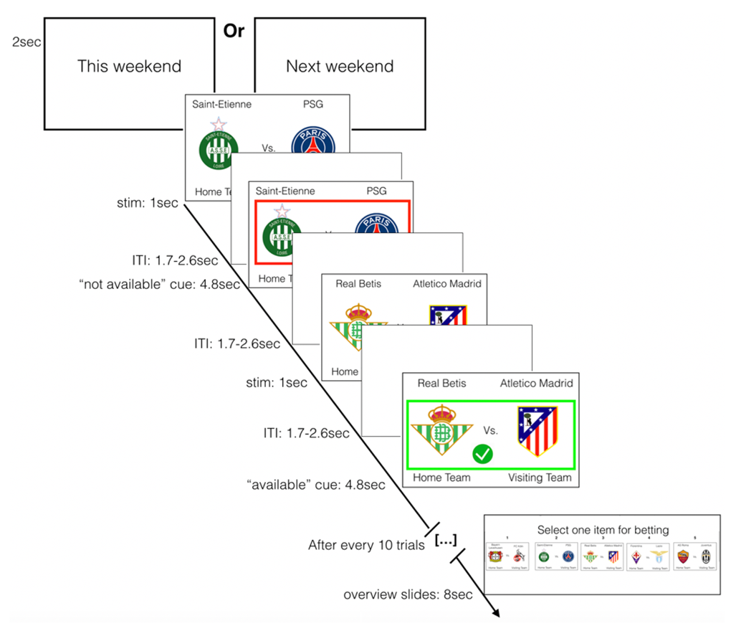

Figure 1. The cue-exposure task. Examples of sport cues used and of one overview slide. Participants viewed cues representing real sport events that will take place in the future and made available or blocked for betting. Participants were instructed to choose, after a run of 10 trials, the team they wanted to bet on. The red frame and the cross signal a trial non-available for betting. The green frame and the check mark indicates a trial available for betting.

fMRI Data acquisition and image Preprocessing

fMRI imaging was conducted with a 3T Siemens MAGNETOM Prisma scanner at the GIfMI Center, UZ Ghent, Ghent University. fMRI Data acquisition and image preprocessing are fully detailed in supplementary materials.

Brain imaging analyses

We examined blood oxygen level-dependent (BOLD) activity during the onset of the game cue (1sec; see Figure 1) and during the onset of “available” and “non-available” betting trials (4.8sec; see Figure 1). To this aim, we modeled the brain imaging data using an event-related general linear model (GLM) within FSL’s Improved Linear Model (FILM) module. First-level statistical analysis included the following explanatory variables (EV): EV1: onsets of the game cue, EV2: onsets for available betting trials, EV3: parametric modulator (PM) assessing winning confidence for available betting trials, EV4: onsets for non-available betting trials; EV5: PM assessing winning confidence for non-available betting trials; EV6 (of no-interest): overview slides (i.e., onset with duration of 8sec at the end of each block), leaving ITI as implicit baseline. We computed the PM regressors by mean centering the post-task confidence ratings and convolved the event onsets with canonical hemodynamic response function (HRF; double-gamma) to generate regressors used in the GLM.

For each participant, we computed the following contrasts: (i) game cues (EV1) (minus implicit baseline); (ii) available (EV2) versus non-available betting (EV4), and (iii) PM (post-task confidence) for available (EV3) versus PM non-available betting trials (EV5). These were then included into a random-effect model for single-group to compare the verum (n = 32) and the sham (n = 32) conditions. Single-group paired differences between the sham and verum conditions were analyzed using FSL FLAME 1 (FSL’s Local Analysis of Mixed Effects), with a height threshold of |z| > 3.1 (i.e., two-tailed) and a cluster probability of p < .05, FWE corrected for multiple comparisons within regions of interest (ROI). For whole brain analyses, a more lenient height threshold of |z| > 2.3 was used (with a cluster probability of p < .05, FWE corrected for multiple comparisons across the whole brain). ROI masks were computed based on previous findings from Brevers et al. (2021; see Figure S4 in supplementary materials for additional details). Specifically, ROI analyses on the “available versus non-available” contrast were undertaken using two different masks: one binarized mask from brain activations obtained by Brevers et al. (2021) for the “available minus non-available” contrast and one binarized mask from brain activations obtained by Brevers et al. (2021) for the “non-available minus available” contrast. ROI analyses on the parametric contrast “PM available versus PM non-available betting” were undertaken with the binarized mask from brain activations obtained by Brevers et al. (2021) for the parametric contrast “PM non-available minus available betting” (no significant brain activation was obtained by Brevers et al. (2021) for the parametric contrast “PM available minus PM non-available betting”).

Because “game cues” event (EV1) was not examined in Brevers et al. (2021), only a whole-brain exploratory approach was adopted for analyzing the “game cues” contrast. The within-condition contrasts (which also included replication analyses using data from the sham condition) were thresholded using FSL FLAME 1, with a height threshold of z > 3.1 and a cluster probability of p < .05, FWE corrected for multiple comparisons across the whole brain. No part of the study procedures and analyses was pre-registered prior to the research being conducted.

RESULTS

Behavioral findings on post-task rating questionnaires

Paired samples t-tests, revealed no significant difference on mean scores of winning confidence between the sham (M = 2.85, SD = 0.47) and verum (M = 2.91, SD = 0.40) conditions, t(32) = -0.93, p = .36. Noteworthy, we observed that the matches related to the highest winning confidence level were most often selected for betting during the task (Mean scores of winning confidence for the games selected for betting during the cue reactivity task = 3.17; Standard Deviation = 0.21). Moreover, in each block, we observed that the 4 other available games for betting (i.e., those not chosen for betting by the participant in the end of each block) were always associated with either lower or equal (but never higher) scores of winning confidence on the post-task rating questionnaires.

Replication of previous brain imaging findings

In order to examine whether the cluster of brain activations observed in the sham condition replicated the main patterns of brain activations observed in our previous work (Brevers et al., 2021), we ran the contrasts (i) available (EV2) minus non-available betting (EV4), (ii) non-available (EV4) minus available betting (EV2); (iii) PM (post-task confidence) for available (EV3) minus PM non-available betting trials (EV5); and (iv) PM non-available (EV5) minus PM available betting (EV3). In line with Brevers et al., 2021, we observed (i) a pattern of activation in the ventral striatum and the OFC for the “non-available minus available betting” contrast; (ii) comparable large clusters of activation that those observed in Brevers et al. (2021) for the “available minus non-available betting” contrast and for the parametric contrast “PM non-available minus PM available betting”, and (iv) no significant activation for the parametric contrast “PM available minus PM non-available betting”. These findings are further detailed in the supplementary materials. For exploratory purpose, we also examined patterns of brain activation observed when comparing (un)available betting to game cues events in the sham condition (see also supplementary materials).

Difference in brain activation between the SHAM and VERUM conditions
Game cues

For the whole brain contrast “game cues (minus implicit baseline)”, we observed (i) increased activation for the verum condition (as compared to the sham condition) in the left posterior insular cortex (voxel cluster size = 1199, peak = -48, -24, 18; z-max = 3.54; see Figure 2A) extending into the left post-central gyrus and the left caudate nucleus, and (ii) increased activation for the sham condition in the occipital pole (as compared to the verum condition) (voxel cluster size = 517, peak = -2, -68, 64; z-max = 4.11; see Figure 2B). Additional analyses were undertaken in order to examine whether this effect was modulated by the order of sham versus verum conditions (i.e., sham stimulation at time 1 versus verum stimulation at time 1). Specifically, we ran a repeated measures ANOVA, with condition (verum, sham) as within group factor, parameter estimates (PEs; extracted for each participant from the significant cluster of activation in the posterior insular cortex) as dependent measure, and condition order (sham stimulation at time 1, verum stimulation at time 1) as covariate. These analyses revealed no significant covariate effect of condition order, F(1,30) = 1.11, p = .30. Brain activations for within-condition analyses are shown in Figure S5 in the supplementary materials.
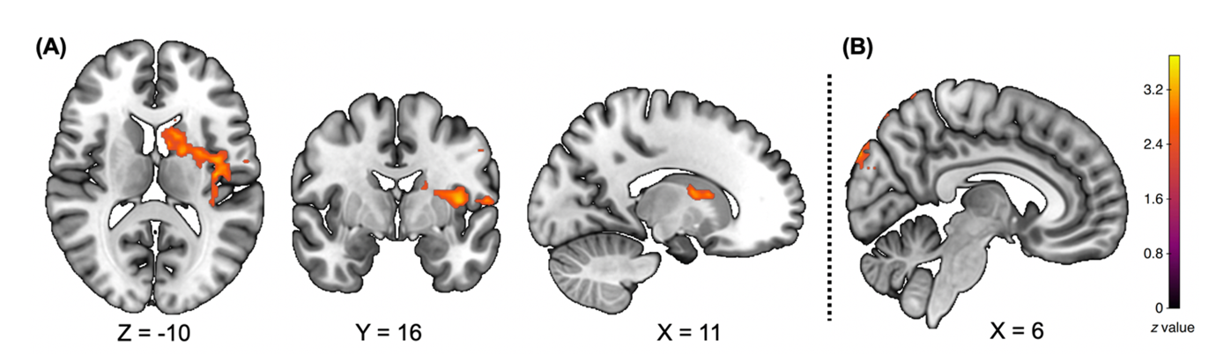

Figure 2. Whole brain differences between the verum and the sham conditions in the “game cues” contrast. (A) Increased activation in left posterior insular cortex, post-central gyrus and caudate nucleus in the verum condition, as compared to the sham condition; (B) increased activation in the occipital pole for the sham condition, as compared to the verum condition. These images were thresholded using FSL FLAME 1, with a height threshold of z > 2.3 and a cluster probability of p < .05, FWE corrected for multiple comparisons across the whole brain.

Cues available versus non-available for betting

Using the ROI mask obtained from the brain activation of “non-available minus available betting” contrast in our previous study (Brevers et al., 2021; see Figure 3A), we observed differences between the verum and the sham conditions in the right ventral striatum (voxel cluster size = 38, peak = 10, 18, -10; see Figure 3B). To determine the directionality of this interaction, we created an ROI mask from the cluster of voxels with significant ventral-striatal activation in the single-group paired comparison for the “available versus non-available” contrast. Using this mask, we performed ROI analyses by extracting PEs for each participant and separately for two additional whole brain simple contrasts: “available (minus implicit baseline)” and “non-available (minus implicit baseline)”. We then plotted the mean PEs in group (verum, sham) and for each type of event (available; non-available). Figure 3C shows the post-hoc simple main effects of the available (minus implicit baseline)” and “non-available (minus implicit baseline)” in the sham and verum conditions. It appears that the difference for the “available versus non-available betting” contrast is driven by increased ventral striatal reactivity to available betting in the verum condition. Hence, in line with our previous findings (see also the section replication of previous findings), we observed a higher ventral striatal activation “non-available betting” than for “available betting” in the sham condition. By contrast, in the verum condition, similar levels of ventral striatal activation were observed for “non-available betting” and “available betting”. In other words, verum HF-rTMS increased ventral striatal reactivity to available betting as compared to sham rTMS, whereas patterns of ventral striatal activity did not differ between the verum and the sham conditions for the non-available betting. No significant covariate effect of condition order was observed.

When using the ROI mask obtained from the brain activation of the “available minus non-available betting” contrast from our previous study (see Figure S4B), we did not find a significant difference between the verum and the sham condition (with either of z > 3.1, z > 2.3 or even z > 2.0). There was no significant whole brain difference for the “available versus non-available betting” contrast. Brain activations for within-condition analyses are depicted in Figure S2 (“available minus non-available betting” contrast) and Figure S6 (“non-available minus available betting” contrast) in supplementary materials.

PM non-available versus PM available betting
With regard to the parametric modulation (PM) of brain responses by confidence ratings (PM post-task confidence available, EV2; PM task confidence non-available betting, EV5), ROI (using the ROI mask obtained from Brevers et al., 2021 for the “PM non-available minus PM available betting” contrast; see Figure S4C) and whole brain analyses showed no significant differences (with either of z > 3.1 or z > 2.3) between the sham and the verum conditions for the contrasts “PM non-available minus PM available betting” and “PM available minus PM non-available betting”. Brain activations for within-condition analyses are depicted in Figure S7 in the supplementary materials.

Assessment of possible moderators
When entered in the GLM as a covariate, we found no significant effects for age, sports betting frequency, problem gambling symptoms, or problem drinking symptoms.

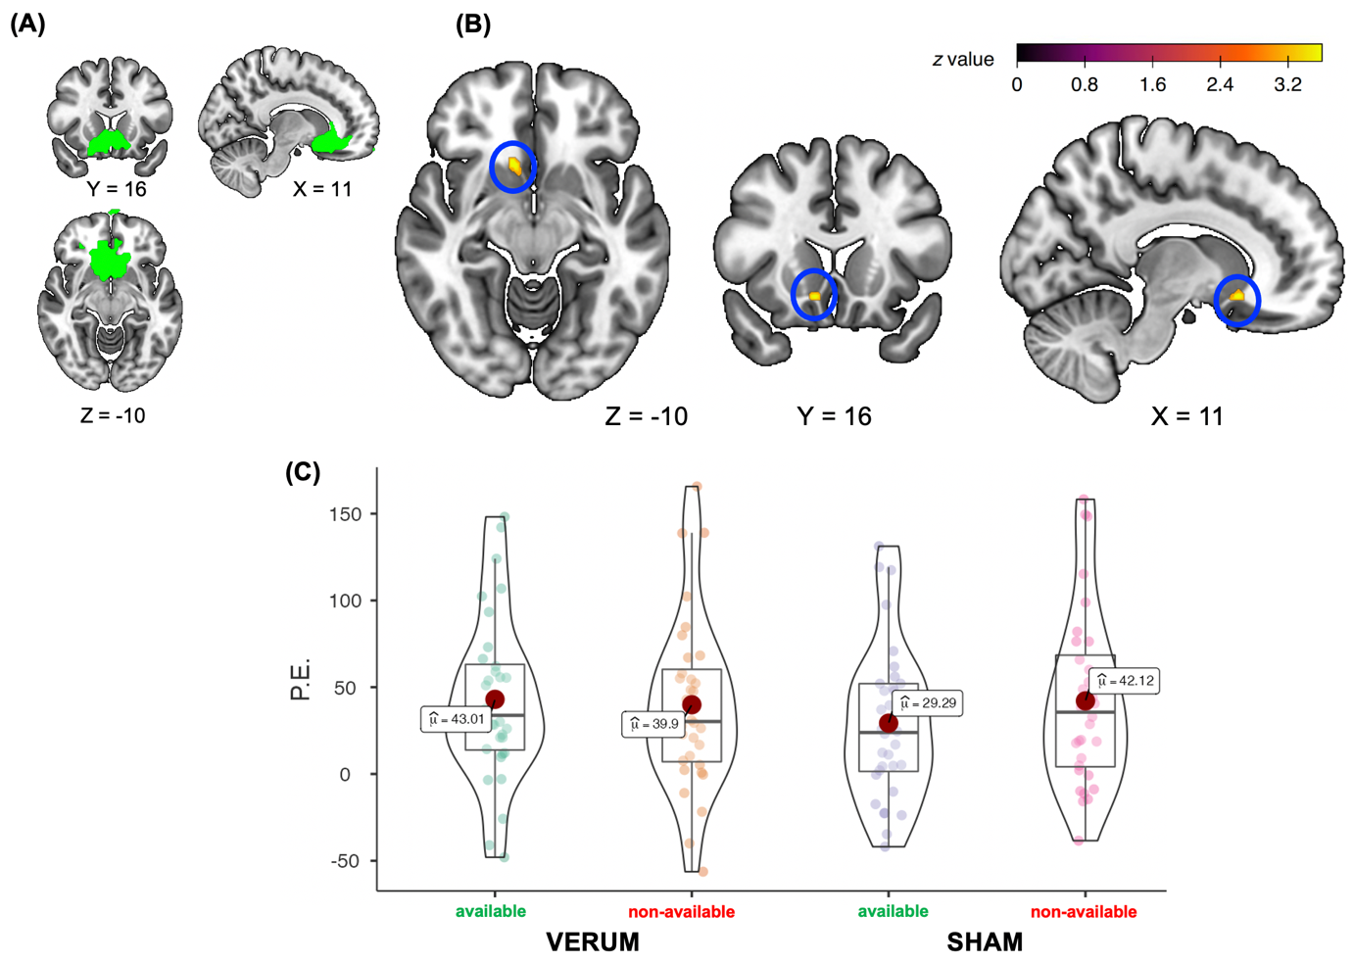

Figure 3. Between-conditions differences on the “available versus non-available betting” contrast. (A) the ROI binarized masks from brain activations obtained for the contrast “non-available minus available betting” in Brevers et al. (2021); (B) between-conditions differences were observed in the right ventral striatum; (C) increased ventral striatal reactivity to available betting trials for the verum condition, as compared to the sham condition. The plots represent mean parameter estimate (PE) within the cluster of voxels showing significant activation in the between-conditions comparisons for the “available betting minus baseline” and “non-available betting minus baseline” contrasts (blue circle). Bidirectional error bars represent 95% confidence interval. The images were thresholded using FSL FLAME 1, with a height threshold of z > 3.1 and a cluster probability of p < .05, FWE corrected for multiple comparisons within the ROI mask. Left on Right.

DISCUSSION
This study examined whether a single session of high-frequency repetitive transcranial magnetic stimulation (HF-rTMS) over the left dlPFC differently impacts brain reactivity to cues signalling either availability or unavailability of a sports betting opportunity. We made two main observations: (i) as compared to the sham condition, verum HF-rTMS modulated brain reactivity to game cues prior to being made (un)available for betting, through simultaneous increases (posterior insula and caudate nucleus) and decreases (occipital pole) in brain activation; (ii) verum HF-rTMS led to increased ventral striatal activity towards cues available for betting but did not modulate brain response to cues unavailable for betting.
In a first exploratory step of data analysis, we observed that stimulation over the dlPFC can increase limbic-insular activity, as well as decrease visual cortex activation when processing cues independent of reward (un)availability. Specifically, when participants were initially exposed to the game cue (i.e., the logos of the two teams are displayed for 1 seconds before being made available or not for betting), whole-brain analyses showed increased activity for the verum condition into the posterior insular cortex and the caudate nucleus, which are two key brain regions involved in the reactivity towards salient cues (Brevers et al., 2019; Jasinska et al., 2014). Importantly, we observed lower activity in the occipital pole in the verum as compared to the sham condition. This part of the visual cortex is commonly activated when viewing drug-related and natural reward-related cues, and is thought to process elementary features of visual stimuli such as local contrast or spatial location and orientation (Hanlon et al., 2014; Hill-Bowen et al., 2021).
By employing hypothesis-driven region of interest analyses, we then observed that, as compared to sham, verum HF-rTMS increases ventral striatal reactivity when participants are exposed to games available for betting. This result is consistent with hypothesis 1a and suggests that a single session of high–frequency rTMS increased brain reactivity when viewing cues signaling for available reward. This finding was observed in the ROI analyses using the mask from the "non-available minus available" contrast from Brevers et al. (2021). Importantly, the present study replicated the pattern of activation in the ventral striatum and the OFC observed in Brevers et al. (2021) for the “non-available minus available betting” contrast. We did not observe, however, an effect of the HF-rTMS in the ROI analyses using the mask from the "available minus non-available" contrast (which covered a more extensive cluster of brain tissue than the other mask; see also replication findings from Brevers et al., (2021) in supplementary materials). Hence, the significance of the HF-rTMS effect not only lies for available trials but also in a cluster of brain regions that previousy showed increased reactivity for non-available betting than for available betting. Indeed, at odds with hypothesis 1b, we failed to find an effect of left dlPFC stimulation on decreasing brain reactivity toward cues non-available for betting. This finding indicates that the single session of left dlPFC HF-rTMS did not increase brain activity in brain regions activated by available betting (i.e., observed without rTMS in Brevers et al., 2021), but in brain regions more strongly activated by non-available compared with available betting. Importantly, this enhanced pattern of brain activation was observed in the ventral striatum, that is, a key brain region involved in the anticipation and the processing of rewards (e.g., Filimon et al., 2020; Jauhar et al., 2021; Knutson & Cooper, 2005). Hence, it appears that the left dlPFC rTMS might have sensitized the ventral striatal pathways toward available, but not non-available betting trials.
These findings contribute to improve our understanding of the neurocognitive pathways involved in cue reactivity. Specifically, even though previous works showed that a single rTMS session over the left dlPFC allows for the modulation of neural reactivity in reaction to reward-related cues, these brain stimulation studies differ, however, in the directionality of their reported effect. Decreased levels of neural reactivity (and self-reported urge related to the concerned rewarding behavior) were observed after both transient focal activation (high-frequency rTMS; Li et al., 2017) and inactivation (low frequency rTMS; Hayashi et al., 2013) of the left dlPFC. The present findings suggest that this discrepancy could be due to the expected availability of rewards following cue exposure (Jasinska et al., 2014). Centrally, the present findings inform on how dlPFC stimulation can impact subsequent brain reactivity to intermittent (un)availability of a monetary-based reward involving sport betting.
A better understanding of this dynamic has the potential to contribute in refining current neurobiological models of frontal circuitry involved in the pursuing and consumption of rewards in a context where they are increasingly available and immediately accessible (e.g., through smartphone betting apps). The sensitisation of the ventral striatal pathways through a single session of HF-rTMS over the left dlPFC is consistent with previous rTMS studies (Hayashi et al., 2013) and likely reflects the complex nature of interactions between the “bottom-up” limbic and “top-down” pre-frontal brain networks. We also showed that increasing the excitability of the left dlPFC does not lead to a down-regulation of the striatal “reward-based” circuitry as commonly described in dual-process models of self-regulation (see Brevers et al., 2013; Cosme et al., 2019; Noël et al., 2013). Instead, dlPFC simulation might reactivate memory traces and increases the salience of cues signalling for the availability of reward-based decision-making (George & Koob, 2010, 2013; Monterroso & Luo, 2013). Indeed, our results are consistent with integrative models of neural cue reactivity (Jasinska et al., 2014) and support that prefrontal brain regions commonly associated with reflective processes do not only support willpower and inhibitory control, but more generally modulate mesolimbic value based on environmental factors, such as reward availability/expectancy.
We did not observe a modulation of the effect of HF-rTMS as a function of confidence (as measured by post-task ratings). Hence, while brain reactivity to non-available betting trials varied as a function of confidence ratings (i.e., reproducing findings from Brevers et al. 2021; see also the results section of supplementary materials and Figure S7), it was not sensitive to the HF-rTMS effect. One explanation for this null finding is that these indexes of confidence were not embedded to the fMRI task. Accordingly, one interesting avenue for future studies would be to examine the neural and behavioral impact of HF-rTMS on confidence generation related to sports betting (e.g., Chiang et al., 2014; Shekhar, & Rahnev, 2018). Another limitation of our within-subject design lies in the absence of low-frequency rTMS. This brain stimulation condition not only transiently inhibits the excitability of the targeted brain region, but also decreases neural cue reactivity to substance-related cue (Hayashi et al., 2013). It also remains possible that both high and low frequency rTMS can produce similar disruptive effects on brain reactivity (e.g., Lee et al 2019). Future studies employing a three-level within-subject design (e.g., featuring single sessions of high-frequency rTMS, low-frequency rTMS session, and sham) would allow to examine whether increasing and decreasing left dlPFC excitability modulates differently brain cue reactivity. Moreover, the current study lacks of a control region rTMS condition. Hence, although the study includes a passive sham to account for the tactile effects of rTMS, an active sham condition would have allowed to target an alternative region (e.g., parietal cortex). Without active sham condition, the present inferences regarding the effect of HF-rTMS are limited because it does not ensure that the observed brain modulation are specifically due to the dlPFC stimulation. In addition, using visual thumb switches to determine the rMT and not using motor evoked potentials (MEP) may have resulted in an overestimation of the real rTMT. Another limitation of this study, is that we did not assess the blindness integrity of the sham versus verum conditions (e.g., the number of participants correctly guessing their treatment allocation at the end of the study). Hence, we were not able to examine whether the observed between-condition effects were modulated by the blindness integrity of the rTMS procedure. Our sample also almost exclusively comprised of male participants, which hampers the generalization of the present results to the female population (football fans). Finally, future studies should also further establish the clinical validity of the impact of brain stimulation on gambling cue reactivity. For instance, we previously showed that game cues non-available for betting elicit higher insular and striatal activation in individuals displaying disordered gambling symptoms, as compared to non-problematic sport bettors (Brevers et al., 2021). As such, brain reactivity to gambling unavailability can be considered a relevant marker of gambling disorder. Individual factors such as clinical status (active user, trying to diminish/quit, abstinent) also modulate neural reactivity to substance-related cues (Devoto et al., 2020; Ekhtiari et al., 2022; Jasinska et al., 2014; Wilson et al., 2013). It would thus be relevant to examine how gambling moderation goals affect brain reactivity to cues non-available for betting, that is, events aligned to gambling moderation goals.
To conclude, this within-subject, hypothesis-driven, and non-invasive brain stimulation experiment further establishes the role of the left dlPFC in modulating brain reactivity to reward-related cues. Our findings shed light on how targeted left dlPFC stimulation affects brain reactivity to cues signalling rewards. The current results, therefore, pave the ground for a better understanding on how humans’ hyper-accessibility to contemporary forms of digitalized rewards impacts the interaction between pre-frontal and limbic brain networks, potentially leading to dysregulated reward-seeking behaviors.

ACKNOWLEDGMENT
The work of D.B. is supported by the Luxembourg National Research Fund (FNR); CORE – Junior Track [BETHAB; C18/BM/12552025]. P.M. (Senior Research Associate) is funded by the Belgian Fund for Scientific Research (F.R.S.-FNRS, Belgium). These funds did not exert any editorial direction or censorship on any part of this article. All authors declare no conflicts of interest relevant to this manuscript. The authors would like to thank Anita Cebolla and Mathieu Petieau for their help in running the brain stimulation sessions.

TRANSPARENCY STATEMENTS
No part of the study procedures was preregistered prior to the research being conducted. No part of the study procedures or analyses was preregistered prior to the research being conducted. We report how we determined our sample size, all data exclusions, all inclusion/exclusion criteria, whether inclusion/exclusion criteria were established prior to data analysis, all manipulations, and all measures in the study. No analysis code was used in this study. The experimental task code and stimuli are available on github: https://github.com/dbrevers/sports_betting_study/tree/task/(un)availability_task. The raw data are available on openneuro: doi:10.18112/openneuro.ds004102.v1.0.0. The unthresholded statistical maps are available on Neurovault.org: https://neurovault.org/collections/12480/. Legal copyright restrictions prevent public archiving of PGSI and AUDIT which can be obtained from the copyright holders in the cited references.

REFERENCES
Barch, D. M., Sheline, Y. I., Csernansky, J. G., & Snyder, A. Z. (2003). Working memory and prefrontal cortex dysfunction: specificity to schizophrenia compared with major depression. Biological psychiatry, 53(5), 376-384.
Bikson, M., Hanlon, C. A., Woods, A. J., Gillick, B. T., Charvet, L., Lamm, C., Madeo, G., Holczer, A., Almeida, J., Antal, A., Ay, M. R., Baeken, C., Blumberger, D. M., Campanella, S., Camprodon, J. A., Christiansen, L., Loo, C., Crinion, J. T., Fitzgerald, P., … Ekhtiari, H. (2020). Guidelines for TMS/tES clinical services and research through the COVID-19 pandemic. Brain Stimulation, 13(4), 1124–1149. https://doi.org/10.1016/j.brs.2020.05.010
Blechert, J., Klackl, J., Miedl, S. F., & Wilhelm, F. H. (2016). To eat or not to eat: Effects of food availability on reward system activity during food picture viewing. Appetite, 99, 254–261. https://doi.org/10.1016/j.appet.2016.01.006
Brevers, D., Baeken, C., Bechara, A., He, Q., Maurage, P., Petieau, M., Sescousse, G., Vögele, C., & Billieux, J. (2021). Increased brain reactivity to gambling unavailability as a marker of problem gambling. Addiction Biology, 26(4), e12996. https://doi.org/10.1111/adb.12996
Brevers, D., Bechara, A., Cleeremans, A., & Noël, X. (2013). Iowa Gambling Task (IGT): Twenty years after - gambling disorder and IGT. Frontiers in Psychology, 4, 665. https://doi.org/10.3389/fpsyg.2013.00665
Brevers, D., Herremans, S. C., He, Q., Vanderhasselt, M.-A., Petieau, M., Verdonck, D., Poppa, T., De Witte, S., Kornreich, C., Bechara, A., & Baeken, C. (2018). Facing temptation: The neural correlates of gambling availability during sports picture exposure. Cognitive, Affective & Behavioral Neuroscience, 18(4), 718–729. https://doi.org/10.3758/s13415-018-0599-z
Brevers, D., Sescousse, G., Maurage, P., & Billieux, J. (2019). Examining neural reactivity to gambling cues in the age of online betting. Current Behavioral Neuroscience Reports, 6(3), 59–71. https://doi.org/10.1007/s40473-019-00177-2
Brevers, D., Vögele, C. & Billieux, J. (2022). The evolving landscape of sports betting: A risk for young people? In Heinen A. (Ed.), Well-being And Health Among Young People. Springer International Publishing.
Brunoni, A. R., & Vanderhasselt, M.-A. (2014). Working memory improvement with non-invasive brain stimulation of the dorsolateral prefrontal cortex: A systematic review and meta-analysis. Brain and Cognition, 86, 1–9. https://doi.org/10.1016/j.bandc.2014.01.008
Chiang, T. C., Lu, R. B., Hsieh, S., Chang, Y. H., & Yang, Y. K. (2014). Stimulation in the dorsolateral prefrontal cortex changes subjective evaluation of percepts. PloS one, 9(9), e106943. https://doi.org/10.1371/journal.pone.0106943
Chumbley, J. R., Burke, C. J., Stephan, K. E., Friston, K. J., Tobler, P. N., & Fehr, E. (2014). Surprise beyond prediction error. Human Brain Mapping, 35(9), 4805–4814. https://doi.org/10.1002/hbm.22513
Claus, E. D., Ewing, S. W. F., Filbey, F. M., Sabbineni, A., & Hutchison, K. E. (2011). Identifying neurobiological phenotypes associated with alcohol use disorder severity. Neuropsychopharmacology: Official Publication of the American College of Neuropsychopharmacology, 36(10), 2086–2096. https://doi.org/10.1038/npp.2011.99
Cosme, D., Ludwig, R. M., & Berkman, E. T. (2019). Comparing two neurocognitive models of self-control during dietary decisions. Social Cognitive and Affective Neuroscience, 14(9), 957–966. https://doi.org/10.1093/scan/nsz068
Courtney, K. E., Schacht, J. P., Hutchison, K., Roche, D. J. O., & Ray, L. A. (2016). Neural substrates of cue reactivity: Association with treatment outcomes and relapse. Addiction Biology, 21(1), 3–22. https://doi.org/10.1111/adb.12314
D'Esposito, M., Detre, J. A., Alsop, D. C., Shin, R. K., Atlas, S., & Grossman, M. (1995). The neural basis of the central executive system of working memory. Nature, 378(6554), 279-281.
D'Esposito, M., Postle, B. R., & Rypma, B. (2000). Prefrontal cortical contributions to working memory: evidence from event-related fMRI studies. Experimental brain research, 133(1), 3-11.
Devoto, F., Zapparoli, L., Spinelli, G., Scotti, G., & Paulesu, E. (2020). How the harm of drugs and their availability affect brain reactions to drug cues: A meta-analysis of 64 neuroimaging activation studies. Translational Psychiatry, 10, 429. https://doi.org/10.1038/s41398-020-01115-7
Ekhtiari, H., Zare-Bidoky, M., Sangchooli, A., Janes, A. C., Kaufman, M. J., Oliver, J. A., Prisciandaro, J. J., Wüstenberg, T., Anton, R. F., Bach, P., Baldacchino, A., Beck, A., Bjork, J. M., Brewer, J., Childress, A. R., Claus, E. D., Courtney, K. E., Ebrahimi, M., Filbey, F. M., … Zilverstand, A. (2022). A methodological checklist for fMRI drug cue reactivity studies: Development and expert consensus. Nature Protocols, 17(3), 567–595. https://doi.org/10.1038/s41596-021-00649-4
Faul, F., Erdfelder, E., Buchner, A., Lang, A. G. (2009). Statistical power analyses using G * Power 3.1: tests for correlation and regression analyses. Behavioral Research Methods, 41, 1149–1160.
Ferris, J., & Wynne, H. (2001). The Canadian Problem Gambling Index: Final report. Ottawa, ON: Canadian Centre on Substance Abuse.
Filimon, F., Nelson, J. D., Sejnowski, T. J., Sereno, M. I., & Cottrell, G. W. (2020). The ventral striatum dissociates information expectation, reward anticipation, and reward receipt. Proceedings of the National Academy of Sciences of the United States of America, 117(26), 15200–15208. https://doi.org/10.1073/pnas.1911778117
Flayelle, M., Brevers, D., King D. L., Maurage, P. , Perales C. J., & Billieux, J. (in press). A classification of technology design features promoting addictive online behaviors, Nature Psychology Reviews, in press.
George, O., & Koob, G. F. (2010). Individual differences in prefrontal cortex function and the transition from drug use to drug dependence. Neuroscience Biobehavioral Reviews, 35(2):232–247.
George, O., & Koob, G. F. (2013). Control of craving by the prefrontal cortex. Proceedings of the National Academy of Sciences of the United States of America, 110(11), 4165–4166. https://doi.org/10.1073/pnas.1301245110
Hanlon, C. A., Dowdle, L. T., Naselaris, T., Canterberry, M., & Cortese, B. M. (2014). Visual cortex activation to drug cues: a meta-analysis of functional neuroimaging papers in addiction and substance abuse literature. Drug and alcohol dependence, 143, 206–212. https://doi.org/10.1016/j.drugalcdep.2014.07.028
Hayashi, T., Ko, J. H., Strafella, A. P., & Dagher, A. (2013). Dorsolateral prefrontal and orbitofrontal cortex interactions during self-control of cigarette craving. Proceedings of the National Academy of Sciences of the United States of America, 110(11), 4422–4427. https://doi.org/10.1073/pnas.1212185110
Hill-Bowen, L. D., Riedel, M. C., Poudel, R., Salo, T., Flannery, J. S., Camilleri, J. A., Eickhoff, S. B., Laird, A. R., & Sutherland, M. T. (2021). The cue-reactivity paradigm: An ensemble of networks driving attention and cognition when viewing drug and natural reward-related stimuli. Neuroscience and biobehavioral reviews, 130, 201–213. https://doi.org/10.1016/j.neubiorev.2021.08.010
Herremans, S. C., Van Schuerbeek, P., De Raedt, R., Matthys, F., Buyl, R., De Mey, J., & Baeken, C. (2015). The Impact of Accelerated Right Prefrontal High-Frequency Repetitive Transcranial Magnetic Stimulation (rTMS) on Cue-Reactivity: An fMRI Study on Craving in Recently Detoxified Alcohol-Dependent Patients. PloS One, 10(8), e0136182. https://doi.org/10.1371/journal.pone.0136182
Howard, J. D., & Kahnt, T. (2017). Identity-Specific Reward Representations in Orbitofrontal Cortex Are Modulated by Selective Devaluation. The Journal of Neuroscience: The Official Journal of the Society for Neuroscience, 37(10), 2627–2638. https://doi.org/10.1523/JNEUROSCI.3473-16.2017
Jasinska, A. J., Stein, E. A., Kaiser, J., Naumer, M. J., & Yalachkov, Y. (2014). Factors modulating neural reactivity to drug cues in addiction: A survey of human neuroimaging studies. Neuroscience and Biobehavioral Reviews, 38, 1–16. https://doi.org/10.1016/j.neubiorev.2013.10.013
Knutson, B., & Cooper, J. C. (2005). Functional magnetic resonance imaging of reward prediction. Current Opinion in Neurology, 18(4), 411–417. https://doi.org/10.1097/01.wco.0000173463.24758.f6
Lee, M. R., Caparelli, E. C., Leff, M., Steele, V. R., Maxwell, A. M., McCullough, K., & Salmeron, B. J. (2020). Repetitive Transcranial Magnetic Stimulation Delivered With an H-Coil to the Right Insula Reduces Functional Connectivity Between Insula and Medial Prefrontal Cortex. Neuromodulation : journal of the International Neuromodulation Society, 23(3), 384–392. https://doi.org/10.1111/ner.13033
Leotti, L. A., & Delgado, M. R. (2011). The inherent reward of choice. Psychological Science, 22(10), 1310–1318. https://doi.org/10.1177/0956797611417005
Li, X., Sahlem, G. L., Badran, B. W., McTeague, L. M., Hanlon, C. A., Hartwell, K. J., Henderson, S., & George, M. S. (2017). Transcranial magnetic stimulation of the dorsal lateral prefrontal cortex inhibits medial orbitofrontal activity in smokers. The American Journal on Addictions, 26(8), 788–794. https://doi.org/10.1111/ajad.12621
Lopatina, N., McDannald, M. A., Styer, C. V., Sadacca, B. F., Cheer, J. F., & Schoenbaum, G. (2015). Lateral orbitofrontal neurons acquire responses to upshifted, downshifted, or blocked cues during unblocking. ELife, 4, e11299. https://doi.org/10.7554/eLife.11299
Mansouri, F. A., Tanaka, K., & Buckley, M. J. (2009). Conflict-induced behavioural adjustment: a clue to the executive functions of the prefrontal cortex. Nature reviews. Neuroscience, 10(2), 141-152.
McBride, D., Barrett, S. P., Kelly, J. T., Aw, A., & Dagher, A. (2006). Effects of expectancy and abstinence on the neural response to smoking cues in cigarette smokers: An fMRI study. Neuropsychopharmacology: Official Publication of the American College of Neuropsychopharmacology, 31(12), 2728–2738. https://doi.org/10.1038/sj.npp.1301075
Monterosso, J., & Luo, S. (2013). Willpower is not synonymous with "executive function". The Behavioral and brain sciences, 36(6), 700–726. https://doi.org/10.1017/S0140525X1300112X
Noël, X., Brevers, D., & Bechara, A. (2013). A neurocognitive approach to understanding the neurobiology of addiction. Current Opinion in Neurobiology, 23(4), 632–638. https://doi.org/10.1016/j.conb.2013.01.018
O’Doherty, J., Critchley, H., Deichmann, R., & Dolan, R. J. (2003). Dissociating valence of outcome from behavioral control in human orbital and ventral prefrontal cortices. The Journal of Neuroscience: The Official Journal of the Society for Neuroscience, 23(21), 7931–7939.
Prisciandaro, J. J., McRae-Clark, A. L., Myrick, H., Henderson, S., & Brady, K. T. (2014). Brain activation to cocaine cues and motivation/treatment status. Addiction Biology, 19(2), 240–249. https://doi.org/10.1111/j.1369-1600.2012.00446.x
Pulopulos, M. M., Allaert, J., Vanderhasselt, M.-A., Sanchez-Lopez, A., De Witte, S., Baeken, C., & De Raedt, R. (2022). Effects of HF-rTMS over the left and right DLPFC on proactive and reactive cognitive control. Social Cognitive and Affective Neuroscience, 17(1), 109–119. https://doi.org/10.1093/scan/nsaa082
Rossi, S., Hallett, M., Rossini, P. M., Pascual-Leone, A., & Safety of TMS Consensus Group. (2009). Safety, ethical considerations, and application guidelines for the use of transcranial magnetic stimulation in clinical practice and research. Clinical Neurophysiology: Official Journal of the International Federation of Clinical Neurophysiology, 120(12), 2008–2039. https://doi.org/10.1016/j.clinph.2009.08.016
Saunders, J. B., Aasland, O. G., Babor, T. F., de la Fuente, J. R., & Grant, M. (1993). Development of the Alcohol Use Disorders Identification Test (AUDIT): WHO Collaborative Project on Early Detection of Persons with Harmful Alcohol Consumption—II. Addiction, 88, 791–804.
Shekhar, M., & Rahnev, D. (2018). Distinguishing the Roles of Dorsolateral and Anterior PFC in Visual Metacognition. The Journal of neuroscience : the official journal of the Society for Neuroscience, 38(22), 5078–5087. https://doi.org/10.1523/JNEUROSCI.3484-17.2018
Stalnaker, T. A., Cooch, N. K., & Schoenbaum, G. (2015). What the orbitofrontal cortex does not do. Nature Neuroscience, 18(5), 620–627. https://doi.org/10.1038/nn.3982
Thut, G., & Pascual-Leone, A. (2010). A review of combined TMS-EEG studies to characterize lasting effects of repetitive TMS and assess their usefulness in cognitive and clinical neuroscience. Brain topography, 22(4), 219–232. https://doi.org/10.1007/s10548-009-0115-4
Vanderhasselt, M. A., De Raedt, R., Baeken, C., Leyman, L., & D'Haenen, H. (2009). A single session of rTMS over the left dorsolateral prefrontal cortex influences attentional control in depressed patients. The world journal of biological psychiatry : the official journal of the World Federation of Societies of Biological Psychiatry, 10(1), 34–42. https://doi.org/10.1080/15622970701816514
Wang, K. S., Yang, Y.-Y., & Delgado, M. R. (2021). How perception of control shapes decision making. Current Opinion in Behavioral Sciences, 41, 85–91. https://doi.org/10.1016/j.cobeha.2021.04.003
Wilson, S. J., Creswell, K. G., Sayette, M. A., & Fiez, J. A. (2013). Ambivalence about smoking and cue-elicited neural activity in quitting-motivated smokers faced with an opportunity to smoke. Addictive Behaviors, 38(2), 1541–1549. https://doi.org/10.1016/j.addbeh.2012.03.020
Wilson, S. J., Sayette, M. A., Delgado, M. R., & Fiez, J. A. (2005). Instructed smoking expectancy modulates cue-elicited neural activity: A preliminary study. Nicotine & Tobacco Research: Official Journal of the Society for Research on Nicotine and Tobacco, 7(4), 637–645. https://doi.org/10.1080/14622200500185520
Wilson, S. J., Sayette, M. A., & Fiez, J. A. (2004). Prefrontal responses to drug cues: A neurocognitive analysis. Nature Neuroscience, 7(3), 211–214. https://doi.org/10.1038/nn1200
Wilson, S. J., Sayette, M. A., & Fiez, J. A. (2012). Quitting-unmotivated and quitting-motivated cigarette smokers exhibit different patterns of cue-elicited brain activation when anticipating an opportunity to smoke. Journal of Abnormal Psychology, 121(1), 198–211. https://doi.org/10.1037/a0025112
Yalachkov, Y., Kaiser, J., & Naumer, M. J. (2012). Functional neuroimaging studies in addiction: Multisensory drug stimuli and neural cue reactivity. Neuroscience and Biobehavioral Reviews, 36(2), 825–835. https://doi.org/10.1016/j.neubiorev.2011.12.004
Yang, L.-Z., Shi, B., Li, H., Zhang, W., Liu, Y., Wang, H., Zhou, Y., Wang, Y., Lv, W., Ji, X., Hudak, J., Zhou, Y., Fallgatter, A. J., & Zhang, X. (2017). Electrical stimulation reduces smokers’ craving by modulating the coupling between dorsal lateral prefrontal cortex and parahippocampal gyrus. Social Cognitive and Affective Neuroscience, 12(8), 1296–1302. https://doi.org/10.1093/scan/nsx055

