A Comparative Evaluation of Some Gesture Recognition Algorithms
François Beuvens

Université de Louvain, Louvain School of Management, Louvain Interaction Lab,
Place des Doyens, 1 – B-1348 Louvain-la-Neuve, Belgium
francois.beuvens@uclouvain.be
Abstract. Several algorithms have been developed for pen-based gesture recognition. Yet, selecting which one is the most appropriate in which context is limited by several shortcomings: they are hard to compare to each other since they operate with different parameters, determining which one is the most suitable in which situation is a research problem, their performance largely vary depending on contextual parameters that are hard to predict, their fine-tuning in a real interactive application remains a challenge. In order to address these shortcomings, this paper reports on an experimental study that involved 30 participants testing 4 algorithms for pen-based gesture recognition based on a data set of 26 letters, 10 figures, 17 action commands, and 8 geometrical shapes. The results of this study suggests that the four algorithms can be effectively compared with respect to the following parameters that provide some guidance for their selection: resampling, rescaling, rotation, kNN multiplicity, multi-stroke, Multi-stroke combined with resampling, pressure, 3 different normalizations according to 3 different metrics, and adapted costs matrix.
Keywords: Gesture recognition, pen-based interaction.
- Introduction
Over the last decade, numerous algorithms and techniques were developed for sketch and shape characterization [2,4,6,11,12,13,18] that lead to pen-based gesture recognition. Therefore, any developer who is willing to exploit such an algorithm into a final application is always facing the same problem: which algorithm is the most adequate for the context of use expected for the final application and what are the values to tune in order to optimize this algorithm? The appropriate selecting and tuning of a gesture recognition algorithm is still an open and challenging question: each algorithm is usually appropriate for a certain context of use that is not yet fully known and turns to be partially or totally inefficient when transposed for another context of use; an algorithm may be considered efficient for a certain type of gesture – say commands [1] – but is no longer that efficient for other types of gestures, thus forcing the developer to consider another option; depending on the training required by the algorithm and/or the tuning of settings, the recognition rate may significantly vary from one context to another; it is overly complex to determine the settings that will optimize an algorithm without implementing it; although adding new parameters to an existing algorithm is potentially attractive, the results are often disappointing, not because of incorporation of these new parameters, but because of inappropriate settings. Several tools exist for comparing and benchmarking recognition algorithms [3,14,15]. Unfortunately, these tools are not always sufficiently flexible, in particular for the methodology and statistical approach to follow for obtaining and exploiting results. In order to get some knowledge about the different aforementioned issues, we provide in our own comparative study aimed at highlighting the strengths and weaknesses of some algorithms for different contexts of use and parameters.
The remainder of this paper is structured as follows: the way the data needed for the study has been collected is firstly described in Section 2; the motivations and specifications of the selected algorithms are then given in Section 3; Section 4 explains the methodology followed to produce the study and the way the results are built; the results themselves are presented and commented in Section 5; Section 6 finally draws some conclusion and highlights the different lessons learned.
- Data Collection
This section describes the procedure and the platform used to collect the data for the comparative study through two different steps. The first step consists in selecting the types of gestures involved in the comparison. The second one is, based on the selected gesture types, the building of the training set through a platform designed for this purpose.
  - Selecting the Gestures
In order to determine the gesture set for the study, we could have selected an existing database. But even if databases such as IAM [10] containing lots of samples can be found, we had to collect the new data ourselves. Indeed, a database like IAM is based on the contribution of more than 500 persons, more than 1500 scanned sheets, 10 000 isolated lines of text and 100 000 isolated words, but is only usable for offline recognition. Other databases such as UniPen [17], UCI [16], UJIPen [8] or Graffiti [9] would be more useful as they provide much more information such as the complete dot set describing the gesture, temporal information, pressure, pen inclination, etc. However these databases only include letters and numbers. Since our purpose is to propose more diversity, we had no other choice left but building our own database so as to integrate geometrical shapes and action commands, in addition to the letters and numbers. The choice of the gestures to obtain was dictated by the feasibility of the encoding. It was not possible to ask to the participants to spend more than one hour sketching gestures. The set of gestures was thus reduced to its minimum, while considering all the various gesture types. Here are the templates used by the training platform (4 representations are depicted for each template in order to encourage participants to use their own writing and not copy the image they see):

- The 26 letters of the alphabet
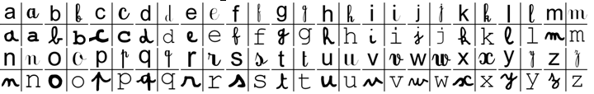
- Figures from 0 to 9
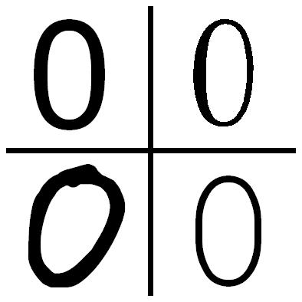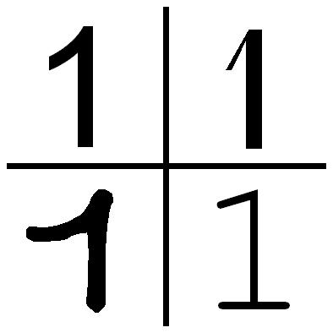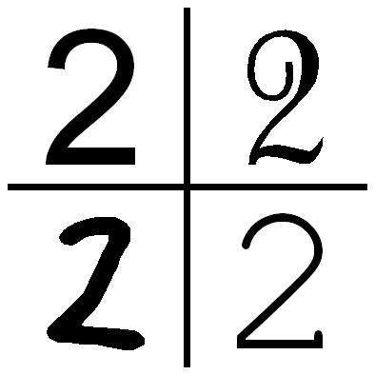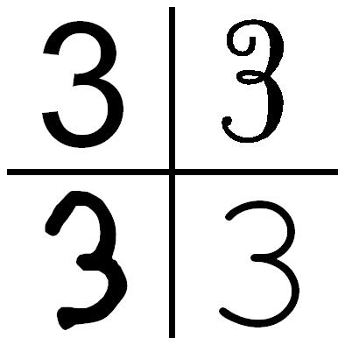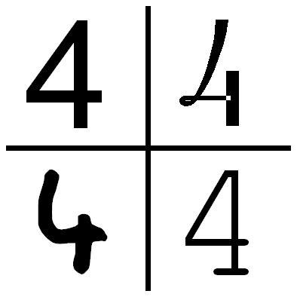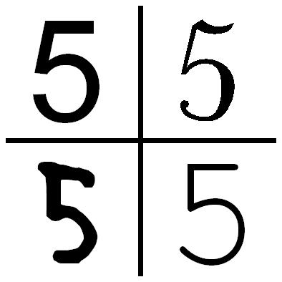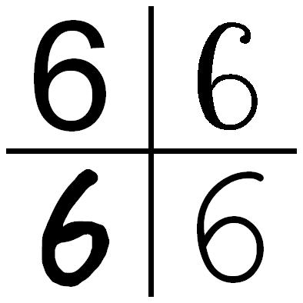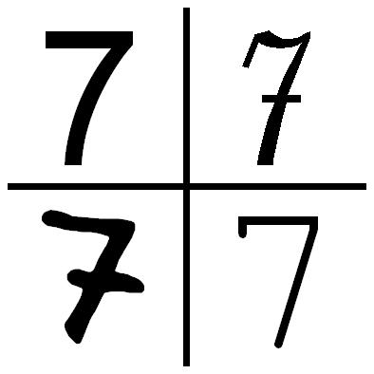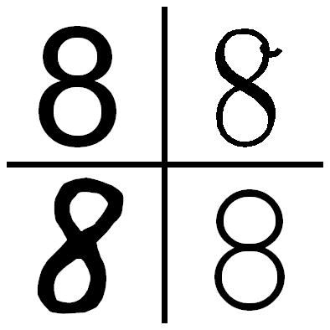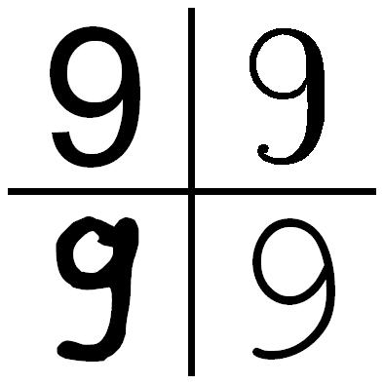
- 16 action commands
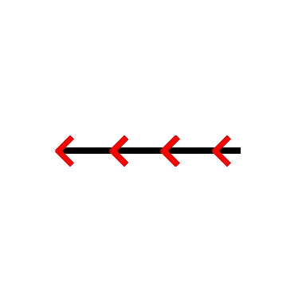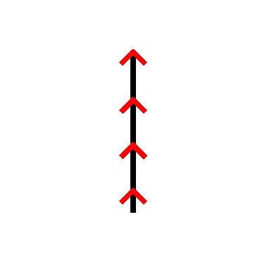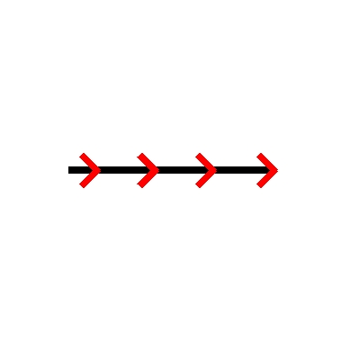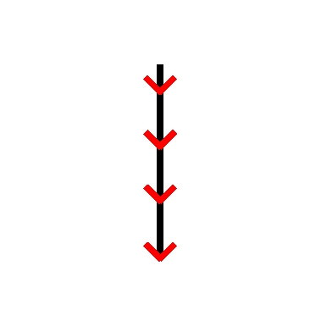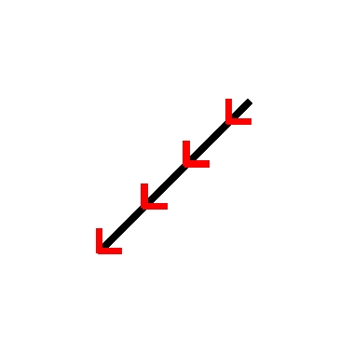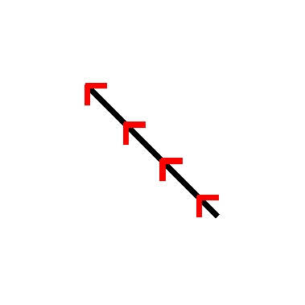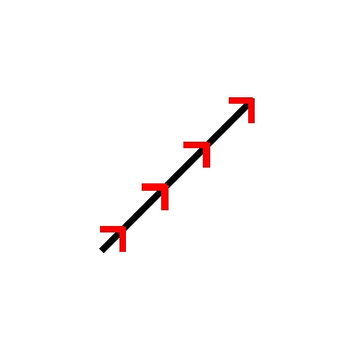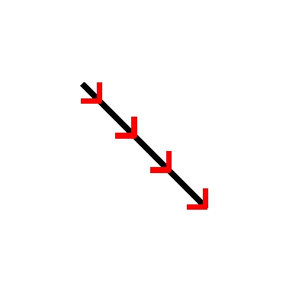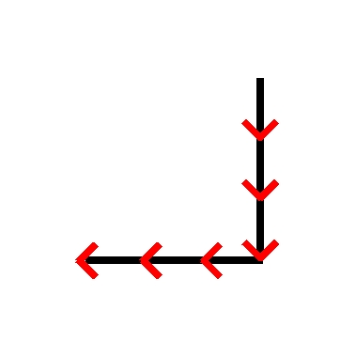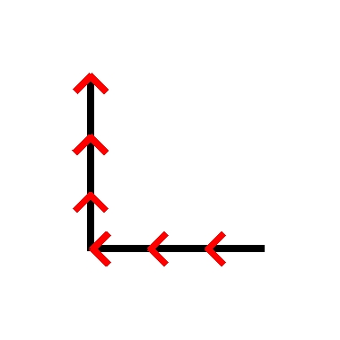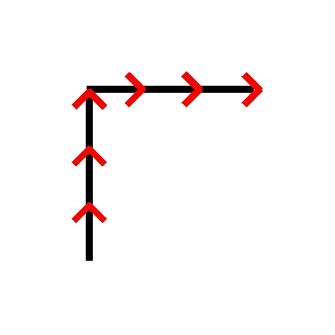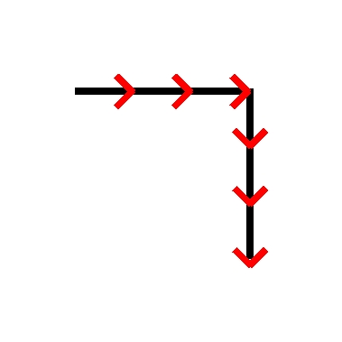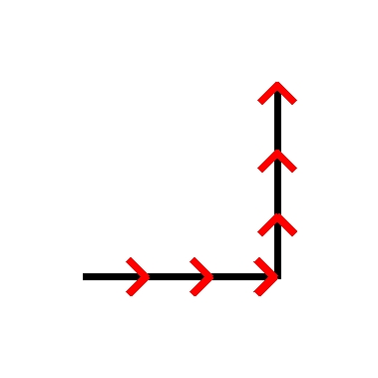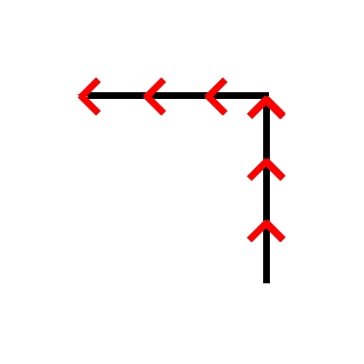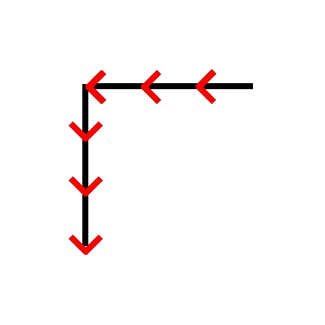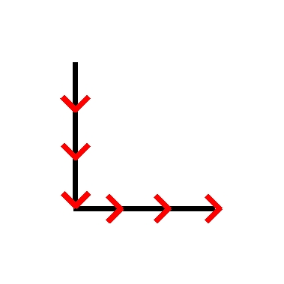
- 8 geometrical shapes
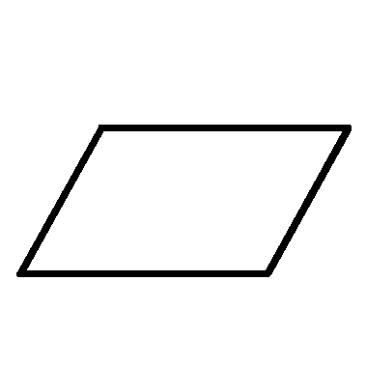
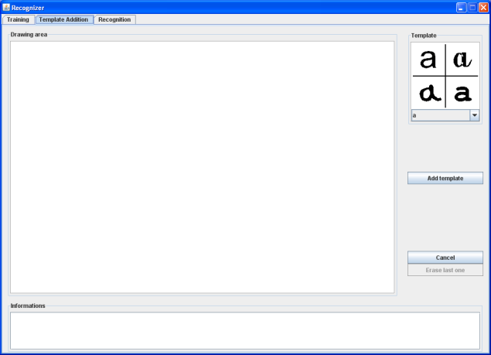
Figure 1. Tool used for collecting data from volunteers.
  - Building the Training Set
To ensure a sufficient training of the algorithms, the participants were asked to provide 10 samples for each gesture through the platform window presented in Figure 1. A total of 30 people participated to the database development. Each gesture was then reproduced 300 times. The participants were asked to produce the gestures in a random order, in order to avoid quality distortion for some gestures. Indeed, during the experiment, the user is likely to take confidence and goes faster and faster trying to end quicker. Mixing the data makes it possible to distribute the various moments of attention and weariness, but also to avoid a biased "noise". Rules were determined for gesture acquisition:
- Participants were requested to avoid making erasures. If necessary, they were asked to erase the complete gesture and to start again. The dimension of the gestures and their position on the screen were free.
- Participants were told it was not a contest. The main purpose was to be as natural as possible.
- Action commands were represented with a black line, and red arrows to indicate the drawing direction.
- Letters and figures had to be drawn with natural writing, with no constraints on the way to write them.
- Geometrical shapes could be drawn with several lines (except for the circle). Participants were informed that the precision and artistic aspects were secondary.
The physical setup was similar for all participants. The computer used was built with an Intel Pentium M 1.6GHz CPU, 2Gb DDR of RAM and a 15 inches LCD screen with a resolution of 1400x1050. The pen-based device was an A4Wacom Intuos3 Pen Tablet (9x12 inches) with a precision of 200 lines per millimeter.
- Algorithm Selection
This section is divided into two parts: the original algorithms selected for the analysis are presented in the first subsection while the second subsection describes the refinements tried on the selected algorithms.
  - Algorithms in their Original Version
Four different approaches have been selected for the comparative study: Rubine [13], One Dollar [18], Levenshtein [4,7] and stochastic Levenshtein [11]. These techniques are different (except for the two algorithms based on the Levenshtein distance) and cover many aspects that can be taken into account when proceeding to shape recognition [2]. All these four algorithms can be trained in a similar way. Other algorithms like Cali [5] are very powerful for geometrical shapes recognition and are trainable for new gesture.
Levenshtein’s algorithm. Levenshtein’s algorihtm [7] is based on the edit distance between two strings thanks to a measure of their dissimilarity. The idea behind the distance is to transform one string into another string using the basic character wise operations delete, insert and replace. The minimal number of these operations for the transformation of one string into another one is called the edit distance or Levenshtein distance. The smaller is the minimal number of needed edit operations for a transformation from string A to string B, the smaller is the distance between these strings.
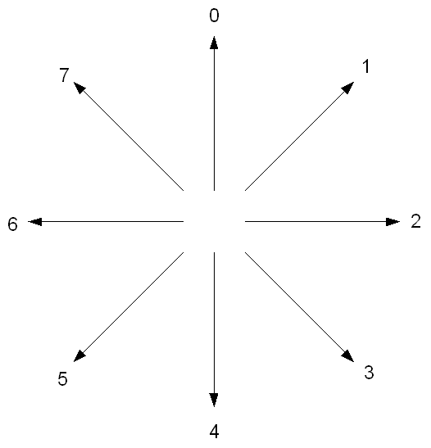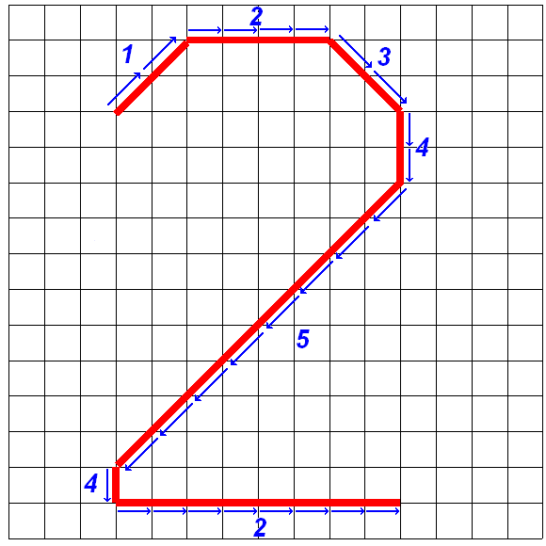
Figure 2. Square grid quantization of freehand shapes.
The features to be extracted from the raw data are based on the idea described in [7]. The drawing plane is superimposed with a grid and the freehand drawing input is quantized with respect to the grid nodes (Figure 2). Each grid node has 8 adjacent grid nodes and for each pair of adjacent nodes one out of 8 directions can be given. So, from the sequence of successive grid nodes, a sequence of directions can be derived. This sequence can be coded using an alphabet 0-7, each value representing one direction. Thus when comparing a sequence representing the gesture to recognize with templates present in the training set, we look for the template with the smallest edit distance.
Stochastic Levenshtein’s algorithm. Stochastic Levenshtein’s algorithm [11] is very close to Levenshtein’s algorithm, which is based on the number of suppressions, insertions and substitutions to transform one chain of characters into another. These operations are modeled with a fixed cost for each operation. An intuitive improvement consists in automatically learning these costs in such a way that the precision of the comparisons is increased. This is the purpose of the stochastic Levenshtein’s algorithm that is based on a probabilistic model to achieve this. The procedure to recognize a gesture is thus similar to the classic version of Levenshtein, the gestures are firstly transformed into sequences of characters and then compared with the gestures of the training set to find its corresponding class. The only difference is the use of a stochastic approach during the strings comparison. The main goal behind the selection of stochastic Levenshtein is the evaluation of the performances of a statistical-based algorithm. The advantage is its quite low time cost while most of the statistical-based algorithms are very time-expensive. Furthermore it represents a natural improvement of the traditional Levenshtein algorithm and is interesting to compare with.
Rubine’s algorithm. Rubine’s algorithm [13] is based on geometrical and temporal characterization of the gestures so as to compute a vector of features for each class represented in the training set (by considering elements of the training set of the same class). From these features vectors, weights are estimated for each of the classes. A score for each available class in the training set is computed for a new gesture to be recognized by determining its vector of features, which is then combined with the different weights of the classes via an inner product. The class attributed to the gesture is the one giving the best score. This algorithm is well known in gesture recognition: its simplicity and its good performances make it an obvious choice.
One Dollar’s algorithm. One Dollar’s algorithm [18] is an algorithm only based on 2D template matching. Its working is very simple: each gesture is initially pre-processed in four steps. The first one is a resampling to have the same number of points for all gestures; the second one consists in a rotation following a certain angle computed such as the shapes are oriented in a similar way; the third step is a rescaling of the gestures to give them the same scale; the final step is a translation of the gestures such that their centroïds match the origin. Once this pre-processing is realized, a simple point-to-point Euclidean distance is computed between the set of training examples and the gesture to be recognized. The class attributed to the new gesture is the class of the closest training example. One Dollar is a new, very simple and cheap algorithm for which very good performances are expected. It is thus very interesting to observe how it behaves with regards to the other approaches.
  - Selected Refinements
Based on our observation, we tried to improve the selected algorithms in different ways. The following is an algorithm by algorithm presentation of the selected modifications.
Rubine’s Algorithm.
Consideration of new features. Pressure, inclination, or orientation of the pen are measurable features thanks to the graphics tablet. Extend the feature vector of Rubine in order to integrate them can thus represent a potential improvement. However, because of the difficulties met to integrate the feature in a pertinent way, this extension has not been selected.
Gesture Preprocessing. One Dollar’s algorithm executes four types of gesture preprocessing before comparing them: a resampling, a rotation, a rescaling and a translation. Testing these transformations on gestures before executing the Rubine’s algorithm constitutes an interesting modification to observe.
One Dollar’s algorithm.
Variation of the number of nearest neighbors. The One Dollar classification of an input gesture consists in attributing it the class of the closest training gesture considering point-by-point quadratic distance. Instead of only taking one training example into account, a possible improvement can be considering more training examples. In this way, the more represented class inside these closest training gestures would be selected. This method is known as kNN, the k-Nearest neighbors’ method. The advantage of this method is that it does not suffer from any high additional computation time since the results for the different numbers of nearest neighbors can be obtained in only one iteration. Indeed, the computation consists in elaborating a list of training gestures sorted by their distance to the input gesture: the first item is considered for kNN = 1, the two first ones for kNN = 2, etc.
Original and Stochastic Levenshtein.
Consideration of new features. As for Rubine’s algorithm, integrate pressure, inclination, and orientation of the pen can be useful. However, the way the algorithm will be impacted is different. For both original and stochastic versions of Levenshtein, these features will be modeled through different generation of the chains of character representing the gestures. More particularly, the symbols of the chains will be associated with difference point-by-point of pressure, inclination, or orientation rather than point-by-point direction. Furthermore, combination of these characteristics can be examined.
Multi-stroke gestures. During the sketching of a gesture, the pen can sometimes be lifted up, involving the apparition of a gap between two successive points. The gesture becomes no longer uni-stroke and is then multi-stroke. In the initial version of the original and stochastic versions of the Levenshtein’s algorithm, two successive points surrounding a gap are processed in the same way than the other point, i.e. by attributing one symbol associated to the direction between them in the chains of characters representing the gesture. For this refinement of the algorithm, the idea is to model the gap in order it would be taken into account. For this purpose, a special symbol representing a piece of gap will be added to the chain of characters a number of times when the pen is lifted up. This number of times depends on some adding frequency (to be determined empirically) and the distance between the two successive points surrounding the gap.
Gesture preprocessing. One Dollar’s algorithm executes four types of gesture preprocessing before comparing them: a resampling, a rotation, a rescaling and a translation. As for Rubine’s algorithm, testing these transformations on gestures before executing the original and stochastic version of Lenvenshtein’s algorithm constitutes an interesting modification to observe.
Normalizations. Instead of estimating the similarity degree between two chains of character with the classical Levenshtein and stochastic Levenshtein algorithms, three normalizations of this distance [19] can be interesting to observe:
- Normalization 1:
- Normalization 2:
- Normalization 3:

Where dL is the initial distance of classical or stochastic Levenshtein and |A| and |B| are the lengths of the two chains of characters.
Modification of the substitution costs (only for original version of the algorithm). In the original version of the Levenshtein algorithm, the insertion costs as the deletion costs of symbol are fixed to a value of 1 while the substitution costs between two symbols can be 0 or 1 depending on the similarity or dissimilarity of the symbols. The idea for this extension (suggested in [11]) is to fix the substitution costs in order to improve the efficiency of the algorithm. This modification is only suited in the particular case where the chains of characters are built with the point-by-point directions of the gestures (see compass rose of directions in Figure 2). The costs are thus modified in a way that their value represents the difference between directions. In other words, more two directions are opposite, more the weight of substituting one direction the other one is big. The matrix presented in Table II shows the different costs of substitution depending of the involved directions.

Table II. Matrix of adapted costs of substitution.
 | 0 | 1 | 2 | 3 | 4 | 5 | 6 | 7
0 | 0 | 1 | 2 | 3 | 4 | 3 | 2 | 1
1 | 1 | 0 | 1 | 2 | 3 | 4 | 3 | 2
2 | 2 | 1 | 0 | 1 | 2 | 3 | 4 | 3
3 | 3 | 2 | 1 | 0 | 1 | 2 | 3 | 4
4 | 4 | 3 | 2 | 1 | 0 | 1 | 2 | 3
5 | 3 | 4 | 3 | 2 | 1 | 0 | 1 | 2
6 | 2 | 3 | 4 | 3 | 2 | 1 | 0 | 1
7 | 1 | 2 | 3 | 4 | 3 | 2 | 1 | 0

- Methodology
This section is aimed at describing the methodology followed to conduct the experiment. It is firstly described for original algorithms and then for refined ones.
  - Original Algorithms
The comparison of the four selected algorithms required a rigorous and identical methodology for each of them in order to obtain pertinent results. Provided that the slowest algorithm is stochastic Levenshtein, this algorithm determined the possibilities concerning the execution time of the tests. Certain choices were thus made to execute the tests in reasonable time. The families of classes were never mixed. All the comparisons were always produced among the examples of a same family, for each family. This choice resulted in a drastic reduction of the execution time. The constituted database is composed of 30 signatures by user, and 10 examples for the other classes. Two types of tests were realized: tests when the algorithms are trained with examples of the user that is used for the recognition (called in the followings tests with training or made dependently of the user), and tests when the algorithms are only trained with examples of other users than the one used for the recognition (called in the followings tests without training or made independently of the user). The statistical method chosen for producing the comparative study is a kind of cross-validation, which will be explained later. A maximum of 9 training examples were thus considered during the study since this number cannot be exceeded for the tests with training. Indeed, 10 examples are available for each user and minimum 1 is required for the recognition.
Tests with Training. For each test, the number of training examples varied between 1 and 9 for One Dollar and original Levenshtein’s algorithms, between 2 and 9 for Rubine and stochastic Levenshtein’s algorithms. For Rubine, it is to avoid a division by 0 in the algorithm if only one training example is provided. For stochastic Levenshtein, two examples of the same class are needed since pairs of strings belonging to the same class are constituted during the training phase.
Five users were used for each test. For each these users, the different algorithms were trained with a number of examples varying between 1 (or 2) and 9, the remaining examples being used for recognition. In order to obtain the more possible pertinent results for a fixed number n of training examples by class, train the algorithms with all the possible combinations of n examples among the 10 ones available would have been ideal. However, it would have implied a too huge number of possibilities. In place of a full cross-validation, a moving window was chosen in order to produce the tests. To illustrate this concept, let us consider a number of training examples by class n = 4: for a given class c, the examples c₁, c₂, c₃ and c₄ are firstly considered for the training (examples c₅ to c₁₀ are thus used for recognition), then the examples c₂ to c₅, then the examples c₃ to c₆, and so on until c₁₀, c₁, c₂ and c₃. In a general way, for a number n of training examples by class, each example is considered n times for the training.
A confusion matrix was thus built for each number of examples by class n. The confusion matrix is a tool allowing measuring the quality of the classification. Each column of the matrix represents the number of examples of an estimated class while each line represents the number of the examples of a real class. It is helpful to determine the recognition rate of n as well as the way each class is categorized.
Tests without Training. Two different methods were considered for the tests without training of the user. The first one took five users into consideration whose one was used for the training all the other ones for the recognition. The second method took ten users into consideration whose one was used for recognition and all the other ones for the training.
The procedure imagined for the first method is similar to the procedure used for a training made dependently of the user. The algorithms are trained each time on one user in the same way than described just before and the difference comes from the examples used for recognition not taken from the same user but other ones. In order to avoid a too long execution time, it was chosen to consider only the examples whose number was not chosen for the training. A confusion matrix was computed for each number of training examples, as well as a classification rate for each user tester. Furthermore, a statistic allowing visualizing the classification rate by user used for the training is provided.
The second method for a training made independently of the user concerned a set of ten users in which nine of them where used for the training and the remaining one for the recognition. As for previous trainings, the number of examples by class varied between 1 (or 2) and 9. For a given class c and a number of training examples by class n, the way the examples were selected was to always take the first one c₁ into account for n of the nine users considered for the training. In other words, the moving window described before is not used on the examples themselves anymore but rather on the users considered. Let us illustrate this for a given class c, a number of examples by class n and ten users. Provided the first example of the class is always taken into account, let u_{x} be the first example of class c for the x^{th} user. Let us then suppose that the first user and thus u₁ is used for the classification, then u₂, u₃, u₄ and u₅ are considered for the training, then u₃ to u₆, and so on until u₁₀, u₂, u₃ and u₄.
  - Refined Algorithms
The tests for the refined algorithms were produced in conditions similar to those described for the original algorithms: one method of training dependent of the user and two independent of the user, for a number of training examples varying between 1 (or 2) and 9. However, all categories were not tested. Only the digits were considered since they represent the more common symbols and allow faster recognition thanks to their reduced number of different classes.
- Results
This section firstly gives and describes the results obtained for the algorithms in their initial version, then for the modified version.
  - Results for the Algorithms in their Initial Version
The experimental study was carried out according to three criteria. (i) The impact of the training type was firstly evaluated following three different ways. The first one is a training made dependently on the user, meaning that we took one user at a time to train the algorithms with a subset of its examples and test them with its other examples not used for the training. The two other ways are user-independent: examples of user tester are not considered for training phase. 10 different users were considered in this study and for the first user-independent training, one of them was used to train the algorithms while the examples of the 9 others were used for the tests. The second user-independent training is a test on the examples of one user when the algorithms were trained with the examples of the 9 other users. (ii) The second criterion has considered the type of gesture to be recognized such as letters, digits, action gestures, and geometrical shapes. (iii) The last test was aimed at comparing the algorithm’s performances.
Due to space restriction, only a subset of the analyses is presented in this part, but it gives an overview of the general tendencies. The results are provided in term of the average recognition rate on all the users (Y-coordinate) for each number of training examples tested (X-coordinate). Figure 3 illustrates the results for Levenshtein’s algorithm applied on digits with respect to the number of samples. It turns out that a training made dependently on the user provides the best results. However, a preliminary training is not always possible. In this case we can see that the diversity of the trainers is beneficial.

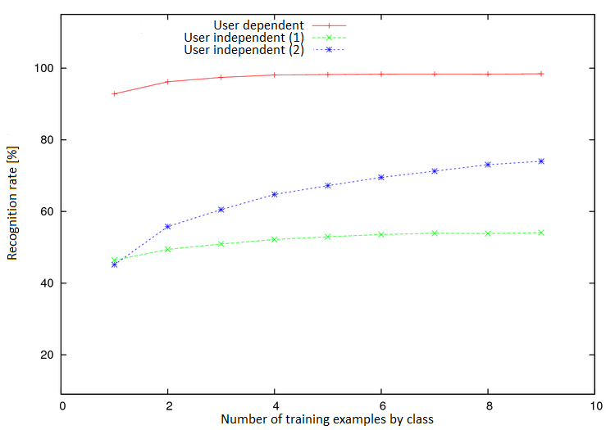
Figure 3. Variation of the training types for Levenshtein's algorithm on digits.

An additional interesting observation is that diversity gives better results in term of absolute performance but also in term of progression as the curve grows unceasingly. It can be explained by the fact that providing examples from a larger set of users increases the probability to find a user with a similar style of writing than the tester and thus find examples that fit for the good class.

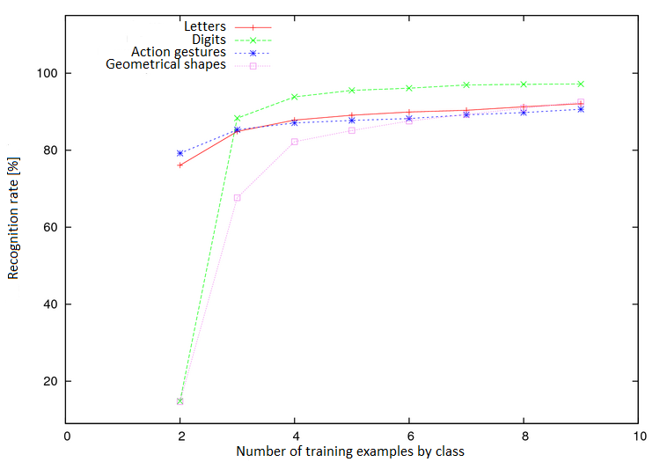
Figure 4. Variation of the gesture types for Rubine's algorithm with user-dependent training.

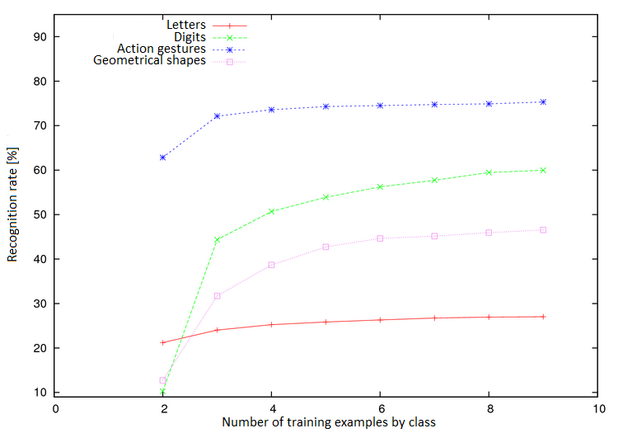
Figure 5. Variation of the gesture types for Rubine's algorithm with user-independent training.

For the variation of gesture types, Figure 5 shows the results for Rubine’s algorithm with user-independent training when we vary the types of gesture. This figure illustrates the general tendency. On one hand when a user-dependent training is applied (Figure 4), the digits class presents the best recognition rate, followed by the letters, the geometric shapes and the actions. This result can be explained: the digits or the letters are more different among them compared to the geometrical shapes or the action gestures. On the other hand when a user-independent training is used, action gestures provide the best results as they show a lower variance across users. An increasing number of items in a family of classes decreases the performance for this family of classes: the letters and digits are two similar families of classes but digits provide better recognition rates because they contain 10 items against 26.

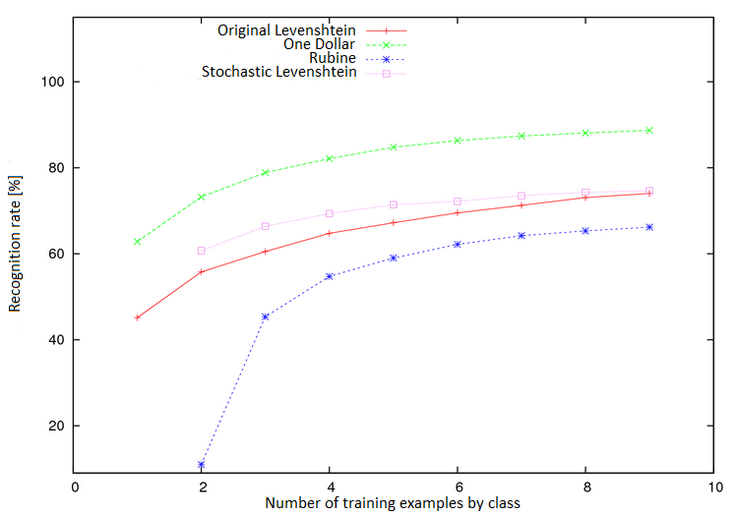
Figure 6. Variation of the algorithms for digits with user-independent training.

For the variation of algorithms, Figure 6 shows the results for the different algorithms applied on digits with user-independent training. We observed that in most situations, One Dollar provides the best results. This can be explained by the extreme simplicity of the algorithm, which needs only a few numbers of examples to reach its highest performances. Another advantage of One Dollar is its high speed. On the other hand One Dollar’s performances are very poor when it comes to recognize gestures that take their difference in geometrical features like action gestures.
  - Results for the Algorithms in their Modified Version
The results presented here are those obtained with a user-independent training with few trainers, since user-dependent training generates curves (not shown here) that are too close and do not present much interest for most situations.
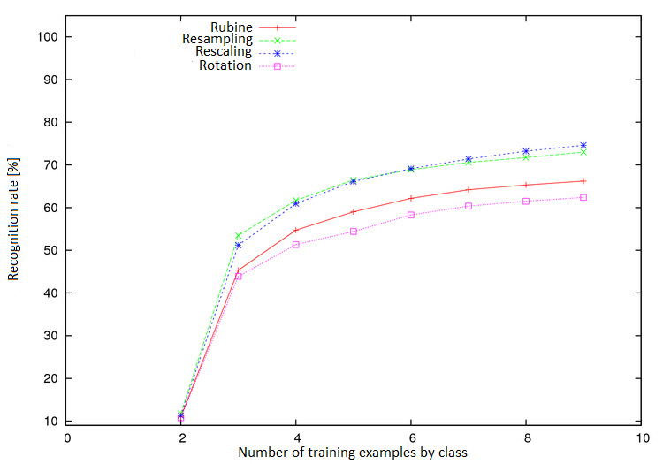
Figure 7. Performances of Rubine's extensions.
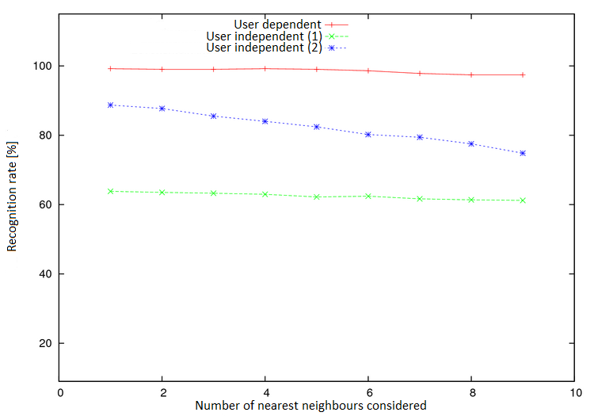
Figure 8. Performances of One Dollar's extensions.
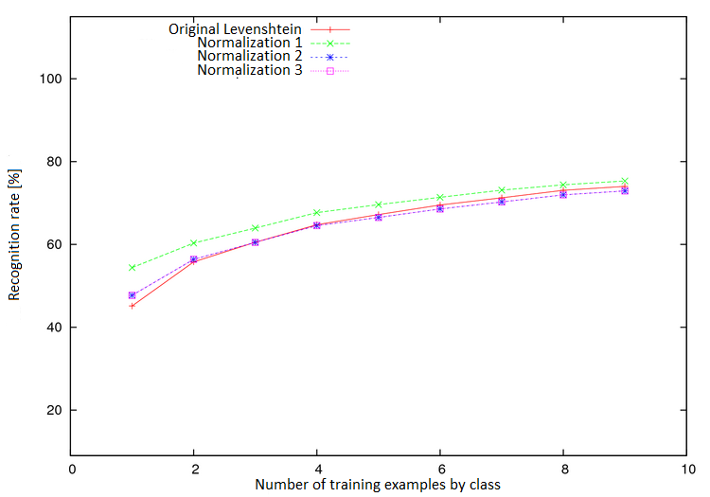
Figure 9. Performances of Levenshtein's normalizations.
For Rubine’s algorithm, the resampling and the rescaling are improved (Figure 7) while the rotation degrades the performances. For One Dollar’s algorithm, we performed a test by growing the number of nearest neighbors. It can be observed in Figure 8 that it decreases the performance. It is not really intuitive but the second, third, etc neighbor tends to be less well classified and causes decreasing performances. It is especially true for a user-independent training with a large number of trainers since it is much easier to find a training example sufficiently close to the test example but belonging to a wrong class. For Levenshtein and stochastic Levenshtein’s algorithms, several extensions were tested that can be sorted in three categories. First of all, we tested the effect of changing the number of nearest neighbors as we did for One Dollar. We do not show the graphs here but the conclusions are roughly the same as it leads to lower performances. Secondly, we tested normalized distances.
The first normalization brings improvements compared to the initial version while the two others are not really helpful (Figure 9).
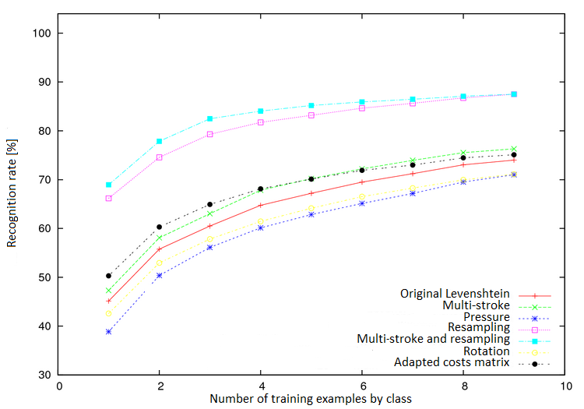
Figure 10. Performances of Levenshtein's extensions.
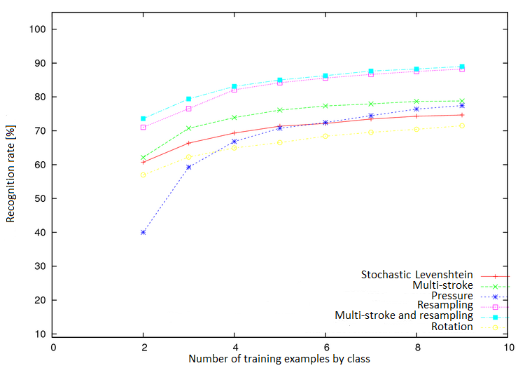
Figure 11. Performances of stochastic Levenshtein's extensions.
The last illustration (Figure 10) presents other extensions. The first one is the modification of the chains of characters in function of the pressure, inclination or orientation of the pen. None of these tests were concluding for the traditional Levenshtein’s algorithm. However, this last modification can improve the stochastic Levenshtein’s algorithm if a sufficient number of training examples is provided (Figure 11). As we did for Rubine, we evaluated the impact of a pre-processing of the data before applying the Levenshtein’s algorithms.
If a reorientation of the shapes decreases the performances for both algorithms, the resampling offers real improvements. Translation as rescaling does not change anything. Another extension consisted in taking account of the multi-strokes gestures. This extension improves both the traditional Levenshtein’s algorithm and its stochastic version. We then tried to combine it with the resampling and we obtained our best improvement. Finally, we tried a more suitable cost matrix for the Levenshtein’s algorithm (only for the original version of the algorithm), leading to an improvement of the performances.
- Conclusion
Three different lines have been followed during the study on the algorithms in their initial version. The first concerns the training types for which the results are unsurprisingly better for the user-dependent way. However, such conditions are not always satisfied and in this case, introducing a maximum of user variability in the learning database increases the recognition rate. The second line deals with the different families of classes. For a user-dependent training, letters and even more digits give the best results while the same conclusion can be drawn for the action gestures for user-independent training. Indeed, action gestures offer more similarity and are thus more similar when the user changes while letters or digits hold more user information.
Finally the last line analyses the algorithms themselves. The observed results matched the expected ones. The constraints about deployment and time conducted us to select only a small number of training examples (9) by family of classes. In this configuration, One Dollar offers the best results (except for the action gestures that are too much dependent of the rotation), even if the stochastic Levenshtein also obtains good results. However, it requires much more training examples to give its best. The advantage of One Dollar is increased by its speed, similar to the speed of Rubine or Levenshtein, but about 1000 times faster than stochastic Levenshtein (speed graphics not shown here).
Improved algorithms have been tested too. Again, for time and deployment constraints, exhaustive investigation was not possible. We thus made some choices and it appears that the real big improvement is obtained for the Levenshtein and stochastic Levenshtein algorithms by applying a resampling as pre-processing on the gestures. Taking the gaps into account still improves a little bit the performances. The other extensions tested do not represent real improvement or may even decrease recognition rates. Table 1 summarizes the different performances for the algorithms in their initial versions by highlighting the best algorithm for each situation.

Table 1. Original algorithms summary.

 | User-dep. | User-indep. 1 | User-indep. 2
Digits | $1 | Lev. | $1
Letters | $1 | Lev. | $1
Actions | Sto. Lev. | Rub. | Sto. Lev.
Shapes | Rub. | Rub. | $1
Table 2. Modified algorithms summary.

 | Rub. | $1 | Lev. | Sto. Lev.
Resampling | + | X | ++ | ++
Rescaling | + | X | X | X
Rotation | - | X | - | -
kNN | X | - | - | -
Multi-stroke | X | X | + | =
Multi-stroke + resampling | X | X | ++ | ++
Pressure | X | X | -- | -
Normalization 1 | X | X | + | -
Normalization 2 | X | X | = | -
Normalization 3 | X | X | = | -
Adapted costs matrix | X | X | + | X

Table 2 gives a performance measure for each modification of the algorithms in comparison with their initial version: ‘—‘ for hard decreasing; ‘-‘ for decreasing; ‘=’ for similarity; ‘+’ for improvement; ‘++’ for hard improvement; ‘X’ if not applicable. The two tables only represent a summary and a general tendency for each feature, under certain circumstances (few number of examples by class). Moreover, it only takes recognition rates performances into account.
References
- Appert, C. and Zhai, Sh. Using Strokes as Command Shortcuts: Cognitive Benefits and Toolkit Support. In: Proc. of CHI'2009 (Boston, 4-9 April 2009). ACM, pp. 2289-2298.
- Artières, T., Marukatat, S., Gallinari, P., Online handwritten shape recognition using segmental hidden Markov models. IEEE Trans. on Pattern Analysis and Machine Intelligence 29, 2 (Feb. 2007), pp. 205–217.
- Blagojevic, R., Schmieder, P., and Plimmer, B. Towards a Toolkit for the Development and Evaluation of Sketch Recognition Techniques. In: Proc. of ACM IUI’09 Workshop on Sketch Recognition (Sanibel Island, February 8, 2009).
- Coyette, A., Schimke, S., Vanderdonckt, J., and Vielhauer, C. Trainable Sketch Recognizer for Graphical User Interface Design. In: Proc. of INTERACT’2007 (Rio de Janeiro, September 10-14, 2007). LNCS, Vol. 4662. Springer, pp. 123–134.
- Fonseca, M. J., Pimentel, C., and Jorge, J.A. Cali, An online scribble recognizer for calligraphic interfaces. In Proc. of the 2002 AAAI Spring Symposium on Sketch Understanding, (2002), pp. 51–58.
- Goh, W.L., Mital D.P., and Babri, H.A. An artificial neural network approach to handwriting recognition. In: Proc. of 1st Int. Conf. on Knowledge-Based Intelligent Electronic Systems KES’97 (Adelaide, May 1997). Vol. 1 (1997), pp. 132–136.
- Levenshtein V. I.: Binary codes capable of correcting deletions, insertions, and reversals. Soviet Physics Doklady 10, 8 (1966) pp. 707–710.
- Llorens, D., et al. The Ujipenchars database: a pen based database of isolated handwritten characters. In: Proc. of the 6th Int. Language Resources and Evaluation LREC’08 (Marrakech, May 28-30, 2008). European Language Resources Association (ELRA), 2008.
- Mackenzie, I.S. and Zhang, S.X. The immediate usability of Graffiti. In: Proc. of the Conf. on Graphics Interface GI’97 (Kelowna, May 21-23, 1997). Canadian Human-Computer Interaction Society (2009), pp. 129–137.
- Marti, U. V., Bunke, H. A full English sentence database for off-line handwriting recognition. In Proc. of the 5th Int. Conf. on Document Analysis and Recognition ICDAR'99, pp. 705–708.
- Oncina, J. and Sebban, M. Learning stochastic edit distance: Application in handwritten character recognition. Pattern recognition 39 (2006), pp. 1575–1587.
- Okumur, D., Uchida, S., and Sakoe, H. An HMM implementation for on-line handwriting recognition based on pen coordinate feature and pen-direction feature. In: Proc. of ICDAR’05 (Aug. 29-Sept. 1, 1995). IEEE Comp. Soc. (1995), pp. 26–30.
- Rubine, D. Specifying gestures by example. SIGGRAPH Computer Graphics 25, 4 (July 1991), 329–337.
- Schmieder, P., Plimmer, B., and Blagojevic, R. Automatic Evaluation of Sketch Recognizers. In: Proc. of 6th Eurographics Symposium on Sketch-Based Interfaces and Modeling SBIM’09 (New Orleans, August 1-2, 2009). ACM Press, New York (2009), pp. 85–92.
- Signer, B., Kurmann, U., and Norrie, M. C. iGesture: A General Gesture Recognition Framework. In: Proc. of 9th Int. Conf. on Document Analysis and Recognition ICDAR’2007 (Curitiba, September 2007). IEEE Computer Society Press, Los Alamitos (2007), pp. 954-958
- The UC Irvine machine learning repository. Accessible at http://archive.ics.uci.edu/ml/. Last visited on Nov. 5th, 2010.
- Unipen, http://unipen.org. Last visited on Nov. 5th, 2010.
- Wobbrock, J.O., Wilson A.D., and Li, Y. Gestures without libraries, toolkits or training: a $1 recognizer for user interface prototypes. In: Proc. of UIST’07 (New York, 2007). ACM Press, New York (2007), pp. 159–168.
- Yujian, L. and Bo, L., A normalized Levenshtein distance metric. IEEE Trans. on Pattern Analysis and Machine Intelligence 29 (2007), pp. 1091–1095.

