To be real or not to be real? The effect of genuine (vs. non-genuine) depictions of social media influencers on followers’ well-being and brand purchase intention
Claeys, P.; Charry, K. & Tessitore, T.
Accepted for publication in “Psychology & Marketing” on 24/09/23.

Abstract
Criticized for the idealized lives portrayed on social media (e.g., Instagram), a growing number of social media influencers are now embracing genuineness, showcasing unfiltered and less sophisticated pictures of themselves. The current research investigated this trend by examining how genuine (vs. non-genuine) visual self-presentations by influencers affect their followers’ purchase intention and, importantly, their well-being. With an experiment (n = 171) and a quasi-experiment with an ex-post facto design (n = 154), we demonstrate that influencers’ genuineness (vs. non-genuineness) not only benefits promoted brands but also followers’ well-being. Specifically, genuine (vs. non-genuine) influencers induce fewer upward comparisons, which, in turn, increases followers’ self-esteem, well-being, and purchase intention. Investigating the role of gender, we show that, while males also tend to purchase more products when recommended by genuine (vs. non-genuine) male influencers, the mediating process through social comparison does not occur. Combining psychosocial and marketing perspectives, this study expands various streams of research on social media influencers and offers pragmatic contributions that reconcile managers, social media influencers, and public policy makers. More genuineness in pictures, using fewer filters and beauty artifices, provides benefits for all. Finally, we suggest future research directions as ways to further reconcile these two perspectives.
Keywords: social media influencers; genuineness; social comparison; self-esteem; well-being; Instagram.

1. Introduction
Anyone who has ever scrolled through Instagram knows what the quest for the perfect picture means. What may be less clear is how it feels to be confronted with those pictures when they feature influencers displaying perfect faces and bodies. Does it boost one’s ego, or does one feel suddenly depressed? And how does this influence the desire to buy the recommended product? Now, what if these influencers were not so perfectly “made-up”? Could this be a game-changer? As influencer marketing, or the use of social media influencers to recommend products and brands to followers through social media posts (Hudders et al., 2020), takes up an ever-growing part of the promotion mix, this issue is becoming all the more relevant. Nowadays, 75% of marketing managers integrate social media influencers into their communication mix (Influencer Marketing Hub, 2020), and in keeping with a long advertising tradition (Cornelis & Peter, 2017), many influencers strive to achieve the “perfect picture,” using image filters and beauty artifices in the hope of increasing their (commercial) influence.
However, some influencers have started to portray themselves in more genuine ways to allegedly avoid the negative impact that idealized (i.e., non-genuine) pictures would have on followers’ well-being (Leighton, 2019; Wells et al., 2021). In June 2022, #nofilter was the 42nd most-used hashtag on Instagram (Tophashtag, 2023) with more than 286 million posts (Moran, 2022), and #nomakeup reached 19 million in June 2023 (Tophashtag, 2023). BeReal, a new social media platform on which pictures cannot be filtered, has also gained popularity (Davis, 2022). These trends signal the need for more truthful self-presentation or “genuineness,” defined as “the ability and willingness to be what one truly is” (Gelso & Carter, 1994, p. 297), and more specifically, “visual genuineness” in self-presentation, as visuals become the dominant form of communication on social media (Dhanesh & Rahman, 2021). However, the impact of visual genuineness (vs. non-genuineness) is unclear. To the best of our knowledge, no prior social media influencer research has studied the impact of genuineness on commercial outcomes such as purchase intention, and none has considered how commercial and psychosocial outcomes, notably well-being, interplay. The present research intended to bridge this gap by examining how genuine vs. non-genuine influencers’ self-presentations affect these two outcomes and whether they can be reconciled.
Most prior social media influencer research indeed focused on commercial outcomes such as engagement, brand attitude, and purchase intention (Hudders et al., 2020; Sokolova & Kefi, 2020; Vrontis et al., 2021). Fortunately, scholars have begun to consider the impact of influencer marketing on psychosocial outcomes such as consumer well-being. However, given the frequency with which the media reports a negative link between social media use, influencers, self-esteem, and well-being (Leighton, 2019; Wells et al., 2021), research still offers limited perspectives on how to help reduce these negative outcomes. Further investigation into ways to induce consumers’ positive emotional and psychosocial responses in this context is needed (Vrontis et al., 2021). Specifically, combining a psychosocial dimension with commercial considerations appears highly relevant (Hudders et al., 2020), rather than treating them as separate elements, as has been done to date.
Finally, most influencer research focuses on women, considering that most influencers are women (Hudders & De Jans, 2022) and that they mostly address women, who are more present on Instagram than men (Dahmani, 2021). Focusing on women also appears relevant as women’s self-esteem and well-being are impacted by their frequent Instagram use (Sherlock & Wagstaff, 2019). However, social media use also increases men’s tendency to engage in appearance-based comparisons with others (Lonergan et al., 2021), often raising concerns (Griffiths et al., 2018). This calls for more research on influencers’ impact on men from both commercial and psychosocial perspectives.
Using a between-subjects experiment and a quasi-experiment, we investigated (1) the impact of influencers’ genuineness (vs. non-genuineness) on consumers’ purchase intention toward the endorsed brand and well-being, (2) the mechanism behind these effects (i.e., through reduced social comparison and increased self-esteem), and (3) whether gender moderates these effects.
The theoretical contributions of this research are threefold. First, it contributes to the literature on influencer marketing. We identified influencers’ visual genuineness as an important factor in determining their effectiveness. Unlike previous research, this research took a dual perspective and found that both commercial and psychosocial outcomes can benefit from influencer genuineness simultaneously. We also unraveled the (psychosocial) processes that underlie these outcomes. Second, this research contributes to the social comparison theory. We showed that the level of visual genuineness of an influencer can modulate the amount of upward social comparison in women, meaning that the same person may induce less or more perceived genuineness and consequently, can trigger more or less upward comparisons. Third, this study extends prior findings on the role of gender in determining susceptibility to social influence (Djafarova & Rushworth, 2017), also in digital contexts. We show that unrealistically perfect (vs. genuine) influencers induce women (not men) to compare themselves with virtual ideals, with negative implications for women’s self-esteem and well-being, while commercial consequences (purchase intention) are negative for both men and women.
The layout of this paper is as follows. First, we develop a theoretical background to build our hypotheses and conceptual models. Next, we present a pretest and two experimental studies. Subsequently, a general discussion elaborates the findings, thereby detailing their theoretical and practical contributions. Finally, we conclude the paper with the limitations of our research and provide interesting paths for future research.

2. Theoretical Background
2.1 Impact of influencers’ genuineness on social comparison
When posting content on social networks, mainly pictures, influencers often tend to offer the “best version of themselves” (Jin et al., 2019). Although the intensity of the use of filters and other beauty artifices varies from one influencer to the next (Javornik et al., 2022), many influencers are still tempted by the promise of reflecting current beauty standards and applying “freckles,” “lighter eyes,” or “smooth skin” filters; adopting unnatural poses; or using sophisticated makeup. These influencers therefore present “non-genuine” versions of themselves, whereby genuineness is defined as “the ability and willingness to be what one truly is” (Gelso & Carter, 1994, p. 297). Genuineness represents one of the three dimensions of authenticity (Joseph, 2016). Although authenticity is a concept generally studied in influencer research (Audrezet et al., 2020), zooming in on genuineness seems to be of particular interest in the context of influencers’ self-presentation in pictures. The other two dimensions of authenticity, namely autonomy (freedom in communication) and congruence with their values (Ryan & Ryan, 2019), indeed seem more difficult to perceive and assess than visual genuineness in pictures. Therefore, it might also be easier for influencers to improve followers’ perceptions of their visual genuineness than their autonomy or congruence.
Inevitably, followers compare themselves to influencers. According to the social comparison theory, people evaluate different aspects of their lives by comparing themselves with others (Festinger, 1954). Although these comparisons can occur in different dimensions, many are related to physical appearance (Couture Bue, 2020). Furthermore, there are two types of comparison: downward, which occurs when one compares oneself to others one considers “lower,” and upward, which occurs when one compares oneself to others one considers superior (Wood, 1989). Comparisons related to pictures posted by influencers on social media tend to be upward because of the idealized nature of the pictures and overevaluations of the comparison targets.
Those who make upward comparisons on social media rate their current selves as different from their ideal selves (Haferkamp & Kramer, 2011); in this phenomenon, known as self-discrepancy, people compare their “actual” selves to their “ideal” selves, according to internalized standards of who they aspire to be. The gap between the self and others is associated with emotional discomfort and negative emotions (e.g., fear, threats, and restlessness) (Higgins, 1987). Therefore, more genuineness or truthiness in one’s self-presentation (Gelso & Carter, 1994) may reduce the gap between observers’ different selves and limit upward comparison. In line with the self-discrepancy theory, we expect that followers who compare themselves with influencers who present embellished self-presentations (i.e., are not genuine in their self-presentations) make upward comparisons with influencers (Wang et al., 2020), whereas those who compare themselves with influencers who present non-embellished, genuine self-presentations are less likely to make upward comparisons with influencers.

2.2 Mediating role of upward comparison and self-esteem
Upward social comparisons have mixed effects (Couture Bue, 2020). Upward comparisons may be positive and encourage people to achieve their comparison targets (Lockwood & Kunda, 1997). However, upward comparisons can also make individuals feel inadequate (Tiggemann & Zaccardo, 2015; Wang et al., 2020) and may lead to discouragement, depression, disordered eating, envy, and degradation of body image (Rousseau et al., 2017; Tandoc et al., 2014; Tiggemann & Zaccardo, 2015; Wang et al., 2020). Specifically, upward comparisons would negatively affect psychosocial variables such as self-esteem (Jan et al., 2017; Richins, 1991). Defined as “an individual’s general sense of his or her value or worth” (Kong et al., 2013, p. 152), self-esteem should be understood here as the attitude individuals hold toward themselves as a whole object (Rosenberg et al., 1995).
Studies on social media have shown that upward social comparison has a negative impact on mental health (e.g., Jang et al., 2016). Kim and Kim (2020b) showed that self-congruency with a favorite influencer increases followers’ perception of quality of life. This means that when followers do not identify gaps between the influencer and themselves, and thus no upward comparison occurs, the psychological consequences, such as perceived quality of life, are positive.
Based on this and our prior prediction that non-genuine influencers’ self-presentation leads individuals to make upward comparisons, we anticipate that non-genuine influencers will lead to unattainable ideals, negative responses, and negative effects on self-esteem (Jan et al., 2017; Javornik et al., 2022; Richins, 199). However, if influencers are genuine in their self-presentations, followers engage less in upward comparison and the discrepancy between their actual and ideal selves lessens or even disappears, which should reduce the negative impact on their self-esteem.

2.3 Self-esteem, well-being, and purchase intention
Self-esteem is an important antecedent of well-being (Rosenberg et al., 1995). Although there seems to be no international consensus definition of “well-being,” recent research proposed that “well-being is a state of positive feelings and meeting full potential in the world” (Simons & Baldwin, 2021). Specifically, self-esteem increases well-being (Apaolaza et al., 2013). People with a comparatively high self-esteem are extroverted, less socially anxious, and less shy (Leary & MacDonald, 2003). They feel less lonely, have more satisfying and stable relationships, experience lower levels of negative emotions and depressive disorders (Leary & MacDonald, 2003), are more likely to enjoy positive moods (Wood et al., 2003), and can repair their negative moods (Heimpel et al., 2002).
In the specific context of influencers, it has been shown that, on the one hand, self-congruency with influencers improves followers’ sense of well-being (Kim & Kim, 2020). On the other hand, influencers who usually exhibit a “glamorized lifestyle” trigger envy —the “painful emotion that stems when one feels inferior compared to another” (Lee et al., 2022, p. 703)— and negatively impact well-being (Lee et al., 2022). Haferkamp and Krämer (2011) argued that exposure to attractive Facebook users can impair well-being.
Based on all the above, we expect that when followers encounter genuine influencers, they are less likely to engage in upward comparison, thereby increasing their self-esteem and benefiting their well-being. Accordingly, we hypothesized the following:

H1. The genuineness (vs. non-genuineness) of influencers’ self-presentations has a positive effect on well-being, which is serially mediated by decreased upward comparison and increased self-esteem.

Self-esteem is also an antecedent to purchase intention. People with comparatively higher self-esteem try harder to maintain those levels of self-esteem by acquiring goods (Sirgy, 1985; Truong & McColl, 2011). Such acquisition helps improve self-esteem by flattering one’s ego (Arndt et al., 2004), such that self-gifts improve self-worth, which is an important element of self-esteem (Mick & Demoss, 1990). Furthermore, people are more likely to buy goods that help maintain their levels of self-esteem when the goods are recommended by those with whom they identify (Sirgy, 2018). If followers are more likely to identify with influencers who portray themselves naturally, without embellishing reality, than with influencers who use filters and beauty artifices to distort reality and show unattainable ideals, then we expect the following:
H2. The genuineness (vs. non-genuineness) of influencers’ self-presentations has a positive effect on purchase intention, which is serially mediated by decreased upward comparison and increased self-esteem.

2.4 Moderating role of gender
According to evolutionary psychology, tens of thousands of years of survival and reproductive pressures have shaped human behavior, creating differences between men and women (Butori & Parguel, 2014; Trivers, 1972). When men and women seek opposite-sex romantic partners, the characteristics they look for tend to differ: women attach more importance to men’s resources, whereas men are more interested in women’s fertility cues, such as attractiveness and youth (Trivers, 1972). Beauty and body size are also more relevant to self-worth in women than in men (Owens et al., 2010). This may explain why women usually invest more in body appearance; hence, they present a higher interest in and involvement in beauty products that are expected to maintain youth and beauty than men. Men are more interested in products that display wealth and the ability to obtain resources (Norton et al., 2015). Another implication is that women are more likely than men to compare themselves physically with others (Heinberg & Thompson, 1992; Jones, 2001), and such comparisons seem to have more negative consequences for women than for men. Women are more likely than men to engage in upward comparisons, while men are more likely than women to engage in downward comparisons (Strahan et al., 2006). Although social media use seems to increase men’s tendency to engage in appearance-based comparisons with others (Lonergan et al., 2021), research shows that when induced to make upward comparisons, they tend to present self-improvement motives, which translate into motivation to pursue the activity (Peng et al., 2019).
Furthermore, women are more likely to compare their physical appearance with unrealistic targets such as models (Strahan et al., 2006). This process of upward comparison damages the self in terms of perception of appearance and can result in body image distortion (Patrick et al., 2004; Richins, 1991). Following an upward comparison, women are more likely than men to report body dissatisfaction (Aruguete et al., 2006). As women tend to engage more frequently than men in upward comparisons and are more negatively affected by them, we expect that the level of genuineness of influencers’ self-presentations will have a stronger impact on women’s upward comparisons than on men’s. Specifically, this stronger decreasing effect on upward comparisons for women will translate into higher self-esteem and well-being for women than for men. Moreover, women are more likely than men to buy products based on endorsers’ reviews, because they are more susceptible to social opinions (Bearden et al., 1990; Wilcox & Stephen, 2013). Therefore, we hypothesized the following:

H3: The genuineness (vs. non-genuineness) of influencers’ self-presentations has a positive effect on well-being via decreased upward comparison and increased self-esteem. However, this serial process is stronger for women than for men.

H4: The genuineness (vs. non-genuineness) of influencers’ self-presentations has a positive effect on purchase intention via decreased upward comparison and increased self-esteem. However, this serial process is stronger for women than for men.

Figure 1. Hypothesized model
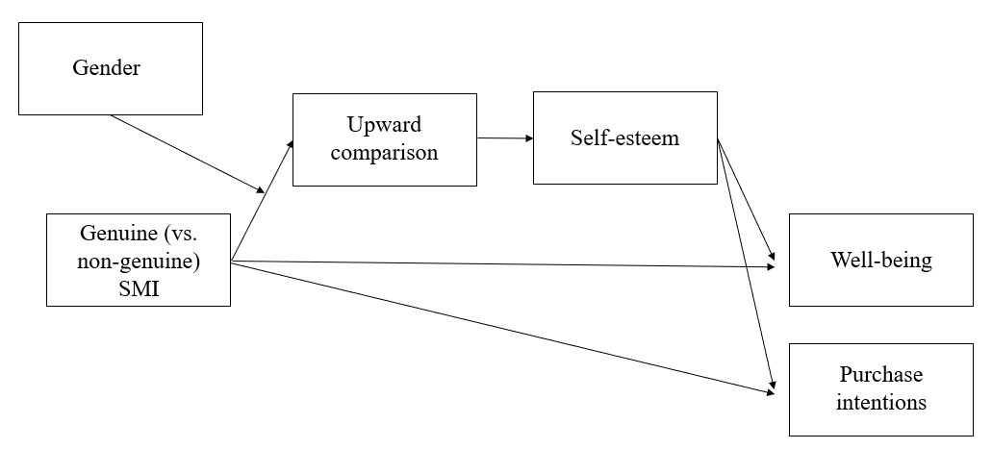

We tested the four hypotheses constituting the hypothesized model in Figure 1 using two studies. In Study 1, we tested H1 and H2 using a scenario-based experiment in which we pretested the scenarios in line with recent influencer marketing research (Boerman, 2020; De Jans et al., 2020; Hudders & De Jans, 2022; Hudders et al., 2020; Jin et al., 2019). We used a female influencer and female respondents to represent the dominant dyad in influencer marketing on social media (Hudders & De Jans, 2022). In the second quasi-experimental study, we aimed to replicate the results of Study 1 by adding gender as a moderator to test H3 and H4 and ensure the validity of our findings.

3. Study 1
The aim of Study 1 was to test H1 and H2; that is, the impact of genuine (vs. non-genuine) influencers on well-being and purchase intention, as well as the mediating role of upward comparison and self-esteem in a context involving a female influencer and female followers. This dyad corresponds to the most prevalent and effective influencer marketing structure on social media (Hudders & De Jans, 2022). Furthermore, women are more prone to making upward social comparisons (Strahan et al., 2006), which is consistent with the objectives of Study 1.

Before conducting this study, we conducted a pretest to confirm that the two experimental scenarios (manipulating levels of influencer genuineness) led to the two expected levels of perceived genuineness—one perceived as genuine and the other as significantly less genuine—corresponding to the two experimental conditions. We recruited 28 women and assigned them to 1 of 2 conditions. We began by presenting the fictional lifestyle influencer Danae on Instagram. We focused on this category of influencers because the fashion/beauty and lifestyle fields are the most represented on social networks (Patard, 2022), and they fit our objective of working with dyads of women. We asked the participants to imagine the following: “While spending some time on Instagram, you find this post by Danae. Danae is a lifestyle influencer you have followed for some time. In her post, she recommends sportswear from Calirae.” We then showed Danae posts to all the participants. In the non-genuine scenario, the Instagram posts portrayed an idealized lifestyle influencer. Danae appeared unnatural, in a position that showed her at her best. In the genuine scenario, the posts portrayed a non-idealized lifestyle influencer. Danae appeared natural with imperfections. All other features of the posts and image backgrounds were the same (e.g., number of likes and descriptive text) to keep everything as constant as possible (see Appendix A). An independent sample t-test showed that, in response to the question “According to you, the influencer is…,” with six items on a 7-point differential scale (e.g., fake/real; disguised/undisguised; Cronbach’s α = .91; Akbar & Wymer, 2017), participants perceived significantly lower genuineness in the non-genuine condition (n = 13; M_{nongenuine} = 2.8; standard deviation [SD] = .62) than in the genuine condition (n = 15; M_{genuine} = 5.16; SD = .74; t(26) = -10.326; p < .001; Ƞ2 =.87). That is, our scenarios induced significantly different levels of genuineness, so we could rely on them to create the two conditions for Study 1. Although the genuineness of the “non-genuine” influencer did not equal zero, it seemed representative of reality and therefore remained labelled as such in our subsequent studies.

3.1 Data collection, procedure, and stimuli
We designed a between-subjects experiment with two conditions, in which we manipulated the perceived genuineness of the influencer (genuine vs. non-genuine), recruited participants from Prolific, and randomly assigned them to one of the two conditions. The experiment began with a “yes or no” filter question: “Are you following lifestyle influencers (bloggers, YouTubers, Instagramers...)?” This enabled us to recruit women acquainted with and interested in influencers. We retained only the respondents who answered “yes.” A total of 171 respondents completed the questionnaire (M_{age} = 23.44 years; SD = 4.64, 100% women). After showing these respondents the pretested scenario text and stimuli (Appendix A), we conducted a manipulation check with validated scales to measure purchase intention, well-being, upward comparisons, self-esteem, and the perceived genuineness of the influencer. We ended the questionnaire with sociodemographic questions.

3.2 Measures
To measure purchase intention toward the fictitious brand Calirae, we used four items adopted from van Reijmersdal et al. (2016) (e.g., “I am interested in buying the recommended product”; “I would like to buy the recommended product”; Cronbach’s α = .93). We measured well-being with a five-item scale adopted from Diener et al. (1985), ranging from 1 (“strongly disagree”) to 7 (“strongly agree”) (e.g., “In most ways, my life is close to my ideal”; “I am satisfied with my life”; Cronbach’s α = .89). We measured purchase intention and well-being on a 7-point Likert scale ranging from 1 (“strongly disagree”) to 7 (“strongly agree”). For self-esteem, we included 10 items on a 7-point Likert scale from Rosenberg (1965) ranging from 1 (“strongly disagree”) to 7 (“strongly agree”) (e.g., “I feel that I am a person of worth”; “I take a positive attitude toward myself”; Cronbach’s α = .72). We captured upward comparison via the question “After seeing this post from Danae, how do you feel, compared to her?” using 11 items on a 7-point semantic differential scale (e.g., “superior/inferior,” “same/different”; Allan & Gilbert, 1995; Cronbach’s α = .91). Finally, to check our manipulation of genuineness, as in the pretest, we used the scale from Akbar and Wymer (2017) with six items on a 7-point differential scale (e.g., “fake/real,” “disguised/undisguised”; Cronbach’s α = .92). Appendix B lists all the measures.

3.3 Manipulation check and group equivalence
An independent-samples t-test showed that participants in the genuine scenario were more likely to indicate the influencer was genuine (n = 95; M_{genuine} = 5.65; SD = .77) than were participants in the non-genuine condition (n = 76; M_{nongenuine} = 3.13; SD = 1.01; t(169) = -18.59; p < .001; Ƞ2 = .81), thereby validating our manipulation and confirming the pretest. We tested the equivalence of the two groups in terms of age; these results confirmed their equivalence (M_{genuine} = 23.55 years; M_{nongenuine} = 23.32 years; t(169) = .32; p = .347). Appendix C presents the descriptive statistics.

3.4 Results
To test H1 and H2, we used the Process Macro model 6 to test for serial mediation (Preacher & Hayes, 2008). We identified well-being (H1) and purchase intention (H2) as the dependent variables (Y), genuineness as the independent variable (X), upward comparison as the first mediator (M1), and self-esteem as the second mediator (M2) (see Figure 2). The results on well-being showed that, compared with non-genuine influencers, genuine influencers had a more positive effect on well-being through lower upward comparisons and greater self-esteem. In detail, genuine influencers (vs. non-genuine) had a negative effect on upward comparison, such that followers compared themselves less (β = -.65; SE = .15; p < .001), but not on self-esteem (β = .24; SE = .14; p = .079). Upward comparisons then had a significant negative impact on self-esteem (β = -.36; SE = .06; p < .001), and self-esteem had a significant positive impact on well-being (β = .35; SE = .11; p = .002). Finally, we found an overall positive indirect effect of genuineness by influencers on well-being through upward comparisons and self-esteem (β = .25; SE = .10; 95% CI = [.0783, .4501]). The direct effect of genuine (vs. non-genuine) influencers on well-being was positive and significant (β = 1.29; SE = .19; p < .001; 95% CI = [.9260, 1.6600]), as well as the total effect (β = 1.54; SE = .19; p < .001; 95% CI = [1.1646, 1.9133]). All of this suggests a partial serial mediation, supporting H1 (Figure 2).

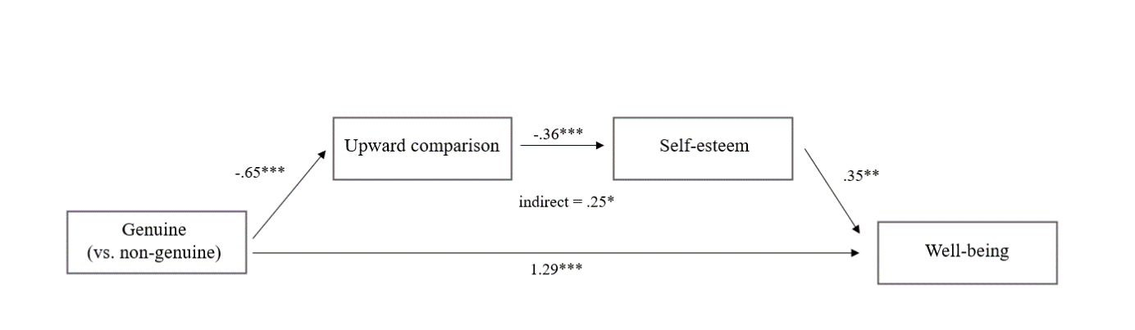
Figure 2. Study 1, Serial mediation of well-being

Notes: Serial mediation from genuineness to well-being through upward comparison and self-esteem. *p < .05, **, p <. 01; ***p < .001.

When we used purchase intention as the dependent variable, the effects of genuineness (vs. non-genuineness) on upward comparisons and self-esteem were similar, and self-esteem had a significant positive effect on purchase intention (β = .37; SE = .09; p < .001). There was also an overall positive indirect effect of genuine (vs. non-genuine) influencers’ self-presentations on purchase intention through upward comparison and self-esteem (β = .09; SE = .04; 95% CI = [.0223, .1808]). The direct effect of genuineness (vs. non-genuineness) on purchase intention was positive and significant (β = 2.12; SE = .17; p < .001; 95% CI = [1.7819, 2.4524]), as well as the total effect (β = 2.22; SE = .17; p < .001; 95% CI = [1.8873, 2.5535]). This finding suggests partial serial mediation, supporting H2 (Figure 3).

Figure 3. Study 1, Serial mediation of purchase intention
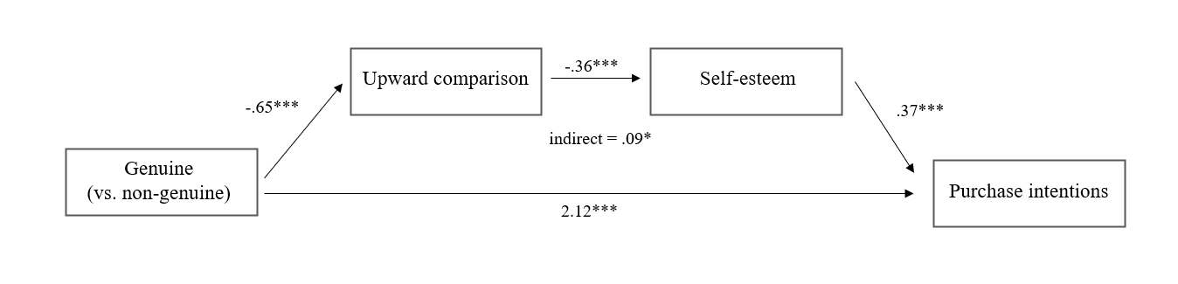

Notes: Serial mediation from genuineness to purchase intentions through upward comparison and self-esteem. *p < .05, ***p < .001.

3.5 Discussion
Study 1 showed that when influencers present themselves genuinely (vs. non-genuinely), it pays off for all stakeholders—that is, it is good for followers’ well-being and the brands endorsed. These effects are driven by fewer upward comparisons, leading to greater self-esteem. We designed a second study to confirm the robustness of these results. In Study 1, only women participated in the experiment; this approach seemed legitimate because it was representative of influencer marketing practices (Hudders & De Jans, 2022) and social network use. Compared to men, women are more present on Instagram and follow more lifestyle influencers (Dahmani, 2021). Our results justified our focus by providing insights into a significant segment of social media users. However, because men are neither completely absent from Instagram nor exempt from social media influence, we sought to verify whether the impact of influencer genuineness differs between women and men. In Study 2, we added nuance to our Study 1 findings by studying gender.

4. Study 2
4.1 Data collection
To test the full model, we designed a quasi-experiment with an ex post facto design according to gender. We manipulated the genuineness and gender of the influencers. To increase similarity perceptions and allow each respondent to identify and easily compare themselves with the influencer, we created fictional male and female influencers. After checking each respondent’s gender identity, we randomly assigned male participants to one of two “male” conditions (male genuine influencer vs. male non-genuine influencer) and randomly assigned female participants to one of two “female” conditions (female genuine influencer vs. female non-genuine influencer). Using a filter question, we retained only those respondents who declared an interest in lifestyle blogs or vlogs, as in Study 1. To test our hypotheses, we designed a questionnaire that measured purchase intention, well-being, upward comparisons, self-esteem, and perceived genuineness (identical order to Study 1); 154 respondents completed our questionnaire (M_{age} = 24.67 years; SD = 3.61; 51% women and 49% men).

4.2 Procedure and stimuli
The four experimental conditions began with the presentation of a fictional lifestyle influencer: Ludo, to male respondents, and Lily, to females. We explained that “(s)he regularly posts content on her social media, and you’ve been following him/her for the past few years.” Then, we asked all participants to project themselves into a text-based scenario: “While surfing on Instagram, you find a post by Ludo/Lily. In his/her post, (s)he presents beard cream from BarberMe/face cream from Myskin.” In the non-genuine scenario, the influencer’s image showed no imperfections. In the genuine scenario, the influencer appeared natural, without makeup and with imperfections. All other features of the post were the same across conditions (e.g., number of likes and descriptive text) (see Appendix D). Unlike in Study 1, in which we controlled for the background of the influencer image, the stimuli used in Study 2 did not have the same background, which should increase the ecological validity of the research findings. Next, we measured purchase intention toward the endorsed product (Cronbach’s α = .91), well-being (Cronbach’s α = .85), self-esteem (Cronbach’s α = .87), upward comparison (Cronbach’s α = .86), and perceived genuineness of the influencer (Cronbach’s α =.90), using similar scales as in Study 1. We ended the questionnaire with sociodemographic questions.

4.3 Manipulation check and group equivalence
As in Study 1, we checked our manipulation with an independent-samples t-test, which showed that participants in the genuine condition found the influencer more genuine (n = 81; M_{genuine} = 4.17; SD = 1.07) than those in the non-genuine condition (n = 73; M_{nongenuine} = 3.11, SD = .93; t(152) = -6.52; p < .001; Ƞ2 = .47). Specifically, male participants in the genuine condition considered the influencer to be more genuine (n = 39; M_{genuine} = 4.16; SD = 1.02) than did male participants in the non-genuine condition (n = 36; M_{nongenuine} = 3.01; SD = 1.01; t(73) = -4.91; p < .001; Ƞ2 = .49). Female participants in the genuine condition also considered the influencer to be more genuine (n = 42; M_{genuine} = 4.17; SD = 1.12) than did female participants in the non-genuine condition (n = 37; M_{nongenuine} = 3.21; SD = .84; t(77) = -4.25; p < .001; Ƞ2 = .44). Thus, the manipulation was effective for both men and women. We also validated the equivalence of the two groups in terms of age (M_{genuine} = 24.62 years; M_{nongenuine} = 26.07 years; t(169) = 1.88; p = .062) (see Appendix E for descriptive statistics).

4.4 Results
We tested the full model using Process Macro model 6 (Preacher & Hayes, 2008), first with well-being and then with purchase intention as the dependent variable (Y), genuineness as the independent variable (X), upward comparison as the first mediator (M1), and self-esteem as the second mediator (M2) (Figure 1). Notably, because male respondents could see only one of the two conditions (genuine male influencer or non-genuine male influencer), and female respondents could see only one of the two other conditions (genuine female influencer or non-genuine female influencer), we did not randomly assign participants to the four conditions. To maintain the internal validity of our study, we divided the analyses between women and men.
The results for women (Figure 4) showed that, as in Study 1, compared with the non-genuine influencer, the genuine influencer had a significant negative effect on upward comparisons (β = -.90; SE = .23; p < .001) and a positive effect on self-esteem (β = 2.74; SE = .22; p < .001), and upward comparisons had a significant negative impact on self-esteem (β = -.31; SE = .10; p = .003). Self-esteem had a significant positive impact on well-being (β = .28; SE = .11; p = .014). There was an overall positive indirect effect of the genuineness of the influencer on well-being through upward comparison and self-esteem (β = .08; SE = .04; 95% CI = [.0131, .1705]). The direct effect of the genuine (vs. non-genuine) influencer on well-being was positive and significant (β = 1.28; SE = .36; p < .001; 95% CI = [.5765, 1.9932]). The total effect of genuineness on well-being was also positive and significant (β = 2.06; SE = .21; p < .001; 95% CI = [1.6382, 2.4864]).
The results for men (Figure 5) showed that the genuine (vs. non-genuine) influencer had neither a significant negative effect on upward comparisons (β = -.02; SE = .23; p = .913) nor self-esteem (β = -.14; SE = .22; p = .533), nor did upward comparisons affect self-esteem (β = -.08; SE = .11; p = .478). The indirect effect of genuineness (vs. non-genuineness) on well-being through upward comparison and self-esteem was non-significant (β = -.00; SE = .02; 95% CI = [-.0283, .0464]). Moreover, the direct effect of genuineness (vs. non-genuineness) on well-being was not significant (β = -.08; SE = .21; p = .707; 95% CI = [-.4983, .3396]), and the total effect was not significant either (β = -.17; SE = .25; p = .508; 95% CI = [-.6587, .3288]). Our finding of significant partial serial mediation for women but not for men supported H3.

Figure 4. Study 2, Conceptual model, women’s well-being
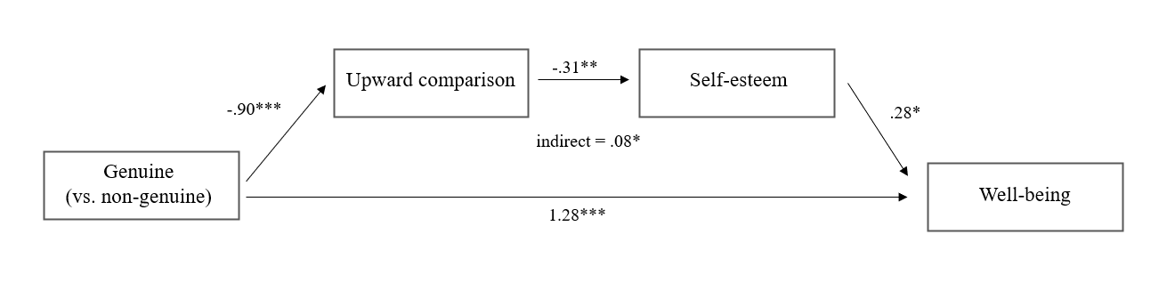

Notes: Serial mediation from genuineness to well-being through upward comparison and self-esteem for women. *p < .05, **p < 01, ***p < .001.

Figure 5. Study 2, Conceptual model, men’s well-being
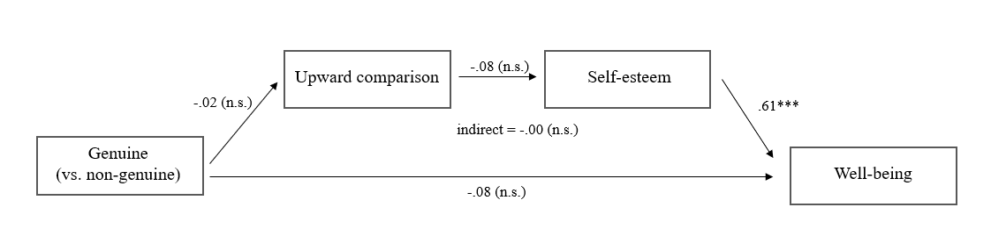

Notes: Serial mediation from genuineness to well-being through upward comparison and self-esteem for men. n.s. non-significant, ***p < .001.

With purchase intention as the dependent variable, for women, self-esteem had a significant positive impact on purchase intention (β = .41; SE = .12; p < .001). Overall, there was a positive indirect effect of influencer genuineness (vs. non-genuineness) on purchase intention for women through upward comparisons and self-esteem (β = .12; SE = .06; 95% CI = [.0276, .2582]). There was no significant direct effect of genuineness (vs. non-genuineness) on purchase intention (β = .55; SE = .36; p = .132; 95% CI = [-.1687, 1.2594]), and the total effect was positive and significant (β = 1.45; SE = .22; p < .001; 95% CI = [1.0059, 1.8989]). This replicated Study 1 and suggested full mediation (Figure 6).

For men, self-esteem did not have a significant impact on purchase intention (β = -.22; SE = .12; p = .070). No indirect effect of genuineness (vs. non-genuineness) via upward comparison and self-esteem on purchase intention (β = .00; SE = .01; 95% CI = [-.0235, .0098]) was found. There was a direct effect of genuineness (vs. non-genuineness) on purchase intention (β = 1.23; SE = .23; p < .001; 95% CI = [.7815, 1.6866]), and the total effect was significant (β = 1.26; SE = .23; p < .001; 95% CI = [.8084, 1.7193]). This supported H4 (Figure 7).
Figure 6. Study 2, Conceptual model, women’s purchase intentions
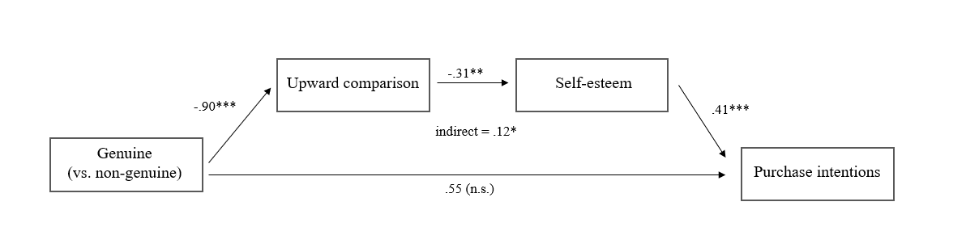
Notes: Serial mediation from genuineness to purchase intentions through upward comparison and self-esteem for women. *p < .05, **p < .01, ***p <. 001.

Figure 7. Study 2, Conceptual model, men’s purchase intentions
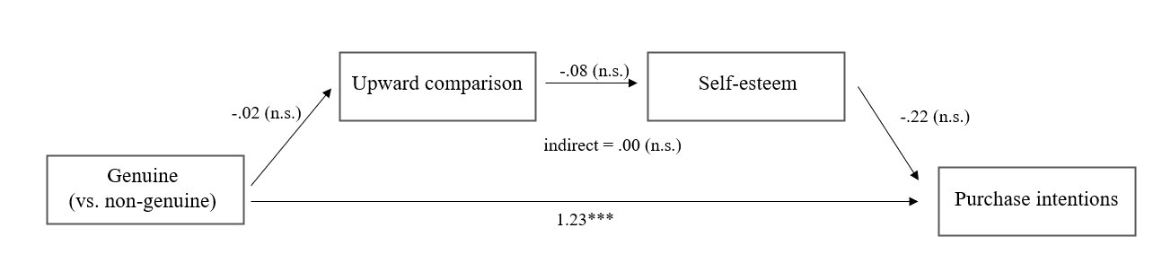
Notes: Serial mediation from genuineness to purchase intentions through upward comparison and self-esteem for men. n.s. non-significant, ***p < .001.

To confirm these results, we conducted a multi-group analysis (MGA) using SmartPLS with two groups: Group 0 for female respondents and Group 1 for male respondents. First, in line with our previous results, with well-being as the dependent variable, the MGA results revealed significant differences between the two groups in each relationship except between self-esteem and well-being, confirming H3. Second, with purchase intention as the dependent variable, we confirmed the previous results, demonstrating significant differences between the two groups in each relationship, except for the direct effect between genuineness and purchase intention, thus confirming H4. Tables 1 and 2 summarize the results of the MGA.
Table 1. MGA results, well-being [support for H3]
 | Female path coeff. | SE | Male path coeff. | SE | Path coeff. Diff. | Welch-Satterthwait test
Genuineness well-being | .382  t-stat = 3.382*** | .11 | .012  t-stat = .112 (n.s.) | .10 | .370  t-stat = 2.417* | t-stat = 2.423*
Genuineness upward comparison | -.284  t-stat = 2.266*** | .11 | .047  t-stat = .0439 (n.s.) | .11 | -.331  t-stat = 2.207* | t-stat = 2.208*
Upward comparison self-esteem | -.217  t-stat = 1.950* | .11 | .050  t-stat = .381 (n.s.) | .13 | -.267  t-stat = 1.569* | t-stat = 1.563*
Self-esteem well-being | .137  t-stat = .800* | .14 | .476  t-stat = 4.675*** | .10 | -.233  t-stat = 2.152 (n.s.) | t-stat = 2.170 (n.s.)

Table 2. MGA results, purchase intention [support for H4]
 | Female path coeff. | SE | Male path coeff. | SE | Path coeff. Diff. | Welch-Satterthwait test
Genuineness purchase intention | .238  t-stat = 2.154* | .11 | .303  t-stat = 3.04*** | .10 | -.065  t-stat = .436 (n.s.) | t-stat = .438 (n.s.)
Genuineness upward comparison | -.284  t-stat = 2.657** | .11 | .047  t-stat = .0415 (n.s.) | .11 | -.331  t-stat = 2.143* | t-stat = 2.141*
Upward comparison self-esteem | -.217  t-stat = 1.882* | .12 | .050  t-stat = .367 (n.s.) | .14 | -.267  t-stat = 1.512* | t-stat = 1.506*
Self-esteem purchase intention | .146  t-stat = 1.120* | .13 | .031  t-stat = .318 (n.s.) | .10 | .115  t-stat = .708* | t-stat = .713*

Finally, Study 2 used pictures with backgrounds that differ due to different levels of picture zoom in the male conditions (i.e., a close-up in the genuine condition and a full-length picture in the non-genuine condition). While this increases the ecological validity of our results for males, this could also have confounded the results. To rule out the level of picture zoom as an alternative explanation for our male results, we conducted a post-test and an extra experiment on the male conditions. These confirmed our previous results (see Web Appendix for designs and results).

5. Discussion and Conclusions
Although research on influencer marketing is growing rapidly, topics such as the impact of influencers on followers’ well-being remain under-researched (Vrontis et al., 2021). With this research, we responded to Hudders et al.’s (2020) call to add a psychosocial dimension to the consideration of commercial impact. We investigated the impact of the genuineness of influencers’ self-presentation on followers’ well-being and purchase intention. Our findings showed that, when women encountered pictures of genuine (vs. non-genuine) influencers, they were less likely to make upward comparisons, leading to increased self-esteem. This increase enhanced well-being and induced a stronger intention to purchase the endorsed products. The results for men were slightly different, as exposure to genuine (vs. non-genuine) influencers did not induce fewer upward comparisons and men’s self-esteem and well-being were unaffected. Although purchase intention increased, this was not due to a decrease in upward comparisons or an increase in self-esteem.

5.1. Contributions
This research contributes to three research areas. First, it advances the influencer marketing and endorsement strategy literature by confirming that influencers influence purchase intention (Hudders et al., 2020; Sokolova & Kefi, 2020), and that they may also play a positive societal role. By taking a dual perspective, we showed that genuine (vs. non-genuine) influencers achieve their commercial effectiveness objective while also having a positive impact on their followers’ self-esteem and well-being. We showed the serial process that explains these effects. Specifically, we showed that the effectiveness of a genuine (vs. non-genuine) influencer is driven by fewer upward comparisons for women, which in turn increases women’s self-esteem and translates positively into greater well-being and intentions to purchase. In other words, female influencers’ commercial influence on women is positively affected by their positive influence on women’s self-esteem, indicating that commercial and psychosocial objectives can coincide. This research also showed that genuineness (vs. non-genuineness) is an important visual factor for influencers, thereby highlighting the importance of genuineness in itself and not merely as a dimension of authenticity.
Second, we contribute to social comparison theory. Prior research indicated that women are more likely than men to compare themselves physically with others (Heinberg & Thompson, 1992; Jones, 2001) and engage in upward comparisons (Strahan et al., 2006). Although recent research suggests that men tend to engage in appearance-based comparisons with others on social media (Lonergan et al., 2021), this remains a predominantly feminine disposition. In our research, female influencers appeared as a new type of aspirational group to which women compare themselves, which may have a positive effect on their self-esteem and well-being. Moreover, we revealed another antecedent of upward comparison. While people generally consider a specific person to be either superior or inferior to them, whether based on a particular characteristic or overall, we showed that the same person, depending on their genuineness in pictures, can lead women to make fewer (or more) upward comparisons. We also confirmed that comparisons influence self-esteem (Jan et al., 2017; Richins, 1991), and that self-esteem increases well-being (Apaolaza et al., 2013).
Third, this work complements previous studies that applied evolutionary psychology to consumer behavior (Su et al., 2020) and provides insights that confirm previous results related to reproductive instincts (Butori & Parguel, 2014; Trivers, 1972). The latter suggests that women compare themselves more than men, specifically to unrealistic targets (Strahan et al., 2006). Our studies showed that females are more likely than males to compare themselves physically to unrealistic (i.e., non-genuine) targets also in digital, although virtual, contexts. Nevertheless, both men and women are more likely to buy endorsed products from genuine (vs. non-genuine) influencers.
Reflecting on what might have influenced the main effect of influencers’ genuineness (vs. non-genuineness) on men’s purchase intention (serial mediation was not confirmed), we might invoke men’s competitive spirit. Indeed, men seem to develop strong competitive attitudes toward other men (Buunk & Massar, 2012), and in this case, we can assume that the non-genuine influencer may have been perceived as an attractive “alpha male” who triggered more competitive responses than comparison responses. Beauty is not as important for men’s self-worth as it is for women (Owens et al., 2010). Therefore, the idealized influencer may have simply represented a serious competitor, potentially limiting another man’s ability to attract a mate, but not something to compare himself to. This explains why, given this competitive spirit, the purchase intention of male followers is low, as the intentions to follow a competitor’s recommendations are less developed.
These studies have important practical implications for influencers, companies, and public decision makers in a context where related practices are evolving rapidly. Indeed, while movements such as #nofilter and the success of BeReal, a social network where no filters are allowed, show the emerging need for genuineness in visual self-presentations on social networks, the temptation of idealization based on the tradition of photoshopping in advertising (Cornelis & Peter, 2017) remains omnipresent. These two trends clash and require scientific insights. Considering both concerns, our research proved that genuineness is beneficial for all parties involved, including social media influencers, marketers, and consumers. Fewer filters, fewer beauty artifices, and more realistic pictures should be offered on social media, and policymakers should take effective action to move in this direction. Specifically, the implications for all parties are as follows:
First, this research provides influencers with concrete guidelines on how to remain commercially effective while positively affecting their followers’ self-esteem and well-being. Female influencers who self-present in a genuine visual manner contribute to limiting the probability that their female followers compare themselves to an ideal that does not exist and devalue themselves in ways that diminish their well-being. This also contributes to followers’ self-acceptance and positive moods (Javornik et al., 2022). Importantly, being genuine does not reduce their commercial influence, and that, whatever the followers’ gender. Therefore, we propose an easy way to reconcile all their objectives, which will most certainly contribute to influencers’ overall satisfaction. However, we stress that genuineness should not be confused with self-disclosure, because the latter has opposing consequences. Self-disclosure, or being overt about one’s personal life and revealing (too) many intimate details, has been shown to trigger perceptions of social inappropriateness, which negatively affect trust and purchase intention (AlRabiah et al., 2022). Therefore, while we recommend that influencers be genuine and offer truthful self-presentations, we do not mean that they should reveal everything about themselves.
Second, our findings will guide marketers in their selection of the relevant influencer to endorse their products and brands, showing that opting for the “perfect” or “ideal” influencer does not necessarily translate into optimal commercial effectiveness. We recommend that marketers work with both female and male influencers who use genuine visual self-presentations to boost consumers’ purchase intention. To identify influencers who frequently display their genuine selves, marketing analysts can use digital image forensic tools that can detect whether a digital image is somehow manipulated. Companies will most likely benefit indirectly from the use of genuine influencers. While some managers might be willing to leverage their “use” of genuine influencers in other brand communications to reinforce the brand image, trigger publicity, and reach mass audiences, marketers may merely expect followers to transfer the influencer’s genuineness to the brand through a spillover effect. A brand’s willingness to maintain consumers’ well-being while pursuing its business objectives will authentically benefit the brand image, stimulating consumer engagement and loyalty to the company.
Third, the findings of this research also have implications for policymakers. First, public policymakers could use our findings to increase consumer and influencer awareness of the societal consequences of idealized pictures in public service announcements (on social media). Aware followers and influencers can further nurture the trend toward greater genuineness on social media, which certainly represents a game-changer. Second, they can restrict the manipulative use of reality-enhancing methods. While some countries, such as the United Kingdom and Norway, already do this (the U.K.’s Advertising Standards Authority prohibits misleading filters on beauty advertisements [Law & Hampson, 2021], and Norway forces the disclosure of retouched pictures posted online [Hutchinson, 2021]), we offer scientific support to help all regulators counter economic arguments in favor of idealized pictures. Furthermore, while we believe that genuineness may be easier to evaluate on a picture than on other concepts, imposing the use of disclaimers, on either retouched or retouch-free posts, could also be recommended. Prior research in traditional advertising found that a retouch-free disclaimer (“the picture of the model in the ad has not been retouched” vs. “the picture of the model has been retouched”) increased women’s appearance satisfaction, attitude toward the ad, and purchase intention compared to no disclaimer (Cornelis & Peter, 2017). Considering our results, we can expect the same positive effects from disclosing genuineness. Finally, public policymakers should focus on social media platforms and impose the use of digital image forensic tools to automatically detect filtered and unfiltered pictures and disclose them accordingly.

5.2 Limitations and directions for future research
This study has some limitations that could be addressed. First, we studied only the visual determinants of genuineness, such as whether the influencers used image filters. However, visuals are not the only relevant aspect; influencers can express their genuine selves through non-visual content, such as when recommending products or discussing their lives. Future research could study the impact of non-visual genuineness.
Second, regarding commercial effectiveness, we focused only on purchase intention. It remains unclear whether influencers’ genuineness has an equal impact on other marketing objectives such as brand visibility, awareness, or brand image. Moreover, according to Pradhan et al. (2021), when followers perceive brands as controlling or supervising influencers’ content, they tend to avoid the brands and their associated influencers. Future research should investigate whether working with genuine influencers limits perceptions of brand control, decreases avoidance, and benefits both influencers and brands. As mentioned above, the effect of disclaimers on filtered or nonfiltered pictures on commercial outcomes should be investigated in the domain of influencer marketing.
Third, in terms of psychosocial variables, we focused on upward comparison, self-esteem, and well-being. However, to fully understand the psychosocial impact of influencers on their followers, future research should study other variables, such as sense of belonging, loneliness, and envy, which often appear in the social networking addiction literature (Apaolaza et al., 2013; Jin & Ryu, 2020; Pittman & Reich, 2016; Tandoc et al., 2014). Farivar et al. (2022) demonstrated that the physical attractiveness of influencers leads to negative affective responses from followers, such as problematic engagement. Leveraging these findings and our results, additional research could analyze whether showing up in genuine ways reduces such negative responses.
Fourth, while most influencer marketing research focuses on women (Hudders & De Jans, 2022), our results call for more research on male influencers and their influence on male followers. Given the absence of a serial mediation process for men in our beauty product/genuineness context (e.g., beard cream), it would be interesting to consider another product category. For example, focusing on products that reflect wealth could be relevant, as wealth triggers more envy in men than in women (whereas beauty triggers more envy in women than in men) (Salovey & Rodin, 1991; Norton et al., 2015), and thus potentially (upward) social comparisons. If this is true, it would be relevant to compare the wealth-probing/envy process to the beaty/genuineness process in terms of purchase intention, as previous research has shown that envy triggers consumption in men (Jin & Ryu, 2020).
Fifth, another interesting research path would be to focus on influencers’ self-presentations that could increase men’s upward social comparisons based on their appearance. Although (young) men have tended to attach increasing importance to their appearance for several years now (Engeln et al., 2013; Field et al., 2014), there is much less research on men than on women (Quittkat et al., 2019), and the few studies mostly focus on muscularity. Although it appears that bare-chested muscular influencer pictures can reduce men’s body satisfaction (Tiggemann & Anderberg, 2020), the results were not mediated by social comparison. It would be interesting to extend the research to other aspects of appearance, as in our study (the male influencer was dressed and did not seem particularly muscled), to further extend the findings.
Finally, Ki and Kim (2019) demonstrated followers’ desire to mimic influencers. Research should address whether genuine influencers, in addition to having a positive effect on well-being, inspire their followers to stop using filters, thereby initiating an overall spiral of genuineness, moving toward a more genuine social media environment. Similarly, we hope that this study will spark more influencer research that simultaneously considers the perspectives of marketers and followers in their search for beneficial strategies.

References
Akbar, M.M., & Wymer, W. (2017). Refining the conceptualization of brand authenticity. Journal of Brand Management, 24(1), 14-32.
Allan, S., & Gilbert, P. (1995). A social comparison scale: Psychometric properties and relationship to psychopathology. Journal of Personality and Individual Differences, 19, 293-99.
AlRabiah, S., Marder, B., Marshall, D., & Angell, R. (2022). Too much information: An examination of the effects of social self-disclosure embedded within influencer eWOM campaigns. Journal of Business Research, 152, 93-105.
Apaolaza, V., Harmann, P., Medina, E. , Barrutia, J., & Echerbarria, C. (2013). The relationship between socializing on the Spanish online networking site Tuenti and teenagers’ subjective wellbeing: The roles of self-esteem and loneliness. Computers in Human Behavior, 29(4), 1282-89.
Arndt, J., Solomon, S., Kasser, T., & Sheldon, K.M. (2004). The urge to splurge: A terror management account of materialism and consumer behavior. Journal of Consumer Psychology, 14(3), 198-212.
Aruguete, M.S., Yates, A., & Edman, J. (2006). Gender differences in attitudes about fat. North American Journal of Psychology, 8(1), 183-92.
Audrezet, A., De Kerviler, G., & Moulard, J. G. (2020). Authenticity under threat: When social media influencers need to go beyond self-presentation. Journal of Business Research, 117, 557-69.
Bearden, W.O., Hardesty, D.M. & Rose, R.L. (1990). Consumer self-confidence: Refinements in conceptualization and measurement. Journal of Consumer Research, 28(1), 121-34.
Boerman, S. C. (2020). The effects of the standardized Instagram disclosure for micro-and meso-influencers. Computers in Human Behavior, 103, 199-207.
Butori, R., & Parguel, B. (2014). The impact of visual exposure to a physically attractive other on self-presentation. International Journal of Research in Marketing, 31, 445-47.
Buunk, A. P., & Massar, K. (2012). Intrasexual competition among males: Competitive towards men, prosocial towards women. Personality and Individual Differences, 52(7), 818-21.
Couture Bue, A.C. (2020). The looking glass selfie: Instagram use frequency predicts visual attention to high-anxiety body regions in young women. Computers in Human Behavior, 108, 106329.
Cornelis, E., & Peter, P. C. (2017). The real campaign: The role of authenticity in the effectiveness of advertising disclaimers in digitally enhanced images. Journal of Business Research, 77, 102-112.
Davis, W. (2022). BeReal is Gen Z's new favorite social media app. Here's how it works., retrieved from https://www.npr.org/2022/04/16/1092814566/bereal-app-gen-z-download, on the 06/07/23.
Dahmani, S. (2021). Les chiffres du marketing d’influence en 2021, Hubpost, retrieved from https://blog.hubspot.fr/marketing/marketing-influence-chiffres, on the 04/06/22.
De Jans, S., Van de Sompel, D., De Veirman, M., & Hudders, L. (2020). # Sponsored! How the recognition of sponsoring on Instagram posts affects adolescents’ brand evaluations through source evaluations. Computers in Human Behavior, 109, 106-342.
Dhanesh, G. S., & Rahman, N. (2021). Visual communication and public relations: Visual frame building strategies in war and conflict stories. Public Relations Review, 47(1), 102003.
Diener, E., Emmons, R., Larsen, R., & Smith, H.L. (1985). The satisfaction with life scale. Journal of Personality Assessment, 49(1), 71–5.
Djafarova, E., & Rushworth, C. (2017). Exploring the credibility of online celebrities' Instagram profiles in influencing the purchase decisions of young female users. Computers in Human Behavior, 68, 1-7.
Engeln, R., Sladek, M., & Waldron, H. (2013). Body talk among college men: Content, correlates, and effects. Body Image, 10(3), 300-08.
Farivar, S., Wang, F., & Turel, O. (2022). Followers’ problematic engagement with influencers on social media: An attachment theory perspective. Computers in Human Behavior, 133, 107-288.
Festinger, L. (1954). A theory of social comparison processes. Human Relations, 7, 117-40.
Field, A. E., Sonneville, K. R., Crosby, R. D., Swanson, S. A., Eddy, K. T., Camargo, C. A., ... & Micali, N. (2014). Prospective associations of concerns about physique and the development of obesity, binge drinking, and drug use among adolescent boys and young adult men. JAMA pediatrics, 168(1), 34-9.
Gelso, C.J., & Carter, J.A. (1994). Components of the psychotherapy relationship: Their interaction and unfolding during treatment. Journal of Counseling Psychology, 41, 296-306.
Griffiths, S., Murray, S. B., Krug, I., & McLean, S. A. (2018). The contribution of social media to body dissatisfaction, eating disorder symptoms, and anabolic steroid use among sexual minority men. Cyberpsychology, Behavior and Social Networking, 21(3), 149– 56.
Haferkamp, N., & Krämer, N. C. (2011). Social comparison 2.0: Examining the effects of online profiles on social-networking sites. Cyberpsychology, Behavior, and Social Networking, 14(5), 309-14.
Heimpel, S.A., Wood, J.V., Marshall, M.A., & Brown, J.D. (2002). Do people with low self-esteem really want to feel better? Self-esteem differences in motivation to repair negative moods. Journal of Personality and Social Psychology, 82, 128-47.
Heinberg, L.H., & Thompson, J.K. (1992). Social comparison: Gender, target importance ratings and relation to body image disturbance. Journal of Social Behavior and Personality, 7(2), 335-44.
Higgins, E.T. (1987). Self-discrepancy theory: A theory relating self and affect. Psychological Review, 94, 319-34.
Hudders, L., & De Jans, S. (2022). Gender effects in influencer marketing: An experimental study on the efficacy of endorsements by same- vs. other-gender social media influencers on Instagram. International Journal of Advertising, 41(1), 128-49.
Hudders, L., De Jans, S., & De Veirman, M. (2020). The commercialization of social media stars: A literature review and conceptual framework on the strategic use of social media influencers. International Journal of Advertising, 40(3), 327-75.
Hutchinson, A. (2021). Norway introduces new law forcing disclosure on retouched photos posted online. Social Media Today, retrieved from https://www.socialmediatoday.com/news/norway-introduces-new-law-forcing-disclosure-on-retouched-photos-posted-onl/602832/, on the 09/11/22.
Influencer Marketing Hub. (2021). 100 influencer marketing statistics For 2021, retrieved from https://influencermarketinghub.com/influencer-marketing-statistics/, on the 25/10/ 21.
Jan, M., Soomro, S.A., & Ahmad, N. (2017). Impact of social media on self-esteem. European Scientific Journal, 13(23), 1857-7881.
Javornik, A., Marder, B., Brannon Barhorst, J., McLean, G., Rogers, Y., Marhsall, P., & Warlop, L. (2022). ‘What lies behind the filter?’ Uncovering the motivations for using augmented reality (AR) face filters on social media and their effect on well-being. Computers in Human Behavior, 128, 107-26.
Jin, V.S., Muqaddam, A., & Ryu, E. (2019). Instafamous and social media influencer marketing. Marketing Intelligence & Planning, 37(5), 567-79.
Jin, V.S., & Ryu, E. (2020). “I'll buy what she's #wearing”: The roles of envy toward and parasocial interaction with influencers in Instagram celebrity-based brand endorsement and social commerce. Journal of Retailing and Consumer Services 55, 101-21.
Jones, D.C. (2001). Social comparison and body image: Attractiveness comparisons to models and peers among adolescent girls and boys. Sex Roles, 45(9/10), 645-64.
Joseph, S. (2016). Authentic: How to be yourself and why it matters. London, United Kingdom: Piatkus.
Ki, C. W.C., & Kim, Y.K. (2019). The mechanism by which social media influencers persuade consumers: The role of consumers’ desire to mimic. Psychology & Marketing, 36(10), 905–22.
Kim, M., & Kim, J. (2020). How does a celebrity make fans happy? Interaction between celebrities and fans in the social media context. Computers in Human Behavior, 111, 106419.
Kong, F., Zhao, J., & You, X. (2013). Self-esteem as mediator and moderator of the relationship between social support and subjective well-being among Chinese university students. Social Indicators Research, 112(1), 151–61.
Law, C. & Hampson, L. (2021). Influencers can no longer use ‘misleading’ filters on beauty ads, ASA rules. Glamour, retrieved from https://www.glamourmagazine.co.uk/article/enhanced-photos-social-media-law, on the 14/07/23.
Leary, M.R., & MacDonald, G. (2003). Individual differences in self-esteem: A review and theoretical integration. In M.R. Leary & J.P. Tangney (Eds.), Handbook of self and identity (pp. 401-418). New York, NY: Guilford Press.
Lee, J. A., Lee, S. Y., Ryoo, Y., Kim, W., & Sung, Y. (2022). The Psychological Consequences of Envying Influencers on Instagram. Cyberpsychology, Behavior, and Social Networking, 25(11), 703-08.
Leighton, H. (2019). Influencers admit that Instagram Is bad for body image, mental health, study shows, in Forbes, retrieved from https://www.forbes.com/sites/heatherleighton/2019/12/13/is-instagram-bad-for-your-mental-health-body-image/?sh=3779fb031e55, on the 14/07/22.
Lockwood, P., & Kunda, Z. (1997). Superstars and me: Predicting the impact of role models on the self. Journal of Personality and Social Psychology, 73(1), 91–103.
Lonergan, A., Mitchison, D., Bussey, K., & Fardouly, J. (2021). Social media and eating and body image concerns among men and boys. Eating disorders in boys and men, 307-316.
Mick, D.G. & Demoss, M. (1990). Self-gifts: Phenomenological insights from four contexts Journal of Consumer Research, 17(3), 322-32.
Moran, S. (2022) #nofilter: the power of transparency on social media. Advertisingweek. Retrieved from https://advertisingweek.com/nofilter-the-power-of-transparency-on-social-media/, on the 18/07/2023.
Norton, M.I., Rucker, D.D., & Lamberton, C. (2015). The Cambridge handbook of consumer psychology. Cambridge: Cambridge University Press.
Patard, A. (2022). Étude marketing d’influence 2022 : les chiffres clés sur Instagram, TikTok et YouTube, in Blog du Modérateur. Retrieved from https://www.blogdumoderateur.com/etude-marketing-influence-2022-chiffres-cles-instagram-tiktok-youtube/#:~:text=Alors%20que%20l'usage%20des,(%2B12%2C6%20%25)%2C%20, on the 05/05/23.
Owens, T. E., Allen, M. D., and Spangler, D. L. (2010). An fMRI study of self-reflection about body image: sex differences. Personality and Individual Differences, 48(7), 849–54.
Patrick, H., Neighbors, C., & Knee, C.R. (2004). Appearance-related social comparisons: The role of contingent self-esteem and self-perceptions of attractiveness. Personality and Social Psychology, 501-14.
Peng, C., Wu, T., Chen, Y., Atkin, D. (2019). Comparing and modeling via social media: The social influences of fitspiration on male Instagram users’ work out intention. Computers in Human Behavior, 99, 156-67.
Pittman, M., & Reich, B. (2016). Social media and loneliness: Why an Instagram picture may be worth more than a thousand Twitter words. Computers in Human Behavior, 62, 155-67.
Pradhan, D., Kuanr, A., Anupurba Pahi, S., & Akram M.S. (2021). Influencer marketing: When and why Gen Z consumers avoid influencers and endorsed brands. Psychology & Marketing, 1-21.
Preacher, K. J., & Hayes, A. F. (2008). Asymptotic and resampling strategies for assessing and comparing indirect effects in multiple mediator models. Behavior Research Methods, 40, 879-91.
Quittkat, H., Hartmann, A., Düsing, R., Buhlmann, U., Vocks, S. (2019). Body Dissatisfaction, Importance of Appearance, and Body Appreciation in Men and Women Over the Lifespan, Frontiers in Psychiatry, 10, https://www.frontiersin.org/articles/10.3389/fpsyt.2019.00864.
Richins, M.L (1991). Social comparison and the idealized images of advertising. Journal of Consumer Research, 18(1), 71-83.
Rosenberg, M. (1979). Rosenberg self-esteem scale (RSES). New York, NY: Basic Books.
Rosenberg, M., Kozlovsky, A., Gelernter, I., Cherniak, O., Gabbay, J., Baht, R., & Eli, I. (1995). Self-estimation of oral malodor. Journal of dental research, 74(9), 1577-82.
Rousseau, A., Eggermont, S., & Frison, E. (2017). The reciprocal and indirect relationships between passive Facebook use, comparison on Facebook, and adolescents’ body dissatisfaction. Computers in Human Behavior, 73, 336-44.
Royal Society for Public Health (2021). Instagram Ranked Worst for Young People’s Mental Health, in Royal Society for Public Health, retrieved from https://www.rsph.org.uk/about-us/news/instagram-ranked-worst-for-young-people-s-mental-health.html, on the 12/06/22.
Ryan, W. S., & Ryan, R. M. (2019). Toward a social psychology of authenticity: Exploring within-person variation in autonomy, congruence, and genuineness using self-determination theory. Review of General Psychology, 23(1), 99-112.
Salovey, P., & Rodin, J. (1991). Provoking jealousy and envy: Domain relevance and self-esteem threat. Journal of Social and Clinical Psychology, 10(4), 395-413.
Simons, G., & Baldwin, D. S. (2021). A critical review of the definition of ‘wellbeing’for doctors and their patients in a post Covid-19 era. International Journal of Social Psychiatry, 67(8), 984-991.
Sirgy, M.J. (1985). Using self-congruity and ideal congruity to predict motivation. Journal of Business Research,13, 195-206.
Sirgy, M.J. (2018). Self-congruity theory in consumer behavior: A little history. Journal of Global Scholars of Marketing Science, 28(2), 197-207.
Sokolova, K., & Kefi, H. (2020). Instagram and YouTube bloggers promote it, why should I buy? How credibility and para-social interaction influence purchase intentions. Journal of Retailing and Consumer Services, 53, 1-9.
Strahan, E.J., Wilson, A.E., Cressman, K.E., & Buote, V.M. (2006). Comparing to perfection: How cultural norms for appearance affect social comparisons and self-image. Body Image, 3(3), 211-27.
Su, Y., Kunkel, T., & Ye, N. (2020). When abs do not sell: The impact of male influencers conspicuously displaying a muscular body on female followers. Psychology & Marketing, 38(2), 286-97.
Tandoc, E. C., Ferrucci, P., & Duffy, M. (2014). Facebook use, envy, and depression among college students: Is Facebooking depressing? Computers in Human Behavior, 43, 139–46.
Tiggemann, M., & Anderberg, I. (2020). Muscles and bare chests on Instagram: The effect of Influencers’ fashion and fitspiration images on men’s body image. Body image, 35, 237-244.
Tiggemann, M., & Zaccardo, M. (2015). “Exercise to be fit, not skinny”: The effect of fitspiration imagery on women's body image. Body Image, 15, 61-7.
Tophashtags, (2023). Top 100 Hashtags on Instagram. Retrieved from https://top-hashtags.com/instagram/, on 17/07/23.
Trivers, R.L. (1972). Parental investment and sexual selection. In B.G. Campbell (Ed.), Sexual selection and the descent of man (pp. 136-1790. Chicago: Aldine.
Truong, Y., & McColl, R. (2011). Intrinsic motivations, self-esteem, and luxury goods consumption. Journal of Retailing and Consumer Services, 18(6), 555-61.
Van Reijmersdal, E.A., Fransen, M.L., Van Noort, G. , Opree, S.J., Vandeberg, L., Reusch, S., van Lieshout, F., & Boerman, S.C. (2016). Effects of disclosing sponsored content in blogs: How to use of resistance strategies mediates effects on persuasion. American Behavioral Scientist, 60(12), 1458-74.
Vrontis, D., Makrides, A., Christofi, M., & Thrassou, A. (2020). Social media influencer marketing: A systematic review, integrative framework and future research agenda. International Journal of Consumer Studies, 45, 617-44.
Wang, W., Wang, M., Hu, Q., Wang, P., & Jiang, S. (2020). Upward social comparison on mobile social media and depression: The mediating role of envy and the moderating role of marital quality. Journal of Affective Disorders, 270, 145-49.
Wells, G., Horwitz, J., & Seetharaman, D. (2021). Facebook Knows Instagram Is toxic for teen girls, company documents show, in The Wall Street Journal, retrieved from https://www.wsj.com/articles/facebook-knows-instagram-is-toxic-for-teen-girls-company-documents-show-11631620739, on th 18/09/22.
Wilcox, K., & Stephen, A. (2013). Are close friends the enemy? Online social networks, self-esteem, and self-control. Journal of Consumer Research, 40(1), 90-103.
Wood, J.V. (1989). Theory and research concerning social comparisons of personal attributes. Psychological Bulletin, 106(2), 231-48.
Wood, J.V., Heimpel, S.A., & Michela, J.L. (2003). Savoring versus dampening: Self-esteem differences in regulating positive affect. Journal of Personality and Social Psychology, 85(3), 566-80.

Appendices

Appendix A: Study 1 stimuli
Genuine influencer Non-genuine influencer
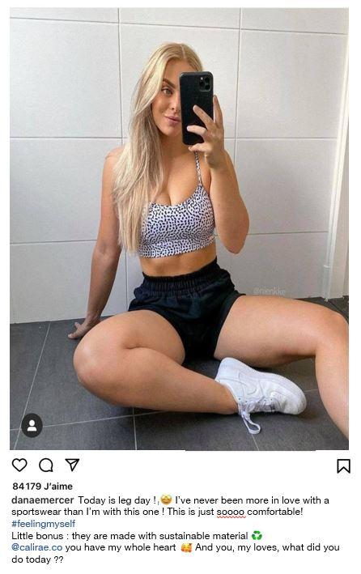
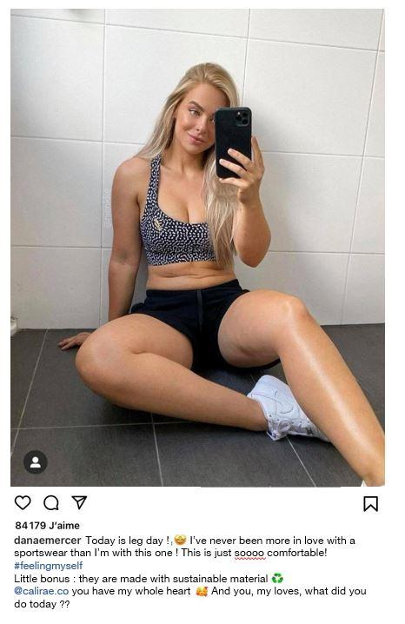

Appendix B: Measurement scale items
Measures | Items
Purchase Intentions | In her/his post, the influencer recommends a product to you. To what extent do you agree with the following statements?  I would like to buy the product that the influencer recommends.  I have the intention to buy the product that the influencer recommends.  I am interested in buying the product that the influencer recommends.  It is likely that I will buy the product that the influencer recommends.
Well-being | To what extent do you agree with the following statements?  In most ways my life is close to my ideal.  The conditions of my life are excellent.  I am satisfied with my life.  So far, I have gotten the important things I want in my life.  If I could live my life over, I would change almost nothing.
Upward comparison | After seeing this post from the influencer, how do you feel compared to her/him?  Superior – Inferior  Competent – Incompetent  Likeable – Unlikeable  Accepted – Left out  Same – Different  More talented – Untalented  Stronger – Weaker  More confident – Unconfident  More desirable – Undesirable  More attractive – Unattractive  Insider – Outsider
Self-esteem | Still after seeing this post from the influencer, how would you answer the following questions?  On the whole, I am satisfied with myself.  At times I think I am no good at all. (-)  I feel that I have a number of good qualities.  I am able to do things as well as most other people.  I feel I do not have much to be proud of. (-)  I certainly feel useless at times. (-)  I feel that I am a person of worth.  I wish I could have more respect for myself. (-)  All in all, I am inclined to think that I am a failure. (-)  I take a positive attitude toward myself.
Genuineness | According to you, the influencer is …  Pretentious – Unpretentious  Insincere – Sincere  Fake – Real  Dishonest – Honest  Disguised – Undisguised  Illegitimate – Legitimate

Appendix C: Study 1 Descriptive statistics
 | Upward comparison | Self-esteem | Well-being | Purchase intentions
Non-genuine (N = 76)
Mean | 4.65 | 4.22 | 3.38 | 2.57
SD | 1.05 | .84 | 1.23 | 1.05
Genuine (N = 95)
Mean | 4.01 | 4.46 | 4.92 | 4.79
SD | .94 | .92 | 1.23 | 1.13
Total (N = 171)
Mean | 4.29 | 4.35 | 4.23 | 3.80
SD | 1.04 | .89 | 1.45 | 1.56

Appendix D: Study 2 Stimuli
Female influencer, Genuine
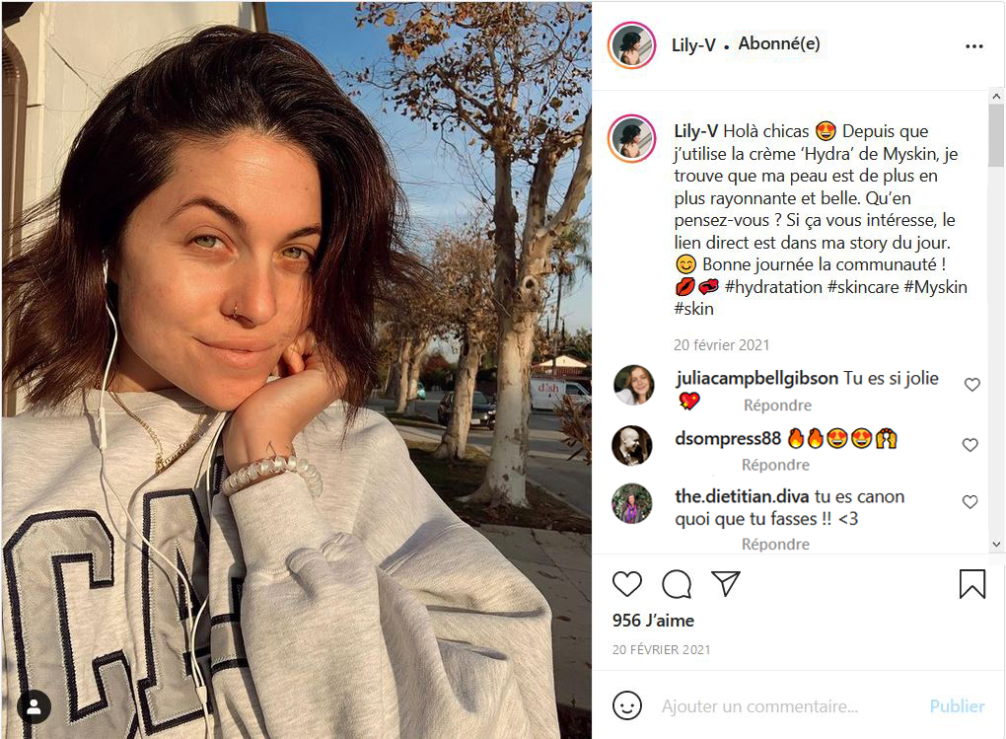
Translation : Hello girls! Since I've been using Myskin's "Hydra" cream, I've found my skin to be increasingly radiant and beautiful! What do you think? If you're interested, the direct link is in today's story! Have a good day community!

Male influencer, Genuine
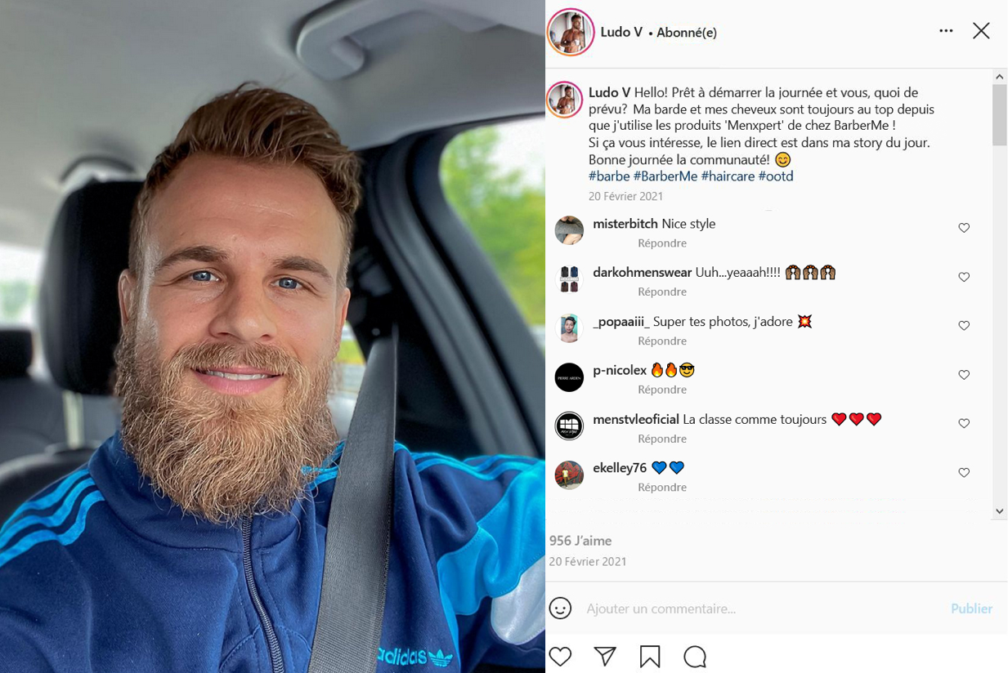
Translation : Hello! Ready to start the day, and what are your plans? My beard and hair are always in top condition since I've been using BarberMe's "Menxpert" products! If you're interested, the direct link is in today's story! Have a good day community!

Female influencer, Non-genuine
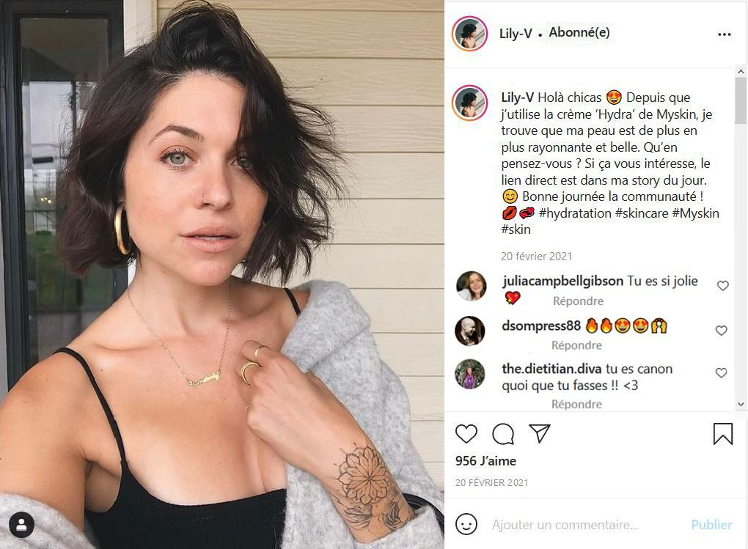
The text is identical to that of genuine influencer.
Male influencer, Non-genuine
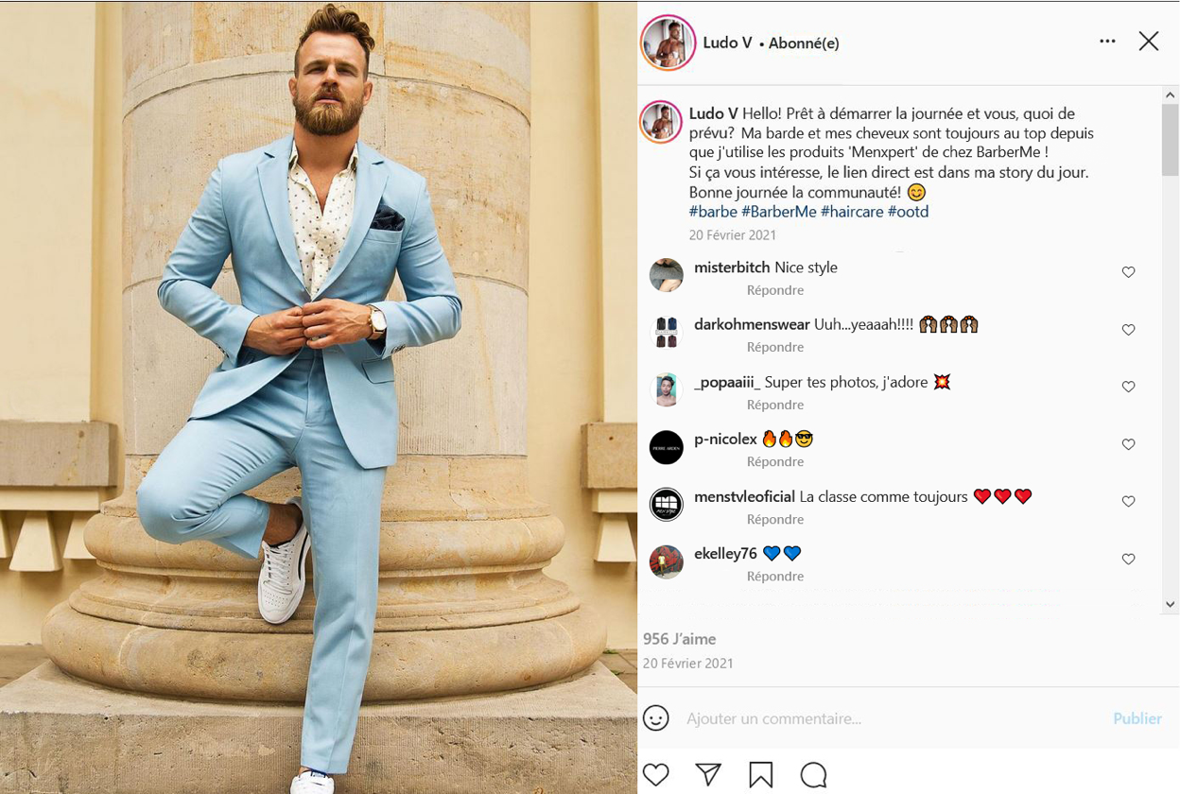
The text is identical to that of genuine influencer.

Appendix E: Study 2 Descriptive statistics
 | Upward comparison | Self-esteem | Well-being | Purchase intentions
Non-genuine (N = 73)
Mean | 4.67 | 3.97 | 3.94 | 2.62
SD | 1.10 | 1.62 | 1.31 | .95
Genuine (N = 81)
Mean | 4.23 | 5.92 | 4.91 | 3.98
SD | 1.05 | .93 | 1.02 | 1.03
Female (N = 79)  Mean  SD | 4.75  1.12 | 4.18  1.69 | 4.25  1.40 | 3.27  1.23
Male (N = 75)  Mean  SD | 4.12  .97 | 5.17  .94 | 4.66  1.10 | 3.40  1.17
Total (N = 154)
Mean | 4.44 | 4.66 | 4.45 | 3.31
SD | 1.09 | 1.46 | 1.26 | 1.20

