Are observers differentially motivated to empathize with stigmatized targets? An investigation using the Empathy Selection Task
Running Title: MOTIVATED EMPATHY AND STIGMATIZED TARGETS
Research Article
Antoine Vanbenedenª, Karl-Andrew Woltinª, & Vincent Yzerbytª
ªInstitut de recherche en sciences psychologiques, Université catholique de Louvain

Corresponding author
Place Cardinal Mercier 10, B-1348, Louvain-la-Neuve, Belgium. E-mail address: antoine.vanbeneden@uclouvain.be (A. Vanbeneden)

Acknowledgements
The authors would like to thank the members of the Louvain Social Psychology Lab for their comments on an earlier version of this work. This work was supported by a Fonds de la Recherche Scientifique (FNRS) grant awarded to Antoine Vanbeneden [grant number 1.A.475.21].

Data Accessibility Statement
The preregistration documents, materials, data and R code are publicly available on Open Science Framework (https://osf.io/cnwsb/).

Ethics and consent
This study was reviewed and approved by the ethics commission of the Institut de recherche en science psychologiques (IPSY), project reference Projet2021-52. The procedures followed were in accordance with the Helsinki Declaration as revised in 2013. The participants provided their written informed consent to participate in this study.

Competing interests
The authors have no competing interests to declare.

Are observers differentially motivated to empathize with stigmatized targets? An investigation using the Empathy Selection Task

Abstract
Research shows that people do not spontaneously show empathy towards stigmatized outgroups, and especially not towards groups lacking both competence and warmth as described in the Stereotype Content Model. However, people do prove capable of empathizing with such targets when required. We hypothesized that this discrepancy is due to a lower motivation to empathize with such stigmatized targets, reflected by people perceiving higher cognitive costs when doing so. In a series of four preregistered studies (N_{total}=719), we tested this hypothesis by contrasting low competence/low warmth stigmatized groups with other groups in an Empathy Selection Task and measuring participants’ perceived cognitive costs of empathizing. Results replicate previous findings that people prefer to avoid empathy due to its perceived cognitive costs. However, targets’ group membership unexpectedly did not moderate effects. We propose a series of potential explanations for the absence of group membership moderating effects and suggest avenues for future works.

Keywords: motivated empathy, social perception, stereotype content model, competence and warmth
Word count: 7394

Empathy is the ability to feel and understand the emotional and cognitive experience of a target (Batson, 2009; Eklund & Meranius, 2021). It is an essential component of social interactions as it plays a crucial part in developing, maintaining and improving intergroup relations (Pettigrew & Tropp, 2008; Soral et al., 2022; Todd & Galinsky, 2014; Vanman, 2016). Although people experience empathy on a daily basis (Depow et al., 2021), conflict at the intergroup level often precludes its emergence towards outgroups (Cikara & Van Bavel, 2014; Richins et al., 2019). Even in the absence of conflict, people may fail to show spontaneous empathy towards members of specific outgroups, namely those that are low on the two fundamental dimensions of group perception, competence and warmth (Fiske et al., 2002; Judd et al., 2005). Indeed, members of these groups are often victims of strong derogation resulting in the absence of empathy shown towards them (Harris & Fiske, 2006; Kteily & Bruneau, 2017). This reaction is all the more surprising that people possess a spontaneous ability to empathize even with objects and non-human entities (see Harris & Fiske, 2011). Moreover, observers seem perfectly capable of adopting the viewpoint of and empathize with such low competence low warmth targets when explicitly required to do so (Batson et al., 2002; Moore-Berg et al., 2022).
One account for people’s lack of spontaneous empathy when facing these specific targets is that they lack the necessary motivation to do so. In other words, they simply see no reason to invest the effort into trying to feel and understand the experience of low competence low warmth targets. We explore the viability of this account by assessing people’s motivation to empathize with low competence low warmth targets using the Empathy Selection Task (Cameron et al., 2019). In addition, we also explore the cognitive cost that people perceive to be associated with empathy related to such targets.

Dehumanized groups in the Stereotype Content Model
Building on extant research on social evaluation, the Stereotype Content Model (SCM; Fiske et al., 2002; for recent reviews, see Abele et al., 2021; Koch et al., 2021) proposes that stereotypes are the product of groups’ interdependence as well as their hierarchical relations. These structural relations lead to perceptions of different degrees of warmth, indicating whether a group aims to cooperate or compete, and competence, indicating whether a group has the ability to carry out its intents. These two dimensions are considered orthogonal, thus making up a four-quadrant space encompassing all social groups (Cuddy et al., 2007, 2009; Lindqvist et al., 2017). Many groups show a mixed pattern of warmth and competence, coming across as high on competence but low on warmth (HCLW; e.g., bankers or politicians) or low on competence but high on warmth (LCHW; e.g., disabled people or blue-collar workers). Some groups are also perceived as being high on both dimensions (HCHW; generally, one’s ingroup or groups one collaborates with) while still others are low on both dimensions (LCLW; e.g., homeless people or drug addicts). Research on the SCM showed that groups from the different quadrants trigger different emotions: HCHW elicit pride, HCLW elicit envy, LCHW elicit pity, and LCLW – our groups of interest – elicit disgust. In addition, membership in these quadrants also shapes observers’ behavioural tendencies, with people’s intentions to help or harm a group member being related to the group’s level of competence and warmth (Cuddy et al., 2007).
As it turns out, groups belonging to the LCLW quadrant seem to be victims of extreme derogation, with observers dehumanizing them and denying them emotions, thoughts, and feelings (Fiske, 2013; Kteily et al., 2015; Rudert et al., 2017; Vaes & Paladino, 2010). For instance, fMRI findings consistently show that contrary to what occurs for groups from the three other quadrants, members of LCLW groups do not activate brain regions related to social cognition – but instead trigger stronger activation in brain areas related to disgust (Harris & Fiske, 2006, 2007). Interestingly, Harris & Fiske (2011) additionally observed that brain areas related to attention and conflict-resolution were also more active for members of LCLW compared to other groups. In their view, this could be a sign that people do perceive these targets’ mind, but also actively dehumanize them. Such a denial of mental states has been observed at an explicit level, with participants using fewer verbs referring to mental states when describing the daily life of LCLW compared to other social targets (Harris & Fiske, 2009) and also directly ascribing less mental states to LCLW targets (Cameron et al., 2016). This perception of LCLW groups as less ‘truly social’ agents can also be observed at the behavioural level, with people more willing to sacrifice LCLW group members compared to other social targets in moral dilemmas (Awad et al., 2018; Cikara et al., 2010). Taken together, these findings clearly demonstrate a lack of empathy towards LCLW targets.
Motivated empathy and its costs
Empathy is a pivotal aspect of human relations, but its specific nature is complex and continues to be debated in the literature (Batson, 2009; Hall & Schwartz, 2022; Wispé, 1986; Zaki, 2014). It is mostly conceptualized as comprising three main components, namely mind perception, referring to observers’ attribution of mental states to the target, experience sharing, referring to observers’ mimicry of the target’s states (including feelings), and mentalizing, referring to observers’ ability to understand a target’s intentions, beliefs, or emotions (Weisz & Cikara, 2021). These components are not mutually exclusive and recent research suggests that they all are at stake in situations involving empathy (Eklund & Meranius, 2021; Zaki, 2014).
Crucially, all three components of empathy are considered context-dependent and contingent upon observers’ motivation (Zaki, 2014). Such motivation can vary as a function of several factors, and most notably the costs and rewards involved with empathizing. Indeed, empathy may entail costs such as financial expenses through prosocial behaviours like donations (Shaw et al., 1994), or through concessions in negotiations (Galinsky et al., 2008). A consideration of such financial costs can reduce one’s motivation to empathize with targets. However, empathizing can also lead to rewards, such as stronger social bounds (Pickett et al., 2004) or a positive self-image (Sassenrath, 2020; Schumann et al., 2014), which likely boost people’s motivation to empathize. As Zaki (2014) details in his Motivated Empathy Model, these costs and rewards likely influence observers’ motivation regarding each of the three components of empathy.
Motivational considerations were also recently put forward by Gehlbach and Mu (2023) in their Social Perspective Taking (SPT) model. In this model, the authors argue that SPT comprises four distinct phases: (a) the Target Perception phase, during which mind attribution takes place; (b) the Motivation phase, which includes a calibration of required effort; (c) the Strategic Approach phase, which entails selecting strategies to gather information; and finally (c) the Evaluation Phase, which consists of evaluating the accuracy of one’s perspective taking.
Interestingly, both models acknowledge the central role of motivation in empathy and detail its (un)favourable impact on subcomponents of empathy (e.g., mind attribution). They also both highlight the role of cost perception on people’s motivation to empathize. Empathy can thus be assumed to depend on observers’ motivation, which is itself shaped by considerations of costs and rewards associated with empathizing.
Recently, Cameron et al. (2019) set out to empirically investigate whether empathy entailed costs in and of itself, and particularly cognitive costs. Specifically, they hypothesized that in the absence of both a reward that could motivate people to empathize and tangible costs that could demotivate them, empathy should be directly related to perceived cognitive costs that could decrease observers’ motivation to empathize. This, in turn, should generally lead observers to avoid putting themselves in a situation of being asked to empathize. To test this hypothesis, they constructed the Empathy Selection Task. In this task, participants are confronted with a series of targets expressing positive or negative emotions. Participants face two choices, illustrated by two decks of cards. On each of a total of 40 trials, they need to choose between either physically describing the target in an objective manner (the Describe deck) or feeling and reporting the target’s emotion (the Feel deck). Depending on their choice, participants must write a few words or sentences either describing the targets or reporting their emotions. At the end of the task, participants report their perception of the cognitive costs associated with each deck using four items of the National Aeronautics and Space Agency (NASA) Task Load Index (Hart & Staveland, 1988). Results consistently indicate that in the absence of a clear reward people prefer to avoid empathy (i.e., the experience sharing component; Zaki, 2014), with participants choosing to describe targets rather than to empathize with them in around 70% of the trials. Moreover, this lack of motivation to empathize with targets goes hand in hand with higher perceived cognitive costs attributed to the Feel task compared to the Describe task. These findings confirm that empathy is cognitively costly and suggest that perceived cognitive costs influence people’s motivation to put themselves in situation requiring their empathy.
Current work
Research shows that people show less empathy towards LCLW targets than other social targets, partly due to a lesser attribution of mind. This pattern is puzzling in light of the fact that people spontaneously attribute a mind to objects and other non-human entities (i.e., anthropomorphism; Harris & Fiske, 2011; Waytz et al., 2010). Moreover, when explicitly asked to empathize with LCLW targets, people are not only capable of doing so, but even show prosocial behaviours towards these targets (Batson et al., 2002). One account of this apparent contradiction may be that whereas people initially attribute a mind to LCLW targets, they also seem to be actively denying it (Harris & Fiske, 2011). This denial seems to be motivated by an anticipated call for help by LCLW targets, which renders salient anticipated emotional costs and exhaustion (Cameron et al., 2016). In short, although observers are quite capable of empathizing with LCLW targets, they may lack the motivation to do so, presumably because they associate higher costs of doing so for these compared to other social targets. This line of reasoning doves well with Dunn et al.’s (2019) proposal that cognitive costs are mainly a function of the perceived probability of making errors during a task, as well as the perceived time required to perform it. When required to empathize with LCLW (i.e., generally dehumanized) targets, observers may anticipate such perceived cognitive costs of empathizing with LCLW compared to other social targets, thereby reducing observers’ motivation to do so.
We decided to test the viability of this account using the Empathy Selection Task proposed by Cameron et al. (2019). This task ensures the tangible costs (e.g., time or money) that usually preclude the emergence of empathy are not at stake (Cameron et al., 2016; Shaw et al., 1994). At the same time, the task is also devoid of possible rewards associated with showing empathy. For these reasons, the Empathy Selection Task stands as a prime candidate to investigate our hypothesis that LCLW group membership has an impact on participants’ motivation to show empathy – and their assumed associated cognitive costs of doing so.
We hypothesized that in the Empathy Selection Task, participants would prefer to physically describe a target (Describe deck) rather than to feel and report a target’s emotions (Feel deck), thereby replicating the findings of Cameron et al. (2019). In statistical terms, this translates to a significant intercept in a logistic regression model with the choice as a dependent variable. In addition, we predicted that observers would be less motivated to empathize with LCLW targets compared to targets from the other quadrants identified by the Stereotype Content Model. This should show in an even lower probability of choosing the Feel deck for LCLW targets compared to other targets, translated to a significant main effect of target’s group membership in a logistic regression model. Turning to the perceived cognitive costs of empathy, we also expected to replicate Cameron et al.’s (2019) findings that people report a higher perceived cognitive costs for the Feel deck compared to the Describe deck (i.e., a main effect of type of task on cognitive costs in a regression model). Here too, we expected a moderation by targets’ group membership (i.e., an interaction between type of task and group membership in a regression model), such that participants would report even higher perceived cognitive costs for the Feel deck when it involved LCLW targets compared to other social targets.
We tested these hypotheses in a series of four preregistered and high-powered experiments. In Experiment 1, we contrasted LCLW targets with HCLW targets. We selected HCLW targets as our first comparison group because targets from groups belonging to this quadrant do not elicit ingroup bias like many HCHW targets do, but at the same time they are not dehumanized as LCLW targets often are. In Experiment 2, we contrasted LCLW targets with HCHW targets to maximize the social distance between targets. In Experiment 3, we opted for a full design and contrasted LCLW targets to targets from all three other quadrants (i.e., HCHW, HCLW, LCHW). In Experiment 4, we again contrasted LCLW to HCHW, but the design included imposed-choice conditions by forcing participants to perform either Describe trials or Feel trials. We preregistered all experiments. All preregistration documents, data and R scripts as well as supplementary material are available on the OSF: https://osf.io/cnwsb/.

Experiment 1

Method
Participants and design. A total of 90 French-speaking participants took part in a 32-minute-long (median time) experiment on Prolific Academic in exchange of 3.50£. We randomly assigned participants to one of the conditions of a 2 (Quadrant: LCLW targets N=44 vs. HCLW target N=46) by 2 (Type of task: Feel vs. Describe) design, with the first factor varying between participants and the second within them. We excluded 10 participants who erred on more than 30% of questions randomly asking them to report if a trial’s target belonged to a LCLW or HCLW group. The final sample thus comprised 80 participants (M_{age}=30.62, SD_{age}=10.43, 40 women) with equal numbers in each condition.
Power calculation. Cameron et al. (2019) reported a meta-analytic effect size for choice of task (Describe vs. Feel) of g=-.64. Based on this, we ran an a priori power analysis for the Quadrant × Type of task interaction using the PANGEA web app, with an effect size of d=.3, corresponding to a medium effect in updated guidelines of Cohen’s d (Lovakov & Agadullina, 2021). This power analysis indicated that we needed at least 41 participants per condition to reach 80% power. To account for the possible loss of participants due to our exclusion criteria, we aimed for 90 participants.
Procedure. Participants gave their informed consent before random assignment to one of the two conditions. The procedure was identical in both conditions except that targets were labelled as members of LCLW or HCLW groups. Participants then read the instructions for the Empathy Selection Task (Cameron et al., 2019, 2022). They performed three training trials to make sure that they understood the task. This also allowed them to understand what their choices entailed, thus ensuring that the first test trials would not be based on random deck selection. Next, participants went through 42 test trials. In each trial, we displayed a target profession for one second (HCLW condition: economist, lawyer, or IT engineer; LCLW: garbage man, truck driver, or baggage handler; all professions were counterbalanced within conditions). We selected professions from an unpublished database containing evaluations of 120 professions on multiple variables, including warmth and competence traits(Nils & Yzerbyt, 2022). Following profession presentation, participants saw the face of a target (all faces were White men taken from the Chicago Face Database as well as the Radboud Faces Database; Langner et al., 2010; Ma et al., 2015) displaying either a positively or negatively valenced emotion (e.g., fear or joy). Participants’ task was to choose between writing down three words describing the target’s facial expression in a neutral, objective way (Describe deck) or adopting the target’s perspective and writing down three words describing what and how this target might feel (Feel deck). To ensure that participants paid enough attention to the targets’ alleged social group membership (i.e., professions corresponding to LCLW or HCLW groups), they were asked 15 times at random to indicate the target’s social group right after a trial. At the end of the task, participants completed the 4-item NASA Task Load Index (Cameron et al., 2019, 2022; Hart & Staveland, 1988), measuring to what extent they perceived the task as cognitively costly. Specifically, they indicated their agreement (1=very low; 5=very high) with four statements (e.g., “How mentally demanding was this trial?”). They did this separately for the Describe (α=.70) and the Feel (α=.59) task. For exploratory purposes, we also asked participants to complete a 10-item Social Dominance Orientation (SDO; Duarte et al., 2004) scale and to indicate their political orientation. Finally, participants completed demographic questions, were debriefed, thanked, and compensated.

Results
For all experiments, we performed analyses using R (R Core Team, 2024) and the lme4 (Bates et al., 2015) and lmerTest (Kuznetsova et al., 2017) packages.
Empathy Selection Task. To examine our first hypothesis, we performed a logistic linear mixed model with Task Choice as our binary dependent variable (0=Describe task; 1=Feel task), and Quadrant (LCLW vs. HCLW) as a between-participant factor and participants and stimuli as random factors. The model intercept proved significant, Odds Ratio (OR)=0.39, z=-4.73, p<.001, indicating that, across conditions, participants were more likely to choose the Describe task than the Feel task (see Figure 1). This replicates previous findings by Cameron et al. (2019, 2022). However, contrary to our hypothesis, there was no main effect of Quadrant, OR=0.76, z=-0.675, p=.499.

[Insert Figure 1 here]

NASA Task Load Index. To investigate our second hypothesis, we submitted scores on the NASA Task Load Index to a 2 (Quadrant: LCLW vs. HCLW) x 2 (Type of task: Describe vs. Feel) mixed model analysis, with Quadrant varying between participants and participants as random factor. There was a main effect of Task, F(1, 558)=8.11, p=.005, η_{p}²=.011, indicating that participants perceived the Feel task as cognitively more demanding than the Describe task, regardless of the target’s social group (see Figure 2). This again replicates previous findings from Cameron et al. (2019, 2022).There was no main effect of Quadrant on Score of NASA Task Load Index, F(1,78)=0.29, p=.592, η_{p}²<.001. Contrary to our hypothesis, no significant interaction emerged, F(1,558)=1.92, p=.167, η_{p}²=.003.

[Insert Figure 2 here]

Discussion
Although we replicated previous findings showing that people are less motivated to empathize with a person than to merely describe their facial expression and that they perceive empathizing with (vs. describing) targets as more cognitively taxing (Cameron et al., 2019, 2022), we did not find evidence for a moderating effect of targets’ social group membership based on the SCM (i.e., a difference of motivation to empathize with LCLW vs. HCLW targets). Although there might indeed be no differences in people’s motivation to adopt various social targets’ perspectives, the absence of moderation by targets’ group membership may also originate from specific features of our procedure. For one thing, we used a between-participants design, presenting participants with targets from a single quadrant in each condition. This type of design is not representative of daily life interactions, where one encounters a variety of social targets in short periods of times. A lack of motivation to adopt LCLW targets’ perspectives may well only emerge when LCLW targets are contrasted with social targets belonging to other quadrants. In line with this interpretation, research showing that LCLW are dehumanized relied on designs presenting multiple social targets in a within-participants design, and thus in a comparative context (Cikara et al., 2010; Harris & Fiske, 2006, 2007, 2009, 2011).
A second limitation of our procedure is its low ecological validity. Indeed, we relied on a very controlled approach, with target faces being identical between conditions and targets’ social group membership (conveyed by their LCLW or HCLW professions) appearing for a very short period as a textual cue without bearing on the subsequent task. As it turns out, there is evidence for a strong relationship between visual cues and group stereotypes, with people having a clear visual representation of what prototypical members of specific groups look like (Dotsch et al., 2008; Schmitz et al., 2024). Some participants did not find specific professions-target faces associations believable due to their visual stereotypes, and this may have played a role in our results.
In Experiment 2, we changed these critical features in our procedure: We adopted a within-participants design, relied on faces that were pretested as fitting the respective professions, and we kept targets’ profession cue visible throughout each trial. Additionally, we contrasted LCLW targets and HCHW targets, thus maximizing their differentiation.

Experiment 2

Method
Participants and design. A total of 120 French-speaking participants took part in a 52-minute-long (median time) experiment on Prolific Academic in exchange of 5.25£. Both Quadrant (LCLW targets vs. HCHW targets) and Type of task (Feel vs. Describe) varied within participants. We again excluded 13 participants who erred on more than 30% of questions randomly controlling their attention paid to targets’ social group. The final sample thus comprised 107 participants (M_{age}=29.26, SD_{age}=10.64, 49 women).
Power calculation. Based on a previous study we conducted relying on an identical design and suggesting an effect of d=.1, we ran simulations using the package simr (Green & MacLeod, 2016). This power analysis indicated that we would need at least 100 participants to reach 80% power. To account for the possible loss of participants due to our exclusion criteria, we collected data from 120 participants.
Procedure. The procedure was identical to the one used in Study 1, except that targets’ faces were pretested as fitting the professions they were associated with, that the targets stemmed from the LCLW quadrant (truck drivers, garbage collector, telemarketer) versus the HCHW quadrant (physiotherapist, veterinarian, paediatrician; all faces were taken from the 10k US Adults Faces Database for this as well as subsequent experiments; Bainbridge et al., 2013), that participants saw targets from both quadrants, and that targets’ professions were visible throughout each of overall 48 trials. Participants again reported their perceived cognitive costs on the NASA Task Load Index (Cameron et al., 2019, 2022; Hart & Staveland, 1988; Describe task: α=.87; Feel task: α=.85).

Results
Empathy Selection Task. To investigate our first hypothesis, we performed a logistic linear mixed model with Task Choice as our binary dependent variable (0=Describe task; 1=Feel task), Quadrant (LCLW vs. HCHW) as a within-participant factor and participants and stimuli as random factors. The model intercept proved significant, Odds Ratio (OR)=0.37, z=-5.57, p<.001, confirming that, across conditions, participants were more likely to choose the Describe task compared to the Feel task (see Figure 3). This again replicates Cameron et al.’s (2019, 2022) findings. However, contrary to our hypothesis, there was no main effect of Quadrant, OR=0.98, z=-0.141, p=.888.

[Insert Figure 3 here]

NASA Task Load Index. To investigate our second hypothesis, we submitted the scores on the NASA Task Load Index to a 2 (Quadrant: LCLW vs. HCHW) x 2 (Type of task: Describe vs. Feel) mixed model analysis, with both factors varying within participants and participants as random factor. Surprisingly, the data failed to replicate Cameron et al. (2019, 2022) as there was no main effect of Task, F(1, 1602)=0.15, p=.703, η_{p}²<.001 (see Figure 4). We found a main effect of Quadrant, F(1,1602)=4.03, p=.045, η_{p}²=.002, indicating that overall, people perceived a higher cognitive costs for the LCLW targets compared to the HCHW targets. However, the predicted two-way interaction was not significant, F(1,1602)=0.08, p=.780, η_{p}²<.001.

[Insert Figure 4 here]

Discussion
As in Experiment 1, we replicated Cameron et al. (2019, 2022) findings that participants prefer the Describe task over the Feel task, indicating that people are less motivated to empathize with a target compared to describing this target. However, they did not report higher cognitive costs for the Feel task than for the Describe task. Although there was a main effect of targets’ group membership on perceived cognitive costs, this effect was unexpected and does not emerge again in the following studies. As such, we refrain from discussing it here.
As in Experiment 1, we did not find evidence for people having a lower motivation to empathize with LCLW compared to other targets. Having said this, targets’ faces with positively- or negatively-valenced facial expressions were visible when participants had to choose between the Feel or Describe task. Because participants were primed with empathy in the instructions, facing such emotional targets may already have triggered experience sharing (Engen & Singer, 2013). This could have contributed to blurring the differences between targets as participants were already subjected to cognitive costs to some extents, leading the choice to be made independently of cost considerations.
We considered these limitations in Experiment 3, and only showed targets’ faces after participants had made their deck choice. In addition, we also opted for a design that included targets from all four SCM quadrants (i.e., comparing LCLW targets to those of the three other quadrants proposed by the SCM; Fiske, 2015, 2018). Finally, Experiments 1 and 2 had participants describe targets’ facial expressions, thus requiring them to focus on targets’ emotions, which may have led to them spontaneously empathize. To prevent this possibility, we modified the instructions for the Describe trials and asked participants instead to describe the physical appearance targets (e.g., age, eye, and hair colour, etc.).

Experiment 3

Method
Participants and design. A total of 360 English-speaking participants took part in the 33-minute-long (median time) experiment on Prolific Academic in exchange of 3.70£. We randomly assigned participants to one of three between-participants conditions, in which LCLW targets were contrasted with either HCHW (N=112), HCLW (N=125), or LCHW (N=123) targets. Type of task (Feel vs. Describe) again was a within-participants factor. We excluded 62 participants who erred on more than 20% of questions randomly controlling for their attention to targets’ social group – we reduced the threshold as the random question was only displayed 8 times throughout the task. The final sample thus comprised 298 participants (M_{age}=41.6, SD_{age}=13.84, 147 women) with N=92 in the LCLW vs. HCHW condition, N=109 in the LCLW vs. HCLW condition and N=97 in the LCLW vs. LCHW condition.
Power calculation. Given the changes in the design, we ran an a priori power analysis for our first order interaction using the package simr (Green & MacLeod, 2016), with an effect size close to a small effect (d=.1, based on a sensitivity analysis performed on our previous studies). This power analysis revealed that we would need 100 participants per condition to reach 80% power. To account for the possible loss of participants due to our exclusion criteria, we collected 360 participants in total. However, due to the strictness of our exclusion criteria, we slightly fell short of the intended number of participants in the LCLW vs. HCHW and LCLW vs. LCHW conditions.
Procedure. The procedure was identical to that of Study 1, with the following exceptions. First, LCLW targets (drug addict, welfare recipient) were contrasted with either HCHW (athlete, teacher), HCLW (politician, rich) or LCHW (disabled, blue collar) targets. Second, no faces were shown during task choice. Third, there were only 24 trials in total (i.e., 12 trials per quadrant). Apart from choosing decks, participants again reported perceived cognitive costs on the NASA Task Load Index (Cameron et al., 2019, 2022; Hart & Staveland, 1988; Describe task: α=.86; Feel task: α=.82).

Results
Empathy Selection Task. To investigate our first hypothesis, we performed a logistic linear mixed model by regressing Task Choice (0=Describe task; 1=Feel task) on a set of Helmert contrasts, with C1 being our contrast of interest by comparing LCLW targets to all three other targets, C2 comparing LCHW targets to both HCLW and HCHW targets, and C3 comparing HCLW to HCHW targets. We included participants and stimuli as random factors. The model intercept proved significant, OR=0.22, z=-11.57, p<.001, confirming that, across conditions, participants were more likely to choose the Describe task compared to the Feel task (see Figure 5). As before, this replicates Cameron et al.’s (2019, 2022) findings. We also found a main effect of C1, OR=0.87, z=-2.02, p=.043, but surprisingly this effect was opposite to the predicted direction in that participants preferred the Feel task for LCLW targets compared to targets from all three other quadrants. No other contrast proved significant, all zs<0.933, all ps>.351

[Insert Figure 5 here]

NASA Task Load Index. To investigate our second hypothesis, we performed a mixed model analysis by regressing NASA Task Load Index scores on the same set of Helmet contrasts as above, with C1 being our contrast of interest (comparing LCLW targets to all three other targets), as well as on Type of task (Describe vs. Feel) and all contrast by task type interaction. We included participants as random factor. Replicating Cameron et al. (2019, 2022), we found a main effect of Task, F(1, 4463.3)=256.48, p<.001, η_{p}²=.039. Again, participants evaluated the Feel task as cognitively more demanding than the Describe task (see Figure 6). No contrast nor any interaction were significant, all Fs<0.86, ps>.354.

[Insert Figure 6 here]

Discussion
We again replicated Cameron et al.’s (2019, 2022) findings, with participants preferring the Describe over the Feel task and reporting higher cognitive costs for the Feel task. We also observed a significant main effect of target group membership on task choice. However, this effect ran counter to our hypothesis, with participants being more likely to choose the Feel task for LCLW targets compared to those of other quadrants. As it did not emerge in previous nor subsequent studies, we refrain from discussing it here.
Taken together, our findings suggest that membership in a stigmatized LCLW group does not influence observers’ motivation to empathize with such targets, nor their perceived cognitive costs related to doing so. In all previous experiments participants could choose freely between describing or empathizing with a given target. Arguably, they may have focused most on this choice, reducing any potential impact of targets’ group membership. This may explain why we systematically observed a main effect of the type of task, an effect that was not qualified by target group. To address this limitation, Experiment 4 restricted the possibility to choose by assigning participants to one of three between-participants conditions. They either saw both the Describe or Feel task (choice of task was imposed at each trial), saw only Feel trials, or saw only Describe trials. Furthermore, Manipulating an independent variable within or between participants can produce different results (Erlebacher, 1977). As such, presenting both tasks as a within- and between-subject factor allows increasing the robustness of our findings.

Experiment 4

Method
Participants and design. A total of 243 English-speaking participants took part in the 36-minute-long (median time) experiment on Prolific Academic in exchange of 6.00£. We randomly assigned them to one of three between-participants conditions. They either had to perform both Describe or Feel trials but choice was imposed (N=117), to perform only Describe trials (N=62) or to perform only Feel trials (N=64). Targets’ group membership (LCLW vs. HCHW) was a within-participants factor. We excluded 9 participants who erred on more than 25% of questions randomly controlling the attention they paid to targets’ social group – we raised the threshold compared to Experiment 4 as we displayed the question 12 times throughout the task. The final sample thus comprised 234 participants (M_{age}=39.68, SD_{age}=14.25, 115 women) with N=110 in the choice condition, N=60 in the Describe only condition and N=64 in the Feel only condition.
Power calculation. Given the changes in the design, we ran an a priori power analysis for our first order interaction using the package simr (Green & MacLeod, 2016), with an effect size close to a small effect (d=.1). This analysis revealed that we would need at least 66 participants per condition to reach 80% power. To take into account the possible loss of participants due to our exclusion criteria, we collected data on 240 participants. However, due to the strictness of our exclusion criteria, we slightly fell short of the intended number of participants in the Describe only and Feel only conditions.
Procedure. The procedure was identical to Study 3, with the following exceptions. First, we contrasted LCLW targets (drug addict, welfare recipient, homeless) with HCHW targets (athlete, teacher, professional). Second, we imposed the type of task (Describe vs. Feel) to the participant. Third, after each trial, we asked participants to indicate their perceived cognitive trial costs using the Effort subscale of the NASA Task Load Index (i.e., “How mentally demanding was this trial?”, “How hard did you have to work to accomplish your level of performance in this trial?”; Describe task [within]: α=.90; Feel task [within]: α=.91; Describe task [between]: α=.95; Feel task [between]: α=.96). This allowed securing more data points as each participant answered these two items 24 times rather than only once at the end of the study, and it ensured more accurate answers (Kühnen, 2010).

Results
NASA Task Load Index Effort subscale. We performed a mixed model analysis by regressing scores on the NASA Task Load Index Effort subscale on Quadrant (LCLW vs. HCHW), Type of task (Describe vs. Feel), Design (Between-subject vs. Within-subject), and all interactions. We included participants as random factor. We once again found a main effect of Task, F(1, 235.85)=6.36, p=.012, η_{p}²=.009, replicating Cameron et al.’s (2019, 2022; see Figure 7) findings. Once again, and contrary to our hypothesis, no other effect emerged, all other Fs<3.44, all other ps>.065.

[Insert Figure 7 here]

General Discussion
People display empathy on a daily basis and this phenomenon is at the heart of interpersonal and intergroup relations (Batson & Ahmad, 2009; Depow et al., 2021; Finlay & Stephan, 2000; Pettigrew & Tropp, 2008). Empathy often even expands beyond human targets, with people being able to empathize with non-human entities or objects (Geiselmann et al., 2023; Harris & Fiske, 2011; Waytz et al., 2010). It is therefore all the more surprising that past research found people to be devoid of empathy when presented with specific outgroups, namely the so-called low competence low warmth groups characterized in the Stereotype Content Model (Cikara et al., 2010; Cuddy et al., 2009; Fiske et al., 2002; Harris & Fiske, 2006, 2009). Because people indeed have the capacity to empathize with such targets (Batson et al., 2002), a reasonable conjecture is that this reduced empathy stems from a lack of motivation to empathize, possibly due to higher perceived cognitive costs. We tested this possibility in a series of four preregistered and well-powered studies, using the Empathy Selection Task. In this task, participants choose between describing or empathizing with a series of targets. All four experiments replicated findings by Cameron et al. (2019), with participants significantly preferring to describing social targets rather than empathizing with them. They also reported perceiving higher cognitive costs when empathizing with compared to describing targets.
We also predicted a moderation of this effect by targets’ social group. However, in none of the experiments did this moderation materialize. This is surprising in light of previous work showing that observers actively dehumanize LCLW targets and attribute them less mental states (Cameron et al., 2016; Harris & Fiske, 2009; Vaes & Paladino, 2010). As such, empathizing with LCLW targets should require more effort (cognitive costs), which is why we expected to observe a reduced motivation to empathize with such targets in the first place. Instead, our results suggest that people are not differentially motivated to empathize with stigmatized LCLW targets when no further tangible costs are potentially involved and that their empathy with these targets is not related to differences in perceived cognitive costs. In our view, a social desirability bias could be a potential explanation for this absence of a moderating effect. Indeed, when faced with LCLW targets, people can be motivated to appear unprejudiced, with this motivation being internal (e.g., concerns with egalitarianism), external (e.g., fear of social sanctions), or both (Bamberg & Verkuyten, 2022; Costarelli & Gerłowska, 2015). In addition to these motivations, appearing unprejudiced is perceived as a desirable social trait (Krumpal, 2013). Therefore, when facing LCLW targets, participants may have been motivated to perform approximatively the same amount of Describe and Feel trials to come across as non-prejudiced. This may also explain why participants indicated similar perceived cognitive costs pertaining to all types of targets.
Having said this, a subset of earlier research efforts putting forward the lack of empathy towards LCLW targets also relied on measures of higher-level processes subjected to social desirability (e.g., Cameron et al., 2016; Rudert et al., 2017). In addition, although empathy is seen as a desirable social trait and participants usually rely on impression management in empathy task (Sassenrath, 2020; Schumann et al., 2014), people have been found to show a consistent preference for not empathizing when given a choice (Cameron et al., 2019, 2022). Moreover, we note that we obtained the same results regardless of whether group membership was manipulated within or between participants – even though participants should be more concerned with social desirability in the former than in the latter case (i.e., when the goal of the experiment is more difficult to gauge). Overall, this suggests that the role of social desirability explaining our results may not be as straightforward as one would expect, and more research is warranted.
One way future work could shed light on the role of social desirability in motivated empathy towards LCLW targets would be to rely on the bogus pipeline paradigm, in which participants are made to believe that researchers can distinguish honest from socially desirable responses (Aguinis & Henle, 2001; Jones & Sigall, 1971; Roese & Jamieson, 1993). Using such a paradigm would allow to look at whether participants show no difference between LCLW and other social targets even when under the impression that researchers have access to their real preferred choice. Another strategy that future research could adopt to rule out the potential role of social desirability would be to measure objective cognitive costs, relying for instance on task-evoked pupillary responses (Sevilla et al., 2014), or through electroencephalogram and event-related potential paradigms (Brouwer et al., 2012). This would allow observing whether the two measures converge or if participants report lower perceived cognitive costs compared to the actual cognitive costs they experienced – hinting to the presence of social desirability.
Additional factors could explain the fact that targets’ group membership did not moderate motivation to empathize and perceived associated cognitive costs. First, the absence of tangible costs in the context of the task may have played a role. Indeed, people anticipate a higher degree of exhaustion and of emotional costs when actually expecting to engage with a stigmatized target or to perform prosocial behaviours (Cameron et al., 2016). In the absence of such expectations, as is the case in the Empathy Selection Task, feeling what a LCLW target may feel should not prove cognitively costlier than doing so for another social target. One could additionally argue that, in light of dehumanization itself seeming to be effortful for people (Harris & Fiske, 2011), the absence of additional costs could lead to participants not engaging in dehumanization. In other words, because dehumanization is itself costly, participants may have refrained from doing so as they were not expecting to interact with the targets. In turn, participants could have felt equally motivated to empathize with LCLW or other social targets. One way that future work could look at this is to integrate prosocial behaviours in the Empathy Selection Task paradigm (e.g., by asking participants to donate a part of their endowment; see Brethel-Haurwitz et al., 2020).
Second, it could also be that targets’ social group did not prove relevant during the task. Stated differently, describing the emotions of a target on the sole basis of their facial emotion may not leave much room for the social group to exert any influence. Consequently, future work could try and adapt the task to render social cues more relevant for the required written answers.
Third, we relied on professions to convey outgroup membership. Although we pretested these professions to ensure their respective location in the SCM quadrants (Nils & Yzerbyt, 2022), social groups classically used in research on the dehumanization of LCLW targets did not rely on professions (e.g., drug addicts; Cikara et al., 2010; Fiske et al., 2002; Harris & Fiske, 2011). One might thus argue that the LCLW professions we focused on may not have been sufficiently disliked to elicit dehumanization and disgust. Our data does not allow us to dismiss this possibility. At the same time, recent work on so-called dirty jobs showed that people derogate and dehumanize many professions that can be classified as LCLW, including professions that we relied on such as garbage collectors or telemarketers (Baldissarri et al., 2022; Terskova & Agadullina, 2019; Valtorta et al., 2019). Future work will need to further explore possible downstream consequences for empathy.
Fourth, we presented participants with targets expressing a variety of emotions during the EST. People also experience empathy when confronted with others expressing positive emotions (De Vignemont & Singer, 2006) and valence of emotion does not seem to influence people’s perceived cognitive cost of or motivation to show empathy (Cameron et al., 2019; see also our Supplementary Material 1). However, many findings on intergroup empathy pertain to people empathizing (or not) with targets who are experiencing pain or who are suffering in other ways (Han, 2018; McAuliffe et al., 2020; Molenberghs & Louis, 2018). Arguably, empathizing with targets in pain or suffering compared to targets who do not imposes potential higher emotional costs, such as feelings of personal distress triggered by being confronted with such targets (Bekkali et al., 2021). By relying on targets displaying a variety of positive and negative emotions, the EST might have inadvertently diluted costs associated with empathy, thereby reducing the gap between LCLW and other social targets. Future research needs to further investigate the role of pain and suffering in people’s perception of cognitive cost associated with empathy.
Finally, the absence of (in)tangible rewards in the EST could prove to be a double-edged sword and an important limitation of this task as it may make the emergence of group differences more difficult. Indeed, one strength of the EST, which is to investigate empathy in a highly controlled environment, comes at the cost of it stripping empathy from any possible rewards such as the opportunity for social connection or feelings of personal accomplishment. Presumably, this renders empathizing more burdensome and less pleasant (Ferguson et al., 2021). In other words, if empathizing with a target does not entail any positive (social) outcome, people might simply avoid it altogether, and thus regardless of the targets’ group membership.
Other limitations not directly linked to the EST should be acknowledged. First, our samples were taken from France and US populations, which are both WEIRD countries (Henrich et al., 2010). Although the Stereotype Content Model is considered to hold across cultures (Cuddy et al., 2009), the relation between empathy and culture may be more complex (Jami et al., 2023). It will be important for future work to consider samples from other countries and cultures for the sake of generalisability. Second, we did not ask participants to provide their perception of each social group used during the Empathy Selection Task. Although we pretested all social groups to ensure that they were seen as belonging in the expected respective quadrants, some participants may have not shared such perceptions, especially regarding LCLW groups. As such, this may have prevented the emergence of effects relying on group membership. Future work could provide participants with a series of pretested social groups, but nonetheless and additionally ask them to evaluate these groups on competence and warmth. This would allow selecting groups idiosyncratically, thus ensuring that the social groups are seen as belonging to the expected quadrants by each participant. Third, we presented participants with faces taken from various face databases (Bainbridge et al., 2013; Langner et al., 2010; Ma et al., 2015). These databases contain strictly controlled stimuli, either devoid of any social cue such as stereotypical clothing or mostly focused on faces. Although it allowed us to investigate our hypothesis in a highly controlled environment, our work may have overlooked the strong relation between group perception and visual cues pertaining to group membership (Dotsch et al., 2008; Todorov et al., 2015). Future research would do well to consider visual stereotypical components in their design to increase ecological validity.

Conclusions
People seem to dehumanize LCLW targets, but at the same time remain capable of empathizing with such targets when asked to. We hypothesized that a reduced motivation to empathize with LCLW compared to other social target groups, along with larger perceived associated cognitive costs, could explain this discrepancy. We tested this hypothesis in a controlled setting across four highly-powered experiments. In contrast to our prediction, we did not find that targets’ group membership moderated people’s motivation to empathize in the Empathy Selection Task, nor their perceived cognitive costs of doing so. Taken together, our findings suggest that when no tangible costs of empathy are involved, empathizing with LCLW targets does not prove costlier than empathizing with other social targets.
Our work contributes to deepening the knowledge on empathy directed towards LCLW targets. Our data point to similar levels of motivation and perceived cognitive costs for LCLW targets compared to other social targets, at least in a controlled environment where potential tangible costs are absent. We suggest future work extends these results by looking at the importance of real-life social cues, as well as the perception of expected prosocial behaviours on the motivation to empathize with LCLW targets and its related cognitive costs.

References
Abele, A. E., Ellemers, N., Fiske, S. T., Koch, A., & Yzerbyt, V. (2021). Navigating the social world: Toward an integrated framework for evaluating self, individuals, and groups. Psychological Review, 128(2), 290–314. https://doi.org/10.1037/rev0000262
Aguinis, H., & Henle, C. A. (2001). Empirical Assessment of the Ethics of the Bogus Pipeline. Journal of Applied Social Psychology, 31(2), 352–375. https://doi.org/10.1111/j.1559-1816.2001.tb00201.x
Awad, E., Dsouza, S., Kim, R., Schulz, J., Henrich, J., Shariff, A., Bonnefon, J.-F., & Rahwan, I. (2018). The Moral Machine experiment. Nature, 563(7729), 59–64. https://doi.org/10.1038/s41586-018-0637-6
Bainbridge, W. A., Isola, P., & Oliva, A. (2013). The intrinsic memorability of face photographs. Journal of Experimental Psychology: General, 142(4), 1323–1334. https://doi.org/10.1037/a0033872
Baldissarri, C., Andrighetto, L., & Volpato, C. (2022). The longstanding view of workers as objects: Antecedents and consequences of working objectification. European Review of Social Psychology, 33(1), 81–130. https://doi.org/10.1080/10463283.2021.1956778
Bamberg, K., & Verkuyten, M. (2022). Internal and external motivation to respond without prejudice: A person-centered approach. The Journal of Social Psychology, 162(4), 435–454. https://doi.org/10.1080/00224545.2021.1917498
Bates, D., Mächler, M., Bolker, B., & Walker, S. (2015). Fitting Linear Mixed-Effects Models Using lme4. Journal of Statistical Software, 67(1), 1–48. https://doi.org/10.18637/jss.v067.i01
Batson, C. D. (2009). These Things Called Empathy: Eight Related but Distinct Phenomena. In J. Decety & W. J. Ickes (Eds.), The social neuroscience of empathy (pp. 3–15). MIT Press.
Batson, C. D., & Ahmad, N. Y. (2009). Using Empathy to Improve Intergroup Attitudes and Relations. Social Issues and Policy Review, 3(1), 141–177. https://doi.org/10.1111/j.1751-2409.2009.01013.x
Batson, C. D., Chang, J., Orr, R., & Rowland, J. (2002). Empathy, Attitudes, and Action: Can Feeling for a Member of a Stigmatized Group Motivate One to Help the Group? Personality and Social Psychology Bulletin, 28(12), 1656–1666. https://doi.org/10.1177/014616702237647
Bekkali, S., Youssef, G. J., Donaldson, P. H., Albein-Urios, N., Hyde, C., & Enticott, P. G. (2021). Is the Putative Mirror Neuron System Associated with Empathy? A Systematic Review and Meta-Analysis. Neuropsychology Review, 31(1), 14–57. https://doi.org/10.1007/s11065-020-09452-6
Brethel-Haurwitz, K. M., Stoianova, M., & Marsh, A. A. (2020). Empathic emotion regulation in prosocial behaviour and altruism. Cognition and Emotion, 34(8), 1532–1548. https://doi.org/10.1080/02699931.2020.1783517
Brouwer, A.-M., Hogervorst, M. A., van Erp, J. B. F., Heffelaar, T., Zimmerman, P. H., & Oostenveld, R. (2012). Estimating workload using EEG spectral power and ERPs in the n-back task. Journal of Neural Engineering, 9(4), 045008. https://doi.org/10.1088/1741-2560/9/4/045008
Cameron, C. D., Harris, L. T., & Payne, B. K. (2016). The Emotional Cost of Humanity: Anticipated Exhaustion Motivates Dehumanization of Stigmatized Targets. Social Psychological and Personality Science, 7(2), 105–112. https://doi.org/10.1177/1948550615604453
Cameron, C. D., Lengieza, M. L., Hadjiandreou, E., Swim, J. K., & Chiles, R. M. (2022). Empathic choices for animals versus humans: The role of choice context and perceived cost. The Journal of Social Psychology, 162(1), 161–177. https://doi.org/10.1080/00224545.2021.1997890
Cameron, C. D., Scheffer, J. A., Hadjiandreou, E., Hutcherson, C. A., Ferguson, A. M., & Inzlicht, M. (2019). Empathy Is Hard Work: People Choose to Avoid Empathy Because of Its Cognitive Costs. Journal of Experimental Psychology: General, 148(6), 962–976. https://doi.org/10.1037/xge0000595
Cikara, M., Farnsworth, R. A., Harris, L. T., & Fiske, S. T. (2010). On the wrong side of the trolley track: Neural correlates of relative social valuation. Social Cognitive and Affective Neuroscience, 5(4), 404–413. https://doi.org/10.1093/scan/nsq011
Cikara, M., & Van Bavel, J. J. V. (2014). The Neuroscience of Intergroup Relations. Perspectives on Psychological Science, 9(3), 245–274. https://doi.org/10.1177/1745691614527464
Costarelli, S., & Gerłowska, J. (2015). I am not prejudiced towards ‘them’. . . I am ambivalent! The moderating roles of attitudinal basis and motivation to respond without prejudice. Group Dynamics: Theory, Research, and Practice, 19(1), 1–14. https://doi.org/10.1037/gdn0000017
Cuddy, A. J. C., Fiske, S. T., & Glick, P. (2007). The BIAS map: Behaviors from intergroup affect and stereotypes. Journal of Personality and Social Psychology, 92(4), 631–648. https://doi.org/10.1037/0022-3514.92.4.631
Cuddy, A. J. C., Fiske, S. T., Kwan, V. S. Y., Glick, P., Demoulin, S., Leyens, J.-P., Bond, M. H., Croizet, J.-C., Ellemers, N., Sleebos, E., Htun, T. T., Kim, H.-J., Maio, G., Perry, J., Petkova, K., Todorov, V., Rodríguez-Bailón, R., Morales, E., Moya, M., … Ziegler, R. (2009). Stereotype content model across cultures: Towards universal similarities and some differences. British Journal of Social Psychology, 48(1), 1–33. https://doi.org/10.1348/014466608X314935
De Vignemont, F., & Singer, T. (2006). The empathic brain: How, when and why? Trends in Cognitive Sciences, 10(10), 435–441. https://doi.org/10.1016/j.tics.2006.08.008
Depow, G. J., Francis, Z., & Inzlicht, M. (2021). The Experience of Empathy in Everyday Life. Psychological Science, 32(8), 1198–1213. https://doi.org/10.1177/0956797621995202
Dotsch, R., Wigboldus, D. H. J., Langner, O., & van Knippenberg, A. (2008). Ethnic out-group faces are biased in the prejudiced mind. Psychological Science, 19(10), 978–980. https://doi.org/10.1111/j.1467-9280.2008.02186.x
Duarte, S., Dambrun, M., & Guimond, S. (2004). La dominance sociale et les “mythes légitimateurs”: Validation d’une version française de l’échelle d’orientation à la dominance sociale. Revue Internationale de Psychologie Sociale, 17(4), 97–126.
Dunn, T. L., Inzlicht, M., & Risko, E. F. (2019). Anticipating cognitive effort: Roles of perceived error-likelihood and time demands. Psychological Research, 83(5), 1033–1056. https://doi.org/10.1007/s00426-017-0943-x
Eklund, J., & Meranius, M. (2021). Toward a consensus on the nature of empathy: A review of reviews. Patient Education and Counseling, 104(2), 300–307. https://doi.org/10.1016/j.pec.2020.08.022
Engen, H. G., & Singer, T. (2013). Empathy circuits. Current Opinion in Neurobiology, 23(2), 275–282. https://doi.org/10.1016/j.conb.2012.11.003
Erlebacher, A. (1977). Design and analysis of experiments contrasting the within- and between-subjects manipulation of the independent variable. Psychological Bulletin, 84(2), 212–219. https://doi.org/10.1037/0033-2909.84.2.212
Ferguson, A. M., Cameron, C. D., & Inzlicht, M. (2021). When does empathy feel good? Current Opinion in Behavioral Sciences, 39, 125–129. https://doi.org/10.1016/j.cobeha.2021.03.011
Finlay, K. A., & Stephan, W. G. (2000). Improving Intergroup Relations: The Effects of Empathy on Racial Attitudes. Journal of Applied Social Psychology, 30(8), 1720–1737. https://doi.org/10.1111/j.1559-1816.2000.tb02464.x
Fiske, S. T. (2013). Varieties of (De) Humanization: Divided by Competition and Status. In S. J. Gervais (Ed.), Objectification and (De)Humanization (Vol. 60, pp. 53–71). Springer New York. https://doi.org/10.1007/978-1-4614-6959-9_3
Fiske, S. T. (2015). Intergroup biases: A focus on stereotype content. Current Opinion in Behavioral Sciences, 3, 45–50. https://doi.org/10.1016/j.cobeha.2015.01.010
Fiske, S. T. (2018). Stereotype Content: Warmth and Competence Endure. Current Directions in Psychological Science, 27(2), 67–73. https://doi.org/10.1177/0963721417738825
Fiske, S. T., Cuddy, A. J. C., Glick, P., & Xu, J. (2002). A model of (often mixed) stereotype content: Competence and warmth respectively follow from perceived status and competition. Journal of Personality and Social Psychology, 82(6), 878–902. https://doi.org/10.1037//0022-3514.82.6.878
Galinsky, A. D., Maddux, W. W., Gilin, D., & White, J. B. (2008). Why It Pays to Get Inside the Head of Your Opponent. Psychological Science, 19(4), 378–384. https://doi.org/10.1111/j.1467-9280.2008.02096
Gehlbach, H., & Mu, N. (2023). How We Understand Others: A Theory of How Social Perspective Taking Unfolds. Review of General Psychology, 108926802311525. https://doi.org/10.1177/10892680231152595
Geiselmann, R., Tsourgianni, A., Deroy, O., & Harris, L. T. (2023). Interacting with agents without a mind: The case for artificial agents. Current Opinion in Behavioral Sciences, 51, 101282. https://doi.org/10.1016/j.cobeha.2023.101282
Green, P., & MacLeod, C. J. (2016). SIMR: An R package for power analysis of generalized linear mixed models by simulation. Methods in Ecology and Evolution, 7(4), 493–498. https://doi.org/10.1111/2041-210X.12504
Hall, J. A., & Schwartz, R. (2022). Empathy, an important but problematic concept. The Journal of Social Psychology, 162(1), 1–6. https://doi.org/10.1080/00224545.2021.2004670
Han, S. (2018). Neurocognitive Basis of Racial Ingroup Bias in Empathy. Trends in Cognitive Sciences, 22(5), 400–421. https://doi.org/10.1016/j.tics.2018.02.013
Harris, L. T., & Fiske, S. T. (2006). Dehumanizing the Lowest of the Low: Neuroimaging Responses to Extreme Out-Groups. Psychological Science, 17(10), 847–853. https://doi.org/10.1111/j.1467-9280.2006.01793.x
Harris, L. T., & Fiske, S. T. (2007). Social groups that elicit disgust are differentially processed in mPFC. Social Cognitive and Affective Neuroscience, 2(1), 45–51. https://doi.org/10.1093/scan/nsl037
Harris, L. T., & Fiske, S. T. (2009). Social neuroscience evidence for dehumanised perception. European Review of Social Psychology, 20(1), 192–231. https://doi.org/10.1080/10463280902954988
Harris, L. T., & Fiske, S. T. (2011). Dehumanized perception: A psychological means to facilitate atrocities, torture, and genocide? Zeitschrift Für Psychologie, 219(3), 175–181. https://doi.org/10.1027/2151-2604/a000065
Hart, S. G., & Staveland, L. E. (1988). Development of NASA-TLX (Task Load Index): Results of Empirical and Theoretical Research. In Advances in Psychology (Vol. 52, pp. 139–183). Elsevier. https://doi.org/10.1016/S0166-4115(08)62386-9
Henrich, J., Heine, S. J., & Norenzayan, A. (2010). The weirdest people in the world? Behavioral and Brain Sciences, 33(2–3), 61–83. https://doi.org/10.1017/S0140525X0999152X
Jami, P. Y., Walker, D. I., & Mansouri, B. (2023). Interaction of empathy and culture: A review. Current Psychology. https://doi.org/10.1007/s12144-023-04422-6
Jones, E. E., & Sigall, H. (1971). The bogus pipeline: A new paradigm for measuring affect and attitude. Psychological Bulletin, 76(5), 349–364. https://doi.org/10.1037/h0031617
Judd, C. M., James-Hawkins, L., Yzerbyt, V., & Kashima, Y. (2005). Fundamental dimensions of social judgment: Understanding the relations between judgments of competence and warmth. Journal of Personality and Social Psychology, 89(6), 899–913. https://doi.org/10.1037/0022-3514.89.6.899
Koch, A., Yzerbyt, V., Abele, A., Ellemers, N., & Fiske, S. T. (2021). Social evaluation: Comparing models across interpersonal, intragroup, intergroup, several-group, and many-group contexts. In Advances in Experimental Social Psychology (Vol. 63, pp. 1–68). Elsevier. https://doi.org/10.1016/bs.aesp.2020.11.001
Krumpal, I. (2013). Determinants of social desirability bias in sensitive surveys: A literature review. Quality & Quantity, 47(4), 2025–2047. https://doi.org/10.1007/s11135-011-9640-9
Kteily, N., & Bruneau, E. (2017). Darker Demons of Our Nature: The Need to (Re)Focus Attention on Blatant Forms of Dehumanization. Current Directions in Psychological Science, 26(6), 487–494. https://doi.org/10.1177/0963721417708230
Kteily, N., Bruneau, E. G., Waytz, A., & Cotterill, S. (2015). The ascent of man: Theoretical and empirical evidence for blatant dehumanization. Journal of Personality and Social Psychology, 109(5), 901–931. https://doi.org/10.1037/pspp0000048
Kühnen, U. (2010). Manipulation Checks as Manipulation: Another Look at the Ease-of-Retrieval Heuristic. Personality and Social Psychology Bulletin, 36(1), 47–58. https://doi.org/10.1177/0146167209346746
Kuznetsova, A., Brockhoff, P. B., & Christensen, R. H. B. (2017). lmerTest Package: Tests in Linear Mixed Effects Models. Journal of Statistical Software, 82(13). https://doi.org/10.18637/jss.v082.i13
Langner, O., Dotsch, R., Bijlstra, G., Wigboldus, D. H. J., Hawk, S. T., & van Knippenberg, A. (2010). Presentation and validation of the Radboud Faces Database. Cognition & Emotion, 24(8), 1377–1388. https://doi.org/10.1080/02699930903485076
Lindqvist, A., Björklund, F., & Bäckström, M. (2017). The perception of the poor: Capturing stereotype content with different measures. Nordic Psychology, 69(4), 231–247. https://doi.org/10.1080/19012276.2016.1270774
Lovakov, A., & Agadullina, E. R. (2021). Empirically derived guidelines for effect size interpretation in social psychology. European Journal of Social Psychology, 51(3), 485–504. https://doi.org/10.1002/ejsp.2752
Ma, D. S., Correll, J., & Wittenbrink, B. (2015). The Chicago face database: A free stimulus set of faces and norming data. Behavior Research Methods, 47(4), 1122–1135. https://doi.org/10.3758/s13428-014-0532-5
McAuliffe, W. H. B., Carter, E. C., Berhane, J., Snihur, A. C., & McCullough, M. E. (2020). Is Empathy the Default Response to Suffering? A Meta-Analytic Evaluation of Perspective Taking’s Effect on Empathic Concern. Personality and Social Psychology Review, 24(2), 141–162. https://doi.org/10.1177/1088868319887599
Molenberghs, P., & Louis, W. R. (2018). Insights From fMRI Studies Into Ingroup Bias. Frontiers in Psychology, 9, 1868. https://doi.org/10.3389/fpsyg.2018.01868
Moore-Berg, S. L., Hameiri, B., & Bruneau, E. G. (2022). Empathy, Dehumanization, and Misperceptions: A Media Intervention Humanizes Migrants and Increases Empathy for Their Plight but Only if Misinformation About Migrants Is Also Corrected. Social Psychological and Personality Science, 13(2), 645–655. https://doi.org/10.1177/19485506211012793
Nils, F., & Yzerbyt, V. (2022). Les stéréotypes associés aux professions et aux personnes qui les exercent [stereotypes associated with professions and the people in those professions]. Unpublished Data, University of Louvain.
Pettigrew, T. F., & Tropp, L. R. (2008). How does intergroup contact reduce prejudice? Meta-analytic tests of three mediators. European Journal of Social Psychology, 38(6), 922–934. https://doi.org/10.1002/ejsp.504
Pickett, C. L., Gardner, W. L., & Knowles, M. (2004). Getting a Cue: The Need to Belong and Enhanced Sensitivity to Social Cues. Personality and Social Psychology Bulletin, 30(9), 1095–1239. https://doi.org/10.1177/0146167203262085
R Core Team. (2024). R: A language and environment for statistical computing [Computer software]. R Foundation for Statistical Computing. https://www.R-project.org/
Richins, M. T., Barreto, M., Karl, A., & Lawrence, N. (2019). Empathic responses are reduced to competitive but not non-competitive outgroups. Social Neuroscience, 14(3), 345–358. https://doi.org/10.1080/17470919.2018.1463927
Roese, N. J., & Jamieson, D. W. (1993). Twenty Years of Bogus Pipeline Research: A Critical Review and Meta-Analysis. Psychological Bulletin, 114(2), 363. https://doi.org/10.1037/0033-2909.114.2.363
Rudert, S. C., Reutner, L., Greifeneder, R., & Walker, M. (2017). Faced with exclusion: Perceived facial warmth and competence influence moral judgments of social exclusion. Journal of Experimental Social Psychology, 68, 101–112. https://doi.org/10.1016/j.jesp.2016.06.005
Sassenrath, C. (2020). “Let Me Show You How Nice I Am”: Impression Management as Bias in Empathic Responses. Social Psychological and Personality Science, 11(6), 752–760. https://doi.org/10.1177/1948550619884566
Schmitz, M., Vanbeneden, A., & Yzerbyt, V. (2024). The many faces of compensation: The similarities and differences between social and facial models of perception. PLOS ONE, 19(2), e0297887. https://doi.org/10.1371/journal.pone.0297887
Schumann, K., Zaki, J., & Dweck, C. S. (2014). Addressing the empathy deficit: Beliefs about the malleability of empathy predict effortful responses when empathy is challenging. Journal of Personality and Social Psychology, 107(3), 475–493. https://doi.org/10.1037/a0036738
Sevilla, Y., Maldonado, M., & Shalóm, D. E. (2014). Pupillary Dynamics Reveal Computational Cost in Sentence Planning. Quarterly Journal of Experimental Psychology, 67(6), 1041–1052. https://doi.org/10.1080/17470218.2014.911925
Shaw, L. L., Batson, C. D., & Todd, R. M. (1994). Empathy Avoidance: Forestalling Feeling for Another in Order to Escape the Motivational Consequences. Journal of Personality and Social Psychology, 67(5), 879–887. https://doi.org/10.1037/0022-3514.67.5.879
Soral, W., Malinowska, K., & Bilewicz, M. (2022). The role of empathy in reducing hate speech proliferation. Two contact-based interventions in online and off-line settings. Peace and Conflict: Journal of Peace Psychology, 28(3), 361–371. https://doi.org/10.1037/pac0000602
Terskova, M. A., & Agadullina, E. R. (2019). Dehumanization of dirty workers and attitudes toward social support. Journal of Applied Social Psychology, 49(12), 767–777. https://doi.org/10.1111/jasp.12633
Todd, A. R., & Galinsky, A. D. (2014). Perspective-Taking as a Strategy for Improving Intergroup Relations: Evidence, Mechanisms, and Qualifications: Perspective-Taking and Intergroup Relations. Social and Personality Psychology Compass, 8(7), 374–387. https://doi.org/10.1111/spc3.12116
Todorov, A., Olivola, C. Y., Dotsch, R., & Mende-Siedlecki, P. (2015). Social Attributions from Faces: Determinants, Consequences, Accuracy, and Functional Significance. Annual Review of Psychology, 66(1), 519–545. https://doi.org/10.1146/annurev-psych-113011-143831
Vaes, J., & Paladino, M. P. (2010). The uniquely human content of stereotypes. Group Processes & Intergroup Relations, 13(1), 23–39. https://doi.org/10.1177/1368430209347331
Valtorta, R. R., Baldissarri, C., Andrighetto, L., & Volpato, C. (2019). Dirty jobs and dehumanization of workers. British Journal of Social Psychology, 58(4), 955–970. https://doi.org/10.1111/bjso.12315
Vanman, E. J. (2016). The role of empathy in intergroup relations. Current Opinion in Psychology, 11, 59–63. https://doi.org/10.1016/j.copsyc.2016.06.007
Waytz, A., Gray, K., Epley, N., & Wegner, D. M. (2010). Causes and consequences of mind perception. Trends in Cognitive Sciences, 14(8), 383–388. https://doi.org/10.1016/j.tics.2010.05.006
Weisz, E., & Cikara, M. (2021). Strategic Regulation of Empathy. Trends in Cognitive Sciences, 25(3), 213–227. https://doi.org/10.1016/j.tics.2020.12.002
Wispé, L. (1986). The Distinction Between Sympathy and Empathy: To Call Forth a Concept, A Word Is Needed. Journal of Personality and Social Psychology, 50(2), 314–321.
Zaki, J. (2014). Empathy: A motivated account. Psychological Bulletin, 140(6), 1608–1647. https://doi.org/10.1037/a0037679

Figures
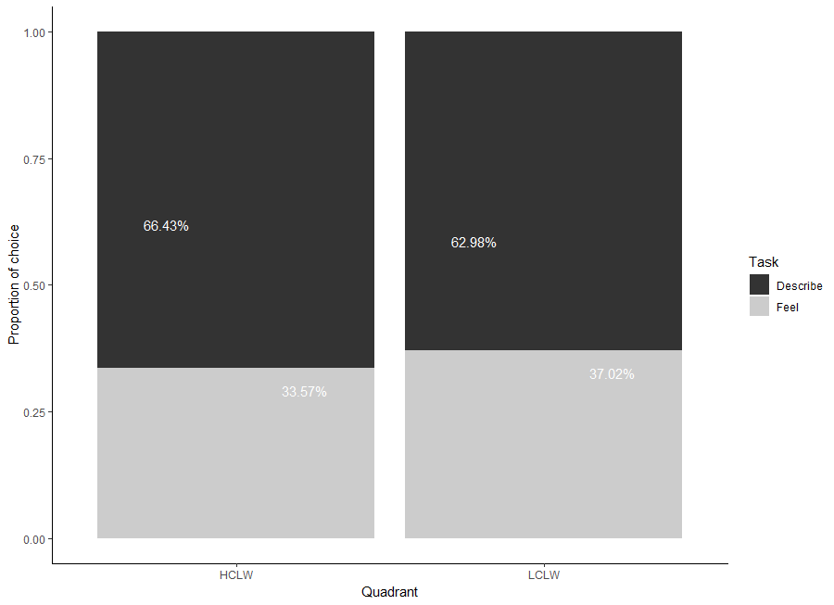
Figure 1. Proportion of choices for Describe vs. Feel tasks as a function of Quadrant.

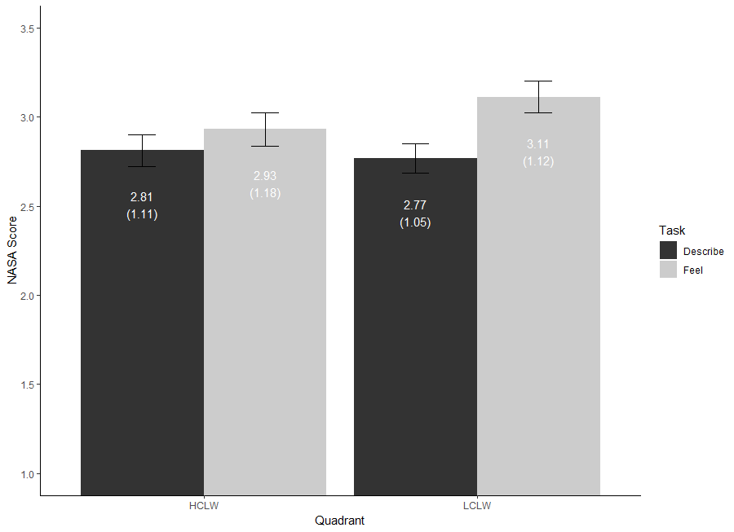
Figure 2. Scores on the NASA Task Load Index as a function of Quadrant and Type of task. Values are means (standard deviations). Bars represent standard errors.

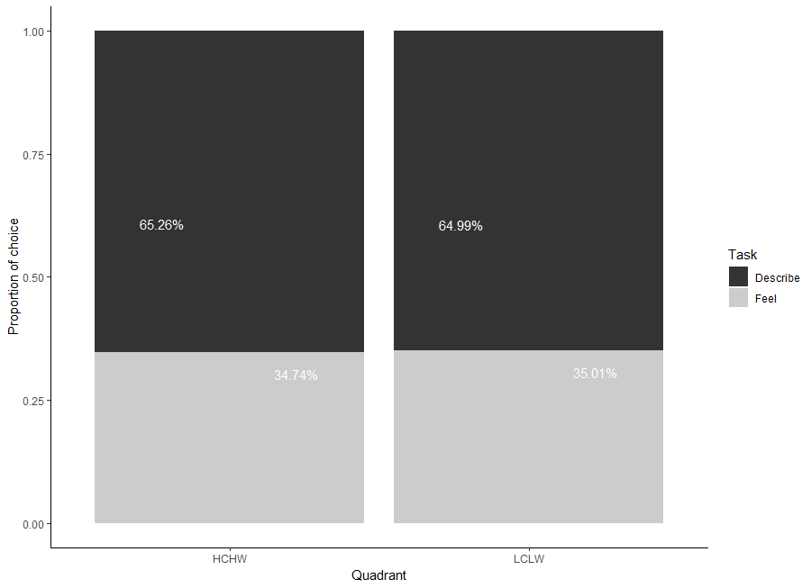
Figure 3. Proportion of choices for Describe vs. Feel tasks as a function of Quadrant.

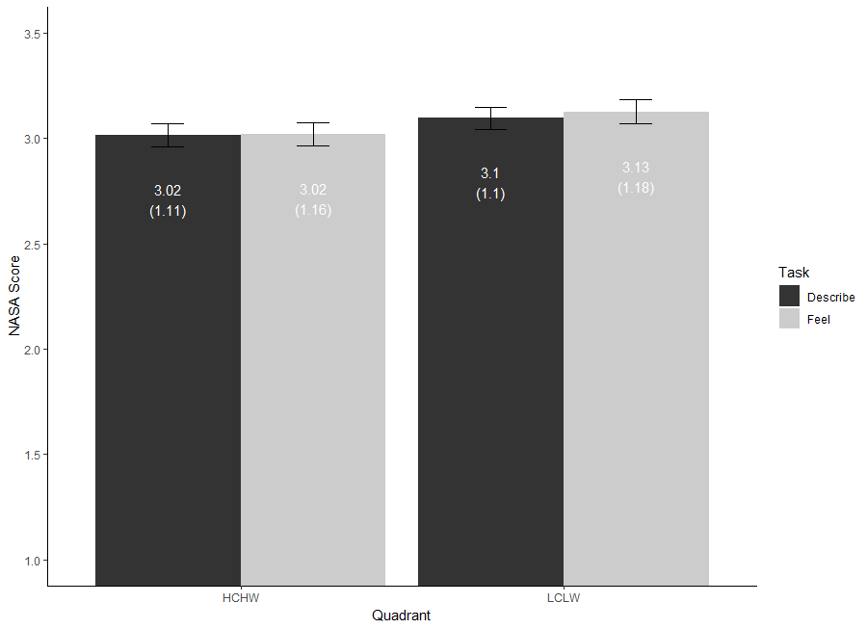
Figure 4. Scores on the NASA Task Load Index as a function of Quadrant and Type of task. Values are means (standard deviations). Bars represent standard errors.

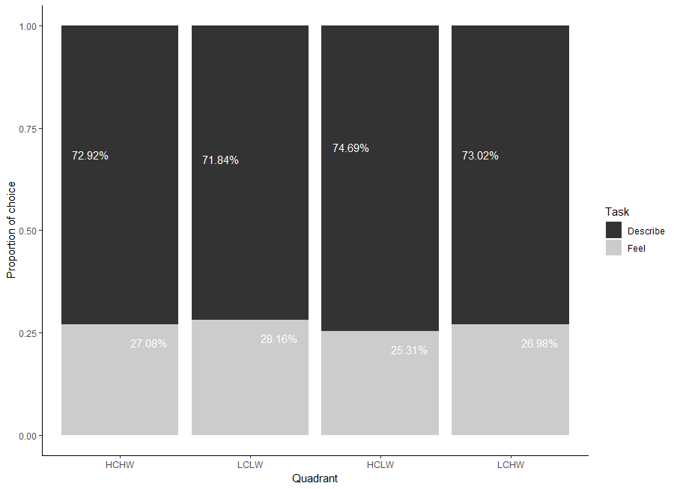
Figure 5. Proportion of choices for Describe vs. Feel tasks as a function of Quadrant.

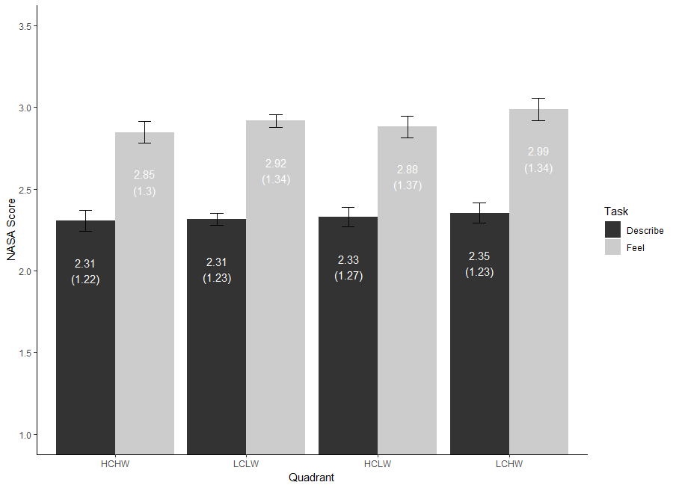
Figure 6. Scores on the NASA Task Load Index as a function of Quadrant and Task. Values are means (standard deviations). Bars represent standard errors.

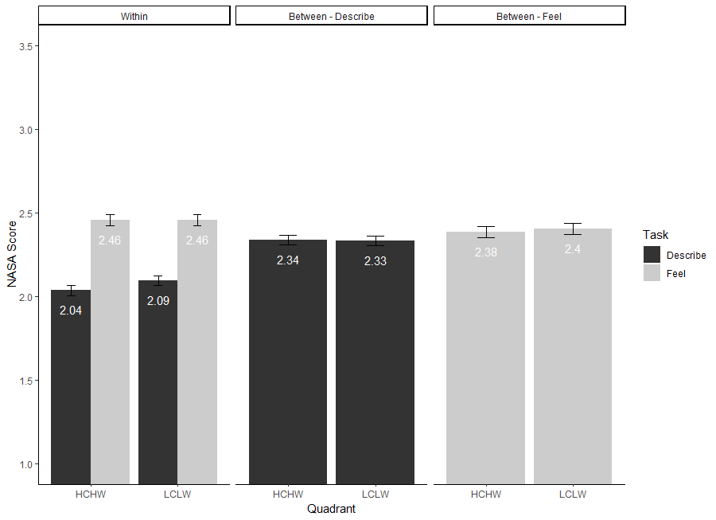
Figure 7. Scores on the NASA Task Load Index as a function of Quadrant, Task and Design. Values are means (standard deviations). Bars represent standard errors.

https://jakewestfall.shinyapps.io/pangea; details of all power analyses can be found in Supplementary Material 1.
As including face valence as a factor did not show robust significant main effect nor any interaction with other factors across all four experiments, we report the analyses without taking into account valence. Interested readers can access analyses taking valence into account in the Supplementary Material 1.
As no statistical analysis including SDO or political orientation emerged as significant, we do not report them here. Interested readers can access these results as well as other statistical indices regarding these scales in the Supplementary Material 1.
As we obtained similar results for the two studies, we only report here the results of the most powered study for the sake of briefness. We report the results of the other study in Supplementary Material 2.
We turned to English-speaking participants in Experiment 3 and 4 as we could not reach our desired sample size with French-speaking Prolific users not having participated in Experiments 1 and 2. Therefore, all social groups and faces used were again pretested for English-speaking participants.

