What Can Emotion and Abstract Words Tell Us About Context Availability Ratings?

Authors:
Catherine Masonª, catherine.mason@mq.edu.au
Solène Hameau^{ab}, solene.hameau@uclouvain.be
Lyndsey Nickelsª lyndsey.nickels@mq.edu.au

Affiliations:
ª School of Psychological Sciences, Macquarie University, Sydney, Australia
^{b} Faculty of Psychology and Educational Sciences, Université́ Catholique de Louvain, Louvain-la-Neuve, Belgium

Author Notes:

Word Count: 2939 (influding abstract and references)

Abstract
Semantic dimensions such as context availability, imageability and valence, form core components of many theoretical accounts of lexical processing. Typically, normative data for such semantic dimensions are drawn from subjective ratings, however, questions have been raised regarding the reliability and validity of these ratings. In this paper, we discuss this issue with a focus on context availability norms. Using data collected for a related study, we show that context availability ratings required significantly higher rates of data exclusions at the level of both participants and items compared to other variables. In addition, high standard deviations at the item level, indicated a substantial degree of disagreement between participants. This suggested that some participants may have had difficulty understanding the concept of context availability which hindered their ability to complete the ratings. We provide recommendations for future research focusing on context availability and for norm collection procedures more broadly in order that the validity of such norms can be improved. In particular, we suggest that clear guidelines are required for data cleaning in order that the reliability of such norms is maximised and to facilitate replication across studies.

Keywords:
Context availability; lexical semantics; lexical processing

Introduction
The range of semantic dimensions which are believed to impact on lexical processing is vast and seemingly ever-increasing (for description see Goh et al., 2016; Nickels et al. 2022).

While word-form characteristics (e.g., frequency, length) may be measured quantitatively, variables indexing semantic dimensions frequently rely on subjective ratings, resulting in methodological challenges: Ratings are constrained by access to sufficient raters and by the number of items which can be realistically rated by an individual. Consequently, many databases have relatively few raters per item or few items in total. In addition, it must be assumed that raters understand the concept that they are rating and are able to readily access the information required to make that rating. If raters are not able to accurately rate words in the manner intended by the researchers or if there is a large degree of variability in the ratings within and/or between participants, this calls into question the validity of the ratings.

The validity of two commonly studied semantic dimensions, concreteness and imageability, has been discussed in the literature (e.g., Connell & Lynott, 2012; Dymarska et al., 2023; Pollock, 2018). Pollock (2018) raised concerns regarding the large standard deviations of these ratings, which suggests substantial disagreement between participants. For example, if, on a scale from 1-7, a word has a concreteness rating of four, but a standard deviation of two, some raters must have considered the word to be concrete while others considered it abstract. Pollock, therefore, recommended excluding high standard deviations items from study stimuli.

Pollock (2018) also questioned whether raters were using the same information when forming concreteness ratings and this echoes similar concerns regarding the face validity of imageability norms (e.g., Connell & Lynott, 2012; Dymarska et al., 2023). Imageability ratings are intended to represent the ease with which a person can generate multimodal imagery in relation to a word (Paivio et al., 1968). Yet, raters are argued to rarely draw on the range of imagery types when rating but instead focus on visual imagery (Connell & Lynott, 2012; Dymarska et al., 2023). Further, Dymarska et al. showed that imageability ratings varied significantly between norm samples and that this could not be accounted for by cultural factors nor by differences in stimuli, but rather pointed to inconsistency between the raters.

The aim of this paper is to further examine the issue of rating reliability and validity for semantic variables, with a focus on “context availability”. This was prompted by our experience when investigating processing of emotion words. In our study (reference redacted), we explored Altarriba and Bauer’s (2004) theory that emotion words have an advantage over non-emotion words due to their high context availability and imageability ratings, as well as Kousta et al.’s (2011) alternative position that this advantage is driven by the “affective variables” of valence and arousal. For this purpose, we collected norms for each of the four variables (context availability, imageability, valence and arousal) on a large set of emotion and non-emotion abstract words and analysed their effects in lexical decision and reading aloud. We found a significant effect of imageability, but not context availability on lexical decision response times. This was unexpected given Altarriba and Bauer’s previous findings that both variables had an effect on abstract/emotion word processing and that previous studies have shown imageability and context availability to be strongly correlated (e.g., Taylor et al., 2022). This led us to examine whether there were any issues with the context availability ratings which may have contributed to the null effect.

Schwanenflugel et al. (1988) introduced the concept of context availability observing that concrete words were more easily related to a context (i.e., “high” in context availability) providing them with strong contextual support. In contrast, abstract words were considered more difficult to link to a specific context with their meaning more likely to vary across contexts. Schwanenflugel et al. proposed that the greater reliance on context for meaning, relative to concrete words, hindered the processing of abstract words when encountered out of context. They demonstrated that when matched for context availability, concrete and abstract words did not show a difference in lexical decision response times. In a later study, Schwanenflugel and Stowe (1989) presented concrete and abstract words in sentences, and found that when supported by a meaningful context, abstract words were recognised as quickly as concrete words.

In this paper, we will explore our context availability norms compared to the norms for other semantic variables (imageability, valence and arousal). By doing so we aim to gain insights into both the validity of context availability norms and the norming process more broadly.

Present Study

Participants
Ninety-seven undergraduate psychology students undertook ratings for course credit. Participants were native English speakers (73 female, 24 male; mean age = 19.3 years). Each participant completed ratings for 156 words (52 emotion words, 52 non-emotion abstract words, 52 (control) concrete words) on two variables: either valence and arousal (49 participants); or context availability and imageability (48 participants). See Supplementary Materials for stimuli details.

Procedure
Participants were asked to rate context availability of items on a 1-7 scale based on how easy they were to put in a context. Instructions for the ratings were based on Schwanenflugel et al. (1988) with minor edits (see Supplementary Materials).

Analysis and Results

Data Cleaning. Problematic participant data were identified through three steps: examining rating diversity, completion time, and the correlation with other raters. Previous studies (e.g., Brysbaert et al., 2014; Rice et al., 2019) excluded data for lacking diversity but didn’t specify benchmarks. We set a defined criterion, excluding data where 90% or more of responses were identical. Participant data were also excluded if the survey was completed in under five minutes. We estimated two minutes for reading instructions and a minimum of three minutes for the task (1125 ms per item). Consequently, context availability data from five participants were removed. We then followed the protocol from Warriner et al. (2013, see also Brysbaert et al., 2014) whereby the correlation of each participant’s ratings with the mean of the other participants’ responses (minus that participant) was calculated and participants with a correlation coefficient less than 0.1 were excluded. This resulted in exclusion of context availability rating data from an additional six participants.

The number of participants excluded from context availability (See Table 1) was significantly greater than the other variables Fisher’s Exact Test, two-tailed, context availability cf. imageability: p = .014; valence p = .022; arousal p = .022), while the number of exclusions from imageability, valence and arousal did not significantly differ from one another (all p >.05).

Following these steps, single
item ratings were removed if they were more than two standard deviations outside the mean for that item (See Table 1).

[Table 1 near here]

Following data cleaning, each item had between 33-46 ratings each. Context availability means before and after the exclusions were strongly correlated r² = .96, however item means were more widely distributed (see Figure 1).

[Figure 1 near here]

Standard Deviations of Ratings. Standard deviations of context availability ratings remained large after data exclusions. Only seven items meeting Pollock’s (2018) recommendation that standard deviations should be < 1. All seven of these items were concrete meaning that all abstract stimuli (emotion and non-emotion abstract words) had a high level of variability. However, we note that the ratings on the other semantic variables also showed concerningly high standard deviations (see Table 1; Figure 2).

[Figure 2 near here]

Discussion
In this paper, we explored context availability ratings in detail, motivated by unexpected patterns for context availability in our lexical decision and reading aloud experiments (redacted reference). There were two points of particular concern regarding the ratings. First, there was a high rate of data exclusions when compared to other ratings collected for our experiment using the same participants (imageability) or participant population (valence, arousal). In addition, the context availability ratings had high standard deviations suggesting a large degree of disagreement between raters.

We excluded a participant’s data when the survey was completed faster than feasible (<5 minutes), there was a uniformity in ratings, or the ratings were very weakly correlated with the rest of the raters. This resulted in exclusion of context availability data from 22.9% participants, significantly more than for the other variables. Rice et al. (2019) also reported a high rate of data exclusions for context availability (28.6% of datasets) and Taylor et al. (2022) excluded data from 11.4% of their participants. This suggests that our exclusions were not due to a unique aspect of our methodology. However, it is difficult to directly compare exclusions across studies due to varying methods of data exclusions. For example, Rice et al. excluded participants who did not use the full scale, repeated the survey and/or did not meet participant inclusion criteria, while Taylor et al., excluded based on the number of control nonwords rated.

Nevertheless, despite relatively strict exclusion criteria, there were concerns regarding the validity of our context availability ratings, informed by the high levels of variance in the retained ratings. As discussed earlier, Pollock (2018) suggested that high standard deviation items should be avoided when selecting experimental stimuli, however, none context availability values of the 104 non-emotion and emotion abstract words in our sample would have passed this criterion. An alternative approach was proposed by Strik-Lievers et al. (2021; see also Winter, 2023): rather than removing items with high standard deviations, instead standard deviations could be integrated into the analysis by using a weighted regression. Using this method, more weight could be given to items with greater agreement between the raters (i.e., low standard deviations) and less weight to items with high level of disagreement (i.e., high standard deviations). This method provides a means of retaining high standard deviation items, however, it is only suited to stimuli where there is high agreement between raters on some items. For our context availability ratings, nearly all items had a high level of disagreement between participants, and so this approach would not address the concerns regarding the validity of the ratings.

Taken together, the high number of participant exclusions and the large standard deviations point to issues with regards to the validity of context availability ratings and that raters may have difficulty understanding the instructions or difficulty accessing the information required to make the ratings. Westbury et al. (2013, p.2) suggest that one problem with context availability may be that context is “a slippery word” that is open to interpretation. Consequently, raters may be using different conceptualisations of context when forming their ratings. Further, unlike ratings for imageability, arousal and valence where the rater can rely on their immediate impressions, rating context availability requires them to reflect on their everyday encounters with the word, demanding greater metacognitive skills. It may also be relevant that in this study, the same participants completed both context availability and imageability ratings, and it is not known if completing context availability ratings in isolation or paired with a different variable would result in different outcomes. In a related study (reference redacted) we surveyed a different group of participants using the same materials and methodology as this current study, however each participant completed all four ratings (context availability, imageability, valence and arousal). In this study, the researcher was available in the same room to answer questions: While few participants queried the imageability, valence or arousal rating instructions, nearly all participants asked for clarification of context availability.

In sum, our findings point to concerns regarding the validity of context availability ratings. This is of significant concern for studies wishing to measure this semantic dimension to test hypotheses that context availability is a key concept influencing lexical processing and it suggests that perhaps future research should consider quantitative measures to capture this dimension.

In addition to insights into the validity context availability ratings, our investigation adds to the discussion with regards to the validity of subjective ratings in general. It is of particular concern that ratings are often used with no attempt to exclude participants, items or data points which could compromise the validity of the norms (e.g., Altarriba et al., 1999; Schwanenflugel et al., 1988). Where data exclusion methods are reported they are variable, and we suggest that a set of best practice methods of collecting and preparing data from normative ratings are needed. First, sufficiently large samples of raters are required to take into account the possibility of heavy data loss. Second, rigorous steps should be taken to ensure that participants understand how to complete the ratings, including piloting materials to obtain feedback on instruction clarity, and providing feedback on a relatively large sample of practice items. Third, participants should be excluded who are unlikely to be performing the task as required, as indicated by a lack of variability in ratings across items, very fast completion and/or a lack of correlation with other participants. Finally, researchers should consider variability at an item level: Mean values taken from items with large standard deviations may have limited usefulness and researchers should attempt where possible to address this in their analysis and/or interpretation of study outcomes. We believe that taking these factors in consideration should improve the quality and validity of normative ratings, thereby increasing their usefulness as a research tool and likely resulting in increased replicability of results.

Declaration of Interest
The authors have no conflict of interests to declare. Funding was provided by an Australian Research Council discovery project grant (DP190101490) through a Research Training Program (RTP) scholarship.

References
Altarriba, J., & Bauer, L. M. (2004). The distinctiveness of emotion concepts: A comparison between emotion, abstract, and concrete words. The American Journal of Psychology, 389-410. Retrieved July 2020 from https://www.jstor.org/stable/4149007
Altarriba, J., Bauer, L. M., & Benvenuto, C. (1999). Concreteness, context availability, and imageability ratings and word associations for abstract, concrete, and emotion words. Behavior Research Methods, Instruments, & Computers, 31, 578-602. https://doi.org/10.3758/BF03200738
Brysbaert, M., Warriner, A. B., & Kuperman, V. (2014). Concreteness ratings for 40 thousand generally known English word lemmas. Behavior Research Methods, 46, 904-911. https://doi.org/10.3758/s13428-013-0403-5
Connell, L., & Lynott, D. (2012). Strength of perceptual experience predicts word processing performance better than concreteness or imageability. Cognition, 125(3), 452-465. https://doi.org/10.1016/j.cognition.2012.07.010
Dymarska, A., Connell, L., & Banks, B. (2023). Weaker than you might imagine: Determining imageability effects on word recognition. Journal of Memory and Language, 129, 104398. https://doi.org/10.1016/j.jml.2022.104398

Goh, W. D., Yap, M. J., Lau, M. C., Ng, M. M., & Tan, L. C. (2016). Semantic richness effects in spoken word recognition: A lexical decision and semantic categorization megastudy. Frontiers in Psychology, 7, 190665. https://doi.org/10.3389/fpsyg.2016.00976
Kousta, S. T., Vigliocco, G., Vinson, D. P., Andrews, M., & Del Campo, E. (2011). The representation of abstract words: Why emotion matters. Journal of Experimental Psychology: General, 140(1), 14–34. https://doi.org/10.1037/a0021446
redacted reference
redacted reference
Nickels, L., Lampe, L. F., Mason, C., & Hameau, S. (2022). Investigating the influence of semantic factors on word retrieval: Reservations, results and recommendations. Cognitive Neuropsychology, 39(3-4), 113-154. https://doi.org/10.1080/02643294.2022.2109958

Pollock, L. (2018). Statistical and methodological problems with concreteness and other semantic variables: A list memory experiment case study. Behavior Research Methods, 50(3), 1198-1216. https://doi.org/10.3758/s13428-017-0938-y

Rice, C. A., Tokowicz, N., Fraundorf, S. H., & Liburd, T. L. (2019). The complex interactions of context availability, polysemy, word frequency, and orthographic variables during lexical processing. Memory & Cognition, 47, 1297-1313. https://doi.org/10.3758/s13421-019-00934-4
Schwanenflugel, P. J., Harnishfeger, K. K., & Stowe, R. W. (1988). Context availability and lexical decisions for abstract and concrete words. Journal of Memory and Language, 27(5), 499-520. https://doi.org/10.1016/0749-596X(88)90022-8
Schwanenflugel, P. J., & Stowe, R. W. (1989). Context availability and the processing of abstract and concrete words in sentences. Reading Research Quarterly, 114-126. https://doi.org/10.2307/748013

Strik-Lievers, F., Bolognesi, M. and Winter, B. (2021) The linguistic dimensions of concrete and abstract concepts: lexical category, morphological structure, countability, and etymology. Cognitive Linguistics, 32 (4), 641-670. https://doi.org/10.1515/cog-2021-0007
Taylor, E., Nation, K., & Hsiao, Y. (2022). Context availability and sentence availability ratings for 3,000 English words and their association with lexical processing. Journal of Cognition, 5(1), 20. https://doi.org/10.5334/joc.211
Warriner, A.B., Kuperman, V. & Brysbaert, M. (2013). Norms of valence, arousal, and dominance for 13,915 English lemmas. Behavior Research Methods, 45, 1191–1207 https://doi.org/10.3758/s13428-012-0314-x
Westbury, C. F., Shaoul, C., Hollis, G., Smithson, L., Briesemeister, B. B., Hofmann, M. J., & Jacobs, A. M. (2013). Now you see it, now you don't: On emotion, context, and the algorithmic prediction of human imageability judgments. Frontiers in Psychology, 4, 68986. https://doi.org/10.3389/fpsyg.2013.00991
Winter, B. (2023). Abstract concepts and emotion: Cross-linguistic evidence and arguments against affective embodiment. Philosophical Transactions of the Royal Society B, 378(1870), 20210368. https://doi.org/10.1098/rstb.2021.0368

Table 1
Data excluded in data cleaning process and percent items with a SD greater than 1.
 | Number of Participants | Number (%) of Participants Excluded | % Single Data Points Excluded (N=) | % Words SD >1 (N=156)
Context Availability | 48 | 11 (22.9%) | 2.7% | 95.5%
Imageability | 48 | 2 (4.2%) | 3.6% | 73.1%
Arousal | 49 | 3 (6.1%) | 3.9% | 94.2%
Valence | 49 | 3 (6.1%) | 2.6% | 40.4%

Figure 1
Distribution of context availability ratings with and without data exclusions

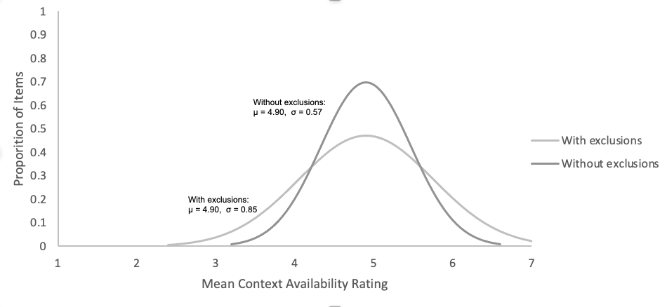

Figure 2
Mean ratings and standard deviations for context availability, imageability, arousal and valence
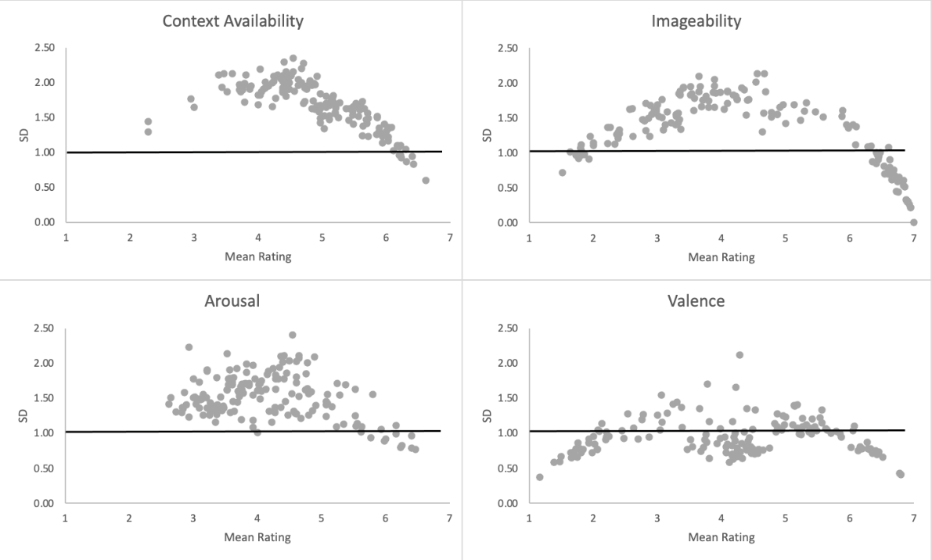
Note. All ratings were based on a 1-7 scale. Standard deviation of 1 is marked on the figure, corresponding with the SD that Pollock (2018) suggests norm ratings should stay below.

