Evolving scale conceptions and directed progressions in THE JOSQUIN ERA*
Anne-Emmanuelle Ceulemans

In a seminal paper published in 1992, Sarah Fuller analysed a fourteenth-century contrapuntal pattern that she called ‘directed progression’. She described it as follows:

A directed progression may be defined as a succession of two adjacent sonorities – the first imperfect in nature and unstable in quality, the second perfect in nature and stable in quality – in which the first resolves to the second according to the norms of contrapunctus voice-leading. The criterion of adjacency is fulfilled when the lowest note of the first sonority is a tone or a semitone distant from the lowest note of the second. In most (but not all) cases, the lowest note of the first stands above that of the second sonority. Contrapunctus voice-leading precepts most commonly stipulate conjunct movement of minor thirds in toward unisons, major thirds out to fifths, and major sixths out to octaves.

While the directed progression plays a fundamental role in the work of Guillaume de Machaut (c. 1300-1377), it continues to shape polyphonic language well beyond the fourteenth century up to the early sixteenth century and even later. Analysing Renaissance polyphony through the lens of directed progression provides valuable insights into musical thinking, particularly with regard to evolving scale conceptions. This issue forms the core of the present article. I suggest that this evolution is related to changes in the tuning habits of keyboard instruments between the fourteenth and sixteenth centuries. The hypotheses developed below are based on an extensive analysis of the work of Josquin des Prez, from which most of the music examples are taken. Nevertheless, the focus of this study is not Josquin himself, but a contribution to the history of contrapuntal thinking, of which he is an outstanding representative. Similar phenomena are observable – albeit to varying degrees – in any polyphonic repertoire of his time.

Directed progression and cadence: two distinct concepts
As the above quote indicates, the directed progression is based on a process of tension followed by resolution. Imperfect consonances, which are considered unstable, demand to be followed by perfect consonances. The most significant directed progressions resolve by moving stepwise in opposite directions (Example 1).
Example 1. Directed progressions.
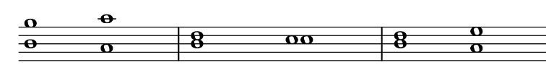
In an oft-quoted passage from his Musica (c. 1355), Johannes Boen (early 14th century-1367) explains that thirds and sixths, which are imperfect intervals, prepare the ear for the arrival of the perfect intervals, the fifth and octave. According to this author, imperfect consonances convey a harmonic tension that is resolved by the arrival of perfect consonances.

Inter tertiam et sextam propter vicissitudinem, quam habent adinvicem, similitudinem adauxerunt, quod sicut tres tertias se invicem sequi licet, ita et sextas, hoc ideo statuentes, ut cantus ille, qui per tertias et sextas imperfectus censetur, non tamen discors aures trahat et alliciat, ut perfectionem cantus, qui per quintam sequetur vel octavam, quarum tertie et sexte sunt nuntie et ancille, exspectatam diutius indicent dulciorem, ut hic, | [Moderns] have increased the similarity between the third and the sixth on account of reciprocal influence, which they have mutually, so that just as three thirds may follow one another, so also may three sixths; and they maintain this for this reason, that a song which is judged to be imperfect on account of thirds and sixths, but is not however inharmonious, draws and attracts the ears, so that the perfection of the song, which is to follow through a fifth or octave, of which the thirds and sixths are heralds and maidservants, they [the moderns] declare the sweeter for being longer awaited, as here;
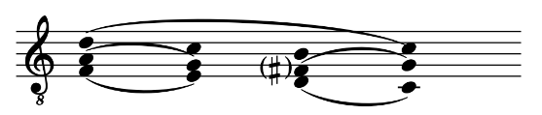

non autem statuentes in quintis vel octavis, ne auris cesset ab advertentia, putans, quod habito fine cesset motus. | but they do not maintain this for fifths and octaves, in case the ear ceases from its attention, thinking that motion ceases with the end having been achieved.

The directed progression is commonly equated with the cadence, understood as a point of harmonic perfection and closure. In fifteenth-century music theory, this idea is expressed in Franchino Gaffurio’s Practica musica (1496), for example.

Septima regula est quod quando ex concordantia imperfecta perfectam petimus concordantiam tanquam cantilenae terminationem: vel alicuius partis eius harmonicae: ad propinquiorem perfectam diuersis vtriusque partis motibus acquirendam concurrere necessum est. […]  Octaua et vltimam Regula est quod omnis Cantilena debet finiri et terminari in concordantia perfecta videlicet aut in vnisono vt Venetis mos fuit. aut in octaua aut in quintadecima: quod omnis musicorum scola frequentius obseruat gratia harmonicae mediocritatis perficiendae. Est enim Finis teste Philosopho vniuscuiusque rei perfectio. | The seventh rule states that when we approach a perfect consonance from an imperfect consonance, as at a final cadence or any other cadence, it is necessary to progress to the perfect interval by contrary motion of the closest imperfect consonance. […]  The eighth and last rule states that every song should end on a perfect consonance, either on a unison, as has been customary in Venice, or on the octave or fifteenth, as every school of musicians commonly observes for the sake of a perfect harmonic union. For according to the philosopher [Aristotle] the perfection of anything is the end.

The association between the directed progression and the cadence is still very much present in contemporary musicology, probably because the authentic cadence derives from the sixth-octave (or third-unison) progression with a lower leading tone. The addition of two extra voices according to the rules of counterpoint brings the authentic cadence close to the commonly practiced V-I formula, even if it was not originally conceived in terms of bass motion.
Sarah Fuller has shown, however, that in the fourteenth century the directed progression is not necessarily conclusive. Besides its well-documented function of providing closure, it also serves to reinforce or contradict the meaning of the sung text, or to emphasise certain degrees of the scale. This observation remains valid until the sixteenth century: many directed progressions have no conclusive value, but nevertheless form a noticeable articulation in the contrapuntal flow. In short, the only condition for a directed progression to be perceived as a structuring element within polyphony is that it be sufficiently emphasised from a melodic, metrical and rhythmic point of view. To illustrate this idea, I hold that the sixth-octave progression in short note values in Example 2 should not be understood as a directed progression, insofar as it results from surface diminution. By contrast, the progressions in Example 3 and the following examples stand out because they possess sufficient melodic, rhythmic or metrical impact to create a true sense of articulation, but not necessarily a closure, even if transient.
Example 2. Factum est autem (19.3), mm. 128-129.
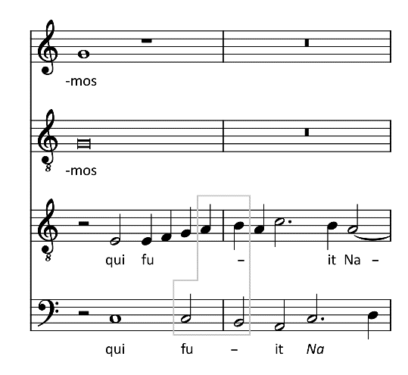
In taking the directed progression as the subject of this article, my aim is to clarify a possible ambiguity. This article does not focus on the treatment of cadences, but on an intervallic construction that occurs in various contexts. Nor is the conclusiveness of this construction key to this article’s argument. For example, while there is no doubt that Examples 3a and 3b represent directed progressions – reinforced by suspensions, which will be discussed further below – their conclusive character, and therefore their cadential quality, is questionable. In Example 3a, the unison of the upper voices on A marks the end of a melodic line in the superius, but in a gesture commonly found in Josquin’s time, the sense of conclusion is negated by a new phrase that sets in a twelfth lower, initiated in the bass. In Example 3b, the octave on E that the superius and tenor reach at the beginning of measure 305 is harmonised with a bare fourth. This situation is exceptional, contrary to the rules, and counteracts any feeling of harmonic closure that might have been achieved before the bass comes in on a new melodic phrase in the second half of the measure.
Example 3a. Memor esto verbi tui (17.14), mm. 102-106.
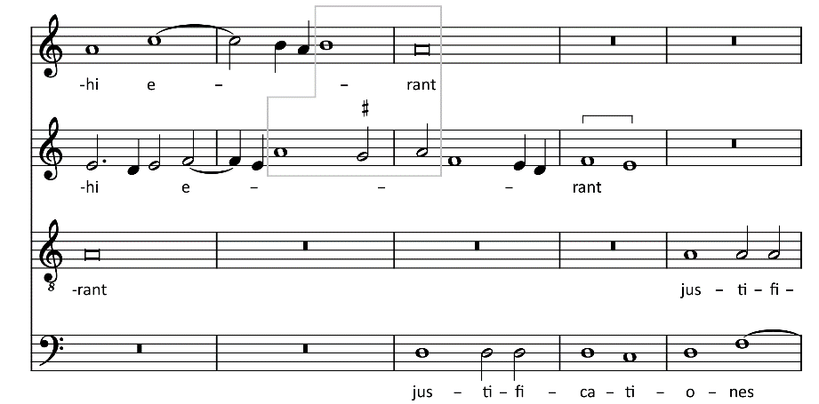
Example 3b. O Domine Jesu Christe (22.1), mm. 302-307.
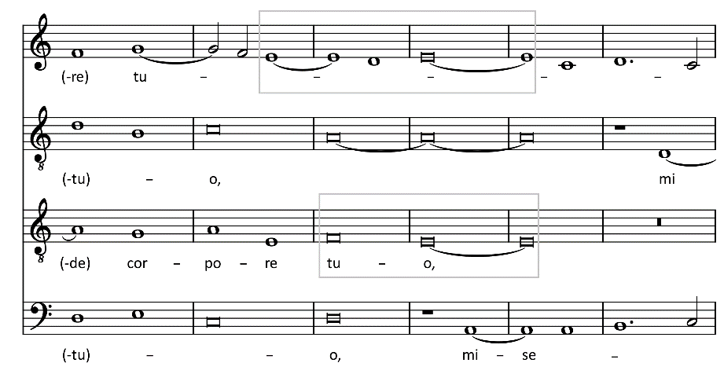
Distinguishing between the directed progression and the cadence is all the more necessary as some works by Josquin and his contemporaries end with harmonic combinations, the conclusive character of which can hardly be disputed, but which do not incorporate any of the progressions of Example 1. Example 4 reminds us that no reciprocal relationship should be assumed between the directed progression and the idea of conclusion.
Example 4. Qui velatus facie fuisti (22.3), mm. 227-234 (end of the Tertia pars).
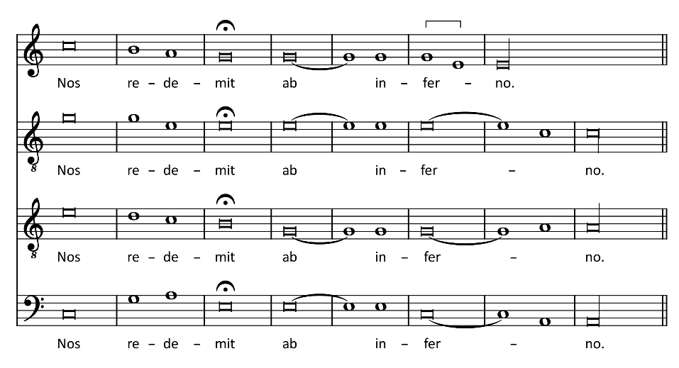
Studying the directed progression independently of a possible cadential context has another advantage: it can be examined as a two-part pattern, or, to use an expression dear to Margaret Bent, from a strictly dyadic perspective. Of course, Josquin’s works cannot be understood as vocal duets to which new voices were added in successive layers, and the same applies to most of his contemporaries. On the contrary, they exhibit a polyphonic structure in which the voices are interdependent, in accordance with the definition of res facta given by Johannes Tinctoris (c. 1430/35-1511). The interlocking dyadic progressions that exist between all voice pairs demonstrate a flexible and masterful approach to tradition. At times, the polyphony even seems to result more directly from a conception that it would be risky to call ‘triadic’, since this term is so closely associated with the later concept of chord, but which nevertheless is based on a three- or multiple-voice framework. Thus the dyadic perspective is interesting, in that it not only shows the tradition’s legacy, but also helps to highlight the limits of an approach that ignores the interaction between all the parts. Nonetheless, many passages can be analysed in either way, as the following simple example shows.
The end of the motet Tu solus qui facis mirabilia (Example 5) features a directed progression that conforms to theoretical prescriptions, with an ascending stepwise motion associated with the upper voice and a descending stepwise motion with the tenor. The bass joins the directed progression in a stereotypical formula. Formally, this part seems to correspond to the root of two successive chords, but before the definition of the trias harmonica as a musical unit in its own right by Johannes Lippius (1585-1612), such an interpretation is obviously anachronistic. Yet the bass transforms the dyadic progression into a three-part framework so common that it could be understood as a whole, that is, as a structure conceived in three voices from the outset. It is also noteworthy that the B in the altus seems momentarily to go against Gaffurio’s prescription to end musical works on perfect consonances, before then rising to D, a twelfth above the bass.
Example 5. Tu solus qui facis mirabilia (22.5), mm. 106-110.
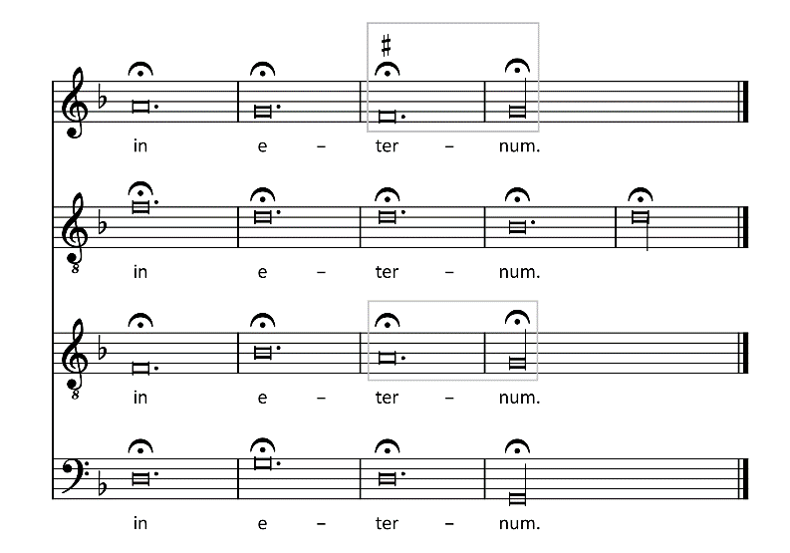
Example 5 serves to establish a few conventions for the analyses that follow. Bernhard Meier popularised the terms clausula cantizans, clausula tenorizans and clausula basizans to describe the characteristic movements of the upper voice, tenor and bass. This late terminology introduces a possible ambiguity between the clausula understood as a two- or multi-voice cadence and the clausula understood as a melodic formula of a single voice. For this reason, and because the present study does not intend to focus on cadences, I follow Julie Cumming’s example and below favour the terminology introduced at the end of the fifteenth century by Guilielmus Monachus: modus suprani, modus tenoris and modus contrae. Because of the referential role of the tenor, the final note of the modus tenoris will be called ‘reference tone’. For instance, in Example 5, the reference tone is the final G of the tenor.

Directed progression as a functional module
In the fourteenth century, the directed progression marks the emergence of a kind of harmony that can be described as functional – not in the terms of eighteenth-century harmony, of course, but in the sense that it has an obligatory resolution. In other words, it is a contrapuntal unit within which the successive order of intervals is not reversible. The reason why fifths and octaves are associated with the idea of perfection, while thirds and sixths are considered imperfect, is rooted in the quadrivium tradition and the legacy of Boethius (c. 480-524). The perfection associated with the octave and fifth is explained by the simplicity of the numerical ratios that define these intervals, according to the maxim that ‘those things which are simpler by nature are demonstrated to be harmonious when brought into relationship’.
Boethius mathematically defines as consonances the octave (2:1), the twelfth (3:1), the double octave (4:1), the fifth (3:2) and the fourth (4:3). These intervals are the ones that form the basis of the Pythagorean scale, the construction of which is reported in the well-known tale of the blacksmith’s forge, reproduced in music treatises throughout the Middle Ages. According to Boethius, the mathematical definition of these intervals goes hand in hand with aural appreciation.
Consonantia est acuti soni gravisque mixtura suaviter uniformiterque auribus accidens. Dissonantia vero est duorum sonorum sibimet permixtorum ad aurem veniens aspera atque iniucunda percussion. | Consonance is a mixture of high and low sound falling pleasantly and uniformly on the ears. Dissonance, on the other hand, is a harsh and unpleasant percussion of two sounds coming to the ear intermingled with each other.

This twofold mathematical and aural-perceptive approach is also found in later treatises, for example in Jacques de Liège (c. 1260-after 1330), who nevertheless distinguishes between consonantia and concordantia. Consonantia, which is mathematical in nature, includes the same intervals as those mentioned by Boethius, with the addition of the nineteenth (6:1) and the whole tone (9:8). Concordantia focuses on hearing and has a more subjective character, defined as follows:

Perfecta concordia est sonorum distinctorum sibi permixtorum unitorumque veniens ad aurem dulcis et uniformis iucundaque melodia. | Perfect consonance is a pleasant, uniform, and delighting sound of diverse, but mixed and blended tones that reach the ear.

The definition of consonance as the heard fusion of two or more notes might explain the exclusion of thirds and sixths from the category of perfect consonances by medieval theorists, not only for mathematical reasons or on grounds of tradition, but because of an acoustic phenomenon that counteracts the sense of fusion. Indeed, according to their Pythagorean definition, imperfect consonances produce significant tremors or beats that make them unstable, as opposed to the ratios of just intonation. The beating phenomenon does not seem to have been described before Arnolt Schlick (c. 1460-after 1521), but it is hard to imagine that it was not perceived by earlier musicians. Some scholars have actually pointed out how imperfect consonances generate a drive to the final in the medieval cadence, especially in the double leading tone cadence, because of their acoustic instability which resolves on non-beating intervals.
Around 1400, the functional tension-resolution process of the directed progression was gradually enriched by a new element: a dissonant suspension preceding the imperfect consonance, of which the following piece by Johannes Ciconia (c. 1370-1412) is an early illustration.
Example 6. Johannes Ciconia, Caçando un giorno, mm. 74-76.
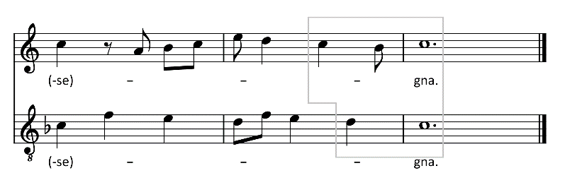
The syncopated dissonance reinforces the instability of the imperfect consonance and extends the directionality of the directed progression to three successive intervals, since the suspension necessarily resolves by a stepwise downward motion. Even when a directed progression of this kind occurs in a non-conclusive context, it induces the expectation of the reference tone more urgently than in the absence of suspension and can thus strengthen tonality, as shown in Example 7. Although the dissonance at the beginning of m. 38 hinders any closure, the directed progression highlights the motet’s final, B. In the tenor, it also allows the word ‘Creator’, sung over a melodic motif borrowed from the antiphon O admirabile commercium, to be emphasised.
Example 7. O admirabile commercium (21.7), mm. 36-39.
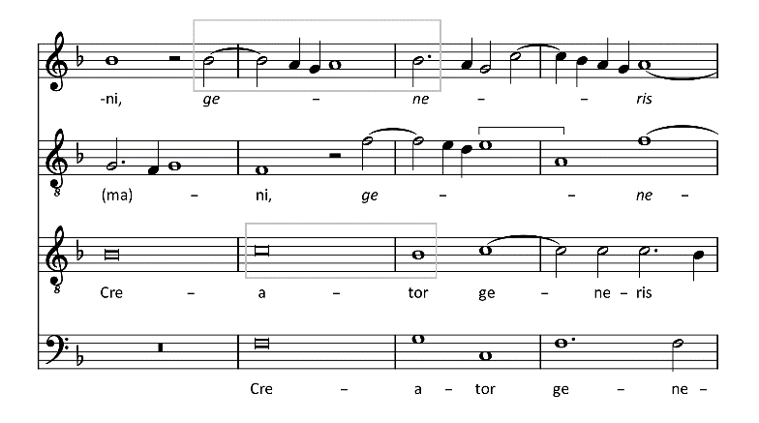

Variations on the directed progression
The models in Example 1 can produce six different types of directed progression, depending on the presence of a lower or upper leading tone, and each can be reinforced by dissonant syncopation. In Josquin, as in most fifteenth- and sixteenth-century composers, the sixth-octave progression with a lower leading tone is the most common (Examples 3a, 5 and 7), but the upper leading tone also occurs regularly (Example 3b), as does the third-unison progression.
The third-fifth progression merits special comment, however. From the fourteenth century onwards, this progression is often combined with a sixth-octave progression, eventually resulting in a double lower leading tone, although an upper leading tone is also possible. In Josquin, the combination of third-fifth and sixth-octave progressions is found occasionally, but the bare third-fifth progression is almost non-existent.
The examples below show different settings. Example 8a combines a third-fifth and a sixth-octave progression, both with a suspension. The tenor has a lower leading tone, but the editor of the New Josquin Edition, Willem Elders, chose not to raise the F of the altus. Example 8b is similar, but has an upper leading tone (F-E). In Example 8c, only the third-fifth progression includes a suspension, and this time the New Josquin Edition features a double leading tone. Finally, Example 8d resembles an isolated third-fifth progression in the lower voices, but one of the upper voices still presents a more ornate sixth-octave progression B-(A)-C parallel to the third-fifth progression.
Example 8a. Alma redemptoris mater (23.2), mm. 44-46.
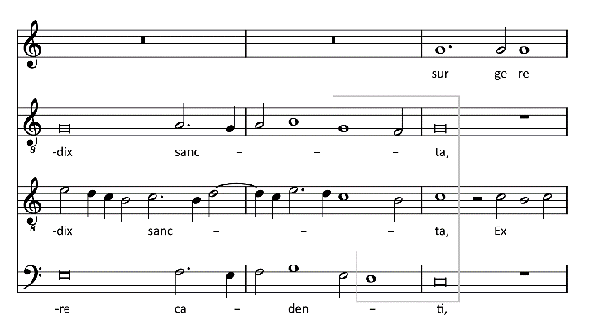

Example 8b. Factum est autem (19.3), mm. 306-307.

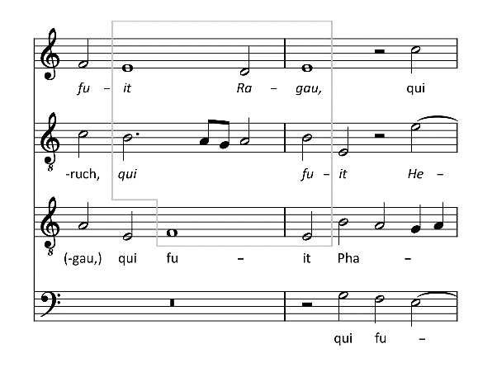

Example 8c. Ave Maria… Virgo serena (23.6), mm. 139-141.
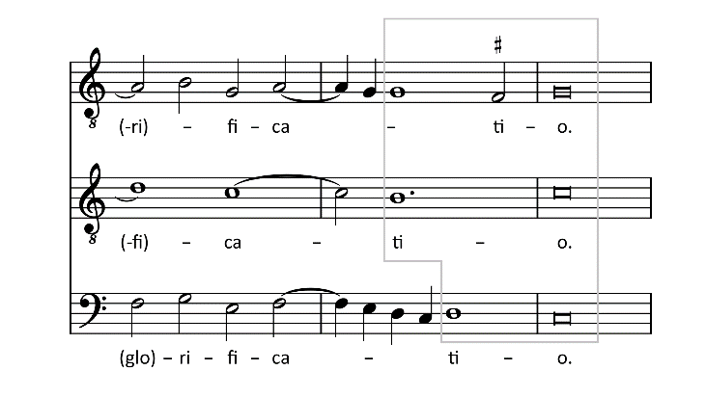

Example 8d. Faulte d’argent (29.7), mm. 65-67.
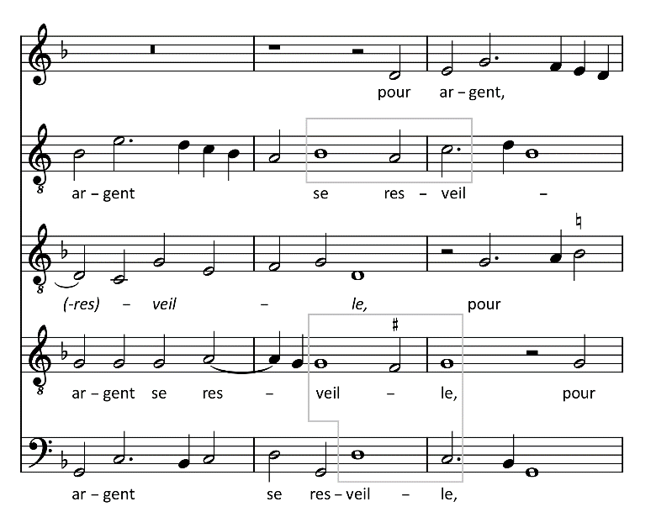
These cadences cannot really be understood from a strictly dyadic viewpoint, as they form commonplace three-part patterns. Nevertheless, they respect all the constraints of the directed progression as a functional module characterised by the passage from dissonance to imperfect consonance and then to perfect consonance.
Around 1500, however, the directed progression underwent an evolution that seems to deviate from the functional process described above. This change concerns the sixth-octave or third-unison progression, the modus tenoris of which is altered and no longer reaches the reference tone, instead arriving at its upper third. Example 9 is an early instance of this development in Josquin.
Example 9. Scaramella (28.30), mm. 30-34.
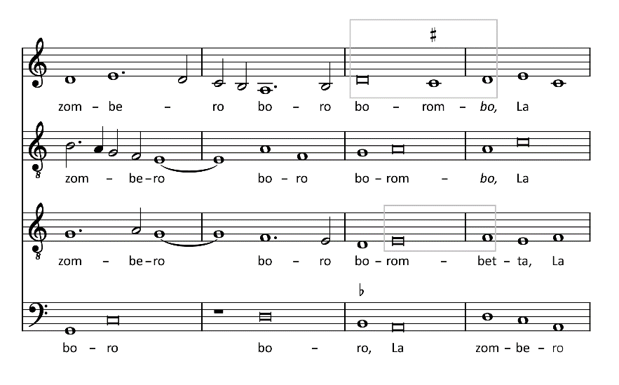

This progression requires special consideration. The two-voice framework of tenor and superius no longer meets the requirements of the directed progression described by Sarah Fuller. It abandons the principle of contrary motion as well as the referential role of the tenor or – in cases where the modus tenoris is assigned to another voice – the melodic formula associated with this part. Last but not least, the imperfect consonance no longer resolves into a perfect consonance. In Example 9, only the suspension still ensures the passage from a strong tension to relative resolution.
This progression is obviously not specific to Josquin, who actually uses it sparingly, and never at the end of a work. Its emergence seems to coincide with two developments mentioned earlier. On the one hand, the bare third-fifth progression is more or less completely abandoned. In this progression, the reference tone is entrusted to the tenor alone, whereas in the sixth-octave and third-unison progressions, it is sung by both voices and can therefore be heard even if the modus tenoris is modified. On the other hand, the combination of the modus contrae (in Example 9, A-D on ‘La zom-’) with the dyadic directed progression doubles the reference tone in the bass and forms a three-part framework sufficiently stable to have an effect similar to an ordinary directed progression.
In this respect, it is significant that Josquin hardly uses the altered modus tenoris in directed progressions with an upper leading tone, probably because in this case it is not possible to add a modus contrae. Without a modus contrae, identifying a modified directed progression may indeed be problematic. In Example 10, the directed progression is recognisable through the suspension in the modus suprani, treated as a motif that passes from one voice to another, but in the absence of the modus contrae, the emphasis on the reference tone (B) is weak. Without syncopation, the directed progression would be barely identifiable.
Example 10. Ile fantazies de Joskin (27.15), mm. 15-21.
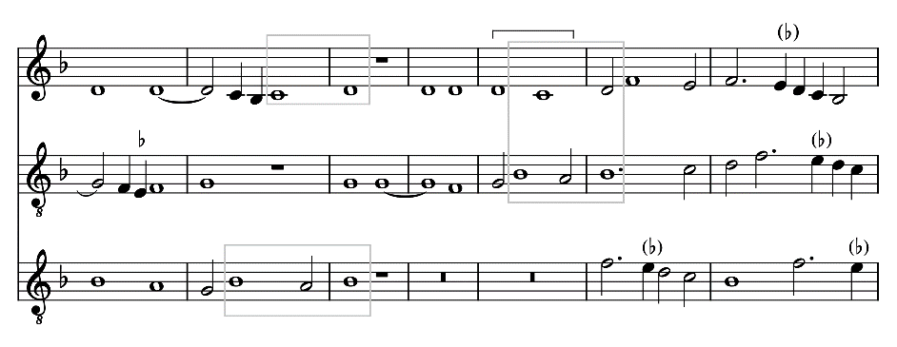

The intonation of imperfect consonances
How can we explain the paradigm shift represented by the alteration of the modus tenoris? Considering that this evolution allows the inclusion of the third of the reference tone above a bass, it is tempting to link it to the ever-increasing inclusion of thirds at points of closure in late fifteenth- and sixteenth-century polyphony, especially in final cadences. Thus, in Example 11, the altus does not participate in the directed progression, but gives this motet an innovative character by featuring the third B over the bass G.

Example 11. Domine, non secundum peccata (16.10), mm. 235-239.
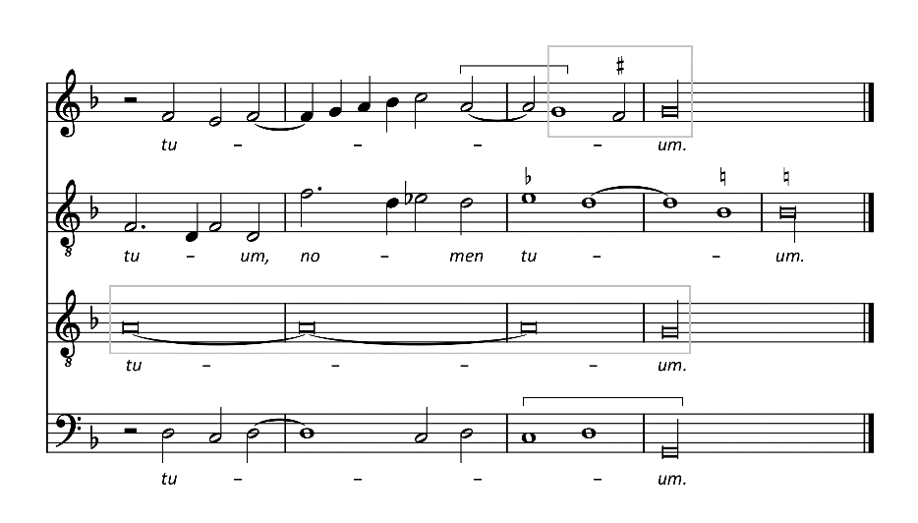
In itself, when merely added to a regular directed progression, the final third does not intrinsically change the dyadic pattern, but it obviously violates the theoretical prescriptions that require all works to end on a perfect consonance. Why did composers of the fifteenth century gradually integrate the third into points of closure in their works? A teleological explanation would see this development as prefiguring common practice harmony, but another interpretation is possible beyond this. The period in which this evolution occurs coincides with the spreading of meantone temperament, first mentioned by Franchino Gaffurio (1451-1522) and first fully described by Pietro Aaron (c. 1480-after 1545). As shown in Table 1, in quarter-comma meantone, major thirds and minor sixths do not beat. Minor thirds and major sixths are not quite pure, but they beat less than in the Pythagorean scale. At the same time, fifths are slightly narrowed and therefore start beating. Variations of meantone temperament result in weakly beating major thirds. All meantone temperaments have in common that the diatonic semitone is larger than the chromatic semitone.
Table 1. Arithmetic definition and cent value of consonances (in bold: non-beating intervals).
Interval | Pythagorean scale | Quarter-comma meantone temperament | Just intonation
Octave | 2/1 1200 cents | 2/1 1200 cents | 2/1 1200 cents
Major sixth | 27/16 906 cents | $\frac{\sqrt[\text{4}]{{\text{5}}^{3}}}{\text{2}}$ 890 cents | 5/3 884 cents
Minor sixth | 128/81 792 cents | 8/5 814 cents | 8/5 814 cents
Perfect fifth | 3/2 702 cents | $\sqrt[\text{4}]{\text{5}}$ 697 cents | 3/2 702 cents
Major third | 81/64 408 cents | 5/4 386 cents | 5/4 386 cents
Minor third | 32/27 294 cents | $\frac{\text{4}\sqrt[\text{4}]{\text{5}}}{\text{5}}$ 310 cents | 6/5 316 cents

In keyboard music, meantone temperament modifies the phenomena of harmonic tension and resolution that are inherent to the directed progression inherited from the fourteenth century. Compared to the Pythagorean scale, the stability of the thirds, and especially the major thirds, now allows them to be used in points of closure. The sixths are less tense. The fifths lose their stability and their sound quality no longer contrasts with the imperfect consonances. This situation in itself is likely to erase the functional drive of the directed progression, which only the dissonant syncopation is able to preserve.
Could meantone temperament explain why the treatment of imperfect and perfect consonances changes in the vocal music of Josquin’s time? The answer to this question requires careful qualification. It would be absurd to claim that singers of the late fifteenth and sixteenth centuries suddenly began to sing vocal polyphony in this or that specific type of meantone temperament. However, the point about the treatment of imperfect consonances is less how they were performed and more how composers thought about them. If composers’ conception of musical scales corresponded approximately to the characteristics of meantone temperament, this would suffice to explain the evolution of the treatment of imperfect consonances, independently of the way in which singers subsequently performed the works in question.
The issue at stake can be expressed in the form of two questions: is it possible that the specificities of meantone temperament influenced the concepts of scale and interval that governed vocal composition? Or, alternatively, is meantone temperament to be seen as a practical response to a musical quest for stable thirds, which was ‘in the air’ and of concern to both vocal and instrumental composers?
In order to clarify these issues, it is necessary to recall a few facts. Even if temperament is specific to keyboard instruments, instrumental music did not evolve in complete isolation from vocal music. At the time we are talking about here, all musicians were in regular contact with organs. It should also be noted that Aaron’s description of meantone temperament is included in a treatise intended for all kinds of musicians, which suggests that he felt they could benefit from it. Indeed, scale construction and interval definition were a widely shared concern. Before Aaron, other theorists had already advocated the use of non-beating thirds. The best known among them is Bartolomeus Ramis de Pareia (c. 1440-after 1490), whose famous monochord gave rise to a controversy involving many authors, including John Hothby (c. 1430-1487), Franchino Gaffurio (1451-1522), Nicolò Burzio (c. 1453-1528), and Giovanni Spataro (1458-1541). Without going into the details of these multi-faceted debates, we will simply note that the protagonists were composers, singers and theorists, but probably not organists and certainly not organ makers.
It is thus not unreasonable to assume that the search for thirds (especially major thirds) considered stable intervals was shared by composers of vocal and instrumental music. This finding implies that by Josquin’s time, the Pythagorean scale had run its course as a compositional tool. Nevertheless, can we postulate that meantone temperament had a direct influence on vocal writing? If this question is taken to imply that composers of vocal music had to master the tuning of keyboard instruments according to this temperament, the answer can only be negative. The treatises of Gaffurio and Aaron provide sufficient evidence that this technique was not within the reach of the average musician.
On the other hand, without taking such an extreme view, it is not unreasonable to imagine that the tonal quality of non- or weakly beating major thirds heard on the organ may have inspired composers of vocal music. The studies of Mark Lindley and Graeme Boone on earlier vocal repertoires could support the existence of such an influence. According to Lindley, in the late fourteenth and early fifteenth centuries, a specific organ tuning already influenced the use of thirds in vocal music and thus set a significant precedent. This tuning, generally referred to as Pythagorean intonation, is constructed, like the Pythagorean scale, with non-beating fifths. It is therefore not a temperament and the ditone corresponds to the ratio 81/64, i.e. 408 cents (see table 1). Nevertheless, the system takes advantage of the difference between the small diatonic semitone (256/243, or 90 cents) and the large chromatic semitone (2187/2048, or 114 cents) typical of the Pythagorean scale. In Pythagorean intonation, the five chromatic keys are tuned as flats. This results in a wolf fifth between B and G/F. However, it turns out that enharmonically, this tuning yields four almost pure major thirds (actually diminished fourths): D-F, E-G, A-C and B-D. This might explain the treatment of thirds in some keyboard works of the Faenza Codex (c. 1410-1420), for example the alternatim Gloria Cunctipotens genitor, where one of the verses ends on E-G-B (Example 12).
Example 12. End of the verse ‘Domine Deus, Agnus Dei’ from the Gloria Cunctipotens genitor (Faenza Codex).
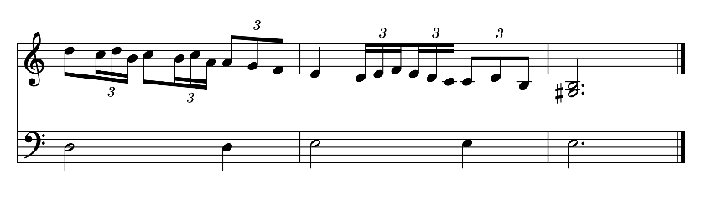
The same type of major thirds, involving a diatonic bass and a raised degree in an upper voice, can be found at points of closure in vocal works, especially by Italian composers. This is the case in a virelai by Matteo da Perugia (fl. 1400-16), Helas Avril, the second part of which also ends on E-G-B (Example 13).
Example 13. Matteo da Perugia, Helas Avril, mm. 64-69.
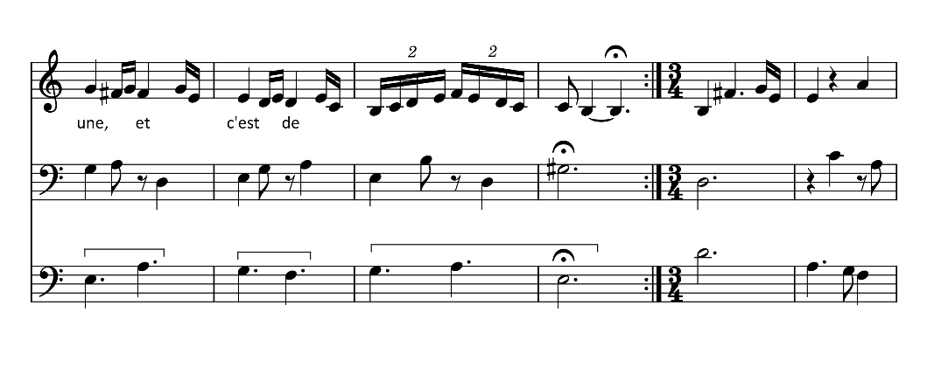
A similar phenomenon might explain the presence of prominent major thirds in the songs of Guillaume Du Fay (1397-1474) preserved in ms. Oxford, Canonici misc. 213, also of Italian origin. For example, in the ballade Mon chier amy, the end of the second part on D-F-A, with the third entrusted to the upper voice, is particularly striking (Example 14, m. 28).
Example 14. Guillaume Du Fay, Mon chier amy, mm. 25-29.

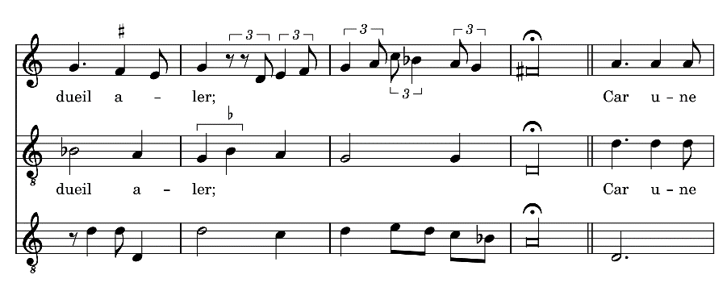

Admittedly, Mark Lindley’s hypotheses remain somewhat uncertain: Pythagorean intonation is not the only fifteenth-century tuning to produce pure thirds, although it seems to have been quite widespread. Moreover, not all the examples Lindley cites are equally convincing. Within a musical phrase, for instance, a third, even if written in long note values, can convey an intentional tension that draws the listener to the rest of the work. In Examples 12-14, however, the raised scale degrees conclude work sections and certainly cannot be understood as leading tones. They are conveniently explained by the abandonment of the traditional Pythagorean scale and the adoption of a theoretical model in which thirds that involve a raised degree are stable.
An issue not addressed by Mark Lindley is that Pythagorean intonation changes the nature of the raised leading tones. According to this tuning, in Example 14, F (actually G) in m. 25 would no longer tend as strongly towards G as in the traditional Pythagorean scale. The interval between the two notes would be 114 cents (instead of 90 cents for the Pythagorean diatonic semitone), while the A-F sixth between the upper voices would be almost pure (882 cents). However, the impact of this change is limited to a few intervals in the scale, and in a strictly vocal piece, singers are free to inflect the intervals according to the context.
Compared to the Pythagorean scale, meantone temperament marks a more complete break than Pythagorean intonation, in the sense that it enables non-beating major thirds between two diatonic degrees and alters the harmonic quality of all consonances. This development must have been quite noticeable in organ music. I suspect that it may also have influenced the conception of vocal works.
In Example 11, the final third is superimposed on a classical directed progression. This helps to maintain the appearance of traditionally conceived counterpoint. By contrast, the altered directed progression (Example 9) turns its back on the past and no longer allows us to consider counterpoint in a dyadic way. The reference tone is now carried by the modus suprani and especially by the modus contrae, which, together with the modus tenoris, form a unified three-voice framework. It is perhaps this shift that explains why Josquin uses the third in final position quite regularly in his works, but never the altered directed progression. It was up to the composers of following generations to seize more widely upon this development.

In conclusion: the role of the singers
The preceding pages have attempted to show the evolution of the directed progression as a functional unit in the light of various scale conceptions, defined successively according to the Pythagorean tradition inherited from Boethius, the so-called Pythagorean intonation that appeared around 1400, and meantone temperament, which must have spread widely by the end of the fifteenth century. According to me, this last development plays a significant role in changing contrapuntal writing in Josquin’s time. In view of this analysis, however, a question might arise. Given the flexibility of the voice, how should we imagine that singers performed polyphony? Margaret Bent considers that unaccompanied singers ‘performed with pure intonation, Pythagorean in principle, but probably with justly tempered thirds in practice’. Despite its apparent contradiction, this statement indicates that singers are free to vary the intonation of intervals, for example for expressive purposes. It is therefore important to distinguish between the scale as a theoretical basis of musical writing and polyphonic singing itself.
This situation can be compared to more recent developments: when Johann Sebastian Bach (1685-1750) wrote his third Partita in E major BWV 1006 and modulated to G minor and to B major, the conceptual framework of eighteenth-century circular temperaments of course allowed him to do so, in the same way that meantone temperament allowed the use of conclusive thirds in the sixteenth century. Nevertheless, it would be risky to claim that baroque violinists played this Partita exactly – say – in Werckmeister III. Similarly, when Arnold Schoenberg composed his opera Moses und Aron, he was undoubtedly thinking in equal temperament, but this does not imply that the orchestra and the singers should all play and sing every single note in equal temperament.
Paradoxically, dissociating the actual intonation of performed intervals from their theoretical conception by composers makes it possible to explain why the directed progression was maintained in the sixteenth century, particularly as a cadential formula and even in the absence of suspension, even though meantone temperament at least in theory had deprived it of its functional drive. Obviously, polyphonic composition was guided by force of habit. The new scale concept superimposed on tradition, however, transformed musical writing in small steps. It led indirectly to the theorisation of chord and inversion in the early seventeenth century. Nevertheless, in the sixteenth century, even though a strictly dyadic contrapuntal approach is no longer tenable, the legacy of the past remains very perceptible.

Anne-Emmanuelle Ceulemans is curator of the European stringed instruments collection at the Musical Instruments Museum in Brussels. She also teaches at the Université catholique de Louvain (Louvain-la-Neuve, Belgium) and at the Institut royal de musique et de pédagogie (Namur, Belgium).
Email: anne-emmanuelle.ceulemans@uclouvain.be.

* This article builds on a lecture given at the online conference ‘Analysing Josquin. Tonal Organization, Form, Structure, Expression and Rhetoric in Josquin’s Music’ held 18-19 November 2021 at the Department of Musicology and Cultural Heritage of the University of Pavia, where I had the opportunity to present some of the points discussed below. I thank Daniele Sabaino for inviting me to this event, and Jesse Rodin and Joshua Rifkin for sharing their ‘Josquin Canon’ prior to publication (see note 39). I also thank Margaret Hiley and Christopher Murray for their linguistic assistance.
Sarah Fuller, ‘Tendencies and Resolutions: The Directed Progression in ‘Ars Nova’ Music’, in JMT 36/2 (1992), 229-258.
Example 1 deliberately omits the clefs, in order to discourage any prior judgements as to possible leading tones, which may be ascending or descending. This example does not exhaust the different ways in which an imperfect consonance can arrive at a perfect consonance. For example, the Speculum Musicae of Jacques de Liège sets out a diverse range of such progressions under the heading cadentia. See David Maw, ‘Redemption and Retrospection in Jacques de Liège’s Concept of Cadentia’, in EMH 29 (2010), 79-118, at 116, and Jacobi Leodiensis Speculum Musicae, ed. Roger Bragard (s.l., 1965), book 4, esp. chap. L. The progressions in Example 1 are nevertheless the most representative, not just for Machaut, but for the Renaissance in general, a view already expressed by Klaus-Jürgen Sachs, Der Contrapunctus im 14. und 15. Jahrhundert. Untersuchungen zum Terminus, zur Lehre und zu den Quellen (Wiesbaden, 1974), 103 sqq. On the alternation between imperfect and perfect consonances and the requirement for contrary motion, see 33-36.
Wolf Frobenius, Johannes Boens Musica und seine Konsonanzenlehre (Stuttgart, 1971), 32-78, at 70. The transcription of the example follows the model on p. 117.
Translation after Maw, ‘Redemption and Retrospection in Jacques de Liège’s Concept of Cadentia’, 113.
Practica Musice Franchini Gafori Laudensis (Milan, 1496; reprint: New York, 1979), book 3, chap. 3, sig. ddij^{v}, quoted after the Thesaurus Musicarum Latinarum (https://chmtl.indiana.edu/tml/).
Franchinus Gaffurius, Practica Musicae, transl. and transcr. by Clement A. Miller (s.l., 1968), 128-129.
See e.g. Don M. Randel, ‘Emerging Triadic Tonality in the Fifteenth Century’, in MQ 57/1 (1971), 73-86; Roland Eberlein, Die Entstehung der tonalen Klangsyntax (Frankfurt am Main, 1994), 105-111.
Fuller, ‘Tendencies and Resolutions’, 252, and by the same author, ‘On Sonority in Fourteenth-Century Polyphony: Some Preliminary Reflections’, in JMT 30/1 (1986), 35-70.
Unless otherwise indicated, all musical examples below are taken from Josquin des Prez and are cited in accordance with the New Josquin Edition (Utrecht, 1987-2016). References in brackets are to this edition. The voices that form the directed progression are framed. All analyses are mine, but a comparison with the automated analyses provided by The Josquin Research Project directed by Jesse Rodin (https://josquin.stanford.edu/) was a great help in formulating the hypotheses below.
Example 3b is not unique, however. A similar case of a fourth – this time combined with a sixth – on a strong beat occurs in Josquin’s Missa Hercules Dux Ferrariae, Kyrie II, m. 47. An overview of the theory on the treatment of fourths can be found in Elisabeth Schwind, Zur Kompositionslehre der klassischen Vokalpolyphonie (Hildesheim, 2009), 56-61.
This warning is a response to the pleas of a number of scholars to dissociate the cadence defined as an interval construction from the cadence as a concluding device. See e.g. Jennifer Bain, ‘Theorizing the Cadence in the Music of Machaut’, in JMT 47/2 (2003), 325-362; Schwind, Kadenz und Kontrapunkt, 4-8.
Margaret Bent, ‘The Grammar of Early Music: Preconditions for Analysis’, in Tonal Structures in Early Music, ed. Cristle Collins Judd (New York, 1998), 15-59, at 25-35.
In 1477, Johannes Tinctoris wrote in his Liber de Arte Contrapuncti: ‘omnes partes rei factae sive tres sive quatuor sive plures sint, sibi mutuo obligentur, ita quod ordo lexque concordantiarum cuiuslibet partis erga singulas et omnes observari debeat’ (‘all the parts [= voices] of a res facta, be they three, four, or more, should be mutually bound to each other, so that the order and law of concords of any part should be observed with respect to each single and all [parts]’). Johannis Tinctoris Opera theoretica, vol. 2, ed. Albert Seay (s.l., 1975), book 2, chap. XX, 107, quoted after the Thesaurus Musicarum Latinarum; translation according to Bonnie J. Blackburn, ‘On Compositional Process in the Fifteenth Century’, in JAMS 40/2 (1987), 210-284, at 249.
On this type of polyphonic design, see Ernst Apfel, ‘Wandlungen des Gerüstsatzes vom 16. zum 17. Jahrhundert Teil I’, in AMw 26/2 (1969), 81-104, and more specifically for Josquin, Julie E. Cumming, ‘From Two-Part Framework to Movable Module’, in Medieval Music in Practice. Studies in Honor of Richard Crocker, ed. Judith A. Peraino (Münster, 2013), 177-215.
Here, I follow the approach of Dietrich Helms, ‘Denken in Intervallenbänden: Kompositionsdidaktik und Kompositionstechnik um 1500’, in Mf 54/1 (2001), 1-23.
Johannes Lippius, Synopsis musicae novae (Strasbourg, 1612), sig. F4. On this author’s contribution to the conceptualisation of chordal theory, see Carl Dahlhaus, Untersuchungen über die Entstehung der harmonischen Tonalität (Kassel, 1968), 104; Joel Lester, Compositional Theory in the Eighteenth Century (Cambridge, MA, 1992), 97-98.
Bernhard Meier, Die Tonarten der klassischen Vokalpolyphonie nach den Quellen dargestellt (Utrecht, 1974), 77-84.
Meier may have been inspired by Johann Walther, Musicalisches Lexicon (Leipzig, 1732), 170, but his terminological choices are more likely to be explained by the relatively common use of these terms in German musicology. See e.g. Hugo Riemann, Musik-Lexicon, 5th ed. (Leipzig, 1900), s.v. ‘Klausel’, 575-576.
Cumming, ‘From Two-Part Framework to Movable Module’, 194. See also Eulmee Park, De Preceptis Artis Musicae of Guilielmus Monachus: A New Edition, Translation, and Commentary (Ph.D. diss. Ohio State University, 1993), 70-73 (original Latin) and 188-191 (translation).
The ‘functional’ qualification of intervallic progressions that juxtapose imperfect and perfect consonances is already advocated by Richard Crocker, ‘Discant, Counterpoint, and Harmony’, in JAMS 15/1 (1962), 1-21.
‘Ea […] probantur coaptationi consentanea, quae sunt natura simplicia’. Boetii De Institutione Arithmetica Libri Duo, ed. Godofredus Friedlein (Leipzig, 1867), book 1, chap. 6, 193, cited after the Thesaurus Musicarum Latinarum. See also Anicius Manlius Severinus Boethius, Fundamentals of Music, transl., with intr. and notes by Calvin M. Bower; ed. by Claude V. Palisca (New Haven, 1989), 14.
Boetii De Institutione Arithmetica Libri Duo, book 1, chap. 7, 195; Boethius, Fundamentals of Music, 15-16.
Boetii De Institutione Arithmetica Libri Duo, book 1, chap. 10, 196-198.
Boetii De Institutione Arithmetica Libri Duo, book 1, chap. 8, 195, cited after the Thesaurus Musicarum Latinarum.
Boethius, Fundamentals of Music, 16.
Frank Hentschel, ‘The Sensuous Music Aesthetics of the Middle Ages: The Cases of Augustine, Jacques de Liège and Guido of Arezzo’, in PMM 20/1 (2011), 1-29, at 19.
Jacobi Leodiensis Speculum musicae, book 4, chap. 32, 93. Jacques de Liège distinguishes three levels within the concordiae and discordiae: perfect, medial and imperfect. Intervals described as perfecta concordia include the unison, octave, double octave, fifth, twelfth and fourth. See Sarah Fuller, ‘“Delectabatur in hoc auris”: Some Fourteenth-Century Perspectives on Aural Perception’, in MQ 82/3-4 (1998), 466-481, at 471.
Translation after Hentschel, ‘The Sensuous Music Aesthetics of the Middle Ages’, 19.
For a detailed account of the Pythagorean scale, see Jan Herlinger, ‘Medieval Canonics’, in The Cambridge History of Western Music Theory, ed. Thomas Christensen (Cambridge, 2002), 168-192.
Schlick describes the tuning of a slightly tempered fifth as follows: ‘Item fach an in ffaut jm manual sein quint ascendendo cffaut / die mach dar zü nitt hoch genug / oder gantz gerade in. sonder etwas in die niedere schweben. so vil das geho^{e} r leyden mag’ (‘Now, beginning on gamut F in the manual, the fifth ascending from it to tenor C: do not make it high enough, or completely pure, but hovering somewhat lower, as much as the ear can stand’). When the notes are held, he adds ‘das man ho^{e} ren mag wie es etwas vnstet lauºt mit schücken’ (‘one may hear how it sounds somewhat unsteady, with wavering’). Arnolt Schlick, Spiegel der Orgelmacher und Organisten, Mainz, 1511, transl. and notes by Elizabeth Berry Barber (Buren, 1980), chap. 8, 79. The verb ‘schücken’ is related to the Middle High German ‘schûchen’, which means ‘to vibrate’ (see ‘schûchen, swv.’, Findebuch zum mittelhochdeutschen Wortschatz, digitalisierte Fassung im Wörterbuchnetz des Trier Center for Digital Humanities, Version 01/21, https://www.woerterbuchnetz.de/FindeB?lemid=S00898, accessed 21 January 2022).
E.g. Herlinger, ‘Medieval Canonics’, 178.
This pattern is already prefigured in fourteenth-century polyphony. See Roland Jackson, ‘Guillaume de Machaut and Dissonance in Fourteenth Century French Music’, in MD 53 (2003-2008), 7-49; Roland Eberlein, ‘Experimente zum Kognitionsprozeß in Musik und ihre Bedeutung für die Musikwissenschaft’, in Systematische Musikwissenschaft/Systematic musicology/Musicologie systématique: Experimentelle und empirische Musikforschung/Experimental and empirical music research 3/2 (1995), 277-289. Example 3 above offers classical instances by Josquin.
Example quoted after The Works of Johannes Ciconia, ed. Margaret Bent and Anne Hallmark (Monaco, 1985), 119-120.
This phenomenon is vividly described by Guilielmus Monachus: ‘Octava regula talis est, quod quamquam posuerimus duodecim consonantias tam perfectas quam imperfectas, tam simplices quam compositas, non obstante, secundum usum modernum consonantiae dissonantes aliquotiens nobis serviunt, sicut dissonantia secundae dat dulcedinem tertiae bassae, dissonantiae vero septimae dat dulcedinem sextae, dissonantiae quartae dat dulcedinem tertiae altae, et illa tertia dat dulcedinem quintae et hoc secundum usum modernum’; ‘The eighth rule is that although we have set forth twelve consonances, both perfect and imperfect, simple and composite according to modern usage, nothing [prevents] dissonances from sometimes serving the needs of consonance, as for example, the dissonance of a second gives sweetness to the third below, or the dissonance of a seventh gives sweetness to the sixth, the dissonance of a fourth gives sweetness to the third higher, and that the third gives sweetness to the fifth, and this according to modern usage.’ See Park, De Preceptis Artis Musicae of Guilielmus Monachus, 56 (Latin); 172 (translation). On the interpretation of this passage from a functional point of view, see Blackburn, ‘On Compositional Process’, 240-241; Christophe Guillotel-Nothmann, ‘Traitement des dissonances et progressions harmoniques. L’impact de la seconda pratica sur l’origine de la tonalité’, in Musurgia 17/4 (2010), 33-55, at 43.
Even in the fourteenth century, the third-fifth progression may not have been felt to be perfectly conclusive. For instance, Jacques de Liège writes: ‘Unisonus autem et diapason, quia perfectissimae sunt concordiae, ideo finis principalis sunt discantuum et organorum. Possunt tamen discantus in diapente terminari, quia saepe fit ubi unus supra tenorem est discantus’ (Jacobi Leodiensis Speculum Musicae, book 4, chap. 50, 123, quoted after the Thesaurus Musicarum Latinarum). ‘However the unison and the octave, which are the most perfect concordances, are the final and initial of discant and organum. The discant can nevertheless terminate in a fifth, which is often done when there is a single discant above the tenor’ (translation after Bain, ‘Theorizing the Cadence in the Music of Machaut’, 358).
The Josquin Canon compiled by Joshua Rifkin (Jesse Rodin, ‘The Josquin canon at 500: with an appendix produced in collaboration with Joshua Rifkin’, EMc (2022), caab062, https://doi.org/10.1093/em/caab062) contains 54 works of secure attribution and 49 works of probable attribution. A systematic analysis of the four- and five-voice motets in this corpus has revealed 25 occurrences of the altered modus tenoris in four-part works and five occurrences in five-part works. Later composers adopted the turn at the end of works, but the classical version of the sixth-octave cadence remained in common use throughout the sixteenth century.
In Josquin, the number of voices seems to have a strong influence on the inclusion of a final third. In Joshua Rifkin’s Josquin canon (see note 39), only one out of fourteen three-voice works of secure or probable attribution has a final third; in the four-voice pieces the proportion rises to 14 out of 55, and in the five-voice pieces to 11 out of 18. All 16 six-part pieces have a final third. A similar observation is made by Liam Patrick Hynes-Tawa, How the Phrygian cadence lost its finality (Ph.D. diss. Yale University, 2020), 44. This is consistent with a remark by Melchior Schanppecher that a large number of voices may force the composer not to end a work on a perfect consonance: ‘Prima regula, quod omnis cantilena in consonantia aliqua perfecta incipi et terminari debeat, nisi vocum multitudo hoc aliter cogat fieri’. See Opus aureum, pars 3 & 4 (Cologne, 1501), pars quarta, chap. 4, ed. by Klaus Wolfgang Niemöller in Die Musica figurativa des Melchior Schanppecher (Cologne, 1961), 23, quoted after the Thesaurus Musicarum Latinarum.
Bent, ‘The Grammar of Early Music’, 48.
Practica musice Franchini Gafori Laudensis, book 3, chap. 3, sig. ddi^{v}: ‘[…] quinta ipsa (quod organistae asserunt) minimae ac latenits incertaeque quodammodo quantitatis diminutionem patienter sustinet quae quidem ab ipsis participata vocatur’; Gaffurius, Practica Musicae, transl. and transcr. by Clement A. Miller, 125: ‘[…] a fifth can be diminished by a very small, hidden and somewhat indefinite amount (as organists assert), which they call participata’. Pietro Aaron, Toscanello in musica (Venezia, 1529), book 2, chap. 31: Della partecipatione et modo d’accordar l’istromento.
In the absence of sufficient information, it is impossible to determine whether Aaron refers exactly to quarter-comma meantone temperament. This question is discussed in Mark Lindley, ‘Early 16th-Century Keyboard Temperaments’, in MD 1974, 28 (1974), 129-151, at 139-141. Variations of meantone temperament are described in J. Murray Barbour, Tuning and Temperament. A Historical Survey (East Lansing, 1951), 25-44.
The size of the intervals in cents is calculated according to the formula y = 1200 ∙ log₂(x), where x is the arithmetic definition of the interval and y is its value in cents.
Mark Lindley, ‘Stimmung und Temperatur’, in Hören, Messen und Rechnen in der frühen Neuzeit, ed. Frieder Zaminer (Darmstadt, 1987), 109-331, at 116-117.
Musica practica Bartolomei Rami de Pareia Bononiae (Bononiae, 1482), chap. 2; Bartolomeo Ramis de Pareia, Musica Practica, commentary and transl. by Clement A. Miller (s.l., 1993), 46-48. On this monochord and the disputes to which it gave rise, see Herlinger, ‘Medieval canonics’, 178-184, and Lindley, ‘Stimmung und Temperatur’, 130-134.
Gaffurio’s description of tempering fifths by ‘a very small, hidden and somewhat indefinite amount’ proves the vagueness of his information (see note 39). On the other hand, much of Aaron’s chapter on temperament is taken from an anonymous letter published in Bonnie J. Blackburn, Edward E. Lowinsky, Clement A. Miller, A Correspondence of Renaissance Musicians (Oxford, 1991, 929-934, especially 933-934). Obviously, Aaron himself was not able to accurately describe meantone temperament.
Mark Lindley, ‘Pythagorean Intonation and the Rise of the Triad’, in RMARC 16 (1980), 4-61; Lindley, ‘Stimmung und Temperatur’, 121-122; Mark Lindley and Graeme M. Boone, ‘Euphony in Dufay: Harmonic 3ds and 6ths with Explicit Sharps in Early Songs’, in JbSIM 2004 (2005), 158-215.
Mark Lindley, ‘Pythagorean Intonation’, Grove Music Online, accessed 30 December 2021.
In mathematical terms, a temperament is defined by the use of irrational numbers in the calculation of intervals (Lindley, ‘Stimmung und Temperatur’, 118-119). The Pythagorean scale is based only on ratios of natural numbers.
These ‘thirds’ correspond to the ratio 8192:6561, i.e. 384 cents, whereas in just intonation, the third (5:4) is equivalent to 386 cents.
This example is given by Lindley, ‘Pythagorean Intonation and the Rise of the Triad’, 39-40. On the question whether the Faenza Codex repertoire is intended for the organ, see Mark Lindley, ‘More on the Faenza Codex’, in EMc, 21/1 (1993), 172-173; Richard Robinson, ‘The Faenza Codex’, in JM 34/4 (2017), 610-646. Regardless of the questions that have been raised about the secular works in this collection, there is little doubt that the sacred pieces are intended for this instrument.
Quoted after Dragan Plamenac (ed.), Keyboard Music of the Late Middle Ages in Codex Faenza 117 (s.l., 1972), 8.
This example is given by Lindley and Boone, ‘Euphony in Dufay’, 179.
Quoted after Gordon K. Greene, French Secular Music, Part 4: Virelais (Monaco, 1987), 28.
The song may date from 1427. See David Fallows, Dufay (London, 1982), 30. The manuscript may have been copied in or around Venice (https://www.diamm.ac.uk/sources/716/#/). The example is given by Lindley and Boone, ‘Euphony in Dufay’, 162.
Quoted after David Fallows, Guilielmi Dufay Opera omnia (Rome, 2006), 32.
Bent, ‘The Grammar of Early Music’, 45-48; Sarah Fuller, ‘Exploring Tonal Structure in French Polyphonic Song of the Fourteenth Century’, in Tonal Structures in Early Music, 61-86, at 66; Bain, ‘Theorizing the Cadence in the Music of Machaut’, 343-349.
Margaret Bent, ‘Diatonic ficta’, in EMH 4 (1984), 1-48, at 18.
Roland Eberlein and Jobst Fricke, Kadenzwahrnehmung und Kadenzgeschichte: ein Beitrag zu einer Grammatik der Musik (Frankfurt am Main, 1992) show that in terms of musical psychology, the conclusive effect of a progression is a feeling that can be acquired by learning or by habit.

