Received 00th January 20xx,
- Institute of Condensed Matter and Nanosciences, Molecular Chemistry, Materials and Catalysis (IMCN/MOST), Université catholique de Louvain, Place Louis Pasteur 1, 1348 Louvain-la-Neuve, Belgium. E-mail: yann.garcia@uclouvain.be
- Department of Electrical Engineering and Computer Science & Research Center MANSiD, "Stefan cel Mare" University, 13 University Street, No. 13, Suceava 720229 Suceava, Romania.
† Dedicated to the memory of Prof. Gerard Sliwinski.
Electronic Supplementary Information (ESI) available: [details of any supplementary information available should be included here]. See DOI: 10.1039/x0xx00000x
Accepted 00th January 20xx
DOI: 10.1039/x0xx00000x

Room temperature light induced spin state switching in a Fe^{II} coordination polymer featuring a photo responsive anion†
Varun Kumar,ª Aurelian Rotaru,^{b} Yann Garcia*ª
The Fe^{II} coordination polymer, [Fe(NH₂trz)₃](psca)₂·2H₂O (CP-1), incorporating a photo-responsive non-coordinated anion, p-sulfocinnamic acid (psca), was synthesized in the pursuit of solid state light-induced spin crossover at room temperature. ⁵⁷Fe Mössbauer spectroscopy shows that CP-1 exists in a mixed spin state with a major low-spin fraction at room temperature. UV irradiation on CP-1 caused a colour change from pink to brown and yielded the photoproduct, [Fe(NH₂trz)₃](dsta)·2.5H₂O (CP-2) at room temperature. Diffuse reflectance spectroscopy suggested successful photodimerization of psca after irradiation and also indicated a change in spin states as an irradiation effect. This is supported by SQUID magnetometry and ⁵⁷Fe Mössbauer spectroscopy measurements of CP-2, which confirmed an increase in the high-spin fraction from 29% to 53% at room temperature, as an effect of UV irradiation. Such Anion Driven Light Induced Spin State Change (AD-LISC), which is observed for the first time, lead to a modification of the spin crossover properties from CP-1 to CP-2. A spin crossover material embedding a non photo-switching anion, [Fe(NH₂trz)₃](tos)₂·H₂O was studied too, to support the photo-irradiation effect, on CP-1.

Introduction
In the current era, the demand to develop new materials which are able to offer multifunctionality is increasing drastically. Stimuli responsive materials offer possibilities to combine various functionalities in one single compound. Spin crossover (SCO) compounds belong to such an intriguing class of advanced materials. SCO is the ability of a coordination compound to switch between two spin states, low-spin (LS) and high-spin (HS). SCO is observed in certain metal coordination compounds with 3d⁴-3d⁷ electronic configuration and can be induced by external stimuli like light, temperature, or pressure. Because SCO alters the electronic structure of the metal ion, consequently it is usually accompanied by a change in chemical and physical properties of the material.¹⁻³ Among all the SCO compounds, Fe^{II} coordination compounds are attracting interest since the spin state change takes place between a diamagnetic and paramagnetic state, thanks to the d⁶ electronic configuration of the metal ion.^{1,2} Due to their SCO behaviour, Fe^{II} compounds may be suitable in photomagnetism,⁴ data storage,⁵ charge transport,⁶⁻⁹ sensors,¹⁰⁻¹⁶ display devices,⁵ etc. SCO is usually induced thermally in materials which restricts their practical use for commercial devices. Light-induced spin state change however with an easy processing and ability to trigger the switching remotely presents a striking alternative to thermal spin crossover.⁴ Light induced excited state spin trapping (LIESST) effect was the first kind of SCO induced by light irradiation discovered by Decurtins et al.¹⁷ For the LIESST effect, the Fe^{II} ion in LS state is targeted with a visible wavelength at low temperatures which causes the spin switching, the reverse transition being also possible by irradiating the sample with another wavelength.¹⁸ Ligand-Driven Light Induced Spin Change (LD-LISC) is another kind of light induced spin transition,¹⁹ but which proceeds indirectly.²⁰ In LD-LISC, photo-isomerizable ligands are employed to perturb the ligand field around Fe^{II} ions using light irradiation.²¹ This includes cis-trans isomerization in stilbenoïd molecules,²¹ ring open-closure in diarylethene derivatives,^{22,23} or [2+2] cycloaddition,²⁴ to modify the spin states. Both types of light-induced SCO effects have been developed since their discoveries,^{25,26} but they still experience limitations when it comes to commercial applications. Thermal relaxation after LIESST has been raised to 120 K,²⁷ but the effect can still be initiated only at very low temperatures below 50 K, whereas LD-LISC has been detected partially in the solid state.^{23, 28,29} This also apply to the recently reported GD-LISC (Guest Driven Light Induced Spin Change), which uses cis-trans photoisomerization of azobenzene guest molecules loaded of a Hofmann type metal organic framework.³⁰ In order to exploit the enticing properties of Fe^{II} SCO compounds for application purposes, it is however necessary that the spin switching be accompanied by a colour change and a magnetic detection, and be observed at room temperature.
In this context, we attempted to induce SCO by light through incorporation of a photo-responsive anionic subunit in the crystal lattice of a SCO compound. This way, we decided to work with p-sulfocinnamic acid (psca) which we recently reported to undergo a [2+2] photodimerization to yield 4,4'-disulfonate-truxillic acid (dsta) when irradiated with UV light (Scheme 1).³¹ The anion was included in a Fe^{II} SCO compound, as non-coordinated species, i.e. at a remote position compared to the metallic centre, responsible of the spin switching effect. The principle of this approach differs from the LD-LISC which is based on a local molecular effect, through a photo-induced change of ligand conformation. LD-LISC actually often suffers from steric hindrance, due to the needed structural reorganization upon photoisomerization.³² Such an anion driven strategy relies however on a long-range effect, through the light-induced structural changes occurring in non-coordinated anions, which are expected to induce a spin state change at the metal centre. Indeed, Fe^{II} SCO is known to be very sensitive to any changes occurring in the crystal lattice. For instance, Dîrtu et al. showed the sensitivity of the transition temperature of SCO complexes depending on both nature and geometry of included non-coordinated anions in 1D 1,2,4-triazole chain complexes.^{33,34} Bearing in mind SCO dependency on non-coordinated anions, it could be possible to achieve an ‘Anion-Driven Light Induced Spin Change’ (AD-LISC) by changing the nature of the anion in the same material, using photo-irradiation. The concept of AD-LISC was coined by our research team,³⁵ but it is yet to be realized experimentally. In order to achieve this, we synthesized a Fe^{II} coordination polymer (CP-1) with 4-amino-1,2,4-triazole (NH₂trz) as ligand, to build a [Fe(NH₂trz)₃]²⁺ 1D framework and selected psca as non-coordinated anion. NH₂trz was chosen because 4-substituted-1,2,4-triazole ligands are particularly interesting as they not only provide a suitable ligand field for Fe^{II} SCO but also facilitate the propagation of elastic interactions between metallic centres through the formation of a triple 1,2,4-triazole bridge in the 1D chain.³⁶⁻⁴⁰
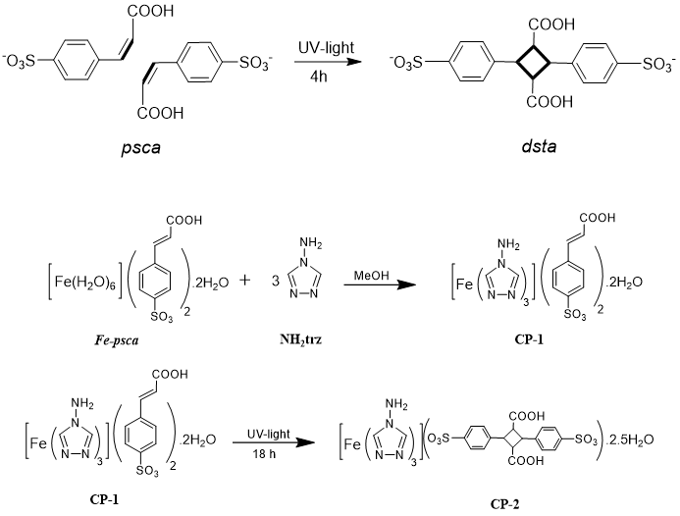

Scheme 1. Molecular representation of CP-1 and CP-2 (bottom) along with [2+2] photodimerization reaction of psca to dsta (top).

In this paper, we present the synthesis and characterization of the coordination polymer, [Fe(NH₂trz)₃](psca)₂·2H₂O (CP-1), which after photodimerization with UV light yields to [Fe(NH₂trz)₃](dsta)·2.5H₂O (CP-2) (Scheme 1). To investigate the irradiation effects on magnetic properties, the two coordination polymers were studied using SQUID magnetometry and ⁵⁷Fe Mössbauer spectroscopy. Diffuse reflectance spectroscopy was used too to study the difference in optical properties of CP-1 and CP-2. A test 1D SCO material, without any photo-switching properties, was also prepared, for comparison purposes.
Results and discussion
CP-1 was synthesized using the conventional approach to obtain Fe^{II} 1D coordination polymers with 1,2,4-triazole ligands (Scheme 1). The Fe^{II} precursor, [Fe(H₂O)₆](psca)₂∙2H₂O was freshly synthesized prior to use because it has the tendency to oxidize over time.³¹ Upon mixing methanolic solutions of precursors, a white precipitate appeared immediately. During the drying process, the precipitate’s colour changes from white to pink due to the absorption of atmospheric H₂O molecules, and replacement of methanol molecules in the crystal lattice. Such solvent exchange is a common observation for Fe^{II} coordination polymers with NH₂trz ligand and aromatic sulfonate anions, which are known to include lattice water molecules on drying in air.⁴¹⁻⁴³ The formula of CP-1 was confirmed by chemical analysis, and FT-IR spectroscopy (Fig. 1), which included major stretching bands of both psca and NH₂trz. Anions are known to stand in between the linear chains formed by triply bridged NH₂trz ligands, as observed on few reported crystal structures of the [M(Rtrz)₃]a.n family, where M = Fe, Cu, a = anion, n = solvent (Scheme S1).⁴⁴⁻⁴⁹ In case of successful photoswitching from psca to dsta, such anion4s may be arranged in a favourable situation, i.e. the distance between the active vinyl bonds shall be less or equal to 4.2 Å and the two bonds should be parallel to each other (Scheme S2).⁵⁰⁻⁵² Because of the poor crystallinity of CP-1 (Fig. S1), psca anions could have however random orientations in the crystal lattice. Considering that molecules can get aligned by applying external stress such as mechanical grinding,^{53,54} we thought to irradiate a grinded sample of CP-1 with UV light for 18 h. Interestingly, after c.a. 12 h of irradiation, colour of the sample started to change from pink to brown gradually (Fig. 3, vide infra). The photo-reaction was continued for 6 more hours until ensuring no further colour change. Such colour change suggests that some certain structural changes occurred upon light irradiation.
IR spectroscopy is known to provide information about [2+2] photodimerization of trans-cinnamic acid by monitoring the C=C stretching band, corresponding to the vinyl bond.⁵⁵ However, in our case the C=N stretching band originating from NH₂trz overlaps with the C=C stretching band at 1639 cm⁻¹. If we compare the IR spectra before and after irradiation (Fig. 1), we notice a slight shift in C=O stretching band which moves to 1701 cm⁻¹, after irradiation. Moreover, some changes in the range 900 - 500 cm⁻¹, were also observed. These changes together with the shift of C=O stretching band indicate that psca underwent photodimerization. PXRD patterns of CP-1 and CP-2, despite their poor crystallinity, is adequate to confirm that a structural change occurred before and after irradiation as suggested by the different 2θ values of the peaks, as seen as low angles (Fig. S1). IR spectra, PXRD patterns combined with the colour change from pink to brown thus suggest that psca successfully underwent photodimerization within CP-1.
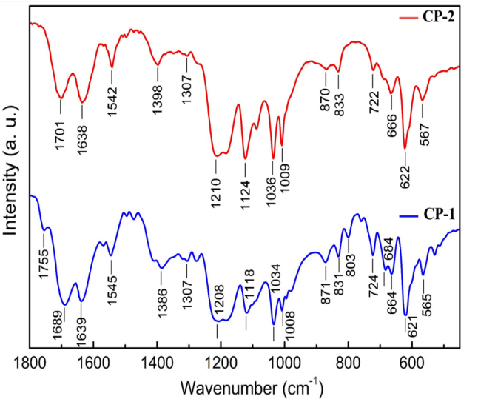

Figure 1. Comparison of IR spectra of CP-1 (before) and CP-2 (after irradiation).
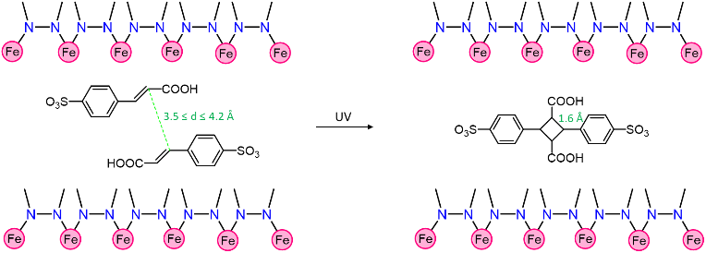
An argument can be made that long hours of UV irradiation (18h) might have caused the decomposition of the NH₂trz ligand in CP-1, which subsequently led to the observed colour change. To check NH₂trz stability, we irradiated the pristine NH₂trz in solid state with UV light for 20 h at room temperature. The irradiation was performed in a closed vial because of the hygroscopic nature of NH₂trz. ¹H NMR spectra did not show any structural changes or any sign of decomposition as all the peaks have same chemical shift values (Fig. S2). Also, the colour of NH₂trz remained untouched after irradiation.

The TGA curves of CP-1 and CP-2 were recorded in air, firstly from 298 K to 408 K at a heating rate of 5 Kmin⁻¹ to determine their water molecules content (Fig. 2). The temperature was lowered back to 298 K at the same scan rate and then kept constant for 60 min at 298 K to verify if any rehydration would occur. From 320 K onwards, CP-1 starts losing mass very rapidly. At 408 K, 4.8% have been lost, which corresponds to the release of two water molecules. During the cooling cycle, a very slight increase in mass was detected. But no further increase in mass was however observed even after letting the sample for 1 h at 298 K. It signifies that CP-1 does not rehydrate once it loses its water molecules. Similarly, CP-2 starts losing mass rapidly from 320 K onwards. However, it loses 5.70% mass as the temperature reaches 408 K, which corresponds to a release of 2.5 water molecules. In contrast to CP-1, a noteworthy increase in mass was observed on cooling, which suggests that CP-2 has the tendency to reabsorb water molecules. Thereafter, the sample was allowed to stand still at 298 K for 1 h. The isotherm measurement revealed that the mass increased by 2.25% compared to the mass at 408 K, corresponding to the reabsorption of one water molecule. The different mass loss and gain behaviour of both coordination polymers supports that their structural arrangement differs, thus leading to different absorption behaviour.
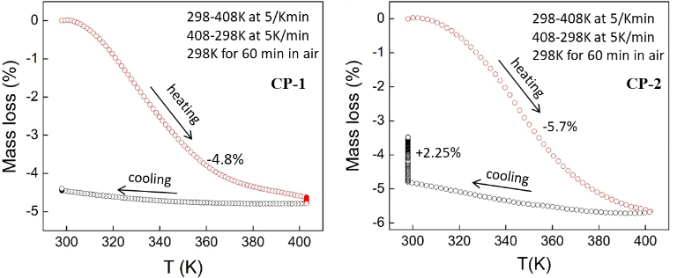

Figure 2 TGA investigation of CP-1 (before) and CP-2 (after irradiation).
Such behaviour can be correlated to the photodimerization of the psca anion, which is believed to stand between 1D chains (Scheme 2). Given that the distance between the two vinyl bonds, which are to be dimerized, should be of the order of 3.5 ≤ d ≤ 4.2 Å,⁵² the two psca molecules in CP-1 should be 3.5 - 4.2 Å apart. Upon dimerization, the two psca molecules move closer to each other in order to form a cyclobutane ring. The typical C-C bond distance in cyclobutene is ca. 1.6 Å,⁵⁶ which implies that the molecules moved by ~ 2.0 Å. As a consequence, more empty space is available in between the 1D chains in CP-2 (Scheme 2), which we believe gets filled up by absorbing more water molecules from the atmosphere. The same reason accounts for the fact that CP-2 reabsorbs water molecules after dehydration in contrast to CP-1.

Scheme 2 Representation of [2+2] photodimerization of psca in CP-1 leading to CP-2.
Room temperature diffuse reflectance spectra of CP-1 (in green) and CP-2 (in red) are shown (Fig. 3) along with spectra of pristine psca and dsta, for reference purposes (Fig. S3). In the spectrum of CP-1, the absorption band at λ_{max} ~ 250 nm corresponds to NH₂trz,⁵⁷ and a shoulder at λ_{max} ~ 308 nm to psca (Fig. S3). A second band was observed at λ_{max} ~ 530 nm, which is attributed to the ¹A_{1g} → ¹T_{1g} transition of LS Fe^{II} ions. A third band of weaker absorption, lies in the near infra-red region at λ_{max} ~ 870 nm and is attributed to the ⁵T_{2g} → ⁵E_{g} transition of HS Fe^{II} HS ions. Thus, diffuse reflectance spectroscopy (DRS) suggests that CP-1 presents a mixed spin state at room temperature with LS sites being the most populated. After UV irradiation, the absorption band in the UV region became broader and the shoulder at λ_{max} ~ 308 nm was red shifted to λ_{max} ~ 342 nm. Such a shift is attributed to the formation of dsta, as observed for the dimerization of pristine psca (Fig. S3). The intensity of the absorption band corresponding to the to ⁵T_{2g} → ⁵E_{g} transition increased after irradiation, which indicates that HS states are more populated after UV irradiation. In contrast, the absorption band in the visible region, assigned to the ¹A_{1g} → ¹T_{1g} transition of LS Fe^{II} sites became broader. Such a broadening is presumably due to the merging of absorption band coming from the brown colour of CP-2. Two important developments were thus inferred from DRS as an effect of UV irradiation; (i) the dimerization of psca as evident by the red shift of absorption band in UV-region, (ii) an increase in Fe^{II} HS sites as suggested by the increase in intensity of the absorption band in near infra-red region.
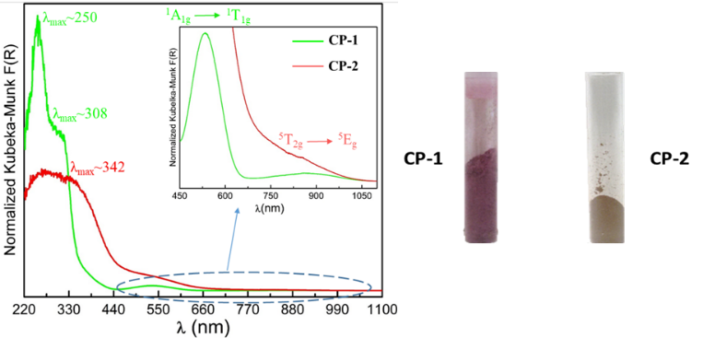

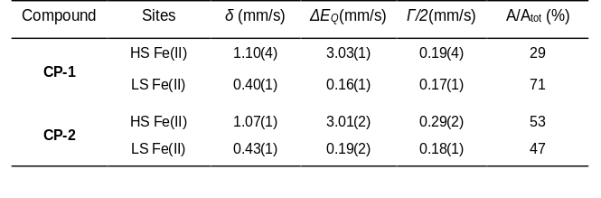

Figure 3. Diffuse reflectance spectra of CP-1 (before) and CP-2 (after irradiation). The inset shows a closer view from 450 nm to ca. 1050 nm (Left). Photographs of CP-1 (before) and CP-2 (after irradiation) (Right).

⁵⁷Fe Mössbauer spectra of CP-1 and CP-2 were recorded at 295 K (Fig. 4). The spectrum of CP-1, shows a major quadrupole doublet (71%) with isomer shift δ = 0.4 mms⁻¹ and quadrupole splitting ΔE_{Q} = 0.16 mms⁻¹ corresponding to LS Fe^{II} ions of [Fe(NH₂trz)₃]²⁺. Such data fit well with the ones obtained for [Fe(NH₂trz)₃](NO₃)₂ which shows a LS doublet at 293 K, with δ = 0.4 mms⁻¹ and ΔE_{Q} = 0.19 mms⁻¹.⁴⁷ Compared to [Fe(NH₂trz)₃](NO₃)₂, another doublet (29%) is observed at δ = 1.10 mms⁻¹ with ΔE_{Q} = 3.03 mms⁻¹. It corresponds to HS Fe^{II} ions with a FeN₆ environment and fits with the isomer shift of δ = 1.07 mms⁻¹ recorded for [Fe(NH₂trz)₃](2ns)₂·2H₂O (2ns = 2-napthalene sulfonate).⁴³ Similarly, the Mössbauer spectrum of CP-2, shows two quadrupole doublets, with similar hyperfine parameters (Table 1). This signifies that the FeN₆ octahedron geometry remains unperturbed upon light irradiation. Most interestingly, the relative intensity of the HS doublet increased with respect to before irradiation spectrum (CP-1), with 53% compared to 29%. Such results fit with DRS results which indicated an increase in HS states.

The temperature dependence of the magnetic properties of CP-1 were first investigated (Fig. 5). At 295 K, χ_{M}T = 0.88 cm³ K mol⁻¹, indicating a mixture of HS and LS states, with dominant LS species as also observed in Mössbauer and Diffuse Reflectance spectroscopies for CP-1. On cooling to 200 K, χ_{M}T decreases suggesting that LS states get more populated at lower temperatures. Upon increasing the temperature up to 400 K, a

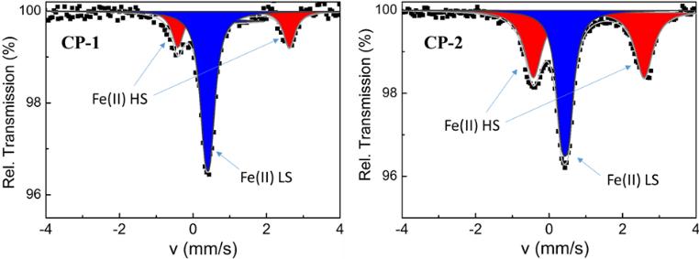

Figure 4. Room temperature ⁵⁷Fe Mössbauer spectra of CP-1 (before) and CP-2 (after irradiation).
Table 1. ⁵⁷Fe Mössbauer parameters for CP-1 and CP-2 at 295 K. Γ/2 = half width of the lines.

continuous rise in χ_{M}T value tells that HS states are more favourable at higher temperatures. A rapid increase in χ_{M}T is observed after 330 K, which corresponds to a loss of water molecules from the sample (Fig. 2). χ_{M}T reaches a maximum value of 3.5 cm³ K mol⁻¹ at 400 K which is typical for a complete LS to HS transition in [Fe(NH₂trz)₃]²⁺ 1D chains.⁴² This temperature actually corresponds to a complete dehydration of CP-1, leading to [Fe(NH₂trz)₃](psca)₂. This new phase reveals a continuous decrease of χ_{M}T on cooling to 200 K, which is attributed to a gradual HS to LS transition. Such SCO behaviour is confirmed by the second and third thermal sequences, on warming and cooling, respectively (Fig. 4). The SCO is in addition found to be incomplete with a χ_{M}T of 1.45 cm³ K mol⁻¹ at 70 K. Such a behaviour may result from the degradation of the H-bonding network in CP-1, after releasing water molecules from the sample,⁴² which in turn leads to a poorly cooperative SCO behaviour. The paramagnetic residue at 70 K may be assigned to lattice defects, as a result of dehydration, or to short 1D chains with coordination of water molecules to Fe^{II} ions at their ends.⁴² The magnetic properties of CP-2, after photo-irradiation, present a different behaviour (Fig. 8). At 295 K , χ_{M}T = 1.86 cm³ K mol⁻¹, which is doubled compared to the value recorded in CP-1. Such a higher χ_{M}T value corresponds to an increase in the HS molar fraction, which matches the observations of both Mössbauer and DRS spectroscopies. On cooling and warming back to 300 K, magnetic properties reveals a gradual SCO behaviour with a drop in χ_{M}T below 40K attributed to zero-field splitting of HS Fe^{II} ions.⁵⁸ On warming further up to 400 K, a smooth rise in χ_{M}T is observed, as result of complete sample dehydration (Fig. 2). The magnetic properties of the new phase [Fe(NH₂trz)₃](dsta)₂, reveal too a gradual SCO behaviour, as seen in the second and third thermal sequences.

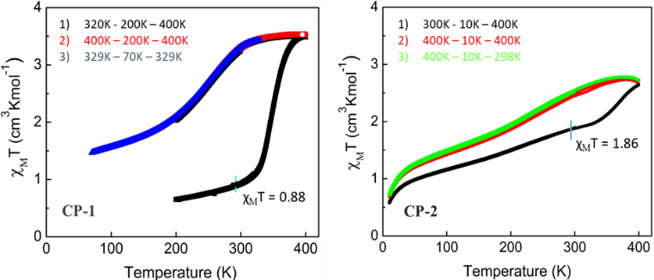

Figure 5. χ_{M}T vs. T plots of CP-1 (before) and CP-2 (after irradiation). Magnetic properties of CP-1 were collected over the sequences: (i) 320 K – 200 K – 400 K – 200 K; (ii) 400 K – 200 K – 400 K; (iii) 329 K – 70 K – 329 K. Those of CP-2 were collected over: (i) 300 K – 10 K – 400 K; (ii) 400 K – 10 K – 400 K; (iii) 400 K – 10 K – 298 K.
Water molecules are well known to influence SCO behaviour in Fe^{II} 1D 1,2,4-triazole chains by favouring the LS state, i.e. the more the number of water molecules, the more the LS state is populated.20 However, in our case the trend is opposite, i.e. in going from CP-1 to CP-2, an increase in 1/2 molecule of H₂O occurred along with an increase in HS fraction. If the change in spin state in our case were a solvent effect, an increase in LS fraction would have occurred according to the usual water molecules and spin state relationship. To provide additional proof in support of light induced SCO, the χ_{M}T vs. T plots of CP-1 and CP-2 during the first cooling cycle from 300 – 200 K were compared (Fig. S4). We chose the first cooling cycle because H₂O molecules during this sequence are still intact with CP-1 and CP-2. As it is quite evident in Fig. S4 that CP-2 not only has higher HS fraction at room temperature but also at lower temperatures. χ_{M}T vs. T plots for dehydrated coordination polymers, CP-1 and CP-2 along with ΔT₈₀ calculation are shown in Fig. S5. ΔT₈₀ is the temperature range in which 80% of the active Fe^{II} ions undergo SCO, and it presents a good technical measure for distinguishing between gradual SCO behaviours.^{59,60} ΔT₈₀ values for dehydrated forms of CP-1 and CP-2 are found to be 162 K and 249 K, respectively and confirm that dehydrated CP-1 and CP-2 show different SCO behaviours. These differences thus support a spin state switching induced by light irradiation.
One may argue that UV irradiation may be affecting the coordination network of [Fe(NH₂trz)₃]²⁺, which would cause the change in the spin state properties of Fe^{II} ions, upon irradiation. In our opinion, this is highly unlikely because such a network is known to be non-responsive upon UV-irradiation, although visible irradiation has proven to yield to the LIESST effect at low temperatures.^{10,25,61} To prove it, we have synthesized the same material holding a non-responsive sulfonate counteranion: tos = p-toluene sulfonate.⁶² [Fe(NH₂trz)₃](tos)₂·H₂O was irradiated for the same period as CP-1 (20 h) at room temperature. The colour of the material remained unchanged (pink) throughout the reaction (Fig. S6), and the number of water molecules did not vary (Fig. S7). ⁵⁷Fe Mössbauer spectroscopy was also used to observe the change in spin properties of [Fe(NH₂trz)₃](tos)₂·H₂O before and after irradiation (Fig. S8). This is noteworthy here that since tos is not a photo-responsive anion, hence any changes in the spin state population after UV irradiation would only originate from the coordination network [Fe(NH₂trz)₃]²⁺ itself. Before irradiation, a major quadrupole doublet is observed with δ = 0.44 mms⁻¹, ΔE_{Q} = 0.21 mms⁻¹, corresponding to LS Fe^{II} ions, along with a minor doublet with δ = 1.05 mms⁻¹ and ΔE_{Q} = 2.79 mms⁻¹, with a HS/LS population of 11/89. After irradiation, this ration was not altered, and no change were observed in the hyperfine parameters (Table S1).

Conclusions
In summary, a coordination polymer [Fe(NH₂trz)₃](psca)₂·2H₂O (CP-1) holding a photo-responsive psca anion was successfully synthesized. This compound exists under a mix spin state situation, low-spin sites being the dominating species at room temperature, as confirmed by ⁵⁷Fe Mössbauer, diffuse reflectance spectroscopies and magnetic susceptibility measurements. Under UV light irradiation, photodimerization of psca takes place to yield to the photoproduct [Fe(NH₂trz)₃](dsta)₂·2.5H₂O (CP-2), which is accompanied by a colour change from pink to brown at room temperature. In addition, an increase in the HS fraction was observed, along with a modification of the magnetic properties, as a result of a Anion-Driven Light Induced Spin state Change (AD-LISC), which is observed for the first time. This effect, although partially observed on CP-1 is ground breaking, given it was realized under ambient conditions and in the solid state, which is a good feat from an application point of view. It also offers perspectives compared to the GD-LISC effect,³⁰ for which the concentration of photo-responsive molecules is random, limited to porous crystal lattices, and which has not yet been observed at room temperature. Such result opens up a gateway for the design of new type of light-induced spin crossover systems, and further remote spin state switching control.

Conflicts of interest
There are no conflicts to declare.

Acknowledgements
This work was supported through the Fonds De La Recherche Scientifique—FNRS (PDR T.0095.21) the Ministère de l’Education et de la Recherche de Roumanie, WBI Roumanie, CCCDI-UEFISCDI (PN-III-CEI-BIM-PBE-2020-0042/8BM/2021).
Notes and References

† Dedicated to the memory of Prof. Gerard Sliwinski.

1. P. Gütlich, Y. Garcia and H. A. Goodwin, Chem. Soc. Rev., 2000, 29, 419–427.
2. P. Gütlich, A. B. Gaspar and Y. Garcia, Beilstein J. Org. Chem., 2013, 9, 342–391.
3. M. Khunisyarov, Chem. Eur. J., 2016, 22, 15178-15191.
4. Photomagnetism of Molecular Systems, P. Gütlich and Y. Garcia, Reference Module in Materials Science and Materials Engineering, ed. S. Hashmi, Oxford, Elsevier, 2016, pp. 1–5.
5. O. Kahn, J. Kröber and C. Jay, Adv. Mater., 1992, 4, 718–728.
6. L. Kipgen, M. Bernien, F. Tuczek and W. Kuch, Adv. Mater., 2021, 33, 2008141.
7. K. S. Kumar and M. Ruben, Coord. Chem. Rev., 2017, 346, 176-205.
8. G. Molnar, S. Rat, L. Salmon, W. Nicolazzi and A. Bousseksou, Adv. Mater., 2018, 30, 1703862.
9. C. Lefter, V. Davesne, L. Salmon, G. Molnár, P. Demont, A. Rotaru and A. Bousseksou, Magnetochemistry, 2016, 2, 18-26.
10. Y. Garcia, V. Ksenofontov and P. Gütlich, Hyperfine Interact., 2002, 139/140, 543–551.
11. J. Linares, E. Codjovi and Y. Garcia, Sensors, 2012, 12, 4479–4492.
12. C. M. Jureschi, J. Linares, A. Rotaru, M. H. Ritti, M. Parlier, M. M. Dîrtu, M. J. Wolff and Y. Garcia, Sensors, 2015, 15, 2388–2398.
13. Y. Guo, S. Xue, M. M. Dîrtu and Y. Garcia, J. Mater. Chem. C, 2018, 6, 3895-3900.
14. L. Sun, A. Rotaru, K. Robeyns and Y. Garcia, Ind. Eng. Chem. Res., 2021, 60, 8788–8798.
15. W. Li, L. Sun and Y. Garcia, Hyperfine Interact., 2021, 242, 7.
16. W. Li, L. Sun, C. Liu, A. Rotaru, K. Robeyns, M. Singleton and Y. Garcia, J. Mater. Chem. C, 2022, doi.org/10.1039/D2TC01655A
17. S. Decurtins, P. Gütlich, C.P. Kohler, H. Spiering and A. Hauser, Chem. Phys. Lett., 1984, 105, 1-4.
18. M. Nakaya, R. Ohtani, L. F. Lindoy and S. Hayami, Inorg. Chem. Front., 2021, 8, 484-498.
19. M.-L. Boillot, C. Roux, J. -P.Audière, A. Dausse and J. Zarembowitch, Inorg. Chem., 1996, 35, 3975–3980.
20. P. Gütlich, Y. Garcia and Th. Woike, Coord. Chem. Rev., 2001, 219-221, 839-879.
21. M. -L. Boillot, J. Zarembowitch and A. Sour, Top. Curr. Chem., 2004, 234, 261-276.
22. Y. Garcia, V. Ksenofontov, R. Lapouyade, A. D. Naik, F. Robert and P. Gütlich, Opt. Mater., 2011, 33, 942-948
23. B. Rösner, M. Milek, A. Witt, B. Gobaut, P. Torelli, R. H. Fink, and M. M. Khusniyarov, Angew. Chem., Int. Ed., 2015, 54, 12976 –12980.
24. L.-F. Wang, W. -M. Zhuang , G.-Z. Huang, Y.-C. Chen, J.-Z. Qiu, Z.-P. Ni and M.-L. Tong, Chem. Sci., 2019, 10, 7496-7502.
25. D. Unruh, P. Homenya, M. Kumar, R. Sindelar, Y. Garcia and F. Renz, Dalton Trans., 2016, 45, 14008.
26. B. Brachňaková and I. Šalitroš, Chem. Papers, 2018, 72, 773-798.
27. V. García-López, M. Palacios-Corella, S. Cardona-Serra, M. Clemente-León and E. Coronado, Chem. Commun., 2019, 55, 12227-12230.
28. K. Takahashi, Y. Hasegawa, R. Sakamoto, M. Nishikawa, S. Kume, E. Nishibor and H. Nishihara, Inorg. Chem., 2012, 51, 5188–5198.
29. M. Estrader, J. Salinas Uber, L. A. Barrios, J. Garcia, P. Lloyd-Williams, O. Roubeau, S. J. Teat and G. Aromí, Angew. Chem. Int. Ed., 2017, 56, 15622-15627.

30. K.-P. Xie, Z.-Y. Ruan, B.-H. Lyu, X.-X. Chen, X. W. Zhang, G. -Z. Huang, Y. -C. Chen, Z. -P. Ni and M.-L. Tong, Angew. Chem., Int. Ed., 2021, 60, 27144.
31. V. Kumar, L. Fusaro, C. Aprile, K. Robeyns and Y. Garcia, Cryst. Growth Des., 2020, 20, 7850-7861.
32. G. Chastanet, M. Lorenc, R. Bertoni and C. Desplanches, C. R. Chimie, 2018, 21, 1075-1094.
33. M. M. Dîrtu, A. Rotaru, D. Gillard, J. Linares, E. Codjovi, B. Tinant and Yann Garcia, Inorg. Chem., 2009, 48, 7838–7852.
34. M. M. Dîrtu, A. D. Naik, A. Rotaru, L. Spinu, D. Poelman and Y. Garcia, Inorg. Chem., 2016, 55, 4278–4295.
35. F. Robert, A. D. Naik, B. Tinant and Y. Garcia, Inorg. Chim. Acta, 2012, 380, 104-113.
36. A. Michalowicz, J. Moscovici, B. Ducourant, D. Cracco and O. Kahn, Chem. Mater., 1995, 7. 1833-1842.
37. A. Michalowicz, J. Moscovici, Y. Garcia and O. Kahn, J. Synchr. Rad., 1999, 6, 231-232.
38. Y. Garcia, J. Moscovici, A. Michalowicz, V. Ksenofontov, G. Levchenko, G. Bravic, D. Chasseau and P. Gütlich, Chem. Eur. J., 2002, 8, 4992-5000.
39. M. Seredyuk, A. B. Gaspar, V. Ksenofontov, Y. Galyametdinov, M. Verdaguer, F. Villain and P. Gütlich, Inorg. Chem., 2008, 47, 10232-10245.
40. A. Grosjean, P. Négrier, P. Bordet, C. Etrillard, D. Mondieig, S. Pechev, E. Lebraud, J. -F. Létard and P. Guionneau, Eur. J. Inorg. Chem., 2013, 796-802.
41. Y. Garcia, P. J. van Koningsbruggen, E. Codjovi, R. Lapouyade, O. Kahn and L. Rabardel, J. Mater. Chem., 1997, 7, 857-858.
42. Y. Garcia, P. J. van Koningsbruggen, R. Lapouyade, L. Fournés, L. Rabardel, O Kahn, V. Ksenofontov, G. Levchenko, and P. Gütlich, Chem. Mater., 1998, 10, 2426-2433.
43. P. J. Koningsbruggen, Y. Garcia, E. Codjovi, R. Lapouyade, O. Kahn, L. Fournès and L. Rabardel, J. Mater. Chem. 1997, 7, 2069–2075.
44. Y. Garcia, P. J. van Koningsbruggen, G. Bravic, P. Guionneau, D. Chasseau, G. L. Cascarano, J. Moscovici, K. Lambert, A. Michalowicz and O. Kahn, Inorg. Chem., 1997, 36, 6357-6365.
45. Y. Garcia, P. J. van Koningsbruggen, G. Bravic, D. Chasseau and O. Kahn, Eur. J. Inorg. Chem., 2003, 356-362.
46. M. Seredyuk, A. B. Gaspar, M. C. Muñoz, M. Verdaguer, F. Villain and P. Gütlich, Eur. J. Inorg. Chem., 2007, 4481–4491.
47. M. M. Dîrtu, C. Neuhausen, A. D. Naik, A. Rotaru, L. Spinu and Y. Garcia, Inorg. Chem., 2010, 49, 5723-5736.
48. A. Grosjean, N. Daro, B. Kauffmann, A. Kaiba, J.-F. Létard and P. Guionneau, Chem. Commun., 2011, 47, 12382-12384.
49. N. Pittala, F. Thétiot, S. Triki, K. Boukheddaden, G. Chastanet and M. Marchivie, Chem. Mater., 2017, 29, 490−494.
50. M. D. Cohen, G. M. J. Schmidt and F. I. Sonntag, Topochemistry. Part II. The photochemistry of trans-cinnamic acids, J. Chem. Soc., 1964, 2000-2013.
51. G. M. J. Schmidt, Topochemistry. Part III. The crystal chemistry of some trans-cinnamic acids, J. Chem. Soc., 1964, 2014-2021.
52. G. M. J. Schmidt, Pure Applied Chem., 1971, 27, 647-678.
53. S. d’Agostino, P. Taddei, E. Boanini, D. Braga and F. Grepioni, Cryst. Growth Des., 2017, 17, 4491−4495.
54. B. B. Rath, G. K. Kole, S. A. Morris and J. J. Vittal, Chem. Commun., 2020, 56, 6289-6292.
55. S. D.M. Atkinson, M. J. Almond, P. Hollins, S. L. Jenkins, Spectrochimica Acta Part A, 2003, 59, 629-635.
56. J. D. Dunitz and V. Schomaker, J. Chem. Phys., 1952, 20, 1703-1707.
57. A. M. Lynch, S. A. Robinson, P. Wilcox, M. D. Smith, M. Kleinman, K. Jiang and R. W. Rees, Mutagenesis, 2008, 23, 111–118.
58. Y. Garcia, C. M. Grunert, S. Reiman, O. van Campenhoudt and P. Gütlich, Eur. J. Inorg. Chem., 2006, 3333-3339.
59. Y. Garcia, P. Guionneau, G. Bravic, D. Chasseau, J. A. K. Howard, O. Kahn, V. Ksenofontov, S. Reiman and P. Gütlich, Eur. J. Inorg. Chem., 2000, 1531-1538.
60. M. Thomann, O. Kahn, J. Guilhem and F. Varret, Inorg. Chem., 1994, 33, 6029-6037.
61. Y. Garcia, F. Renz and P. Gütlich, Curr. Inorg. Chem., 2016, 6, 4-9.
62. E. Codjovi, L. Sommier, O. Kahn and C. Jay, New. J. Chem., 1996, 20, 503-505.

