A Novel Approach to pH-Responsive Targeted Cancer Therapy: Inhibition of FaDu Cancer Cell Proliferation with a pH Low Insertion Peptide-Conjugated DGAT1 Inhibitor
Marine Deskeuvre^{1,2}, Junjie Lan³, Joris Messens ^{4,5,6}, Olivier Riant³, Olivier Feron^{2,7,§} and Raphaël Frédérick^{1,§,*}
¹Louvain Drug Research Institute (LDRI), Medicinal Chemistry Research Group (CMFA), Université Catholique de Louvain (UCLouvain), 73 Avenue Emmanuel Mounier, B-1200 Brussel, Belgium
²Pole of Pharmacology and Therapeutics (FATH), Institut de Recherche Expérimentale et Clinique (IREC), Université Catholique de Louvain (UCLouvain), 57 Avenue Hippocrate B1.57.04, B-1200 Brussels, Belgium
³Institute of Condensed Matter and Nanosciences, MOST Division, Place Louis Pasteur, Université Catholique de Louvain (UCLouvain), Louvain-la-Neuve B-1348, Belgium
⁴ VIB-VUB Center for Structural Biology, Vlaams Instituut voor Biotechnologie (VIB), 1050 Brussels, Belgium
⁵Brussels Center for Redox Biology, 1050 Brussels, Belgium
⁶Structural Biology Brussels, Vrije Universiteit Brussel (VUB), 1050 Brussels, Belgium
⁷Walloon Excellence in Life Sciences and BIOtechnology (WELBIO) department, WEL Research Institute, B-1300 Wavre, Belgium.

§these authors co-supervised the work.
*corresponding author: raphael.frederick@uclouvain.be

Abstract:
Targeting enzymes involved in lipid metabolism is increasingly recognized as a promising anticancer strategy. Efficient inhibition of diacylglycerol O-transferase 1 (DGAT1) can block fatty acid (FA) storage. This, in turn, triggers an increase in free polyunsaturated FA concentration, leading to peroxidation and ferroptosis. In this study, we report the development of a pH-sensitive peptide (pHLIP)-drug conjugate designed to selectively deliver DGAT1 inhibitors to cancer cells nested within the acidic microenvironment of tumors. We utilized two previously established pHLIP sequences for coupling with drugs. The study of DGAT1 conjugates in large unilamellar vesicles (LUVs) of different compositions did not reveal enhanced pH-dependent insertion compared to POPC LUVs. However, using in vitro 3D tumor spheroids, significant antiproliferative effects were observed upon exposure to pHLIP-T863 (DGAT1 inhibitor) conjugates, surpassing the inhibitory activity of T863 alone. In conclusion, our study provides the first evidence that pHLIP-based conjugates with DGAT1 inhibitors have the potential to specifically target the acidic compartment of tumors. Moreover, it sheds light on the limitations of LUV models in capturing the pH-dependency of such conjugates.
Keywords: pH Low Insertion Peptides, T863, A922500, conjugates, cancer, acidosis, drug delivery
Abbreviations: BSA, bovine serum albumin; CD, circular dichroism; chol, cholesterol; DGAT1, Diacylglycerol O-acyltransferase 1; DHA, docosahexaenoic acid; DIAD, diisopropyl azodicarboxylate; DIPEA, N-N-diisopropylethylamine; DMAP, 4-dimethylaminopyridine; EDCI, 1-ethyl-3-(3-dimethylaminopropyl)carbodiimide; ESI, electrospray ionization; FA, fatty acids; HOBt, 1-hydroxybenzotriazole hydrate; HPLC, high-performance liquid chromatography; IC₅₀: half maximal inhibitory concentration; LUVs, large unilamellar vesicles; MMA, monomethyl auristatin; MS, mass spectrometry; NMR, nuclear magnetic resonance; pHLIP, pH Low Insertion Peptide; POPC, 1-palmitoyl-2-oleoyl-sn-glycero-3-phosphocholine; POPE, 1-palmitoyl-2-oleoyl-sn-glycero-3-phosphoethanolamine; POPS, 1-palmitoyl-2-oleoyl-sn-glycero-3-phospho-L-serine; PSA, polar surface area; SM, spectral maximum; SSF, steady-state fluorescence; T_{1/2}: half-life time; TG: triglyceride.

1 Introduction
Acidosis, like hypoxia, is a prevalent characteristic of solid tumor microenvironment (Corbet and Feron 2017b, Pillai et al. 2019). Today it is well acknowledged that acidosis plays a significant role in the inception and advancement of tumors. Additionally, it contributes to drug resistance and the dissemination of metastases. These effects stem from various changes in the phenotype of cancer cells exposed to extracellular acidosis. These alterations encompass evading apoptosis, eluding immune surveillance, initiating (epi)genetic reprogramming, displaying reduced proliferation or entering a quiescent state, undergoing epithelial-to-mesenchymal transition, and experiencing disrupted metabolism (Peppicelli et al. 2017, Vander Linden and Corbet 2019). Notably, acidic cancer cells become less dependent on glucose to support their metabolic needs but instead preferentially use lipids (Corbet and Feron 2017a). We have previously shown that acidic cancer cells actually become so addicted to fatty acids that their uptake ends up exceeding their needs, and storage of excess fatty acids as triglycerides (TG) is then required to prevent lipotoxicity and ferroptosis (Corbet et al. 2020, Dierge et al. 2021). More generally, TG storage into lipid droplets is increasingly described as a safeguard mechanism to maintain cancer cell viability and proliferation (Du et al. 2017, Hoy et al. 2017). Consequently, targeting the synthesis and accumulation of TGs is emerging as a potential therapeutic avenue to treat cancers.
Diacylglycerol O-acyltransferase 1 (DGAT1) constitutes one of the two enzymes responsible for catalyzing the synthesis of TGs in the human body (Cases et al. 1998). Its function involves the esterification of diacylglycerol (DAG) using acyl-CoA, producing TGs within the endoplasmic reticulum (ER). In human physiology, this enzymatic reaction holds significance for storing metabolic energy, particularly in organs like the intestine, liver, and adipose tissue (Yen et al. 2008). Furthermore, DGAT1 assumes a role in safeguarding the endoplasmic reticulum from the buildup of bioactive lipids stemming from an excess of fatty acids (Chitraju et al. 2017). Clinical trials for diabetes or heart failure conditions have revealed that DGAT1 inhibitors can induce gastrointestinal side effects in a dose-dependent manner, which curtails their use for managing long-term metabolic ailments (Denison et al. 2014). Nevertheless, investigations involving these inhibitors in animal models propose a potential therapeutic role in treating cancers characterized by disrupted TG metabolism, such as glioblastoma (Cheng et al. 2020) and prostate (Nardi et al. 2019) cancers.
pH Low Insertion Peptides (pHLIP) are a unique peptide class that has garnered significant attention in biophysics and biomedical research. These peptides are water-soluble at neutral pH but undergo a conformational change and spontaneously insert into lipid bilayers when exposed to mildly acidic environments, such as those found in tumor tissues (Reshetnyak et al. 2006, Andreev et al. 2007, Reshetnyak et al. 2007, Vavere et al. 2009). The mechanism behind pHLIP insertion involves the transformation of the peptide from a water-soluble state to a transmembrane α-helical structure. At neutral pH, pHLIPs adopt a coil-like conformation, which becomes an α-helix upon insertion into the lipid bilayer under acidic conditions. The binding of peptides of the pHLIP family with the lipid bilayer of the membrane is predominantly driven by hydrophobic interactions since pHLIPs are moderately hydrophobic peptides. In cancer research, pHLIPs have been used to deliver drugs selectively to acidic tumor environments, potentially reducing off-target effects and enhancing therapeutic efficacy (An et al. 2010, Wijesinghe et al. 2011, Moshnikova et al. 2013, Burns et al. 2015, Song et al. 2016, Burns et al. 2017, Gayle et al. 2021).
In this study, we explore the conjugation of two DGAT1 inhibitors to pHLIPs. Our investigation includes assessing the integration of these conjugates into lipid bilayers of varying compositions, using steady-state fluorescence (SSF). Additionally, we utilize circular dichroism spectroscopy (CD) to analyze their structural conformation. Furthermore, we evaluate the conjugates' capacity to influence cancer cell growth within 3D tumor spheroid models mimicking the spontaneous development of a pH gradient.
2 Material and methods

2.1 Chemistry

2.1.1 Chemical and reagents
Unless otherwise mentioned, all chemical reagents were purchased from various commercial sources (Merck/Sigma, TCI, Acros, FluoroChem, VWR) and used without further purification. All solvents were dried from Na or CaH2 and purified by distillation before being used. Thin layer chromatography was performed on prepared thin layers of precoated plates: Silica gel Merck 60 F254. Column chromatography was performed over ROCC Silica gel 60 (40-63 µm). The visualization of spots on TLC plates was done by UV light (254 nm or 365 nm) or KMnO4 solution staining. Compounds were characterized using 1H and 13C NMR, recorded on a 300 Hz or a 400 Hz Bruker Avance UltraShield instrument, and their spectra were analyzed using MestraNova software. NMR analyses were performed on either CDCl3, DMSO-d6, or MeOD, all purchased from Eurisotop. Chemical shifts (δ) are in parts per million (ppm), and coupling constants (J) are in hertz (Hz). Standard abbreviations indicating multiplicity were used as follows: s = singlet, d = doublet, t = triplet, dd = double doublet m = multiplet, q = quartet. Melting ranges were determined using an electrothermal IA9000 apparatus and were reported uncorrected. LC-MS analyses were performed on an Agilent 6200 series TOF mass spectrometer equipped with ESI and API as ionization sources and TOF (Time of Flight) detector, coupled with an Agilent 1200 series LC system with a flux of 0.25 mL/min. A C18 “brand” column was used. Water (A) and ACN (B) were used as eluents. Both were prepared to contain a final concentration of 0.1% of trifluoroacetic acid (TFA). The wavelength for UV detection was 210 nm. High-resolution mass spectra were carried on a Thermo Fisher Scientific LQT-Orbitrap XL hybrid mass spectrometer(Thermo Fisher Scientific, Bremen, Germany). The following compounds were synthesized by Dr. Junjie Lan of Olivier Riant's laboratory: 2, 4, 6, 7, 8, 9, 10, and 24. 1H-NMR, 13C-NMR, and HRMS analysis of compounds 24, and 25 are shown in the Supporting information section. The synthesis of compounds (3-5, 13-20) and compounds (7-10) were developed by Abbott Laboratories ® (Ravn et al. 2010, Yeh et al. 2012) and Japan Tobacco Inc®(Fox et al. 2014), respectively.

2.1.2 Ethyl 2-(4-phenylcyclohexylidene)acetate (3)
To a solution of sodium hydride NaH (60% wt in mineral oil, 1.6 g, 36.16 mmol, 1.1 eq) was added in portions a solution of triethyl phosphonoacetate 2 (7.6 mL, 36.16 mmol, 1.1 eq) in THF (25.0 mL) at 0°C. The mixture was stirred at room temperature for 30 min before adding dropwise a solution of 4-phenylcyclohexanone 1 (6.0 g, 34.43 mmol, 1.0 eq) in THF (8.0 mL). After 30 minutes at room temperature, the reaction mixture was poured into 5% KHSO₄ and extracted with Et₂O. The organic layer was washed with water, and brine, dried over anhydrous MgSO₄, filtered, and concentrated in vacuo. The residue was purified by silica gel column chromatography (PE/EtOAc: 100/1) to give the compound ethyl 2-(4-phenylcyclohexylidene) acetate as a colorless oil (7.5 g, 30.7 mmol, 85%).
Chemical Formula: C₁₆H₂₀O_{2,} Molecular weight: 244.3340 g/mol
¹H NMR (300 MHz, CDCl₃, δ ppm): 7.20-7.16 (m, 5H), 5.68 (s, 1H), 4.12 (q, J = 6.0 Hz, 4H), 2.78 - 2.68 (m, 1H), 2.43 - 2.29 (m, 2H), 2.10 - 2.06 (m, 2H), 1.72 - 1.54 (m, 2H), 1.29 (t, J = 6.0 Hz, 3H).
¹³C NMR (75 MHz, CDCl₃, δ ppm): 166.70, 161.78, 146.00, 128.46, 126.79, 126.23, 113.81, 59.58, 44.10, 37.72, 35.62, 34.83, 29.77, 29.47, 14.38.

2.1.3 trans Ethyl 2-(4-phenylcyclohexyl)acetate (5)
To a solution of ethyl 2-(4-phenylcyclohexylidene)acetate 3 (6.0 g, 24.56 mmol, 1 eq) in EtOH (50.0mL) was added 10% Pd/C (0.6 g). The reaction mixture was stirred at room temperature for 3 h under an atmospheric pressure of hydrogen. Then, the catalyst was removed by filtration and the filtrate was concentrated in vacuo to give a colorless oil corresponding to a mixture of cis and trans isomer (trans/cis 2.8/1) of ethyl 2-(4-phenylcyclohexyl) acetate 4 (5.9 g, 23.95 mmol, 97%). The trans version was isolated following a procedure previously reported by Vince S. C. Yeh at al. (Yeh et al. 2012) After the dissolution of the crude (15.0 g, 60.89 mmol) in EtOH, an aqueous solution of LiOH (10.0 g in 50 mL water) was added, and the resulting reaction mixture was warmed to 50°C. After 1 hour, the trans Li-carboxylate crystallized as a thick slurry, and additional water was added to facilitate mixing, which continued at 50° for an additional 6 hours. After cooling to room temperature, the trans Li salt was collected by filtration and washed with aqueous 5% LiOH (2 x 30 mL). The wet cake was partitioned between EtOAc (100 mL) and 6 M HCl (50 mL), and the suspension was mixed until all solids were dissolved. After the separation of the layers, the organic layer was concentrated under reduced pressure, and the residue was treated with EtOH, which was then removed in the same manner, to give the trans 2-(4-phenylcyclohexyl)acetic acid as a white solid, directly used to the next step. The residue was dissolved in EtOH (100 mL) and H₂SO₄ (0.3 mL) was added. The reaction mixture was heated to reflux and mixed for 18 h. After cooling the temperature to room temperature, the solvent was removed under reduced pressure to a volume of approximately 10 mL. Next, water and EtOAc were added, the layers were separated, and the organic layer was washed with saturated aqueous NaHCO₃ and brine, dried over anhydrous MgSO₄, filtered, and concentrated in vacuo. The residue was purified by silica gel column chromatography (PE/EtOAc: 50/1-20/1) to give the compound trans ethyl 2-(4-phenylcyclohexylidene) acetate 5 as a colorless oil (4.9 g, 1.99 mmol, 33%, trans/cis 100:7).
Chemical Formula: C₁₆H₂₂O_{2,} Molecular weight: 246.35 g/mol
¹H NMR (300 MHz, CDCl₃, δ ppm): 7.34-7.17 (m, 5H), 4.16 (q, J = 6.0 Hz, 4H), 2.54 - 2.44 (m, 1H), 2.24 (d, J = 6.0 Hz, 2H), 1.94 – 1.81 (m, 2H), 1.59 – 1.44 (m, 2H), 1.72 - 1.54 (m, 2H), 1.27 (t, J = 6.0 Hz, 3H), 1.18 - 1.13 (m, 2H).
¹³C NMR (75 MHz, CDCl₃, δ ppm): 173.06, 147.33, 128.32, 126.80, 125.92, 60.19, 44.09, 42.09, 34.59, 33.90, 33.22, 14.32.

2.1.4 trans Ethyl 2-(4-(4-(2-bromo-2-methylpropanoyl)phenyl)cyclohexyl)acetate (7)
To a solution of trans ethyl 2-(4-phenylcyclohexylidene) acetate 5 (3.0 g, 12.18 mmol, 1 eq) in DCM was added in portion anhydrous AlCl₃ (4.87 g, 36.53 mmol, 3 eq) at 0°C followed by dropwise addition of 2-bromo-2-methylpropanoyl bromide 6 (1.6 mL, 13.40 mmol, 1.1 eq). The mixture was stirred for 1.5 h at 0°C and then poured into ice water and extracted with DCM. The combined organic layers were washed with saturated aq NaHCO₃ and brine, dried over anhydrous MgSO₄, filtered, and concentrated in vaccuo. The residue was purified by silica gel column chromatography (PE/EtOAc: 50/1-20/1) to give the compound trans ethyl 2-(4-(4-(2-bromo-2-methylpropanoyl)phenyl)cyclohexyl) acetate 7 as a light yellow oil (3.7g, 9.36 mmol, 77%).
Chemical Formula: C₂₀H₂₇BrO_{3,} Molecular weight: 395.34 g/mol
¹H NMR (300 MHz, CDCl₃, δ ppm): 8.10 (dd, J=3.0 Hz, J=6.0 Hz, 2H), 7.27 (dd, J=3.0 Hz, J=6.0 Hz, 2H), 4.15 (q, J = 6.0 Hz, 2H), 2.57 - 2.49 (m, 1H), 2.24 (d, J = 9.0 Hz, 2H), 2.03 (s, 6H), 1.93 – 1.84 (m, 5H), 1.59 – 1.46 (m, 2H), 1.72 - 1.54 (m, 2H), 1.27 (t, J = 6.0 Hz, 3H), 1.19 - 1.14 (m, 2H).
¹³C NMR (75 MHz, CDCl₃, δ ppm): 196.25, 172.98, 152.38, 132.34, 130.55, 126.61, 60.24, 44.11, 41.98, 34,46, 33.53, 33.00, 31.70, 14.32.

2.1.5 trans-Ethyl 2-(4-(4-(4-amino-7,7-dimethyl-7H-pyrimido[4,5-b] [1,4]oxazin-6-yl) phenyl) cyclohexyl)acetate (9)
To a solution of 4,5-6, diaminopyrimidine-4(1H)-one 9 (0.16 g, 1.26 mmol, 0.5 eq) was added trans ethyl 2-(4-(4-(2-bromo-2-methylpropanoyl)phenyl)cyclohexyl)acetate (1.0 g, 2.53 mmol, 1 eq) and 1 M HCl (1.26 mL, 1.26 mmol, 0.5 eq) in 50% aqueous EtOH. The mixture was heated at reflux for 18 h. After cooling to room temperature, the mixture was concentrated to half volume, diluted with Et₂O, washed 1 M NaOH three times and brine, dried over anhydrous MgSO₄, and concentrated in vacuo. The residue was purified by silica gel column chromatography (DCM/ MeOH: 50/1) to give the compound trans ethyl 2-(4-4-(4-amino-7,7-dimethyl-7H-pyrimid[4,5-b][1,4]oxazin-6-yl)phenyl)cyclohexyl)acetate 9 as a light yellow solid (0.22 g, 0.52 mmol, 21%).
Chemical Formula: C₂₄H₃₀N₄O_{3,} Molecular weight: 422.53 g/mol
HRMS ESI: Calculated for C₂₄H₃₀N₄O₃ [M+H]⁺: 423.2390, found: 423.2390.
¹H NMR (300 MHz, CDCl₃, δ ppm): 8.12 (s,1H), 7.56 (d, J= 9.0 Hz, 2H), 7.25 (dd, J=3.0 Hz, J=6.0 Hz, 2H), 5.59 (s, 2H), 4.13 (q, J = 7.20 Hz, 2H), 2.56 - 2.48 (m, 1H), 2.24 (d, J = 6.8 Hz, 2H), 1.89 – 1.80 (m, 5H),1.69 (s, 6H), 1.59 – 1.43 (m, 2H), 1.27 (t, J = 6.0 Hz, 3H), 1.21 - 1.13 (m, 2H).
¹³C NMR (75 MHz, CDCl₃, δ ppm): 158.91,149.86,147.04, 137.20, 133.33, 126.46,121.18, 120.33, 115.82, 115.16, 66.29, 45.84, 36.64, 8.63.

2.1.6 trans-2-(4-(4-(4-amino-7,7-dimethyl-7H-pyrimido[4,5,b][1,4]oxazin-6-yl)phenylcyclohexyl)acetic acid (10)
To the solution of trans ethyl 2-(4-(4-(4-amino-7,7-dimethyl-7H-pyrimido[4,5-b][1,4]oxazin-6-yl)phenyl)cyclohexyl)acetate 9 (400 mg, 0.946 mmol, 1 eq) in EtOH and THF (v/v=6/4) was treated with 1 M NaOH in aqueous EtOH (EtOH/H₂O 90/10) at 50°C for 1 h. After this time, the solution was cooled to room temperature, and the volume was lowered under reduced pressure. The residue was dissolved in aqueous saturated NH₄Cl and the mixture was extracted with DCM, and concentrated under reduced pressure. The residue was purified by silica gel column chromatography (DCM/MeOH: 50/1-30/1) to give the trans-2-(4-(4-(4-amino-7,7-dimethyl-7H-pyrimido[4,5,b][1,4]oxazin-6-yl)phenylcyclohexyl)acetic acid 10 (256 mg, 0.65 mmol, 69%).
Chemical Formula: C₂₂H₂₆N₄O_{3,} Molecular weight: 394.48 g/mol
¹H NMR (300 MHz, CDCl₃, δ ppm): 12.06 (s,1H), 7.95 (s,1H), 7.64 (d, J= 9.0 Hz, 2H), 7.30 (d, J=9.0 Hz, 2H), 6.96 (s, 2H), 2.14 (d, J = 9.0 Hz, 2H), 1.83 - 1.70 (m, 5H),1.60 (s, 6H), 1.55 – 1.42 (m, 2H), 1.18 - 1.06 (m, 2H).
¹³C NMR (75 MHz, CDCl₃, δ ppm): 174.23, 162.37,159.94, 157.72, 157.17, 149.59, 134.59, 128.79, 126.96, 108.57, 78.36, 43.65, 41.92, 34.30, 33.76, 32.98, 25.93.

2.1.7 2-(4-Bromobenzoyl)cyclohexanone (13)
A suspension of MgCl₂ (8.68 g, 91.2 mmol, 2 eq) in DCM (100 mL) and 4-bromobenzoyl chloride 12 (10.0 g, 45.6 mmol, 1 eq) were mixed at 20 °C in a cold water bath as cyclohexanone 11 (4.7 mL, 4.47 g, 45.6 mmol, 1 eq) followed by DIPEA (15.9 mL, 11.8 g, 91.2 mmol, 2 eq) was added slowly. (Note: exothermic!) The resulting solution was mixed at 22 °C for 22 h. Then, the reaction was quenched with 5 M HCl (30 mL) and mixed at 20°C for 1 h before separating the layers. The organic layer was washed with water (100 mL), 10% K₂HPO₄ (100 mL), and water (100 mL) and dried over anhydrous MgSO₄ to give a yellow-brown powder of 2-(4-Bromobenzoyl)cyclohexanone 13 (12.5 g, quantitative yield).
Chemical Formula: C₁₃H₁₃BrO_{2,} Molecular weight: 280.01 g/mol
Mp: 80-84°C
¹H NMR (400 MHz, CDCl₃, δ ppm): 7.77-7.72 (m, 1H), 7.60-7.53 (m, 2H), 7.44-7.39 (m, 1H), 4.31 (ddd, J = 8.6, 5.6, 1.0 Hz, 1H), 2.59-2.44 (m, 1H), 2.49 (t, J = 6.7 Hz, 1H), 2.39 (t, J = 6.1 Hz, 1H), 2.35-2.24 (m, 0.5H), 2.17-2.06 (m, 0.5H), 2.06-1.96 (m, 1H), 1.96-1.84 (m, 0.5H), 1.83-1.72 (m, 1.5H), 1.62 (dtd, J = 8.9, 6.0, 3.0 Hz, 1H).
¹³C NMR (100 MHz, CDCl₃, δ ppm): 207.72, 195.98, 189.56, 189.37, 136.03, 135.16, 131.78, 131.20, 129.85, 129.18, 128.34, 124.82, 107.03, 59.06, 42.63, 33.14, 30.24, 27.71, 26.87, 23.85, 23.61, 22.26.

2.1.8 2-Bromo-6-(4-bromobenzoyl)cyclohexanone (15a/b)
2-(4-Bromobenzoyl)cyclohexanone 13 (12.0 g, 42.5 mmol, 1eq) was dissolved in ACN (60 mL). The resulting slurry was stirred as dibromodimethylhydantoin 14 (7.3 g, 25.5 mmol, 0.6 eq) was added followed by TFA (325 µL, 0.485g, 4.3 mmol, 0.1 eq) was added over 5 minutes. (Note: exotherm to 32°C!) The reaction was heated to 60 °C. After 17 h, the solution was cooled to 20°C, and 2:1 water/IPA (30 mL) was slowly added, during which time crystallization was observed. The resulting slurry was stirred at 20°C for 1 h and 0°C for 1 h. The product was filtered, washed with 1:1 water/IPA (2 × 50 mL), and dried at 20°C under vacuum to give a brown solid. Small yellow crystals were formed in the filtrate (2.2 g), NMR spectra show that the crystals correspond to the enol form of the product (15a). Also, the crystallization of the precipitate was performed in H₂O/IPA (1/1), and other crystals were obtained. This time, NMR spectra showed that the major product was the diketo form of the product (15b).
Chemical Formula: C₁₃H₁₂Br₂O_{2,} Molecular weight: 360.05 g/mol
Mp (enol): 130-135°C / Mp (keto): 140-145°C.
¹H NMR (400 MHz, CDCl₃, δ ppm): 15.90 (s, J enol) δ 7.74 (d, J = 8.4 Hz, 2H), 7.59 (d, J = 8.4 Hz, 2H), 4.71 (dd, J = 9.7, 5.4 Hz, 1H), 4.34 (dd, J =9.5, 5.4 Hz, 1H, keto), 2.70-2.55 (m, 1H), 2.49-2.34 (m, 1H), 2.31-2.06 (m, 3H), 1.94-1.80 (m, 1H).
¹³C NMR (100 MHz, CDCl₃, δ ppm): 197.82, 193.62, 135.12, 131.87, 131.44, 129.88, 129.00, 128.49, 57.95, 55.15, 38.95, 29.49, 23.32.

2.1.9 trans-((±)-2-(4-Bromobenzoyl)cyclopentanecarboxylic Acid (16)
A cooled suspension of 2-bromo-6-(4-bromobenzoyl)cyclohexanone 15a/b (4.56 g, 12.7 mmol, 1 eq) in THF (45 mL) and MeOH (45 mL) at 2 °C was rapidly mixed as 2 M KOH (45 mL, 7.2 eq) was added in a single portion. The reaction was exothermic and rapidly rose to 20 °C and became a homogeneous solution, and the cooling bath was removed after 4 min. After 40 h, the reaction was completed by TLC (PE/Et₂O: 8/2). The reaction was concentrated under reduced pressure to remove most of the organic solvents, diluted with water (45 mL), and extracted with MTBE (45 mL) to remove some organic soluble impurities. The resulting aqueous layer was acidified with conc HCl (8 mL) and extracted twice with EtOAc (70 mL, 30 mL). The combined EtOAc layers were concentrated into an oil. The oil was dissolved in MeOH (20 mL) and stirred at 20 °C as water (10 mL) was added slowly, during which time crystallization was initiated. After 1 h, an additional portion of water (10 mL) was slowly added over 2 h. After 1 h, the resulting slurry was filtered, washed with 1:1 aqueous MeOH (2 × 10 mL), and dried under reduced pressure at 40°C to give an off-white solid (3.06 g, 10.3 mmol, 81%). Recrystallization of the compound was performed in a mixture of IPA/water 1:2 with slow cooling (115°C to 25°C by 5°C), and the filtrate was put in a freezer for 18 h.
Chemical Formula: C₁₃H₁₃BrO_{3,} Molecular weight: 296.00 g/mol
Mp: 105-110°C.
¹H NMR (400 MHz, CDCl₃, δ ppm): 11.36 (s, 1H), 7.90-7.76 (m, 2H), 7.67-7.50 (m, 2H), 4.04 (dt, J = 9.2, 6.9 Hz, 1H), 3.51 (q, J = 7.9 Hz, 1H), 2.23-2.10 (m, 2H), 2.03-1.93 (m, 1H), 1.87-1.66 (m, 3H).
¹³C NMR (100 MHz, CDCl₃, δ ppm): 199.24, 181.02, 134.76, 131.83, 130.04, 128.30, 49.59, 46.12, 32.02, 30.76, 26.24.

2.1.10 1-phenyl-3-[4-(-4,4,5,5-tetramethyl-1,3,2-dioxaborolan-2-yl)phenyl] urea (19)
A solution of 4-(4,4,5,5-tetramethyl-1,3,2-dioxaborolan-2-yl)aniline 17 (4 g, 18.3 mmol, 1 eq) in toluene (65 mL) was stirred at ambient temperature as phenyl isocyanate 18 (2.28 g, 2.1 mL, 19.2 mmol, 1.05 eq) was added in a single portion, and the subsequent solution was warmed to 50°C. After 16 h, during which time the product crystallized from the reaction mixture, the suspension was cooled to 20°C. After 3 h, the solids were filtered, washed with toluene (2 × 20 mL), and dried in vacuo to give 1-phenyl-3-[4-(-4,4,5,5-tetramethyl-1,3,2-dioxaborolan-2-yl)phenyl] urea 18 (5.86 g, 94%) as a light-tan solid.
Chemical Formula: C₁₉H₂₃BN₂O_{3,} Molecular weight: 428.17 g/mol
Mp: 205-210 °C
¹H NMR (400 MHz, DMSO-d6, δ ppm): 8.80 (s, 1H), 8.68 (s, 1H), 7.60 (d, J = 8.5 Hz, 2H), 7.41-7.53 (m, 4H), 7.27 (t, J = 7.5 Hz, 2 H), 6.96 (t, J = 7.4 Hz, 1 H), 1.27 (s, 12 H).
¹³C NMR (100 MHz, DMSO-d6, δ ppm): 152.31, 142.73, 139.54, 135.46, 128.79, 121.99, 118.31, 117.08, 83.30, 24.65.

2.1.11 trans-2-(4′-(3-Phenylureido)biphenylcarbonyl)-cyclopentanecarboxylic Acid (20)
Trans-2-(4-Bromobenzoyl) cyclopentanecarboxylic acid 16 (0.50 g, 1.68 mmol, 1 eq), 1-phenyl-3-(4-(4,4,5,5-tetramethyl-1,3,2-dioxaborolan- 2-yl)phenyl)urea 19 (0.60 g, 1.85 mmol, 1.1 eq), K₂HPO₄ (0.88 g, 5.0 mmol, 3 eq), and PdCl₂(dtbpf) catalyst (0.01 mg, 0.17 mmol, 1%) were combined in a flask and purged well with nitrogen. In a separate flask, a mixture of DMF, EtOH, and water (2:2:1 v/v/v, 7mL total) was prepared and sparged with nitrogen for 15 min before transferring by cannula to the solids. After 22 h, the reaction mixture was diluted with tetrahydrofuran (THF, 10 mL) and 1 M HCl (10 mL). The layers were separated, and the aqueous layer was extracted with THF (10 mL). The combined organic layers were washed three times with water (2 × 10 mL, 5 mL). The organic layer was filtered on celite and dried with MgSO₄. The product solution was concentrated under reduced pressure and then purified by trituration in ACN. The product obtained is an off-white solid (0.16 g, 0.373 mmol, 22%).
Chemical Formula: C₂₆H₂₄N₂O_{4,} Molecular weight: 428.17 g/mol
¹H NMR (400 MHz, DMSO-d6, δ ppm): 12.22 (s, 1H), 8.86 (s, 1H), 8.72 (s, 1H), 8.05 (d, J = 8.5 Hz, 2H), 7.80 (d, J = 8.5 Hz, 2H), 7.70 (d, J = 8.7 Hz, 2H), 7.60 (d, J = 8.7 Hz, 2H), 7.48 (d, J =7.6 Hz, 2H), 7.29 (t, J = 8.2 Hz, 2H), 6.97 (t, J =7.3 Hz, 1H), 4.09 (q, J = 7.6 Hz, 1H), 3.24 (q, J = 8.2 Hz, 1H), 2.24-2.09 (m, 1H), 2.08-1.93 (m, 1H), 1.89-1.52 (m, 4H).
¹³C NMR (100 MHz, DMSO-d6, δ ppm): 200.15, 175.98, 152.50, 144.38, 140.31, 139.66, 134.26, 132.06, 129.18, 128.85, 127.49, 126.23, 122.01, 118.59, 118.37, 49.10, 45.98, 31.12, 29.87, 25.41.

2.1.12 (2-hydroxyethyl)pyridyl disulfide (23)
The (2-hydroxyethyl)pyridyl disulfide 23 was prepared following a procedure previously reported by R. Horikawa et al. (Horikawa et al. 2016). To a solution of 2,2′-Dipyridyldisulfide 21 (2.00 g, 9.08 mmol, 1 eq) in MeOH (20 mL) supplemented with AcOH (0.5 mL) was added a solution of 2-mercaptoethanol 22 (460 μL, 6.48 mmol, 0.7 eq) in MeOH (5 mL) dropwise over a 30 min period under continuous stirring at room temperature. The reaction mixture was further stirred for 18h at room temperature. Then, the solvent was removed under reduced pressure to give a yellow oil. The crude was purified by silica gel column chromatography (PE/EtOAc: 10/1) to give the compound (2-hydroxyethyl)pyridyl disulfide 23 as a light yellow oil (0.75 g, 3.99 mmol, 44 %).
Chemical Formula: C₇H₉NOS₂, Molecular weight: 187.28 g/mol
HRMS ESI: Calculated for C₇H₁₀NOS₂ [M+H]⁺: 188.0198, found: 188.0199.
¹H NMR (300 MHz, CDCl₃, δ ppm): 8.51-8.49 (m, 1H), 7.61-7.55 (m, 1H), 7.41-7.38 (m, 1H), 7.17-7.12 (m, 1H), 5.74 (s, 1H), 3.80 (t, J = 9.0 Hz, 2H), 2.95 (t, J = 4.0 Hz, 2H).
¹³C NMR (75 MHz, CDCl₃, δ ppm): 159.13, 149.79, 136.89, 121.82, 121.49, 58.30, 42.59.

2.1.13 trans-2-(4-(4-(7,7-dimethyl-4-(((2-pyridin-2-yldisulfaneyl)ethoxy)carbonyl)amino)-7H-pyrimido[4,5-b][1,4]oxazin-6-yl)phenyl)cyclohexyl)acetic acid (24)
The trans ethyl 2-(4-(4-(4-amino-7,7-dimethyl-7Hpyrimido[4,5-b][1,4]oxazin-6-yl)phenyl) cyclohexyl) acetate (200 mg, 0.507 mmol, 1 eq) was dissolved in DCM, followed by addition (2-hydroxyethyl)pyridyl disulfide (114 mg, 0.68 mmol, 1.4 eq), DMAP (20mg, 0.152 mmol, 0.3 eq), EDCI (145 mg, 0.760 mmol, 1.5 eq), HOBt (137 mg, 1.01 mmol, 2 eq) and DIPEA (220 µL, 1.27 mmol, 2.5 eq). The mixture was stirred at room temperature for 18 h and was then loaded directly onto a silica gel column and purified by flash column chromatography, eluting with 3% MeOH in CHCl₃, to provide the product trans 2-(4-(4-(7,7-dimethyl-4-(((2-pyridin-2-yldisulfaneyl)ethoxy)carbonyl)amino)-7H-pyrimido[4,5-b][1,4]oxazin-6-yl)phenyl)cyclohexyl)acetic acid as a brownish yellow solid (156 mg, 0.28 mmol, 54%).
Chemical Formula: C₂₉H₃₃N₅O₃S_{2,} Molecular weight: 563.74 g/mol
HRMS ESI: Calculated for C₂₉H₃₃N₅O₃S₂ [M+H]⁺: 564.2098, found: 564.2094.
¹H NMR (300 MHz, CDCl₃, δ ppm): 8.50-8.47 (m, 1H), 8.14 (s, 1H), 7.71-7.61 (m, 2H), 7.55 (d, J = 9.0 Hz, 2H), 7.24 (d, J=9.0 Hz, 2H), 7.14-7.08 (m, 1H), 4.36 (t, J = 9.0 Hz, 2H), 3.06 (t, J = 6.0Hz, 2H), 2.57-2.24 (m, 1H), 2.26 (d, J = 6.0Hz, 2H), 1.97-1.82 (m, 5H), 1.70 (s, 6H), 1.60 – 1.45 (m, 2H), 1.29 - 1.10 (m, 2H).
¹³C NMR (75 MHz, CDCl₃, δ ppm): 172.36, 162.38, 159.97, 159.41, 157.71, 157.19, 150.08, 149.48, 138.42, 134.35, 128.93, 126.90, 121.49, 119.77, 108.54, 78.12, 61.77, 43.11, 41.45, 37.37, 34.23, 33.60, 32.79, 25.84.

2.1.14 2-(pyridin-2-yldisulfaneyl)ethyl (1R,2R)-2-(4'-(3-phenylureido)-[1,1'-biphenyl]-4-carbonyl)cyclopentane-1-carboxylate (25)
To a solution of 2-(4′-(3-Phenylureido)biphenylcarbonyl)-cyclopentanecarboxylic acid 19 (1.20 g, 2.80 mmol, 1eq) in DMF (10 mL) was added DMAP (0.034 g, 0.28 mmol, 0.1 eq), 2-(pyridin-2 yldisulfaneyl)ethan-1-ol 35 (0.524 g, 2.80 mmol, 1 eq) and EDCI (0.478 g, 3.08 mmol,1.1 eq). After 22h, DCM was added (10 mL) and the organic phase was washed with water (2 x 10 mL) and brine (2 x 10 mL). Then the solvents were evaporated under reduced pressure. The crude was purified through a silica column with DCM/MeOH (95/5) and then through another silica column with DCM/MeOH (98/2). The product is obtained as small yellow crystals (0.350 g, 0.59 mmol, 21%).
Chemical Formula: C₃₃H₃₁N₃O₄S₂, Molecular weight: 597,75 g/mol
HRMS ESI: Calculated for C₃₃H₃₁N₃O₄S₂ [M+H]⁺: 597,18 found: 598.37.
¹H NMR (300 MHz, CDCl₃, δ ppm): 8.44 (d, J = 4.3 Hz, 1H), 8.04 (d, J= 8.4 Hz , 2H), 7.70-7.60 (m, 4H), 7.56 (d, J=8.1 Hz, 2H), 7.45 (d, J=8.1 Hz, 2H), 7.40-7.32 (m, 4H), 7.19-7.12 (m, 1H), 7.10-7.04 (m, 1H), 6.84 (s, 1H), 6.75 (s, 1H), 4.32 (t, J=6.04 Hz , 2H), 4.12 (q, J= 7.8 Hz, 1H), 3.47 (q, J=7.9 Hz, 1H), 2.98 (t, J=6.4 Hz, 2H), 2.26-2.10 (m, 2H), 1.99-1.88 (m, 1H), 1.86-1.72 (m, 3H).¹³C NMR (75 MHz, CDCl₃, δ ppm): 200.1, 175.1, 159.6, 153.8, 149.6, 145.0, 138.6, 137.2, 134.6, 129.3, 129.2, 127.8, 126.8, 123.9, 120.9, 120.8, 120.5, 119.8, 62.3, 49.5, 46.1, 37.2, 31.7, 30.5, 25.8.

2.2 Peptide synthesis and conjugation with T863 and A922500
pHLIPd and pHLIPr were synthesized and purified by Genecust or Proteogenic firm. For drug conjugates synthesis, compounds 24, 25, and peptides were dissolved in a mixture of water and acetonitrile (1/1). The reaction medium was stirred for 18 h at room temperature. For fluorescent variants preparation, drug conjugates were dissolved in a mixture of 1 M NaHCO₃ pH 8 and acetonitrile in a ratio of 1/1. Then, Sulfo-Cyanine 5 NHS ester (Lumiprobe) dissolved in DMSO was introduced in excess into the solution. The reaction medium was agitated for 18h at room temperature, with protection from light to prevent undesired photochemical reactions. Analytical HPLC-MS was used to follow the formation of the conjugate or variants (Agilent Zorbax Eclipse 5 µm x 4.6 x 50 mm; flow rate 1mL/min phase A: water 0.1%TFA; phase B acetonitrile 0.1% TFA; gradient: 15 min 95/5 A/B to 20/80 A/B) and conjugates or variant were purified using semi-preparative high-pressure liquid chromatography (Phenomenex Kinetex 5 µm x 150 x 21.2 mm; flow rate 25 mL/min phase A: water 0.1% TFA; phase B acetonitrile 0.1% TFA) or Sep pack column. After sample lyophilization, the purity was checked by analytical HPLC-MS (purity <95% for all conjugates).

Name | Sequence | Calculated (M+3H⁺)³⁺ | Found (M+3H⁺)³⁺
pHLIPd-T863 (26) | AADDQNPWRAYLDLLFPTDTLLLDLLVDADEGTC(-S-S-(CH₂)₂-T863)G | 1435.68 | 1435.98
pHLIPr-T863 (27) | AAEQNPIYWARYADWLFTTPLLLLDLALLVDADEGTC(-S-S-(CH₂)₂-T863)G | 1564.77 | 1565.42
pHLIPd-A92 (28) | AADDQNPWRAYLDLLFPTDTLLLDLLVDADEGTC(-S-S-(CH₂)₂-A922500)G | 1446.67 | 1446.06
pHLIPr-A92 (29) | AAEQNPIYWARYADWLFTTPLLLLDLALLVDADEGTC(-S-S-(CH₂)₂-A922500)G | 1576.09 | 1576.78
SCy5-pHLIPd-T863 | Sulfo-Cyanine5-AADDQNPWRAYLDLLFPTDTLLLDLLVDADEGTC(-S-S-(CH2)2-A922500)G | 1643.4 | 1643.0
SCy5-pHLIPr-T863 | Sulfo-Cyanine5- AAEQNPIYWARYADWLFTTPLLLLDLALLVDADEGTC(-S-S-(CH2)2-T863)G | 1772.5 | 1772.9

2.3 Preparation of lipid vesicles
1-palmitoyl-2-oleoyl-glycero-3-phosphocholine (POPC), 1-palmitoyl-2-oleoyl-sn-glycero-3-phosphoethanolamine (POPE), 1-palmitoyl-2-oleoyl-sn-glycero-3-phospho-L-serine (POPS) and cholesterol ovine (chol) were supplied by Merck®. The composition of unilamellar vesicles of 100 nm diameter prepared is depicted in the following table. 700 μL of 25 mg/mL lipids in chloroform were evaporated (40°C, 450 atm, 2h). The dried lipid film was rehydrated with 1 mL of 5 mM NaPi pH 8.0 and mixed by vigorous vortex for 30 seconds. The resulting multilamellar vesicle solution was frozen in a bath of dry ice in acetone (-78°C) and then reheated to 55°C in a water bath for five cycles. Then, the liposomes were extruded through a polycarbonate membrane with 100 nm diameter pores using a mini extruder (Avanti Polar Lipids) to produce large unilamellar vesicles. Lipid concentration was checked using the SPV reaction (Anschau 2017). The size distribution was monitored by dynamic light scattering analysis performed at a scattering angle of 173° using zeta sizer Nano ZS from Malvern instruments.
Formulation | POPC | POPS | POPE | Chol.
1 | 100%
2 | 75% | 25%
3 | 75% |  | 25%
4 | 70% |  |  | 30%
5 | 52.5% | 17.5% |  | 30%
6 | 52.5% |  | 17.5% | 30%

2.4 Circular dichroism (CD) spectroscopy
First, a lyophilized stock of peptide or conjugate was dissolved in 5 mM sodium phosphate pH 8.0. Then, peptide concentration was controlled by Eppendorf BioSpectrometer using the extinction coefficient ε₂₈₀ = 6990 M⁻¹cm⁻¹ or 13890 M⁻¹cm⁻¹ in function of studied pHLIP. Afterward, peptides were incubated with POPC vesicles (prepared as described earlier) in 5 mM NaPi pH 8.0 buffer solution. Finally, the pH was adjusted with 0.1 M sodium phosphate and sodium fluoride pH 5.0 buffer solution or 0.1 M sodium phosphate and sodium fluoride pH 8.0 buffer solution (60 µL). The pH value was checked with a micro-pH-meter. The final sample volume was 600 µL. The lipid/peptide was 200:1 with a final peptide concentration around 8 to 10 µM. Measurements were performed on the Jasco J-715 spectropolarimeter at 25°C. Spectra were collected from 195 to 260 nm in 1 nm steps. Each spectrum was corrected with the corresponding blank spectrum, a sample without peptide.

2.5 Intrinsic tryptophan fluorescence measurements
Peptide dissolved in 5 mM sodium phosphate pH 8.0 was incubated for 1h in the presence of liposomes (prepared as described earlier) in the same ratio as the CD experiment. Then, the mixture (187.5 µL) was transferred to a Thermo Scientific™ Nunc™ MicroWell™ 96-Well. The pH of the well was adjusted with 0.1 M sodium phosphate and sodium fluoride buffer (62.5 µL) to obtain the desired pH values. The final peptide concentration was 3.75 µM. The mixture was incubated for 30 min before the measurement. Emission spectra were recorded using a SpectraMax M2 spectrophotometer from Molecular Devices. The excitation wavelength was 280 nm, and the emission wavelength range was 310 to 400 nm with a step of 1 nm. Liposome blanks were subtracted for peptide samples, whereas lipid blanks with the drug were at the same concentration for conjugates. The measurements were performed from the top of the plate.

2.6 Cell culture
Hypopharyngeal FaDu cancer cell lines were purchased from ATCC. Cell lines were stored according to the supplier’s instructions and used within 6 months after resuscitation of frozen aliquots. All cells were maintained in DMEM supplemented with 10% heat-inactivated FBS, 10 mM D-glucose, 2 mM L-glutamine, and 25 mM of PIPES and HEPES before adjusting the pH to 7.4. All cell lines were tested for mycoplasma contamination with the MycoAlertTM Mycoplasma Detection kit (Lonza). After collection, the cell number was assessed manually with Trypan Blue exclusion dye.

2.6.1 3D cell culture
Spheroids were formed with 7.4/ FaDu cells seeded at a density of 2,000 cells/well in 96-well ultra-low attachment plates (Corning) in a pH 7.4 culture cell medium. Spheroids were treated with 5 or 15 µM DGAT1 inhibitor and conjugates with the supplementation or not of DHA 2 days after seeding (day 0). Afterward, the treatment was renewed every 2 or 3 days. Spheroid growth was monitored using a live-cell phase contrast microscope (EVOS XL Core Imaging System) and spheroid area was measured by Fiji software. For immunofluorescence staining, spheroids were treated with 5 Sulfo-cyanine5 conjugate following the same procedure as non-fluorescent conjugates. Afterward, spheroids were counterstained with DAPI. The staining was visualized by AxioImager.z1-ApoTome1 (Zeiss). All spheroid samples from the same experiment were imaged with the same gain and exposure settings.

2.6.2 Key resources table
REAGENT or RESOURCE | SOURCE | IDENTIFIER
D-glucose | Merck | G8270
Docosahexaenoic acid | Larodan | 10-2206
Dulbecco’s Modified Eagle’s Medium (DMEM) | Merck | D5030
DAPI | Merck | D9542
Fetal Bovine Serum | Merck | F7524
Free-fatty acid bovine serum albumin | Merck | A7030
HEPES | Merck | H3375
L-glutamine | Thermo Fisher Scientific | 25030024
PIPES | Merck | P2949
Sulfocyanine5 NHS ester | Lumiprobe | 43320
Trypan Blue | Thermo Fisher Scientific | 15250061
Experimental Models: Cell Lines
Human: FaDu cells | ATCC | HTB-43
Software and Algorithms
Fiji | ImageJ | N/A

3 Results

3.1 DGAT1 inhibitor synthesis, modification, and peptide coupling
We selected two inhibitors of DGAT1 to be coupled with pHLIPs, namely T863 which is described as an inhibitor with a high affinity for human DGAT1 but a short half-life when administered intravenously in rats and dogs (Table 1) (Birch et al. 2009) and A922500, another DGAT1 inhibitor, endowed with superior inhibition capabilities while maintaining a similar half-life range (Table 1) (Zhao et al. 2008). The polarity and weight of the cargo play a crucial role in determining the conjugate's affinity for a lipid bilayer. To assess this, we first analyzed some molecular properties of the studied inhibitors using Chemicalize (ChemAxon®). Our findings revealed that both inhibitors possessed favorable properties for membrane permeability (Table 1), such as a molecular weight (Mw) less than 500 g/mol, logP, logD_{7.4} values of ≥ 5, and PSA inferior to 140 Å².
Table 1. Biological and structural properties of DGAT1 inhibitors. (Zhao et al. 2008, Birch et al. 2009) Log P, Log D_{7.4} and PSA were predicted by Chemicalize from ChemAxon.
DGAT1 inhibitor | IC₅₀ (nM) | Rat T_{1/2} (h) | Dog T_{1/2} (h) | Mw (g/mol) | LogP | LogD_{7.4} | PSA (Å²)
T863 | 9 | 3.0 | 3.9 | 394.475 | 3.988 | 1.50 | 110.69
A922500 | 7 | 3.9 | 3.3 | 428.488 | 5.215 | 2.21 | 95.5

Next, we prepared the molecules before their modification for coupling purposes. To synthesize T863 (Figure 1 10), we initially followed the procedure developed by the research and development department of Global Pharmaceutical (Abbott Laboratories)(Yeh et al. 2012). Commercially available 4-phenylcyclohexanone 1 reacted with triethylphosphonoacetate 2 in the presence of NaH to afford the Horner–Emmons product, α,β-unsaturated ester 3 followed by hydrogenation leading to intermediate 4 (2.8/1, trans/cis). Once saponification was carried out, we selectively crystallized the trans isomer as a lithium salt and subsequently re-esterified the carboxylic acid group. We succeeded in obtaining the trans 5 (trans/cis 100:7) with a yield of 33% after a purification step. Subsequently, we performed a Fridel-Craft acylation with compound 6 and aryl ester 5 in the presence of AlCl₃, resulting in the formation of bromo ketone 7 with a correct yield (Fox et al. 2014). Afterward, we conducted a condensation between bromo ketone 7 and commercially available compound 8 in acidic conditions. Finally, we saponified the ester 9 in carboxylic acid 10 under moderate heating. After purification steps, we isolated the desired DGAT1 inhibitor T863 (10), with an overall yield of 0.3% in a 6-step process from starting material 1.
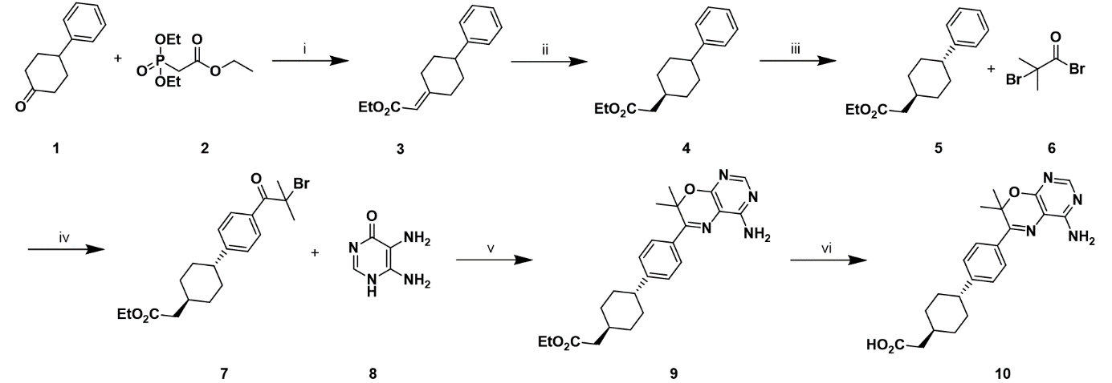
Figure 1. Synthetic route for T863. (i) 2 (1.1 eq), NaH (60% mineral oil, 1.1 eq), THF, 0°C r.t., 1h, 85%; (ii) H₂ Pd/C, EtOH, r.t., 3h, 97%; (iii) a. LiOH (8,35M, 6.9 eq.), H₂O, 50°C, 7h. b.H₂SO₄ (0.1 eq.), EtOH, reflux, 18h, 33%; (iv) 6 (1.1 eq), AlCl₃ (3.0 eq.), DCM, 0°C, 1.5 h, 77%; (v) 8 (0.5 eq), 1M HCl (0.5 eq), EtOH/H₂O (1/1), reflux, 18 h, 21%; (vi) 1M NaOH, EtOH/H₂O/THF (15/1/4), 50°C, 1 h, 69%.
To obtain A922500 (Figure 2 20), we followed the optimized synthetic route developed by the research and development department of Global Pharmaceutical (Abbott Laboratories). (Ravn et al. 2010) Initially, we prepared the diketo 13 from the commercially available cyclohexanone (11) and 4-bromobenzoyl chloride (12) under soft enolization conditions catalyzed by magnesium salts. The bromination of diketo 13 with dibromodimethylhydantoin (DBDMH, 14) under acid catalytic conditions gave the compound 15. Next, the cycle restriction occurred with Favorskii rearrangement conditions to obtain the ketoacid 16. In parallel, we synthesized the urea 19 from isocyanate 17 and the aniline derivative 18 with good yield. Finally, we performed a Suzuki-Miyaura coupling between the ketoacid 16 and the boronate urea 19 with a palladium catalyst. After several purification steps, we obtained the DGAT1 inhibitor A922500 (20), with an overall yield of 16% in a 5-step process from starting material 11.
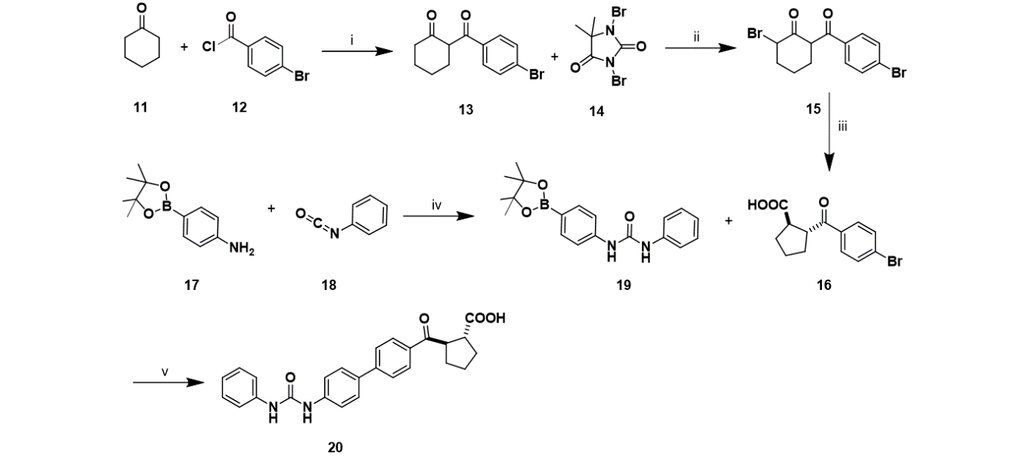
Figure 2. Synthetic route for A922500. (i) MgCl₂ (2.0 eq.), DIPEA (2.0 eq), DCM, 0°C r.t., 22h, quant.; (ii) TFA (0.1 eq.), ACN, reflux, 17h, 97%; (iii) 2M KOH (7.2 eq.), 2°C r.t., 40h. 81%; (iv) 18 (1.05 eq.), Tol, 50°C, 16h, 94%; (v) 19 (1.1 eq.), K₂HPO₄ (3.0 eq.), PdCl₂(dtbpf) (1%mol), DMF/EtOH/H₂O (2:2:1), 22h, r.t., 22%.
We considered the two identical pHLIPs sequences we previously used for this new study of delivering inhibitors of fatty acid metabolism with pHLIPs (Deskeuvre et al. 2022): a sequence reported to deliver toxins (Reshetnyak et al. 2006, Burns et al. 2015) or chemotherapeutic agents (Burns et al. 2015, Burns et al. 2017) only to acidic cancer cells, that we named pHLIPr (AAEQNPIYWARYADWLFTTPLLLLDLALLVDADEGTCG), and a second sequence, that we named pHLIPd (AADDQNPWRAYLDLLFPTDTLLLDLLVDADEGTCG), and that is based on the pHLIP Var3 (Weerakkody et al. 2013), which displays the highest tumor targeting in the murine models after conjugation to a fluorophore. Typically, drug conjugation with pHLIPs occurs through a covalent disulfide bond with the cysteine located on the C-terminal flank. The use of this strategy required the chemical modification of both inhibitors before they could be successfully coupled with pHLIPs. The synthetic route for peptide conjugation with drugs possessing a carboxylic acid group was described in our prior work (Deskeuvre et al. 2022).
Briefly, we performed a disulfide exchange between the disulfide 21 and 2-mercaptoethanol (22) to obtain the disulfide-alcohol 23. Next, the DGAT1 inhibitor ester versions (24 and 25) were synthesized from compounds 23 and their respective carboxyl acid versions (10 and 20) by esterification using N-ethyl-N’-(3-dimethylaminopropyl)carbodiimide hydrochloride (EDCI) as a coupling agent.(Horikawa et al. 2016) Finally, the conjugates (Figure 3 (26-29)) between the modified inhibitors (24 and 25) and the peptides (pHLIPd/r) were prepared in a mixture of acetonitrile and water (1/1) and then purified by semi-preparative high-pressure liquid chromatography (HPLC) system. Their purity was checked with HPLC-MS, and the chromatograms and mass spectra are available in the supplementary information section (Figure S8-SI15).
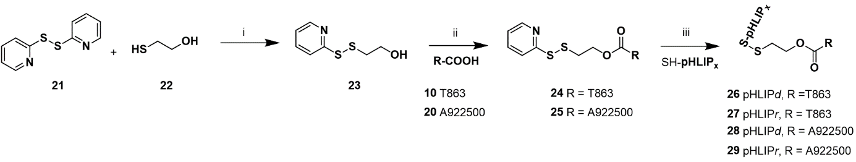
Figure 3. Synthetic route for conjugates. (i) 22 (0.7 eq), AcOH (1.00 eq), MeOH, r.t., 18h, 44%, (ii) 23 (1.1 eq) DMAP (0.3 eq), HOBt (1.5 eq), EDCI (1.5 eq), DIPEA (1.5 eq), DCM, r.t., 18h, 24 54%, 25 21% (iii) SH-pHLIPx (1.0 eq) ACN/H₂O (v/v 1/1), r.t., 18h, 26 62%, 27 49%, 28 47%, 29 29%.

3.2 Biophysical characterization of conjugates
We examined whether the conjugates could undergo transmembrane insertion using steady-state fluorescence (SSF). First, we measured the fluorescence of the conjugates at pH 8, corresponding to the state I condition. Then, we introduced freshly prepared POPC large unilamellar vesicles (LUVs) to the conjugates in a lipid/peptide ratio of 200/1. After 1 h incubation, the media was adjusted to pH 5 or 8 to simulate either state III or II. We additionally assessed the fluorescence of blank solutions corresponding to those wherein the drug (T863 or A922500) replaced the conjugates. For each fluorescence spectrum presented in this study, blank signals were subtracted from the respective conjugate measurements. Unfortunately, the characterization of A922500 conjugates (28 and 29) was hampered by their absorption at the studied wavelength (Figure SI1). However, pHLIPd-T863 presented a pH-dependent insertion, as evidenced by an increase in its intrinsic fluorescence and a shift in its maximal fluorescence intensity under acidic conditions compared to basic ones (Figure 4 A). These changes in fluorescence are attributed to the proximity of tryptophan to the acyl chain of lipids, creating a lipophilic environment. Conversely, we did not observe a pH preference for pHLIPr-T863 insertion inside POPC LUVs, as the signals of state II or III appeared similar (Figure 4 B). However, both conjugates increased the fluorescence between state I and state II, primarily due to the transition from a polar to an apolar environment surrounding the tryptophans.
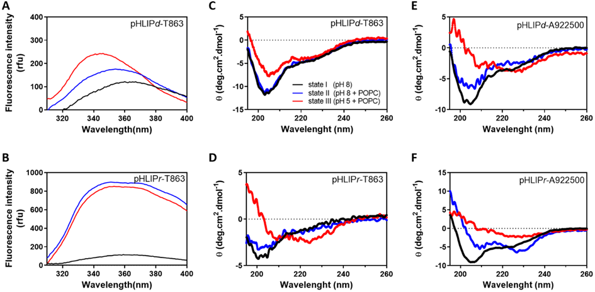
Figure 4. Interactions of conjugates (pHLIPd/r-T863/A922500) with lipid bilayers. Tryptophan fluorescence measurements (A-B) and CD spectroscopy (C-D) of peptides in state I (pH 8, black curve), state II (pH 8 and POPC LUVs, blue curve), and state III (pH 5 and POPC LUVs, red curve). Only pHLIPd-T863 exhibited a pH-dependent insertion according to the fluorescence increase observed at low pH. Interestingly, pHLIPr-T863 demonstrated no preference of insertion into POPC LUVs at low and high pH. No tryptophan fluorescence spectra for A922500 conjugates were obtained due to their absorption in the wavelength studied. CD spectra of pHLIPd-A922500 and pHLIPr-T863 revealed a pH-dependent structuration inside POPC vesicles.
Next, we conducted structural characterizations of conjugates with circular dichroism (CD), maintaining the same conditions as in the SSF experiments. We also subtracted blank signals from conjugate ones. Among the four conjugates, pHLIPd-T863 showed a minimum of ellipticity at 203 nm for the states I and II (Figure 4 C, black and blue curves), indicating that it adopts a random conformation under these conditions. Notably, under state III conditions (Figure 4 C, red curve), we observed a signal corresponding to a 3₁₀ helix, defined by a minimum at 207 nm and a shoulder at 225 nm, that corresponds to a mixture of random and α-helical conformations. Intriguingly, pHLIPr-T863 displayed α-helix structuration with two minima (208 and 225 nm) at pH 5 in the presence of POPC LUVs (Figure 4 D, red curve). Although the ellipticity is relatively low, pHLIPr-T863 still demonstrated a pH-dependent structuration inside POPC vesicles, as no such structuration was observed for states I and II (Figure 4 D, black and blue curves). These results suggest that a pH value of 5 is not acidic enough to structure pHLIPd-T863 as an α-helix, while pHLIPr-T863 exhibits peptide characteristics consistent with the pHLIP family.
Regarding the A922500 conjugates, pHLIPd-A922500 also displayed two minima (e.i. 207 and 225 nm) in the presence of POPC LUVs at pH 5 (Figure 4E, red curve), indicating its structuration as an α-helix. However, the conjugate adopted a random coil conformation in the presence or absence of vesicles at pH 8 (Figure 4E, blue and black curve). In the case of pHLIPr-A922500, structural characterization revealed no pH preference for its structuration in the presence of the vesicles (Figure 4F). At pH 8, pHLIPr-A922500 displays a distinct minimum of around 230 in the presence of LUVs. This characteristic minimum corresponds to a typical exciton signal, previously observed in aggregated pHLIPs when aromatic residue rings or the drug form stacks. These findings confirm that both the cargo’s nature and the specific pHLIP sequence impact the peptide’s insertion and structural conformation.

3.3 3D tumor spheroids evaluation
Since the above biophysical models have intrinsic limitations that may have led to underestimating the potential of the synthesized conjugates, we set out biological experiments using more complex 3D tumor spheroid models where acidosis naturally develops. We generated spheroids from the human cancer cell line human FaDu derived from squamous cell carcinoma of our previous work (Dierge et al. 2021); the choice of these cell types was guided by their capacity to form large spheroids with a limited necrotic core. DGAT1 inhibition prevents PUFA incorporation into triglycerides (within lipid droplets) wherein they are protected from peroxidation. We also employed culture conditions where docosahexaenoic acid (DHA) was added to the extracellular medium to further sensitize acidic cancer cells to ferroptosis. This approach was based on our earlier findings demonstrating that DGAT1 inhibitors may enhance lipid peroxidation in acidic cancer cells and 3D tumor spheroid models. To ensure a more physiologically relevant delivery of DHA, DHA was conjugated to BSA.
First, we compared the growth inhibitory effects, by measuring the spheroid area, of the free drugs and their conjugates at 5 µM in 3D FaDu tumor spheroid models, supplemented with 50 µM DHA. The treatment was renewed every 2 or 3 days. We confirmed that DGAT1 inhibitors (T863 and A922500) increased the cytotoxic potential of DHA. More importantly, we found that pHLIPr-T863 had a more pronounced inhibitory effect than either T863 alone or pHLIPd-T863 (Figure 5 A, C). Interestingly, we also observed that pHLIPr-T863 inhibited FaDu spheroid growth in the absence of DHA to a larger extent than the drug alone. Regarding the second DGAT1 inhibitor conjugate, we observed that in the presence of DHA, pHLIPd-A922500, and pHLIPr-A922500 demonstrated a comparable effect to A922500 (Figure 5 B, C). As A922500 and T863 demonstrated similar inhibition of DGAT1 in vitro, as shown in Table 1, we hypothesized that conjugates with A922500 could aggregate at the tested concentration, even if not visually observed. Given that A922500 is more hydrophobic than T863, the respective conjugates might exhibit differences in inhibitory effects on the growth of FaDu spheroids. This observation aligns with the data obtained from CD analysis. Consequently, we have chosen not to pursue further evaluation of these conjugates.
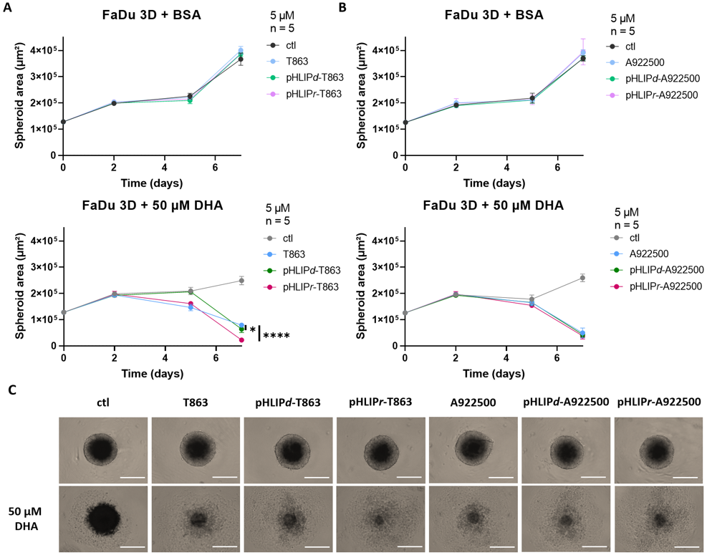
Figure 5. Effects of 5 µM of T863 and conjugates (A) and A922500 and conjugates (B) on the growth of 3D FaDu tumor spheroids in the presence (or not) of 50 µM DHA; representative pictures of spheroids at day 7 are also shown (C). Scale bar, 500 µm. Data are represented as mean ± SD of 5 different spheroids. Significance was determined by two-way ANOVA with Tukey’s multiple comparisons test. *p < 0.05; **p < 0.01; ***p < 0.001; ****p < 0.0001.
Following the promising results observed for T863 conjugates in FaDu tumor spheroids, we conducted further investigations in vitro. Also, we used larger spheroids to recapitulate the development of a steeper acidic gradient and examined the effects of T863 and conjugates. Both conjugates displayed higher inhibitory effects on tumor spheroid growth (vs. T863 alone) (Figure 6). Again, pHLIPr-T863 presented a greater effect than pHLIPd-T863. Of note, the discernible difference between T863 and conjugates emerged around day 5-7, which corresponded to approximately a 500-600 µm spheroid diameter and the development of acidosis in the spheroid core (Dierge et al. 2021). Notably, FaDu tumor spheroid growth was increased when treated with T863 or conjugates in the absence of DHA. These data suggest that in the absence of DHA, the inhibition of DGAT1 could promote FA oxidation instead of storage, and thereby stimulate cell growth.
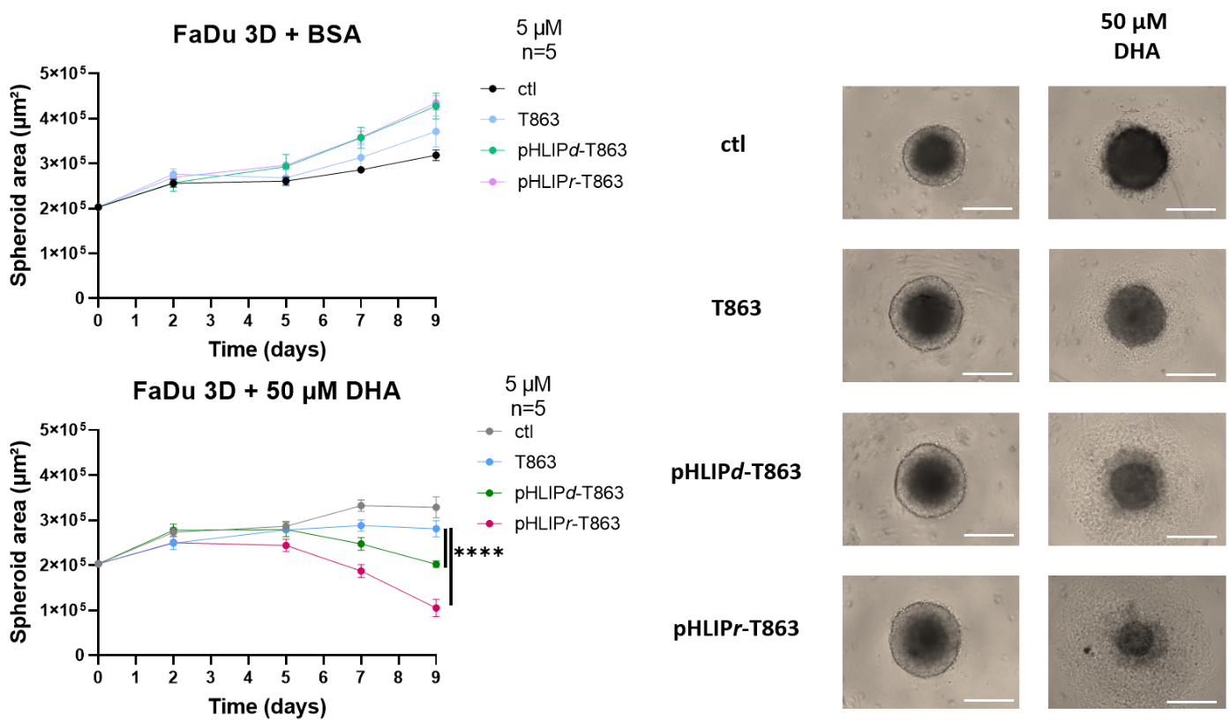
Figure 6. Effects of 5 µM T863 and conjugates on the growth of 3D FaDu tumor spheroids in the presence (or not) of 50 µM DHA; representative pictures of spheroids at day 9 are also shown. Scale bar, 500 µm. Data are represented as mean ± SD of 5 different spheroids. Significance was determined by two-way ANOVA with Tukey’s multiple comparisons test. *p < 0.05; **p < 0.01; ***p < 0.001; ****p < 0.0001.
3.4 Preliminary evaluation of DGAT1 conjugate fluorescent variants
To assess the capacity of T863 conjugates to specifically target the acidic compartment within FaDu spheroids, fluorescent variants of T863 conjugates were prepared. The procedure involved the selective labeling of the N-terminal end using sulfocyanine5 (SCy5, Lumiprobe®) through NHS ester conjugation. We conducted the reaction in a mixture of acetonitrile and phosphate buffer at pH 8, and the reaction duration spanned 2 h under light-protected conditions (Figure 7 A). Finally, a purification step was performed to eliminate any excess of fluorescent dye. This strategic approach enabled the incorporation of an irreversible tag onto our conjugates, ensuring their integrity and stability.
We treated FaDu spheroids with 5 µM T863 and SCy5-conjugated variants in the presence or the absence of 50 µM DHA. We observed that the fluorescent variants displayed inhibitory growth effects when supplemented with DHA although to a lesser extent than pHLIPd/r-T863 (Figure 7 B). In the absence of DHA, SCy5-pHLIPd/r-T863 also exhibited an ability to promote the growth of FaDu spheroids from day 7 onwards.
We conducted confocal imaging microscopy to visualize the staining of SCy5-pHLIPd/r-T863 within FaDu spheroids at the end of the experiment (day 9) (Figure 7 C, red). Before imaging, we employed DAPI staining to counterstain the cell nucleus (Figure 7 C, blue). We found that fluorescent variants accumulate primarily in the central region of spheroids, particularly those cultured under DHA-free conditions. In contrast, the staining within spheroids treated with DHA appeared less specific, in agreement with the cytotoxic effects of DHA and a likely unspecific entrapment of the peptide. Of note, in these non-physiological conditions, the more pronounced SCy5-pHLIPr-T863 staining within FaDu spheroids supplemented with DHA (than SCy5-pHLIPd-T863) could align with our biophysical findings indicating that pHLIPr-T863 showed less pH-dependence specificity in the presence of POPC LUVs.

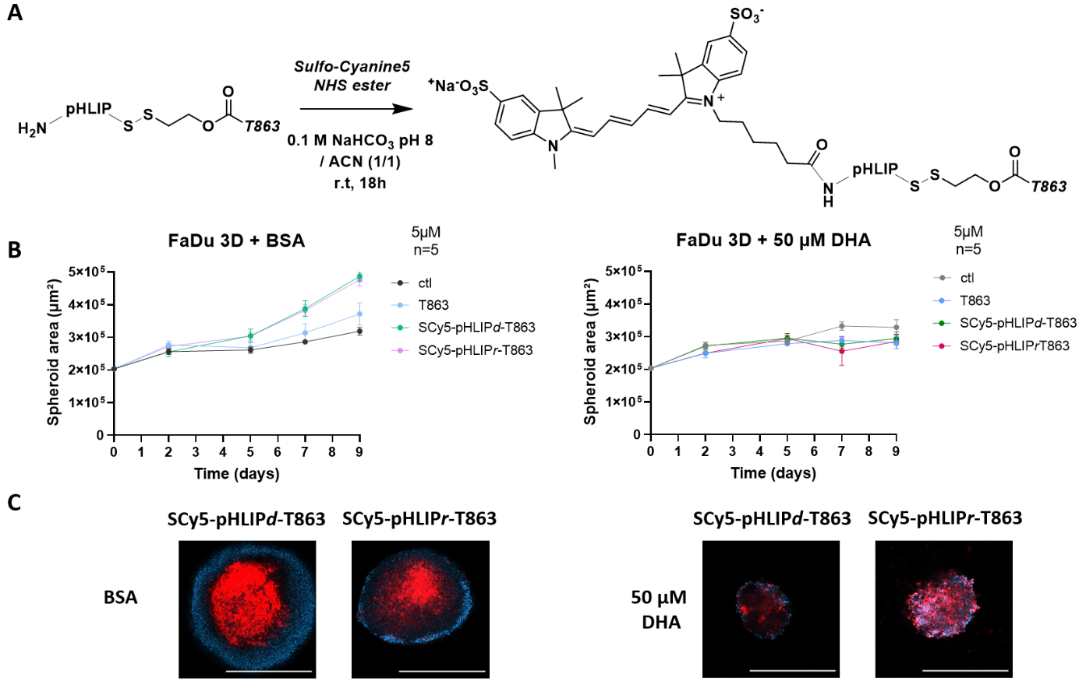
Figure 7. Synthetic route for fluorescent drug conjugate variants (A) and effects of 5 µM of T863 and fluorescent drug conjugates with and without DHA (B) and representative pictures of larger spheroids at day 9 are also shown (C). Scale bar, 500 µm. Data are represented as mean ± SD of 5 different spheroids. The SCy5-pHLIPd/r-T863 and DAPI staining are in red and blue, respectively.

4 Discussion
Numerous studies have examined the biophysical mechanisms of pHLIPs, both in vitro and in vivo models. The insertion of pHLIPs depends on several factors, such as the presence and nature of the cargo. (An et al. 2010, Song et al. 2016), lipid bilayer composition (Barrera et al. 2012, Kyrychenko et al. 2015, Vasquez-Montes et al. 2018), and the peptide sequence (Silva et al. 2023). In our investigation, we explored the effects of pHLIP-conjugated DGAT1 inhibitors, namely T863 and A922500, within the context of lipid bilayer vesicles and 3D tumor spheroid models.
We demonstrated that the lipophilicity of the cargo contributes to the efficacy of pHLIPs delivery, aligning with findings in the literature. We employed Steady-State Fluorescence (SSF) and Circular Dichroism (CD) to characterize the four prepared conjugates. It was found that the pHLIPd/r-T863 conjugates present a pH-dependent insertion profile and a helicoidal structuration while the pHLIPd/r-A922500 conjugates could not be characterized using SSF. However, their structuration could be analyzed in the presence of LUVs. pHLIPd-A922500 was found as an α-helix in acidic condition while the presence of excitons in the circular dichroism (CD) spectra for pHLIPr-A922500 suggested aggregation of this conjugate in the presence of POPC LUVs.
We next sought to investigate the insertion pKa of pHLIPd-T863 and pHLIPr-T863 in LUVs of different compositions using their tryptophan fluorescence (Figure S2-3). The insertion pKa corresponds to the pH value at which 50% of the peptide is inserted into vesicles while the other 50% remains in solution (Hunt et al. 1997). Unfortunately, this experiment revealed inconclusive as the variation in pH did not induce a significant change in fluorescence for most conditions. Our hypothesis was that the experimental setup using LUVs may not adequately model the behavior of pHLIPs. So, we proceeded with biological experiments utilizing more intricate 3D tumor spheroid models, where acidosis occurs naturally.
Our investigation into the inhibitory growth effect on FaDu spheroids revealed that the conjugates demonstrated a remarkable ability to enhance the growth-inhibitory actions of DHA, highlighting their potential in targeted cancer therapy. We observed that only 5 µM of DGAT1 inhibitors (including conjugates) could significantly decrease the proliferation of FaDu spheroids in supplementation with 50 µM of DHA, which was half the concentration demonstrated previously. Our in vitro analysis revealed that conjugates with A922500 failed to enhance the growth inhibitory effect on the FaDu spheroid model compared to A922500 alone. This lack of effects could be due to the aggregation of these conjugates as demonstrated in the CD experiment. However, among the conjugates, pHLIPr-T863 emerged as the most potent, surpassing the efficacy of both T863 and pHLIPd-T863. Finally, we successfully demonstrated that the fluorescent variants of our conjugate could target the acidic core of the spheroid. However, it's noteworthy that they did not impede spheroid growth without the supplementation of DHA.
In conclusion, while our findings emphasize the limitation of using lipid models for investigating drug conjugate insertion, the use of relevant 3D tumor spheroid models has proven instrumental in unveiling the therapeutic potential of pHLIP-conjugated DGAT1 inhibitors. The observed variations in efficacy underscore the multifaceted nature of these conjugates, influenced by factors like the specific pHLIP sequence used and the presence of DHA supplementation. These insights offer valuable guidance for further research and potential applications in cancer therapy. Moving forward, the in vivo evaluation of our conjugates holds the promise of confirming anticancer effects while preserving the health of surrounding tissues.
Author contributions
Conceptualization, M.D, O.F. and R.F.; Experimental work, M.D., J.L.; Data analysis and interpretation, M.D., O.F. and R.F. Writing - Review & Editing, M.D., J.L., J.M., O.F. and R.F.; Funding and resources, J.M., O.R., O.F. and R.F.; Supervision, O.F. and R.F.
Declaration of interest
The authors declare no competing interests.
Acknowledgments
This work was supported by the Université Catholique de Louvain, Belgium. The authors thank Vincent Stroobant, Bénédicte Tollet, Bernard Ukacar, Kevin Vanvarenberg, Khadija Wahni and Santiago Agustín Martínez Gache for technical assistance and fruitful discussions. We acknowledge the VIB-VUB Center for Structural Biology for access to the circular dichroism instrument, Pr. Rita Vanbever (UCLouvain) for access to Avanti® Mini Extruder and Pr. Anne des Rieux for access to EVOS XL Core Imaging System.
References
An, M., D. Wijesinghe, O. A. Andreev, Y. K. Reshetnyak and D. M. Engelman, 2010. "pH-(low)-insertion-peptide (pHLIP) translocation of membrane impermeable phalloidin toxin inhibits cancer cell proliferation." Proc Natl Acad Sci U S A 107(47): 20246-20250.
Andreev, O. A., A. D. Dupuy, M. Segala, S. Sandugu, D. A. Serra, C. O. Chichester, et al.Y. K. Reshetnyak, 2007. "Mechanism and uses of a membrane peptide that targets tumors and other acidic tissues in vivo." Proc Natl Acad Sci U S A 104(19): 7893-7898.
Anschau, A. C., C. S.; Kuhn, R. C. and Franco, T. T., 2017. "Validation of the sulfo-phosphovanillin (SPV) method for the determination of lipid content in oleaginous microorganisms." Braz. J. Chem. Eng. 34(1): 19-27.
Barrera, F. N., J. Fendos and D. M. Engelman, 2012. "Membrane physical properties influence transmembrane helix formation." Proc Natl Acad Sci U S A 109(36): 14422-14427.
Birch, A. M., S. Birtles, L. K. Buckett, P. D. Kemmitt, G. J. Smith, T. J. Smith, et al.S. J. Wang, 2009. "Discovery of a potent, selective, and orally efficacious pyrimidinooxazinyl bicyclooctaneacetic acid diacylglycerol acyltransferase-1 inhibitor." J Med Chem 52(6): 1558-1568.
Burns, K. E., M. K. Robinson and D. Thevenin, 2015. "Inhibition of cancer cell proliferation and breast tumor targeting of pHLIP-monomethyl auristatin E conjugates." Mol Pharm 12(4): 1250-1258.
Burns, K. E., H. Hensley, M. K. Robinson and D. Thevenin, 2017. "Therapeutic Efficacy of a Family of pHLIP-MMAF Conjugates in Cancer Cells and Mouse Models." Mol Pharm 14(2): 415-422.
Cases, S., S. J. Smith, Y. W. Zheng, H. M. Myers, S. R. Lear, E. Sande, et al.R. V. Farese, Jr., 1998. "Identification of a gene encoding an acyl CoA:diacylglycerol acyltransferase, a key enzyme in triacylglycerol synthesis." Proc Natl Acad Sci U S A 95(22): 13018-13023.
Cheng, X., F. Geng, M. Pan, X. Wu, Y. Zhong, C. Wang, et al.D. Guo, 2020. "Targeting DGAT1 Ameliorates Glioblastoma by Increasing Fat Catabolism and Oxidative Stress." Cell Metab 32(2): 229-242 e228.
Chitraju, C., N. Mejhert, J. T. Haas, L. G. Diaz-Ramirez, C. A. Grueter, J. E. Imbriglio, et al.R. V. Farese, Jr., 2017. "Triglyceride Synthesis by DGAT1 Protects Adipocytes from Lipid-Induced ER Stress during Lipolysis." Cell Metab 26(2): 407-418 e403.
Corbet, C. and O. Feron, 2017a. "Emerging roles of lipid metabolism in cancer progression." Curr Opin Clin Nutr Metab Care 20(4): 254-260.
Corbet, C. and O. Feron, 2017b. "Tumour acidosis: from the passenger to the driver's seat." Nat Rev Cancer 17(10): 577-593.
Corbet, C., E. Bastien, J. P. Santiago de Jesus, E. Dierge, R. Martherus, C. Vander Linden, et al.O. Feron, 2020. "TGFbeta2-induced formation of lipid droplets supports acidosis-driven EMT and the metastatic spreading of cancer cells." Nat Commun 11(1): 454-469.
Denison, H., C. Nilsson, L. Lofgren, A. Himmelmann, G. Martensson, M. Knutsson, et al.J. W. Eriksson, 2014. "Diacylglycerol acyltransferase 1 inhibition with AZD7687 alters lipid handling and hormone secretion in the gut with intolerable side effects: a randomized clinical trial." Diabetes Obes Metab 16(4): 334-343.
Deskeuvre, M., J. Lan, E. Dierge, J. Messens, O. Riant, C. Corbet, et al.R. Frederick, 2022. "Targeting cancer cells in acidosis with conjugates between the carnitine palmitoyltransferase 1 inhibitor etomoxir and pH (low) insertion peptides." Int J Pharm 624: 122041.
Dierge, E., E. Debock, C. Guilbaud, C. Corbet, E. Mignolet, L. Mignard, et al.O. Feron, 2021. "Peroxidation of n-3 and n-6 polyunsaturated fatty acids in the acidic tumor environment leads to ferroptosis-mediated anticancer effects." Cell Metab 33(8): 1701-1715.
Du, W., L. Zhang, A. Brett-Morris, B. Aguila, J. Kerner, C. L. Hoppel, et al.S. M. Welford, 2017. "HIF drives lipid deposition and cancer in ccRCC via repression of fatty acid metabolism." Nat Commun 8(1): 1769.
Fox, B. M., K. Sugimoto, K. Iio, A. Yoshida, J. K. Zhang, K. Li, et al.F. Kayser, 2014. "Discovery of 6-phenylpyrimido[4,5-b][1,4]oxazines as potent and selective acyl CoA:diacylglycerol acyltransferase 1 (DGAT1) inhibitors with in vivo efficacy in rodents." J Med Chem 57(8): 3464-3483.
Gayle, S., R. Aiello, N. Leelatian, J. M. Beckta, J. Bechtold, P. Bourassa, et al.V. M. Paralkar, 2021. "Tumor-selective, antigen-independent delivery of a pH sensitive peptide-topoisomerase inhibitor conjugate suppresses tumor growth without systemic toxicity." NAR Cancer 3(2): 1-13.
Horikawa, R., H. Sunayama, Y. Kitayama, E. Takano and T. Takeuchi, 2016. "A Programmable Signaling Molecular Recognition Nanocavity Prepared by Molecular Imprinting and Post-Imprinting Modifications." Angew Chem Int Ed Engl 55(42): 13023-13027.
Hoy, A. J., S. Balaban and D. N. Saunders, 2017. "Adipocyte-Tumor Cell Metabolic Crosstalk in Breast Cancer." Trends Mol Med 23(5): 381-392.
Hunt J. F., P. Rath, K. J. Rothschild, D. M. Engelman, 1997. "Spontaneous, pH-dependent membrane insertion of a transbilayer alpha-helix." Biochemistry 36(49): 15177-15192
Karabadzhak, A. G., D. Weerakkody, J. Deacon, O. A. Andreev, Y. K. Reshetnyak and D. M. Engelman, 2018. "Bilayer Thickness and Curvature Influence Binding and Insertion of a pHLIP Peptide." Biophys J 114(9): 2107-2115.
Kyrychenko, A., V. Vasquez-Montes, M. B. Ulmschneider and A. S. Ladokhin, 2015. "Lipid headgroups modulate membrane insertion of pHLIP peptide." Biophys J 108(4): 791-794.
Moshnikova, A., V. Moshnikova, O. A. Andreev and Y. K. Reshetnyak, 2013. "Antiproliferative effect of pHLIP-amanitin." Biochemistry 52(7): 1171-1178.
Nardi, F., O. E. Franco, P. Fitchev, A. Morales, R. E. Vickman, S. W. Hayward and S. E. Crawford, 2019. "DGAT1 Inhibitor Suppresses Prostate Tumor Growth and Migration by Regulating Intracellular Lipids and Non-Centrosomal MTOC Protein GM130." Sci Rep 9(1): 3035.
Otieno, S. A. and W. Qiang, 2021. "Roles of key residues and lipid dynamics reveal pHLIP-membrane interactions at intermediate pH." Biophys J 120(21): 4649-4662.
Peppicelli, S., E. Andreucci, J. Ruzzolini, A. Laurenzana, F. Margheri, G. Fibbi, et al.L. Calorini, 2017. "The acidic microenvironment as a possible niche of dormant tumor cells." Cell Mol Life Sci 74(15): 2761-2771.
Pillai, S. R., M. Damaghi, Y. Marunaka, E. P. Spugnini, S. Fais and R. J. Gillies, 2019. "Causes, consequences, and therapy of tumors acidosis." Cancer Metastasis Rev 38(1-2): 205-222.
Ravn, M. M., S. H. Wagaw, K. M. Engstrom, M. Jianzhang, B. Kotecki, A. J. Souers, et al.G. Zhao, 2010. "Process Development of a Diacyl Glycerolacyltransferase-1 Inhibitor." Org. Process Res. Dev. 14(2): 417-424.
Reshetnyak, Y. K., O. A. Andreev, U. Lehnert and D. M. Engelman, 2006. "Translocation of molecules into cells by pH-dependent insertion of a transmembrane helix." Proc Natl Acad Sci U S A 103(17): 6460-6465.
Reshetnyak, Y. K., M. Segala, O. A. Andreev and D. M. Engelman, 2007. "A monomeric membrane peptide that lives in three worlds: in solution, attached to, and inserted across lipid bilayers." Biophys J 93(7): 2363-2372.
Silva, T. F. D., H. Visca, C. Klumpp, O. A. Andreev, Y. K. Reshetnyak and M. Machuqueiro, 2023. "Arginine Residues Modulate the Membrane Interactions of pHLIP Peptides." J Chem Inf Model 63(14): 4433-4446.
Song, Q., X. Chuan, B. Chen, B. He, H. Zhang, W. Dai, et al.Q. Zhang, 2016. "A smart tumor targeting peptide-drug conjugate, pHLIP-SS-DOX: synthesis and cellular uptake on MCF-7 and MCF-7/Adr cells." Drug Deliv 23(5): 1734-1746.
Vander Linden, C. and C. Corbet, 2019. "Therapeutic Targeting of Cancer Stem Cells: Integrating and Exploiting the Acidic Niche." Front Oncol 9: 159.
Vasquez-Montes, V., J. Gerhart, D. Thevenin and A. S. Ladokhin, 2019. "Divalent Cations and Lipid Composition Modulate Membrane Insertion and Cancer-Targeting Action of pHLIP." J Mol Biol 431(24): 5004-5018.
Vasquez-Montes, V., J. Gerhart, K. E. King, D. Thevenin and A. S. Ladokhin, 2018. "Comparison of lipid-dependent bilayer insertion of pHLIP and its P20G variant." Biochim Biophys Acta Biomembr 1860(2): 534-543.
Vavere, A. L., G. B. Biddlecombe, W. M. Spees, J. R. Garbow, D. Wijesinghe, O. A. Andreev, et al.J. S. Lewis, 2009. "A novel technology for the imaging of acidic prostate tumors by positron emission tomography." Cancer Res 69(10): 4510-4516.
Weerakkody, D., A. Moshnikova, M. S. Thakur, V. Moshnikova, J. Daniels, D. M. Engelman, et al.Y. K. Reshetnyak, 2013. "Family of pH (low) insertion peptides for tumor targeting." Proc Natl Acad Sci U S A 110(15): 5834-5839.
Wijesinghe, D., D. M. Engelman, O. A. Andreev and Y. K. Reshetnyak, 2011. "Tuning a polar molecule for selective cytoplasmic delivery by a pH (Low) insertion peptide." Biochemistry 50(47): 10215-10222.
Yeh, V. S., D. W. Beno, S. Brodjian, M. E. Brune, S. C. Cullen, B. D. Dayton, et al.A. J. Souers, 2012. "Identification and preliminary characterization of a potent, safe, and orally efficacious inhibitor of acyl-CoA:diacylglycerol acyltransferase 1." J Med Chem 55(4): 1751-1757.
Yen, C. L., S. J. Stone, S. Koliwad, C. Harris and R. V. Farese, Jr., 2008. "Thematic review series: glycerolipids. DGAT enzymes and triacylglycerol biosynthesis." J Lipid Res 49(11): 2283-2301.
Zhao, G., A. J. Souers, M. Voorbach, H. D. Falls, B. Droz, S. Brodjian, et al.P. R. Kym, 2008. "Validation of diacyl glycerolacyltransferase I as a novel target for the treatment of obesity and dyslipidemia using a potent and selective small molecule inhibitor." J Med Chem 51(3): 380-383.

