Supplementary material

Residual stresses of friction melt bonded aluminum/steel joints determined by neutron diffraction
N. Jimenez-Mena¹, T. Sapanathan^{1,*}, J.M. Drezet², T. Pirling³, P. J. Jacques¹, A. Simar¹
¹ Institute of Mechanics, Materials and Civil Engineering, UCLouvain, B-1348 Louvain-la-Neuve, Belgium

² École Polytechnique Fédérale de Lausanne, Institut des Matériaux, station 12, 1015 Lausanne, Switzerland
³ Institut Laue-Langevin, 71 avenue des Martyrs, CS 20156, 38042 Grenoble cedex 9, France

* Corresponding author e-mail : thaneshan.sapanathan@uclouvain.be

This file includes supplementary figures of;
- Fig. S1 – Flow behavior of the base materials
- Fig. S2 to S4 - Geometrical model to calculate the centroid of the sampled gauge volume (SGV)

Fig. S1: Flow behavior of the base materials
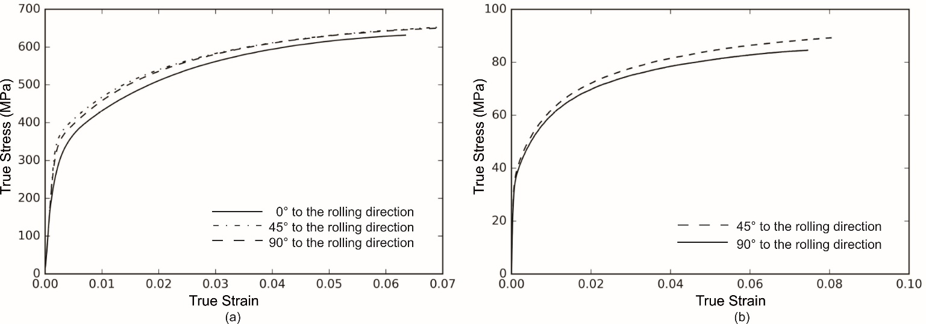
Fig. S1. True stress- true strain curves of the base materials (a) steel and (b) aluminum alloy (AA1050+ 2% Al-5Ti-1B) used in the Friction Melt Bonding process.

The mechanical behaviours of DP600 steel and Al alloy shown respectively in Fig. S1a and b were obtained using a Zwick tensile test machine at a constant crosshead speed of 1 mm.min⁻¹, following ASTM E8M-16a (2016) standard. In the case of steel, tensile specimens were extracted at 0° (parallel to the rolling direction), 45° and 90° (perpendicular to the rolling direction). For the aluminium plate, specimens were only tested at 45° and 90°.

Fig. S2 – S4: Geometrical model to calculate the centroid of sampled gauge volume (SGV)
These figures include a brief explanation of the adaptation of the model developed by Bruno et al. (2006) to our dissimilar welding to correct the artificial peak shift. It consists on a geometrical model to calculate the position of the gravity center of the interaction between the instrumental gauge volume (IGV) and the sample, i.e., sampled gauge volume (SGV). The interaction depends on the following properties:

(i) The intensity of the primary beam follows a triangular distribution. It is maximum at the center of the beam and linearly decreases to zero at the sides of the beam (see Fig. 3.20 in Hutchings et al, 2005);
(ii) The shape of the SGV is defined by the intersection of the instrumental gauge volume (IGV) and the sample, as represented in Fig. S2;
(iii) The artificial peak shift is corrected comparing the distance between the gravity center of the SGV, the center of the IGV (ΔZ_{SGV} in Fig. S2), and the experimental measurements provided in Fig. S4c.

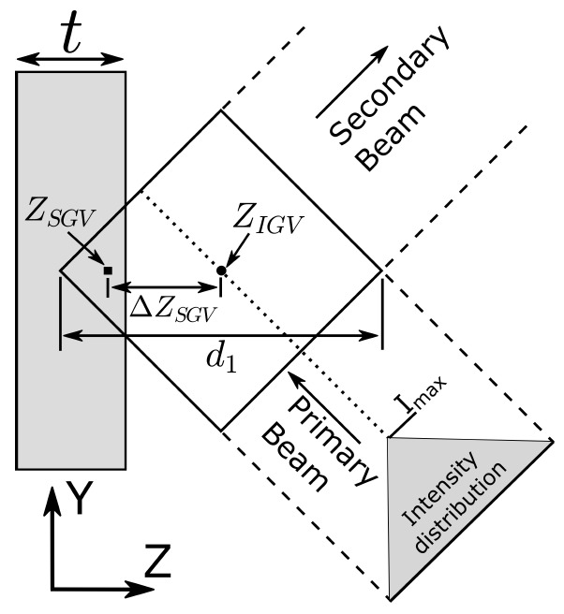
Fig. S2. Dimensions of the interaction between the instrumental gauge volume (IGV) and the sample. The dotted line indicates the position of the maximum intensity of the incident beam.

Fig. S2 is the simplified 2D geometrical representation of the IGV and the interaction between the sample SGV. To account for the intensity distribution of the primary beam, this one is included as a third dimension (Bruno et al., 2006). Only the position of the centroid of the SGV along the Z axis is used for the correction. The only difference in this work with respect to the model of Bruno et al. (2006) is that the diffraction angle 2θ is not kept constant at 90°. Hence, the shape of the SGV is not necessarily a square, i.e., it can be a rhombus. To ease the calculations, the position of the centroid is calculated by dividing the total volume into pyramids with triangular base and using mass weighted addition given by the following equation:

$$Z_{SGV}= \frac{\sum{Z_{SGV,i} V_{i}}}{\sum{V_{i}}}$$ | (Eq.1)
Where, $Z_{SGV,i }$and $V_{i }$are the centroid and volume, respectively, of each of the triangular pyramids in which the total interaction volume is divided into.
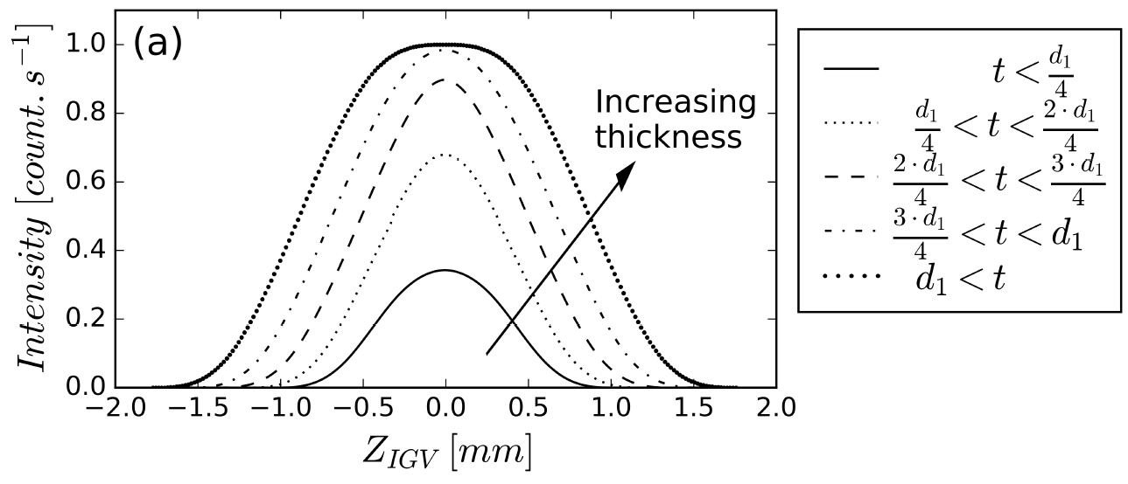
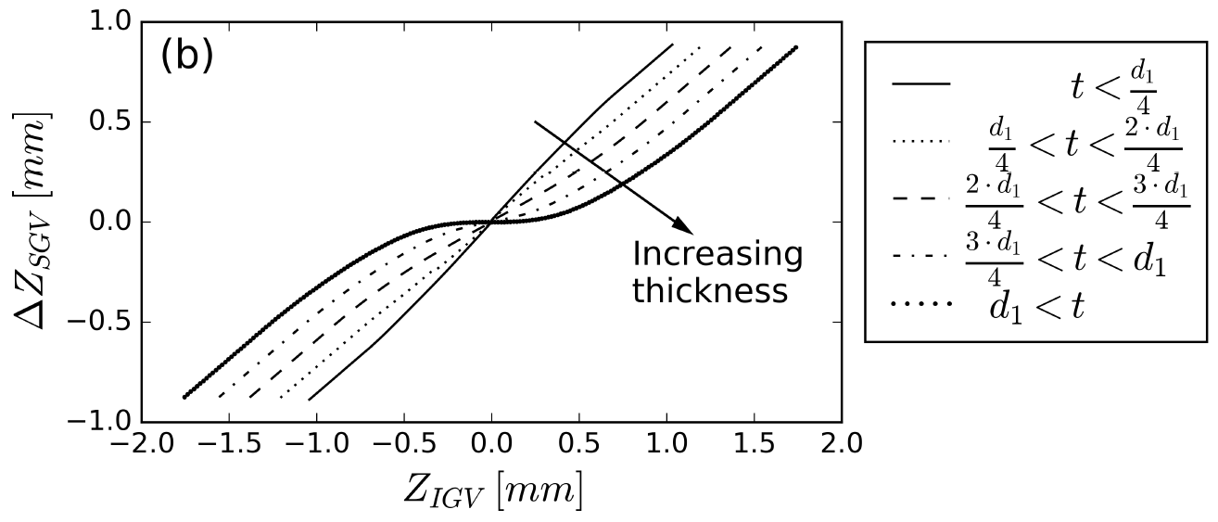
Fig. S3. (a) Evolution of the normalized intensity and (b) of ΔZSGV as a function of the position of the centroid of the instrumental gauge volume Z_{IGV}.

Fig. S3a provides the evolution of the intensity as the beam crosses the steel plate. The beam width is set to a=1.3 mm and the intensity is normalised to the intensity when the IGV is fully inside the sample.
The results are provided for 5 different plate thicknesses according to the diagonal of the IGV in Bruno et al. (2006). These are the curves used to calibrate the model in Fig. S4a and S4b (given below) and in the identification of interface position in Fig. 6 in the manuscript.

Fig. S3b shows the distance between the centroids of the SGV and IGV as the IGV crosses the plate for the same plate thicknesses represented in Fig. S3a. This is the distance used to correct the artificial peak measurements using the linear fitting provided in Fig. S4c.
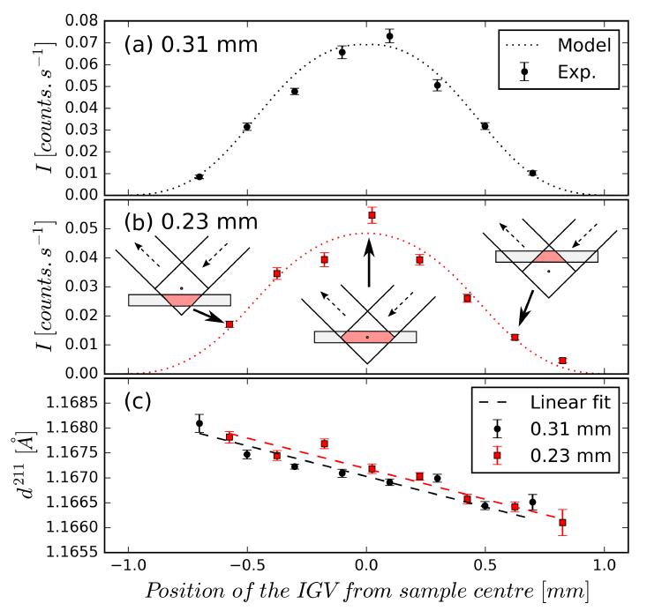
Fig. S4. Experimental and modelled fitted evolution of the intensity profile for (a) 0.31 mm and (b) 0.23 mm ferritic steel sampled as a function of the position of the IGV. (c) Evolution of d211 for both samples. The evolution of d211 has been fitted by a linear law.

It is worth noting that, when the thickness of the sample is very small (t < d1/4), ΔZ_{SGV} $≈$ Z_{SGV} (Fig. S4b). Therefore, the linear fit of the peak shift in Fig. S4c as a function of Z_{IGV} is also valid to describe the peak shift as a function of ΔZ_{SGV}, since the thicknesses of the plates are small, 0.23 and 0.31 mm, respectively. This approximation is not valid in the case of the welded DP600 plate (0.9 mm thick), since ΔZ_{SGV} $≠$ Z_{IGV} . Therefore, to correct the artificial peak shift, ΔZ_{SGV} is first identified from the relative position of the sample and the IGV. Then the peak shift is determined by comparing ΔZ_{SGV} to Z_{IGV} as shown in Fig. S4c.

References
Bruno, G., Fanara, C., Hughes, D.J., Ratel, N., 2006. Procedures for interface residual stress determination using neutron diffraction: Mo-coated steel gear wheel. Nuclear Instruments and Methods in Physics Research Section B: Beam Interactions with Materials and Atoms 246, 425-439.
Hutchings, M.T., Withers, P.J., Holden, T.M., Lorentzen, T., 2005. Introduction to the characterization of residual stress by neutron diffraction. CRC press, Boca Raton, USA, p.112.

